Challenges and Institutional Barriers in Implementing Carbon Market Initiatives among Pastoralist Communities: Experiences from Ngaremara, Northern Kenya
Abstract
Carbon market initiatives have been promoted as mechanisms to enhance climate resilience and provide economic benefits to vulnerable communities. However, their successful implementation is often hindered by governance, institutional, and socio-cultural challenges. This study examines barriers to carbon market implementation among pastoralist communities in Ngaremara, Isiolo County, Kenya. Using a cross-sectional survey and qualitative responses from 367 households, the research analyzes stakeholder participation, benefit-sharing mechanisms, financial accessibility, and policy-related constraints affecting project success. Quantitative findings indicate that 62.9% of respondents reported conflicts over benefit-sharing, while 33.5% felt excluded from decision-making processes, and 70% cited difficulties accessing technical expertise and financial resources. Qualitative responses further revealed concerns about unclear policy frameworks, limited transparency in benefit distribution, and tensions between carbon project requirements and pastoralist grazing traditions. Socio-cultural factors such as trust deficits (52%) and perceived misalignment with local land-use practices (30.8%) further constrained project adoption. Statistical analysis confirmed a significant negative association between implementation challenges and livelihood outcomes (p < 0.001). The study concludes that governance weaknesses, inadequate financial structures, policy implementation gaps, and limited community engagement pose major obstacles to carbon market success in pastoralist regions. Addressing these barriers requires strengthening participatory governance, improving financial access, and designing culturally responsive climate finance mechanisms.
Keywords: participatory governance; financial accessibility; policy gaps; trust-building; traditional land-use systems; dryland adaptation

Introduction
Carbon markets have emerged as important mechanisms for mobilizing climate finance and promoting climate change mitigation through land-based interventions. By putting an economic value to carbon sequestration and emission reductions, these initiatives aim to align environmental conservation with broader sustainable development objectives. Carbon market initiatives have increasingly been promoted as tools for supporting activities such as afforestation, rangeland restoration, and improved land management, particularly in developing regions where climate mitigation can also contribute to livelihood improvement (IPCC, 2021; Atela et al., 2015). These initiatives have the potential to strengthen rural economies, enhance environmental outcomes, and improve climate resilience. However, their effectiveness depends heavily on governance structures, institutional frameworks, and the socio-economic contexts in which they are implemented (Mathur et al., 2014; Bond et al., 2020). In pastoralist landscapes where communal land tenure systems and traditional livelihood practices shape resource management, the implementation of carbon market initiatives may therefore encounter complex governance and institutional challenges.
Effective governance has been identified as a critical determinant of carbon market success. In many African pastoralist communities, land tenure insecurity, lack of transparency, and weak stakeholder engagement hinder equitable benefit-sharing (Bernard & Adkins, 2014; Mburu, 2015). Communal land tenure systems complicate ownership rights and revenue distribution, often leading to elite capture and exclusionary practices (Little, 1996; Munene, 2019; Wako, 2022). When communities are excluded from decision-making, projects face mistrust, disputes, and resistance (Herr et al., 2019).
These governance challenges can be further understood through the lens of Common-Pool Resource (CPR) theory, which examines how communities collectively manage shared resources such as rangelands, forests, and fisheries (Ostrom, 1990; Agrawal, 2001). In pastoralist systems, rangelands function as communal resources governed by informal institutions, customary rules, and collective decision-making structures. The success of externally introduced initiatives such as carbon market projects often depends on how well they align with these existing governance systems. When project rules conflict with local norms or fail to clearly define rights, responsibilities, and benefit-sharing mechanisms, collective action problems can emerge, leading to mistrust, elite capture, or reduced participation. Applying a CPR perspective therefore helps explain why governance transparency, inclusive decision-making, and clearly defined resource rights are critical for the effective implementation of carbon market initiatives in pastoralist landscapes.
Kenya has increasingly recognized the importance of carbon markets as part of its broader climate policy framework. The Climate Change Act of 2016 established the legal and institutional foundation for climate governance, while the Climate Change (Amendment) Act of 2023 introduced provisions to regulate carbon markets and ensure equitable benefit-sharing from carbon trading activities. These policy instruments are complemented by the National Climate Change Action Plan (NCCAP) and Kenya’s Nationally Determined Contribution (NDC) under the Paris Agreement, both of which emphasize sustainable land management, restoration, and climate finance mechanisms. Despite these progressive frameworks, translating national policy ambitions into effective implementation at the local level remains challenging, particularly in pastoralist regions where communal land tenure systems, governance complexities, and limited institutional capacity can affect participation in carbon market initiatives.
Socio-cultural factors also shape carbon market adoption. Pastoralist economies are deeply tied to livestock and traditional grazing practices, and conservation measures can be perceived as threats to livelihoods (Little, 1996; Mathur et al., 2014). Conflicts between modern conservation policies and indigenous knowledge systems can slow project uptake, while skepticism persists due to past development programs that failed to deliver tangible benefits (Atela et al., 2015; Wako, 2022).
Financial and technical barriers are equally significant. Many pastoralist households face difficulties accessing credit, microfinance, or reinvestment opportunities needed to participate in carbon markets (Bond et al., 2020; Bryan et al., 2018). Limited technical capacity in areas such as carbon measurement, emissions reporting, and pricing negotiations further constrains participation (Mathur et al., 2014; Mburu, 2015).
Recent global debates have also highlighted both the potential and the limitations of carbon market mechanisms in supporting climate mitigation and local development outcomes. While carbon markets are increasingly promoted as tools for mobilizing climate finance and supporting land restoration, several recent assessments have raised concerns about governance transparency, uneven distribution of benefits, and the effectiveness of some carbon credit systems (World Bank, 2023; IPCC, 2022). Investigative reporting and policy analyses have also pointed to cases where carbon offset projects generated limited benefits for local communities despite significant financial flows, raising questions about accountability and community participation in carbon market governance (Guardian, 2023). At the same time, evidence from successful projects suggests that when carbon initiatives incorporate strong community governance structures, transparent benefit-sharing mechanisms, and locally adapted land management systems, they can contribute to both climate mitigation and improved livelihood resilience (Jiang et al., 2024). These global discussions highlight the importance of understanding the institutional and socio-cultural context in which carbon market initiatives are implemented, particularly in pastoralist dryland regions.
Although global and regional studies highlight these governance, financial, and socio-cultural barriers, there remains limited empirical research focusing specifically on pastoralist communities in Kenya, particularly for rangeland-based carbon projects. Most existing research centers on forestry-based carbon initiatives, leaving a gap in understanding how carbon markets function in dryland ecosystems.
In Ngaremara, Isiolo County, carbon market projects have been introduced to promote sustainable land use and generate financial benefits for local communities. However, obstacles such as restricted participation, conflicts over benefit-sharing, and insufficient technical and financial support have constrained their success. This study addresses these gaps by examining the governance, institutional, and socio-cultural barriers to carbon market implementation in Ngaremara. By identifying key constraints and proposing targeted interventions, it aims to inform the design of more inclusive, effective, and sustainable carbon market models for pastoralist and other dryland communities.

Methodology

Study Area
This study was conducted in Ngaremara, Isiolo County, Kenya, a semi-arid region where pastoralism is the primary livelihood. The region faces significant climate variability, land tenure challenges, and increasing resource competition, making it a suitable case for examining governance and institutional barriers to carbon market implementation (Mburu, 2015). Carbon market initiatives in Ngaremara focus on planned grazing, afforestation, and community-led conservation projects, but challenges related to participation, benefit-sharing, and financial accessibility persist (Munene, 2019). The figure below shows the map of the study area:
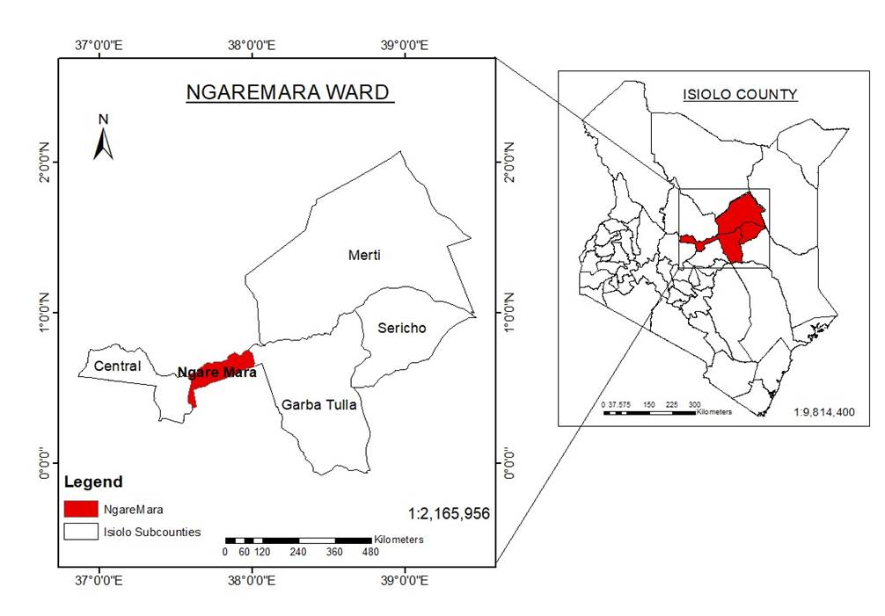

Figure 1: GIS map of Isiolo North Constituency, Kenya
Research Design
The study adopted a cross-sectional survey approach to collect both quantitative and qualitative data on the governance, institutional, and socio-cultural factors influencing carbon market implementation. This design was chosen because it allows for the examination of relationships between reported challenges and household-level socio-economic indicators at a single point in time, while also incorporating narrative accounts from respondents to enrich understanding.
Sampling and Data Collection
A stratified random sampling method was applied to ensure balanced representation of households with differing types of involvement in carbon market activities. The final sample comprised 367 households, a number determined through statistical sample size calculations that accounted for the total population of Ngaremara and targeted a 95% confidence level with a reasonable margin of error.
Data Collection Procedures
Data gathering involved several complementary techniques. Structured household questionnaires were used to capture demographic characteristics, participation status, experiences with governance processes, benefit-sharing arrangements, and socio-cultural dynamics affecting project adoption. Field observations provided additional insights into community interactions and cultural practices relevant to land use and project engagement. Contextual information was also drawn from secondary sources, including published studies, policy frameworks, and project records. Data entry during the field phase was facilitated through the use of Open Data Kit (ODK) software.
Data Analysis
Quantitative responses were analyzed using descriptive statistics, correlation, and regression analysis to examine relationships between governance challenges, institutional barriers, and livelihood outcomes. Group differences were tested using independent samples t-tests and Wilcoxon rank-sum tests to assess the effect of reported challenges on household livelihood scores. Qualitative data was analyzed thematically, with emerging themes organized around governance gaps, socio-cultural factors, and policy constraints.

Results

Stakeholder Participation and Community Engagement
Out of the 367 households surveyed, 82.8% reported attending community meetings related to carbon market initiatives. However, only 42% indicated that they were meaningfully involved in project decisions, and 33.5% reported being completely excluded from decision-making processes.

Institutional and Governance Barriers
Conflicts over benefit-sharing were reported by 62.9% of respondents. Additionally, 70% cited difficulties in accessing technical expertise and financial resources required for effective participation in carbon market activities. Land tenure insecurity and unclear policies were noted as contributing to disputes over ownership and rights to carbon revenues.

Financial and Technical Barriers
A total of 56.1% of respondents were unaware of financial mechanisms available to support participation in carbon markets. Furthermore, 70% experienced difficulty in accessing credit or other funding sources for conservation activities. Although 76.3% of respondents had received some form of training, 57.5% considered these training programs inadequate for enabling them to fully benefit from carbon market opportunities. The figure below indicates top five challenges that were reported in CMI participation:
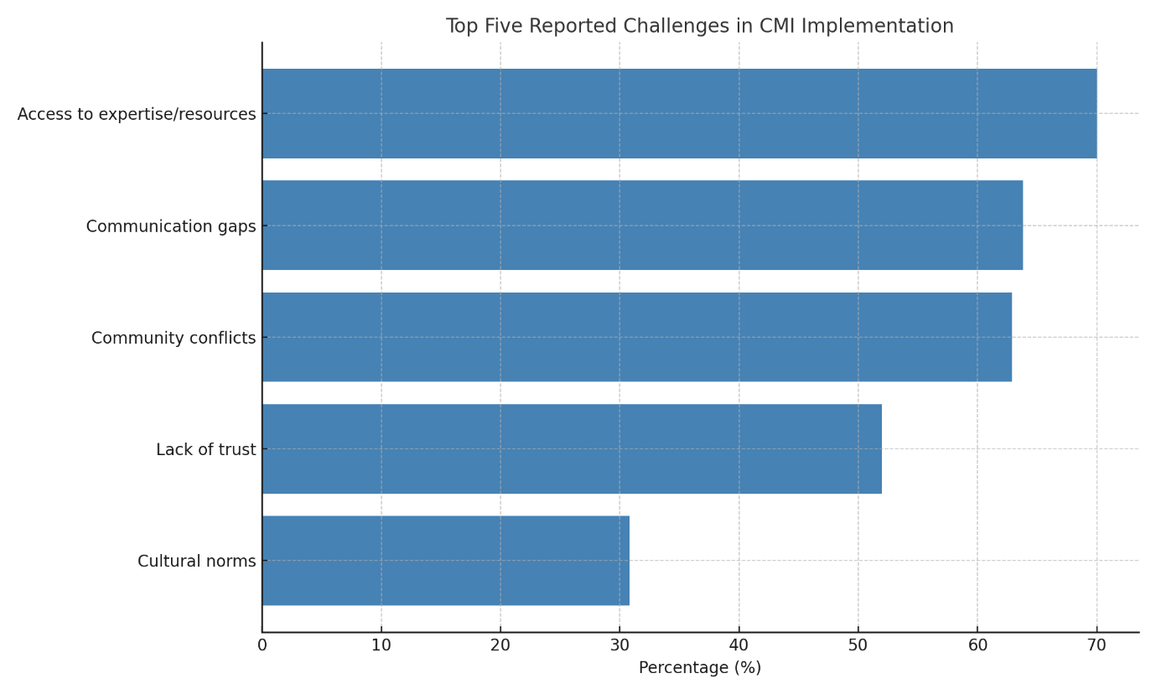
Fig 2: Top Five Reported Challenges in CMI Implementation

Socio-Cultural Barriers and Trust Issues
Lack of trust in project implementers was reported by 52% of respondents. Additionally, 30.8% stated that traditional pastoralist customs conflicted with project land-use requirements, such as restrictions on grazing areas.

Policy Gaps and Regulatory Challenges
While 56.1% of respondents were aware of existing government policies on carbon markets, only 28.1% believed these policies effectively supported community participation. The challenges reported have been grouped in the figure below:
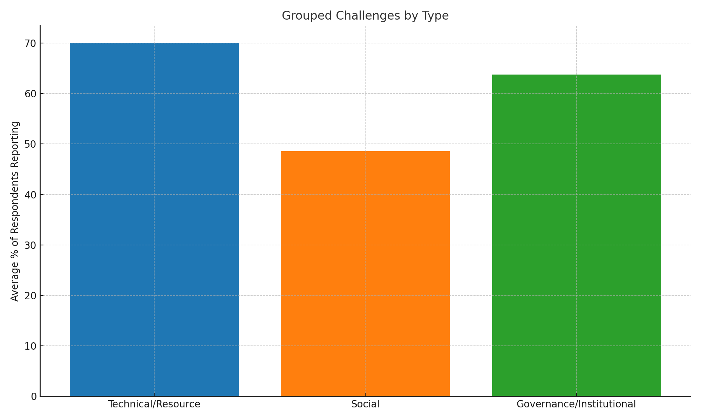
Figure 3: Grouped Challenges by Type
Hypothesis Testing
Hypothesis testing was conducted to examine whether households experiencing implementation challenges reported different livelihood outcomes compared to those not facing such challenges. Independent samples t-test results indicate a statistically significant difference in livelihood scores between the two groups (mean difference = –0.394, p < 0.001). This finding suggests that households encountering governance, financial, or socio-cultural barriers are significantly less likely to realize the livelihood benefits associated with carbon market initiatives. The Wilcoxon rank-sum test further confirmed this relationship (p < 0.001), reinforcing the robustness of the observed association. These statistical results indicate that implementation barriers are not only widely reported but also have measurable implications for household well-being in the study area.
Table 1: t-test & Wilcoxon test Results
Test | Comparison | Mean Difference | Test Statistic | P-value | 95% CI Lower | 95% CI Upper
T-test | Livelihood Score ~ Encountered Challenges | -0.394 | -4.829588 | 0.000 | -0.554 | -0.233
Wilcoxon test | Livelihood Score ~ Encountered Challenges |  | 9,956.500000 | 0.000

Discussion
This study reveals that while carbon market initiatives in Ngaremara, Isiolo County, hold significant potential for enhancing livelihoods and strengthening climate resilience, their effectiveness is substantially constrained by a combination of governance weaknesses, institutional limitations, and socio-cultural barriers. Carbon markets are often promoted as mechanisms capable of linking climate mitigation efforts with local development benefits by rewarding communities for sustainable land management practices. However, the successful realization of these benefits depends heavily on the strength of governance structures that regulate participation, ensure transparency, and manage the distribution of financial returns generated through carbon credits. In contexts where governance systems are weak or poorly coordinated, climate finance interventions may fail to deliver their intended outcomes, leading to dissatisfaction and limited community engagement.
These findings reinforce earlier research showing that equitable and transparent governance is a cornerstone of successful climate finance interventions (Bernard & Adkins, 2014; Bryan et al., 2018). Studies across several developing regions have demonstrated that the effectiveness of carbon market initiatives is closely linked to the degree to which local communities are meaningfully involved in decision-making processes and benefit-sharing arrangements. In pastoralist areas such as Ngaremara, these governance challenges are often compounded by the complexity of communal land tenure systems, the coexistence of customary and formal institutions, and historically limited investment in local administrative capacity. As a result, even well-intentioned carbon market initiatives may encounter significant implementation barriers if project design does not adequately align with existing governance arrangements and socio-cultural dynamics. A closer examination of the study’s mixed-method findings helped to clarify how these governance and institutional constraints manifest at the community level.
The quantitative findings are further enriched by qualitative responses from respondents, which provide important contextual explanations for the patterns observed in the statistical analysis. While the survey data identifies the prevalence of specific barriers such as conflicts over benefit-sharing and limited participation in decision-making, the qualitative accounts help illuminate the underlying dynamics shaping these challenges. Respondents frequently pointed to unclear governance arrangements, limited transparency in project management processes, and uncertainty regarding how carbon revenues are calculated and distributed. These concerns suggest that the barriers reported by participants are not merely technical or administrative in nature but are closely tied to perceptions of fairness, accountability, and trust within project governance structures.
Qualitative narratives also revealed that community engagement is influenced by a complex interplay of local institutional structures and knowledge gaps. For example, respondents described how decision-making processes often occur through traditional leadership channels, which can sometimes limit broader participation if consultation mechanisms are not deliberately designed to include diverse community voices. In addition, limited awareness of how carbon markets function, particularly regarding long-term benefits and contractual obligations, contributes to hesitancy among community members to fully engage with project activities. By integrating these qualitative insights with the quantitative findings, the study provides a more nuanced understanding of how governance structures, institutional communication, and community perceptions interact to shape participation in carbon market initiatives within pastoralist landscapes. These broader governance dynamics become particularly visible when examining specific barriers reported by respondents.
The limited meaningful participation in decision-making (42% involvement) highlights persistent gaps in community engagement within carbon market initiatives in Ngaremara. Participation is widely recognized as a critical element in the governance of community-based environmental programs, as it allows affected populations to influence project design, implementation, and benefit distribution. However, the relatively low level of involvement reported in this study suggests that many community members perceive decision-making processes as distant or controlled by a small number of actors. Similar patterns have been observed in pastoralist regions where development projects often rely on consultations with local elites, administrative authorities, or formally recognized leaders, while broader grassroots participation remains limited (Mathur et al., 2014).
In pastoralist contexts such as Ngaremara, this dynamic can be further complicated by the coexistence of formal governance institutions and customary leadership structures. While traditional leaders often play an important role in coordinating communal resource management, development interventions that engage only a narrow group of representatives may unintentionally exclude other segments of the community, including women, youth, and marginalized households. Such exclusion can weaken trust in project governance and reduce community willingness to support project activities. Strengthening participatory governance structures through inclusive consultation mechanisms, community assemblies, and targeted efforts to involve underrepresented groups could enhance the legitimacy of carbon market initiatives and foster a stronger sense of local ownership. Greater participation also increases transparency and accountability, both of which are essential for maintaining long-term community support for climate finance interventions.
Conflicts over benefit-sharing, reported by 62.9% of respondents, underscore the governance complexities associated with implementing carbon market initiatives within communal land tenure systems. In pastoralist landscapes such as Ngaremara, rangelands are typically managed collectively, with access and use rights shared among community members rather than assigned to individual landholders. While such arrangements have historically supported flexible grazing patterns and collective resource management, they can complicate the allocation of financial benefits generated through carbon market mechanisms. When carbon revenues are introduced into communal systems without clearly defined distribution frameworks, disagreements may emerge regarding who holds legitimate claims to the benefits and how those benefits should be shared among community members.
Previous studies indicate that without formalized benefit-sharing agreements and transparent governance arrangements, carbon revenues risk being captured by a limited number of actors, including local elites, project intermediaries, or administrative authorities, thereby reducing the incentives for broader community participation (Munene, 2019; Wako, 2022). This challenge is further amplified in contexts where legal frameworks governing carbon rights remain unclear or poorly understood at the community level. In the absence of clear rules specifying ownership of carbon credits and the mechanisms for distributing revenues, community members may perceive carbon market initiatives as externally imposed systems that provide uncertain or uneven benefits. Addressing these conflicts therefore requires not only legal clarification regarding carbon rights within communal lands but also the establishment of transparent and accountable financial management systems that ensure equitable benefit distribution. Such mechanisms may include community-managed funds, participatory oversight structures, and clearly documented benefit-sharing agreements that align with both statutory regulations and customary governance practices.
Financial and technical constraints also emerged as significant barriers to the effective participation of households in carbon market initiatives. The lack of awareness about financial mechanisms (56.1%) and the widespread difficulty in accessing credit (70%) reflect broader patterns of financial exclusion commonly observed in pastoralist and dryland regions. In many such areas, limited access to formal banking systems, low financial literacy, and the absence of collateralizable assets restrict households’ ability to engage with financial instruments associated with environmental programs. These structural constraints reduce the capacity of communities to invest in improved land management practices that are often required for participation in carbon market initiatives (Bond et al., 2020).
In addition to financial limitations, technical capacity gaps further constrain effective participation. Although training programs are reportedly being implemented, the perception among 57.5% of respondents that the training is insufficient suggests a disconnect between the content delivered and the practical knowledge required by pastoralist households. Carbon market mechanisms often involve complex technical concepts, including carbon measurement, verification procedures, and compliance requirements, which may be difficult to fully understand without sustained and contextually appropriate capacity-building efforts. Training initiatives that are delivered in local languages, incorporate practical demonstrations, and are aligned with pastoralist livelihood systems may therefore improve comprehension and participation. Furthermore, extension support and peer-learning approaches could help bridge knowledge gaps and enable communities to more effectively engage with carbon market opportunities.
Socio-cultural barriers, including trust deficits (52%) and perceived tensions between pastoralist customs and carbon market requirements (30.8%), point to the importance of aligning climate finance interventions with local cultural and livelihood systems. Pastoralist communities in northern Kenya have long relied on mobility, flexible grazing arrangements, and communal decision-making to manage highly variable dryland environments. These adaptive practices are central to maintaining rangeland productivity and resilience under conditions of climatic uncertainty. However, some carbon market initiatives introduce land-use restrictions, monitoring requirements, or contractual obligations that may unintentionally conflict with these traditional management systems, particularly when project rules are perceived as limiting mobility or altering established patterns of resource access.
Previous interventions in pastoralist regions have encountered similar challenges when externally designed programs failed to sufficiently recognize local customs, social institutions, and indigenous knowledge systems (Little, 1996; Atela et al., 2015). When development initiatives are introduced without meaningful dialogue with community members or without adaptation to local livelihood strategies, they may generate skepticism and resistance among affected populations. In the context of carbon markets, trust becomes especially important because community members must rely on project intermediaries and external institutions to manage complex financial and technical processes. Engaging cultural leaders, elders, and other respected community representatives in project governance can therefore help bridge this trust gap. Furthermore, integrating indigenous knowledge and traditional rangeland management practices into project frameworks may improve local legitimacy, enhance community ownership, and ensure that carbon market initiatives complement rather than disrupt pastoralist livelihoods.
These challenges observed in Ngaremara also reflect broader governance dynamics that characterize many arid and semi-arid land (ASAL) regions in Kenya. ASAL counties, which account for a significant proportion of Kenya’s land area, have historically faced limited investment in infrastructure, public services, and institutional capacity compared to more agriculturally productive regions of the country. As a result, environmental governance initiatives in these areas often operate within contexts where administrative structures are still evolving and where coordination between national policies and local implementation can be uneven. For pastoralist communities, whose livelihoods depend on flexible land-use systems and collective resource management, externally designed environmental interventions may therefore encounter institutional and socio-economic barriers if they do not sufficiently account for local governance realities. The challenges identified in this study, particularly those related to participation, benefit-sharing, and institutional trust, are therefore not unique to Ngaremara but reflect broader structural conditions shaping climate and land governance across Kenya’s dryland landscapes.
The statistical analysis further confirms that households experiencing these challenges consistently report lower livelihood scores, indicating that the barriers identified in this study have tangible socio-economic consequences. In practical terms, this relationship suggests that governance inefficiencies, financial exclusion, limited participation, and socio-cultural misalignment do not merely affect the administrative functioning of carbon market initiatives but directly influence the ability of households to realize the livelihood benefits these projects are intended to generate. For pastoralist households whose livelihoods depend heavily on rangeland productivity and diversified income sources, such constraints may reduce both the perceived value and the practical feasibility of participating in carbon market programs.
These findings support the study’s hypothesis that structural and cultural obstacles significantly reduce the potential benefits that carbon markets can deliver at the community level. When communities perceive carbon market interventions as opaque, technically complex, or misaligned with their livelihood strategies, participation becomes limited and the expected development outcomes may fail to materialize. The statistical evidence therefore underscores the importance of addressing the institutional and socio-economic barriers identified throughout this study. Without targeted reforms that improve governance transparency, strengthen financial access, and enhance community engagement, the scalability and long-term sustainability of carbon market initiatives in pastoralist regions are likely to remain constrained.
These findings suggest that while carbon markets offer a promising pathway for integrating climate mitigation efforts with livelihood improvement in pastoralist regions, their success ultimately depends on how well project design aligns with the social, institutional, and economic realities of the communities involved. In Ngaremara, the barriers identified in this study, including limited participation in decision-making, conflicts over benefit-sharing, financial exclusion, and tensions between project requirements and pastoralist livelihood systems, demonstrate that the effectiveness of carbon market initiatives is shaped not only by technical implementation but also by the broader governance and socio-economic context in which they operate. Addressing these challenges requires more inclusive governance frameworks that ensure meaningful community participation, transparent and equitable benefit-sharing mechanisms, improved access to financial and technical resources, and project designs that recognize and integrate pastoralist knowledge systems and land-use practices. Policymakers, project implementers, and development partners must therefore move beyond purely market-driven approaches and adopt locally grounded strategies that strengthen institutional capacity and community trust. By doing so, carbon market initiatives in dryland regions can better fulfill their potential to contribute to both climate resilience and equitable rural development.
Conclusion and Recommendations
Conclusion
This study demonstrates that the implementation of carbon market initiatives in Ngaremara, Isiolo County, is constrained by a combination of governance weaknesses, financial exclusion, technical capacity gaps, and socio-cultural barriers. While carbon markets hold promise as a climate finance mechanism that can support sustainable land management and improve pastoralist livelihoods, their current design and delivery models in this context limit their potential impact.
The evidence shows that limited participation in decision-making, conflicts over benefit-sharing, and inadequate policy support undermine trust and equity in carbon market operations. Furthermore, barriers to financial access and the lack of practical, context-relevant training hinder meaningful engagement by households. Socio-cultural factors, including mistrust of implementers and misalignment with pastoralist traditions, further reduce community buy-in. These systemic challenges collectively reduce the livelihood benefits households can derive from carbon markets, as confirmed by the statistical association between reported challenges and lower livelihood scores. For carbon markets to achieve their intended outcomes in pastoralist settings, they must be restructured to prioritize inclusivity, transparency, cultural sensitivity, and long-term capacity-building.

Recommendations
- Strengthening community participation and inclusive governance: Ensuring active engagement of local communities in decision-making can enhance trust and participation. Establishing transparent governance structures that involve community elders, women, and youth can improve benefit-sharing and reduce conflicts.
- Developing clear land tenure and benefit-sharing policies: Addressing land tenure insecurity through legal recognition of community land rights is essential. Transparent benefit-sharing mechanisms, with defined revenue distribution models, should be formalized to prevent elite capture and inequities.
- Improving financial accessibility and market linkages: Developing accessible microfinance models, community investment funds, and reinvestment mechanisms can enhance participation. Strengthening direct payments to households rather than centralized fund management may increase trust and engagement.
- Expand training and technical capacity-building: Providing tailored training programs on carbon measurement, financial literacy, and sustainable land management can empower pastoralist communities. Training efforts should be delivered in local languages and adapted to cultural contexts.
- Align carbon market policies with pastoralist land-use systems: National and county-level climate finance policies should integrate rangeland conservation into carbon credit frameworks. Developing policies that support flexible, mobile pastoralism while incorporating sustainable grazing practices is crucial for success.
Ethical Approval and Consent:
Ethical clearance was obtained from Kenyatta University’s Graduate School, and research authorization was granted by the National Commission for Science, Technology, and Innovation (NACOSTI). Participation was voluntary, with informed consent obtained from all respondents. Privacy and confidentiality were strictly upheld, and all interactions were conducted with cultural sensitivity and respect for local traditions.

Disclaimer (Artificial intelligence)
Author(s) hereby declare that NO generative AI technologies such as Large Language Models (ChatGPT, COPILOT, etc.) and text-to-image generators have been used during the writing or editing of this manuscript.

References
Agrawal, A. (2001). Common property institutions and sustainable governance of resources. World Development, 29(10), 1649–1672. https://doi.org/10.1016/S0305-750X(01)00063-8
Asquith, N. M., Vargas Ríos, M. T., & Smith, J. (2002). Can forest-protection carbon projects improve rural livelihoods? Analysis of the Noel Kempff Mercado climate action project, Bolivia. Mitigation and Adaptation Strategies for Global Change, 7(4), 323–337. Retrieved from https://www.cifor-icraf.org/knowledge/publication/1273/
Atela, J. O., Minang, P. A., Quinn, C. H., & Duguma, L. A. (2015). Implementing REDD+ at the local level: Assessing the key enablers for credible mitigation and sustainable livelihood outcomes. Journal of Environmental Management, 157, 238–249. https://doi.org/10.1016/j.jenvman.2015.04.015
Bernard, F., & Adkins, B. (2014). Community-based conservation and carbon markets: A critical analysis. Global Environmental Change, 24, 53-64. https://doi.org/10.1016/j.gloenvcha.2013.11.007
Bond, I., Millar, I., & Ramos, C. (2020). Governance challenges in carbon market implementation: Lessons from sub-Saharan Africa. Environmental Policy and Governance, 30(2), 129-144. https://doi.org/10.1002/eet.1885
Bryan, E., Ringler, C., Okoba, B., Roncoli, C., Silvestri, S., & Herrero, M. (2018). Adaptive capacity and climate resilience of Kenyan smallholder farmers. Climate Risk Management, 4, 43–54. https://doi.org/10.1016/j.crm.2014.10.004
Government of Kenya. (2016). Climate Change Act, 2016.
Government of Kenya. (2023). Climate Change (Amendment) Act, 2023.
Government of Kenya. (2023). National Climate Change Action Plan (2023–2027).
The Guardian (2023). Revealed: More than 90% of rainforest carbon offsets by biggest certifier are worthless. https://www.theguardian.com/environment/2023/jan/18/revealed-forest-carbon-offsets-biggest-provider-worthless-verra-aoe
Herr, D., Blum, M., Himes-Cornell, A., & Sutton-Grier, A. (2019). The role of blue carbon in climate adaptation and sustainable development. Frontiers in Marine Science, 6, 237. https://doi.org/10.3389/fmars.2019.00237
IPCC. (2022). Climate Change 2022: Mitigation of Climate Change.
https://www.ipcc.ch/report/ar6/wg3/
IPCC. (2021). Climate Change 2021: The Physical Science Basis. Contribution of Working Group I to the Sixth Assessment Report of the Intergovernmental Panel on Climate Change. Cambridge University Press. Retrieved from https://www.ipcc.ch/report/ar6/wg1/
Jiang, Y., Luo, L., Tsang, A., & Zhang, Y. (2024). Carbon emission trading scheme and carbon performance: The role of carbon management system. The British Accounting Review, Article 101492. https://doi.org/10.1016/j.bar.2024.101492
Little, P. D. (1996). Pastoralism, biodiversity, and the shaping of savanna landscapes in East Africa. Africa, 66(1), 37–51. https://doi.org/10.2307/1161510
Mathur, V. N., Afionis, S., Paavola, J., Dougill, A. J., & Stringer, L. C. (2014). Experiences of host communities with carbon market projects: Towards multi-level climate justice. Climate Policy, 14(1), 42–62. https://doi.org/10.1080/14693062.2013.861728
Mburu, C. W. (2015). Factors influencing implementation of selected donor-funded projects in Kenya: The case of World Vision Isiolo County, Kenya (Master's thesis). University of Nairobi. Retrieved from http://erepository.uonbi.ac.ke/handle/11295/90505
McCarthy, J., & Di Gregorio, M. (2007). Climate change adaptation, rural institutions, and development. World Development, 35(3), 341–363. https://doi.org/10.1016/j.worlddev.2006.10.008
Mukami, D. M. (2016). Carbon markets and livelihood sustainability in dryland regions: Evidence from Kenya (Doctoral dissertation). Kenyatta University. Retrieved from https://ir-library.ku.ac.ke/
Munene, M. W. (2019). Factors influencing management of rangelands by pastoral communities in Gotu, Ngaremara ward, Isiolo County, Kenya (Master's thesis). University of Nairobi. Retrieved from http://erepository.uonbi.ac.ke/handle/11295/106751
Ostrom, E. (1990). Governing the commons: The evolution of institutions for collective action. Cambridge University Press.
Republic of Kenya. (2020). Kenya’s Updated Nationally Determined Contribution (NDC). Nairobi: Ministry of Environment and Forestry. https://doi.org/10.2307/3146384
Wako, A. G. (2022). Socio-economic impacts of carbon projects in Northern Kenya: An assessment of governance structures and equity in benefit-sharing (Master’s thesis). University of Nairobi. Retrieved from http://erepository.uonbi.ac.ke/
World Bank. (2023). State and Trends of Carbon Pricing 2023.
https://doi.org/10.1596/978-1-4648-2006-9

