Effects of Carbon Market Participation on Pastoralist Livelihoods and Household Resilience in Ngaremara, Isiolo County, Kenya

Abstract
Carbon market initiatives are increasingly recognized as mechanisms for enhancing climate adaptation while simultaneously improving livelihoods in vulnerable regions. This study examines the outcomes of carbon market initiatives on pastoralist livelihoods and household resilience in Ngaremara, Isiolo County, Kenya. A cross-sectional survey of 367 households was conducted to assess how participation in carbon markets has influenced income stability, employment opportunities, and household adaptation to climate variability. Quantitative data were analyzed using descriptive statistics and regression analysis, while qualitative responses were thematically analyzed to capture community experiences. The findings reveal that while carbon markets have generated some economic benefits such as increased income and employment opportunities, challenges remain in ensuring equitable benefit distribution and effective household adaptation. Approximately 51.2% of respondents reported improved household incomes, while 48.2% indicated no significant financial change, and 0.5% reported that their incomes had decreased significantly following participation in carbon market initiatives (percentages may not sum to exactly 100% due to rounding). Household resilience to climate variability showed moderate improvement, with 55% of respondents reporting enhanced adaptive capacity. However, governance challenges, limited financial access, and socio-cultural barriers constrained the full realization of benefits. These findings highlight the need for policy interventions that strengthen financial inclusion, improve governance structures, and enhance technical training for pastoralist communities to ensure equitable and sustainable outcomes from carbon market initiatives. Strengthening these frameworks can help align carbon finance mechanisms with broader climate adaptation and rural development strategies in dryland regions.
Keywords: climate finance; dryland communities; adaptive capacity; sustainable land management; socio-economic impacts; pastoral economies

Introduction
Climate change poses significant threats to dryland ecosystems and the communities that depend on them, with pastoralist groups being among the most vulnerable due to their reliance on natural resources for sustenance and economic stability (IPCC, 2021; Bryan et al., 2018). In these regions, increasing temperature extremes, erratic rainfall patterns, and prolonged droughts undermine traditional livelihood systems, exacerbating poverty and food insecurity.
Carbon markets have emerged as innovative mechanisms that align climate mitigation with sustainable development objectives. By offering financial incentives for carbon sequestration activities such as afforestation, reforestation, and improved rangeland management, they aim to link environmental conservation with socio-economic benefits (Asquith et al., 2002; Atela et al., 2015). In developing countries, these initiatives have been associated with improved livelihoods, stronger resource governance, and enhanced environmental stewardship (Bond et al., 2020; Bryan et al., 2018). However, their effectiveness in ensuring long-term and equitable livelihood improvements remains debated, particularly among marginalized communities (Mathur et al., 2014; Bernard & Adkins, 2014).
Recent scholarship has emphasized the growing role of carbon markets as part of broader climate finance mechanisms aimed at supporting sustainable land management and rural livelihoods. Studies increasingly highlight that carbon market initiatives — particularly those linked to land-use practices such as agroforestry, rangeland restoration, and regenerative agriculture — can generate co-benefits beyond carbon sequestration. These include improved soil fertility, biodiversity conservation, and diversified income streams for smallholder and pastoral communities (Awazi et al., 2025). However, the ability of communities to access these benefits often depends on institutional capacity, technical knowledge, and the presence of effective monitoring and verification systems that allow land-based carbon projects to participate in voluntary carbon markets.
Pastoralist communities in northern Kenya face distinctive barriers to participating in carbon markets. Limited land tenure security, inequitable benefit distribution, and governance challenges often restrict access to these initiatives (Herr et al., 2019; Little, 2011). While some research highlights increased income, employment opportunities, and adaptive capacity among participants, others reveal persistent constraints such as low financial inclusion, limited awareness, and socio-cultural barriers (McCarthy & Di Gregorio, 2007; Munene, 2019). Elite capture and weak governance mechanisms can further undermine community trust and participation.
Recent studies on climate vulnerability among pastoral and agro-pastoral communities further demonstrate that climate finance mechanisms must be integrated with broader livelihood resilience strategies. Empirical research in dryland regions shows that pastoral households face multidimensional risks, including water scarcity, declining pasture productivity, and limited access to markets and financial services. These pressures heighten the importance of diversified livelihood strategies and improved institutional support systems that can enhance adaptive capacity and reduce vulnerability to climate shocks (Tofu et al., 2025). Such findings suggest that climate finance initiatives — including carbon markets — must be carefully designed to address underlying socio-economic vulnerabilities rather than focusing solely on emission reductions.
Resilience in pastoralist systems hinges on adaptive strategies such as diversifying income sources, improving water management, and adopting sustainable grazing practices (IPCC, 2021; Mburu, 2015). Carbon market projects have the potential to fund and incentivize these strategies, yet their real impact on household stability is contested (Mukami, 2016; Wako, 2022). Achieving meaningful resilience outcomes often requires participatory governance structures, accessible financing, and integration with indigenous knowledge systems (Bryan et al., 2018).
Within the broader climate policy landscape, carbon markets have also been recognized as instruments capable of mobilizing private finance for climate mitigation and adaptation. However, scholars increasingly point out that the effectiveness of these mechanisms varies widely depending on project design, governance structures, and benefit-sharing arrangements. Reviews of carbon pricing and compensation mechanisms suggest that while market-based instruments can contribute to emission reductions and resource mobilization, concerns remain regarding transparency, equity, and the distribution of financial benefits among local communities. These challenges highlight the importance of robust governance frameworks and participatory approaches in ensuring that carbon finance contributes to sustainable development outcomes in rural areas.
In pastoral regions of Africa, policy debates increasingly emphasize the need to align climate mitigation initiatives with local development priorities and pastoral livelihood systems. Emerging research indicates that pastoral economies are undergoing rapid transformation due to climate change, land-use pressures, and evolving policy environments. Integrating climate finance instruments such as carbon markets with pastoral development strategies has therefore become an important area of inquiry, particularly in regions where livestock production remains central to local economies and social systems. Strengthening the alignment between climate policies, pastoral governance structures, and livelihood diversification strategies is considered essential for achieving sustainable and equitable outcomes.
Ngaremara in Isiolo County, Kenya, offers a relevant case study for exploring these dynamics. This semi-arid area is characterized by recurrent droughts, resource-based conflicts, and shrinking grazing lands (Mburu, 2015). Carbon market initiatives in the region — focusing on planned grazing, tree planting, and improved water management — seek to diversify livelihoods and strengthen climate adaptation. Despite growing interest in carbon markets as climate finance mechanisms, empirical evidence on their household-level impacts in pastoralist systems remains limited, particularly in African drylands. Existing studies often focus on environmental outcomes or project-level carbon performance, with far less attention given to how these initiatives affect livelihood stability and resilience among pastoral households. In the Kenyan context specifically, few studies have systematically examined the socio-economic outcomes of carbon market participation at the household level.
This study addresses this gap by assessing the outcomes of carbon market participation on livelihoods and household resilience in Ngaremara, Isiolo County, Kenya. Specifically, the study examines how participation in carbon market initiatives influences key livelihood outcomes, including income stability, employment generation, and overall quality of life among pastoralist households. In addition, the study evaluates the extent to which these initiatives contribute to strengthening household resilience to climate variability, particularly through enhanced adaptive capacity and improved livelihood strategies. By grounding the analysis in localized evidence and drawing from broader literature on carbon markets in pastoralist contexts, the study contributes to ongoing discussions on designing more inclusive, equitable, and sustainable carbon finance mechanisms for dryland communities.
Research Hypotheses
Based on the study objectives and the existing literature on climate finance and livelihood resilience, the study tests the following hypotheses:
H1: Participation in carbon market initiatives has a positive effect on pastoralist household livelihood outcomes, including income stability, employment opportunities, and quality of life.
H2: Participation in carbon market initiatives positively influences household resilience to climate variability, particularly through improved adaptive capacity and livelihood diversification.
These hypotheses were examined using regression analysis to assess the relationship between participation in carbon market initiatives and selected livelihood and resilience indicators among pastoralist households in the study area.

Methodology

Study Area
This study was conducted in Ngaremara, a semi-arid region in Isiolo County, Kenya, where pastoralist communities predominantly rely on livestock for their livelihoods. The region is characterized by recurrent droughts, resource conflicts, and increasing climate variability, making it a suitable case for assessing the outcomes of carbon market initiatives on livelihoods and household resilience (Mburu, 2015). Carbon market initiatives in the area focus on sustainable land use, planned grazing, and reforestation as mechanisms to promote carbon sequestration and community adaptation. The figure below shows the map of the study area:
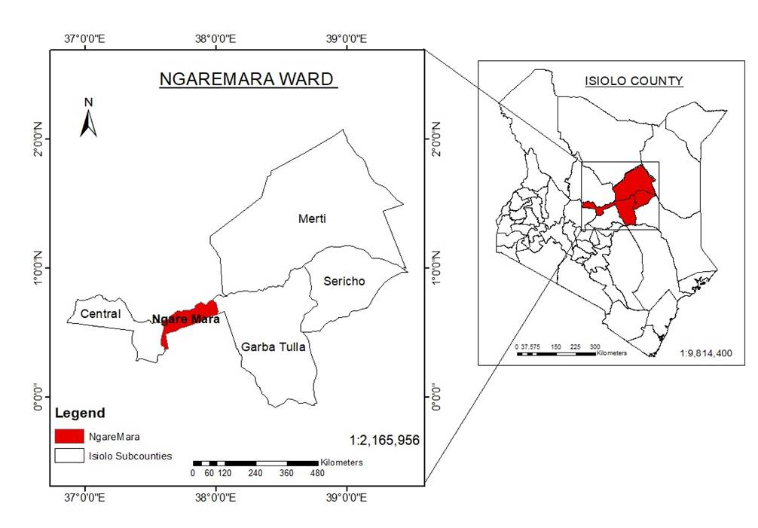
Figure 1: GIS map of Isiolo North Constituency, Kenya

Research Design
A cross-sectional survey design was employed to capture both quantitative and qualitative data on the livelihood and resilience outcomes of carbon market initiatives. This design was selected for its suitability in analyzing relationships between carbon market participation and household-level socio-economic indicators at a single point in time, while also incorporating contextual narratives from participants.

Sampling and Data Collection
A stratified random sampling technique was used to ensure adequate representation of pastoral households across different villages and levels of participation in carbon market initiatives within Ngaremara Ward, Isiolo County. Households were first categorized based on their involvement in key carbon market activities such as planned grazing, tree planting, and water resource management. These households were then grouped according to village location and participation level, after which respondents were randomly selected from each stratum to ensure balanced representation across the study area.
The sample size for the study was determined using the Cochran sample size formula for finite populations (Nanjundeswaraswamy & Divakar, 2021). The estimated population of pastoral households in Ngaremara Ward was N = 8,324 households. The sample size was calculated using the formula:
$$n=\frac{NZ^{2}pq}{E^{2}(N-1)+Z^{2}pq}$$
where n represents the required sample size, N is the population size, Z is the standard normal deviation corresponding to the desired confidence level (1.96 for a 95% confidence level), p represents the estimated proportion of the population possessing the attribute of interest, q = 1 − p, and E represents the acceptable margin of error (0.05). Based on these parameters, the calculated sample size for the study was 367 households, which ensured adequate statistical representation of pastoral households within the study area and allowed for reliable inferential statistical analysis.
Primary data were collected using structured household questionnaires administered to household heads or adult representatives. The questionnaire contained both closed and open-ended questions and was organized into several sections capturing demographic characteristics, livelihood sources, income changes, participation in carbon market activities, and indicators of household resilience to climate variability.
In addition to household surveys, semi-structured interviews were conducted with selected participants and community members to obtain deeper insights into perceptions of carbon market initiatives, including perceived benefits, challenges, and governance issues. Direct observation was also employed to document local land management practices and socio-cultural dynamics that influence participation in carbon market initiatives.
Data collection was facilitated using Open Data Kit (ODK) digital survey tools, which enabled real-time data entry, improved accuracy, and reduced transcription errors during fieldwork.

Data Analysis
Quantitative data were analyzed using descriptive and inferential statistical techniques to examine the relationships between carbon market participation and livelihood and resilience outcomes. Descriptive statistics, including frequencies, percentages, and summary measures, were used to describe participation patterns, economic outcomes, and adaptation strategies among households.
To assess the influence of carbon market participation on household outcomes, linear regression analysis was used. The regression models examined the association between participation in carbon market initiatives (independent variable) and key dependent variables, including livelihood score, income change, income stability, quality of life, resilience score, and adaptation ability.
Control variables such as access to financial services, education, and socio-economic barriers were included in the models to account for potential socio-demographic influences on livelihood and resilience outcomes. Regression coefficients (β), standard errors (SE), and p-values were used to determine the strength and statistical significance of these relationships.
The general regression model used in the analysis can be expressed as:
$$Y_{i}=β_{0}+β_{1}CMI_{i}+β_{2}Z_{i}+ϵ_{i}$$
where $Y_{i}$ represents the livelihood or resilience outcome for household $i$, $CMI_{i}$ represents participation in carbon market initiatives, and $Z_{i}$ represents a vector of control variables including household characteristics such as education level, access to financial services, and socio-economic constraints. The parameter $β_{0}$represents the intercept, while $β_{1}$and $β_{2}$ measure the marginal effects of carbon market participation and control variables on the outcome variable. The error term $ϵ_{i}$captures unobserved factors that may influence household livelihood and resilience outcomes.
Qualitative responses obtained from interviews were analyzed using thematic analysis, where recurring patterns related to benefits, challenges, governance structures, and community perceptions of carbon market initiatives were identified and interpreted to complement the quantitative findings.
The combination of quantitative and qualitative analysis enabled a more comprehensive understanding of the socio-economic and resilience outcomes of carbon market participation among pastoralist households.

Results

Participation in Carbon Market Initiatives
Out of the 367 households surveyed, 70.8% reported participation in carbon market projects, while 29.2% indicated no involvement. The main activities undertaken by participants included planned grazing (34.9%), tree planting (32.6%), and improved water management (29.2%). The figure below shows the various types of participation in carbon market initiatives:
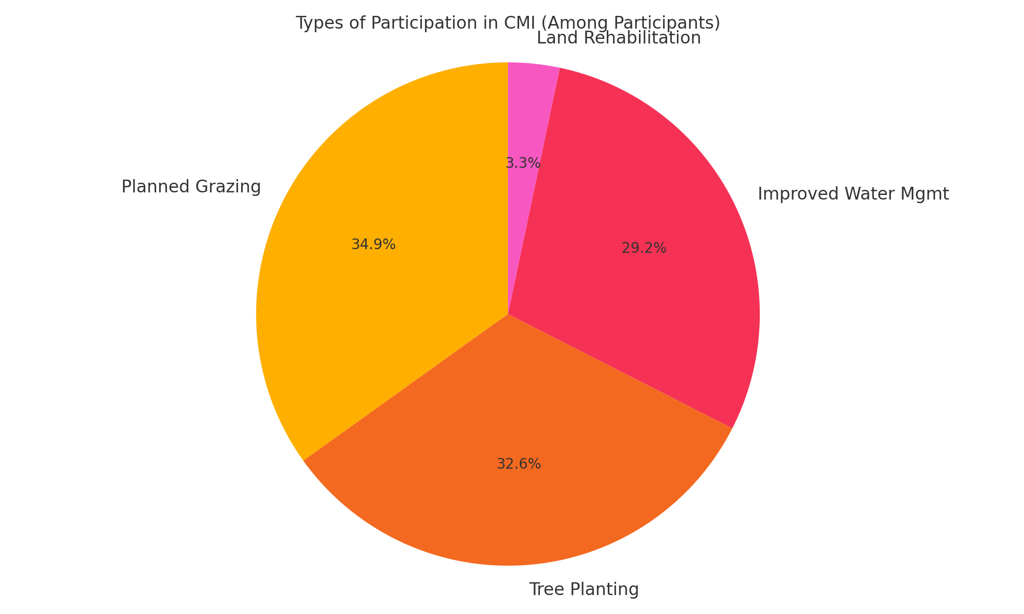
Figure 2: Types of Participation in CMI
Source: Author’s Survey Data (2025)

Economic Outcomes of Carbon Market Participation
Among participants, 51.2% reported increased income, 48.2% indicated no financial change, and 0.5% experienced decreased income. Employment opportunities through carbon market initiatives were reported by 24.6% of respondents. Only 18.8% of households engaged in new income-generating activities beyond their primary livelihood. The reported economic outcomes are shown in the figure below:
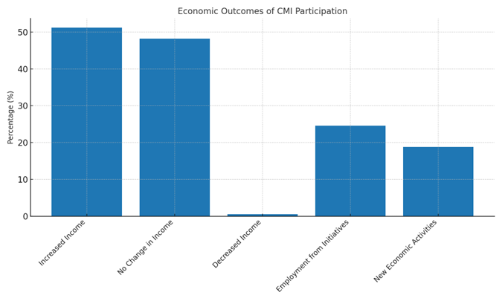
Figure 3: Economic Outcomes of CMI Participation
Source: Author’s Survey Data (2025)

Household Resilience and Climate Adaptation
A total of 55% of respondents reported improved adaptive capacity to climate variability. No change in resilience was reported by 26.4% of respondents, and 0.6% reported a decline in resilience. Common adaptation measures included improved water management, small-scale farming, and participation in savings initiatives. The figure below shows the reported resilience outcomes:
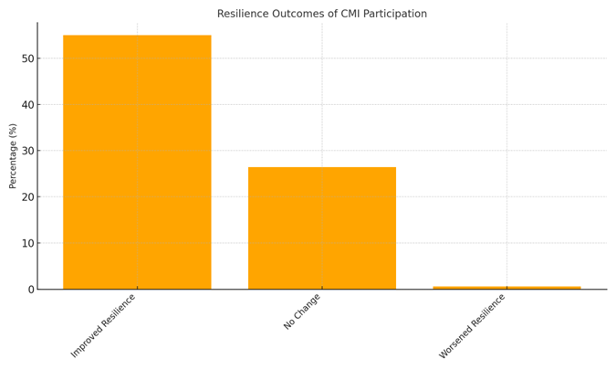
Figure 4: Resilience Outcomes of CMI Participation
Source: Author’s Survey Data (2025)

Statistical Analysis – Livelihood Outcomes
Regression analysis indicated a significant positive association between carbon market participation and several livelihood indicators. Participation was positively associated with livelihood score (β = 1.045, p < 0.001, R² = 0.445), income change (β = 1.319, p < 0.001, R² = 0.386), and quality of life (β = 0.826, p < 0.001, R² = 0.405). In this study, income stability refers to the ability of households to maintain relatively consistent income levels over time despite climate variability or livelihood shocks. It was assessed based on respondents’ perceptions of changes in the regularity and reliability of their income following participation in carbon market activities. These results are summarized in Table 1 below:
Table 1: Regression Results - CMI Impact on Livelihood Outcomes
Outcome Variable | β | SE | t | p-value | Sig. | R²
Livelihood Score | 1.045 | 0.068 | 15.339 | 0.00 | *** | 0.445
Income Change | 1.319 | 0.095 | 13.866 | 0.00 | *** | 0.386
Income Stability | 0.455 | 0.291 | 1.564 | 0.12 |  | 0.023
Quality of Life | 0.826 | 0.064 | 12.998 | 0.00 | *** | 0.405
Note: *p < 0.05, **p < 0.01, ***p < 0.001. Controlled for family size and education level.
Source: Author’s Survey Data (2025)
Statistical Analysis – Resilience Outcomes
Participation in carbon market initiatives was significantly associated with higher resilience scores (β = 0.349, p < 0.001, R² = 0.118) and adaptation ability (β = 0.729, p < 0.001, R² = 0.339). Climate confidence was not significantly influenced (β = -0.030, p = 0.748). These results are summarized in Table 2 below:
Table 2: Linear Regression Results - CMI Impact on Resilience Outcomes
Outcome Variable | β | SE | t | p-value | Sig. | R²
Resilience Score | 0.349 | 0.068 | 5.165 | 0.000 | *** | 0.118
Climate Confidence | -0.030 | 0.095 | -0.322 | 0.748 |  | 0.014
Adaptation Ability | 0.729 | 0.066 | 11.017 | 0.000 | *** | 0.339
Source: Author’s Survey Data (2025)
Social and Environmental Co-Benefits
Additional reported benefits included strengthened community cohesion (28.1%), enhanced environmental conservation (22.1%), and empowerment of women and youth (18.8%). Furthermore, 85.8% of respondents reported improved access to essential services such as education, water, and healthcare. Some of the social and environmental benefits of carbon market initiatives are indicated in the figure below:
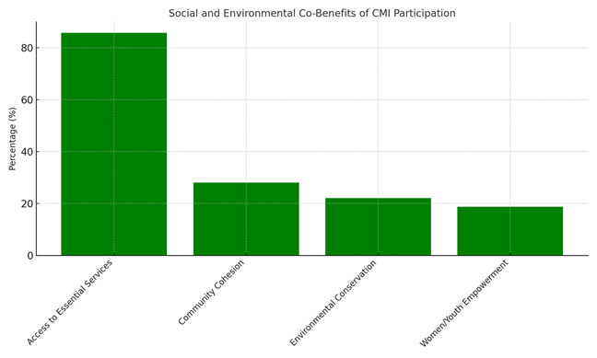
Figure 5: Social and Environmental Co-Benefits of CMI Participation
Source: Author’s Survey Data (2025)

Discussion
Participation in Carbon Market Initiatives
A participation rate of 70.8% indicates a relatively high level of community engagement in carbon market initiatives within the study area. This level of participation suggests that pastoral households recognize the potential benefits associated with carbon market projects, including opportunities for supplementary income, improved natural resource management, and enhanced resilience to climate variability. In pastoral systems where livelihoods are highly dependent on climate-sensitive resources such as rangelands and water availability, participation in climate finance initiatives can provide incentives for adopting sustainable land management practices. The relatively high engagement observed in this study may therefore reflect growing awareness among pastoral households about the importance of climate adaptation and the potential role of carbon markets in supporting sustainable livelihoods.
However, the presence of 29.2% non-participation also highlights persistent barriers that may limit broader community inclusion in such initiatives. These barriers may include limited access to information, institutional constraints, socio-cultural dynamics, or unequal access to resources required for participation. Similar patterns have been documented in other dryland contexts, where participation in carbon market and climate finance initiatives is often uneven across communities due to differences in awareness, institutional capacity, and governance arrangements (Atela et al., 2015; Mathur et al., 2014). Studies examining carbon finance projects in sub-Saharan Africa further emphasize that inclusive participation often depends on effective community engagement strategies, transparent governance mechanisms, and clear benefit-sharing structures that build trust among local stakeholders. Strengthening these enabling conditions is therefore critical for ensuring that carbon market initiatives contribute not only to climate mitigation but also to equitable livelihood opportunities in pastoralist regions.
Economic Outcomes
The finding that 51.2% of respondents reported increased income following participation in carbon market initiatives suggests that these interventions have the potential to generate modest economic benefits for pastoral households. In dryland environments where livelihoods are highly vulnerable to climate variability, access to supplementary income sources can play an important role in reducing vulnerability and improving household welfare. Carbon market initiatives often provide financial incentives linked to activities such as sustainable grazing management, tree planting, and rangeland restoration, which can create opportunities for short-term employment or periodic carbon payments. The observed income improvements among participating households therefore indicate that such initiatives may contribute to diversifying livelihood sources and supporting household economic stability in pastoral systems.
However, the finding that 48.2% of households reported no significant change in income and that only 18.8% reported engaging in new income-generating activities suggests that the economic benefits of carbon market initiatives remain limited in scale for many households. This pattern indicates that while some participants may benefit directly from project-related payments or employment opportunities, the broader transformative impact on local economies may still be constrained. Similar observations have been reported in studies examining carbon finance and climate mitigation projects in developing regions, where financial benefits often remain modest due to irregular carbon payments, unequal benefit-sharing arrangements, or limited integration with broader market opportunities (Bryan et al., 2018; Bond et al., 2020). Research on carbon market projects in pastoral and rural contexts also highlights governance challenges, including limited transparency in benefit distribution and weak institutional capacity, which can affect the extent to which communities experience meaningful economic gains (McCarthy & Di Gregorio, 2007). Addressing these constraints through improved project design, equitable benefit-sharing mechanisms, and stronger linkages to local value chains may enhance the economic contributions of carbon market initiatives to pastoral livelihoods.
Household Resilience
The finding that 55% of households reported improvements in adaptive capacity suggests that participation in carbon market initiatives may contribute positively to strengthening resilience in pastoral communities. In dryland environments where climate variability frequently disrupts traditional livelihood systems, interventions that support improved water management, sustainable land use practices, and community-based financial mechanisms can play a critical role in enhancing household coping strategies. In this study, resilience improvements were associated with activities such as better water resource management, small-scale farming, and participation in community savings groups, which can help households buffer against climate-related shocks and livelihood disruptions. These findings highlight the potential role of carbon market initiatives not only as mitigation instruments but also as mechanisms that indirectly support climate adaptation and livelihood stability in vulnerable pastoral systems.
These results are consistent with broader evidence from semi-arid regions indicating that targeted adaptation interventions can significantly enhance household resilience by strengthening local resource management and diversifying livelihood options (IPCC, 2021; Mukami, 2016). However, the persistence of 26.4% of households reporting no change in resilience and 0.6% reporting worsening resilience suggests that the benefits of these initiatives may not be evenly distributed across all households. Such disparities may arise from differences in access to training, financial resources, or institutional support required to fully engage in adaptation activities. Previous research has shown that climate adaptation programs in pastoral regions are more effective when they incorporate local knowledge systems, strengthen community participation, and provide sustained technical support (Bryan et al., 2018). Without these enabling conditions, climate finance initiatives such as carbon markets may struggle to translate environmental interventions into meaningful resilience outcomes for all community members. Strengthening the integration of traditional pastoral knowledge with formal adaptation strategies may therefore be essential for maximizing the resilience benefits of carbon market initiatives.
Statistical Insights
The regression analysis provides empirical evidence that participation in carbon market initiatives is significantly associated with several positive household outcomes, including improved livelihood scores, income changes, quality of life, resilience, and adaptation capacity. These results suggest that involvement in carbon market activities may contribute to strengthening both economic and adaptive dimensions of pastoral livelihoods. In dryland regions where climate variability often disrupts traditional livelihood systems, interventions that combine environmental restoration with financial incentives can help households diversify their income sources and adopt more sustainable resource management practices. The statistically significant relationships observed in this study therefore reinforce the argument that carbon market initiatives can play an important role in supporting integrated climate mitigation and livelihood development objectives in vulnerable pastoral contexts.
However, the absence of a statistically significant relationship between carbon market participation and climate confidence indicates that improvements in economic conditions do not necessarily translate into stronger perceptions of long-term preparedness for climate shocks. This finding suggests that while carbon market initiatives may generate short-term livelihood benefits, broader structural factors such as access to financial services, institutional support, and climate information systems may also influence households’ perceived ability to cope with future climate risks. Similar observations have been reported in studies examining climate adaptation and rural resilience, which highlight that financial incentives alone are often insufficient to strengthen long-term adaptive capacity without complementary investments in knowledge, infrastructure, and governance systems (Bryan et al., 2018; IPCC, 2021). Strengthening institutional support mechanisms, improving access to climate information, and integrating local knowledge systems into project design may therefore enhance the long-term resilience outcomes associated with carbon market initiatives.
Social and Environmental Co-Benefits
Beyond direct economic outcomes, the findings also highlight important social and environmental co-benefits associated with participation in carbon market initiatives. Respondents reported improvements in community cohesion, environmental conservation, and empowerment of women and youth, indicating that these initiatives may contribute to broader social development within pastoral communities. In many dryland contexts, collective natural resource management practices such as coordinated grazing systems, tree planting, and community-based water management can strengthen social networks and encourage cooperation among households. These forms of collective action can enhance community cohesion by fostering shared responsibility for managing local ecosystems while simultaneously supporting livelihood sustainability. The observed environmental benefits, including improved rangeland management and increased vegetation cover, further suggest that carbon market initiatives may promote more sustainable land-use practices in pastoral landscapes.
These findings support the broader argument that climate finance interventions can generate multiple co-benefits when designed in ways that align environmental objectives with local development priorities. Previous research on carbon finance and ecosystem restoration initiatives highlights that well-structured projects can simultaneously contribute to ecological restoration, livelihood diversification, and social inclusion (Herr et al., 2019). In particular, the reported empowerment of women and youth reflects the potential of climate finance programs to promote more inclusive development outcomes by creating new participation opportunities for groups that are often marginalized in pastoral economies. However, realizing these co-benefits requires effective governance structures, transparent benefit-sharing mechanisms, and sustained community engagement to ensure that project benefits are distributed equitably. Strengthening these institutional dimensions is therefore essential for maximizing the social and environmental contributions of carbon market initiatives in pastoral regions.
Limitations and Implications
Despite the positive outcomes observed in some areas, the findings also reveal important limitations in the distribution of benefits associated with carbon market initiatives. While certain households reported improvements in income, adaptive capacity, and environmental management practices, others experienced little or no change in their livelihood conditions. These differences may reflect variations in households’ access to information, resources, and institutional support required to effectively participate in project activities. In pastoral systems where socio-economic inequalities already exist, households with greater access to land, labor, or social networks may be better positioned to take advantage of opportunities offered by climate finance initiatives. As a result, the benefits of carbon market projects may be concentrated among a subset of participants rather than being evenly distributed across the community.
These disparities highlight broader governance and equity challenges that have also been documented in other carbon finance initiatives across sub-Saharan Africa. Studies have shown that factors such as elite capture, limited financial inclusion, weak institutional oversight, and the exclusion of marginalized groups can undermine the intended impacts of climate finance interventions (Mathur et al., 2014). In contexts where governance structures are not sufficiently inclusive or transparent, project benefits may disproportionately favor local elites or households with greater economic or political influence. Addressing these limitations requires stronger community-led governance structures, transparent benefit-sharing frameworks, and targeted capacity-building programs that enable broader participation. Strengthening these institutional mechanisms can help ensure that carbon market initiatives deliver more equitable and sustainable outcomes for pastoral communities while maximizing their potential contributions to climate mitigation and adaptation goals.
Conclusion and Recommendations
Conclusion
This study examined the outcomes of carbon market initiatives (CMIs) on pastoralist livelihoods and household resilience in Ngaremara Ward, Isiolo County, Kenya. The findings indicate that participation in CMIs has contributed to moderate improvements in household income, adaptive capacity, and access to livelihood-supporting activities, while also generating important social and environmental co-benefits, including enhanced community cohesion and improved environmental conservation practices. Regression analysis further confirms that participation in CMIs is significantly associated with improvements in several livelihood and resilience indicators, suggesting that carbon finance interventions can play a meaningful role in supporting sustainable livelihood strategies in climate-vulnerable pastoral systems.
However, the results also highlight important limitations. The uneven distribution of benefits and the substantial proportion of households reporting no significant economic or resilience improvements indicate that the impacts of CMIs remain constrained by governance challenges, unequal access to resources, and limited institutional support. The lack of significant improvement in climate confidence further suggests that while CMIs may provide short-term livelihood benefits, broader structural factors continue to shape households’ perceptions of long-term preparedness for climate shocks.
The study underscores the potential of carbon market initiatives to contribute to both climate mitigation and livelihood development in dryland pastoral regions. However, realizing this potential will require stronger community-led governance systems, transparent benefit-sharing mechanisms, and sustained investments in capacity-building and technical support. Future research should further examine the long-term socio-economic and ecological impacts of carbon market projects in pastoral landscapes and explore strategies for designing more inclusive and equitable climate finance mechanisms that better align with the livelihood realities of pastoral communities.

Recommendations
- Strengthening income diversification mechanisms within carbon market projects
Given that only 51.2% of households reported increased income while nearly half experienced no change, carbon market initiatives should incorporate stronger income diversification mechanisms to enhance economic benefits for participating households. This could include reinvesting a portion of carbon payments into community-managed livelihood enterprises such as livestock value addition, small-scale irrigation farming, and rangeland-based enterprises. Strengthening linkages between carbon market projects and local value chains can help ensure that participation generates more stable and long-term economic opportunities for pastoral households.
- Expand capacity-building programs focused on climate adaptation and livelihood management
The study found that while 55% of households reported improved adaptive capacity, a significant proportion experienced no change in resilience outcomes. This suggests that participation alone may not be sufficient to strengthen household resilience without adequate technical support. Carbon market projects should therefore integrate structured training programs on climate-smart pastoralism, water management, sustainable grazing practices, and financial literacy. Strengthening community knowledge and skills can enable households to more effectively utilize project resources and adapt to increasing climate variability.
- Improve inclusive governance and benefit-sharing mechanisms
The uneven distribution of benefits observed in the study indicates the need for more inclusive governance structures within carbon market initiatives. Project implementers should establish transparent community decision-making platforms that ensure equitable representation of women, youth, and marginalized pastoral groups in project governance. Strengthening participatory monitoring systems and clearly communicating benefit-sharing arrangements can reduce risks of elite capture and improve community trust in carbon market initiatives.
- Integrate carbon market initiatives with local development and climate adaptation policies
To enhance long-term sustainability, carbon market initiatives should be better aligned with county-level and national climate adaptation and dryland development strategies. Integrating carbon market projects with existing policies on rangeland management, drought resilience, and pastoral livelihood development can help ensure that project benefits extend beyond short-term carbon payments. Increased investment in technical support, climate information services, and infrastructure for sustainable land management will also be critical for strengthening the long-term resilience of pastoral communities participating in carbon market initiatives.
Ethical Approval and Consent:

The study received approval from Kenyatta University’s Graduate School and a research permit from the National Commission for Science, Technology, and Innovation (NACOSTI). Informed consent was obtained from all participants, with assurances of confidentiality and voluntary participation. Cultural sensitivity was observed throughout the research process to ensure respectful engagement with community members.

Disclaimer (Artificial intelligence)

Author(s) hereby declare that NO generative AI technologies such as Large Language Models (ChatGPT, COPILOT, etc.) and text-to-image generators have been used during the writing or editing of this manuscript.

References
- Asquith, N. M., Vargas Ríos, M. T., & Smith, J. (2002). Can forest-protection carbon projects improve rural livelihoods? Analysis of the Noel Kempff Mercado climate action project, Bolivia. Mitigation and Adaptation Strategies for Global Change, 7(4), 323–337. Retrieved from https://www.cifor-icraf.org/knowledge/publication/1273/
- Atela, J. O., Minang, P. A., Quinn, C. H., & Duguma, L. A. (2015). Implementing REDD+ at the local level: Assessing the key enablers for credible mitigation and sustainable livelihood outcomes. Journal of Environmental Management, 157, 238–249. https://doi.org/10.1016/j.jenvman.2015.04.015
- Awazi, N. P., et al. (2024). Promoting the carbon market in agroforestry systems: opportunities and challenges for climate mitigation and rural livelihoods.
https://doi.org/10.1007/s44415-025-00013-4
- Bernard, F., & Adkins, B. (2014). Community-based conservation and carbon markets: A critical analysis. Global Environmental Change, 24, 53-64. https://doi.org/10.1016/j.gloenvcha.2013.11.007
- Bond, I., Millar, I., & Ramos, C. (2020). Governance challenges in carbon market implementation: Lessons from sub-Saharan Africa. Environmental Policy and Governance, 30(2), 129-144. https://doi.org/10.1002/eet.1885
- Bryan, E., Ringler, C., Okoba, B., Roncoli, C., Silvestri, S., & Herrero, M. (2018). Adaptive capacity and climate resilience of Kenyan smallholder farmers. Climate Risk Management, 4, 43–54. https://doi.org/10.1016/j.crm.2014.10.004
- Herr, D., Blum, M., Himes-Cornell, A., & Sutton-Grier, A. (2019). The role of blue carbon in climate adaptation and sustainable development. Frontiers in Marine Science, 6, 237. https://doi.org/10.3389/fmars.2019.00237
- IPCC. (2021). Climate Change 2021: The Physical Science Basis. Contribution of Working Group I to the Sixth Assessment Report of the Intergovernmental Panel on Climate Change. Cambridge University Press. Retrieved from https://www.ipcc.ch/report/ar6/wg1/
- Little, P. D. (2011). Pastoralism, biodiversity, and the shaping of savanna landscapes in East Africa. Africa, 66(1), 37–51. https://doi.org/10.2307/1161510
- Mathur, V. N., Afionis, S., Paavola, J., Dougill, A. J., & Stringer, L. C. (2014). Experiences of host communities with carbon market projects: Towards multi-level climate justice. Climate Policy, 14(1), 42–62. https://doi.org/10.1080/14693062.2013.861728
- Mburu, C. W. (2015). Factors influencing implementation of selected donor-funded projects in Kenya: The case of World Vision Isiolo County, Kenya (Master's thesis). University of Nairobi. Retrieved from http://erepository.uonbi.ac.ke/handle/11295/90505
- McCarthy, J., & Di Gregorio, M. (2007). Climate change adaptation, rural institutions, and development. World Development, 35(3), 341–363. https://doi.org/10.1016/j.worlddev.2006.10.008
- Mukami, D. M. (2016). Carbon markets and livelihood sustainability in dryland regions: Evidence from Kenya (Doctoral dissertation). Kenyatta University. Retrieved from https://ir-library.ku.ac.ke/
- Munene, M. W. (2019). Factors influencing management of rangelands by pastoral communities in Gotu, Ngaremara ward, Isiolo County, Kenya (Master's thesis). University of Nairobi. Retrieved from http://erepository.uonbi.ac.ke/handle/11295/106751
- Nanjundeswaraswamy, T. S., & Divakar, S. (2021). Determination of sample size and sampling methods in applied research. Proceedings on Engineering Sciences, 3(1), 25-32. https://doi.org/10.24874/PES03.01.003
- Tofu, D. A., et al. (2024). Analysis of vulnerability, its drivers, and strategies applied towards reducing pastoral and agro-pastoral livelihood vulnerability to climatic shocks. Scientific Reports. https://doi.org/10.1038/s41598-024-79165-w
- Wako, A. G. (2022). Socio-economic impacts of carbon projects in Northern Kenya: An assessment of governance structures and equity in benefit-sharing (Master’s thesis). University of Nairobi. Retrieved from http://erepository.uonbi.ac.ke/

