Thermodynamics and Hydrogeochemical Evolution of the Shallow Aquifer in Enugu Urban, Southeastern Nigeria

Abstract
The shallow aquifer system in Enugu Urban, southeastern Nigeria, represents a critical groundwater resource but is increasingly affected by complex hydrogeochemical and thermodynamic processes driven by rapid urbanization, lithological heterogeneity, and climatic variability. This study integrates field-based hydrochemical investigations (via groundwater sampling and laboratory analysis), graphical and statistical tools, and thermodynamic modeling using PHREEQC to elucidate the key controls on groundwater chemistry, mineral stability, and water–rock interactions. Results reveal a dominance of the Na-HCO₃ water type, coupled with active cation exchange and extensive silicate weathering. Thermodynamic indices indicate that calcite, dolomite, and gypsum are predominantly undersaturated, with spatial and seasonal variations reflecting the interplay between geogenic factors and anthropogenic influences, particularly from land use changes and urban development. These findings underscore the aquifer’s limited buffering capacity and its vulnerability to quality degradation, with significant implications for groundwater management and aquifer sustainability in rapidly urbanizing settings. The study provides a scientific basis for informed decision-making aimed at preserving groundwater quality and ensuring long-term water security in Enugu.
Keywords: Hydrogeochemical evolution · Thermodynamics · Saturation index · Silicate weathering · Cation exchange · Enugu aquifer
1. Introduction
The examination of the chemical evolution of groundwater serves as an essential planning tool for various sectors, including municipal, commercial, industrial, agricultural, and drinking water supplies. Water's chemical composition is primarily influenced by its constituent dissolved mineral species, often undergoing modifications through different processes. Shallow groundwater in Enugu Urban, southeastern Nigeria, is a vital resource for domestic and agricultural use, but its quality and sustainability are increasingly threatened by urbanisation and geogenic processes (Ezeh et al., 2017; Edet, 2021; Nwachukwu et al., 2020). Understanding the thermodynamic and hydrogeochemical evolution of the aquifer is essential for predicting water quality trends, mineral stability, and the impacts of anthropogenic activities (Appelo and Postma, 2005; Ganyecz et al., 2022). Hydrogeochemical evolution in shallow aquifers is governed by water-rock interactions, ion exchange, mineral dissolution/precipitation, and mixing, all of which are influenced by thermodynamic constraints (Gibbs, 1970; Stuyfzand, 1993).
A comprehensive study in the Huainan coalfield (Anhui, China) used PHREEQC to calculate saturation index(SI), found calcite and dolomite to be oversaturated in shallow groundwater, indicating active dissolution at early stages. The positive SIs in the study indicate carbonate precipitation/deposition tendencies, even though fresh carbonate aquifer rock is concurrently dissolving especially at early stages when groundwater is undersaturated with respect to Ca²⁺ and Mg²⁺ (Hasan et al., 2023).
Volcanic aquifers in Indonesia evolve from Ca – Mg - HCO₃ in recharge zones to Na – Cl – SO₄ in discharge zones driven by prolonged rock-water interaction and ion exchange (e.g., Ca/Mg uptake in exchange sites and Na/Cl release) (Razi et al., 2024). Saturation index (SI) computed via PHREEQC offers insights into dissolution or precipitation trends in aquifers (Song and Zhon, 2024). PHREEQC power lies in coupling thermodynamics with reaction pathways and flow for competitive weathering simulations and health-risk groundwater models (Sunkari et al., 2021). Shallow aquifers evolve via overlapping geochemical pathways, mineral dissolution/precipitation, cation-exchange, evaporation effects, recharge input and reactive transport modeling. Modern hydrochemical investigations combine SI analysis, cation exchange identification, and reactive-transport modeling using PHREEQC to reveal a nuanced picture. This allows comprehensive tracking of aquifer maturation from recharge through geochemical development to guide water management, predict contaminant interactions (e.g., fluoride, arsenic), and inform remediation design (Ansari and Umar, 2019).
In "Applied Hydrogeology" (Fetter, 2001), Fetter not only elucidates hydrogeological principles but also includes a section dedicated to the chemical evolution of groundwater. By addressing water-rock interactions and factors influencing groundwater quality over time, his work enhances the broader understanding of hydrochemical processes. Similarly, Bethke (2008) in "Geochemical and Biogeochemical Reaction Modelling" focuses on reactive transport modeling offering a quantitative perspective on hydrochemical evolution. This study aims to characterize the hydrogeochemical facies, quantify thermodynamic stability (saturation indices), and elucidate the dominant geochemical processes shaping the Enugu urban aquifer.
2. The Study Area
Enugu Urban is the capital city of Enugu State, southeastern Nigeria. The study area lies between latitudes 6°24'N and 6°30'N and longitudes 7°27'E and 7°34'E (Fig 1), covering approximately 350 square kilometres and encompassing districts such as Coal Camp, Uwani, Abakpa, and Trans-Ekulu. The city is characterized by undulating terrain, with elevations ranging from about 100 to 250 meters above sea level. The physiography is influenced by the underlying Enugu Shale, which forms low ridges and valleys, and ephemeral streams and drainage channels flowing predominantly southwest (Alichi, 2024; Reyment, 1965; Offodile, 2002). It is positioned at the eastern base of a north-south-oriented geological cuesta, which serves as a significant surface and subsurface watershed division between two major drainage basins, namely, the Cross River and the Anambra River basins, situated to the east and west of the town, respectively.
As of the 2006 Nigerian census, the study area had an estimated population of 722,664 people. However, by 2015, this population had grown to nearly two million people. A 30-year population record spanning from 1952 to 1982 revealed substantial population growth in Enugu, a trend typical of many major Nigerian cities. The current sizeable population of Enugu Urban can be attributed to the presence of numerous industries and government offices, as the city serves as a state capital. This has led to extensive structural development, placing considerable stress on the available water resources and resulting in the proliferation of hand-dug wells as an alternative water supply system.
The escarpment slope rises steeply westward from Enugu Urban and reaches a maximum mean elevation of approximately 400 meters above mean sea level (a.m.s.l.), as reported by Nwankwo et al. (1988). At the base of the escarpment lies an extensive undulating plain underlain by the Enugu Shale and part of the Mamu Formation. Three major river systems drain the study area: the Ekulu, Ogbete-Asata, and Nyaba Rivers. These rivers originate near the base of the escarpment and flow eastward into the Cross-River Basin. The drainage pattern is dendritic, characterized by irregular branching in multiple directions. Geological exposures are commonly found along river channels and road cuts. Rapid urbanization has led to increased groundwater abstraction, land use changes, and a heightened potential for anthropogenic contamination (Nwachukwu et al., 2020; Ocheri et al., 2014).
Enugu Urban experiences a tropical climate with annual rainfall ranging between 1,800 and 2,000 mm. The area has two distinct seasons: the wet season, which occurs from April to October, and the dry season, lasting from November to March. According to the Nigerian Meteorological Agency (NIMET), annual rainfall in the region ranges from approximately 1,500 to 2,500 mm. The climate is classified as humid tropical and is characterized by daytime temperatures ranging from 27°C to 32°C and nighttime temperatures between 17°C and 28°C.
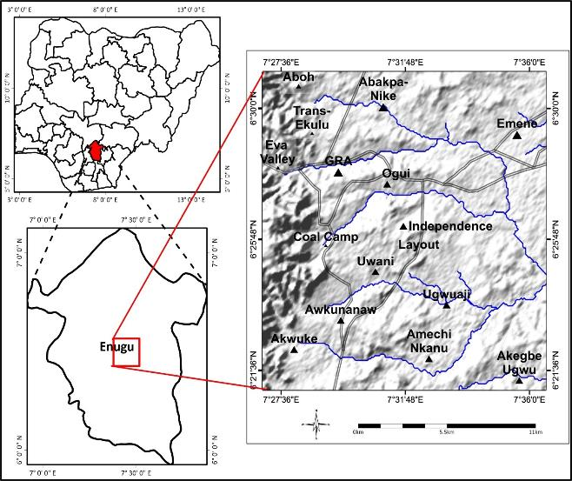
Fig. 1. Location map of study area; insert: maps of Enugu State and Nigeria
2.1 Geology and Hydrogeology

Enugu Urban is underlain by the Cretaceous Enugu Shale, which consists of dark grey fissile shales interbedded with sandstones and siltstones (Alichi, 2024; Reyment, 1965; Offodile, 2002). The shallow aquifer, located at depths of 2–18 meters, is developed within the weathered and fractured shale, exhibiting unconfined to semi-confined conditions (Edet, 2021; Ezeh et al., 2017). Recharge occurs primarily through rainfall, with groundwater flow generally directed from northeast to southwest (Fig. 2).
Fig.2: Geologic map of Enugu Urban and its environs (insert: geologic map of Enugu State modified after Nigeria Geological Survey Agency (NGSA, 2006)
3. Materials and Methods
A total of 122 groundwater samples were collected from hand-dug wells during wet and dry seasons. The samples were taken after allowing water to flow for some time to ensure that water directly from the aquifer was collected. Each sample was collected using a one-litre plastic container with cover, which had been pre-washed with detergent and rinsed with distilled water. At each sampling point, the container was rinsed with the sample water before collection and then securely covered. To preserve the samples for cation analysis, a few drops of nitric acid were added to adjust the pH to below 2. The sample containers were labelled properly and stored in an ice- packed cooler and transported to the laboratory for further analysis. In-situ parameters such as pH, electrical conductivity (EC), and temperature were measured in the field using a multi-parameter meter (Hanna Multi-meter- H198194). Major ions and trace elements were analyzed using standard methods (APHA, 2017; Freeze and Cherry, 1979). Hydrochemical and thermodynamic assessments were carried out using Piper, Durov, Gibbs diagrams, and PHREEQC modeling (Piper, 1944; Parkhurst and Appelo, 2013). Multivariate statistical methods, including correlation analysis, hierarchical cluster analysis (HCA), and principal component analysis (PCA), were employed to support interpretation of geochemical processes (Ganyecz et al., 2022; Vasanthavigar et al., 2010).
4. Results and Discussion
4.1 Hydrogeological Framework
The groundwater flow pattern, as illustrated in Fig. 3, shows a predominant west-to-east flow direction, which aligns with the regional topographic gradient and the structural dip of the Enugu Shale Formation. This flow direction plays a critical role in shaping the hydrogeochemical evolution of the aquifer. As groundwater migrates along this pathway, it interacts progressively with the host rock, facilitating silicate weathering, ion exchange, and the dissolution of carbonate and sulfate minerals—as evidenced by the widespread undersaturation of calcite, dolomite, and gypsum.
The directional flow pattern also helps explain the observed spatial variation in major ion concentrations and saturation indices, which tend to increase along the flow path due to longer residence times and sustained water–rock interaction. Furthermore, this west-to-east gradient is significant in assessing the transport of anthropogenic solutes from urban centres located in recharge zones toward more distal discharge areas. Understanding the groundwater flow dynamics is therefore essential not only for interpreting current geochemical conditions but also for predicting future aquifer responses to land use changes, potential contaminant migration, and recharge vulnerability under increasing urban pressure.

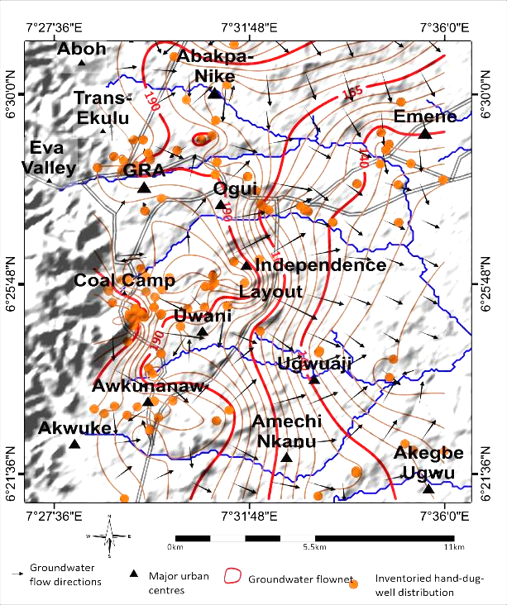
Fig. 3. Static water level (SWL) map and groundwater flow pattern in Enugu Urban and its environs
4.2 Hydrochemical Facies and Major Ion Chemistry
The Piper diagram (Fig. 4) indicates that Na-HCO₃ is the dominant hydrochemical facies representing 52% of groundwater samples. This suggests that silicate weathering and cation exchange are the primary geochemical processes controlling groundwater chemistry in the Enugu Urban area. The occurrence of secondary Ca-Mg-Cl and mixed facies reflects localized influences, possibly from anthropogenic sources (e.g., domestic waste, latrines) or minor carbonate weathering, consistent with shale-rich lithology.
Descriptive statistics (Table 1) supports these interpretations with TDS values ranging from 42 to 410 mg/L, indicating fresh water with low mineralization. The generally high electrical conductivity (EC) TDS during the dry season reflect increased mineral dissolution, longer residence time, and reduced dilution due to low recharge, which is consistent with findings by Ezeh et al (2023) and Egbi and Afolabi (2023).
The pH values indicate generally acidic to slightly alkaline groundwater in both seasons. The lower pH values observed during the rainy season may be attributed to the oxidation of sulphide minerals, particularly pyrite, as well as enhanced microbial activity that release organic acids into the aquifer system. Acid rain and leachates from surrounding waste sites may also contribute to this acidity. Similar trends have been observed in groundwater studies conducted in southeastern Nigeria (Onu et al., 2024; Nwachukwu et al., 2020). The pH suggests limited carbonate buffering capacity, typical of areas underlain by shale formations.
The sodium (Na⁺) concentration increased in dry season. This increase suggests enhanced silicate weathering, ion exchange, and evapoconcentration during dry season. Elevated Na⁺ levels in many samples further corroborate the dominance of silicate mineral dissolution and ion exchange processes. These findings align with recent studies on shale aquifers and urban groundwater systems in similar tropical sedimentary settings (Ehirim et al., 2014; Ocheri et al., 2021; Tiwari and Rai, 2020). Furthermore, the observed facies evolution aligns with conceptual models proposed by Appelo and Postma (2005); Ezeh et al., (2017), which attribute Na-HCO₃ facies to longer residence times and ion exchange in clay-rich aquifers. Calcium and magnesium were slightly higher in the rainy season, indicating the carbonate dissolution process. The overall dominance of Na⁺ over Ca²⁺ supports a Na-HCO3 water type, which aligns with the Durov and Piper diagrams' interpretations (Figs. 4 and 5) and confirms active cation exchange along groundwater flow paths (Ajayi et al., 2022).
Bicarbonate concentration was relatively stable across seasons, suggesting continuous carbonate weathering as a primary buffering system. Chloride concentrations increased in dry season, likely due to sewage effluents, agricultural runoff, or urban leachates. Nitrate values, although slightly lower in dry season, were elevated enough in both seasons to suggest influence from fertilizer application and organic waste, as documented in similar urban-rural studies in Nigeria (Ugwu et al., 2023). Total hardness (CaCO3) remained relatively constant across seasons, reflecting a moderately hard water category. This indicates equilibrium in carbonate mineral dissolution, likely controlled by calcite and dolomite buffering.
Iron and manganese concentrations were significantly higher in the rainy season, likely due to reducing conditions that promote the mobilisation of iron and manganese from aquifer materials. During the dry season, iron dropped to.75mg/L and manganese 0.18mg/L, reflecting oxidising conditions and possible precipitation of oxides. Lead levels exceeded WHO guidelines (0.01mg/L) in both seasons, especially in the rainy season, suggesting industrial pollution or pipe corrosion. Zinc, chromium, and nickel remain within acceptable limits, although continuous monitoring is necessary due to urban encroachment risks.
Fig. 4. Piper-Trilinear diagram of rainy and dry seasons water samples (after Hill, 1940; Piper, 1944,).

Table 1: Descriptive statistics of concentration of both seasons hydrochemical parameters in Enugu Urban
Parameters |  | Rainy Season |  |  |  | Dry Season
Parameters | Units | Min | Max | Mean | STDEV | Min | Max | Mean | STDEV
pH |  | 3.5 | 8.9 | 6.1 | 1.4 | 4.1 | 8.2 | 5.9 | 0.8
Electrical Conductivity (EC) | µS/cm | 118.2 | 872.7 | 389.8 | 202.0 | 38.0 | 855.0 | 416.9 | 230.4
Total Dissolved Solids (TDS) | mg/l | 10.5 | 500.0 | 156.4 | 124.4 | 80.0 | 480.0 | 217.6 | 86.0
Sodium (Na⁺) | mg/l | 1.2 | 153.4 | 45.1 | 36.1 | 10.3 | 210.3 | 63.1 | 36.1
Potassium (K⁺) | mg/l | 0.7 | 54.7 | 11.1 | 12.8 | 0.9 | 39.0 | 10.2 | 9.5
Magnesium (Mg²⁺) | mg/l | 0.2 | 26.1 | 5.3 | 5.2 | 0.9 | 27.9 | 4.5 | 4.6
Calcium (Ca²⁺) | mg/l | 2.4 | 84.2 | 15.9 | 14.1 | 0.9 | 68.0 | 13.5 | 12.3
Bicarbonate (HCO₃⁻) | mg/l | 8.2 | 291.9 | 76.3 | 60.3 | 6.2 | 218.3 | 75.0 | 48.5
Sulphate (SO₄²⁻) | mg/l | 1.2 | 197.8 | 33.7 | 36.3 | 1.4 | 161.0 | 33.3 | 34.5
Chloride (Cl⁻) | mg/l | 0.4 | 86.0 | 25.3 | 27.0 | 1.5 | 132.8 | 37.0 | 31.7
Nitrate (NO₃⁻) | mg/l | 0.4 | 108.0 | 22.5 | 21.3 | 1.4 | 79.1 | 19.7 | 18.5
Total Hardness (CaCO₃) | mg/l | 7.2 | 280.2 | 61.6 | 49.7 | 12.7 | 233.0 | 61.6 | 44.4
Manganese (Mn²⁺) | mg/l | 0.002 | 3.1 | 0.26 | 0.56 | 0.13 | 0.27 | 0.18 | 0.03
Iron (Fe) | mg/l | 0.03 | 29.9 | 2.92 | 4.68 | 0.39 | 1.82 | 0.75 | 0.36
Lead (Pb) | mg/l | 0.05 | 6.16 | 1.17 | 1.62 | 0.13 | 0.83 | 0.50 | 0.21
Zinc (Zn) | mg/l | <0.002 | 4.95 | 0.15 | 0.56 | 0.24 | 0.81 | 0.67 | 0.13
Chromium (Cr) | mg/l | <0.003 | 4.95 | 0.15 | 0.08 | 0.08 | 0.12 | 0.10 | 0.01
Nickel (Ni) | mg/l | <0.004 | 4.95 | 0.15 | 0.16 | 0.19 | 0.24 | 0.21 | 0.01

4.3 Hydrochemical Evolution and Process Interpretation
The Durov diagram (Fig. 5) and the facies summary (Table 2) further confirm the dominance of Na-HCO₃ water types, particularly in quadrants associated with ion exchange, mixing trends, and progressive mineralization along flow paths. Several samples plot in fields 5 and 9, indicating that cation exchange (e.g., Ca²⁺ replaced by Na⁺ from clays or feldspars) and anthropogenic mixing may be occurring along the groundwater flow paths. The presence of mixed facies highlights the influence of multiple geochemical processes, including recharge dilution, evaporation concentration, and sewage infiltration.
The TDS distribution map (Fig. 6) shows elevated salinity in densely populated and low-lying areas, indicating intense water-rock interaction, land use, septic infiltration, and longer resident time, which promote greater mineral dissolution and contaminant accumulation. These zones are often associated with shallow water tables, increasing vulnerability to surface contamination. These findings align with regional hydrogeochemical studies in southeastern Nigeria (Ehirim et al., 2014; Nwachukwu et al., 2020).
Gibbs diagram (Fig. 7) showed that most samples fall within the rock dominance field, confirming that rock-water interaction is the major geochemical process controlling the groundwater chemistry in the study area, with minor contributions from precipitation and evaporation. This pattern aligns with previous findings in humid tropical environments, where high infiltration and mineral dissolution dominate over evaporation processes (Gibbs, 1970, Kumari and Rai, 2020; Onu et al., 2024).

Fig. 5. Durov plot depicting hydrochemical processes involved in the groundwater evolution (after Lloyd and Heathcoat, 1985; Hussien and Faiyad, 2016).
Fig. 6. TDS distribution map of study area: (A) Rainy season; (B) Dry season

Table 2: Groundwater classification chart based on Durov diagram (Lloyd and Heathcoat, 1985)
S/  No. | Water Types | Rainy Season |  | Dry Season
 |  | No. of samples | % | No. of samples | %
1 | Ca–HCO₃; typical of recharge in limestone/sandstone aquifers | – | – | – | –
2 | Ca–HCO₃; Mg suggests dolomite, Na suggests ion exchange | 13 | 21.3 | 4 | 6.6
3 | Na–HCO₃; ion exchange or CO₂-driven HCO₃ formation | 23 | 37.7 | 18 | 29.5
4 | Ca–SO₄ or SO₄-dominant; recharge in gypsum/lava or mixing | 1 | 1.6 | – | –
5 | No dominant ions; simple dissolution or mixing | 4 | 6.6 | 11 | 18.0
6 | Na–SO₄ or SO₄-dominant; uncommon, indicates mixing/dissolution | 16 | 26.2 | 21 | 34.4
7 | Na–Cl; may suggest cement pollution or reverse ion exchange | – | – | – | –
8 | Na–Cl; likely reverse ion exchange | – | – | 1 | 1.6
9 | Na–Cl; end-point waters via dissolution | 4 | 6.6 | 6 | 9.8

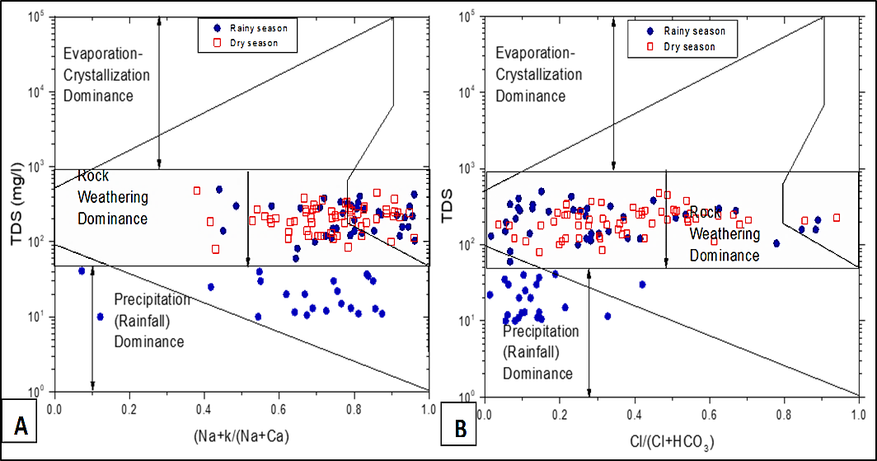
Fig. 7. Gibbs plots of TDS (mg/l) versus (Na+K)/(Na+Ca), and Cl/(Cl+HCO₃) ratios in the study area

4.4 Ion Exchange Processes in the Enugu Urban Shallow Aquifer
Ion exchange is a key hydrogeochemical mechanism shaping groundwater chemistry in the Enugu Urban shallow aquifer. The prevalence of Na–HCO₃ facies, as illustrated by Piper and Durov diagrams (Figs. 4 and 5), reflects active cation exchange between groundwater and the clay-rich, weathered shale matrix (Appelo & Postma, 2005; Ezeh et al., 2017). As groundwater flows, Ca²⁺ and Mg²⁺ ions in solution are exchanged with Na⁺ adsorbed on aquifer minerals, resulting in progressive sodium enrichment and the transformation from Ca–HCO₃ to Na–HCO₃ water types.
The presence of negative Chloro-Alkaline Indices (CAI) (Fig. 8) further supports this interpretation, indicating direct base-exchange reactions in which alkali metals in groundwater displace alkaline earth metals on mineral surfaces. The Gibbs diagram (Fig. 6) places most samples in the rock dominance field, reinforcing that water–rock interaction, including ion exchange, is the principal factor controlling groundwater chemistry.
Moreover, elevated sodium concentrations can affect the Sodium Adsorption Ratio (SAR), an important parameter for assessing groundwater's suitability for irrigation, where excessive sodium may degrade soil structure over time (Ayers & Westcot, 1985; Nwankwoala & Udom, 2011). Such effects are particularly relevant in shale aquifers where clay minerals facilitate ion exchange and sodium retention.
Recent investigations in Enugu’s regolith aquifers have confirmed the significance of ion exchange and silicate weathering, with buffering mechanisms maintaining relatively stable sodium levels despite seasonal recharging (Ozoko and Ezeugwu, 2025; Chukwuemeka and Ezeugwu, 2021). These studies highlight the dynamic nature of groundwater evolution in shale terrains, where redox processes, microbial activity, and hydrologic inputs interact to influence water chemistry.

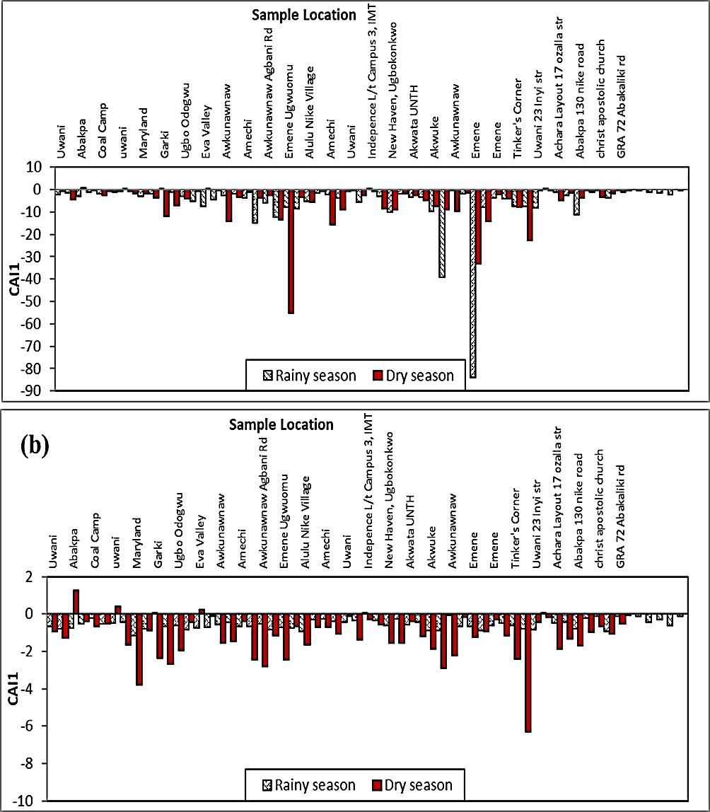
Fig. 8. Chloro-Alkaline Indices 1 and 2 (CAI1 and CAI2) for groundwater in the study area
4.5 Thermodynamic Stability and Saturation Indices
PHREEQC-derived saturation indices (Fig. 9, Table 3) reveal that the majority of groundwater samples remain undersaturated with respect to calcite and dolomite, signalling ongoing mineral dissolution and limited buffering capacity. Gypsum and halite are likewise undersaturated, suggesting negligible evaporite contribution to water chemistry (Appelo & Postma, 2005; Parkhurst & Appelo, 2013). The facies data (Table 2) indicate a hydrogeochemical evolution linking silicate weathering as the main driver, alongside limited carbonate equilibrium.
Spatial and seasonal patterns of saturation indices show lower SI values in recharge zones and during the wet season, attributable to dilution of solutes, while dry-season samples exhibit modestly higher SI values due to solute concentration, consistent with findings by Ganyecz et al. (2022). Furthermore, Figure 10 illustrates a positive correlation between saturation indices and total dissolved solids (TDS), indicative of progressive mineral dissolution along groundwater flow paths. This suggests that as groundwater migrates through the aquifer, it acquires higher ionic concentrations, impacting both its thermodynamic stability and suitability for domestic and agricultural use.
These observations align with results from similar Nigerian hydrogeochemical studies. For instance, groundwater along the Lagos coastal belt was found to be variably undersaturated with gypsum and halite, while exhibiting transitioning saturation states for calcite, supporting the predominance of carbonate weathering and limited evaporite influence in shaping groundwater mineralogy. These patterns varied by season and residence time (Ako et al., 2012; Sunkari et al., 2019).
Fig. 9. Comparative consideration of saturation indices of some ionic species in the water samples analysed: (a) SI calcite versus HCO₃⁻; (b) SI dolomite versus HCO₃⁻; (c) SI gypsum versus SO₄²⁻; (d) SI halite versus Cl⁻.

Table 3: Saturation Indices with respect to various mineral phases (Aragonite, Calcite, Dolomite, Anhydrite, Halite, and Gypsum).

 | Saturation Indices Rainy Season |  |  |  |  |  | Saturated Indices Dry Season
Mineral Phase | Max SI | Min  SI | Mean  SI | Range SI | Std. Dev | Max SI |  | Min  SI | Mean  SI | Range | Std.  Dev
Anhydrite (CaSO₄) | -1.85 | -4.37 | -3.04 | 2.53 | 0.64 | -1.71 |  | -5.13 | -3.06 | 3.42 | 0.60
Calcite CaCO₃) | 0.79 | -5.65 | -2.37 | 6.44 | 1.62 | -0.28 |  | -2.48 | -1.51 | 2.20 | 0.45
Aragonite (CaCO₃) | 0.65 | -5.79 | -2.51 | 6.44 | 1.62 | -0.83 |  | -5.48 | -3.64 | 4.65 | 1.36
Dolomite (CaMgCO₃) | 1.18 | -11.60 | -5.01 | 12.78 | 3.33 | -1.28 |  | -5.82 | -3.43 | 4.54 | 0.86
Gypsum (CaSO₄.2H₂O) | -1.63 | -4.16 | -2.83 | 2.53 | 0.64 | -1.47 |  | -4.89 | -2.82 | 3.42 | 0.60
Halite (NaCl) | -6.60 | -10.23 | -7.94 | 3.63 | 0.88 | -6.51 |  | -9.34 | -7.46 | 2.83 | 0.59

Fig 10. Plot of saturation indices (SI) of carbonate and sulphate minerals as a function of TDS for groundwater of the Enugu regolith aquifer during the (A) rainy season (B) dry seasons
4.6 Synthesis and Implications
The integration of graphical, statistical, and thermodynamic analyses highlights a hydrogeochemical evolution pathway primarily governed by silicate weathering and cation exchange, with minimal contribution from carbonate equilibrium. These processes suggest that the aquifer is in an early stage of geochemical maturity, undergoing dynamic evolution influenced by both natural and anthropogenic factors.
Urbanization has exacerbated solute loading through increased surface runoff, leachate infiltration, and disruption of natural flow regimes. These modifications have altered the hydrochemical baseline and accelerated geochemical transformations within the aquifer system.
The widespread undersaturation with respect to carbonate (e.g., calcite, dolomite) and sulfate (e.g., gypsum) minerals implies a low buffering capacity, rendering the aquifer vulnerable to acidification, enhanced trace metal mobility, and infrastructure corrosion. These geochemical conditions could have significant implications for groundwater potability, irrigation suitability, and pipe material degradation, particularly in urban or peri-urban settings.
The evolving chemical composition of groundwater also reflects ongoing water–rock interaction processes that should be continuously monitored, especially under changing land-use and climatic conditions. Proactive groundwater management and pollution mitigation strategies will be critical to preserving water quality and preventing long-term aquifer degradation.

5. Summary and Conclusions
This study presents a comprehensive assessment of the thermodynamic and hydrogeochemical evolution of the shallow aquifer in Enugu Urban, southeastern Nigeria. The findings indicate that groundwater chemistry is primarily influenced by silicate weathering and active cation exchange within the weathered and fractured Enugu Shale. The dominance of the Na-HCO₃ facies, along with spatial and seasonal variations in major ions and total dissolved solids (TDS), reflects a dynamic interplay between natural geochemical processes and anthropogenic pressures, such as urbanization and land use change.
PHREEQC modeling confirms that most groundwater samples are undersaturated with respect to calcite, dolomite, and gypsum, suggesting ongoing mineral dissolution and a limited natural buffering capacity. The persistence of ion exchange and widespread undersaturation further underscores the aquifer's vulnerability to acidification, trace metal mobilization, and other external stresses.
While seasonal recharge and urban expansion continue to introduce new geochemical inputs and modify flow regimes, the aquifer’s evolution remains fundamentally controlled by lithology and water–rock interactions. These insights emphasize the importance of continuous monitoring, sustainable groundwater management, and protective measures for recharge zones to mitigate the effects of anthropogenic activities.
In conclusion, the shallow aquifer system in Enugu Urban is a dynamically evolving and geochemically immature environment, shaped by both natural geological processes and the intensifying pressures of urban development. Its low buffering capacity and chemical vulnerability call for proactive interventions to preserve water quality. By deepening our understanding of the underlying thermodynamic and hydrogeochemical processes, this study offers a robust scientific foundation for the sustainable management of groundwater resources not only in Enugu Urban but also in similar rapidly developing urban centres globally.
Disclaimer (Artificial intelligence)

Author(s) hereby declare that NO generative AI technologies such as Large Language Models (ChatGPT, COPILOT, etc.) and text-to-image generators have been used during the writing or editing of this manuscript.

References
Ajayi, B. D., Adekola, G., & Omo-Irabor, O. O. (2022). Hydrogeochemical evolution and water–rock interactions in basement complex terrain of Nigeria. Journal of African Earth Sciences, 193, 104555. https://doi.org/10.1016/j.jafrearsci.2022.104555
Ako, A. A., Shimada, J., Hosono, T., Kagabu, M., Ayuk, A. R., Nkeng, G. E., Eyong, G. E. T., & Takounjou, A. L. F. (2012). Spring water quality and usability in the Mount Cameroon area revealed by hydrogeochemistry. Environmental Geochemistry and Health, 34(5), 615–639. https://doi.org/10.1007/s10653-012-9453-3
Alichi, A. U. (2024). Hydrochemical Characterization and Quality Indices of Shallow Groundwater in Enugu Urban, Southeastern Nigeria. PhD Dissertation, Nnamdi Azikiwe University, Awka.
American Public Health Association (APHA), American Water Works Association (AWWA), & Water Environment Federation (WEF). (2017). Standard methods for the examination of water and wastewater (23rd ed.). Washington, DC: American Public Health Association.
Ansari, J. A., & Umar, R. (2019). Evaluation of hydrogeochemical characteristics and groundwater quality in the Quaternary aquifers of Unnao District, Uttar Pradesh, India. Hydrology Research, 50(2), 361–376. https://doi.org/10.1016/j.hydres.2019.01.001 ResearchGateagris.fao.org
Appelo, C.A.J. & Postma, D. (2005). Geochemistry, Groundwater and Pollution. 2nd Ed. CRC Press.
Ayers, R.S. & Westcot, D.W. (1985). Water Quality for Agriculture. FAO Irrigation and Drainage Paper 29 Rev. 1, Rome.
Bethke, C. M. (2008). Geochemical and biogeochemical reaction modeling (2nd ed.). Cambridge University Press.
Chukwuemeka, O. D., & Ezeugwu, I. O. (2021). Redox processes in regolith aquifers at Enugu, southeastern Nigeria. International Journal of Earth & Environmental Sciences, 6(1), 1–15. https://ijees.ielas.org/index.php/ijees/article/view/42
Edet, A. E. (2021). Hydrogeology and groundwater quality of Nigeria: A review. Applied Water Science, 11, 34.
Egbi, O. G., & Afolabi, O. O. (2023). Groundwater quality dynamics in Nigeria: Insights from urban and peri-urban monitoring. International Journal of Environmental Chemistry, 7(1), 11–24. https://journalijecc.com/index.php/IJECC/article/view/4174
Ehirim, C.N., Okiongbo, K.S. & Akpokodje, E.G. (2014). Hydrogeochemical evaluation of groundwater in Port Harcourt, Nigeria. Applied Water Science, 4, 19–28.
Ezeh, H. N., Ezeabasili, A. C. C. & Ezeabasili, I. C. C. (2017). Groundwater quality assessment in parts of Enugu State, Nigeria. Journal of African Earth Sciences, 134, 160–170.
Ezeh, H. N., Uchegbu, F. C., & Okonkwo, C. I. (2023). Seasonal variation in groundwater quality in urban southeastern Nigeria. Springer Environmental Monitoring and Assessment, 195(2), 218. https://doi.org/10.1007/s10661-023-11190-2
Fetter, C. W. (2001). Applied Hydrogeology (4th ed.). Prentice Hall
Freeze, R.A. & Cherry, J.A. (1979). Groundwater. Prentice Hall.
Ganyecz, Á., Szabó, A., Szabó, J. & Tanos, P. (2022). Urban groundwater quality assessment using integrated hydrochemical and statistical approaches. Environmental Science and Pollution Research, 29, 12345– 12360.
Gibbs, R.J. (1970). Mechanisms controlling world water chemistry. Science, 170, 1088–1090.
Hasan, S. S., Salem, Z. E., & Sefelnasr, A. (2023). Assessment of hydrogeochemical characteristics and seawater intrusion in coastal aquifers by integrating statistical and graphical techniques: Quaternary Aquifer, West Nile Delta, Egypt. Water, 15(10), 1803. https://doi.org/10.3390/w15101803
Kumari, M., & Rai, S. C. (2020). Hydrogeochemical evaluation of groundwater quality for drinking and irrigation purposes using Water Quality Index in semi-arid region of India. Journal of the Geological Society of India, 95(2), 159–168. https://doi.org/10.1007/s12594-020-1405-4 Geoscience World
Nigerian Geological Survey Agency. (2006). Geological map of Nigeria [Map]. N.G.S.A
Nwachukwu, M. A., Anike, L. O., Onu, N. N. & Ukaegbu, V. U. (2020). Assessment of groundwater contamination in Enugu, Nigeria. Environmental Monitoring and Assessment, 192, 456.
Nwankwoala, H. O. & Udom, G. J. (2011). Hydrochemical facies and ionic ratios of groundwater in Port Harcourt, Nigeria. Applied Water Science, 1, 129–137.
Ocheri, M.I., Auta, S. & Omonona, O.V. (2014). Hydrogeochemical assessment of groundwater quality in Makurdi, North Central Nigeria. Journal of African Earth Sciences, 100, 282–293.
Offodile, M.E. (2002). Groundwater Study and Development in Nigeria. Mecon Geology & Engineering Services Ltd, Jos.
Onu, N. N., Etu-Efeotor, J. O., & Ngah, S. A. (2024). Geochemical assessment of water–rock interaction in fractured aquifers of Enugu, Nigeria. Environmental Earth Sciences, 83(1), 59. https://link.springer.com/article/10.1007/s42452-024-05837-x
Ozoko, D. C., & Ezeugwu, I. O. (2025). Carbon speciation in regolith aquifers at Enugu, southeastern Nigeria. International Journal of Earth & Environmental Sciences, 10(1), 36–55. https://ijees.ielas.org/index.php/ijees/article/view/56
Parkhurst, D.L. & Appelo, C.A.J. (2013). Description of input and examples for PHREEQC version 3—A computer program for speciation, batch-reaction, one-dimensional transport, and inverse geochemical calculations. USGS Techniques and Methods, book 6, chap. A43.
Piper, A.M. (1944). A graphic procedure in the geochemical interpretation of water analyses. Transactions of the American Geophysical Union, 25, 914–923.
Razi, M. H., Wilopo, W., & Putra, D. P. E. (2024). Hydrogeochemical evolution and water–rock interaction processes in the multilayer volcanic aquifer of Yogyakarta-Sleman Groundwater Basin, Indonesia. *Environmental Earth Sciences, 83*(5), 477. [https://doi.org/10.1007/s12665-024-11477-6](https://doi.org/10.1007/s12665-024-11477-6)
Reyment, R.A. (1965). Aspects of the geology of Nigeria. Ibadan University Press.
Song, J., & Zhou, X. (2024). Hydrochemical characterization and health risk assessment of shallow groundwater in a northern coalfield of Anhui Province, China. Frontiers in Earth Science, 12, 1368328. https://doi.org/10.3389/feart.2024.1368328
Stuyfzand, P.J. (1993). Hydrochemistry and hydrology of the coastal dune area of the Western Netherlands. PhD Thesis, Vrije Universiteit Amsterdam.
Sunkari, E. D., Abu, M., Bayowobie, P. S., & Dokuz, U. E. (2019). Hydrogeochemical appraisal of groundwater quality in the Ga West Municipality, Ghana: Implication for domestic and irrigation purposes. Groundwater for Sustainable Development, 8, 501–511. https://doi.org/10.1016/j.gsd.2019.02.002
Ugwu, E. I., Agwu, A. E., & Nwankwo, E. U. (2023). Nitrate contamination in groundwater around urban farmlands in Enugu. International Journal of Hydrogeology, 9(3), 54–62.
Vasanthavigar, M., Srinivasamoorthy, K., Rajiv Ganthi, R., Vijayaragavan, K., Sarma, V.S., Chidambaram, S., Anandhan, P., Manivannan, R. & Vasudevan, S. (2010). Application of water quality index for groundwater quality assessment: Thirumanimuttar sub-basin, Tamilnadu, India. Environmental Monitoring and Assessment, 171, 595–609.

