Climate Change Impacts on Sericulture: Evidence from Mulberry Physiology, Silkworm Biology and Northeast Indian Muga Ecosystems

Abstract
Climate change has emerged as a major driver of agro-ecological instability, influencing temperature regimes, atmospheric carbon dioxide concentrations, precipitation patterns, and the frequency of extreme climatic events. This review aims to synthesize current knowledge on the impacts of climate change on sericulture, with particular emphasis on mulberry physiology, silkworm biology, and the vulnerability of non-mulberry silk ecosystems in Northeast India. These environmental changes pose significant challenges to sericulture, a climate-sensitive agro-based industry that depends on the complex interaction between host plant physiology and silkworm biology. Mulberry (Morus spp.), the primary host plant of the domesticated silkworm (Bombyx mori), follows the C3 photosynthetic pathway and is therefore highly sensitive to variations in temperature and moisture availability. Rising temperatures and altered carbon dioxide dynamics influence photosynthesis, transpiration, and leaf nutritional quality, which directly affect silkworm growth, development, and silk productivity. Silkworms, being poikilothermic organisms, exhibit strong sensitivity to environmental fluctuations throughout their life cycle, and deviations from optimal temperature and humidity conditions can lead to reduced cocoon weight, lower shell ratio, and increased susceptibility to diseases.
Climate variability also affects cocoon morphology and silk fiber properties, thereby reducing reeling efficiency and market value. Evidence from Northeast India further demonstrates the vulnerability of non-mulberry sericulture systems, particularly muga silk production in Assam, where rising temperatures, recurrent flooding, and host plant degradation have disrupted traditional rearing practices and reduced productivity. The review also highlights key adaptation and mitigation strategies, including the development of climate-resilient mulberry varieties, stress-tolerant silkworm breeds, improved rearing technologies, and adaptive management practices to sustain sericulture under changing climatic conditions.
Keywords: Climate change, Sericulture, Mulberry, Silkworm, Muga silk, Tasar silk, Temperature stress, Flood impact

1. Introduction
Climate change is a global phenomenon of longlasting weather changes impacting ecosystems, health, and economies (Adger, 2005; Feliciano et al., 2022). Climate change refers to persistent and long-term alterations in key climatic parameters such as temperature, precipitation patterns, relative humidity, and wind dynamics. These changes are primarily driven by anthropogenic greenhouse gas emissions associated with industrialization, fossil fuel combustion, and land-use change. Since the pre-industrial period (around 1850), atmospheric carbon dioxide (CO₂) concentrations have increased by nearly 47%, reaching approximately 415–420 ppm in recent years (NOAA; IPCC, 2021). This rise in greenhouse gas concentrations has been accompanied by an increase in global mean surface temperature of about 1.1°C above pre-industrial levels, with the past decade being the warmest on record (NASA-GISS; IPCC, 2021). In addition, global mean sea levels are rising at an estimated rate of about 3.3 mm per year, primarily due to thermal expansion of seawater and accelerated melting of glaciers and polar ice sheets. The increasing frequency and intensity of extreme climatic events such as floods, droughts, cyclones, and heat waves further highlight the accelerating impacts of global climate change.
Agricultural systems are particularly vulnerable to such climatic perturbations because crop productivity depends on relatively narrow environmental thresholds. Variations in temperature, atmospheric CO₂ levels, and soil moisture availability influence plant physiological processes, nutrient cycling, pest and disease dynamics, and overall ecosystem stability. Within this broader agricultural framework, sericulture represents one of the most climate-sensitive agro-based industries. Increased pest infestations, flash floods, agricultural runoff, soil erosion, frequent crop damage from heat waves, habitat destruction, northward crop shifts, reduced agricultural yields, economic and psychological stress on farming communities, soil quality degradation, and permanent loss of fertile soil are some immediate impacts of temperature trends and rainfall patterns because of climate change (Raihan, 2023; Godde et al., 2021). Unlike many conventional cropping systems, sericulture involves a closely integrated biological chain consisting of host plant cultivation, silkworm rearing, cocoon production, and silk processing, all of which are highly responsive to environmental conditions.
Mulberry (Morus spp.), the primary host plant of the domesticated silkworm (Bombyx mori), is particularly sensitive to fluctuations in temperature and water availability. Changes in leaf moisture content, protein levels, and carbohydrate composition can directly influence silkworm feeding behavior, growth, and cocoon quality. Furthermore, silkworms are poikilothermic organisms and therefore lack internal temperature regulation. As a result, their growth, development, metabolic activity, and disease susceptibility are strongly influenced by ambient environmental conditions, and even small deviations from optimal rearing temperatures may significantly affect cocoon yield and silk quality (Rahmathulla, 2012).
In addition to mulberry-based sericulture, non-mulberry silk systems such as Muga and Tasar are closely linked with natural forest ecosystems, making them even more vulnerable to climate variability and habitat degradation. Reports from Northeast India have documented production instability associated with erratic rainfall, rising summer temperatures, and recurrent flooding events that damage host plant plantations and disrupt traditional rearing practices (Assam Sericulture Department reports).
Therefore, understanding the complex interactions between climatic variables, host plant physiology, silkworm biology, and ecosystem dynamics is essential for developing climate-resilient sericulture systems. This review examines the major impacts of climate change on sericulture, including effects on host plant physiology, silkworm development, cocoon quality, and regional silk production systems, while highlighting potential adaptation and mitigation strategies to ensure the long-term sustainability of the silk industry.

2. Global Climate Change Indicators and Their Agricultural Implications
Global climate change is characterized by several measurable environmental indicators that reflect the increasing influence of anthropogenic activities on the Earth’s climate system. Climate change reduces global crop production by approximately 5.5 × 10¹⁴ kilocalories per year for every 1 °C rise in global temperature (Hultgren et al., 2025). One of the most significant indicators is the rapid increase in atmospheric greenhouse gases such as carbon dioxide (CO₂), methane (CH₄), and nitrous oxide (N₂O). Among these gases, CO₂ plays a dominant role in enhancing the greenhouse effect. Since the beginning of the industrial era around 1850, atmospheric CO₂ concentrations have increased by approximately 47%, reaching about 415 ppm in recent years according to the National Oceanic and Atmospheric Administration. This increase has contributed significantly to global warming by trapping infrared radiation within the Earth's atmosphere.
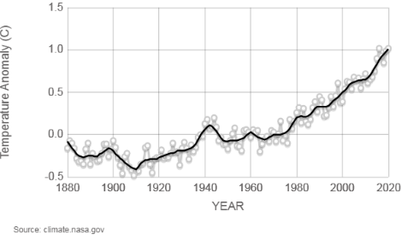
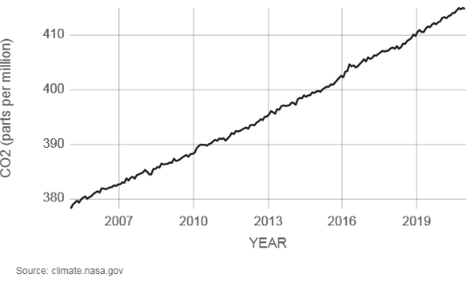

Fig 1- Rise in atmospheric CO₂ concentration and temperature anomaly
The consequences of rising greenhouse gas concentrations are evident in the increasing global mean surface temperature. Data from NASA Goddard Institute for Space Studies indicate that the global temperature anomaly reached approximately 1.02°C above the twentieth-century average in 2020, with the years 2016 and 2020 ranking among the warmest on record. Rising temperatures have also contributed to large-scale cryospheric changes, including the rapid decline of Arctic sea ice. Satellite observations show that Arctic sea ice extent in September, when it reaches its annual minimum, has been declining at a rate of approximately 13.1% per decade relative to the 1981–2010 average.



Fig 3-Arctic Sea Ice cover in 2020
Fig 2-Arctic Sea Ice cover in 1979
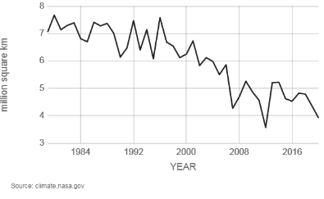

Fig 4- Decline in Arctic sea ice extent
Another critical indicator of climate change is global sea-level rise. Measurements from satellite altimetry reveal that global mean sea level has risen by approximately 95 ± 4 mm since 1993, with an average increase of about 3.3 mm per year. This rise is primarily attributed to thermal expansion of seawater and the accelerated melting of polar ice sheets in Greenland and Antarctica.
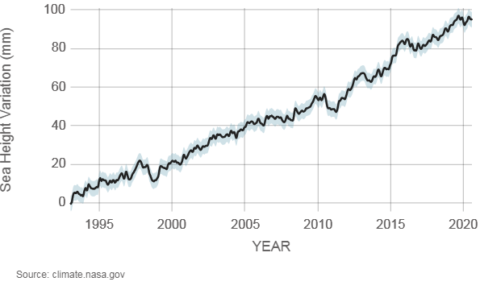

Fig 5- Sea-level rise
In addition to gradual changes, climate change has intensified extreme weather events such as cyclones, floods, droughts, and heatwaves. Increased rainfall variability and prolonged dry periods have caused desertification in many regions, reduced agricultural productivity, and forced environmental migration in vulnerable communities. These environmental changes directly influence agricultural systems by altering soil moisture availability, increasing pest and disease outbreaks, and reducing crop productivity. Sericulture, which depends on a delicate interaction between host plant physiology and silkworm biology, is therefore particularly vulnerable to these climatic fluctuations.

Fig 6-Tidal flooding Sea-level rise increases flooding in low-lying coastal regions. Venice,Italy(2009).

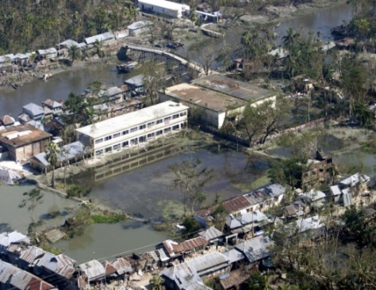
Fig 7-Storm intensification catastrophic flooding from increased rainfall after Cyclone Sidr in Bangladesh.

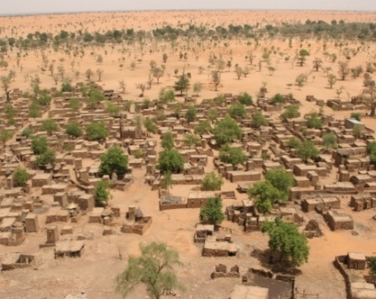
Fig 8-Environmental migration Sparser rainfall leads to desertification that harms agriculture and can displace populations. Shown: Telly, Mali

3. Impact on Mulberry Physiology

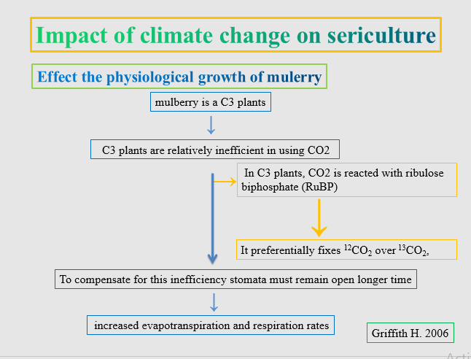

Fig 9- Climate change and sericulture
Mulberry (Morus spp.), the primary host plant for silkworms, is a typical C3 plant whose photosynthetic efficiency is strongly influenced by environmental conditions such as temperature, light intensity, and atmospheric CO₂ concentration. In C3 photosynthesis, carbon dioxide is fixed in the mesophyll cells through the reaction between CO₂ and ribulose-1,5-bisphosphate (RuBP), catalyzed by the enzyme ribulose-1,5-bisphosphate carboxylase/oxygenase (RuBisCO). However, RuBisCO has relatively low substrate specificity and can also react with oxygen, leading to photorespiration, a process that reduces photosynthetic efficiency and carbon assimilation (Griffiths and Smith, 2000; Rahmathulla, 2012).
Due to this physiological limitation, C3 plants require prolonged stomatal opening to absorb sufficient CO₂, which results in increased transpiration and water loss. Consequently, mulberry plants perform optimally under moderate temperature and adequate moisture conditions. In contrast, C4 plants possess a specialized carbon-concentrating mechanism that minimizes photorespiration and improves water-use efficiency, allowing them to thrive in high-temperature and drought-prone environments. During carbon fixation in C3 plants, RuBisCO preferentially assimilates the lighter carbon isotope (¹²CO₂) over ¹³CO₂, resulting in characteristic isotopic fractionation, which is commonly observed in plant physiological studies.
Since mulberry is a C3 plant, its photosynthetic performance and leaf productivity are particularly sensitive to rising temperatures and water stress associated with climate change. Increased temperature and drought conditions can enhance photorespiration and reduce net photosynthetic rates, ultimately affecting leaf yield and nutritional quality for silkworm feeding.

3.1 Elevated CO₂ Effects
Elevated atmospheric carbon dioxide levels have complex effects on plant physiology, particularly in C3 plants such as mulberry. In the short term, increased CO₂ concentrations may stimulate photosynthetic activity by enhancing carbon fixation. However, this initial stimulation is often offset by other environmental factors associated with climate change, including higher temperatures and increased evapotranspiration. As stomata remain open for longer durations to facilitate carbon uptake, plants experience greater water loss, which can lead to moisture stress under conditions of limited water availability.
Furthermore, elevated temperatures associated with increased atmospheric CO₂ levels can accelerate plant respiration and alter the balance between photosynthesis and photorespiration. In mulberry plants, these physiological changes may lead to alterations in leaf biochemical composition, including reductions in protein content, changes in carbohydrate balance, and variations in leaf moisture levels. Since silkworms rely exclusively on mulberry leaves for nutrition, any decline in leaf quality can significantly influence larval growth, feed conversion efficiency, and silk gland development. Ultimately, such nutritional deficiencies may result in lower cocoon weight, reduced shell ratio, and decreased silk yield, thereby affecting the overall productivity of sericulture systems.

4. Effect on Silkworm Rearing

Silkworms are poikilothermic organisms whose growth, development, and metabolic activities are strongly regulated by environmental temperature and humidity. Because they lack the ability to regulate their body temperature internally, even minor changes in ambient environmental conditions can significantly influence their physiological processes. Climatic variations therefore have a direct impact on both early-stage and late-stage silkworm rearing.

4.1 Chawki Rearing
Chawki rearing refers to the early larval stages of silkworm development, typically encompassing the first and second instars. During this stage, the larvae are particularly sensitive to environmental conditions and require carefully controlled temperature and humidity levels. The optimum temperature for the production of high-quality cocoons generally ranges between 22°C and 27°C. Within this range, silkworm larvae exhibit optimal feeding behavior, efficient digestion, and steady growth.
Although chawki worms demonstrate moderate tolerance to slightly elevated temperatures, excessive heat stress can negatively affect larval vigor and feeding efficiency. Under mild temperature increases, survival rates may improve due to enhanced metabolic activity; however, prolonged exposure to temperatures above the optimal range may lead to physiological stress, reduced immunity, and increased susceptibility to diseases.

4.2 Late-Age Rearing
The later larval instars are responsible for the majority of leaf consumption and silk protein synthesis. Temperature fluctuations during this stage can therefore have significant effects on cocoon characteristics. Higher temperatures tend to accelerate metabolic processes, resulting in faster larval growth and a shortened larval period. While this may initially appear beneficial, excessive temperature stress can disrupt silk gland development and reduce cocoon quality.
Conversely, lower temperatures slow down metabolic activity and prolong the larval duration, often reducing feeding efficiency and increasing the risk of disease outbreaks. In addition, temperature fluctuations combined with low relative humidity create favorable conditions for the spread of silkworm diseases such as flacherie and grasserie, which can cause severe crop losses in sericulture operations.

5. Effect on Cocoon Morphology and Mechanical Properties
Environmental conditions during silkworm rearing play a crucial role in determining cocoon morphology and the mechanical properties of silk fibers. Variations in temperature and humidity can significantly influence cocoon shape, shell thickness, filament quality, and overall commercial value. Higher rearing temperatures generally accelerate larval metabolism and spinning activity, often resulting in elongated or thinner cocoons with comparatively reduced shell thickness. In contrast, moderate and stable temperature conditions favor the formation of well-developed oval cocoons with thicker shells and better filament characteristics, which are desirable for efficient silk reeling (Rahmathulla, 2012; Offord, 2016).
Humidity also has a strong influence on cocoon quality. Excessively high humidity levels during cocoon formation may lead to discoloration, weakening of the cocoon shell, and deterioration of fiber strength. Studies conducted on Antheraea pernyi have reported noticeable discoloration of cocoons under high humidity conditions, which adversely affects their market quality and processing efficiency (Brunet and Coles, as cited in Offord, 2016). Such environmental stress can ultimately reduce the reeling efficiency and commercial value of silk, highlighting the importance of maintaining optimal climatic conditions during silkworm rearing.

6. Climate Change and Muga Silk in Northeast India
Muga silk, produced by the silkworm Antheraea assamensis, is geographically restricted to the northeastern region of India, particularly the state of Assam. The species is highly sensitive to environmental conditions and thrives best under warm and humid climates, with optimal temperatures ranging from 30–35°C and relative humidity levels between 80–85%. Any significant deviation from these environmental parameters can adversely affect larval development, cocoon formation, and overall silk productivity. In recent decades, climate variability in Assam, characterized by increasing temperatures and erratic rainfall patterns, has begun to alter the ecological conditions required for sustainable muga cultivation.
One of the major impacts of climate change has been the decline of som (Persea bombycina) plantations, which serve as the primary host plant for muga silkworms. Rising summer temperatures in many parts of Assam now frequently exceed 32°C, creating physiological stress for both host plants and silkworm larvae. In addition, recurrent flooding and silt deposition in the Brahmaputra valley damage the root systems of host plants, reduce plant vigor, and limit the availability of nutritious leaves required for successful silkworm rearing. These environmental disturbances have resulted in fluctuations in cocoon yield and have contributed to the gradual decline in muga silk production in traditional rearing areas.
In contrast, certain high-altitude regions of Mizoram have recently emerged as comparatively suitable areas for muga cultivation. Cooler temperatures, relatively stable rainfall patterns, and favorable ecological conditions in these regions provide a more conducive environment for host plant growth and silkworm development. As a result, since 2007 there has been a gradual increase in the proportion of muga silk production from Mizoram, indicating a geographic shift in suitable rearing zones driven by changing climatic conditions.

7. Flood Impacts: Dhemaji and Lakhimpur
Flooding has emerged as one of the most significant climate-related threats to muga sericulture in northeastern India, particularly in the districts of Dhemaji and Lakhimpur. These regions are located in the flood-prone Brahmaputra valley and represent important centers of traditional muga silk production. In Dhemaji district, where nearly 85 percent of the population depends on agriculture, a large proportion of rural households are engaged in labor-intensive muga cultivation involving family participation in silkworm rearing, reeling, and weaving activities.
However, recurrent annual flooding has increasingly disrupted this traditional livelihood system. Reports from the local agriculture department indicate that approximately 50,500 farm families were affected during a single flood event, impacting nearly 250,000 people out of a total district population of about 700,000. Floodwaters and subsequent silt deposition covered around 3,718 hectares of agricultural land, severely damaging plantations of som (Persea bombycina), the primary host plant for muga silkworms (Antheraea assamensis). Many sumonis (som plantations) have been buried under sandy silt or displaced due to soil erosion, resulting in reduced availability of quality leaves and planting materials required for silkworm rearing. Consequently, frequent flood disturbances have disrupted indigenous muga cultivation systems and forced many farming households to gradually shift toward alternative livelihoods, highlighting the vulnerability of flood-prone sericulture regions to climate variability.
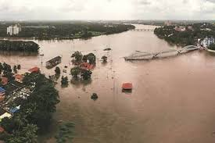


Fig 10-Floods in Dhemaji, 2015

Data source: Mubina Akhtar, 2015

8. Decline in Muga Production
Muga silk production in Assam has shown a gradual decline over the past two decades as a result of climatic variability and environmental stress. Muga silkworms depend primarily on host plants such as Persea bombycina (som) and Litsea monopetala (soalu), whose growth and leaf quality are strongly influenced by temperature, rainfall patterns, and soil conditions. Irregular rainfall, prolonged drought periods, and repeated flooding events have adversely affected host plant productivity, thereby limiting the availability of nutritious foliage required for successful silkworm development.
According to reports from the Assam Sericulture Department, muga silk production has experienced an annual shortfall of approximately 24–34 metric tonnes since 2007. In 2020, the total production reached 241 metric tonnes against a target of 255 metric tonnes. At the farmer level, the decline is reflected in reduced cocoon yields, which have dropped from around 30,000 cocoons to fewer than 18,000 cocoons per farmer annually. Consequently, average income per crop cycle has decreased from about ₹12,000 to less than ₹7,000. In addition to climatic stress, increased incidence of silkworm diseases, pesticide drift from nearby tea plantations, and environmental pollution have further contributed to the decline in muga silk productivity.

9. Impact on Tasar and Oak Host Ecosystems
Climate change also affects non-mulberry sericulture systems, particularly tasar and oak silk production, which rely heavily on forest ecosystems. Tasar silkworms depend on host plants such as Terminalia arjuna and Terminalia tomentosa, while oak silkworms utilize species of Quercus distributed across temperate and subtropical forest regions. Changes in temperature regimes, rainfall distribution, and humidity levels can significantly influence the growth, phenology, and nutritional quality of these host plants, thereby affecting silkworm survival, larval growth, and cocoon productivity.
Erratic precipitation patterns and prolonged dry periods may reduce host plant vigor and cause premature leaf fall, limiting the availability of suitable foliage during critical rearing periods. Furthermore, climate-induced changes in forest ecosystems may alter pest populations, pathogen prevalence, and overall biodiversity within host plant habitats. These ecological disturbances increase the vulnerability of tasar and oak silkworm populations to environmental stress and disease outbreaks. Since these sericulture systems are closely linked to forest resources and tribal livelihoods, ecological degradation of host plant ecosystems can have significant socio-economic consequences for communities dependent on non-mulberry silk production.

10. Major Climate-Induced Challenges in Sericulture
Climate change has introduced multiple challenges that threaten the sustainability of sericulture production systems. One of the primary impacts is the physiological stress experienced by host plants, particularly mulberry, due to rising temperatures, irregular rainfall, and prolonged drought conditions. These stresses can reduce leaf yield and nutritional quality, thereby affecting silkworm growth and cocoon production.
Another major challenge is the increasing incidence of pests and diseases under fluctuating climatic conditions. Warmer temperatures and high humidity often create favorable conditions for the proliferation of pathogenic microorganisms and insect pests, resulting in higher disease outbreaks in silkworm crops. Environmental stress may also influence cocoon characteristics by affecting cocoon size, shell thickness, and fiber strength, ultimately reducing reeling efficiency and market value.
In addition, climate change has led to shifts in the geographical suitability of sericulture regions. Areas that were previously optimal for silk production are becoming less suitable due to extreme temperatures and erratic rainfall, while some cooler or high-altitude regions are emerging as new potential rearing zones. Climate-induced natural disasters such as floods and droughts further threaten host plant plantations and rural livelihoods. The depletion of forest-based host plants in tasar and muga sericulture systems adds to the vulnerability of traditional silk production systems, ultimately contributing to income instability among farmers who depend on sericulture as a primary source of livelihood.

11. Adaptation and Mitigation Strategies
Addressing the impacts of climate change on sericulture requires integrated adaptation strategies targeting both mulberry cultivation and silkworm rearing. The development of heat- and drought-tolerant mulberry varieties is essential to sustain leaf yield and nutritional quality under fluctuating temperature and rainfall conditions. Likewise, breeding climate-resilient silkworm hybrids with improved tolerance to thermal stress and disease incidence can help maintain cocoon productivity under changing environmental conditions. Technological interventions such as improved rearing houses with temperature and humidity regulation can further reduce the adverse effects of climatic variability on silkworm growth and development. At the field level, climate-resilient plantation practices, including improved irrigation, drainage management, and agroforestry-based host plant cultivation for non-mulberry silks, enhance ecosystem stability and resource availability. In addition, integrated pest and disease management and climate-based advisory services can help farmers anticipate climatic risks and adopt timely management practices, thereby strengthening the resilience and sustainability of the sericulture sector.

12. Conclusion
Climate change has emerged as a critical challenge to the sustainability of sericulture systems by influencing host plant growth, silkworm physiology, pest and disease incidence, and overall silk productivity. Rising temperatures, irregular rainfall, and increasing frequency of extreme events such as floods and droughts are altering the ecological balance required for successful silkworm rearing. These climatic disturbances not only affect mulberry cultivation but also significantly impact non-mulberry sericulture systems.
The case of muga silk production in Northeast India clearly illustrates the vulnerability of geographically restricted sericulture systems. Climate-induced factors such as flooding, host plant degradation, and environmental stress have contributed to declining cocoon yields and reduced farmer income. Similarly, tasar and oak sericulture are increasingly threatened by climate-driven changes in forest ecosystems that affect host plant availability and silkworm survival.
Ensuring the long-term sustainability of sericulture requires the adoption of climate-resilient strategies, including improved host plant management, development of stress-tolerant silkworm breeds, conservation of forest-based host plants, and expansion of sericulture into newly suitable agro-climatic zones. Strengthening research, technological innovation, and policy support will be essential to safeguard silk production and protect the livelihoods of rural communities dependent on this climate-sensitive industry.

Disclaimer (Artificial intelligence)

Author(s) hereby declare that NO generative AI technologies such as Large Language Models (ChatGPT, COPILOT, etc.) and text-to-image generators have been used during the writing or editing of this manuscript.

References
- Adger, W. N., Arnell, N. W., & Tompkins, E. L. (2005). Successful adaptation to climate change across scales. Global Environmental Change, 15(2), 77–86. https://doi.org/10.1016/j.gloenvcha.2004.1 2.005.
- Akhtar, M., Rahman, S., and Ahmed, S. (2015). Flood impact and environmental vulnerability of Muga silk cultivation in Assam. Indian Journal of Sericulture, 54(1), 45–52.
- Ashrith, S., Pavithra, M. R., Harish Reddy, C., Jekinakatti, B., Arun Kumar, M. R., and Suhas, B. V. (2025). Climate change and its impact on sericulture: A brief review. International Journal of Advanced Biochemistry Research, 9(8), 656–661.
- Borah, A., Choudhury, S. N., and Das, P. (2018). Decline of Muga silk production in Assam: Climatic and socio-economic perspectives. Indian Silk, 57(6), 18–22.
- Borah, M. B. (2024). Geographical and demographic patterns of Muga silk: An analytical study of food plant area, rearers and production in Assam. International Education and Research Journal, 10(5), 44–50.
- Chapman, R. F., Simpson, S. J., and Douglas, A. E. (2013). The Insects: Structure and Function (5th ed.). Cambridge University Press.
- Das, P., and Saikia, M. (2023). Comparative impact of climate change on eri and muga cultivation and the resultant impact on rural income and employment in Assam. Cadernos de Geografia, 47(1), 65–79.
- Feliciano, D., Recha, J., Ambaw, G., MacSween, K., Solomon, D., & Wollenberg, E. (2022). Assessment of agricultural emissions, climate change mitigation and adaptation practices in Ethiopia. Climate Policy, 22(4), 427–444.
- Fouad, T. A., and Ahmed, G. M. (2025). Adapting silkworm rearing techniques under temperate conditions to sustain productivity. Egyptian Academic Journal of Biological Sciences, 18(3), 87–103.
- Godde, C. M., Mason-D’Croz, D., Mayberry, D. E., Thornton, P. K., & Herrero, M. (2021, March 1). Impacts of climate change on the livestock food supply chain: A review of the evidence. Global Food Security, 28, 100488.
- Gogoi, S., Saikia, M., Narzary, P. R., Saikia, S., and Kashyap, B. (2025). Anthropogenic pollution and its impact on silkworm health and silk production. International Journal of Environment and Climate Change, 15(10), 111–118.
- Griffiths, H., and Smith, J. A. C. (2000). Photosynthetic pathways and environmental adaptation in plants. Plant, Cell and Environment, 23(4), 457–465.
- Hultgren, A., Carleton, T., Delgado, M., Gergel, D. R., Greenstone, M., Houser, T., et al. (2025, June 18). Impacts of climate change on global agriculture accounting for adaptation. Nature, 642(8068), 644–652.
- Indrani, N., Dutta, P. L., and Narzary, P. R. (2025). Muga silk: A review on its structural, physical and biomedical significance. Journal of Experimental Agriculture International, 47(7), 850–863.
- Kaushik, A., Borah, G., Saikia, S., Kaushiki, B., and Phukan, T. (2025). Climate-resilient sericulture: Strategies for sustainable silk production in a changing climate. International Journal of Advanced Biochemistry Research, 9(8), 891–897.
- Neven, L. G. (2000). Physiological responses of insects to heat stress. Environmental Entomology, 29(5), 867–874.
- Pandey, R., Sharma, S., and Negi, G. (2014). Climate change and oak forest decline in the Himalayan region. Forest Ecology and Management, 310, 104–112.
- Raihan, A. (2023). A review of the global climate change impacts, adaptation strategies, andmitigation options in the socio-economic and environmental sectors. Journal of Environmental Science and Economics, 2(3), 36–58.
- Rahmathulla, V. K. (2012). Management of climatic factors for successful silkworm (Bombyx mori) crop and higher silk production: A review. Psyche: A Journal of Entomology, 2012, 1–12.
- Shafique, M., Ali, W., Bukhari, S. M., and Mehmood, S. (2025). Improving silkworm growth and survival through mulberry leaves: A study on sustainable sericulture and biodiversity. Journal of Wildlife and Biodiversity, 9(4), 134–152.
- Sudan, N., Devi, S., Qadir, J., and Naan, T. (2025). From mulberry to cocoon: The influence of climate variability on sericulture. Journal of Biology and Nature, 17(2), 347–355.
- Intergovernmental Panel on Climate Change (IPCC). (2021). Climate Change 2021: The Physical Science Basis. Cambridge University Press.
- National Aeronautics and Space Administration (NASA). (2020). Global Surface Temperature Analysis (GISTEMP v4). NASA Goddard Institute for Space Studies.
- National Oceanic and Atmospheric Administration (NOAA). (2020). Trends in Atmospheric Carbon Dioxide. NOAA Earth System Research Laboratory.
- Government of Assam. (2020). Annual Report of the Directorate of Sericulture. Department of Sericulture, Government of Assam.

