Impact of Zonal configuration of the South Atlantic and South Indian Ocean Subtropical Highs on March-May Surface air temperature variability over Southern Africa

Abstract
The zonal configuration of the South Atlantic (SASH) and South Indian (SISH) subtropical highs significantly influences southern Africa’s climate variability from daily to decadal scales. This study examines the impact of their zonal positioning on March-May (MAM) surface air temperature (SAT) from 1940-2024. The Empirical Orthogonal Function (EOF) method was used to analyze monthly sea level pressure (SLP) to identify different zonal displacement phases. Composite analysis was also used on net shortwave radiation (SSR), surface energy fluxes, and total cloud cover to diagnose physical mechanisms associated with SAT variability. Joint westward displacement of the highs triggers SAT cooling over the central plateaus and Mozambique Channel, while joint eastward displacement is associated with SAT cooling over East Africa and parts of the southern and central plateaus. Westward SASH and eastward SISH displacement results in slight SAT cooling over East Africa, the central plateaus, western Madagascar, and the western coast. Conversely, eastward SASH and westward SISH displacement cool the eastern region extending to the central interior, while warming the remaining parts. These configurations strengthen the subtropical ridge, increasing subsidence and reducing cloud cover, which increases net SSR and surface sensible heat flux (SSH) and reduces outgoing longwave radiation (OLR) and surface latent heat (SLH) flux, leading to surface warming. Away displacement triggers ascent and increased cloud cover, leading to less SSR and SSH and more OLR and SLH flux, contributing to observed SAT cooling. These findings demonstrate that the zonal configurations of subtropical high structures modify the net energy pattern in opposing ways depending on the phase configuration, highlighting their importance for improved seasonal SAT predictability.
Keywords: South Atlantic Subtropical High; South Indian Subtropical High; Surface air temperature; Zonal configuration; Southern Africa; March-April-May

1. Introduction
Southern Africa is the continental landmass located south of the Equator (0-35 ⁰S, 0-60 ⁰E; Fig.1) (Morioka et al. 2015; Driver & Reason, 2017). This region is critical for examining climatic variability and change due to their complex interactions between subtropical and extratropical systems (Mahlobo et al. 2024; Rouault et al. 2024). Characterizing the spatial and temporal variability of surface air temperature (SAT) is essential in this context, as temperature fluctuations directly influence ecological functioning, water availability, agricultural productivity, and human health, particularly across countries characterized by pronounced inequalities in adaptive capacity (Rowhani et al. 2011; Lobell & Field, 2007).
Recent comprehensive assessments indicate that temperature extremes have increased across the region, with a higher frequency of warm days and nights observed in both interior and coastal areas over recent decades (Demissie & Gebrechorkos, 2024; Limbu & Makula, 2023; Chang’a et al. 2017; Van Der Walt & Fitchett, 2021; Kruger & Nxumalo 2017). It is noted that, This warming is spatially and temporally non-uniform with notably minimum night-time temperatures increasing at a faster rate than maximum daytime temperatures, significantly triggered by the impact of climate change as reported in previous studies (Engelbrecht et al. 2015; Onyutha 2020; Demissie & Gebrechorkos 2024); Seneviratne et al. 2021).The increasing trend has significant implications for evapotranspiration, thermal stress, and ecosystem functioning (Mbokodo et al. 2020; Engelbrecht et al. 2015). Furthermore, evidence also has pointed out an increase in the frequency, intensity, and duration of heatwave events across the region (Mbokodo et al. 2020; New et al. 2006).
SAT variability in Southern Africa is governed by a complex interplay of large-scale atmospheric circulation, regional oceanic influences, topographic heterogeneity, and land–atmosphere feedbacks (Cherchi et al. 2018; Driver & Reason, 2017). Key drivers include the subtropical high-pressure systems, the seasonal migration of the Inter-Tropical Convergence Zone (ITCZ), mid-latitude cyclones and frontal systems, the El Niño-Southern Oscillation (ENSO), Heat lows, and the Botswana High, among others (Driver & Reason, 2017; Mphale et al. 2018; Rouault et al. 2024; Lennard, 2019). Understanding these controlling factors is fundamental for improving climate prediction and informing adaptation strategies in this vulnerable region.
Prominent among these drivers are the South Atlantic Subtropical High (SASH; also known as the Saint Helena High) and the South Indian Subtropical High (SISH; the Mascarene High). These semi-permanent high pressure modulate the zonal and meridional distribution of incoming solar radiation by influencing convection patterns, atmospheric stability, and the distribution of precipitation and cloud cover (Quagraine et al. 2025; Mahlobo et al. 2024; Ogwang et al. 2015; Frank & Parth Sarthi, 2024). The SASH, for instance, exhibits a distinct annual cycle with two peaks in both intensity and spatial extent, reaching its maximum during the solstitial months (Sun et al., 2017). Shifts in the position and intensity of both SASH and SISH have been shown to affect the regional climate of Southern Africa and to establish teleconnections with more distant regions (Reboita et al. 2019; Feng et al. 2003; Xue et al. 2004; Usmani et al. 2019). The impacts of the climate change is also projected in altering these subtropical highs maintenance mechanisms, intensity and position configuration due to the fact that, they are descending limb of Hadley cell which have already shown poleward shift leading to tropical expansion (Mahlobo et al. 2019; Chile Baldoni et al. 2025).
To date, however, most research investigating the impacts of SASH and SISH on precipitation (e.g., Gilliland & Keim, 2018; Hameed et al. 2011; Quagraine et al. 2025; Kebacho et al. 2025), with comparatively limited attention given to their influence on SAT variability. We acknowledge that few studies (e.g., Dyer et al. 2022) have explored the combined influence of these two high-pressure systems on precipitation, meanwhile their joint effects on temperature remain critically under-examined. Given the increasing prevalence of extreme temperature events, understanding the zonal configurations of SASH and SISH and their potential influence on SAT variability over Southern Africa is essential for improving heatwave prediction and supporting risk management efforts.

Addressing this gap, the present study aims to investigate and enhance understanding of the combined zonal configuration of the South Atlantic and South Indian Subtropical Highs and their influence on surface air temperature variability across Southern Africa during March-May (MAM) season.
2. Methodology
2.1 Data
This study used monthly mean-sea level pressure (SLP), net downward shortwave solar radiation (SSR), upward surface sensible heat flux (SSH), downward outgoing longwave radiation (OLR), upward surface latent heat flux (SLH), Total cloud cover, and 2m air temperature (surface air temperature; SAT) fields. All of these data were obtained from the European Centre for Medium-Range Weather Forecasts (ECMWF) Reanalysis version 5 (ERA5). The ERA5 dataset provides high spatial resolution (on 0.25⁰ grids) and extensive temporal coverage from 1940 to the present, offering a quality-assured record suitable for regional climate studies (Hersbach et al. 2020). This study covers a period spanning from 1940 to 2024.
The monthly fields for all variables selected and monthly anomalies are detrended and computed as deviations from the 1981-2010 climatology, in an attempt to minimize the impacts of long-term trends, seasonality and noise in the data (Wilks, 2011).
2.2 Methods
The study employs Empirical Orthogonal Function (EOF) analysis to characterize the zonal variability of SASH and SISH and its corresponding temporal variability, commonly used in meteorological studies (Lorenz,1956; Hannachi et al. 2007). The EOF is a robust and widely used technique for identifying and quantifying dominant modes of variability performed on the monthly datasets within the MAM-mean SLP anomaly field over the South Atlantic (45⁰ W-20⁰ E,15⁰-45⁰ S; Lübbecke et al. 2014; Sun et al. 2017) and the South Indian Ocean (35⁰-110⁰ E, 15⁰-45⁰ S; Zhao et al. 2022; Ravichandran et al. 2020; Jury, 2025) basins shown in Fig.1 respectively for the 1981-2024 period. The method decomposes the spatially weighted anomaly covariance matrix of the mean-SLP field into eigenvalues and eigenvectors, thereby isolating the leading modes of variability (EOFS) and their temporal evolution (Principal Components; PCs). The significance of EOF modes were then tested using North test (North et al. 1982).
In order to quantify the relationship between SASH and SISH zonal configuration and SAT over southern Africa, firstly identifying and creating their respective indices was done. The process of developing these indices does not bind in exploring the existing association between the two highs only but justify their relative relationship with the tested parameters. The standardized PC time series provides the strength of the EOFs pattern over time. It is noteworthy that the spatial association of the negative and positive anomaly of EOF2 suggests that EOF2 serves as a reliable indicator of zonal configuration activity (Sheng et al. 2024). Henceforth, we will adopt the second principal component of both SASH and SISH (PC2), do their cross-basin scatter plot (Fig. 3) as our subtropical high zonal configuration index for subsequent analyses. The scatterplots quadrants (Q) used were constructed from the asymmetric (positive (+) and negative (-)) PC values for both SASH and SISH as follows: Q1(+SASH PC2, +SISH PC2), Q2(-SASH PC2, +SISH PC2), Q3(-SASH PC2, -SISH PC2) and Q4 (+SASH PC2, -SISH PC2). Then the years corresponding to each quadrant (Q) will be utilized for Composite analysis.
Consequently, Composite analysis was applied on all datasets, including SLP, SAT, SSR, SSH, SLH, OLR and total cloud cover, to identify patterns related to SAT variability during MAM season. This focused on the SASH and SISH zonal (East and West) configurations correspond to quadrant years obtained from the cross-basin scatterplots. The composite analysis is utilized to identify and quantify patterns associated with MAM season SAT in response of different phases of SASH and SISH zonal configuration, since it is a standard approach for diagnosing large-scale climate anomalies by averaging climatic variables over year’s corresponding to specific event categories to reveal coherent spatial patterns (Folland 1983; Sun et al. 2017). The technique has been widely used to quantify the dominant modes of climate variability over southern Africa (Kebacho & Chen, 2022; Sun et al. 2017; Lim Kam Sian et al. 2023). In order to make sure that the definition of an anomaly is consistent, the composite anomalies of all parameters were computed relative to the 1981-2010 climatology. Additionally, the statistical significance of the composite anomalies is tested using a two-tailed Student’s t-test determined at the 95% confidence level (Wilks, 2011), with the effective degrees of freedom adjusted to account for temporal autocorrelation following the method described in the study (Bretherton et al. 1999).
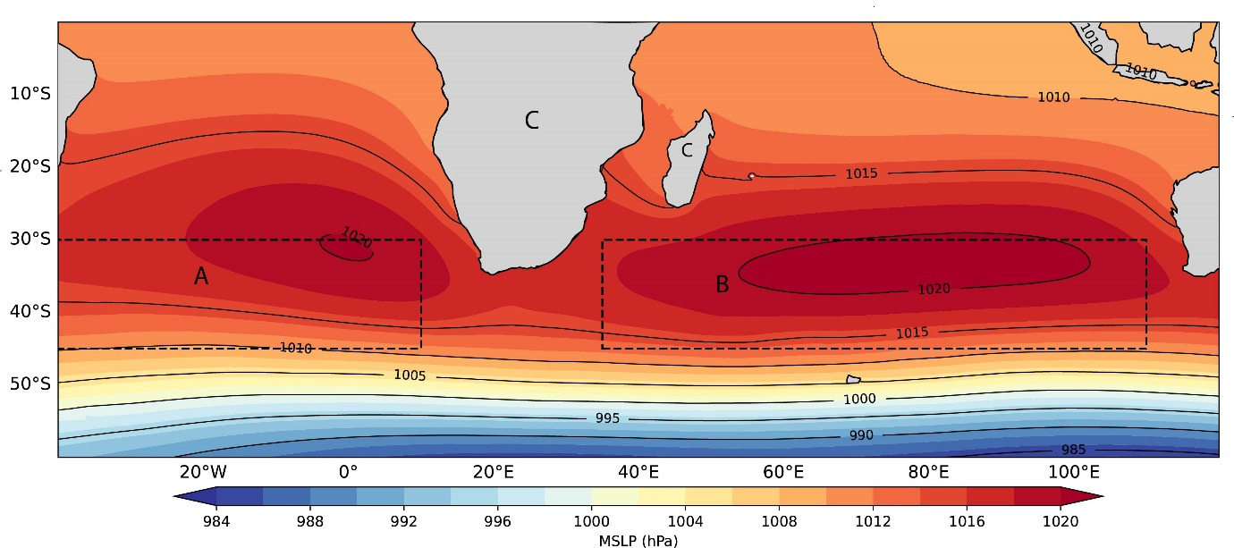

Fig 1: MAM mean-SLP climatology (contours, unit: hPa) over the enclosed dashed rectangular boxes A: SASH B: SISH for the period 1940-2024, and the grey color landmass C represents the study region.
3. Results and discussion
3.1 Spatial variability characteristics of SLP over the South Atlantic and the South Indian Ocean
The mean distribution of SLP Seasonal climatology in the southern hemisphere over the Atlantic and Indian oceans during austral autumn (MAM) for the period 1940-2024 is shown in Fig. 1. The two high-pressure center cores strength increases significantly to >1018 hPa with horizontal spread, while maintaining the location of 1020hPa core around 5° W-0°, 30°-32° S for SASH and much closer to southern Africa while SISH core around 55°-100° E, 32°-37° S, which is also slightly close to southern Africa subcontinent particularly near Madagascar, consistent with the previous observations from the studies (eg., Reboita et al. 2019; Quagraine et al. 2024; Mahlobo et al. 2024; Quagraine et al.2025). These subtropical highs share common characteristics at which they show strong, coherent systems with central pressures consistently at 1020 hPa.
Fig. 2 show spatial variability characteristics of SASH and SISH during MAM. The SASH (Fig. 2a) and the SISH (Fig. 2c) explains about 19.3% and 17.3% of the total variance respectively. The explained variance describes the contribution of the EOF mode (i.e., zonal configuration) to the total variability of the highs but does not necessarily measure the directly physical significance (Monahan et al. 2009). The SASH EOF2 (Fig. 2a) and SISH EOF2 (Fig. 2c) display a zonal dipole of positive and negative SLP anomaly centers oriented in East-West, indicating longitudinal displacement of the highs (Sheng et al. 2024). The zonal displacement configurations results are consistent with past studies (e.g., Usmani et al., 2019; K. A. Quagraine et al., 2024; Manatsa et al., 2014), despite the difference in methodology. The climatological SLP values >1018hPa showing centers position similar to findings of previous studies (Lee et al. 2013; Sun et al. 2017; Reboita et al. 2019; Quagraine et al. 2024; Quagraine et al.2025). The second EOF modes are found to be significantly separated from other modes according to North’s et al. 1982 test (not shown). The principal components (PCs; Fig. 2b, d) of SASH and SISH during MAM exhibit significant interannual variations. Notably, this study focuses on the zonal position displacement of these two highs. Fig. 3 shows the cross-basin relationship (scatter plots) of the PCs related to the zonal (PC2) configurations. The scatterplots represent the co-occurrence of joint phases of SASH and SISH and are instrumental for identifying preferred coupled states linked to seasonal SAT anomalies across Southern Africa. Specifically, the four identified distinct quadrants found to correspond to different phases of zonal displacement (see Table 1), which are then complemented by the SLP composite (Fig. 4).
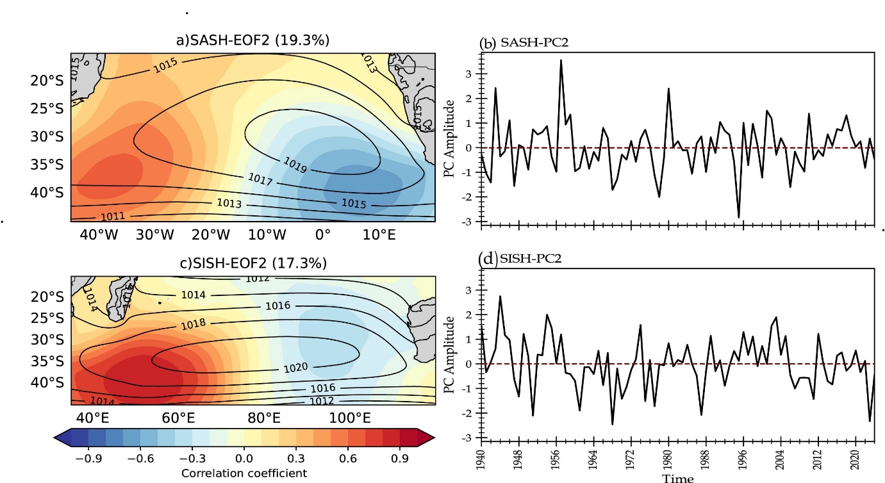
Fig 2: Second EOF modes of de-trended March-May (MAM) mean anomalies of sea level pressure (SLP; shading, unit: hPa) for the (a) SASH and (c) SISH, overlaid with climatological MAM mean-SLP (contours, unit: hPa) and their corresponding principal components (PCs) (b) SASH and (d) SISH during 1940-2024.
Table 1. Categories of years with zonal displacement configurations of SASH and SISH during the austral Autumn (MAM) for the period of 1940-2024
 | PC2
Q1 | Years with westward-shifted SASH and westward-shifted SISH (wSASH/wSISH): 1943, 1946, 1949, 1952, 1953, 1954, 1957, 1967, 1974, 1976, 1980, 1982, 1989, 1991, 1996, 1998, 2002, 2004, 2016, 2017, 2020
Q2 | Years with westward-shifted SASH and eastward-shifted SISH (wSASH/eSISH):1948, 1951, 1958, 1959, 1962, 1966, 1972, 1975, 1981, 1986, 1987, 1992, 1993, 1999, 2001, 2010, 2014, 2015, 2018, 2019, 2021, 2023
Q3 | Years with eastward-shifted SASH and eastward-shifted SISH (eSASH/eSISH): 1941, 1947, 1960, 1961, 1963, 1964, 1968, 1969, 1970, 1971, 1977, 1978, 1979, 1985, 1988, 1990, 2006, 2007, 2008, 2009, 2011, 2024
Q4 | Years with eastward-shifted SASH and westward-shifted SISH (eSASH/wSISH): 1940, 1942, 1944, 1945, 1950, 1955, 1956, 1965, 1973, 1983, 1984, 1994, 1995, 1997, 2000, 2003, 2005, 2012, 2013, 2022
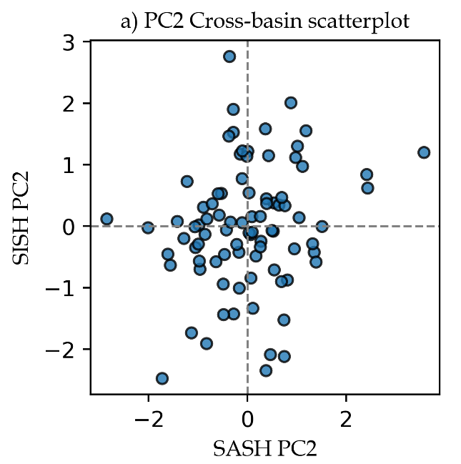
Fig 3: Cross-basin scatter plots of the SASH versus the SISH for PC2
The pronounced seasonal distinct configuration in position displacement of the SASH and SISH is illustrated in Fig. 4, where the composites of SLP anomalies showing the zonal shift groups (PC2) are presented. These SASH and SISH distinct East-West displacement configurations concur with the EOF (Fig. 2a, c) results, have also been revealed by previous studies (Rizvi & Iqbal, 2014;Quagraine et al. 2024;Manatsa et al. 2014;Sun et al. 2017). The zonal-shift displacement groups feature significant negative and positive anomalies of SLP dipoles (p<0.05) across the two highs in east-west orientation, portraying the substantial zonal configuration displacement where SASH and SISH (Fig. 4a) show joint westward displacement; Fig. 4b show SASH (westward) and SISH (eastward); Fig. 4c show both eastward displaced and Fig. 4d indicating SASH (eastward) and SISH (westward) displacement. These zonal displacement configurations of SASH and SISH are influenced by other climate modes such as Southern Annular Mode (SAM), El-Niño Southern Oscillation (ENSO), extratropical cyclones and Hadley cell variation (e.g., Reboita et al. 2019; Mahlobo et al. 2024).
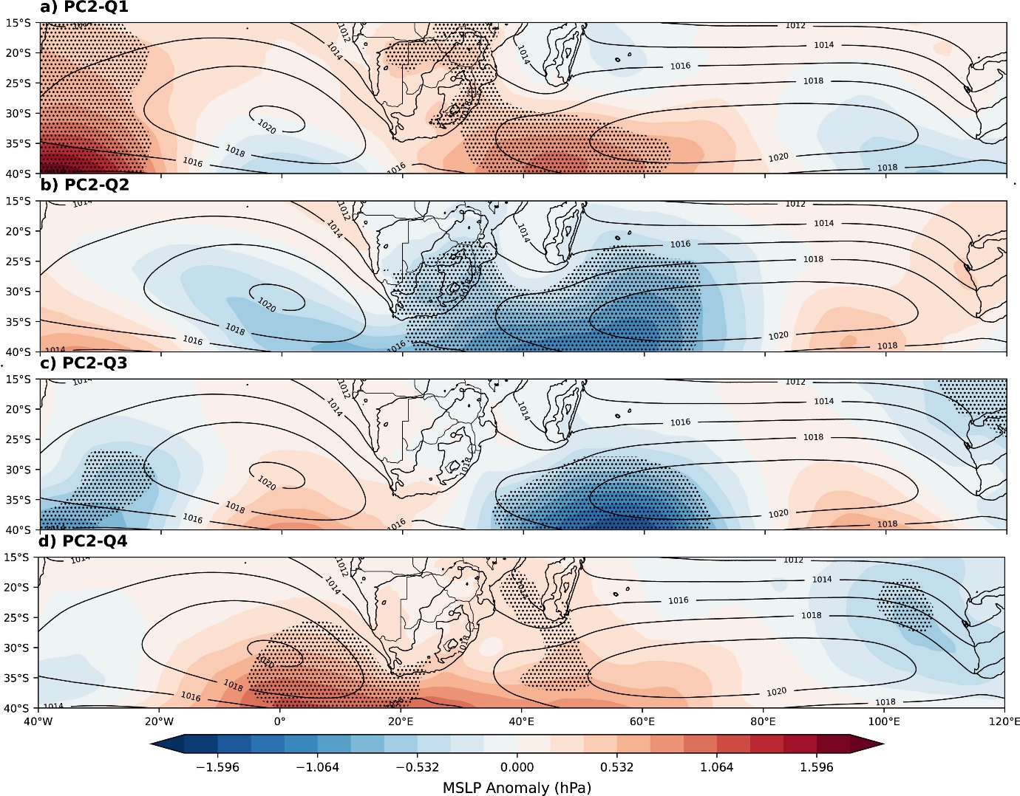
Fig 4: Composite detrended MAM SLP anomalies (shading, unit: hPa) for the (a-d) zonal configuration of SASH and SISH:(a)Q1(wSASH/wSISH), b)Q2(wSASH/eSISH), c)Q3(eSASH/eSISH) and d)Q4(eSASH/wSISH)) during 1940-2024 overlaid with the climatological MAM mean-SLP contours for comparison. The stippling denotes SLP anomalies significant at the 95% confidence level according to Student’s t test
3.2 Impacts of zonal displacement configuration on MAM surface air temperature
The detrended SAT anomaly composite linked to the zonal configuration of SASH and SISH during MAM is presented in Fig. 5. For the Q1 group (Fig. 5a), show cooling over the central plateau with mild warming over the remaining part. The Q2 group (Fig. 5b) displays mild cooling over central Tanzania extending diagonally towards central plateau, western coast and Madagascar, while the remaining area experiences mild warming. For the Q3 group (Fig. 5c), cooling appears in the northeast (East Africa) extending to the southern part including the central plateau and Madagascar, while the rest of the part features slight warming. The Q4 group (Fig. 5d) shows cooling conditions over the southeastern part, including Madagascar extending to parts of the central plateaus, with the rest diagonally north to western featuring mild warming conditions. There is an observed slight warming over the parts of inland South Africa in all Fig. 5(a-d), which is in partial agreement with the previous findings of (Van Der Walt & Fitchett. 2021; Kruger & Nxumalo. 2017; MacKellar et al. 2014), although they reported increasing trends of maximum and minimum temperature in austral autumn, which explicitly demonstrate increasing warm days and nights. Additionally, parts of Eastern and Central Africa close to the Equator (Figure.5a-d) show a slight increase in signal of SAT warming which is similar to earlier observations of increased trend of warm days and warm nights revealed in the studies (e.g., Omondi et al. 2014; Engelbrecht et al. 2015). The increased SAT can be regarded as the signal to these increasing trends of warm days and nights, maximum and minimum temperatures which are revealed to be triggered by the ongoing global warming of which the southern Africa is not isolated (e.g., Serykh et al. 2025; Meque et al. 2024;Van Der Walt & Fitchett 2022). There is observed persistence of slight warming signal between 0.2 to 0.4 °C over parts of coast and inland areas, likely related with the observed and projected impacts of climate change in the region as revealed by recent studies (e.g.,Serykh et al. 2025; Seneviratne et al. 2021)
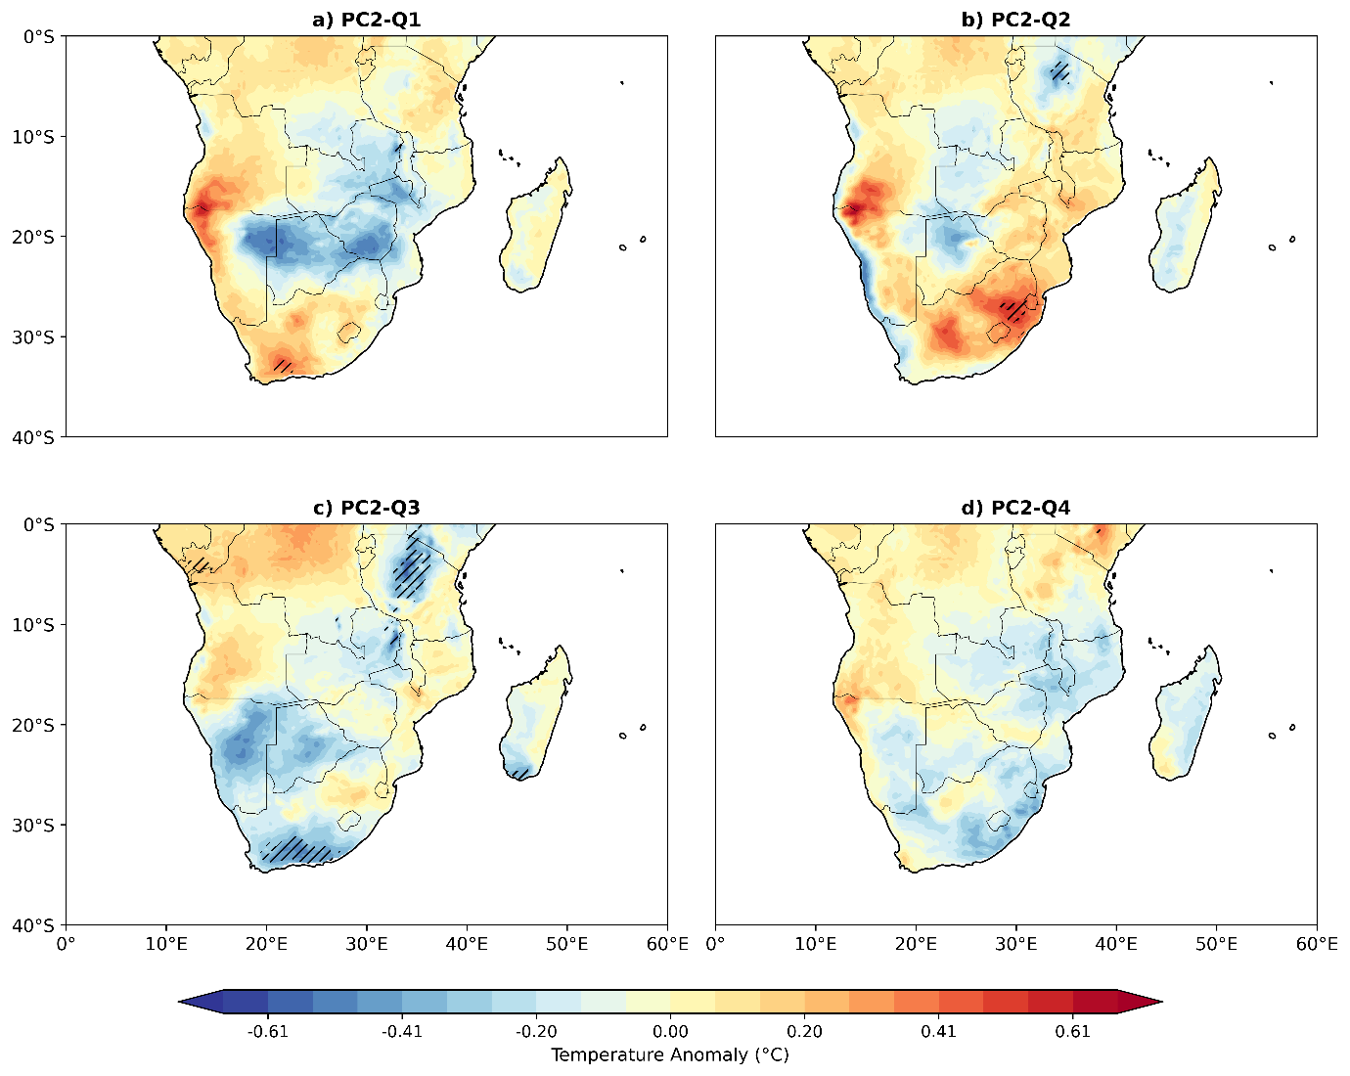
Fig 5: Composite detrended MAM surface air temperature anomalies (SAT; shading, unit: °C) over southern Africa during 1940-2024 for the zonal configuration of SASH and SISH: a)Q1(wSASH/wSISH), b)Q2(wSASH/eSISH), c)Q3(eSASH/eSISH) and d)Q4(eSASH/wSISH)). The hatching denotes the surface air temperature anomalies significant at the 95% confidence level according to Student’s t test
The net shortwave radiation (SSR) is the key thermodynamic mechanisms link between SAT variability and SASH and SISH. SSR composites closely align with SAT composites (Fig. 6), confirming that east-west displacement of subtropical highs controls temperature variability over southern Africa. In the Q1 group (Fig. 6a), the negative anomaly is concentrated over Madagascar, East Africa, north and central plateau, while positive anomalies occur over the western and southern. The Q2 group (Fig. 6b) exhibits a negative anomaly extending from the northern to central and southwestern areas (0-20⁰ S), while the southern parts (20-35⁰ S), including Madagascar feature positive anomaly. For the Q3 group (Fig. 6c), shows negative anomalies over east Africa, extending to the central plateau and extreme southeastern coast, while positive anomaly is present elsewhere including Madagascar. The Q4 group (Fig. 6d) highlights a dominant significant positive anomaly with slight pockets of negative anomaly along the southeastern coast and northern Madagascar. Negative SSR anomalies indicate decreased surface energy absorption, that likely increase night-time cooling and accounting for decrease SAT. Meanwhile, positive SSR anomaly demonstrate increased surface energy absorption, potentially leading to increased SAT (Trenberth et al. 2009; Rodrigues et al. 2019). From the results, SSR is described as the principal source of heat to the surface and its contribution is highly considered compared to surface turbulent fluxes, although the net balance of SSR with the surface turbulent fluxes and total cloud cover decides patterns of warming and cooling of SAT.
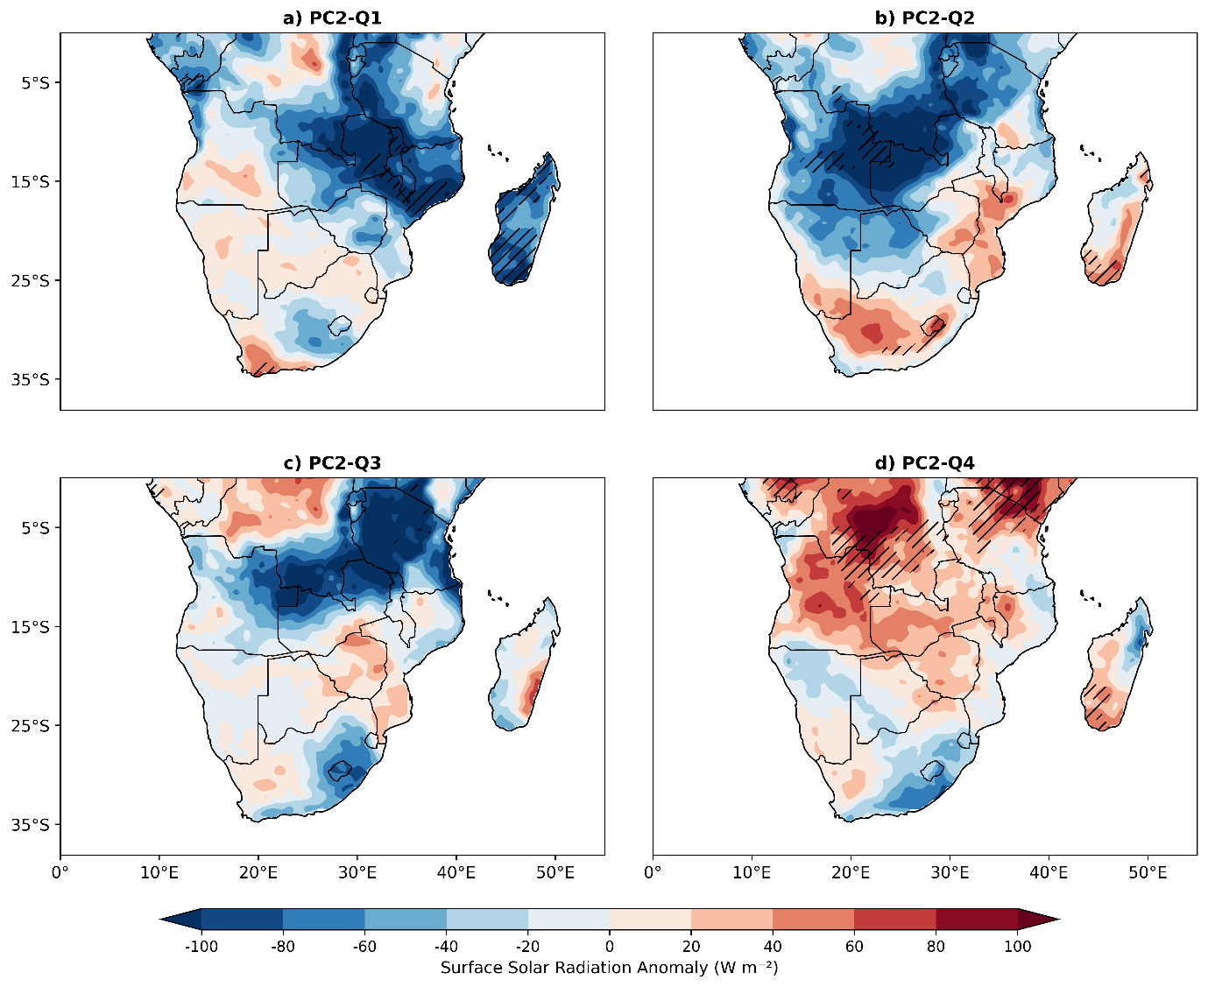
Fig 6: Composite detrended anomalies of net surface solar radiation (SSR; unit: W m⁻²) a)Q1(wSASH/wSISH), b)Q2(wSASH/eSISH), c)Q3(eSASH/eSISH) and d)Q4(eSASH/wSISH)) for the zonal displacement configuration of SASH and SISH over southern Africa during MAM 1940-2024: The hatching denotes the anomalies significant at the 95% confidence level according to Student’s t test.
In addition, Fig. 7 illustrates composite anomalies of outgoing longwave radiation (OLR) for the zonal configuration of SASH and SISH. The Q1 group (Fig. 7a) exhibits a negative anomaly over the central areas extending to the southern plateau, with the positive anomaly over the northeastern, southeastern, and western coast, with significant patterns over Madagascar. The Q2 (Fig. 7b) displays positive anomaly over East Africa extending through central and the entire southern area, with a few pockets of negative anomaly limited over Madagascar and the southwestern coast. Q3 (Fig. 7c) reveals a positive SSR anomaly over East Africa and southeastern flank, while the western, southern, northwestern and Mozambique channel feature negative anomaly. Q4 (Fig. 7d) is characterized by widespread negative anomaly over the entire domain, including Madagascar with few patches of positive anomaly over southeastern flank. The negative OLR anomaly flux is associated with hot, clear sky conditions, while positive OLR anomaly suggests deep convection and rainfall, leading to surface cooling (warming) and a likely decrease (increase) in SAT (e.g., Fauchereau et al. 2009; Jury 2025; Ramanathan et al. 2014; Dewitte & Clerbaux, 2018a).
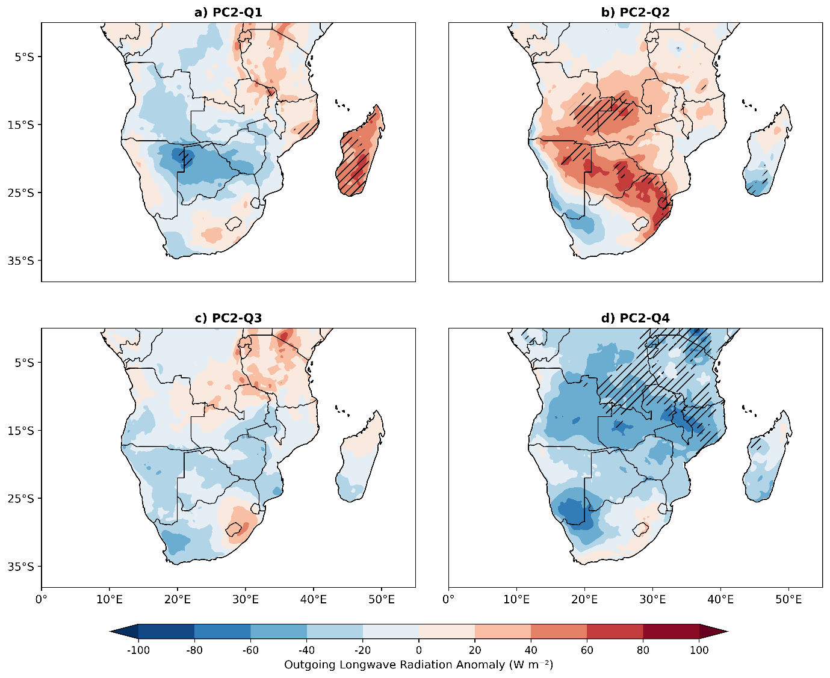
Fig 7: Composite detrended anomalies of Outgoing Long wave Radiation (OLR; unit: W m⁻²) a)Q1(wSASH/wSISH), b)Q2(wSASH/eSISH), c)Q3(eSASH/eSISH) and d)Q4(eSASH/wSISH)) for the zonal displacement configuration of SASH and SISH over southern Africa during MAM 1940-2024: The hatching denotes the anomalies significant at the 95% confidence level according to Student’s t test.
Fig. 8 shows the composite anomalies of surface sensible heat flux (SSH) for the zonal configuration. The Q1 group (Fig. 8a) demonstrates a widespread positive anomaly over the eastern part extending to the central, and negative anomaly localized over the western region. The Q2 group (Fig. 8b) shows positive anomaly over East Africa, extending to central and southern plateaus and Madagascar, with the negative anomaly along the western and southern coasts. Q3 (Fig. 8c) display a significant positive anomaly over East Africa, extending to the central and western parts, while pockets of negative anomaly are observed over southern region, Mozambique channel and northwestern near the equator. The Q4 group (Fig. 8d) reveals a widespread negative anomaly over the northern to central and parts of southern Madagascar, while the positive anomaly is observed over the southern and western parts, including Mozambique. Positive SSH anomalies indicate increased surface energy (surface warmer than normal) and heat released to the near-surface air which likely amplifies SAT. Conversely, negative SSH anomalies signify less energy at the surface presumably leading to surface cooling, which in turn decreases SAT (Miralles et al. 2011; Seneviratne et al. 2010). The SSH magnitude is great to the interior areas compared to coastal indicating less surface cooling processes and more warming to dominate.
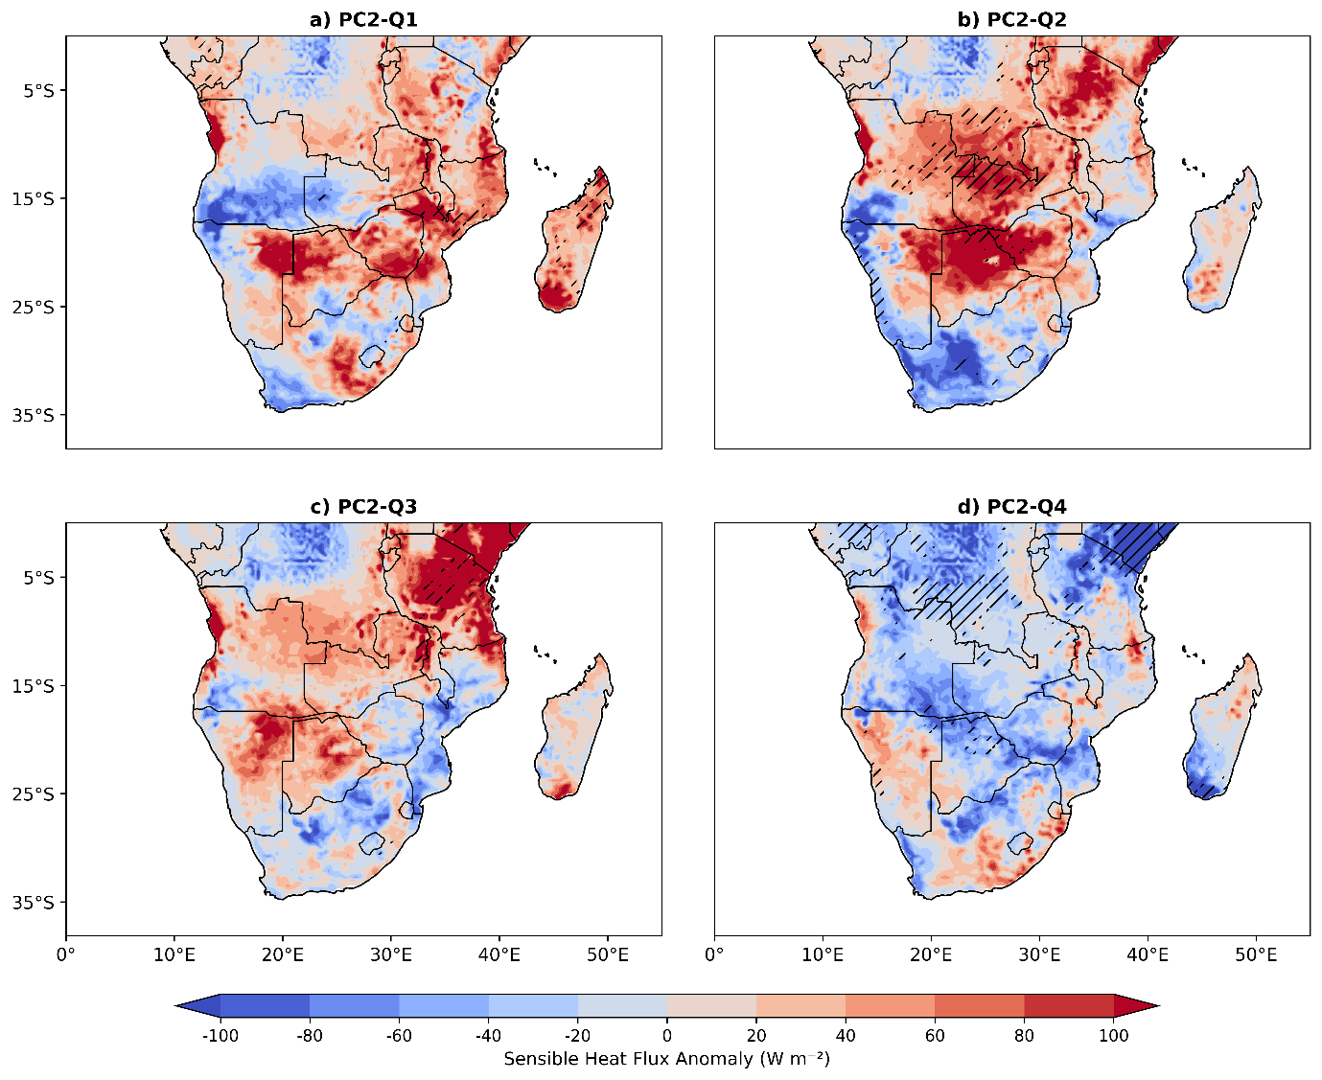
Fig 8: Composite detrended anomalies of surface sensible heat flux (SSH; unit: W m⁻²) a)Q1(wSASH/wSISH), b)Q2(wSASH/eSISH), c)Q3(eSASH/eSISH) and d)Q4(eSASH/wSISH)) for the zonal displacement configuration of SASH and SISH over southern Africa during MAM 1940-2024: The hatching denotes the anomalies significant at the 95% confidence level according to Student’s t test.
Fig. 9 further demonstrates the composite anomalies of surface latent heat flux (SLH) for the zonal configuration. In the Q1 group (Fig. 9a), a pocket of the negative anomaly occurs over the eastern part, extending to the southern plateaus and Madagascar, while a positive anomaly observed over southwestern flank and central to the northern areas, including East Africa. The Q2 group (Fig. 9b) shows a negative anomaly over east Africa, spreading to the central plateau and parts of Mozambique channel, with a positive anomaly over the southern and western sector to the north. For the Q3 group (Fig. 9c), the negative anomalies are observed over East Africa and southwestern plateau, with positive anomaly covering the remaining northern, southern and southeastern coast. The Q4 group (Fig. 9d) displays positive anomaly across entire domain with few pockets of the negative anomalies over the southern and western plateaus. During MAM, parts of southern Africa observed enhanced precipitation (not shown) which leads to increased soil moisture, resulting in positive SLH anomalies. These anomalies act as negative feedback on SAT by diverting energy into evaporation, cooling the surface rather than heating (likely cooling SAT) and vice versa (Seneviratne et al. 2010; Miralles et al. 2011).
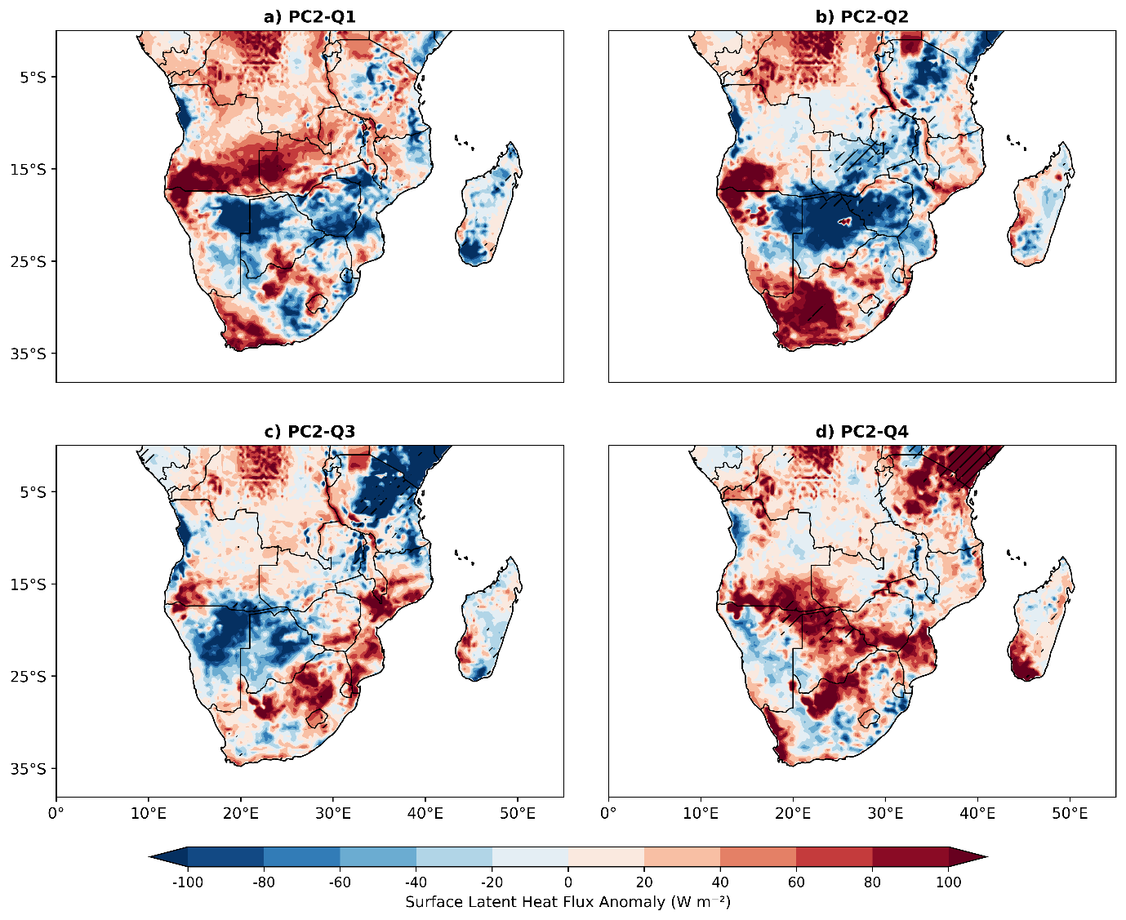
Fig 9: Composite detrended anomalies of surface latent heat flux (SLH; unit: W m⁻²) a)Q1(wSASH/wSISH), b)Q2(wSASH/eSISH), c)Q3(eSASH/eSISH) and d)Q4(eSASH/wSISH)) for the zonal displacement configuration of SASH and SISH over southern Africa during MAM 1940-2024: The hatching denotes the anomalies significant at the 95% confidence level according to Student’s t test.
The composite anomalies of Total Cloud Cover fraction (TCC) for the zonal configuration are shown in Fig 10. Result in Fig 10(a) for the Q1 group shows a positive anomaly over eastern part, including the Madagascar and parts of central plateau, while a negative anomaly appears in the western part. Q2 (Fig. 10b) exhibits a widespread positive TCC anomaly across most areas, with notable negative anomaly in the north, western and Madagascar. Q3 (Fig. 10c) shows a positive anomaly over East Africa extending to the central and entire southeastern coast, including Madagascar, with negative pockets in the western and central near equatorial belt. The Q4 group (Fig. 10d) displays a significant negative anomaly over northern regions (East Africa, Central Africa, northwestern areas) and Madagascar, with a notable positive anomaly over the southeastern flank. Clouds regulate Earth’s SAT by influencing surface net shortwave radiation and surface heat fluxes (e.g., Mahlobo et al. 2019; Rodrigues et al. 2019; Dai, et al. 1999). By affecting sunlight and infrared radiation, clouds influence the distribution of surface and atmospheric heating, of which more (fewer) clouds generally increase surface cooling (warming), consistent with observed decrease (increase) in SSR (Stephens et al. 2012; Ramanathan et al. 2014).
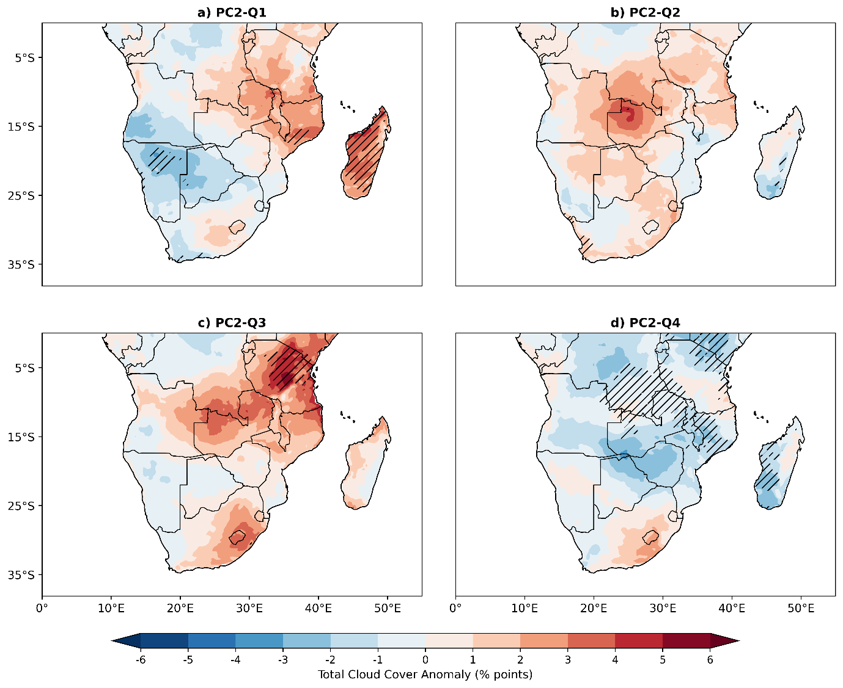
Fig 10: Composite detrended anomalies of MAM Total cloud fraction (unit: % points) a)Q1(wSASH/wSISH), b)Q2(wSASH/eSISH), c)Q3(eSASH/eSISH) and d)Q4(eSASH/wSISH)) for the zonal configuration of SASH and SISH over southern Africa during 1940-2024. The hatching denotes the anomalies significant at the 95% confidence level according to Student’s t test
4. Summary and conclusions
This study examined how the zonal configurations of SASH and SISH influence SAT variability in southern Africa, which lies between humid tropical and dry subtropics, making the region more sensitive to temperature variability across seasonal and annual timescales. The analysis of the zonal configurations of SASH and SISH were carried out using the EOF method and the ERA5 monthly SLP dataset. Additionally, composite anomaly of monthly datasets such as net shortwave radiation, surface sensible heat flux, surface latent heat flux, outgoing longwave radiation and total cloud cover from ERA5 were further employed to investigate thermodynamic physical mechanisms associated with SAT variability. The main conclusions are as follows.
Results show that during all phases of SASH and SISH zonal displacement configuration, most parts of the region (Fig. 5a-d) experience a slight warming of between 0.2 to 0.5 °C meanwhile, few areas especially over the central plateaus and parts of eastern Africa featuring slight cooling of -0.01 to -0.4 °C. The warming areas agree with the findings of other studies (Kruger & Nxumalo 2017); (Serykh et al. 2025); (Demissie & Gebrechorkos 2024); (van der Walt & Fitchett 2021)). that revealed upward trends of maximum, minimum and warm days and nights attributed to impacts of ongoing and projected climate change. The results also indicate that westward displacement of both SASH and SISH leads to SAT cooling over the central plateaus and Mozambique channel with slight warming over the remaining areas. Eastward displacement is associated with SAT cooling over East Africa, southern and parts of central plateaus, but warming over Mozambique channel. When SASH is displaced westward and SISH eastward shows slight cooling of SAT over East African flank, central plateaus, western Madagascar and western coast belt, while warming occurs in the remaining areas. Meanwhile eastward displacement of SASH and westward displacement of SISH result in cooling across eastern parts extending to the central interior, with the warming over East Africa and the rest of the northwest areas.
The consistency of the physical mechanisms across different phases of zonal configurations is a testament to the robustness of our findings. During the zonal configuration, the moisture flux convergence and westerly and southerly winds convergence dominates the central part close to equatorial belt towards east Africa while most of the southern tip feature anticyclonic flow with divergence of moisture triggering more clouding and precipitation over east Africa and less over southern tip. The central plateaus and areas over parts of East Africa show negative anomaly SSR, positive anomaly total Cloud cover, positive anomaly OLR, positive anomaly SLH and in turn slight cooling signals of SAT are observed and vice versa for SAT warming. The observed linkages between circulation anomalies, moisture transport, cloud radiative effects, and heat fluxes form a coherent and physically credible image of the SASH-SISH influence on the SAT. Despite the promising results, the study did not incorporate advanced statistical and dynamical model simulations to investigate SASH and SISH in controlled experiments, isolating their individual and combined influences and quantifying their impacts under projected emission scenarios. In conclusion, understanding the influence of these position displacement configurations and thermodynamic physical mechanisms will improve seasonal SAT predictability, strengthening heatwave risk assessment, thereby contributing to climate resilience across sensitive dimensions.

Disclaimer (Artificial intelligence)

Author(s) hereby declare that NO generative AI technologies such as Large Language Models (ChatGPT, COPILOT, etc.) and text-to-image generators have been used during the writing or editing of this manuscript.

Refences:
- Alex Ogwang, B. A., Ongoma, V. A., Xing, L. A., & Katchele Ogou, F. A. (2015). Influence of Mascarene High and Indian Ocean Dipole on East African Extreme Weather Events. Geographica Pannonica •, 19(2), 64–72. https://doi.org/10.18421/GP19.02-05
- Bretherton, Christopher S., Martin Widmann, Valentin P. Dymnikov, John M. Wallace, and Ileana Bladé. 1999. The Effective Number of Spatial Degrees of Freedom of a Time-Varying Field. Journal of Climate 12(7):1990-2009. doi:10.1175/1520-0442(1999)012%3C1990:TENOSD%3E2.0.CO;2
- Chang’a, L. B., Kijazi, A. L., Luhunga, P. M., Ng’ongolo, H. K., & Mtongor, H. I. (2017). Spatial and Temporal Analysis of Rainfall and Temperature Extreme Indices in Tanzania. Atmospheric and Climate Sciences, 07(04), 525–539. https://doi.org/10.4236/acs.2017.74038
- Cherchi, A., Ambrizzi, T., Behera, S., Freitas, A. C. V., Morioka, Y., & Zhou, T. (2018). The Response of Subtropical Highs to Climate Change. In Current Climate Change Reports (Vol. 4, Number 4, pp. 371–382). Springer. https://doi.org/10.1007/s40641-018-0114-1
- Chile Baldoni, Thales, Michelle Simões Reboita, Natália Machado Crespo, João Gabriel Martins Ribeiro, and Rosmeri Porfírio da Rocha. 2025. ‘South Atlantic Subtropical Anticyclone Responses to Stratospheric Aerosol Injection’. Environmental Research: Climate 4(1). doi:10.1088/2752-5295/ada8cb.
- Dai, A., Trenberth, K. E., and Karl, T. R. (1999). Effects of Clouds, Soil Moisture, Precipitation, and Water Vapor on Diurnal Temperature Range. Journal of Climate,12:2451-2473
- Demissie, Teferi, and Solomon H. Gebrechorkos. 2024. ‘Spatio-Temporal Trends in Precipitation, Temperature, and Extremes: A Study of Malawi and Zambia (1981–2021)’. Sustainability (Switzerland) 16(10). doi:10.3390/su16103885.
- Dewitte, S., & Clerbaux, N. (2018). Decadal changes of earth’s Outgoing Longwave Radiation. In Remote Sensing (Vol. 10, Number 10). MDPI AG. https://doi.org/10.3390/rs10101539
- Driver, P., & Reason, C. J. C. (2017). Variability in the Botswana High and its relationships with rainfall and temperature characteristics over southern Africa. International Journal of Climatology, 37, 570–581. https://doi.org/10.1002/joc.5022
- Dyer, E., Hirons, L., & Taye, M. T. (2022). July–September rainfall in the Greater Horn of Africa: the combined influence of the Mascarene and South Atlantic highs. Climate Dynamics, 59(11–12), 3621–3641. https://doi.org/10.1007/s00382-022-06287-0
- Engelbrecht, F., Adegoke, J., Bopape, M. J., Naidoo, M., Garland, R., Thatcher, M., McGregor, J., Katzfey, J., Werner, M., Ichoku, C., & Gatebe, C. (2015). Projections of rapidly rising surface temperatures over Africa under low mitigation. Environmental Research Letters, 10(8). https://doi.org/10.1088/1748-9326/10/8/085004
- Fauchereau, N., Pohl, B., Reason, C. J. C., Rouault, M., & Richard, Y. (2009). Recurrent daily OLR patterns in the Southern Africa/Southwest Indian ocean region, implications for South African rainfall and teleconnections. Climate Dynamics, 32(4), 575–591. https://doi.org/10.1007/s00382-008-0426-2
- Feng, X., Huijun, W., & Jinhai, H. (2003). Interannual variability of Mascarene high and Australian high and their influences on summer rainfall over East Asia. In Chinese Science Bulletin (Vol. 48, Number 5).
- Folland, C.K. (1983) Regional-scale international variability of climate. A North-West European perspective. Meteorological Magazine, 112, 163–183.
- Gilliland, J. M., & Keim, B. D. (2018). Position of the South Atlantic anticyclone and its impact on surface conditions across Brazil. Journal of Applied Meteorology and Climatology, 57(3), 535–553. https://doi.org/10.1175/JAMC-D-17-0178.1
- Hameed, S., Iqbal, M., & Collins, D. (2011). Impact of the Indian Ocean high pressure system on winter precipitation over western and southwestern Australia. In Australian Meteorological and Oceanographic Journal (Vol. 61).
- Hannachi, A., Jolliffe, I. T., & Stephenson, D. B. (2007). Empirical orthogonal functions and related techniques in atmospheric science: A review. In International Journal of Climatology (Vol. 27, Number 9, pp. 1119–1152). https://doi.org/10.1002/joc.1499
- Hersbach, H., Bell, B., Berrisford, P., Hirahara, S., Horányi, A., Muñoz-Sabater, J., Nicolas, J., Peubey, C., Radu, R., Schepers, D., Simmons, A., Soci, C., Abdalla, S., Abellan, X., Balsamo, G., Bechtold, P., Biavati, G., Bidlot, J., Bonavita, M., … Thépaut, J. N. (2020). The ERA5 global reanalysis. Quarterly Journal of the Royal Meteorological Society, 146(730), 1999–2049. https://doi.org/10.1002/qj.3803
- Jury, M. R. (2025). Springtime Influence of the Mascarene High over SE Africa: Linking El Niño to Early Rains. Climate, 13(11). https://doi.org/10.3390/cli13110237
- Kebacho, L. L., & Chen, H. (2022). The dominant modes of the long rains interannual variability over Tanzania and their oceanic drivers. International Journal of Climatology, 42(10), 5273–5292. https://doi.org/10.1002/joc.7532
- Kebacho, L. L., Sarfo, I., & Ongoma, V. (2025). The modulation of the MJO and tropical cyclone impact on East African rainfall by the Mascarene high during the 2018 “long rains”. Natural Hazards, 121(2), 2053–2070. https://doi.org/10.1007/s11069-024-06879-5
- Kruger, A. C., & Nxumalo, M. (2017). Surface temperature trends from homogenized time series in South Africa: 1931–2015. International Journal of Climatology, 37(5), 2364–2377. https://doi.org/10.1002/joc.4851
- Lee, S. K., Mechoso, C. R., Wang, C., & Neelin, J. D. (2013). Interhemispheric influence of the northern summer monsoons on southern subtropical anticyclones. Journal of Climate, 26(24), 10193–10204. https://doi.org/10.1175/JCLI-D-13-00106.1
- Lennard, C. (2019). Multi-Scale Drivers of the South African Weather and Climate. In World Regional Geography Book Series: Part F3068 (pp. 81–89). Springer Nature. https://doi.org/10.1007/978-3-319-94974-1_9
- Lim Kam Sian, K. T. C., Dosio, A., Ayugi, B. O., Hagan, D. F. T., Kebacho, L. L., & Ongoma, V. (2023). Dominant modes of precipitation over Africa, and their associated atmospheric circulations from observations. International Journal of Climatology, 43(10), 4603–4618. https://doi.org/10.1002/joc.8105
- Limbu, P., & Makula, K. (2023). Investigation of Temporal Trends and Spatial Patterns of Extreme Temperatures and Their Relationship to Climate Circulation Indices in Tanzania. JOURNAL OF THE GEOGRAPHICAL ASSOCIATION OF TANZANIA, 43(2), 67–85. https://doi.org/10.56279/jgat.v43i2.261
- Lobell, D. B., & Field, C. B. (2007). Global scale climate-crop yield relationships and the impacts of recent warming. Environmental Research Letters, 2(1). https://doi.org/10.1088/1748-9326/2/1/014002
- Lorenz, E.N. (1956) Empirical orthogonal functions and statistical weather prediction, Vol. 49. Cambridge, Massachusetts: Department of Meteorology, MIT, p. 52. Technical report statistical forecast project report 1.
- Lübbecke, J. F., Burls, N. J., Reason, C. J. C., & Mcphaden, M. J. (2014). Variability in the South Atlantic anticyclone and the Atlantic Niño mode. Journal of Climate, 27(21), 8135–8150. https://doi.org/10.1175/JCLI-D-14-00202.1
- MacKellar, N., New, M., & Jack, C. (2014). Observed and modelled trends in rainfall and temperature for South Africa: 1960-2010. South African Journal of Science, 110(7–8). https://doi.org/10.1590/sajs.2014/20130353
- Mahlobo, D. D., Ndarana, T., Grab, S., & Engelbrecht, F. (2019). Integrated climatology and trends in the subtropical Hadley cell, sunshine duration and cloud cover over South Africa. International Journal of Climatology, 39(4), 1805–1821. https://doi.org/10.1002/joc.5917
- Mahlobo, D., Engelbrecht, F., Ndarana, T., Abubakar, H. B., Olabanji, M. F., & Ncongwane, K. (2024). Analysis of the Hadley cell, subtropical anticyclones and their effect on South African rainfall. Theoretical and Applied Climatology, 155(2), 1035–1054. https://doi.org/10.1007/s00704-023-04674-z
- Manatsa, D., Morioka, Y., Behera, S. K., Matarira, C. H., & Yamagata, T. (2014). Impact of Mascarene High variability on the East African ‘short rains’. Climate Dynamics, 42(5–6), 1259–1274. https://doi.org/10.1007/s00382-013-1848-z
- Mbokodo, I., Bopape, M. J., Chikoore, H., Engelbrecht, F., & Nethengwe, N. (2020). Heatwaves in the future warmer climate of South Africa. Atmosphere, 11(7). https://doi.org/10.3390/atmos11070712
- Meque, Arlindo O., Izidine S. Pinto, and Clifford Chuwah. 2024. ‘Spatial Variability of Cold Waves over Southern Africa and Their Potential Physical Mechanisms’. Environmental Research: Climate 3(4). doi:10.1088/2752-5295/ad9f92.
- Miralles, D. G., Holmes, T. R. H., De Jeu, R. A. M., Gash, J. H., Meesters, A. G. C. A., & Dolman, A. J. (2011). Global land-surface evaporation estimated from satellite-based observations. Hydrology and Earth System Sciences, 15(2), 453–469. https://doi.org/10.5194/hess-15-453-2011
- Monahan, Adam H., John C. Fyfe, Maarten H. P. Ambaum, David B. Stephenson, and Gerald R. North. 2009. ‘Empirical Orthogonal Functions: The Medium Is the Message’. Journal of Climate 22(24):6501–14.
- Morioka, Y., Engelbrecht, F., & Behera, S. K. (2015). Potential sources of decadal climate variability over southern Africa. Journal of Climate, 28(22), 8695–8709. https://doi.org/10.1175/JCLI-D-15-0201.1
- Mphale, K., Adedoyin, A., Nkoni, G., Ramaphane, G., Wiston, M., & Chimidza, O. (2018). Analysis of temperature data over semi-arid Botswana: trends and break points. Meteorology and Atmospheric Physics, 130(6), 701–724. https://doi.org/10.1007/s00703-017-0540-y
- New, M., Hewitson, B., Stephenson, D. B., Tsiga, A., Kruger, A., Manhique, A., Gomez, B., Coelho, C. A. S., Masisi, D. N., Kululanga, E., Mbambalala, E., Adesina, F., Saleh, H., Kanyanga, J., Adosi, J., Bulane, L., Fortunata, L., Mdoka, M. L., & Lajoie, R. (2006). Evidence of trends in daily climate extremes over southern and west Africa. Journal of Geophysical Research Atmospheres, 111(14). https://doi.org/10.1029/2005JD006289
- North, G., T. R. Bell, R. Cahalan, and F. Moeng, 1982: Sampling errors in estimation of empirical orthogonal functions. Mon. Wea. Rev., 110, 699–706.
- Frank O. Lydia., & Parth Sarthi, P. (2024). Causal Relationships between Monsoon Systems, the Mascarene High, and Rainfall Variability over Botswana, Southern Africa. Journal of Atmospheric Science Research, 7(3), 129–147. https://doi.org/10.30564/jasr.v7i3.6190
- Omondi, P. A. o., Awange, J. L., Forootan, E., Ogallo, L. A., Barakiza, R., Girmaw, G. B., Fesseha, I., Kululetera, V., Kilembe, C., Mbati, M. M., Kilavi, M., King’uyu, S. M., Omeny, P. A., Njogu, A., Badr, E. M., Musa, T. A., Muchiri, P., Bamanya, D., & Komutunga, E. (2014). Changes in temperature and precipitation extremes over the Greater Horn of Africa region from 1961 to 2010. International Journal of Climatology, 34(4), 1262–1277. https://doi.org/10.1002/joc.3763
- Onyutha, Charles. 2020. ‘Analyses of Rainfall Extremes in East Africa Based on Observations from Rain Gauges and Climate Change Simulations by CORDEX RCMs’. Climate Dynamics 54(11–12):4841–64. doi:10.1007/s00382-020-05264-9.
- Ravichandran P.J, V., M., Subeesh, M. P., Chatterjee, S., & Nuncio, M. (2020). Global warming hiatus contributed weakening of the Mascarene High in the Southern Indian Ocean. Scientific Reports, 10(1). https://doi.org/10.1038/s41598-020-59964-7
- Quagraine, K. A., Hewitson, B., Nkrumah, F., Quagraine, K. T., & Egbebiyi, T. S. (2024). A simple subtropical high-pressure system index over the South Atlantic. Atmospheric Science Letters, 25(11). https://doi.org/10.1002/asl.1266
- Quagraine, K. T., Quagraine, K. A., Nkrumah, F., Egbebiyi, T., & Klutse, N. A. B. (2025). Assessing the Impact of the South Indian Ocean High-Pressure System Using a Novel Index. International Journal of Climatology. https://doi.org/10.1002/joc.70031
- Ramanathan, V., Cess, R. D., Harrison, E. F., Minnis, P., Barkstrom, B. R., Ahmadr, E., & Hartmann, D. (2014). Cloud-Radiative Forcing and Climate: Results from te Earth Radiation Budget Experiment (Vol. 14). www.sciencemag.org
- Reboita, M. S., Ambrizzi, T., Silva, B. A., Pinheiro, R. F., & da Rocha, R. P. (2019). The south atlantic subtropical anticyclone: Present and future climate. Frontiers in Earth Science, 7. https://doi.org/10.3389/feart.2019.00008
- Rizvi, S. H., and M. J. Iqbal. (2017). “The Zonal Movement of South Pacific and Indian High Pressure System's in Austral Winter.” Journal of GeoSpace Science 2, no. 1: 15–24.
- Rodrigues, R. R., Taschetto, A. S., Sen Gupta, A., & Foltz, G. R. (2019). Common cause for severe droughts in South America and marine heatwaves in the South Atlantic. Nature Geoscience, 12(8), 620–626. https://doi.org/10.1038/s41561-019-0393-8
- Rouault, M., Dieppois, B., Tim, N., Hünicke, B., & Zorita, E. (2024). Southern Africa Climate Over the Recent Decades: Description, Variability and Trends (pp. 149–168). https://doi.org/10.1007/978-3-031-10948-5_6
- Rowhani, P., Lobell, D. B., Linderman, M., & Ramankutty, N. (2011). Climate variability and crop production in Tanzania. Agricultural and Forest Meteorology, 151(4), 449–460. https://doi.org/10.1016/j.agrformet.2010.12.002
- Seneviratne, S. I., Corti, T., Davin, E. L., Hirschi, M., Jaeger, E. B., Lehner, I., Orlowsky, B., & Teuling, A. J. (2010). Investigating soil moisture-climate interactions in a changing climate: A review. In Earth-Science Reviews (Vol. 99, Numbers 3–4, pp. 125–161). https://doi.org/10.1016/j.earscirev.2010.02.004
- Seneviratne, S.I., X. Zhang, M. Adnan, W. Badi, C. Dereczynski, A. Di Luca, S. Ghosh, I. Iskandar, J. Kossin, S. Lewis, F. Otto, I. Pinto, M. Satoh, S.M. Vicente-Serrano, M. Wehner, and B. Zhou, 2021: Weather and Climate Extreme Events in a Changing Climate. In Climate Change 2021: The Physical Science Basis. Contribution of Working Group I to the Sixth Assessment Report of the Intergovernmental Panel on Climate Change [Masson-Delmotte, V., P. Zhai, A. Pirani, S.L. Connors, C. Péan, S. Berger, N. Caud, Y. Chen, L. Goldfarb, M.I. Gomis, M. Huang, K. Leitzell, E. Lonnoy, J.B.R. Matthews, T.K. Maycock, T. Waterfield, O. Yelekçi, R. Yu, and B. Zhou (eds.)]. Cambridge University Press, Cambridge, United Kingdom and New York, NY, USA, pp. 1513–1766, doi:10.1017/9781009157896.013.
- Serykh, Ilya, Svetlana Krasheninnikova, Tatiana Gorbunova, Roman Gorbunov, Joseph Akpan, Oluyomi Ajayi, Maliga Reddy, Paul Musonge, Felix Mora-Camino, and Oludolapo Akanni Olanrewaju. 2025. ‘Climate Change of Near-Surface Temperature in South Africa Based on Weather Station Data, ERA5 Reanalysis, and CMIP6 Models’. Climate 13(8). doi:10.3390/cli13080161.
- Sheng, Chen, Guoxiong Wu, Yimin Liu, and Bian He. 2024. ‘Roles of Thermal Forced and Eddy-Driven Effects in the Northward Shifting of the Subtropical Westerly Jet Under Recent Climate Change’. Journal of Geophysical Research: Atmospheres 129(5). doi:10.1029/2023JD039937.
- Stephens, G. L., Li, J., Wild, M., Clayson, C. A., Loeb, N., Kato, S., L’Ecuyer, T., Stackhouse, P. W., Lebsock, M., & Andrews, T. (2012). An update on Earth’s energy balance in light of the latest global observations. Nature Geoscience, 5(10), 691–696. https://doi.org/10.1038/ngeo1580
- Sun, X., Cook, K. H., & Vizy, E. K. (2017). The South Atlantic subtropical high: Climatology and interannual variability. Journal of Climate, 30(9), 3279–3296. https://doi.org/10.1175/JCLI-D-16-0705.1
- Trenberth, K. E., Fasullo, J. T., & Kiehl, J. (2009). Earth’s global energy budget. Bulletin of the American Meteorological Society, 90(3), 311–323. https://doi.org/10.1175/2008BAMS2634.1
- Usmani, B. A., Saqib-Ur-Rehman, Hussain, S. A., Khan, K., & Elahi, A. (2019). Regional Precipitation Variability Associated with Zonal Movement of Indian Ocean High Pressure System. Asia-Pacific Journal of Atmospheric Sciences, 55(4), 751–760. https://doi.org/10.1007/s13143-019-00119-8
- Van Der Walt, A. J., and Fitchett, J. M. (2021). Exploring extreme warm temperature trends in South Africa: 1960-2016. Theoretical and Applied Climatology 143:1341–1360 https://doi.org/10.1007/s00704-020-03479-8
- Van Der Walt, Adriaan J., and Jennifer M. Fitchett. 2022. ‘Extreme Temperature Events (ETEs) in South Africa: A Review’. South African Geographical Journal 104(1):70–88. doi:10.1080/03736245.2021.1907219.
- Wilks, D.S. (2011) Statistical Methods in the Atmospheric Sciences. Academic Press, Cambridge
- Xue, F., Wang, H., & Klme, J. H. (2004). Interannual Variability of Mascarene High and Australian High and Their Influences on East Asian Summer Monsoon. In Journal of the Meteorological Society of Japan (Vol. 82, Number 4).
- Zhao, Y., Wen, Z., Li, X., Chen, R., & Chen, G. (2022). Structure and maintenance mechanisms of the Mascarene High in austral winter. International Journal of Climatology, 42(9), 4700–4715. https://doi.org/10.1002/joc.7498

