Hydrogels in Modern Agronomy: Enhancing Crop Growth, Water Productivity, Nutrient and Weed Dynamics

ABSTRACT
Water scarcity, declining soil quality and increasing weed pressure pose significant challenges to sustainable crop production, particularly in arid and semi-arid regions. This review synthesizes current knowledge on the agronomic role of hydrogels (superabsorbent polymers, SAPs) in improving soil properties, crop growth, nutrient dynamics, water-use efficiency, and crop–weed interactions. Hydrogels are classified into synthetic, natural, and semi-synthetic types, each differing in swelling capacity, ion sensitivity, and biodegradability. Their physicochemical properties enable enhanced soil moisture retention, moderated soil temperature, improved porosity, and modified hydraulic conductivity, particularly in coarse-textured soils. These soil-level improvements translate into better seed germination, root architecture development, vegetative growth, photosynthetic stability, and reproductive performance under water-limited conditions. Hydrogels demonstrate strong synergy with deficit irrigation strategies, improving water productivity indices and mitigating drought stress by stabilizing rhizosphere moisture and nutrient availability. Furthermore, hydrogel incorporation influences nutrient retention and fertilizer use efficiency, particularly for nitrogen, phosphorus, and potassium, by reducing leaching losses and enabling controlled-release formulations. However, modifications in soil moisture dynamics may alter weed germination timing, species composition, and crop–weed competition. While improved crop vigour can enhance competitive advantage, the ecological consequences for weed communities remain context-dependent and require integration with sound weed management practices. Overall, hydrogels offer substantial potential as multifunctional soil amendments in climate-resilient agriculture, particularly in water-limited environments, but their agronomic efficiency depends on soil texture, application strategy, and integration with holistic crop and weed management systems.

Keywords: Hydrogel; Superabsorbent polymers; Water-use efficiency; Soil moisture retention; Nutrient-use efficiency; Crop–weed interactions; Deficit irrigation; Sustainable agriculture

- INTRODUCTION
Agricultural productivity is intrinsically linked to water availability, yet global freshwater resources are under increasing strain from climate change, rising demand, and unsustainable extraction (Ali et al., 2024). Agriculture accounts for over 70% of global freshwater consumption, and this proportion is expected to rise as populations grow and demand for food increases (Zhu et al., 2024). Water scarcity and drought episodes are becoming more frequent in many regions, undermining crop growth, yield stability, and production reliability (Muhammad et al., 2025). The cumulative impact of these pressures threatens food security and agricultural sustainability worldwide, motivating the search for novel soil and water management strategies that increase water productivity while buffering crops against drought stress.
Soil moisture constraints are among the most significant abiotic factors limiting crop performance. Low soil water availability reduces plant water uptake, leading to stomatal closure, reduced photosynthesis, impaired nutrient transport, and ultimately lower biomass accumulation and yield (Palma et al., 2024). These effects are magnified under climate variability, creating yield instability across seasons and farming systems. Traditional methods to improve soil moisture, such as irrigation and mulching, have limitations: irrigation can be costly and unsustainable in water-scarce regions, while mulches are labour-intensive and not universally effective across soil types. Moreover, soil texture particularly in sandy soils with low water holding capacity severely limits plant available water, further constraining crop growth (Omar et al., 2024). There is thus a critical need for solutions that improve the soil’s capacity to retain available water in the root zone, especially under water stress.
Superabsorbent hydrogels, including synthetic and natural polymer types, have emerged as promising soil conditioners capable of addressing these soil moisture limitations. Hydrogels are three-dimensional polymer networks with high hydrophilicity, enabling them to absorb and retain hundreds of times their own weight in water (Krasnopeeva et al., 2022). When incorporated into soil, these materials act as reservoirs that absorb water during precipitation or irrigation and release it slowly as the soil dries, enhancing moisture availability in the root zone and reducing the frequency of irrigation required (Agbna & Zaidi, 2025). Improved soil water retention with hydrogel amendments has been reported across diverse crop systems, with increased water productivity and reduced irrigation demands in both controlled and field studies (Muhammad et al., 2025; Palma et al., 2024). Beyond water retention, hydrogels also influence soil physical properties: they improve structure, increase infiltration and reduce run-off and evaporation losses, thereby enhancing soil health and crop resilience (Oladosu et al., 2022).
Hydrogels function not merely as passive water reservoirs but as active soil conditioners that can modify multiple facets of plant–soil interactions. For example, their ability to hold and gradually release water can create a more favorable microenvironment for root development and nutrient uptake, particularly in marginal soils with low organic matter or poor structure (Oladosu et al., 2022). The strategic use of hydrogels has also been linked to improved crop growth metrics, such as increased vegetative biomass, chlorophyll content, and yield components in various crops including lettuce, cereals, and horticultural species (Palma et al., 2024).
Despite these agronomic advantages, the integration of hydrogels into cropping systems raises questions about their broader ecological effects, particularly on weed dynamics. Weeds compete with crops for limited soil water, and changes in soil moisture distribution induced by hydrogels have the potential to alter weed emergence, species composition, and competitive interactions. In a rice cropping system, hydrogel application improved water productivity and yield while changing weed community outcomes: total weed biomass declined and the prevalence of specific species shifted, suggesting that hydrogels may affect the competitive balance between crops and weeds (Ashraf et al., 2021). These observations underline the need to consider crop and weed responses jointly when evaluating hydrogel performance.
The rationale for integrating hydrogel, weed, and crop interactions stems from the recognition that soil water is a shared and limiting resource in plant communities. Both crops and weeds draw on available moisture, and modifications to the soil water regime can affect their competitive dynamics. Weeds with early germination and rapid water uptake may be advantaged or disadvantaged in hydrogel-amended soils depending on species-specific traits and moisture release patterns, complicating predictions of net crop benefit (Ghobashy et al., 2024). Moreover, hydrogel interactions with soil biota and agrochemicals such as potential effects on herbicide diffusion and efficacy remain poorly understood. Understanding these multifaceted interactions is essential for developing integrated management strategies that optimize water use and crop yield while managing weed competition sustainably. The review focuses on their influence on soil moisture dynamics, crop growth and productivity, water-use efficiency, nutrient retention, and fertilizer-use efficiency. It also examines how hydrogel-mediated changes in soil water availability may influence weed emergence and crop–weed interactions, with the aim of providing an integrated perspective for improving water productivity and sustainable crop management under water-limited conditions.

2. Hydrogel Fundamentals
2.1 Hydrogel and its Classification
Hydrogels are cross-linked, three-dimensional polymeric networks capable of absorbing and retaining substantial quantities of water without dissolving, owing to the presence of hydrophilic functional groups such as –COOH, –OH, –NH₂, and –CONH₂ along their polymer backbone. In agricultural systems, hydrogels are commonly referred to as superabsorbent polymers (SAPs) due to their exceptionally high swelling capacity and ability to act as localized water reservoirs within the soil matrix (Buchholz & Graham, 1998; Guilherme et al., 2015). When incorporated into soil, these materials absorb irrigation or rainwater and subsequently release it gradually in response to soil water potential gradients, thereby increasing plant-available water and improving drought resilience.

Hydrogels used in agronomy are broadly classified into synthetic, natural (bio-based), and semi-synthetic (grafted) types.
Synthetic hydrogels: primarily based on polyacrylamide (PAAm), polyacrylic acid (PAA), or their potassium/sodium salts (e.g., potassium polyacrylate), are the most widely used commercial SAPs in agriculture. These materials exhibit high swelling ratios, mechanical strength, and durability in soil environments (Ahmed, 2015). Their cross-link density can be tailored during synthesis to regulate swelling behavior and longevity in soil systems.
Natural and bio-based hydrogels: derived from renewable polymers such as starch, cellulose, chitosan, alginate, and guar gum. These materials offer improved biodegradability and reduced environmental persistence compared to synthetic polymers (Thakur & Voicu, 2016). However, their intrinsic swelling capacity and mechanical stability are often lower unless chemically modified or graft-copolymerized with acrylic monomers. In terms of environmental persistence, synthetic hydrogels generally exhibit slower biodegradation and greater structural stability in soil, whereas natural or bio-based hydrogels derived from polymers such as starch, cellulose, and chitosan are more biodegradable and environmentally sustainable.
Semi-synthetic hydrogels: combine natural backbones grafted with synthetic monomers to achieve a balance between biodegradability and high water absorption capacity. Such hybrid systems are increasingly favored in sustainable agriculture research (Montesano et al., 2015). The classification of hydrogels is not merely chemical but functional, as polymer origin influences swelling behavior, degradation rate, ion sensitivity, and long-term soil interactions.

2.2 Physicochemical Properties
The agronomic effectiveness of hydrogels depends on key physicochemical properties that determine their interaction with soil and plant systems.
Swelling Capacity
Swelling capacity refers to the amount of water absorbed per unit dry mass of polymer. Superabsorbent hydrogels may absorb 100–1000 times their dry weight in distilled water, depending on polymer composition and cross-link density (Ahmed, 2015). The swelling process is driven by osmotic pressure differences between the polymer network and surrounding solution, balanced by elastic retractive forces of cross-linked chains (Buchholz & Graham, 1998). In soils, swelling is lower than in pure water due to mechanical constraints and ionic interactions.
Water Retention and Release Kinetics
Hydrogels function as dynamic water buffers. After water uptake, the polymer matrix releases moisture gradually as soil matric potential decreases. Release kinetics are influenced by soil texture, temperature, and hydrogel particle size. Studies demonstrate that SAP incorporation increases soil field capacity, reduces bulk density, and extends the duration of plant-available water, particularly in sandy soils with inherently low water holding capacity (Montesano et al., 2015; Ekebafe et al., 2011). The controlled desorption behavior of hydrogels reduces evaporative losses and improves water use efficiency by maintaining root-zone moisture for longer periods between irrigation events.
Ion Sensitivity and Salinity Effects
Hydrogel swelling is highly sensitive to ionic strength and multivalent cations present in soil solutions. Increased salinity reduces swelling due to charge screening and osmotic pressure suppression within the polymer network (Guilherme et al., 2015). Divalent and trivalent cations (e.g., Ca²⁺, Mg²⁺) can further decrease swelling by forming ionic cross-links between polymer chains. Consequently, hydrogel performance in saline soils may be significantly reduced compared to non-saline conditions. This ion sensitivity necessitates site-specific evaluation before field application in salt-affected soils.

2.3 Methods of Application
The agronomic effectiveness of hydrogels also depends on appropriate application methods tailored to crop type and soil conditions.
Soil Incorporation
The most common practice involves mixing dry hydrogel granules into the soil during land preparation. Incorporation within the root zone (typically 5–20 cm depth) ensures uniform moisture buffering and enhances plant water availability throughout the growing period (Montesano et al., 2015). This method is particularly effective in coarse-textured soils where rapid drainage limits water retention.
Seed Coating
Hydrogels may be applied as seed coatings or pelleting materials. The coating forms a moisture-retentive layer around the seed, promoting germination under limited soil moisture conditions (Ekebafe et al., 2011). In addition, hydrogel seed coatings can serve as carriers for nutrients or plant growth regulators, improving early seedling vigor.
Root Dipping
In transplant-based systems such as vegetable cultivation or forestry, seedlings are dipped in hydrated hydrogel slurry before transplanting. This method reduces transplant shock by ensuring immediate moisture availability at the root–soil interface (Thakur & Voicu, 2016). Root dipping is particularly useful in arid environments where post-transplant irrigation may be delayed.
Band Placement
Band application involves placing hydrogel granules along seed rows or adjacent to fertilizer bands. This targeted placement optimizes water availability directly within the crop root zone, enhancing water use efficiency while minimizing material use (Guilherme et al., 2015). Band placement is increasingly aligned with precision agriculture practices.
From an economic perspective, band placement is often more cost-effective than broadcast application because the hydrogel is concentrated directly within the crop root zone, allowing lower application rates while maintaining moisture buffering efficiency. This targeted placement reduces material requirement and improves cost–benefit ratios, particularly in high-value or water-limited cropping systems.

3. Effects of Hydrogels on Soil Properties
Hydrogels function not only as water reservoirs but also as soil modifiers that alter the physical, hydraulic, thermal, and biological properties of soils. Their incorporation into soil systems can substantially influence water dynamics, structural characteristics, and microbial activity, particularly in coarse-textured and drought-prone environments. Understanding these soil-level modifications is fundamental for evaluating their agronomic and ecological performance.

3.1 Soil Moisture Retention and Water Dynamics
The most widely recognized function of superabsorbent hydrogels (SAPs) in agriculture is their capacity to improve soil moisture retention. When incorporated into soil, hydrogels absorb water during rainfall or irrigation and gradually release it as soil water potential decreases. This buffering mechanism increases plant-available water (PAW) and extends the duration between irrigation events (Dorraji et al., 2010).
Hydrogel amendments have been shown to increase field capacity and reduce evapotranspiration losses, particularly in sandy soils with low inherent water-holding capacity (Islam et al., 2011). The presence of swollen hydrogel particles enhances the soil’s ability to store water within the root zone while limiting gravitational drainage. Studies in arid and semi-arid systems indicate that hydrogel-treated soils maintain higher volumetric water content over time compared to untreated controls, improving crop drought resilience (Hüttermann et al., 2009). The improvement in soil water dynamics is largely attributed to the hydrophilic polymer network, which retains water through osmotic and capillary forces and releases it under matric suction gradients. This mechanism modifies soil water retention curves and shifts available water thresholds upward, thereby increasing soil water buffering capacity.

3.2 Bulk Density, Porosity, and Aggregation
Hydrogel incorporation can influence soil structural properties, particularly bulk density and porosity. Swollen hydrogel particles occupy pore spaces and contribute to aggregate stabilization, thereby modifying soil bulk density. Research indicates that SAP amendments generally reduce soil bulk density and increase total porosity in coarse-textured soils (Abedi-Koupai & Sohrab, 2004).
The expansion and contraction cycles of hydrogels during wetting and drying also promote micro-aggregate formation and improved soil aggregation. Improved aggregation enhances aeration and root penetration while maintaining favorable moisture conditions. In sandy soils, hydrogels increase water-holding pores while reducing excessive macroporosity responsible for rapid drainage (Hüttermann et al., 2009). However, the magnitude of structural improvement depends on application rate, soil texture, and polymer composition. Excessive hydrogel concentration may temporarily disrupt soil structure due to over-swelling under high moisture conditions.

3.3 Infiltration Rate and Hydraulic Conductivity
Hydrogel amendments can modify soil hydraulic properties, including infiltration rate and saturated hydraulic conductivity (Ks). In sandy soils, hydrogels tend to reduce saturated hydraulic conductivity by partially blocking macropores, thereby slowing water percolation and increasing residence time in the root zone (Dorraji et al., 2010). Islam et al. (2011) demonstrated that SAP application reduced infiltration rate while increasing soil water retention in sandy soils, improving irrigation efficiency. The altered hydraulic conductivity enhances water distribution uniformity and minimizes nutrient leaching losses. Conversely, in fine-textured soils, hydrogels may have limited influence on infiltration due to already high water retention capacity. Therefore, their hydraulic benefits are most pronounced in coarse-textured and degraded soils. However, excessive hydrogel application may lead to temporary pore blockage or swelling-induced clogging of soil pores, which can restrict water movement and aeration under high moisture conditions.

3.4 Soil Temperature Moderation
Soil temperature is a critical factor influencing seed germination, root growth, and microbial activity. Hydrogels indirectly influence soil temperature by increasing moisture content, as water has a higher heat capacity than dry soil particles. Soils with higher moisture levels experience reduced temperature fluctuations compared to dry soils (Hüttermann et al., 2009). By moderating diurnal temperature extremes, hydrogel-treated soils may provide a more stable microenvironment for root development. This effect is particularly relevant in arid regions where high surface temperatures can impair seedling establishment. Enhanced soil moisture also reduces thermal stress during peak daytime temperatures.

3.5 Influence on Soil Microbial Communities
Soil microbial activity is strongly influenced by moisture availability. Hydrogels can enhance microbial biomass and enzymatic activity by maintaining favorable moisture conditions for longer periods (Abedi-Koupai & Sohrab, 2004). Increased microbial activity may improve nutrient cycling, organic matter decomposition, and overall soil fertility. However, interactions between hydrogels and soil biota are complex. While improved moisture promotes microbial growth, the polymer composition and degradation by-products must be evaluated for ecological safety. Studies indicate that most agricultural-grade hydrogels are relatively inert and do not exert toxic effects on microbial communities when applied at recommended rates (Hüttermann et al., 2009).

4. Impact on Crop Growth and Development
Hydrogel application in agricultural soils has demonstrated measurable effects on multiple stages of crop growth and development. By improving soil moisture availability, reducing drought stress, and modifying nutrient dynamics, superabsorbent polymers (SAPs) influence physiological, morphological, and reproductive processes. The magnitude of response varies with crop species, soil texture, irrigation regime, and hydrogel formulation.

4.1 Germination and Seedling Establishment
Successful germination depends heavily on adequate moisture in the seed zone. In water-limited soils, hydrogel incorporation enhances seed imbibition by maintaining higher and more stable soil water content. Research has shown that SAP-treated soils improve germination percentage and reduce emergence time under drought conditions (Sarvaš et al., 2007). By preventing rapid drying of the seedbed, hydrogels create a favorable microenvironment for radicle protrusion and early root elongation.
Seed coating with hydrogels has also been reported to enhance early seedling vigor by providing localized moisture at the seed surface (Bhardwaj et al., 2007). In maize and wheat systems, hydrogel amendments improved seedling survival under intermittent irrigation stress (El-Hady & Abo-Sedera, 2006). Improved early establishment is critical because seedling-stage stress often determines final stand density and yield potential.

4.2 Root Architecture and Rhizosphere Interactions
Root development is highly responsive to soil moisture gradients. Hydrogels, by modifying soil water distribution, can stimulate deeper and more extensive root systems. Increased root length density and root biomass have been reported in hydrogel-treated soils, particularly in coarse-textured environments (Akhtar et al., 2004). Enhanced root proliferation improves access to water and nutrients, strengthening drought tolerance mechanisms.
In addition to structural root changes, hydrogels influence rhizosphere processes. Sustained moisture availability promotes microbial activity and enhances nutrient mineralization, indirectly benefiting root nutrient uptake. Enhanced nitrogen and phosphorus availability has been observed in hydrogel-amended soils due to reduced leaching and improved nutrient retention (Boateng et al., 2015). The improved rhizosphere environment supports symbiotic associations such as mycorrhizae, although further long-term studies are needed to clarify these interactions under repeated hydrogel application.

4.3 Vegetative Growth Parameters (Plant Height, LAI, Biomass)
Hydrogel-mediated improvement in soil moisture translates into enhanced vegetative growth. Increased plant height, leaf area index (LAI), and total dry matter accumulation have been reported in several crops under water-deficit conditions (Johnson & Leah, 2010). In wheat and barley, hydrogel incorporation improved shoot biomass and canopy development, likely due to sustained turgor and prolonged photosynthetic activity.
Studies in horticultural crops such as tomato and cucumber demonstrate that hydrogel-treated plants maintain higher relative water content and leaf expansion rates under drought stress (Akhter et al., 2004). Improved canopy structure increases light interception and carbon assimilation, contributing to greater biomass accumulation. The degree of vegetative response is typically more pronounced under moderate drought than under fully irrigated conditions, suggesting that hydrogels act primarily as stress mitigators rather than yield boosters under optimal water supply.

4.4 Photosynthesis and Physiological Traits
Water stress directly affects photosynthesis through stomatal closure and reduced CO₂ assimilation. By maintaining higher soil moisture, hydrogels support stomatal conductance and chlorophyll stability. Islam et al. (2011) reported increased antioxidant enzyme activity and reduced lipid peroxidation in maize grown with superabsorbent polymer under drought stress, indicating improved physiological resilience.
Hydrogel-treated plants often exhibit higher chlorophyll content, improved relative water content (RWC), and enhanced photosynthetic rate compared to untreated controls under water-limited conditions (Abedi-Koupai et al., 2008). Sustained leaf hydration reduces oxidative damage and delays senescence. These physiological improvements contribute to greater biomass production and improved crop productivity, particularly in semi-arid environments.

4.5 Reproductive Development and Yield Components
Improved vegetative growth and physiological performance often translate into enhanced reproductive development. Hydrogel application has been associated with increased number of spikes per plant, grains per spike, and 1000-grain weight in cereals under deficit irrigation (El-Hady & Abo-Sedera, 2006). In legumes, improved pod number and seed weight have been reported when hydrogels were incorporated into sandy soils (Boateng et al., 2015). Yield responses are generally linked to improved water availability during critical reproductive stages such as flowering and grain filling. Sustained soil moisture reduces floral abortion, enhances pollination success, and supports carbohydrate translocation to developing grains. However, yield improvements depend on appropriate hydrogel dosage and environmental context. Excessive application may not proportionally increase yield and may increase production costs. Therefore, agronomic optimization is essential for maximizing benefit–cost ratios.

5. Water-Use Efficiency and Irrigation Management
Efficient water management is central to sustainable crop production under increasing climatic variability. Superabsorbent hydrogels (SAPs) have been investigated as tools to enhance water-use efficiency (WUE), optimize irrigation scheduling, and buffer crops against transient water deficits. By modifying soil water storage capacity and release patterns, hydrogels interact synergistically with irrigation strategies, particularly under deficit irrigation systems.

5.1 Deficit Irrigation and Hydrogel Synergy
Deficit irrigation (DI) is a water management strategy in which irrigation is deliberately applied below full crop evapotranspiration (ETc; crop evapotranspiration) requirements in order to improve water productivity while maintaining acceptable yield levels. Deficit irrigation (DI) is a strategy in which water supply is deliberately maintained below full crop evapotranspiration (ETc) requirements to maximize water productivity rather than absolute yield (Fereres & Soriano, 2007). While DI can conserve water, it often induces moderate stress that reduces biomass accumulation and reproductive performance. Hydrogel incorporation into the soil can partially compensate for these moisture deficits by enhancing soil water retention and prolonging water availability between irrigation events.
Field studies demonstrate that hydrogels reduce irrigation frequency without significant yield penalties under DI regimes. For example, Koupai et al. (2008) observed that SAP-treated soils under reduced irrigation maintained higher soil moisture levels and improved crop performance compared to untreated controls. Similarly, research on vegetable crops under regulated deficit irrigation showed that hydrogel amendments mitigated yield losses by maintaining root-zone moisture during critical growth stages (Sivapalan, 2006). The synergy between hydrogels and deficit irrigation is particularly relevant in semi-arid regions, where irrigation water is limited and water productivity becomes a key performance indicator. Hydrogels act as intermediate reservoirs, reducing soil drying rates and smoothing fluctuations in soil matric potential.

5.2 Water Productivity Indices
Water-use efficiency (WUE) is commonly expressed as the ratio of biomass or grain yield to water consumed (ET or irrigation input). Hydrogels have been reported to increase WUE by enhancing soil water storage and reducing non-productive water losses such as deep percolation and evaporation (Blanco-Canqui, 2017).
Studies in maize and wheat have shown that hydrogel-treated plots produced higher grain yield per unit of water applied compared to untreated soils under limited irrigation (Liu et al., 2014). This improvement is largely attributed to prolonged soil moisture availability, which supports sustained transpiration and carbon assimilation. Water productivity indices such as irrigation water productivity (IWP) and crop water productivity (CWP) have demonstrated positive responses to hydrogel application, particularly in sandy soils where baseline water retention is low. However, under fully irrigated conditions, WUE gains may be marginal, indicating that hydrogels primarily enhance productivity under water-limited scenarios.

5.3 Drought Mitigation Mechanisms
The capacity of hydrogels to mitigate drought stress operates through multiple mechanisms. First, by increasing soil field capacity and reducing evaporation, hydrogels extend the duration of available water in the rhizosphere (Abobatta, 2018). Second, sustained soil moisture reduces stomatal closure and maintains higher relative water content in leaves, preserving photosynthetic activity during dry spells.
At the physiological level, improved water status reduces oxidative stress and membrane damage, contributing to improved plant resilience under drought conditions (Farooq et al., 2009). Hydrogel-treated plants often show delayed onset of wilting and prolonged green leaf area during drought cycles. In addition, hydrogels can reduce nutrient leaching under episodic rainfall, ensuring more consistent nutrient availability during stress recovery phases. This integrated moisture–nutrient buffering effect enhances drought tolerance and yield stability.

5.4 Comparative Performance Across Soil Textures
The effectiveness of hydrogels varies substantially across soil types. In coarse-textured sandy soils, characterized by high hydraulic conductivity and low water-holding capacity, hydrogels significantly improve field capacity and plant-available water (Sivapalan, 2006). The reduction in saturated hydraulic conductivity slows drainage and increases water residence time in the root zone.
In loamy soils, moderate improvements in water retention have been reported, although the relative benefit is smaller compared to sandy soils due to higher inherent moisture storage (Blanco-Canqui, 2017). In clay-rich soils, hydrogel benefits are often minimal because clay minerals already provide substantial water retention capacity. Therefore, the agronomic efficiency of hydrogels is strongly soil-texture dependent, with the greatest gains observed in degraded, sandy, or structurally poor soils. Optimizing hydrogel rates according to soil texture is critical to achieving economic and agronomic benefits.

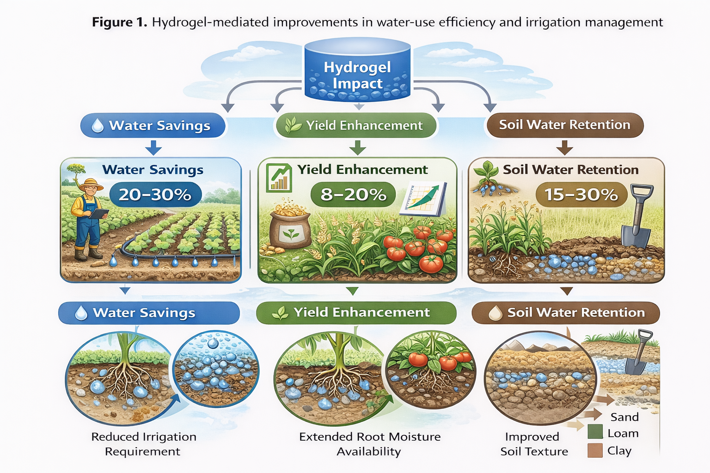
Fig. 1. Hydrogel effects on soil water retention, irrigation savings, and crop water productivity
6. Nutrient Dynamics and Fertilizer Use Efficiency
Beyond their role in water retention, hydrogels significantly influence soil nutrient dynamics and fertilizer efficiency. By modifying soil moisture regimes and acting as nutrient carriers, superabsorbent polymers (SAPs) contribute to reduced nutrient losses, improved synchronization between nutrient supply and crop demand, and enhanced fertilizer use efficiency. Their dual function as water and nutrient reservoirs makes them increasingly relevant in sustainable nutrient management strategies.

6.1 Nutrient Retention and Controlled Release
One of the primary agronomic advantages of hydrogels is their ability to reduce nutrient leaching losses, particularly in coarse-textured soils prone to rapid drainage. The polymer network of hydrogels can adsorb nutrient ions and release them gradually, functioning as a controlled-release matrix (Shaviv, 2001). This mechanism enhances nutrient residence time in the root zone and minimizes environmental losses.
Quantitative evidence indicates that hydrogel amendments can substantially improve nutrient retention and fertilizer-use efficiency. Studies in sandy soils report reductions in nitrate leaching ranging from approximately 18–35%, accompanied by increases in nitrogen-use efficiency (NUE) of about 15–30% compared with untreated soils. Improvements are generally more pronounced in coarse-textured soils due to their inherently low nutrient retention capacity. In contrast, loamy soils typically show moderate benefits, with nitrate leaching reductions of around 10–20% and NUE increases of approximately 8–15%. Similar trends have been reported for phosphorus and potassium, where hydrogel incorporation enhanced phosphorus-use efficiency (PUE) and potassium recovery by roughly 10–25%, primarily through improved moisture-mediated nutrient diffusion and reduced percolation losses.
Guilherme et al. (2015) demonstrated that polysaccharide-based hydrogels can serve as carriers for mineral nutrients, improving nutrient retention while maintaining soil moisture. Similarly, Li et al. (2019) reported that hydrogel incorporation reduced nitrate leaching and increased nutrient availability in sandy soils under irrigation. Controlled-release fertilizer (CRF) systems integrated with hydrogels have shown improved nutrient uptake efficiency by aligning nutrient release rates with crop growth stages (Rajanna et al., 2022). This synchronization reduces volatilization and leaching, particularly in high-rainfall or irrigated systems.

6.2 Nitrogen-Use Efficiency
Nitrogen (N) is highly mobile in soil and susceptible to losses via leaching, volatilization, and denitrification. Hydrogel amendments improve nitrogen-use efficiency (NUE) by enhancing soil moisture stability and reducing nitrate mobility. Stable moisture conditions support microbial-mediated nitrogen transformations and reduce abrupt N losses following irrigation or rainfall events (Azeem et al., 2014).
Research indicates that hydrogel-based systems increase N uptake and grain yield compared to conventional fertilization practices under water-limited conditions (Ni et al., 2009). By retaining ammonium and nitrate ions within the polymer matrix, hydrogels can slow nitrogen release and improve plant recovery efficiency. Furthermore, moisture stabilization reduces drought-induced N stress, allowing crops to maintain active nitrogen assimilation during moderate water deficits. The integration of hydrogels with urea or ammonium-based fertilizers has demonstrated improved NUE under both rainfed and deficit irrigation regimes.

6.3 Phosphorus and Potassium Dynamics
Phosphorus (P) availability is often limited due to fixation in soils, particularly in calcareous and acidic conditions. Hydrogels can enhance P availability indirectly by improving soil moisture and microbial activity, which promote P solubilization and diffusion toward roots (Teodorescu & Lungu, 2016). Enhanced root growth under hydrogel-treated conditions further increases P acquisition efficiency.
Potassium (K), while less prone to fixation than phosphorus, is susceptible to leaching in sandy soils. Hydrogel incorporation has been shown to improve K retention by reducing percolation losses and maintaining exchangeable potassium within the root zone (Li et al., 2019). The combined improvement in N, P, and K availability under hydrogel-amended systems contributes to balanced nutrient uptake and improved overall fertilizer use efficiency. However, nutrient retention efficiency varies depending on polymer chemistry, cross-link density, soil texture, and irrigation practices.

6.4 Hydrogel-Based Fertilizer Formulations
Recent advances in material science have led to the development of hydrogel-based fertilizer formulations, including nutrient-loaded hydrogels and composite slow-release systems. These formulations encapsulate fertilizers within polymer networks, enabling gradual nutrient release triggered by soil moisture conditions (Azeem et al., 2014).
Such systems aim to enhance nutrient synchronization with crop growth demand while reducing environmental impacts associated with conventional fertilizers. Controlled-release hydrogel fertilizers have demonstrated improved crop growth, reduced nutrient runoff, and enhanced nutrient recovery rates compared to traditional broadcast fertilization (Shaviv, 2001). Biodegradable hydrogel matrices based on starch, cellulose, or chitosan are increasingly investigated to combine environmental sustainability with agronomic performance. However, large-scale field validation and cost-benefit analyses remain necessary for widespread adoption.

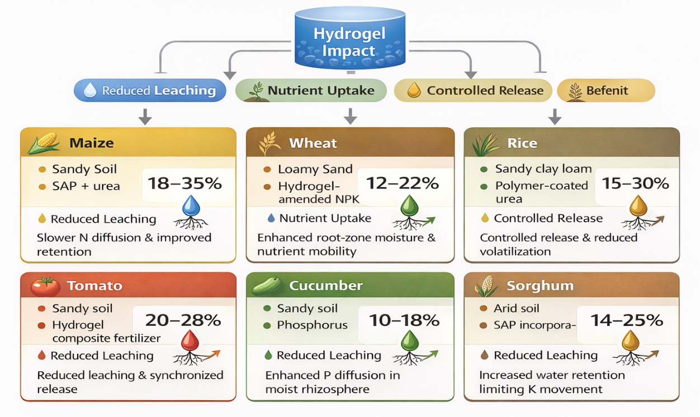
Fig. 2. Hydrogel-mediated enhancement of nutrient retention and fertilizer-use efficiency
Table 1. Effects of Hydrogel Application on Water-Use Efficiency, Irrigation Saving and Crop Productivity Under Different Soil and Irrigation
Crop | Soil Texture | Irrigation Regime | Hydrogel Type | Irrigation Saving (%) | Yield Increase (%) | WUE Improvement (%) | Key Mechanism Reported | Reference
Maize | Sandy loam | Deficit irrigation (70% ETc) | Polyacrylamide SAP | 20–30 | 12–18 | 15–25 | Increased root-zone moisture retention; reduced percolation | Sivapalan (2006)
Wheat | Sandy soil | 60–80% ETc | Cross-linked polyacrylate | 25 | 10–22 | 18–28 | Extended soil moisture availability during grain filling | Koupai et al. (2008)
Barley | Loam | Reduced irrigation | Hydrogel soil amendment | 15–20 | 8–15 | 12–20 | Improved soil water holding capacity | Akhtar et al. (2004)
Tomato | Sandy soil | Regulated deficit irrigation | Biodegradable hydrogel | 20 | 14–19 | 22 | Stabilized transpiration and delayed wilting | Montesano et al. (2015)
Maize | Sandy soil | Water stress conditions | SAP composite | 18 | 9–17 | 20 | Reduced drought-induced oxidative stress | Islam et al. (2011)
Pine seedlings | Sandy soil | Rainfed | Hydrogel incorporation | — | Increased survival rate (≈30%) | — | Prolonged soil moisture retention | Hüttermann et al. (2009)

Table 2. Influence of Hydrogel-Based Systems on Nutrient Retention and Fertilizer Use Efficiency in Cropping Systems
Crop | Soil Type | Hydrogel/Fertilizer Type | Nutrient Studied | Main Nutrient Effect | Improvement (%) | Mechanism Reported
Maize | Sandy soil | SAP + urea | Nitrogen | Reduced nitrate leaching | 18–35% reduction | Slower N diffusion & improved retention
Wheat | Loamy sand | Hydrogel-amended NPK | N, P | Increased N uptake | 12–22% | Enhanced root-zone moisture & nutrient mobility
Rice | Sandy clay loam | Polymer-coated urea | Nitrogen | Improved NUE | 15–30% | Controlled release & reduced volatilization
Tomato | Sandy soil | Hydrogel composite fertilizer | NPK | Increased nutrient recovery | 20–28% | Reduced leaching & synchronized release
Cucumber | Sandy soil | Biodegradable hydrogel + P fertilizer | Phosphorus | Improved P availability | 10–18% | Enhanced P diffusion in moist rhizosphere
Sorghum | Arid soil | SAP incorporation | Potassium | Reduced K leaching | 14–25% | Increased water retention limiting K movement

7. Weed Ecology and Crop–Weed Interactions
Quantitative observations from hydrogel-amended systems indicate that changes in soil moisture availability can alter weed density and biomass depending on species composition and cropping conditions. For instance, hydrogel incorporation in irrigated cereal systems has been reported to reduce total weed biomass by approximately 15–30% due to improved crop canopy development and competitive suppression, although initial weed density may increase by 5–15% where enhanced surface moisture stimulates early germination. Moisture-responsive C3 weed species often show greater emergence under stabilized soil moisture conditions, whereas drought-adapted C4 species may decline in relative abundance by about 10–20% when crop competition intensifies. Additionally, improved soil moisture retention may enhance the activation and diffusion of pre-emergence herbicides, resulting in 10–18% higher weed control efficiency in some studies, although polymer–herbicide interactions may occasionally modify herbicide mobility and persistence in the soil.

7.1 Influence on Weed Germination and Emergence Timing
Weed seed germination is highly sensitive to soil moisture, temperature, and light conditions. Hydrogel incorporation increases soil water availability in the seed zone, potentially altering germination timing and emergence synchrony. Seeds of many weed species require adequate matric potential for imbibition; thus, increased moisture retention may either stimulate or delay germination depending on species-specific moisture thresholds.
Hydrogel-amended soils maintain more stable moisture regimes, reducing rapid drying cycles that typically suppress germination in sandy soils. This may result in earlier or more uniform weed emergence under certain conditions. Conversely, by stabilizing soil moisture deeper in the profile rather than at the immediate surface, hydrogels may reduce surface crusting and alter microenvironmental cues influencing weed seed dormancy break. The timing of weed emergence relative to crop establishment is critical. Early-emerging weeds often exert disproportionate competitive pressure. If hydrogel application enhances rapid crop establishment, it may shift the competitive balance in favor of the crop despite potential stimulation of weed germination.

7.2 Species-Specific Responses and Community Shifts
Weed communities respond differently to changes in soil moisture. Species with shallow root systems and rapid germination cycles may respond positively to improved surface moisture, whereas deep-rooted or drought-adapted species may gain less advantage.
Alterations in soil water distribution can shift weed species composition. Moisture-sensitive grasses may decline under stabilized moisture conditions if crop canopy closure improves more rapidly, whereas certain broadleaf weeds adapted to moderate moisture may proliferate. Studies in irrigated and semi-arid systems demonstrate that water management practices strongly influence weed community structure (Singh et al., 2022). Because hydrogels alter the spatial and temporal availability of water, they may indirectly drive shifts in functional weed groups (C3 vs C4 species, annual vs perennial weeds). Long-term studies evaluating community-level responses to repeated hydrogel application remain limited, highlighting a research gap in agroecological impact assessment.

7.3 Weed Biomass and Density Patterns
Weed biomass accumulation is directly linked to resource availability. In water-limited soils, hydrogels can increase soil moisture to levels that support both crop and weed growth. The net effect on weed biomass depends on relative competitive responses.
Under improved moisture conditions, weed density may initially increase if germination constraints are alleviated. However, enhanced crop vigor under hydrogel treatment can result in stronger canopy closure and reduced light penetration, suppressing subsequent weed biomass accumulation. Empirical evidence suggests that water management practices influencing soil moisture often have stronger impacts on weed biomass than on weed density alone. Therefore, hydrogel effects on weed dynamics must be evaluated in terms of both emergence counts and dry matter production to fully assess ecological consequences.

7.4 Crop Competitive Advantage Under Hydrogel Treatment
Crop–weed competition is fundamentally determined by relative growth rates, resource capture efficiency, and phenological timing. By improving early crop vigor and root development, hydrogels may enhance the crop’s competitive ability for water and nutrients.
Increased crop biomass accumulation and leaf area development under improved moisture conditions strengthen light interception and reduce weed growth potential. Furthermore, improved water-use efficiency in crops may allow them to maintain growth during moderate drought, whereas weed growth may decline if their physiological plasticity is lower. Integrated water management strategies that favor crop competitiveness have been shown to reduce yield losses from weeds (Singh et al., 2022). Thus, hydrogels may indirectly contribute to integrated weed management (IWM) when combined with timely cultural or mechanical control methods.

7.5 Interaction with Herbicide Behavior and Efficacy
Hydrogels can potentially influence herbicide performance by altering soil moisture and sorption dynamics. Herbicide efficacy depends on adequate soil moisture for activation, particularly for pre-emergence herbicides. Increased soil moisture retention may enhance herbicide diffusion into the germination zone of weed seeds.
However, polymeric materials may also adsorb or interact with certain herbicide molecules, potentially affecting bioavailability. The extent of interaction depends on herbicide chemistry, polymer charge, and soil conditions. Studies on polymer–agrochemical interactions indicate that adsorption phenomena can modify release rates and persistence (Pereira et al., 2015). Therefore, evaluating hydrogel–herbicide compatibility is essential before large-scale adoption. Research is needed to determine whether hydrogels improve herbicide stability, delay degradation, or alter mobility within the soil profile.

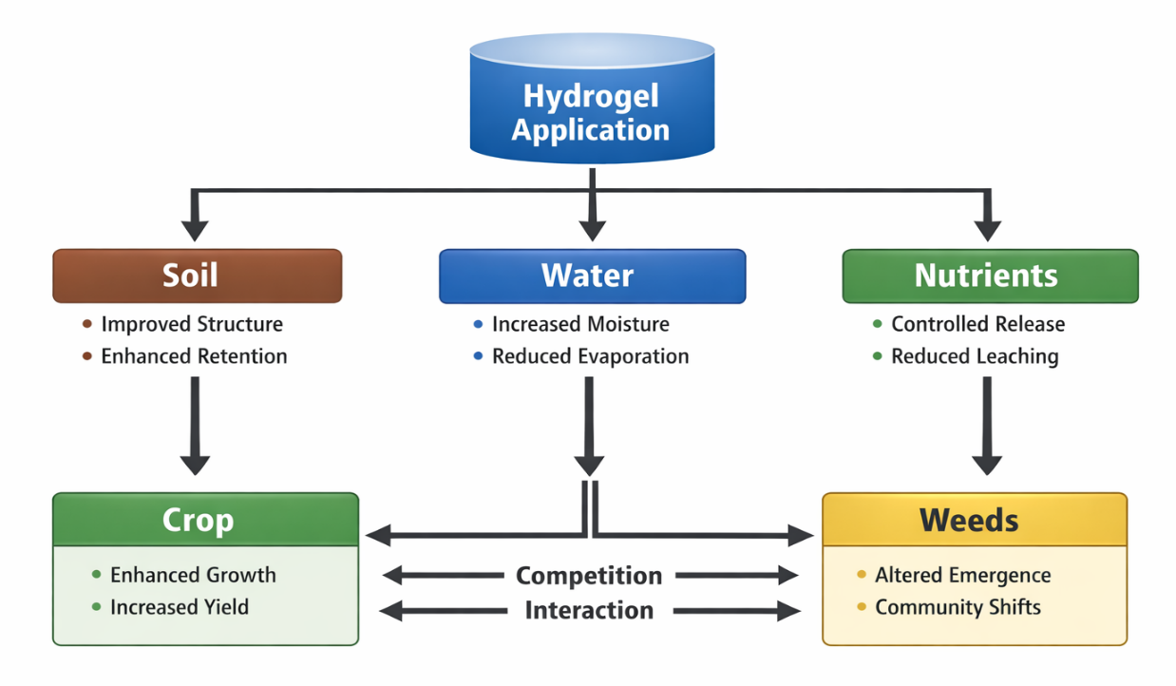
Fig. 3. Hydrogel-driven soil–water–nutrient–crop–weed interaction

8. Conclusions
Hydrogels represent a promising agronomic tool for enhancing soil water retention, improving water-use efficiency, stabilizing nutrient availability, and strengthening crop performance under water-limited conditions. Their greatest benefits are consistently observed in coarse-textured, sandy, and degraded soils where low inherent water-holding capacity constrains productivity. By buffering soil moisture fluctuations, hydrogels can improve germination, root development, vegetative growth, and reproductive performance, particularly under deficit irrigation regimes. However, their influence on weed ecology is context dependent; improved moisture conditions may stimulate weed emergence in some systems, necessitating integration with timely cultural and chemical weed management strategies. For practical application, hydrogel selection should consider polymer type (synthetic vs bio-based), swelling behavior under local salinity conditions, and biodegradability. Application rates must be optimized according to soil texture and crop water requirements to avoid unnecessary costs or structural disruption. Band placement or root-zone incorporation is generally more efficient than broadcast application, and integration with controlled-release fertilizers can further enhance nutrient-use efficiency. Importantly, hydrogel use should not replace sound agronomic practices such as crop rotation, residue management, and integrated weed management but rather complement them. Long-term field trials, cost–benefit analyses, and environmental impact assessments are essential before large-scale adoption. When strategically applied within climate-resilient production systems, hydrogels can serve as a supportive technology for sustainable intensification, particularly in drought-prone regions facing increasing water scarcity.

DISCLAIMER (ARTIFICIAL INTELLIGENCE)

Author(s) hereby declare that (ChatGPT 5.2) used in grammar check and text-to-image generators during the writing or editing of this manuscript.

REFERENCES
- Ali, K., Asad, Z., Agbna, G. H., Saud, A., Khan, A., & Zaidi, S. J. (2024). Progress and innovations in hydrogels for sustainable agriculture. Agronomy, 14(12), 2815. https://doi.org/10.3390/agronomy14122815
- Ashraf, A. M., Ragavan, T., & Begam, S. N. (2021). Superabsorbent Polymers (SAPs) Hydrogel: Water Saving Technology for Increasing Agriculture Productivity in Drought Prone Areas: A Review. Agricultural Reviews, 42(2). https://doi.org/10.18805/ag.R-2023
- Muhammad, N., Kader, M. A., Al-Solaimani, S. G., Abd El-Wahed, M. H., Abohassan, R. A., & Charles, M. E. (2025). A review of impacts of hydrogels on soil water conservation in dryland agriculture. Farming System, 100166. https://doi.org/10.1016/j.agwat.2025.108607
- Oladosu, Y., Rafii, M. Y., Arolu, F., Chukwu, S. C., Salisu, M. A., Fagbohun, I. K., ... & Haliru, B. S. (2022). Superabsorbent polymer hydrogels for sustainable agriculture: A review. Horticulturae, 8(7), 605. https://doi.org/10.3390/plants8070605
- Palma, D., Lagos, O., Souto, C., Pérez, A., Quezada, L., Hirzel, J., ... & Urbano, B. (2024). Evaluation of a natural superabsorbent polymer on water retention capacity in coarse-textured soils. Water, 16(22), 3186. https://doi.org/10.3390/w16223186
- Zhu, J., Zhang, Z., Wen, Y., Song, X., Tan, W. K., Ong, C. N., & Li, J. (2024). Recent advances in superabsorbent hydrogels derived from agro waste materials for sustainable agriculture: a review. Journal of Agricultural and Food Chemistry, 72(41), 22399-22419. https://doi.org/10.1021/acs.jafc.4c04970
- Krasnopeeva, E. L., Panova, G. G., & Yakimansky, A. V. (2022). Agricultural applications of superabsorbent polymer hydrogels. International Journal of Molecular Sciences, 23(23), 15134. https://doi.org/10.3390/polym14245407
- Omar, H., Ghezal, A., & El-Azeem, S. A. (2024). Improving water retention in sandy soils with high water absorption superabsorbent hydrogels. ACS Omega, 9(15), 12345-12356. https://doi.org/10.1021/acsomega.4c00727
- Rajanna, G. A., Manna, S., Singh, A., Babu, S., Singh, V. K., Dass, A., ... & Parmar, B. S. (2022). Biopolymeric superabsorbent hydrogels enhance crop and water productivity of soybean–wheat system in Indo-Gangetic plains of India. Scientific Reports, 12(1), 11955. https://doi.org/10.1038/s41598-022-16049-x
- Ghobashy, M. M., Amin, M. A., Mustafa, A. E., El-Diehy, M. A., El-Damhougy, B. K., & Nady, N. (2024). Synthesis and application of a multifunctional poly (vinyl pyrrolidone)-based superabsorbent hydrogel for controlled fertilizer release and enhanced water retention in drought-stressed Pisum sativum plants. Scientific Reports, 14(1), 27734. https://doi.org/10.1038/s41598-024-76255-7
- Ahmed, E. M. (2015). Hydrogel: Preparation, characterization, and applications: A review. Journal of Advanced Research, 6(2), 105–121. https://doi.org/10.1016/j.jare.2013.07.006
- Buchholz, F. L., & Graham, A. T. (1998). Modern superabsorbent polymer technology. Wiley-VCH. https://doi.org/10.1002/9783527611160
- Ekebafe, L. O., Ogbeifun, D. E., & Okieimen, F. E. (2011). Polymer applications in agriculture. Biokemistri, 23(2), 81–89. https://doi.org/10.4314/biokem.v23i2.7
- Guilherme, M. R., Aouada, F. A., Fajardo, A. R., Martins, A. F., Paulino, A. T., Davi, M. F. T., Rubira, A. F., & Muniz, E. C. (2015). Superabsorbent hydrogels based on polysaccharides for application in agriculture as soil conditioner and nutrient carrier: A review. European Polymer Journal, 72, 365–385. https://doi.org/10.1016/j.eurpolymj.2015.04.017
- Montesano, F. F., Parente, A., Santamaria, P., Sannino, A., & Serio, F. (2015). Biodegradable superabsorbent hydrogel increases water retention properties of growing media and plant growth. Agricultural and Agricultural Science Procedia, 4, 451–458. https://doi.org/10.1016/j.aaspro.2015.03.052
- Thakur, V. K., & Voicu, S. I. (2016). Recent advances in cellulose and chitosan-based hydrogels for water purification and agricultural applications. International Journal of Biological Macromolecules, 92, 1–13. https://doi.org/10.1016/j.ijbiomac.2016.07.026
- Abedi-Koupai, J., & Sohrab, F. (2004). Evaluation of superabsorbent polymers for increasing soil water retention and plant growth. Journal of Plant Nutrition, 27(12), 2153–2166. https://doi.org/10.1081/PLN-200034686
- Dorraji, S. S., Golchin, A., & Ahmadi, S. (2010). The effects of hydrophilic polymer and soil salinity on corn growth in sandy and loamy soils. Clean – Soil, Air, Water, 38(7), 584–591. https://doi.org/10.1002/clen.200900041
- Pereira, E. I., Giroto, A. S., Bortolin, A., Yamamoto, C. F., Marconcini, J. M., de Campos Bernardi, A. C., & Ribeiro, C. (2015). Perspectives in nanocomposites for the slow and controlled release of agrochemicals: Fertilizers and pesticides. Nanotechnologies in food and agriculture, 241-265.
- Hüttermann, A., Zommorodi, M., & Reise, K. (2009). Addition of hydrogels to soil for prolonging the survival of Pinus halepensis seedlings subjected to drought. Soil & Tillage Research, 103(2), 446–452. https://doi.org/10.1016/j.still.2008.11.003
- Islam, M. R., Hu, Y., Mao, S., Mao, J., Eneji, A. E., & Xue, X. (2011). Effects of water-saving superabsorbent polymer on antioxidant enzyme activities and lipid peroxidation in maize under drought stress. Journal of the Science of Food and Agriculture, 91(5), 813–819. https://doi.org/10.1002/jsfa.4249
- Abedi-Koupai, J., Sohrab, F., & Swarbrick, G. (2008). Evaluation of hydrogel application on soil water retention characteristics. Journal of Plant Nutrition, 31(2), 317–331. https://doi.org/10.1080/01904160801894952
- Akhtar, M., Ahmad, I., & Khan, M. A. (2004). Effect of hydrogel amendment on water storage of sandy loam and loam soils and seedling growth of barley, wheat and chickpea. Plant, Soil and Environment, 50(10), 463–469. https://doi.org/10.17221/4059-PSE
- Akhter, J., Mahmood, K., Malik, K. A., Mardan, A., Ahmad, M., & Iqbal, M. M. (2004). Effects of hydrogel amendment on water storage of sandy loam and loam soils and seedling growth of barley, wheat and chickpea. Plant, Soil and Environment, 50(10), 463–469. https://doi.org/10.17221/4059-PSE
- Bhardwaj, A. K., Shainberg, I., Goldstein, D., Warrington, D. N., & Levy, G. J. (2007). Water retention and hydraulic conductivity of cross-linked polyacrylamides in sandy soils. Soil Science Society of America Journal, 71(2), 406–412. https://doi.org/10.2136/sssaj2006.0180
- Boateng, S. A., Zickermann, J., & Kornahrens, M. (2015). Poultry manure effect on growth and yield of maize. International Journal of Plant Production, 9(3), 385–398. https://doi.org/10.22069/IJPP.2015.2234
- El-Hady, O. A., & Abo-Sedera, S. A. (2006). Conditioning effect of composts and acrylamide hydrogels on sandy calcareous soils. International Journal of Agriculture & Biology, 8(6), 876–884.
- Islam, M. R., Hu, Y., Mao, S., Mao, J., Eneji, A. E., & Xue, X. (2011). Effects of water-saving superabsorbent polymer on antioxidant enzyme activities and lipid peroxidation in maize under drought stress. Journal of the Science of Food and Agriculture, 91(5), 813–819. https://doi.org/10.1002/jsfa.4249
- Johnson, M. S., & Leah, R. T. (2010). Effects of superabsorbent polymers on growth and water use efficiency of crops. Agricultural Water Management, 97(4), 653–658. https://doi.org/10.1016/j.agwat.2009.11.008
- Singh, M., Kukal, M. S., Irmak, S., & Jhala, A. J. (2022). Water use characteristics of weeds: A global review, best practices, and future directions. Frontiers in Plant Science, 12, 794090.
- Sarvaš, M., Pavlenda, P., & Takáčová, E. (2007). Effect of hydrogel application on survival and growth of pine seedlings. Journal of Forest Science, 53(5), 204–209. https://doi.org/10.17221/2017-JFS
- Abobatta, W. F. (2018). Impact of hydrogel polymer in agricultural sector. Advances in Agriculture and Environmental Science, 1(2), 59–64. https://doi.org/10.30881/aaeoa.00011
- Blanco-Canqui, H. (2017). Biochar and soil physical properties. Soil Science Society of America Journal, 81(4), 687–711. https://doi.org/10.2136/sssaj2017.01.0017
- Farooq, M., Wahid, A., Kobayashi, N., Fujita, D., & Basra, S. M. A. (2009). Plant drought stress: Effects, mechanisms and management. Agronomy for Sustainable Development, 29, 185–212. https://doi.org/10.1051/agro:2008021
- Fereres, E., & Soriano, M. A. (2007). Deficit irrigation for reducing agricultural water use. Journal of Experimental Botany, 58(2), 147–159. https://doi.org/10.1093/jxb/erl165
- Koupai, J. A., Sohrab, F., & Swarbrick, G. (2008). Evaluation of hydrogel application on soil water retention characteristics. Journal of Plant Nutrition, 31(2), 317–331. https://doi.org/10.1080/01904160801894952
- Liu, F., Jensen, C. R., & Andersen, M. N. (2014). Drought stress effect on carbohydrate concentration in soybean. Agricultural Water Management, 147, 77–85. https://doi.org/10.1016/j.agwat.2014.08.011
- Sivapalan, S. (2006). Benefits of treating a sandy soil with a crosslinked-type polyacrylamide. Australian Journal of Experimental Agriculture, 46(4), 579–584. https://doi.org/10.1071/EA04153
- Azeem, B., KuShaari, K., Man, Z. B., Basit, A., & Thanh, T. H. (2014). Review on materials and methods to produce controlled release coated urea fertilizer. Journal of Controlled Release, 181, 11–21. https://doi.org/10.1016/j.jconrel.2014.02.020
- Guilherme, M. R., Aouada, F. A., Fajardo, A. R., Martins, A. F., Paulino, A. T., Davi, M. F. T., Rubira, A. F., & Muniz, E. C. (2015). Superabsorbent hydrogels based on polysaccharides for application in agriculture as soil conditioner and nutrient carrier: A review. European Polymer Journal, 72, 365–385. https://doi.org/10.1016/j.eurpolymj.2015.04.017
- Li, X., Li, Q., Xu, X., Su, Y., Yue, Q., & Gao, B. (2019). Characterization, swelling behavior, and slow-release properties of superabsorbent polymer composites. Journal of Agricultural and Food Chemistry, 67(8), 2340–2348. https://doi.org/10.1021/acs.jafc.8b06659
- Ni, B., Liu, M., Lü, S., & Xie, L. (2009). Environmentally friendly slow-release nitrogen fertilizer. Journal of Agricultural and Food Chemistry, 57(19), 10208–10213. https://doi.org/10.1021/jf901646z
- Shaviv, A. (2001). Advances in controlled-release fertilizers. Advances in Agronomy, 71, 1–49. https://doi.org/10.1016/S0065-2113(01)71011-5
- Teodorescu, M., & Lungu, A. (2016). Superabsorbent hydrogels in agriculture: Soil conditioning and nutrient retention. Romanian Agricultural Research, 33, 1–10. https://doi.org/10.59665/rar3301

