VEGETATION HEALTH DYNAMICS AND THE IMPACTS ON CLIMATE CHANGE AND AGRICULTURE IN EBONYI STATE SOUTHEASTERN NIGERIA

ABSTRACT
This study investigates vegetation health dynamics and the impacts on climate change and agriculture in Ebonyi State Southeastern Nigeria using geospatial techniques covering a period 39 years (1986 to 2025). Normalized Difference Vegetation Index (NDVI) was used to assess the health of vegetation. The results indicate that No vegetation area increased slightly from 40.7808km² in 1986 to 40.7871km² in 2025 representing an increase of 0.02%. Low vegetation/degraded area increased significantly from 618.8688km² in 1986 to 1058.554km² in 2025 representing an increase of +71%. Stressed vegetation area decreased from 2636.77km² in 1986 to 2546.817m² in 2025 representing a decrease of -3.41%. Moderately healthy vegetation area decreased from 2469.672km² in 1986 to 2032.174km² in 2025 representing a decrease of -17.71% while healthy vegetation increased from 659.0556km² in 1986 to 746.9181km² in 2025 representing an increase of +13.33%. The largest increase was in low vegetation/degraded area (+71.05%) followed by healthy vegetation (+13.33%) while the largest decrease was in moderately healthy vegetation (-17.71%) followed by stressed vegetation (-3.41%). These findings provide valuable insights into the vegetation health dynamics and their implications for climate change and agriculture as well as ecosystem sustainability and resilience in Ebonyi State as evidenced by the very strong and significant statistical relationships among the variables. The study contributes to our understanding of the impacts of climate change and human activities on vegetation dynamics and land cover transformation in the region, informing evidence-based decision-making and sustainable land management practices.

Key words: Vegetation health, Impacts, Agriculture, climate change, Environment.
INTRODUCTION
The recent trends like global warming and population growth have necessitated the assessment of earth landscape transformation particularly the growing challenge on sustainable agriculture and food security as well as climate change mitigating measures adaptation. The recent decades have witnessed intensified man's activities trying to unravel nature's enormous resources applied in sustenance but pose a risk to the survival of other living organisms as well. Global climate change triggers temperature, precipitation pattern, and extreme event change with direct effect on vegetation growth and condition (IPCC, 2014). Impacts are manifested in the alteration of vegetation phenology, productivity, and structure with associated consequences on ecosystem function and services (Cleland et al., 2007). Vegetation health dynamics over time should be comprehended to estimate climate change impacts on ecosystems. Climate change and human activity have immensely reversed the trends of vegetation on the global scene (Myneni et al., 1997). Normalized Difference Vegetation Index (NDVI) has also been considered a critical tool to quantify vegetation state and dynamics through time (Pettorelli et al., 2005). Temporal NDVI data include information on long-term trends as well as vegetational responses to climate change (Verbesselt et al., 2010). Natural land cover, incorporates and contains a place's general climate, geology and soils, and already present biota over several decades or longer.
At shorter timescales, land cover can be altered by naturally occurring disturbances (e.g., storms, floods, fires, volcanic eruptions, landslides, and insects) and anthropogenic activities (e.g., road building, industrialization and urbanization, water diversion, deforestation or afforestation, population growth). These transitions can be considered improvements or degradations in land cover state, either positively or negatively, depending on perspective (Perez-Hoyos et al 2017; Sleeter et al 2018; Sterling et al 2013). Land cover affects or alters environmental conditions in one or more of the following manners: impacting other environmental processes like water quality, watersheds' hydrology, species and habitat composition, climate, and carbon storage; impacting mass and energy flux from surface to atmosphere and hence influencing weather and climate; impacting species and habitat, a component of ecological structure and function; altering hydrologic regimes, flood buffering, and watersheds' runoff (Sleeter et al 2018; Sterling et al 2013;Yasser and Vahid, 2025). Land use and land cover data are crucial to environmental comprehension and regulation, sustainable progress, and provision of assistance to programs of various choices, e.g., environmental planning, resource administration, and city planning. It provides base knowledge on environmental hazard appraisal, food availability, and reduction of natural hazards.

Thus on the basis of NDVI trends for a number of decades, researchers can map areas experiencing vegetation degradation, expansion, or shift in composition (Tucker et al., 2005). These assessments are important in guiding land management, conservation, and climate change mitigation policy (Boisvenue & Running, 2006). In a nation like Nigeria with diverse ecological zones, monitoring these processes is vital for evidence-based environmental management and sustainable development planning. This study therefore attempts to assess the temporal trend of land use land cover and vegetation health during the past thirty-nine (39) years (1986-2025 and its impact on climate change and agriculture in Ebonyi State Southeastern Nigeria using NDVI data at 1986, 2000, 2015, and 2025. NDVI is an index of vegetation density and health and indicates information on ecosystem trends and temporal change. Understanding the temporal trends of land cover and vegetation health in Ebonyi State will aid in the identification of environmental trends, assessment of climate change effects, and formulation of targeted mitigation and adaptation measures.
Therefore this study will contribute to the body of knowledge on environmental monitoring and management in Nigeria with useful information for policymakers, researchers, and stakeholders in the environment.
Study Area
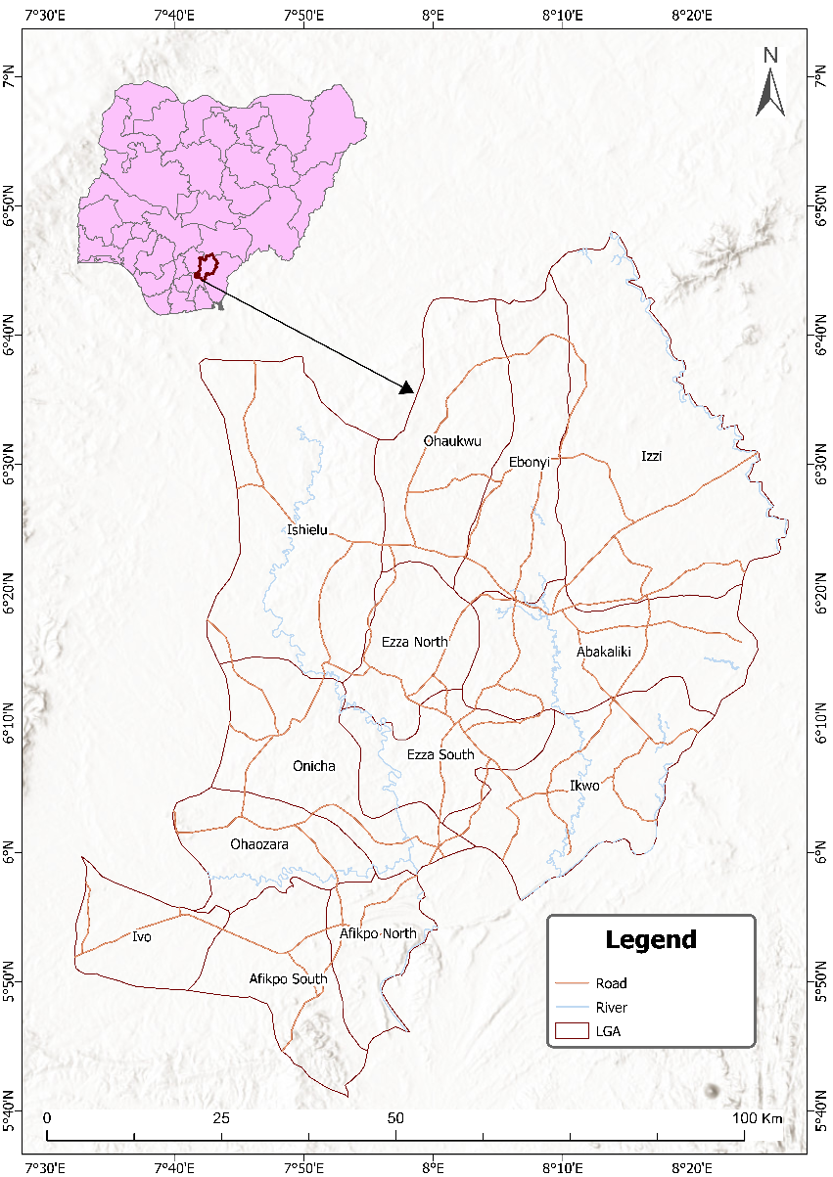
Figure 1: Geographical Location of Ebonyi State - Map of the Study Area

Ebonyi State was created on October 1, 1996 with Abakaliki as its capital. The state was calved out of the old Abakaliki Division of Enugu State and the old Afikpo Division of Abia State. The name of the state was derived from the River Abonyi which flows through the north-central parts of the State. The state is located in the South Eastern part of Nigeria and lies approximately within latitudes 5/40’ and 6/45’N, and longitudes 7/30’ and 8/30’E (Hegazy and Kaloop, 2015). It has boundaries with Enugu State to the west, Benue State to the north, Cross River State to the east and Abia State to the south. The land area of the state is approximately 5,935 square kilometer (km²) and its inhabitants are Igbo. Ebonyi State has an estimated population of about 2,176,947 based on the 2006 National Population Census. The largest city in the State is Abakaliki, the state capital. Some important towns are Afikpo, Edda, Onueke, Nkalagu, Uburu, Onicha, Ishiagu, Amasiri and Okposi. The state has 13 Local Government Areas, 3 Senatorial Districts, 6 Federal Constituencies, 24 State Constituencies, and 171 Registration Areas/Wards (ABK 2021).
The state is divided between the Cross-Niger transition forests in the far south and the drier Guinean forest–savanna mosaic in the rest of the state. Ebonyi State has a humid tropical climate, with one rainy season and one dry season lasting for 8 and 4 months, respectively. The temperature typically ranges from 20 to 38 degrees Celsius during the dry season and from 16 to 28 degrees Celsius during the rainy season. Harmattan winds are common between December and January. The average annual temperature is 28 degrees Celsius, and the average annual humidity is 50-60%. The region receives an average annual precipitation of 2500mm (Wizor and Chinyere 2023). Ebonyi State is mainly an agricultural region and a leading producer of rice, yam, potatoes, maize, beans, and cassava (MANR 2021). Rice is largely cultivated in Ikwo, yams in Izzi, with other regions in the state such as Amasiri, Edda and Ezillo making remarkable contributions as well. Effium and Ezzamgo lead in cassava production, and basket production in Ntezi. Ebonyi has several solid mineral resources, including lead, crude oil, and natural gas, but few large-scale commercial mining mines (Diagi B. Edewede 2018; EO 2025). Ebonyi State is called "the salt of the nation" for its huge salt deposit at the Okposi and Uburu Salt Lakes. There are also some tourist locations within the state prominent ones include Abakaliki Green Lake, Uburu Salt Lake, Unwana and Ikwo Beaches (ES 2020).

MATERIALS AND METHODS
Data Collection
Satellite imagery data from Landsat 5, Landsat 7 and Landsat 8, acquired during different years and utilizing specific sensors (containing bands in the red (R) and near-infrared (NIR) spectra) used for this study includes. The Landsat data employed the TM (Thematic Mapper) and ETM+ (Enhanced Thematic Mapper Plus). Landsat 8 data, utilized the OLI (Operational Land Imager) and TIRS (Thermal Infrared Sensor) sensors. All the imageries were sourced from the Google Earth Engine (GEE) platform
Pre-processing:
NDVI is the most common vegetation indices and has a range of -1 to +1. NDVI is computed from the visible and near-infrared light reflected by vegetation. Healthy vegetation absorbs most of the visible light in its contact and reflects a large portion of the near-infrared light. Unhealthy or sparse vegetation reflects more visible light and less near-infrared light. The NDVI was also used because it has been well documented as good measures of biomass and vegetation vigour. The data were pre-processed to remove any artifacts or inconsistencies such as atmospheric effects, clouds and shadows, and perform radiometric and geometric corrections to ensure data quality and reliability and consistency across different time periods.
Image Registration:
The NDVI images were registered from different time periods to a common coordinate system to facilitate accurate comparison and analysis. This step ensures that pixel values correspond to the same geographical locations across all images.

Change Detection Analysis:
Use change detection techniques to identify areas of significant change in vegetation health and land cover between different time periods. This involved methods such as thresholding, image differencing, and machine learning algorithms to detect changes in NDVI values over time. The land use change detection in this study was conducted using ArcMap. Initially, a classified raster layer representing land use classes was created. This raster layer was then converted to a polygon feature class based on the distinct classes using the "Conversion" tool. Subsequently, vectorized representations of land use for both the later and former time periods were obtained. To identify areas of change, the "Intersection" tool was applied to compare the two vectorized land use layers. This process generated a new feature class, and a "Change" column was incorporated into the attribute table to designate areas where land use had altered. Utilizing the "Attribute Field Calculator," the change in land use was determined by the class of the former time period to the corresponding class value of the later time period

Classification:
The NDVI images were defined into different land cover classes (e.g., very healthy vegetation, moderately healthy vegetation, unhealthy vegetation, bare land) using supervised classification techniques. This step assigns each pixel in the image to a specific land cover class based on its spectral characteristics. The land cover classification was conducted by creating band combinations of 5, 4, 3 (Landsat 8 OLI) and 4, 3, 2 (Landsat ETM+ and TM) color composite images, specifically for vegetation. These images were prepared to facilitate visual interpretation and the delineation of training areas for each predetermined Land Use/Land Cover (LULC). A set of samples was generated based on training samples representing desired land use types. These samples were utilized in the classification of the images. The selection of training samples involved using the point locations of characteristic sites utilizing Google Earth Engine's base map of the study area as a reference. The digitization of points for each training sample, corresponding to similar land cover, was carried out using the chosen color composite. Each known Landuse/Land cover (LULC) type was then assigned a distinctive identifier. The image classification was performed using a supervised classification approach, employing the smileCart algorithm in Google Earth Engine.

Accuracy Assessment:
Accuracy assessment was computed using a systematic approach on Google Earth Engine to evaluate the precision of the image classification results. Validation points were extracted from the classified image using the sample Regions function. These points, derived from the Land Cover property of the training points dataset, were sampled at a scale of 30 meters to ensure a detailed assessment. The error matrix was computed using the error Matrix function. This matrix breaks down classification accuracy into categories such as true positives, false positives, true negatives, and false negatives, providing a comprehensive understanding of classification performance. The overall accuracy was determined using the accuracy formula:

$\frac{TP+TN}{TP+TN+FP+FN}$ - Eqn…1

Where:
TP represents true positives,
TN represents true negatives,
FP represents false positives, and
FN represents false negatives.

For the computation of kappa value on excel, the error matrix was exported
The Kappa coefficient (κ) was calculated using the formula:

$K= \frac{Overall Accuracy-Random Accuracy}{1-Random Accuracy}$ - Eqn…2

Where Random Accuracy is calculated as:

$\frac{(TotalObservedPositive×TotalPredictedPositive+TotalObservedNegative×TotalPredictedNegative)}{Total Observation}$ - Eqn…3

Temporal/Spatial Analysis:
The Normalized Differential Vegetation Index (NDVI) for the target years was derived from the surface reflectance images using the built-in normalized Difference function in Google Earth Engine. The near-infrared (NIR) band (Landsat 8 band 5 and Landsat 5 and 7 band 4) was input as the first parameter, while the red band (Landsat 8 band 4 and Landsat 5 and 7 band 3) was input as the second parameter. The function subtracted the red band values from the NIR band values on a per-pixel basis across the images. It then divided this difference by the sum of the NIR and red bands. This generated NDVI values ranging from -1 to 1 for each pixel. Higher positive values indicate greater green vegetation density and health due to higher NIR reflectance and lower red absorbance.

$NDVI=\frac{NIR-RED}{NIR+RED}$ - Eqn….4

RESULTS
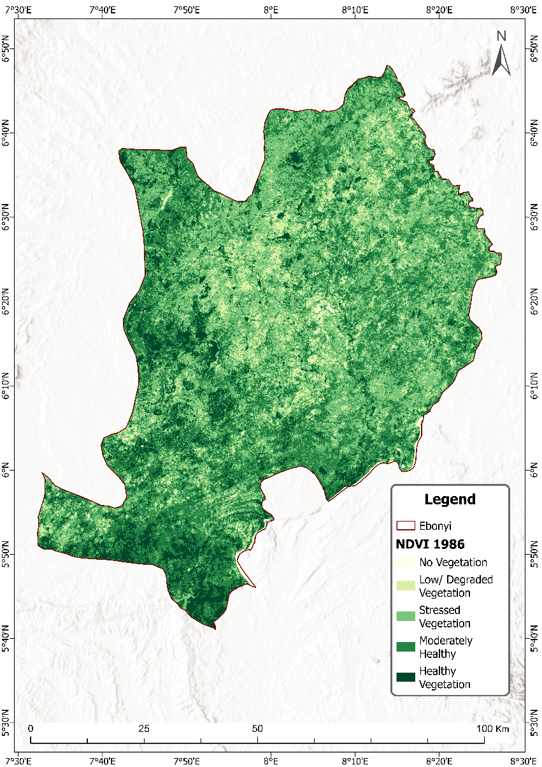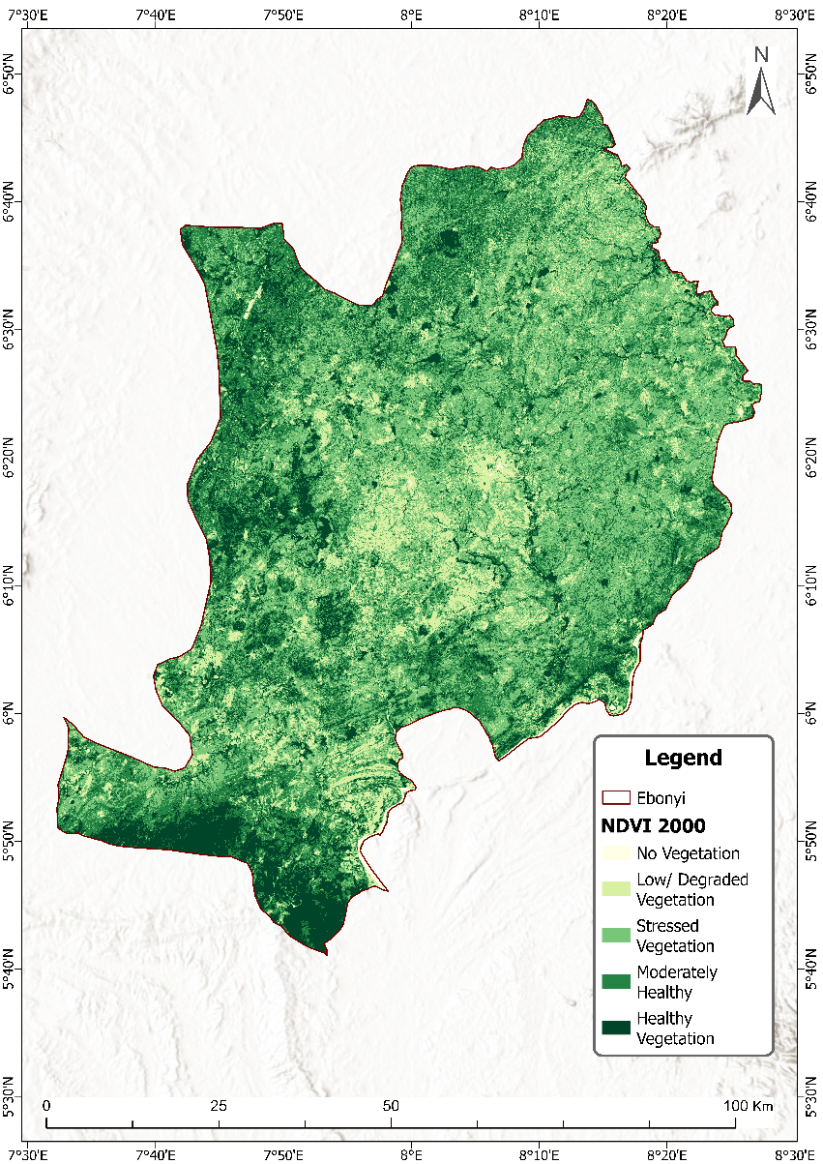
Figure 3: NDVI for 1986 Figure 4: NDVI for 1986

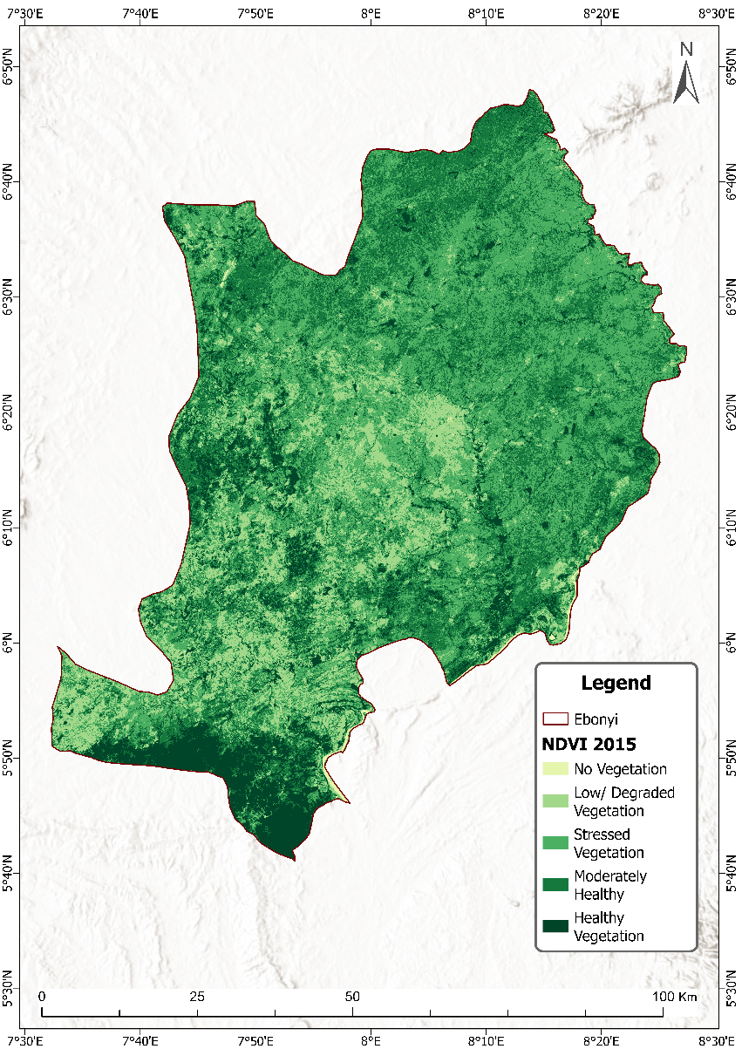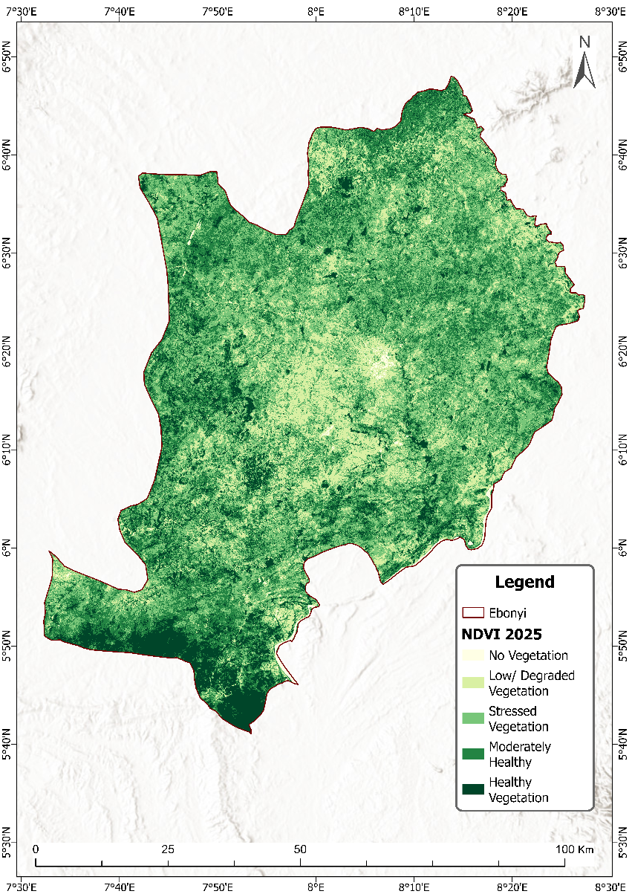
Figure 5: NDVI for 2015 Figure 6: NDVI for 2025

Table 1: Magnitude of Normalized Difference Vegetation Index (NDVI) for 1986 to 2025
NDVI | 1986 (km²) | 2000 (km²) | 2015 (km²) | 2025 (km²)
No Vegetation | 40.7808 | 23.0778 | 19.4994 | 40.7871
Low/ Degraded Vegetation | 618.8688 | 853.1118 | 889.4322 | 1058.554
Stressed Vegetation | 2636.77 | 2572.542 | 2627.101 | 2546.817
Moderately Healthy | 2469.672 | 2057.686 | 2108.327 | 2032.174
Healthy Vegetation | 659.0556 | 918.8316 | 780.8913 | 746.9181

Table 1 above shows the magnitude of Normalized Difference Vegetation Index (NDVI) for 1986 to 2025 covering a period of 39 years.

Figure 7: Showing a graphical illustration of Vegetation distribution or spread of 1986 across the entire landscape of Ebonyi State with Stressed Vegetation occupying the most area of 2,636.77km² followed by Moderately Healthy Vegetation with 2,469.67km², Healthy Vegetation with 659.06km², Low/degraded Vegetation with 618.87km² and No Vegetation with 40.78 km²

Figure 8: Showing a graphical illustration of Vegetation distribution or spread of 2000 with Stressed Vegetation occupying the most area of 2,572.54km² followed by Moderately Healthy Vegetation with 2,057.69km², Healthy Vegetation with 918.83km², Low/degraded Vegetation with 853.11km² and No Vegetation with 23.08 km²

Figure 9: Showing a graphical illustration of Vegetation distribution or spread of 2015 with Stressed Vegetation occupying the most area of 2,627.10km² followed by Moderately Healthy Vegetation with 2,108.33km², Healthy Vegetation with 780.89km², Low/degraded Vegetation with 889.43km² and No Vegetation with 19.50 km²

Figure 10: Showing a graphical illustration of Vegetation distribution or spread of 2025 with Stressed Vegetation occupying the highest area of 2,546.82km² followed by Moderately Healthy Vegetation with 2,032.17km², Low/degraded Vegetation with 1,058.55km², Healthy Vegetation with 746.92km²and No Vegetation with 40.79 km²
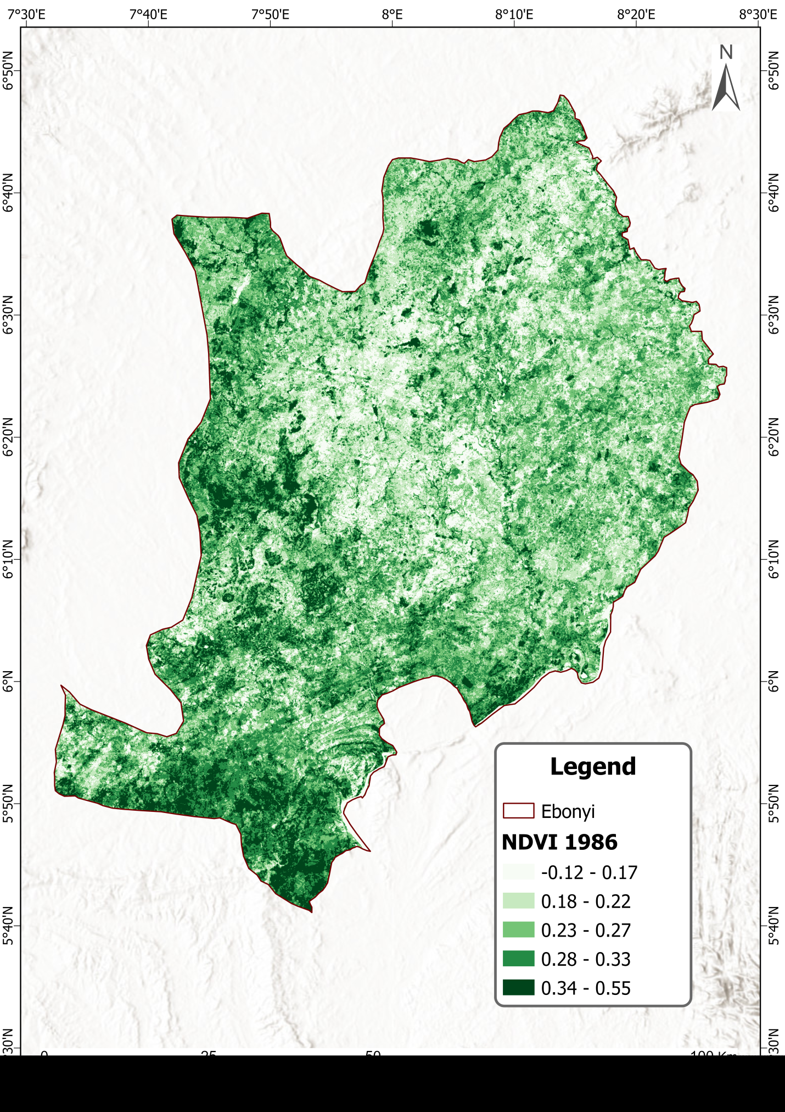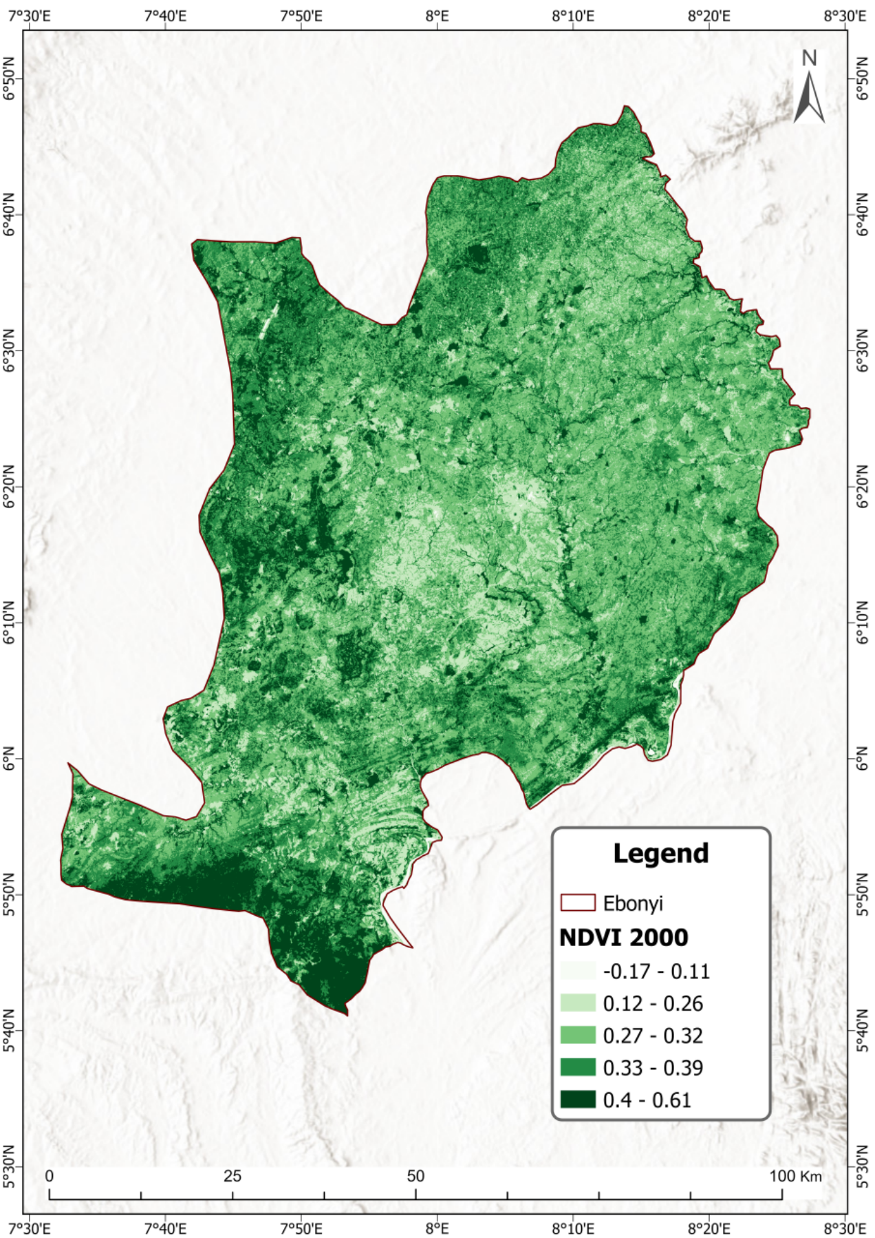
Figure 11: NDVI with figures for 1986 Figure 12: NDVI with figures for 2000

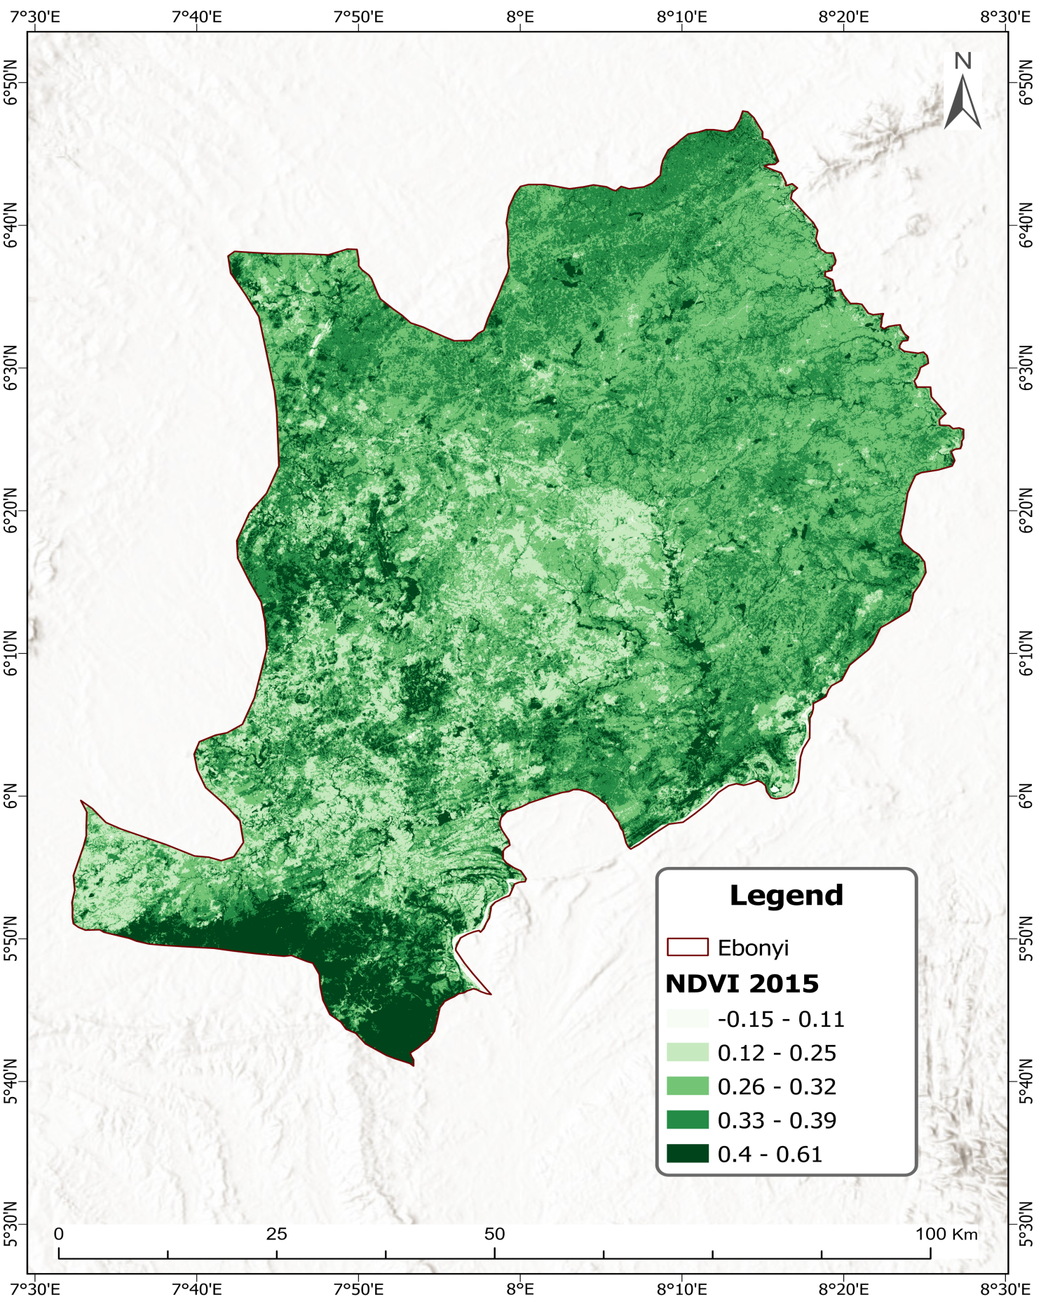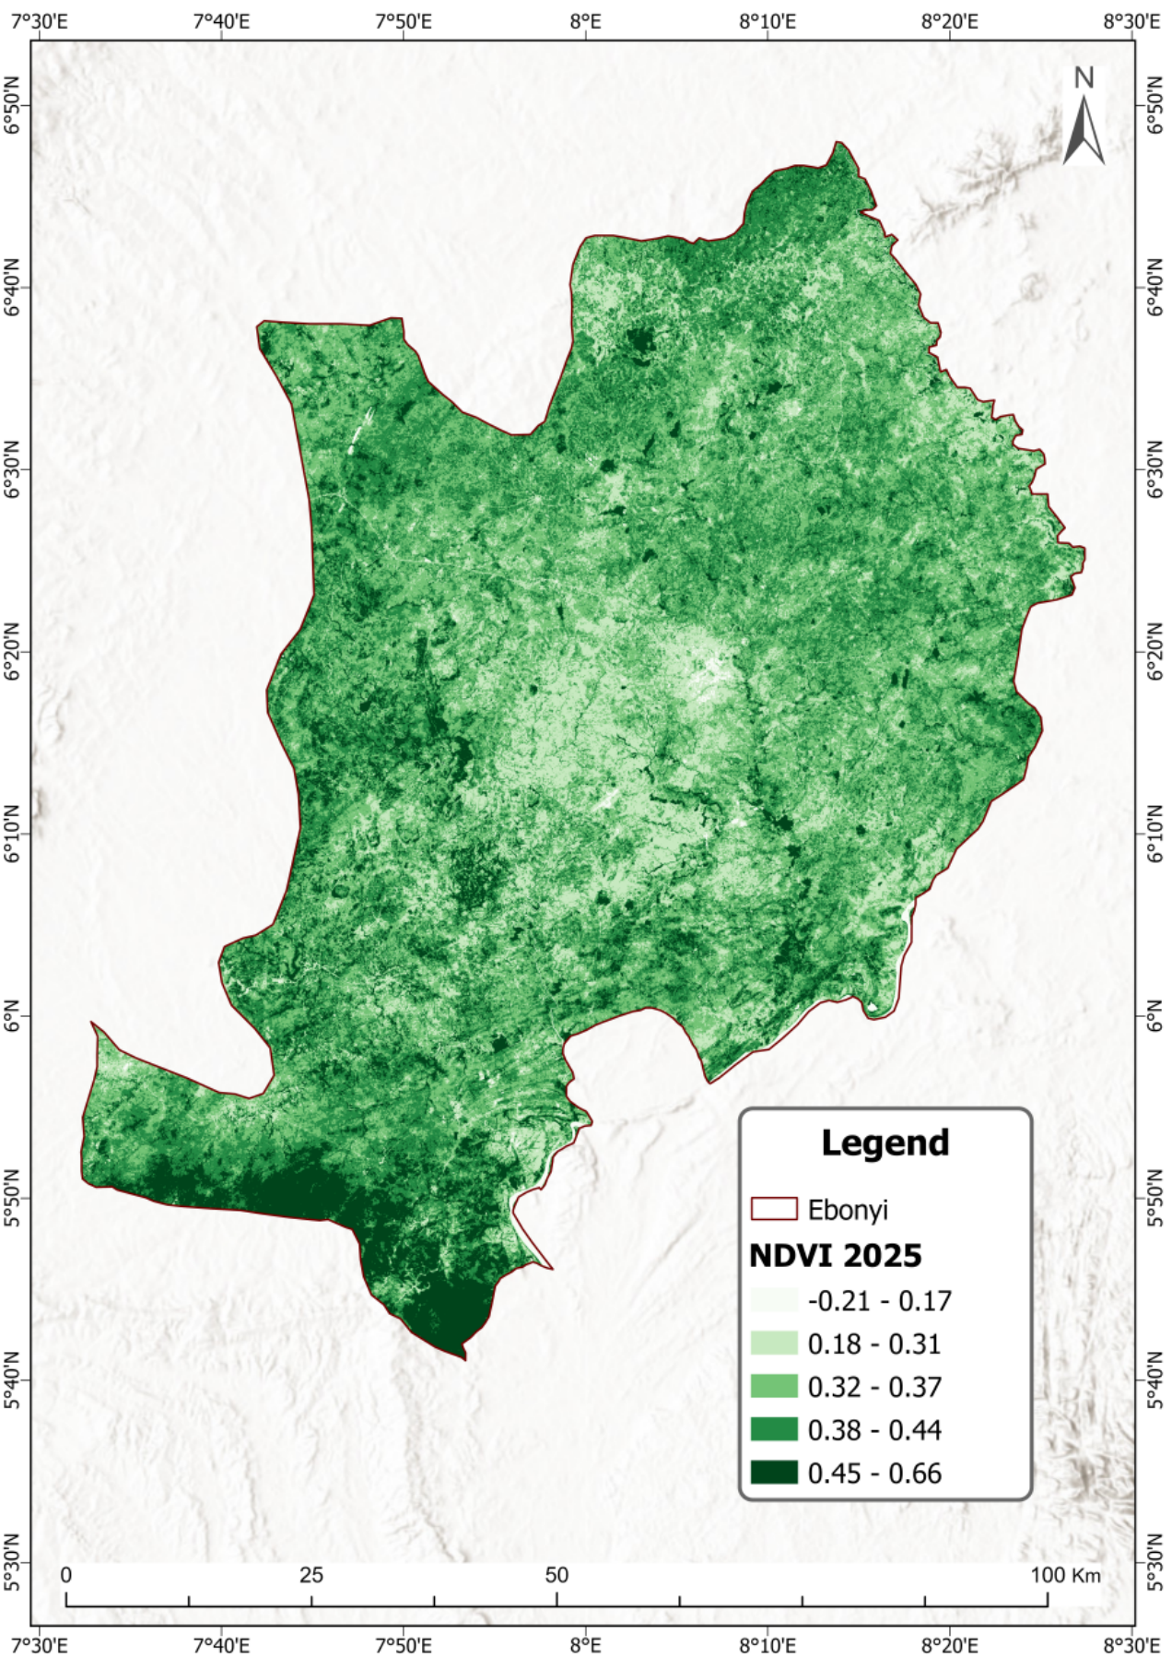
Figure 13: NDVI with figures for 2015 Figure 14: NDVI with figures for 2025

1986
Id NDVI INDEX Land type Area (km²)
1 -0.12 - 0.17 No Vegetation 40.7808
2 0.18 – 0.22 Low/Degraded Vegetation 618.8688
3 0.23 - 0.27 Stressed Vegetation 2636.77
4 0.28 - 0.33 Moderately Healthy Veg. 2469.672
5 0.34 - 0.55 Healthy Vegetation 659.0556

2000
Id NDVI INDEX Land type Area (km²)
1 -0.7 - 0.11 No Vegetation 23.0778
2 0.12 – 0.26 Low/Degraded Vegetation 853.1118
3 0.27 - 0.32 Stressed Vegetation 2572.542
4 0.33 - 0.39 Moderately Healthy Veg. 2057.686
5 0.4 - 0.61 Healthy Vegetation 918.8316

2015
Id NDVI INDEX Land type Area (km²)
1 -0.15 - 0.11 No Vegetation 19.4994
2 0.12 – 0.25 Low /Degraded Vegetation 889.4322
3 0.26 - 0.32 Stressed Vegetation 2627.101
4 0.33 - 0.39 Moderately Healthy Veg. 2108.327
5 0.4 - 0.61 Healthy Vegetation 780.8913
2025
Id NDVI INDEX Land type Area (km²)
1 -0.21 - 0.17 No Vegetation 40.7871
2 0.18 – 0.31 Low /Degraded Vegetation 1,058.554
3 0.32 - 0.37 Stressed Vegetation 2546.817
4 0.38 - 0.44 Moderately Healthy Veg. 2032.174
5 0.45 - 0.66 Healthy Vegetation 746.9181

Table 2: Percentage Change (1986–2025)
NDVI Category | 1986 (km²) | 2025 (km²) | % Change (1986 to 2025)
No Vegetation | 40.78 | 40.79 | +0.02%
Low/Degraded Vegetation | 618.87 | 1058.55 | +71.05%
Stressed Vegetation | 2636.77 | 2546.82 | –3.41%
Moderately Healthy | 2469.67 | 2032.17 | –17.71%
Healthy Vegetation | 659.06 | 746.92 | +13.33%
Largest increase: Low/Degraded Vegetation (+71.05%)
Largest decrease: Moderately Healthy Vegetation (–17.71%)
Source: Authors own Elaboration

Table 2 above shows the percentage change in magnitude of Normalized Difference Vegetation Index (NDVI) from 1986 to 2025 covering a period of 39 years which indicates that No vegetation area increased slightly from 40.7808km² in 1986 to 40.7871km² in 2025 representing an increase of 0.02%. Low vegetation/degraded area increased significantly from 618.8688km² in 1986 to 1058.554km² in 2025 representing an increase of +71%. Stressed vegetation area decreased from 2636.77km² in 1986 to 2546.817km² in 2025 representing a decrease of -3.41%. Moderately healthy vegetation area decreased from 2469.672km² in 1986 to 2032.174km² in 2025 representing a decrease of -17.71% while healthy vegetation increased from 659.0556km² in 1986 to 746.9181km² in 2025 representing an increase of +13.33%. The largest increase was in low vegetation/degraded area (+71.05%) followed by healthy vegetation (+13.33%) while the largest decrease was in moderately healthy vegetation (-17.71%) followed by stressed vegetation (-3.41%).
Table 3: Test of Significance (Paired Sample t-test)
Paired Samples Test
 |  | Paired Differences |  |  |  |  | t | df | Sig. (2-tailed)
 |  | Mean | Std. Deviation | Std. Error Mean | 95% Confidence Interval of the Difference |  | t | df | Sig. (2-tailed)
 |  |  |  |  | Lower | Upper | t | df | Sig. (2-tailed)
Pair 1 | 1986 - 2025 | -.02000 | 316.43923 | 141.51592 | -392.93119 | 392.89119 | .000 | 4 | 1.000

There is no statistically significant difference between the NDVI values in 1986 and 2025 overall (p > 0.05). This suggests that, despite individual category changes, the total distribution of vegetation types has not significantly changed in a statistical sense.
Table 4: Test of Relationship (Pearson Correlation)
Correlations
1986 | Pearson Correlation | 1 | .972**
1986 | Sig. (2-tailed) |  | .006
1986 | N | 5 | 5
2025 | Pearson Correlation | .972** | 1
2025 | Sig. (2-tailed) | .006
2025 | N | 5 | 5
**. Correlation is significant at the 0.01 level (2-tailed).

There is a very strong positive correlation between NDVI values in 1986 and 2025, which is statistically significant (p < 0.01). This indicates a consistent pattern in the relative magnitude of NDVI categories over time, despite some shifts in specific categories.

DISCUSSION
Further insights into the NDVI data as shown in Table 1 and 2 reveal significant environmental and climate change implications:

Loss of Vegetation Cover: The No Vegetation area which was 40.78km² in 1986 decreased to 23km² in 2000 and further decreased to 19.5km² in 2015 and then increased again to 40.78km² in 2025 representing an overall change of +0.02%. Low/degraded vegetation which was 618.87km² in 1986 increased to 853km² in 2000, 889,4km² in 2015 and 1058.6km² in 2025 representing change of +71% implying serious environmental concerns bordering on ecosystem balance and sustainability.
Stressed vegetation declined by -3.4% during the period indicates expansion in agricultural activities and built-up area as the peripheral zone vulnerable to several human activities.
Moderately healthy vegetation decreased by -17.7% suggests degradation of natural ecosystems and potential impacts on ecosystem services such as carbon sequestration, soil stabilization, and water regulation.
Interestingly, healthy vegetation increased by +13.3% which is a positive development indicating probably a change in land use policy, management, strategies, and attitudes of concerned stakeholders.
Infrastructure Development and Urbanization: The area of No vegetation cover or bare land, has shown fluctuations but an overall increasing trend. This indicates ongoing land degradation or conversion of vegetated areas to non-vegetated land. The expansion of bare land area may be attributed to urbanization, industrialization, and infrastructure development in the state. Swift urban expansion leads to land-use change, habitat fragmentation and loss of green spaces, enhancing environmental degradation and increasing vulnerability to climate change.
Climate Change Challenges: Changes in land cover and vegetation health impact the resilience of ecosystems and communities to climate change. Loss of vegetation cover diminishes the ability of ecosystems to cushion against climate extremes, such as droughts, floods, and heat waves, increasing the vulnerability of local populations.
Soil Degradation and Erosion: The expansion of bare land area as seen may quickens and enhances soil erosion, sedimentation, and soil degradation in the state. This leads to loss of fertile topsoil, reduced agricultural productivity, and increased susceptibility to landslides and erosion-related hazards.
Biodiversity Loss: The decline in moderately healthy vegetation cover and habitat loss contribute to biodiversity loss in the state with its attendant impacts on the ecosystem and inhabitants.
Also, the sharp and enormous increase in degraded/low vegetation area could be as a result of increased mining activities in the state notable among these are lead mining in Ikwo Local Government Area, stones mining in areas like Ishiegu, Nkalagu, Afikpo, and others. Mining sites and degraded land may not be suitable for agriculture and in most cases the sludge are not contained and treated before discharge into the surrounding lands which eventually impact negatively on vegetation, humans and livelihoods of the inhabitants of areas where these activities are carried out unchecked.

CONCLUSION
This study provides valuable insights into the natural environment of Ebonyi State Southeastern Nigeria which encompasses vegetation health dynamics. Farming activities and practices must be made sustainable with innovative styles and approaches to check the continuous stress to vegetation health. Vegetation serves as purifiers and sequesters in natural environment and must be kept in balance in spite of humans’ dependence on forest and forest resources for livelihoods. Thus stressed vegetation or low vegetation and degradation have enormous consequences on human health, climate change, and agriculture in the state and beyond.
These findings reveal the current state of vegetation health dynamics and their implications for climate change and agriculture as well as ecosystem sustainability and resilience in study area as evidenced by the very strong and significant statistical relationships among the variables. The study contributes to our understanding of the impacts of climate change and human activities on vegetation dynamics and land cover transformation in the region, informing evidence-based decision-making and sustainable land management practices.

REFERENCES
- ABK (2021). "Abakaliki". Encyclopædia Britannica. Retrieved 21 December 2021
- Boisvenue, Céline & RUNNING, STEVEN. (2006). Impacts of climate change on natural forest productivity - Evidence since the middle of the 20th century. Global Change Biology. 12. 862 - 882. 10.1111/j.1365-2486.2006.01134.x.
- Cleland, Elsa & Chuine, Isabelle & Menzel, Annette & Mooney, Harold & Schwartz, Mark. (2007). Shifting plant phenology in response to global change. Trends in ecology & evolution. 22. 357-65. 10.1016/j.tree.2007.04.003 .
- Diagi B. Edewede (2018). Assessment of Changes in Landcover and Landuse in Ebonyi State, Using Remote Sensing Technique. Journal of Environment and Earth Science ISSN 2224-3216 (Paper) ISSN 2225-0948 (Online) Vol.8, No.9, 2018
  - DOI: 10.9790/2402-1410014155 www.iosrjournals.org
- EO (2025) "Ebonyi Online - About Ebonyi State". www.ebonyionline.com.
- ES (2020) "Ebonyi State". www.ebonyistate.gov.ng. Archived from the original on 14 February 2016. Retrieved 15 June 2020.
- Hegazy.,I. R and Kaloop,,M. R.(2015). “Monitoring urban growth and land use change detection with GIS and remote sensing techniques in Daqahlia governorate Egypt,” International Journal of Sustainable Built Environment, vol. 4, no. 1, pp. 117–124. https://doi.org/10.1016/j.ijsbe.2015.02.005
- IPCC. (2014). Climate Change 2014: Synthesis Report. Contribution of Working Groups I, II and III to the Fifth Assessment Report of the Intergovernmental Panel on Climate Change [Core Writing Team, R.K. Pachauri and L.A. Meyer (Eds.)]. IPCC, Geneva, Switzerland, 151 pp.
- MANR (2021) "Ministry of Agriculture And Natural Resources, Ebonyi State Government". www.ebonyistate.gov.ng. Retrieved 10 June 2021.
- Moarrab, Yasser; Novin, Vahid. (2025). Scenario-based modelling of ecological security: Integrating land use and climate change impacts in the Lavasanat Watershed. Environmental Resources Research, 13(1), 137-158. 10.22069/ijerr.2025.23274.1475
- Myneni, R. & Keeling, C. & Tucker, Compton & Asrar, G. & Nemani, Ramakrishna. (1997). Increased Plant Growth in the Northern High Latitudes from 1981 to 1991. Nature. 386. 698-702. doi:10.1038/386698a0
- Perez Hoyos, Ana & Rembold, Felix & Kerdiles, Hervé & Gallego Pinilla, Francisco Javier. (2017). Comparison of Global Land Cover Datasets for Cropland Monitoring. Remote Sensing. 9. 10.3390/rs9111118.
- Pettorelli, Nathalie & Vik, Jon Olav & Mysterud, Atle & Gaillard, Jean-Michel & Tucker, Compton & Stenseth, Nils Chr. (2005). Using the satellite-derived NDVI to assess ecological responses to environmental change. Trends in ecology & evolution. 20. 503-10. 10.1016/j.tree.2005.05.011.
- Sleeter, B. M., Loveland, T., Domke, G., Herold, N., Wickham, J., & Wood, N. (2018) Land Cover and Land-Use Change. In: Reidmiller, D.R., Avery, C.W., Easterling, D.R., Kunkel, K.E., Lewis, K.L.M., Maycock, T.K. and Stewart, B.C., Eds., Impacts, Risks, and Adaptation in the United States: Fourth National Climate Assessment, Vol. 2, US Global Change Research Program, Washington DC, 202-231.
https://doi.org/10.7930/NCA4.2018.CH5
- Sterling, S.M., A. Ducharne, and J. Polcher. 2013. The impact of global land-cover change on the terrestrial water cycle. Nature Climate Change 3(4):385-39. https://ui.adsabs.harvard.edu/link_gateway/2013NatCC...3..385S/doi:10.1038/nclimate1690
- Tucker, Compton & Pinzon, Jorge & Brown, Molly & Slayback, Daniel & Pak, Edwin & Mahoney, Robert & Vermote, E. & Saleous, Nazmi. (2005). An extended AVHRR 8-km NDVI dataset compatible with MODIS and spot vegetation NDVI data. International Journal of Remote Sensing. 26. 4485-4498. 10.1080/01431160500168686.
- Verbesselt, J., Hyndman, R., Newnham, G. and Culvenor, D. (2010) Detecting Trend and Seasonal Changes in Satellite Image Time Series. Remote Sensing of Environment, 114, 106-115. http://dx.doi.org/10.1016/j.rse.2009.08.014
- Wizor, C. H., & Chinyere, I. A.(2023). Utilizing Biogas Technology as Alternative Energy Source in Nigerian Urban and Peri-urban Centres. World Journal of Innovative Research (WJIR) Retrieved 11 March 2023.

Competing Interests/Conflict of Interest
Author(s) has/have no competing financial, professional, or personal interests from other parties or in publishing this manuscript. There is no conflict of interest with the publisher or the editorial team or the reviewers.

Funding
No financial support was received for the research and writing of this article.

Disclaimer (Artificial intelligence)

Author(s) hereby declare that NO generative AI technologies such as Large Language Models (ChatGPT, COPILOT, etc.) and text-to-image generators have been used during the writing or editing of this manuscript.

