Occurrence, spatial distribution and source assessment of organophosphate flame retardants in surface sediments of Afiesere River, Niger Delta, Nigeria

Abstract
The occurrence, spatial distribution and source assessment of six organophosphate flame retardants (OPFRs) were investigated in the sediments of the Afiesere River in the Niger Delta, Nigeria. Sediment samples were collected from twelve (12) locations along the river. Samples were subjected to ultrasound-assisted extraction using a 1:1 mixture of dichloromethane and acetonitrile. Thereafter, the extracts were analyzed for OPFRs on a gas chromatograph-mass spectrometer (GC-MS). Regression analysis was used to established if total organic carbon (TOC) influenced the geochemistry of OPFRs in the sediment. Principal component analysis (PCA) and Pearson’s correlation coefficient were used to establish the sources of OPFRs in the sediment. The concentrations of ∑6 OPFRs in surface sediments of the Afiesere River varied from 1.12 to 43.5 ng/g and were within the range of those reported in sediments from other river systems around the world. The occurrence pattern of OPFRs was in the order of TCEP > TPTP > TCPP > IDPP > TNBP > RDP. Regression analysis showed a very high correlation (R² = 0.7273) between ∑6 OPFRs and sediments total organic carbon (TOC) indicating that TOC influenced the geochemistry and fate of OPFRs in the sediments. The Source assessment indicated that OPFRs in sediments of the Afiesere River are from mixed pollution. Further research is needed to determine the impact of the OPFRs in the Afiesere River.

KEYWORDS: OPFRs, Plasticizer, Sediment, Afiesere River, Niger Delta

INTRODUCTION
Organophosphate flame retardants (OPFRs) are one class of chemical additives that are used as flame retardants and plasticizers for decades due to their excellent chemical and physical properties, low cost, and simple production process, as well as their good compatibility with polymer materials and high fire-retardant efficiency (Wang et al., 2015). In place of the phased-out hexabromocyclododecanes and polybrominated diphenyl ethers, the worldwide OPFRs production and consumption have greatly increased from approximately 0.3 to 1.0 million tons (Li et al., 2019). These OPFRs include tris(methyl‑phenyl) phosphate (TMPP), tributylphosphate (TNBP) and tris(2‑ethylhexyl) phosphate (TEHP). OPFRs are widely utilized in various industrial products, such as plastics, building materials, textiles, furniture, electronics and vehicle parts (Wei et al., 2015).
Several adverse effects of OPFRs on the ecosystem and human health have been reported (Chokwe and Okonkwo, 2019). For example, Triphenyl phosphate (TPhP) and Tris(1,3-dichloro-2-propyl) phosphate (TDCiPP) exposure reduced sperm counts and hormone levels in humans (Meeker and Stapleton, 2010), Tris(2-carboxyethyl) phosphine (TCEP) and TDCiPP are considered carcinogens, potential neurotoxicants and may cause acute or chronic adverse effects to aquatic organisms (Salamova et al., 2014). Tributyl phosphate or Tri-n-butyl phosphate (TBP) has neurotoxic properties after chronic exposure (Reemtsma et al., 2008) while TPhP and 2-Ethylhexyl diphenyl phosphate (EHDPP) have potential bioaccumulative and toxic properties to aquatic ecosystems (Kim et al., 2011), tris (1,3-dichloroisopropyl) phosphate (TDCPP) affects liver cells and neurons, while tris (clorisopropyl) phosphate (TCPP) affects fertility (Feng et al., 2016). OPFRs could slowly be released into the environment through volatilization, leaching and abrasion (Yang et al., 2014). Because of their physicochemical characteristics, OPFRs exhibit a wide range of log K_{ow} values (1.44-9.49) and log K_{oc} (2.21-6.87) (Shi et al., 2016) and as such they have been detected in the aquatic ecosystem (Chokwe and Okonkwo, 2019). However, information regarding the occurrence and distribution of OPFRs within the African and Nigerian aquatic ecosystems is inadequate. The Afiesere River is a river in the western Niger Delta of Nigeria. The river is impacted by activities related to agriculture, urbanization, and industrial developments (Iwegbue et al., 2024; 2022). Environmental quality within the area has severely deteriorated and various contaminants such as polychlorinated biphenyls (PCBs), metals, polybrominated diphenyl ethers (PBDEs), polycyclic aromatic hydrocarbons have been detected in the sediment of the river (Iwegbue et al., 2024; Iwegbue et al., 2022). As most OPFRs are listed as high-production volume (HPV) chemicals, we can safely hypothesize that these pollutants are ubiquitous in this river. Thus, the objective of this study is to determine the occurrence and distribution of OPFRs in sediments of the Afiesere River in Niger Delta, Nigeria.

MATERIALS AND METHODS
Description of the study area
The study area is Afiesere River in Ughelli, Niger Delta, Nigeria (Figure 1). The river lies between latitude 5º25’30’’ to 5º36’30’’ N and longitude 5º54’0’’ to 6º55’0’’ E. The river is about 32km from Ujevbe to Oguname-Olomu. There are discharges into the Afiesere River from a rubber industry, the influence of urbanization of Ughelli town, and the accompanying outflows from commercial and other anthropogenic activities (Iwegbue et al., 2022). The study area has a typical tropical equatorial climate with two distinct seasons: the wet season (April to October) and the dry season (November to March). There are, however, sporadic rainfalls during the dry season and a brief dry spell in August. The study area experiences 32.8°C and 2673.8 mm of annual temperature precipitation, respectively.
Reagents
A standard mixture of organophosphate flame retardants consisting of six (6) congeners (TCEP, TCPP, TPTP, IDPP, RDP and TNBP) was obtained from Merck (Darmstadt, Germany). Hexane, dichloromethane, copper powder, anhydrous sodium sulfate, florisil and silica gel was purchased from Merck (Darmstadt, Germany).
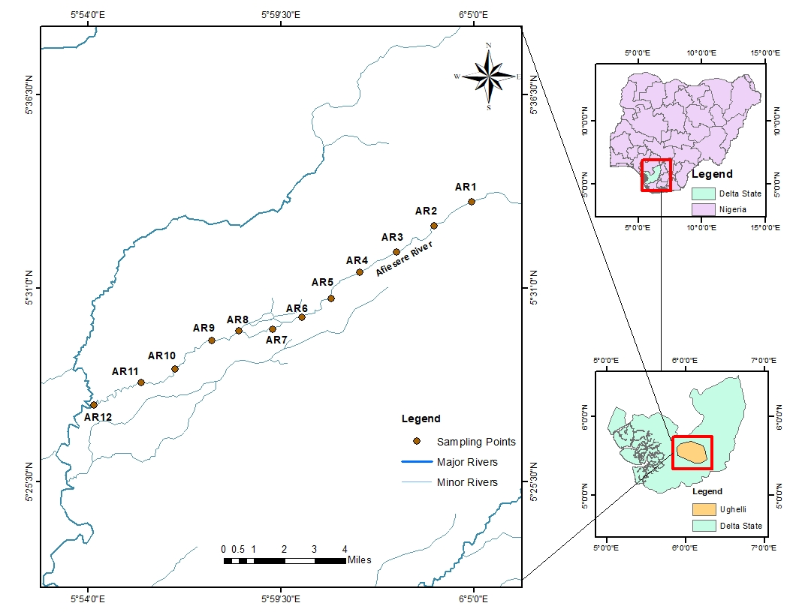
Figure 1: Map of study area showing sampling points

Sample collection
Using a modified Ekman grab sampler, surface sediments (0–5 cm depth) were collected from twelve (12) locations along the Afiesere River, encased with aluminium foil and taken to the laboratory in an ice chest. In the laboratory, the samples were allowed to dry, and sieved using a 2mm mesh sieve and stored at less than 4°C before the extraction procedure.

Determination of sediment physicochemical properties
The pH and electrical conductivity (EC) of the sediment were determined after appropriate treatments with a bench-top multi-parameter meter (XS-PC8+DHS) while the Walkley-Black titration was used to measure the sediment's total organic carbon (TOC).
OPFRs' extraction and cleanup in sediment
Ultrasound-assisted extraction was used to remove OPFR from the sediments as described by Zhang et al. (2021) with slight modification. Ten grams of homogenized sediment was weighed into a 50 mL glass tube and 30 ng/g of surrogates were added. By sonicating 50 mL of dichloromethane:acetonitrile (1:1,v/v) for 30 minutes at 40 °C, the sample was extracted three times. The extracts were mixed and centrifuged for 10 minutes at 2500 rpm to gather the supernatants. One gram of powdered activated copper was added to eliminate the elemental sulfur. Under the influence of a high-purity nitrogen stream, the extract was decreased to 1-2 mL. After adding 40 millilitres of water, the extracts were filtered by solid-phase extraction. For instrumental analysis, the eluate was reconstituted in 300 μL of ethyl acetate after it was evaporated.
Instrumental Analysis
Instrumental analysis was done on the extracts from the samples using a gas mass spectrometry (GC–MS) in conjunction with a chromatograph (Agilent 6890N). The Agilent J&W DB-17 column (30 m × 250 µm × 0.25 µm) has a temperature of 25 ºC at injection and 290 ºC at the detector. Helium (99.9 % pure) was the carrier gas, moving steadily at a rate of 0.8mL/min. In splitless mode, a 1μL sample was added to the device. The oven's initial temperature was 150 ºC for 1.3 minutes, increased to 280 ºC at a rate of 15 ºC per minute for 2 minutes, and then closed at 300 ºC for 4 minutes.

Quality control and statistical analysis
Analysis of variance (ANOVA) was used to determine whether there was a significant variation in the concentrations of OPFRs. The analytical procedure was validated using method blanks, surrogate OPFRs, and sample matrix spike recoveries. Acceptable percentage recoveries of 88.6 to 92.4 per cent and 87.9 to 96.3 per cent were achieved for the surrogate and sample matrix spikes, respectively. The limits of quantification (LOQs) for the OPFRs varied between 0.04 and 0.15 ng/g. Regression analysis was used to established if TOC influences the geochemistry of OPFRs in the sediment. Principal component analysis (PCA) and Pearson’s correlation coefficient were used to establish the sources of OPFRs in the sediment samples. All statistical analyses were carried out with SPSS version 23 software.

RESULTS AND DISCUSSION
Occurrence and distribution of OPFRs in the sediment of the Afiesere River
OPFRs concentrations in Afiesere River sediments are displayed in Table 1.
Table 1: OPFRs concentrations (ng/g) in the sediment of Afiesere River
 | AR1 | AR2 | AR3 | AR4 | AR5 | AR6 | AR7 | AR8 | AR9 | AR10 | AR11 | AR12
pH | 5.30 | 4.90 | 5.20 | 5.60 | 4.30 | 4.60 | 5.30 | 4.90 | 4.50 | 5.30 | 4.80 | 4.60
EC µS/cm | 35.6 | 47.7 | 35.8 | 26.2 | 21.9 | 56.1 | 60.3 | 38.2 | 25.3 | 26.8 | 21.3 | 19.5
TOC (%) | 0.54 | 0.15 | 1.20 | 0.48 | 2.72 | 1.42 | 2.94 | 2.84 | 0.18 | 0.28 | 0.34 | 0.22
TCEP | 2.74 | 0.23 | 0.15 | 12.2 | 17.6 | 23.7 | 42.2 | 28.4 | 5.84 | 1.45 | 2.02 | 1.22
TCPP | 0.06 | 0.61 | 0.20 | 0.15 | 0.16 | 0.12 | 0.33 | 0.12 | 0.06 | 0.18 | 0.26 | 0.14
TPTP | 0.07 | 0.10 | 0.12 | 0.99 | 0.10 | 0.33 | 0.60 | 0.91 | 0.34 | 0.24 | 0.10 | 0.91
IDPP | <LOQ | 0.05 | <LOQ | 0.32 | 0.07 | <LOQ | 0.20 | 0.23 | 0.12 | <LOQ | <LOQ | <LOQ
RDP | <LOQ | 0.09 | 0.45 | 0.09 | <LOQ | <LOQ | 0.11 | 0.15 | <LOQ | <LOQ | <LOQ | <LOQ
TNBP | <LOQ | 0.04 | 0.67 | <LOQ | 0.08 | <LOQ | 0.10 | <LOQ | <LOQ | <LOQ | 0.07 | <LOQ
∑6 OPFRs | 2.87 | 1.12 | 1.59 | 13.8 | 18.0 | 24.2 | 43.5 | 29.8 | 6.36 | 1.87 | 2.45 | 2.27

The ∑6 OPFR concentrations in sediment of the Afiesere River varied from 1.12 ng/g at point AR2 to 43.5 ng/g at point AR7. The concentrations of OPFRs in the sediment varied significantly (p < 0.05) from one sampling point to another and between the upstream, downstream and midstream sections of the river. The midstream (AR5-AR8) has the highest ∑6 OPFRs concentration, followed by the upstream (AR1-AR4) and then the downstream (AR9-AR12). The high concentration of OPFRs in the midstream may be due to the human activities in that section of the river which include commercial activities from the Ughelli main market, burning of tyres, etc. The range of OPFR concentration obtained in this study was within concentrations reported in literature for sediments in other river systems around the world as shown in Table 2.

Table 2: OPFRs in sediment of the Afiesere River in comparison with others in literature
River system | Country | No. of samples | No. of OPFRs | ∑OPFRs concentration (ng/g) | Reference
Afiesere River | Nigeria | 12 | 6 | 1.12-43.5 | This Study
Ogun River | Nigeria | 60 | 8 | 13.1-2110 | Gbadamosi et al. (2023)
Osun River | Nigeria | 20 | 8 | 24.7-589 | Gbadamosi et al. (2023)
South Sea | China | 15 | 7 | 2.5-32.3 | Pan et al. (2022)
Coastal waters | Korea | 50 | 18 | 2.18-347 | Choi et al. (2020)
Vaal River | South Africa | 16 | 12 | 68-278 | Chokwe and Okonkwo (2019)
Lake Shihwa | Korea | 43 | 18 | 2.99-3800 | Lee et al. (2018)
Adige River | Italy | 20 | 14 | 11.5-549 | Giulivo et al. (2017)
Sava River | Serbia | 20 | 14 | 10.5-249 | Giulivo et al. (2017)
Evrotas River | Greece | 12 | 14 | 0.31-31.0 | Giulivo et al. (2017)
Pearl River Delta | China | 52 | 12 | 8.3-470 | Tan et al. (2016)

The distribution pattern of the OPFRs in the sediment of the Afiesere River is presented in Figure 2.

Figure 2: Percentage composition of OPFRs in sediments of the Afiesere River

TCEP was the dominant OPFR compound in the sediment with an average concentration of 11.5 ng/g. This was followed by TPTP (0.40 ng/g), TCPP (0.20 ng/g), IDPP (0.08 ng/g), TNBP (0.08 ng/g) and the least was RDP with an average concentration of 0.17 ng/g. TCEP, TCPP and TPTP were found in all sediment samples. The amount of TCEP in the sediments varied from 0.23 to 42.2 ng/g and constituted 20.5 to 98.1 % of the ∑6 OPFRs. Concentrations of TCPP in the sediments ranged from 0.06 to 0.61 ng/g and constituted 0.4 to 54.5 % of the ∑6 OPFRs. The concentrations of TPTP in the sediments varied from 0.07 to 0.99 ng/g and constituted 0.6 to 12.8 % of the ∑6 OPFRs. IDPP were found in 60 % of samples. The amount of IDPP varied from 0.05 to 0.32 ng/g and constituted 0.0 to 4.5 % of the ∑6 OPFRs. RDP and TNBP were each detected in 40 % of the sediment of the Afiesere River. The concentrations of RDP and TNBP in the sediments varied from 0.09 to 0.15 ng/g and 0.04 to 0.1 ng/g respectively. RDP and TNBP constituted up to 8.0 % and 3.6 % respectively of the ∑6 OPFRs.

Relation between sediment TOC and OPFR concentrations in the sediment
Sediment characteristics like TOC may influence the occurrence pattern, behaviour and the entire geochemistry of OPFRs in sediments. The pH values of the sediments ranged between 4.30 at AR5 to 5.60 at AR4. The pH values suggested that the sediments of the Afiesere River were acidic. The sediment EC ranged between 19.5 µS/cm at AR12 and 60.3 µS/cm at AR7 while the sediment TOC varied between 0.15 % at AR2 and 2.94 % at AR7 (Table 1). The values found for the sediment characteristics were comparable to those previously documented for the sediment of the Afiesere River (Iwegbue et al., 2021; 2024). Some sediment physicochemical properties like TOC influences the geochemistry of organic pollutants in sediments. Regression analysis of OPFR concentrations with sediment TOC indicated a very high correlation (R2 = 0.7273) as shown in Figure 3. This implies that the sediment TOC influenced the geochemistry and fate of OPFRs in the Afiesere River sediments.

Figure 3: Regression plot of TOC versus ∑6 OPFRs concentrations in the Afiesere River

Potential sources of OPFRs in the sediment
In this study, we tried to establish the potential sources of OPFRs in the sediment of the Afiesere River using Pearson’s correlation coefficient and PCA of the concentrations of different OPFRs in sediment samples. Pearson’s correlation results from the Afiesere River sediment showed a significant positive correlation between TCEP and both TPTP and IDPP (r =0.60 and 0.56) and between TPTP and IDPP (r =0.69) (Table 3). A significant positive correlation was found between RDP and TCPP (r =0.90) (Table 3). The results of a principal component analysis (PCA) (Figure 4) supported these findings, which indicate that these compounds have a common source of contamination and/or similar environmental route and behaviour. In the PCA, two components were extracted and amounted to 68.797% of data. Component one explained 35.981 % with a high loading of TCEP (.746), TPTP (.836) and IDPP (.909) while component 2 explained 32.816 % with high loading of RDP (.975) and TNBP (.956). TCEP and TPTP are frequently utilized in the production of plastics for cables, polyurethane foam and other construction materials (You et al. 2022). RDP is widely used in electrical and electronic products, engineering plastics etc while TNBP is a lacquer, plasticizer, hydraulic fluids, wax, paint, anti-foam agent, glue, and industrial processes (Chokwe et al., 2020). These indicates that OPFRs in sediments of the Afiesere River are from mixed pollution sources such as industrial discharges and atmospheric deposition and domestic sources (Han et al., 2022; Zhang et al., 2021).
Table 3: Pearson’s correlation coefficients of OPFRs in sediments of the Afiesere River
 | TCEP | TCPP | TPTP | IDPP | RDP | TNBP
TCEP | 1.00
TCPP | -0.04 | 1.00
TPTP | 0.60* | -0.24 | 1.00
IDPP | 0.56* | -0.04 | 0.70** | 1.00
RDP | -0.01 | 0.16 | 0.00 | 0.10 | 1.00
TNBP | -0.18 | 0.10 | -0.30 | -0.22 | 0.90** | 1.00
**Pearson correlation is significant @ 0.01 level of significance
*Pearson correlation is significant @ 0.05 level of significance

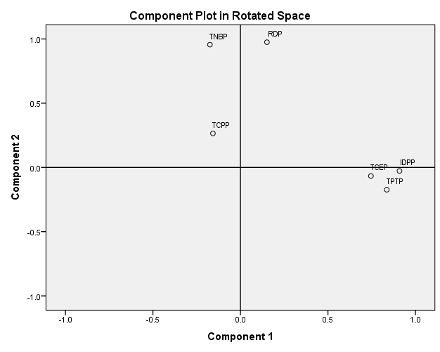
Figure 4: Two-dimensional principal component loading plots for OPFRs in the sediment of Afiesere river

Conclusions
This study has shown the presence of OPFRs in river sediments in Afiesere, Niger Delta Nigeria. The midstream of the river exhibited the highest concentrations of the OPFRs due to high urbanization and anthropogenic activities in the midstream section of the river. The TCEP was the dominant OPFR in the sediments. There was a very high correlation between the OPFRs and TOC concentrations in sediment which indicates TOC influenced geochemistry and fate of OPFRs in sediments. We hereby recommend further studies to determine the impact of the OPFRs in the Afiesere River.

Disclaimer (Artificial intelligence)

Author(s) hereby declare that NO generative AI technologies such as Large Language Models (ChatGPT, COPILOT, etc.) and text-to-image generators have been used during the writing or editing of this manuscript.

REFERENCES
Cai, L., Shi, Y., Pan, C., Zhu, F., Wang, S., Dai, J., Yang, M., & Ma, J. (2022). Occurrence, distribution, and risk of organophosphate flame retardants in sediments from Jiulong river estuary and adjacent western Taiwan strait, China. Int. J. Environ. Res. Public Health, 19: 2449
Choi, W., Lee, S., Lee, H.K., & Moon, H.B. (2020). Organophosphate flame retardants and plasticizers in sediment and bivalves along the Korean coast: occurrence, geographical distribution, and a potential for bioaccumulation. Mar Pollut Bull., 156: 111275
Chokwe, T.B., & Okonkwo, J.O. (2019). Occurrence, distribution and ecological risk assessment of organophosphorus flame retardants and plasticizers in sediment samples along the Vaal River catchment, South Africa. Emerg Contam., 5: 173–178.
Chokwe, T.B., Abafe, O.A., Mbelu, S.P., Okonkwo, J.O., & Sibali, L.L. (2020). A review of sources, fate, levels, toxicity, exposure and transformations of organophosphorus flame-retardants and plasticizers in the environment. Emerging Contaminants, 6: 345-366
Feng, L., Ouyang, F., Liu, L., Wang, X., Wang, X., Li, Y.J., Murtha, A., Shen, H., Zhang, J., & Zhang, J.J. (2016). Levels of urinary metabolites of organophosphate flame retardants, TDCIPP, and TPHP, in pregnant women in Shanghai. J. Environ. Public Health, 2016: 9416054.
Gbadamosi, M.R., Ogunneye, A.L., Jegede, D.O., Abdallah, M.A., & Harrad, S. (2023). Occurrence, source apportionment, and ecological risk assessment of organophosphate esters in surface sediment from the Ogun and Osun Rivers, Southwest Nigeria. Environmental Science and Pollution Research, 30: 124274–124285
Giulivo, M., Capri, E., Kalogianni, E., Milacic, R., Majone, B., Ferrari, F., Eljarrat, E., & Barcelo, D. (2017). Occurrence of halogenated and organophosphate flame retardants in sediment and fish samples from three European river basins, Sci. Total Environ. 586: 782-791
Han, B., Chen, L., Li, Y., Yu, L., Zhang, J., Tao, S., & Liu, W. (2022). Spatial distribution and risk assessment of 11 organophosphate flame retardants in soils from different regions of agricultural farmlands in mainland China. Sci Total Environ 842: 156806
Iwegbue, C.M.A., Oshenyen, V.E., Peretiemo-Clarke, B.O., Olisah, C., Nwajei, G.E., & Martincigh, B.S. (2022). Polybrominated diphenyl ether contamination in sediments from rivers in the western Niger Delta of Nigeria. Marine Pollution Bulletin, 202: 116040
Iwegbue, C.M.A., Oshenyen, V.E., Tesi, G.O., Olisah, C., Nwajei, G.E., & Martincigh, B.S. (2022). Occurrence and spatial characteristics of polychlorinated biphenyls (PCBs) in sediments from rivers in the western Niger delta of Nigeria impacted by urban and industrial activities. Chemosphere, https://doi.org/10.1016/j.chemosphere.2021.132671
Kim, J.W., Isobe, T., Chang, K.H., Amano, A., Manega, R.H., Zamora, P.B., Siringan, F.P., & Tanabe, S. (2011). Levels and distribution of organophosphorus flame retardants and plasticizers in fishes from Manila Bay, the Philippines. Environ. Pollut. 159: 3653-3659.
Lee, S., Cho, H.J., Choi, W., & Moon, H.B. (2018). Organophosphate flame retardants (OPFRs) in water and sediment: occurrence, distribution, and hotspots of contamination of Lake Shihwa, Korea. Mar. Pollut. Bull. 130: 105-112.
Li, J., Wang, J., Taylor, A.R., Cryder, Z., Schlenk, D., & Gan, J. (2019). Inference of organophosphate ester emission history from marine sediment cores impacted by wastewater effluents. Environ Sci Technol 53(15): 8767–8775
Meeker, J.D., & Stapleton, H.M. (2010). House dust concentrations of organophosphate flame retardants in relation to hormone levels and semen quality parameters, Environ. Health Perspect. 118: 318-323
Pan, X., Liu, A., Zheng, M., Liu, J., Du, M., & Wang, L. (2022). Determination and environmental risk assessment of organophosphorus flame retardants in sediments of the South China Sea. Environ Sci Pollut Res., 29: 70542–70551
Reemtsma, T., Quintana, J.B., Rodil, R., Garcia-Lopez, M., & Rodriquez, I. (2008). Organophosphorus flame retardants and plasticizers in water and air: Occurrence and fate. Trends Anal. Chem., 27: 727-737.
Salamova, A., Ma, Y., Venier, M., & Hites, R.A. (2014). High levels of organophosphate flame retardants in the Great Lakes atmosphere. Environ. Sci. Technol. Lett. 1: 8-14.
Shi, Y., Gao, L., Li, W.H., Wang, Y., Liu, J.M., & Cai, Y. (2016). Occurrence, distribution and seasonal variation of organophosphate flame retardants and plasticizers in urban surface water in Beijing, China. Environ. Pollut. 209: 1-10.
Tan, X.X., Luo, X.J., Zheng, X.B., Li, Z.R., Sun, R.X., & Mai, B.X. (2016). Distribution of organophosphorus flame retardants in sediments from the Pearl River Delta in South China. Sci. Total Environ., 544: 77–84
Wang, Q., Lam, J.C.W., Man, Y.C., Lai, N.L.S., Kwok, K.Y., Guo, Y.Y., Lam, P.K.S., & Zhou, B. (2015). Bioconcentration, metabolism and neurotoxicity of the organophorous flame retardant 1,3-dichloro 2-propyl phosphate (TDCPP) to zebrafish. Aquat. Toxicol. 158: 108–115
Wei, G.L., Li, D.Q., Zhuo, M.N., Liao, Y.S., Xie, Z.Y., Guo, T.L., Li, J.J., Zhang, S.Y. & Liang, Z.Q. (2015). Organophosphorus flame retardants and plasticizers: sources, occurrences, toxicity and human exposure. Environ. Pollut. 196: 29-46.
Yang, F., Ding, J., Huang, W., Xie, W., & Liu, W. (2014). Particle size-specific distributions and preliminary exposure assessments of organophosphate flame retardants in office air particulate matter. Environ. Sci. Technol. 48: 63-70
Zhang, L., Lu, L., Zhu, W., Yang, B., Lu, D., Dan, S.F., & Zhang, S. (2021). Organophosphorus flame retardants (OPFRs) in the seawater and sediments of the Qinzhou Bay, Northern Beibu Gulf: occurrence, distribution, and ecological risks. Mar Pollut Bull., 168: 112368.

