Changing Climatic Patterns and Their Implications for Muga Sericulture in Jorhat, Assam, India

ABSTRACT
Muga silk from Assam, produced by the muga silkworm Antheraea assamensis, is a unique, high-value fabric known for its golden color, durability, and cultural significance, and has been granted GI status in India. However, climate change and rising temperatures threaten silkworm growth and silk production, as these insects are highly sensitive to environmental conditions like temperature and humidity, posing risks to the sericulture industry. The study investigates the impact of climate change on production of muga silk, with a special focus on five regions such as Jagduar, Titabar, Borhula, Tamulbari, and Lahdoigarh of Jorhat district of Assam, from the year 2005 to 2024. Muga silk, known for its natural golden colour, is indigenous to Assam and holds immense cultural, economic and ecological significance. However, changing climatic conditions have been adversely affecting the productivity and quality of muga silk. Based on data collected over a 20-year period (2005–2024) and field insights from the selected sericulture, the findings clearly indicate that climate change has significantly influenced both the biological and economic dimensions of Muga silk production in the Jorhat district. These changes in climatic conditions are highly impacting the quality and quantity of leaves of host plants, which are essential for larval nourishment. Moreover, farmers have reported increased larval mortality, lower cocoon yields, and diminished fiber quality. The present study aims to examine the key climatic parameters like temperature, rainfall, and humidity and analyze their direct and indirect effects on muga cocoon and silk yield.
Key words: Climate, muga, temperature, rainfall, humidity, silk, production.

INTRODUCTION
Muga silk, a luxurious fabric produced in Assam, India, has been a symbol of the region's rich cultural heritage for centuries(Reddy et al.,2024). Muga silk is derived from the muga( Antheraea assamensis) silkworm. Muga silk, due to the rare natural golden color, durability, and glossy texture, is a highly prized material in both domestic and international markets (Nath et al,2025). Muga silk is found exclusively in India, as the Muga silkworm thrives only in the climatic conditions of the northeastern region. Assam is the primary producer of muga silk contributing 89–90% of total muga production. Muga silk of Assam was granted the Geographical Indication (GI)status in 2007 under the Geographical Indications of Goods (Registration and Protection) Act, 1999(Kalita,2022).
Ecosystem integrity and species survival may be seriously threatened by climate change worldwide. It is widely acknowledged as the most imminent and pressing problem threatening human survival in the twenty-first century. An increase in worldwide atmospheric temperature rise is the key factor determining greenhouse gas (GHG) concentrations, such as those of carbon dioxide (CO2), methane (CH4), and nitrous oxide (NO2). “The burning of fossil fuels, rapid industrialization, deforestation, agricultural activities, luxury lifestyles, space explosion, grazing, wetland destruction, and land use change are all associated with rising GHG emissions” (Ram et al. 2016). Based on the increase in greenhouse gases, climate models predict a 1.4°C to 5.8°C average increase in global warming from 1990 to 2100, likely leading to a more rapid increase in temperature at the surface of the earth”(Karl et al,2003).
Antheraea assamensis., the muga silkworm is a polyphagous insect with significant economic importance that feeds primarily on host plants such as Som and Soalu . Silkworms are cold-blooded creatures with body temperatures that are roughly similar to those of their surroundings. The successful growth of silkworm and the production of silk, are determined by environmental parameters including temperature and humidity. The silkworms are sensitive to changes in ambient temperature and humidity and even a small change in these variables may lead to complete crop loss. Temperature and humidity directly affect larval growth, development, and physiological activity, as well as nutrient absorption, digestion, blood circulation, and respiration, among other things (Neelaboina et al.,2018). Rising temperatures and daily changes in weather patterns are linked to global warming, which poses a threat to the sericulture industry for both India and other countries that are associated with it.
In recent years, the traditional production of muga silk has been facing significant challenges due to the impacts of climate change. Rising temperatures, erratic rainfall patterns, and changing seasonal cycles have disrupted the delicate ecological balance required for silkworm farming. These climatic shifts have altered the natural conditions that muga silkworms depend on, such as temperature, humidity, and the availability of food sources, leading to reduced silk yields, poor quality silk, and even silkworm mortality. The present research seeks to explore the multifaceted impact of climate change on muga silk production in Assam, examining how changing weather patterns are affecting the muga silk production. It will also investigate the economic implications for the local communities dependent on muga silk production and evaluate potential adaptation strategies to mitigate the adverse effects of climate change. Through a comprehensive study, this research aims to provide valuable insights into the challenges faced by the muga silk industry and propose sustainable solutions for preserving this unique tradition in the face of an uncertain climatic future.

METHODOLOGY
1. Area of Study
The research focuses on key muga silk-producing areas of Jorhat district in Assam, such as:Jogduar, Titabar, Borhola, Tamulbari and Lahdoigarh.

2. Sources of Data
- Field visits and surveys among muga rearers, weavers, and farmers and
- questionnaires administered to muga producers.
- Government reports from the Directorate of Sericulture, Assam.
- Meteorological data from IMD (India Meteorological Department).
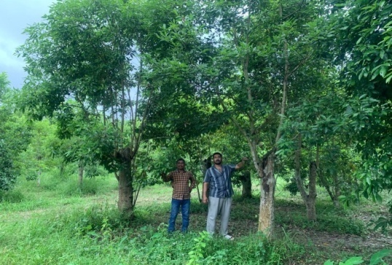 | 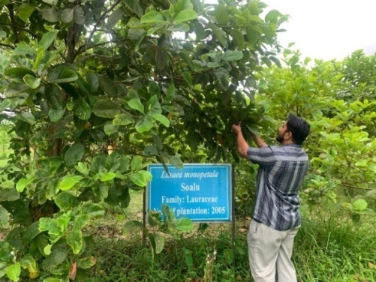
Plate 1. Field visit to Som and Soalu farm, CMER&TI, Lahdoigarh
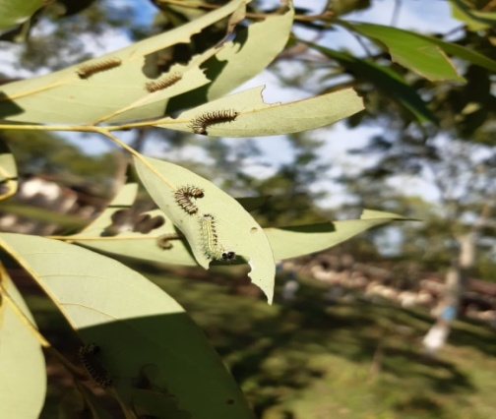 | 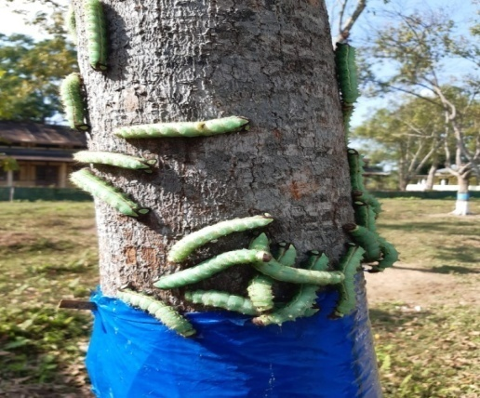
Plate 2. Field visit to muga rearing farm at Jogduar | Plate 3. Field visit to muga rearing farm at Titabar
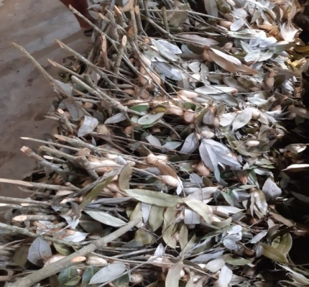 | 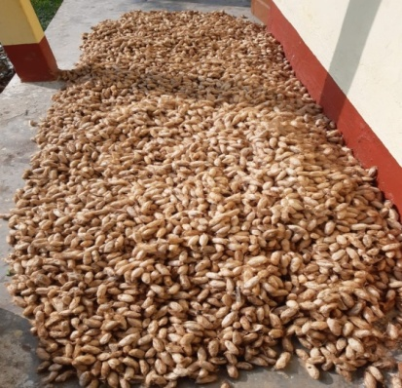
Plate 4: Cocoon formation in Jali by muga silkworm(Tamulbari) | Plate 5: Muga cocoon (Titabar)

3. Sampling Technique
A purposive sampling method will be used to select muga rearers and sericulture units from the chosen district. Approximately 50 respondents were selected and questionnaires (See appendix) were given.

5. Data Analysis Techniques
The collected data will be analyzed using both descriptive statistics (percentages and averages) and comparative analysis (year-wise production vs climatic data). graphs, and tables will be used for visualization.

RESULT AND DISCUSSION:
The present study showed a noticeable shift in climatic conditions and a gradual decline in muga silk production from the year 2005 to 2024. Over this 20-year period, the maximum temperature has steadily increased from 30.1°C to 33.8°C, while the minimum temperature has risen from 17.2°C to 20.4°C. This consistent increase in the temperature levels indicates a rise of approximately 3.7°C in maximum and 3.2°C in minimum temperature, which could be creating stressful environmental conditions for both the muga silkworms and their host plants. Tripath et al. (2017) also reported that elevated air temperatures particularly during the 4th and 5th larval instars pose a significant climatic challenge that can adversely affect both silkworms and cocoon crops.
Rainfall levels have also decreased significantly, from 2020 mm in 2005 to 1400 mm in 2024, marking a reduction of about 31%. This decline in precipitation likely contributes to drier conditions that are less favorable for the growth of Som and Soalu plants, the primary food sources for Muga silkworms.
In parallel, relative humidity (RH) has declined. Pre-monsoon RH dropped from 72% to 61%, while post-monsoon RH declined from 85% to 71% over the same period. Muga silkworms require a humid environment for optimal development, and decreasing RH may negatively affect cocoon formation and larval survival rates. Studies by Gowda and Reddy (2007) explored the impact of temperature on cocoon and reeling parameters of new bivoltine hybrids during the spinning period. Additionally, Rahmathulla et al. (2012)evaluated the influence of various nutritional and environmental stress factors on silk fiber characteristics of bivoltine silkworms.
These environmental changes correlate with a significant decline in muga cocoon and silk production. Cocoon output has decreased from 137 metric tonnes in 2005 to 98 metric tonnes in 2024, while silk production has fallen from 21.4 metric tonnes to 14.8 metric tonnes, representing a drop of over 30%. This steady decline in productivity is likely influenced by the combination of rising temperatures, reduced rainfall, and lower humidity, all of which adversely affect the muga silkworm rearing process. Similar work was done by Das et al,2023, on effect of climate change on eri and muga cultivation and the resultant impact on rural income and employment in Assam. They reported that The IPCC (2007) has projected that the global temperature would most likely rise by 4.3 to11.5 degrees Fahrenheit in the next century and silk being an agro-industrial product will be deeply affected. With muga being more susceptible to climate change, the muga cultivators would be more severely affected than the eri cultivators. Sanghi et al. (1998) calculated that a 2°C rise in mean temperature and a 7% increase in mean precipitation could reduce net revenues by 12.3% for the entire country. These findings emphasize the need for comprehensive strategies to address the multifaceted impacts of climate change on the sericulture industry.
In summary, the data strongly suggests that climate change manifested in rising temperatures, diminishing rainfall, and reduced humidity is having a detrimental impact on muga silk production in the region.
Table 1: Data on Temperature, Rainfall and Relative Humidity from the year 2005 to 2024
Year | Max Temp (°C) | Min Temp (°C) | Rainfall (mm) | RH Pre-Monsoon (%) | RH Post-Monsoon (%)
2005 | 30.1 | 17.2 | 2020 | 72 | 85
2006 | 30.4 | 17.4 | 1980 | 73 | 84
2007 | 30.3 | 17.1 | 2045 | 71 | 86
2008 | 30.6 | 17.3 | 1960 | 74 | 85
2009 | 30.9 | 17.7 | 1880 | 73 | 83
2010 | 31.0 | 17.9 | 1830 | 72 | 82
2011 | 31.3 | 18.2 | 1775 | 70 | 80
2012 | 31.6 | 18.4 | 1700 | 69 | 81
2013 | 31.8 | 18.5 | 1655 | 68 | 80
2014 | 31.7 | 18.7 | 1620 | 68 | 79
2015 | 32.0 | 18.9 | 1605 | 67 | 78
2016 | 32.3 | 19.1 | 1580 | 66 | 77
2017 | 32.5 | 19.3 | 1555 | 65 | 76
2018 | 32.7 | 19.5 | 1530 | 65 | 76
2019 | 32.9 | 19.6 | 1505 | 64 | 75
2020 | 33.0 | 19.8 | 1490 | 64 | 74
2021 | 33.2 | 20.0 | 1460 | 63 | 73
2022 | 33.4 | 20.1 | 1440 | 63 | 72
2023 | 33.6 | 20.3 | 1425 | 62 | 72
2024 | 33.8 | 20.4 | 1400 | 61 | 71
* RH=Relative Humidity

Fig 1: Graph on muga silk production (MT) during the year 2005 to 2024

Fig 2: Graph on muga cocoon production (MT) during the year 2005 to 2024

Perceptions of muga silk farmers and rearers in response to climate variability.
Farmers’ Perceptions of Climate Change and Its Impact: Farmers involved in muga silkworm rearing have reported noticeable changes in local climate patterns and their adverse effects on silkworm productivity and host plant health. About 83 per cent of respondents agreed that due to irregular rainfall patterns both plantation schedules and silkworm rearing is being affected negatively. They also reported that erratic or delay in rains is hindering timely leaf maturity. The farmers have also observed that these erratic or delay in rain has increased disease incidence among larvae. 76 per cent of farmers reported that increase in summer temperatures is hampering the main season of commercial muga rearing i.e. Kotia generation. A 69 per cent majority noted a decline in winter dew and fog, which are essential for maintaining leaf moisture. 65 per cent of respondents observed weakened nutritional value of leaves and degradation of leaf quality and quality of muga host plants. Finally, 72 per cent of farmers expressed concern over a rise in pest and disease outbreaks, which they attribute to climate stress. Notably, there has been a sharp increase in infestations by uzifly (a parasitic fly) and fungal infections, both of which can devastate Muga crops if left unmanaged.

CONCLUSION
Muga silk being a symbol of Assam’s cultural identity and economic sustenance, its future is inextricably tied to the region’s climate stability. As the gradual change in climatic condition is posing a significant threat to the muga production, a combination of proper study, scientific innovation and policy support is essential to ensure the continuity and prosperity of this golden legacy. This study reinforces the necessity of urgent and sustained interventions to protect not only a traditional livelihood but also the biodiversity and heritage it represents.

Disclaimer (Artificial intelligence)
Author(s) hereby declare that NO generative AI technologies such as Large Language Models (ChatGPT, COPILOT, etc.) and text-to-image generators have been used during the writing or editing of this manuscript.

REFERENCES
- Chanotra, S., Kumara, R. R., Saicharan, D., Guha, L. M., & Hemachandran, H. (2024). Variation in season-wise performance of Muga silkworm (Antheraeaassamensis Helfer) aimed to climate change trends: A descriptive study. International Journal of Zoology and Applied Biosciences, 9(6), 78–83.
- Das, N. (2002). A study of Muga culture with reference to income and employment generation in Kamrup District [PhD thesis, Gauhati University].
- Das, N. (2022). Geographical indication (GI) as a means of craft tourism: a case of Muga silk in Assam, India. RevistaBrasileira de Ecoturismo, 15(4).
- Das, P., & Saikia, M. (2023). Comparative impact of climate change on eri and muga cultivation Cand the resultant impact on rural income and employment in Assam. Cadernos de Geografia, 47, 1–17.
- Gowda, B.N. and Reddy, N.M. (2007). Influence of different environmental conditions on cocoon parameters and their effects on reeling performance of bivoltine hybrids of silkworm, Bombyx mori.International Journal of Industrial Entomology, 14,15-21.
- Das,P;Saikia,M and Neog,D.(2026). Effect of climate change on Eri and Muga cultivation and the resultant impact on rural income and employment in Assam.Journal of Livestock Science. Vol:14: 135-147
- Hansen, J., Sato, M., Ruedy, R., Lo, K., Lea, D. W., & Medina-Elizade, M. (2006). Global temperature change. Proceedings of the National Academy of Sciences, 103(39), 14288–14293.
- Held, I. M., & Soden, B. J. (2006). Robust responses of the hydrological cycle to global warming. Journal of Climate, 19(21), 5686–5699.
- Karl TR, Trenbeth KE. Modern global climate change sciencs. The Pharma Innovation Journal .2003;302(5651):1719-1723
- Konwar, J., Borthakur, M. K., & Goswami, J. (2024). Impact of Muga silkworm culture in augmenting rural income of Assam, India. Asian Journal of Agricultural Extension, Economics & Sociology, 42(9), 133–139.
- Kumar, V., Singh, A., Majumdar, M., Kumar, N., & Bhatia, N. K. (2025). Impact of seasonal variations on economic grainage traits of Muga silkworm (Antheraeaassamensis) in Garo Hills, India. Archives of Current Research International, 25(4), 164–169.
- Narzary, P. R. N., Manimegalai, S., Shanmugam, R., Vinothkumar, B., Suganthi, A., & Radha, P. (2023). Golden threads of tradition: endurance and evolution of Muga culture and silk weaving in Assam. Journal of Survey in Fisheries Sciences, 10(3).
- Neelaboina BK,Khan GA,Kumar S,Gani M,Ahmad MN,GhoshMK. Impact of climate change on agriculture and sericulture. Journal of Entomology and Zoology Studies.2018;6(5):426-429
- Nath, I; Dutta,L.D and Narzary,P.R(2015). Muga Silk: A Review on its Structural, Physical, and Biomedical Significance.Journal of Experimental Agriculture International. Volume 47( 7): 850-863.
- Parmesan, C., & Yohe, G. (2003). A globally coherent fingerprint of climate change impacts across natural systems. Nature, 421(6918), 37–42.
- Rajkhowa, A., Saikia, M., Brahma, D., Sarma, J., Bora, N. R., & Saikia, R. R. (2024). Impact of ant infestation on Muga silkworms: insights from farmer observations. International Journal of Plant & Soil Science, 36(8), 766–772.
- Ram RL, Maji C, Bindroo BB. Impact of Climate Change on Sustainable Sericultural Development in India. International Journal of Agriculture Innovations and Research. 2016;4(6):110-118.
- Rahmathulla, V.K. (2012). Management of climatic factorsfor successful silkworm (Bombyx mori L.) crop andhigher silk production: a review. Psyche: A Journal of Entomology, pp. 1-12.
- Reddy, A. G. (2022). Economic analysis of Muga culture in Lakhimpur district of Assam [Master’s thesis]. Krishikosh Repository, CAU-Imphal.
- Reddy,Y.P.; Kashyap,B. and Patil,N.M.(2024). Muga Silkworms: A Treasure of Assam’s Textile Heritage. the agriculture magazine. Vol 4( 3).
- Sanghi A, Mendelsohn R, and Dinar A. (1998). The climatesensitivity of Indian agriculture In Measuring theimpact of climate change on Indian agriculture, editedby A Dinar, R Mendelsohn, R Evenson, J Parikh, ASanghi, K Kumar, J Mckinsey, and S LonerganWashington, DC: World Bank.
- Thomas, C. D., Cameron, A., Green, R. E., Bakkenes, M., Beaumont, L. J., Collingham, Y. C., ... & Williams, S. E. (2004). Extinction risk from climate change. Nature, 427(6970), 145–148.
- Tripathi, A.K. and Singh Prashant. 2017. The effect ofclimate change on the mulberry insect fauna in Indiatemperate and subtropical regions. Journal ofMultidisciplinary Peer Reviewed, 3(11), 2581-4230.

Appendix: QUESTIONNAIRE FORM
Questionnaire for the farmers to collect information regarding “Impact of climate change on Muga silk production in Assam”.

Section A: General Information
- Age Group:
- 18-25
- 26-35
- 36-45
- 46 and above

- Occupation:
- Student
- Business Owner
- Government Employee
- Private Sector
- Other (please specify): ___________

Section B: Awareness of climate change
- Are you aware of the harmful effects of climate change on Sericulture?
- Yes
- No
- Do you know how climate change is impacting Muga production ?
- Yes
- No
- How does rising temperature affecting muga silkworm?
- Increase in silkworm mortality
- Increase in disease incidence
- Both
- No impact
Other (please specify): ___________

- Does prolonged rainfall has any impact on muga rearing?
- Increase in silkworm mortality
- Increase in disease incidence
- Both
- No impact
Other (please specify): ___________
- Does lack of rainfall has any impact on muga rearing?
- Increase in silkworm mortality
- Increase in disease incidence
- Both
- No impact
Other (please specify): ___________
- Which season is most favourable as any?
- Spring
- Summer
- Autumn
- Winter
- All of the above
- Are you facing reduction in muga production due to climate change?
- Yes
- No

Section C: Perception of Policies and Management
- Do you think the government is doing enough to manage the problems related to Muga production?
- Yes
- No
- Not sure
- Have you noticed any government campaigns promoting awareness on climate change ?
- Yes
- No
- What do you think could improve muga silk production in Assam?
(Select all that apply)
- More awareness campaigns
- Sustainable use of sericulture
- Availability of good quality seed cocoon
Other (please specify): ___________

Section D: Personal Opinions
- Would you be willing to participate in a community program focused on mitigating climate change problems on muga sector ?
- Yes
- No
- Maybe
- Do you think public awareness about climate change to br improved?
- Yes
- No
- Not sure
- .Any suggestions or comments on how impact of climate change can be managed in Assam ?

Thank you for your time and participation!

