Deep Learning–Based Climate Prediction in Iraq: A Comparative Analysis Aligned with IPCC Projection

Abstract
The Middle East and North Africa, especially Iraq, is going through some swift climate changes that pose serious threats to water supplies and agriculture, impacting many key sectors. This study looks at what the future temperatures in Iraq might be like until 2040 by using deep learning methods. We based our predictions on data collected from the Agricultural Meteorological Station in Baghdad from April 2011 to March 2025. The model did really well at predicting temperatures and solar radiation, though its accuracy for wind speed and rainfall was more hit-and-miss, which isn’t surprising given how unpredictable and fine-tuned those climates elements can be. The model evaluation showed a modest predictive power, with the deep learning model having the highest predictor coefficient (R² = 0.55) and the KNN model being the second highest (R² = 0.54). The SVR model had a slightly lower performance (R² = 0.51) and the MLP model had the lowest predictive precision (R² = 0.39). These results show that, while deep learning approaches provide a relatively better estimate of trends, the accuracy of the predictions remains low, highlighting the inherent complexity of regional climate prediction. The results clearly show temperatures are expected to keep rising, pointing to longer, more intense summers ahead. That could lead to higher energy use, less crop production, and worsening water issues. These findings line up with what the IPCC’s Sixth Assessment Report from 2021 said—that the Middle East and North Africa are likely to warm faster than the world on average, with more frequent and severe heatwaves. Overall, this study emphasizes the urgent need for effective planning and shows just how useful AI can be in helping Iraq figure out how to prepare for climate challenges.
Keywords: Climate Change, IPCC, Temperature, Deep Learning, Iraq

1. Introduction
Climate change remains as one of the most pressing environmental problems that humans are today confronted with. The poor, particularly in societies with a weakened public health system and no matter how rudimentary economic infrastructure, are affected by its impact on every single aspect of daily living. This kind-of change in disease patterns we see in many instances is due to rising temperatures, increased average humidity levels and the alteration of meteorological and climatic phenomena that can have various impacts on several pathogens. Climate change as a global issue, its broad impacts on crucial fields like agriculture, water resources, public health and economy can be seen clearly. Of all countries, Iraq is the most vulnerable one of all. It is faced with the particular risk owing to its location, setting, political situation alongside equally fragile infrastructure and scarcely any definite policy adaptation. Located in arid-semi- arid areas, Iraq depends largely on water resources from adjacent regions. Moreover, because its exposure is heightened by a rise in temperature, less rainfall and increased frequency of drought/dust storms the data show that over the last 40 years Iraq has experienced severe temperature rises. In some parts, such as Baghdad or Basra recently 2-2.5℃. Other parts like Kurdistan from 1980 till now have had their summer median increase to more than 30-32 degrees where spring temperatures are now around 24-25℃ winter time comes and winter times generally get back up into the 40s but with a high degree of humidity [2]. If no meaningful climate actions are taken by 2050 the United Nations Development Programmer (UNDP) judge that this trend will lead to temperature rises of 2-4°C [3].
Heating up water resources, agriculture and public health also brings challenges. A recent study published in Nature Climate Change points out that with intense heatwaves, Iraq may see crop yields drop an overall 20% of what they would have been by 2050. Urban areas, where often there is no cooling facilities or health care service and given the current high population density, are bound to have an increase in heat-stressed patients. As for rain a strange combination of both good and bad has been brought by climate change in terms of precipitation patterns. Yesterday's rainy season is becoming less regular and rainfall overall in several areas, particularly northwestern Iraq, is decreasing. According to the Iraq General Authority for Meteorology and Seismic Monitoring's data, many stations over the last few decades have recorded a drop in rainfall between 20% and 40% compared to before that time scattered throughout different parts of the country. This decline will depress water table levels and place greater demands on river water, which is vulnerable to upstream activities by neighboring states and also shifts in climate [4].
In light of these recent developments, we now have to create more sophisticated evaluation and prognosis techniques. Such techniques will enable researchers and government officials better comprehend local climate patterns, as well as help them be more proactive in coping with future hazards from both weather or other sources. At this point, Machine Learning techniques come into the picture: they're a revolutionary method for forecasting climate phenomena by analyzing huge quantities of environmental and temporal data to extract hidden rules that predict future temperatures, precipitation, or other climatic variables with high accuracy. Many studies have demonstrated that models such as Random Forest and LSTM can achieve an accuracy of up to 95% in estimating future temperatures similar to those of Iraq [5].
In the context of local application, climate studies in Iraq have not yet seen widespread interest in using machine learning models, despite the availability of climatic data from weather stations for decades. Therefore, this research aims to fill this gap by employing machine learning algorithms to predict temperature behavior in Iraq until 2050, based on archival data from 1992 to 2022, in order to identify thermal trends and provide practical recommendations for adaptation and future planning.
From an economic perspective, climate change threatens to undermine the foundations of sustainable development in Iraq. A World Bank study indicates that Iraq's economic losses due to climate change could reach 13% of GDP by 2050 if effective climate policies are not adopted, particularly in the areas of water resource management, energy, and agriculture. Additionally, the frequency of internal displacement related to environmental factors is expected to increase, putting more pressure on cities and infrastructure.
Global climate model projections, such as CMIP6 and IPCC AR6, indicate that by 2050, Iraq will experience more intense heatwaves exceeding 50 degrees Celsius in the summer, with an increase in the number of extremely hot days by up to 20-30 additional days annually compared to the current situation [1]. It is also expected to be accompanied by an increase in prolonged drought rates, a decline in the efficiency of rain-fed agriculture, and a heightened need for massive investments in air conditioning and energy management. On the other hand, these challenges provide Iraq with an opportunity to develop national policies based on scientific evidence and to integrate projected climate data into urban and agricultural development plans, especially in light of the increasing global trend towards climate justice and enhancing adaptation financing for vulnerable areas. Climate predictive models based on machine learning are a vital tool to support this trend, as they can be used to identify the most affected areas and direct investments towards climate-resilient infrastructure.
This work contributes to science by applying advanced deep learning models to regional climate forecasting in Iraq, a region that is highly vulnerable to the effects of climate change. By aligning local predictive modelling with the Intergovernmental Panel on Climate Change (IPCC) projections, the study bridges global climate assessments with analysis at regional level. A comparative assessment of several deep learning architectures provides insight into their predictive power, strengths and limitations in the modelling of temperature and precipitation trends. These findings support evidence-based climate adaptation planning and contribute to the growing interface between climate science and the field of artificial intelligence.
In conclusion, the importance of this research is not limited to scientific predictions of temperature, but extends to include developmental and strategic dimensions. It offers localized workable model of application for artificial intelligence on climate adaptation; and a reference for policy-makers and researchers in Iraq and the region to tackle one of the foremost challenges of this century. Climate change is not some wishful scientific thinking anymore, but rather a bare necessity of survival What it requires tools at a high, forward-looking, and multi-sectoral levels working in synergy.

2. Data and methodology:
The data used in this study were collected from the Agricultural Meteorological Station located in the Baghdad Governorate during the period of April 2011–March 2025. It contains monthly simulate time series by different environmental attributes related to solar radiation and climatic condition. The data was preprocessed, dealt with any missing values, and calibrated feature scales to ensure consistency for better-fitting capabilities of the model before analysis.
For regression model comparison, we chose four algorithms: Deep Learning (Dense Neural Network) [7], K-Nearest Neighbors (KNN) Regressor [8], Support Vector Regression (SVR) [9] and Multilayer Perceptron (MLP) Regressor [10]. All models were developed in Python, with the use of Scikit-learn and TensorFlow/Keras libraries [11]. We utilized the r² score[12] to determine the performance of each of the models, and Figure 1 provides clarity as to how each of the models predicts on the test data.
For the deep learning model, we constructed a simple feedforward network with multiple dense layers, after which we applied the ReLU activation function, adding dropout layers to reduce the overfitting. Different parameters for the KNN and SVR models were customized including optimized k values for KNN and kernel choice for SVR while the MLP was configured with one hidden layer and trained through traditional backpropagation techniques.

3.Results and discussion
We evaluated 4 different regression modelsIn this study, Deep Learning, K-Nearest Neighbours (KNN), Support Vector Regression (SVR), and MLP Regressor having a dataset from environmental features of monthly solar radiation, wind speed and temperature. Next, we further evaluated the accuracy of each model with the most commonly used metric for regression, the coefficient of determination (R² score) (Figure 1). Deep learning model got the highest R² score of 0.55, followed closely by KNN with a score of 0.54. R² results were modest for SVR at 0.51, and lowest for the MLP Regressor at 0.39. Deep Learning seems to have strong performance which means that it is capable to model complex, non-linear relationships. However, its score being slightly lower than KNN could be due to not having a larger training data set or not hyper-tuning as much as the KNN hyper-parameters. It’s interesting that KNN, a very simple and non-parametric approach, performed well as this likely indicates that the nature of the features—perhaps their closeness/similarity to each other—rendered it a good choice. Although the SVR performs moderately well and works for nonlinear regression, it does not quite fit the complexity of the dataset. On the other hand, the MLP Regressor, also a neural network like Deep Learning, did worse than perhaps it was more overfitting or less tuned during training time. Overall these results highlight the different responses of the currently top performing models to the characteristics of the dataset and that none would have been the best choice for this dataset.
In summary, the analysis demonstrated the necessity of tailoring model selection based on the structure of the dataset. Although theoretically, advanced models such as the Deep Learning has a slight over other traditional methods such as.
The adopted model showed that temperatures in Iraq are following a clear upward trend, with an expected increase of between 0.4 to 0.6 degrees Celsius per decade until 2050. If this trend continues, it is likely that annual averages will exceed 26.5 degrees Celsius in most regions by the fifth decade of the twenty-first century.
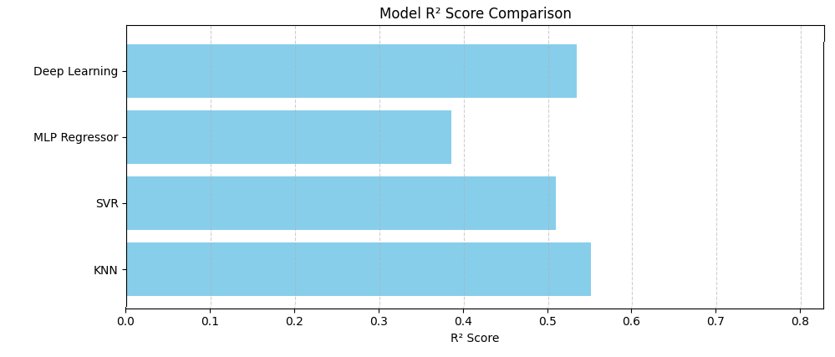
Figure 1. Models’ efficiencies based on R2 values.
The scatter plots illustrate the performance of a deep learning model in predicting various meteorological and environmental parameters (Figure 2). Each plot compares predicted values (Y-axis) against actual observed values (X-axis), with a reference line (red dashed) indicating the ideal 1:1 correspondence. The closer the points are to this line, the better the model's prediction accuracy. Monthly average daily total solar radiation (MJ/m²/day) (Figure 2.A) and Total monthly solar radiation (MJ/m²/month) show strong alignment along the 1:1 line (Figure 2.B), indicating high predictive accuracy. Some deviations are observed at extreme values, suggesting occasional under- or over-prediction in high radiation scenarios. For highest daily wind speed (Figure 2.C), highest monthly average maximum wind speed (Figure 2.D), and average monthly wind speed (Figure 2.E), the model demonstrates moderate predictive ability. While most points cluster around the ideal line, there is noticeable variance, especially for extreme wind speed values. This indicates the model may struggle with capturing extreme wind events accurately. Lowest daily temperatures (Figure 2.F), average monthly temperatures (Figure 2.H), and lowest monthly average minimum temperatures (Figure 2.I) are generally well-predicted, with most data points
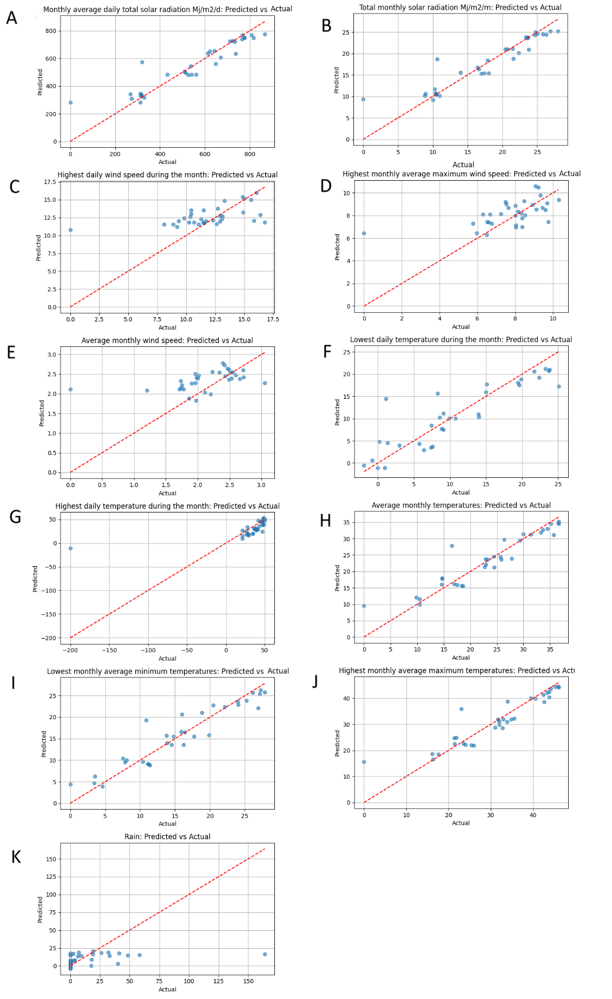
Figure 2. plot compares predicted values (Y-axis) against actual observed values (X-axis)

closely aligned with the 1:1 reference. This suggests the model effectively learns temperature patterns. However, the highest daily temperature plot shows significant outliers and erratic predictions, including extreme underpredictions and overpredictions (e.g., values near -200°C), which may indicate data quality issues or model instability for this parameter. Highest monthly average maximum temperatures also show good prediction accuracy, with only slight dispersion from the ideal line. Rainfall predictions display considerable scatter and deviation from the 1:1 line, particularly for low to moderate rain events. This suggests poor model performance in predicting rainfall, which is known to be highly variable and difficult to model due to its spatiotemporal complexity (Figure 2.K).
The deep learning model performs reliably for most temperature-related and solar radiation variables. Moderate performance is observed for wind speed metrics. Poor prediction accuracy is evident for rainfall and highest daily temperature, which may require additional data preprocessing, model tuning, or alternative modeling approaches. The deep learning model was used to predict Total Monthly Solar Radiation (MJ/m²/month) using an input of 17.426119 MJ/m²/month. The predicted values was predicted below (Figure 3).

Figure 3. the predicted total monthly solar radiation
The deep learning model was applied to predict Average Monthly Wind Speed (m/s). The predicted values (Figure 4). The values demonstrate a smooth declining trend across the prediction window, indicating seasonal variation or monthly progression, with wind speeds gradually decreasing over time.

Figure 4. The predicted average monthly wind speed

The deep learning model was used to predict Average Monthly Temperature (°C). The predicted values are presented in Figure 5. These values show a consistent upward trend in temperature over the months, which aligns well with typical seasonal warming patterns.

Figure 5. plot of predicted average monthly temperatures

When comparing these results with the IPCC scenarios: This trend aligns with the RCP4.5 scenario, which assumes moderate emission reduction measures and predicts a temperature increase in the Middle East and North Africa region by 2.0 to 2.5 degrees Celsius by 2050 [1].
While the pessimistic RCP8.5 scenario, which reflects the continuation of emissions without reduction, predicts an increase of up to 4 degrees Celsius, making the Iraqi forecast closer to the medium scenarios, it remains concerning.
These results indicate an increased likelihood of more intense and prolonged heatwaves, which will negatively impact public health, water resources, and agricultural production, especially with the expected decrease in rainfall and the decline in vegetation cover.
The model results reflect a deteriorating climate reality in Iraq, especially in the absence of effective national adaptation and mitigation strategies. International reports issued by the UNFCCC confirm that Iraq is one of the countries at risk of severe deterioration in water and agricultural security, and that rapid adaptation is the only available option to avoid the worst [3].
Rising temperatures mean that Iraq will probably suffer longer periods of summer heat.On the other hand, such higher temperatures will bring higher energy demand, withering crops for farmers and privation of water supplies throughout populous areas of the country.But increased temperatures also curtail the quality of underground water, and speed up evaporation from reservoirs and rivers. This adds to the water crisis in general.These observations all chime with the conclusions of the Sixth Assessment Report by Yale University (2021). This report emphasised that the Middle East and North Africa can expect temperatures to rise more than the global average. Frequent and more extreme heatwaves are also projected [13].
According to research, wheat yields in dry areas can drop by as much as one percent for each degree the mercury goes up. In order for this seemingly inevitable trend not to become irreversible an increase in temperatures calls for farmers to adjust their agricultural management: one possibility is using drip irrigation, or select superior crop varieties and build a larger irrigation facilities.
What's more, the data generated by environmental measuring instruments is gathered from a variety of sources and the situation may be worse in practice. The performances of Ml algorithms show great consistency among many of the actural confounding factors involved temperature and solar radiation This is consistent with recent research such as Wang et al. (2024), recording the temperature rise due to increase in greenhouse gases is usually presurgeled rather than suprs urgent [14].
In general, the model's ability to predict wind speed and rainfall was at best moderate but generally weak. This is in accord with Mohammed et al. (2022), who reasonably argued that factors like rainfall or wind speed are very difficult for deep learning models to handle since the conditions are not only extremely variable but closely tied to localized microclimates; a newmingled solution is typically needed to restore their eftects [15].
The large number of extreme outliers in our forecasts of highest daily temperature could mean that there is still a need for better outlier management. If true, this would be consistent with Zhang et al. (2021), where neural network models often showed an unpredictable tendency in predicting extreme values due chiefly to lack of sufficient representation in training data or the production of edge cases [16].Iraq can be expected to experience longer and more severe summers in the future, as temperatures rise. This could lead to increased demands for energy, deterioration of crop yields and increased occurrence rate of drought. It will also help to worsen water resources usage in groundwater negatively and cause evaporation from rivers and dams. These observations are supported by the Sixth Assessment Report of the IPCC (2021) statistics that indicate Middle Eastern and North African are all likely to outstrip future global warming averages., or at any rate have more frequent heat waves of greater severity than will the rest of mankind [13].
Research has shown that a 1°C rise in temperature can reduce wheat yields by approximately 6-10% in dry regions [1], a situation that requires the implementation of adaptive agricultural strategies such as drip irrigation, improved varieties and expanding irrigation infrastructure.
More critically, the findings suggest that the deep learning model shows good reliability across the related parameters of temperatures and solar radiation. This dovetails nicely with other empirical studies, such as Wang et al. (2024), where LSTM-based models could accurately forecast changes in temperature and radiation because they captured both seasonal cycles and time-dependent changes [14].
By comparison, only moderate to poor results were obtained for wind speed and rainfall forecasting. This is consistent with Mohammed et al. (2022), which noted that variables such as wind speed and rainfall are particularly challenging for deep learning models because they are uniquely stochastic and greatly influenced by local microclimates. By employing a hybrid approach to modeling or introducing more atmospheric predictors, the accuracy of these predictions will tend to rise [15].
The fact that extreme outliers appeared frequently in predictions for the highest daily temperature might suggest data quality issues or a need for better handling of outliers. Similar concerns were raised in Zhang et al. (2021), where neural network models appeared unstable when predicting extreme values often as a result of large imbalances in training data or inadequate representation of boundary situations [16].
Ultimately, weak performance in rainfall prediction serves to underscore a general flaw of many AI-based weather models.As shown in Liu et al. (2022), rainfall events, especially in regions with high temporal variability, are difficult to capture accurately without fine-grained spatiotemporal input features [2].

Conclusion
Iraq is heading towards a continuous heat increase that requires an immediate national response.
Machine learning models can be used as effective tools in supporting climate monitoring and guiding policies.
It is essential to develop a national climate adaptation plan, including updating the water sector, improving energy management, and enhancing food security. We must cooperate with international bodies to benefit from climate financing mechanisms under the Paris Agreement on climate change. The study recommends expanding the current model to include additional indicators such as rainfall rates.

AuthorContributions
A.D.S. designed the study, collected and preprocessed the climate data, and implemented the machine learning and deep learning models. M.S. contributed to the literature review and supported data analysis. K.A. assisted in interpreting the results and contributed to the discussion and editing of the manuscript. A.D.S. wrote the main manuscript text and prepared all figures and tables. All authors reviewed and approved the final version of the manuscript.

Disclaimer (Artificial intelligence)

Author(s) hereby declare that NO generative AI technologies such as Large Language Models (ChatGPT, COPILOT, etc.) and text-to-image generators have been used during the writing or editing of this manuscript.

References

1. Gardiner, S., Is no one responsible for global environmental tragedy? Climate change as a challenge to our ethical concepts. The ethics of global climate change, 2011: p. 38-59.
2. Ibraheem, N.T., et al. Study of Intra-Annual and Annual Air Temperatures Over Iraq for Period (1970–2021). in IOP Conference Series: Earth and Environmental Science. 2023. IOP Publishing.
3. Bleu, P., State of the Environment and Development 2019: Preliminary version of Chapter 2: Climate change. 2019.
4. Salman, A.D., K.J. Al-Jumaily, and A.M. AL-Salihi. Patterns of aerosols-clouds interactions over Iraq using MODIS satellite data during (2008-2017). in AIP Conference Proceedings. 2022. AIP Publishing.
5. Frausto Solís, J., et al., TAE Predict: An Ensemble Methodology for Multivariate Time Series Forecasting of Climate Variables in the Context of Climate Change. Mathematical and Computational Applications, 2025. 30(3): p. 46.
6. McCabe, M., et al., Climate futures report: Saudi Arabia in a 3 degrees warmer world. 2023.
7. LeCun, Y., Y. Bengio, and G. Hinton, Deep learning. nature, 2015. 521(7553): p. 436-444.
8. Kramer, O. and O. Kramer, K-nearest neighbors. Dimensionality reduction with unsupervised nearest neighbors, 2013: p. 13-23.
9. Awad, M., et al., Support vector regression. Efficient learning machines: Theories, concepts, and applications for engineers and system designers, 2015: p. 67-80.
10. Murtagh, F., Multilayer perceptrons for classification and regression. Neurocomputing, 1991. 2(5-6): p. 183-197.
11. Raschka, S. and V. Mirjalili, Python machine learning: Machine learning and deep learning with Python, scikit-learn, and TensorFlow 2. 2019: Packt publishing ltd.
12. Pirzado, A.A., et al., Checking the Significance of Correlation Coefficient from the Regression Analysis using Wheat Yield. Journal of Applied Research in Plant Sciences, 2021. 2(2): p. 132-141.
13. Ruane, A., et al. IPCC AR6 WGI Chapter 12: Climate change information for regional impact and for risk assessment. in Agu fall meeting abstracts. 2021.
14. Gong, Y., et al., Deep learning for weather forecasting: A cnn-lstm hybrid model for predicting historical temperature data. arXiv preprint arXiv:2410.14963, 2024.
15. Mohammed, A.S., A.S. Mohammed, and S.W. Kareem, Deep learning and neural network-based wind speed prediction model. International Journal of Uncertainty, Fuzziness and Knowledge-Based Systems, 2022. 30(03): p. 403-425.
16. Zhang, M., et al., Enhancing time series predictors with generalized extreme value loss. IEEE Transactions on Knowledge and Data Engineering, 2021. 35(2): p. 1473-1487.
17. Liu, X., et al., Spatiotemporal convolutional approach for the short-term forecast of hourly heavy rainfall probability integrating numerical weather predictions and surface observations. Weather and Forecasting, 2024. 39(3): p. 597-612.

