Climate Change Education: The Past, Present Publication Trends and Future Research Agenda

Abstract
Climate Change Education (CCE) has developed as a critical field for promoting climate literacy, resilience, and sustainable behaviour among global communities. Despite various bibliometric studies on environmental education and climate change, there is still a lack of comprehensive longitudinal studies, particularly on CCE. This study closes the gap by undertaking a quantitative bibliometric analysis of CCE using three-decade Scopus publications, looking at productivity, social networks, and co-occurrence networks. The bibliometric analysis of CCE highlights a rapidly evolving field marked by high levels of collaboration, citation impact, and an accelerating publication trend, particularly since 2017. The most recent quinquennium (2020-2024) accounts for nearly 62% of all articles on the subject, indicating a surge in research interest and likely greater financing for CCE research. The significant increase in publications from 2022 to 2024 shows an almost 100% increase over two years, demonstrating an exceptional spike in research focus on CCE. This indicates both a growing awareness of CCE's importance and likely increased research funding in response to global climate challenges. The analysis reveals that CCE research is multi-disciplinary and trans-disciplinary, encompassing not only environmental education but also the integration of technological, psychological, and sociocultural dimensions that collectively enrich the pedagogical landscape. The study's findings provide a resourceful academic foundation for expanding CCE as a transformational research area in global education policy and practice, and emphasizing the importance of collaborative, inclusive, and accessible approaches to preparing policy frameworks for current and future generations to address the challenging realities of climate change and education.

Keywords: Bibliometric analysis, Climate literacy, Climate justice, Teacher education, Environmental education.
INTRODUCTION
Climate change is one of the vital issues that humanity faces today ^{[1][2]}. It is acknowledged as a very complex global issue, ^{[3]} affecting practically every element of human and biological systems, with certain regions experiencing increased danger. Countries where agriculture is the major economic driver are especially susceptible, since climate change may seriously impact food production and economic stability ^{[4]}. Climate change is increasingly recognized not merely as an environmental concern but also as a security threat, given its ability to stymie national growth, exacerbate socioeconomic gaps, and fuel resource conflicts. In light of recent catastrophic weather occurrences, policy frameworks have begun to approach climate-related risks as vital to national security, tying climate discourse to wider agendas connected to anthropogenic dangers ^{[5][6]}.
Education has emerged as an important instrument for addressing the urgency of climate change^{[7]}. Universities, in particular, play an important role in CCE, preparing future leaders to make educated, sustainable decisions ^{[8],[9]}. Effective climate education goes beyond individual action, shaping public perception and cultivating a culture that incorporates climate mitigation activities across professional and personal spheres. As a result, climate change has prompted a rethinking of formal education, urging a focus on sustainability and cross-disciplinary collaboration to address scientific, social, environmental, and political problems ^{[10], [11].} While climate change is a global issue that requires international collaboration, CCE is still under-represented in formal school curricula across the world ^{[12]}, because there are few standardized climate education programs, knowledge and understanding of climate change are sometimes restricted to the efforts of dedicated individuals or isolated projects, rather than being integrated into educational systems ^{[13]}. As a result, there is an urgent need for a comprehensive, coordinated approach to CCE across all educational levels.

LITERATURE REVIEW
In addition to scientific education, multidisciplinary approaches are widely recognized as critical for addressing the numerous challenges posed by climate change. Because environmental, social, and economic systems are interrelated, joint efforts are required to investigate long-term solutions and encourage behavioural changes ^{[14]}. Climate change communication methods must adapt in order to engage broad audiences and encourage real action ^{[15]}. Integrating climate change education into the formal science curriculum allows students to build essential competencies such as scientific literacy, systems thinking, and problem-solving skills ^{[16]}. Moreover, Climate Change Education has become a cornerstone agenda of the global call under Education for Sustainable Development to combat climate change and is counted as one of the significant subgoals of Sustainable Development (SDG13.3) ^{[17]}. This recognition is ratified in Article 12 of the Paris Agreement, which urges all signatory countries to integrate CCE into their curricula and raise public awareness and skills^{[18]}. Intensifying the scale of these movements, the UNFCCC’s Action for Climate Empowerment (ACE) agenda advocates for enhancing climate literacy and promoting greening initiatives among countries ^{[19]}. In short, all these endeavors have culminated in significant progress, raising a specialized academic discipline and integrating climate-related topics across diverse disciplines, such as engineering and healthcare, with a focus on developing practical skills to address climate change.
To quantitatively evaluate and understand the structure of the literature related to climate change education, previous scientific analyses have been conducted by Lestari et al., (2024) to explore the international knowledge base on climate change education to address the climate emergency by fostering climate-literate citizens. The study uses bibliometric techniques to analyze 1,264 articles published between 2000 and 2022. Data has been collected only from Web of Science. The study identified the intellectual knowledge structure and inter-journal referencing, including the theoretical basis of CCE, psychology of CCE, communication, climate change within socio-scientific issues, conceptions of climate change, and epistemology of CCE. Subsequently, Ridwan et al., (2023) also quantitatively analyze the literature on Climate change education in experiential learning to explore emerging trends in climate change education and experiential learning in science education. The study used 480 Scopus articles on climate change and experiential learning in science education published from 2013 to 2022.
Despite the growing importance of Climate Change Education (CCE), no comprehensive study has examined its development, focusing exclusively on the domain of Climate Change Education (CCE) over the past three decades (1992–2024). Given the growing global significance of climate change, it is essential to critically examine how CCE research has evolved, its current state, and its future agenda. Such an inquiry should map the intellectual growth of the field by identifying leading scholars, major contributing countries, emerging thematic trends, most importantly, patterns of international and author collaboration, and funding sources that have influenced and shaped the CCE knowledge landscape.
Bibliometric analysis has been provided academic prominence among higher education researchers [22], [23], [24], [25], [26], [27]. Collaboration in academics and academic publication is crucial for growth and development since it helps authors, institutions, and countries as a whole in several ways ^{[26]}. Collaboration across authors, affiliations, and countries is critical in CCE research for a variety of significant reasons. Throughout the years, various initiatives and expenditures have been established to increase research capacity and encourage collaborative research ^{[28]}. Collaboration networks can be a beneficial supplement to publications and citation outputs ^{[29]}, and academic contribution is acknowledged through citation ^{[30]}, collaboration and citation are essential in the realm of research and publications ^{[31]}.The Co-occurrence network analysis of authors' keywords provides useful insights and has been the top priority among scholars in bibliometric analysis in the academic landscape. [32], [33], [34], [35], [36], [37].

Research Gap
Existing bibliometric studies highlight the climate change-related aspects; bibliometrics on climate literacy ^{[38]}, exploration of the international knowledge base on CCE ^{[39]}, comprehensive analysis of the state of environmental education ^{[40]}, understanding climate literacy research ^{[41]}Trends in climate change education and experiential learning in science education ^{[42]}, academic production on climate change in the educational field ^{[43]}, bibliometric overview of climate literacy ^{[44]}, overview of climate change and environmental risk ^{[45]} on climate change and related topics, have mostly focused on specific periods and frequently employed data from Scopus or Web of Science. However, there needs research to look at a comprehensive longitudinal dataset containing the crucial combination of educational key terms 'climate change education' and ‘climate literacy’ as the combination that cover three decades from 1993 to 2024.
Research Questions
This study aims to evaluate the academic landscape of CCE research by addressing the following research questions:

- What are the trends in annual publication growth, and which authors, journals, affiliations, countries, funding sponsors, and articles contribute most significantly to climate change education research?

- How do collaborations occur among authors, affiliations, and countries within the field of climate change education?

- What thematic clusters emerge from co-occurrence network analysis of authors' keywords, and what research trends can be identified from these clusters?

- What future research agenda can be recommended for advancing research in climate change education?

METHODOLOGY
This study used bibliometric analysis, a systematic and quantitative approach which is exceptionally effective in investigating the changing landscape of CCE research. R Biblioshiny package was used, a software for science mapping, for bibliometric investigations that facilitates data analysis with advanced visualizations ^{[46]}. First, the Scopus database was searched, which is known for its comprehensive multidisciplinary coverage ^{[47]}, using the following keywords: ‘Climate Change Education, Climate Education, Climate Literacy, and Climate Change Literacy’. These keywords have been used as search words because they are closely related to the topic of education. After retrieving an initial dataset, a rigorous screening procedure was undertaken. Next, a systematic and rigorous inclusion and exclusion criteria used to further filter the dataset.
Exclusion and Inclusion Criteria
With the guidelines of Preferred Reporting Items for Systematic Reviews and Meta-Analyses (PRISMA 2020) comprehensive literature search ^{[48]}, Figure 1, was systematically conducted on 20th October 2024, in the Scopus database of the scientific publications with scientific key terms "Climate Change Education" OR "Climate Education" OR "Climate Literacy" OR "Climate Change Literacy".
During the preliminary literature screening, the authors identified 5,257 documents using the search strategy ALL. Subsequently, the authors found 1,254 documents using the search strategy with TITLE-ABS-KEY. Further, the authors made a very precise search strategy and found 473 documents with TITLE.

Finally, the comprehensive inclusion strategy applied and found 321 documents with TITLE ( "Climate Change Education" OR "Climate Education" OR "Climate Literacy" OR "Climate Change Literacy" ) AND ( LIMIT-TO ( DOCTYPE, "ar" ) OR LIMIT-TO ( DOCTYPE, "re" ) ) AND ( LIMIT-TO ( LANGUAGE, "English" ) ) AND ( LIMIT-TO ( SRCTYPE, "j" ) ), inclusion of articles and reviews published in English language in journals. The final dataset of inclusion criteria of the articles (n=305) and reviews (n=16) that were published by journals in English language selected for further analysis. The reason behind the articles and reviews selection was to have the research based comprehensive overview.

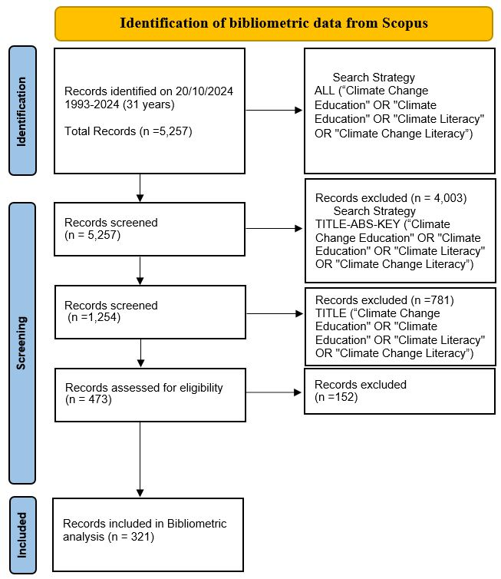
Figure 1: PRISMA-2020 flow diagram

FINDINGS AND DISCUSSION

Figure 2: Annual Publication Productivity of CCE
The annual publication productivity, presented in Figure 2, reveals varied patterns in the expansion of CCE research between 1993 and 2024. Initially, articles appeared in the early era (1993-2007), with a notable decade-long hiatus until 2003. During the initial expansion period (2008-2013), there was a consistent presence, with 1 to 6 articles published. The first surge in 2014 displays tremendous growth, with 23 publications indicating CCE is getting increasingly often recognized. Sustained Growth Phase (2017-2024), increasing publications in 2024 reflect a considerable acceleration in scientific productivity, with 71 publications being the best level of publication productivity.
Table 1: Top Ten Cited Articles
Article’s Title | Article Type | Access type | Authors | Journal’s Name, Volume (Issue) and Page No. | Year of Publication | Scopus Citations
Identifying effective climate change education strategies: a systematic review of the research | Article (review) | Open Access | Monroe, M.C.,  Plate, R.R.,  Oxarart, A.,  Bowers, A.,  Chaves, W.A. | Environmental Education Research, 25(6), pp. 791–812 | 2019 | 529
A systematic review of climate change education: giving children and young people a ‘voice’ and a ‘hand’ in redressing climate change | Article (review) | Open Access | Rousell, D.,  Cutter-Mackenzie-Knowles, A. | Children's Geographies, 18(2), pp. 191–208 | 2020 | 244
Climate change education and the ecological footprint | Article | Open Access | Cordero, E.C.,  Todd, A.M.,  Abellera, D. | Bulletin of the American Meteorological Society, 89(6), pp. 865–872 | 2008 | 119
The role of climate change education on individual lifetime carbon emissions | Article | Open Access | Cordero, E.C.,  Centeno, D.,  Todd, A.M. | PLoS ONE  , 15(2), 1-23 | 2020 | 114
The virtual field trip: Investigating how to optimize immersive virtual learning in climate change education | Article | Open Access | Petersen, G.B.,  Klingenberg, S.,  Mayer, R.E.,  Makransky, G. | British Journal of Educational Technology  , 51(6), pp. 2098–2114 | 2020 | 109
What Is Climate Change Education? | Article | Closed Access | Stevenson, R.B.,  Nicholls, J.,  Whitehouse, H. | Curriculum Perspectives  , 37(1), pp. 67–71 | 2017 | 109
GREENIFY: A Real-World Action Game for Climate Change Education | Article | Closed Access | Lee, J.J.,  Ceyhan, P.,  Jordan-Cooley, W.,  Sung, W. | Simulation and Gaming, 44(2-3), pp. 349–365 | 2013 | 96
Climate change education for universities: A conceptual framework from an international study | Article | Open Access | Molthan-Hill, P.,  Worsfold, N.,  Nagy, G.J.,  Leal Filho, W.,  Mifsud, M. | Journal of Cleaner Production  , 226, pp. 1092–1101 | 2019 | 88
Clarifying climate confusion: Addressing systemic holes, cognitive gaps, and misconceptions through climate literacy | Article | Closed Access | McCaffrey, M.S.,  Buhr, S.M. | Physical Geography  , 29(6), pp. 512–528 | 2008 | 85
Experimentation with a socio-constructivist process for climate change education | Article | Closed Access | Pruneau, D.,  Gravel, H.,  Bourque, W.,  Langis, J. | Environmental Education Research  , 9(4), pp. 429–446 | 2003 | 83

Table 1 focuses on the top ten cited documents on CCE, revealing trends in academic production, publication types, access, and citation impact. A significant number of publications, six out of ten, are open access, indicating a research trend towards making research more available to the worldwide academic community. The publication time varies from 2003 to 2020, demonstrating a consistent scholarly interest in CCE over time. Interestingly, three publications published in 2020 have already been highly cited, with 244, 114, and 109 citations. The most cited article, ‘Identifying effective climate change education strategies: a systematic review of the research’ (2019), has received 529 citations, demonstrating its rapid popularity in the field. The documents were published in a range of journals, with Environmental Education Research appearing twice, indicating its importance in the discussion over CCE. Other journals, such as Children's Geographies, PLoS ONE, and the British Journal of Educational Technology, are also represented, demonstrating that this area is related to geography, environmental sciences, and education technology. Additionally, multidisciplinary journals such as the Journal of Cleaner Production and Bulletin of the American Meteorological Society publish articles on CCE, demonstrating that it is researched not just within educational frameworks, but also in scientific and environmental contexts.
Cordero, E.C. is a prominent contributor, appearing twice on this top-cited list, indicating expertise and influence in the subject. Two of the top three most-cited articles are systematic reviews that highlight the success of education programs and include children's perspectives. The documents from 2019 to 2020 have received more citations. The possible reasons for high citation impact are; Open access publication, literature review documents and technology inclusion in CCE appear to have a considerable effect on citation impact, highlighting the necessity of accessibility in sharing vital educational research. The diverse emphasis on educational practices, student participation, and carbon footprint reduction underscores the multidisciplinary nature of this growing academic field.
Table 2: Top Ten Productive Journals
Journal Title | Scopus Indexing period | Publisher | Scopus indexing subject area | Publications | Scopus  CiteScore 2023
Environmental Education Research | 1995 to 2024 | Taylor & Francis | Social Sciences | 38 | 6.1
Sustainability Switzerland | 2009 to 2024 | MDPI | Social Sciences | 26 | 6.8
Journal of Geoscience Education | 1996 to 2024 | Taylor & Francis | Social Sciences, Earth and Planetary Sciences | 18 | 3.2
Bulletin of The American Meteorological Society | 1972 to 2024 | American Meteorological Society | Earth and Planetary Sciences | 6 | 9.8
Climatic Change | 1977 to 2024 | Springer Nature | Earth and Planetary Sciences and Environmental Science | 6 | 10.2
International Journal of Global Warming | 2009 to 2024 | Inderscience Publishers | Environmental Science and Earth and Planetary Sciences | 6 | 1.8
International Research in Geographical and Environmental Education | 1992 to 2024 | Taylor & Francis | Social Sciences | 6 | 5.2
Applied Environmental Education and Communication | 2002 to 2024 | Taylor & Francis | Social Sciences | 5 | 2.3
Physical Geography | 1975, 1980 to 2024 | Taylor & Francis | Earth and Planetary Sciences and Environmental Science | 5 | 3.6
Curriculum Perspectives | 1980 to 1994, 1996 to 2003, 2006 to 2024 | Springer Nature | Social Sciences | 4 | 2.5

According to the number of articles published on CCE, Table 2 lists the top ten most productive journals. The Journal, Environmental Education Research, has the most published documents, with 38 articles. This journal focuses exclusively on educational research in CCE. Sustainability Switzerland has published 26 articles, highlighting its multidisciplinary approach. The CiteScore figures indicate the journals' academic importance in 2023, with Climatic Change (10.2) and Bulletin of the American Meteorological Society (9.8), Sustainability Switzerland (6.8), and Environmental Education Research (6.1) receiving the highest CiteScores. Among the journal publishers, Taylor & Francis leads the academic publications of CCE, publishing five of the top ten among the most productive publishers. This shows that Taylor & Francis is highly engaged, followed by other leading publishers. Scopus indexing periods reveal information on the longevity and academic evolution of these journals.
Table 3: Top Ten Productive Authors
Author’s Name | Publications | Affiliation and Country | Total no. of documents in Scopus with their Citations by no. of Documents Cited | Author’s h-index
Lars Keller | 11 | Universität Innsbruck,  Austria | 33 Documents, 324  Citations by 263 documents | 11
Johann Stötter | 6 | Universität Innsbruck,  Austria | 91 Documents, 2,181  Citations by 1,842 documents | 27
Veronika Deisenrieder | 4 | Universität Innsbruck,  Austria | 7 Documents, 63  Citations by 57 documents | 4
Efrat Eilam | 4 | Victoria University, India | 19 Documents, 350  Citations by 333 documents | 10
Melanie Frick | 4 | Universität Innsbruck,  Austria | 6 Documents, 23  Citations by 21 documents | 3
Nina Liebhaber | 4 | Universität Innsbruck,  Austria | 6 Documents, 23  Citations by 21 documents | 3
Edward W. Maibach | 4 | George Mason University, The United States | 236 Documents, 16,329  Citations by 12,188 documents | 69
Martha C Monroe | 4 | University of Florida, The United States | 122 Documents, 3,285  Citations by 2,840 documents | 25
Essi Aarnio-Linnanvuori | 3 | Tampere University, Finland | 7 Documents, 110  Citations by 108 documents | 2
Diego Corrochano | 3 | Universidad de Salamanca, Spain | 31 Documents, 212  Citations by 199 documents | 7

Table 3 shows the research output and impact of the most productive authors in CCE publications. Lars Keller of Universität Innsbruck, Austria, is the most productive author in CCE research, with 11 publications and an h-index of 11. However, his modest h-index suggests a specialized yet influential presence in the area, implying that his contributions are notable within a broader academic audience focused on environmental education and policy. Johann Stötter, the second most productive author from the same institute, with 6 publications and an h-index of 27, demonstrates a high h-index reflects his larger academic effect, notably in allied fields like sustainable development, which reinforces CCE. On the other hand, authors like Martha C. Monroe with 4 publications, h-index 25), from the University of Florida, USA, and Edward W. Maibach with 4 publications, h-index 69, from George Mason University, USA, show the impact of authors whose research goes far beyond the boundaries of CCE but still significantly shapes the field. More specifically, Edward W. Maibach is an example of an author whose larger contributions to climate change policy and communication have a significant impact on CCE with h-index 69.
The strong multidisciplinary focus of CCE researchers is further demonstrated by Veronika Deisenrieder with 4 publications, h-index 4, who specializes in interdisciplinary and trans-disciplinary methods. Similarly, Efrat Eilam with 4 publications, h-index 10, of Victoria University from India provides a new interdisciplinary perspective by bringing mindfulness and scientific education into the CCE discourse. Diego Corrochano’s 3 publications, h-index 7, from the Universidad de Salamanca in Spain exemplify this interdisciplinary by including Earth sciences, geography education, and nutrition education, demonstrating how CCE is linked across many disciplines.
Geographically, CCE research is being conducted in a variety of areas, including contributions from experts in Europe, the United States, and beyond. The significant presence of researchers from Universität Innsbruck, Austria, such as Lars Keller, Johann Stötter, Melanie Frick, and Nina Liebhaber, demonstrates the institution's significance as a hub for CCE and environmental policy research across Europe. In contrast, Edward W. Maibach and Martha C. Monroe are major voices from the United States who have contributed to the global conversation on CCE via their important work in climate change communication, policy, and environmental education. At the same time, Essi Aarnio-Linnanvuori, with 3 publications, h-index 2, from Tampere University in Finland provides a new perspective on the relationship between environmental policy and education for sustainable development learning.
Table 4: Top Ten Productive Affiliations
Affiliation’s Name | Publications | Affiliation’s country
Universität Innsbruck | 11 | Austria
Pennsylvania State University | 6 | The United States
NC State University | 6 | The United States
Cooperative Institute for Research in Environmental Sciences | 6 | The United States
University of Florida | 6 | The United States
George Mason University | 6 | The United States
University of Nebraska–Lincoln | 6 | The United States
University of Wisconsin-Madison | 6 | The United States
University of Colorado Boulder | 5 | The United States
National Institute of Education | 5 | Singapore

The institutions listed in table 4 made a significant contributions to CCE research, demonstrating their leadership in impacting worldwide discourse around CCE. The United States, which leads this ranking with eight universities providing six or more articles each, is home to the majority of the top ten institutions. This demonstrates how important the US is to the advancement of CCE research. Leading affiliations from The US include the University of Florida, George Mason University, Pennsylvania State University, and NC State University. Outside of the United States, Universität Innsbruck in Austria and the National Institute of Education in Singapore make significant contributions, reflecting European and Asian research efforts in CCE. Universität Innsbruck leads the ranking with 11 publications, making it the most active university in this field. Its considerable output shows that Austria is a key player in CCE research in Europe. Universities such as Pennsylvania State University and the University of Nebraska-Lincoln have established themselves as major contributors to the area, through numerous publications. The existence of the Cooperative Institute for Research in Environmental Sciences and the University of Colorado Boulder highlights the multidisciplinary pattern of CCE in the United States, where education intersects with environmental sciences, policy, and sustainability.
Table 5: Top Ten Productive Countries
Country’s Name | Publications
The United States | 121
The United Kingdom | 42
Australia | 28
Germany | 21
Canada | 16
Austria | 14
South Africa | 10
Finland | 9
Portugal | 9
The Netherlands | 8

Table 5 reveals the top ten most productive countries in CCE, emphasizing worldwide engagement and academic dominance. Several factors contribute to the differences in publication output across these countries, including government policies, educational systems, climate change programs, and research funding. The United States leads the way with 121 research publications with strong financing systems. The United Kingdom comes second with 42 publications, with the European Union and Commonwealth. Australia has 28 publications, placing it third. Given Australia's direct susceptibility to climate change and its regular occurrence of extreme weather events like floods, droughts, and wildfires, climate education should be a top concern for the country. Germany has 21 publications, placing it fourth with major targets for carbon reduction and renewable energy. With 16 publications, Canada comes in fifth place, mostly because of its abundance of natural resources and proximity to climate-related problems like forest degradation and ice cap melting, which makes climate education essential to the country's sustainability strategy. Among the top country publications, other countries like Austria with 14, South Africa with 10 followed by Finland with 9, Portugal with 9 and The Netherlands with 8 publications.
Table 6: Top Ten Funding Sponsors
Funding Sponsor | Publications | Country | Funding Sponsor’s Affiliation
National Science Foundation | 22 | The United States | Independent Federal Agency
European Commission (Erasmus+) | 6 | Belgium (Brussels) | Governmental Organization
Deutsche Forschungsgemeinschaft | 5 | Germany | Governmental Organization
National Institute of Food and Agriculture | 5 | The United States | Governmental Organizations
Directorate for Education and Human Resources | 3 | The United States | Governmental Organization
Engineering and Physical Sciences Research Council | 3 | The United Kingdom | Governmental Organization
National Aeronautics and Space Administration | 3 | The United States | Governmental Organization
UK Research and Innovation | 3 | The United Kingdom | Governmental Organization
China Scholarship Council | 2 | China | Governmental Organization
Department of the Environment, Climate and Communications | 2 | Ireland | Governmental Organization

Table 6 of the major funding sources in CCE research displays many interesting patterns of geographical distribution and funding concentration. Analyzing the primary financial organization indicates that the National Science Foundation (NSF) is the leading funding sponsor, sponsoring 22 publications, a much larger share than other funding agencies in CCE research. The geographical distribution of financial sponsors exhibits a distinct concentration in Western nations. The global distribution of funding sponsors reveals an evident concentration in Western countries, with the United States leading with multiple major funding bodies such as the National Science Foundation (22 articles), National Institute of Food and Agriculture (5 articles), Directorate for Education and Human Resources (3 articles), and National Aeronautics and Space Administration (3 articles). The European representation is recognized through the European Commission's Erasmus+ program (6 articles), Germany's Deutsche Forschungsgemeinschaft (5 articles), and UK-based organizations such as the Engineering and Physical Sciences Research Council (3 articles) and UK Research and Innovation (3 articles). Asia is predominantly represented by the China Scholarship Council (2 articles). The dominance of governmental organizations in the funding environment is notable. This governmental dominance implies that CCE research is predominantly funded by the public sector, rather than private or corporate support. This stratification indicates that funding sources should be diversified to provide long-term, balanced research support for CCE. This concentration of public funding, particularly in the United States, not only reinforces the country's leadership in CCE research but also raises important questions about the resilience and sustainability of the field under changing academic and political conditions.

The concentration of publications, institutional achievement, and funding in the United States underscores its pivotal role in influencing the worldwide Climate Change Education (CCE) research agenda. Nonetheless, due to the changing structural, political, and financial dynamics inside the U.S. academic system, concerns emerge about the future sustainability of this superiority. The United States presently dominates research output and funding; however, analyses of the country and its partnership networks reveal a gradual increase in contributions from European and East Asian countries. This rising heterogeneity indicates that CCE scholarship may be transitioning towards a more decentralized global research framework. Strengthened international collaboration, diversified funding mechanisms, and proactive academic engagement with policymakers to protect climate change educational initiatives are likely to be necessary for sustained growth in CCE research in the event of funding fluctuations or policy shifts within the United States.

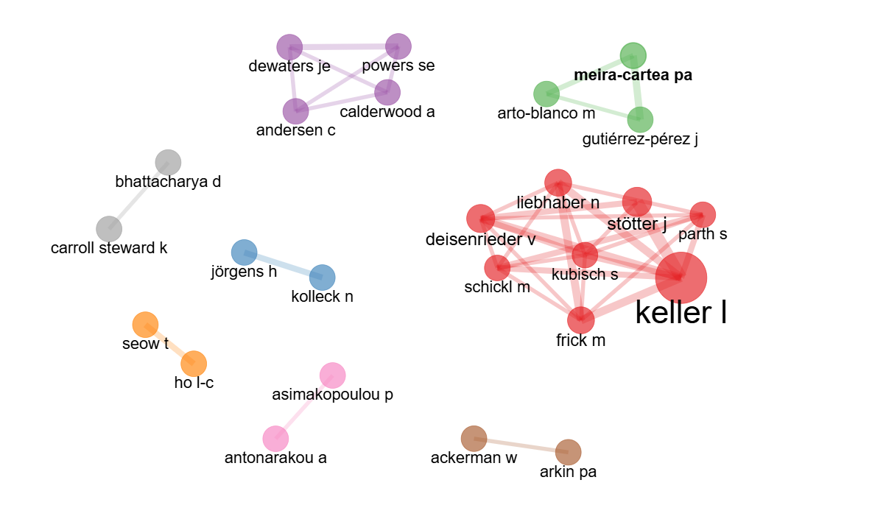
Figure 3: Authors’ Social Network
Figure 3 depicts multiple distinctive author collaboration networks in CCE research, identified by different colours and node sizes that signify the strength of collaboration and author impact in the area. Cluster Distribution shows the authors are divided into eight separate clusters, demonstrating that well-defined groups of researchers collaborate across specific subfields of CCE. The largest Red cluster, centred on Keller l, indicates that this researcher is a key influential author in CCE. This cluster is strongly interconnected with multiple collaborators, including kubisch s, deisenrieder v, liebhaber n, stötter j, parth s, schickl m, and frick m. The dense connections among these authors point to a well-established research group with significant academic output. The Purple Cluster, which consists of Dewaters je, powers se, Calderwood a, and Andersen c, demonstrates modest collaborative relationships. The Green Cluster, including Meira-cartea pa, Arto-blanco m, and Gutiérrez-pérez j, may signify a regional or institutional collaborative group, followed by the Blue Cluster which demonstrates direct cooperation between jörgens h and Kolleck n. The pairs of smaller collaborative clusters reveal the Grey cluster with Bhattacharya d and Carroll steward k; the Orange cluster has Seow T and ho l-c; the Pink cluster has Asimakopoulou p and Antonarakou a; and the Brown cluster has Ackerman w and Arkin pa.

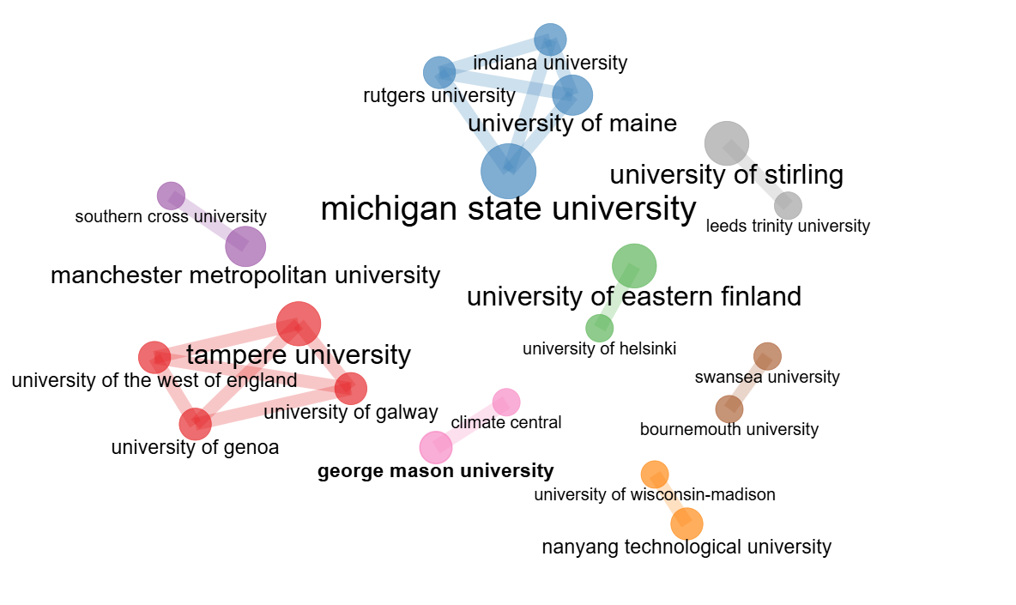
Figure 4: Affiliations’ Social Network
Figure 4 displays a network visualization of eight unique institutional collaboration clusters in CCE research. The Blue Cluster depicts U.S. universities centred on Michigan State University, including Indiana University, Rutgers University, and the University of Maine. Michigan State University is the biggest node, suggesting institutional leadership and a key role in CCE research. This cluster exemplifies major inter-state collaboration in US higher education. The red cluster depicts a European-Finnish cluster centred on Tampere University, notable collaborations with the Universities of the West of England, the University of Galway, and the University of Genoa reveal substantial trans-European institutional collaboration. The Green Cluster represents Finnish institutions. The University of Eastern Finland and the University of Helsinki demonstrate substantial national-level collaboration in Finnish CCE research. The grey cluster depicts the UK Institutional Pairs, including the University of Stirling and Leeds Trinity University. Swansea and Bournemouth universities are shown by the brown cluster. The purple cluster indicates an Australian-UK connection with Southern Cross University and Manchester Metropolitan University. The orange cluster represents the Asian-American connection to Nanyang Technological University and the University of Wisconsin-Madison. The pink cluster represents the partnership between George Mason University and Climate Central.

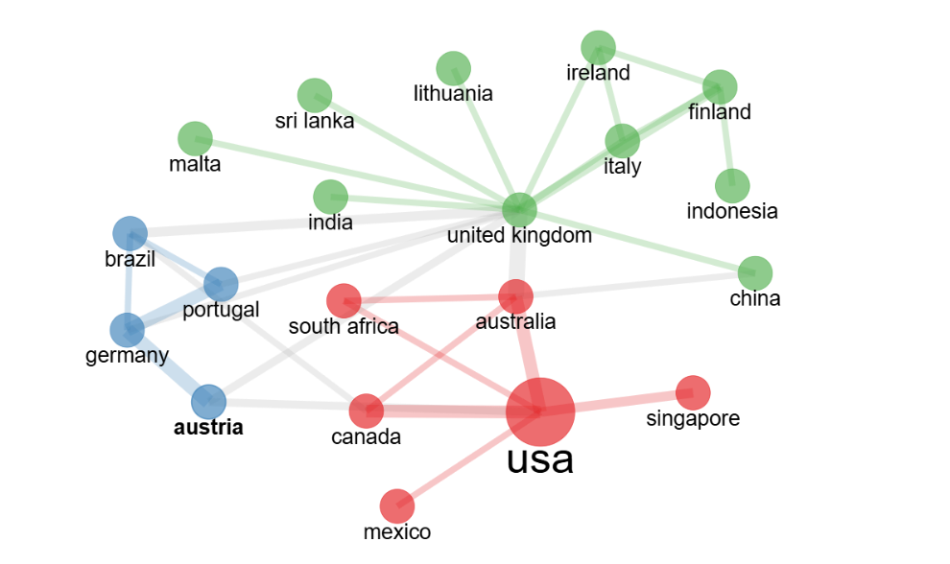
Figure 5: Countries’ Social Network
The Country Collaboration Network, visualization in Figure 5, identifies three major collaborative clusters and depicts the international research environment in CCE. The Larger node sizes indicate increased research output or collaboration intensity. The primary cluster, depicted in red, shows the United States as the major research centre with the highest node size, demonstrating its prominent position in CCE research. Strong bilateral cooperation with Canada and Australia indicates significant ties, while Singapore and Mexico show direct interconnections, and South Africa represents North-South engagement. The blue cluster represents European collaboration. Germany, Portugal, Austria, and Brazil have considerable intra-European collaboration, with Brazil's involvement suggesting transatlantic research partnerships. Austria appears to function as a bridge between this cluster and other networks. The UK-Centered Network in Green Cluster indicates that the United Kingdom serves as a secondary hub with numerous peripheral connections to various geographical regions, including European nations such as Ireland, Italy, Finland, and Lithuania, Asian countries such as Indonesia, China, Sri Lanka, a small island state as Malta, and a South Asian region as India. Since climate change is an international priority, developing collaborations among premier institutions in the United States, Europe, and Asia might result in novel, scalable educational frameworks that address climate literacy on an international level. The presence of both developed and developing countries suggests diversified viewpoints. Collaboration patterns include geographic clustering particularly in North America and Finland, cross-continental collaboration, and combination of public and private institutions, limited inter-cluster connection, and strong intra-regional collaboration.

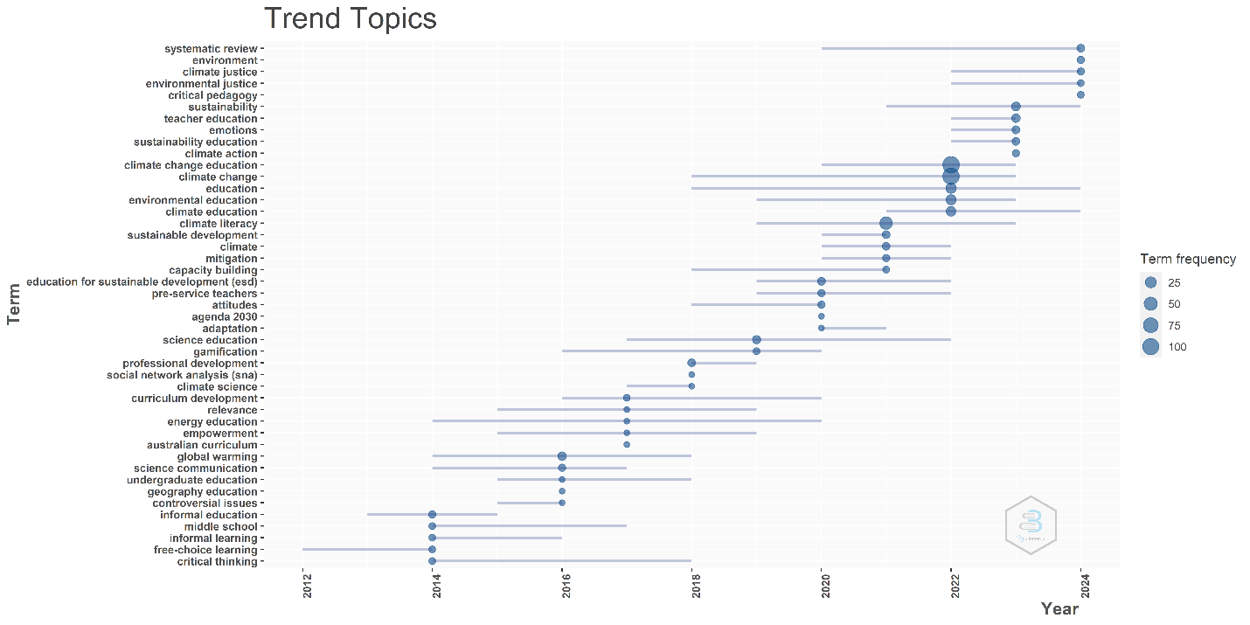
Figure 6: Trending Topics in Climate Change Education
Figure 6 reveals the trend analysis of the author's keywords in CCE during the latest decade, from 2012 to 2024. The keywords are categorized according to their frequency as well as prominence in articles published during the period. There is a rising focus and attention on key concepts such as ‘climate change education, sustainability education, climate justice, and environmental education’ from 2018 to 2024, with word frequency peaking between 2020 and 2024. These advancements indicate a developing multidisciplinary approach to addressing climate change via education.
The emerging concepts such as ‘climate literacy, climate action, and environmental justice’ have become more popular since 2020, reflecting the influence of global climate activism and social movements, such as Extinction Rebellion in the United Kingdom, Ende Gelande in Germany, and other climate justice-oriented campaigns have significantly shaped public discourse by linking environmental concerns with social equity, governance, and systemic change. The growing visibility of youth-led and community-based activism has contributed to reframing climate change not merely as a scientific issue, but as a matter of justice and collective responsibility. This broader socio-political context may partially explain the rising academic attention to justice-oriented and action-driven approaches within Climate Change Education research.
The foundational themes of ‘education for sustainable development (ESD), sustainable development, and teacher education’ stay continuous throughout the decade, serving as a foundation for new topics to arise. Terms such as ‘critical pedagogy, gamification, and professional development’ have been more prevalent in recent years, indicating a pedagogical advancement. The specific educational contexts such as ‘middle school, pre-service teachers, and informal learning’ highlight a growing diversity in educational settings. This underscores the trend towards incorporating climate education into both formal and informal educational environments. Terms like ‘Agenda 2030 and adaptation’ indicate that educational research is aligned with global sustainability frameworks and policies, such as those established by the United Nations.
The trend analysis reveals a dynamic emerging field, with a greater emphasis on justice, action, and innovative pedagogy. The ongoing integration of sustainability and development goals, together with evidence-based research approaches, demonstrates the evolving nature of CCE research as it responds to global challenges and educational needs.
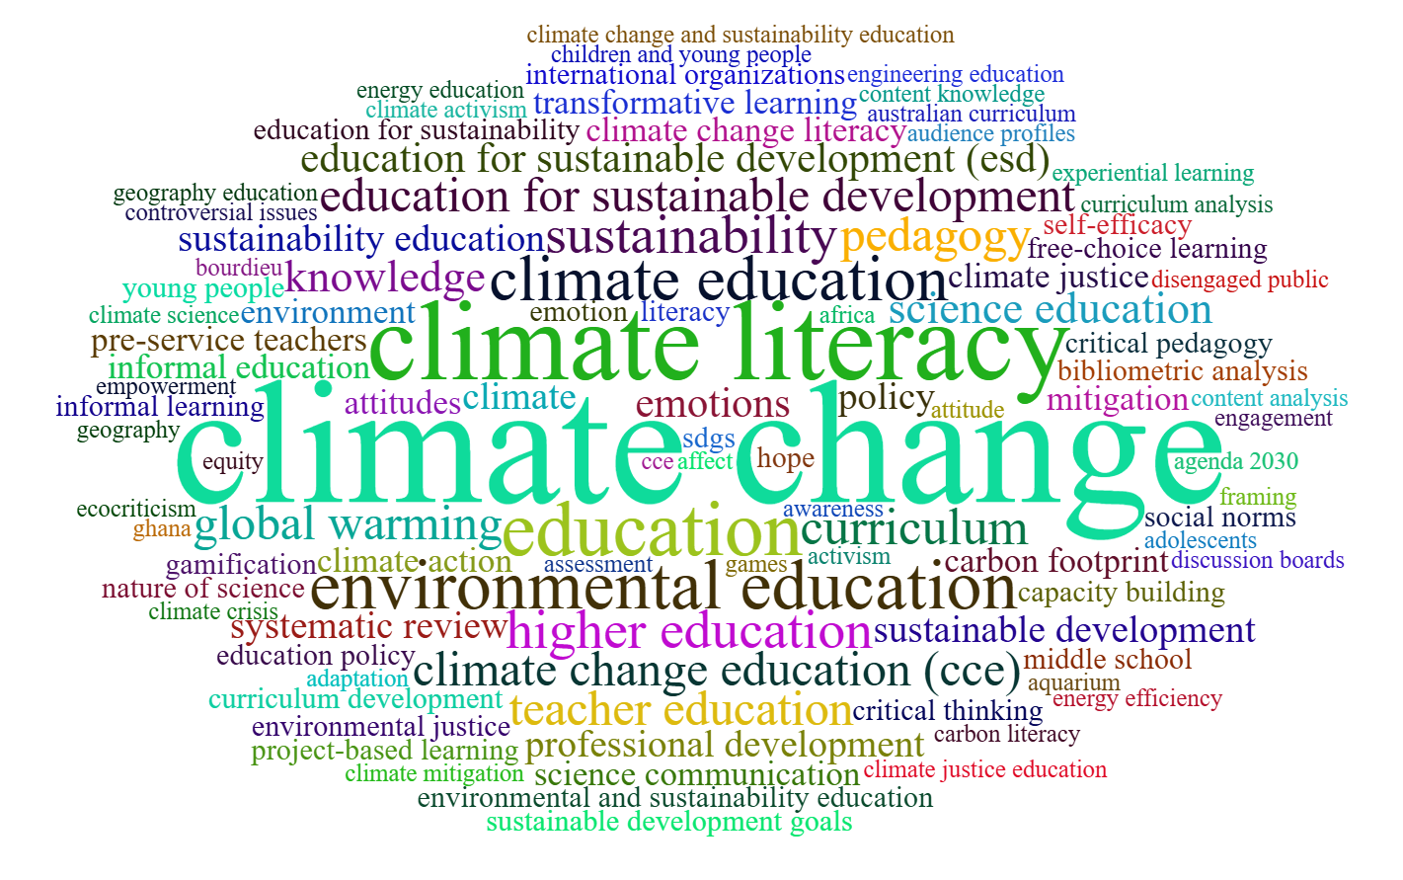
Figure 7: Word Cloud of Top 100 keywords in Climate Change Education

Figure 7, depicts the word cloud of the top 100 most prominent keywords used by authors in the field of CCE. The size of each word correlates to its frequency. This word cloud uncovers dominating themes and emerging fields of interest in CCE research. The largest keywords, such as ‘climate change, climate literacy, environmental education, and sustainability,’ represent essential topics that are key to CCE such as knowledge, comprehension, and education about climate challenges. Keywords such as ‘education for sustainable development (ESD) and climate change education (CCE)’ indicate climate education's integration into greater sustainability targets, as well as the emphasis on integrating such topics into the educational curriculum.
Significant key terms, such as ‘curriculum, policy, teacher education, and higher education,’ reveal a major emphasis on designing and implementing climate change issues at all levels of education, as well as informing educators to teach these areas successfully. The key terms ‘attitudes, emotions, and engagement’ emphasize the psychological and behavioural aspects of climate education, indicating a focus on how education may foster environmental values and drive pro-environmental behaviours. The inclusion of ‘social norms, justice, equity, and empowerment’ demonstrates a rising understanding of social factors, such as environmental justice and equitable climate solutions, which are getting more prominent in climate education discourse.

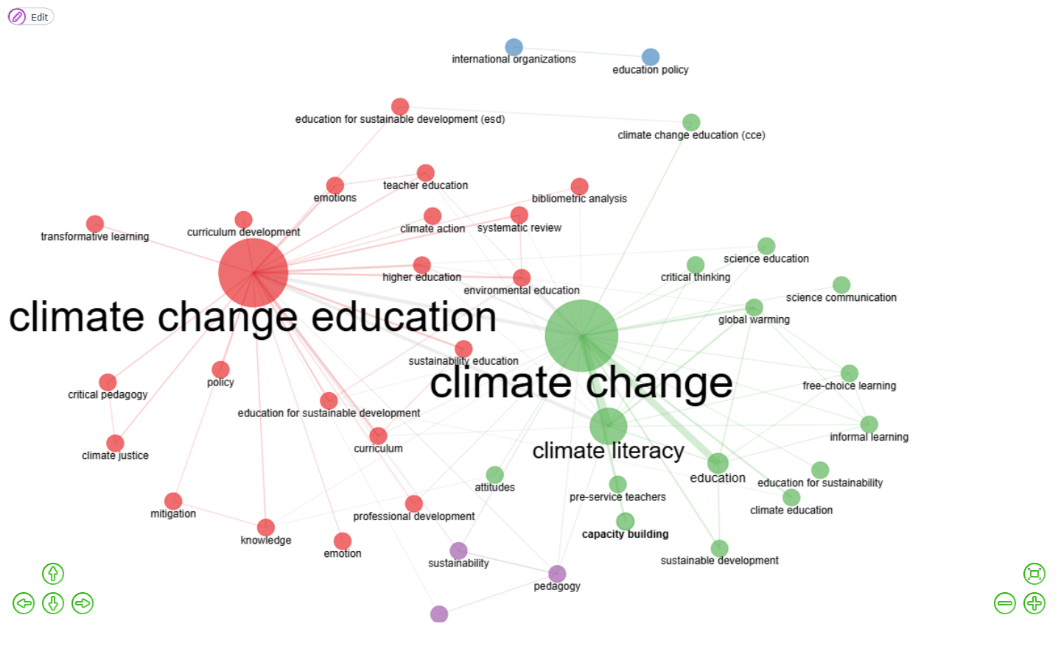
Figure 8: Co-occurrence Network of Author's Keyword
The author's keyword co-occurrence network in Figure 8 reveals a complicated network with primary thematic clusters. The Red Cluster ‘Climate change education’ appears as a main node, demonstrating its importance in the field and strong links to pedagogical features such as curriculum development, transformative learning, teacher education, critical pedagogy, and professional development. The educational policy themes include ESD, higher education, and policy. The emotional and social components cover emotions, climate justice, and climate action. The green cluster ‘Climate Change’ is the second main hub, focusing on educational approaches such as science education, communication, critical thinking, free-choice learning, and informal learning. Climate literacy, capacity building, sustainability education, and sustainable development are all examples of practical implementation components. The supporting themes in blue and purple represent the international and policy context, including international organizations and education policy. The pedagogical foundations cover pedagogy, sustainability, and environmental education. The author's keyword co-occurrence network shows strong connections between educational and climate science topics, including theoretical and practical keyword linkages.

IMPLICATIONS
The findings have significant implications for policy and practice in CCE. First, the prevalence of government financing implies a strong public commitment to climate literacy, however diversifying funding sources may improve research sustainability. Increased private-sector and philanthropic financing would ensure the long-term financial stability of CCE research, allowing for initiatives that promote cross-sectorial and community-based methods. The study emphasis on collaborative, multi-author research underscores the need of collaboration across disciplines and countries, particularly given the global interconnectedness of climate change implications. Institutional collaboration between the Global North and South are already obvious, but they should be extended further to include varied educational frameworks and settings. South-South alliances, might provide useful insights from places that are more vulnerable to climate change, and also increasing the inclusion and relevance of CCE research and educational initiatives.
FUTURE RESEARCH AGENDA
In recent years, the rising urgency of climate change has created an extraordinary demand for CCE that transcends traditional educational boundaries, emphasizing collaborative, emotional, community-based, and technologically connected techniques. Based on the results and findings the following is the research agenda proposed for the future in Figure 9.
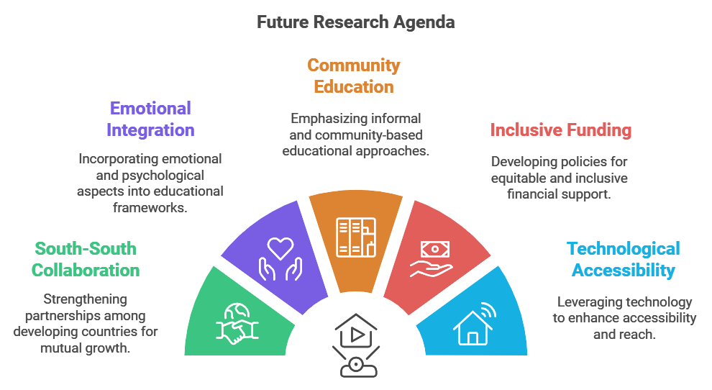
Figure 9: Research Agenda
Enhanced South-South Collaboration: Collaborating with developing countries would generate various perspectives, particularly from regions significantly affected by climate change. These collaborations might concentrate on localized, culturally relevant climate education strategies that address specific geographical challenges.
Integration of Emotional and Psychological Components: The publication trends highlight the importance of emotional and psychological components in climate literacy. Future study could enquire into frameworks that combine empathy, resilience, and personal responsibility to provide a comprehensive approach to CCE.
Focus on Informal and Community-Based Education: Besides formal education, informal community initiatives are critical to improving climate change awareness. Researchers should look at how community-based and experiential learning could raise climate change awareness, particularly among people with limited access to formal educational resources.
Policy Recommendations for Inclusive funding: Given the largely public financing framework, governments should explore private investment in CCE. Expanding funding sources would help balance research priorities, enabling a broader range of initiatives that address local, national, and global CCE agendas.
Technological Integration for Broader Accessibility: The significance of technology in making CCE more accessible. Future research might design and test accessible digital platforms that democratize access to CCE resources, particularly for underrepresented populations and areas with insufficient educational infrastructure.
This research agenda seeks long-term, collaborative, and inclusive initiatives to promote CCE, tackling the complex challenges posed by the global climate catastrophe in innovative and accessible ways.

CONCLUSION
The bibliometric analysis of Climate Change Education (CCE) sheds significant light on the field's rapidly growing scope and multidimensionality. The significant rise in publications, particularly over the last five years, reflects increased worldwide awareness and funding for CCE research in response to pressing international climate issues. The present research study findings highlight the interdisciplinary approach of CCE, which incorporates environmental, technical, psychological, and societal components to create a comprehensive framework for addressing climate change, climate literacy, and climate change education as predominant variables. Overall, this study presents a roadmap for expanding the scope of CCE as a key component of global education, emphasizing the importance of collaborative, inclusive, and accessible approaches to preparing policy frameworks for current and future generations to address the challenging realities of climate change and education.
Disclaimer (Artificial intelligence)

Author(s) hereby declare that NO generative AI technologies such as Large Language Models (ChatGPT, COPILOT, etc.) and text-to-image generators have been used during the writing or editing of this manuscript.

REFERENCES
1. Drewes A, Henderson J, Mouza C. Professional development design considerations in climate change education: teacher enactment and student learning. International Journal of Science Education 2018;40(1):67–89. Available from: https://www.scopus.com/inward/record.uri?eid=2-s2.0-85033715861&doi=10.1080%2F09500693.2017.1397798&partnerID=40&md5=00da26cbccc033648e676bd1bf2e98ec
2. 2021:Summary for policymakers I change 2021:The physical SB. C of WGI to the SAR of the I panel on CCI. IPCC, 2007. Geneva, Switzerland: 2007.
3. Newton MH, Annetta LA. The Influence of Extended Reality on Climate Change Education. Science & Education 2024; Available from: https://www.scopus.com/inward/record.uri?eid=2-s2.0-85192348480&doi=10.1007%2Fs11191-024-00518-y&partnerID=40&md5=c2d85f6bedbc6e599c370de697b1dae8
4. Hossain MS, Qian L, Arshad M, Shahid S, Fahad S, Akhter J. Climate change and crop farming in Bangladesh: an analysis of economic impacts.International Journal of Climate Change Strategies and Management; 2019;11(3):424–40.
5. Chmutina K, Fussey P, Dainty A, Bosher L. Implications of transforming climate change risks into security risks. Disaster Prevention and Management An International Journal; 2018;27(5):460–77. https://doi.org/10.1108/DPM-04-2018-0121?urlappend=%3Futm_source%3Dresearchgate.net%26utm_medium%3Darticle
6. Romeo J, Lee H, J K et. al. IPCC,2023: Summary for Policymaker In: Climate Change 2023: Synthesis Report.. Contribution of Working Groups I, II and III to the Sixth Assessment Report of the Intergovernmental Panel on Climate Change. Geneva, Switzerland: 2023.
7. UNESCO. Country progress on Climate Change Education, Training and Public Awareness-An analysis of country submissions under the United Nations Framewowk Convention on Climate change [Internet]. 2019. Available from: https://unesdoc.unesco.org/ark:/48223/pf0000372164/PDF/372164eng.pdf.multi
8. McKenzie M, Benavot A, Redman A. Global indicators of progress on climate change education: Non-state actor data collaboration for SDG 4. Int J Educ Dev [Internet] 2024;104. Available from: https://www.scopus.com/inward/record.uri?eid=2-s2.0-85180581159&doi=10.1016%2Fj.ijedudev.2023.102968&partnerID=40&md5=bcac8074eace98852bfc52757af73986
9. Molthan-Hill P, Worsfold N, Nagy GJ, Leal Filho W, Mifsud M. Climate change education for universities: A conceptual framework from an international study. J Clean Prod [Internet] 2019;226:1092–101. Available from: https://www.scopus.com/inward/record.uri?eid=2-s2.0-85064539161&doi=10.1016%2Fj.jclepro.2019.04.053&partnerID=40&md5=ad22d2fc37a29741ada380e2985643a3
10. Puttick S, Chandrachud P, Chopra R, Khosla R, Robson J, Singh S, et al. Knowledge and (un)certainty in climate change education in India. Br Educ Res J [Internet] 2024;50(2):794–813. Available from: https://www.scopus.com/inward/record.uri?eid=2-s2.0-85180239965&doi=10.1002%2Fberj.3939&partnerID=40&md5=ae75969a61b845d2dd0eb7f314985f68
11. Leite S. Towards a transformative climate change education: questions and pedagogies. Environ Educ Res [Internet] 2024;Available from: https://www.scopus.com/inward/record.uri?eid=2-s2.0-85196669399&doi=10.1080%2F13504622.2024.2365983&partnerID=40&md5=455e7fb8541dd70f73c34ece5a3cb75d
12. Eilam E. Climate change education: the problem with walking away from disciplines. Stud Sci Educ [Internet] 2022;58(2):231–64. Available from: https://www.scopus.com/inward/record.uri?eid=2-s2.0-85122283063&doi=10.1080%2F03057267.2021.2011589&partnerID=40&md5=180fcdf732ada6d0e959bf025d3c6279
13. Beasy K, Jones C, Kelly R, Lucas C, Mocatta G, Pecl G, et al. The burden of bad news: educators’ experiences of navigating climate change education. Environ Educ Res [Internet] 2023;29(11):1678–91. Available from: https://www.scopus.com/inward/record.uri?eid=2-s2.0-85165487227&doi=10.1080%2F13504622.2023.2238136&partnerID=40&md5=49d20d4c3b1d0381d7f4049b84fb5dc2
14. Walsh EO, Davis EC. The geology and sociology of consumption: Team-teaching sustainability in an interdisciplinary first-year seminar. J Geosci Educ 2017;65(2):126–35.
15. Pfirman S, O’Garra T, Bachrach Simon E, Brunacini J, Reckien D, Lee JJ, et al. “Stickier” learning through gameplay: An effective approach to climate change education. J Geosci Educ [Internet] 2021;69(2):192–206. Available from: https://www.scopus.com/inward/record.uri?eid=2-s2.0-85099062178&doi=10.1080%2F10899995.2020.1858266&partnerID=40&md5=8334d96bc639d48718f258215404bc82
16. Carroll Steward K, Gosselin D, Bhattacharya D, Chandler M, Forbes CT. Teachers’ use and adaptation of a model-based climate curriculum: a three-year longitudinal study. J Geosci Educ 2024;
17. Global Education Monitoring Report, Monitoring and Evaluating Climate Communication and Education Project and University of Saskatchewan. Education and climate change: learning to act for people and planet. first. UNESCO; 2024.
18. United Nations. The Paris Agreement [Internet]. United Nations2016;1–11. Available from: https://www.un.org/en/climatechange/paris-agreement
19. Action for Climate Empowerment , UNFCCC [Internet]. [cited 2025 Nov 23];Available from: https://unfccc.int/topics/education-and-youth/big-picture/ACE
20. Lestari NA, Hariyono E, Madlazim M. Role of climate literacy in fostering climate change education, mitigation, and adaptation for sustainability: A bibliometric analysis. AIP Conf Proc 2024;3106(1).
21. Ridwan IM, Kaniawati I, Suhandi A, Ramalis TR, Novia N. a Decades of Climate Change Education in Experiential Learning - a Bibliometric Study and Research Agenda. J Eng Sci Technol 2023;18(3):81–8.
22. Vijaykumar R, Thamizhiniyan K, Naseema S. Environmental Literacy Research: Global Scientometric Mapping of Five Decades. Curr World Environ 2021;16(3).
23. Gera M, Batra DK, Kumar V. Mobile advertising research: a comprehensive domain mapping analysis of 22 years (2001 – 2022). Glob Knowledge, Mem Commun 2023;
24. Tijjani B, Ur Rehman S, Peter Z, Bajwa IA, Khan MA. Research productivity of International Financial Reporting Standards (IFRS) from 2003 to 2020. Glob Knowledge, Mem Commun 2023;72(1–2):1–23.
25. Shah TA, Pattusamy M, Parray ZA. Psychological detachment: a bibliometric investigation within the organization’s behavior domains. Glob Knowledge, Mem Commun 2024;
26. Thamizhiniyan K, Chellamani K, Begum AHJ, Naseema S. Scientific productivity and collaboration Networks in lifelong learning : A longitudinal bibliometric analysis (1963-2022). J Scientometr Res 2024;13(1):201–16.
27. Shivangi S, Kumar J. Mapping the field of sensory marketing: a comprehensive bibliometric analysis. Glob Knowledge, Mem Commun 2024;
28. Cavadas A. Visualising the collaboration network of a European marine research infrastructure: A bibliometric and social network analysis. UPorto J Eng 2020;6(2):98–118.
29. Pina DG, Barać L, Buljan I, Grimaldo F, Marušić A. Effects of seniority, gender and geography on the bibliometric output and collaboration networks of European Research Council (ERC) grant recipients. PLoS One 2019;14(2).
30. Singson M, Sunny SK, Thiyagarajan S, Dkhar V. Citation behavior of Pondicherry University faculty in digital environment: a survey. Glob Knowledge, Mem Commun 2020;69(4–5):363–75.
31. Thamizhiniyan K, Chellamani K, Begum AHJ, Naseema S. Scientific Productivity and Collaboration Networks in Lifelong Learning: A Longitudinal Bibliometric Analysis (1963-2022). J Scientometr Res 2024;13(1):201–16.
32. Schweiggart N. Mapping the role of animal welfare in tourism: examining discourses in tourism research and beyond using a bibliometric co-occurrence analysis of author keywords. J Ecotourism 2024;
33. Klarin A. How to conduct a bibliometric content analysis: Guidelines and contributions of content co-occurrence or co-word literature reviews. Int J Consum Stud 2024;48(2).
34. Majumder S, Biswas D. A Bibliometric and Co-Occurrence Analysis of Work-Life Balance: Related Literature Published Pre- and During COVID-19 Pandemic. Int J Inf Syst Supply Chain Manag 2023;16(1).
35. Wang Y, Huo X, Li W, Xiao L, Li M, Wang C, et al. Knowledge Atlas of the Co-Occurrence of Epilepsy and Autism: A Bibliometric Analysis and Visualization Using VOSviewer and CiteSpace. Neuropsychiatr Dis Treat 2022;18:2107–19.
36. Zhou X, Zhou M, Huang D, Cui L. A probabilistic model for co-occurrence analysis in bibliometrics. J Biomed Inform 2022;128.
37. Jalal SK. Co-authorship and co-occurrences analysis using bibliometrix r-package: A case study of india and bangladesh. Ann Libr Inf Stud 2019;66(2):57–64.
38. Lestari NA, Hariyono E, Madlazim M. Role of climate literacy in fostering climate change education, mitigation, and adaptation for sustainability: A bibliometric analysis [Internet]. In: H. H, T. R, editors. AIP Conference Proceedings. Department of Physics Education, Universitas Negeri Surabaya, Surabaya, Indonesia: American Institute of Physics; 2024. Available from: https://www.scopus.com/inward/record.uri?eid=2-s2.0-85194743290&doi=10.1063%2F5.0215904&partnerID=40&md5=d0531004907a1c414f3d5f2c2dfba42f
39. Wang CY, Tseng YC, Lin SS, Liu SC, Reid A, Monroe MC. Addressing the climate emergency with educational approaches: a bibliometric analysis of climate change education scholarship. Environ Educ Res [Internet] 2024;Available from: https://www.scopus.com/inward/record.uri?eid=2-s2.0-85200497747&doi=10.1080%2F13504622.2024.2386443&partnerID=40&md5=d6174dae9cfddcc61b7c843b47957862
40. Tian Y, Jin Y, Zhao Y, Du Y, Shen S, An J. Analysis of Knowledge Graph: Hotspots and Future Trends in Environmental Education Research. Sustain 2024;16(6).
41. Ismail MH, Rauf A, Abdullah MF, Mohd Noor MI, Ayu Amir Mustafa AM, Gandaseca S, et al. Understanding climate literacy research using scientometrics analysis. Heliyon 2024;10(20).
42. Ridwan, Kaniawati, Suhandi, Ramalis, Novia. A Decade of Climate Change Education in Experiential Learning - A Bibliometric Study and Research Agenda. J Eng Sci Technol [Internet] 2023;18(3):81–8. Available from: https://www.scopus.com/inward/record.uri?eid=2-s2.0-85183988235&partnerID=40&md5=2bb43de739aafaad463517bd3cb06ee5
43. Varela-Losada M, Peérez-Rodríguez U, Lorenzo-Rial M, Vega-Marcote P. Education Research Facing a Future Marked by Climate Emergency: Analysis of Recent Scientific Production. In: Handbook of Sustainability Science in the Future. University of Vigo, Pontevedra, Spain: Springer International Publishing; 2023. page 273–98.
44. Suhaimi N, Mahmud SND. A Bibliometric Analysis of Climate Change Literacy between 2001 and 2021. Sustain 2022;14(19).
45. Nobanee H, Dilshad MN, Abu Lamdi O, Ballool B, Al Dhaheri S, AlMheiri N, et al. Insurance for climate change and environmental risk: a bibliometric review. Int J Clim Chang Strateg Manag 2022;14(5):440–61.
46. Aria M, Cuccurullo C. bibliometrix: An R-tool for comprehensive science mapping analysis. J Informetr 2017;11(4):959–75.
47. Naseema S, Sevukan R. Exploration of Data Literacy Research using a Network of Cluster Mapping Approach. J Scientometr Res 2022;11(2):1–14.
48. Page MJ, McKenzie JE, Bossuyt PM, Boutron I, Hoffmann TC, Mulrow CD, et al. The PRISMA 2020 statement: An updated guideline for reporting systematic reviews. PLoS Med 2021;18(3):1–15.

