Seasonal Evolution of Surface Water Quality in the Tropical Sub-basin of the Tilé River, Guinea

.
ABSTRACT

This study assesses the physicochemical and microbiological quality of the Tilé River in N’Zérékoré (Republic of Guinea) according to seasonal variability. The study, conducted at five sampling sites, reveals that during the rainy season, the waters exhibit moderate temperatures (15.71-21.28 °C), a neutral to slightly acidic pH (6.93-7.27), high conductivity (up to 932.67 µS/cm), and high concentrations of suspended solids (up to 786.67 mg/L) and turbidity (130.67-184.33 NTU). Nitrate levels reach 60.3 mg/L, and fecal contamination is significant, with fecal coliform counts reaching up to 603.67 CFU/100 mL. During the dry season, the temperature increases (21.45-25.78 °C) and the pH become slightly alkaline (7.08–7.41), while conductivity, turbidity, and suspended solids decrease significantly. Nitrate concentrations remain low (4.60-8.96 mg/L) and fecal contamination is reduced (≤ 80 CFU/100 mL). Principal Component Analysis (PCA) highlights three key factors influencing seasonal variability: (i) suspended solids loading and turbidity, (ii) nutrients (NO₃⁻, PO₄³⁻), and (iii) microbiological indicators. The results indicate that the rainy season is characterized by a strong positive correlation between these parameters, reflecting the effect of runoff and anthropogenic inputs, while the dry season reflects generally better water quality, although locally affected by domestic and commercial discharges.
This study contributes empirical data from West Africa, helping to fill major gaps in global water quality knowledge from tropical basins. The findings support improved prediction of pollution dynamics and ecological responses across wet and dry seasons in Tilé river. Moreover, the findings of the research may be helpful for decision-makers of the region for doing the needful to monitor water quality in Tilé river and for the sustainable preservation of the Tilé River. The study's findings offer valuable scientific data that could inform the development of local policies for integrated water resource management in Guinea, a country often referred to as the 'water tower of West Africa' but facing increasing threats to its water resources. By highlighting the degradation of water quality, particularly during the rainy season due to anthropogenic inputs, the research underscores a global problem and provides a crucial reference for similar urban basins in West Africa and beyond, contributing to the broader understanding of environmental vulnerability in developing regions.

Keywords: Water pollution, Physico-chemical and microbiological quality, Tilé river, N’Zérékoré, Guinea

1. INTRODUCTION

Water is a vital resource for ecosystems and human societies, and its management is a major challenge for achieving Sustainable Development Goal 6, which aims for universal access to safe drinking water and sanitation (UN, 2020). In developing countries, population growth, unplanned urbanization, and agricultural and industrial practices are placing increasing pressure on water resources, exacerbating their vulnerability to pollution (dos Santos et al., 2017; Yadav et al., 2019). Urban rivers are particularly exposed to microbiological and chemical contamination, thus becoming vectors of preventable waterborne diseases (UN, 2021; WaterAid, 2021). Several studies have shown that surface water quality depends on both natural conditions and anthropogenic pressures (Diawara et al., 2024). In West Africa, (Dan et al., 2018; Al-Afify et al., 2018) demonstrated the impact of riverside populations on turbidity in waterways in Burkina Faso, while other research conducted in Benin (Hounsounou et al., 2017) and Togo (Amesitor et al., 2025; Ouéda et al., 2025; Soncy et al., 2015) confirms the extent of urban pollution. Similar cases observed in Asia, such as in South Korea (Chang, 2005) and China (Yang et al., 2024; Wang et al., 2024), serve as a reminder that the degradation of urban rivers is a global problem.

In Guinea, often called the “water tower of West Africa,” abundant water resources are increasingly threatened by rapid urbanization, poor waste management, and unsustainable agriculture, despite the existence of a legislative framework (FAO, 2005). The urban commune of N’Zérékoré exemplifies this situation: bisected by the Tilé River, it is a hub of diverse human activities that contribute to water quality degradation (Guilavogui et al., 2025). Yet, few scientific studies have conducted in-depth, comparative assessments of this river's water quality across different seasons. Existing research is often limited to isolated analyses or focuses on other transboundary waterways (Guilavogui et al., 2025).
In this context, the present study aims to address this knowledge gap by proposing an integrated seasonal assessment of the water quality of the Tilé River. Through a physicochemical and microbiological approach, it seeks to identify pollution sources, analyze their variations between the dry and rainy seasons, and discuss the implications for public health and the sustainability of aquatic ecosystems. This study is focused on Tilé River, because Tilé River is a waterway, essential for domestic supply and socio-economic activities and the most polluted in the Forest Guinea region. The originality of this work lies in its application to a poorly documented urban basin in Guinea, thus providing useful scientific data for the development of local policies for integrated water resource management. Brief details of materials and methods are presented in Section 2. Before concluding the study in Section 4, the results are shown and discussed in Section 3.

2. material and methods
2.1 STUDY AREA DESCRIPTION
The urban commune of N’Zérékoré, located between 7°42’ and 7°47’ North latitude and between 8°46’ and 8°51’ West longitude, is the main administrative, commercial, and cultural center of the N’Zérékoré prefecture in southeastern Guinea. It comprises twenty-two districts and has an estimated population of over 300,000, making it the second largest urban area in the country after Conakry. This high population density results in considerable pressure on natural resources, particularly aquatic ecosystems, which are a vital source of water, agricultural production, and livelihoods for the surrounding communities (Lamah et al., 2022; Camara et al., 2025). The Tilé River, a major hydrological axis of the watershed, originates in the rural commune of Samoé, north of the city, then flows through the urban commune of N’Zérékoré before emptying into the Oulé River, a left-bank tributary of the Diani River basin. This hydrographic network is enriched by several secondary tributaries, among which the Zali stream occupies a unique position. Originating behind the N’Zérékoré civil prison and flowing through the heart of the city, it shapes the urban landscape while remaining particularly vulnerable to anthropogenic pressures related to domestic waste, intensive agricultural practices, and fishing activities (Guilavogui et al., 2025). From a socio-economic perspective, the city of N’Zérékoré relies primarily on subsistence farming, small-scale trade, artisanal fishing, and forestry. While these activities are fundamental to survival and local economic development, they contribute to the progressive deterioration of surface water quality through increased organic and chemical pollution. Rapid population growth, coupled with unplanned urbanization and inadequate sanitation infrastructure, exacerbates these pressures, making the sustainable management of the Tilé River a major environmental, social, and health challenge for the region (Solie et al. 2025).

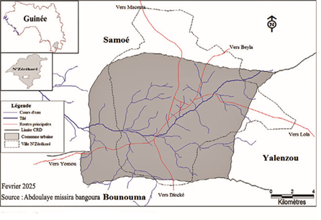
Figure 1: Map of the urban commune of N’Zérékoré

2.2 METHODS
2.2.1 IN SITU MEASUREMENTS

To assess the spatial evolution of pollution levels along the Tilé river, we sampled at several sites in Tilé, namely: Bellevue Wessoua, Commercial, Mohomou and Nakoyakpala. At each sampling site, dissolved oxygen and saturation levels were measured using a portable oximeter (HANNA HI9147). Electrical conductivity, pH, temperature, and turbidity were determined respectively using a conductivity meter (HANNA HI99301), a pH meter coupled with a thermometer (WTW 3110), and a turbidimeter (HACH 2100Q), with direct in situ readings (Rodier et al., 2009).
2.2.2 LABORATORY ANALYSIS
In the laboratory, a DR/850 spectrophotometer (HACH) was used to quantify for each sampling site the suspended solids (SS), nitrates, nitrites, and orthophosphates. Microbiological analysis was performed by membrane filtration followed by incubation on TTC and Tergitol media for the isolation and enumeration of total and fecal coliforms (APHA, 2017).
2.2.3 DATA PROCESSING
Direct observation was conducted in 44 sectors across the 22 districts of N’Zérékoré, supplemented by semi-structured interviews with 29 key stakeholders and a questionnaire survey administered to 50 riverside households. These surveys, focusing on water use, sanitation practices, waste management, and waterborne diseases, enabled the development of a diagnostic assessment of the interactions between the population and the Tilé River. The interviews were analyzed individually, and the data from the observation grids and questionnaires were processed using Sphinx 4.0 software for frequency calculation (Paillé and Mucchielli, 2021). Physicochemical and bacteriological parameters were analyzed according to spatial (upstream-downstream) and temporal (dry-rainy season) variables using SPSS 21. A one-way ANOVA was used to test the significance of the variations (Kim, 2017, Pujar et al., 2020, Mohammed et al., 2022; Le, 2025). Univariate correlations and principal component analysis (PCA) highlighted the interrelationships between variables.
3. results and discussion
3.1 Physico-chemical and bacteriological characteristics of the water

Figure 2 presents the spatial and seasonal comparison of the physical parameters of the Tilé River. It is observed that the physical parameters of the Tilé River vary seasonally depending on the site, with the exception of pH (Figure 2). pH generally ranges from 6.5 to 7 for all sites, regardless of the season (Figure 2b). The highest temperatures are recorded during the dry season (maximum 25°C) at the Wessoua and Commercial sites (Figure 2a). The lowest temperatures are recorded during the wet season, averaging around 15°C. The highest conductivity values ​​are recorded at the Mohomou (850 µS/cm) and Commercial (900 µS/cm) sites during the dry season (Figure 2c). Conductivity varies very little throughout the seasons at the other sampling sites (Belle-vue, Wessoua, Nakoyakpala). Turbidity also fluctuates seasonally (Figure 2d). Indeed, during the wet season, the highest turbidity value was recorded at the Belle-vue site (approximately 170 NTU), and the lowest during the dry season. However, it reached a value of over 200 NTU at the Commercial site during the dry season, followed by the Nakoyakpala site (approximately 175 NTU) (Figure 2d). The concentration of Total Dissolved Solids (TDS) at the different sites averages around 120 mg/L during the wet season (Figure 2e). Conversely, these same sampling sites show a Total Dissolved Solids concentration of around 50 mg/L during the dry season. The TDS concentrations at the different sites during the wet season are significantly higher than those during the dry season. Suspended solids (SS) are generally higher during the wet season, except at the Belle-Vue site (Figure 2f). The highest SS concentration is recorded at the Wessoua site (approximately 780 mg/L) during the wet season. During the dry season, the highest SS concentration is obtained at the Belle-Vue site (approximately 750 mg/L). This analysis shows that the physical parameters of the different sites along the Tilé River vary from one site to another depending on the season.

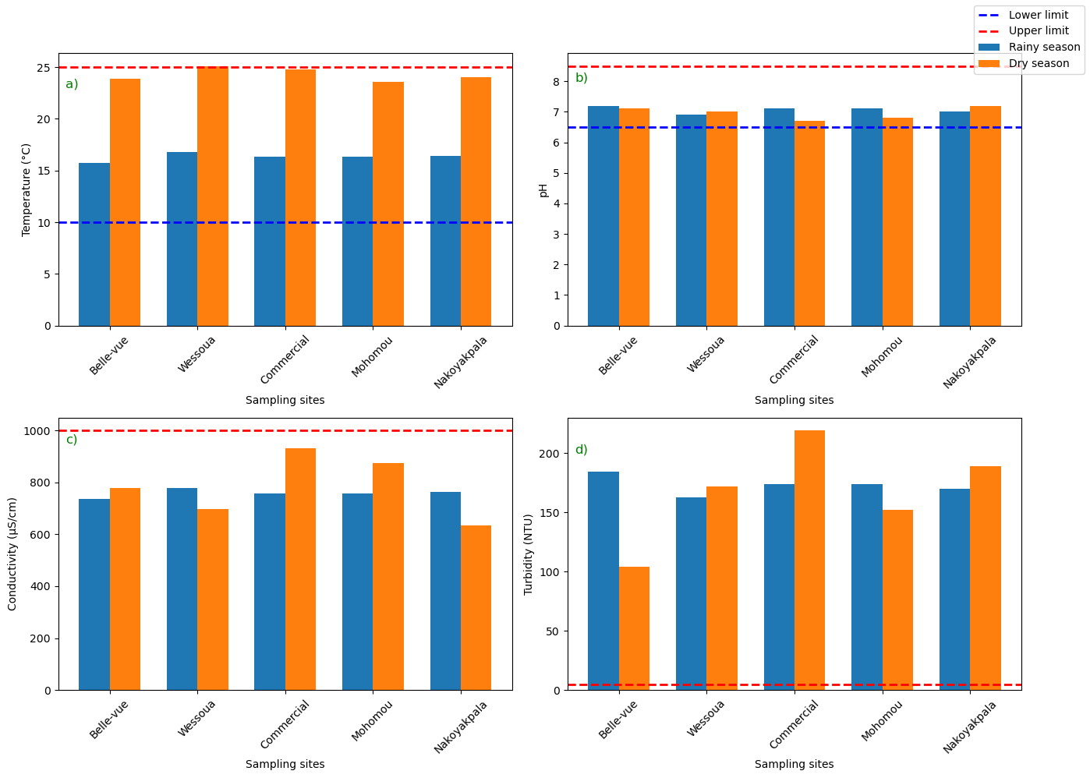
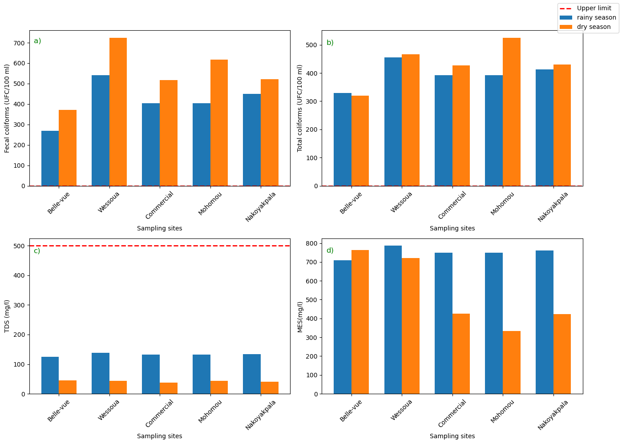
e
f

Figure 2: Spatial and seasonal comparison of the physical parameters of the Tilé River in the forest region (N’Zérékoré) of Guinea: a) Temperature; b) pH; c) Conductivity and d) Turbidity; e) TDS and f) suspended solids (SS)

Figure 3 presents the microbiological parameters of the different sites along the Tilé River. Indeed, high concentrations of fecal and total coliforms are recorded in the various water samples from the different sites, regardless of the season. However, fecal coliforms are more abundant during the dry season (ranging from 350 to 700 CFU/100 ml) than during the wet season (ranging from 250 to 520 CFU/100 ml) (Figure 3a). The same trend is observed for total coliforms (more abundant during the dry season than the wet season) (Figure 3b). The highest concentration of total coliforms during the dry season is recorded at Mohomou (approximately 520 CFU/100 ml).

Figure 3: Spatial and seasonal comparison of the microbiological parameters of the Tilé River in the forest region (N’Zérékoré) of Guinea: a) Fecal coliforms; b) Total coliforms

Figure 4 shows the spatial and seasonal comparison of the chemical parameters of the Tilé River in the forest region. The spatial and seasonal comparison of chemical parameters shows high concentrations of nitrate and phosphate during the wet season, at 60 mg/L and 1.75 mg/L respectively, at the Wessoua site (Figure 4a and c). Similarly, nitrate concentrations in the water at the Nakoyakpala site reached the upper limit of 50 mg/L during the wet season, followed by the Commercial and Mohomou sites (Figure 4a). During the dry season, low nitrate levels were observed at the different study sites (Figure 4a). However, the waters at the Nakoyakpala site have a higher concentration (approximately 35 mg/L) than the other sites. Nitrite concentrations at the different sites are relatively low, although they show higher average values ​​during the wet season than during the dry season (Figure 4b). As for phosphate concentrations, they are relatively high at the different sites studied during the wet season (between 1.5 and 1.75 mg/L) and low during the dry season (Figure 4c). The same trend is observed for potassium concentrations (Figure 4d).

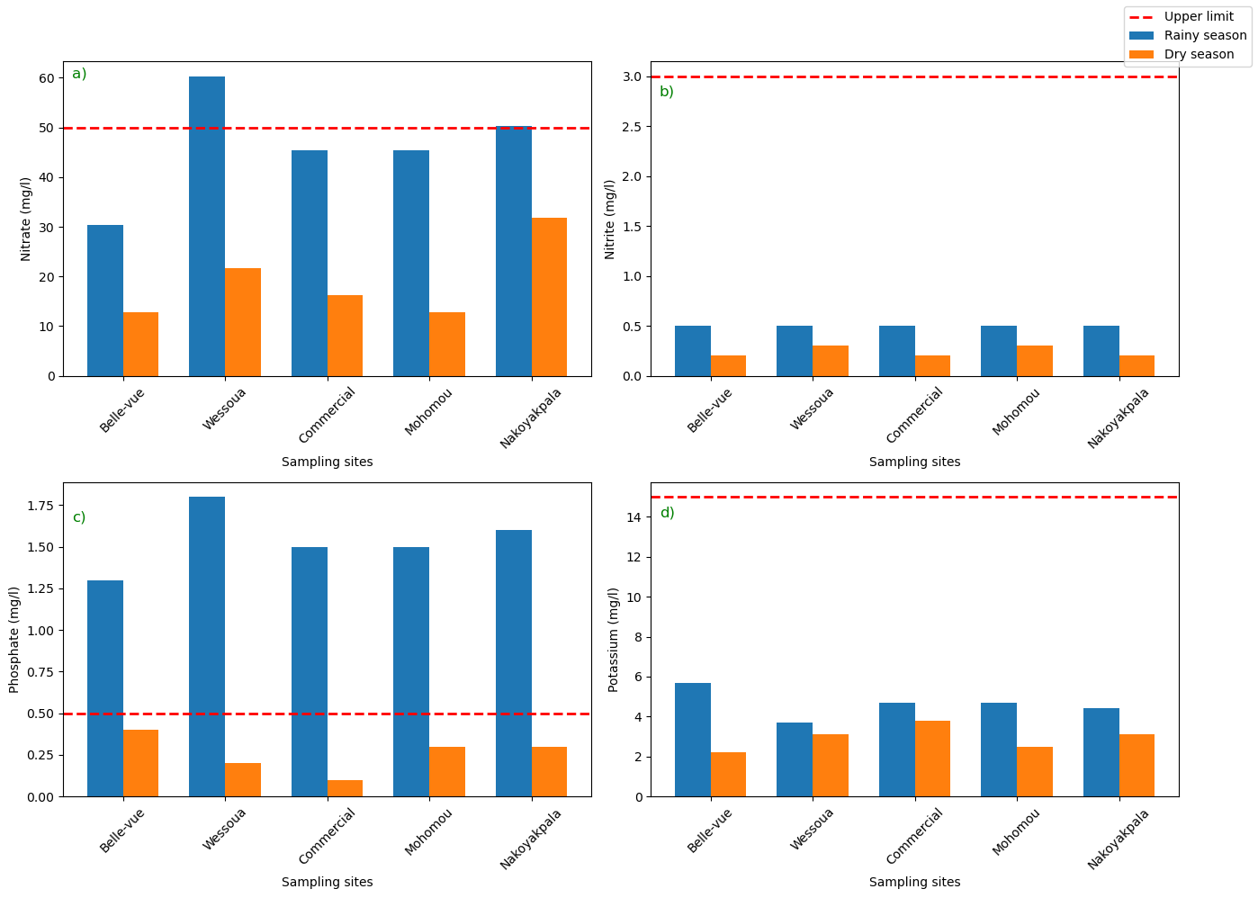

Figure 4: Spatial and seasonal comparison of the chemical parameters of the Tilé River in the forest region (N’Zézérkoré) of Guinea: a) Nitrate; b) Nitrite; c) Phosphate and d) Potasium

The Spatial and seasonal comparison of the chemical parameters of the Tilé River are depicted in Figure 5. Dissolved oxygen concentrations during the wet season were slightly above the lower limit at all study sites, unlike the concentrations at the same sites during the dry season (Figure 5a). The saturation level was above 70% during the wet season (Figure 5b), while it was around 50% during the dry season (Figure 5b). The Wessoua site had the highest manganese concentration, followed by the Nakoyapkala site (Figure 5c). The Belle-vue site recorded the highest iron concentration (greater than 4 mg/L) during the wet season. Furthermore, the iron concentrations at the various study sites during the wet season were higher than those during the dry season (Figure 5c).

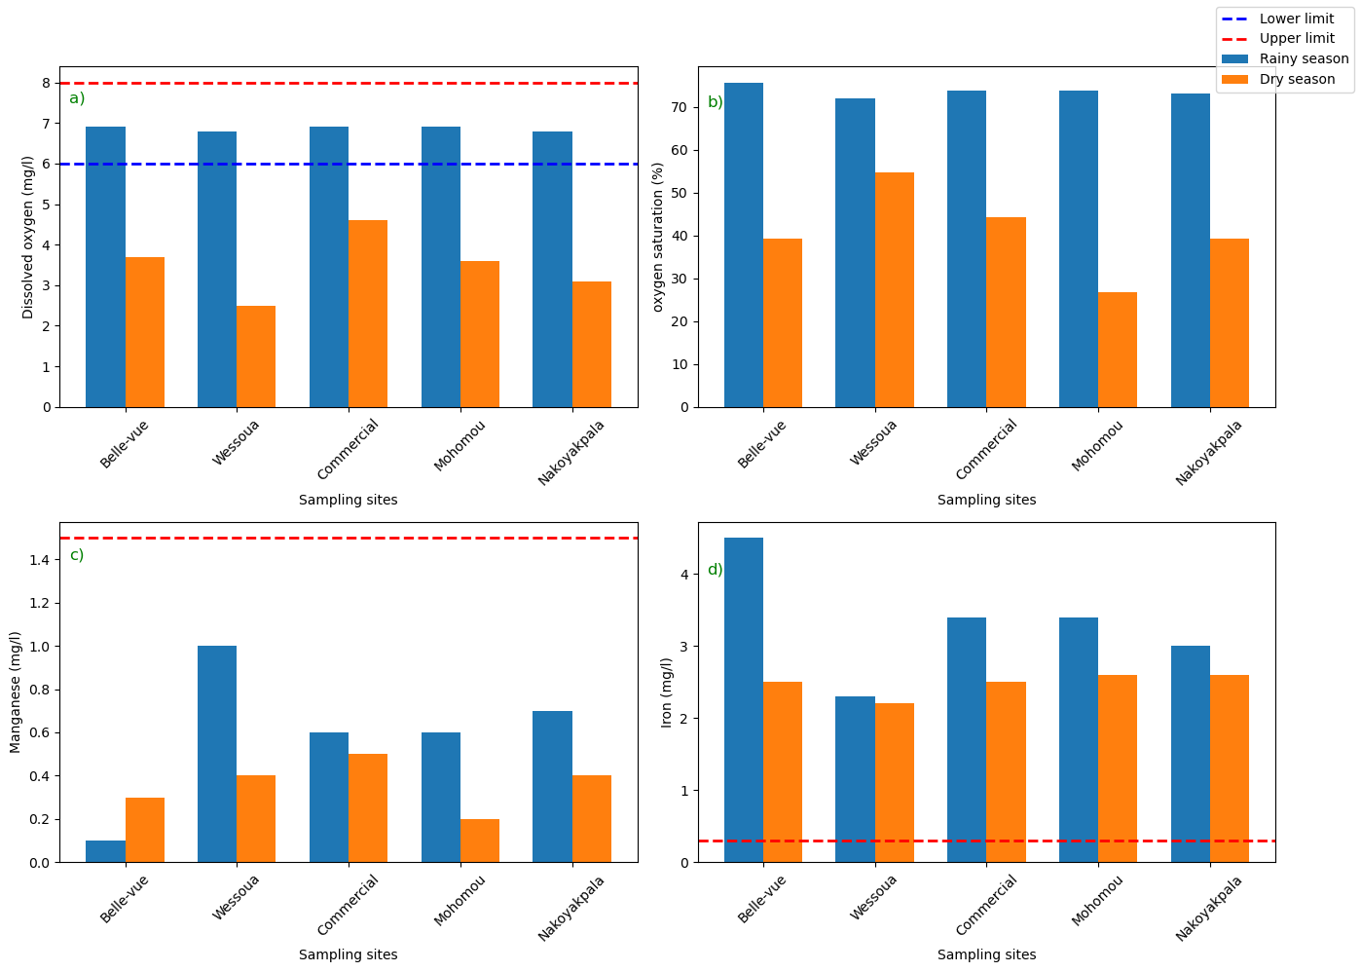

Figure 5: Spatial and seasonal comparison of the chemical parameters of the Tilé River in the forest region (N’Zérékoré) of Guinea: a) Dissolved oxygen; b) Oxygen saturation; c) Manganese and d) Iron

Principal component analysis of the physicochemical and microbiological parameters indicated that 73.2% of the total variance is explained by the first two principal components (PC1 and PC2), which contribute 55.5% and 17.7%, respectively (figure 6a). Concerning the correlation circle (figure 6a), axis 1 (PC1) is strongly and positively correlated with temperature, electrical conductivity, and fecal and total coliforms, while it was negatively correlated with temperature.

Axis 2 (PC2) showed strong positive correlations with manganese, nitrate, turbidity, phosphate, dissolved oxygen, and dissolved oxygen saturation, while suspended solids, iron, and pH showed negative correlations. Based on these correlations, Axis 2 defines a turbidity-phosphate-oxygen-nitrate gradient for particulate matter-laden waters (PM2). The distribution of the stations on the factorial plane (Figure 6b) shows a clear spatial differentiation. The commercial sites, Mohomou and Wessoua, characterized by the dry season, are located on the positive side of the PC1 axis, corresponding to waters with high levels of fecal and total coliforms and a lower dissolved oxygen concentration. Conversely, the Nakoyapkala and Belle-vue sites are negatively correlated with PC1 but are located positively on the PC2 axis, corresponding to waters with high concentrations of phosphates, nitrates, manganese, and dissolved oxygen, but during the rainy season (Figure 6b). The waters of the Belle-vue site are located negatively on the PC2 axis, associated with a high iron concentration and an acidic pH during the rainy season.

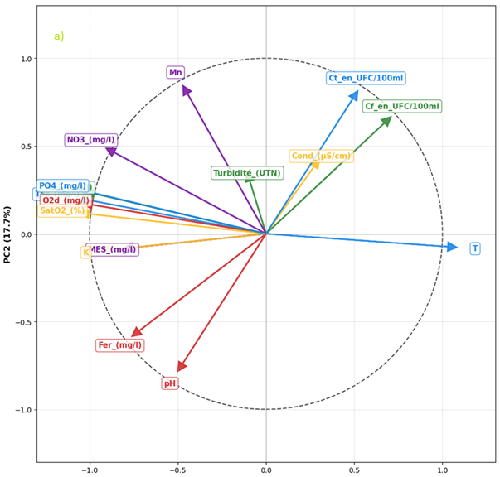

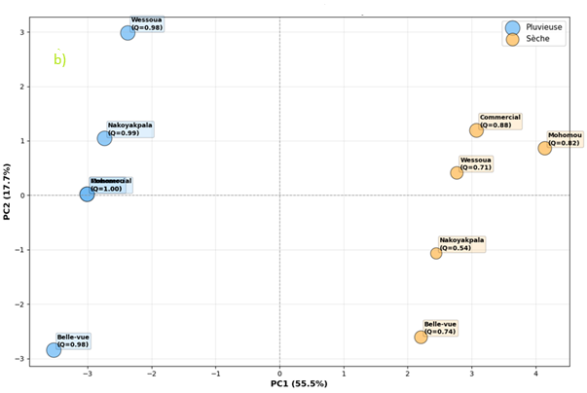

Figure 6: projection of water quality variables onto different sites (a) and sampled sites (b) in the factorial plane (PC1-PC2)

Discussion
The temperature of the Tilé River exhibits a marked seasonal pattern, being higher in the dry season than in the rainy season, consistent with observations made in other basins (Laniyan et al., 2025; Adewumi et al., 2020). The pH remains neutral to slightly alkaline and relatively stable between seasons, a result similar to that reported by Laniyan et al. (2025). Conductivity and total dissolved solids (TDS) are higher in the dry season due to evaporation, while turbidity and suspended solids increase in the rainy season, linked to runoff and soil leaching (Adeyemi et al., 2021). Dissolved oxygen concentrations are lower during the dry season, a consequence of high temperatures and organic runoff, as observed by Akinyemi and Ifabiyi (2021). Nutrient levels show contrasting dynamics: phosphates increase during the dry season due to domestic and agricultural runoff , while nitrates are higher during the rainy season due to agricultural leaching. Nitrites reach a maximum in Nakoyakpala and Belle-Vue during the rainy season, reflecting the impact of agricultural and domestic runoff, which corroborates the observations of Fagbayide et al. (2018) and Adomi et al. (2025). Metals are present at concerning concentrations: iron far exceeds the WHO standard, particularly in Belle-Vue (Olomukoro et al., 2022). Potassium shows spatiotemporal variability, being particularly high during the rainy season in Belle-Vue and Nakoyakpala, but persisting in Mohomou during the dry season, indicating local sources of pollution. Manganese also remains high, especially during the wet season, confirming ongoing pollution of anthropogenic origin. Dissolved oxygen saturation levels decrease during the dry season (55–65%) and improve during the rainy season (75–85%), consistent with trends observed in West Africa (Traoré et al., 2023; Adamou et al., 2020). Finally, microbiological pollution persists: total and fecal coliform concentrations far exceed drinking water standards, particularly in Mohomou, Commercial, and Wessou during the rainy season, a phenomenon also reported by several regional studies (Dan et al., 2018; Al-Afify et al., 2018; Alhou et al., 2009).
The analysis highlights that the main sources of pollution in the Tilé River are anthropogenic, this situation is mainly exacerbated in Tilé River because it is located in N’Zérékoré where agricultural residues, domestic waste, and wastewater are discharged without treatment. This finding aligns with that of Yapo et al. (2023) in Coast Ivory, who demonstrated that the intensive use of fertilizers and pesticides exacerbates pollution downstream from agricultural areas. Fecal contamination is an aggravating factor, linked to domestic waste and the lack of adequate sanitation. Rainy season leads to a significant increase in microbial loads (total and fecal coliforms) in the Tilé River as demonstrated by (Traoré et al., 2023; Adamou et al., 2020; Dan et al., 2018; Al-Afify et al., 2018; Alhou et al., 2009) at others rivers in West Africa. Overall, the findings are in agree with those reported by Camara (2017) in Conakry, in Accra by Baffoe et al. (2024) and (Hounsou et al., 2010; Tossou et al., 2022) on the Ouémé River in Benin, confirming the ongoing nature of urban and agricultural pollution in African watersheds. These results underscore the need for strict regulation of human activities and integrated water resource management in the municipality of N’Zérékoré.
4. Conclusion

The seasonal analysis of surface water quality in the Tilé River watershed, located in the urban commune of N’Zérékoré (Republic of Guinea), reveals a marked degradation of the physicochemical and microbiological quality of the water, particularly pronounced during the rainy season. The assessment, based on key pollution parameters (such as nutrients, metals, turbidity, and total and fecal coliforms), combined with the Physicochemical Biological Quality Index (IQBP), identified the main factors contributing to the degradation of this essential resource. The results indicate that all sampling sites at Belle-Vue, Wessou, Commercial, Mohomou, and Nakoyakpala exhibit significant levels of pollution, with water quality ranging from average to very poor depending on the season. The IQBP values are particularly low during the rainy season (often < 50), reflecting water quality that does not meet drinking water standards in more than 80% of the samples analyzed. This deterioration is linked to a combination of untreated domestic wastewater, pollutant-laden runoff, excessive use of chemical inputs in agriculture, and the near-total absence of sanitation infrastructure. This diffuse and chronic pollution represents a serious threat to human health, but also compromises agricultural, domestic, and fish farming uses of water resources. It reflects a worrying situation of environmental vulnerability that is part of a broader dynamic observed in several urban basins in West Africa as demonstrated by others studies. Faced with this problem, it is urgent to adopt an integrated approach to watershed management, based on reducing pollution at its source, implementing wastewater treatment systems, raising community awareness, and regularly monitoring water quality. The sustainable preservation of the Tilé River necessarily requires concerted actions, adapted to the local context, and taking into account both demographic changes and the effects of climate change.

Disclaimer (Artificial intelligence)

Author(s) hereby declare that NO generative AI technologies such as Large Language Models (ChatGPT, COPILOT, etc.) and text-to-image generators have been used during the writing or editing of this manuscript.

References

- Abigail Abena Baffoe, Razak Seidu, Serwaa Akoto Bawua, Julius Fobil, John Arko-Mensah; Microbiological quality of drinking water from three flood-prone communities along the Odaw River in Accra, Ghana. Journal of Water and Climate Change 1 December 2024; 15 (12): 6013–6021. doi: https://doi.org/10.2166/wcc.2024.668
- Adamou,H.;Ibrahim,B.;Salack,S.; Adamou,R.; Sanfo, S.; Liersch, S.Physico-chemical and bacteriological quality of groundwater in a rural area of Western Niger: A case study of Bonkoukou. J. Water Health 2020, 18, 77–90. [CrossRef]
- Adeyemi, O. G., Ojo, O. A., & Ogunleye, O. (2021). Seasonal dynamics of physicochemical and microbial water quality in selected Nigerian rivers. Environmental Monitoring and Assessment, 193, 582. https://doi.org/10.1007/s10661-02109349-9
- Adewumi, J. R., Otun, J. A., & Adebola, A. A. (2020). Assessment of microbial water quality of selected rivers in Osun State, Nigeria. Applied Water Science, 10, 93. https://doi.org/10.1007/s13201-020-1178-2
- Adomi, P. O., Anozie, A. J., Morka, E., & Odum, E. I. (2025). Microbial and Physicochemical Quality of River Water in Delta State, Nigeria. World Journal of Environmental Biosciences, 14(1), 21-28. https://doi.org/10.51847/MCmrpuO9Qe
- Akinyemi, S. A., & Ifabiyi, I. P. (2021). Seasonal variation of water quality in Asa River, Ilorin, Nigeria. Environmental Challenges, 4, 100124. https://doi.org/10.1016/j.envc.2021.100124
- Al-Afify, A. D. G., Othman, A. A. & Ramadan, M. F. 2018. Characterization of chemical and microbiological quality of Nile River surface water at Cairo (Egypt). Rendiconti Lincei.Scienze Fisiche e Naturali 29, 725–736.
- APHA. (2017). Standard methods for the examination of water and wastewater (23rd ed.). American Public Health Association.
- Boukerche, S., Bensouiah, T., & Chabaca, M. (2021). Seasonal evolution of the microbiological quality of the Soummam River waters (Algeria). Applied Hydroecology, 24(3), 205–215.
- Camara, T. (2017) Assessment of the Quality of Water Supply Sources in the Urban Commune of Conakry. Doctoral Thesis, Gamal Abdel Nasser University of Conakry.
- Dan, O.F., Aho, E., Ahouansou, D.M.M., Sintondji, L.O., Assoti, L., Zandagba, J. and Amouzouvi, D. (2018) Study of the Physico-Chemical and Bacteriological Characteristics of Drinking Water in So-Ava, South Benin. Journal of Water Resource and Protection, 10, 1031-1046. https://doi.org/10.4236/jwarp.2018.1011060
- Diawara, B.L., Quoie Jr, G.D.S., Li, Z. and Loua, J.J. (2024) Water Scarcity in Conakry, Guinea: Challenges and Proposed Strategies for a Way Forward. Journal of Water Resource and Protection, 16, 264-280.
- Djaffar, S., & Kettab, A. (2015). Sustainable water management in developing countries. Applied Hydroecology, 19, 139–150.
- Dongo, K., N’Goran, K. D., Kouadio, K. E., & Biemi, J. (2010). Impact of urbanization on the water quality of the Agnéby River: The case of the municipality of Agboville (Southern Côte d’Ivoire). Journal of Water Science, 23(2), 171–182. https://doi.org/10.7202/045360ar
- E. O. Hounsounou, M. Agassounon Djikpo Tchibozo, N. C. Kelome, E. W. Vissin, G. A. Mensah, et E. Agbossou, «Hounsounou, E. O., Agassounon Djikpo Tchibozo, M., Kelome, N. C., Vissin, E. W., Mensah, G. A., & Agbossou, E. (2017). Pollution des eaux à usages domestiques dans les milieux urbains défavorisés des pays en développement : Synthèse bibliographique. International Journal of Biological and Chemical Sciences, 10(5), 2392.», Int. J. Biol. Chem. Sci., vol. 5, no 5, p. 2392, 2017.
- FAO. (2005). Water and agriculture information system: Guinea. Food and Agriculture Organization of the United Nations. http://www.fao.org
- Guilavogui, K., Gbilimou, L.T., Bangoura, S., Sangaré, A. and Keita, A. (2025) Physico-Chemical and Microbiological Assessment of Borehole and Tap Water in Nzérékoré (Republic of Guinea). American Journal of Analytical Chemistry, 16, 161-173. https://doi.org/10.4236/ajac.2025.168010
- Hounsou, M. B., Agbossou, E. K., Ahamide, B. & Akponikpe, I. 2010 Qualité bactériologique de l’eau du bassin de l’Ouémé: cas des coliformes totaux et fécaux dans les retenues d’eau de l’Okpara, de Djougou et de Savalou au Bénin (Bacteriological water quality in the Ouémé basin: case of total and faecal coliforms in the water reservoirs of Okpara, Djougou and Savalou in Benin). International Journal of Biological and Chemical Sciences 4 (2), 377–390.
- Kim TK. Understanding one-way ANOVA using conceptual figures. Korean J Anesthesiol. 2017 Feb;70(1):22-26. doi: 10.4097/kjae.2017.70.1.22. Epub 2017 Jan 26. PMID: 28184262; PMCID: PMC5296382
- Lamah SP, Diallo A, Bah AL. Environmental impact of agricultural practices in the Tilé watershed in the urban commune of N'Zérékoré, Republic of Guinea. Environmental impact of agricultural practices in the Tilé watershed in the urban commune of N'Zérékoré, Republic of Guinea. Rev. Ivoir. Sci. Technol. 2022; 39, 84 – 99.
- Laniyan, A. B., Olugbenga, O. M., Odjegba, E. E., & Ademeno, W. O. (2025). Seasonal Climate Variability and Water Quality Dynamics in The Osun River Basin, Southwestern Nigeria. Journal of Environment, Climate, and Ecology, 2(2), 114-129. https://doi.org/10.69739/jece.v2i2.1028
- Le, T. (2025). Evaluation of the surface water system using statistical method (PCA, FA AND ANOVA): a case study of Binh Thuan province, Vietnam. VNUHCM Journal of Earth Science and Environment, 9(1), 1086-1100. https://doi.org/https://doi.org/10.32508/stdjsee.v9i1.800
- Mariama Camara , Adama Sirima , Hamidou Bah, Nouhan Keita , Alhassane Diallo and Aïssata Camara. Analysis of agricultural practices' impact on the quality of irrigation water for growing vegetables in the Urban Commune of N'Zérékoré, Republic of Guinea. World Journal of Advanced Research and Reviews, 2025, 25(03), 2212-2219. DOI: https://doi.org/10.30574/wjarr.2025.25.3.0855
- Mohammed, A.; Samara, F.;Alzaatreh, A.; Knuteson, S.L.Statistical Analysis for Water Quality Assessment: A Case Study of Al Wasit Nature Reserve. Water 2022, 14,3121. https://doi.org/10.3390/w14193121
- Nombamba Ouéda, Bawa Koffi Essewata, Ibrahim Tchakala, Moctar Limam Bawa. 2025. “Contrôle de la qualite physico-chimique et bacteriologique des sources d’eau (puits et forages) en saison hivernale d’une zone inondable dans le district de Lomé: Cas de Zogbedji”, Asian Journal of Science and Technology, 16, (02), 13509-13515.
- Olomukoro JO, Obi-Obueze NO, Eko-Imirianye R, Anani OA and Obot V (2022), Water quality evaluation using physicochemical and biological indices to characterize the integrity of the Orogodo River in sub-Saharan Africa. Front. Environ. Chem. 3:961369. doi: 10.3389/fenvc.2022.961369
- Paillé, P., & Mucchielli, A. (2021). Qualitative analysis in the humanities and social sciences (5th ed.). Armand Colin.
- Pujar, P.M., Kenchannavar, H.H., Kulkarni, R.M. et al. Real-time water quality monitoring through Internet of Things and ANOVA-based analysis: a case study on river Krishna. Appl Water Sci 10, 22 (2020). https://doi.org/10.1007/s13201-019-1111-9
- Rodier, J., Legube, B., & Merlet, N. (2009). Water analysis: Natural waters, wastewater, seawater (9th ed.). Dunod.
- Sawadogo A, Sanou Y, Paré S. Evaluation de la qualité des eaux de forage de la commune de Ouagadougou, Burkina Faso. Int. J. Biol. Chem. Sci (2023), 17 (6), 2550–2563.
- Solie, L., Bangoura, M. R., & Gbilimou, A. (2025). Impact of Urbanization on the Tile Watershed in the Urban Commune of N’Zerekore. Journal of Geoscience and Environment Protection, 13, 277-288. https://doi.org/10.4236/gep.2025.137017
- Soncy K., B. Djeri, K. Anani, M. Eklou-Lawson, Y., Adjrah, D.S. Karou, Y. Amaeyapoh et C. de Souza, 2015. Evaluation de la qualoité bactériologique des eaux de puits et de forage à Lomé, Togo, Journal of Applied Biosciences 91 : 8464-8469.
- Stéphanie dos Santos, E. Adams, G. Neville, Y. Wada, A. de Sherbinin, et al. Urban growth and water access in sub-Saharan Africa: Progress, challenges, and emerging research directions. Science of the Total Environment, 2017, 607-608, pp.497- 508. 10.1016/j.scitotenv.2017.06.157. hal-01784924.
- Tossou E, Chouti WK, Osseni S. Evaluation of the chemical and bacteriological parameters of well and borehole waters in the city of natitingou in the north west of Benin. Journal of Fundamental and Applied Sciences. 2022; 14(3): 518-538. DOI: http://dx.doi.org/10.4314/jfas.1253.
- Traoré, O.; Kpoda, D.S.;Dembélé, R.; Saba, C.K.S.; Cairns, J.;Barro, N.; Haukka, K. Microbiological and Physicochemical Quality of Groundwater and Risk Factors for Its Pollution in Ouagadougou, Burkina Faso. Water 2023, 15, 3734. https://doi.org/10.3390/w15213734
- UN. (2020). The Sustainable Development Goals. https://sdgs.un.org/goals
- UN. (2021). World water development report 2021: Valuing water. UNESCO. https://unesdoc.unesco.org
- Wang R, Liu L, Tao Z, Wan B, Wang Y, Tang X, Li Y, Li X. Effect of urbanization and urban forests on water quality improvement in the Yangtze River Delta: A case study in Hangzhou, China. J Environ Manage. 2024 Feb;351:119980. doi: 10.1016/j.jenvman.2023.119980. Epub 2024 Jan 4. PMID: 38176386.
- Yadav, S., Babel, M.S., Shrestha, S. et al. Land use impact on the water quality of large tropical river: Mun River Basin, Thailand. Environ Monit Assess 191, 614 (2019). https://doi.org/10.1007/s10661-019-7779-3
- Yang Q, Chen J, Liu Y, Li Y, Zhang H, Zhang J,Sun X, Lu M, Ma R and Wu Y (2024), Analysis of changes in water quality and treatment effectiveness of seven major river basins in China from 2001 to 2020.Front. Environ. Sci. 12:1340994.doi: 10.3389/fenvs.2024.1340994
- Yapo Toussaint Wolfgang, Kpaibe Sawa Andre Philippe, Gbagbo Tchape Aubin George, Kouassi Agbessi Therese, Amin Ncho Christophe. Quality of River Water and Impact on the Health of Populations in the Village of M'pody (Anyama, Ivory Coast). International Journal of Environmental Chemistry. Vol. 7, No. 1, 2023, pp. 1-8. doi: 10.11648/j.ijec.20230701.11

