Stability Evaluation of Bambara Groundnut (Vigna subterranea L. Verdc.) Powder Using Adsorption Isotherm Analysis and GAB Modeling

Abstract
The transformation of foods into powder form, for improved preservation, ensures their availability throughout the year despite their seasonal nature. Moisture adsorption isotherms therefore constitute an essential source of information for assessing food stability and defining optimal drying and storage conditions. The storage of Bambara groundnut (Vigna subterranea) powder requires prior hygroscopic characterization to ensure better preservation. The adsorption isotherm of Bambara groundnut powder was experimentally determined using the gravimetric method with different saturated salt solutions. The water activity range studied extended from 0.07 to 0.95 at an ambient temperature of 28 ± 2 °C. Desiccators were used to contain the prepared salt solutions at various relative humidities, above which the samples were placed. Hygroscopic equilibrium was reached after 27 to 31 days. The results revealed that the adsorption isotherm obtained was classified as type II, characterized by a sigmoid shape typical of carbohydrate-rich food products. Experimental data were fitted using the Guggenheim–Anderson–de Boer (GAB) mathematical model. The modeling showed excellent agreement with the experimental data (R² = 0.982), indicating that this model effectively predicts the hygroscopic behavior of the product. Furthermore, the moisture content of Bambara groundnut powder should be maintained below the monolayer moisture content (X₀), estimated at 0.0517 (5.17%), to ensure extended shelf life during storage.
Keywords: Bambara groundnut; hygroscopicity; adsorption isotherm; modeling; GAB

- Introduction
Legumes are promising sources of plant-based proteins. In tropical regions, cowpea (Vigna unguiculata L. Walp.) and groundnut (Arachis hypogaea L.) are widely consumed, unlike other species such as Bambara groundnut (Vigna subterranea L. Verdc.) (Yusuf et al., 2008). Bambara groundnut is the third most important legume in terms of production and consumption after groundnut and cowpea (Diallo et al., 2015). The crop is cultivated for its seeds, which are rich in proteins, carbohydrates, lipids, and micronutrients (Mahala and Mohammed, 2010; Bonny and Dje, 2011).
The storage and preservation of these legumes remain the primary means of ensuring their nearly continuous availability (Sibiri et al., 2024). Food shortages are not solely due to insufficient production; post-harvest losses also contribute significantly (Cissokho et al., 2015). In sub-Saharan Africa, post-harvest losses of agricultural commodities such as cereals and legumes have been estimated at approximately 5 to 18% (Waongo et al., 2013).
Therefore, preserving these food products during the post-harvest phase is a major concern for rural producers. Indeed, a large portion of the diet consists of agricultural products that are generally seasonal and highly perishable. To ensure year-round food availability, several traditional preservation methods have been developed to extend product shelf life (Gandaho et al., 2017).
However, these traditional preservation technologies are often inadequate and may expose stored products to infestation by toxigenic molds and other spoilage agents that compromise product quality (Kpatinvoh et al., 2017). It is estimated that 25 % of global harvests are contaminated by mycotoxins produced by toxigenic molds. Among traditionally used preservation techniques, open-air drying is widely practiced in developing countries (Yiannikouris and Jouany, 2002). In the agri-food industry, drying is recognized as one of the most delicate unit operations, as processing conditions strongly influence not only rheological properties (deformation, surface characteristics, etc.) but also the nutritional quality of dried foods (Kechaou et al., 1996).
A thorough understanding of the hygroscopic behavior of a food product is therefore essential for accurately controlling drying processes. Food is dried for subsequent applications that generally require a specific moisture content related to product stability. In the hygroscopic domain, where migrating water exists primarily as bound water or water vapor, a macroscopic relationship exists between the equilibrium moisture content of the food and the surrounding environment. The sorption isotherm relates the equilibrium moisture content at a given temperature to the relative humidity of the environment surrounding the product. It reflects the numerous interactions between the food matrix and water molecules occurring at the microscopic scale.
Sorption isotherms are of major importance in the agri-food industry, particularly in solar drying, storage, and food preservation. Their determination provides information on the hygroscopic or moisture equilibrium of the food product. Indeed, identifying the stability range of a dried product is only possible through these curves, which also provide insight into the different types of water present in the food matrix. The availability of analytical expressions of sorption isotherms applicable to various foods and temperatures would facilitate the prediction of the shelf life of dehydrated products (Furmaniak et al., 2009).
Given the complexity of the phenomena involved in water adsorption, the Guggenheim-Anderson-de Boer (GAB) model, which is based on semi-physical assumptions, has been widely tested. The GAB equation is the most extensively used model in European food science research laboratories. It is applicable over a water activity range of 0.05 to 0.95 (Ferradji et al., 2008). The use of this model for analyzing experimental data is a crucial step in the design and optimization of drying systems. The objective of this study is therefore to determine the hygroscopic characteristics of Bambara groundnut powder, experimentally establish its adsorption isotherm, and model it using a fitting approach based on the GAB model to improve storage stability.

2. Materials and Methods

2.1 Sample Collection and Preparation

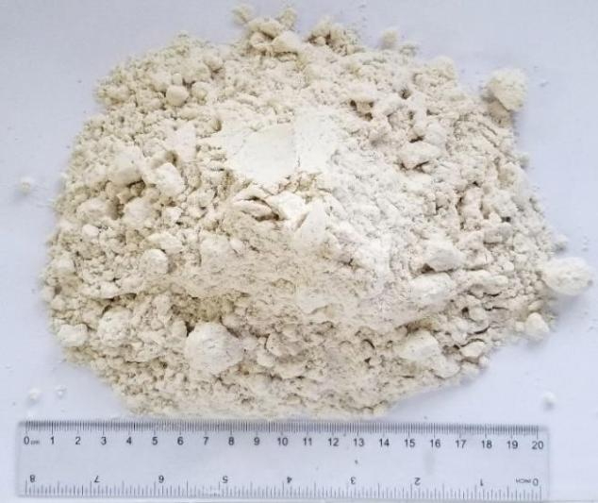
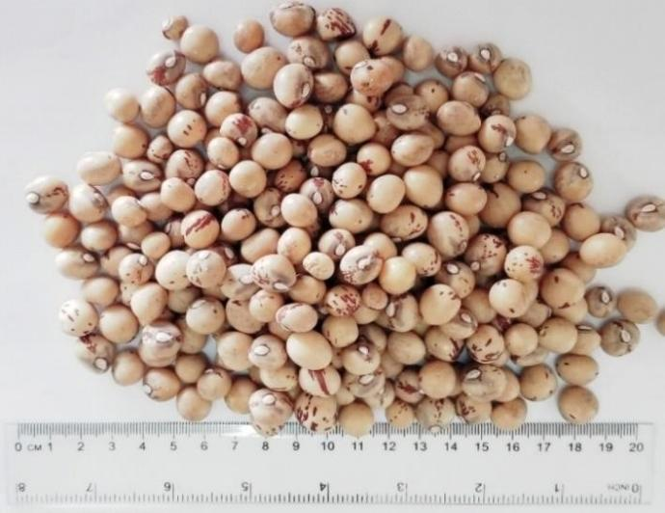
The plant material used in this study consisted of Bambara groundnut (Vigna subterranea L.) seeds (Figure 1A) collected in northern Côte d’Ivoire from randomly selected vendors at the Katiola market. The samples were transported to Abidjan in jute bags and subsequently processed at the Biochemistry Laboratory of Nangui Abrogoua University. The seeds were sun-dried until a constant weight was reached, then crushed and ground using a grinder (Moulinex Blender) to obtain a fine powder (Figure 1B). The resulting powder was sieved through a 0.025 cm mesh sieve to remove seed coat debris. The flour obtained at the end of the process was stored in sealed glass jars for subsequent analyses.

A

B

Figure 1: Bambara groundnut (Vigna subterranea L. Verdc.), seeds (A) and powder (B)

2.2. Determination of adsorption isotherms
The method used to determine the adsorption isotherms was the gravimetric method, also known as the static microclimate method. A recommended procedure defined within the framework of the European COST 90 project is based on the use of thermostatically controlled sealed jars containing oversaturated salt solutions at the bottom to maintain the desired relative humidity (Baucour and Daudin, 2000). Dried Bambara groundnut powder was placed in glass desiccators and maintained at ambient laboratory temperature (28 ± 2 °C) under constant relative humidity conditions, controlled by the type of saturated salt solution used. Seven types of saturated salts were employed to generate specific relative humidities at 28 °C: KOH, K₂CO₃, Ca (NO₃)₂, NaCl, KCl, BaCl₂, and K₂SO₄.

Table 1: Water activity of different saline solutions
Saline solutions | Water activity of salts
KOH | 0,07
K₂CO₃ | 0,43
Ca (NO₃)₂ | 0,56
NaCl | 0,75
KCl | 0,85
BaCl₂ | 0,90
K2SO₄ | 0,95
KOH : Potassium Hydroxide; K₂CO₃ : Potassium Carbonate ; Ca (NO3)2 : Calcium Nitrate ; NaCl : Sodium chloride; KCl : Potassium chloride ; BaCl₂ : Barium chloride; K₂SO₄ : Potassium sulfate

Adsorption isotherms were determined using the static gravimetric method with saturated salt solutions. In desiccators corresponding to water activity (aw) values higher than 0.7, thymol was added to prevent microbial growth. Individual samples of Bambara groundnut powder intended for isotherm determination during the first phase of the experiment were weighed to approximately 2.00 g ± 0.1 mg and placed in shallow dishes of approximately 35 mm diameter to ensure uniform layer distribution. The dishes were then introduced into a desiccator containing phosphorus pentoxide (P₂O₅), used as a strong desiccant, and maintained at ambient temperature for three weeks to reduce the initial moisture content to approximately 2%. At the end of this period, the initial masses of the dehydrated samples were accurately recorded. The samples were subsequently transferred into desiccators containing the appropriate saturated salt solutions corresponding to different water activity levels. The desiccators were kept at laboratory ambient temperature, and the samples were left until equilibrium was reached, indicated by the absence of significant mass variation. The equilibrium moisture content was calculated from the initial mass after P₂O₅ desiccation and the mass changes recorded during the adsorption process. Weighings were carried out at regular intervals until stabilization of the sample weight. Hygroscopic equilibrium was considered achieved when the difference between two successive mass measurements was less than the analytical balance precision (± 0.001 g). The total time required for removing, weighing, and returning the samples to the desiccators was approximately 30 seconds, thereby minimizing atmospheric moisture uptake during handling. To assess reproducibility and estimate experimental error, each moisture content measurement was performed in triplicate.

2.3. Determination of the amount of adsorbed moisture (X)
The amount of moisture adsorbed at equilibrium (X), expressed as grams of water per gram of dry matter (or percentage of water on a dry basis), was determined from the mass difference of the samples measured before and after exposure to controlled relative humidity conditions (Nadia and Mohamed 2017).
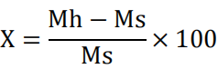
(I)

Mh = wet mass; Ms = dry mass; X = percentage of water content

2.4. Modelling of experimental adsorption isotherms
To model adsorption–desorption curves, numerous empirical models describing the relationship between equilibrium moisture content, relative humidity, and temperature have been reported in the literature. Among them, the Guggenheim–Anderson–de Boer (GAB) model is considered one of the most appropriate theoretical models for food materials (Ferradji et al., 2008). It is applicable over a water activity (aw) range of 0.07 to 0.95. The GAB model is described by the following equation:
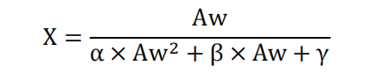
(II)

aw is the water activity; X is the monolayer moisture content
This equation, previously used by Lewicki (1997), makes it possible to construct the theoretical adsorption isotherm curve from experimental data. The correlation coefficients were determined by nonlinear regression analysis, by fitting experimental values of X as a function of aw. This curve has the equation:
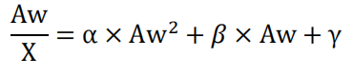
(III)

With a coefficient of determination R², which is the coincidence between theoretical and experimental values. which reflects the degree of agreement and thus the adequacy of the GAB equation (Chuang and Toledo, 1976). After rearrangement of the GAB equation, theoretical moisture content values were calculated accordingly:
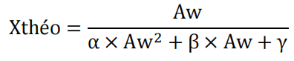
(IV)

2.5. Determination of the terms Xm, K, C of the GAB model
The parameters Xm, C, and K of the GAB model were determined using a second-order polynomial relationship solved by nonlinear regression analysis in order to optimize the coefficient of determination R² (Abramovič and Klofutar, 2002). The values of these parameters were obtained through the corresponding regression equations:
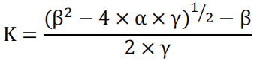
(V)

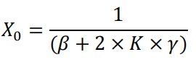
(VI)
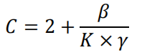
(VII)

X₀: water content of the monolayer; C and K are constants related to the interaction energies between water molecules and the solid matrix.

2.6. Statistical Analysis

Regression analysis was performed using SPSS version 17.0 and Microsoft Excel 2013. Nonlinear regression was employed to estimate model parameters using the Levenberg–Marquardt algorithm, which iteratively adjusts response values and recalculates a least-squares fit of a nonlinear model to optimize parameter estimation.

3. Results and Discussion

3.1. Results

3.1.1. Isotherm curve for the adsorption of Bambara groundnut powder
The stabilization of the adsorption moisture content values of Bambara groundnut powder was presented in Table 2. Hygroscopic sorption equilibrium was reached after 31 days. The adsorption isotherm curve obtained at an ambient temperature of 28 ± 2 °C shows that at higher water activity values, the moisture content of the sample increases.

Table 2: Experimental values of the water content (%) of Bambara groundnut powder as a function of water activity
Water activity (Aw) | X exp (%)
0,07 | 5,5
0,43 | 8,9
0,56 | 12,8
0,75 | 23,1
0,85 | 35,2
0,90 | 46,0
0,95 | 66,9
X exp (%): experimental water content of Bambara groundnut powder
The experimental adsorption isotherm of Bambara groundnut powder (Figure 2) exhibits a sigmoid “S”-shaped profile characteristic of a Type II isotherm, with three distinct regions. The first region extends from aw = 0 to 0.34 and is characterized by a slight increase in moisture content. The second region ranges from aw = 0.34 to 0.75 and shows a progressive increase in moisture content. Beyond aw = 0.75, corresponding to water activity values between 0.75 and 0.95, a sharp increase in moisture content is observed, reflecting the exponential growth of the curve in this region.
.

0
10
20
30
40
50
60
70
80
0
0
,
1
0
,
2
0
,
3
,
4
0
0
,
5
0
,
6
0
7
,
0
,
8
0
,
9
1
Water content (% on a dry basis)
)
Water activity
Figure 2: Experimental curve of the adsorption isotherm of Bambara groundnut powder

3.1.2. modelling of the adsorption isotherm curve of Bambara groundnut powder
Table 3 also presents the different Aw/X values as a function of aw for the sample, enabling the determination of the trend line equation.
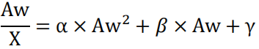

Table 3: Aw/X values as a function of Aw

Aw | Aw/X
0,07 | 1,2
0,43 | 4,8
0,56 | 4,3
0,75 | 3,2
0,85 | 2,4
0,90 | 1,9
0,95 | 1,4
Nonlinear regression analysis (Figure 3) was applied to determine the parameters (X₀, K, and C) of the GAB mathematical model. The model equation was used to fit the experimental moisture content data of Bambara groundnut powder.
0
1
2
3
4
5
6
0
1
0
,
0
,
2
0
,
3
0
,
4
0
,
5
0
,
6
0
,
7
0
,
8
0
,
9
1
Aw/X
Water activity (A_{w})
Figure 3: Nonlinear regression of Aw/X as a function of Aw

This gives us the following equation:
Y = -17,271x² + 17,559x + 0,099 with a correlation coefficient: R² = 0,982
By identification: y= Aw/X_{theo}; x=Aw; α=-17,271; β=17,559 et γ=0,099, on subsequently obtained: Aw/X_{theo} = -17,271 Aw²+17,559 Aw+0,099
The theoretical values were calculated using the following equation.
X_{theo} = Aw/ (-17,271. Aw² + 17,559. Aw + 0,099)
All these calculations enable us to arrive at the theoretical water content values shown in the table 4.

Table 4: Theoretical water content values for Bambara groundnut powder

Aw | X théo (%)
0,07 | 5,6
0,43 | 9,6
0,56 | 12,4
0,75 | 21,1
0,85 | 33,3
0,90 | 47,0
0,95 | 79,6

X théo: Theoretical water content of Bambara groundnut powder
Regarding the GAB model parameters (X₀, C, K, and R) presented in Table 5, the monolayer moisture content (X₀) was determined. The monolayer moisture content represents the maximum amount of water below which moisture is not available for chemical and biochemical reactions. This parameter is essential for controlling product stability during storage. For Bambara groundnut powder, the value of X₀ was found to be 0.051 g/100 g dry matter. This monolayer moisture content corresponds to a water activity of 0.076.

Table 5: Parameters of GAB

Model Parameters Values
GAB | X0  K | 0,051  0,878
 | C | 39,78
 | R² | 0,982

The values of water activity (aw) and both experimental and theoretical moisture contents were used to simultaneously plot the experimental and theoretical sorption isotherm curves of Bambara groundnut powder (Figure 4). The theoretical and experimental curves overlap closely up to aw = 0.56. Beyond this value, the difference becomes noticeable. For water activity values between 0.56 and 0.94, the theoretical curve lies slightly above the experimental curve. At water activity values higher than 0.94, the experimental curve falls below the theoretical curve.

0
10
20
30
40
50
60
70
80
90
0
0
,
1
0
2
,
3
,
0
0
,
4
0
,
5
0
6
,
0
,
7
0
,
8
0
,
9
1
Water content (% on a dry basis)

Water Activity (A_{w})
Xexp
X theoretical
Figure 4: Comparison of experimental and theoretical curves of the adsorption isotherm of Bambara groundnut powder

4. Discussion
The sorption isotherm of the tested Bambara groundnut flour sample was classified as a Type II sorption isotherm. According to Limousin et al. (2007), the sigmoid sorption curve indicates that the observed phenomenon reflects the formation of polymolecular water layers on the surface of the studied flours. “S”-shaped isotherms, characterized by the presence of two inflection points, are used to describe a three-stage adsorption process involving at least two opposing mechanisms (Limousin et al., 2007). At high relative humidity values, the amount of absorbed water increases. This increase in moisture content mainly depends on the relative humidity of the surrounding air within the chamber and the temperature (Varghese et al., 2014; Cruz et al., 2015). Analysis of the curve revealed two inflection points, allowing it to be divided into three distinct regions. The first region extends from a water activity (aw) of 0.00 to 0.40; it is governed by the interaction of polar groups of hydrophilic components, characterized by high binding energy. These established bonds enable the formation of a monolayer (Kelly et al., 2016). The unavailability of this water slows biochemical reactions and prevents its use by microorganisms for growth (Moreira et al., 2015). The second region of the isotherm ranges from 0.40 to 0.77; in this region, aggregation of water molecules is observed. Absorption is slow and gradual, promoting the formation of a second layer in addition to the first, resulting in multilayer formation. This phenomenon may be explained by a slight increase in absorbable water within the chamber, leading to partial dissolution of macromolecules. The third region reflects the accumulation of water in intermolecular spaces. In this zone, water activity is higher (aw > 0.75); the steep rise of the curve indicates a rapid increase in water absorption until a maximum is reached. Water becomes sufficiently available to allow the powder to absorb moisture until pore saturation occurs. Excess water is present due to total hydrolysis of sugars and their transition from the crystalline to the amorphous state (Ferradji et al., 2008). Water becomes free in capillary form, retained in large capillaries and cell walls; it is weakly bound (Al-Muhtaseb et al., 2002; Yué and Tano, 2008). Consequently, free water promotes several chemical reactions (oxidation, browning) and biological developments (molds, yeasts) responsible for food deterioration. The use of the GAB mathematical model in this study to compare experimental and theoretical moisture contents was recommended because it covers a water activity range from 0 to 0.95 (Furmaniak et al., 2009; Yué Bi et al., 2018). Furthermore, the correlation coefficient (R² = 0.982), lying between 0.85 and close to 1, confirms the suitability of the GAB model. This agrees with the findings of Akanbi et al. (2006), who stated that the GAB model is applicable when R ≥ 85%. The obtained constants X₀, K, and C were 0.0517, 0.878, and 39.78, respectively, and were considered significant. The variable X₀ is the most important, as it represents the monolayer moisture content, which ensures product stability during storage (Benseddik et al., 2014). This value is similar to that reported for bulgur powder, considered a wheat-based functional food, and for seaweeds, with X₀ values of 5.01 and 5.5, respectively (Erbas et al., 2016; Moreira et al., 2015). However, oxidation and enzymatic reactions are not completely inhibited above this value; rather, it mainly prevents the development of biological spoilage agents, whose threshold water activity for growth is approximately 0.6. The constants C and K are related to interaction energies. The constant C also indicates the isotherm characteristics. If C < 10, the isotherm is classified as Type III; if C > 10, it is classified as Type II according to Medeiros et al. (2006). In this study, the C value (39.78) is greater than 10, confirming the Type II classification. This theoretical result predicts the shape of the adsorption isotherm obtained experimentally (Medeiros et al., 2006).

5. Conclusion
Establishing the moisture sorption isotherm of Bambara groundnut powder is essential for providing useful information for its storage and drying. The equilibrium moisture content determined during the sorption process can help optimize drying conditions. The value of the GAB model constant indicates that the moisture absorption process of Bambara groundnut flour is classified as a Type II isotherm. The GAB model is therefore appropriate for describing the experimental sorption data of Bambara groundnut powder. However, further research on the effects of drying conditions, storage practices, and packaging materials on the final quality of Bambara groundnut powder could be conducted to extend its shelf life.

Disclaimer (Artificial intelligence)
Author(s) hereby declare that NO generative AI technologies such as Large Language Models (ChatGPT, COPILOT, etc.) and text-to-image generators have been used during the writing or editing of this manuscript.

Reference
- Abramovi H, Klofutar C. (2002). Isothermes d'adsorption d’eau de certains échantillons de maltodextrine. Acta Chimica Slovenica. Abstracts on Tropical Agriculture 12 (7), 9-16.
- Akanbi CT, Adeyemi RS, Ojo A. (2006). Drying characteristics and sorption isotherm of Tomato slices. Journal of Food Engineering 73 (2), 157-163.
https://doi.org/10.1016/j.jfoodeng.2005.01.015
- Al-Muhtaseb AH, McMinn Wam, et Magee TRA. (2004). Water sorption isotherms of starch powders. Journal of Food Engineering 61(3), 297-307.
https://doi.org/10.1016/S0260-8774(03)00133-X
- Al-Muhtaseb AH, McMinn W, Magee TRA. (2002). Moisture Sorption Isotherm Characteristics of Food Products: A Review. Food and Bioproducts Processing 80 (2), 118-128.
https://doi.org/10.1205/09603080252938753
- Baucour P, Daudin JD. 2000. Development of anew method for fast measurement of water sorption isotherms in the high humidity range validation on gelatine gel. Journal of Food Engineering (44), 97-107.
https://doi.org/10.1016/S0260-8774(99)00171-5

- Benseddik A, Azzi A, Allaf K. (2014). Modélisation des isothermes de désorption de la citrouille en vue de leur séchage solaire. Revue des Energies Renouvelables SIENR’14 Ghardaïa 173 – 182.
- Bonny BS, Djè Y. (2011). Variabilité morphologique et agronomique des variétés traditionnelles de voandzou [Vigna subterranea (L.) Verde. (Fabaceae)] de Côte d’Ivoire. Journal of Applied Biosciences 41, 2820- 2835.
- Cissokho PS, Gueye MT, Sow EH, Diarra K. (2015). Substances inertes et plantes à effet insecticide utilisées dans la lutte contre les insectes ravageurs des céréales et légumineuses au Sénégal et en Afrique de l’Ouest. International Journal of Biological and Chemical Sciences, 9(3), 1644-1653.
- Cruz B J, Ezequiel C, Leandro J, & Ricardo AMT. (2015). Relative humidity stabilization in a temperature-controlled chamber. Workshop on Information Processing and Control, 14.
https://doi.org/10.1109/rpic.2015.7497168
- Diallo S, Doudjo S, Youssouf KK, Emmanuel AN, Benjamin YK, Dago G. (2015). Fortification et substitution de la farine de blé par la farine de Voandzou (Vigna subterranea L. verdc) dans la production des produits de boulangerie. International Journal of Innovation and Scientific Research 18 (2), 434-443.
- Erbas M, Aykin E, Arslan S, Durak AN. (2016). Adsorption behaviour of bulgur. Food chemistry 195, 87-90.
https://doi.org/10.1016/j.foodchem.2015.06.050
- Ferradji A, Matallah MAA, Malek A. (2008). Conservation des dattes Deglet Nour Isothermes d’adsorption à 25,30 et 40°C, Revue des Energies Renouvelables. 207 - 219
- Furmaniak S, Terzyk AP, Goembiewski R, Gauden PA, Czepirski L. (2009). Searching the most optimal model of water sorption on foodstuffs in the whole range of relative humidity. Food Research International 42 (8) :1203-1214.
https://doi.org/10.1016/j.foodres.2009.06.004
- Gandaho PS, Goudjinou C, Tchobo FP, Soumanou MM. (2017). Séchage du sorgho produit dans le Nord-Bénin : Caractérisation thermophysique et qualité microbiologique du produit séché. Journal of Applied Biosciences, 112, 11016-11024.
https://dx.doi.org/10.4314/jab.v112i1.6
- Kechaou N, Bagane M, Maalej M, Kapseu C. (1996). Approche empirique de la cinétique du séchage des dattes, Sciences des aliments 16 (6), 593-606.
- Kelly G M, O'Mahony JA, Kelly AL, O'Callaghan DJ. (2016). Water sorption and diffusion properties of spray-dried dairy powders containing intact and hydrolysed whey protein. LWTFood Science and Technology 68 119-126.
https://doi.org/10.1016/j.lwt.2015.11.056
- Kpatinvoh B, Adjou ES, Dahouenon-Ahoussi E, Konfo TC, Atrevi B, Soumanou MM, Sohounhloue DC. (2017). Efficacité des huiles essentielles de trois plantes aromatiques contre la mycoflore d’altération du niébé (Vigna unguiculata L., Walp) collectée dans les magasins de vente du Sud-Bénin. Journal of Applied Biosciences 109, 10680-10687.
http://dx.doi.org/10.4314/jab.v109i1.12
- Lewicki PP. (1997). The applicability of the GAB model to food water sorption isotherms. International Journal of Food Science and Technology 32, 553-557.
- Limousin G, Gaudet JP, Charlet L, Szenknect S, Barthès V, Krimissa M, (2007). Sorption isotherms: A review on physical bases, modeling and measurement. Applied Geochemistry 22, 249-275.
https://doi.org/10.1016/j.apgeochem.2006.09.010
- Mahala G, Abdallah AM. (2010). Nutritive Evaluation of Bambara Groundnut (Vigna subterranean) Pods, Seeds and Hull as Animal Feeds. 6 (5), 383-386.
- Medeiros ML, Ayrosa AMB, Pitombo RNM, Lannes SCS. (2006). Isothermes de sorption des produits de cacao et de capuassu. Journal of Food Engineering 73: 402 406.https://doi.org/10.1016/j.jfoodeng.2005.02.002

- Moreira R, Chenlo F, Sineiro J, Sanchez M, Arufe S. (2015). Water sorption isotherms and air-drying kinetics modelling of the brown seaweed Bifurcaria bifurcate. Journal of Applied Phycology 28 (1), 609-618.
- Nadia N, Mohamed B. (2017). Détermination Expérimentale Et Modélisation Des Isothermes De Sorption Du Laurus Nobilis.L Du Sud Tunisien. Journal of Environmental Science, Toxicology and Food Technology 11, 52-56.
- Sibiri N, Fatoumata Hama-Ba, Sibiri B, Véronique RK, Adama S, Aly S. (2024). Assessment of Cowpea [Vigna unguiculata (L), Walp] Storage Technique and some Stocks Sanitary Quality in Center North Region of Burkina Faso. Journal of Agriculture and Ecology Research International 25 (5), 54-71.
DOI : 10.9734/jaeri/2024/v25i5629
- Varghese KS, Radhakrishna K, Bawa AS. (2014). Moisture sorption characteristics of freeze dried whey-grape beverage mix. Journal of food science and technology 51(10):2734-2740.
- Waongo A, Yamkoulga M, Dabire-Binso CL, Ba MN, Sanon A.(2013). Conservation post-récolte des céréales en zone sud-soudanienne du Burkina Faso : Perception paysanne et évaluation des stocks. International Journal of Biological and Chemical Sciences, 7(3), 1157-1167.
10.4314/ijbcs.v7i3.22
- Yiannikouris A, Jouany JP. (2002). Mycotoxines dans les aliments pour animaux et leur devenir chez les animaux : un bilan. Recherche animale, 51 (2), 81-99.
- Yué BYC, Yao NB, Assemand EF, Tano K. (2018). Moisture adsorption isotherm of commercial wheat flour in Côte d’Ivoire. International Research Journal of Engineering and Technology.5 (4). 1318-1326.
- Yué Bi YC, Tano K. (2008). Détermination expérimentale des isothermes de sorption du lactose « bêta », du nouvel absorbant d’eau et du sodium Bicarbonate. Tourillon de technologie alimentaire 6 (4): 152-157.
- Yusuf AA, Ayedun, Sanni LO (2008). Chemical composition and functional properties of raw and roasted Nigerian benniseed (Sesamum indicum) and bambara groundnut (Vigna subterranean). Food Chemistry. 111, 277-282.
https://doi.org/10.1016/j.foodchem.2007.12.014

