Case report

A case of Pseudo- bisalbuminemia and Nephrotic syndrome in an adult

.
ABSTRACT

Bisalbuminemia, whether hereditary or acquired, remains a rare electrophoretic abnormality of albumin; "pseudo-bisalbuminemia” is even rarer. It presents in several forms and is not a pathological condition in itself. In this paper, we report a rare case of "pseudo-bisalbuminemia” in an adult with nephrotic syndrome. In patients with nephrotic syndrome, significant quantitative and qualitative changes in serum proteins occur due to increased glomerular permeability and selective urinary protein loss. Hypoalbuminemia, increased hepatic synthesis of certain proteins, and alterations in albumin structure or binding properties may modify the electrophoretic profile. Rarely, nephrotic syndrome may be associated with pseudo-bisalbuminemia, potentially related to altered albumin metabolism, drug interactions, or post-translational modifications under conditions of heavy proteinuria and systemic inflammation. The detection of bisalbuminemia on the electrophoresis, even without inherent pathological significance, should nevertheless alert the clinician, especially when clearly associated with nephrotic syndrome in an adult. Outside of this context, the presence of interfering molecules should also prompt the prescriber to adopt an appropriate approach to this abnormality.
Keywords: Hypoalbuminemia, Bisalbuminemia, hepatic synthesis, nephrotic, syndrome

1. INTRODUCTION
Bisalbuminemia corresponds to a qualitative alteration of the serum albumin electrophoretic pattern, characterized by the presence of two albumin fractions with different electrophoretic mobilities. On serum protein electrophoresis (SPEP), it may manifest as a classic “bifid albumin pattern” with two clearly separated peaks of either equal or unequal height, as a broadening of the albumin band, or as a shoulder appearing anterior or posterior to the main albumin peak [1,3]. The anomaly is most commonly detected incidentally during routine laboratory investigations performed for unrelated clinical indications.
Although bisalbuminemia is generally not associated with a specific disease entity, it often attracts clinical attention because of its unusual electrophoretic appearance and the need to exclude monoclonal gammopathies or other dysproteinemias [2,4]. The reported prevalence ranges from 0.01% to 0.1% in the general population, depending on the detection method and population studied [3,5]. Improved resolution with capillary electrophoresis has led to more frequent identification of subtle albumin variants that might previously have gone unnoticed with conventional agarose gel techniques [6].
Two principal etiological categories are recognized: genetic (inherited) bisalbuminemia and acquired (transient) bisalbuminemia.
The genetic form, also referred to as alloalbuminemia, is usually inherited in an autosomal codominant manner and results from point mutations in the albumin (ALB) gene located on chromosome 4q13. These mutations produce structurally altered albumin variants with modified electrophoretic mobility [3,7]. To date, more than 70 albumin variants have been described, including well-characterized forms such as Albumin Lille, Albumin Naskapi, and Albumin B [7,8]. Most individuals with hereditary bisalbuminemia are asymptomatic, and the condition is considered benign. However, certain variants may alter ligand-binding affinity, particularly for thyroid hormones, corticosteroids, or drugs, potentially leading to misleading laboratory findings such as familial dysalbuminemic hyperthyroxinemia [8,9]. In inherited cases, the electrophoretic abnormality is persistent over time and may be identified in other family members.
In contrast, the acquired form is typically transient and secondary to structural modifications of circulating albumin. These modifications may result from prolonged high-dose β-lactam antibiotic therapy (especially penicillins and cephalosporins), acute pancreatitis, multiple myeloma, nephrotic syndrome, or other conditions associated with altered albumin metabolism [4,10]. In such cases, albumin may bind to exogenous substances (e.g., drugs) or endogenous compounds, leading to changes in electrophoretic mobility that mimic true bisalbuminemia—hence the term pseudo-bisalbuminemia [6,10]. Once the underlying cause resolves or the responsible agent is discontinued, the electrophoretic pattern usually returns to normal.
In patients with nephrotic syndrome, significant quantitative and qualitative changes in serum proteins occur due to increased glomerular permeability and selective urinary protein loss. Hypoalbuminemia, increased hepatic synthesis of certain proteins, and alterations in albumin structure or binding properties may modify the electrophoretic profile [11]. Rarely, nephrotic syndrome may be associated with pseudo-bisalbuminemia, potentially related to altered albumin metabolism, drug interactions, or post-translational modifications under conditions of heavy proteinuria and systemic inflammation.
Differential diagnosis is important to distinguish bisalbuminemia from analytical artifacts or co-migrating monoclonal components. Correlation with clinical findings, repeat electrophoresis, family studies, and, when necessary, molecular analysis of the ALB gene may help clarify the diagnosis [3,7]. In this paper, we report a rare and unusual case of serum protein electrophoresis demonstrating pseudo-bisalbuminemia associated with nephrotic syndrome in an adult, highlighting the importance of recognizing this benign but potentially misleading electrophoretic pattern in clinical practice.
.

Case Presentation

2. oBSERVATION
This concerns patient X, a 69-year-old man, who presented with rapidly developing edema of the lower limbs, along with asthenia and pruritus. An abdominopelvic ultrasound revealed homogeneous hepatomegaly without focal lesions, poorly differentiated echogenic kidneys associated with mild ascites, and anectic cholestasis. Laboratory tests were performed: plasma protein = 40 g/L, plasma albumin = 27 g/L, proteinuria >3 g/24 h , and elevated gamma-glutamyl transferase (GGT) 5N, alkaline phosphatases (ALP) 6N and normal Unconjugated Bilirubin and serum protein electrophoresis shows a profile in favor of nephrotic syndrome.
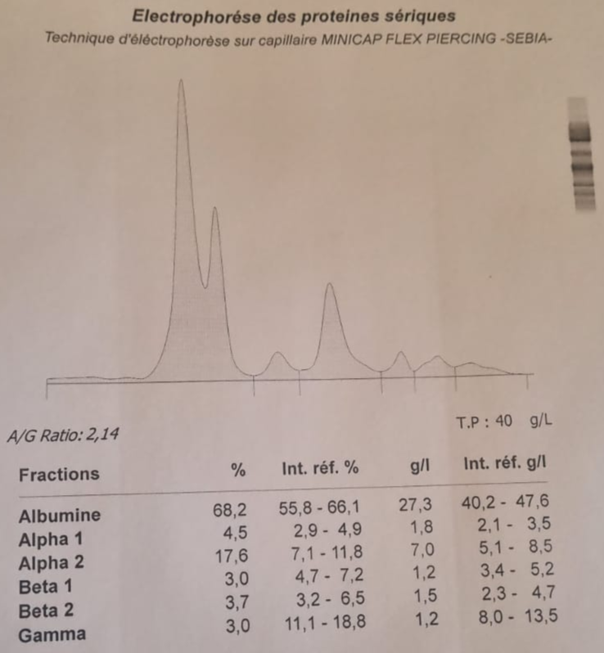
Figure 1: Profile in favor of a nephrotic syndrome (pseudo- bisalbuminemia with an increase in the alpha 2-globulin fraction).

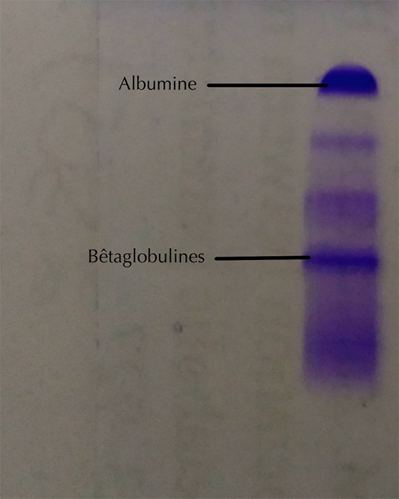
Figure 2: Serum protein electrophoresis on Hydrasys agarose gel (Sebia) showing the disappearance of all abnormalities and the appearance of a characteristic lipoprotein band at the level of beta globulins.

3. discussion

Serum protein electrophoresis is a laboratory test used to detect qualitative and/or quantitative abnormalities of circulating proteins [3]. Bisalbuminemias remain rare, but their frequency has increased with the development of capillary electrophoresis, which has higher resolution [2]. They can be either hereditary or therefore permanent, or acquired and generally transient.
Among the forms acquired, two mechanisms main are described:
- Pseudo - bisalbuminemia , corresponding to an electrophoretic appearance artifact related to the migration of interfering molecules in the albumin zone;
- A modification of the migration of a part of the albumin, which then appears with a more cathodic mobility than the variant during electrophoresis.
Certain endogenous substances such as unconjugated bilirubin , bile acids , or lipids , as well as various xenobiotics , can induce these changes by increasing their binding to albumin and altering its electrophoretic profile [4]. Dyslipidemias, in particular, constitute the most frequent interference observed in capillary electrophoresis, because lipoprotein molecules can migrate into a region close to that of albumin [3]. With this technique, and under the migration conditions of the "6-protein" buffer, beta-lipoproteins migrate in parallel with albumin (Figure 1). In our observation, serum protein electrophoresis was also performed on an agarose gel using the Sebia Hydrasys 2 Phoresis system. On this support, the pseudo- bisalbuminemia observed in the capillary is no longer visible and is replaced by a band migrating in the beta1 region. Densitometric analysis of the stained and dried gel confirms the lipoprotein nature of one of the peaks, due to its shift into the betaglobulin region (Figure 2).
Transient acquired bisalbuminemia has been described in various pathologies, including nephrotic syndrome (NS) [5]. The case presented here is distinguished by its occurrence in a 69-year-old adult. It corresponds to the biochemical definition of NS, characterized by proteinuria greater than 3 g/24 h in adults, hypoalbuminemia less than 30 g/L, and most often hyperlipidemia. Marked by elevated cholesterol and/or triglyceride levels. This hyperlipidemia results from hypoalbuminemia, which reactively and nonspecifically stimulates hepatic synthesis of all proteins, including lipoproteins. It is also linked to increased LDL and VLDL production, associated with reduced catabolism. This case also presents the peculiarity of an impure nephrotic syndrome; nearly 90% of nephrotic syndromes are pure, generally responsive to corticosteroids, and have a good prognosis [6]. The urine confirms this impure nature with the presence of microscopic hematuria.

4. Conclusion

Pseudo- bisalbuminemia induced by hyperlipidemia secondary to an impure nephrotic syndrome in an adult is a rarely described condition. The detection of bisalbuminemia on the electrophoresis, even without inherent pathological significance, should nevertheless alert the clinician, especially when clearly associated with nephrotic syndrome in an adult. Outside of this context, the presence of interfering molecules should also prompt the prescriber to adopt an appropriate approach to this abnormality.

Disclaimer (Artificial intelligence)

Author(s) hereby declare that NO generative AI technologies such as Large Language Models (ChatGPT, COPILOT, etc.) and text-to-image generators have been used during the writing or editing of this manuscript.

References

[1] Faviou E, Nounopoulos C, Dionyssiou-Asteriou A. Bisalbuminemia from a clinical chemist's viewpoint: a case report and review of the recent literature. Minerva Med. 2006; 97(3):287-93.
[2] Lefrere B, Dedôme E, Garcia- Hejl C et al. Bisalbuminemia: report of a case. Rev Internal Medicine. 2018; 39(12):950-4.
[3] Szymanowicz A, Cartier B, Couaillac JP et al. Proposal of ready-to-use interpretative comments for serum protein electrophoresis. Ann Biol Clin (Paris). 2006; 64(4):367-80.
[4] Cellier CC, Lombard C, Dimet I, Kolopp Sarda MN. Serum protein electrophoresis in medical biology: interferences and confounding factors. Rev Francoph Lab. 2018; 2018(499):47-58.
[5] Ahmad J, Khan AS, Siddiqui MA et al. Bisalbuminemia in nephrotic syndrome (a case report). Jpn J Med. 1984; 23(1):45-7
[6] Baudin B. Nephrotic syndrome. Rev Francoph Lab. 2013; 455:51-6.
7. Hoang, M. P., Baskin, L. B., & Wians Jr, F. H. (1999). Bisalbuminuria in an adult with bisalbuminemia and nephrotic syndrome. Clinica chimica acta, 284(1), 101-107.
8. Shetty, J. K., Maradi, R., Prabhu, K., & Bhat, G. (2015). Bisalbuminemia in a hypothyroid patient with diabetes: a case report. Journal of Clinical and Diagnostic Research: JCDR, 9(9), BD01.
9. Zoulati, G., El Boukhrissi, F., Maïga, R. Y., El Abdallaoui, O., Zinebi, A., Bamou, Y., ... & Balouch, H. (2021). Un cas de bisalbuminémie associée à un syndrome néphrotique induit par les anti-inflammatoires non stéroïdiens. Cahiers Santé Médecine Thérapeutique, 30(2), 131-135.

10. Beanlands, H., Maione, M., Poulton, C., Herreshoff, E., Hladunewich, M. A., Hailperin, M., ... & Gipson, D. S. (2017). Learning to live with nephrotic syndrome: experiences of adult patients and parents of children with nephrotic syndrome. Nephrology Dialysis Transplantation, 32(suppl_1), i98-i105.

11. Huang, J., Pan, Y., Zhang, Y. M., Wang, X., Meng, L. Q., Cheng, X. Y., ... & Investigators, N. S. N. N. (2025). The efficacy and safety of rituximab in adult patients with steroid-dependent or frequent relapsing nephrotic syndrome: A retrospective study. International Immunopharmacology, 158, 114795.

