Computational Exploration of 4-Hydroxy-3-Methoxycinnamic acid Derivatives Derived from Natural Product Scaffolds for Anticancer Activity

ABSTRACT:
Objective: This study seeks to investigate 4-hydroxy-3-methoxycinnamic acid(Ferulic acid)derivatives using computational approaches—specifically Lipinski’s Rule of Five, ADMET profiling, Mol-Inspiration analysis, and molecular docking—in order to evaluate their drug-likeness, pharmacokinetic properties, and therapeutic potential, with a particular focus on lung cancer treatment.
Methodology: The study examined the physicochemical, pharmacokinetic, and pharmacodynamic properties of 4-hydroxy-3-methoxycinnamic acidderivatives substituted with aromatic amines through in-silico approaches. Computational analyses were performed using web-based tools and specialized programs, including Pre-ADMET, Mol-Inspiration, and Molegro Virtual Docker 6.0.
Result and Discussion: Computational evaluation of 15 aromatic amine–substituted 4-hydroxy-3-methoxycinnamic acid(Ferulic acid)derivatives demonstrated favourable drug-likeness, as confirmed by Mol-Inspiration analysis and compliance with Lipinski’s Rule of Five. ADMET predictions indicated promising pharmacokinetic behaviour with minimal toxicity risks. Molecular docking against tyrosine kinase targets (PDB IDs: 4ZSE, 8A27, 5T4B, 6CU6) revealed strong binding affinities, with 6CU6 showing the most significant interactions suggestive of inhibitory potential. Key binding modes included hydrogen bonding and π–π stacking with active site residues, underscoring the suitability of these derivatives as potential lead candidates for lung cancer therapy.The test compound FA-6 exhibited the highest binding affinity with a MolDock score of −172.892, forming multiple hydrogen-bond interactions with Ala 146, Lys 147, Asp 119, Thr 35, Ser 17, Asp 33, Tyr 32, Arg 12, Gly 60, and Lys 16 indicating strong and stable binding within the active site. In comparison, the standard drug gefitinib showed a lower MolDock score (−157.872) with fewer hydrogen-bond interactions (Thr35, Ser17, and Glu31). Overall, FA-11 demonstrated superior docking performance compared to gefitinib and other tested ligands, highlighting its potential as a promising lead compound.
Conclusion:This study demonstrates that the selected 4-hydroxy-3-methoxycinnamic acid(Ferulic acid)derivatives possess favourable ADMET profiles, strong drug-likeness, and notable tyrosine kinase inhibitory activity. These findings highlight their promise as potential lead candidates for the development of lung cancer therapeutics.
Key words: Lung cancer, 4-hydroxy-3-methoxycinnamic acid(Ferulic acid), ADMET, mol- inspiration, molecular docking.

INTRODUCTION:
Cancer is a multifaceted disease marked by uncontrolled cell growth and proliferation, often resulting from disruptions in cellular metabolism and enzyme regulation. (1) Lung cancer remains one of the most prevalent and deadly forms, accounting for about 11.6% of all new cancer diagnoses and contributing to 18.4% of global cancer-related deaths. (2) Receptor tyrosine kinases (RTKs), key transmembrane glycoproteins, play a critical role in tumor initiation and progression, making them prime therapeutic targets. Small-molecule tyrosine kinase inhibitors act by blocking phosphorylation of intracellular tyrosine residues, thereby preventing activation of downstream signalling pathways involved in cancer development. (3)
Receptor tyrosine kinases (RTKs) share a conserved structural organization consisting of an extracellular ligand-binding domain, a single transmembrane helix, and an intracellular region that includes a juxtamembrane regulatory segment, a tyrosine kinase domain (TKD), and a carboxyl-terminal tail. Activation of RTKs typically occurs through the binding of specific ligands, such as growth factors, to the extracellular domain. This ligand engagement induces receptor dimerization or oligomerization, which in turn triggers conformational changes essential for receptor activation. These structural rearrangements facilitate trans-autophosphorylation of tyrosine residues within the TKD, a process that amplifies kinase activity and initiates downstream signalling cascades.
Beyond this canonical mechanism, RTK activation serves as a molecular switch that regulates diverse cellular processes, including proliferation, differentiation, survival, and migration. Dysregulation of RTK signalling—through mutations, overexpression, or aberrant ligand stimulation—has been strongly implicated in oncogenesis and cancer progression. Consequently, RTKs represent critical therapeutic targets, with small-molecule inhibitors and monoclonal antibodies designed to block ligand binding, receptor dimerization, or kinase activity, thereby disrupting malignant signalling pathways.
Traditional chemotherapy and radiotherapy have increased patient survival to a certain extent, but many patients still face a high recurrence rate and poor prognosis(4).
Advances in lung cancer treatment include next-generation tyrosine kinase inhibitors (TKIs) that more precisely target EGFR and ALK mutations, reducing resistance. Immunotherapies such as PD-1/PD-L1 checkpoint inhibitors have achieved lasting responses in advanced cases. Liquid biopsies now support early detection and ongoing monitoring, while AI-based diagnostics improve personalized treatment planning, collectively enhancing patient outcomes and survival rates.
Tyrosine kinase inhibitors (TKIs) are targeted anticancer agents with anti-proliferative and anti-angiogenic effects. By blocking abnormal signaling pathways that drive tumor growth, TKIs provide effective treatment options, particularly for cancers such as lung cancer and leukemia that harbor specific genetic mutations.
TKIs received the approval for their use in clinical practice, such as gefitinib, erlotinib, dasatinib, sorafenib, and sunitinib. These agents have a common mechanism of action, that is represented by competitive ATP inhibition at the catalytic binding site of tyrosine kinase(5).
Scientific Rationale and Target Selection: KRAS is a downstream signaling molecule in receptor tyrosine kinase pathways and plays a crucial role in mediating cell proliferation and survival. Mutations in KRAS lead to constitutive pathway activation and resistance to tyrosine kinase inhibitors.

Gefitinib Erlitinib
Desartinib
Figure 01: Molecular Structure of Standard drug for comparative study
Computational study: computational study utilizes various in-silico tools to streamline drug discovery. Lipinski’s Rule of Five (ROF) is applied to assess drug-likeness, Pre-ADMET predicts pharmacokinetic behaviour, Molinspiration evaluates bioactivity profiles, and molecular docking determines binding affinities with target proteins. Together, these approaches enable efficient compound screening and rational drug design in modern pharmaceutical research. Examples of commonly used computational tools include ROF, Pre-ADMET, Mol-Inspiration, and docking software.
Lipinski’s Rule of Five:Lipinski’s Rule of Five outlines four critical parameters for evaluating drug-likeness: molecular weight, hydrogen bond donors, hydrogen bond acceptors, and the octanol–water partition coefficient (log P). According to this guideline, compounds are more likely to exhibit favourable pharmacokinetic and pharmaceutical properties when their molecular weight is under 500 Da, they contain no more than five hydrogen bond donors, no more than ten hydrogen bond acceptors, and have a log P value below 5 (6). By assessing these molecular characteristics, Lipinski’s Rule of Five helps predict oral bioavailability and overall drug-likeness.
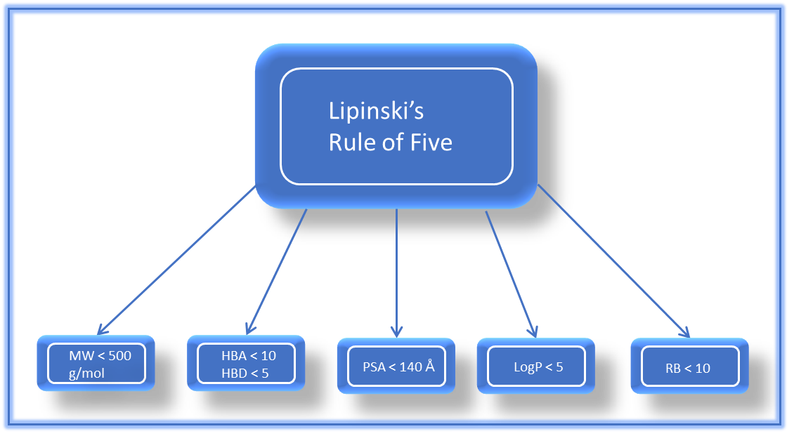
Figure 02: Lipinski’s rule of five
Pre-ADMET:Pre-ADMET evaluation is a crucial step in the early stages of drug discovery and development, allowing researchers to assess potential drug candidates for pharmacokinetic behaviour, safety, efficacy, and toxicity before progressing to expensive in vivo studies or clinical trials. (7) This analysis examines key parameters such as blood–brain barrier (BBB) penetration, CaCO₂ permeability, CYP2D6 inhibition, human intestinal absorption (HIA), MDCK cell transport, plasma protein binding, and skin permeability, thereby providing insights into a compound’s drug-likeness and overall safety profile.
Pre-ADMET toxicity evaluation indicated an acceptable safety profile, with results showing non-mutagenicity in the Ames test, low carcinogenic risk in rats, and only weak inhibition of the HERG channel. These findings suggest a favourable preliminary toxicity profile, supporting the potential of these compounds for further drug development.
Mol-Inspiration:Mol-Inspiration provides an accessible web-based platform for calculating a wide range of molecular descriptors, including LogP (octanol–water partition coefficient), topological polar surface area (TPSA), molecular weight, hydrogen bond donors and acceptors, and the number of rotatable bonds. In addition, it predicts bioactivity scores for key pharmaceutical targets such as nuclear receptor ligands, G-protein coupled receptors (GPCRs), ion channel modulators, kinase inhibitors, and general enzyme inhibitors. These predictions are derived from fragment-based models built using extensive datasets of biologically active compounds, making Mol-Inspiration a valuable tool for drug-likeness and bioactivity assessment.
Molecular docking: Molecular docking is a widely applied computational technique in computer-aided drug design (CADD). It involves two key components: the protein, which serves as the target site, and the ligand, which binds to that protein. (9) Docking predicts how a small molecule fits into a protein’s active site by estimating binding affinity, orientation, and critical molecular interactions. This approach aids in identifying potential inhibitors, analyzing structure–activity relationships, and prioritizing compounds before laboratory validation. By modelling ligand–receptor complementarity, molecular docking accelerates early drug discovery and facilitates the rational design of more selective and potent therapeutic agents.(10)
GMPPNP-bound G12R mutant of Human KRAS4b (6CU6): The receptor target selected for the anti-lung cancer study wasGMPPNP-bound G12R mutant of human KRAS, an established oncogenic protein involved in cell proliferation and survival signalling pathways. The three-dimensional crystal structure of KRAS was retrieved from the Protein Data Bank (PDB ID: 6CU6). This protein is classified as an oncoprotein and originates from Homo sapiens, while its recombinant expression was carried out in Escherichia coli. The selected structure contains mutation(s) relevant to cancer progression, making it a suitable target for evaluating anticancer activity. The crystal structure was resolved at a high resolution of 1.50 Å, ensuring structural accuracy and reliability for molecular docking and in silico interaction studies related to lung cancer therapeutics.
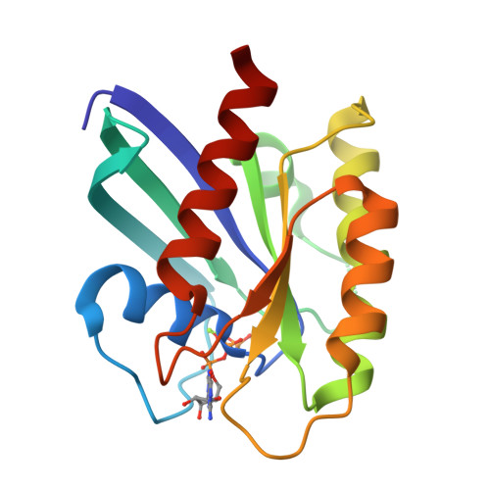
Figure 03.Crystal structure of GMPPNP-bound G12R mutant of human KRAS
Table 1: Computational tools for prediction of Drug likeness, Pharmacokinetics Properties and Toxicity Study.
Sr. no. | Computational tool | Purpose | Key Applications
1. | Rule of Five (ROF) | Drug-likeness evaluation | Applies Lipinski’s criteria for oral bioavailability
2. | Pre-ADMET | Predicts pharmacokinetics (ADME/Tox) | Screens compounds for absorption, distribution, metabolism, excretion, and toxicity
3. | Mol-inspiration | Bioactivity prediction | Estimates activity against GPCRs, ion channels, nuclear receptors, and enzymes
4. | Molecular Docking | Binding affinity simulation | Models ligand–protein interactions to identify potential drug candidates

MATERIAL AND METHOD:
Dataset of compounds:
Where R: Cl, NH_{2,} CH_{3,} C₂H₅,

Fig 4. Molecular Structure of 4-hydroxy-3-methoxycinnamic acid

The methodology comprised an in-silico investigation of 4-hydroxy-3-methoxycinnamic acid(Ferulic acid)derivatives as potential therapeutic agents for lung cancer. Initially, the compounds were screened using Lipinski’s Rule of Five (ROF) to evaluate drug-likeness. Bioactivity predictions were then carried out with Mol-Inspiration. Pharmacokinetic and toxicity parameters were estimated through Pre-ADMET analysis. Finally, molecular docking studies were performed to assess binding affinity and interaction profiles with lung cancer-associated target proteins, thereby establishing their therapeutic relevance.
Lipinski’s Rule of Five
Central to the pursuit of ﬁnding suitable drugcandidates is the application of RO5. The RO5 wasproposed by Lipinski in 1997, which eﬀectively guidedthe design of smallmolecule drugs over thesubsequent 20 years. This rule has been widely used in medicinal research and a molecule that obeysthe physicochemical property guidelines of the rulewould be labelled as an ideal drug molecule. (11)
Drug-likeness of compounds are measured by Lipinski Rule of Five (https://scfbio-iitd.res.in/software/drugdesign/lipinski.jsp )
The evaluation of drug-likeness for 4-hydroxy-3-methoxycinnamic acid(Ferulic acid)derivatives using Lipinski’s Rule of Five (ROF) began with molecular design in ChemDraw software. ChemDraw, a widely adopted chemical drawing tool, enables precise construction and visualization of molecular structures with features such as bond alignment, stereochemical representation, and automated property generation. Derivatives of 4-hydroxy-3-methoxycinnamic acidwere synthesized virtually by introducing aromatic amine substitutions onto the parent scaffold. The finalized structures were exported in .mol format to preserve connectivity and stereochemistry, and in .pdb format for computational analysis. Drug-likeness was then assessed using the ROF web platform, applying Lipinski’s criteria: molecular weight < 500 Da, logP< 5, no more than 5 hydrogen bond donors, and no more than 10 hydrogen bond acceptors. Prior to submission, the system pH was standardized to 7 to reflect physiological conditions and ensure accurate ionization states. The ROF tool processed the uploaded files and identified derivatives that complied with Lipinski’s Rule of Five as drug-like candidates with potential oral bioavailability, while non-compliant molecules were flagged for further structural optimization. (12)
Methodology ofMol-inspiration:
Physicochemical properties and pharmacokinetic descriptors of selected organic crystalline compounds were computed using the Molinspiration Cheminformatics server. Drug-likeness was evaluated by analyzing parameters such as MiLogP (partition coefficient), molecular weight, heavy atom count, hydrogen bond donors and acceptors, number of violations, rotatable bonds, and molecular volume. These descriptors provided a comprehensive assessment of the compounds’ suitability as drug candidates. (13)
The activity of 4-hydroxy-3-methoxycinnamic acid(Ferulic acid)derivatives was evaluated using the Mol-Inspiration Cheminformatics platform, which predicts drug-likeness and receptor binding potential. Molecular structures were first saved in .mol format, opened in Notepad, and converted into SMILES notation. The SMILES codes were then entered into the platform’s input interface, where the compounds were reconstructed for visual verification. Upon submission, the server performed computational analysis and generated activity predictions, providing insights into the potential pharmacological relevance of the designed derivatives. (14)
In silico ADME properties, Drug Likeness and Toxicity study of designed compounds:
Four phases make up the pharmacokinetic Properties are: absorption, distribution, metabolism, and excretion (ADME). It recently included a phase for the toxicological assessment of new drug candidates, leading to the ADME-T research. (15)
ADMET analysis was performed using reliable online platforms such as Pre ADMET (16).
Computational tools were employed to generate in silico predictions of critical pharmacokinetic parameters, including oral bioavailability, gastrointestinal absorption, blood–brain barrier penetration, and possible metabolic pathways. Their use enables early evaluation of drug-like characteristics, thereby streamlining the drug discovery pipeline and supporting the identification of compounds with favorable pharmacokinetic profiles. (17)
The ADMET profiling of 4-hydroxy-3-methoxycinnamic acid(Ferulic acid)derivatives was conducted using the Pre-ADMET tool through a structured computational workflow. Molecular structures were prepared in .mol format with molecular modeling software and subsequently opened in a text editor to extract structural codes. These codes were entered into the Pre-ADMET web interface, which reconstructed the compounds for verification prior to analysis. Following submission, the platform generated predictive outputs for key ADMET parameters, including absorption (human intestinal uptake), distribution (blood–brain barrier penetration), metabolism (cytochrome P450 interactions), excretion tendencies, and toxicity (mutagenicity and carcinogenicity). This systematic approach ensured reliable in silico estimation of pharmacokinetic and toxicity profiles. (18)
Molecular docking:Molecular docking was conducted using Molegro Virtual Docker 6.0. The overall workflow included several essential stages: retrieval of ligands and target proteins, preparation of protein structures, identification of potential leads or hits, prediction of active binding sites, execution of protein–ligand docking, and post-docking analysis. This systematic process enabled evaluation of binding affinities and interaction profiles to determine the therapeutic potential of the designed compounds.
Ligand preparation: Ligand preparation constituted the first stage of the molecular docking study. The ligands were designed as 4-hydroxy-3-methoxycinnamic acid(Ferulic acid)derivatives, incorporating diverse functional groups with varying polarities, such as amino, hydroxyl, carboxyl, acetoxy, and halogen substituents. Structural drawings were created using ChemDraw Ultra 2D 8.0 for accurate representation, and Chem3D Ultra was employed to generate and optimize three-dimensional molecular conformations.
Protein preparation:For the anti-lung cancer docking study, receptor proteins were selected, including GMPPNP-bound G12R mutant of human KRAS(PDB ID: 6CU6), human dipeptidyl peptidase 4 (PDB ID: 5T4B), and human epidermal growth factor receptor (PDB IDs: 8A27 and 4ZSE). These structures were retrieved from the Protein Data Bank (http://www.rcsb.org). The downloaded protein files were refined by adding missing atoms or residues and subjected to energy minimization to relieve steric clashes and stabilize the conformation. Protonation states of ionizable residues were assigned to ensure accurate electrostatic interactions during docking. To simplify the system, water molecules and non-essential ligands were removed. Finally, appropriate force field parameters were applied to optimize the protein structure, providing a reliable starting point for molecular docking simulations. (19)
The ligands to be docked are selected based on various criteria, such as their chemical diversity, their known biological activity, or their potential for drug development. The ligands are then prepared for docking by assigning charges, generating conformers, and optimizing their geometry. (20)
Molecular docking was performed using Molegro Virtual Docker, with all stages visualized in three dimensions. Critical considerations during this process included the careful selection of docking ligands and identification of the binding cavity within the target protein where drug–receptor interactions occur. These steps ensured accurate evaluation of binding affinity and molecular complementarity. (21)The binding pocket was identified using the cavity detection algorithm in Molegro Virtual Docker (MVD), with emphasis on the largest druggable site. In certain cases, inhibition constants were calculated for ligand–protein complexes to assess binding affinity and inhibitory potential, though this step is dependent on the research objectives and study design. Ligands were docked against the prepared protein structures, and the resulting interactions were examined. The scoring function in MVD generated docking scores, with the most favorable ligand–protein complexes selected based on binding energy and interaction profiles. (22)
Post docking analysis: Following ligand docking to the target proteins, the results were examined to identify the most promising candidates for further investigation. Binding affinity was calculated based on predicted interaction energies, and ligands were ranked according to their affinity scores. The docked complexes were further analysed to characterize key molecular interactions, including hydrogen bonding, hydrophobic contacts, and electrostatic forces. These interaction profiles provided valuable insights into the potential mechanisms of ligand action and guided structural optimization for enhanced therapeutic efficacy. (23)
During the docking process, several energy-based parameters were measured, including the MolDock Score, Re-rank Score, hydrogen bond energy, and the RMSD value. Among these, the Re-rank Score is most commonly used to evaluate the strength of drug–receptor binding, as it provides a reliable measure of binding affinity and stability of the docked complex.
RESULT AND DISCUSSION:
Result of physiochemical properties of designed compounds using ROF:As presented in Table 2, all 4-hydroxy-3-methoxycinnamic acid(Ferulic acid)derivatives substituted with aromatic amines demonstrated acceptable drug-like properties alongside other drug-likeness parameters. This outcome is attributed to the fact that each derivative complied with Lipinski’s Rule of Five, meeting the criteria of molecular weight ≤ 500 Da, LogP< 5, hydrogen bond donors ≤ 5, and hydrogen bond acceptors ≤ 10.
Although molecular weight (MW < 500 Da) is an important factor influencing oral bioavailability, the 500 Da threshold does not strictly distinguish compounds with poor versus good bioavailability. Moreover, only molecules that violate two or more of Lipinski’s Rule of Five parameters are generally considered unlikely to exhibit oral bioavailability. (24)
Table 2: Result of Molecular Properties using Lipinski rule of five
CODE | MW | HBA | HBD | MolLogP | MolPSA | MolVol | Drug likeness model  score
FA1 | 284.12 | 4 | 2 | 3.24 | 57.00 | 293.58 | 0.01
FA2 | 284.12 | 4 | 2 | 2.49 | 56.28 | 294.39 | 0.22
FA3 | 270.10 | 4 | 2 | 2.57 | 56.91 | 272.47 | 0.33
FA4 | 270.10 | 4 | 2 | 2.13 | 56.81 | 273.15 | 0.36
FA5 | 270.10 | 4 | 2 | 2.02 | 56.72 | 272.98 | 0.33
FA6 | 329.09 | 6 | 4 | 3.12 | 92.25 | 322.04 | 0.72
FA7 | 299.12 | 4 | 2 | 2.25 | 54.23 | 309.92 | -0.23
FA8 | 299.12 | 4 | 2 | 3.17 | 54.84 | 309.60 | -0.29
FA9 | 299.12 | 4 | 2 | 3.05 | 54.84 | 309.53 | -0.08
FA10 | 347.02 | 3 | 2 | 3.93 | 47.29 | 299.54 | -0.13
FA11 | 348.05 | 5 | 2 | 3.69 | 79.98 | 319.13 | -0.60
FA12 | 348.05 | 5 | 2 | 3.85 | 79.68 | 321.11 | -0.46
FA13 | 337.03 | 3 | 2 | 4.36 | 46.60 | 311.34 | 0.10
FA14 | 297.14 | 3 | 2 | 3.53 | 45.90 | 319.38 | 0.36
FA15 | 297.14 | 3 | 2 | 3.88 | 46.60 | 319.44 | -0.29

Result of pharmacokinetic properties by pre-ADME tool:
Poor ADMET characteristics are often a major cause of drug development failure. As shown in Table 3, the theoretical ADMET profiles of the synthesized 4-hydroxy-3-methoxycinnamic acidderivatives were evaluated. Parameters such as P-glycoprotein (P-gp) interaction and human intestinal absorption were used to assess the uptake potential of the compounds. Notably, intestinal absorption is considered favorable when the predicted score exceeds 30%. (25)
Pharmacokinetics prediction study like GI absorption, BBB penetration, Caco2 absorption, p-gp, CYP2C19 Inhibitor, plasma protein binding and skin permeability mentioned in table 2.
Table 3: In silico pharmacokinetic (ADME) properties of designed compounds
Comp. | BBB | CaCO2 | CY2D6 | HIA | MDCK | Pgp | PPB | Skin permeability
FA1 | 0.263 | 23.30 | NON | 92.99 | 1.167 | NON | 80.86 | -3.20
FA2 | 0.202 | 24.00 | NON | 92.99 | 1.742 | NON | 76.22 | -3.19
FA3 | 0.132 | 22.79 | NON | 92.97 | 15.84 | NON | 75.72 | -3.32
FA4 | 0.076 | 23.24 | NON | 92.81 | 49.49 | NON | 62.87 | -3.56
FA5 | 0.063 | 23.42 | NON | 92.81 | 24.20 | NON | 64.90 | -3.56
FA6 | 0.084 | 20.98 | NON | 84.94 | 0.382 | NON | 81.07 | -3.79
FA7 | 0.519 | 28.82 | NON | 93.20 | 0.200 | NON | 81.10 | -2.95
FA8 | 0.459 | 29.06 | NON | 93.20 | 1.700 | NON | 82.45 | -2.98
FA9 | 0.545 | 28.81 | NON | 93.20 | 1.718 | NON | 79.10 | -2.98
FA10 | 2.203 | 24.80 | NON | 94.56 | 0.032 | NON | 90.17 | -2.75
FA11 | 0.044 | 10.78 | NON | 94.04 | 0.059 | INHIBITOR | 100.00 | -2.92
FA12 | 0.044 | 12.86 | NON | 94.04 | 0.057 | INHIBITOR | 100.00 | -2.92
FA13 | 3.593 | 25.90 | NON | 94.75 | 0.071 | INHIBITOR | 87.95 | -2.97
FA14 | 2.585 | 26.95 | NON | 93.45 | 0.050 | NON | 85.11 | -2.61
FA15 | 2.612 | 26.95 | NON | 93.45 | 0.076 | NON | 85.75 | -2.64

The evaluation of 4-hydroxy-3-methoxycinnamic acid(Ferulic acid)derivatives indicated an overall favourable pharmacokinetic profile across most parameters. With respect to human intestinal absorption (HIA), all compounds exhibited high absorption, suggesting strong oral bioavailability potential. Plasma protein binding (PPB) results revealed that 3 derivatives (FA6, FA11 and FA12) were highly bound, whereas the majority (10 compounds) displayed weak binding, reflecting variability in distribution. For CaCO₂permeation,all compounds demonstrated moderate permeation. Importantly, all derivatives were identified as non-inhibitors of CYP2D6, thereby reducing the risk of drug–drug interactions. In MDCK cell permeability assays, one compound (FA4) exhibited moderate permeation, while the remaining 14 showed lower transport efficiency. Regarding P-glycoprotein (P-gp) interactions, only 3 compounds (FA11, FA6 and FA13) acted as an inhibitor, while the majority (11) were non-inhibitors, minimizing concerns about efflux-related bioavailability issues. Blood–brain barrier (BBB) penetration analysis revealed that 4 compounds were CNS-active, indicating potential neurological applications, while 11 were non-CNS active. Collectively, the derivatives demonstrated promising absorption and metabolic safety, with notable CNS activity in a subset of compounds. The boiled egg model of FA6 is presented in Figure 5
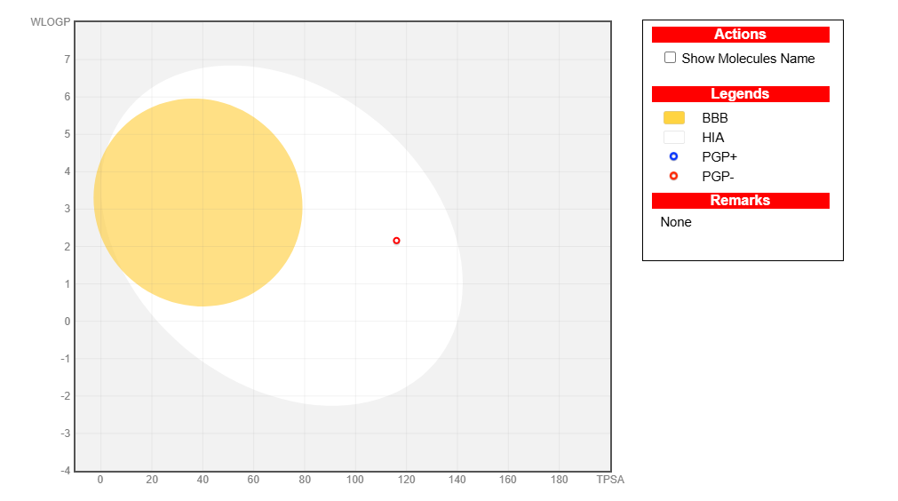
Figure 05: Boiled Egg model for compound FA6 as HIAInhibitor
Result of toxicity of compounds by pre-ADMET tool:
The result of toxicity of designed compoundsdetailed in table 4
At the Ames test endpoint of PreADMET, there are 14mutagenic compounds and only 1 compound (FA13) are non-mutagenic compounds. The positive test results on Ames test indicate that the compound is mutagenic and has the possibility as carcinogenic. In the prediction of carcinogenicity in rat produced 14carcinogenic positive compounds and only compound is negative carcinogenic. While in the prediction of carcinogenicity in mouse 5 compounds are not carcinogenicity. At the H ERG Inhibition all compounds show medium risk.
Table 4: Result of Toxicity studies and drug likeness of designed compounds
COMP | AMES TEST | CARCINO MOUSE | CARCINO RAT | HERG
FA1 | mutagen | +ve | +ve | Medium risk
FA2 | mutagen | +ve | +ve | Medium risk
FA3 | mutagen | +ve | +ve | Medium risk
FA4 | mutagen | +ve | +ve | Medium risk
FA5 | mutagen | -ve | +ve | Medium risk
FA6 | mutagen | -ve | +ve | Medium risk
FA7 | mutagen | +ve | +ve | Medium risk
FA8 | mutagen | -ve | +ve | Medium risk
FA9 | mutagen | -ve | +ve | Medium risk
FA10 | mutagen | +ve | +ve | Medium risk
FA11 | mutagen | +ve | +ve | Medium risk
FA12 | mutagen | +ve | +ve | Medium risk
FA13 | Non mutagen | +ve | -ve | Medium risk
FA14 | mutagen | -ve | +ve | Medium risk
FA15 | mutagen | +ve | +ve | Medium risk

Result of Drug likeness properties of designed derivatives of 4-hydroxy-3-methoxycinnamic acid:
Table 5: Result of Molecular Properties using online program (Molinspiration)
code | miLogP | TPSA | natoms | MW | nON | nOHNH | nviolations | nrotb | volume
FA1 | 2.36 | 71.45 | 21 | 284.31 | 5 | 2 | 0 | 4 | 260.22
FA2 | 1.96 | 71.45 | 21 | 284.31 | 5 | 2 | 0 | 4 | 260.22
FA3 | 1.91 | 71.45 | 20 | 270.29 | 5 | 2 | 0 | 4 | 243.66
FA4 | 1.74 | 71.45 | 20 | 270.29 | 5 | 2 | 0 | 4 | 243.66
FA5 | 1.52 | 71.45 | 20 | 270.29 | 5 | 2 | 0 | 4 | 243.66
FA6 | 2.72 | 116.09 | 24 | 329.31 | 7 | 4 | 0 | 5 | 282.84
FA7 | 2.86 | 67.79 | 22 | 299.33 | 5 | 2 | 0 | 5 | 273.36
FA8 | 2.84 | 67.79 | 22 | 299.33 | 5 | 2 | 0 | 5 | 273.36
FA9 | 2.86 | 67.79 | 22 | 299.33 | 5 | 2 | 0 | 5 | 273.36
FA10 | 3.62 | 58.56 | 21 | 348.20 | 4 | 2 | 0 | 4 | 265.70
FA11 | 3.37 | 104.38 | 24 | 348.74 | 7 | 2 | 0 | 5 | 284.69
FA12 | 3.37 | 104.38 | 24 | 348.74 | 7 | 2 | 0 | 5 | 284.69
FA13 | 4.09 | 58.56 | 22 | 338.19 | 4 | 2 | 0 | 4 | 274.89
FA14 | 2.67 | 58.56 | 22 | 297.35 | 4 | 2 | 0 | 4 | 280.94
FA15 | 3.62 | 58.56 | 22 | 297.35 | 4 | 2 | 0 | 4 | 280.94

To investigate molecular interactions, all compounds were docked with theGMPPNP-bound G12R mutant of human KRAS4b protein (PDB ID: 6CU6). Organic molecules can associate with proteins through the formation of chemical bonds as well as non-covalent interactions, including hydrogen bonding, hydrophobic contacts, and electrostatic forces between the ligand and the receptor. These interactions provide insight into the binding mechanism and potential biological activity of the compounds.(26)
Hydrogen bonding and hydrophobic interactions are critical factors in assessing binding affinity and the pharmacological effectiveness of new drug candidates. Hydrogen bonds, in particular, play a pivotal role in stabilizing drug–receptor complexes and maintaining the structural integrity of essential biomolecules such as proteins and DNA. These interactions contribute significantly to the overall specificity and strength of ligand–protein binding. (27)
For final evaluation, the poses with the most negative docking scores were chosen, as these represent the strongest binding affinities of the compounds toward the target receptors. This selection highlights the ligand–protein complexes with the greatest potential for therapeutic relevance.
For PDB ID 4ZSE, the ligand exhibited a MolDock score of −123.236, forming hydrogen-bond interactions withPhe723, Ser720, Met793, andAla722. In the case of PDB ID 5T4B, a stronger binding affinity was observed with a MolDock score of −126.614, supported by hydrogen bonds involving Asp739,Ser630, Asp709, Arg125, His740, and Gly632. Similarly, docking against PDB ID 8A27 resulted in a MolDock score of −161.412, with key hydrogen-bond interactions formed with Ala743, Thr790, and Ile759. In contrast, the test compound FA-6 demonstrated a markedly superior binding affinity, with a MolDock score of −191.092. FA-6 established an extensive hydrogen-bonding network involving Ser17, Asp33,vArg12, Thr32, Ser145, Thr35,Lys147, and Asp119, indicating strong and stable interactions within the active site. For comparison, the standard reference drug gefitinib showed a MolDock score of −151.272, forming hydrogen bonds with Thr35, Ser17, and Glu31. Although gefitinib exhibited favorable binding, its docking score and number of hydrogen-bond interactions were lower than those observed for FA-6.
Overall, the docking results suggest that FA-6 possesses a significantly higher binding affinity and a more extensive hydrogen-bond interaction profile than the standard drug gefitinib and ligands docked against PDB IDs 4ZSE, 5T4B, and 8A27, highlighting its potential as a promising lead compound for further investigation.The reliability of the molecular docking protocol was validated by calculating the root mean square deviation (RMSD) between the co-crystallized ligand and the redocked pose for PDB ID 6CU6. The obtained RMSD value was 1.57 Å, which lies well within the generally accepted threshold of ≤ 2.0 Å for successful docking validation.The results were shown in table 6.

Table 6: result of molecular docking with GMPPNP-bound G12R mutant of human KRAS4bpdb (6CU6)
Sr No. | code | Moldock score | H bond | Steric interaction
 | Co-crystallized  ligand | -250.535 | ASP119, Ala 146, Asn 116, lys117, Ser 11, Ala18, Lys 16, Gly 16, Gly15, Thr 35, Tyr 32, Arg 12, Asp 30, Val 29 | Arg 12, Thr 35, Gly 13, Gly 60
 | FA1 | -144.206 | Ser 145, Asp 119, Lys 147 | Thr 35, Gly 15, Asn 116, Lys 147, Ala 146
 | FA2 | -139.333 | Lys 16, Asp 33, Thr 35 | Asn 116, Asp 119, Lys 16, Asp 33
 | FA3 | -134.734 | Gly 15, Lys 16, Ser 145, Asp 119, Lys 147 | Gly 15, Asn116, Ala 146, Lys 147
 | FA4 | -133.487 | Ala 146, Lys 147, Gly 13, Ser 17, Thr 35, Asp 33 | Ala 146, Asp 119, Ala 18, Lys 16
 | FA5 | -127.427 | Lys 16, Thr 35, Asp 33, Ser 17 | Asp 119
 | FA6 | -172.896 | Ala 146, Lys 147, Asp 119, Thr 35, Ser 17, Asp 33, Tyr 32, Arg 12, Gly 60, Lys 16 | Gly 13, Ala 146, Lys 116, Asp 119
 | FA7 | -132.621 | Gly 15, Lys 16, Ala 146, Lys 147, asp 119 | Gly 13, Lys 16, Val 14, Ala 146, Lys 147, Lys 117, Asp 119
 | FA8 | -155.46 | Gly 13, Lys 16, Lys 147, Ser 145, Asp 119 | Asp 33, Gly 15, Asn 116, Ala 146
 | FA9 | -174.911 | Ser 145, Lys 147, Asp119 | Gly 15, Asn 116, Ala146, Lys 147
 | FA10 | -143.463 | Asp 119, Ser 145, Lys 147, | Lys 147, Ala 146, Asn 116,Thr 35, Gly 15
 | FA11 | -171.204 | Arg 12, Tyr 32, Thr 35, Lys 147, Ser 145, Asp 119 | Pro 34, Thr 35, Ala 146, Lys 147
 | FA12 | -163.174 | Asp 33, Ser 17, Asp 119, Ser 145, Lys 147 | Thr 35, Gly 15, Asn 116, Asp 33, Ala 146, Lys 147
 | FA13 | -127.182 | Lys 16, Thr 35 | Thr 35, Ala 18, Asn 116, Ala 146, Gly 15, Asp 119
 | FA14 | -144.026 | Ser 145, Asp 119, Lys 147, | Ala 146, Asn 116, Gly 15, Asp 33
 | FA15 | -157.522 | Asp 119, Lys 147, Ser 145, | Ala 146, Asn116, Ala 146

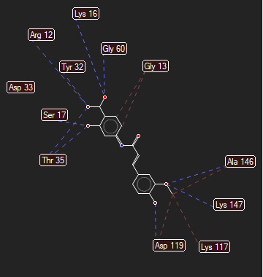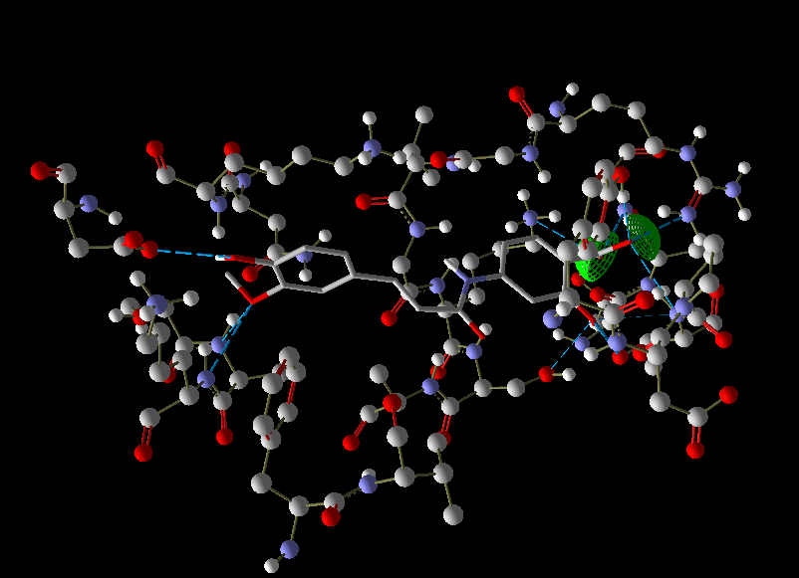
Figure 06: H-bond interaction and docking pose of FA6

Resultof molecular docking when standard tyrosine kinase inhibitor such as gefitinib is docked withGMPPNP-bound G12R mutant of human KRAS4b (6CU6 PDB ID).
Table 7: result of molecular docking of standard TKIs
Sr No. | Standard TKI | Moldock score | H bond | Steric interaction
 | Gefitinib | -157.872 | Thr 35, Ser 17, Glu 31 | Asp 119, Lys 147, Gly 13, Gly15, Thr32, Asp 33, Ser 17, Val 29

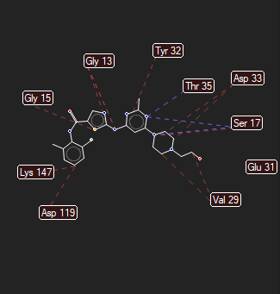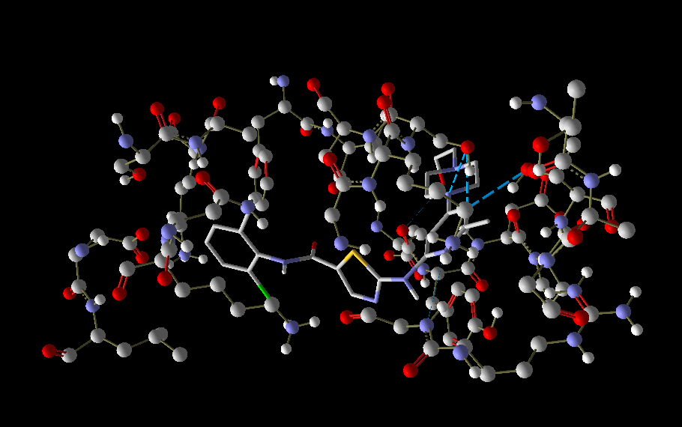
Figure 07: H- bond interaction of Gefitinib (standard tyrosine kinase inhibitor)
Among all the 15 derivatives compound FA6 which is derivative of 4-hydroxy-3-methoxycinnamic acid(Ferulic acid)with 4 amino salicylic acid shows the relatable results with standard tyrosin kinase inhibitors in terms of binding affinity and interactions.
Fig 8: Molecular structure of 4-hydroxy-3-methoxycinnamic acid(Ferulic acid)with 4 amino salicylic acid
Discussion:
All 4-hydroxy-3-methoxycinnamic acid (Ferulic acid)derivatives substituted with aromatic amines exhibited acceptable drug-like characteristics along with favorable drug-likeness parameters. This outcome can be attributed to their full compliance with Lipinski’s Rule of Five, as all derivatives satisfied the criteria for molecular weight (≤ 500 Da), lipophilicity (LogP< 5), hydrogen bond donors (≤ 5), and hydrogen bond acceptors (≤ 10). Overall pharmacokinetic evaluation indicated a generally favorable profile for the studied compounds. All derivatives demonstrated high human intestinal absorption (HIA), suggesting strong potential for oral bioavailability. Plasma protein binding (PPB) analysis showed that three derivatives (FA10, FA11, and FA12) were highly bound, while the majority of the compounds exhibited weak binding, indicating variability in their distribution behavior. All compounds showed moderate CaCO₂ permeability, reflecting acceptable membrane transport properties.
Importantly, none of the derivatives inhibited CYP2D6, thereby reducing the likelihood of metabolic instability and potential drug–drug interactions. In the MDCK cell permeability model, one compound (FA4) exhibited moderate permeability, whereas the remaining derivatives showed lower transport efficiency. Evaluation of P-glycoprotein (P-gp) interactions revealed that only three compounds (FA11, FA12, and FA13) acted as P-gp inhibitors, while most derivatives were non-inhibitors, suggesting minimal efflux-related limitations on bioavailability. Blood–brain barrier (BBB) penetration analysis indicated that four compounds were CNS-active, whereas the remaining derivatives were non-CNS active. Collectively, these findings indicate that the designed derivatives possess promising absorption and metabolic safety profiles, with a subset showing potential central nervous system activity.
To explore molecular interactions at the target level, all compounds were subjected to molecular docking studies against the GMPPNP-bound G12R mutant of human KRAS4b protein (PDB ID: 6CU6). Small organic molecules interact with proteins through a combination of chemical bonding and non-covalent interactions, including hydrogen bonds, hydrophobic interactions, and electrostatic forces between the ligand and the receptor. These interactions provide valuable insight into the binding mode and potential biological activity of the compounds.
Hydrogen bonding and hydrophobic interactions are key determinants of binding affinity and pharmacological efficacy in drug–receptor interactions. In particular, hydrogen bonds play a crucial role in stabilizing ligand–protein complexes and maintaining the structural integrity of essential biomolecules such as proteins and nucleic acids. These interactions significantly influence the specificity and strength of ligand binding.For PDB ID 4ZSE, the ligand exhibited a MolDock score of −106.832, forming hydrogen-bond interactions with Lys745, Ala722, Phe723, Gly 723 and Ser720. In the case of PDB ID 5T4B, a stronger binding affinity was observed with a MolDock score of −127.684, supported by hydrogen bonds involving His740, Arg125, and Gly632. Similarly, docking against PDB ID 8A27 resulted in a MolDock score of −110.492, with key hydrogen-bond interactions formed with Gly 721, Gly724, and His 837. In contrast, the test compound FA6 demonstrated a markedly superior binding affinity for PDB Id 6CU6, with a MolDock score of −181.092. FA6 established an extensive hydrogen-bonding network involving Asp33, Ser17, Thr35, Thr32, Arg12, Ser145, Lys147, and Asp119, indicating strong and stable interactions within the active site. For comparison, the standard reference drug gefitinib showed a MolDock score of −157.872, forming hydrogen bonds with Thr35, Ser17, and Glu31. Although gefitinib exhibited favorable binding, its docking score and number of hydrogen-bond interactions were lower than those observed for FA6.
Overall, the docking results suggest that FA6 possesses a significantly higher binding affinity and a more extensive hydrogen-bond interaction profile than the standard drug gefitinib and ligands docked against PDB IDs 6CU6, 4ZSE, 5T4B, and 8A27, highlighting its potential as a promising lead compound for further investigation.The reliability of the molecular docking protocol was validated by calculating the root mean square deviation (RMSD) between the co-crystallized ligand and the redocked pose for PDB ID 6CU6. The obtained RMSD value was 1.60 Å, which lies well within the generally accepted threshold of ≤ 2.0 Å for successful docking validation
For final evaluation, docking poses with the most negative docking scores were selected, as these represent the strongest binding affinities between the ligands and the target protein. This approach enabled the identification of ligand–protein complexes with the highest potential for therapeutic relevance.
CONCLUSION:
This study investigated the anti-lung cancer potential of substituted 4-hydroxy-3-methoxycinnamic acid(Ferulic acid)derivatives by targeting GMPPNP-bound G12R mutant of human KRAS4b. Docking simulations revealed that these derivatives exhibited stronger binding affinities and more favourable interaction profiles compared to established kinase inhibitors such as gefitinib, erlotinib, and dasatinib. Drug-likeness and bioactivity predictions further supported their suitability as promising candidates, with several derivatives demonstrating favourable pharmacokinetic properties and kinase receptor activity. Collectively, these findings highlight substituted 4-hydroxy-3-methoxycinnamic acidderivatives as potential ligands forGMPPNP-bound G12R mutant of KRAS4b and suggest their utility as future drug candidates in lung cancer therapy. Further experimental validation and optimization are warranted to translate these computational insights into clinical applications.
In the present study, the test compound FA-6 demonstrated outstanding molecular docking performance, exhibiting a significantly higher binding affinity than the standard drug gefitinib and other screened ligands. FA-11 achieved the most favorableMolDock score and formed an extensive hydrogen-bonding network with key active-site residues, indicating strong and stable interactions within the target binding pocket. These results suggest that FA-6 has a high potential to effectively inhibit the target protein.
In addition to its superior docking profile, ADMET predictions revealed that FA-6 possesses acceptable pharmacokinetic properties, including favorable absorption, distribution, and drug-likeness parameters, along with a low predicted toxicity risk. The combined docking and ADMET results indicate that FA-6 satisfies essential criteria for a promising lead compound and supports its suitability for further experimental validation.
PDB ID 6CU6 was selected as the docking target due to its high-resolution crystal structure and the presence of a co-crystallized ligand within the active site, enabling reliable docking validation. The low RMSD value obtained during redocking confirmed the accuracy and robustness of the docking protocol. Moreover, 6CU6 represents a biologically relevant and well-characterized target associated with disease progression, making it an appropriate model for evaluating the inhibitory potential of novel compounds such as FA-6.
Overall, the integrated docking, ADMET, and validation results strongly support FA-6 as a promising candidate for further in vitro and in vivo studies.

Disclaimer (Artificial intelligence)

Author(s) hereby declare that NO generative AI technologies such as Large Language Models (ChatGPT, COPILOT, etc.) and text-to-image generators have been used during the writing or editing of this manuscript.

REFERENCES:
- Aftab H, Islam M,Şenol H, Batoo Z, Ateşoğlu S, Çakır F, Akbaş F, Taslimi F, Alanazi A K, Noreen F&Shafiq Z. Synthesis, antiproliferative activity targeting lung cancer and in silico studies of hydroxypiperidine substituted thiosemicarbazones. Scientific records 2025. Article number: 18735 (2026). DOI: 10.1038/s41598-025-18735-y
- Bray F, laversanne M, Sung H, Ferlay J, Siegel R, Soejomataram I, Jemel A. Global cancer statistics 2022: GLOBOCAN estimates of incidence and mortality worldwide for 36 cancers in 185 countries. 2024; 74(3): 229–263. https://doi.org/10.3322/cFAc.21834
- Shivika, Sharma M, Bajpai A, Dar ZA, Singh R, Bansa R. Therapeutic dominance of tyrosine kinase inhibitors in non-small cell lung cancer(NSCLC). National library of medicine. 2025;18(3): DOI: 10.1016/j.bioorg.2025.108660
- Li Y, Xue J, Zhang L. New advances in lung cancer treatment: Efficacy, safety, and future research directions. National library of medicine. 2024;17(9):181-182. doi:10.1016/j.cpt.2024.09.005.
- Fazio N, La Salvia A. Newly emerging tyrosine kinase inhibitors for the treatment of neuroendocrine neoplasms. Expert OpinEmerg Drugs. 2025;30(2):149-157. doi:10.1080/14728214.2025.2508994.
- PhogatD.Pati J C, Lipinski’s rule and biological activity of molecules. IntAdv J EngSciManag. 2020;July–Dec:46-52. ISSN 2393-8048.
- Sen DJ, Chaudhary PK, Sharma UD, Oza MV, Raval DH, Chaudhary DP. Molinspiration is inspiration to molecule by software in drug discovery. World J Pharm Med Res. 2025;11(5):165-173. ISSN 2455-3301.
- Dubey R, Deshmukh N, Patud A, Trivedi G, Soni P, Patidar M. Oxadiazole derivatives as potential EGFR protein kinase inhibitors: prediction of in-silico ADMET properties and molecular docking study. Int J Adv Res. 2025;13(5):112-120. doi:10.21474/IJAR01/53789.
- Nadaf T, Mulla M, Chougule S, Khot S, Shinde S, Nevrekar S, Chavan S, Patil A, Chaugule N. Molecular docking: types, applications and approach in novel drug design. Journal of Pharmaceutical Technology research. 2020;13(12):6029-6035. doi:10.5958/0974-360X.2020.01052.9.
- Patidar M, Dubey R, Deshmukh N. Exploring 1,3,4-oxadiazole derivatives for hepatocellular carcinoma: synthesis and bioactivity evaluation. Journal of Applied Pharmaceutical Research. 2025; 13(2): 127–138.
- Nhlapho S, Nyathi MHL, Ngwenya BL, Dube T, Telukdarie A, Munien I, Vermeulen A, Chude-Okonkwo UAK. Druggability of pharmaceutical compounds using Lipinski rules with machine learning. Sci Pharm. 2024;3(4):177-192. doi:10.58920/sciphar0304264.
- Deshmukh N, Kumar SL. Prediction of in-silico ADMET properties and molecular docking study of substituted thiadiazole for screening of antiviral activity against protein target COVID-19 main protease. Research Journal of Pharmacy and Technology. 2023; 16(12): 5802–5807
- Suganya M, Hemamalini M, Kavitha SJ, Rajakannan V. Insilico studies of molecular property and bioactivity of organic crystalline compounds using Molinspiration. Int Res J Eng Technol. 2020;7(11):1220-1226. ISSN 2395-0072.
- Ibrahim ZY, Uzairu A, Shallangwa GA, Abechi SE, Isyaku S. Homology modeling, docking, and ADMET studies of benzoheterocyclic 4-aminoquinolines analogs as inhibitors of Plasmodium falciparum. J BiomolStructDyn. 2025;43(5):1123-1135. doi:10.1080/07391102.2025.1234567
- Patadiya N. Vaghela V. Design, in-silico ADME Study and molecular docking study of novel quinoline-4-on derivatives as Factor Xa Inhibitor as Potential anti-coagulating agents. Asian Journal of Pharmaceutical Research. 2022; 12(3):207-1. doi.org/10.52711/2231-5691.2022.00034
- Available online:PreADMET | Prediction of ADME/Tox – Just another BMDRC Sites site
- Ahmed IIJ, AbdulHamidFA, AbdHalim KB, Che Has AT. P-glycoprotein: new insights into structure, physiological function, regulation and alterations in disease. Heliyon. 2022;8(6):e09777. Doi:10.1016/j.heliyon.2022.e09777
- Abelian A, Dybek M, Wallach J, Gaye B, Adejare A. Pharmaceutical chemistry. In: Adejare A, editor. Remington: The Science and Practice of Pharmacy. 23rd ed. Philadelphia: Elsevier; 2021. p.105-128.
- Mansouri R, Bouzina A, Frissou N. Docking and in silico ADMET analysis of flavone glucoside compounds as antioxidant agents. MDPI chemistry proceeding. 2025;18(1):45-52. doi:10.5958/0974-360X.2025.00008.7.
- Agu PC, Afiukwa CA, Orji OU, Ezeh EM, Ofoke IH, Ogbu CO, Ugwuja EI, Aja PM. Molecular docking as a tool for the discovery of molecular targets of nutraceuticals in diseases management. Sci Rep. 2023;13:40160. doi:10.1038/s41598-023-40160-2.
- Chaudhary KK, Mishra N. A review on molecular docking: novel tool for drug discovery. JSM Chem. 2016;4(3):1029. doi:10.47739/2334-1831/1029.
- Yuliani NN, Siswandono, Erawati T, Sambara J, Mandala MS. Molecule docking using molegro virtual docker method from ethanol extract of Bougainvillea spectabilisWilldbractea as an inhibitor in tyrosinase for sunscreen. Int J ChemChemEng Syst. 2024;9(1):16-23. doi:10.52711/0974-360X.2024.00131.
- Torres PHM, Sodero ACR, Jofily P, Silva-Jr FP. Key topics in molecular docking for drug design. Int J Mol Sci. 2019;20(18):4574. doi:10.3390/ijms20184574.
- Pinzi L, Rastelli G. Molecular docking: shifting paradigms in drug discovery. Int J Mol Sci. 2019;20(18):4331. doi:10.3390/ijms20184331.
- Ibrahim ZY, Uzairu A, Shallangwa G, Abechi S. Molecular docking studies, drug-likeness and in-silico ADMET prediction of some novel β-amino alcohol grafted 1,4,5-trisubstituted 1,2,3-triazoles derivatives as elevators of p53 protein levels. J Mol Graph Model. 2025;124:108119. doi:10.1016/j.jmgm.2025.108119
- Bors L, Erdo F. Overcoming the blood–brain barrier: challenges and tricks for CNS drug delivery. Sci Pharm. 2019;87(1):6. doi:10.3390/scipharm87010006.
- Hasan MM, Khan Z, Chowdhury MS, Khan MA, Moni MA, Rahman MH. In silico molecular docking and ADME/T analysis of quercetin compound with its evaluation of broad-spectrum therapeutic potential against particular diseases. Sci Rep. 2024;14:22345. doi:10.1038/s41598-024-22345-9.

