In silico evaluation of anti-inflammatory compounds from Euphorbia hirta against inflammatory drug target proteins associated with asthma

.
ABSTRACT

Background: Asthma is a chronic respiratory disease that affects the airways in the lungs. The airways become inflamed and narrow, making it difficult to breathe. Asthma symptoms can vary from person to person and can range from mild to severe.
Aims: This study identified and evaluated potential anti-inflammatory compounds in Euphorbia hirta and assessed their ability to inhibit inflammatory drug targets associated with asthma using molecular docking analyses.
Methodology: A comprehensive ligand library was constructed based on GC-MS analysis data of Euphorbia hirta, providing molecular details of various phytochemical compounds. Molecular docking simulations using AutoDock Vina, AutoDock tools, and Discovery Studio Visualizer were performed against target proteins associated with asthma (Interleukin 4, Interleukin 5, Leukotriene receptor, and Tumour Necrosis Factor-Alpha) to assess binding affinity and specificity of the compounds.
Results: In the current study, Ergost-5-En-3-Ol, which is a sterol, was observed to be a promising lead compound for the development of anti-inflammatory drugs, as seen in the binding affinity. Ergost-5-En-3-Ol, a sterol compound, emerged as a promising lead candidate for potential anti-inflammatory drug development. It demonstrated significant binding affinity to the selected drug target proteins, particularly TNF-α, IL-4, IL-5, and Leukotrienes. The binding interactions involved in the active sites of these proteins indicated potential interference with inflammatory signalling, crucial for asthma pathology. Moreover, Ergost-5-En-3-Ol adheres to Lipinski's rule of five, suggesting potential oral bioavailability.
Conclusion: This study confirms the anti-inflammatory properties of Euphorbia hirta and suggests its use for the development of a new therapeutic agent for managing asthma. Ergost-5-En-3-Ol warrants further investigation as a potential anti-inflammatory drug candidate. Furthermore, Ergost-5-En-3-Ol meets Lipinski's rule of five criteria, suggesting its potential for oral bioavailability, a crucial factor for drug development.

Keywords: anti-inflammatory, asthma, Euphorbia hirta, molecular docking, target proteins

1. INTRODUCTION
Asthma is a heterogeneous lung disease that affects more than 300 million people worldwide. It is characterised by variable airflow obstruction and airway hyperresponsiveness (AHR), leading to episodic and reversible bronchoconstriction, because of an exaggerated airway-narrowing response to many environmental triggers, such as allergens (Habib et al., 2022). It is a chronic respiratory disease that affects the airways in the lungs. The airways become inflamed and narrow, making it difficult to breathe (American Lung Association (ALA), 2023). Asthma symptoms can vary from person to person and can range from mild to severe (Bateman et al., 2022). Asthma is characterised by inflammation, bronchoconstriction and allergic conditions (Wang et al., 2023). Inflammation is a complex process that is involved in the development and progression of asthma (Al-Ahmad and Al-Harbi, 2021). There are a number of drug target proteins, that have been shown to be involved in the inflammatory response in asthma (Zhang and Yang, 2022). The exact cause of asthma is unknown, but it is thought to be a combination of genetic and environmental factors. Some of the environmental factors that can trigger asthma symptoms include allergens, such as pollen, dust mites, pet dander, cold air, exercise and respiratory infections (World Health Organisation (WHO), 2022). The most common symptoms of asthma include: coughing, wheezing, shortness of breath, chest tightness, chest pain, trouble sleeping, fatigue and anxiety (Global Initiative for Asthma (GINA), 2023). There is no single test that can diagnose asthma. Doctors typically diagnose asthma based on a patient's medical history, physical examination, and lung function tests (National Heart, Lung and Blood Institute (NHLBI), 2022). Asthma remains one of the most common chronic respiratory diseases. It is estimated that approximately 300 million people of all ages and all ethnic backgrounds suffer from asthma, and the burden related to this disease to governments and health care systems. Asthma affects 5-10% people, which can be estimated to be 23.4 million people which including 7 million children. 300 million individuals are estimated to be affected by asthma worldwide. The WHO (World Health Organisation) has estimated that 15 million disability adjusted life years are lost annually, and 250000 asthma deaths are reported worldwide (Hadia et al., 2021). It is estimated that over 262 million people worldwide suffer from asthma, and the disease is a leading cause of death in children (GINA, 2023). There is no known cure for asthma, but it can be managed with medication and lifestyle changes. The goal of treatment is to control asthma symptoms and manage asthma attacks (GINA, 2023). Computational methods can be used to optimise the design of new asthma drugs, making them more potent, selective, and less likely to cause side effects (Miller et al., 2023).
The use of natural products to manage asthma is achieving a rapid growth worldwide, and Euphorbia hirta is one of many plants that have been claimed to have the ability to cure asthma (Gupta and Kumari, 2014). It is well known and used by the major tribes in Nigeria, particularly among the Yorubas, who call it “Emi-ile” (Afolabi et al., 2010). Around the world, it is used as a folk remedy for a variety of skin conditions, wounds, warts, gonorrhea, migraines, diarrhoea, dysentery, conjunctivitis, diabetes, and kidney stones, dengue and intestinal parasites (Khan et al., 2014; Khurshid et al., 2013; Kumar et al., 2022). Additionally, it has diuretic, analgesic, antipyretic, anti-inflammatory (Aasha et al., 2016), antibacterial, anti-allergy, anti-tumour, anti-tumour, and anxiolytic properties (Anitha et al., 2014).
Despite the aforementioned anti-inflammatory effects of Euphorbia hirta, no research has been carried out to evaluate the specific compound or compounds that are responsible for its anti-inflammatory effect. The largest genus of the family Euphorbiaceae is Euphorbia with about 1600 species. It is characterised by the presence of white milky latex, which is more or less toxic 1. (Kumar et al., 2010; Costa et al., 2025). By using molecular docking, this study will be able to identify the specific anti-inflammatory bioactive compounds from Euphorbia hirta that have the strongest potential to inhibit the activity of inflammatory drug target proteins. Therefore, the main objective of this research is to evaluate the specific phytocompound(s) present in Euphorbia hirta that account for its anti-inflammatory effects in asthma, as well as conduct molecular docking studies to evaluate the binding interactions and specificity of these compounds to their designated inflammatory drug target proteins. This is in a bid to uncover novel and effective treatment compounds for asthma from the medicinal herb Euphorbia hirta.
The focus of this study is purely a computational analysis, especially the molecular docking of compounds from Euphorbia hirta and their possible role in asthma management. This study does not include any experimental verification of the expected interactions and therapeutic effects. The study will concentrate on certain compounds found in Euphorbia hirta and how they interact with asthma-related molecular therapeutic targets. However, although this study does not involve any direct medical interventions or human clinical trials, it will give important insights into the possible advantages of Euphorbia hirta in controlling asthma.

2. Materials and Methods

2.1. Software Used
The following software programs were used for this study: Autodock vina 4.2.6, Autodock tools app, Discovery Studio Visualizer by Biovia and Command Prompt. These apps and software were free and accessible online for download.

2.2. Databases Used
PubChem, Protein Database and Google Scholar were the online databases used for the study.
2.3. Target Proteins
The target proteins used for this study inchude: Interleukin 5 (1HUL), Interleukin 4 (1BBN), Leukotriene receptor (3U3U) and Tumour Necrosis Factor-alpha (5B86).
2.4. Retrieval of GC-MS Analysis Data of E. hirta and Preparation of Ligand Library
The GC-MS data was retrieved using the Google Scholar Database. A ligand library showing the name of the phytocompound, retention time, retention area in %, molecular weight, molecular structure, molecular formula, biological activity and references (sources) of the phytocompounds found in Euphorbia hirta from the GC-MS analysis result was created using an Excel Spreadsheet.
2.5. Retrieval of Protein Structure
Structures of the drug target proteins associated with asthma were downloaded from https://www.rcsb.org/, the Protein Data Bank (PDB), in pdb format.
2.6.Retrieval of Ligand Structure
The structures of the ligands to be docked with the target proteins were downloaded from https://pubchem.ncbi.nlm.nih.gov/, PubChem and saved in pdb format. The best match 3D ligand structure (as recommended by PubChem) was selected and downloaded in SDF format. The SDF format of the ligand was converted to PDB format using Discovery Studio Visualizer.
2.7. Purification of Protein Structure
The structures retrieved from https://www.rcsb.org/ were opened using Discovery Studio Visualiser the heteroatoms were deleted. This ensures that the pure protein form was obtained.
2.8. Molecular Docking Procedure
Molecular docking was carried out using AutoDock with pre-installed MGL tools and AutoDock Vina 4.2.6 to predict the interactions between the identified phytocompounds and relevant drug target proteins associated with asthma. A grid box was configured to encompass the entire area, guaranteeing full coverage of the active site, with grid parameters recorded. The docking results showing the binding affinity for each target protein were recorded in an MS Word with each row representing a phytocompound and a docking score. Phytochemicals were ranked based on their docking scores, with those achieving the lowest (most negative) scores being prioritised as potential drug candidates.

3. results and discussion

Phytochemical (Ligand) Library Results
The present study involved the compilation and analysis of a ligand library comprising 34 compounds derived from Euphorbia hirta as obtained by Indra et al., 2020 and summarised in Table 1. The table lists 34 compounds found in Euphorbia hirta, along with their retention time, area %, molecular weight, molecular structure, molecular formula, bioactivity, and references. The phytocompounds are classified into seven groups: alcohols (7), sterols (3), hydrocarbons (7), alkaloids (7), vitamins (2), fatty acids (4) and phenolic compounds (4). The most abundant compound in the table is 2,3-Dihydrobenzofuran (8.53%), which has antibacterial, antifungal, antiviral, antioxidant, anti-inflammatory, and anticancer activities.
The table also shows that the phytocompounds in Euphorbia hirta have a wide range of molecular weights from 84.16 g/mol (cyclohexane) to 430.7 g/mol (vitamin E) and bioactivities (antifungal, antibacterial, antioxidant, anticancer, and anti-inflammatory). Six phytocompounds were selected because they showed anti-inflammatory bioactivities: 2-methoxy-4-vinylphenol, hexadecanoic acid, methyl ester, 2,3-dihydrobenzofuran, geraniol, caryophyllene, and ergost-5-en-3-ol.

Table 1: Ligand library of the bioactive compounds present in Euphorbia hirta.
S/N | Compound Name | Retention Time | Area % | Mol. Weight | Mol.  Structure | Mol.  Formula | Bio. Activity | References
ALCOHOLS
1. | Citronellol | 12.931 | 0.36 | 156.26 g/mol | 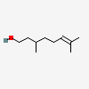 | C₁₀H₂₀O | Antifungal activity | National Center for Biotechnology Information (2023). PubChem Compound Summary for CID 8842, beta-CITRONELLOL, (+/-)-. Retrieved July 26, 2023, from https://pubchem.ncbi.nlm.nih.gov/compound/beta-CITRONELLOL.
2. | Geraniol | 13.386 | 0.43 | 154.25 g/mol | 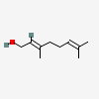 | C₁₀H₁₈O | Anti-cancer, anti-microbial, antioxidant  anti-inflammatory | National Centre for Biotechnology Information (2023). PubChem Compound Summary for CID 637566, Geraniol. Retrieved July 26, 2023, from https://pubchem.ncbi.nlm.nih.gov/compound/Geraniol.
3. | 1H-1,3a-Ethanope ntalen -5-Ol Hexahydro-, Trans | 17.257 | 0.34 | 152.23 g/mol | 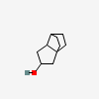 | C₁₀H₁₆O | anti-cancer, anti-microbial activity | National Centre for Biotechnology Information (2023). PubChem Compound Summary for CID 556791, 1H-1,3a-Ethanopentalen-5-ol, hexahydro-, trans-. Retrieved July 27, 2023 from https://pubchem.ncbi.nlm.nih.gov/compound/1H-1_3a-Ethanopentalen-5-ol_-hexahydro-_-trans.

S/n | Compound Name | Retention Time | Area % | Mol. Weight | Mol.  Structure | Mol. Formula | Bio. Activity | References
 |  |  |  |  | ALCOHOLS
4. | Trans,Trans-2,6- Dimethyl-2,6- Octadiene-1,8-Diol | 19.102 | 0.19 | 170.25 g/mol | 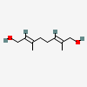 | C₁₀H₁₈O₂ | Anti-microbial, antipyretic | National Center for Biotechnology Information (2023). PubChem Compound Summary for CID 5363397, 2,6-Dimethyl-2,6-octadiene-1,8-diol, (2E,6E)-. Retrieved July 27, 2023 from https://pubchem.ncbi.nlm.nih.gov/compound/6E_-8-hydroxygeraniol.
5. | Isospathulenol | 19.608 | 0.48 | 220.35 g/mol | 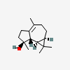 | C₁₅H₂₄O | Anti-microbial | National Center for Biotechnology Information (2023). PubChem Compound Summary for CID 102303030, Isospathulenol. Retrieved July 27, 2023 from https://pubchem.ncbi.nlm.nih.gov/compound/Isospathulenol.
6. | Neointermedeol | 20.078 | 0.29 | 222.37 g/mol | 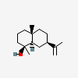 | C₁₅H₂₆O | Antioxidant, enzyme inhibiting | National Center for Biotechnology Information (2023). PubChem Compound Summary for CID 11877394, Neointermedeol. Retrieved July 27, 2023 from https://pubchem.ncbi.nlm.nih.gov/compound/Neointermedeol.
7. | Farnesol | 23.373 | 0.09 | 222.37 g/mol | 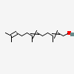 | C₁₅H₂₆O | Antimicrobial and fungicide activity | National Center for Biotechnology Information (2023). PubChem Compound Summary for CID 3327, Farnesol. Retrieved July 27, 2023 from https://pubchem.ncbi.nlm.nih.gov/compound/Farnesol.

S/N | Compound  Name | Retention Time | Area % | Mol. Weight | Mol.  Structure | Mol.  Formula | Bio.  Activity | References
 |  |  |  |  | STEROLS
8. | Ergost-5-En-3-Ol | 39.997 | 0.71 | 400.7 g/mol | 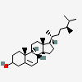 | C₂₈H₄₈O | Anticancer, anti-inflammatory,  antibacterial | National Center for Biotechnology Information (2023). PubChem Compound Summary for CID 18660356, Ergost-5-en-3-ol. Retrieved July 27, 2023 from https://pubchem.ncbi.nlm.nih.gov/compound/Ergost-5-en-3-ol.
9. | Stigmasterol | 40.596 | 1.15 | 412.7 g/mol | 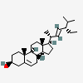 | C₂₉H₄₈O | Anti-angiogenic, anti-cancer | National Center for Biotechnology Information (2023). PubChem Compound Summary for CID 5280794, Stigmasterol. Retrieved July 27, 2023 from https://pubchem.ncbi.nlm.nih.gov/compound/Stigmasterol.
10. | Gamma-Sitosterol | 42.149 | 3.62 | 414.7 g/mol | 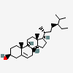 | C₂₉H₅₀O | Antioxidant, free radical scavenging, antidiabetic | National Center for Biotechnology Information (2023). PubChem Compound Summary for CID 457801, Clionasterol. Retrieved July 27, 2023 from https://pubchem.ncbi.nlm.nih.gov/compound/Clionasterol.

S/N | Compound  Name | Retention Time | Area % | Mol. Weight | Mol.  Structure | Mol.  Formula | Bio. Activity | References
HYDROCARBONS
11. | Cyclohexane | 9.871 | 0.31 | 84.16 g/mol | 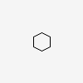 | C₆H₁₂ | Antibacterial | National Center for Biotechnology Information (2023). PubChem Compound Summary for CID 8078, Cyclohexane. Retrieved July 26, 2023 from https://pubchem.ncbi.nlm.nih.gov/compound/Cyclohexane.
12. | Cis-Alpha- Bergamotene | 19.102 | 0.19 | 204.35 g/mol | 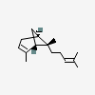 | C₁₅H₂₄ | Antimicrobial | National Center for Biotechnology Information (2023). PubChem Compound Summary for CID 6429303, alpha-CIS-BERGAMOTENE. Retrieved July 26, 2023 from https://pubchem.ncbi.nlm.nih.gov/compound/alpha-CIS-BERGAMOTENE.
13. | 1,4,8-Cycloundecatriene | 16.947 | 0.11 | 148.24 g/mol | 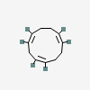 | C₁₁H₁₆ | Antiarthritic, antifungal antimicrobial | National Center for Biotechnology Information (2023). PubChem Compound Summary for CID 101634359, (1E,4E,8Z)-1,4,8-Cycloundecatriene. Retrieved July 27, 2023 from https://pubchem.ncbi.nlm.nih.gov/compound/101634359.
14. | Alpha-Farnesene | 17.594 | 0.70 | 204.35 g/mol | 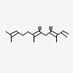 | C₁₅H₂₄ | Anti-bacterial, antimicrobial | National Center for Biotechnology Information (2023). PubChem Compound Summary for CID 5281516, Alpha-Farnesene. Retrieved July 27, 2023 from https://pubchem.ncbi.nlm.nih.gov/compound/Alpha-Farnesene.

S/N | Compound  Name | Retention Time | Area % | Mol. Weight | Mol.  Structure | Mol.  Formula | Bio.  Activity | References
 | HYDROCARBONS
15. | Caryophyllene | 16.514 | 0.11 | 204.35 g/mol | 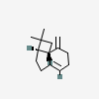 | C₁₅H₂₄ | Anti-inflammatory, antibiotic, antioxidant, anti-carcinogenic, local anesthetic activities | National Center for Biotechnology Information (2023). PubChem Compound Summary for CID 5281515, Caryophyllene. Retrieved July 26, 2023 from https://pubchem.ncbi.nlm.nih.gov/compound/Caryophyllene.
16. | Beta-Bisabolene | 17.695 | 0.48 | 204.35 g/mol | 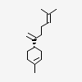 | C₁₅H₂₄ | Antioxidant, antimicrobial | National Center for Biotechnology Information (2023). PubChem Compound Summary for CID 10104370, beta-Bisabolene. Retrieved July 27, 2023 from https://pubchem.ncbi.nlm.nih.gov/compound/beta-Bisabolene.
17. | Neophytadiene | 22.301 | 0.13 | 278.5 g/mol | 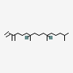 | C₂₀H₃₈ | Antioxidant antibacterial | National Center for Biotechnology Information (2023). PubChem Compound Summary for CID 10446, Neophytadiene. Retrieved July 27, 2023 from https://pubchem.ncbi.nlm.nih.gov/compound/Neophytadiene.

S/N | Compound  Name | Retention Time | Area % | Mol. Weight | Mol.  Structure | Mol.  Formula | Bio.  Activity | References
ALKALOIDS
18. | 1-(3-Methyl-3-Butenyl) Pyrrolidine | 8.824 | 1.23 | 139.24 g/mol | 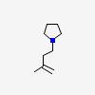 | C₉H₁₇N | Antibacterial, antifungal, enzyme inhibition | National Center for Biotechnology Information (2023). PubChem Compound Summary for CID 558410, Pyrrolidine, N-(3-methyl-3-butenyl)-. Retrieved July 26, 2023 from https://pubchem.ncbi.nlm.nih.gov/compound/Pyrrolidine_-N-_3-methyl-3-butenyl.
19. | 2H-1-Benzopy ran-2-One | 24.337 | 0.96 | 146.14 g/mol | 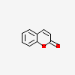 | C₉H₆O₂ | Antibacterial, anti-arrhythmic | National Center for Biotechnology Information (2023). PubChem Compound Summary for CID 323, Coumarin. Retrieved July 27, 2023 from https://pubchem.ncbi.nlm.nih.gov/compound/Coumarin.
20. | 1,5-Dibromo-3-Methylpentane | 24.795 | 0.07 | 243.97 g/mol | 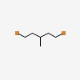 | C₆H₁₂Br₂ | Antibacterial | National Center for Biotechnology Information (2023). PubChem Compound Summary for CID 138258, 1,5-Dibromo-3-methylpentane. Retrieved July 27, 2023 from https://pubchem.ncbi.nlm.nih.gov/compound/1_5-Dibromo-3-methylpentane.
21. | Nonanenitrile | 10.013 | 0.42 | 139.24 g/mol | 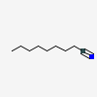 | C₉H₁₇N | Antimicrobial | National Center for Biotechnology Information (2023). PubChem Compound Summary for CID 16715, Nonanenitrile. Retrieved July 27, 2023 from https://pubchem.ncbi.nlm.nih.gov/compound/Nonanenitrile.

S/N | Compound  Name | Retention Time | Area % | Mol. Weight | Mol.  Structure | Mol.  Formular | Bio. Activity | References
 |  |  |  |  | ALKALOIDS
22. | 2,3-Dihydro- Benzofuran | 13.070 | 8.53 | 120.15 g/mol | 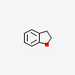 | C₈H₈O | Antibacterial, antifungal, antiviral, antioxidant, antiinflammatory, anticancer | National Center for Biotechnology Information (2023). PubChem Compound Summary for CID 10329, 2,3-Dihydrobenzofuran. Retrieved July 27, 2023 from https://pubchem.ncbi.nlm.nih.gov/compound/2_3-Dihydrobenzofuran.
23. | 1,2,3,4-TetrahydroCyclopenta [B] Indole | 19.191 | 0.09 | 157.21 g/mol | 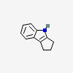 | C₁₁H₁₁N | Antifungal, cytotoxic | National Center for Biotechnology Information (2023). PubChem Compound Summary for CID 270305, 1,2,3,4-Tetrahydrocyclopenta[b]indole. Retrieved July 27, 2023 from https://pubchem.ncbi.nlm.nih.gov/compound/1_2_3_4-Tetrahydrocyclopenta_b_indole.
24. | 3-(Alpha-Hydroxyethyl)-Aniline | 13.784 | 0.12 | 137.18 g/mol | 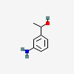 | C₈H₁₁NO | Antifungal | National Center for Biotechnology Information (2023). PubChem Compound Summary for CID 222461, 1-(3-Aminophenyl)ethanol. Retrieved July 27, 2023 from https://pubchem.ncbi.nlm.nih.gov/compound/1-_3-Aminophenyl_ethanol.

S/N | Compound  Name | Retention Time | Area % | Mol. Weight | Mol.  Structure | Mol.  Formular | Bio. Activity | References
VITAMINS
25. | Gamma-Tocopherol | 36.622 | 0.24 | 416.7 g/mol | 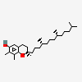 | C₂₈H₄₈O₂ | Antioxidant | National Center for Biotechnology Information (2023). PubChem Compound Summary for CID 92729, gamma-Tocopherol. Retrieved July 27, 2023 from https://pubchem.ncbi.nlm.nih.gov/compound/gamma-Tocopherol.
26. | Vitamin E | 37.974 | 1.52 | 430.7 g/mol | 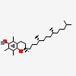 | C₂₉H₅₀O₂ | Antioxidant | National Center for Biotechnology Information (2023). PubChem Compound Summary for CID 14985, Alpha-Tocopherol. Retrieved July 27, 2023 from https://pubchem.ncbi.nlm.nih.gov/compound/Alpha-Tocopherol.
FATTY ACIDS
27. | Hexadecanoic Acid, Methyl Ester | 23.439 | 0.53 | 270.5 g/mol | 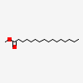 | C₁₇H₃₄O₂ | Anti-inflammatory, cytotoxic | National Center for Biotechnology Information (2023). PubChem Compound Summary for CID 8181, Methyl palmitate. Retrieved July 27, 2023 from https://pubchem.ncbi.nlm.nih.gov/compound/Methyl-palmitate.
28. | Octadecanoic Acid | 32.556 | 0.14 | 284.5 g/mol | 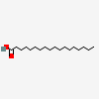 | C₁₈H₃₆O₂ | antioxidant, anticancer, antimicrobial | National Center for Biotechnology Information (2023). PubChem Compound Summary for CID 5281, Stearic Acid. Retrieved July 27, 2023 from https://pubchem.ncbi.nlm.nih.gov/compound/Stearic-Acid.

S/N | Name of Compound | Retention Time | Area % | Mol. Weight | Molecular Structure | Molecular Formula | Bio. Activity | References
 |  |  |  |  | FATTY ACIDS
29. | Beta-D-Glucopy- ranoside, Methyl | 20.788 | 5.55 | 194.18 g/mol | 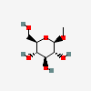 | C₇H₁₄O₆ | Antimicrobial, cytotoxic activity | National Center for Biotechnology Information (2023). PubChem Compound Summary for CID 445238, Methyl beta-D-glucopyranoside. Retrieved July 27, 2023 from https://pubchem.ncbi.nlm.nih.gov/compound/Methyl-beta-D-glucopyranoside.
30. | Citronellyl Palmitoleate | 34.242 | 0.20 | 392.7 g/mol | 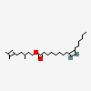 | C₂₆H₄₈O₂ | Antimicrobial | National Center for Biotechnology Information (2023). PubChem Compound Summary for CID 91715872, (Z)-3,7-dimethyloct-6-en-1-yl hexadec-9-enoate. Retrieved July 27, 2023 from https://pubchem.ncbi.nlm.nih.gov/compound/Z_-3_7-dimethyloct-6-en-1-yl-hexadec-9-enoate.
PHENOLIC COMPOUNDS
31. | 2-Methoxy-4 –Vinylphenol | 14.518 | 3.12 | 150.17 g/mol | 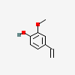 | C₉H₁₀O₂ | Antioxidant, anti-inflammatory, antimicrobial activities | National Center for Biotechnology Information (2023). PubChem Compound Summary for CID 332, 2-Methoxy-4-vinylphenol. Retrieved July 27, 2023 from https://pubchem.ncbi.nlm.nih.gov/compound/2-Methoxy-4-vinylphenol.

S/N | Name of Compound | Retention Time | Area % | Mol. Weight | Molecular Structure | Molecular Formula | Bio. Activity | References
32. | 3-Tert-Butyl-4- Hydroxyanisole | 18.563 | 0.95 | 180.24 g/mol | 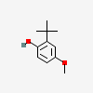 | C₁₁H₁₆O₂ | Acute toxicity, tumorpromoting activities | National Center for Biotechnology Information (2023). PubChem Compound Summary for CID 8456, 2-tert-Butyl-4-methoxyphenol. Retrieved July 27, 2023 from https://pubchem.ncbi.nlm.nih.gov/compound/2-tert-Butyl-4-methoxyphenol.
33. | Geranyl Acetate | 15.533 | 0.42 | 196.29 g/mol | 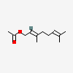 | C₁₂H₂₀O₂ | Antimicrobial activity | National Center for Biotechnology Information (2023). PubChem Compound Summary for CID 1549026, Geranyl acetate. Retrieved July 26, 2023 from https://pubchem.ncbi.nlm.nih.gov/compound/Geranyl-acetate.
34. | Methoxsalen | 25.015 | 0.35 | 216.19 g/mol | 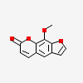 | C₁₂H₈O₄ | Antibacterial | National Center for Biotechnology Information (2023). PubChem Compound Summary for CID 4114, Methoxsalen. Retrieved July 27, 2023 from https://pubchem.ncbi.nlm.nih.gov/compound/Methoxsalen.
Source: Indra et al., (2020).

Grid Box Parameters
The grid box parameters for docking with drug targets like Interleukin-4, Interleukin-5, leukotrienes, and TNF-α are crucial, with higher values indicating an allosteric site preference and lower values suggesting closer association with the active site. The grid box parameters used for molecular docking with drug target proteins (Interleukin-4, Interleukin-5, Leukotriene, and Tumour Necrosis Factor-Alpha) are presented in Table 2. The table shows the 3D coordinates and sizes of the grid box for four drug target proteins associated with Asthma: Interleukin4, Interleukin5, Leukotriene, and Tumour Necrosis Factor-Alpha docked against the six selected phytocompounds.
Table 2: Grid box parameters of selected drug target proteins
S/N | TARGET | Center_x | Center_y | Center_z | Size_x | Size_y | Size_z
1. | Interleukin4 | -0.018 | 0.322 | 0.02 | 54 | 52 | 44
2. | Interleukin5 | 32.036 | 27.872 | 43.603 | 66 | 82 | 98
3. | Leukotriene | 23.557 | -0.268 | 6.858 | 74 | 48 | 62
4. | Tumour Necrosis Factor-Alpha | -26.431 | 14.658 | -39.288 | 110 | 94 | 126

Binding Affinity Results
The binding affinity values for the six phytocompounds from Euphorbia hirta that have anti-inflammatory biological activity docked with the selected drug target proteins implicated in Asthma (Interleukin4, Interleukin5, Leukotriene and Tumour Necrosis Factor-Alpha) using AutoDock vina 4.2.6 are shown in Table 3. From the table, Ergost-5-En-3-Ol shows the best binding affinity across all drug target proteins, followed by Caryophyllene, 2-Methoxy-4-Vinylphenol, 2,3-DihydroBenzofuran, Geraniol and Hexadecanoic Acid, Methyl ester. The lowest value shows the best binding score.

Table 3: Binding affinity values (kcal/mol) of phytocompounds to selected proteins
S/N | Ligand (Phytocompounds) | Interleukin4 | Interleukin5 | Leukotriene | Tumor Necrosis Factor-Alpha
1. | 2-Methoxy-4-Vinylphenol | -5.5 | -5.5 | -5.9 | -5.2
2. | Hexadecanoic Acid, Methyl ester | -4.3 | -3.6 | -6.2 | -4.6
3. | 2,3-DihydroBenzofuran | -5.3 | -5.0 | -5.8 | -5.2
4. | Geraniol | -4.5 | -4.7 | -5.9 | -4.5
5. | Caryophyllene | -5.7 | -5.7 | -6.0 | -7.8
6. | Ergost-5-En-3-Ol | -6.4 | -6.4 | -7.2 | -8.1

Lipinski's Properties of Selected Phytochemicals Present in E.hirta
Table 4 lists the pharmacokinetic parameters of the ligands (phytochemicals), which were obtained from the SwissADME website following the Lipinski rule. All six selected phytocompounds obey Lipinski's rule of five, which means they have potential for use in developing new asthma drugs.
Table 4: Lipinski’s biological and pharmacokinetics properties of the phytocompounds (ligands).
Ligand (phytocompounds) | MW  (g/mol) | LogP | Hydrogen Bond Donor | Hydrogen Bond Acceptor | No. of Violations
2-Methoxy-4-Vinylphenol | 150.17 | 1.71 | 1 | 2 | 0
Hexadecanoic Acid, Methyl ester | 270.5 | 4.44 | 0 | 2 | 1
2,3-DihydroBenzofuran | 120.15 | 1.75 | 0 | 1 | 0
Geraniol | 154.25 | 2.59 | 1 | 1 | 0
Caryophyllene | 204.35 | 4.63 | 0 | 0 | 1
Ergost-5-En-3-Ol | 400.7 | 6.54 | 1 | 1 | 1

Binding Interactions Between the Ergost-5-En-3-Ol and Selected Drug Target Proteins
Figure 1 shows the 2D diagrams of the interactions between Ergost-5-En-3-Ol and the drug target proteins.

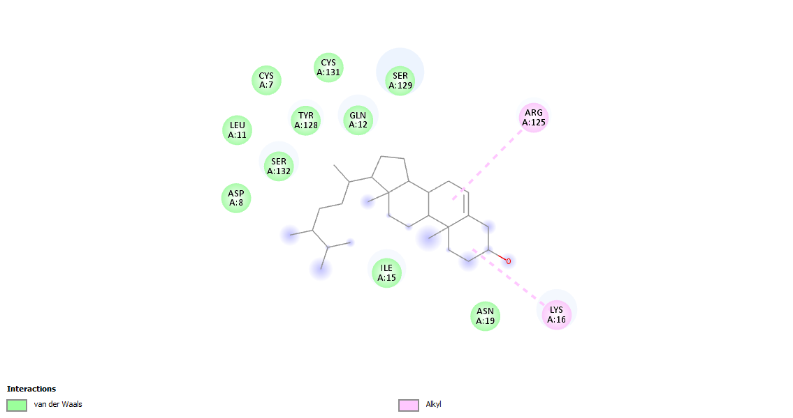
A

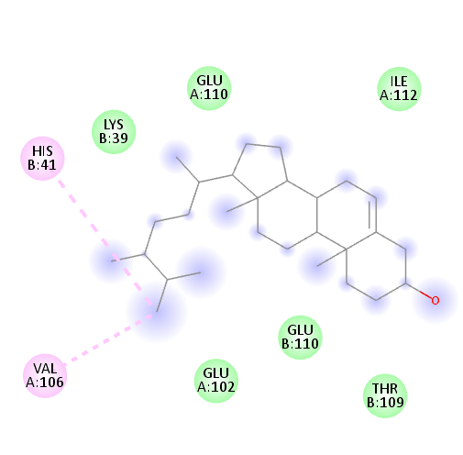
B

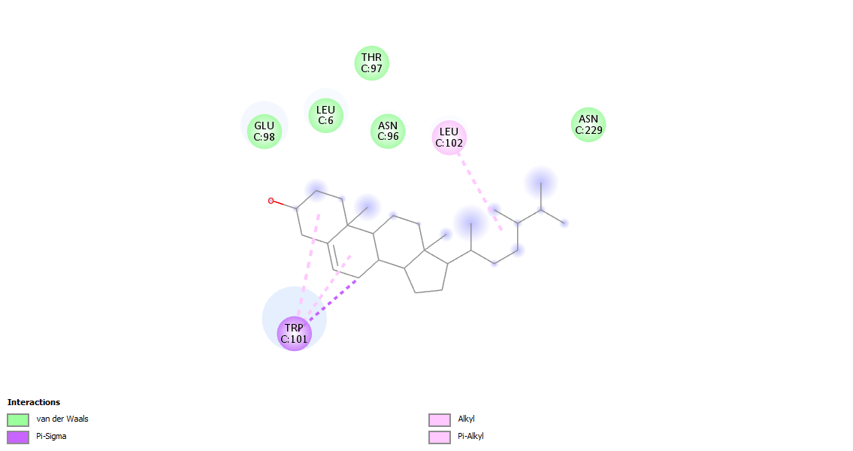
C

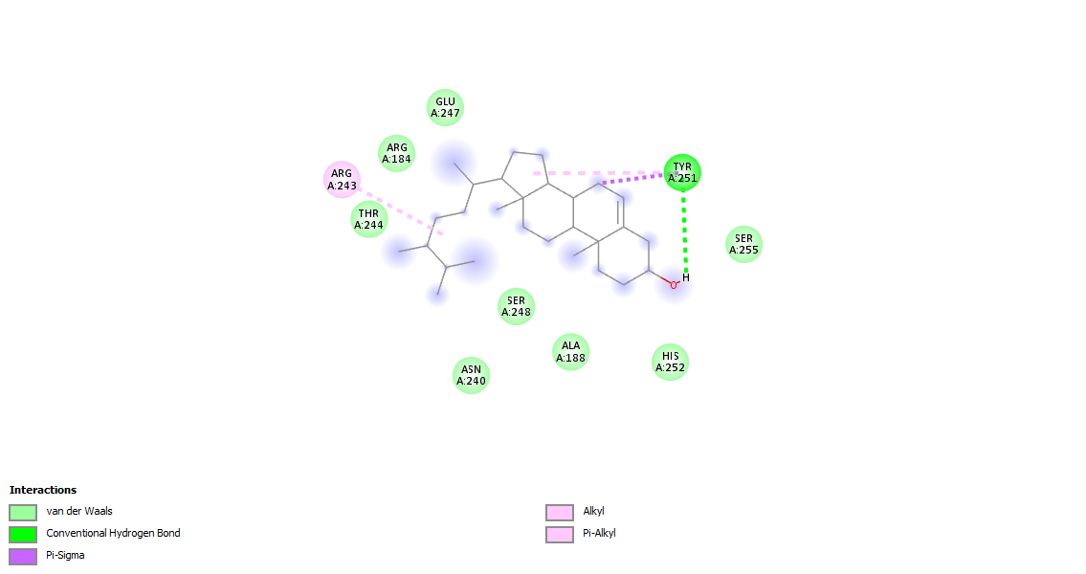
D
Figure 1: A). 2D structure of ergost-5-en-3-ol-interleukin4 interactions (-6.4). Green indicates van der Waals forces, while pink indicates alkyl bonds. B). 2D structure of ergost-5-en-3-ol- interleukin5 interactions (-6.4). Green indicates van der Waals forces, dark pink indicates pi-alkyl bonds, while light pink indicates alkyl bonds. C). 2D structure of ergost-5-en-3-ol - leukotriene interactions (-7.2). Green indicates van der Waals forces, light pink indicates alkyl bonds, dark pink pi-alkyl bonds and purple indicates Pi-Sigma bonds. D). 2D structure of ergost-5-en-3-ol- TNF-alpha interactions (-8.1). Light green indicates van der Waals forces, dark green indicates conventional Hydrogen bonds, dark pink indicates Pi-alkyl bonds, light pink indicates alkyl bonds, while purple indicates Pi-Sigma bonds.

People are using more herbal medicines than ever before. This is because people are more interested in natural ways to stay healthy and treat diseases (Singh and Bharadwaj, 2022). Also, more people have chronic diseases, and herbal medicines can be a cheaper way to treat them (Singh et al., 2017). Euphorbia hirta, a plant that is well-known and used by many tribes in Nigeria, has been claimed to have medicinal properties for asthma. It is commonly called the asthma plant because of its alleged effectiveness in treating asthma and other respiratory problems in East and West Africa (Ojewole and Egbunike, 2013).
In the current study, Ergost-5-En-3-Ol, which is a sterol, was observed to be a promising lead compound for the development of anti-inflammatory drugs, as seen in the binding affinity. By binding to and inhibiting TNF-α, Interleukin 4, Interleukin 5 and Leukotrienes, Ergost-5-En-3-Ol could potentially reduce inflammation and improve symptoms in patients with a variety of inflammatory conditions.
TNF-α is a pro-inflammatory cytokine that plays a key role in many inflammatory diseases (Al-Muhsen et al., 2022). TNF-alpha levels are elevated in the bronchoalveolar lavage fluid (BALF) and sputum of patients with asthma (Fahy and O'Byrne, 2020). TNF-alpha also contributes to the development of AHR in animal models of asthma. In humans, TNF-alpha levels are correlated with the severity of asthma (Chung and Barnes, 2019). The specific amino acids that Ergost-5-En-3-Ol binds to in the active site of TNF-α are all important for the cytokine's function. For example, ARG243 and ARG184 are involved in the binding of TNF-α to its receptor, while GLU247, THR244, and SER248 are involved in the catalytic activity of the cytokine (Figure 1). By binding to these amino acids, Ergost-5-En-3-Ol could interfere with the ability of TNF-α to signal to its target cells and promote inflammation. The types of bond interactions that Ergost-5-En-3-Ol forms with the amino acids in the active site of TNF-α are also significant. Van der Waals bonds are weak bonds that are caused by the attraction between the electron clouds of different atoms. Hydrogen bonds are stronger bonds that are formed between hydrogen atoms and electronegative atoms, such as oxygen and nitrogen. Pi-sigma bonds are formed between the pi orbitals of one atom and the sigma orbital of another atom. Alkyl and pi-alkyl bonds are formed between different types of carbon atoms.
The fact that Ergost-5-En-3-Ol forms a variety of bond interactions with the amino acids in the active site of TNF-α suggests that it binds tightly to the cytokines Interleukin 4 and Interleukin 5, which are also cytokines.
Interleukin-4 (IL-4) is a cytokine that plays a key role in the development and progression of asthma. It is produced by activated T helper 2 (Th2) cells and other immune cells, and it acts on a variety of cells, including B cells, eosinophils, and mast cells. Interleukin-5 (IL-5) also plays a critical role in the development of asthma. IL-5 is a cytokine that promotes the development, activation, and survival of eosinophils. Eosinophils are a type of white blood cell that is involved in allergic and inflammatory responses. Leukotrienes are a group of inflammatory mediators that play a significant role in the development and progression of asthma. Leukotrienes are produced by a variety of cells, including mast cells, eosinophils, and epithelial cells in the airways.
This tight binding is likely essential for Ergost-5-En-3-Ol's anti-inflammatory activity. In addition to its high docking score and strong binding to TNF-α, Interleukin 4, Interleukin 5 and Leukotrienes, Ergost-5-En-3-Ol also conforms to Lipinski's rule of five. Lipinski's rule of five is a set of four rules that describe the molecular properties of drugs that are likely to be orally bioavailable. The four rules are: Molecular weight ≤ 500 Da, LogP ≤ 5, Hydrogen bond donors ≤ 5 and Hydrogen bond acceptors ≤ 10.
Ergost-5-En-3-Ol has a molecular weight of 426 Da, a LogP of 5.2, 1 hydrogen bond donor, and 2 hydrogen bond acceptors. Therefore, it conforms to all four rules of Lipinski's rule of five, suggesting that it is likely to be orally bioavailable. Overall, the results suggest that Ergost-5-En-3-Ol is a promising lead compound for the development of anti-inflammatory drugs. It has a high docking score, binds strongly to the active site of the drug target proteins selected for this study, and conforms to Lipinski's rule of five. The results support the study according to Xia et al., 2018, that Euphorbia hirta has anti-inflammatory properties and this present study implies that Ergost-5-En-3-Ol is responsible for that effect.

4. Conclusion

The use of herbal medicines, including plants like Euphorbia hirta, is increasing due to the growing interest in natural approaches to maintaining health and managing diseases. Herbal medicines are particularly attractive for individuals with chronic conditions, such as asthma, due to potential cost-effectiveness and perceived efficacy. Euphorbia hirta, known as the asthma plant, is a widely used traditional remedy in Nigeria for treating asthma and respiratory issues. This plant contains phytochemicals that possess properties like pain relief, fever reduction, and anti-inflammatory effects.
The compound Ergost-5-En-3-Ol has been identified as having potential for the development of anti-inflammatory drugs. It binds strongly to various inflammatory markers such as TNF-α, Interleukin 4, Interleukin 5, and Leukotrienes, which are associated with inflammatory conditions, particularly asthma.
Furthermore, Ergost-5-En-3-Ol meets Lipinski's rule of five criteria, suggesting its potential for oral bioavailability, a crucial factor for drug development. This study confirms the anti-inflammatory properties of Ergost-5-En-3-Ol and it shows promise as a lead compound for developing anti-inflammatory drugs, potentially offering a natural and effective solution for managing inflammatory conditions like asthma. The study supports previous findings that Euphorbia hirta has anti-inflammatory properties, implying that Ergost-5-En-3-Ol might be responsible for this effect.

Competing interests

Authors declare that no competing interests exist.

Disclaimer (Artificial intelligence)
Option 1:
Author(s) hereby declare that NO generative AI technologies such as Large Language Models (ChatGPT, COPILOT, etc.) and text-to-image generators have been used during the writing or editing of this manuscript.
Option 2:
Author(s) hereby declare that generative AI technologies such as Large Language Models, etc. have been used during the writing or editing of manuscripts. This explanation will include the name, version, model, and source of the generative AI technology and as well as all input prompts provided to the generative AI technology
Details of the AI usage are given below:
1.
2.
3.

References

- Al-Ahmad, A. and Al-Harbi, N. (2021). Recent insights into the management of inflammation in asthma. Journal of Inflammation Research, 14: 6047-6061.
- American Lung Association (ALA). (2023). Asthma. Retrieved from https://www.lung.org/lung-health-diseases/lung-disease-lookup/asthma on 15th October, 2023 at 10:43am
- Bateman, E. D., Hurd, S. S., Barnes, P. J., Bousquet, J., Drazen, J. M. and FitzGerald, J. M. (2022). Global strategy for asthma management and prevention: GINA executive summary. The European Respiratory Journal, 59(1): 1-45.
- Zhang, Y. and Yang, P. (2022). Recent advances in druggable targets for asthma. Frontiers in Pharmacology, 13: 864877.
- Wang, Y., Wang, J. and Zhang, J. (2023). IgE as a therapeutic target in allergic diseases. Expert Opinion on Drug Discovery, 18(2): 185-201.
- World Health Organization (2022). Asthma. Retrieved from https://www.who.int/news-room/fact-sheets/detail/asthma on 14th October, 2023 at 5:34pm.
- Miller, J. C., Jackson, S. E., Jones, D. A., Kilty, D. J., Schofield, C. J. and Ward, S. G. (2023). Computational methods for asthma drug discovery. Nature Reviews Drug Discovery, 22 (2023): 68-82.
- National Heart, Lung, and Blood Institute (NHLBI). (2022). Asthma. Retrieved from https://www.nhlbi.nih.gov/health/asthma on 14th October, 2023 at 1:46pm.
- GINA Global Initiative for Asthma. (2023). Global initiative for asthma (GINA) Global strategy for asthma management and prevention. Retrieved from https://ginasthma.org/2023-gina-main-report on 16th October, 2023 at 9:34am.
- Pandey, A. and Kushwaha, S. (2023). Recent advances in molecular docking for drug discovery. Frontiers in Pharmacology, 14: 834009. Wang, J. and Wang, W. (2022). Molecular docking and drug discovery: a review on recent advances. Journal of Chemical Information and Modeling, 62(5): 1442-1459.
- Wang, J. and Wang, W. (2022). Molecular docking and drug discovery: a review on recent advances. Journal of Chemical Information and Modeling, 62(5): 1442-1459.
- Gupta, V. K. and Kumari, G. (2015). Phytochemistry and pharmacological activities of Euphorbia hirta: a review. International Journal of Pharmaceutical Sciences Review and Research, 3(1): 1-8.
- Khan, S., Ahmed, B., Khalilullah, H. and Masoodi, M. H. (2014). Neuro-pharmacological activity of Euphorbia hirta and its isolated compound. Journal of Pharmacognosy and Phytochemistry, 3(2): 138-146.
- Khurshid, R., Saleen, M., Karim, S. and Mir, M. (2013). Antipyretic, antiviral, antithrombotic properties of Euphorbia hirta against dengue fever. Pharmacia, 60(3): 8.
- Kumar, S., Yadav, A., Kumar, S., Yadav, S., Yadav, S. K. and Yadav, J. P. (2022). Euphorbia hirta: a review on its pharmacological and toxicological properties. Frontiers in Pharmacology, 13: 931956.
- Aasha, S., Thirunavukkarasu, V., Magendira, M. and Mohamad, S. A. (2016). Antioxidant activity of Euphorbia hirta (linn) leaves extracts. The European Journal of Medicinal Plants, 14(1): 1-14.
- Anitha, P., Geegi, P. G., Yogeswari, J. and Anthoni, S. A. (2014). In Vitro anticancer activity of ethanolic extract of Euphorbia hirta (Linn). Science, Technology and Arts Research Journal, 3(1): 8-13.
- Indra, S., Sarma, P. S., Patil, A. and Reddy, D. K. (2020). Phytochemical analysis of methanolic extract of Euphorbia hirta linn. leaves by GC-MS. National Journal of Basic Medical Sciences, 10(4): 396-403.
- Radhakrishnan, V. and Murugesan, K. (2016). Euphorbia hirta: a comprehensive review on its phytochemistry, traditional uses, pharmacological activities and toxicological aspects. Journal of Ethnopharmacology, 186: 185-205.
- Xia, M., Liu, L., Qiu, R., Li, M., Huang, W., Ren, G. and Zhang, J. (2018). Anti-inflammatory and anxiolytic activities of Euphorbia hirta extract in neonatal asthmatic rats. AMB Express, 8(179): 54-57.
- Habib, N., Pasha, M. A., & Tang, D. D. (2022). Current understanding of asthma pathogenesis and biomarkers. Cells, 11(17), 2764.
- 22.Kumar, S., Malhotra, R., & Kumar, D. (2010). Euphorbia hirta: Its chemistry, traditional and medicinal uses, and pharmacological activities. Pharmacognosy reviews, 4(7), 58.
23. Costa, J. A. D., Marinho, A. D. O., Alves, R. R. D. V., de Barros, M. C., Nova, I. C. V., de Oliveira, S. A., ... & Paiva, P. M. G. (2025). Phytochemical Profile, Toxicological Screening, Antitumor Activity, and Immunomodulatory Response of Saline Extract from Euphorbia hirta L. Leaves. Molecules, 30(15), 3105. 24. Hadia, R., Shaikh, A., Ajay, T., Philip, E., Joshi, D., Rathod, T., Shah, A., & Rajput, H. S. (2021). A Cross-sectional Observational Study on Pharmacoeconomic Burden of Asthma in a Tertiary Care Teaching Hospital. Journal of Pharmaceutical Research International, 33(37A), 292–301.

