Research Article
Studies on Quality Analysis of a High-Protein Buffalo Meat Incorporated Nutribar

ABSTRACT

Energy bars are compact, nutrient-dense food supplements formulated to deliver a rapid source of energy. Generally weighing between 30 and 50 g, they provide approximately 200-300 kcal, with 3-9 g of fat, 7-15 g of protein and 20-40 g of carbohydrates. These products serve multiple functions, including sustaining athletes during endurance activities, functioning as convenient meal replacements for weight management and helping address malnutrition. Fruit-based nutribars have gained popularity as quick energy options, while whey protein is recognized for its role in promoting muscle growth and reducing physiological stress markers linked to intense physical exertion. The present study focused on the development and shelf-life evaluation of value-added nutribars enriched with buffalo meat. Four formulations were prepared: a control without beef jerky (C) and three treatments containing 10% (T1), 15% (T2) and 20% (T3) buffalo meat. The bars were packaged aerobically in laminated pouches and stored at ambient temperature. Physico-chemical characteristics, sensory quality and microbiological status were assessed on days 0, 7, 14 and 21 of storage. Results indicated significant differences in proximate composition and cooking yield between T1, the control and other treatments. Among the treatments, T3 exhibited the highest protein and lowest fat content, while T1 demonstrated higher energy levels. Throughout the 21-day storage period, all formulations maintained acceptable microbiological quality and sensory attributes, showing no signs of spoilage, confirming their stability and safety for consumption.
Keywords: Nutribars, value addition, buffalo meat, energy source, carabeef and protein source

INTRODUCTION

Energy bars have emerged as convenient, nutrient-dense foods designed to provide rapid and sustained energy for physically active individuals. Typically formulated with a balanced combination of carbohydrates, proteins and fats, these products are widely consumed as pre- and post-workout snacks, meal replacements and functional foods. In sports nutrition, adequate intake of high-quality protein and carbohydrates is essential to support glycogen replenishment, muscle repair and optimal performance. Increasing consumer awareness of health, fitness and protein intake has accelerated the demand for innovative, high-protein snack options with improved nutritional profiles (Sakhare et al., 2024).
Animal-derived proteins are recognized for their superior amino acid composition and high biological value. Buffalo meat, in particular, is rich in high-quality protein, essential amino acids, iron and other micronutrients, while generally containing lower fat compared to many conventional red meats (Purchas et al., 2004). Incorporating buffalo meat into a ready-to-eat nutribar offers an opportunity to develop a value-added functional product with enhanced protein content and improved satiety. However, successful development of such a product requires careful optimization of formulation to ensure desirable sensory attributes, physicochemical stability, microbiological safety and acceptable shelf life. Therefore, the present study focuses on the optimization and quality evaluation of a protein rich buffalo meat incorporated nutribar to assess its nutritional potential, storage stability and overall consumer acceptability.

MATERIALS AND METHODS

Preparation of Beef Jerky

Beef jerky was prepared using semimembranosus muscle collected from fresh beef. The collected meat was first sliced into uniform pieces and washed thoroughly to remove any adhering impurities. A curing solution was prepared using pepper powder, coriander powder, sugar powder, chilli powder, salt and soya sauce. The sliced meat was then marinated in the prepared curing solution for one hour to allow proper flavour infusion.
After marination, the meat pieces were arranged uniformly on trays. Drying was carried out in a hot air dryer at 70°C for 3 hours, followed by further drying at 40°C for 24 hours to achieve the desired moisture reduction. Upon completion of drying, the jerky was cooled at room temperature for 30 minutes.
The dried product was then ground into powder form as required and packed in laminated pouches. Finally, the packaged product was stored in a deep freezer at –18°C to maintain its quality and extend shelf life.

Table 1. Formulation of Beef Jerky

Ingredients (%) | Weight (grams)
Beef | 1000
Pepper Powder | 11.38
Coriander Powder | 11.38
Sugar Powder | 11.38
Salt | 11.38
Chilli Powder | 11.38
Soya Sauce | 20

Preparation of Nutribar with Beef Jerky and Foxtail Millet

To prepare the nutribar, peanuts, poha and foxtail millet were first roasted in a pan until crisp and kept aside. Separately, dates and raisins were ground into a smooth paste. Butter was melted in a pan and jaggery was added to it, allowing it to dissolve completely to form a uniform syrup. The roasted mixture of peanuts, poha and foxtail millet was then incorporated into the melted jaggery mixture and sauted thoroughly to ensure even blending. Crushed almonds were added and cooked briefly. Prepared jerky powder was subsequently incorporated into the mixture and mixed well to obtain a homogeneous mass. Three treatments of beef jerky powder were used: T1 with 30 g, T2 with 45 g and T3 with 60 g of beef jerky powder. Then sesame seeds were added and blended uniformly.
A mould was lightly greased with butter and the prepared mixture was transferred into it, spread evenly and pressed firmly to obtain a compact layer. The mould was then refrigerated for one hour to allow proper setting. After firming, the product was removed from the mould and cut into desired bar shapes. Finally, the nutribars were wrapped in LDPE covers and stored at room temperature until further use.

Table 2. Formulation of Nutribar

Ingredients (%) | Weight (grams)
Foxtail Millet | 13
Dates | 13
Almond | 4
Raisins | 4
Sesame | 4
Poha | 17
Beef Jerky | 30 (T1-10%)  45 (T2-15%)  60 (T3-20%)
Jaggery | 16
Butter | 16
Peanut | 13

Product yield

The cooking yield percentage is determined by measuring the weight of the prepared nutribar, multiplying it by 100 and then dividing the result by the nutribar's initial weight before preparation.

Proximate composition

The proximate composition, including moisture, crude protein, ether extract, NFE and total ash, of nutribar was determined using the methods recommended by AOAC (2016).

Energy Value

The total caloric content of the nutribar was calculated on a wet matter basis according to FAO (2002).
Calories from fat were calculated as: Fat (%) × 9
Calories from protein were calculated as: Protein (%) × 4
Calories from carbohydrates were calculated as: Carbohydrate (%) × 4
The total energy value (kcal/100 g) was determined using the formula:
Total calories (kcal/100 g) = (Fat % × 9) + (Protein % × 4) + (Carbohydrate % × 4)

Shelf-life Study

Moisture

Approximately, 10 g of sample was taken in a petri dish and was kept in a hot air oven at 105±2℃ for 16 to 18 h. The weight of the dried sample was taken after cooling in a desiccator. The difference in the weight before drying and after drying is the moisture content of the sample and it was expressed as per cent of the nutribar. Moisture content was calculated by applying the following formula:
Moisture (%) = W₂ - W₃ x 100
W₂ - W₁
Where, W₁ = Weight of empty petri dish
W₂ = Weight of petri dish + fresh sample
W₃ = Weight of petri dish + dried sample

Thio-Barbituric Acid Reactive Substances

Thio-Barbituric Acid Reactive Substances (TBARS) value of nutribar was determined by the extraction method of Witte et al. (1970). TBARS estimation can be accomplished by measuring the concentration of secondary lipid oxidised products like malonaldehyde. Twenty grams of the sample was added with 50 mL of chilled extracting solution containing twenty per cent trichloroacetic acid in two molar orthophosphoric acid and was homogenised for about 1.5 to 2 minutes. The resultant slurry was transferred to a 100 mL volumetric flask and made up to 100 mL with deionised distilled water and this solution was filtered through Whatman No.1 filter paper. The filtrate was termed as Tri-Chloro Acetic acid (TCA) extract and five mL of TCA extract was mixed with five mL of 2- thiobarbituric acid solution (0.005 M in distilled water). Blank was constituted with five mL distilled water and 2- thiobarbituric acid solution. The constituted samples along with blank in tightly closed test tubes were placed in a boiling water bath (100℃) for 30 minutes and this was cooled for ten minutes under cold running water. The developed colour was measured as absorbance value at 530 nanometers (Double Beam Spectrophotometer Systronics-India, AU-2703) and expressed as thio-barbituric acid number. TBARS value was expressed as mg malonaldehyde per kg of the sample. TBARS values of the nutribar stored at ambient temperature were measured on day 0, 7th, 14th and 21st days of storage period.
Yeast and Mould

The yeast and mould count per gram of the sample was estimated using the method outlined by Beuchat and Cousin (2001). Sabouraud’s Dextrose Agar (HiMedia, Mumbai) served as the culture medium and the plates were incubated at 25-27°C for three days. The results were recorded as log10 CFU/g.

Sensory Evaluation

A semi-trained panel of seven members from the Department of Livestock Products Technology at the College of Veterinary and Animal Sciences, Mannuthy, Thrissur, conducted the sensory evaluation using an eight-point Hedonic scale. Samples were evaluated for appearance, flavour, juiciness, binding, texture and over all acceptability using 8-point hedonic scale.

Statistical analysis

The physicochemical, proximate and sensory characteristics of nutribar were analysed using SPSS software (version 24.0), following the guidelines of Snedecor and Cochran (1994).

RESULTS AND DISCUSSION

The research focused on formulating a nutribar enriched with buffalo meat and assessing its quality. The prepared products were kept at room temperature and periodically examined over a 21-day period to evaluate their physicochemical properties, sensory attributes and microbiological stability.

Product yield

Product yield (%) | 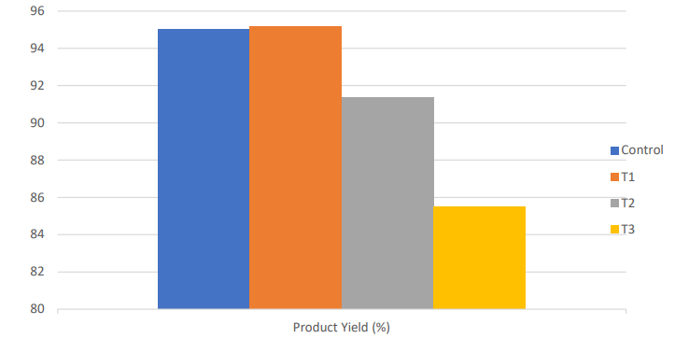
 | Control and treatment samples
Control – Nutri Bar without meat; T1- Nutri Bar with 10 % beef; T2- Nutri Bar with 15 % beef; T3- Nutri Bar with 20 % beef
Fig. 1 . Product yield

The highest product yield was observed in the T1 (95.47±0.47 %) formulation, while the lowest was recorded in T3 (85.5±0. 50 %). The cooking yield decreased significantly (P < 0.05) with the addition of carabeef powder, which may be attributed to the lower pH of buffalo meat. Since pH influences the water-holding capacity (WHC) of meat proteins, a reduction in pH toward the proteins isoelectric point reduces their net charge. Consequently, the proteins retain less water, resulting in a lower product yield. Similar results were observed by Goswami et al. (2017) in carabeef biscuits prepared with higher levels of buffalo meat powder.

Proximate composition

Table 3. Proximate composition

Parameter | Control | Nutribar with different levels of beef jerky
Parameter | Control | T1 | T2 | T3
Moisture (%) | 16.14±0.46^{c} | 8.32±0.14^{b} | 7.47±0.08^{b} | 4.72±0.15ª
Protein (%) | 9.77±0.07ª | 14.82±0.41^{b} | 18.71±0.13^{c} | 19.56±0.36^{c}
Fat (%) | 26.13±0.34^{b} | 25.93±0.28^{b} | 23.57±0.04^{b} | 13.66±0.07ª
Ash (%) | 1.67±0.03ª | 1.97±0.01^{b} | 2.3±0.06^{c} | 2.35±0.01^{c}
NFE (%) | 46.29±0.73ª | 48.96±0.32ª | 47.95±0.15ª | 59.71±0.35^{b}
Control – Nutri Bar without meat; T1- Nutri Bar with 10 % beef; T2- Nutri Bar with 15 % beef; T3- Nutri Bar with 20 % beef

Proximate composition analysis showed significant differences (P<0.05) in moisture, protein, fat, ash and NFE contents across the various treatments. Moisture and fat content were found to be highest in the control formulation and lowest in T3. Because beef jerky is a dehydrated, low-moisture and fat product (Mediani et al., 2022), its incorporation in powder form increases the total dry matter, protein and solid content of the formulation, thereby reducing the overall moisture and fat percentage of the nutribar. Mean protein and ash percentage increased significantly (P<0.05) in nutribar prepared by incorporation of buffalo meat powder, the possible reason might be because of higher protein and ash content of buffalo meat powder. Similar findings were also reported by Yashoda et al. (2008) and Nemade et al. (2021). The NFE content was highest in the T3 formulation and lowest in the control, likely because decreases in moisture or fat lead to a corresponding increase in the calculated NFE value.

Energy Value

Table 4. Energy Value

Parameter | Control | Nutribar with different levels of beef jerky
Parameter | Control | T1 | T2 | T3
Energy Value (Kcal/100g) | 459.42±1.38^{b} | 488.49±1.86^{c} | 478.76±0.43^{c} | 440±0.76ª

Energy content was found to be highest in T1, followed by T2 and lowest in T3. The higher energy value in T1 compared to T3 is mainly attributed to variations in the fat and carbohydrate content of the formulated product (Rolls, 2009).

Sensory Evaluation

No significant differences (P > 0.05) were found among the treatments for appearance, flavour, juiciness, binding, texture, or overall acceptability. Sensory evaluation showed that the control formulation had the highest overall acceptability score, followed closely by T1, then T2 and T3 in descending order. These results are consistent with the findings of Goswami et al. (2017).

Sensory score | 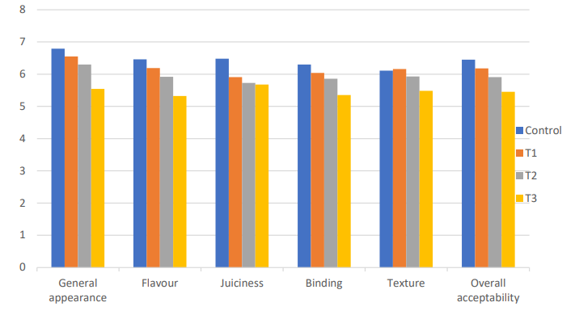
 | Sensory attributes of control and treatment samples

Fig. 2. Sensory Evaluation

Storage Study

Moisture

During the storage period, the moisture content was higher in the control than in the treatment groups, likely because the control absorbed more moisture and lacking the low-moisture, high-protein jerky component that restricts water uptake (Galus and Kadzinska, 2016).

Moisture (%) | 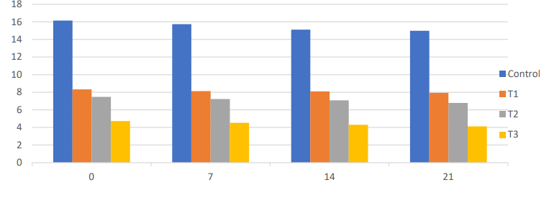
 | Storage period

Fig. 3. Moisture

TBARS

TBARS (mg/kg) | 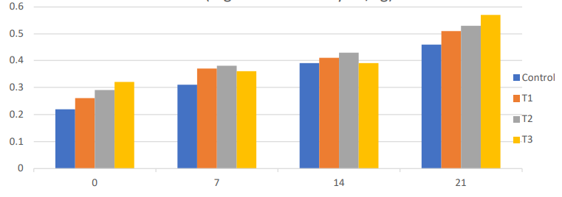
 | Storage period

Fig. 4. TBARS

The thio-barbituric acid reactive substances (TBARS) values, which indicate oxidative rancidity, increased significantly (p<0.01) over the 21-day storage period in both the control and the treated nutribars. These results are consistent with Ratanatriwong et al. (2011), who observed a gradual rise in TBARS values in fish and chicken snacks stored at ambient temperature. Despite this increase, TBARS values remained below 2 mg/kg, preserving the sensory quality of the products. Throughout storage, the control showed significantly (p<0.01) different TBARS values compared to T1, T2, and T3. Similarly, Naveena et al. (2006) reported no significant difference in TBARS values between control and finger millet treated patties during storage, supporting the present observations.

Yeast and Mould Count

Yeast & mould count (log10 CFU/g) | 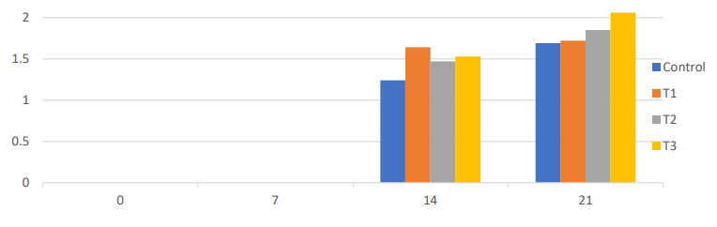
 | Storage period

Fig. 5 . Yeast and Mould Count

Microbiological evaluation revealed that yeast and mould counts increased gradually during storage but remained within acceptable limits throughout the study period. Rokka (2013) attributed reduced microbial growth to low moisture content and the antimicrobial effects of spices. Similarly, Sarkar et al. (2020) reported no yeast or mould growth in traditional bhujia formulations, which they associated with their low moisture content, supporting the present findings.

Sensory Evaluation

Sensory evaluation revealed no significant (p > 0.05) changes in appearance, flavour, binding, juiciness, texture or overall acceptability of the treatment samples during the storage period. This indicates that the incorporation of buffalo meat did not adversely affect the sensory quality of the nutribar.

Sensory score | 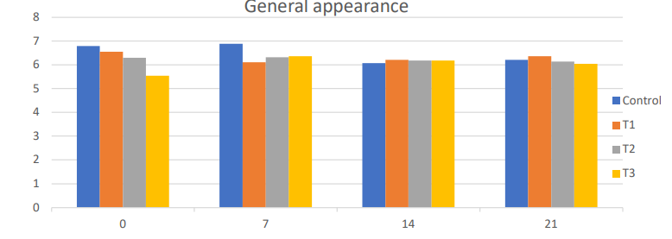
 | General appearance – sensory attribute during storage period

Fig. 6. General appearance

Sensory score | 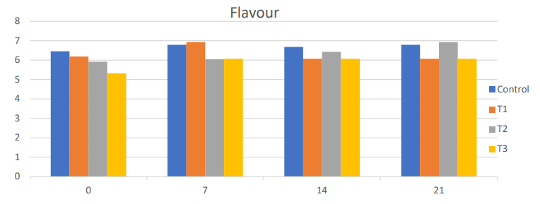
 | Flavour attribute of control and treatment samples during storage period

Fig. 7. Flavour

Sensory score | 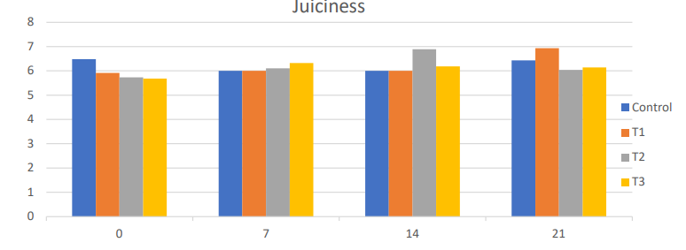
 | Juiciness attribute of control and treatment samples during storage period

Fig. 8. Juiciness

Sensory score | 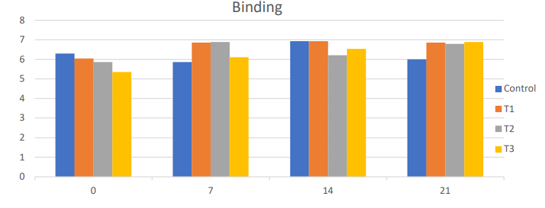
 | Binding attribute of control and treatment samples during storage period

Fig. 9. Binding

Sensory score | 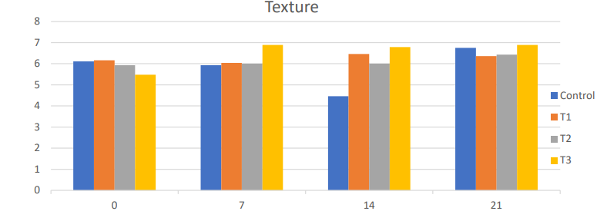
 | Texture attribute of control and treatment samples during storage period

Fig. 10. Texture

Sensory score | 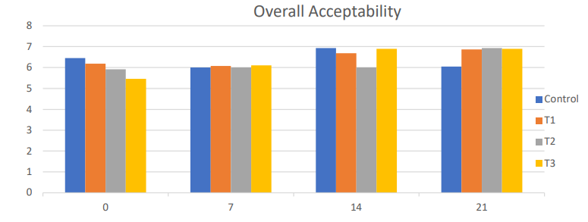
 | Overall acceptability of control and treatment samples during storage period

Fig. 11. Overall acceptability

CONCLUSION

The development of a nutribar fortified with buffalo meat led to the successful creation of a value-added meat product with enhanced sensory characteristics. Among the formulations tested, T1 (10% buffalo meat) was the most acceptable, owing to its well-balanced nutritional composition, providing 14.82% protein, 1.97% total ash and 488.49 kcal/100 g of energy. The product demonstrated good shelf stability, attributed to its low microbial load as well as the antimicrobial and preservative properties of the added spices and condiments. It remained stable without spoilage for up to 21 days at room temperature, retaining its sensory attributes and exhibiting no significant microbial deterioration. Overall, the findings suggest that buffalo meat–enriched nutribar has strong potential as a nutritious, shelf-stable and commercially promising value-added meat product.

CONFLICTS OF INTEREST

The authors declare that they have no conflict of interest.

Disclaimer (Artificial intelligence)

Author(s) hereby declare that NO generative AI technologies such as Large Language Models (ChatGPT) and text-to-image generators have been used during the editing of this manuscript.

REFERENCES

AOAC [Analysis of Official Analytical Chemists]. (2016). Meat and meat products. In Official Methods of Analysis of Official Analytical Chemists. (20th ed., pp. 3172). Association of Official Analytical Chemists Inc, Rockville, Maryland, USA.
Beuchat, L.R., & Cousin, M.A. (2001). Yeasts and moulds. In Downes, F.P., & Ito, K. (Ed.), Compendium of methods for the microbiolgical examination of food (4th Ed., pp. 209-215). APHA, Washington, D.C.
FAO [Food and Agricultural Organization of the United Nations]. (2004). Human energy requirements: report of a joint FAO/WHO/UNU expert consultation: Rome, 17-24 October 2001 (Vol. 1). Food and Agriculture Organisation.
Galus, S., & Kadzinska, J. (2016). Moisture sensitivity, optical, mechanical and structural properties of whey protein-based edible films incorporated with rapeseed oil. Food Technology and Biotechnology, 54(1), 78-89.
Goswami, G., Sharma, B.D., Mendiratta, S.K., & Pathak, V. (2017). Development and quality assessment of nutritional carabeef cookies. Ruminant Science, 6, 161-165.
Mediani, A., Hamezah, H.S., Jam, F.A., Mahadi, N.F., Chan, S.X.Y., Rohani, E.R., Che, Lah, N.H., Azlan, U.K., Khairul, Annuar, N.A., Azman, N.A.F., Bunawan, H., Sarian, M.N., Kamal, N., & Abas, F. A. (2022). Comprehensive review of drying meat products and the associated effects and changes. Frontier Nutrition, 28(9), 1057366.
Naveena, B.M., Muthukumar, M., Sen, A.R., Babji, Y., & Murthy, T.R.K. (2006). Quality characteristics and storage stability of chicken patties formulated with finger millet flour (Eleusine coracana). Journal of Muscle Foods, 17, 92-104.
Nemade, A.S., Londhe, S.V., & Waghamare, R.N. (2021). Shelf stability of cookies incorporated with spent hen meat powder in aerobic packaging at ambient temperature (37±1℃). International Journal of Livestock Research, 11, 65-71.
Purchas, R.W., Rutherfurd, S.M., Pearce, P.D., Vather, R., & Wilkinson, B.H.P. (2004). Concentrations in beef and lamb of taurine, carnosine, coenzyme Q10 and creatine. Meat Science, 66, 629-637.
Ratanatriwong, P.A., Wongsa-Ngasri, W., Suwansri, S., & Thanasukarn, P. (2011). Optimisation of drying process efficiency and shelf-life extension by active packaging in crispy minced-fish snacks. In The 12th Asean Food Conference; 16th to 18th June, 2011, Thailand. Food Science and Technology Association of Thailand.
Rokka, G.K. (2013). Preparation of chicken and pork meat pickle and comparison of their storage stability. Dissertation. Institute of Science and Technology, Tribhuvan University, Nepal.
Rolls, B.J. The relationship between dietary energy density and energy intake. (2009). Physiology and Behaviour, 97(5), 609-15.
Sakhare, S.B., Londhe, S.V., Chappalwar, A.M., Rindhe, S.N., Waghamare, R.N., Munde, V.K., & Patil, D.P. (2024). Development and quality assessment of chicken meat cookies enriched with various levels of rice flour. International Journal of Veterinary Science and Animimal Husbandry, 9, 507-510.
Sarkar, B.K., Upadhyay, S., Hazarika, M., Gogoi, P., Das, A., & Choudhury, S. (2020). Development and quality evaluation of bhujia incorporated with spent hen meat powder. Journal of Entomology and Zoology Studies, 8, 114-120.
Snedecor, G.M., & Cochran, W.G. (1994). Statistical Methods. (8th Ed.). The Iowa State University, Ames, Iowa, 313p.
Witte, V.C., Krause, G.F., & Bailey, M.E. (1970). A new extraction method for determining 2‐thiobarbituric acid values of pork and beef during storage. Journal of Food Science, 35, 582-585.
Yashoda K.P., Modi, V.K., Jagannatha, Rao, R., & Mahendrakar, N.S. (2008). Egg chips prepared by using different millet flours as binders and changes in product quality during storage. Food Control, 19, 170–177.

