Anatomical, Phytochemical and Toxicological Characterization of
Drynaria quercifolia (L.) J.Sm Rhizome Scales

.
ABSTRACT

Background and Aims: The rhizome of Drynaria quercifolia (L.) J.Sm. is traditionally consumed after removal of the outer scale layer; however, the scientific basis of this practice remains unclear. The present study aimed to elucidate the anatomical, phytochemical and toxicological characteristics of the rhizome scales to understand their functional significance and justify their traditional exclusion prior to medicinal use.
Study design: Experimental laboratory-based study integrating anatomical observation, phytochemical screening, spectroscopic characterization and bioassay-based toxicological evaluation.
Place and Duration of Study: PG and Research Department of Botany, Government Arts College, Coimbatore, Tamil Nadu, India, between September 2023 and March 2024.
Methodology: Rhizome scales of D. quercifolia were collected from Kolli Hills, Tamil Nadu and subjected to macroscopic and microscopic examination. Aqueous extracts were prepared following traditional infusion methods. Preliminary phytochemical screening was conducted using standard qualitative tests. Functional groups were identified through Fourier Transform Infrared (FT-IR) spectroscopy. Toxicological evaluation was performed using Artemia salina lethality assay, Daphnia magna acute toxicity assay and Allium cepa root tip assay, each conducted in triplicate. to assess cytotoxic and genotoxic effects
Results: Microscopic analysis revealed a uniseriate epidermal layer with multicellular non-glandular trichomes and thick-walled marginal cells, indicating a structurally specialized protective tissue. Phytochemical screening confirmed the presence of alkaloids, sterols and carbohydrates. FT-IR analysis showed prominent O–H stretching (3317 cm⁻¹), free hydroxyl groups (3657 cm⁻¹) and C–O functional groups, indicating predominance of polar constituents. Toxicological assays demonstrated moderate cytotoxicity in Artemia salina with LC₅₀ of 175 µg/mL. The Daphnia magna assay showed an EC₅₀ of approximately 1350 µg/mL with concentration-dependent morphological abnormalities. In the Allium cepa assay, mitotic activity decreased progressively, with mitotic index reduced to 12.82% at 1500 µg/mL and chromosomal stickiness observed at higher concentrations.
Conclusion: The rhizome scales of Drynaria quercifolia represent a structurally and chemically distinct outer tissue layer containing defense-associated metabolites with measurable biological reactivity. These findings provide experimental evidence supporting the traditional removal of rhizome scales prior to medicinal use, as the scale layer contains defense-associated metabolites exhibiting measurable cytotoxic and antimitotic activity.

Keywords: Drynaria quercifolia, rhizome scales, phytochemical screening, toxicity bioassay, Artemia salina, Allium cepa

1. INTRODUCTION

Drynaria quercifolia (L.)J.sm (Syn. Agalomorpha quercifolia) is commonly known as “Mudavanattukal Kilangu” or “Attukalkilangu” in Western and Eastern Ghats of Tamilnadu, India as the rhizome is traditionally consumed in the form of soup for rheumatic complaints. Beyond regional use, the Rhizome is widely used against inflammation, bone disorders and certain metabolic conditions. Previous phytochemical investigations of the rhizome are reported to have high phenolic and notable antioxidant activity which supports its therapeutic relevance in relation to oxidative stress-associated conditions (Narthanaa et al., 2025). Despite extensive documentation of rhizome pharmacology, minimal attention has been directed toward the outer woolly brown scales that are routinely removed prior to medicinal use. Ethnopharmacological processing often reflects empirical optimization to enhance efficacy and reduce irritant or toxic constituents (Heinrich et al., 2021). Although scale removal is consistently practiced, its biological and structural basis remains unexplored. Ethnobotanical records indicate that these dense scales are deliberately discarded before therapeutic utilization (Modak et al., 2021). In ferns, such scales may function as protective integuments covering meristematic tissues, contributing to mechanical protection, moisture regulation, and microbial defense (Mehltreter et al., 2010; Watkins &, Cardelús, 2012).Tissue-specific metabolic specialization is recognized as an adaptive strategy balancing defense and physiological functions. Therefore, comprehensive phytochemical profiling of D. quercifolia scales is essential to clarify their chemical composition and correlate it with biological activity. Secondary metabolites such as alkaloids and sterols are associated with plant defense and potential cytotoxicity (Heinrich et al., 2021). FT-IR spectroscopy complements phytochemical screening by identifying dominant functional groups. Although the phenolic-rich rhizome extracts were commonly associated with antioxidant effects, the chemical composition of the outer scales layer may differ substantially. Fourier-transform infrared (FT-IR) spectroscopy further supports this phytochemical screening by identifying the dominant chemical nature of the extracts. The preliminary toxicological evaluations using various bioindicator systems provides efficient reliable approach to evaluate the biological activity. The Artemia salina (Brine shrimp) lethality assay serves as a general cytotoxicity screening bioassay for screening cytotoxic potential of natural products (Hamidi et al., 2014; Meyer et al., 1982). Furthermore, Daphnia magna immobilization assay were standard models in ecotoxicological evaluation for assessing concentration- dependent toxicity (OECD, 2004). The Allium cepa assay detects cytotoxic and genotoxic potential through mitotic index suppression and chromosomal aberrations (Leme & Marin-Morales, 2009; Bonciu et al., 2018). This integrated approach enables comprehensive evaluation of biological reactivity. Despite their distinct morphology and routine exclusion in traditional preparations, the outer rhizome scales remain inadequately characterized, representing a clear empirical knowledge gap. Therefore, the present study systematically investigates the anatomical, phytochemical, and toxicological properties of Drynaria quercifolia outer scales to define their biological significance and functional role within the rhizome system.

2. material and methods

2.1 Collection and Authentication of Plant Material

Fresh rhizomes of Drynaria quercifolia (L.) J. Sm. were collected from the Kolli hills, Tamil Nadu, India, during the September–October 2023. The plant material was authenticated by a Botanical survey of India, Southern Circle, Coimbatore and a voucher specimen was deposited in a college herbarium for future reference.

2.2 Preparation of Aqueous Extract of Rhizome Scales

Separated rhizome scales were shade-dried at room temperature (28 ± 2 °C) for 7–10 days until constant weight was achieved. While, a portion of fresh scales were set aside for immediate macroscopic examination in their fresh state. The dried scales were pulverized using a mechanical grinder and sieved to obtain a uniform powder. Aqueous extraction was performed to reflect traditional preparation practices. Briefly, 100 g of powdered material was extracted with 500 mL of distilled water by infusion at 60–70 °C for 30 minutes with intermittent stirring. The extract was cooled, filtered through muslin cloth followed by Whatman No. 1 filter paper and concentrated under reduced pressure. The dried extract was stored at 4 °C until further analysis
(Harborne, 1998).

2.3 Macroscopic and Microscopic analysis

2.3.1. Macroscopic and Organoleptic Analysis

The macroscopic features of the rhizome scales were documented in both fresh and dried forms. An organoleptic evaluation was performed to record sensory characteristics of scales dried powder, including colour, odour, taste and texture, following the standardized protocols
(Evans, 2009). Surface morphological features, specifically the shape, base attachment and marginal characteristics, were examined using a handheld magnifying lens (10X) to confirm the diagnostic identity of the material.

2.3.2 Microscopic Evaluation
The surface morphology of the rhizome scales was examined using a whole-mount microscopic technique. Freshly separated scales were placed on a glass slide and treated with a 1% Safranin solution to differentiate lignified tissues. Excess stain was removed and the specimens were mounted in glycerin to prevent desiccation. The slides were observed under a light microscope at 10x and 40x magnifications to document the marginal cilia, trichomes and the cellular arrangement of the peltate base.

2.4 Preliminary Phytochemical Screening

Qualitative phytochemical screening of the aqueous extract was performed to detect major classes of secondary metabolites including alkaloids, flavonoids, phenols, tannins, sterols, terpenoids, carbohydrates, and proteins using standard chemical tests. Observations were recorded based on colour development or precipitate formation (Harborne, 1998; Evans, 2009; Raman, 2006) .

2.5 Fourier Transform Infrared (FTIR) Spectroscopy

FTIR analysis was conducted to identify functional groups present in the aqueous extract. Dried extract (10 mg) was mixed with spectroscopic-grade potassium bromide and compressed into pellets. Spectra were recorded using an FTIR spectrophotometer in the range of 400–4000 cm⁻¹ at a resolution of 4 cm⁻¹. Functional groups were assigned based on characteristic absorption peaks (Stuart, 2004).

2.6 Toxicological Evaluation

2.6.1 Brine Shrimp (Artemia salina) Lethality Assay

The brine shrimp lethality assay was used as a preliminary cytotoxicity screening model.
Artemia salina eggs were hatched in artificial seawater under continuous aeration and illumination. After 48 hours, active nauplii were collected.Test concentrations (100, 250, 500, 1000 and 1500 µg/mL) were prepared in artificial seawater. Each concentration was tested in triplicate using 30 nauplii per group. Mortality was recorded after 24 hours and percentage mortality was calculated.

Percentage of Mortality%= $\frac{No. of Brine shrimp dead}{Total number of brine shrimp present}$ x 100

LC₅₀ (Lethality concentration) values were estimated using linear interpolation between adjacent concentrations bracketing 50% mortality (Meyer et al., 1982).

LC₅₀​=C_{L}​+ $\frac{50-M_{L} }{M_{H}-M_{L}}$× (C_{H}​−C_{L})

Where,C_{L}​ = lower concentration producing mortality below 50%,C_{H} = higher concentration producing mortality above 50%, M_{L}​ = percentage mortality at C_{L,} M_{H} = percentage mortality at C_{H.} Confidence limits (95%) were estimated based on the concentration interval surrounding the 50% response, consistent with standard acute toxicity estimation procedures.

2.6.2 Daphnia magna Acute Toxicity Assay

Copepods were collected from Singanalur Lake, Coimbatore (November 2023) using
200 µm and 160 µm mesh nets. Samples were sorted microscopically, fixed in 5% formalin for identification, and species were confirmed using standard taxonomic keys. Toxicity of
D. quercifolia scales was assessed in 24-well plates containing 3 mL freshwater with 30 (24 h old) Daphnia magna per well. Test concentrations (100–1500 µg/mL) were evaluated in triplicate, with untreated controls. Survival was recorded at 24 and 48 h. Yeast served as the feeding control. Survival rate and morphological abnormalities were documented using a stereomicroscope. The survival rate percentage was calculated using the formula:

$$Survival rate percentage=\frac{Number of live Daphnia magna}{Number of Animals treated }×100$$

The EC₅₀ (Effective concentration) value was calculated by linear interpolation between adjacent concentrations bracketing the 50% immobilization level using,

EC₅₀​=C₁​+ $\frac{50-E_{1} }{E_{2}-E_{1}}$× (C₂−C₁)

Where, C₁ = lower concentration, C₂ = higher concentration, E₁ = % effect at C₁, E₂ = % effect at C₂ . Approximate 95% confidence intervals were derived from the effective concentration range surrounding the 50% response threshold (Hamilton et al., 1978). This assay was conducted following established ecotoxicological protocols (OECD, 2004).

2.6.3 Allium cepa Root Tip Assay

The Allium cepa assay was performed to assess cytotoxic and genotoxic effects. Healthy onion bulbs were allowed to develop roots in distilled water and then exposed to extract concentrations of 100–1500 µg/mL for 48 hours. Root tips were fixed in Carnoy’s fixative, hydrolyzed in 1 N HCl, stained with acetocarmine and squashed on microscope slides.
A minimum of 30-50 cells per slide were examined. Mitotic index was calculated as the percentage of dividing cells relative to total cells counted. Chromosomal aberrations were recorded following established criteria (Leme & Marin-Morales, 2009; Rank & Nielsen, 1993) .The formula for Mitotic index calculations is as follows,

$$Mitotic index=\frac{Number of Dividing mersitamatic cells}{Number ofmersitamatic cells}×100$$

2.7 Statistical analysis

All experiments were performed in triplicate (n = 3), and results are expressed as mean ± standard deviation (SD). Statistical analyses were carried out using SPSS software (Version 16.0) and Microsoft Excel 2013.

ETHICAL Consideration:
All experimental procedures were conducted in accordance with standard laboratory protocols for biological assays. The study involved plant materials and established bioindicator organisms (Artemia salina, Daphnia magna and Allium cepa) and no vertebrate animals or human subjects were used.

3. results and discussion

3.1 Macroscopic and organoleptic Characteristics.
Macroscopic examination showed that the rhizome scales formed a dense, imbricated, and continuous outer covering. Fresh scales displayed a reddish-copper to dark brown color, turning uniformly ferruginous brown upon drying without inter-sample variation. They were soft and membranous when fresh but became curled, rigid, brittle, and scariose after drying. Organoleptically, both fresh and dried scales exhibited a consistent bitter taste; the fresh material had a faint earthy odour that intensified to a woody-earthy aroma upon drying.
Morphologically, the scales were linear-lanceolate with central attachment and could be detached intact using forceps. The surface remained smooth and free from cracks or abnormalities, and scales were removed along with the brown epidermal layer. Detailed macroscopic and organoleptic features are presented in Table 1A and Figure 1A–1C.
Pulverization of dried scales produced a uniform rusty-brown, fine, fibrous, and fluffy powder with a woody-earthy odour and bitter-astringent taste. No extraneous matter was observed, confirming sample purity (Table 1B).

Table. 1A Macroscopic and Organoleptic Characteristics of D. quercifolia Scales
Parameter | Fresh Scales | Dried Scales
Colour | Reddish-copper brown | Dark ferruginous brown
Odour | Faint, earthy | Woody–earthy
Taste | Bitter | Bitter
Texture | Soft, pliable, membranous | Brittle, scariose
Shape | Linear–lanceolate | Linear–lanceolate (curled)
Surface | Smooth, intact | Smooth, intact
Attachment | Peltate, centrally anchored; detachable with forceps | Centrally anchored; brittle at point of union

Table. 1B Macroscopic and organoleptic Characteristics of D. quercifolia Scales powder
Parameter | Observation
Colour | Rusty ferruginous brown
Odour | Woody and earthy
Taste | Bitter and mildly astringent
Texture | Fine, fibrous, fluffy
Foreign matter | Not observed

Figure 1. Macroscopic documentation of rhizome scales of Drynaria quercifolia.

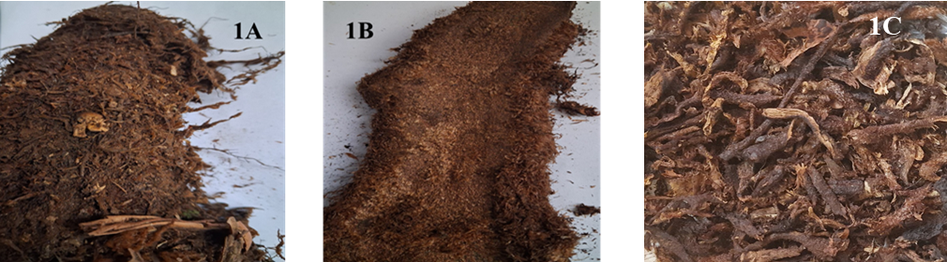

(A) Fresh rhizome showing dense, imbricated scale covering; (B) Exposed rhizome surface after scale removal; (C) Separated dried rhizome scales with skin

The dense overlapping arrangement of scales indicates a structural adaptation for protecting internal rhizome tissues. Similar protective scale layers in ferns function as barriers against desiccation, microbial invasion and herbivory, thereby safeguarding the developing meristematic regions of the rhizome (Mehltreter, 2008; Barón et al., 2019; Wang et al., 2021). Hence, the structural specialization observed suggests that the scales function as a defensive outer layer rather than a metabolically active storage tissue.

3.2 Microscopic characteristics
The scales revealed distinct epidermal structures which were organized distinctly. The epidermal layer composed of prominent ridges and furrows throughout the section of field view. It has winged extensions with multicellular non –glandular trichomes which were consistently found within the furrow regions. The marginal region has rectangular epidermal cells are thick-walled which were distributed uniformly. No vascular elements were observed within the scale tissue. The anatomical features of the examined section were presented in the figure 2.

Figure 2. Microscopic characteristics of rhizome scales of Drynaria quercifolia.
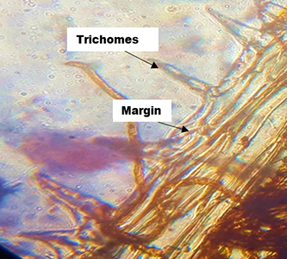

The absence of vascular tissues indicates that the scales function primarily as protective integuments rather than transport tissues. Similar anatomical structures in fern scales have been reported to reduce water loss, buffer microclimatic variations and protect young tissues from environmental stress (Mehltreter, 2008; Watkins and Cardelús, 2012). The presence of trichomes further enhances the defensive capability of the tissue by providing mechanical protection and limiting herbivore access.

3.3 Preliminary Phytochemical Screening
Qualitative phytochemical analysis of the aqueous extract of rhizome scales revealed the presence of alkaloids, sterols and carbohydrates. Alkaloids were confirmed by Mayer’s and Dragendorff’s tests. Sterols were detected through the Liebermann–Burchard reaction and Carbohydrates were confirmed by Molisch’s and Fehling’s tests. The detailed screening results are presented in Table 2.

Table -2 Preliminary phytochemical screening of Drynaria quercifolia scales aqueous extract

S. No. | Phytochemical group | Test performed | Observation | Result
1 | Alkaloids | Mayer’s test | Cream-coloured precipitate | +
 |  | Dragendorff’s test | Reddish-brown precipitate | +
2 | Flavonoids | Alkaline reagent test | No colour change | –
 |  | Concentrated H₂SO₄ test | Reddish-orange colour | +
 |  | Lead acetate test | No white precipitate | –
 |  | Shinoda test | No crimson-pink colour | –
3 | Sterols | Liebermann–Burchard test | Reddish-brown ring formation | +
4 | Terpenoids | Liebermann–Burchard test | No green colour | –
5 | Anthraquinones | Borntrager’s test | No reddish-orange colour | –
6 | Anthocyanins | HCl test | No colour change | –
7 | Proteins | Ninhydrin test | No purple colour | –
 |  | Biuret test | No blue colour | –
 |  | Xanthoproteic test | Yellow colouration | +
8 | Phenolic compounds | Ferric chloride test | No bluish-green colour | –
 |  | Gelatin test | No white precipitate | –
 |  | Ellagic acid test | No brown precipitate | –
9 | Quinones | Concentrated HCl test | No yellow precipitate | –
 |  | Alcoholic KOH test | No reddish colour | –
10 | Carbohydrates | Molisch’s test | Violet ring formation | +
 |  | Fehling’s test | Brick-red precipitate | +
11 | Tannins | Braymer’s test | No bluish-green colour | –
 |  | Gelatin test | No white precipitate | –
 |  | 10% NaOH test | No emulsion | –
12 | Saponins | Foam test | No persistent foam | –
13 | Cardiac glycosides | Baljet test | No yellow-orange colour | –
 |  | Bromine water test | No yellow precipitate | –
 |  | Keller–Killiani test | No brown ring | –
14 | Glycosides | Borntrager’s test | No pink colour | –
 |  | Aqueous NaOH test | No yellow colour | –
15 | Lignin | Gallic acid test | No olive-green colour | –
16 | Coumarins | Fluorescence test | No yellow fluorescence | –
 |  | NaOH–CHCl₃ test | No yellow colour | –
17 | Volatile oils | Fluorescence test | No pinkish fluorescence | –
Results based on Presence/Absence (+/-).

Secondary metabolites such as alkaloids and sterols are widely associated with plant defense mechanisms and may exhibit cytotoxic or deterrent effects against herbivores and pathogens (Heinrich et al., 2021). The absence of phenolic compounds and tannins, which are reported to occur abundantly in the inner rhizome tissues of D. quercifolia¹, suggests tissue-specific metabolite compartmentalization within the rhizome system. Such spatial differentiation of metabolites is a well-recognized adaptive strategy that balances defense and physiological functions in plants (Saoi and Britz-McKibbin, 2021; Lino et al., 2023)

3.4 Fourier Transform Infrared (FTIR) spectroscopy

FT-IR analysis (4000–400 cm⁻¹) of the aqueous extract of D. quercifolia rhizome scales showed a broad intense band at 3317 cm⁻¹ (hydrogen-bonded O–H stretching) and a weak band at 3657 cm⁻¹ (free O–H groups). A peak at 1643 cm⁻¹ corresponded to C=O stretching or H–O–H bending. Prominent absorptions in the 1400–1200 cm⁻¹ region indicated C–O stretching of alcohols and carbohydrate-associated groups. Additional bands at 678, 601, and 556 cm⁻¹ were assigned to out-of-plane C–H bending and skeletal vibrations. Overall, the spectrum confirms predominance of polar functional groups (Figure 3; Table 3).

Figure 3. Fourier Transform Infrared (FT-IR) spectrum of the aqueous extract of
D. quercifolia rhizome scales recorded in the range of 4000–400 cm⁻¹.
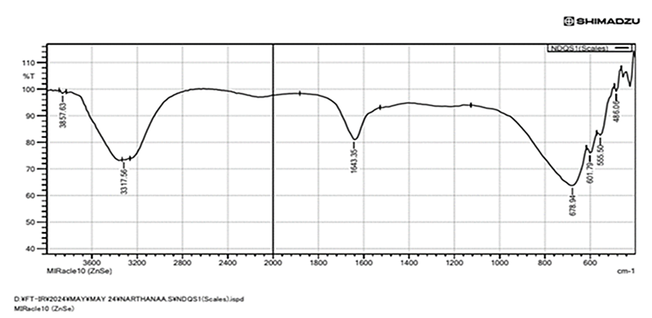

Table 3. FT-IR absorption bands and corresponding functional group assignments of the aqueous extract of D. quercifolia rhizome scales.

Observed Wavenumber (cm⁻¹) | Relative Intensity | Functional Group Assignment
3657 | Weak | Free O–H stretching vibration
3317 | Strong (broad) | Hydrogen-bonded O–H stretching
1643 | Moderate | C=O stretching / H–O–H bending vibration
678 | Strong | C–H out-of-plane bending vibration
601 | Weak–Moderate | Skeletal vibration of aliphatic structures
556 | Weak | Ring deformation / skeletal vibration

These spectral features confirm the predominance of polar functional groups within the scale extract. The presence of hydroxyl and carbonyl groups is commonly associated with alkaloid and sterol derivatives, supporting the results of phytochemical screening. FT-IR spectroscopy has been widely used to identify major functional groups in plant extracts and provide rapid confirmation of their chemical composition (Stuart, 2004; Silverstein et al., 2014)

3.5 Brine Shrimp Lethality Assay Results

Exposure of Artemia salina nauplii to the aqueous extract of Drynaria quercifolia rhizome scales resulted in a clear concentration-dependent increase in mortality after 24 h(Table-4). Mortality increased from 40.0% at 100 µg/mL to 99.0% at 1500 µg/mL. Intermediate concentrations showed progressive increases in lethality, with 60.0% mortality at 250 µg/mL, 76.7% at 500 µg/mL, and 87.7% at 1000 µg/mL. The mean number of dead nauplii increased proportionally with concentration, indicating a strong dose–response relationship. The median lethal concentration (LC₅₀), calculated by linear interpolation between 100 µg/mL (40% mortality) and 250 µg/mL (60% mortality), was determined to be 175 µg/mL. The 95% confidence interval ranged from 160 to 190 µg/mL. According to commonly used toxicity classification criteria in the brine shrimp lethality assay, extracts with LC₅₀ values between 100–500 µg/mL are considered moderately cytotoxic, whereas values below 100 µg/mL indicate strong toxicity (Meyer et al., 1982; Clarkson et al., 2004).

Table -4. Concentration-dependent mortality of Artemia salina exposed to the aqueous extract of Drynaria quercifolia rhizome scales.
Concentration (µg/mL) | Mean Dead ± SD | % Mortality
100 | 12.0 ± 2.65 | 40.0
250 | 18.0 ± 2.00 | 60.0
500 | 23.0 ± 2.00 | 76.7
1000 | 26.3 ± 1.15 | 87.7
1500 | 29.7 ± 0.58 | 99.0
LC₅₀ (by interpolation between 100 and 250 µg/mL) = 175 µg/mL
Values are expressed as Mean± SD(n=3).

The brine shrimp lethality assay is widely recognized as a rapid screening method for detecting cytotoxic compounds in plant extracts (Meyer et al., 1982; Hamidi et al., 2014). The moderate LC₅₀ value observed in the present study indicates the presence of biologically active compounds within the rhizome scale extract. Such activity may reflect the defensive chemical nature of outer plant tissues.

3.6 Daphnia magna Acute Toxicity Results

Exposure of Daphnia magna to the aqueous extract of Drynaria quercifolia rhizome scales resulted in a concentration-dependent decrease in survival over 72 h(Table-5). Survival decreased progressively from 96.6% at 100 µg/mL to 40.5% at 1500 µg/mL. Intermediate concentrations exhibited survival rates of 91.1% at 250 µg/mL, 83.3% at 500 µg/mL, and 72.2% at 1000 µg/mL. The percentage inhibition of survival increased correspondingly, reaching 59.5% at the highest tested concentration. The median effective concentration (EC₅₀), calculated by linear interpolation between 1000 µg/mL (27.8% inhibition) and 1500 µg/mL (59.5% inhibition), was estimated to be approximately 1350 µg/mL. 95% of confidence limits were observed between 1200–1550 µg/mL

Microscopic examination (Figure-4) revealed concentration-dependent morphological alterations in Daphnia magna. While control and lower concentrations (100–250 µg/mL) maintained normal structural integrity, higher concentrations (1000–1500 µg/mL) exhibited internal opacity, body deformation, and carapace distortion, with partial rupture observed at
1500 µg/mL.

Table 5. Survival percentage of Daphnia magna following 72 h exposure to the aqueous extract of Drynaria quercifolia rhizome scales.
Concentration (µg/mL) | Survival (%) | Inhibition (%)
100 | 96.6± 3.35 | 3.4
250 | 91.1± 1.91 | 8.9
500 | 83.3± 3.33 | 16.7
1000 | 72.2± 5.05 | 27.8
1500 | 40.5± 5.05 | 59.5
EC₅₀ ≈ 1350 µg/mL
Values are expressed as Mean± SD where survival percentages recorded at 24,48 and 72 h (n=3)

Daphnia magna is widely recognized as a sensitive freshwater bioindicator species for evaluating aquatic toxicity and environmental hazards of natural or synthetic compounds (OECD, 2004; Morrow et al., 2001). Comparative studies have demonstrated that Daphnia species exhibit variable sensitivity depending on the chemical nature of the tested compounds. For example, Buhl et al., (1993) reported acute toxicity of the herbicide bromoxynil to Daphnia magna, highlighting the high sensitivity of this organism to toxic substances in aquatic environments. In the present study, the comparatively higher EC₅₀ value observed relative to the Artemia salina assay suggests lower sensitivity of Daphnia to the rhizome scale extract, although the observed morphological abnormalities confirm measurable biological reactivity. These findings indicate that metabolites present in the outer rhizome scales possess moderate ecotoxicological activity.

Figure-4. Morphological alterations in Daphnia magna following 72 h exposure to different concentrations of the aqueous extract of Drynaria quercifolia rhizome scales 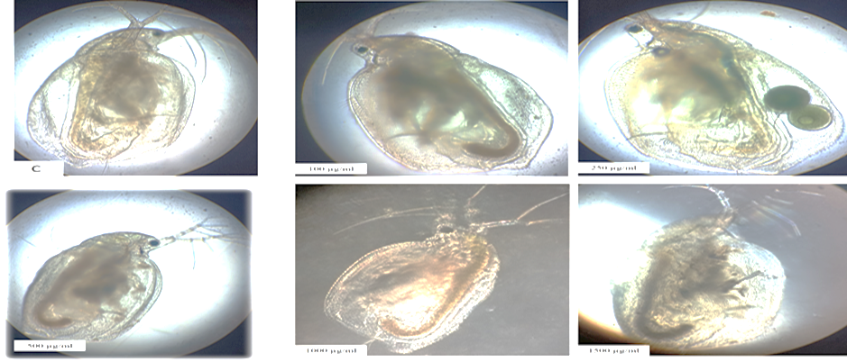
(C: Control; 100, 250, 500, 1000 and 1500 µg/mL).

3.7 Allium cepa Root Tip Assay Results

3.7.1 Effect of Aqueous Extract on Mitotic Activity

The cytotoxic effect of the aqueous extract of D. quercifolia rhizome scales was evaluated using the mitotic index (MI) in Allium cepa root tip meristematic cells. A total of 35–45 cells were examined per treatment group (Table-6; Figure- 5). The control group (distilled water) exhibited a mitotic index of 55.56%, with 25 dividing cells out of 45 total cells counted. The positive control showed a mitotic index of 48.57% (17 dividing cells out of 35). Treatment with the aqueous extract resulted in a concentration-dependent reduction in mitotic activity. At 100 µg/mL, the mitotic index decreased to 34.21% (13/38). Further reductions were observed at 250 µg/mL (27.50%; 11/40) and 500 µg/mL (27.78%; 10/36). At higher concentrations, the mitotic index declined to 21.43% at 1000 µg/mL (9/42) and reached 12.82% at 1500 µg/mL (5/39). Mitotic figures corresponding to interphase (I), prophase (P), and metaphase (M) were observed across all treatment groups. However, the proportion of dividing cells progressively decreased with increasing extract concentration.

Table-6. Effect of aqueous extract of D. quercifolia rhizome scales on mitotic index in Allium cepa root tip cells
Treatment (µg/mL) | Total Cells Counted | Dividing Cells | Mitotic Index (%)
Control (Water) | 45 | 25 | 55.56±1.20
Positive Control | 35 | 17 | 48.57±1.12
100 | 38 | 13 | 34.21±1.35
250 | 40 | 11 | 27.50±1.45*
500 | 36 | 10 | 27.78±1.30**
1000 | 42 | 9 | 21.43±1.15***
1500 | 39 | 5 | 12.82±0.90****
Values represent mean ± SD (n = 3). *p < 0.05; **p < 0.01; ***p < 0.001; ****p < 0.0001 versus control.

3.7.2 Chromosomal Aberrations

Microscopic evaluation (Table-7&Figure-5) of chromosomal morphology revealed normal mitotic stages in the control and lower concentration groups (100–1000 µg/mL). No chromosomal abnormalities were observed in these groups. At 1500 µg/mL, chromosomal stickiness was observed predominantly during prophase. The abnormality was characterized by clumped chromatin and loss of distinct chromosome boundaries.

Table 7. Chromosomal aberrations observed in Allium cepa root tip cells following treatment with aqueous extract of D. quercifolia rhizome scales

Treatment (µg/mL) | Mitotic Stages Observed | Chromosomal Aberration | Stage Involved | Presence
Control (Water) | I, P, M | None observed | — | –
100 | I, P, M | None observed | — | –
250 | I, P, M | None observed | — | –
500 | I, P, M | None observed | — | –
1000 | I, P, M | None observed | — | –
1500 | I, P, M | Chromosomal stickiness | Prophase | +
I – Interphase; P – Prophase; M – Metaphase

Figure 5 A-B. Effect of aqueous extract of D. quercifolia rhizome scales on mitotic stages and chromosomal morphology in Allium cepa root tip cells.
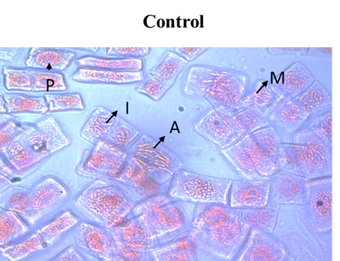
A
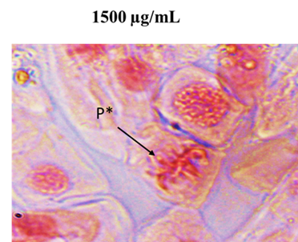
B
A- Control, B- 1500 µg/mL (I – Interphase, P – Prophase, M – Metaphase, A – Anaphase) and chromosomal stickiness observed during prophase (P*) at 1500 µg/mL following treatment with aqueous extract of Drynaria quercifolia rhizome scales.

Treatment with the aqueous extract of Drynaria quercifolia rhizome scales resulted in a concentration-dependent decrease in mitotic index in Allium cepa root tip cells, indicating inhibition of cell division and mitodepressive effects on meristematic tissues. Similarly cytogenetic responses have been reported in Allium cepa following exposure to toxic agents. For instance, Babu et al., (2008) demonstrated that nano-silver significantly reduced mitotic activity and induced chromosomal abnormalities such as stickiness, disturbed metaphase and anaphase bridges in onion root cells.

In the present study, chromosomal stickiness observed at higher concentrations suggests disturbances in chromatin organization and spindle activity during mitosis.
The Allium cepa assay is widely recognized as a sensitive cytogenetic model for evaluating cytotoxic and genotoxic effects of plant extracts (Leme and Marin-Morales, 2009; Bonciu et al., 2018) and such reductions in mitotic index with chromosomal abnormalities indicate the presence of biologically active metabolites in the rhizome scales (Nicuță et al., 2025).

The structural, phytochemical and toxicological findings collectively indicate that the rhizome scales represent a biologically active outer tissue layer. In rhizomatous plants, metabolic specialization often results in enrichment of defense compounds in peripheral tissues. Moreover, polyphenol oxidase (PPO) activity is typically higher in outer plant layers, leading to oxidative transformation of bioactive compounds when such tissues are not removed (Queiroz et al., 2008). Therefore, the traditional removal of rhizome scales prior to medicinal use may represent an empirical strategy to reduce exposure to defensive metabolites while preserving the therapeutically beneficial inner rhizome.

4. Conclusion

The rhizome scales of Drynaria quercifolia represent a structurally specialized outer tissue layer. The presence of defense-associated constituents and the concentration-dependent cytotoxic and antimitotic effects observed in multiple bioassays indicate that the scale layer possesses measurable biological reactivity. Based on these findings, removal of the outer scale layer prior to consumption appears to be a prudent preparatory step to minimize potential exposure to bioactive defensive compounds. While further compound-level and mechanistic toxicological studies are required to establish definitive safety parameters, the present results suggest that prior separation of the scales should be considered before medicinal use of the rhizome.

Disclaimer (Artificial intelligence)
Author(s) hereby declare that NO generative AI technologies such as Large Language Models and text-to-image generators have been used during the writing or editing of this manuscript.

AcknowledgEments
The authors gratefully acknowledge the PG and Research department of botany, Government Arts college, Coimbatore, Tamil nadu, India for providing laboratory facilities to carry out this research work.

AUTHORS’ CONTRIBUTIONS
Narthanaa s performed the experimental work, data analysis and prepared the initial draft of the manuscript. Ragunath c and Pradheeba Massisted in toxicological assays and data interpretation. Pugalenthi m and deepa ma supervised the study, critically reviewed the manuscript and approved the final version. All authors read and approved the final manuscript.

References

- Arulvasu, C., Jennifer, S. M., Prabhu, D., & Chandhirasekar, D. (2014). Toxicity effect of silver nanoparticles in brine shrimp Artemia. The Scientific World Journal, 2014, 706919. https://doi.org/10.1155/2014/706919
- Aziz, M. M., Raza, M. A., Saleem, H., Wajid, M., Bashir, K., & Ikram, M. (2018). Medicinal values of herbs and plants, in vivo phytochemical evaluation and ethnopharmacological screening: An illustrated review essay. Journal of Pharmacognosy and Phytochemistry, 6(1), 1–10.
- Babu, K., Deepa, M. A., Shankar, S. G., & Rai, S. (2008). Effect of nano-silver on cell division and mitotic chromosomes: A prefatory siren. The Internet Journal of Nanotechnology, 2(2).
- Balachandran, S., Prakasham, K., Gurrani, S., Shiea, J. T., Wu, M. T., Wu, C. F., Ku, Y. J., Tsai, T. Y., Hua, H. T., Lin, Y. J., Huang, P. C., Andaluri, G., & Ponnusamy, V. K. (2026). Toxicological evaluation of rhizome-derived medicinal products: Acute, sub-acute, and genotoxicity studies. Food and Chemical Toxicology, 184, Article 114321. https://doi.org/10.1016/j.fct.2025.114321
- Barón, A., Mehltreter, K., & Kessler, M. (2019). Functional roles of indument in fern fronds: Protection against desiccation and herbivory. Annals of Botany, 123(5), 843–854. https://doi.org/10.1093/aob/mcy214
- Bonciu, E., Firbas, P., Fontanetti, C. S., Waisi, K., Al-Khamis, H. H., Postolache, A. N., et al. (2018). An evaluation of the Allium test as a cytogenetic tool. Mutation Research/Reviews in Mutation Research, 780, 9–21. https://doi.org/10.1016/j.mrrev.2018.05.002
- Buhl, K. J., Hamilton, S. J., & Schmulbach, J. C. (1993). Acute toxicity of the herbicide bromoxynil to Daphnia magna. Environmental Toxicology and Chemistry, 12, 1455–1468.
- Clarkson, C., Maharaj, V. J., Crouch, N. R., Grace, O. M., Pillay, P., Matsabisa, M. G., Bhagwandin, N., Smith, P. J., & Folb, P. I. (2004). In vitro antiplasmodial activity of medicinal plants native to or naturalised in South Africa. Journal of Ethnopharmacology, 92(2–3), 177–191. https://doi.org/10.1016/j.jep.2004.02.011
- Chidananda, C., Thakur, G., Datta, D., & Popat, K. (2025). A comprehensive review of alkaloids in cancer therapy: Focusing on molecular mechanisms and synergistic potential of piperine in colorectal cancer. 3 Biotech, 15(11), 403. https://doi.org/10.1007/s13205-025-04535-8
- Escorihuela L, Pathak RK, Martorell B, Kumar V. Food contaminants: mechanisms of toxicity, computational assessment, and mitigation. Front Toxicol. 2026 Jan 12;7:1719447. doi: 10.3389/ftox.2025.1719447. PMID: 41602274; PMCID: PMC12832527.
- Evans, W. C. (2009). Trease and Evans’ pharmacognosy (16th ed.). Edinburgh: Saunders Elsevier.
- Hamidi, M. R., Jovanova, B., & Panovska, T. K. (2014). Brine shrimp lethality test for screening cytotoxic activity of plant extracts. Journal of Coastal Life Medicine, 2(12), 971–975.
- Hamilton, M. A., Russo, R. C., & Thurston, R. V. (1978). Trimmed Spearman-Karber method for estimating median lethal concentrations in bioassays. Environmental Science & Technology, 12(4), 417–417. https://doi.org/10.1021/es60140a017
- Harborne, J. B. (1998). Phytochemical methods: A guide to modern techniques of plant analysis (3rd ed.). London: Chapman & Hall.
- Heinrich, M., Mah, J. L., & Amirkia, V. (2021). Alkaloids as pharmacologically active plant metabolites. Phytochemistry Reviews, 20(1), 123–145. https://doi.org/10.1007/s11101-020-09692-9
- Leme, D. M., & Marin-Morales, M. A. (2009). Allium cepa test in environmental monitoring: A review on its application. Mutation Research/Reviews in Mutation Research, 682(1), 71–81. https://doi.org/10.1016/j.mrrev.2009.06.002
- Lino, V., Reis, A., Canaveze, Y., Farah, M. S., Sylvestre, L. S., & Ferreira, B. G. (2023). Beyond the physical protection: What can Asplenium glandular scales secrete? Flora, 305, 152338. https://doi.org/10.1016/j.flora.2023.152338
- Mehltreter, K. (2008). Hairs and scales in ferns: Morphology, distribution and functional significance. The Fern Gazette, 18(3), 87–102.
- Mehltreter, K., Walker, L. R., & Sharpe, J. M. (Eds.). (2010). Fern ecology. Cambridge: Cambridge University Press.
- Meyer, B. N., Ferrigni, N. R., Putnam, J. E., Jacobsen, L. B., Nichols, D. E., & McLaughlin, J. L. (1982). Brine shrimp: A convenient general bioassay for active plant constituents. Planta Medica, 45(5), 31–34. https://doi.org/10.1055/s-2007-971236
- Modak, D., Ghosh, S., Sarkar, S., Roy, S. K., Chakraborty, A., Ray, R., et al. (2021). Ameliorative effect of Drynaria quercifolia (L.) J. Sm., an ethnomedicinal plant, in arthritic animals. Food and Chemical Toxicology, 151, 112124. https://doi.org/10.1016/j.fct.2021.112124
- Morrow, D., Corrigan, D., & Waldren, S. (2001). Development of a bioassay for phytochemicals using Daphnia pulex. Planta Medica, 67(9), 843–846. https://doi.org/10.1055/s-2001-18859
- Narthanaa, S., Pradheeba, M., Vasuki Priyadharshini, G., Narmatha Sri, J., Pugalenthi, M., & Deepa, M. A. (2025). Comparative phytochemical profiling and mechanistic antioxidant evaluation of Drynaria quercifolia (L.) J.Sm. and Curcuma aeruginosa Roxb. rhizomes in relation to gouty arthritis. International Journal of Biology Sciences, 7(10), 126–134.
- Nerdy, N., Lestari, P., Sinaga, J. P., Ginting, S., Zebua, N. F., Mierza, V., et al. (2021). Brine shrimp (Artemia salina Leach.) lethality test of ethanolic extract from green betel (Piper betle Linn.) and red betel (Piper crocatum Ruiz and Pav.) through the soxhletation method for cytotoxicity test. Open Access Macedonian Journal of Medical Sciences, 9(A), 407–412.
- Nicuță, D., Grosu, L., Patriciu, O. I., Voicu, R. E., & Alexa, I. C. (2025). The Allium cepa model: A review of its application as a cytogenetic tool for evaluating the biosafety potential of plant extracts. Methods and Protocols, 8(4), 88. https://doi.org/10.3390/mps8040088
- Organisation for Economic Co-operation and Development. (2004). Test No. 202: Daphnia sp. acute immobilisation test. Paris: OECD Publishing. https://doi.org/10.1787/9789264069947-en
- Queiroz, C., Mendes Lopes, M. L., Fialho, E., & Valente-Mesquita, V. L. (2008). Polyphenol oxidase: Characteristics and mechanisms of browning control. Food Reviews International, 24(4), 361–375.
- Raman, N. (2006). Phytochemical techniques. New Delhi: New India Publishing Agency.
- Rank, J., & Nielsen, M. H. (1993). A modified Allium test as a tool in the screening of the genotoxicity of complex mixtures. Hereditas, 118(1), 49–53. https://doi.org/10.1111/j.1601-5223.1993.tb00063.x
- Saoi, M., & Britz-McKibbin, P. (2021). New advances in tissue metabolomics: A review. Metabolites, 11(10), 672. https://doi.org/10.3390/metabo11100672
- Shaikh, J. R., & Patil, M. (2020). Qualitative tests for preliminary phytochemical screening: An overview. International Journal of Chemical Studies, 8(2), 603–608.
- Silverstein, R. M., Webster, F. X., Kiemle, D. J., & Bryce, D. L. (2014). Spectrometric identification of organic compounds (8th ed.). Hoboken: John Wiley & Sons.
- Stuart, B. H. (2004). Infrared spectroscopy: Fundamentals and applications. Hoboken: John Wiley & Sons.
- Wang, F., Liu, H., & Schneider, H. (2021). Adaptive significance of trichome diversity in ferns under varying environmental conditions. Frontiers in Plant Science, 12, 642398. https://doi.org/10.3389/fpls.2021.642398
- Watkins, J. E., & Cardelús, C. L. (2012). Fern functional ecology: Interpreting the phenotypes of the forgotten plants. New Phytologist, 196(1), 12–36. https://doi.org/10.1111/j.1469-8137.2012.04194.x

