Effect of Jaboticaba berry (M. cauliflora) on macro- and microvascular function in individuals with cardiovascular risk factors following one week of consumption: A randomized study
ABSTRACT
Background: The consumption of berries is widely recommended as part of a cardioprotective diet due to their bioactive properties. Jaboticaba, a Brazilian berry, has been reported to possess high antioxidant activity. However, to date, no human studies have evaluated the effects of jaboticaba consumption on vascular function in individuals at risk of cardiovascular disease (CVD). Aim: This study aimed to investigate the effects of seven-day jaboticaba consumption on macro and microvascular function in individuals with risk factors for CVD. Study design: This was a randomized, parallel, placebo-controlled study. Methodology: Twelve volunteers with CVD risk factors consumed 420 mL of jaboticaba smoothies twice a daily (1,457.28 ± 21.51 mg of total polyphenols per day) or placebo (247.95 ± 118.32 mg of total polyphenols per day) for one week. Brachial artery flow-mediated dilation (FMD) and tissue oxygen saturation (StO₂) responses to 5-minute cuff occlusion were assessed using Doppler ultrasound and near-infrared spectroscopy, respectively. Blood samples were collected for the analysis of reduced glutathione (GSH) levels. Results: Supplementation with jaboticaba smoothies promoted improvements in macrovascular function, evidenced by a significant increase in ΔFMD when the data were analyzed using an allometric scale (p = 0.029), in addition to a moderate to large effect size in favor of jaboticaba (d = 0.72). On the other hand, no significant changes were observed in StO₂ parameters and plasma GSH levels(p > 0.05). Conclusion: This study demonstrated that jaboticaba smoothie consumption may improve macrovascular function but did not affect microvascular reactivity and redox balance in individuals at risk of CVD.
Keywords: Functional foods, antioxidants, vascular function, polyphenols, endothelial function, reactive hyperemia

- INTRODUCTION
Endothelial dysfunction is an early finding in the development of cardiovascular diseases (CVDs) (Donato et al., 2015). Under physiological conditions, the endothelium is responsible for synthesizing vasoactive molecules, such as nitric oxide (NO), that play several roles, among them regulation of vascular tone. However, the presence of cardiovascular risk factors (i.e., hypertension, diabetes mellitus, hypercholesterolemia, among others) can negatively affect the endothelium, reducing NO bioavailability (Feron et al., 1999; Hermann et al., 2006; Tessari et al., 2010).
The reduced NO bioavailability in individuals with cardiovascular risk factors may be partially explained by redox imbalance (i.e., overproduction of reactive oxygen species and reactive nitrogen species that overcome protective defense mechanisms) observed in these conditions (Förstermann et al., 2017). This may occur through increased superoxide anion production, which may inactivate the enzyme responsible for NO synthesis, the endothelial nitric oxide synthase (eNOS). Furthermore, the persisting redox imbalance promotes eNOS uncoupling and increases superoxide anion production, which can react with NO to produce peroxynitrite (Förstermann et al., 2017).
Several studies have investigated the effects of antioxidant-rich foods on the prevention or improvement of endothelial dysfunction (Rodriguez-Mateos et al., 2013; 2014; Fuchs et al., 2016; Woolf et al., 2023). Berry fruits such as blueberry, cranberry, and raspberry are important sources of polyphenols, and their consumption has been widely studied for their potential to improve endothelial function (Rodriguez-Mateos et al., 2013; 2014; Fuchs et al., 2016; Woolf et al., 2023). However, most of the available evidence is derived from berries commonly consumed in North America and Europe, while the potential cardiovascular effects of Brazilian native berries remain largely unexplored. Jaboticaba (Myrciaria cauliflora), a dark-colored Brazilian berry rich in phenolic compounds, particularly anthocyanins and ellagitannins, has attracted growing scientific interest due to its high antioxidant capacity. Nevertheless, its effects on vascular function in humans are still poorly understood, particularly regarding flow-mediated dilation (FMD), the gold standard for assessing endothelial function in conduit arteries, and tissue oxygen saturation reperfusion (StO₂), a marker of microvascular reactivity.
For this reason, the primary aim of the present study was to evaluate the effect of seven days of jaboticaba consumption on flow-mediated dilation (FMD) and tissue oxygen saturation (StO₂) parameters in individuals with cardiovascular risk factors. In addition, we investigated whether jaboticaba intake could enhance antioxidant defense by assessing plasma glutathione (GSH) concentration. We hypothesized that one week of jaboticaba consumption would improve redox balance and, consequently, enhance vascular function, as evidenced by increased FMD and improved StO₂ reperfusion in individuals with cardiovascular risk factors.
- MATERIAL AND METHODS
  - Participants
Thirteen adults presenting with cardiovascular risk factors were recruited through advertisements at the Federal University of Rio de Janeiro. Eligibility was based on the presence of at least one of the following criteria: elevated triglycerides (≥ 150 mg/dL), reduced high-density lipoprotein (HDL) cholesterol (< 50 mg/dL for women and < 40 mg/dL for men), elevated total cholesterol (> 200 mg/dL), elevated low-density lipoprotein (LDL) cholesterol (> 150 mg/dL), fasting blood glucose > 100 mg/dL, or hypertension (systolic blood pressure > 135 mmHg or diastolic blood pressure > 90 mmHg), or the use of antihypertensive medication (Visseren et al., 2021). Exclusion criteria included the use of antioxidant or amino acid supplements, a history of alcohol or drug abuse within the six months preceding the study, pregnancy or lactation, and known allergy to jaboticaba. All eligible participants were fully informed about the nature and objectives of the study and provided written informed consent prior to participation.
  - Study design
The study was conducted as a randomised, double-blind (with both participants and investigators blinded to treatment allocation), parallel, placebo-controlled trial between May 2022 and March 2023. Treatment allocation was performed in a balanced 1:1 ratio using the Research Randomizer (www.randomizer.org). Both participants and investigators remained unaware of the treatment sequence, and randomisation was implemented by laboratory personnel to ensure unbiased measurements. Participants attended the Dynamic Vascular Laboratory at the Federal University of Rio de Janeiro, located in Macaé, Brazil, on two separate occasions, with a minimum interval of one week between visits. During the first visit, participants were allowed to rest for 10 minutes in a quiet, temperature-controlled environment upon arrival. Subsequently, blood samples were collected for the determination of plasma reduced glutathione (GSH). Baseline (PRE) measurements were then obtained, including arterial blood pressure, flow-mediated dilation (FMD), and tissue oxygen saturation (StO₂).
Participants were asked to consume 420 mL of jaboticaba berry smoothie or the same volume of a placebo smoothie twice a day for seven days. On the eighth day, the participants returned to the laboratory for the second visit (POST), and the same measurements from the first visit were taken (see Figure 1). The two visits were held between 07:00 and 12:00 a.m. The participants were instructed to fast for at least 8 hours before each visit and to refrain from physical activity 24 hours prior to analysis.
Figure 1 – Experimental design
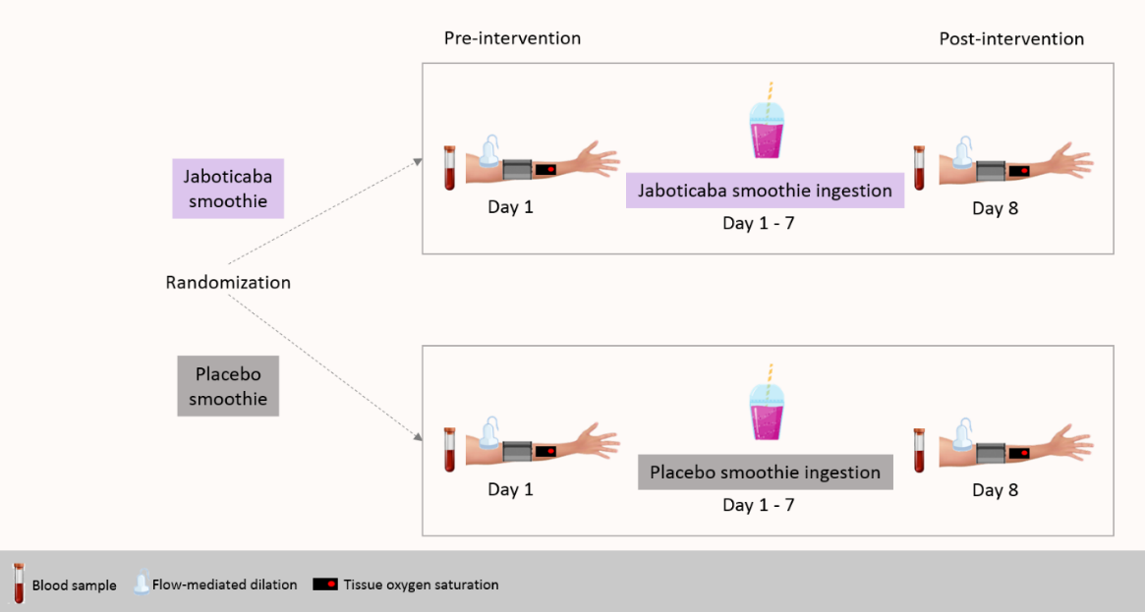
  - Nutritional intervention
The participants ingested 420 mL of jaboticaba smoothie or 420 mL of placebo smoothie twice a day for seven days. One portion of jaboticaba smoothie (420 mL) was obtained by mixing whole jaboticaba berries (126 g), banana (40 g), and milk (250 g), and in 420 mL jaboticaba berry smoothie contained 728.64 ± 10.76 mg of total polyphenols (totalizing 1,457.28 ± 21.51 mg of total polyphenols/day). One portion of the placebo smoothie consisted of maltodextrin (20 g) diluted with water (106 g), banana (40 g), and milk (250 g) containing 123.98 ± 59.16 mg of polyphenols (247.95 ± 118.32 mg of polyphenols/day). The placebo smoothie was colored with artificial non-energetic food colorings.
  - Flow-mediated dilation
Brachial artery flow-mediated dilation (FMD) was assessed in accordance with established guidelines (Thijssen et al., 2019). Brachial artery diameter was measured using an ultrasound system (Prosound Alpha 6®, Aloka) equipped with a linear transducer operating at a frequency range of 5.0–13.0 MHz (model UST-5413, Aloka). The insonation angle was maintained at approximately 60°, and image depth and focal settings were optimised individually for each participant. Continuous recordings of the brachial artery diameter were obtained from the medial aspect of the arm, capturing a longitudinal section of the artery located 2–5 cm above the cubital fossa throughout the FMD procedure. All image sequences were stored for subsequent offline analysis. Arterial diameters were quantified automatically using dedicated wall-tracking software (Cardiovascular Suite, version 4.2.1; Quipu Srl, Pisa, Italy). Absolute FMD was calculated as the difference between the peak diameter (PD; 3-second average) and the baseline diameter (BD; 30-second average). Relative FMD (%) was expressed as the percentage change from baseline to peak arterial diameter. The change in FMD (ΔFMD) was defined as the difference between post-intervention (POST) and pre-intervention (PRE) values. Additionally, FMD data were adjusted using allometric scaling, in accordance with previously established methodology (Atkinson and Batterham, 2013).
  - Tissue oxygen saturation (StO2)
Tissue oxygen saturation (StO₂) of the forearm muscles was assessed using near-infrared spectroscopy (NIRS), following previously described protocols (Oliveira et al., 2020; Volino-Souza et al., 2023). NIRS probes were positioned over the muscle belly of the forearm, and a pneumatic cuff was attached to an automatic rapid inflation system. Arterial occlusion pressure was standardised at 250 mmHg. Forearm StO₂ was recorded continuously during the vascular occlusion protocol, which comprised 30 seconds of baseline measurement, 5 minutes of occlusion, and 3 minutes of reperfusion. The following parameters were derived from the NIRS data: (i) minimum StO₂ (StO₂min), defined as the lowest value attained during occlusion; (ii) magnitude of occlusion, calculated as the difference between baseline StO₂ and StO₂min; (iii) StO₂ downslope (%·s⁻¹), representing the rate of decline in StO₂ during the occlusion phase; (iv) StO₂ upslope (%·s⁻¹), defined as the rate of increase in StO₂ during the initial 10 seconds of the reperfusion phase; and (v) magnitude of reperfusion, calculated as the difference between StO₂min and the peak StO₂ value achieved during reperfusion. Additionally, changes in StO₂ (ΔStO₂) were determined as the difference between post-intervention (POST) and pre-intervention (PRE) values.
  - Plasma Glutathione (GSH)
Plasma GSH analysis was performed by using a high-performance liquid chromatography (HPLC) system, as previously described (Giustarini et al., 2013). Briefly, 3 mL of blood sample was collected and added to the tube with 68 µL of tripotassium EDTA and 300 µL of NEM310 (3.88 g of NEM per 100 mL of water). The tube was mixed by slowly tilting for 1 min. The samples were stored at -80 ºC until analysis. For HPLC analysis, 250 µL of samples was mixed with 250 µL of trichloroacetic acid (TCA) 15 and was centrifuged at 14,000g for 2 min at room temperature. 15 µL of samples were injected into HPLC system. The HPLC system (Shimadzu, Kyoto, Japan) was fitted with a C18 column (150 × 4.6 mm Kromasil) and photodiode array detector monitoring absorbance at 265 nm. ΔGSH was calculated by the difference between GSH concentration POST and PRE ingestion.
  - Statistical analysis
Data were assessed for normality, homogeneity of variances, and sphericity using the Shapiro–Wilk, Levene’s, and Mauchly’s tests, respectively. Differences in baseline characteristics, ΔFMD, adjusted ΔFMD, and ΔGSH between groups were analysed using an independent samples t-test. In cases where the assumptions of normality and homogeneity of variances were not met, the non-parametric Mann–Whitney U test was applied. A two-way repeated-measures analysis of variance (ANOVA) was conducted to evaluate differences in FMD, adjusted FMD, StO₂ parameters, and plasma GSH between groups over time. Where significant F-values were detected, post hoc comparisons with Bonferroni adjustment were performed. In instances where the assumption of sphericity was violated, the Greenhouse–Geisser correction was applied. Effect size was calculated using Cohen’s d to determine the magnitude of the effect of jaboticaba smoothie consumption relative to the control. Effect sizes were interpreted as follows: <0.2 (trivial), 0.2–<0.5 (small), 0.5–<0.8 (moderate), and ≥0.8 (large). Statistical significance was set at an alpha level of 0.05. All analyses were performed using IBM SPSS Statistics (version 26 for Mac, Chicago, IL), and results were expressed as mean ± standard deviation (SD). Graphical representations were generated using GraphPad Prism (version 7.0).

- RESULTS
From thirteen participants recruited for eligibility assessment, twelve (n = 6 Jaboticaba; n = 6 Placebo) were randomized and completed the study (Figure 2). A significant difference was not observed between groups for baseline characteristics of participants (p > 0.05) (Table 1). The assumption of normality was violated only for ΔStO_{2 occlusion} and ΔStO_{2 reperfusion}.

Figure 2. Schematic of participant recruitment of the study.
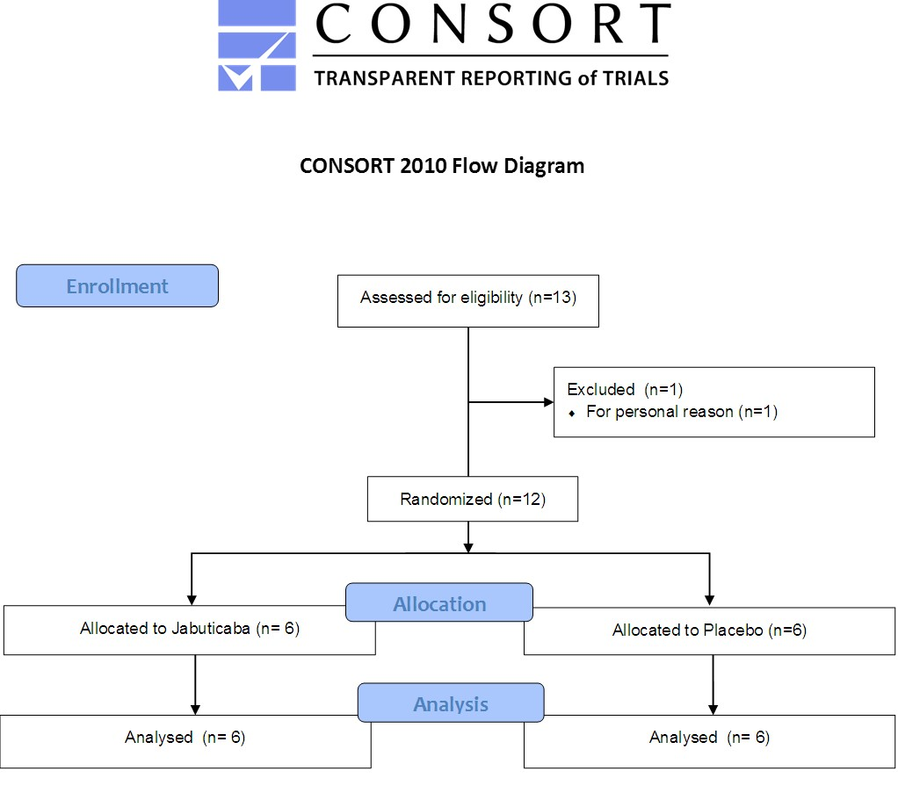
Table 1. Baseline characteristics of the participants.
Characteristic | Jaboticaba | Placebo | p
Demographics
n (M/F) | 6 (3/3) | 6 (2/4)
Age (years) | 56.83 ± 9.86 | 61.16 ± 9.06 | 0.447
Body mass (kg) | 69.56 ± 18.19 | 70.08 ± 8.85 | 0.951
Height (m) | 1.65 ± 0.09 | 1.58 ± 0.07 | 0.184
BMI (kg/m²) | 21.53 ± 11.61 | 27.31 ± 3.26 | 0.271
Waist circumference (cm) | 80.03 ± 7.45 | 84.70 ± 6.16 | 0.458
Forearm skinfold (mm) | 2.50 ± 0.89 | 1.98 ± 0.04 | 0.216
Biochemical
Glucose (mg/dL) | 137.50 ± 101.79 | 97.00 ± 5.36 | 0.412
Total cholesterol (mg/dL) | 174.83 ± 49.37 | 197.33 ± 75.92 | 0.556
LDL-c (mg/dL) | 107.67 ± 49.43 | 123.66 ± 71.37 | 0.661
VLDL-c (mg/dL) | 13.00 ± 5.05 | 15.16 ± 3.31 | 0.401
HDL-c (mg/dL) | 54.17 ± 7.25 | 68.33 ± 22.73 | 0.176
Triglycerides (mg/dL) | 72.33 ± 27.06 | 82.66 ± 18.35 | 0.457
Clinical
SBP (mmHg) | 120.50 ± 22.25 | 124.16 ± 18.22 | 0.733
DBP (mmHg) | 80.33 ± 7.73 | 82.83 ± 12.56 | 0.687
Heart rate (bpm) | 66.16 ± 12.89 | 67.51 ± 8.65 | 0.836
Values are expressed as mean ± standard deviation. DBP, diastolic blood pressure; HDL-c, high-density lipoprotein cholesterol; HDL-c, high-density lipoprotein cholesterol; LDL-c, low-density lipoprotein cholesterol; SBP, systolic blood pressure; VLDL-c; very low-density lipoprotein cholesterol.

3.1. Flow-mediated dilation (FMD)
There was no significant main effect for time (FMD: p = 0.811; FMD adjusted: p = 0.989) and interaction effect (time x treatment) (FMD: p = 0.116; FMD adjusted: p = 0.059) for FMD and FMD adjusted. In addition, no significant difference was observed for non-adjusted ∆FMD (p = 0.293). However, a significant difference was observed for adjusted ∆FMD (p = 0.029). Furthermore, a moderate to large effect size was observed for non-adjusted ∆FMD (d = 0.72) and adjusted ∆FMD (d = 1.23) (Figure 3).
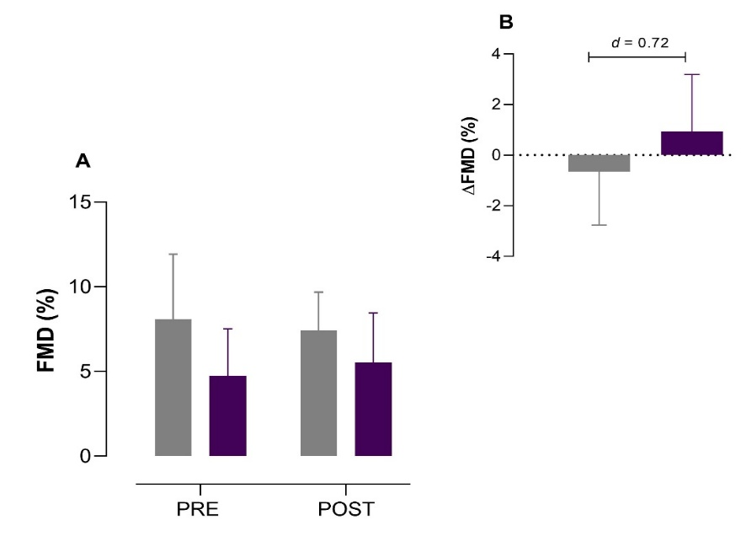
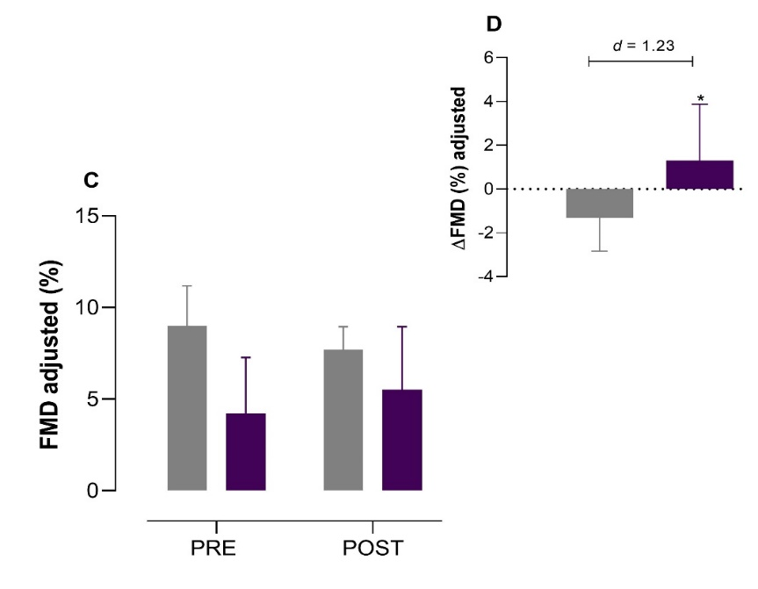
Figure 3. (A) Flow-mediated dilation (FMD), (B) ΔFMD, (C) FMD adjusted, and (D) ΔFMD adjusted before (PRE) and after (POST) jaboticaba berry smoothie (purple bars) and placebo smoothie (grey bars) ingestion. d, Cohen’s d.
3.2. Tissue oxygen saturation (StO2) parameters
There was no significant main effect for StO_{2 min} (p = 0.243), StO_{2 magnitude of occlusion} (p = 0.231), StO_{2 downslope} (p = 0.565), StO_{2 maximum} (p = 0.316), StO_{2 magnitude of reperfusion} (p = 0.159), and StO_{2 upslope} (p = 0.603). Furthermore, there was no interaction effect for StO_{2 min} (p = 0.491), StO_{2 magnitude of occlusion} (p = 0.531), StO_{2 downslope} (p = 0.393), StO_{2 maximum} (p = 0.922), StO_{2 magnitude of reperfusion} (p = 0.548), and StO_{2 upslope} (p = 0.332) (Table 2). Also, there was no difference between Jaboticaba and Placebo groups for ΔStO_{2 min} (p = 0.492), ΔStO_{2 magnitude of occlusion} (p = 0.240), ΔStO_{2 downslope} (p = 0.383), ΔStO_{2 maximum} (p = 0.925), ΔStO_{2 magnitude of reperfusion} (p = 0.631), and ΔStO_{2 upslope} (p = 0.326). In addition, a trivial to small effect size was observed for ΔStO_{2 maximum} (d = 0.05), ΔStO_{2 minimum} (d = 0.41), and ΔStO_{2 reperfusion} (d = 0.35). A moderate effect size was observed for ΔStO_{2 occlusion} (d = 0.56), ΔStO_{2 downslope} (d = 0.63), and ΔStO_{2 upslope} (d = 0.59) (Table 2).
3.3. Plasma GSH
No significant main effect (p = 0.313) and interaction effect (p = 0.777) were observed for plasma GSH between Jaboticaba berry and placebo groups. In addition, no significant changes in ΔGSH were observed between jaboticaba smoothie and placebo groups (p = 0.778). A trivial effect size was observed for ΔGSH (d = 0.16).
- Discussion
The primary aim of the present study was to evaluate the effect of consuming a jaboticaba berry smoothie for one week on macrovascular function (FMD response) and microvascular function (reperfusion of tissue oxygen saturation—StO₂) in individuals at cardiovascular risk. Secondarily, plasma GSH was also evaluated before and after jaboticaba intake as a measure of oxidative stress. We demonstrated that one week of jaboticaba berry smoothie consumption did not improve microvascular reactivity or antioxidant status in individuals with the presence of risk factors for CVD. However, it seems that jaboticaba berry consumption can positively affect macrovascular function.

Table 2. Flow-mediated dilation (FMD) and tissue oxygen saturation (StO₂) parameters before (PRE) and after (POST) jaboticaba and placebo ingestion for 7 days.
Variables | Jaboticaba |  |  | Placebo
Variables | PRE | POST | Δ | PRE | POST | Δ | d (Δ)**
Baseline diameter (cm) | 0.40 ± 0.06 | 0.41 ± 0.07 | 0.00 ± 0.01 | 0.43 ± 0.07 | 0.40 ± 0.03 | -0.02 ± 0.05 | 0.55
Peak diameter (cm) | 0.42 ± 0.06 | 0.43 ± 0.06 | 0.01 ± 0.01 | 0.46 ± 0.08 | 0.43 ± 0.03 | -0.03 ± 0.05 | 1.10
FMD (%) | 4.75 ± 2.77 | 5.53 ± 2.92 | 0.93 ± 2.25 | 8.08 ± 3.83 | 7.43 ± 2.25 | -0.65 ± 2.10 | 0.72
FMD adjusted | 4.23 ± 3.04 | 5.51 ± 3.43 | 1.30 ± 2.57* | 9.00 ± 2.19 | 7.70 ± 1.25 | -1.31 ± 1.52* | 1.23
Occlusion
StO_{2 minimum} (%) | 49.81 ± 6.53 | 48.80 ± 8.13 | -1.00 ± 5.22 | 57.43 ± 3.32 | 53.70 ± 6.78 | 3.72 ± 7.75 | 0.41
StO_{2 magnitude of occlusion} (%) | -17.43 ± 4.81 | -18.66 ± 6.40 | -0.34 ± 5.31 | -12.74 ± 3.13 | -16.16 ± 6.61 | -3.69 ± 6.40 | 0.56
StO_{2 downslope} (%.s⁻¹) | -0.06 ± 0.01 | -0.06 ± 0.02 | 0.00 ± 0.01 | -0.04 ± 0.01 | -0.05 ± 0.02 | -0.01 ± 0.02 | 0.63
Desocclusion
StO_{2 maximum} (%) | 74.85 ± 2.62 | 75.72 ± 2.91 | 0.86 ± 2.30 | 74.54 ± 2.20 | 75.25 ± 2.36 | 0.72 ± 2.86 | 0.05
StO_{2 magnitude of reperfusion} (%) | 25.04 ± 5.18 | 26.91 ± 8.62 | 1.87 ± 5.71 | 17.10 ± 3.51 | 21.55 ± 8.45 | 4.45 ± 8.39 | 0.35
StO_{2 upslope} (%.s⁻¹) | 1.04 ± 0.52 | 1.23 ± 0.32 | 0.20 ± 0.54 | 1.05 ± 0.43 | 0.99 ± 0.36 | -0.06 ± 0.29 | 0.59
Values are expressed as mean ± standard deviation. * denotes significant difference from Placebo. ** Cohen’s d effect size classification: < 0.2 represent a trivial effect; 0.2 – < 0.5 is a small effect; 0.5 – < 0.8 is a moderate effect, and ≥ 0.8 is a large effect.

It was expected that jaboticaba berry consumption could significantly improve FMD in individuals with cardiovascular risk factors since jaboticaba berry is an essential source of polyphenols, mainly anthocyanins, and ellagitannins, possessing antioxidant capacity (Abe et al., 2012; Volino-Souza M. et al., 2025). Increased plasma antioxidant activity has been observed after ingestion of jaboticaba (Plaza et al., 2016; Balisteiro et al., 2017). Previous studies have demonstrated that jaboticaba extract can increase the expression of antioxidant enzymes and prevent mitochondrial dysfunction, which explains the ability of jaboticaba phenolic compounds to scavenge free radicals (reducing oxidative stress) (Calloni et al., 2015; Mannino et al., 2020). Therefore, it was speculated that polyphenols from jaboticaba would reduce oxidative stress, increase NO bioavailability and, hence, improve vascular health.
In the present study, we observed that one week of consumption of jaboticaba berry smoothie improved the macrovascular function (i.e., as evaluated by FMD) of individuals at risk for CVD. However, it is important to point out that statistical significance was observed only in FMD change from pretreatment when data was converted to the allometric scale. Data conversion to an allometric scale has been recommended when base artery diameter differs between groups (Atkinson and Batterham, 2013). The present study was performed in a parallel design (i.e., different subjects for placebo and jaboticaba groups) which could result in differences in baseline diameter and, consequently, affect FMD values. Thus, in order to eliminate the influence of differences in baseline diameter in the observed results, we logarithmically transformed the baseline diameter to calculate the adjusted FMD.
In agreement with our results of adjusted FMD, previous evidence has been demonstrated that ingestion of polyphenols from berries can improve FMD (Rodriguez-Mateos et al., 2013; 2014; Woolf et al., 2023). For example, Rodriguez-Mateos et al. (2013) observed that three different doses of freeze-dried wild-blueberry powder (766, 1278, and 1791 mg of polyphenols) improved FMD 1h, 2h, and 6h after ingestion. Furthermore, Rodriguez-Mateos et al. (2014) showed an improved FMD 1h, 2h, and 6h after ingestion of blueberry products (blueberry drink or bun with 692 and 637 mg of polyphenols, respectively). Woolf et al. (2023) demonstrated that consuming 22 g of freeze-dried highbush blueberry powder for 12 weeks increased FMD in postmenopausal women with high-normal blood pressure.
In contrast to the adjusted FMD response after jaboticaba ingestion, changes in StO₂ parameters were not observed in the present study. A previous study demonstrated that consuming 300g of blueberry (containing 242.4 mg of total phenolic compounds per 100g) significantly improved microvascular function as evaluated by reactive hyperemia response of small finger arteries of subjects exposed to cigarette smoke (Del Bo et al., 2014). In addition, Fuchs et al. (2016) evaluated the effect of a single dose of black tea (228.1 mg of total polyphenols) on postprandial skeletal muscle blood flow in subjects with obesity and insulin resistance and observed that tea polyphenols reduced vascular resistance of forearm microvessels after a glucose load. Besides evidence showing a positive effect of polyphenols intake (e.g., anthocyanins, procyanidins, epicatechin) in the microvascular function, there is evidence demonstrating no significant effect of polyphenols from berries on the microvasculature (Dohadwala et al., 2011; Greyling et al., 2016; Ellis L.R. et al., 2024). For example, Dohadwala et al. (2011) demonstrated that four weeks of supplementation of 480 mL cranberry juice (835 mg total polyphenols) did not change pulse amplitude tonometry, a measurement of microvascular function. However, in the Dohadwala et al. (2011) study, microvascular function was assessed several hours after the last dose of cranberry juice, which could explain the lack of a significant effect on microvascular response. Similarly, in the present study, the parameters of microvascular reactivity were performed on the day after the last dose of jaboticaba berry smoothie. This may explain the lack of significant changes in the microvascular function parameters investigated after jaboticaba berry intake. However, it is important to note that although no statistical differences in StO₂ response were observed after seven days of jaboticaba smoothie consumption, a moderate effect size was observed for ΔStO_{2 upslope}. Effect size is the magnitude of the difference between interventions (Barry et al., 2016). Therefore, the effect size observed in the present study suggests the presence of a moderate effect of jaboticaba berry consumption which may potentially affect the microvascular function.
It has been demonstrated that jaboticaba berry exhibits high antioxidant protection against reactive oxygen species (Mannino et al., 2020). For example, Mannino et al. (2020) demonstrated that when cancer cell line HepG2 incubated with hydrogen peroxide (H₂O₂) (a reactive oxygen species) was exposed to jaboticaba berry extract, a reactivation of glutathione peroxidase (GPx) genes (an intracellular antioxidant enzyme) was observed, suggesting antioxidant protection of jaboticaba berry extract. The GPx uses glutathione (GSH) as a cosubstrate to reduce H₂O₂ to water, and low GSH concentration suggests a redox imbalance (Lubos et al., 2011). In this context, the effect of jaboticaba berry consumption on plasma GSH concentration was also evaluated in the present study. However, in contrast to our hypothesis, seven days of consuming a jaboticaba berry smoothie (containing 1,457.28 mg of total polyphenols) did not change plasma GSH concentrations. Furthermore, we observed a trivial effect size for changes in plasma GSH after jaboticaba berry smoothie consumption, suggesting that jaboticaba berry smoothie has a small effect in modulating the antioxidant status in the participants of the present study.
4.1. Experimental considerations
A limitation of the present study was the small sample size (n = 12), which may have increased the probability of making a statistical type II error; thus, our findings should be interpreted with caution. However, the effect size was calculated in the present study in order to determine the magnitude of the effect of jaboticaba berry consumption on the investigated variables since the effect size reflects the magnitude of the effect of interventions without considering the sample size (Sullivan and Feinn, 2012). A moderate effect size (D = 0.72) was observed for ∆FMD between the jaboticaba berry and placebo group, suggesting a moderate to large effect of jaboticaba berry consumption on endothelial macrovascular function. In addition, plasma polyphenols were not evaluated in the present study after jaboticaba ingestion in order to estimate polyphenol’s bioavailability and correlate it with vascular responses. However, a previous study (Rodriguez-Mateos et al., 2014) demonstrated that acute and chronic blueberry intake (a polyphenol-rich fruit) increased plasma concentrations of polyphenol metabolites in healthy participants, which were significantly correlated with improvements in macrovascular function (as evaluated by FMD).
5. CONCLUSION
In conclusion, the present study demonstrated that one week of jaboticaba berry smoothie (containing 1,457.28 mg of total polyphenols) consumption improves macrovascular function in individuals with the presence of risk factors for cardiovascular disease. However, no significant changes were observed in microvascular reactivity and redox balance. Even though the overall response indicates that there might be beneficial effects on macrovascular function, the present findings need to be cautiously interpreted since they still rely on a small number of participants. Further studies with large sample sizes are warranted to determine the effect of polyphenols from jaboticaba berries on cardiovascular health.
Consent
As per international standards or university standards, patient(s) written consent has been collected and preserved by the author(s).
Disclaimer (Artificial intelligence)
Author(s) hereby declare that NO generative AI technologies such as Large Language Models (ChatGPT, COPILOT, etc.) and text-to-image generators have been used during the writing or editing of this manuscript.

REFERENCES
- Donato AJ, Morgan RG, Walker AE, et al. (2015) Cellular and molecular biology of aging endothelial cells. Journal of molecular and cellular cardiology, 89(Pt B), 122–135.
- Feron O, Dessy C, Moniotte S, et al . (1999) Hypercholesterolemia decreases nitric oxide production by promoting the interaction of caveolin and endothelial nitric oxide synthase. The Journal of clinical investigation, 103(6), 897–905.
- Hermann M, Flammer A, Lüscher TF (2006) Nitric oxide in hypertension. Journal of clinical hypertension (Greenwich, Conn.), 8(12 Suppl 4), 17–29.
- Tessari P, Cecchet D, Cosma A, et al. (2010) Nitric oxide synthesis is reduced in subjects with type 2 diabetes and nephropathy. Diabetes, 59(9), 2152–2159.
- Förstermann U, Xia N, Li H. (2017) Roles of Vascular Oxidative Stress and Nitric Oxide in the Pathogenesis of Atherosclerosis. Circulation research, 120(4), 713–735.
- Rodriguez-Mateos A, Rendeiro C, Bergillos-Meca T, et al. (2013) Intake and time dependence of blueberry flavonoid-induced improvements in vascular function: a randomized, controlled, double-blind, crossover intervention study with mechanistic insights into biological activity. The American journal of clinical nutrition, 98(5), 1179–1191.
- Rodriguez-Mateos A, Del Pino-García R, George TW, et al. (2014) Impact of processing on the bioavailability and vascular effects of blueberry (poly)phenols. Molecular nutrition & food research, 58(10), 1952–1961.
- Fuchs D, Nyakayiru J, Draijer R, et al. (2016) Impact of flavonoid-rich black tea and beetroot juice on postprandial peripheral vascular resistance and glucose homeostasis in obese, insulin-resistant men: a randomized controlled trial. Nutrition & metabolism, 13, 34.
- Del Bo' C, Porrini M, Fracassetti D, et al. (2014) A single serving of blueberry (V. corymbosum) modulates peripheral arterial dysfunction induced by acute cigarette smoking in young volunteers: a randomized-controlled trial. Food & function, 5(12), 3107–3116.
- Woolf EK, Terwoord JD, Litwin NS, et al. (2023) Daily blueberry consumption for 12 weeks improves endothelial function in postmenopausal women with above-normal blood pressure through reductions in oxidative stress: a randomized controlled trial. Food & function, 14(6), 2621–2641.
- Volino-Souza M, Barcellos TMA, Alvares TS, The Impact of Berries on Macro- and Microvascular Function: A Systematic Review of Randomized Studies, Nutrition Reviews, 2025;, nuaf186, https://doi.org/10.1093/nutrit/nuaf186
- Visseren FLJ, Mach F, Smulders YM, et al. (2021) 2021 ESC Guidelines on cardiovascular disease prevention in clinical practice. European heart journal, 42(34), 3227–3337.
- Thijssen DHJ, Bruno RM, van Mil ACCM, et al. (2019) Expert consensus and evidence-based recommendations for the assessment of flow-mediated dilation in humans. European heart journal, 40(30), 2534–2547.
- Atkinson G, Batterham AM (2013) Allometric scaling of diameter change in the original flow-mediated dilation protocol. Atherosclerosis, 226(2), 425–427.
- Oliveira GV, Volino-Souza M, Leitão R, et al. (2020) Is flow-mediated dilatation associated with near-infrared spectroscopy-derived magnitude of muscle O2 desaturation in healthy young and individuals at risk for cardiovascular disease?. Microvascular research, 129, 103967.
- Volino-Souza M, Oliveira GV, Tavares AC, et al. (2023) The effect of microencapsulated watermelon rind (Citrullus lanatus) and beetroot (Beta vulgaris L.) ingestion on ischemia/reperfusion-induced endothelial dysfunction: a randomised clinical trial. Food & function, 14(17), 7959–7968.
- Giustarini D, Dalle-Donne I, Milzani A, et al. (2013) Analysis of GSH and GSSG after derivatization with N-ethylmaleimide. Nature protocols, 8(9), 1660–1669.
- Abe LT, Lajolo FM, Genovese MI (2012) Potential dietary sources of ellagic acid and other antioxidants among fruits consumed in Brazil: jabuticaba (Myrciaria jaboticaba (Vell.) Berg). Journal of the science of food and agriculture, 92(8), 1679–1687.
- Plaza M, Batista ÂG, Cazarin CB, et al. (2016) Characterization of antioxidant polyphenols from Myrciaria jaboticaba peel and their effects on glucose metabolism and antioxidant status: A pilot clinical study. Food chemistry, 211, 185–197.
- Balisteiro DM, Araujo RL, Giacaglia LR, et al (2017) Effect of clarified Brazilian native fruit juices on postprandial glycemia in healthy subjects. Food research international (Ottawa, Ont.), 100(Pt 2), 196–203.
- Calloni C, Agnol RD, Martínez LS, et al. (2015) Jaboticaba (Plinia trunciflora (O. Berg) Kausel) fruit reduces oxidative stress in human fibroblasts cells (MRC-5). Food Research International, 70, 15-22.
- Mannino G, Perrone A, Campobenedetto C, et al. (2020) Phytochemical profile and antioxidative properties of Plinia trunciflora fruits: A new source of nutraceuticals. Food chemistry, 307, 125515.
- Dohadwala MM, Holbrook M, Hamburg NM, Shenouda SM, Chung WB, Titas M, et al. Effects of cranberry juice consumption on vascular function in patients with coronary artery disease. Am J Clin Nutr. 2011 May;93(5):934-40. doi: 10.3945/ajcn.110.004242. Epub 2011 Mar 16. PMID: 21411615; PMCID: PMC3076649.
- Greyling A, Bruno RM, Draijer R, et al. (2016) Effects of wine and grape polyphenols on blood pressure, endothelial function and sympathetic nervous system activity in treated hypertensive subjects. Journal of Functional Foods, 27, 448-460.
- Ellis LR, Boesch C, Dye L. Effects of Anthocyanins on Cognition and Vascular Function: A Systematic Review. Mol Nutr Food Res. 2024 Jul;68(13):e2300502. doi: 10.1002/mnfr.202300502. Epub 2024 Jul 3. PMID: 38961529.
- Barry AE, Szucs LE, Reyes JV, et al. (2016) Failure to Report Effect Sizes: The Handling of Quantitative Results in Published Health Education and Behavior Research. Health education & behavior : the official publication of the Society for Public Health Education, 43(5), 518–527.
- Lubos E, Loscalzo J, Handy DE (2011) Glutathione peroxidase-1 in health and disease: from molecular mechanisms to therapeutic opportunities. Antioxidants & redox signaling, 15(7), 1957–1997.
- Sullivan GM, Feinn R. (2012) Using Effect Size-or Why the P Value Is Not Enough. Journal of graduate medical education, 4(3), 279–282.

