Identification of Bioactive Phytochemicals in Grewia hirsuta Vahl Leaf Extract using GC-MS Analysis

Abstract:
Grewia hirsuta, popularly known as nagbala, is extensively utilized in traditional medicine due to its remarkable pharmacological properties stemming from its diverse array of phytochemicals. In this research, Gas Chromatography-Mass Spectrometry (GC-MS) analysis was utilized to phytochemical compounds found in the methanolic extract of Grewia hirsuta vahl. GC-MS analysis shows that major bioactive compounds included 20 bioactive compounds with varying molecular structures and functional groups including silanediol. Notable pharmacologically active compounds identified were amphetamine, fluoxetine N-acetyl, nordazepam TMS derivative, and tenamfetamine. The analysis also revealed antioxidants like catechol and hydroquinone, alongside thymol Silanediol, Nortrimipramine, Butyrolactone, Catechol, m-Guaiacol, Methylphosphonic acid, Vanillin, Bupropion, Demecolcine, Lupeol, and Tetrasiloxane (decamethyl). The comprehensive understanding of the phytochemical composition of Grewia hirsute leaf extract obtained through GCMS analysis offers valuable information for further exploration of its medicinal properties and development of novel therapeutic agents.
Keywords: Grewia hirsuta, phytochemicals, GC-MS analysis, medicinal properties
- Introduction
The genus “Grewia” was named in honor of Botanist Nehemiah Grew, renowned as the father of plant anatomy. Belonging to the extensive flowering plant family Malvaceae. In traditional Ayurvedic medicine, Grewia hirsuta Vahl. is esteemed as one of the Nagbala species, known locally as Gangeruki. This species, along with two others, Sida spinosa and Sida humilis Cav., are regarded for their medicinal significance and collectively referred to as Nagbala (Qamar et al., 2021).
Grewia species are commonly observed as either trees or shrubs. Their leaves typically display one to nine veins. While flowers predominantly grow axillary, The species within this genus possess significant nutritional value, encompassing a variety of micronutrients and macronutrients.
Initial analysis of G. hirsuta has revealed a significant presence of phenolics, carbohydrates, alkaloids, flavonoids, and tannins (El-Bondkly et al., 2022) 4Z,12Z-Cyclopentadeca-4,12-dienone, identified in the methanolic extract of G. hirsuta leaves, has demonstrated promising potential as a leading candidate for the development of anti-diabetic medications (Natarajan et al., 2014).
The application of Grewia leaves on the skin has been reported to yield beneficial effects such as enhancing connective tissue and possessing anti-toxic properties (Kaur et al., 2024). It has been utilized to address numerous ailments including stomach upsets, fevers, coughs, inflammations, respiratory infections, rheumatism, and blood disorders. Recent research has unveiled additional beneficial attributes such as radioprotective qualities, antifertility effects, anti-hyperglycemic properties, and efficacy against diseases like cancer, Alzheimer’s, and diabetes. Scientific investigations have further identified Grewia plants as valuable sources of nutrition, boasting antimicrobial and antiviral properties (Khattab et al., 2015).
2. Materials and Methods
2.1 Collection and Preparation of plant material
The leaves of Grewia hirsuta were collected from Jabalpur district, central India (Figure 1). Collected leaves were washed, shade dried and powdered using mechanical blender. The powder was stored in air tight plastic container for the future evaluation with proper labelling.
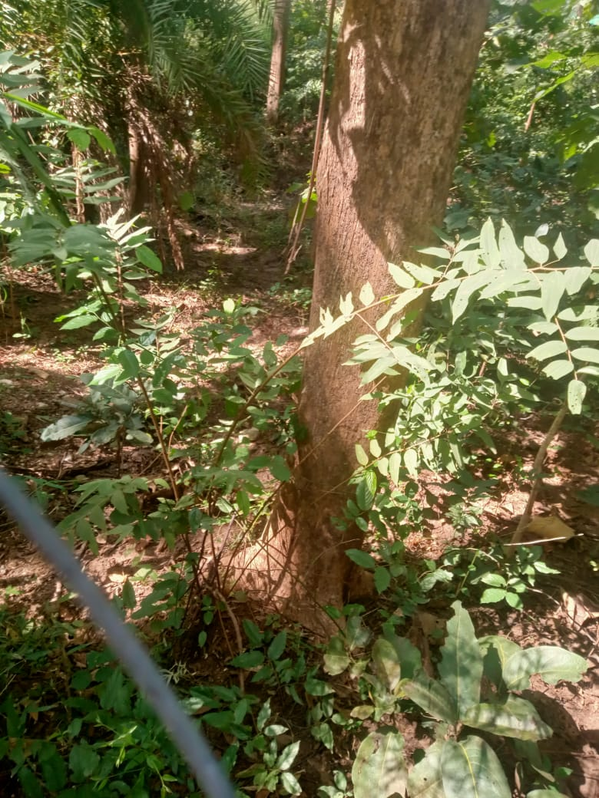  a | 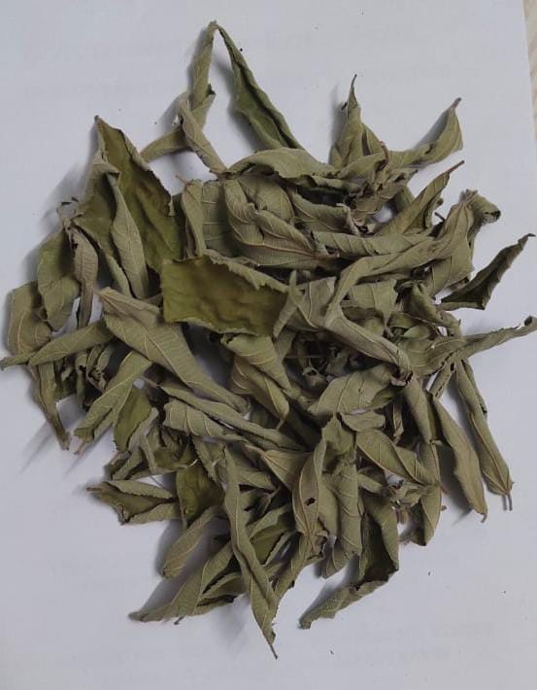  b
Figure 1: Morphological characters a) whole plant of Grewia hirsuta b) collected leaf of Grewia hirsuta

2.2 Preparation of plant extract
2.2.1 For phytochemical Identification
The dried powdered leaf underwent defatting using petroleum ether (60 to 80°C) through hot extraction in a Soxhlet apparatus. Subsequently, the defatted powder was further extracted with methanol, and the resulting concentrated methanol extracts were utilized for analysis.
2.2.2 For GC-MS analysis:
The organic solvent extract of the plant was prepared according to the method described by Ladd Jr. and Jacobson. Methanol was selected as the polar solvent for extraction. Dry powders of the plant’s leaves and fruits (10 g each) were weighed separately and placed into a Soxhlet extractor using a thimble. A solvent mixture of methanol and water (75:75 mL) was added to each sample, and extraction was carried out for 48 hours at 80 °C. This procedure was repeated multiple times to obtain the required quantity of extract for the experiment. For GC–MS analysis, the resulting extracts were filtered and centrifuged twice at 10,000 rpm for 10 minutes each. After the second filtration, 3 mL of the clarified extract was transferred into a GC–MS vial for subsequent analysis.
2.3 Qualitative evaluation of phytochemicals
Secondary metabolites, including alkaloids, flavonoids, terpenoids, tannins, and coumarins, within the crude methanol leaf extract were identified. This was accomplished through preliminary phytochemical studies employing various standard tests (Kokate el al, 2001).
2.3.1 Test for Alkaloids
Dragendroff’s test: The plant extract underwent heating on boiling water with 10 ml of 2% sulphuric acid for duration of 2 minutes. Following cooling, a few drops of Dragendorff’s reagent were introduced. The observation of an orange-brown precipitate indicated the presence of alkaloids.
2.3.2 Test for Steroids
Liebermann Burchard Reaction: To the plant extract, 0.5 ml of acetic anhydride and 0.5 ml of chloroform were added, followed by the gradual addition of a few drops of concentrated sulphuric acid. The presence of steroids was confirmed by the appearance of a greenish-blue coloration.
2.3.4 Test for Terpenoids
Salkowski Reaction: The plant extract was dissolved in 2 ml of chloroform, followed by the gradual addition of 3 ml of concentrated sulphuric acid along the side. The observation of a reddish-brown interphase indicated the presence of terpenoids.
2.3.5 Test for Flavonoids
Shinoda test: The plant extract solution was heated with 1.5 ml of a 50% methanol solution, followed by the addition of magnesium metal. Subsequently, 5-6 drops of concentrated hydrochloric acid were slowly added. The formation of a red color indicated the presence of flavonoids.
2.3.6 Test for Glycosides
Keller-Kiliani test: The plant extract was mixed with glacial acetic acid, ferric chloride, and concentrated sulphuric acid. The observation of a reddish-brown ring at the junction of the two layers confirmed the presence of glycosides.
2.3.7 Test for Tannins
FeCl₃ Solution Test: The plant extract was subjected to treatment with 2 drops of a 2% ferric chloride solution. The appearance of a dirty green coloration indicated the presence of tannins.
2.3.8 Test for Coumarins
The extract underwent treatment with both sodium hydroxide and alcoholic sodium hydroxide. Subsequently, concentrated hydrochloric acid was slowly introduced through the side walls of the test tube. The appearance and subsequent disappearance of a yellow color indicated the presence of coumarins.
2.4 GC-MS analysis:
GC–MS analysis of the plant extracts was conducted using a Shimadzu GC-MS-QP 2020 system (Japan) equipped with a non-polar VF-5MS capillary column (30 m × 0.25 mm i.d., 0.25 μm film thickness) and a polar CP-Wax 52 capillary column (30 m × 0.25 mm i.d., 0.25 μm film thickness). Chromatographic conditions were set as follows: helium served as the carrier gas at a flow rate of 1 mL·min⁻¹, and the injector temperature was maintained at 250 °C. The oven temperature programme consisted of an initial isothermal period at 50 °C for 2 minutes, followed by a ramp to 250 °C at 20 °C·min⁻¹ with a 5-minute hold, then a further increase to 300 °C at 20 °C·min⁻¹ with a 10-minute hold. The total run time was 32 minutes. Sample injection volume was 1 μL with a split ratio of 1:10.
Mass spectrometry conditions included an ionization voltage of 70 eV, an ion source temperature of 230 °C, an interface temperature of 280 °C, and a mass scan range of 45–450 m/z, with a solvent cut time of 3 minutes. In the present study, bioactive compounds were extracted from the leaves of Grewia hirsuta Vahl and subsequently identified using GC–MS analysis.

3. Results and Discussions
3.1 The methanol leaf extract of Grewia hirsuta was found to contain a diverse array of phytochemicals, including alkaloids, terpenoids, flavonoids, tannins. (Refer to Table 1 for details).
The analysis showed a negative result for carbohydrates (Molish test) and glycosides (Keller- Killiani test).
However, proteins were detected as indicated by a positive Biuret test. Flavonoids were confirmed through a positive lead acetate test, while alkaloids were detected with a positive Wagner’s test.
Phenolic compounds were present, as evidenced by a positive ferric chloride test. Organic compounds such as oxalic acid and malic acid were also identified. Among the inorganic compounds, chloride was found to be present, while sulphate was not detected.
The test for steroids showed a negative result. These findings suggest that Grewia hirsuta contains significant bioactive constituents, which may contribute to its medicinal properties.
Although this study provided qualitative data, it laid a foundation for future quantitative research, emphasizing the diverse range of secondary metabolites found in the plant.
These methods enabled the identification of bioactive compounds, contributing to a comprehensive understanding of the plant’s chemical constituents. The plant is known to contain key phytoconstituents, including, flavonoids, alkaloids, and tannins (Yamazaki & Kawano, 2011).

Table 1: Phytochemical analysis methanolic leaf extract of Grewia hirsuta
S. NO. | TEST NAME | RESULTS
- Test for Carbohydrate

 | Molish test: | -ve
- Test for Protein

 | Biuret test: | +ve
- Test for Glycoside
 | Test for deoxysugar (Keller Killiani test): | -ve
- Test for Flavonoids
 | Lead acetate test: | +ve
- Test for Alkaloids
 | Mayer’s Test:  b. Wagner’s test: | +ve
- Test for Phenolic compound
 | Ferric Chloride Test: | +ve
- Test for Organic compound
 | Oxalic acid:  Malic acid: | +ve
- Test for Inorganic compound
 | Sulphate Test:  Chloride Test: | +ve
- Test for steroid
 | Salkowski reaction: | -ve

3.2 GC-MS Analysis
The GC-MS analysis is the valuable method which has been increasingly applied for the analysis of medicinal plants for non-polar components, volatile essential oil, fatty acids and alkaloids. Gas Chromatogram Mass Spectrometry (GC-MS) is commonly favoured as the analytical method in toxicology, forensics, food science, and environmental research.
Identification of these compounds were done with the help of the retention time, molecular weight, molecular formula of the standard molecules obtained from NIST library available in the GCMS analysis results. Based on retention time and peak area analysis.
In current investigation revealed the presence of 20 bioactive compounds in the extract leaf of G. hirsute. Among the compounds detected, silanediol, dimethyl, amphetamine, 2,2'-stilbenediamine, fluoxetine, N-acetyl, catechol, and nordazepam, TMS derivative Hydroquinone, cyclotrisiloxane, hexamethyl, α-cadinol silanediol, dimethyl- (C₂H₈O₂Si) and silane, diethoxydimethyl- (C₆H₁₆O₂Si), which belong to the silane derivatives. Notable pharmacologically active compounds identified were amphetamine (C₉H₁₃N), fluoxetine N-acetyl (C₁₉H₂₀F₃NO₂), nordazepam TMS derivative (C₁₈H₁₉ClN₂OSi), and tenamfetamine (C₁₀H₁₃NO₂). The analysis also revealed antioxidants like catechol (C₆H₆O₂) and hydroquinone (C₆H₆O₂), alongside thymol (C₁₃H₂₂OSi) and α-cadinol (C₁₅H₂₆O), known for their antimicrobial and anti-inflammatory properties. Long-chain hydrocarbons, such as 1-tetracosene (C₂₄H₄₈), and complex sterols like cholesta-3,5-diene (C₂₇H₄₄) were also detected. Additionally, lup-20 (C₃₂H₅₂O₂), a triterpenoid, and cyclobarbital (C₁₂H₁₆N₂O₃), a barbiturate derivative, were identified. The detection of diethyl phthalate (C₁₂H₁₄O₄), commonly used as a plasticizer, suggests potential contamination. Lup 20 pentacyclic lupin type triterpanoid which antitumor activity in various types of cancer. Hydroquinone is topical medication has good therapeutic value of hyper pigmentation caused by acne, aexima , syrosys, and also treat for different skin diseases.
Although Grewia hirsuta has been studied less extensively than some other plants, it has long been used in traditional medicine for its wound-healing, antimicrobial, and anti-inflammatory effects. The leaves contain several bioactive compounds, including flavonoids, tannins, and saponins, which contribute to their medicinal, value (Mishra et al., 2020). Traditional healers in different parts of India have employed Grewia hirsuta to treat ulcers, wounds, and skin infections, emphasizing its potential as a valuable source of new bioactive compounds (Sharma & Gupta, 2017).

Table 2: GC-MS Data - Identified Compound and Structure of leaf extract of Grewia hirsuta

S. No | R. Time | F. Time | Molecular formula | Molecular weight | IUPAC Names of compounds | Structure of Compound
 | 3.195 | 3.165 | C₂H₈O₂Si | 92 | Silanediol, dimethyl- | 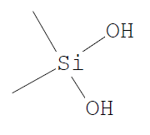
 | 6.715 | 6.8 | C₁₉H₂₄N₂ | 135 | Amphetamine | 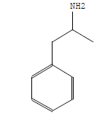
 | 6.8 | 6.85 | C₄H₆O₂ | 210 | 2,2'-Stilbenediamine | 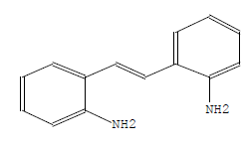
 | 6.89 | 6.99 | C₆H₁₂O₂ | 113 | Nanofin | 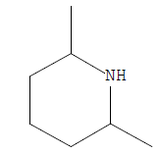
 | 6.99 | 5.06 | C₆H₁₈O₃Si₃ | 351 | Fluoxetine, N-acetyl | 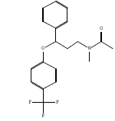
 | 5.1 | 5.205 | C₆H₇NO | 168 | Silane, diethoxydimethyl- | 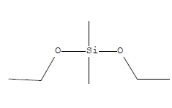
 | 6.99 | 7.095 | C₉H₁₁N₃O | 110 | Catechol | 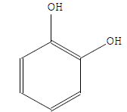
 | 7.28 | 7.325 | C₆H₇N₃O | 362 | Nordazepam, TMS derivative | 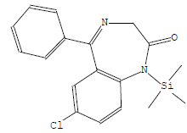
 | 7.7 | 7.77 | C₁₀H₁₄O₂ | 110 | Hydroquinone | 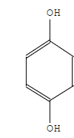
 | 7.77 | 7.82 | C₆H₆O₂ | 222 | Cyclotrisiloxane, hexamethyl- | 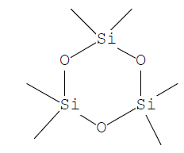
 | 9.8 | 9.905 | C₇H₈O₂ | 222 | .alpha.-Cadinol | 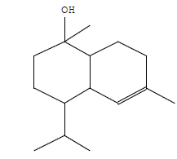
 | 11.155 | 11.26 | C₇H₉NO₂ | 336 | 1-Tetracosene | 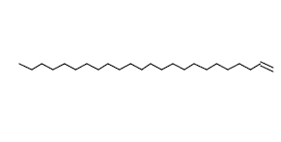
 | 17.6 | 17.835 | C₇H₁₃NO | 179 | Tenamfetamine | 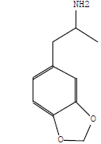
 | 22.395 | 22.66 | C₇H₂₁O₃PSi₂ | 222 | Thymol | 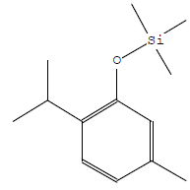
 | 23.165 | 23.205 | C₂₂H₄₆O₃Si | 265 | Desmethyldoxepin | 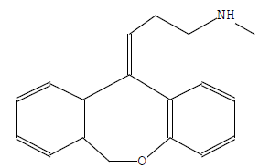
 | 23.56 | 23.63 | C₄H₁₃N₃ | 668 | Lup-20 | 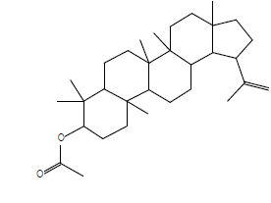
 | 23.665 | 23.805 | C₈H₈O₃ | 368 | Cholesta-3,5-diene | 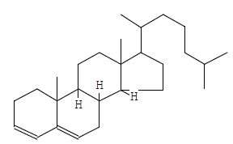
 | 21.5 | 21.575 | C₉H₁₀O₃ | 236 | Cyclobarbital | 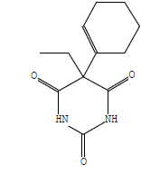
 | 21.695 | 21.755 | C₁₇H₃₄O₂ | 177 | 5-APDB | 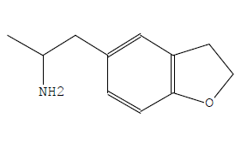
 | 9.965 | 10.085 | C₁₆H₂₂O₄ | 222 | Diethyl Phthalate | 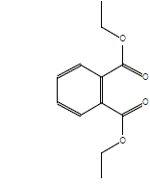

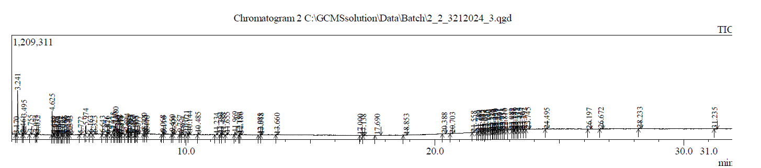

Figure 2: GC-MS Chromatogram of Methanolic leaf extract of Grewia hirsuta.
Conclusion
The current investigation identified twenty chemical constituents through Gas Chromatogram Mass Spectrometry (GC-MS) analysis of the methanolic leaf extract of Grewia hirsute plant. These compounds possess various biological activities such as antioxidant, anti-inflammatory, antimicrobial, and anticancer properties, which are crucial for their potential pharmacological applications. This research contributes to the growing body of knowledge regarding the bioactive constituents of medicinal plants, paving the way for future investigations in drug discovery and natural product-based pharmaceuticals.
Disclaimer (Artificial intelligence)
Author(s) hereby declare that NO generative AI technologies such as Large Language Models (ChatGPT, COPILOT, etc.) and text-to-image generators have been used during the writing or editing of this manuscript.
References

- El-Bondkly, E. A. M., Al Shammari, B., El-Gendy, M. M. A. A., Alsafari, I. A., El-Bondkly, A. A. M. A., El-Shenawy, F. S., & El-Bondkly, A. M. (2022). Phytochemical screening, antifungal, and anticancer activities of medicinal plants Thymelaea hirsuta, Urginea maritima, and Plantago albicans. BioMed Research International, 2022, 9544915.
- Eshete, M. A., & Molla, E. L. (2021). Cultural significance of medicinal plants in healing human ailments among Guji semi-pastoralist people, Suro Barguda District, Ethiopia. Journal of Ethnobiology and Ethnomedicine, 17, 61.
- Fouche, Gerda, Afolayan, Anthony J., Wintola, Olubunmi A., Khorombi, Tendani E., & Senabe, Jeremiah. (2015). Effect of the aqueous extract of the aerial parts of Monsonia angustifolia E. Mey. Ex A. Rich., on the sexual behavior of male Wistar rats. BMC Complementary and Alternative Medicine, 15(1), 343.
- Janani SR, Singaravadivel K. Screening of Phytochemical and GC-MS Analysis of some bioactive constituents of Asparagus racemosus. Int J Pharm Tech Res. 2014; 6(2):428-432.

- Kala C.P. ((2011)). Indigenous uses and sustainable harvesting of trees by local people in the Pachmarhi Biosphere Reserve of India, Int. J. Med. Arom. Plants. 1 153-161. in traditional and modern medicine.
- Kaur, S., Shams, R., Dash, K. K., Pandey, V. K., Shaikh, A. M., Harsányi, E., & Kovács, B. (2024). Phytochemical and pharmacological characteristics of phalsa (Grewia asiatica L.): A comprehensive review. Heliyon, 10(2), e25046.
- Khattab, H. A., El-Shitany, N. A., Abdallah, I. Z., Yousef, F. M., & Alkreathy, H. M. (2015). Antihyperglycemic potential of Grewia asiatica fruit extract against streptozotocin-induced hyperglycemia in rats: Anti-inflammatory and antioxidant mechanisms. Oxidative Medicine and Cellular Longevity, 2015, 549743.
- Mishra, A., Verma, R., & Tiwari, P. (2020). Traditional uses and pharmacological potential of Grewia hirsuta: A review. Indian Journal of Ethnopharmacology, 18(3), 150-165.

- Natarajan, K., Rajendran, I., & Ramakrishnan, S. (2014). Identification of bioactive compounds in Grewia hirsuta using GC-MS analysis. International Journal of Pharmacy and Pharmaceutical Sciences, 6(8), 123-128.
- Sharma, S., & Gupta, R. (2017). Ethnobotanical relevance and medicinal applications of Grewia hirsuta in Indian traditional medicine. Journal of Herbal Medicine, 10(4), 120-132.

- Tiwari DK and Yadav A. Ethnobotanical Investigation of Some Medicinal Plants Availed by Gond Tribe of Naoradehi Wild Life Sanctuary, Madhya Pradesh, Anthropologist 2003; 5(3): 201-202.
- Yamazaki, Yoshimitsu, & Kawano, Yasuhiro. (2011). Inhibitory effects of herbal alkaloids on the tumor necrosis factor-α and nitric oxide production in lipopolysaccharide-stimulated RAW264 macrophages. Chemical & Pharmaceutical Bulletin, 59(3), 388–391.
- Qamar, M., Akhtar, S., Ismail, T., Wahid, M., Barnard, R. T., Esatbeyoglu, T., & Ziora, Z. M. (2021). The Chemical Composition and Health-Promoting Effects of the Grewia Species—A Systematic Review and Meta-Analysis. Nutrients, 13(12), 4565. https://doi.org/10.3390/nu13124565

