GC-MS Analysis of Secondary Metabolites of Endophytic Fusarium sp. isolated from Two Medicinal Plants: Zingiber Officinale. Roscoe and Ocimum Tenuiflorum. L.

ABSTRACT
Endophytic fungi represent an untapped reservoir of bioactive compounds with significant pharmaceutical and agricultural potential. This study aims to explore the endophytic fungal diversity associated with Zingiber officinale. Roscoe (ginger) and Ocimum tenuiflorum. L. (tulsi) and to investigate their secondary metabolite production. The present work is carried out for isolation, characterization of endophytic fungi from selected medicinal plants and further extraction and characterization of secondary metabolites with potential bioactivity. The study conclusively established the successful isolation and morphological characterization of diverse endophytic fungal communities residing within the tissues of Zingiber officinale and Ocimum tenuiflorum. A variety of genera, prominently including Fusarium sp., Aspergillus sp., and Penicillium sp., were consistently identified, confirming the strong endophytic association within these important medicinal plants. comprehensive chemical profiling of secondary metabolites from a selected Fusarium sp. Isolate (Code ZOF1). This isolate demonstrated robust growth in submerged fermentation, yielding substantial biomass and a rich crude extract. GC-MS analysis unveiled a complex and varied metabolome, with 13 distinct compounds tentatively identified . Key among these were significant quantities of fatty acids (e.g., Tetradecanoic acid), as well as a notable presence of cyclic dipeptides (e.g., Cyclo(L-prolyl-L-valine), Pyrrolo[1,2-a]pyrazine-1,4-dione, hexahydro-3-(2-methylpropyl)-) and pyridine derivatives. This study underscores the biotechnological potential of endophytic fungi as a sustainable source of secondary metabolites and highlights their role in the discovery of new antimicrobial compounds.This finding significantly contributes to the catalogue of fungal endophytes associated with traditional medicinal flora, highlighting these specific host plants as rich and underexplored biodiversity hotspots for microbial natural product discovery.
Keywords: Endophytic fungi, secondary metabolites, antimicrobial activity, Ocimum tenuiflorum, Zingiber officinale, bioactive compounds, ethyl acetate, pharmaceutical applications.

INTRODUCTION
The escalating global health crisis posed by antimicrobial resistance (AMR) has underscored an urgent need for the discovery of novel therapeutic agents (WHO, 2017). Recent scientific inquiry has increasingly turned its focus to the microbial symbionts residing within these plants, particularly endophytic fungi. These fascinating microorganisms colonize the internal tissues of plants without causing overt disease symptoms, often engaging in mutualistic relationships that enhance host growth, bolster stress tolerance, and fortify defense mechanisms (Saikkonen et al., 2010). Crucially, endophytic fungi are also recognized as prolific producers of diverse secondary metabolites, many of which possess significant pharmacological activities, including antimicrobial, anticancer, and antioxidant properties, making them a prime focus for bioprospecting initiatives (Schulz and Boyle 2006, Mishra et al., 2020).
Among the myriad medicinal plants, Zingiber officinale (Ginger) and Ocimum tenuiflorum (Holy Basil or Tulsi) stand out due to their profound historical significance in traditional medicine and their well-documented therapeutic efficacy. Zingiber officinale is particularly known for its anti-inflammatory, antioxidant, and antimicrobial properties, while Ocimum tenuiflorum is renowned for its adaptogenic, immunomodulatory, and antimicrobial attributes (Sahu,2025). The rich phytochemical profiles and long-standing medicinal applications of these plants represent exceptional candidates for hosting diverse and metabolically active endophytic fungal communities (Naseer and Adil, 2025). Previous research has hinted at the contribution of their endophytes to these plants’ overall health and medicinal value, specifically in promoting growth, enhancing disease resistance, and producing valuable bioactive compounds (Alam et al., 2021).The term endophyte is derived from the Greek words endon (within) and phyte (plant), and was first introduced by De Bary in 1886.These fungi are increasingly recognized for their capacity to produce novel bioactive secondary metabolites that address various challenges, including AMR, pest control, and agricultural diseases (Yousaf et al., 2022).Endophytic fungi produce a wide range of secondary metabolites, including alkaloids, terpenoids, phenolics, and saponins, which are associated with biological activities such as antimicrobial, anticancer, antioxidant, and antifungal properties (Gouda et al., 2016,Rani et al.,2023). Despite being ubiquitous found in nearly all of the 420,000 documented plant species globally only a small fraction of endophytic fungal species have been extensively studied for their biological roles (Blackwell, 2011,Sharaf, et al., 2022).
This pressing demand has catalyzed intense research into medicinal plants and their associated endophytic microorganisms fungi that reside asymptomatically within plant tissues (Akram et al., 2023). These ubiquitous fungal symbionts are increasingly recognized as prolific producers of unique secondary metabolites with diverse biological activities, including antimicrobial, anticancer, and antioxidant properties, making them a significant focus for drug discovery and sustainable agriculture (Singh and kumar, 2023). This research aims to isolate and characterize the endophytic fungal diversity within these two important medicinal plants, employing morphological and microscopic identification techniques. Furthermore, the study will leverage Gas Chromatography–Mass Spectrometry (GC-MS) to profile the secondary metabolites produced by these isolated fungi, thereby elucidating their potential for novel bioactive compound discovery and addressing critical needs in pharmacology and agriculture (Kang, et al., 2025).

Endophytic Fungi in Zingiber officinale (Ginger):
Zingiber officinale, commonly known as ginger, is a globally valued medicinal plant with a rich history of use for its anti-inflammatory, antioxidant, and antimicrobial properties. Emerging research highlights the crucial role of its endophytic fungal communities in both supporting plant vitality and contributing to its therapeutic potential (Pereira, et al., 2025).
Studies on ginger’s endophytes demonstrate a dual functionality:
- Plant Growth Promotion: Endophytic fungi, such as Sarocladium strictum, can enhance ginger’s growth by stimulating root and shoot development, even promoting clustered shoot formation in tissue culture (Potshangbam et al., 2017).
- Disease Resistance: Ginger’s endophytes act as natural defense agents. Acremonium species, for instance, exhibit strong antagonism against Pythium myriotylum, a major ginger soft rot pathogen (Princy, et al., 2023). Broader surveys have identified genera like Aspergillus, Penicillium, Fusarium, and Trichoderma from ginger, many of which demonstrate significant antagonistic activity against common ginger pathogens like Fusarium oxysporum, indicating their potential as biocontrol agents (Borrego, et al.,2025)
- Bioactive Compound Production: Ginger’s endophytic fungi are a recognized source of valuable bioactive metabolites. Previous studies have isolated diverse fungal genera, including Aspergillus, Penicillium, and Fusarium, from ginger, with many strains demonstrating antimicrobial properties (Zhang et al., 2023). These fungi are known to produce secondary metabolites such as alkaloids, terpenoids, and phenolics, which contribute to the plant’s overall medicinal efficacy and offer avenues for discovering novel pharmaceuticals (Dilkush et al., 2025). Analytical techniques like Gas Chromatography-Mass Spectrometry (GC-MS) are frequently employed to characterize these complex mixtures of volatile and semi-volatile compounds produced by endophytic fungi, allowing for the identification of active components. For example, endophytic fungi from red ginger have shown antimicrobial activity against bacterial pathogens like Staphylococcus aureus and Escherichia coli, with GC-MS analysis often revealing the specific compounds responsible for such bioactivity (Handayani et al., 2023, Sadrati, et al., 2023).
Endophytic Fungi in Ocimum tenuiflorum (Holy Basil/Tulsi):
Ocimum tenuiflorum, revered as Holy Basil or Tulsi, is a cornerstone of Ayurvedic medicine, celebrated for its adaptogenic, anti-inflammatory, and antimicrobial properties. The plant’s therapeutic profile is significantly enhanced by its resident endophytic fungal communities.
- Enhanced Bioactive Profile: Endophytic fungi isolated from O. tenuiflorum are known to produce a wide array of bioactive compounds with antimicrobial, antioxidant, and antitumor properties (Loganathan,et al., 2021). Specific genera like Aspergillus, Penicillium, and Fusarium have been identified from Tulsi, exhibiting potent antimicrobial activities against various pathogens (Abo-Elyousr et al., 2022). The comprehensive characterization of these fungal-derived compounds often relies on sophisticated analytical methods like GC-MS, enabling researchers to identify the specific molecules contributing to the observed bioactivities (Asogwa, ,et al., 2024).
- Plant Vigor and Adaptation: Beyond producing medicinal compounds, Tulsi’s endophytes also contribute to plant vigor by improving nutrient uptake and bolstering resistance to environmental stresses. The diversity and activity of these fungal communities in O. tenuiflorum are influenced by environmental factors, with tropical climates often yielding a higher diversity of fungi and more potent antimicrobial activity (Hussein,et al., 2024). In contemporary mycology, molecular identification techniques, particularly the use of the Internal Transcribed Spacer (ITS) region of ribosomal DNA for DNA barcoding, have become the widely accepted standard for precise, species-level classification (Harnelly, et al., 2022).Gas Chromatography-Mass Spectrometry (GC-MS) stands out as a powerful and indispensable technique for the separation, identification, and quantification of volatile and semi-volatile secondary metabolites (e.g., terpenoids, certain alkaloids, fatty acids) (Frolova, et al., 2025).
MATERIALS AND METHODS
Sample Collection:
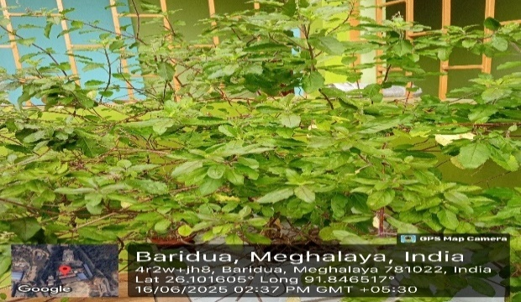
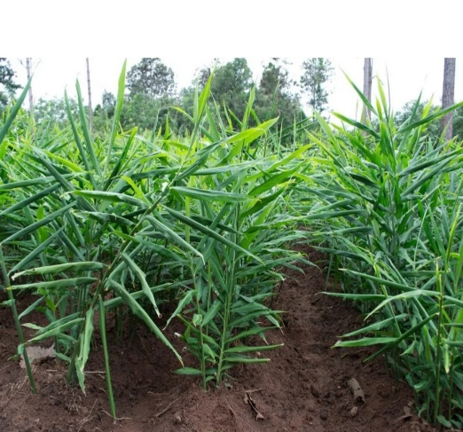
Healthy and disease-free plant parts of Zingiber officinale (rhizome) and Ocimum tenuiflorum (leaves) were collected from local field of Ribhoi district in sterile zip-lock polybags. Each sample was labelled and transported to the laboratory under aseptic conditions for further processing (Figures 1 and 2).
Fig 2 : Ocimum tenuiflorum.L.

Fig 1 : Zingiber officinale .Roscoe

Identification and Characteriztaion of endophytic fungi:
The colony forming fungi were isolated on potato dextrose Agar (PDA). Culture character istics including reverse and obverse colony colour, size of the colony, growth pattern, surface texture, margin character, pigmentation etc., were recorded from each culture media. Fungi were identified up to genus level using Barnet and Hunter (1998). Cultures were identified to species level using colony diameter and spore measurement following references and monographs adopted by Chua et al.(2024). The endophytic fungi was morphologically identified as Fusarium sp based on colony texture, pigmentation, and microscopic structures. Solvent Quantification and Evaporation was done as per the procedure described by Choudhury et al. (2022)
Gas Chromatography–Mass Spectrometry (GC-MS) Profiling
The concentrated crude extract was subjected to GC-MS analysis for chemical profiling and identification of secondary metabolites. The sample was injected into the GC-MS system (instrument model and specifications to be added based on lab protocol, and the chromatographic conditions were optimized for fungal metabolite detection (Kaur and kaur,2025). Resulting mass spectra were compared against the National Institute of Standards and Technology (NIST) database for compound identification. The detected peaks represented various bioactive compounds, indicating the metabolic diversity of the isolated endophytic fungus (Abdel-Wareth, et al., 2023)
Results and Discussion:
This chapter delineates the comprehensive experimental outcomes derived from the systematic isolation, purification, morphological characterization, chemical profiling, and antimicrobial evaluation of endophytic fungi associated with Zingiber officinale and Ocimum tenuiflorum. The methodologies employed yielded both qualitative and quantitative data that underscore the bioactive potential of select fungal isolates.Following rigorous surface sterilization, rhizomes of Zingiber officinale and leaves of Ocimum tenuiflorum were inoculated on freshly prepared Potato Dextrose Agar (PDA) plates under aseptic conditions. Initial fungal emergence was observed within 3 to 4 days of incubation at 28 ± 2°C, with 2–3 morphologically distinct colonies appearing per plate were further subcultured and preserved for downstream applications. Among the diverse fungal morphotypes observed, three dominant genera Fusarium, Penicillium, and Aspergillus were consistently isolated and morphologically characterized based on their colony architecture, pigmentation, growth rate, and microscopic features. The isolate ZOF1 (Fusarium sp.) was selected for further analysis due to its prolific growth, abundant biomass, and promising bioactivity during preliminary screening (Toghueo,2020, Wasito, et al.,2026).
Extraction of Secondary Metabolites from Fusarium sp. (ZOF1)
The selected isolate (Fusarium sp.) was cultivated in 100 mL of Potato Dextrose Broth (PDB) and incubated in a shaking incubator at 120 rpm and 28°C for a duration of 10 days to facilitate optimal secondary metabolite production. Post-incubation, the culture was filtered to separate mycelial biomass from the culture filtrate. A triple-phase solvent extraction using ethyl acetate (1:1 v/v) was performed to recover extracellular fungal metabolites. The final ethyl acetate extract, rich in non-polar fungal metabolites, was used for both chemical profiling and bioassay evaluation. The instrument was used ISQ-7000 with runtime of 41.99 min and volume was taken 1.00 µL with dilution factor 1(Wen, et al., 2023).There are total 13 chromatographic peaks were observed as in Table 1.

Table 1: Chromatographic Peak showing total of 13 peaks with retention time
PEAK NO | RETENTION  TIME (min) | AREA | HEIGHT | RELATIVE AREA℅ | RELATIVE HEIGHT ℅
1 | 3.922 | 7,146,087.359 | 26,549,797.541 | 0.56 | 0.16
2 | 5.361 | 742,649,308.834 | >high | 57.93 | 40.22
3 | 7.143 | 8,456,412.342 | 73,467,929.031 | 0.66 | 0.45
4 | 7.976 | 133,551,981.839 | >high | 10.42 | 23.83
5 | 9.837 | 229,867,571.270 | >high | 17.93 | 22.35
6 | 11.160 | 18,552,669.182 | 360,794,364.281 | 1.45 | 2.19
7 | 11.694 | 9,775,862.099 | 164,001,142.349 | 0.76 | 0.99
8 | 12.673 | 18,979,709.478 | 294,640,067.594 | 1.48 | 1.79
9 | 14.500 | 77,577,709.573 | 765,055,556.785 | 6.05 | 4.64
10 | 15.183 | 456,743.185 | 47,877,660.061 | 0.04 | 0.29
11 | 18.125 | 12,437,602.683 | 150,200,519.367 | 0.97 | 0.91
12 | 21.635 | 14,098,654.156 | 224,332,804.871 | 1.10 | 1.36
13 | 23.611 | 8,318,429.304 | 137,842,274.745 | 0.65 | 0.84
Total |  | >1.2 Billion | >2.2 Billion | 100.00 | 100.00

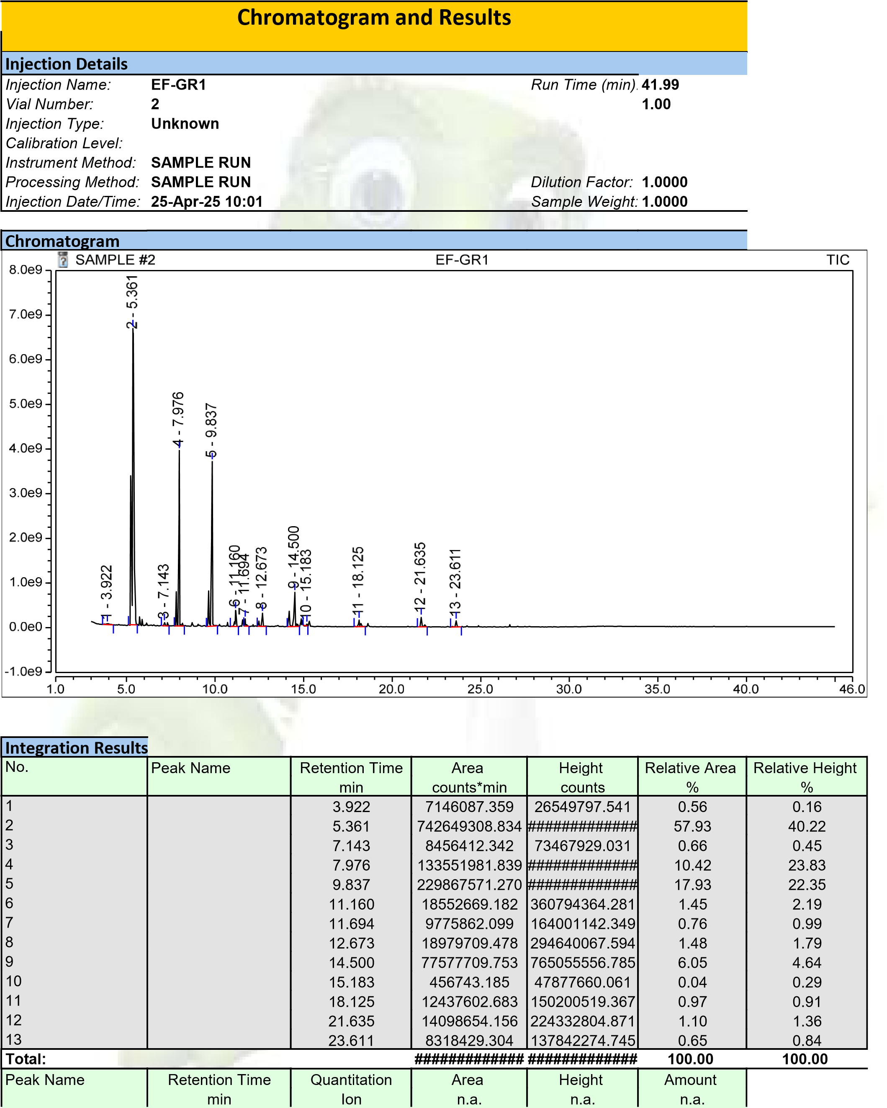
Figure 3: Chromatography- Mass Spectrometry (GC-MS) separation Chromatograms for ethyl acetate extract of Fusarium sp.
Table 2: GC-MS Analysis of EF-GR1 Extract (ISQ-7000) showing the isolated compounds with reported bioactive property and Chemical structure

RETENTION TIME(min) | NAME OF COMPOUNDS | MW  g/mol | REPORTED BIOACTIVE PROPERTY | CHEMICAL STRUCTURE | ORGANISM IN WHICH THE COMPOUND IS OBTAINED
3.922 | Propanal, 2,3-dihydroxy-, (S)  sec-Butyl nitrite  (3-Methyl-oxiran-2-yl)-methanol | 90.08  89.1  88.1 | Antioxidant (scavenges free radicals), intermediate in biochemical pathways  Vasodilator, used in angina treatment, potential DNA-damaging agent  Epoxide; reactive intermediate, cytotoxic potential (possible anticancer precursor) | 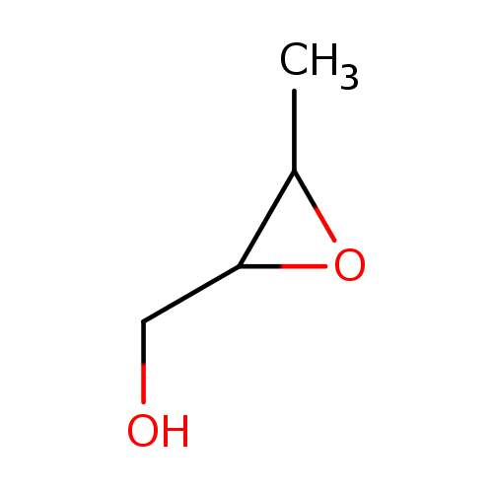  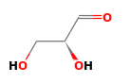  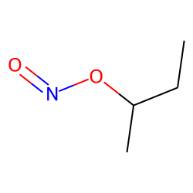 | Fusarium sp
5.361 | Pyridine, 3-butyl-  4-Butyl pyridine  Pyridine, 3-(2-methylpropyl)- | 121.18  121.18  121.18 | Pyridine derivatives; antimicrobial, insecticidal, allelopathic potential | 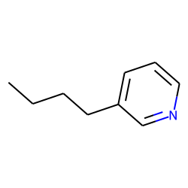  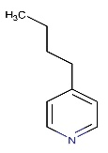  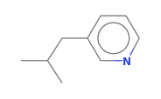 | Fusarium sp
7.143 | Pyridine, 2-methyl-5-(1-methylethenyl)-  2-(2-Aminophenyl)propan-2-ol | ~135  151.21 | Aromatic pyridine compound; possible antimicrobial, insecticidal, allelopathic activity | 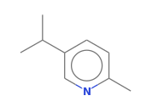  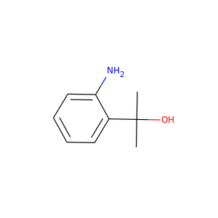 | Fusarium sp
7.976 | 1-(2,3-Dihydro-1,4-benzoxazin-4-yl)ethanone | 177.2 | Benzoxazine derivative; antimicrobial, allelopathic, potential antifungal and pesticidal activity | 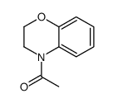 | Fusarium sp
9.837 | 2-Pyridinecarboxylic acid, 5-butyl-  Methyl  5-butylpyridine-2-carboxylate  Adamantane,  1-chloro- | ~179 | Pyridine derivative; anti-inflammatory, antioxidant, metal chelator | 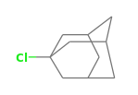  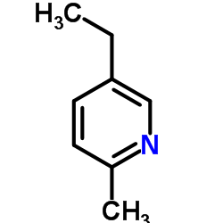  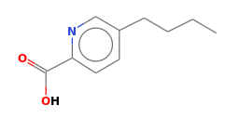 | Fusarium sp
11.160 | 2-Furanmethanol derivative  Acetic acid, 10,11-dihydroxy-dodeca ester  Formic acid, dodecatrien-3-yl ester | ~114-130  ~118-140 | Furan derivatives; antioxidant, flavorant, antimicrobial  Antimicrobial, anti-inflammatory, solvent or flavoring uses | 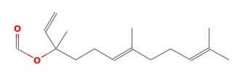  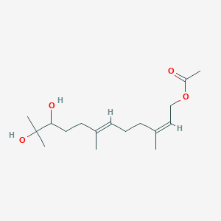  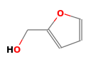 | Fusarium sp
11.694 | Tetradecanoic acid  Tridecanoic acid | 228.37  214.34 | Antibacterial, emulsifier, used in cosmetic/pharma industry  Antioxidant, antimicrobial, larvicidal, anti-inflammatory | 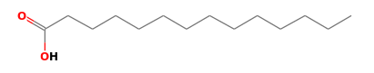  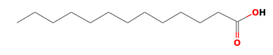 | Fusarium sp
12.673 | Cyclo(L-prolyl-L-valine)  Pyrrolo[1,2-a]pyrazine-1,4-dione, hexahydro | 196.26 | Diketopiperazine (DKP); potent antimicrobial, cytotoxic, quorum-sensing inhibitor | 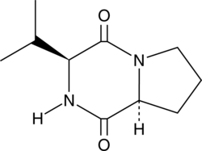  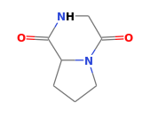 | Fusarium sp
14.500 | Pyrrolo[1,2-a]pyrazine-1,4-dione, hexahydro  Cyclo(L-prolyl-L-valine) | 210.25  198.3 | DKP; antimicrobial, anticancer, antiviral, antifungal |  | Fusarium sp
15.183 | 3,7-Dimethyl-6-nonen-1-ol acetate  1,5-Diazabicyclo[3.1.0]hexane, 6-spiro  3-Pyridinecarboxylic acid, ethyl ester | 198.3 | Fragrance/flavoring compound; insect attractant/repellent properties | 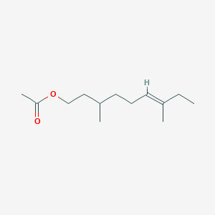  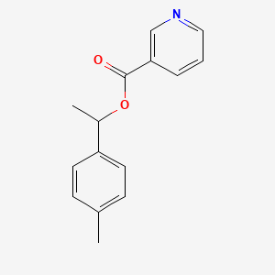  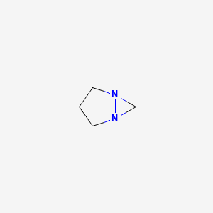 | Fusarium sp
18.125 | Benzamide, 4-nitro-N-[2-methyl-4-(2-tolylazo)phenyl] | ~380-400 | Azo compound; potentialgenotoxicity, dye-like structure, environmental pollutant | 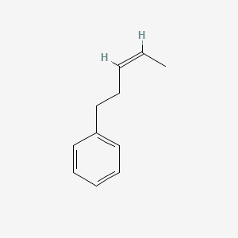 | Fusarium sp
21.635 | Pyrrolo[1,2-a]pyrazine-1,4-dione, hexahydro-3-(phenylmethyl)-  Ergotaman derivatives (e.g., Ergotamine) | 244.29 | DKP; antimicrobial, cytotoxic (anticancer), biofilm inhibitor  Alkaloids; vasoconstrictor, CNS stimulant, potential anticancer, migraine treatment | 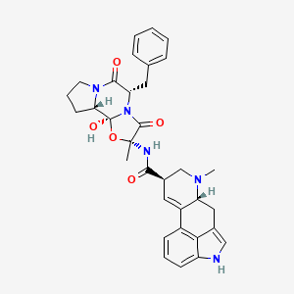  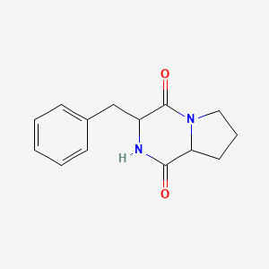 | Fusarium sp
23.611 | Hexadecanoic acid, 2-hydroxy-1-(hydroxymethyl)ethyl ester | 330.5 | anti-inflammatory, antioxidant, and anthelmintic properties | 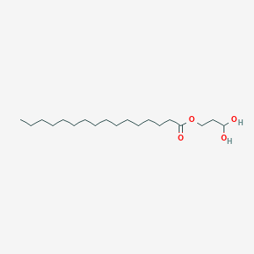 | Fusarium sp

The overarching aim of the present study was to explore the hidden pharmaceutical potential residing within endophytic fungal communities associated with Zingiber officinale (ginger) and Ocimum tenuiflorum (holy basil), two revered medicinal plants. Specifically, this research focused on isolating and morphologically characterizing these fungal symbionts, followed by a detailed chemical profiling and antimicrobial assessment of secondary metabolites from a promising isolate (Table 2). The comprehensive findings illuminate the intricate biochemical capabilities of these endophytes and their potential contribution to the expanding arsenal of natural product-based therapeutics.
Chemical Profiling of Fusarium sp. and Its Bioactive Potential
The successful isolation of diverse endophytic fungal strain from surface-sterilized plant tissues of both Z. officinale rhizomes and O. tenuiflorum leaves underscores the ubiquitous nature of these endosymbionts and their intimate association with their host plants A promising isolate Identified morphologically as Fusarium sp. (ZOF1) was selected for secondary metabolite analysis due to its robust growth and unique characteristics in culture. GC-MS profiling of the crude extract revealed a spectrum of 13 compounds, including fatty acids (e.g., tetradecanoic acid), pyridine derivatives, esters, and cyclic dipeptides such as Cyclo(L-prolyl-L-valine) (Figure 3). These metabolite classes are of considerable interest in drug discovery due to their known biological activities. The diversity of detected compounds affirms the chemical richness of Fusarium sp. And reinforces its potential as a source of bioactive secondary metabolites with pharmaceutical relevance (Table 2).
Correlation between Chemical Constituents and Bioactivity
The antimicrobial screening of the Fusarium sp. Extract demonstrated notable growth inhibition against tested microbial strains. The biological efficacy observed aligns with the chemical profile obtained via GC-MS, particularly the presence of fatty acids and cyclic dipeptides both recognized for their antimicrobial and bio-modulatory properties (Huang, et al., 2022). The convergence of chemical and biological data in this study strengthens the argument that endophytic Fusarium sp. Holds considerable potential for the development of novel therapeutic agents. While the current study established a foundational correlation, further bioassay-guided fractionation and purification will be essential to pinpoint the exact contributors to this bioactivity (Sumalatha and Maheshwar, 2021).
Broader Implications, Novelty and Research Contribution
This study contributes significantly to the understanding of endophyte-derived natural products. The isolation of a Fusarium sp. With a rich secondary metabolome from a traditional medicinal plant like Zingiber officinale provides a unique perspective, as Fusarium species are less commonly explored as endophytes than other fungal genera, especially concerning specific compound profiles like those identified here. The discovery of a diverse array of compounds, including fatty acids, pyridine derivatives, and cyclic dipeptides, underscores the vast chemical diversity that endophytic fungi can offer, often exceeding that of their host plants (Bódalo, et al., 2023, Nahid and Bhuiyan,2024). These findings not only broaden the existing knowledge base on fungal endophyte chemistry but also highlight the immense, largely untapped potential of these microbial symbionts as a sustainable source of novel therapeutic agents, particularly in the context of combating antimicrobial resistance (Gupta et al., 2022). The success in isolating and characterizing these endophytes from locally abundant medicinal plants further supports bioprospecting efforts in specific geographical regions, aligning with principles of sustainable drug discovery (Huang, et al., 2024, Kamini, et al., 2025).
CONCLUSION
This present work explored the endophytic fungal communities associated with Zingiber officinale and Ocimum tenuiflorum, offering profound insights into their symbiotic relationship and the pharmaceutical potential embedded within their secondary metabolites. The study conclusively established the successful isolation and morphological characterization of diverse endophytic fungal communities residing within the tissues of Zingiber officinale and Ocimum tenuiflorum. A variety of genera, prominently including Fusarium sp., was consistently identified, confirming the A major breakthrough of this research was the comprehensive chemical profiling of secondary metabolites from a selected Fusarium sp. Isolate (Code ZOF1). This isolate demonstrated robust growth in submerged fermentation, yielding substantial biomass and a rich crude extract. GC-MS analysis unveiled a complex and varied metabolome, with 13 distinct compounds tentatively identified. Key among these were significant quantities of fatty acids (e.g., Tetradecanoic acid), as well as a notable presence of cyclic dipeptides (e.g., Cyclo(L-prolyl-L-valine), Pyrrolo[1,2-a]pyrazine-1,4-dione, hexahydro-3-(2-methylpropyl)-) and pyridine derivatives. The identification of these compound classes is particularly compelling, as they are widely known in phytochemistry and natural product chemistry for their diverse and potent biological activities, including antimicrobial, antioxidant, and immunomodulatory effects. This direct correlation between the metabolic profile and the observed bioactivity strongly validates the potential of this Fusarium sp. Endophyte as a source of novel antimicrobial agents, vital in addressing the escalating challenge of drug resistance. The findings contribute significantly to the global endeavor of discovering new pharmaceutical leads, reinforcing the strategic importance of exploring microbial biodiversity as a sustainable pathway to innovative therapeutic solutions for infectious diseases.
Acknowledgements:
The authors wish to thank the Department of Botany, University of Science and Technology, Meghalaya for providing financial support while carrying out this work.
Disclaimer (Artificial Intelligence):
Author(s) hereby declare that NO generative AI technologies such as Large Language Models (ChatGPT, COPILOT, etc.) and text-to-image generators have been used during the writing or editing of this manuscript.

REFERENCES:
- Abdel-Wareth MT, Ali EA & El-Shazly MA (2023). Biological activity and GC-MS/MS analysis of extracts of endophytic fungi isolated from Eichhornia crassipes (Mart.) solms. Journal of Applied Biotechnology Reports. (1):895-909. 10.30491/JABR.2022.359352.1559
- Abo-Elyousr, K. A., Ibrahim, O. H., Al-Qurashi, A. D., Mousa, M. A., & Saad, M. M. (2022). Biocontrol potential of endophytic fungi for the eco-friendly management of root rot of Cuminum cyminum caused by Fusarium solani. Agronomy, 12(11), 2612. https://doi.org/10.3390/agronomy12112612
- Akram S, Ahmed A, He P, He P, Liu Y, Wu Y, Munir S & He Y.(2023). Uniting the role of endophytic fungi against plant pathogens and their interaction. Journal of Fungi. 9(1),72. https://doi 10.3390/jof9010072
- Alam B, Lǐ J, Gě Q, Khan MA, Gōng J, Mehmood S, Yuán Y, &Gǒng W.(2021) Endophytic fungi: from symbiosis to secondary metabolite communications or vice versa?. Frontiers in Plant Science. 17(12), 791033 https://doi.org/10.3389/fpls.2021.791033
- Asogwa, I. S., Eze, C. O., Onah, A. I., Agbo, C. A., Evurani, S. A., & Attama, A. A. (2024). New options in drug discovery: endophyte technology. Int J Sci Res Arch, 11(2), 302-321. https://doi10.30574/ijsra.2024.11.2.0379
- Barnet, H.L. and Hunter, B.B. (1998). Illustrated Genera of Imperfect Fungi. 4th Edition, APSPress,218.http://apspress.edu.com
- Blackwell, M. (2011). The Fungi: 1, 2, 3… 5.1 million species? American Journal of Botany. 98(3), 426–438. https://doi: 10.3732/ajb.1000298.
- Bódalo, A., Borrego, R., Garrido, C., Bolivar-Anillo, H.J., Cantoral, J.M., Vela-Delgado, M.D., González-Rodríguez, V.E. & Carbú, M. (2023). In vitro studies of endophytic bacteria isolated from ginger (Zingiber officinale) as potential plant-growth-promoting and biocontrol agents against Botrytis cinerea and Colletotrichum acutatum. Plants, 12(23), p.4032. https://doi.org/10.3390/plants12234032
- Borrego R, Bódalo A, Izquierdo-Bueno I, Moraga J, Carbú M, Bolivar-Anillo HJ, Vela-Delgado MD, Cantoral JM, Garrido C. & González-Rodríguez VE (2025). Multifunctional Endophytic Fungi from Ginger (Zingiber officinale) with Antimicrobial, Enzymatic, and Antioxidant Potential. Agronomy. 15(12), 2711. https://doi.org/10.3390/agronomy15122711
- Choudhury, F.K.; Pandey, P.; Meitei, R.; Cardona, D.; Gujar, A.C& Shulaev, V. (2022). GC-MS/MS Profiling of Plant Metabolites. Methods Mol. Biol. 2396: 101-115 https://doi.10.1007/978-1-0716-1822-6_9
- Chua, R. W., Song, K. P. & Ting, A. S. Y. (2024) Characterization and identification of antimicrobial compounds from endophytic Fusarium incarnatum isolated from Cymbidium orchids. Int. Microbiol. 27, 977-992. https://doi.org/10.1007/s10123-023-00442-1
- Dilkush F, Sarathambal C, Alfiya PV, Praveena R & Prasath D (2025). Metabolic optimization of endophytic bacteria from aromatic ginger (Kaempferia galanga), and black turmeric (Curcuma caesia), for enhanced biocontrol of Pythium myriotylum. Physiological and Molecular Plant Pathology.102898. https://doi.10.1016/j.pmpp.2025.102898
- Frolova, N., Orlova, A., Popova, V., Bilova, T. and Frolov, A. (2025). Gas Chromatography–Mass Spectrometry (GC-MS) in the Plant Metabolomics Toolbox: Sample Preparation and Instrumental Analysis. Biomolecules. 16(1): 16. https://doi.org/10.3390/biom16010016
- Gouda, S., Das, G., Sen, S. K., Shin, H. S., & Patra, J. K. (2016). Endophytes: A treasure house of bioactive compounds of medicinal importance. Frontiers in Microbiology. 7:1538. https://doi.org/10.3389/fmicb.2016.01538
- Gupta S, Choudhary M, Singh B, Singh R, Dhar MK& Kaul S.(2022). Diversity and biological activity of fungal endophytes of Zingiber officinale Rosc. with emphasis on Aspergillus terreus as a biocontrol agent of its leaf spot. Biocatalysis and Agricultural Biotechnology, 39:102234. https://doi.org/10.1016/j.bcab.2021.102234
- Handayani D, Sari HC, Julianti E, & Artasasta MA (2023). Endophytic fungus isolated from Zingiber officinale Linn. var. rubrum as a source of antimicrobial compounds. Journal of Applied Pharmaceutical Science. 13(9),115-20. https://doi10.7324/JAPS.2023.134154
- Harnelly E, Kusuma Hi, Thomy Z(2022). Internal Transcribed Spacer (ITS) gene as an accurate DNA barcode for identification of macroscopic fungus in Aceh, Indonesia. Biodiversitas: Journal of Biological Diversity. 23(5). https://doi: org/10.13057/biodiv/d230514
- Huang K, Sun X, Li Y, Xu P, Li N, Wu X, Pang M & Sui Y (2024). Fusarium as potential pathogenic fungus of Ginger (Zingiber officinale Roscoe) wilt disease. Science of Food. 3;8(1):72. https://doi.org/10.1038/s41538-024-00312-8
- Huang K, Sun X, Zou Y, Li H, Xu P, Zhang W, Zhang Y, Li H, Sun H, Wang W& Pang M. (2022).Comparison of the endophytic bacterial microbiota of asymptomatic and symptomatic ginger rhizomes during the activation of adventitious bud development. Plant disease. 106(9):2470-9. https://doi: 10.1094/PDIS-09-21-2069-RE
- Hussein, J. M., Myovela, H., & Tibuhwa, D. D. (2024). Diversity of endophytic fungi from medicinal plant Oxalis latifolia and their antimicrobial potential against selected human pathogens. Saudi journal of biological sciences, 31(4), 103958.
- Kamini A, Sundravadana S, Rajeswari E, Gnanachitra M, Chandrakumar K. Endophytic associations in Zingiberaceae: Impact on plant health. Annals of Phytomedicine. 2025;14(1):505-16. http://dx.doi.org/10.54085/ap.2025.14.1.48
- Kang, S.-H.; Uy, N.P.; Lee, Y.; Kim, H.& Lee, S.(2025). Comprehensive LC-MS/MS and HPLC-based profiling of secondary metabolites in Aster incisus from diverse cultivation regions. J. Chromatogr. B Anal. Technol. Biomed. Life Sci.1267: 124787. https://doi.org/10.1016/j.jchromb.2025.124787
- Kaur, R., & Kaur, H. (2025). Biology and Chemistry of Secondary Metabolites from Endophytic Fungi. In Natural Products: Phytochemistry, Botany, Metabolism of Alkaloids, Phenolics and Terpenes (pp. 1-30). Berlin, Heidelberg: Springer Berlin Heidelberg. https://doi.org/10.1007/978-3-642-36202-6_199-1
- Loganathan T., Barathinivas A., Soorya C., Balamurugan S., Nagajothi T.G., Jayakumararaj R.(2021) GCMS profile of bioactive secondary metabolites with therapeutic potential in the ethanolic leaf extracts of Azadirachta indica: A sacred traditional medicinal plant of India. J. Drug Deliv. Ther. 11:119-126. doi: 10.22270/jddt.v11i4-S.4967
- Mishra, R. C., Goel, M., Barrow, C. J., & Deshmukh, S. K. (2020). Endophytic fungi-an untapped source of potential antioxidants. Current Bioactive Compounds. 16(7): 944-964. https://doi.org/10.2174/1573407215666191007113837
- Nahid, M., & Bhuiyan, M. N. I. (2024). Gc-ms analysis of leaf and rhizome essential oil of zingiber purpureum roxb. from Bangladesh. Bangladesh Journal of Botany, 53(1): 153-158. https://doi.org/10.3329/bjb.v53i1.72274
- Naseer, M., & Adil, M. (2025). Phytochemical profiling, HPLC analysis, and antimicrobial potential of Curio radicans (L. f.) PV Heath. Scientific Reports, 15(1), 34753 https://doi.org/10.1038/s41598-025-18323-0
- Pereira, G. C., Fernandes, C. C., Pereira, J. L., Gonçalves, D. S., Calefi, G. G., Martins, C. H.& Miranda, M. L. (2025). Antibacterial activity of essential oil from Zingiber officinale Roscoe against Xanthomonas strains: chemical composition and docking study of α-zingiberene. Journal of Toxicology and Environmental Health, 88(22): 893-905. https://doi.org/10.1080/15287394.2025.2514533
- Potshangbam, M., Devi, S. I., Sahoo, D., & Strobel, G. A. (2017). Functional characterization of endophytic fungal communities associated with ginger. Fungal Biology. 121(7): 548–561 https://doi.org/10.3389/fmicb.2017.00325.
- Princy P, Nair AR, Raj S (2023). Ginger rhizome priming with lipopeptide-producing endophytic Bacillus species to control ginger soft-rot disease caused by Pythium myriotylum. Acta Physiologiae Plantarum. 45(5):70. https://doi.org/10.1007/s11738-023-03544-5
- Rani M, Jaglan S, Beniwal V & Chhokar V. (2023) Bioactive saponin profiling of endophytic fungi from Asparagus racemosus. Natural Product Research, 37(22), 3889-95. https://doi: 10.1080/14786419.2022.2156997.
- Sadrati N, Zerroug A, Demirel R, Harzallah D (2023). Anti-multidrug-resistant Staphylococcus aureus and anti-dermatophyte activities of secondary metabolites of the endophytic fungus Penicillium brevicompactum ANT13 associated with the Algerian endemic plant Abies numidica. Archives of Microbiology. 205(4):110. https://doi: 10.1007/s00203-023-03452-9.
- Sahu, O. (2025). A Comprehensive Review on Ocimum tenuiflorum. Journal of Ayurveda and Integrated Medical Sciences, 10(7), 193-200. https://doi 10.21760/jaims.10.7.29
- Saikkonen, K., Young, C. A., Helander, M., & Schardl, C. L. (2010). Endophytic Epichloë species and their role in plant protection. Fungal Ecology.3(1),1-7. https://doi.org/10.1007/s11103-015-0399-6
- Schulz, B., & Boyle, C. (2006). What are endophytes? In Schulz, B., Boyle, C., & Sieber, T. (Eds.), Microbial Root Endophytes (pp. 1-13). Springer. https://doi10.1007/3-540-33526-9_1
- Sharaf, Mohamed H., Amer M. Abdelaziz, Mohamed H. Kalaba, Ahmed A. Radwan, and Amr H. Hashem.(2022). Antimicrobial, antioxidant, cytotoxic activities and phytochemical analysis of fungal endophytes isolated from Ocimum basilicum. Applied biochemistry and biotechnology 194,(3), 1271-1289. https://doi: 10.1007/s12010-021-03702-w.
- Singh, V. K., & Kumar, A. (2023). Secondary metabolites from endophytic fungi: Production, methods of analysis, and diverse pharmaceutical potential. Symbiosis, 90(2), 111-125. https://doi: 10.1007/s13199-023-00925-9
- Sumalatha P, Maheshwar PK (2021). Management of Fusarium species isolated from Zingiber officinale (ginger) by essential oils. Plant Archives,21(1). https://doi.org/10.51470
- Toghueo, RM. Bioprospecting endophytic fungi from Fusarium genus as sources of bioactive metabolites. Mycology. 2020 Jan 2;11(1):1-21. https://doi: 10.1080/21501203.2019.1645053
- Wasito, H., Fauziyah, A. R., Tasfiyati, A. N., Antonius, H., Widyastuti, Y., & Septama, A. W. (2025). GC–MS Metabolomic Dataset of Zingiber officinale and Zingiber cassumunar Essential Oils with Antibacterial Activity. Chemical Data Collections, 101217. https://doi.org/10.1016/j.cdc.2025.101217
- Wen, H., Yang, T., Yang, W., Yang, M., Wang, Y., & Zhang, J. (2023). Comparison of metabolites and species classification of thirteen Zingiberaceae spices based on GC–MS and multi-spectral fusion technology. Foods, 12(20): 3714. https://doi.org/10.3390/foods12203714
- World Health Organization (WHO). (2017). Global priority list of antibiotic-resistant bacteria to guide research, discovery, and development of new antibiotics. WHO Press.
- Zhang, S., Pei, Y., Wang, J., Lin, X., Tang, Z., Zhou, L. & Yuan, M. (2023). Isolation and characterization of an endophytic fungi from Zingiber officinale Rosc. and its activity to promote the growth of tissue culture ginger plantlets in bottles. Plant Cell, Tissue and Organ Culture (PCTOC), 154(3), 587-594 https://doi.org/10.1007/s11240-023-02534-2.

