Biodiesel Production from Jatropha Seeds Using a Waste-Derived Periwinkle Shell Heterogeneous Catalyst

ABSTRACT
Biodiesel is increasingly gaining popularity as an alternative to diesel fuel because of its renewable, biodegradable, eco-friendly, non-toxic, and cleaner characteristics, and it may be blended with diesel in any proportion. The research on non-toxic, alternative, renewable, biodegradable fuel is attracting interest. This work involved biodiesel production from Jatropha carcass through transesterification utilising periwinkle shell as a heterogeneous catalyst. The response surface method (RSM) was employed to examine and optimise the influence of temperature, reaction time, and methanol-to-oil ratio on biodiesel output. The biodiesel was combined with diesel in various ratios. The maximum biodiesel output of 87% was achieved at 62 °C, for 59 minutes, with a 6:1 alcohol-to-oil ratio. The biodiesel produces fewer CO emissions than diesel due to its higher oxygen content. The influence of blending on fuel properties, including density, specific gravity, acid value, free fatty acids (FFA), iodine value, saponification value, viscosity, and cetane index, was examined for various blends ranging from B100 (pure biodiesel) to B80, B50, B20, and BO (pure petroleum diesel) to optimise blend concentrations for use in compression engines. The high biodiesel yield under optimised conditions highlights the feasibility of scaling up this method for industrial applications, providing a renewable alternative to fossil fuels and offering a solution to the waste disposal issues associated with periwinkle shells. Overall, the study presents a significant step forward in the development of greener, more sustainable biofuels.

Keywords: Biodiesel; periwinkle shell; heterogeneous catalyst; Sustainability; Response surface method

- INTRODUCTION
Biodiesel is one of the renewable energy alternatives for fossil fuels because of its biodegradability, non-toxicity, and environmentally friendly nature. Biodiesel can displace fossil-related fuels due to its biodegradability, renewable nature, lack of toxicity, and environmentally friendly nature (Lie et al., 2020). Escalating environmental concerns, declining fossil fuel reserves, rising energy consumption, and the worldwide depletion of fossil fuels are projected to increase by 28% from 2015 to 2040, thereby driving the search for bio-based fuel alternatives (Elsayed et al., 2024). Biodiesel has attracted considerable interest as a viable alternative owing to its renewable characteristics, environmental benefits, and potential to mitigate resource depletion during manufacturing (Sahu et al., 2018). The environmental benefits of biodiesel are primarily attributed to its lower carbon footprint, as it is widely considered a carbon-neutral fuel. This is due to the carbon dioxide (CO₂) released during its combustion being roughly equivalent to the CO₂ absorbed by the plants from which the feedstock was derived. Moreover, biodiesel is biodegradable, less toxic, and produces lower sulphur and particulate matter emissions, enhancing its eco-friendly characteristics (Shafi et al., 2024). El Shenawy et al. (2019) assert that the combustion of fossil fuels generates exhaust emissions of carbon dioxide (CO2), carbon monoxide (CO), nitrogen oxides (NOx), hydrocarbons (HC), and sulfur oxides (SOx), which are primary contributors to environmental pollution. Therefore, it is essential to progressively transition to renewable alternative fuels to diminish reliance on fossil fuels (Elkelawy et al., 2019). The utilization of biodiesel in diesel engines as a direct substitute for conventional diesel fuel is increasingly common globally (Ruatpuia et al., 2024; Venu and Appavu, 2020). Utilizing alternative fuels such as biodiesel in place of diesel fuel presents a viable option to alleviate energy insecurity and the adverse impacts associated with fossil fuel consumption (Elkelawy et al., 2021).
Biodiesel is increasingly gaining popularity as an alternative to diesel fuel because of its renewable, biodegradable, eco-friendly, non-toxic, and cleaner characteristics, and it may be blended with diesel in any proportion. Biodiesel-diesel blends have consistently enhanced performance while reducing hydrocarbons (HC), carbon monoxide (CO), and particulate matter emissions (Singh et al., 2021). It is applicable in various domains, including marine engines, agricultural machinery, small-scale power generation, aircraft engines, mobile engines, and process heating. The utilization of edible oils for biodiesel production may disrupt the food chain (Piloto-Rodríguez et al., 2020). Jatropha is a rapidly growing small tree or big perennial shrub, reaching heights of 3 to 7 meters, and is classified within the Euphorbiaceae family (Ong et al., 2013). The plant originates from tropical Mexico and Central America and is extensively dispersed in Asia and Africa (Ewunie et al., 2021). Numerous assertions have been made regarding Jatropha as a prospective biodiesel crop, and it has been lauded as a 'wonder crop' capable of withstanding drought and thriving on 'marginal land'. The extensive taproot and superficial lateral roots of Jatropha enhance soil stabilization, mitigating landslides and soil erosion induced by wind and water (Prabhu et al., 2021). Jatropha is regarded as a promising tropical and subtropical species for sustainable biodiesel production, owing to its numerous advantages and favourable physicochemical qualities.
Transesterification is acknowledged as the most feasible and widely appealing technique among several biodiesel processing methods, owing to its simplicity and cost-effectiveness (Azeez et al., 2019). Moreover, it is a recognized process for synthesizing biodiesel that utilizes suitable catalysts. Catalysis is a pivotal technique that has facilitated substantial advancements in the biodiesel sector. The predominant biodiesel catalysts were once derived from homogeneous catalysis. Homogeneous acid or alkaline catalysts are advantageous for transesterification due to their ability to deliver high biodiesel outputs rapidly and cost-effectively (Ejeromedoghene, 2021). Nonetheless, the application of this catalyst type is often linked to challenges such as catalyst-product mixture separation, equipment corrosion, excessive wash-water consumption, and water contamination, among others (Kumar and Sani, 2018). Heterogeneous catalysts are the preferred choice for biodiesel production due to their superior capacity to facilitate transesterification reactions and their efficient, environmentally sustainable post-reaction processes, including catalyst-product separation, water washing, and catalyst reusability (Chozhavendhan et al., 2020; Orege et al., 2022).
Calcium oxide (CaO) is the most notable among basic heterogeneous catalysts due to its significant catalytic activity and capacity to be regenerated and reused. Various cost-effective supplies for CaO manufacturing encompass chicken bones, eggshells, mud crab shells, and periwinkle shells (Okoye et al., 2020; Aisien et al., 2023). Periwinkle is a specific species of marine gastropod characterized by its unique morphology and markings. They are frequently located along riverbanks and predominantly in coastal regions. The periwinkle snail possesses a sturdy shell. The mantle comprises cells that generate an organic matrix, which mineralizes with calcium carbonate, endowing the shell with intricate structural features (Ogunkunle and Laseinde, 2023). This project seeks to produce biodiesel from Jatropha with a heterogeneous catalyst derived from periwinkle shells.

2. MATERIALS AND METHODS

2.1 Materials
The Jatropha seed was selected for this project and was purchased from the Shendam town area in Plateau State, Nigeria. The periwinkle shell was collected from Akwa Ibom State, Nigeria. The reagents were of analytical standard and were procured from Obyno Science Laboratory Ltd., Main Market, Onitsha, Anambra State, Nigeria.

2.2 Methods
2.2.1 Jatropha preparation
The jatropha fruit was carefully cleaned to exclude dirt, small twigs, and underdeveloped seeds. Following appropriate treatments, the jatropha fruits were peeled for use. The seeds were dehulled to eliminate the shell and acquire the kernel. Jatropha oil was extracted by milling the seeds.

2.2.2 Extraction and characterisation of oil
The prior methodologies for oil extraction from seeds utilising the solvent extraction technique with a Soxhlet extractor were implemented (Egbuna et al., 2019; Umeagukwu et al., 2022). The Soxhlet extractor, containing ground jatropha, was attached to a round-bottom flask containing 500 ml of n-hexane. The flask was heated to 60°C, causing both the oil and solvent to vaporise, which was then condensed via a condenser into a beaker. The oil and n-hexane in the beaker were separated by heating the two liquids to a temperature exceeding 70 ᴼC to vaporise and recover the n-hexane. The remaining mass of oil in beaker "N" was determined using Equation 1. The oil was subsequently characterised using the American Standard for Testing Materials (ASTM 6751) procedure.
$N=\frac{M_{O}}{M}×100$ Equation 1
Where N is the oil yield, M_{O} is the mass of oil extracted, and M is the mass of the ground jatropha seed.

2.2.3 Preparation of Periwinkle Catalyst
Periwinkle shells (PS), primarily consisting of CaCO₃ (Okoye et al., 2020), were decreased in size and subjected to sieving through a 75μm standard mesh. The sieved sample underwent thermal activation through calcination in a muffle furnace at 400°C for 4 hours to eliminate carbonaceous and volatile substances from the shells. The thermally activated Periwinkle shells (TAPS) were preserved in an airtight container and later employed as catalysts in the transesterification procedure.

2.2.4 Synthesis of biodiesel
A specific volume of oil was quantified and transferred into a conical flask. The oil was preheated to 50 °C utilising a temperature-regulated water bath. A designated quantity of periwinkle shell was measured and combined with the requisite amount of methanol. The methanol-oil-periwinkle combination in the covered flat-bottom flask was positioned on a heated magnetic stirrer, set to a temperature of 60 °C and an agitation speed of 300 rpm. The reaction was permitted to proceed for a specified duration and subsequently terminated. The reaction's product was stored overnight to ensure adequate settling of the created biodiesel. The product was separated from glycerol via a separating funnel.
Subsequently, 50 ml of water was measured and carefully applied to the product sample for purification. The mixture was gently agitated to prevent foam formation and allowed to settle overnight into two distinct phases: the water-impurity phase and the biodiesel phase. The biphasic mixture was separated via a separating funnel. The catalyst was also retrieved through filtration employing filter paper. The biodiesel layer was subsequently heated to 100 °C for 1 hour to eliminate the residual water molecules. The biodiesel yield % was calculated by comparing the weight of the biodiesel layer to the weight of the jatropha oil utilised (Equation 2).
$Biodiesel yield=\frac{Weight of biodiesel}{Weight of oil}×100$ Equation 2

2.2.5 Physiochemical characterization of jatropha oil
2.2.5.1 Determination of the moisture content
Approximately 1 g of oil was measured in pre-weighed petri dishes. The specimen was subjected to drying in an oven at 100 °C for 2 hours. The sample weights were recorded every 30 minutes. The procedure was repeated until a stable weight was achieved. Every 30 minutes, the sample was extracted from the oven, placed in a desiccator to cool, and subsequently reweighed. The cooled dishes were weighed, and each dry sample's weight was ascertained and documented. The moisture content in the samples was determined using the formula:
$Percentage moisture content=\frac{W_{1}-W_{2}}{W_{1}}×100$ Equation 3
where, W₁ = original weight of the sample before drying, W₂ = weight of the sample after drying.

2.2.5.2 Determination of saponification value
1 g of the oil was dissolved in 25 ml of 0.5 M ethanolic potassium hydroxide solution, utilising a 250 ml quick-fit flask. The flask was subjected to heating in a steam bath under reflux for 30 minutes, with intermittent swirling. The resulting solution was boiled with 0.5 M HCl in the presence of a phenolphthalein indicator. A blank determination was conducted under analogous settings. The disparity between the two titre values indicates the volume in millilitres of HCl acid necessary to neutralise the alkali post-saponification. The saponification value will be determined as follows:
$Saponification value=\frac{56.1×M×(B-V)}{W}$ Equation 4
Where M is the morality of standard HCl (0.5 M), B is the volume of HCl in ml used in the blank titration, V is the volume of HCl in ml used for oil and biodiesel titration, respectively, 56.1 is the molar mass of potassium hydroxide, and W is the weight in grams of the oil sample.

2.2.5.3 Determination of iodine value
1 g of the sample was dissolved in 15 ml of carbon tetrachloride. The solution was combined with 25 ml of Wiji's solution. The flask containing the substance was stopped and permitted to remain in the dark for thirty minutes at ambient temperature to facilitate oxidation. Subsequently, 100 ml of distilled water and 20 ml of a 10% potassium iodide solution were incorporated into the flask's contents. The resulting combination was titrated with 0.1 M sodium thiosulphate using a 10% starch solution (weight by volume). A blank determination was conducted identically under comparable conditions. The iodine value was computed as follows:
$Iodine value(gI_{2}∕100goil)=\frac{12.29×M(B-V)}{W}$ Equation 5
where M is the morality/strength of standard thiosulphate solution, B is the volume of Na₂S₂0₄ in ml used in the blank titration, V is the volume of Na₂S₂0₄ in ml used in the test titration, and W is the weight in grams of the oil sample.
2.2.5.4 Determination of acid value
1 g of the sample will be dissolved in a 25 ml neutral solvent mixture (equal volumes of diethyl ether and 100% ethanol). The resulting oil solution underwent titration with a 0.1 M potassium hydroxide (KOH) solution, utilising phenolphthalein as an indicator. The titration proceeded until a pink solution was achieved, signifying the endpoint. The acid value was determined using the following equation:
$Acid value=\frac{5.61×M×V}{W}$ Equation 6
M is the morality of standard KOH (0. l M), V is the volume of KOH in ml, and 56.1 is the molar mass of potassium hydroxide. W is the weight in grams of the oil sample.

2.2.5.5 Determination of the peroxide value
One gram of oil was introduced into a clean, dry boiling tube containing 1 g of powdered potassium iodide and 20 ml of a solvent mixture (two volumes of glacial acetic acid and one volume of chloroform). Carbon dioxide was carefully introduced into the combination of each sample and solvent. The tube was immersed in boiling water and subjected to vigorous boiling for 30 seconds. The contents were rapidly transferred into a flask containing 20 ml of 5% potassium iodide solution. The tubes were rinsed twice with 10 ml of water and subsequently titrated with 0.002 M sodium thiosulphate solution employing a starch indicator. The titration persisted until the yellow hue vanished. A blank determination was conducted concurrently under identical conditions. The peroxide value was determined using the following equation:
$Peroxide value(mili{equivalent}/{100g}oil)=\frac{1000×N×(V-B)}{W}$ Equation 7
where, N = the normality of sodium thiosulphate solution, B = the titration of blank in ml, V = the titration of test sample in ml, W = the weight of the oil, and 1000 is the standard factor for peroxide value.
2.2.5.6 Determination of specific gravity
The empty weight of a 25 ml specific gravity bottle was recorded. The bottle was filled with water and subsequently reweighed. Upon emptying the bottle, the oil was transferred into the containers, and the weights were documented. The experiment was conducted expeditiously at a consistent temperature (room temperature). The specific gravity of the oil sample was computed from the measured weight using the following relation;
$Specific gravity=\frac{Weight of sample}{Weight of equal vol. of water}$ Equation 8

2.2.5.7 Determination of viscosity
The rheological behaviour was assessed by the absolute viscosity measured with a Brookfield viscometer LV-DVII model, at different temperatures with spindle 62. The samples' temperature was elevated to different levels using a constant temperature magnetic hot plate. Viscosity measurements were thereafter conducted at various shear rates.

2.2.5.8 Determination of refractive index
A few drops of oil and a biodiesel sample were placed on the glass slide of the refractometer. Water at 30 °C was pumped over the glass slide to maintain a constant temperature. A small fluorescence tube was positioned near the device on the glass slide and examined through the aperture, namely the eyepiece of the refractometer. The middle of the circle was modified to align with the graduated scale indicating the refractive index. Therefore, the refractive indices of the oil and biodiesel samples were ascertained.

2.2.5.9 Determination of Smoke, flash and Fire points:
The smoke, flash, and fire points of fatty substances indicate their thermal stability. The smoke point is the temperature at which smoke is first observed in a laboratory apparatus shielded from drafts and equipped with specialised lighting. The flash point denotes the temperature at which volatile substances emitted from heated oil ignite but do not sustain burning. The temperature at which the material facilitates combustion is the cloud point.

2.2.6 Cetane index
The cetane index quantifies the ignition quality of diesel fuel. A higher cetane index facilitates the ignition of a conventional diesel engine. The Cetane index was ascertained using the Boerlage method.
$$Cetane Index= \frac{Anile point \left(°C\right)×APIgravity}{10}$$
2.2.7 Fourier Transform Infra-red (FTIR)
Fourier transfer infrared analysis will be carried out using FTIR 8400S spectrophotometer for the determination of functional groups present in the sample.

2.2.8 Experimental design
The synthesis of biodiesel was developed and optimised with response surface methodology (RSM) facilitated by Design-Expert software 13 (Stat-Ease Inc., Minneapolis, USA). A standard Response Surface Methodology (RSM) technique, termed Central Composite Design (CCD), was utilised to investigate the catalyzed transesterification reaction variables. Four identified independent variables are A: reaction duration (25–75 minutes), B: methanol to oil molar ratio (3–10), C: reaction temperature (40–90 °C), and D: catalyst loading (0.5–1.5 wt.%). The selected response pertains to the yields of fatty acid methyl esters (FAME) derived from the process. Table 1 defines the ranges and levels of the four independent variables, including both actual and coded levels for each parameter. The independent variables are encoded at two levels: low (−1) and high (+1), whereas the axial points are designated as −α and +α. In this study, the α value represents the distance of the axial point from the centre, so enabling the design to be rotatable. A five-level, three-factor central composite design is utilised to construct a second-order response surface model, necessitating 20 experiments, comprising 8 factorial points, 6 axial points, and 6 repetitions at the centre points for this investigation. The central points are often replicated 4–6 times to ascertain the experimental error (pure error) and the repeatability of the results. The experiments are conducted randomly to reduce mistakes from systematic trends in the variables.
Table 1. Independent variables and levels used for response surface design.
Parameter/code | Reaction time (minutes) | methanol to oil ratio | Temperature (°C)
-α | 25 | 3:1 | 40
-1 | 38 | 5:1 | 53
0 | 50 | 7:1 | 65
+1 | 63 | 8:1 | 78
+α | 75 | 10:1 | 90

2.2.9 Statistical analysis
The experimental data acquired via CCD was analysed by the response surface approach. The second-order polynomial equation model for predicting the optimal point between the response variable (FAME yield) and the independent variables of the transesterification reaction is articulated in Eq. 9, where Y denotes the predicted response; βo, βj, βij, and βjj represent constant coefficients; xi and xj are the coded independent variables or factors; and ε signifies random error. The model's degree of fit was assessed using the coefficients of determination (R²), and the significance of its regression coefficients was examined by analysis of variance (ANOVA) via Fisher's test (F-test) (Mohammed et al., 2021). Response surface plots will be generated utilising the quadratic polynomial equation derived from regression analysis of experimental data, maintaining one independent variable at constant values while varying the other two variables.
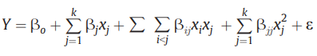 Equation 9
Table 3.2. Experimental set-up for response surface design for biodiesel production from jatropha

3. RESULTS AND DISCUSSIONS
3.1 Composition of Jatropha Biodiesel
The gas chromatography analysis presented in Table 2 below indicates the quantities of glycerol, monoglycerides, diglycerides, and triglyceride biodiesel esters detected in a biodiesel sample following the transesterification process. Diglyceride and monoglyceride are analogous to triglyceride, differing only by the absence of one and two fatty acid chains, respectively (Kouame, 2011). The existence of these molecules in biodiesel may pose issues due to their propensity to act as contaminants in biodiesel.
Table 2: Gas Chromatography-Mass Spectrometry of the biodiesel
Components | Concentration (ug/ml) | % Concentration
Alcohol | 7.6894 | 3.077
Fatty Acid Methyl Ester | 190.9343 | 76.398
Diglyceride | 5.7588 | 2.390
Monoglyceride | 14.4958 | 5.800
Triglyceride | 20.1588 | 8.066
Glycerol | 10.8843 | 4.355
TOTAL | 249.9214

An elevated level of triglycerides is a beneficial characteristic for biodiesel conversion. Jatropha oil exhibited elevated levels of triglycerides. A low concentration of diglycerides is another advantageous characteristic for biodiesel conversion. The currently stated diglyceride level is lower than that of prior reporting (Naresh et al., 2012).
3.2 Physiochemical properties of Jatropha oil and Biodiesel
The physicochemical parameters of jatropha oil, jatropha biodiesel, diesel, and the blend of biodiesel and diesel were assessed and are displayed in Table 3 below. These qualities influence biodiesel and its application. The flash point of biodiesel is the temperature at which the fuel forms a mixture capable of igniting upon exposure to a spark or flame. Flashpoint is a significant characteristic linked to the composition of biodiesel (Prodhan et al., 2020). This characteristic is subsequently associated with the quantity of unconverted triacylglycerides or a diminished concentration of mono-alkyl esters. A high flash point enhances safety in handling and storage, and ASTM D93 stipulates a minimum of 130 °C for biodiesel. The flash point of jatropha FAME (155 °C) exceeded that of diesel (58 °C). Biodiesel possesses a higher flash point than conventional diesel, rendering it a safer fuel option. The flash point increases with an increasing proportion of biodiesel in the blend. The inclusion of fossil fuels significantly lowers the flash point of the blends (Prodhan et al., 2020).
Viscosity is a crucial characteristic of any fuel, signifying the material's capacity to flow. This metric is beneficial for assessing the methyl and ethyl ester concentrations in biodiesel samples, as there exists a link between ester content and viscosity: increased viscosity corresponds to decreased ester content. Biodiesel possesses a greater viscosity (395 pas-1) compared to fossil diesel (350 pas-1). Biodiesel-diesel mixes represent an alternative to enhance this biofuel characteristic. Moreover, the viscosity of biodiesel is influenced by its fatty acid composition, allowing biodiesel blends to decrease viscosity (Candeia et al., 2009).
Table 3: Physico-chemical properties of Jatropha, biodiesel, and blends
S/N |  | Jatropha oil | 20/80 | 50/50 | 80/20 | Jatropha Biodiesel | Diesel
1 | Acid value (mgK0H/g) | 2.227 | 2.244 | 5.61 | 5.89 | 1.391 | 2.252
2 | Saponification value (Mg/KOH) | 85.381 | 75.219 | 92.306 | 113.641 | 80.859 | 143.56
3 | Viscosity (Pas⁻¹) | 522 | 353.9 | 361.2 | 369.4 | 395 | 350.5
4 | Specific gravity (g/ml) | 0.932 | 0.864 | 0.879 | 0.559 | 0.884 | 0.846
5 | Smoke point (⁰C) | 60 | 140 | 123 | 120 | 122 | 120
6 | Fire point (⁰C) | 55⁰C | 190 | 110 | 95 | 53 | 95
7 | Flashpoint (⁰C) | 85⁰C | 63 | 75 | 78 | 155 | 58
8 | Cetane Index |  | 57 | 59 | 60 | 63 | 48
Specific gravity is the ratio of the biodiesel's density to that of an equivalent volume of water. Consequently, the elevated specific gravity of biodiesel facilitates the provision of a somewhat increased fuel mass, thereby enhancing power generation. The specific gravity of biodiesel was found to be marginally greater than that of pure diesel, and it rose with the increasing proportion of biodiesel in the blends due to a heightened degree of unsaturation in fatty acid methyl esters (FAME) (Altaie et al., 2015).
Table 4 Physico-chemical properties of Jatropha to ASTM
S/N |  | Acid value (mgK0H/g) | Saponification value (Mg/KOH) | Kinematic Viscosity (Pas⁻¹) | Specific gravity (g/ml) | Smoke point (⁰C) | Fire point (⁰C) | Flashpoint (⁰C) | Cetane Index
1 | Jatropha Biodiesel | 1.391 | 80.859 | 0.447 | 0.884 | 122 | 53 | 105 | 48
2 | ASTM  Standard | <0.5 |  | 1.9-4.1 | 0.82-0.88 |  | 197 | 100-170 | 40-55
The acidity value is an essential metric indicating the concentration of free fatty acids in the fuel. This is usually quantified in milligrams of potassium hydroxide (KOH) necessary to neutralise the free fatty acids in 1 gramme of the fuel sample (Qi et al., 2010). An elevated acidic number signifies a greater concentration of free fatty acids, which can adversely affect engine performance, fuel system components, and overall fuel stability. The biodiesel exhibited the lowest acidity value in comparison to both the diesel and the blend. A higher saponification value signifies the existence of shorter-chain fatty acids or an increased degree of unsaturation in the fuel.
The smoke point is the temperature at which a substance starts to emit visible smoke upon heating. This parameter is crucial as it offers insights into the thermal stability and combustion characteristics of the fuel. A greater smoke point is typically advantageous, as it signifies that the fuel may be heated to elevated temperatures without generating excessive smoke, which may result in engine deposits, diminished combustion efficiency, and heightened emissions. The fire point is the temperature at which fuel ignites and sustains combustion upon exposure to a flame or spark. This is a critical safety parameter since it signifies the minimum temperature at which the fuel may present a fire risk. An elevated fire point is typically advantageous as it indicates an increased level of safety in the handling, storage, and utilisation of fuel. The blend of biodiesel with diesel enhanced both the smoke point and fire point of the fuel.

3.3 Fourier transform infrared spectroscopy.
The structure of fatty acid methyl esters (biodiesel) was analysed by recording IR spectra of their corresponding peaks, with distinct absorption bands illustrated in Figures 1 and 2 below. Bands in the range of 1750–1730 cm⁻¹ are connected with C=O, while bands in the range of 1300–1000 cm⁻¹ are attributed to C–O (asymmetric axial stretching). The bands in the range of 2980–2950 cm⁻¹ correspond to CH₃ groups, whereas adjacent bands at 2950–2850 cm⁻¹ are attributed to CH₂ groups, and bands at 3050–3000 cm⁻¹ pertain to CH groups. The band at 1475–1350 cm⁻¹ is attributed to CH₃ bending; the bands at 1350–1150 cm⁻¹ are ascribed to CH₂ bending, while the closely related band at 722 cm⁻¹ confirms CH bending. The FT-IR spectra of jatropha oil and biodiesel were identical; nonetheless, distinctions must be noted for identification reasons. The absorption maxima of the oil move from 1067, 1612, 1873, 2013, and 2755 cm⁻¹ to 1013, 1614, 1861, 2090, and 1816 cm⁻¹ in the biodiesel, respectively. The absence of peaks at 922 cm−1 and 1436 cm⁻¹ in the spectra, along with the emergence of a new band at 1739 cm⁻¹, validates the synthesis of biodiesel.
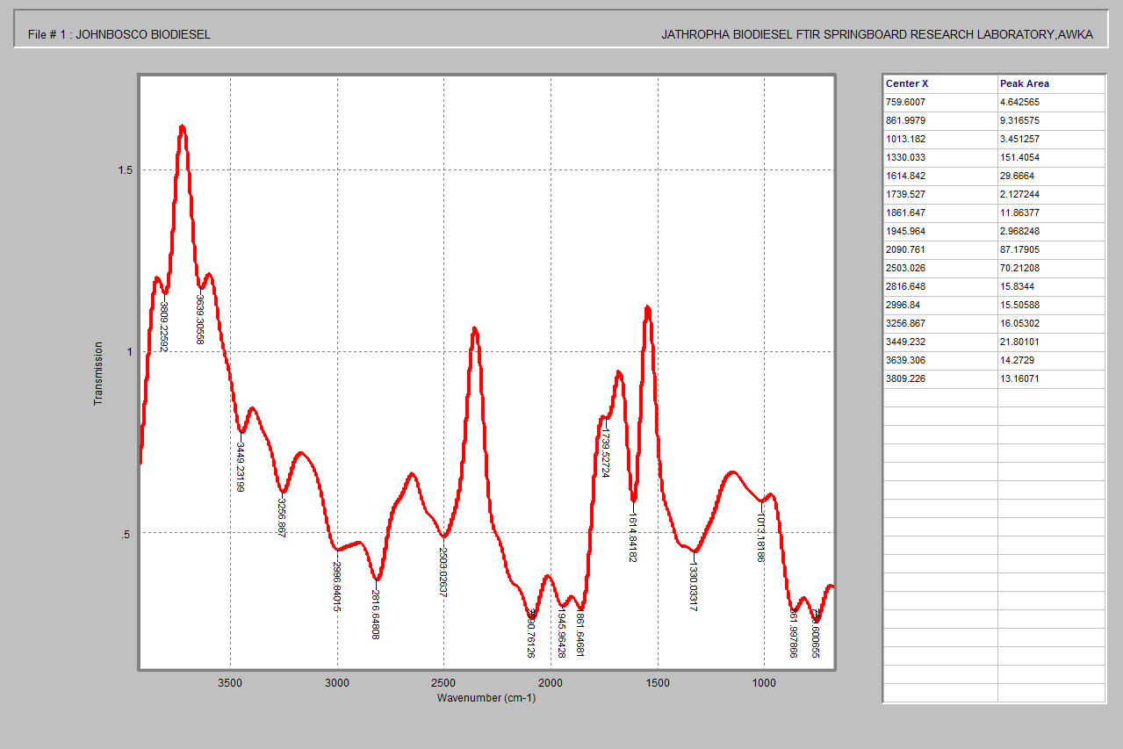
Figure 1: FTIR of the jatropha biodiesel
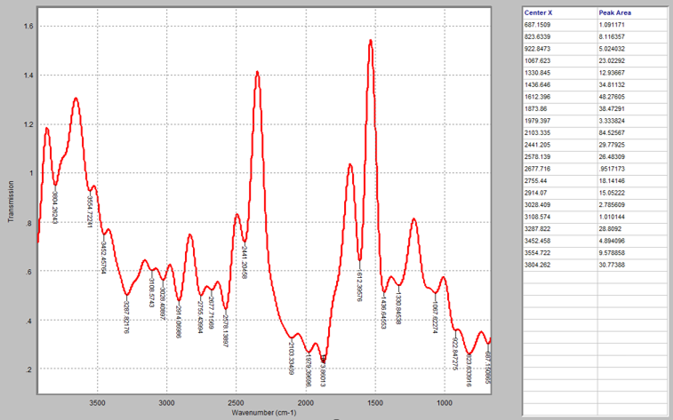
Figure 2: FTIR of the jatropha oil

3.4 Statistical studies of FAME yield from Jatropha seed
The central composite design (CCD) was employed to assess the impacts of temperature, methanol-to-oil ratio, and reaction duration on biodiesel output from jatropha. The investigation indicated that actual yield values varied between 52.63% and 89.12%. Table 5 presents the design matrices for the actual value utilising Central Composite Design (CCD) and the response variable (Yield).
Table 5: CCD design matrix showing the actual and predicted biodiesel yield
Run | A: Temperature  ᴼ C | B: M/O ratio | C: Reaction time  Min | Actual Yield  % | Predicted Yield
1 | 90 | 7 | 50 | 64.14 | 65.14
2 | 65 | 7 | 50 | 85.78 | 87.06
3 | 80 | 4 | 65 | 78.67 | 77.20
4 | 80 | 4 | 35 | 59.80 | 59.57
5 | 65 | 7 | 25 | 58.79 | 60.67
6 | 40 | 7 | 50 | 78.73 | 78.64
7 | 80 | 9 | 35 | 61.89 | 59.81
8 | 65 | 7 | 50 | 86.23 | 87.06
9 | 80 | 9 | 65 | 52.63 | 54.20
10 | 50 | 9 | 65 | 76.79 | 76.37
11 | 65 | 7 | 50 | 89.12 | 87.06
12 | 50 | 9 | 35 | 70.57 | 71.40
13 | 65 | 7 | 50 | 85.85 | 87.06
14 | 50 | 4 | 65 | 80.23 | 81.66
15 | 65 | 7 | 50 | 88.16 | 87.06
16 | 65 | 7 | 75 | 80.64 | 79.67
17 | 65 | 10 | 50 | 59.68 | 59.43
18 | 65 | 7 | 50 | 87.39 | 87.06
19 | 50 | 4 | 35 | 55.67 | 53.46
20 | 65 | 3 | 50 | 62.51 | 63.68

Following the regression analysis of the data, the quadratic model was selected as the optimal model for evaluating biodiesel yield (table 6). The model optimised the statistically adjusted R², R², and anticipated R² values (Nwanna et al., 2023). The predicted R-square value indicates the efficacy of a regression model in forecasting response values, whereas the adjusted R-square value demonstrates the model's explanatory power when several variables are incorporated.

Table 6: Model summary statistics showing quadratic model as the most suited model
Source | Std. Dev. | R² | Adjusted R² | Predicted R² | PRESS
Linear | 11.99 | 0.2276 | 0.0828 | -0.1390 | 3390.13
2FI | 11.82 | 0.3898 | 0.1082 | -0.4783 | 4399.90
Quadratic | 1.82 | 0.9889 | 0.9789 | 0.9286 | 212.40 | Suggested
Cubic | 1.38 | 0.9962 | 0.9878 | 0.8399 | 476.51 | Aliased

The R² value of 0.98 approaches unity and the disparity between predicted and adjusted R² is less than 0.2, signifying reasonable concordance. The signal-to-noise ratio is established by adequate precision, with a preference for a ratio exceeding 4 (table 7). Adeq Precision quantifies the signal-to-noise ratio. A ratio of 26.133 signifies a satisfactory signal. Consequently, the quadratic model is applicable for traversing the design space.

Table 7: the quadratic model fit statistics
Std. Dev. | 1.82 | R² | 0.9889
Mean | 73.16 | Adjusted R² | 0.9789
C.V. % | 2.49 | Predicted R² | 0.9286
 |  | Adeq Precision | 26.1334

3.5 Analysis of variance (ANOVA) for biodiesel yield of Jatropha seed.
Table 8 presents the analysis of variance (ANOVA) for the fitted quadratic model along with the relevant significant model terms for the dependent variable. The model's F-value of 98.88 indicates statistical significance. Furthermore, the probability that such a substantial F-value arises from random variation is about 0.01%. Additionally, p-values below 0.05 indicate that the model terms are statistically significant. A, B, C, AB, AC, BC, A², B², and C² are significant model terms.
Table 8: ANOVA for the quadratic model
Source | Sum of Squares | df | Mean Square | F-value | p-value
Model | 2943.30 | 9 | 327.03 | 98.88 | < 0.0001 | significant
A-Temperature | 219.99 | 1 | 219.99 | 66.51 | < 0.0001
B-M/O ratio | 21.78 | 1 | 21.78 | 6.59 | 0.0281
C-Reaction time | 435.79 | 1 | 435.79 | 131.76 | < 0.0001
AB | 156.69 | 1 | 156.69 | 47.37 | < 0.0001
AC | 56.04 | 1 | 56.04 | 16.94 | 0.0021
BC | 269.94 | 1 | 269.94 | 81.62 | < 0.0001
A² | 414.52 | 1 | 414.52 | 125.33 | < 0.0001
B² | 1172.22 | 1 | 1172.22 | 354.42 | < 0.0001
C² | 513.85 | 1 | 513.85 | 155.36 | < 0.0001
Residual | 33.07 | 10 | 3.31
Lack of Fit | 23.73 | 5 | 4.75 | 2.54 | 0.1649 | not significant
Pure Error | 9.35 | 5 | 1.87
Cor Total | 2976.38 | 19

Moreover, the F-value of 2.54 and p-value of 0.16 for lack of fit suggest that the lack of fit is negligible in comparison to pure error. This indicates that noise has a 16.49% probability of resulting in a significant Lack of Fit F-value. This indicates that the model is suitable for the experiment. The biodiesel yield was represented using a quadratic polynomial model, as illustrated in the equation below. The formulated equations illustrated the empirical link between the dependent and independent variables. The positive coefficients signify that the factors exert a beneficial influence on the response (yield), whilst the negative coefficients imply that the factors have an opposing effect on the response.
$$Yield=0.87.06-4.01A-1.26B+5.65C-4.43AB-2.65AC-5.81BC-5.36A^{2}-9.02B^{2}-5.97C^{2}$$
3.6 Effect of the process variables on the biodiesel yield
The statistically significant factors derived from the analysis were utilised to create the 3D Diagrams. The figures below illustrate the cumulative impact of the independent variables on the dependent variable (FAME yield). Figures 3(a and b) illustrate the influence of the methanol/oil molar ratio and temperature on FAME yield. The molar ratio of alcohol is a critical parameter influencing the yield of biodiesel (Özgür, 2021). Figures 3a and b illustrate that biodiesel output rises with the quantity of alcohol until it attains its optimal value. An excessive quantity of alcohol diminishes biodiesel yield, as the increased alcohol concentration complicates biodiesel separation by enhancing glycerol solubility within the biodiesel phase (Hamze et al., 2015).
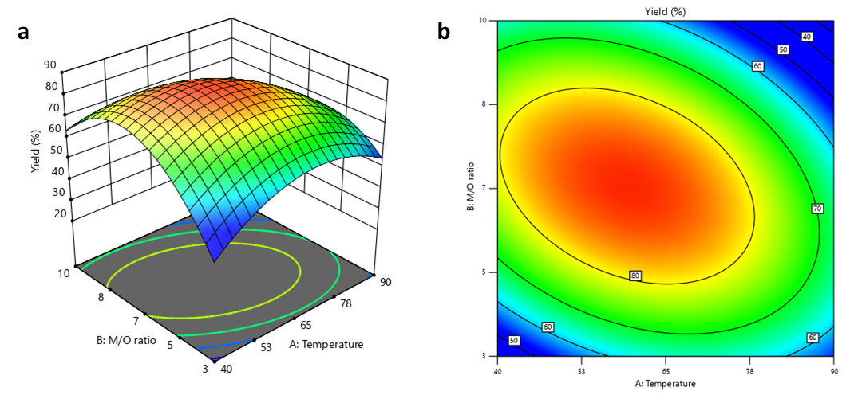
Figure 3. The effect of methanol/oil ratio and temperature on FAME yield. a)3D-plot. b) Contour plot.
The FAME yield resulting from the combined effects of temperature and time are illustrated in Fig. 4 a and b. The contour and 3D surface indicate that the lowest FAME yield was produced at the minimum level, which subsequently significantly climbed to the optimal level as temperature and time were elevated. This demonstrates a beneficial synergistic impact for optimising FAME production. Yahya et al. (2020) achieved a similar notable combinatorial impact in their research on Fe-exchanged montmorillonite utilised as a catalyst for the conversion of waste cooking oil to biodiesel. Nonetheless, as the reaction temperature exceeded the boiling point of the alcohol, the yield diminished. This may be ascribed to the evaporation of methanol at elevated temperatures.
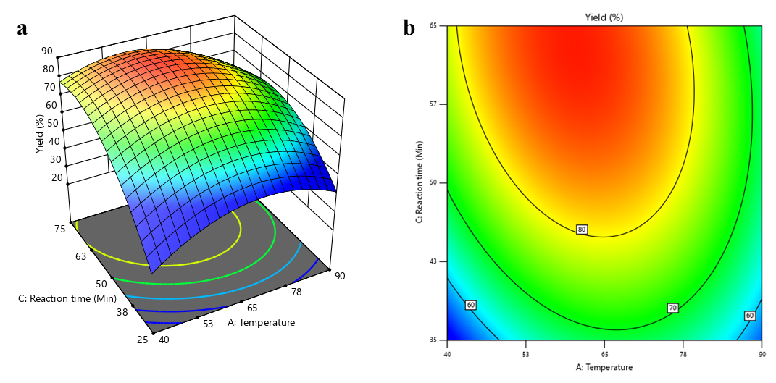
Figure 4. The effect of reaction time and temperature on FAME yield. a)3D-plot. b) Contour plot.
Figures 5a and b illustrate the interaction effect of reaction time and alcohol-to-oil ratio on FAME yield. The graphs indicate that an increase in reaction time correlates with a rise in FAME yield. Nevertheless, an optimal duration was attained at approximately 60 minutes, after which a marginal decline in production was noted. The reduction in yield after 60 minutes may be ascribed to the reversible characteristics of the transesterification process. The dissolving of produced glycerol in methanol for extended reaction durations has been proposed (Latchubugata et al., 2018). Extended heating may revert the produced biodiesel to its initial state, hence constraining the overall biodiesel output (Aworanti et al., 2019).
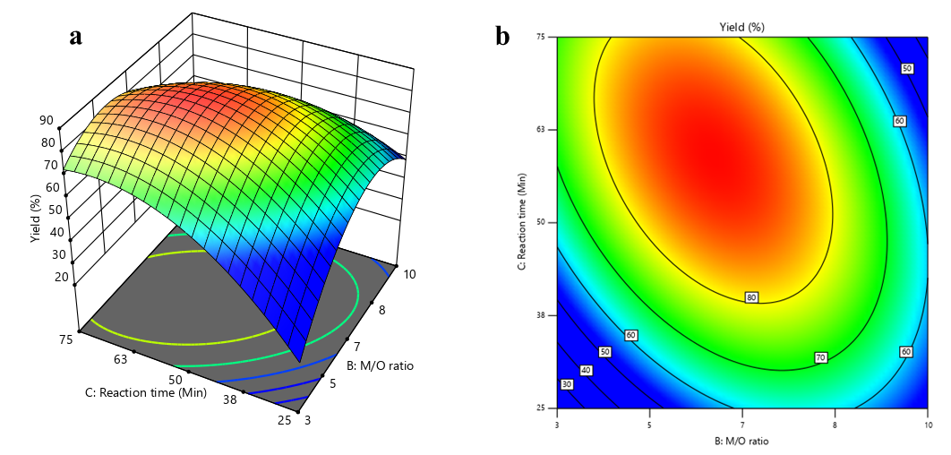
Figure 5. The effect of reaction time and methanol-to-oil ratio on FAME yield. a)3D-plot. b) Contour plot.

3.7 Optimization and verification of the experiment
The experimental design was employed to enhance the yield of FAME. The optimal outcomes were achieved with an alcohol ratio of 6:1, a temperature of 62 °C, and a reaction time of 59 minutes, resulting in a predicted FAME yield of 89%. Validation trials were conducted, and the results were compared with the model's predictions. The mean experimental yield of FAME was 87%. The percentage error between predicted and experimental values was 2.2%, which is below 5%, indicating acceptable agreement. Consequently, these study design models are essential for evaluating FAME yield from Jatropha seeds.

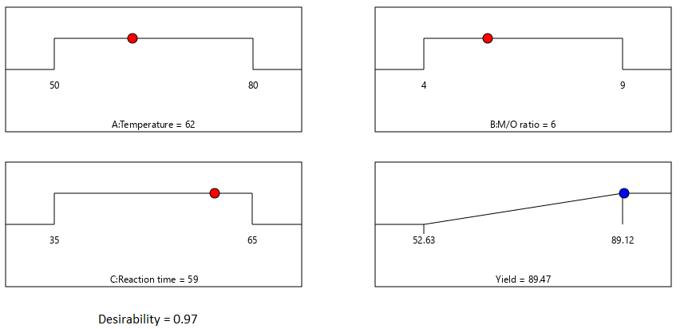
Figure 6: Optimized values of the quadratic model for FAME yield
3.8. CONCLUSION
This study successfully demonstrated the viability of using periwinkle shell waste as a heterogeneous catalyst in the transesterification of Jatropha seed oil for biodiesel production. By utilising Response Surface Methodology (RSM), the optimal reaction conditions were determined to be a reaction temperature of 62°C, an alcohol-to-oil ratio of 6:1, and a reaction time of 59 minutes. These conditions yielded a maximum biodiesel output of 89.47%, showcasing the efficacy of the periwinkle shell catalyst in converting Jatropha oil into a high-quality biofuel. The results of this research not only emphasise the potential of waste materials like periwinkle shells as cost-effective and eco-friendly catalysts but also contribute to the broader aim of sustainable energy production. The high biodiesel yield under optimised conditions highlights the feasibility of scaling up this method for industrial applications, providing a renewable alternative to fossil fuels and offering a solution to the waste disposal issues associated with periwinkle shells. Overall, the study presents a significant step forward in the development of greener, more sustainable biofuels.

Disclaimer (Artificial intelligence)
Author(s) hereby declare that NO generative AI technologies such as Large Language Models (ChatGPT, COPILOT, etc.) and text-to-image generators have been used during the writing or editing of this manuscript.

REFERENCES
- Aisien, F. A., Uwadiae, K. O., & Aisien, E. T. (2023). Process optimization for blended waste frying oil in biodiesel production using CaO derived from African periwinkle shell catalyst through response surface methodology. Sustainable Chemistry for the Environment, 4, 100042. https://doi.org/10.1016/j.scenv.2023.100042
- Altaie, M. A. H., Janius, R. B., Rashid, U., Taufiq-Yap, Y. H., Yunus, R., Zakaria, R., & Adam, N. M. (2015). Performance and exhaust emission characteristics of direct-injection diesel engine fueled with enriched biodiesel. *Energy Conversion and Management*, *106*, 365-372. https://doi.org/10.1016/j.enconman.2015.09.050
- Aworanti, O. A., Ajani, A. O., & Agarry, S. E. (2019). Process parameter estimation of biodiesel production from waste frying oil (vegetable and palm oil) using homogeneous catalyst. Journal of Food Processing & Technology, 10(811). https://doi.org/10.35248/2157-7110.19.10.811
- Azeez, A., Fasakin, A., & Orege, J. (2019). Production, characterisation and fatty acid composition of jatropha curcas biodiesel as a viable alternative to conventional diesel fuel in nigeria. Green and Sustainable Chemistry, 9, 1-10. https://doi.org/10.4236/gsc.2019.91001
- Candeia, R. A., Silva, M. C. D., Carvalho Filho, J. R., Brasilino, M. G. A., Bicudo, T. C., Santos, I. M. G., & Souza, A. G. (2009). Influence of soybean biodiesel content on basic properties of biodiesel–diesel blends. Fuel, 88, 738-743. https://doi.org/10.1016/j.fuel.2008.10.015
- Chozhavendhan, S., Singh, M. V. P., Fransila, B., Kumar, R. P., & Devi, G. K. (2020). A review on influencing parameters of biodiesel production and purification processes. Current Research in Green and Sustainable Chemistry, 1, 1-6. https://doi.org/10.1016/j.crgsc.2020.04.002
- Egbuna, S. O., Onwubiko, D. C., & Asadu, C. O. (2019). Kinetics and thermodynamic studies of beta carotene extraction from palm oil by solvent extraction. Journal of Materials Science Research and Reviews, 2(4), 480-492. https://doi.org/10.9734/jmsrr/2019/v2i430074
- Ejeromedoghene, O. (2021). Acid-catalyzed transesterification of Palm Kernel Oil (PKO) to biodiesel. Materials Today: Proceedings, 47, 1580-1583. https://doi.org/10.1016/j.matpr.2021.04.042
- El Shenawy, E. A., Elkelawy, M., Bastawissi, H. A.-E., Shams, M. M., Panchal, H., Sadasivuni, K., & Thakar, N. (2019). Investigation and performance analysis of water-diesel emulsion for improvement of performance and emission characteristics of partially premixed charge compression ignition (PPCCI) diesel engines. Sustainable Energy Technologies and Assessments, 36, 100546. https://doi.org/10.1016/j.seta.2019.100546
- Elkelawy, M., Bastawissi, H. a.-E., El Shenawy, E. A., Shams, M. M., Panchal, H., Sadasivuni, K. K., & Choudhary, A. K. (2021). Influence of lean premixed ratio of PCCI-DI engine fueled by diesel/biodiesel blends on combustion, performance, and emission attributes; a comparison study. Energy Conversion and Management: X, 10, 100066. https://doi.org/10.1016/j.ecmx.2020.100066
- Elkelawy, M., Bastawissi, H. a.-E., Esmaeil, K. K., Radwan, A. M., Panchal, H., Sadasivuni, K. K., Ponnamma, D., & Walvekar, R. (2019). Experimental studies on the biodiesel production parameters optimization of sunflower and soybean oil mixture and DI engine combustion, performance, and emission analysis fueled with diesel/biodiesel blends. Fuel, 255, 115791. https://doi.org/10.1016/j.fuel.2019.115791
- Elsayed, M., Eraky, M., Osman, A. I., Wang, J., Farghali, M., Rashwan, A. K., Yacoub, I. H., Hanelt, D., & Abomohra, A. (2024). Sustainable valorization of waste glycerol into bioethanol and biodiesel through biocircular approaches: a review. Environmental Chemistry Letters, 22, 609-634. https://doi.org/10.1007/s10311-023-01671-6
- Ewunie, G. A., Morken, J., Lekang, O. I., & Yigezu, Z. D. (2021). Factors affecting the potential of Jatropha curcas for sustainable biodiesel production: A critical review. Renewable and Sustainable Energy Reviews, 137, 110500. https://doi.org/10.1016/j.rser.2020.110500
- Hamze, H., Akia, M., & Yazdani, F. (2015). Optimization of biodiesel production from the waste cooking oil using response surface methodology. Process Safety and Environmental Protection, 94, 1-10. https://doi.org/10.1016/j.psep.2014.12.005
- Kouame, S.-D. B. (2011). Comparative characterization of Jatropha, soybean and commercial biodiesel. Journal of Fuel Chemistry and Technology, 39, 258-264. https://doi.org/10.1016/S1872-5813(11)60020-0
- Kumar, S., & Sani, R. K. (Eds.). (2018). *Biorefining of biomass to biofuels: Opportunities and perception*. Springer International Publishing. https://doi.org/10.1007/978-3-319-67678-4
- Latchubugata, C. S., Kondapaneni, R. V., Patluri, K. K., Virendra, U., & Vedantam, S. (2018). Kinetics and optimization studies using Response Surface Methodology in biodiesel production using heterogeneous catalyst. *Chemical Engineering Research and Design*, *135*, 129-139. https://doi.org/10.1016/j.cherd.2018.05.022
- Mohammed, N. I., Kabbashi, N. A., Alam, M. Z., & Mirghani, M. E. S. (2021). Optimization of Jatropha Biodiesel Production by Response Surface Methodology. Green and Sustainable Chemistry, 11, 23-37. https://doi.org/10.4236/gsc.2021.111003
- Naresh, B., Reddy, M. S., Vijayalakshmi, P., Reddy, V., & Devi, P. (2012). Physico-chemical screening of accessions of Jatropha curcas for biodiesel production. Biomass and Bioenergy, 40, 155-161. https://doi.org/10.1016/j.biombioe.2012.02.012
- Nwanna, E., Orakwe, L., Nwabanne, J., Nwachukwu, C., Ekpo, A., Oyeoka, H. & Maduegbuna, J. 2023. Synthesis and utilization of rice husk cellulose nanocrystals as biocomposite film reinforcement for edible packaging application. UNIZIK Journal of Engineering and Applied Sciences, 2, 416-426.
- Ogunkunle, O., & Laseinde, O. T. (2023). Development of heterogeneous catalyst from assorted periwinkle snail shells for sustainable biodiesel synthesis. E3S Web of Conferences. https://doi.org/10.1051/e3sconf/202343001230
- Okoye, C. C., Okey-Onyesolu, C. F., Nwokedi, I. C., Eije, O. C., & Asimobi, E. I. (2020). Biodiesel Synthesis from Waste Cooking Oil Using Periwinkle Shells as Catalyst. Journal of Energy Research and Reviews, 4(4), 32-43. https://doi.org/10.9734/jenrr/2020/v4i430135 .
- Ong, H. C., Silitonga, A. S., Masjuki, H. H., Mahlia, T. M. I., Chong, W. T., & Boosroh, M. H. (2013). Production and comparative fuel properties of biodiesel from non-edible oils: Jatropha curcas, Sterculia foetida and Ceiba pentandra. Energy Conversion and Management, 73, 245-255. https://doi.org/10.1016/j.enconman.2013.04.011
- Orege, J. I., Oderinde, O., Kifle, G. A., Ibikunle, A. A., Raheem, S. A., Ejeromedoghene, O., Okeke, E. S., Olukowi, O. M., Orege, O. B., Fagbohun, E. O., Ogundipe, T. O., Avor, E. P., Ajayi, O. O., & Daramola, M. O. (2022). Recent advances in heterogeneous catalysis for green biodiesel production by transesterification. Energy Conversion and Management, 258, 115406. https://doi.org/10.1016/j.enconman.2022.115406
- Özgür, C. (2021). Optimization of biodiesel yield and diesel engine performance from waste cooking oil by response surface method (RSM). Petroleum Science and Technology, 39, 683-703. https://doi.org/10.1080/10916466.2021.1954019
- Piloto-Rodríguez, R., Tobío-Pérez, I., & Suárez-Hernández, J. (2020). Diesel engine fuelled with blends of Jatropha curcas oil and diesel fuel. Revista Cubana de Ingeniería, 11(2), 12-19. https://rci.cujae.edu.cu/index.php/rci/index
- Prabhu, A., Venkata Ramanan, M., & Jayaprabakar, J. (2021). Production, properties and engine characteristics of Jatropha biodiesel – a review. International Journal of Ambient Energy, 42(15), 1810-1814. https://doi.org/10.1080/01430750.2018.1557548
- Prodhan, A., Hasan, M. I., Sujan, S. M. A., Hossain, M., Quaiyyum, M. A., & Ismail, M. (2020). Production and characterization of biodiesel from Jatropha (Jatropha curcas) seed oil available in Bangladesh. Energy Sources, Part A: Recovery, Utilization, and Environmental Effects. https://doi.org/10.1080/15567036.2020.1851819
- Qi, D. H., Chen, H., Geng, L. M., & Bian, Y. Z. (2010). Experimental studies on the combustion characteristics and performance of a direct injection engine fueled with biodiesel/diesel blends. Energy Conversion and Management, 51, 2985-2992. https://doi.org/10.1016/j.enconman.2010.06.042
- Ruatpuia, J. V., Halder, G., Shi, D., Halder, S., & Rokhum, S. L. (2024). Comparative life cycle cost analysis of bio-valorized magnetite nanocatalyst for biodiesel production: Modeling, optimization, kinetics and thermodynamic study. Bioresource Technology. https://doi.org/10.1016/j.biortech.2023.130160
- Sahu, G., Gupta, N. K., Kotha, A., Saha, S., Datta, S., Chavan, P., Kumari, N., & Dutta, P. (2018). A review on biodiesel production through heterogeneous catalysis route. ChemBioEng Reviews, 5, 231-252. https://doi.org/10.1002/cben.201700014
- Singh, A., Sinha, S., Choudhary, A. K., Sharma, D., Panchal, H., & Sadasivuni, K. K. (2021). An experimental investigation of emission performance of heterogenous catalyst jatropha biodiesel using RSM. Case Studies in Thermal Engineering, 25, 100876. https://doi.org/10.1016/j.csite.2021.100876
- Umeagukwu, O. E., Onukwuli, O. D., Ude, C. N., & Asadu, C. O. (2022). Methanolysis of Africa Pear Seed Oil via Thermally Activated Empty Palm Fruit Bunch Ash (TAEPFBA) Catalyst, ANN Prediction and Sensitivity Analysis. Journal of Engineering Research and Reports, 23(12), 87–103. https://doi.org/10.9734/jerr/2022/v23i12767
- Venu, H., & Appavu, P. (2020). Al2O3 nano additives blended Polanga biodiesel as a potential alternative fuel for existing unmodified DI diesel engine. Fuel, 279, 118518. https://doi.org/10.1016/j.fuel.2020.118518
- Yahya, S., Muhamad Wahab, S. K., & Harun, F. W. (2020). Optimization of biodiesel production from waste cooking oil using Fe-Montmorillonite K10 by response surface methodology. Renewable Energy, 157, 164-172. https://doi.org/10.1016/j.renene.2020.04.149
- Lie, J., Rizkiana, M. B., Soetaredjo, F. E., Ju, Y. H., Ismadji, S., & Yuliana, M. (2020). Non-catalytic transesterification of waste cooking oil with high free fatty acids content using subcritical methanol: process optimization and evaluation. Waste and Biomass Valorization, 11(11), 5771-5781.Shafi, M. E., Alsabi, H. A., Almasoudi, S. H., Mufti, F. A. M., Alowaidi, S. A., & Alaswad, A. A. (2024). Catalytic Conversion of Jatropha curcas Oil to Biodiesel Using Mussel Shell-Derived Catalyst: Characterization, Stability, and Comparative Study. Inorganics, 12(4), 109. https://doi.org/10.3390/inorganics12040109

