The Reliability Gap in Modern Lakehouse Architectures: A Failure Fingerprinting Framework for Operational Intelligence

ABSTRACT
Modern Lakehouse platforms provide extensive operational observability, including queryable telemetry, execution histories, and runtime diagnostics. Yet data engineering teams repeatedly diagnose and resolve the same failure patterns with no platform-level memory of prior resolutions. This paper formalizes this disconnect as the Observability–Reliability Gap: a structural property of platforms that can reconstruct any individual failure in detail but cannot recognize a current failure as an instance of a previously resolved class. I introduce Failure Fingerprinting, a technique that encodes each failure episode as a normalized feature vector derived from operational signals at failure time, maps it to a stable SHA-256-based identifier, and stores it in a queryable registry. I propose a four-layer reference architecture spanning signal collection, feature engineering, fingerprint generation, and a failure intelligence layer supporting historical matching, fleet-wide pattern detection, and pre-execution predictive warnings. I describe a five-phase incremental adoption methodology delivering standalone operational value at each phase. I further consider the framework in the context of AI-native workloads—embedding pipelines, vector index builds, and large language model inference batches—where static threshold-based alerting is inadequate. This paper presents a prospective framework contribution; all quantitative projections are grounded in published benchmarks from analogous systems, and a complete empirical evaluation design is specified for future validation on production Lakehouse failure data.
Keywords: data Lakehouse; reliability engineering; failure fingerprinting; observability; data platform operations; predictive failure detection; mean time to repair; AI-native workloads; AIOps; incident deduplication

1. INTRODUCTION
Over the past decade, large-scale data platforms have matured in both architecture and operational observability. Modern Lakehouse architectures are built on open table formats such as Apache Iceberg [5] and Delta Lake [4], and hosted on platforms including Databricks, Snowflake, and Google BigQuery. These platforms now expose per-task execution telemetry, executor memory saturation curves, stage-level DAG topologies, and structured failure timelines through SQL-queryable interfaces [1], [2], [3], [24].
Yet a persistent operational failure mode cuts across organizations that have adopted these platforms. The same failure classes recur and are diagnosed from first principles by different engineers on different occasions. These failures are resolved through essentially identical interventions, without any platform-level mechanism to recognize or surface the recurrence. Prior work on troubleshooting recurring problems in production systems [6] and large-scale incident analysis [30], [31] indicates that failure recurrence is a structurally significant property of distributed platforms, though the exact recurrence distribution varies by deployment. The platform records what happened with high fidelity. It does not record that it has seen this before.
This paper identifies the structural root of this problem, formalizes it as the Observability–Reliability Gap, and proposes Failure Fingerprinting as a deployable framework for addressing it within existing Lakehouse infrastructure.
1.1 Motivation
Consider a representative operational scenario. A Spark job processing customer order aggregations fails at 02:00 with an ExecutorLostFailure. The on-call engineer traces executor memory graphs in the Spark UI, identifies a data skew condition on the customer_id join key, applies salting, and adjusts spark.sql.shuffle.partitions from 200 to 800, resolving the incident in approximately 90 minutes. Three months later, the same failure pattern manifests on a different pipeline. A different engineer repeats the same forensic process, arriving at the same remediation in approximately 75 minutes.
The first engineer’s knowledge was encoded in a closed incident ticket and personal memory—invisible to the platform and inaccessible to colleagues. The platform captured every signal required to identify the pattern on both occasions. This is not a failure of instrumentation; it is a failure of architecture. The diagnostic effort was paid twice because the platform stores failure events as isolated records rather than as instances of a classifiable pattern.
1.2 The Observability–Reliability Gap
Contemporary Lakehouse platforms provide a comprehensive observability stack [22], [23]. Standard capabilities include per-task execution logs with structured error messages and stack traces; executor memory utilization sampled over time; shuffle read/write volumes and spill statistics at the stage level; stage-level DAG topology with task duration distributions; runtime configuration snapshots; SQL-queryable telemetry tables; and cluster-level metrics including autoscaling events and spot instance interruptions.
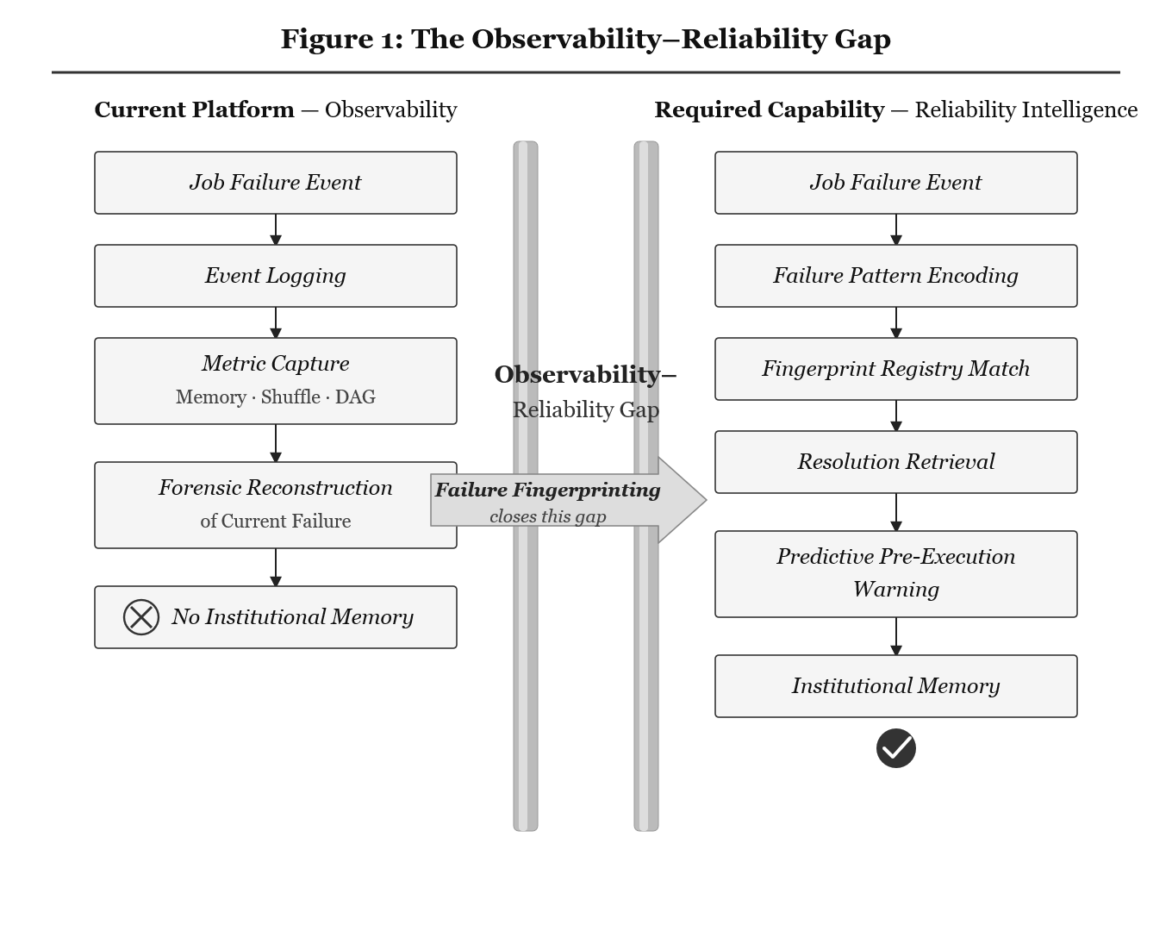
Fig. 1. The Observability–Reliability Gap.
These capabilities allow an engineer to answer: What happened during this failure? They do not answer a qualitatively different class of questions: Has this failure occurred before? What resolved it? Which other pipelines exhibit the same pattern? These questions demand institutional memory of past failure episodes, not merely instrumentation of the current one. I define this gap formally:
Definition 1 (Observability–Reliability Gap). A platform exhibits this gap when it can reconstruct any individual failure in full detail but cannot recognize a current failure as an instance of a previously observed and resolved failure class. The consequence is that every recurrence of a known failure pattern imposes the full cognitive and time cost of first-time diagnosis.
This definition is falsifiable: a platform that maintains a structured failure registry with automated recurrence recognition does not exhibit the gap. The definition distinguishes the gap from monitoring deficiencies (insufficient instrumentation) and alerting deficiencies (missing threshold rules). A platform may have excellent monitoring and alerting while still exhibiting the Observability–Reliability Gap, because neither monitoring nor alerting provides cross-episode pattern memory.
1.3 Scope and Exclusions
The failure modes addressed are recurring operational failures in Lakehouse data pipelines characterized by identifiable patterns in operational signals: shuffle volume, memory utilization, data skew coefficients, cluster configuration, and structured error classes. The paper does not address data correctness failures (e.g., semantic errors in transformation logic), infrastructure-level outages (e.g., cloud region unavailability), or model performance drift in machine learning systems.
1.4 Contributions
This paper makes the following contributions:
Problem formalization. A precise, falsifiable definition of the Observability–Reliability Gap as a structural platform property, distinct from monitoring or alerting deficiencies.
Failure Fingerprinting model. A normalized feature vector encoding scheme for failure episodes with a SHA-256-based hashing methodology producing stable, deterministic identifiers. The choice of p95-denominator normalization over alternatives (IQR, MAD, z-score) is justified analytically and through domain-specific considerations.
Four-layer reference architecture. A complete reference architecture with component specifications, interface definitions, and algorithmic descriptions for each layer.
Five-phase incremental adoption methodology. A phase-gated adoption path, each phase delivering standalone operational value, progressing from schema enrichment to predictive failure prevention.
Prospective evaluation framework with projected bounds. Formally defined metrics (recurrence detection precision/recall, MTTR reduction, failure prevention rate) with projected performance ranges derived from analogous systems in network intrusion detection [7], crash report deduplication [32] and AIOps log clustering [8], [28], [33].
AI-native workload extension. An extended fingerprint schema covering embedding pipelines, vector index builds, LLM inference batches, and API-dependent workloads.
This paper presents a prospective framework contribution. All evaluation metrics are formally defined, and projected performance ranges are derived from analogous systems in network intrusion detection, crash report deduplication, and AIOps log clustering. Empirical validation on production Lakehouse failure data is planned as future work and is specified in the evaluation design. The framework is positioned as an architectural and conceptual contribution intended to establish the theoretical foundation and design blueprint for deployment-ready failure intelligence systems.
2. RELATED WORK
2.1 Lakehouse Architecture and Platform Observability
The Lakehouse architecture emerged to resolve the tension between data lake cost efficiency and data warehouse transactional reliability [1], [4], [5]. Open table formats—Delta Lake [4] and Apache Iceberg [5]—provide ACID transactions, schema evolution, and time travel over object storage. Platform observability has evolved with SQL-queryable system telemetry tables, structured job execution histories, and cluster metrics APIs [1], [2], [3]. Li et al. [22] survey industrial observability practices for microservice tracing and find that while per-request tracing is mature, cross-episode pattern memory remains an open problem. Peng et al. [23] confirm this finding in large-scale trace analysis. The present paper addresses this gap specifically for Lakehouse operational telemetry.
2.2 AIOps and Automated Incident Management
The AIOps paradigm applies machine learning to IT operations for anomaly detection, root cause analysis, and incident management [16]. Zhang et al. [16] survey AIOps in the context of large language models, identifying automated log analysis, metric anomaly detection, and incident triage as core capabilities. Du et al. [28] introduce DeepLog, which applies LSTM-based deep learning to system log sequences for anomaly detection and diagnosis. He et al. [8] provide a comprehensive survey of automated log analysis for reliability engineering, covering log parsing (Drain [33], Spell), log clustering, and anomaly detection methods.
These AIOps approaches address a related but distinct problem. Log-based anomaly detection identifies that something is wrong; Failure Fingerprinting identifies which previously observed failure class is recurring and what resolved it before. AIOps anomaly detectors typically operate on log sequences or metric streams and produce anomaly scores; they do not maintain a structured registry of resolved failures with associated remediations. Jiang et al. [26] (Xpert) apply LLMs to incident management through query recommendations, demonstrating that structured incident knowledge improves resolution efficiency.
2.3 Fault Fingerprinting and Signature-Based Diagnosis
Encoding failures as structured, searchable representations has precedents across computing domains. In network security, signature-based intrusion detection systems (IDS) such as Snort [7] maintain pattern libraries of known attack behaviors and achieve classification precision in the range of 0.85–0.95 on known signature classes [7]. More recent security-driven frameworks, such as X-SecureNet [35], demonstrate that intelligent, multi-layered detection architectures can achieve high classification accuracy in industrial environments by combining signature based and anomaly-based methods. This hybrid approach parallels the present work’s combination of exact fingerprint matching (signature based) with approximate similarity search (anomaly aware). Unlike IDS signatures, which encode discrete packet header fields and byte patterns, Lakehouse failure patterns are characterized by continuous resource utilization profiles that vary by orders of magnitude across workloads.
In software bug tracking, crash report deduplication systems provide the closest methodological precedent. Mozilla’s Socorro system [32] groups crash reports by stack trace signature, reducing duplicate bug reports by approximately 80%. These systems demonstrate that structured failure encoding enables effective recurrence recognition at scale; however, they operate on discrete event records rather than on the continuous, multi-dimensional resource utilization vectors characteristic of Lakehouse workloads.
2.4 Distributed Systems Failure Analysis
Luo et al. [6] study transiently recurring problems and demonstrate that blame-proportional logging improves diagnosis of recurring failures. Gunawi et al. [30] analyze failure characteristics across cloud services, finding that a majority of critical failures follow recurring patterns amenable to automated detection. Yuan et al. [31] study catastrophic failures in distributed data-intensive systems and find that the majority are caused by a small number of recurring error-handling patterns. The SRE practice formalized by large-scale internet operators [27] addresses organizational knowledge management through structured postmortem culture. Root cause analysis in microservices through causal discovery [9] represents an automated approach to failure diagnosis.
2.5 Workload Characterization and Telemetry Mining
Research on workload fingerprinting in cloud and HPC environments demonstrates that resource utilization profiles can serve as discriminative features for workload classification, exhibiting sufficient regularity for statistical modeling while maintaining inter-workload variance that enables classification.
2.6 Data Pipeline Operations and Reliability
Apache Spark’s execution model—shuffle-heavy DAG-based computation with distributed memory management—creates a specific failure taxonomy studied in the distributed query processing literature [17], [18]. Data skew in parallel join execution is a well-documented failure mode with established remediation techniques [18], [27]. Spot instance interruption patterns affect job reliability depending on cluster composition [19]. Schema evolution introduces compatibility failures when upstream producers change formats without consumer coordination [20].
2.7 Approximate Nearest-Neighbor Search
The similarity-based matching capability relies on approximate nearest-neighbor (ANN) search. FAISS [10] provides efficient ANN through inverted file index (IVF) and product quantization, supporting sub-millisecond query latency at tens of millions of vectors. The HNSW graph index [15] offers superior recall at higher memory cost. ANN benchmarking research [14] establishes the recall-latency-memory tradeoff space.
2.8 Summary and Positioning
Table 1 positions Failure Fingerprinting relative to the approaches surveyed above. No prior work combines signature-based identification with percentile-relative normalization and a structured remediation registry for the Lakehouse domain.
Table 1. Positioning of Failure Fingerprinting Relative to Related Approaches
Approach | Signal Type | Recurrence Memory | Remediation Link | Domain | Normalization
IDS (Snort) [7] | Discrete packets | Signature library | None | Network | Byte-pattern
Socorro [32] | Stack traces | Deduplication | Bug tracker | Software | Hierarchical hash
DeepLog [28] | Log sequences | None (anomaly) | None | General | Sequence model
Drain [33] | Log templates | Cluster-based | None | General | Template parse
Xpert [26] | Incident text | Query-based | Partial (LLM) | Cloud ops | Embedding
SRE Postmortem [27] | Narrative | Doc search | Narrative | General | None
This paper | Cont. + cat. | FP registry | Structured | Lakehouse | Percentile-rel.

3. METHODOLOGY
3.1 Recurring Failure Taxonomy
A prerequisite for fingerprinting is characterization of the failure classes that are both common and recurring. Table 2 enumerates the principal recurring failure categories in Lakehouse platforms.
Table 2. Common Lakehouse Failure Classes and Associated Signal Signatures
Failure Class | Root Cause | Primary Signal | Secondary Signals | Typical Resolution
Data Skew | Non-uniform key dist. | Task dur. variance >10× median | High shuffle write; uneven partitions | Join key salting; repartition; increase shuffle.partitions
Memory Saturation | Executor JVM heap exhaust. | Peak memory util. >95% | GC overhead >25%; OOM events | Cluster upsizing; broadcast join threshold reduction
Shuffle Spill | Insufficient executor memory | Disk spill >50% of shuffle write | Degraded throughput; elevated time | Increase shuffle.partitions; executor memory increase
Spot Interruption | Cloud provider preemption | Abrupt executor loss | Autoscaling events; heartbeat gaps | On-demand capacity; maxTaskFailures; speculation
Schema Drift | Upstream schema change | Deserialization exception | Catalog audit log events | Schema evolution policy (Delta/Iceberg)
API Rate Limiting | External API quota exhaust. | HTTP 429 response codes | Retry exhaustion; API latency | Exponential backoff with jitter; throttling

3.2 Failure Fingerprinting: Conceptual Model
Failure Fingerprinting treats each failure episode as a structured pattern rather than an isolated event. The operational state at failure time—cluster configuration, resource utilization profile, error class, and workload characteristics—is encoded as a normalized feature vector. A deterministic hash of this vector produces a stable identifier: the Failure Fingerprint.
Unlike IDS signatures, which encode discrete packet header fields and byte patterns [7], Lakehouse failure patterns are defined over continuous resource utilization vectors spanning multiple orders of magnitude across workloads. Crash report deduplication [32], [33] groups failures by stack trace identity. In contrast, Failure Fingerprinting combines categorical error classes with normalized continuous resource features. This enables it to distinguish failure classes that share error messages but differ in operational profiles.
3.2.1 Fingerprint Schema
A Failure Fingerprint is constructed from the ten attributes in Table 3, recorded at failure time before cluster teardown.
Table 3. Fingerprint Feature Vector Specification. Defines the complete structured encoding of a failure episode.
Attribute | Type | Normalization | Description | Example
error_class | Categorical | Label-encoded | Structured error category | ExecutorLostFailure
cluster_type | Categorical | Label-encoded | Instance family of workers | memory-optimized-r
runtime_version | String | Raw (stratification) | Platform runtime ID | DBR 14.3
shuffle_volume_gb | Continuous | Percentile-relative | Total shuffle write (GB) | 240→norm: 2.14
skew_coefficient | Continuous | Percentile-relative | Max task dur. / median | 3.9→norm: 1.87
executor_mem_pct | Continuous | Percentile-relative | Peak executor memory % | 96%→norm: 2.31
join_strategy | Categorical | Label-encoded | Active join strategy | SortMergeJoin
partition_count | Integer | Raw | Active shuffle partitions | 200
input_gb | Continuous | Percentile-relative | Total input volume (GB) | 1840→norm: 0.92
fingerprint_id | String | SHA-256 output | 8-char hex display ID | 7a3f9c2e

Feature selection rationale. The ten attributes were selected based on three criteria: (a) availability from standard platform telemetry without custom instrumentation; (b) discriminative power across the six failure classes in Table 2; and (c) stability across repeated executions of the same failure class. Formal feature importance analysis via ablation is identified as a priority for the planned empirical validation (Section 3.5).Upon a subsequent failure yielding fingerprint 7a3f9c2e, the registry returns: “Fingerprint 7a3f9c2e matched. 9 prior occurrences. Last resolved 2026-01-18. Remediation: salt the customer_id join key; set spark.sql.shuffle.partitions=800.”
3.2.2 Feature Normalization
Continuous features must be normalized relative to each job’s historical baseline. A shuffle volume of 50 GB is unremarkable for a large daily batch but anomalous for a routine hourly incremental. The normalization formula for continuous feature f of job j at time t is:
f_normalized(j, t) = ( f(j, t) − p50(f, j) ) / ( p95(f, j) − p50(f, j) )
where p50(f, j) and p95(f, j) are the 50th and 95th percentiles of feature f over the job’s rolling historical execution window (30–90 days).
Choice of denominator. The denominator p95 − p50 (the upper semi-interquartile range) was chosen over three alternatives. Standard deviation is sensitive to outliers and assumes approximate normality, an assumption violated by the heavy-tailed distributions typical of data workloads. The full interquartile range (p75 − p25) provides less discrimination in the upper tail, where failure-relevant deviations occur. Median absolute deviation (MAD) is robust but compresses the upper tail, reducing sensitivity to the anomalous-high values characteristic of the failure classes in Table 2.
Edge cases. When p95(f, j) = p50(f, j), the denominator is zero. In this case, if f(j, t) = p50(f, j), f_normalized is assigned 0; otherwise, f_normalized is assigned a configurable sentinel value (default: 3.0). For jobs with fewer than 20 executions, percentile estimates are unreliable; such jobs fall back to absolute-value features and their fingerprints are flagged with reduced confidence (see L3 in Section 5.6).
Per-job statistics are maintained using incremental estimation algorithms (P-square algorithm [12] or reservoir sampling [13]) applied to a rolling execution window.
3.2.3 Approximate Matching
Exact fingerprint matching—identity of the SHA-256 hash—identifies recurrences of the identical failure signature. Approximate matching uses cosine similarity [14] over normalized feature vectors:
sim(v_query, v_i) = (v_query · v_i) / (||v_query|| × ||v_i||)
Threshold selection. A similarity threshold of τ = 0.85 is proposed for same-class attribution. This value is derived from analogous systems: Snort IDS achieves effective classification at thresholds of 0.80–0.90 [7]; crash report deduplication operates at 0.85–0.95 [32]; log template clustering reports effective grouping at 0.80–0.90 [8], [33]. I adopt τ = 0.85 as a conservative starting point. The threshold should be calibrated per deployment; sensitivity analysis across τ ∈ [0.60, 0.95] is specified in Section 3.5. For pre-execution partial vectors, a relaxed threshold τ_pre = 0.70 is applied.
3.3 System Architecture: Four-Layer Reference Design
The Failure Fingerprinting system is organized as four functionally distinct layers with specified interfaces.
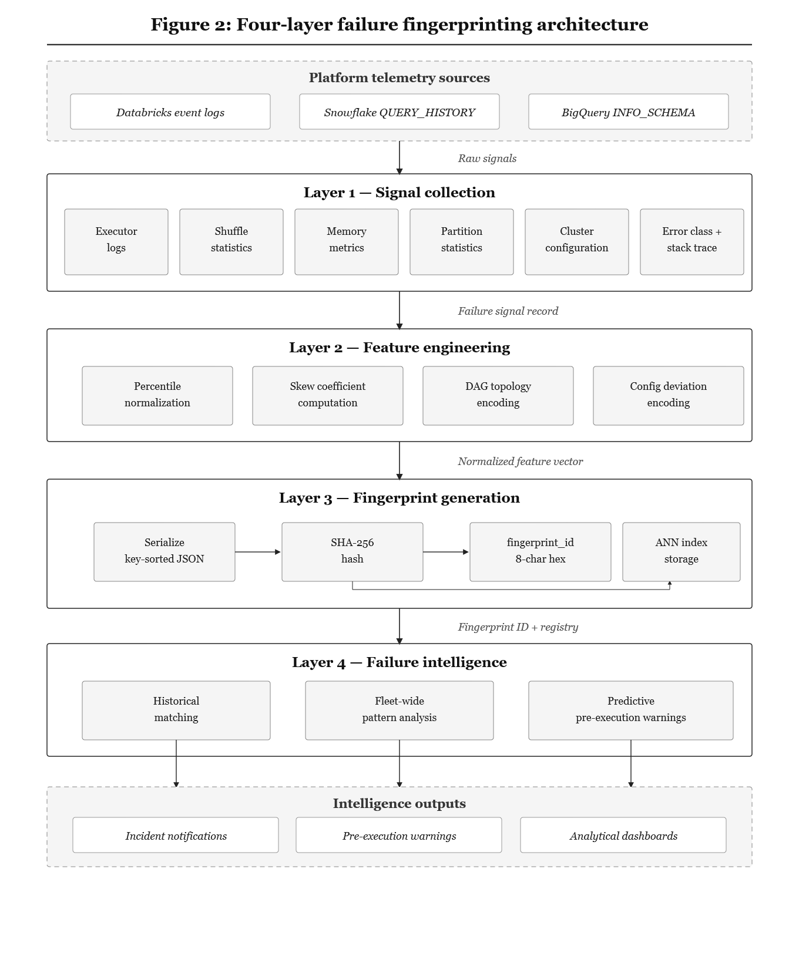Fig. 2. Four-Layer Failure Fingerprinting Architecture.
3.3.1 Signal Collection Layer
Collection trigger and timing. Signal collection is triggered by the job failure event through a webhook or callback. On platforms supporting event-driven integration (Databricks job run state change callbacks, Snowflake task failure notifications), the collector is invoked synchronously. Where unavailable, a polling-based collector with sub-30-second resolution provides acceptable coverage. The collection process must complete within the cluster teardown grace period (30 seconds to 5 minutes). If interrupted, the partial record is flagged with a completeness score.
Platform-specific telemetry sources. On Databricks: system tables (system.compute.clusters, system.lakeflow.job_run_timeline [2], [24]) and the Spark UI event log. On Snowflake: QUERY_HISTORY and TASK_HISTORY views [3]. On Google BigQuery: INFORMATION_SCHEMA.JOBS and Cloud Logging.
Required signals. Shuffle read/write volumes and spill by stage; executor memory utilization (peak and time-averaged); task duration distributions (p50, p95, max); active Spark configuration parameters; input partition count and size distribution; cluster instance type and executor count; structured error class with stack trace hash.
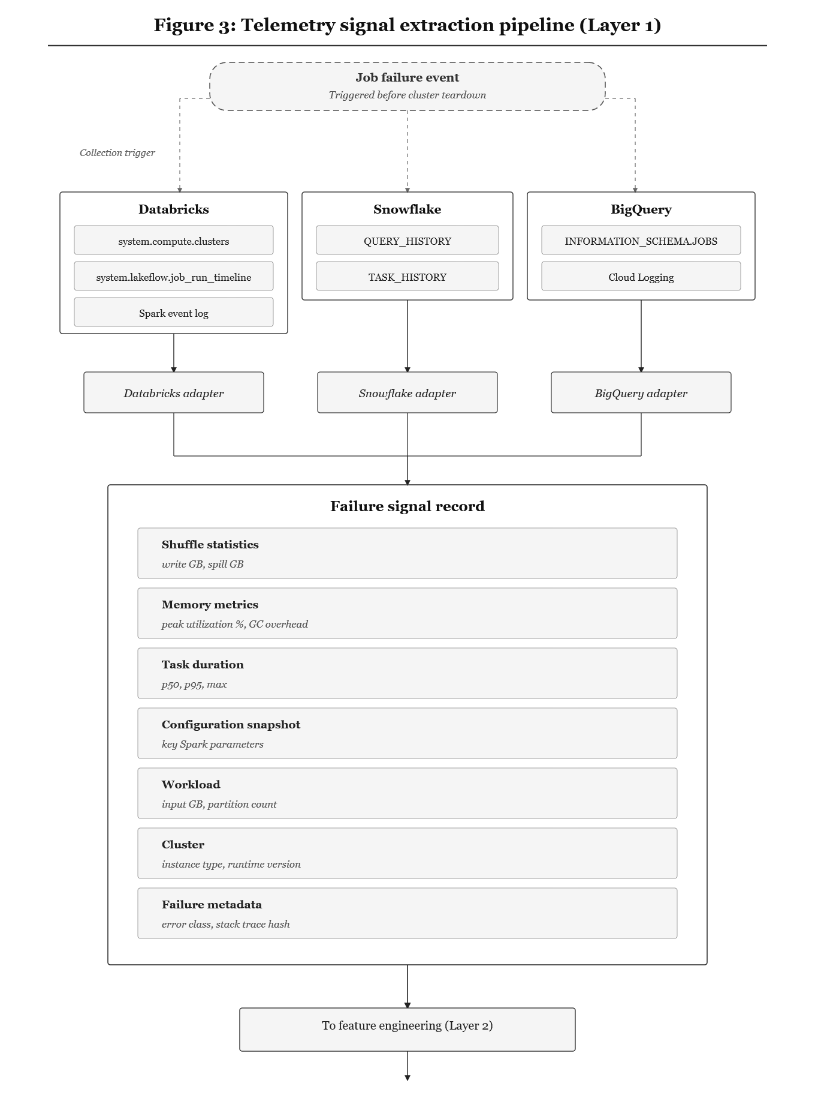Fig. 3. Telemetry Signal Extraction Pipeline.

3.3.2 Feature Engineering Pipeline
The feature engineering pipeline transforms raw signals into the normalized feature representation through four parallel transformation paths.
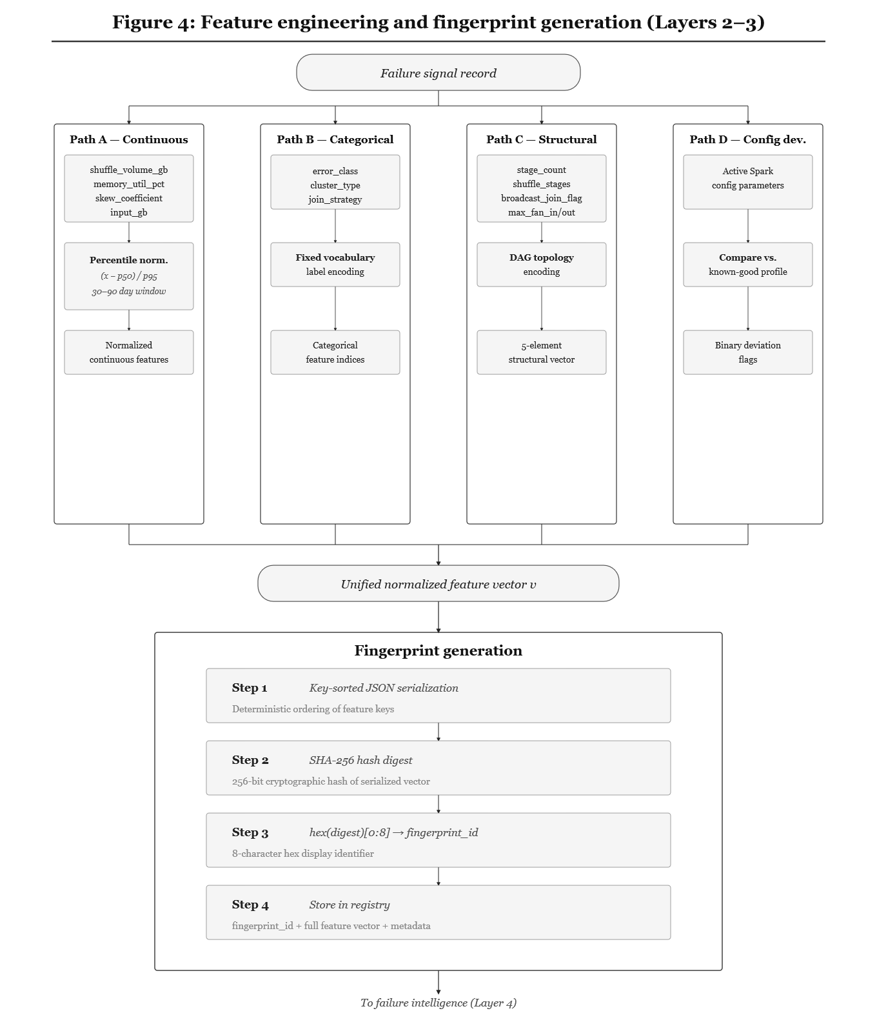Fig. 4. Feature Engineering and Fingerprint Generation.
The pipeline operates through four parallel transformation paths. In Path A (continuous normalization), continuous signals are normalized using the percentile-relative formula described in Section 3.2.2. In Path B (categorical encoding), the error_class, cluster_type, and join_strategy fields are encoded as integer indices against a fixed vocabulary derived from the failure taxonomy in Table 2, augmented with an UNKNOWN token for out-of-vocabulary values. In Path C (DAG topology encoding), the execution DAG is compressed into a five-element structural vector capturing stage count, shuffle-inducing stage count, broadcast join presence, maximum stage fan-in, and maximum stage fan-out; for jobs with Adaptive Query Execution enabled, the vector is computed from the post-AQE executed DAG. This representation is intentionally lossy—structurally different DAGs may produce identical summaries—and graph-level embeddings via graph neural networks are discussed as future work in Section 5.7. Finally, in Path D (configuration deviation encoding), active Spark configuration parameters are compared against a known-good profile—defined as the parameter set under which the job has succeeded for at least 90% of executions in the prior 30-day window—versioned by platform runtime, with deviations encoded as binary flags. For jobs that legitimately operate under different configurations depending on input volume (e.g., different partition counts for daily versus monthly loads), the known-good profile is stratified by input volume quartile to produce regime-specific baselines.
3.3.3 Fingerprint Generation Algorithm
The fingerprint generation algorithm proceeds in four deterministic steps. Given a normalized feature vector V, the algorithm first serializes V into a canonical string representation using key-sorted JSON with floating-point values rounded to four decimal places, ensuring that identical feature vectors always produce identical string encodings regardless of insertion order. Second, a SHA-256 cryptographic digest [11] is computed over the canonical string. Third, the first eight hexadecimal characters of the digest are extracted to produce the display-level fingerprint_id; at this truncation length, the collision probability is approximately 1/2³² per pairwise comparison, yielding fewer than 2.3×10⁻⁴ expected collisions at a registry scale of one million entries. Fourth, the full record—comprising fingerprint_id, the complete 64-character hex hash, the feature vector V, job_id, pipeline_id, failure_time, and error_class is persisted to the failure registry with resolution and MTTR fields initialized as null, to be populated upon incident closure.
3.3.4 Failure Registry Design
Figure 5 depicts the design of the failure registry and the associated pattern-matching engine used to support efficient failure lookup and similarity-based retrieval.
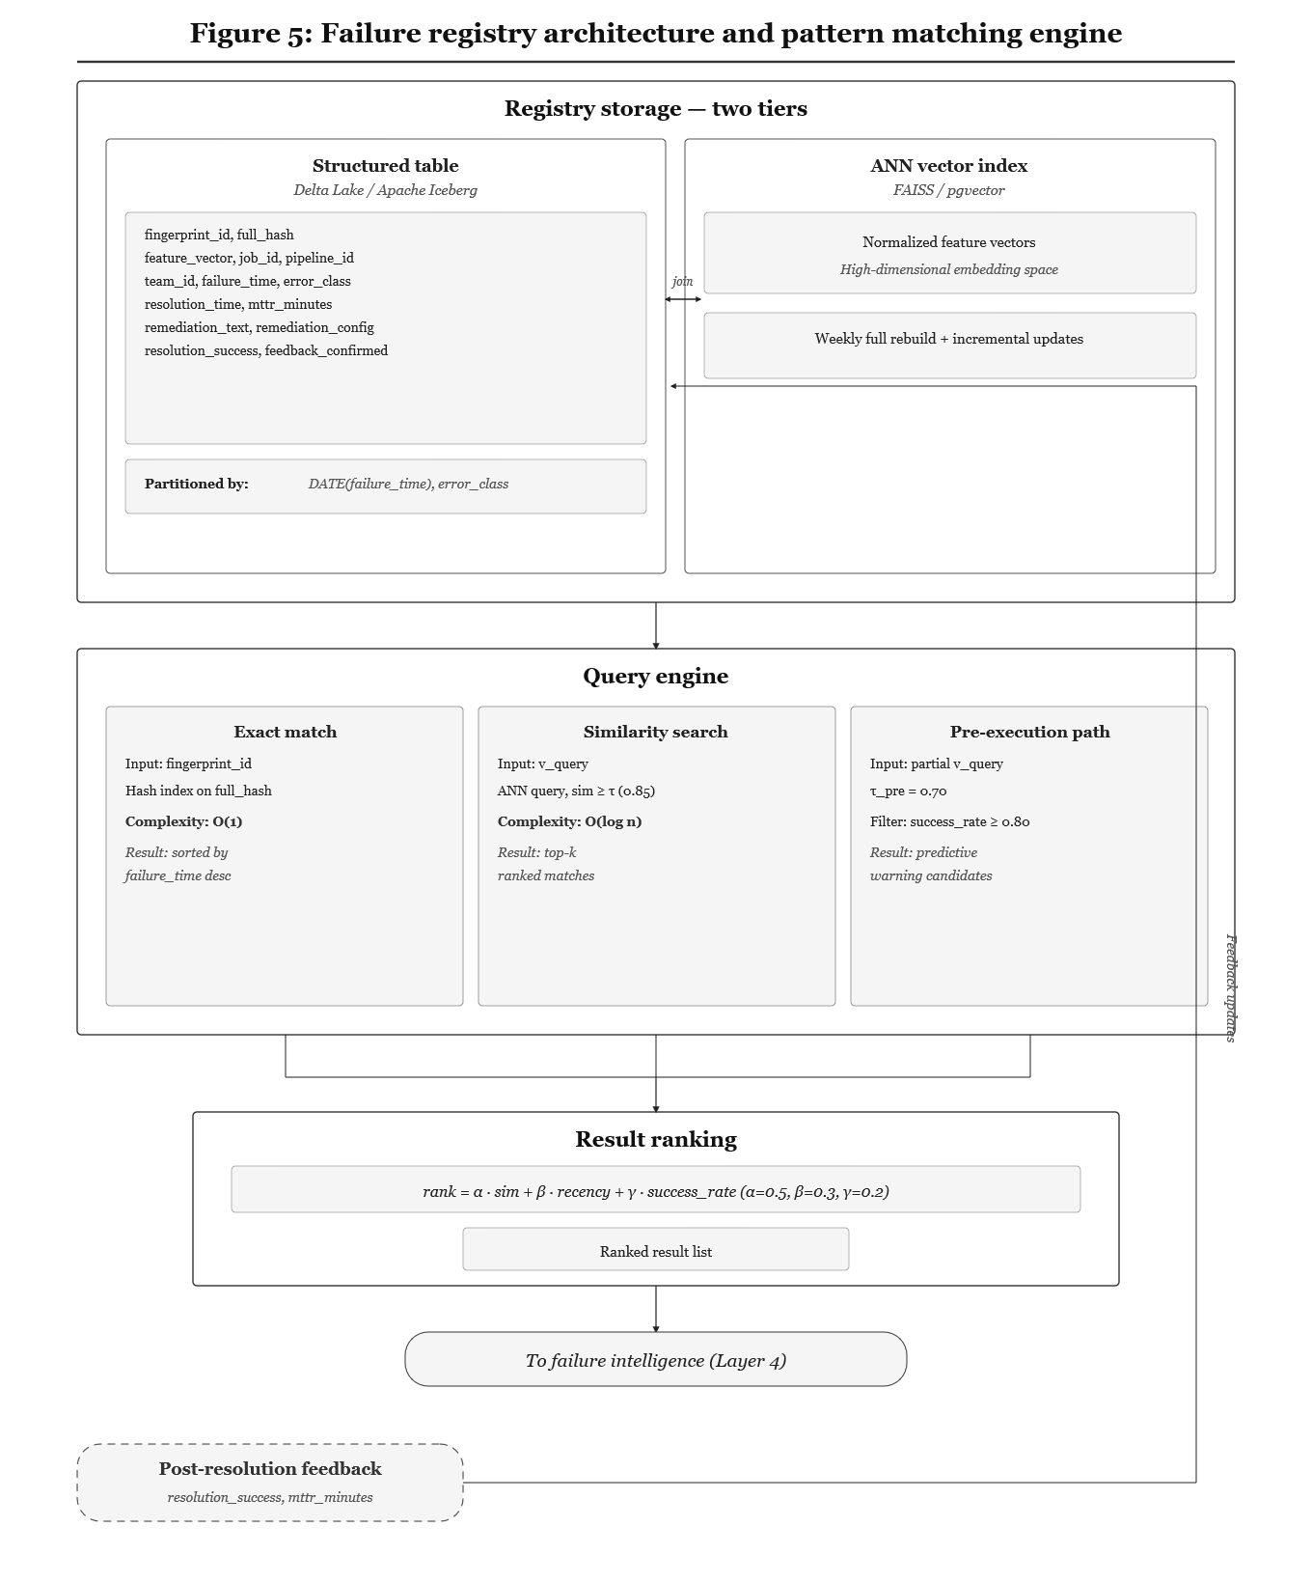Fig. 5. Failure Registry Architecture and Pattern Matching Engine.
The failure registry employs a two-tier storage design. The first tier is a Delta Lake [4] or Apache Iceberg [5] table partitioned by DATE(failure_time) and error_class, storing the complete fingerprint record: fingerprint_id, full hash, serialized feature vector, job and pipeline identifiers, team and platform metadata, error class, resolution fields (remediation text, configuration, MTTR, success flag), and a completeness score. The second tier is an ANN vector index—FAISS [10] or pgvector—over the normalized feature vectors, rebuilt weekly with incremental updates on insertion, supporting sub-millisecond similarity queries at scale. Both tiers are joined by fingerprint_id, allowing the query engine to route exact lookups through the structured table and similarity searches through the ANN index. A schema_version field supports version-stratified matching as the fingerprint schema evolves (e.g., with the AI-native extensions in Table 6); cross-version queries fall back to the intersection of common fields. For new deployments, a backfill pipeline seeds the registry from up to 12 months of historical failure data. During cold start (fewer than 90 days indexed), τ is relaxed to 0.75 and matches are flagged as low coverage.
3.3.5 Pattern Matching and Retrieval
Three query modes are supported: exact match (O(1) via hash index), similarity search (O(log n) via ANN index), and pre-execution partial match (τ_pre = 0.70). Results are ranked by composite score:
rank(i) = α · sim(v_query, v_i) + β · recency(failure_time_i) + γ · success_rate(i)
Default weights α = 0.5, β = 0.3, γ = 0.2. These starting values are informed by analogous ranking designs in information retrieval [14] and incident search systems [26]. Weight optimization is specified in Section 3.5.
Novel failure handling. When no match meets the threshold, the query returns “No match—novel failure signature.” The record is persisted for future reference.
3.3.6 Predictive Alert Generation
For jobs whose input statistics are available at submission time—file sizes, partition counts, and DAG structure from the job definition—the platform queries the failure registry before execution begins. A partial feature vector is constructed from the pre-execution signals only, and a similarity query is executed against the registry at the relaxed threshold τ_pre = 0.70, filtered to return only entries with a confirmed resolution success rate of at least 0.80. If a qualifying match is found, the platform generates and delivers a structured warning to the submitting engineer that includes the matched fingerprint, its historical occurrence count, and the previously validated remediation. Regardless of whether the engineer acts on the warning, the job proceeds to execution and its outcome is recorded as a feedback signal in the registry, enabling continuous refinement of match quality over time. Recommendations are strictly advisory; automated application of configuration changes without engineer confirmation is outside the scope of this framework (Section 5.6, L4). Based on analogous pre-failure warning systems in cloud operations [16], [30], I project a target false positive rate below 15%, a threshold informed by research on alert fatigue in production environments [27] which establishes that false positive rates above 15–20% lead to systematic alert disengagement.
3.4 Incremental Adoption Methodology
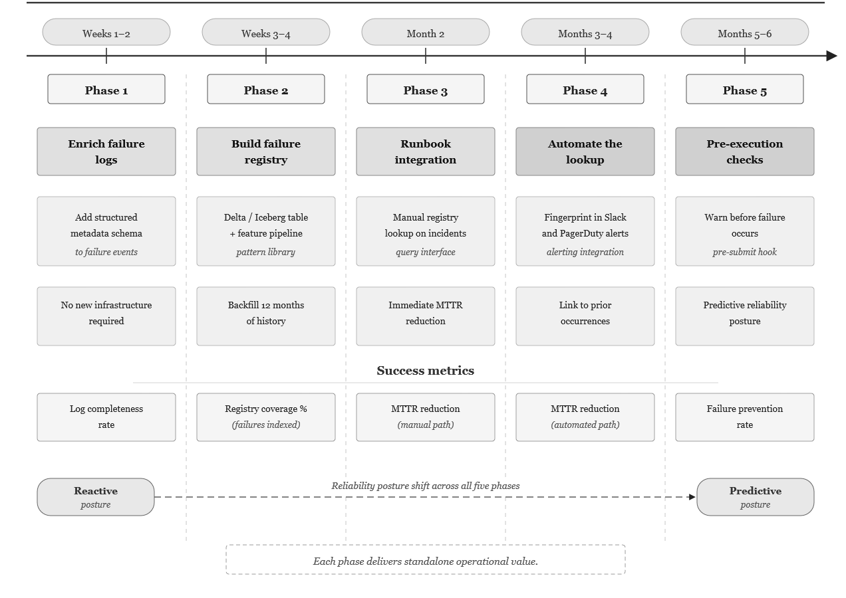Fig. 6. Five-Phase Incremental Adoption Roadmap.
Table 4. Five-Phase Incremental Adoption Path. Provides a structured reference for platform engineering teams evaluating the adoption investment at each phase.
Phase | Capability | Infrastructure | Metric | Value Delivered | Effort
1 — Log Enrich. | Structured failure schema | None | Completeness | Data fingerprint-ready | Low
2 — Registry | Pattern library established | Delta/Iceberg + pipeline | Coverage % | 12-month history indexed | Medium
3 — Manual | Runbook-integrated query | Query interface | MTTR (manual) | Lookup-based resolution | Low
4 — Automated | Fingerprint in notifications | Alerting integration | MTTR (auto) | No manual query needed | Medium
5 — Predictive | Pre-execution prevention | Input stats + hook | Prevention rate | Predictive reliability | High

Phase gate criterion. When fingerprint matches are found for ≥50% of recurring failures over a 60-day observation window, the registry has sufficient coverage to justify Phase 4 automation.
3.5 Prospective Evaluation Design
This section specifies the evaluation framework for future empirical validation. All metrics are formally defined below, and projected performance ranges are grounded in published benchmarks from analogous systems rather than measured from the proposed framework. The evaluation assumes a deployment context of at least 500 active pipelines generating 50 or more failure events per week, with a minimum of 12 months of historical failure telemetry available for registry backfill.
Four metrics are defined. Recurrence detection accuracy is measured by precision (TP_recurrence / (TP_recurrence + FP_recurrence)) and recall (TP_recurrence / (TP_recurrence + FN_recurrence)). I project precision in the range of 0.82–0.92 and recall in the range of 0.75–0.88. These bounds are derived from comparable systems: Snort IDS reports signature-matching precision of 0.85–0.95 on known classes [7], Socorro's crash deduplication achieves approximately 80% duplicate detection recall [32], and Drain log template clustering reports F1 scores of 0.85–0.94 across benchmark datasets [33]. The lower bound reflects the additional complexity of continuous feature normalization relative to discrete signature matching; the upper bound reflects the structured, bounded domain of six failure classes with distinct signal profiles. MTTR reduction is defined as ΔMTTR = MTTR_without_fingerprint − MTTR_with_fingerprint, measured in minutes. I project a reduction of 50–80 minutes per matched recurrence, consistent with Jiang et al. [26], who report 40–60% investigation time reduction for recurring incidents when structured knowledge is available. Failure prevention rate, defined as the fraction of high-confidence pre-execution warnings that result in an averted failure, is projected at 0.30–0.55, reflecting the subset of failure classes where input statistics alone carry sufficient predictive signal. The false positive rate for pre-execution warnings is targeted below 0.15, informed by research on alert fatigue in operations contexts [16], [27] which establishes that rates above 15–20% lead to systematic alert disengagement.
The planned evaluation will compare against three baselines: native platform observability (Spark UI, system table queries, log search) representing unassisted diagnosis; keyword-based incident ticket search representing current organizational memory practice; and automated log clustering via Drain [33] representing an AIOps baseline. Ablation studies will assess feature importance by removing attributes individually and in groups, evaluate threshold sensitivity across τ ∈ [0.60, 0.95] in increments of 0.05, optimize the composite ranking weights (α, β, γ) via grid search, and measure recurrence detection accuracy as a function of registry maturity to characterize cold-start degradation. A separate fingerprint stability analysis will inject controlled Gaussian noise at 5%, 10%, and 20% levels into continuous telemetry features and measure fingerprint consistency for known-same failure pairs, alongside evaluation of fingerprint stability across platform runtime version upgrades.
4. ANALYTICAL PROJECTIONS OF OPERATIONAL IMPACT
The projections in this section are analytical, derived from the framework’s design properties and performance benchmarks of analogous systems in adjacent domains. They are not empirical measurements. Each projection is identified as such, and the assumptions underlying each are stated explicitly. These projections serve as testable hypotheses for the empirical validation specified in Section 3.5.
4.1 Diagnostic Resolution Acceleration
With fingerprint-assisted lookup (Phase 4), I project per-incident time savings of 65–80 minutes for recurring failure classes. Studies of production distributed systems [6], [30], [31] consistently report that a majority of critical failures follow recurring patterns concentrated within a limited number of classes.
4.2 Cross-Pipeline Pattern Detection
Fleet-wide registry aggregation can surface systemic patterns invisible to per-pipeline analysis. When multiple unrelated pipelines exhibit the same skew fingerprint on a common join key, the pattern points to distribution shift in a shared dimension table rather than independent defects—a single upstream fix resolves the failure across all consumers. Similarly, a cluster of novel fingerprints appearing within 72 hours of a runtime upgrade signals a regression detectable before it propagates to critical pipelines. Recurring memory saturation fingerprints at predictable calendar intervals (month-end, quarter-close) identify capacity planning gaps addressable through pre-provisioning rather than repeated reactive investigation.
4.3 Cross-Team Knowledge Reuse
The shared registry enables knowledge transfer across organizational boundaries. Research on knowledge-centered service [25] and incident management [26] consistently finds that structured, searchable knowledge systems outperform unstructured team-local communication.
4.4 Pre-Execution Warning Capabilities
The projected prevention rate (0.30–0.55) reflects failure classes where input statistics provide sufficient predictive signal. The false positive rate target (<0.15) reflects the requirement that warnings must be credible to be actionable [27].
5. DISCUSSION
5.1 Why Observability Alone Is Insufficient
Modern observability stacks can reconstruct any single failure in fine-grained detail. The gap is not in what they capture but in what they remember. Because failure data is persisted as isolated event records rather than as instances within a pattern taxonomy, each recurrence starts the diagnostic clock from zero. This is an architectural property, not a monitoring gap. Static threshold-based alerting [16] addresses a different problem entirely: it detects when current metrics exceed defined bounds. It does not identify which class of failure is occurring, whether it has occurred before, or what resolved it. Table 5 makes this distinction concrete.
5.2 Relationship to AIOps and SRE Practice
Failure Fingerprinting occupies a specific position in the AIOps landscape [16]. AIOps anomaly detection methods address “is something abnormal happening?” Failure Fingerprinting addresses the downstream question: “given that a failure has occurred, is it an instance of a previously resolved class?” The two are complementary. SRE postmortem practice [27] targets significant, novel incidents. Failure Fingerprinting addresses high-volume, routine failures too numerous for formal postmortems but that collectively consume substantial engineering time.
Table 5. Capability Comparison Across Failure Diagnosis Approaches. Contrasts Failure Fingerprinting against four incumbent approaches across seven operational capability dimensions, highlighting where the proposed framework provides architectural support that existing methods lack.
Capability | Native Obs. | Ticket Search | Static Alert | AIOps (log) | Failure Fprint
Failure recording | Full | Partial | Partial | Full | Full (automated)
Recurrence detect. | None | Partial | None | Partial | Designed for
Cross-team sharing | None | Partial | None | None | Designed for
Fleet-wide patterns | None | None | None | Partial | Designed for
Pre-exec prevention | None | None | Partial | None | Designed for (Ph5)
AI-native support | Partial | None | None | Partial | Designed for (Tbl6)
Incremental adopt. | N/A | Low effort | Low effort | Medium | Yes (Phase 1)
Note: “Designed for” indicates architectural support; empirical confirmation is planned as future work.
5.3 Application to AI-Native Workloads
AI-native workloads do not share the predictable resource profiles of traditional ETL. Embedding generation pipelines produce token counts varying by orders of magnitude. Vector index builds (HNSW [15]) exhibit super-linear memory scaling. LLM inference batches experience GPU memory pressure governed by multiple interacting factors. These include batch size, model parameter count, input sequence length, and KV cache behavior, which combine non-linearly.
Table 6. Extended Fingerprint Schema for AI-Native Workloads. Defines eight supplementary attributes that capture the resource and behavioral signals.
Attribute | Type | Signal Source | Workload | Description
token_count_p50 | Continuous | Tokenizer output | Embed.; LLM | Median token count per input record
token_count_p95 | Continuous | Tokenizer output | Embed.; LLM | 95th pctl token count; long-tail docs
sequence_length_p95 | Continuous | Inference metrics | LLM inference | 95th pctl input sequence length
gpu_memory_peak | Continuous | CUDA / cloud GPU | LLM; GPU embed. | Peak GPU memory utilization (%)
gpu_memory_avg | Continuous | CUDA / cloud GPU | LLM; GPU embed. | Time-averaged GPU memory util. (%)
api_latency_p95_ms | Continuous | HTTP response log | API-dependent | 95th pctl external API latency (ms)
rate_limit_count | Integer | HTTP 429 count | API-dependent | Total HTTP 429 responses in batch
retry_count_total | Integer | Retry handler | API-dependent | Total retry attempts across API calls

5.4 Design Principles
Three design principles are proposed to guide implementation of a Failure Intelligence Platform. The first principle—treat failures as first-class data—recognizes that failure events carry information value that persists well beyond their immediate operational cost; platform architectures that discard failure context after resolution effectively discard reliability intelligence that has already been paid for in diagnostic effort. The second principle—make reliability knowledge institutional rather than individual—addresses the fragility of resolution knowledge that resides in individual engineers’ memory or team-specific communication channels, where it is subject to loss through personnel turnover and inaccessible across organizational boundaries [25], [26], [27]. The third principle design for cross-team discoverability—acknowledges that a fingerprint registry is operationally useful only if the teams most likely to encounter a given failure pattern can find its record; common schemas, shared registry infrastructure, search interfaces, and integration with existing incident management tooling are therefore necessary conditions, not optional enhancements. The principles underlying Failure Fingerprinting structured signal collection, pattern-based classification, and automated response recommendation are shared with intelligent monitoring frameworks in adjacent domains, including IoT-driven environmental monitoring [36] and AI-assisted research methodology design [37], where structured data collection and automated pattern recognition similarly transform raw observability into actionable intelligence.
5.5 Threats to Validity
Three categories of validity threat apply to this work. With respect to construct validity, the fingerprint schema assumes that the ten selected features are sufficient to capture the operationally significant dimensions of Lakehouse failures; if important failure classes are distinguished by signals not included in the schema—such as network I/O patterns, storage throttling events, or cross-service dependency latencies—the fingerprint may fail to discriminate them, and the planned feature ablation study described in Section 3.5 is designed to assess this sufficiency empirically. With respect to internal validity, the projected performance ranges presented in Section 3.5 and Section 4 are derived from analogous systems operating in different domains (network intrusion detection, crash report deduplication, log clustering), and the degree to which these projections transfer to Lakehouse operational telemetry—which may exhibit heavier-tailed distributions, higher feature dimensionality, and stronger inter-feature correlations than the reference signal types—remains uncertain until empirical validation is conducted. With respect to external validity, the framework is designed for Spark-based Lakehouse environments with standard platform telemetry; generalizability to non-Spark execution engines such as Flink, Trino, and Presto, to serverless query engines, and cross-platform transferability of signal collection adapters between Databricks, Snowflake, and BigQuery are testable but currently unverified assumptions.
6. CONCLUSION
Modern Lakehouse platforms generate, during normal operation, all data necessary to construct a failure memory system. The instrumentation exists. The storage layer exists. What has been absent is the architectural decision to treat failure episodes as structured, searchable patterns—to persist their operational context alongside their resolutions and to build the registry and retrieval infrastructure that transforms individual resolution knowledge into institutional intelligence.
The Observability–Reliability Gap is a structural property of current platforms, not a monitoring deficiency addressable by additional alerting rules. Closing this gap requires Failure Fingerprinting: encoding failures as normalized feature vectors, persisting them in a queryable registry linked to verified remediations, and exposing that registry through historical pattern matching, fleet-wide analysis, and predictive pre-execution warnings.
The five-phase incremental adoption path allows teams to begin with minimal infrastructure change—structured log enrichment requiring no new systems—and progress toward predictive failure prevention as registry coverage and organizational confidence develop. Each phase delivers standalone value, reducing adoption risk.
This paper presents the framework as a prospective contribution with projected performance ranges derived from analogous systems in network intrusion detection, crash report deduplication, and AIOps log clustering. Empirical validation on production Lakehouse failure data—measuring recurrence detection accuracy, MTTR reduction, fingerprint stability, and pre-execution warning precision against the projected ranges—is the immediate priority for future work.

5.6 Limitations and Constraints
Eight limitations bound the current framework. First, fingerprint quality is directly bounded by telemetry signal completeness; partial signal collection and log retention gaps degrade fingerprint quality, and the completeness score included in the registry schema is designed to propagate this uncertainty to matching confidence. Second, feature discriminability is imperfect: schema drift failures may exhibit signal profiles similar to non-schema-drift failures at the same data volume, and while secondary classification using error class and stack trace signature provides a supplementary discriminator, the false-match rate for overlapping failure classes requires empirical quantification. Third, the percentile-relative normalization introduces a cold-start period requiring approximately 20 executions for basic reliability and 30–90 days for statistical stability; new jobs fall back to absolute-value features during this period, and the accuracy degradation this introduces is a planned measurement. Fourth, a matched fingerprint indicates operational similarity to a prior failure but does not guarantee that the prior remediation is applicable in the current context; remediations are therefore presented as recommendations with confidence scores, and automated application without engineer confirmation is explicitly excluded from this framework. Fifth, at scales exceeding 50,000 failures per month, the registry requires partitioned ANN indexes and potential sharding by error class, and while standard Lakehouse-native tooling supports this scale architecturally, query latency at this scale has not been benchmarked. Sixth, transient measurement spikes in telemetry introduce variance in the computed fingerprint, and the similarity threshold τ must be calibrated to balance sensitivity against false positive rate; the planned noise injection analysis in Section 3.5 will quantify this effect. Seventh, platform runtime upgrades may shift feature distributions without underlying workload changes, creating spurious fingerprint drift; the runtime_version field enables version-stratified matching, and the known-good profile mechanism re-calibrates automatically after upgrades. Eighth, and most fundamentally, this paper presents a framework with projected performance bounds rather than measured results; all quantitative claims are prospective and grounded in analogous-system benchmarks, and empirical validation is the primary direction for future work.
5.7 Future Research Directions
Seven directions for future research emerge from this work. The highest priority is empirical validation: conducting the full evaluation specified in Section 3.5 on production Lakehouse failure data, measuring recurrence detection accuracy, MTTR reduction, and fingerprint stability against the projected ranges established in this paper. Second, the current linear normalization scheme could be augmented or replaced by failure embeddings learned through self-supervised contrastive learning [29] over failure event pairs, which could produce lower-dimensional, higher-fidelity representations that capture non-linear feature interactions missed by the current approach. Third, supervised classification models [16], [28] trained on labeled failure data could replace the heuristic similarity thresholds with a learned discriminator, potentially improving performance for failure classes with overlapping signal signatures. Fourth, the lossy five-element DAG topology vector could be replaced with graph-level embeddings produced by graph neural networks, providing richer structural representations that distinguish execution plans currently collapsed by the summary vector. Fifth, an LLM-based agent with access to the failure registry, current failure context, and platform documentation could generate context-sensitive remediation recommendations for novel failures that have no registry match [16], [26]. Sixth, modeling the time series of fingerprint occurrences would enable failure rate trend detection, degradation trajectory early warnings, and demand-based capacity forecasting. Seventh, demonstrating that signal collection adapters produce comparable feature vectors on Databricks, Snowflake, and BigQuery for equivalent workloads would establish the framework’s cross-platform generalizability.

Framing note
This paper is structured as a prospective framework contribution. All evaluation metrics are formally defined, and projected performance ranges are grounded in published benchmarks from analogous systems in adjacent domains (network intrusion detection, crash report deduplication, AIOps log clustering). Empirical validation on production Lakehouse failure data is identified as the immediate priority for future work and is fully specified in the evaluation design (Section 3.5). The author maintains transparency throughout regarding which claims are design projections and which await empirical confirmation.
The primary contributions are: (1) formalization of the Observability–Reliability Gap as a structural platform property; (2) a normalized fingerprinting schema with SHA-256-based identity methodology; (3) a four-layer reference architecture with specified component interfaces; (4) a five-phase incremental adoption strategy; (5) projected performance bounds derived from analogous systems with a formal prospective evaluation design; and (6) an extended fingerprint schema for AI-native workloads.

COMPETING INTERESTS DISCLAIMER
Authors have declared that they have no known competing financial interests OR non-financial interests OR personal relationships that could have appeared to influence the work reported in this paper.

Disclaimer (Artificial intelligence)

Author(s) hereby declare that NO generative AI technologies such as Large Language Models (ChatGPT, COPILOT, etc.) and text-to-image generators have been used during the writing or editing of this manuscript.

REFERENCES
[1] Armbrust, M.; Ghodsi, A.; Xin, R.; Zaharia, M. Lakehouse: A New Generation of Open Platforms that Unify Data Warehousing and Advanced Analytics. In Proceedings of the CIDR Conference; 2021. Available online: https://www.cidrdb.org/cidr2021/papers/cidr2021_paper17.pdf
[2] Databricks. Monitor Account Activity with System Tables. Databricks Documentation, 2026. Available online: https://docs.databricks.com/aws/en/admin/system-tables/
[3] Snowflake. QUERY_HISTORY View. Snowflake Documentation, 2026. Available online: https://docs.snowflake.com/en/sql-reference/account-usage/query_history
[4] Armbrust, M.; et al. Delta Lake: High-Performance ACID Table Storage over Cloud Object Stores. Proc. VLDB Endow. 2020, 13, 3411–3424. https://doi.org/10.14778/3415478.3415560
[5] Apache Software Foundation. Apache Iceberg Documentation. 2026. Available online: https://iceberg.apache.org/docs/latest/
[6] Luo, L.; et al. Troubleshooting Transiently-Recurring Problems in Production Systems with Blame-Proportional Logging. In USENIX ATC 2018. Available online: https://www.usenix.org/system/files/conference/atc18/atc18-luo.pdf
[7] Roesch, M. Snort: Lightweight Intrusion Detection for Networks. In LISA ’99; pp. 229–238.
[8] He, S.; et al. A Survey on Automated Log Analysis for Reliability Engineering. ACM Comput. Surv. 2021, 54, Article 25. https://doi.org/10.1145/3460345
[9] Ikram, A.; et al. Root Cause Analysis of Failures in Microservices through Causal Discovery. In NeurIPS 2022.
[10] Johnson, J.; Douze, M.; Jégou, H. Billion-Scale Similarity Search with GPUs. IEEE Trans. Big Data 2021, 7, 535–547. https://doi.org/10.1109/TBDATA.2019.2921572
[11] NIST. Secure Hash Standard (SHS), FIPS PUB 180-4. 2015. Available online: https://csrc.nist.gov/publications/detail/fips/180/4/final
[12] Jain, R.; Chlamtac, I. The P² Algorithm for Dynamic Calculation of Quantiles. Commun. ACM 1985, 28, 1076–1085. https://doi.org/10.1145/4372.4378
[13] Vitter, J.S. Random Sampling with a Reservoir. ACM Trans. Math. Softw. 1985, 11, 37–57. https://doi.org/10.1145/3147.3165
[14] Manning, C.D.; Raghavan, P.; Schütze, H. Introduction to Information Retrieval. Cambridge University Press, 2008.
[15] Malkov, Y.A.; Yashunin, D.A. Efficient and Robust ANN Search Using HNSW Graphs. IEEE TPAMI 2020, 42, 824–836. https://doi.org/10.1109/TPAMI.2018.2889473
[16] Zhang, L.; et al. A Survey of AIOps in the Era of Large Language Models. ACM Comput. Surv. 2026, 58, Article 44. https://doi.org/10.1145/3746635
[17] Apache Spark. Performance Tuning. Spark Documentation, 2026.
[18] Rödiger, W.; et al. Flow-Join: Adaptive Skew Handling for Distributed Joins. In IEEE ICDE 2016; pp. 1194–1205. https://doi.org/10.1109/ICDE.2016.7498324
[19] Kim, K.; Lee, K. Making Cloud Spot Instance Interruption Events Visible. In ACM WWW 2024. https://doi.org/10.1145/3589334.3645548
[20] Klettke, M.; et al. Uncovering the Evolution History of Data Lakes. In IEEE BigData 2017; pp. 2462–2471. https://doi.org/10.1109/BigData.2017.8258204
[21] Serbout, S.; et al. API Rate Limit Adoption—A Pattern Collection. In EuroPLoP 2023; pp. 5:1–5:20. https://doi.org/10.1145/3628034.3628039
[22] Li, B.; et al. Enjoy Your Observability: An Industrial Survey of Microservice Tracing and Analysis. Empir. Softw. Eng. 2022, 27, 25. https://doi.org/10.1007/s10664-021-10063-9
[23] Peng, X.; et al. Large-Scale Trace Analysis for Microservice Anomaly Detection. In ESEC/FSE 2022. https://doi.org/10.1145/3531056.3542765
[24] Databricks. Jobs System Table Reference. Databricks Documentation, 2026. Available online: https://docs.databricks.com/aws/en/admin/system-tables/jobs
[25] Lineberry, R.; et al. Solve and Evolve: Practical Applications for Knowledge-Centered Service. In ACM SIGUCCS 2019; pp. 70–75. https://doi.org/10.1145/3347709.3347793
[26] Jiang, Y.; et al. Xpert: Empowering Incident Management with Query Recommendations via LLMs. In ICSE 2024. https://doi.org/10.1145/3597503.3639081
[27] Beyer, B.; et al., Eds. Site Reliability Engineering: How Google Runs Production Systems. O’Reilly Media, 2016.
[28] Du, M.; et al. DeepLog: Anomaly Detection and Diagnosis from System Logs through Deep Learning. In ACM CCS 2017; pp. 1285–1298. https://doi.org/10.1145/3133956.3134015
[29] Chen, T.; et al. A Simple Framework for Contrastive Learning of Visual Representations. In ICML 2020; PMLR 119, 1597–1607.
[30] Gunawi, H.S.; et al. What Bugs Live in the Cloud? A Study of 3000+ Issues in Cloud Systems. In ACM SoCC 2014; pp. 7:1–7:14.
[31] Yuan, D.; et al. Simple Testing Can Prevent Most Critical Failures. In USENIX OSDI 2014; pp. 249–265.
[32] Mozilla. Socorro: Mozilla Crash Report System. Mozilla Wiki. Available online: https://wiki.mozilla.org/Socorro
[33] He, P.; et al. Drain: An Online Log Parsing Approach with Fixed Depth Tree. In IEEE ICWS 2017; pp. 33–40.
[34] Jeganathan, B. (2025). Machine Learning and Deep Learning in Wafer Defect Detection: Current State and Future Directions. Current Journal of Applied Science and Technology, 44(12), 1-14.
[35] Shafique, A.; Wu, G.; Saeed, M.S.; Javeed, D. X-SecureNet: A Security-Driven Intelligent Framework for Intrusion Detection in Smart Industrial Infrastructures. Cluster Comput. 2026, 29, 168. https://doi.org/10.1007/s10586-026-05972-7
[36] Danish, M.U.; Asghar, S.; Shabbir, S.; Shafique, A.; Saeed, A. SAMF-RPL: An IoT-Driven RPL-Based Smart Agriculture Monitoring Framework for Pest Detection. 2025. https://doi.org/10.5281/zenodo.17224936
[37] Qureshi, K.N.; Jeon, G., Eds. Next Generation AI Language Models in Research: Promising Perspectives and Valid Concerns. CRC Press: Boca Raton, FL, USA, 2024. https://doi.org/10.1201/9781032667911

