Development and Preliminary Characterization of a Composite Material Produced from Recycled Plastic and Sand for Sustainable Construction Applications

ABSTRACT
The sustainable management of plastic waste is a critical environmental issue, particularly in developing countries where collection and recycling rates remain low. In this context, this study focuses on the development of an innovative composite material, made from recycled plastic and sand, to provide an alternative for the recovery of plastic waste in the construction materials sector. The composite material was manufactured by melting the recycled plastic at a temperature of approximately 255 °C, then gradually incorporating sand that had been previously sieved and analyzed for particle size distribution in accordance with standard NF EN 933-1. Three distinct formulations were produced by varying the proportions of recycled plastic relative to the sand. We used proportions of 15%, 20%, and 25% by mass of recycled plastic relative to the sand. The results of the particle size analyses revealed that the sand used falls within the 0/5 particle size class, with a uniform particle size distribution, conducive to obtaining a homogeneous material. Examination of the produced test specimens indicates a gradual improvement in compactness, surface appearance, and overall material quality as the percentage of recycled plastic increases. The composite containing 25% plastic exhibits a particularly dense structure, a smooth surface, and a significant reduction in intergranular voids, demonstrating improved cohesion between the matrix and the aggregates. The density decreases as the percentage of plastic relative to sand increases. Thus, we obtain densities of 1903.72 kg/m³ for the material containing 15% plastic, 1795.53 kg/m³ for the material containing 20% plastic, and 1693.58 kg/m³ for the material containing 25% plastic. The results obtained in this study highlight the potential of recycled plastic as an alternative binder to cement for producing innovative construction materials while helping to reduce the environmental footprint of plastic waste.

Keywords: plastic waste, sand, particle size distribution, recycling, composite material.

1. INTRODUCTION
Global plastic production has increased dramatically over the past decades, exceeding several hundred million tons annually. This rapid growth has led to a substantial accumulation of plastic waste in the environment, generating significant ecological and public health concerns. A considerable proportion of plastics produced worldwide is not effectively recycled and ultimately accumulates in landfills or natural ecosystems, contributing to terrestrial and marine pollution as well as greenhouse gas emissions (Ford et al., 2022; Nayanathara Thathsarani Pilapitiya & Ratnayake, 2024; Ritchie et al., 2023).
Future projections indicate that global plastic production could triple by 2060, resulting in severe environmental and socio-economic consequences. The annual global cost of plastic pollution has been estimated to range between 300 and 600 billion USD (WHO, 2023). Waste management systems in many developing countries remain insufficient to cope with the growing volume of plastic waste generated by rapid urbanization and population growth. Despite the increasing global awareness of plastic pollution, the recycling rate of plastic materials remains relatively low. It is estimated that only 10–15% of plastic waste generated worldwide is effectively recycled, while the majority is disposed of in landfills, incinerated, or released into the natural environment (OCDE, 2022; Plastics Europe, 2022).
Recent reports indicate that global plastic production exceeded 390 million tons in 2021 and is expected to continue increasing significantly in the coming decades if sustainable management strategies are not implemented (Plastics Europe, 2023). This situation is particularly critical in developing countries, where inadequate waste management infrastructure exacerbates environmental pollution caused by plastic waste (Navarro & Vincenzo, 2025).
In this context, the valorization of plastic waste has emerged as a key strategy for promoting sustainable development and supporting the transition toward a circular economy (Kunlere & Shah, 2023; Ochigue et al., 2025). Among the various approaches proposed, the transformation of plastic waste into composite materials has attracted considerable interest in both scientific research and industrial applications.
Polymer matrix composites exhibit several advantageous properties, including high mechanical strength, low density, excellent corrosion resistance, and high design flexibility. These characteristics make them attractive for numerous engineering and industrial applications (Musa et al., 2025; Rupal et al., 2022; Sukumaran & Dirviyam, 2021). The incorporation of recycled plastics into such materials not only reduces the volume of plastic waste but also decreases the demand for virgin raw materials and lowers the overall carbon footprint associated with material production (S. Ahmed & Ali, 2023; Macedo et al., 2018; Nuruzzaman et al., 2025).
Recent studies have demonstrated that plastic wastes such as polyethylene (PE), polypropylene (PP), and polyethylene terephthalate (PET) can be effectively used either as matrices or reinforcing components in the development of innovative composite materials (.K & Pradha, 2023; Luna et al., 2022)). These composites can also incorporate a wide range of fillers and reinforcements, including natural fibers, agricultural residues, mineral particles, and industrial by-products, which can significantly enhance their mechanical, thermal, and structural properties (Prasad et al., 2024; Zhao et al., 2022).
Several investigations have shown that the addition of natural fibers, wood sawdust, or mineral particles improves the stiffness and mechanical performance of recycled plastic composites while simultaneously reducing their production costs (Martinez Lopez et al., 2020).
In the field of civil engineering, plastic-based composites have demonstrated promising potential for the production of sustainable construction materials such as bricks, paving blocks, panels, and wood–plastic composites. These materials often exhibit favorable properties, including good mechanical resistance, low water absorption, and high durability, making them suitable for both structural and non-structural applications (.K & Pradha, 2023; Rupal et al., 2022). Moreover, their use contributes to reducing the environmental impact of the construction industry by limiting the consumption of natural resources while promoting plastic waste recycling(N. Ahmed, 2023; Wang et al., 2026).
In particular, recycled plastic–sand composites have recently attracted increasing attention for the production of sustainable construction elements such as paving blocks, bricks, and roofing tiles. Several studies have reported that these materials can exhibit satisfactory compressive strength, water resistance, and durability while simultaneously contributing to the reduction of plastic pollution (Hassan et al., 2025). Such materials represent a promising alternative to conventional construction products, particularly in regions where access to traditional building materials is limited or expensive (Firoozi et al., 2024).
The use of recycled plastics in construction applications offers several benefits, including waste reduction, conservation of natural resources, and the development of low-cost building materials(Kareem et al., 2025). Furthermore, polymer composites reinforced with mineral aggregates such as sand have demonstrated promising mechanical and durability properties suitable for non-structural construction applications(Dai et al., 2024).
Recent studies have also highlighted that combining recycled plastic with mineral fillers such as sand can lead to the development of innovative composite materials with improved physical and mechanical characteristics. In such materials, the plastic component acts as a binding matrix that encapsulates mineral particles, forming a dense and cohesive structure(Mekideche et al., 2025).
Despite these promising developments, several challenges remain. These include the variability in the properties of recycled plastics, compatibility issues between polymer matrices and reinforcement materials, and limitations related to recycling and processing technologies(Namjoufar et al., 2026). Consequently, ongoing research focuses on optimizing composite formulations, improving recycling processes, and evaluating the environmental performance of recycled materials to ensure their long-term sustainability and industrial viability (Das et al., 2026).
From an environmental perspective, the valorization of plastic waste into construction materials contributes to reducing landfill waste volumes and minimizing the environmental footprint associated with conventional construction materials such as cement. The integration of recycled polymers into construction composites therefore supports the principles of sustainable development and circular economy by transforming waste into valuable resources (Aranda et al., 2023; Hamada et al., 2024).
In this context, the present study aims to develop and preliminarily characterize a composite material produced from recycled plastic and sand for potential applications in sustainable construction. The research focuses on the preparation of several composite formulations with varying proportions of recycled plastic and sand, followed by the evaluation of their granulometric characteristics and preliminary physical properties. The findings of this study are expected to contribute to the advancement of knowledge on sustainable construction materials derived from recycled plastic waste and to promote environmentally friendly solutions for plastic waste management.

2. MATERIALS AND METHODS
Several materials and laboratory equipment were used for the preparation and characterization of the recycled plastic–sand composite. The main materials include recycled plastic and natural sand, while the experimental setup consisted of weighing, sieving, and molding equipment.

2.1 Raw Materials
- Recycled Plastic
The recycled plastic used in this study was obtained from post-consumer plastic waste. The collected plastic was first sorted to remove unwanted materials, then mechanically crushed using a plastic grinder in order to obtain smaller particles suitable for melting. After crushing, the plastic particles were washed with water to remove dust and contaminants and subsequently air-dried before use (Figure 1).
This pretreatment process ensures better melting behavior and improves the homogeneity of the composite during the mixing stage.


Fig. 1. Recycled plastic

- Sand
Natural sand was used as the mineral filler in the composite formulation. After collection, the sand was cleaned to remove impurities such as organic matter and fine debris. The cleaned sand was then dried and stored before use (Figure 2).
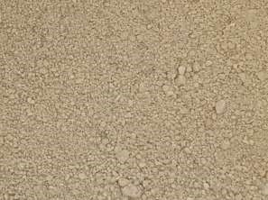
Fig. 2. Sand

2.2 Experimental Equipment
Several laboratory devices were used during the experimental process.
- Electronic Balance
An electronic precision balance was used to measure the mass of both plastic and sand during the preparation of the composite mixtures (Figure 3).
The balance provides accurate mass measurements, which are essential for controlling the mass proportions of the composite components and ensuring reproducibility of the experimental formulations.
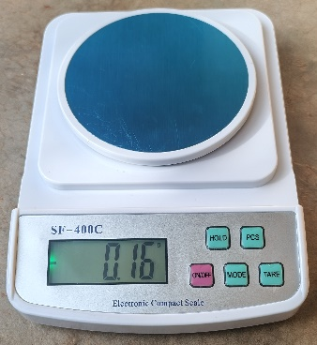
Fig. 3. Electronic balance

- Electromagnetic Sieve Shaker
An electromagnetic sieve shaker was used to determine the particle size distribution of the sand (Figure 4). The device generates controlled mechanical vibrations that allow sand particles to pass through a stack of standard laboratory sieves with different mesh sizes.
This equipment ensures efficient separation of particles according to their size and provides reliable data for the granulometric analysis of aggregates.


Fig. 4. Electromagnetic sieve shaker

- Cylindrical Mold
A cylindrical metallic mold was used to produce test specimens with a cylindrical cross-section of 60 mm in diameter and 120 mm in height (Figure 5). These specimens were prepared for subsequent experimental testing and material characterization.
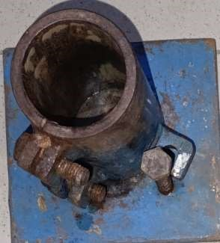
Fig. 5. Cylindrical mold

- Rectangular Mold
A rectangular metallic mold was also used to produce composite specimens with a square cross-section of 40 mm × 40 mm and a length of 160 mm (Figure 6).
These molds allow the preparation of standardized samples that can be used for different mechanical and physical tests.

Fig. 6. Square-section molds

  - Methods
The experimental methodology adopted in this study consists of two main steps:
- the granulometric characterization of the sand;
- the preparation of the recycled plastic–sand composite material.

2.3.1 Granulometric Analysis of Sand
The particle size distribution of the sand was determined by mechanical sieving using an electromagnetic sieve shaker (Figure 3), in accordance with the NF EN 933-1. The detailed steps of this sieving method are:
- Sample Preparation: A representative sand sample was collected and dried in order to remove any moisture that could affect the accuracy of the granulometric analysis.
- Assembly of the Sieve Column: A set of standard sieves was stacked in decreasing order of mesh opening size. The assembly was placed above a container intended to collect the fine particles. The dried sand sample was then placed on the upper sieve.
- Sieving Operation: The sieve column was subjected to mechanical agitation for a specified duration in order to separate the particles according to their size.
- Weighing of Granulometric Fractions: After sieving, the mass of sand retained on each sieve was determined using a precision balance. The mass of the material that passed through all the sieves (sieving residue or pan fraction) was also measured.
- Calculation of Granulometric Parameters: The percentage by mass of material retained on each sieve is calculated using the following expression:

$$R_{i}=\frac{m_{i}}{M}×100$$
where:
$R_{i}$: percentage retained on sieve i
$m_{i}$: mass of material retained on sieve i
$M$: total mass of the sample
The cumulative percentage retained is given by:
$$R_{c}=\sum_{i=1}^{n}{R_{i}}$$
The cumulative percentage passing is calculated as:
$$P_{c}=100-R_{c}$$
The particle size distribution curve is then plotted by representing:
- the sieve mesh diameter (mm) on the horizontal axis;
- the cumulative percentage passing on the vertical axis.
This curve makes it possible to characterize the particle size distribution of the sand used in the preparation of the composite.

2.3.2 Preparation of the Recycled Plastic–Sand Composite
The production of the composite material is based on a melting–mixing–molding process.
- Melting of Recycled Plastic: The recycled plastic was melted using a multifunctional furnace. A predetermined quantity of shredded plastic was gradually introduced into a metal crucible resistant to high temperatures. The temperature was maintained at approximately 255 °C in order to ensure complete melting of the polymer and obtain a homogeneous polymer matrix.
- Sand Incorporation: Once the plastic was completely melted, sand was gradually incorporated into the molten polymer matrix according to predefined mass proportions. The mixture was subjected to continuous mixing to ensure a uniform dispersion of sand particles within the molten polymer matrix. This step is essential to improve the interfacial adhesion between the polymer matrix and the mineral filler.
- Composite Molding: The homogeneous mixture obtained was poured into metal molds previously lubricated to facilitate demolding. Manual pressure was applied in order to reduce the presence of voids and improve the compactness of the material.
- Cooling and Demolding: After molding, the molds were kept at room temperature for approximately 3 hours to allow complete solidification of the composite material.

2.4 Composite Formulations
In this study, three composite formulations were produced by varying the mass proportion of recycled plastic in the mixture (table 1).
Table 1. Components of the composite material.
Composite | Recycled Plastic (%) | Sand (%)
C1 | 15 | 85
C2 | 20 | 80
C3 | 25 | 75

This variation in the mass fraction of the polymer matrix makes it possible to analyze the influence of material composition on the mechanical and physical properties of the composite.

3. RESULTS AND DISCUSSIONS
3.1 Granulometric Characterization of Sand
The granulometric analysis carried out by mechanical sieving made it possible to determine the particle size distribution of the sand used as a mineral filler in the composite. The obtained results allowed the cumulative percentages of particles passing through the different sieves in accordance with the NF EN 933-1 standard. Table 2 presents the cumulative percentage of particles passing as a function of the mesh diameter of the sieves used.

Table 2. Summary of cumulative percentages of sieved material.
Sieve diameter (mm) | % of cumulative sieving | Sieve diameter (mm) | % of cumulative sieving
0.08 | 0.66 | 0,8 | 75.69
0.1 | 1.34 | 1 | 85.97
0.125 | 2.34 | 1.25 | 91.79
0.16 | 5.48 | 1.6 | 94.93
0.2 | 8.19 | 2 | 96.84
0.25 | 13.43 | 2.5 | 97.94
0.315 | 21.19 | 3.15 | 98.76
0.4 | 29.50 | 4 | 99.30
0.5 | 48.70 | 5 | 99.75
0.63 | 58.30 | 6.3 | 100
A granular material is characterized from a granulometric point of view by its class d/D. d represents the minimum particle diameter of the sand grains and D represents the maximum particle diameter. The sand used in this study belongs to the 0/5 granulometric class, meaning that the particles range from fine fractions to a maximum size of 5 mm. Sands belonging to this granulometric class are widely used in mortar formulations and polymer matrix composites because they offer a satisfactory compromise between workability, stability, and mechanical performance (Farhana et al., 2021). The cumulative percentage of particles passing enabled the plotting of the grain size distribution curve of the sand used in this study (Figure 7).
Fig. 7. Particle size distribution curve of the sand

The obtained granulometric curve shows a regular and continuous evolution. This type of curve is characteristic of a well-graded granular material, which is particularly favorable for the manufacturing of composite materials. Indeed, a continuous particle size distribution promotes better particle packing and contributes to the reduction of intergranular voids, thereby improving the compactness of the material (Bhattacharjee et al., 2025).
The particle sizes in mm, corresponding to 10%, 30%, 50%, 60%, and 90% of the cumulative sieved percentages, are:
- 10% of the sieved particles have a diameter less than or equal to 0.24 mm (D10 = 0.24 mm);
- 30% of the sieved particles have a diameter less than or equal to 0.43 mm (D30 = 0.43 mm);
- 50% of the sieved particles have a diameter less than or equal to 0.51 mm (D50 = 0.51 mm);
- 60% of the sieves have a diameter less than or equal to 0.66 mm (D60 = 0.66 mm);
- and 90% of the sieves have a diameter less than or equal to 1.22 mm (D90 = 1.22 mm).
These values were used to calculate the uniformity coefficient:

$$C_{u}=\frac{D_{60}}{D_{10}}=2.75$$
A uniformity coefficient lower than 4 indicates a relatively homogeneous particle distribution. Such a distribution limits segregation phenomena during mixing operations and promotes a more stable dispersion of particles within the polymer matrix. Sands exhibiting a moderate uniformity coefficient generally show good compatibility with polymer matrices, which improves the internal cohesion of composites (Renke et al., 2025). From a composite manufacturing perspective, these granulometric characteristics are particularly advantageous. A relatively uniform particle size distribution facilitates the coating of mineral particles by the molten polymer matrix and increases the contact surface between sand particles and the plastic binder. This phenomenon contributes to improving interfacial adhesion and the homogeneity of the composite material. It is demonstrated that well-graded sands improve the compactness and cohesion of plastic–sand composites, reported by similar results (Gemlak Paul et al., 2025).

3.2 Composite Materials Produced
Three composite formulations have been developed by varying the recycled plastic content to 15%, 20%, and 25% by mass relative to the sand content. Composite specimens with square cross-sections of 40 mm sides and a length of 160 mm, and cylindrical specimens with a diameter of 60 mm and a height of 120 mm have be produced. The macroscopic analysis of the produced samples revealed several significant differences in the structural quality and homogeneity of the materials obtained.
- Composite Containing 15% Recycled Plastic
The composite containing 15% recycled plastic exhibits several visible defects, including surface irregularities and internal cavities. These defects can be attributed to an insufficient quantity of polymer matrix to ensure a complete coating of the sand particles. When the polymer proportion is too low, the matrix cannot effectively fill the intergranular voids, leading to the formation of low-cohesion zones. The measured density for this formulation is 1903.73 kg/m³, which is the highest among the studied composites. This value is explained by the higher proportion of sand, whose density is significantly greater than that of thermoplastic polymers. However, the presence of internal porosity and structural irregularities indicates that this plastic proportion does not allow the formation of a sufficiently cohesive material. Plastic–sand composites containing low polymer proportions generally exhibit high porosity and limited internal cohesion, reported by similar observations (Gemlak Paul et al., 2025; Hassan et al., 2025).
Figures 8 and 9 show the composite material containing 15% plastic, for the square and cylindrical cross-sections, respectively.
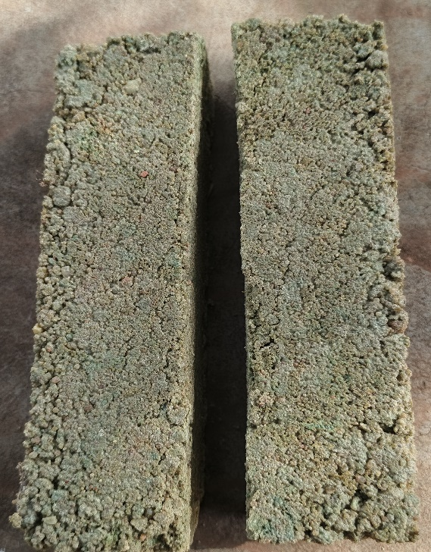
Fig. 8. Square cross-section test tube
containing 15% plastic

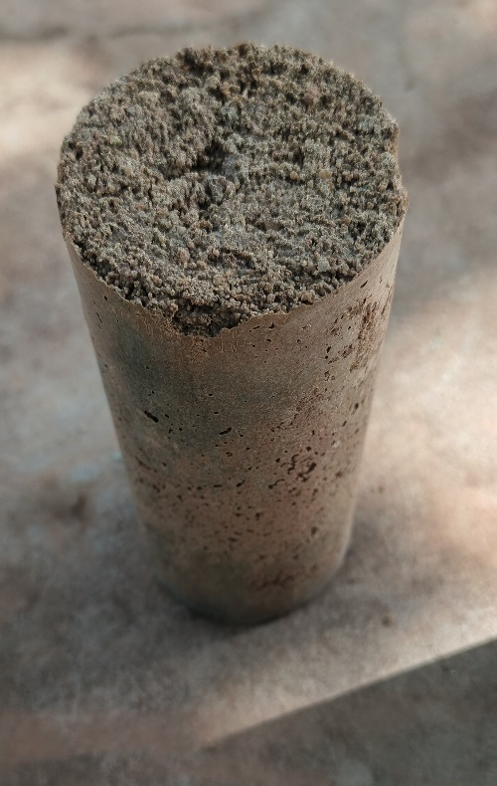
Fig. 9. Cylindrical specimen containing 15% plastic

- Composite Containing 20% Recycled Plastic

Increasing the recycled plastic content to 20% resulted in a notable improvement in the quality of the produced samples. Surface defects are less numerous and the specimens exhibit better dimensional stability. This improvement can be attributed to the larger quantity of molten plastic available to act as a binding matrix. The increase in polymer proportion promotes better coating of sand particles and more effectively fills intergranular voids. As a result, the internal cohesion of the composite is improved. The measured density for this formulation is 1795.54 kg/m³, slightly lower than that of the composite containing 15% plastic. This density reduction is consistent with the increased proportion of plastic, which has a lower density than mineral aggregates. Similar findings have been reported in several recent studies on recycled plastic-based composites, which demonstrated that increasing the polymer content improves internal cohesion while reducing apparent density (Gemlak Paul et al., 2025; Kareem et al., 2025).
Figures 10 and 11 show the composite material containing 20% ​​plastic, respectively for the square and cylindrical cross-sections.
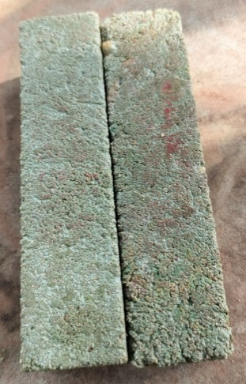
Fig. 10. Square cross-section test tube
containing 20% ​​plastic

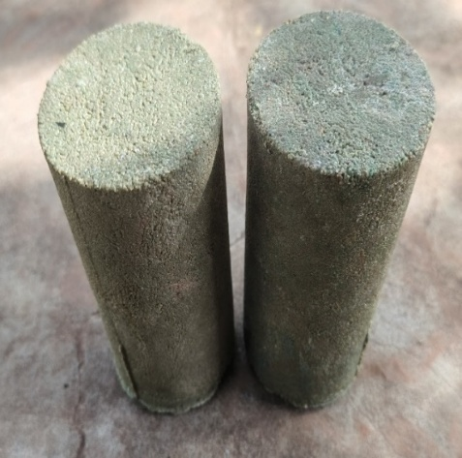
Fig. 11. Cylindrical specimen containing 20% ​​plastic

- Composite Containing 25% Recycled Plastic

The composite containing 25% recycled plastic exhibits the best macroscopic characteristics among the studied formulations. The obtained samples show smooth surfaces, a more homogeneous structure, and no apparent shape defects. This behavior can be explained by the presence of a sufficient amount of polymer matrix to ensure the complete coating of sand particles. The formation of a continuous binding network within the composite promotes load transfer between the matrix and mineral particles, which is a key factor in the overall performance of composite materials. The measured density for this formulation is 1693.59 kg/m³, representing the lowest value among the studied composites. This progressive decrease in density with increasing plastic content is consistent with the density difference between polymers and mineral aggregates. Similar observations have been reported in several experimental studies on plastic–sand composites. For example, it is demonstrated that composites containing 20–30% polymer generally exhibit better structural homogeneity and lower internal porosity (Martinez Lopez et al., 2020). Plastic content improves surface quality and binder efficiency in recycled plastic-based construction materials (Kareem et al., 2025).
Figures 12 and 13 show the composite material containing 25% plastic, respectively for the square and cylindrical cross-sections.
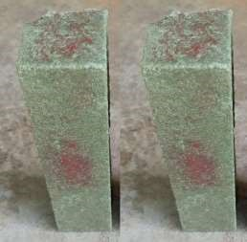
Fig. 12. Square section test tube containing 25% plastic

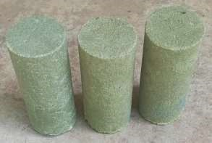
Fig. 13. Cylindrical test specimen containing 25% plastic

4. CONCLUSION
This study demonstrated the feasibility of developing a composite material based on recycled plastic and sand using a simple process involving melting, mixing, and molding. The results obtained made it possible to evaluate the influence of sand granulometry and recycled plastic content on the physical properties and structural quality of the produced composites.The granulometric analysis of the sand revealed a relatively uniform particle distribution, characterized by a continuous grain size distribution curve and a uniformity coefficient of 2.75. This granulometry proved favorable for composite manufacturing because it facilitates good particle packing and allows efficient coating by the molten polymer matrix, thereby improving the material’s homogeneity. Three composite formulations were studied with recycled plastic contents of 15%, 20%, and 25% by mass. Macroscopic observations showed a progressive improvement in structural quality with increasing plastic content. The composite containing 15% plastic exhibited surface defects and more pronounced internal porosity, indicating an insufficient amount of polymer matrix to ensure complete coating of sand particles. In contrast, the formulations containing 20% and 25% plastic showed better cohesion and a more homogeneous structure. Density results also revealed a progressive decrease in composite density with increasing recycled plastic content. The density decreased from 1903.73 kg/m³ for the 15% plastic formulation to 1693.59 kg/m³ for the 25% formulation, which can be explained by the lower density of the polymer compared with mineral aggregates. Among the studied formulations, the composite containing 25% recycled plastic exhibited the best macroscopic characteristics, with a smoother surface, improved internal cohesion, and a significant reduction in structural defects. These results suggest that this plastic proportion could represent a promising formulation for manufacturing composite materials intended for non-structural construction applications, such as paving blocks, coating elements, or certain urban furniture components.
Future research will focus primarily on in-depth mechanical testing, analysis of the material's thermal behavior and durability, and optimization of formulations through the addition of additives or fillers. A techno-economic and environmental study, incorporating a life cycle assessment, would also allow this composite material to be positioned relative to its traditional counterparts available on the market. This future work will contribute to strengthening the scientific and industrial relevance of this composite within a sustainable development framework.

COMPETING INTERESTS DISCLAIMER:
Authors have declared that they have no known competing financial interests OR non-financial interests OR personal relationships that could have appeared to influence the work reported in this paper.
Disclaimer (Artificial intelligence)
Author(s) hereby declare that NO generative AI technologies such as Large Language Models (ChatGPT, COPILOT, etc.) and text-to-image generators have been used during the writing or editing of this manuscript.

REFERENCES
Ahmed, N. (2023). Utilizing plastic waste in the building and construction industry : A pathway towards the circular economy. Construction and Building Materials, 383, 131311. https://doi.org/10.1016/j.conbuildmat.2023.131311
Ahmed, S., & Ali, M. (2023). Potential of Different Forms of Recycled Plastic as Construction Material&mdash;A Review. https://doi.org/10.3390/IOCBD2023-15177
Aranda, F. L., Zúñiga, M., Rivas, B. L., Aranda, F. L., Zúñiga, M., & Rivas, B. L. (2023). Polymers in Circular Economy : A Comprehensive Approach to Sustainability. An overview. Journal of the Chilean Chemical Society, 68(3), 5950‑5962. https://doi.org/10.4067/s0717-97072023000305950
Bhattacharjee, T., Klinger, J., Fillerup, E., Carilli, S., Casajus, M. S., Jin, W., & Xia, Y. (2025). Effects of particle size, distribution, and morphology on bulk shear behavior of milled loblolly pine. Powder Technology, 457, 120911. https://doi.org/10.1016/j.powtec.2025.120911
Dai, C., Liu, J., Jing, M., Che, W., Song, Z., Bu, F., Feng, Y., & Zhu, X. (2024). Polymer-fiber combined effect for improving sand mechanical and micro-damage response. Construction and Building Materials, 432, 136672. https://doi.org/10.1016/j.conbuildmat.2024.136672
Das, T. K., Jesionek, M., Ali, M. D., Ganguly, S., & Poater, A. (2026). Advancing sustainability : Circular economy strategies for fibrous polymer composites. Cleaner Materials, 19, 100381. https://doi.org/10.1016/j.clema.2026.100381
Farhana, A., Razali, A., Romlay, F., & Mohd Razelan, I. S. (2021). Influence of polymer coated aggregate on the aggregate impact and crushing value. IOP Conference Series: Materials Science and Engineering, 1078, 012039. https://doi.org/10.1088/1757-899X/1078/1/012039
Firoozi, A. A., Firoozi, A. A., Oyejobi, D. O., Avudaiappan, S., & Flores, E. S. (2024). Emerging trends in sustainable building materials : Technological innovations, enhanced performance, and future directions. Results in Engineering, 24, 103521. https://doi.org/10.1016/j.rineng.2024.103521
Ford, H. V., Jones, N. H., Davies, A. J., Godley, B. J., Jambeck, J. R., Napper, I. E., Suckling, C. C., Williams, G. J., Woodall, L. C., & Koldewey, H. J. (2022). The fundamental links between climate change and marine plastic pollution. Science of the Total Environment, 806, 150392. https://www.sciencedirect.com/science/article/pii/S0048969721054693
Gemlak Paul, Y., Nafu, Y., Gilbert, T., Tendo, F., Kingsly Mofor, W., & Yuyoh, N. (2025). Impact of Sand Particle Size on the Mechanical and Thermal Properties of Sand/PET Composites. Engineering Reports, 7. https://doi.org/10.1002/eng2.70462
Geyer, R., Jambeck, J. R., & Law, K. L. (2017). Production, use, and fate of all plastics ever made. Science Advances, 3(7), e1700782. https://doi.org/10.1126/sciadv.1700782
Hamada, H. M., Al-Attar, A., Abed, F., Beddu, S., Humada, A. M., Majdi, A., Yousif, S. T., & Thomas, B. S. (2024). Enhancing sustainability in concrete construction : A comprehensive review of plastic waste as an aggregate material. Sustainable Materials and Technologies, 40, e00877. https://doi.org/10.1016/j.susmat.2024.e00877
Hassan, M., Siddiqui, A., Ahmed, R., Ahmed, A., Tanoli, M., & Ali, R. (2025). Mechanical and Microstructural Characterization of Recycled Plastic Waste in Sustainable Building Applications. https://doi.org/10.4123/CUBS.115.6
.K, S., & Pradha, S. (2023). Recycling Plastic Waste into Construction Materials for Sustainability. 1210. https://doi.org/10.1088/1755-1315/1210/1/012016
Kareem, I., Alzuhairi, M., Hashim, F., & Al-Ghaban, A. (2025). Recycled Plastics in Building Materials : Enhancing Sustainability and Economic Efficiency. International Journal of Design & Nature and Ecodynamics, 20. https://doi.org/10.18280/ijdne.200419
Kunlere, I. O., & Shah, K. U. (2023). A recycling technology selection framework for evaluating the effectiveness of plastic recycling technologies for circular economy advancement. Circular Economy, 2(4), 100066. https://doi.org/10.1016/j.cec.2023.100066
Li, D., & Kaewunruen, S. (2019). Mechanical properties of concrete with recycled composite and plastic aggregates. International Journal of GEOMATE, 17, 231‑238. https://doi.org/10.21660/2019.60.8114
Luna, C., Silva, W., Araujo, E., Silva, L., Melo, J., & Wellen, R. (2022). From Waste to Potential Reuse : Mixtures of Polypropylene/Recycled Copolymer Polypropylene from Industrial Containers: Seeking Sustainable Materials. Sustainability, 14, 6509. https://doi.org/10.3390/su14116509
Macedo, K., Cestari, S., Mendes, L. C., Valencia, G., & Rodrigues, D. (2018). Sustainable hybrid composites of recycled polypropylene and construction debris. Journal of Composite Materials, 52, 2949‑2959. https://doi.org/10.1177/0021998318758367
Martinez Lopez, Y., Paes, J. B., Gustave, D., Gonçalves, F. G., Méndez, F. C., & Theodoro Nantet, A. C. (2020). Production of wood-plastic composites using cedrela odorata sawdust waste and recycled thermoplastics mixture from post-consumer products—A sustainable approach for cleaner production in Cuba. Journal of Cleaner Production, 244, 118723. https://doi.org/10.1016/j.jclepro.2019.118723
Mekideche, S., Rokbi, M., Rahmouni, Z. E. A., Phiri, R., Mavinkere Rangappa, S., & Siengchin, S. (2025). Manufacture and characterization of lightweight sand-plastic composites made of plastic waste and sand : Effect of sand types. International Journal of Lightweight Materials and Manufacture, 8(1), 53‑65. https://doi.org/10.1016/j.ijlmm.2024.08.004
Musa, N., Shanmugam, M., Mohamad, N., Ab Maulod, H. E., Abd Razak, J., Abd Manaf, M., Shueb, M. I., Rabiah, P., & Abdullah, M. M. A. B. (2025). Mechanical Performance of Recycled Polypropylene Composites Reinforced with Activated Carbon-Treated Clay as Concrete Aggregates. Malaysian Journal on Composites Science and Manufacturing, 16, 100‑110. https://doi.org/10.37934/mjcsm.16.1.100110
Namjoufar, M., Wei, Y., Maloney, K. J.-R., Laghaei, M., Patadiya, J., Hadigheh, S. A., Naebe, M., & Zabihi, O. (2026). Overcoming technical barriers in mechanical recycling of plastic waste : The role of engineered additives. Journal of Environmental Chemical Engineering, 14(2), 121559. https://doi.org/10.1016/j.jece.2026.121559
Navarro, F., & Vincenzo, T. (2025). Waste Mismanagement in Developing Countries : A Review of Global Issues. ResearchGate. https://doi.org/10.3390/ijerph16061060
Nayanathara Thathsarani Pilapitiya, P. G. C., & Ratnayake, A. S. (2024). The world of plastic waste : A review. Cleaner Materials, 11, 100220. https://doi.org/10.1016/j.clema.2024.100220
Nuruzzaman, M., Shathi, A., Yousuf, A., Islam, M., Rana, M., Alam, M., Biswas, P., Rahman, Md. A., & Mondal, Md. I. H. (2025). Composite materials from waste plastics : A sustainable approach for waste management and resource utilization. Polymers and Polymer Composites, 33. https://doi.org/10.1177/09673911251318542
OCDE. (2022). Perspectives économiques de l’OCDE, Volume 2022 Numéro 2. Perspectives économiques de l’OCDE, 2022(2). https://doi.org/10.1787/25b26d2e-fr
Ochigue, P. C. D., Aguilos, M. A., Lubguban, A. A., & Bacosa, H. P. (2025). Circular Economy Solutions : The Role of Thermoplastic Waste in Material Innovation. ResearchGate. https://doi.org/10.3390/su17020764
Plastics Europe. (2022, octobre). Plastics—The Facts 2022 • Plastics Europe. Plastics Europe. https://plasticseurope.org/knowledge-hub/plastics-the-facts-2022/
Plastics Europe. (2023). Plastics – the fast Facts 2023 • Plastics Europe. Plastics Europe. https://plasticseurope.org/knowledge-hub/plastics-the-fast-facts-2023/
Prasad, V., Alliyankal Vijayakumar, A., Jose, T., & George, S. (2024). A Comprehensive Review of Sustainability in Natural-Fiber-Reinforced Polymers. Sustainability, 16, 1223. https://doi.org/10.3390/su16031223
Renke, M. S., Kulkarni, D. S. B., Pawar, S. P., Kokane, A. A., & Pawar, D. D. (2025). Sustainable Utilization of Plastic Waste as Construction Material : A Revolutionary Approach. Journal of Engineering and Technology Management.
Ritchie, H., Samborska, V., & Roser, M. (2023). Plastic Pollution. Our World in Data. https://ourworldindata.org/plastic-pollution
Rupal, A., Meda, S., Gupta, A., Tank, I., Kapoor, A., Sharma, S., Sathish, T., & Murugan, P. (2022). Utilization of Polymer Composite for Development of Sustainable Construction Material. Advances in Materials Science and Engineering, 2022, 1‑15. https://doi.org/10.1155/2022/1240738
Singh, N., Hui, D., Singh, R., Ahuja, I. P. S., Feo, L., & Fraternali, F. (2017). Recycling of plastic solid waste : A state of art review and future applications. Composites Part B: Engineering, 115, 409‑422. https://doi.org/10.1016/j.compositesb.2016.09.013
Sukumaran, S., & Dirviyam, P. S. (2021). A review on polymer matrix composite materials and their applications. Materials Today: Proceedings, 47. https://doi.org/10.1016/j.matpr.2021.08.034
Wang, S., Lanau, M., Österbring, M., Wallbaum, H., & Rosado, L. (2026). Barriers to reducing, reusing, and recycling plastic waste in the construction sector : A European perspective for construction companies. Cleaner Environmental Systems, 20, 100400. https://doi.org/10.1016/j.cesys.2026.100400
WHO. (2023). Climate Change, Pollution and Health. The Lancet Planetary Health, 7(10), e831‑e840. https://doi.org/10.1016/S2542-5196(23)00166-3
Zhao, X., Copenhaver, K., Wang, L., Korey, M., Gardner, D. J., Li, K., Lamm, M. E., Kishore, V., Bhagia, S., Tajvidi, M., Tekinalp, H., Oyedeji, O., Wasti, S., Webb, E., Ragauskas, A. J., Zhu, H., Peter, W. H., & Ozcan, S. (2022). Recycling of natural fiber composites : Challenges and opportunities. Resources, Conservation and Recycling, 177, 105962. https://doi.org/10.1016/j.resconrec.2021.105962

