Original Research Article

Finite element modeling of the mechanical behavior of diagonally stressed masonry reinforced with welded mesh

.
ABSTRACT

The aim of this study was to evaluate the mechanical behavior of reinforced masonry constructed with concrete blocks from two regions of Mexico (Veracruz and Querétaro) and to develop a calibrated numerical model capable of reproducing its structural response under shear loading. Experimental testing included compressive strength of individual units and prisms, as well as diagonal tension tests on masonry walls with and without steel reinforcement. Experimental data were used to develop a computational model based on the Finite Element Method (FEM), complemented with the damage–plasticity microplane theory. Model calibration incorporated critical parameters such as elastic modulus, uniaxial, biaxial and triaxial compressive strengths, and Poisson’s ratio. Comparison between experimental and numerical results demonstrated satisfactory agreement, validating the predictive capacity of the proposed model. Findings highlight that the inclusion of steel reinforcement in masonry walls significantly improves shear resistance and ductility, thereby enhancing structural resilience. These outcomes contribute valuable insights for strengthening local construction standards and provide practical guidance for building and rehabilitation projects in seismic-prone areas. Furthermore, the study emphasizes the importance of integrating experimental testing with advanced modeling tools to achieve more reliable structural assessments. Overall, the results demonstrate that properly characterized and modeled reinforced masonry constitutes a viable alternative for the development of safe and sustainable housing solutions. The knowledge generated serves as a reference framework for engineers and designers to support decision-making processes guided by safety, cost-efficiency, and durability criteria.

Keywords: Reinforced masonry; Finite element analysis; microplane model; cohesive model; structural reinforcement.

1. INTRODUCTION

At the international level, numerous experimental studies have focused on the characterization of masonry through diagonal and axial compression tests, conducted both in situ and under laboratory conditions. Research carried out in New Zealand, Italy, Portugal, and Latin America has demonstrated that these tests provide reliable characterization of local masonry materials and their structural response (Dizhur et al., 2013; Brignola et al., 2009; Milosevic et al., 2012; Rodríguez et al., 2020). In Mexico, experimental characterization is regulated by standards such as NMX-C-036-ONNCCE-2013, NMX-C-404-ONNCCE-2012, NMX-C-061-ONNCCE-2001, and NMX-C-464-ONNCCE-2010, which establish procedures for determining mechanical strengths and derived parameters.
The current Mexican regulations for masonry structures are primarily defined by the “Normas Técnicas complementarias para el diseño y construcción de estructuras de mampostería” (NTC, 2020), which are mandatory only in Mexico City. Although these standards represent a significant advancement, their limited geographical applicability does not ensure material quality homogeneity across the country. As a result, construction practices in many regions lack experimental validation, often leading structural engineers to adopt conservative design approaches that unnecessarily increase construction costs.
Masonry construction accounts for approximately 92% of residential buildings in Mexico, using materials such as brick, block, stone, and quarry stone (INEGI, 2020). However, significant regional variability in material quality directly affects structural safety, with an estimated 7.4 million dwellings built using precarious materials (Ordaz, 2019).
Complementary to experimental approaches, finite element–based computational models have been widely employed to reproduce failure mechanisms and evaluate the structural performance of masonry under various loading conditions. Constitutive strategies such as coupled damage–plasticity microplane models and cohesive zone formulations have proven effective in simulating the nonlinear response of masonry materials (Imadeddin et al., 2017; Brignola et al., 2009). Statistical goodness-of-fit criteria, including the chi-square distribution, have further supported model calibration and validation against experimental data.
In Mexico, Fernández Baqueiro (2008) conducted experimental tests on hollow concrete block wallettes in Mérida, complemented by numerical simulations using DIANA to analyze stress distributions. These studies highlight the benefits of combining experimental testing with computational modeling to better understand masonry behavior under diagonal compression.
In parallel, reinforcement techniques aimed at improving masonry safety have been extensively studied. Ruiz García et al. (1994) demonstrated that anchored welded wire mesh reinforced with mortar significantly increases the strength and stiffness of damaged masonry walls. Subsequent studies by the Mexican Society of Structural Engineering (SMIE, 2019) confirmed that such rehabilitation techniques can increase strength by up to 50%, stiffness by 20%, and deformation capacity by up to 100%, underscoring welded wire mesh reinforcement as an efficient and cost-effective strategy.
Despite the extensive research on numerical modeling of masonry structures, the accurate representation of masonry behavior remains challenging due to the strong heterogeneity of materials and the variability of construction practices across different regions. In particular, limited research has addressed the calibration of advanced constitutive models using experimentally characterized materials representative of contemporary masonry construction in Mexico.
The present study contributes to this field by integrating experimental characterization and advanced finite element modeling to evaluate the mechanical behavior of reinforced masonry constructed with concrete blocks from two different Mexican regions. A coupled damage–plasticity microplane formulation combined with cohesive zone modeling was implemented to reproduce the nonlinear response of masonry components and interfaces. The numerical model was calibrated using experimentally obtained properties and validated against diagonal compression tests on masonry wallettes with and without welded mesh reinforcement.
By linking regional material characterization with advanced constitutive modeling and experimental validation, the study provides a reproducible framework for simulating reinforced masonry behavior and contributes to improving the understanding of strengthening strategies using welded steel mesh in masonry structures

2. material and methodS

The flowchart (Fig. 1) presented in summarizes the main stages of the research methodology, which was structured around the following specific objectives: (i) experimental characterization of the mechanical properties of the materials; (ii) development of a representative finite element–based numerical model; and (iii) evaluation of the model’s goodness of fit using experimental results.

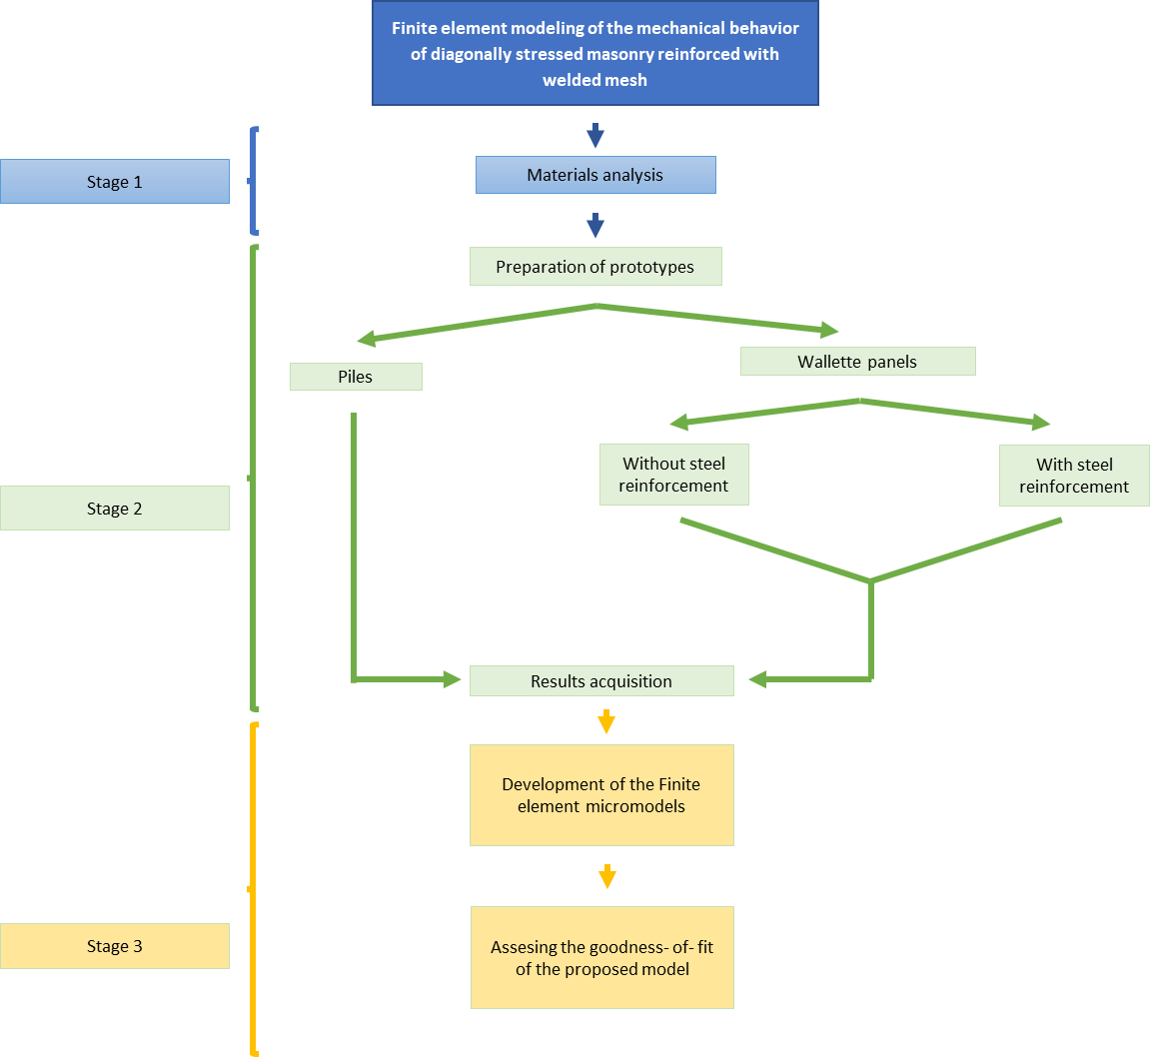
Fig. 1. Methodology flowchart

2.1 Microplane Theory with Coupled Damage and Plasticity

The objective of this study was to establish a numerical model capable of representing the behavior of masonry, with and without steel reinforcement, through the application of a coupled damage–plasticity microplane constitutive model for the material response and cohesive zone models to describe contact interactions.
Microplane models have proven effective in reproducing the nonlinear behavior of quasi-brittle materials such as concrete, rock, and clay. In this work, the formulation was applied to the components of the masonry system subjected to various loading conditions. The adopted microplane model incorporates a smooth three-surface yield formulation that captures the full range of stress states through combined plasticity and damage mechanisms, including a tension–compression split to represent stress transition effects.
Material behavior was defined through the construction of the microplane yield surface composed of three regions, as illustrated in Fig. 2; a compression cap, a central Drucker–Prager yield surface, and a tensile cap. The admissible stress states prior to yielding are contained within the initial surface; once the stress limits are exceeded, the yield surface evolves, defining a new yielding criterion.

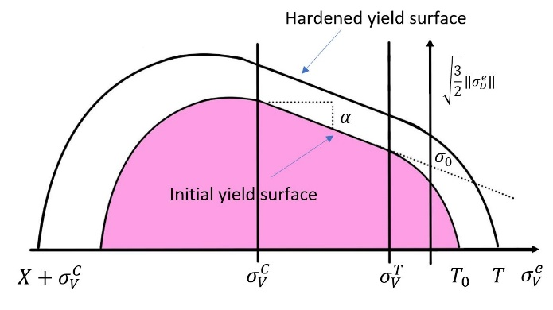
Fig. 2. Microplane model yield surface (adapted from Imadeddin et al., 2017)

The initial yield surface was defined using three key stress states: uniaxial compression, biaxial compression, and uniaxial tension (Fig. 3). While these parameters are typically obtained from laboratory testing, in this study they were partially estimated using known material properties and empirical relationships to approximate unavailable data.

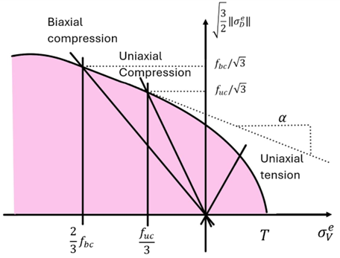
Fig. 3. Representation of different stress states as points on the yield surface (adapted from Imadeddin et al., 2017)
The parameters required for model implementation are summarized in ¡Error! No se encuentra el origen de la referencia., corresponding to different stages of the constitutive formulation. Although compressive and tensile strengths are generally determined experimentally, reasonable estimates may be obtained using empirical expressions, as described herein.

Table 1. Parameters required for calibration of the coupled damage – plasticity microplane model (Imadeddin et al., 2017)
Parameter | Stage | Symbol | Unit
Uniaxial compressive stress | Yield surface | $$f_{C}$$ | Mpa
Biaxial compressive stress | Yield surface | $$f_{b}$$ | Mpa
Uniaxial tensile stress | Yield surface | $$f_{t}$$ | Mpa
Compression cap intersection | Compression cap | $$O_{v}^{c}$$ | Mpa
Compression cap ratio | Compression cap | $$R_{C}$$ | -
Elastic modulus | Elastic behavior | $$E$$ | Mpa
Poisson´s ratio | Elastic behavior | $$V$$ | -
Hardening constant | Hardening | $$D$$ | Mpa^2
Tensile cap hardening | Hardening | $$R_{T}$$ | Mpa
Tensile damage threshold | Damage | $$γ_{t0}$$ | -
Compressive damage threshold | Damage | $$γ_{c0}$$ | -
Tensile damage evolution | Damage | $$β_{t}$$ | -
Compressive damage evolution | Damage | $$β_{c}$$ | -
Nonlocal parameter range | Nonlocal | $$C$$ | mm^2
Nonlocal parameter range | Nonlocal | $$m$$ | -

The stress values defining the initial yield surface (first surface domain) in compression and tension are related to the yield surface coordinates, as expressed by the following equations:
$$τ_{h}=\frac{1}{3}\sqrt{\left(σ_{1}-σ_{2}\right)+\left(σ_{1}-σ_{3}\right)+\left(σ_{2}-σ_{3}\right)}$$ | ( 1 )
$$σ_{h}=\frac{σ_{1}+σ_{2}+σ_{3}}{3}=σ_{V}$$ | ( 2 )
Here, τₕ and σₕ denote the octahedral shear and normal stresses, respectively, while σ₁, σ₂, and σ₃ represent the principal stresses. The biaxial compressive stress is therefore expressed as:
$$σ1=σ2=ƒ_{bc} ; σ3=0$$ | ( 3 )
The yield surface coordinates shown in Fig. 2. are defined by the following equations:
$$\sqrt{3/2}\left\|σ_{D}\right\|=f_{bc}/\sqrt{3}$$ | ( 4 )
$$σ_{V}=\frac{2}{3}f_{bc}$$ | ( 5 )
In this study, empirical expressions derived as functions of the uniaxial compressive stress—obtained from standard uniaxial compression tests—were adopted. These formulations are presented as follows.
$$ƒ_{bc}=1.15 ƒ_{uc}$$ | ( 6 )
$$ƒ_{ut}=\frac{ƒ_{ut}}{10}$$ | ( 7 )
For the compression cap regime, the compression cap intersection stress (σᵥc) and the cap shape ratio (R) define the yield surface parameters. The stress σᵥc corresponds to the intersection between the pressure cap and the Drucker–Prager surface, representing the transition from plastic volumetric expansion to plastic volumetric compaction. The parameter R describes the ratio between the major and minor axes of the cap surface and is defined by the following expression.
$$R=Xo/ƒ_{1}(σ_{v}^{c})$$ | ( 8 )
Since triaxial testing requires specialized equipment and complex procedures, approximate values were adopted. The estimated value of σᵥc is given by the following expression, while R is assumed to vary according to:
$$R=Xo/ƒ_{1}(σ_{v}^{c}) σ_{v}^{c}=\frac{2}{3}ƒ_{bc}$$ | ( 9 )
$$R=(1-3)$$ | ( 10 )
The elastic regime is defined by two parameters: the Young’s modulus (E) and Poisson’s ratio (ν), which were adopted from the literature and previous experimental studies.
The hardening regime includes the hardening constant (D) and the tensile hardening parameter (Rₜ), which are coupled with the damage formulation defined by the tensile damage threshold (γₜ₀), compressive damage threshold (γ𝑐₀), and the damage evolution parameters in tension (βₜ) and compression (β𝑐). These parameters are typically obtained from cyclic compression tests that provide stress–strain curves, as illustrated in Fig. 4.

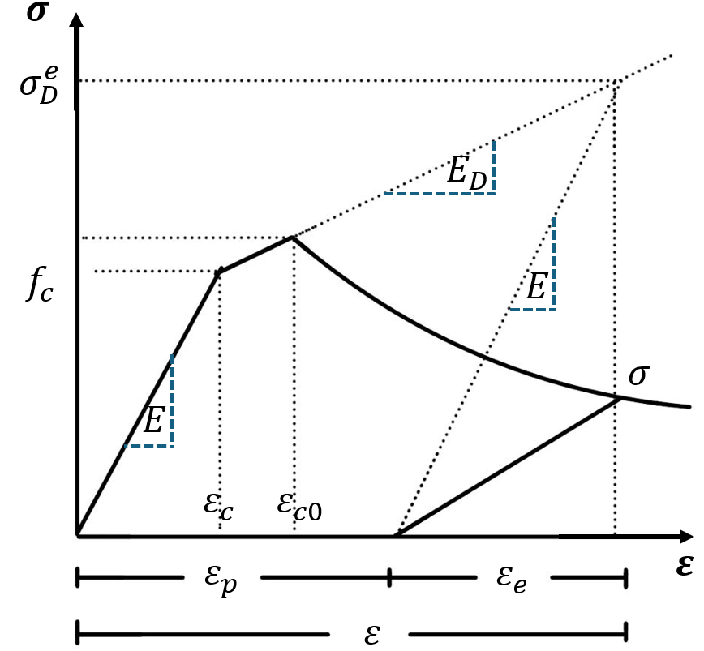

Fig. 4. One – dimensional interpretation of the stress – strain curve under cyclic compression (adapted from Imadeddin et al., 2017)
When such experimental data are unavailable, approximate values may be adopted based on experimental evidence. The hardening constant D is assumed to range between 1,000 and 60,000 MPa, while Rₜ is taken as 1 MPa. The tensile damage threshold γₜ₀ is assumed to be negligible and set to zero, whereas γ𝑐₀ is assumed to lie between 0 and 3×10⁻⁵. For damage evolution, β𝑐 is assumed to range between 1,000 and 10,000, and βₜ is defined as 1.5β𝑐 (Imadeddin et al., 2017).
Finally, nonlocal parameters, which are not directly associated with experimental testing, are defined to ensure solution regularization and numerical convergence. The parameter m is taken greater than unity, while C is defined as l², following the recommendations of Imadeddin et al. (2017).

2.2 Cohesive Zone Model

This modeling approach is suitable for representing the interface between masonry units and mortar. The cohesive zone model (CZM) exhibits linear elastic behavior until tensile or shear stresses reach their critical values, leading to brittle failure characterized by crack opening or sliding governed by the fracture energy.
The adopted CZM follows a bilinear traction–separation law, in which the interface initially behaves elastically until the tensile or shear strength is reached. After this limit is exceeded, progressive damage occurs and the interface stress decreases linearly with increasing separation until complete decohesion is achieved. This formulation enables the simulation of crack initiation and propagation along mortar joints and reinforcement interfaces.
Within this framework, two fracture modes are considered. Mode I represents tensile opening of the interface and is characterized by the tensile strength $f_{xt}$and the corresponding fracture energy $G_{I}^{f}$. Mode II represents sliding failure and is defined by the maximum shear stress $τ_{max}$and the shear fracture energy $G_{II}^{f}$ (Bernat-Maso E. et al., 2015). The interaction between both fracture modes is governed by a mixed-mode energy criterion expressed as:
$$\frac{G^{I}}{G_{f}^{I}}+\frac{G^{II}}{G_{f}^{II}}=1$$ | ( 11 )
where $G^{I}$ and $G^{II}$ are the energy release rates associated with tensile opening and sliding, respectively. These parameters were estimated using analytical expressions that provide reasonable approximations to laboratory test results.
$$G_{f}^{I}\left(\frac{N}{m}\right)=36.65*f_{xt}$$ | ( 12 )
$$τ_{max}=\frac{T}{b*m}$$ | ( 13 )
$$G_{f}^{II}\left(\frac{N}{m}\right)=36.65*τ_{max}$$ | ( 14 )

This modeling strategy requires only a limited number of parameters while still capturing the essential mechanisms governing interface failure. Consequently, cohesive zone models have been widely used to simulate the tensile response and debonding behavior of masonry and reinforced mortar systems in finite element analyses.
2.3 Finite Element Methodology

Masonry walls consist of two primary components resisting axial loads: masonry units and the mortar joints. Although both materials act jointly under loading, masonry units—being mechanically stronger—limit the transfer of transverse shear stresses to the mortar, which exhibits less favorable stress–strain characteristics (Zeevaert, 2001).
For the finite element analysis of masonry wallettes, ANSYS Workbench 2022 R2 (student version) was employed. The models were discretized using CPT216 elements, which are suitable for three-dimensional solid modeling and are compatible with the coupled damage–plasticity microplane constitutive formulation implemented in the software, unlike conventional SOLID65 elements.
CPT216 elements are 20-node quadratic elements well suited for irregular meshes. They feature four degrees of freedom at corner nodes three translational components (x, y, z) and one pore-pressure degree of freedom and exhibit tensile stiffness, elastic behavior, large deflection capability, and high deformability. These elements support prismatic, tetrahedral, and pyramidal configurations, as shown in Fig. 5.
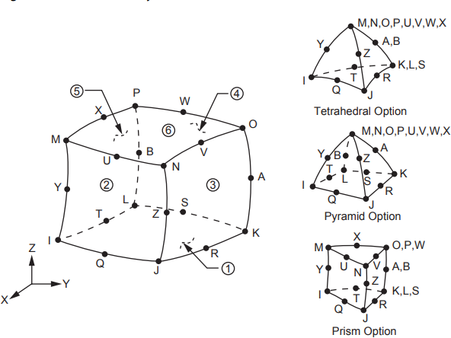

Fig. 5. Homogeneous structural solid geometry of SOLID216 (Ansys, 2023)

2.4 Mesh Sensitivity and Convergence Verification

Damage–plasticity formulations incorporating strain-softening behavior may exhibit mesh dependency due to strain localization effects. In continuum finite element modeling of quasi-brittle materials such as masonry, the introduction of post-peak softening may cause the width of the localization zone to become artificially governed by the discretization size, potentially leading to non-objective energy dissipation and mesh-dependent structural response. This phenomenon has been extensively discussed in fracture mechanics and computational damage modeling (Bažant & Oh, 1983; de Borst, 1992).
Recent studies on nonlinear damage-based finite element formulations continue to emphasize that insufficient mesh verification may result in artificially stiff or excessively brittle responses depending on the discretization size, particularly when strain-softening and fracture energy regularization are involved (Zhang et al., 2020). Therefore, numerical objectivity must be explicitly verified to ensure that global structural indicators are not governed by the element size.
In accordance with these principles, a mesh sensitivity study was conducted for the reinforced 15 cm wallette configuration, identified as the most demanding nonlinear case. A characteristic element size $h$was defined based on the block geometry, and three discretization levels were evaluated by scaling this parameter (0.5h, h, and 1.2h), corresponding to fine, medium, and coarse meshes, respectively.
Mesh convergence was assessed using two global response parameters: peak load $P_{max}$and initial stiffness $K_{0}$. The initial stiffness was defined as the slope of the load–displacement curve within the quasi-linear portion of the response, computed between 10% and 40% of the peak load:
$$K_{0}=\frac{P_{0.4}-P_{0.1}}{Δ_{0.4}-Δ_{0.1}}$$ | ( 15 )
where $P_{0.1}$and $P_{0.4}$correspond to 10% and 40% of $P_{max}$, respectively. This definition follows the classical structural mechanics interpretation of stiffness.
The variation in peak load between mesh refinements was quantified using the standard definition of relative numerical error, taking the finest discretization as reference:
$${\%∆P}_{max}=∣\frac{P_{max,i}-P_{\max{ },ref}}{P_{\max{ },ref}}∣x 100$$ | ( 16 )
where $P_{max⁡,i}$corresponds to the value obtained for mesh $i$, and $P_{max⁡,ref}$is the result computed with the finest mesh. This procedure is consistent with conventional finite element verification practices for nonlinear structural analysis (Jirásek & Bažant, 2002).
Convergence was considered achieved when the relative variation in peak load between successive refinements remained below 3%. Such tolerance is consistent with accepted practices in nonlinear finite element simulations of quasi-brittle materials, where small variations in global structural parameters indicate numerical stability and mesh objectivity (Mauludin and Oucif, 2020).

2.5 Parameter Calibration Strategy

The constitutive parameters used in the numerical model were determined following a hierarchical calibration procedure combining experimental measurements, analytical relationships, and numerical calibration.
First, fundamental mechanical properties were obtained directly from laboratory testing. These parameters include compressive strength, elastic modulus, and Poisson’s ratio of the masonry units and mortar. These experimentally derived values define the primary elastic and strength characteristics of the material model.
Second, additional parameters required by the constitutive formulation were derived from analytical relationships reported in the literature for quasi-brittle materials. These include estimates of tensile strength, biaxial compressive strength, and fracture energy parameters used to characterize damage initiation and propagation.
Finally, a limited number of parameters associated with the damage evolution and nonlocal regularization of the microplane model were calibrated numerically. These parameters, such as the damage evolution coefficients and nonlocal interaction range, do not correspond to directly measurable physical quantities and are commonly adjusted to ensure stable numerical behavior and realistic post-peak response.
The calibration procedure was performed by iteratively comparing numerical predictions with experimental load–displacement curves obtained from diagonal compression tests. The final parameter set was selected based on its ability to reproduce the experimentally observed stiffness, peak load, and failure mechanism of the masonry specimens.
2.6 Materials Used

2.6.1 Concrete Blocks

Two types of solid concrete masonry units, measuring 12×40×20 cm and 15×40×20 cm, sourced from two different regions of Mexico, were tested in accordance with NMX-C-036-ONNCCE-2013. The unit compressive strength was determined using the following expression:
$$R=\frac{F}{A}$$ | ( 17 )
Donde:
$R=$ Compressive strength MPa (kgf/cm2)
$F=$ Maximum applied load N (kgf)
$A=$ Specimen cross-sectional area (cm2)

The material properties used in the numerical model are summarized in Table 2, including parameters associated with the coupled damage–plasticity microplane model and the cohesive contact formulation.
Table 2. Block material properties for microplane model with coupled damage and plasticity
Propierties of the material “Block 12”
Parameter | Stage | Symbol | Typical Values | Unit
Uniaxial compressive stress | Yield surface | $$f_{C}$$ | 3.39 | Mpa
Biaxial compressive stress | Yield surface | $$f_{b}$$ | 3.90 | Mpa
Uniaxial tensile stress | Yield surface | $$f_{t}$$ | 0.34 | Mpa
Compression cap intersection | Compression cap | $$O_{v}^{c}$$ | -2.60 | Mpa
Compression cap ratio | Compression cap | $$R_{C}$$ | 2.00 | -
Elastic modulus | Elastic behavior | $$E$$ | 1500.00 | Mpa
Poisson´s ratio | Elastic behavior | $$V$$ | 0.12 | -
Hardening constant | Hardening | $$D$$ | 200.00 | Mpa^2
Tensile cap hardening | Hardening | $$R_{T}$$ | 1.00 | Mpa
Tensile damage threshold | Damage | $$γ_{t0}$$ | 0.00 | -
Compressive damage threshold | Damage | $$γ_{c0}$$ | 0.00 | -
Tensile damage evolution | Damage | $$β_{t}$$ | 1500.00 | -
Compressive damage evolution | Damage | $$β_{c}$$ | 1000.00 | -
Nonlocal parameter range | Nonlocal | $$C$$ | 400.00 | mm^2
Nonlocal parameter range | Nonlocal | $$m$$ | 1.00 | -
Propierties of the material “Block 15”
Parameter | Stage | Symbol | Typical Values | Unit
Uniaxial compressive stress | Yield surface | $$f_{C}$$ | 7.35 | Mpa
Biaxial compressive stress | Yield surface | $$f_{b}$$ | 8.45 | Mpa
Uniaxial tensile stress | Yield surface | $$f_{t}$$ | 0.74 | Mpa
Compression cap intersection | Compression cap | $$O_{v}^{c}$$ | -5.64 | Mpa
Compression cap ratio | Compression cap | $$R_{C}$$ | 2.00 | -
Elastic modulus | Elastic behavior | $$E$$ | 1250.00 | Mpa
Poisson´s ratio | Elastic behavior | $$V$$ | 0.12 | -
Hardening constant | Hardening | $$D$$ | 950.00 | Mpa^2
Tensile cap hardening | Hardening | $$R_{T}$$ | 1.00 | Mpa
Tensile damage threshold | Damage | $$γ_{t0}$$ | 0.00 | -
Compressive damage threshold | Damage | $$γ_{c0}$$ | 0.00 | -
Tensile damage evolution | Damage | $$β_{t}$$ | 2250.00 | -
Compressive damage evolution | Damage | $$β_{c}$$ | 1500.00 | -
Nonlocal parameter range | Nonlocal | $$C$$ | 400.00 | mm^2
Nonlocal parameter range | Nonlocal | $$m$$ | 3.00 | -

2.6.2 Mortar Cubes

Mortar cube specimens measuring 5×5×5 cm were prepared in accordance with NMX-C-061-ONNCCE-2001 using commercial CEMEX mortar. The material properties adopted for the numerical model are summarized in Table 3, including parameters associated with the coupled damage–plasticity microplane formulation and the cohesive contact model.

Table 3. Mortar material properties for microplane model with coupled damage and plasticity
Propierties of the joint - mortar
Parameter | Stage | Symbol | Typical Values | Unit
Uniaxial compressive stress | Yield surface | $$f_{C}$$ | 20.61 | Mpa
Biaxial compressive stress | Yield surface | $$f_{b}$$ | 23.70 | Mpa
Uniaxial tensile stress | Yield surface | $$f_{t}$$ | 2.06 | Mpa
Compression cap intersection | Compression cap | $$O_{v}^{c}$$ | -15.80 | Mpa
Compression cap ratio | Compression cap | $$R_{C}$$ | 1.00 | -
Elastic modulus | Elastic behavior | $$E$$ | 5500.00 | Mpa
Poisson´s ratio | Elastic behavior | $$V$$ | 0.15 | -
Hardening constant | Hardening | $$D$$ | 25000.00 | Mpa^2
Tensile cap hardening | Hardening | $$R_{T}$$ | 1.00 | Mpa
Tensile damage threshold | Damage | $$γ_{t0}$$ | 0.00 | -
Compressive damage threshold | Damage | $$γ_{c0}$$ | 0.00 | -
Tensile damage evolution | Damage | $$β_{t}$$ | 1500.00 | -
Compressive damage evolution | Damage | $$β_{c}$$ | 1000.00 | -
Nonlocal parameter range | Nonlocal | $$C$$ | 400.00 | mm^2
Nonlocal parameter range | Nonlocal | $$m$$ | 3.00 | -
Propierties of the mortar layer
Parameter | Stage | Symbol | Typical Values | Unit
Uniaxial compressive stress | Yield surface | $$f_{C}$$ | 27.36 | Mpa
Biaxial compressive stress | Yield surface | $$f_{b}$$ | 31.46 | Mpa
Uniaxial tensile stress | Yield surface | $$f_{t}$$ | 2.74 | Mpa
Compression cap intersection | Compression cap | $$O_{v}^{c}$$ | -20.98 | Mpa
Compression cap ratio | Compression cap | $$R_{C}$$ | 2.00 | -
Elastic modulus | Elastic behavior | $$E$$ | 6500.00 | Mpa
Poisson´s ratio | Elastic behavior | $$V$$ | 0.15 | -
Hardening constant | Hardening | $$D$$ | 58000.00 | Mpa^2
Tensile cap hardening | Hardening | $$R_{T}$$ | 1.00 | Mpa
Tensile damage threshold | Damage | $$γ_{t0}$$ | 0.00 | -
Compressive damage threshold | Damage | $$γ_{c0}$$ | 0.00 | -
Tensile damage evolution | Damage | $$β_{t}$$ | 3750.00 | -
Compressive damage evolution | Damage | $$β_{c}$$ | 1000.00 | -
Nonlocal parameter range | Nonlocal | $$C$$ | 400.00 | mm^2
Nonlocal parameter range | Nonlocal | $$m$$ | 3.00 | -

2.6.3 Masonry Piers

The masonry piers were constructed with three courses of blocks bonded with mortar. The specimens were tested following NMX-C-464-ONNCCE, which specifies an axial compressive force to determine the masonry compressive strength (f’m) and Young’s modulus (Eᵐ). The strength was calculated using:

$$f_{m}= \frac{P}{t*b}*slenderness correction factor$$ | ( 18 )
Donde:
$f_{m}$ = Resistencia a compresión de la pila en Mpa (kgf/cm2)
$P$ = Carga máxima aplicada en N (kg)
$t$ = Espesor de la pila en mm (cm)
$b$ = Ancho de la pila en mm (cm)
$$E_{m}= \frac{σ_{2}-σ_{1}}{ε_{2}-0.00005}$$ | ( 19 )
Donde:
$E_{m}$ = Modulo de elasticidad de la mampostería en Mpa (kgf/cm2)
$σ_{1}$ = Esfuerzo axial correspondiente a 0.00005 de deformación en Mpa (kgf/cm2)
$σ_{2}$ = Esfuerzo axial correspondiente al 40% de la carga máxima en Mpa (kgf/cm2)
$ε_{2}$ = Deformación unitaria producida por el esfuerzo $σ_{2}$

In the numerical model, symmetric bonded contacts were defined together with a cohesive zone model (CZM) to represent the mortar–unit interface. The CZM parameters are summarized in Table 4.
Table 4. Cohesive zone model parameters
Cohesive zone model parameters (CZM)
$$F_{xt}(Mpa)$$ | $$G_{f}^{I} (N/m)$$ | $$τ_{max} (Mpa)$$ | $$G_{f}^{II} (N/m)$$
0.294 | 12.25 | 0.46 | 16.63

2.6.4 Wallette Masonry Testing

As with the masonry piers, wallette testing followed NMX-C-464-ONNCCE-2010. Two wallette configurations were evaluated (Fig. 6): an unreinforced specimen and a specimen reinforced with 6–6/10–10 welded wire mesh.

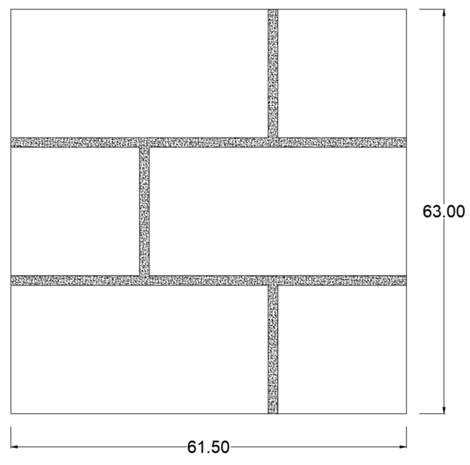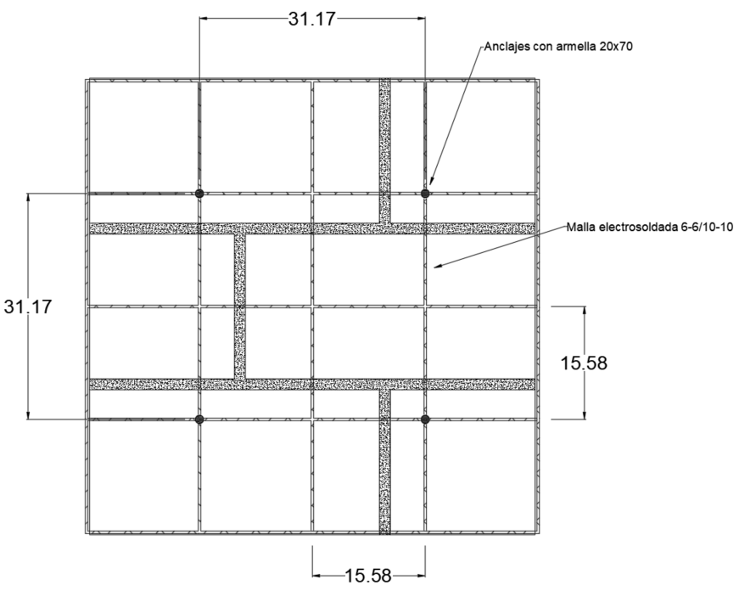

(a) (b)

Fig. 6. Geometry of the masonry wallettes (a) and with reinforcement (b)

3. results and discussion

The results integrate data from experimental testing and numerical simulations performed in ANSYS Workbench, enabling comparison between measured and simulated responses and demonstrating the predictive capability of the coupled damage–plasticity microplane model and the cohesive zone formulation.
3.1 Mesh Sensitivity and Convergence Verification

To ensure numerical objectivity and exclude discretization-driven response, a detailed mesh sensitivity analysis was conducted for the reinforced 15 cm wallette configuration (Table 5). Since the numerical model includes different material domains — concrete block units, mortar joints, and mortar coating layer — discretization was controlled independently for each component while maintaining proportional geometric scaling.
Three refinement levels were defined by scaling a characteristic element size parameter $h$: coarse (1.2h), medium (h), and fine (0.5h) (Fig. 7). Table X presents the complete discretization parameters and resulting structural response indicators.
Table 5. Mesh sensitivity results
Mesh sensitivity results for reinforced 15 cm wallete
 | Element size
Scale | Block (mm) | Joint mortar (mm) | Mortar layer (mm) | Peak load (kN) | ΔPmax (%) | Initial Stiffness (kN/mm) | ΔK0 (%)
1.2 h | 120 | 18 | 24 | 140.38 | 1.03 | 366.94 | 2.25
h | 100 | 15 | 20 | 140.33 | 1.95 | 366.83 | 4.49
0.5 h | 60 | 10 | 14 | 137.59 | - | 357.47 | -

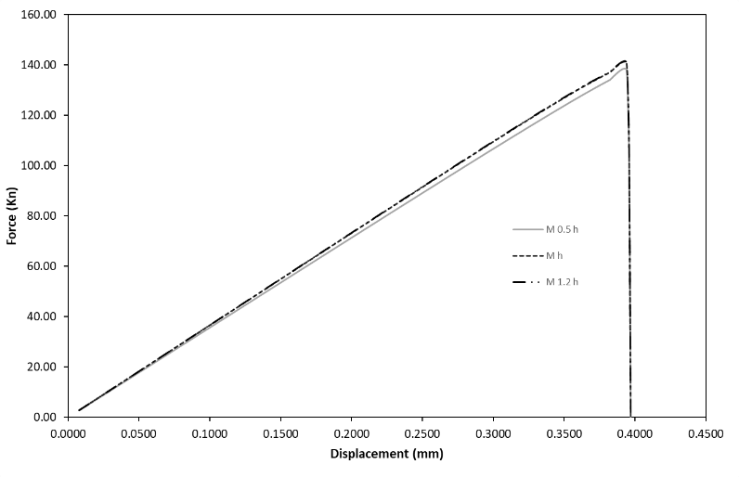
Fig. 7. Force – displacement response of the reinforced 15 cm Wallette for different mesh discretizations (0.5h, h and 1.2 h).

The maximum variation in peak load between the 0.5h and h discretizations was 1.95%, while the variation between h and 1.2h meshes was 1.03%, remaining below the adopted 3% convergence tolerance. This confirms that the predicted load-carrying capacity is not governed by discretization size.
A slightly higher sensitivity was observed in the initial stiffness, with a maximum variation of 4.49% between 0.5h and h meshes. This behavior is consistent with improved resolution of strain localization and cohesive interface response in refined meshes. In damage–plasticity formulations, stiffness tends to exhibit moderate sensitivity to element size due to better representation of early microcrack distribution and interface traction–separation behavior.
Importantly, despite differences in element size across the block, joint mortar, and mortar layer domains, the structural response remained stable and monotonic with refinement. No spurious hardening, artificial brittleness, or abrupt changes in failure mechanism were detected.
These results demonstrate that the adopted microplane damage–plasticity formulation coupled with cohesive interface modeling exhibits stable and mesh-objective global behavior within the investigated discretization range. The medium mesh (h) was therefore selected for subsequent analyses, providing an adequate compromise between computational efficiency and numerical accuracy.
3.2 Parametric Sensitivity Analysis
To evaluate the robustness of the numerical model and quantify the influence of key constitutive parameters, a parametric sensitivity analysis was conducted using the calibrated reinforced 15 cm wallette model. Three parameters were independently perturbed around the baseline calibration: elastic modulus $E$(±10%), cohesive fracture energy $G_{f}^{I}$ (±20%), and the compressive damage evolution parameter $β_{c}$(±10%). The influence of each parameter was evaluated in terms of peak load $P_{max}$, initial stiffness $K_{0}$, and displacement at peak load.

Table 6. Parametric sensitivity analysis results for the reinforced 15 cm Wallette model
Parameter Varied | Variation | $$P_{max}$$ | $$∆P_{max}$$ | $$K0$$ | $$∆K0$$ | $$Displacement$$ | $$∆Displacement$$
 |  | (kN) | (%) | (kN/mm) | (%) | (mm) | (%)
Base | - | 140.01 | - | 366.83 | - | 0.394 | -
$$E$$ | -10% | 139.71 | 0.21 | 350.14 | 4.5 | 0.401 | 1.52
$$E$$ | +10% | 140.28 | 0.19 | 383.07 | 4.4 | 0.390 | 1.02
$$G_{f}^{I}$$ | -20% | 137.02 | 2.14 | 366.83 | 0 | 0.375 | 4.82
$$G_{f}^{I}$$ | +20% | 141.08 | 0.76 | 366.83 | 0 | 0.422 | 7.35
$$β_{c}$$ | -10% | 140.75 | 0.53 | 366.83 | 0 | 0.395 | 0.46
$$β_{c}$$ | +10% | 140.75 | 0.53 | 366.83 | 0 | 0.395 | 0.46

Variations in the elastic modulus produced negligible changes in peak load (below 0.25%) but resulted in noticeable variations in the initial stiffness, reaching approximately 4.5%. This behavior is consistent with the direct proportionality between elastic modulus and structural stiffness in the linear response stage.
Changes in fracture energy $G_{f}^{I}$ had a more pronounced effect on displacement capacity. While the peak load varied moderately (up to 2.14%), the displacement at peak load showed larger variations, reaching up to 7.35%. This result reflects the role of fracture energy in governing damage evolution and post-peak softening behavior in quasi-brittle materials.
In contrast, perturbations of the compressive damage evolution parameter $β_{c}$ produced minimal changes in all response indicators, with variations below 1%. This indicates that the calibrated model response is relatively insensitive to small variations of this parameter within the investigated range.
Overall, the sensitivity results demonstrate that the proposed numerical model exhibits stable predictions for global response indicators. The peak load prediction remains robust with respect to moderate variations in material parameters, while stiffness and displacement responses show physically consistent sensitivity patterns.
3.3 Concrete Blocks and Mortar Cubes

Uniaxial compression tests on solid concrete blocks yielded average strengths of 68.56 kg/cm² for the 15 cm and 34.64 kg/cm² for the 12 cm, indicating that the 15 cm blocks are approximately 50–60% stronger. However, the 12 cm exhibited a lower coefficient of variation.
Finite element simulations (Fig. 8) predicted a maximum load of 395.05 kN for the 15 cm, corresponding to a compressive strength of 67.13 kg/cm², while the 12 cm reached a maximum load of 158.46 kN, corresponding to 33.66 kg/cm².

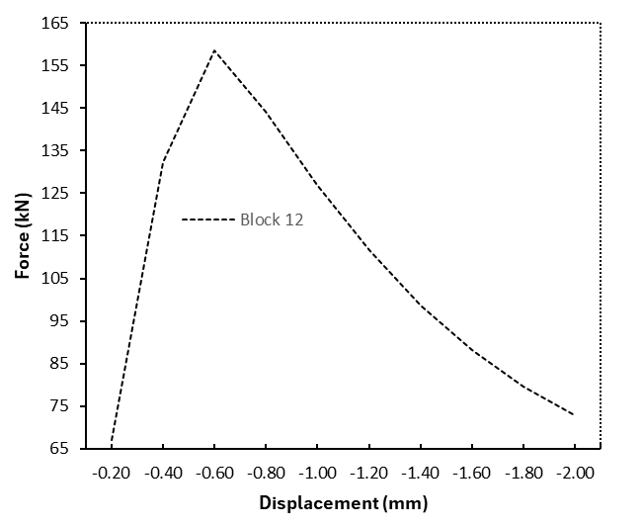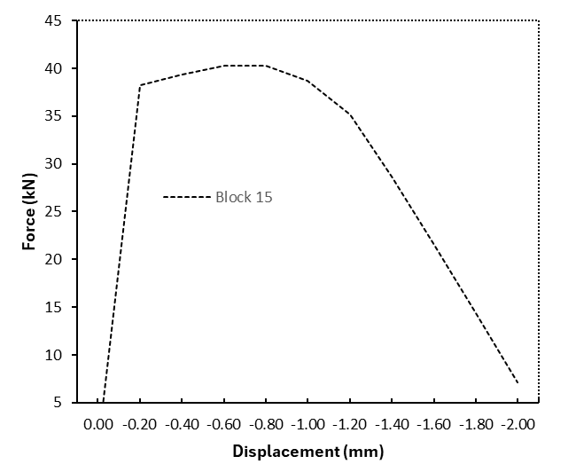
(a) (b)

Fig. 8. Force – displacement graph of block pieces of (a) Block 12 and (b) Block 15

In the case of Mortar cubes, the tests yielded average compressive strengths of 237.52 kg/cm² for masonry pier joints, 191.25 kg/cm² for unreinforced wallette joints, 202.03 kg/cm² for reinforced wallette joints, and 279.99 kg/cm² for the mortar coating.
Numerical simulations (Fig. 9) predicted maximum loads of 52.72 kN for the joints, corresponding to a compressive strength of 214.42 kg/cm², and 70.28 kN for the coating, corresponding to 286.66 kg/cm².
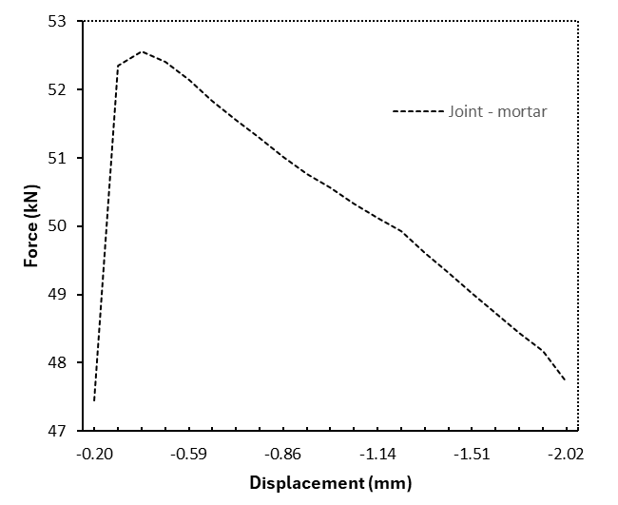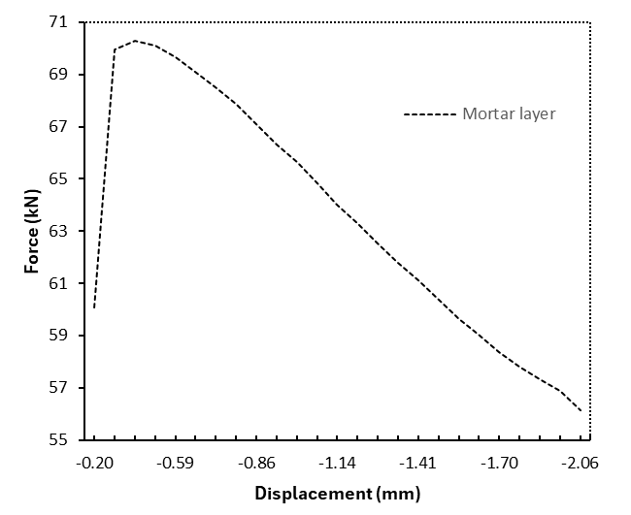
(a) (b)
Fig. 9. Force – displacement graph of mortar samples of (a) joint – mortar and (b) mortar layer

Calibration of the primary materials (masonry units and mortar) was performed using compressive strength as the reference parameter. For the 12 cm units, the numerical model showed a percentage difference of −2.82% relative to the experimental average, while the 15 cm unit model exhibited a difference of −2.08%. The corresponding deformation patterns of the proposed models are shown in Fig. 10.
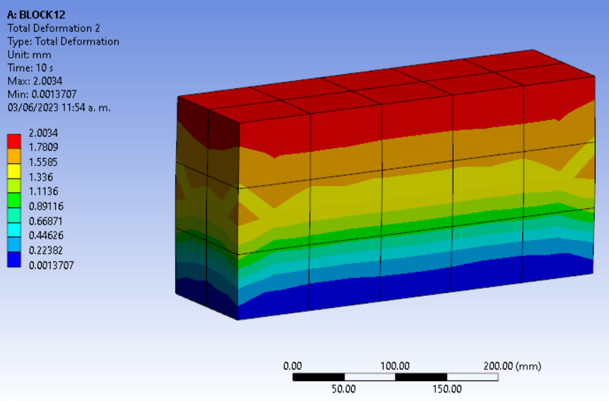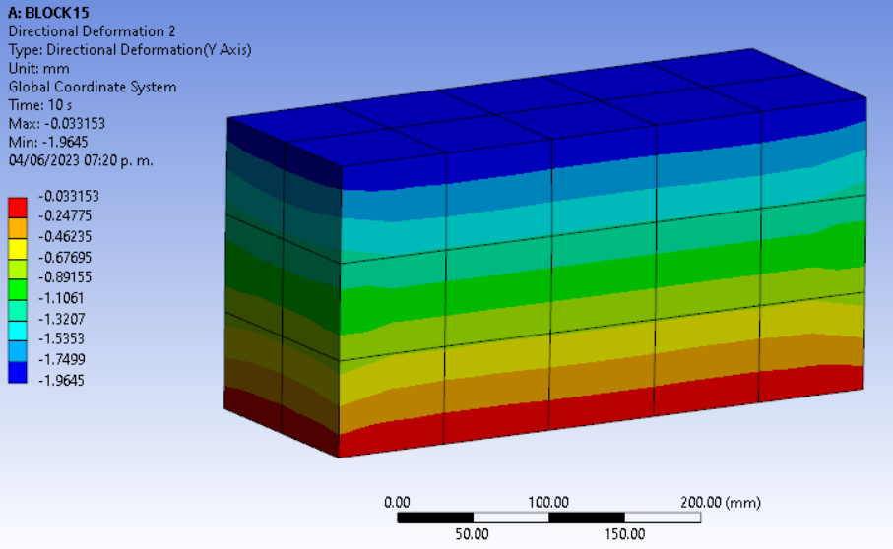
(a) (b)
Fig. 10. Deformation graph of block pieces on the “Y” axis of (a) Block 15 and (b) Block 12

Mortar cube model results are presented in Fig. 11 The numerical model for mortar used in joints showed a percentage difference of +4.16% compared to the experimental average, whereas the mortar coating model exhibited a difference of +6.67%.
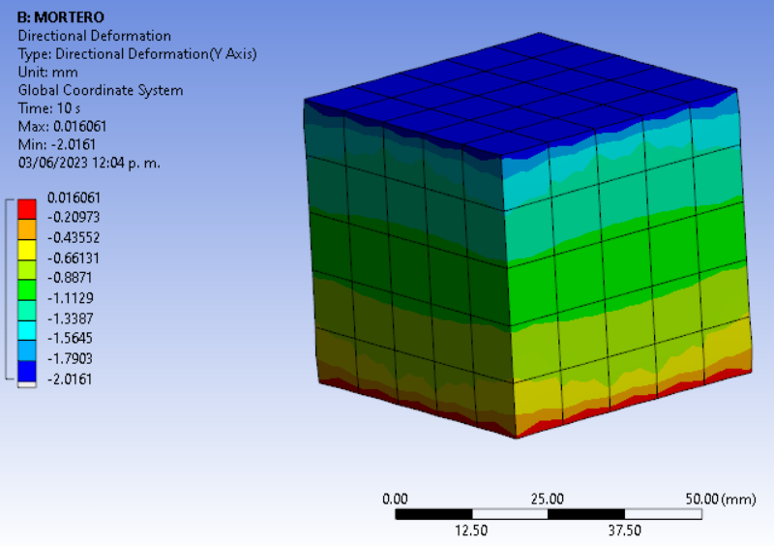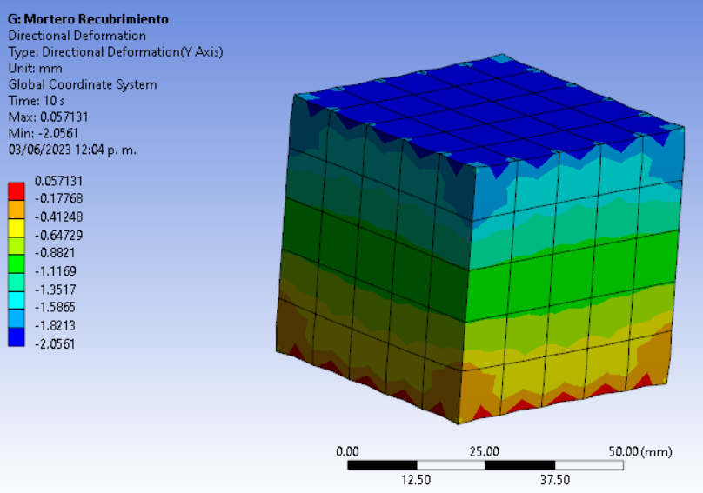
(a) (b)
Fig. 11. Deformation graph of mortar pieces on the “Y” axis of (a) joint – mortar and (b) mortar layer
3.4 Masonry Piers
Experimental tests predominantly exhibited vertical cracking failure modes, although some specimens—particularly those constructed with 12 cm units—showed localized crushing of masonry units. For the average compressive strength, the 15 cm masonry piers was 91.98 kg/cm², and the corresponding stress–strain curves (Fig. 12) yielded an average Young’s modulus of 44,874.71 kg/cm². In contrast, specimens constructed with 12 cm units exhibited an average compressive strength of 31.58 kg/cm² and a lower Young’s modulus of 39,085.23 kg/cm².

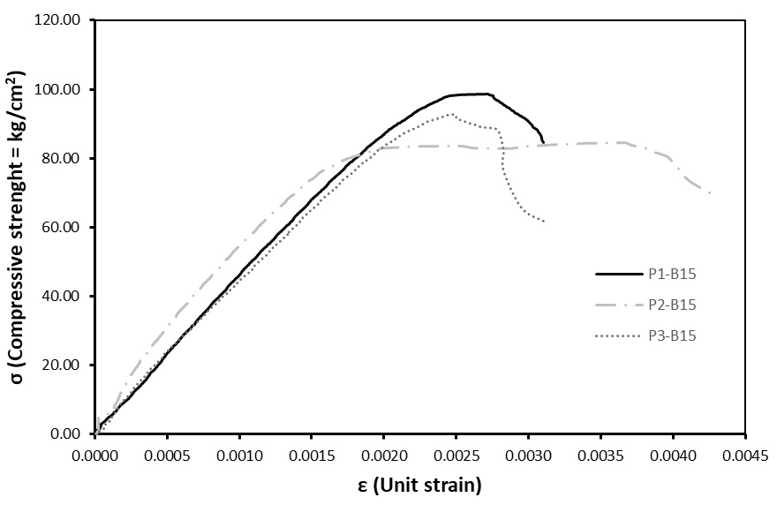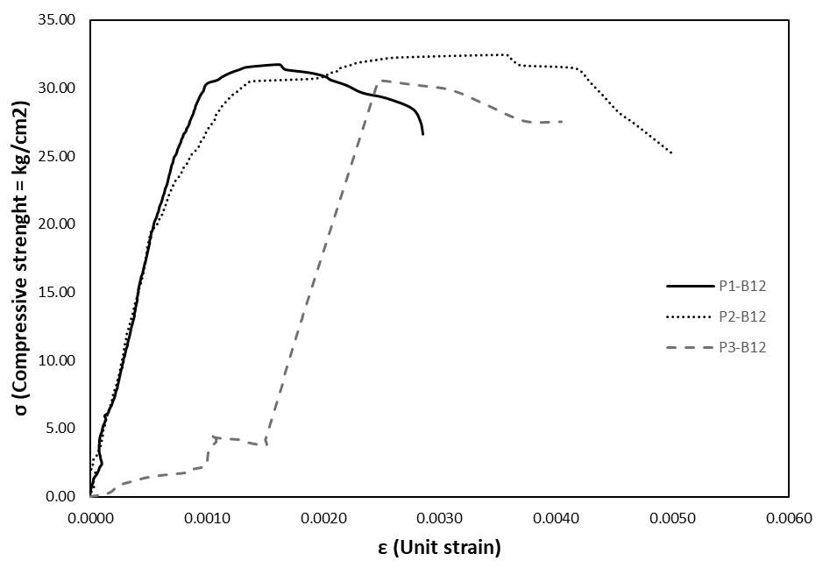
(a) (b)
Fig. 12. Stress – strain graph corresponding to masonry piers of (a) Block 15 and (b) Block 12

Numerical models incorporating masonry units, mortar joints, and contact interfaces are shown in Fig. 13. The 12 cm unit model reached a maximum load of 158.17 kN with a displacement of 0.598 mm, whereas the 15 cm unit model sustained 391.25 kN with a displacement of 1.49 mm.
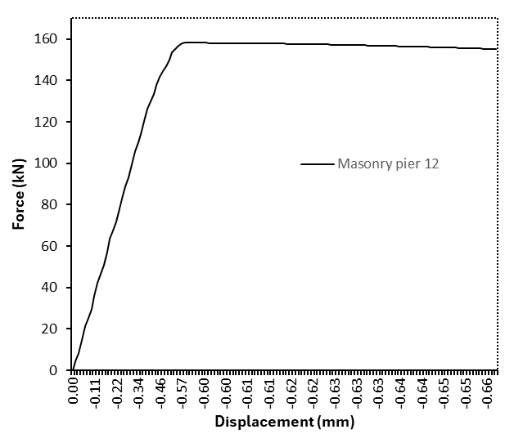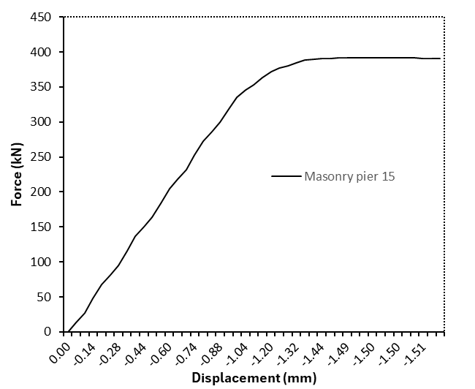
(a) (b)
Fig. 13. Stress – strain graph corresponding to masonry piers of (a) Block 15 and (b) Block 12

Comparison between numerical predictions and experimental averages revealed noticeable discrepancies. For masonry piers constructed with 12 cm units, the experimental average peak load was 141.13 kN, resulting in a +12.07% difference in the numerical model, while the average experimental displacement of 1.03 mm corresponded to a −41.94% difference. For the 15 cm unit piers, the experimental average peak load was 508.6 kN, yielding a +23.07% difference in the numerical prediction, and the average displacement of 1.23 mm resulted in a +21.13% difference. The load–displacement discrepancies are illustrated in Fig. 14, and the corresponding deformation patterns of the numerical models are shown in Fig. 15.

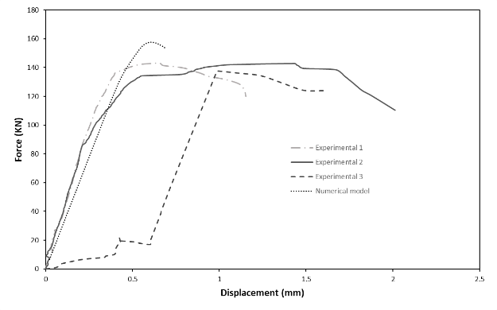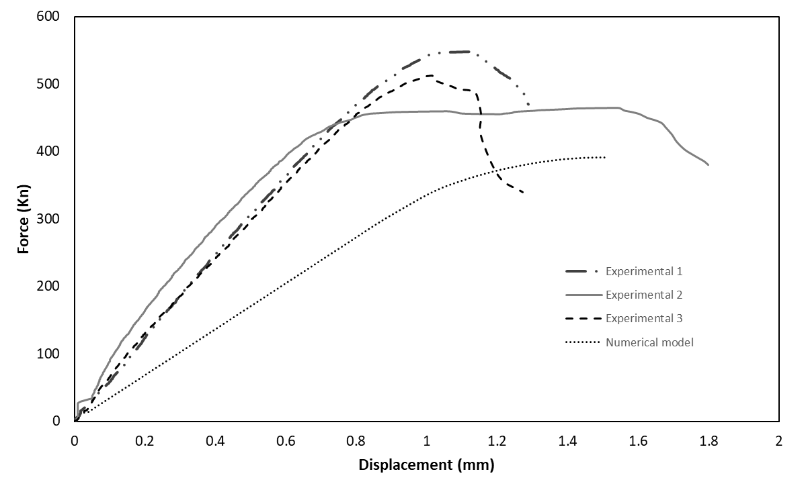
(a) (b)
Fig. 14. Force – displacement graph of experimental and numerical model masonry piers of (a) Block 15 and (b) Block 12

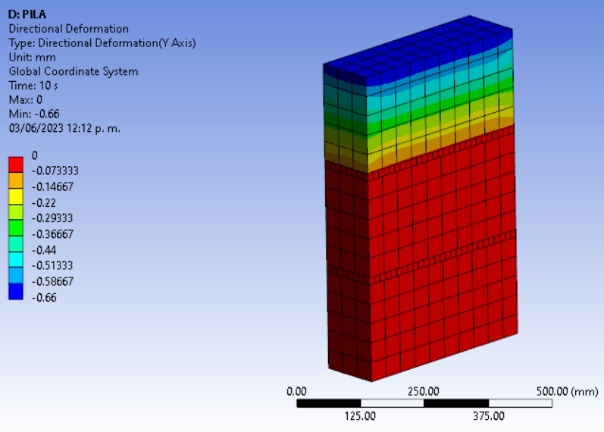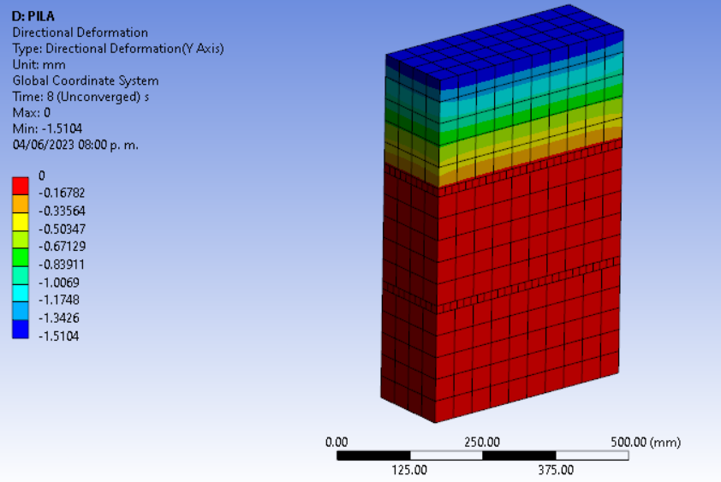
(a) (b)
Fig. 15. Deformation graph of masonry piers on the “Y” axis of (a) Block 15 and (b) Block 12
3.5 Unreinforced Masonry Wallettes
Experimental tests exhibited similar failure patterns for both 12 cm and 15 cm masonry units, characterized as combined failure modes. In most wallettes, the primary crack initiated in the masonry unit, propagated into the mortar joint, and progressed in a stepped pattern.
Unreinforced wallettes constructed with 12 cm units achieved an average shear strength of 4.06 kg/cm² and an average shear modulus of 4,727.71 kg/cm², whereas specimens built with 15 cm units reached an average shear strength of 7.98 kg/cm² and a shear modulus of 8,179.00 kg/cm². The corresponding stress–strain curves are shown in Fig. 16.
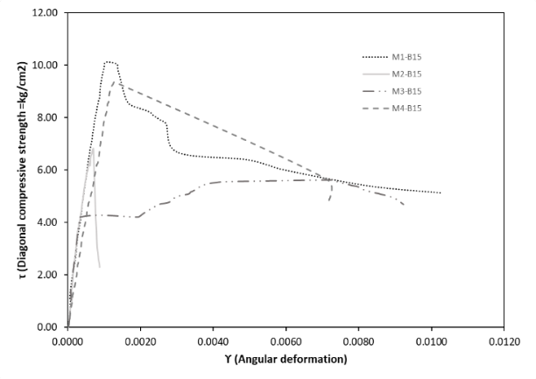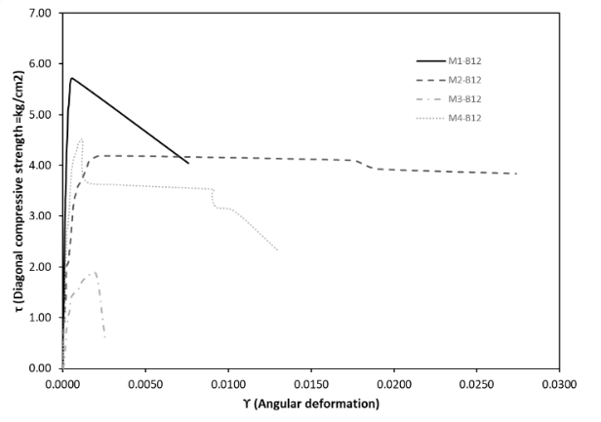
(a) (b)
Fig. 16. Stress – strain graph corresponding to wallets masonry of (a) Block 15 and (b) Block 12

Numerical simulations for the 12 cm wallettes (Fig. 17) predicted a maximum load of 41.28 kN with a displacement of 0.22 mm. In contrast, the 15 cm wallette model reached a maximum load of 106.32 kN with a displacement of 0.50 mm.

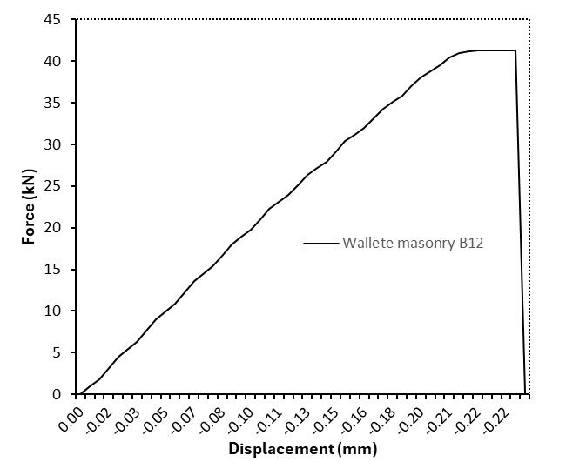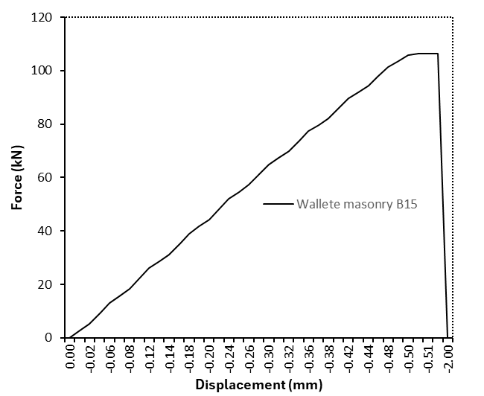
(a) (b)
Fig. 17. Stress – strain graph corresponding to wallets masonry of (a) Block 15 and (b) Block 12

For unreinforced masonry wallettes, the comparison between numerical and experimental results showed improved agreement in terms of peak load relative to masonry piers, with smaller percentage differences for both unit sizes. However, discrepancies in displacement predictions remained on the order of 20–30%.
For the 12 cm units, the experimental average peak load was 41.29 kN, resulting in a −0.02% difference in the numerical model, while the average experimental displacement of 0.32 mm led to a −31.25% difference. For the 15 cm units, the experimental average peak load was 100.48 kN, corresponding to a +5.81% difference in the numerical prediction, and the average displacement of 0.69 mm resulted in a −27.53% difference. The load–displacement comparisons are shown in Fig. 18, and the numerical deformation patterns are presented in Fig. 19.

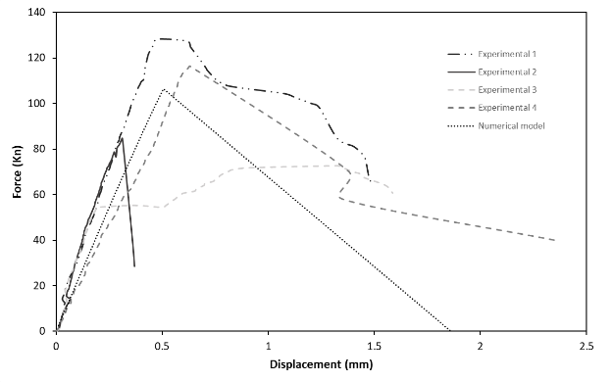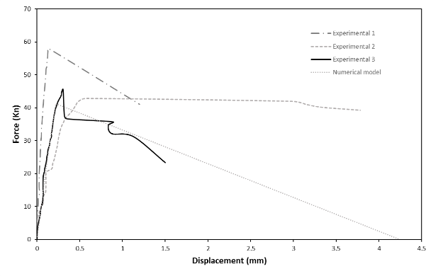
(a) (b)
Fig. 18. Force – displacement graph of experimental and numerical wallette panels of (a) Block 15 and (b) Block 12

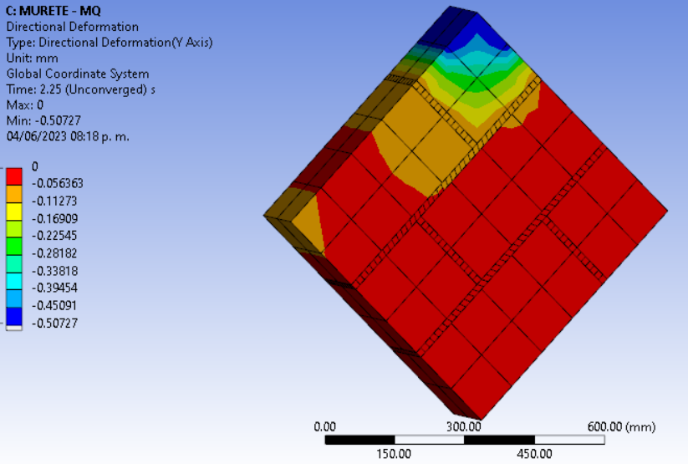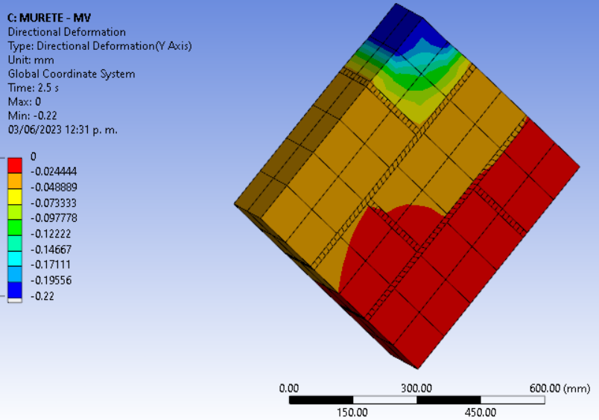
(a) (b)
Fig. 19. Deformation graph of wallette panels on the “Y” axis of (a) Block 15 and (b) Block 12

3.6 Reinforced Masonry Wallettes
Experimental tests on steel-reinforced wallettes showed a predominant vertical cracking failure mode on the front face, where the mortar coating is located. On the rear face, cracking patterns were similar to those observed in unreinforced specimens, initiating in the masonry unit and propagating through the mortar joints toward the base of the Wallette.
Experimental results (Fig. 20) indicated that wallettes constructed with 12 cm units achieved an average shear strength of 8.30 kg/cm² and a shear modulus of 11,100.48 kg/cm², whereas specimens with 15 cm units reached an average shear strength of 9.60 kg/cm² and a shear modulus of 14,714.19 kg/cm².
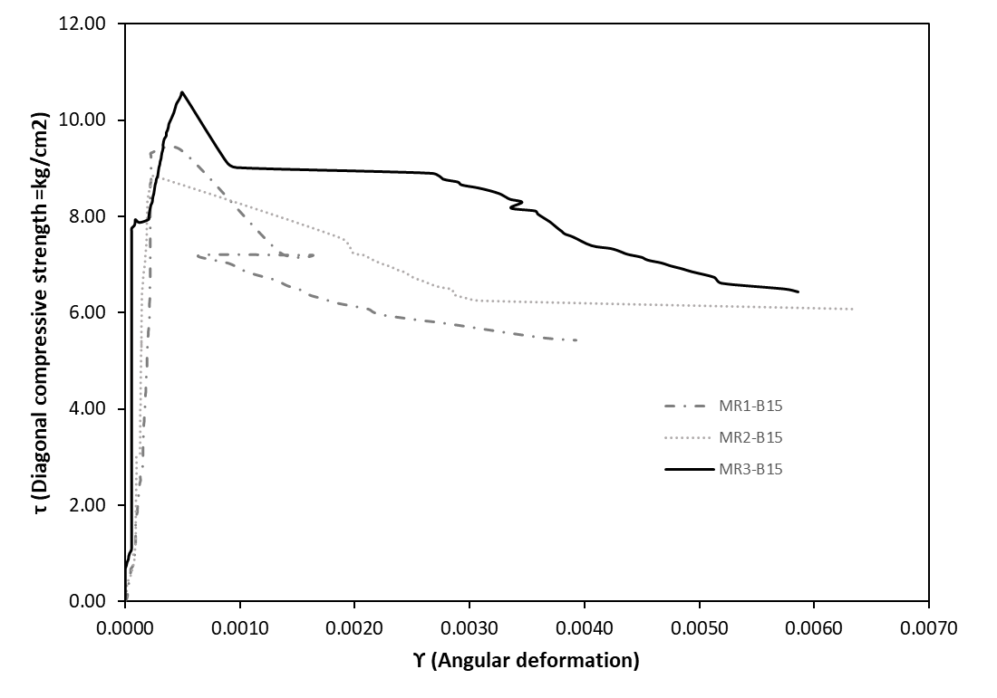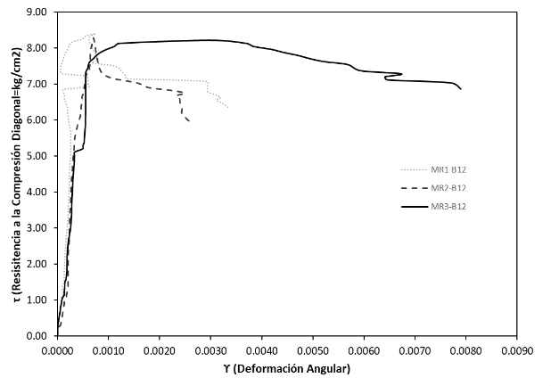
(a) (b)
Fig. 20. Stress – strain graph corresponding to wallets masonry reinforced of (a) Block 15 and (b) Block

Numerical simulations (Fig. 21) predicted a maximum load of 77.70 kN with a displacement of 0.28 mm for the 12 cm wallettes, and 140.01 kN with a displacement of 0.39 mm for the 15 cm wallettes.

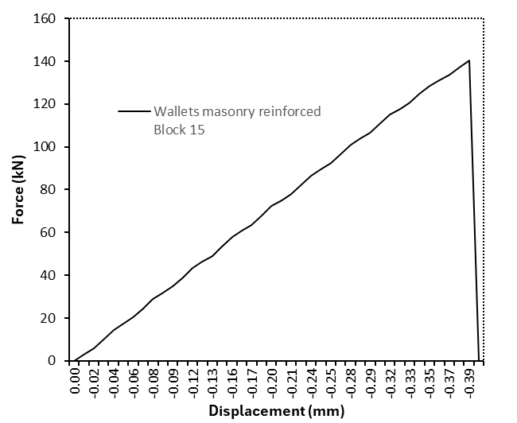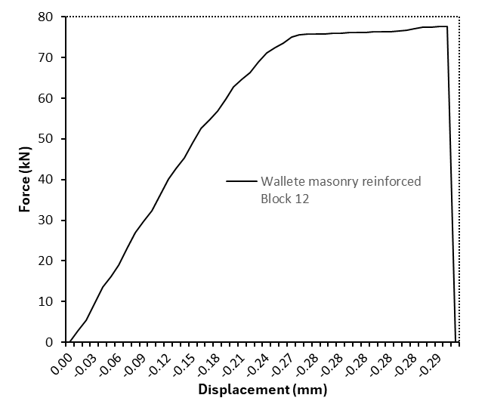
(a) (b)
Fig. 21. Stress – strain graph corresponding to wallets masonry reinforced of (a) Block 15 and (b) Block 12

For reinforced masonry wallettes, models with 15 cm units exhibited closer agreement with experimental results in terms of peak load compared to those with 12 cm units. In contrast, displacement predictions showed better agreement for the 12 cm unit models. Accordingly, the force–displacement response of the 12 cm reinforced wallettes followed the experimental trends more closely than that of the 15 cm specimens.
Quantitatively, for the 12 cm units, the experimental average peak load was 92.84 kN, resulting in a −16.30% difference in the numerical model, while the average experimental displacement of 0.68 mm led to a −58.82% difference. For the 15 cm units, the experimental average peak load was 138.32 kN, corresponding to a +1.94% difference in the numerical prediction, whereas the average displacement of 0.20 mm resulted in a +95% difference. The load–displacement comparisons are shown in Fig. 22, and the corresponding deformation patterns are presented in Fig. 23.
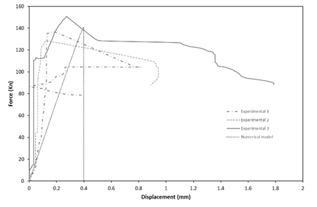
(a)
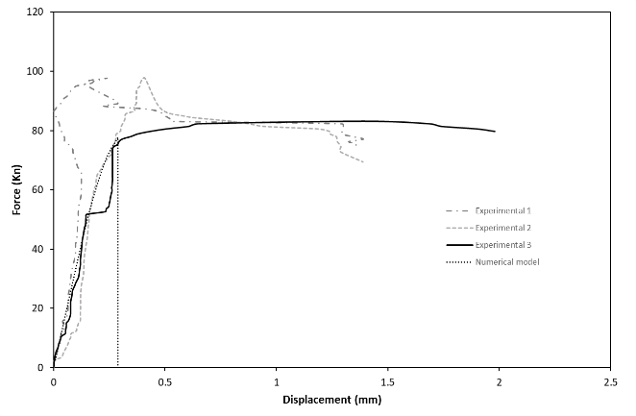
(b)

Fig. 22. Force – displacement graph of experimental and numerical wallette reinforced panels of (a) Block 15 and (b) Block 12

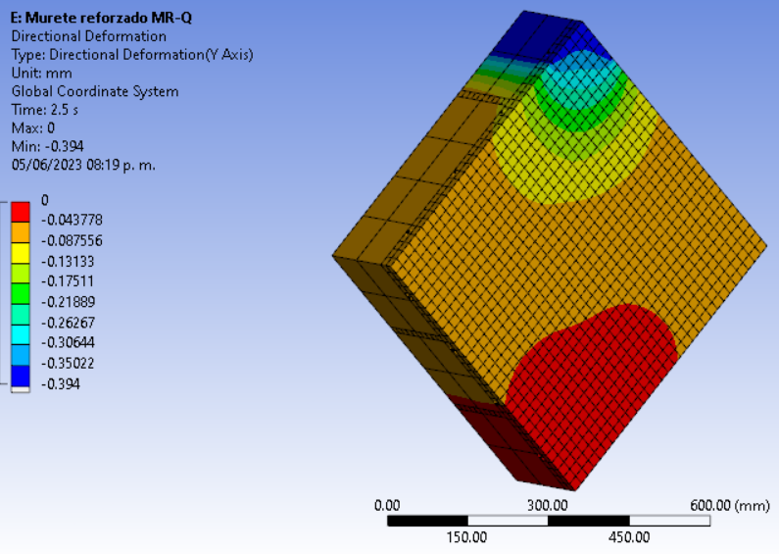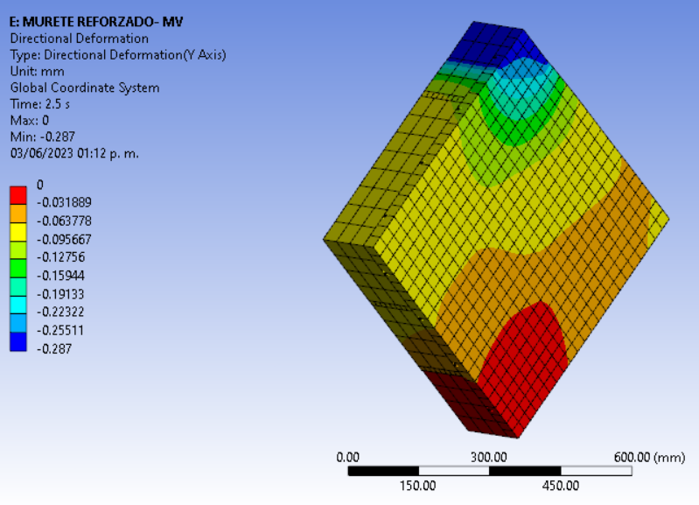
(a) (b)
Fig. 23. Deformation graph of wallette reinforced panels on the “Y” axis of (a) Block 15 and (b) Block 12

Additionally, equivalent Von Mises stress results were obtained, showing that the welded wire mesh reached maximum stress levels between 136 and 139 MPa. These values indicate that wallette failure occurred prior to steel yielding, which has a yield strength of 490.33 MPa, corresponding to approximately 27.94% of the mesh capacity (Fig. 24).

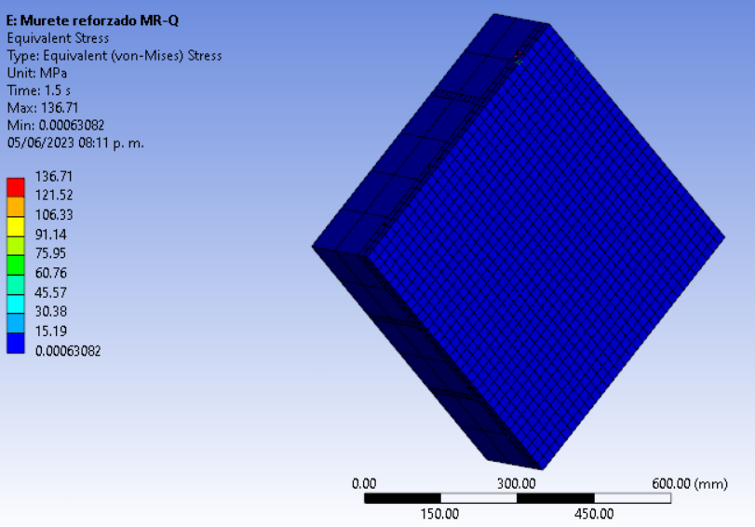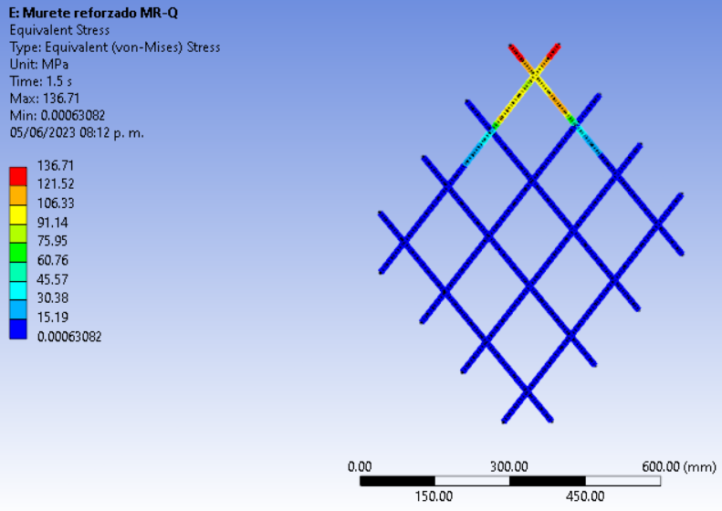
(a) (b)
Fig. 24. Equivalent Von – Mises stresses graph for wallette reinforced panels, showing the layer mortar and the mesh, for (a.1) (b.1) Block 15 and (a.2) (b.2) Block 12

Although the numerical model reproduces the peak load with good accuracy, larger discrepancies were observed in the displacement predictions, particularly for reinforced 15 cm wallettes. This behavior is consistent with the well-known sensitivity of displacement-based response indicators in quasi-brittle materials.
The parametric sensitivity analysis conducted in this study provides insight into this behavior. While variations in elastic modulus and damage parameters produced negligible changes in peak load predictions, the displacement response showed a higher sensitivity to fracture energy variations. In particular, perturbations of the cohesive fracture energy parameter resulted in displacement variations of up to 7.35%, whereas the corresponding peak load variation remained below 2.14%.
This behavior reflects the physical role of fracture energy in controlling the post-peak softening process and crack propagation. In contrast, the peak load is primarily governed by the compressive strength of the masonry components and is therefore less sensitive to variations in damage evolution parameters.
Additional discrepancies may also arise from the simplified representation of the mortar–reinforcement interface through a cohesive zone model. In real masonry systems, the interaction between mortar coatings and welded mesh reinforcement involves complex mechanisms such as local debonding, frictional sliding, and heterogeneous stress transfer, which are difficult to capture completely in numerical simulations.
Furthermore, experimental measurements of displacement in masonry tests often exhibit greater variability compared to strength values due to localized cracking and measurement sensitivity. Considering these factors, the level of agreement obtained between experimental and numerical displacement responses can be considered acceptable for predictive modeling purposes. Despite these differences, the model successfully captures the global structural response and failure mechanism, which are the primary indicators for structural performance assessment.
3.7 Determination of Model Goodness of Fit
After obtaining the experimental data, the results were organized and interpolated to compute representative average values, which were subsequently subjected to regression analysis to derive equations describing the observed response trends.
To assess the goodness of fit between the numerical and experimental models, a statistical hypothesis test was performed. A chi-square test was selected, for which second-degree polynomial regressions were first generated using the averaged experimental data and the corresponding numerical results.
Fig. 25 presents the experimental and numerical response curves together with the resulting second-degree polynomial regression equations. The displacement values obtained from these regressions, as well as the detailed procedure for the chi-square statistical test, are summarized in Table 7.
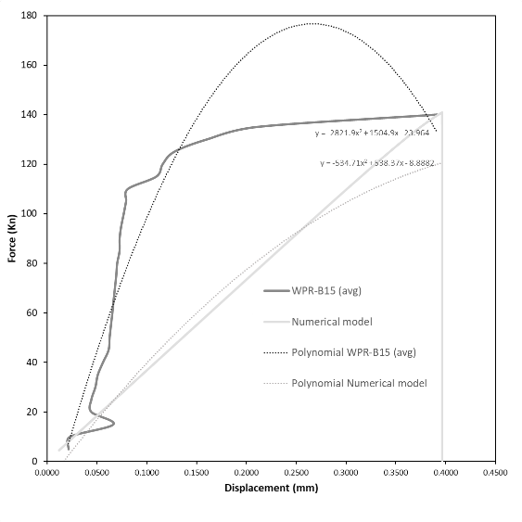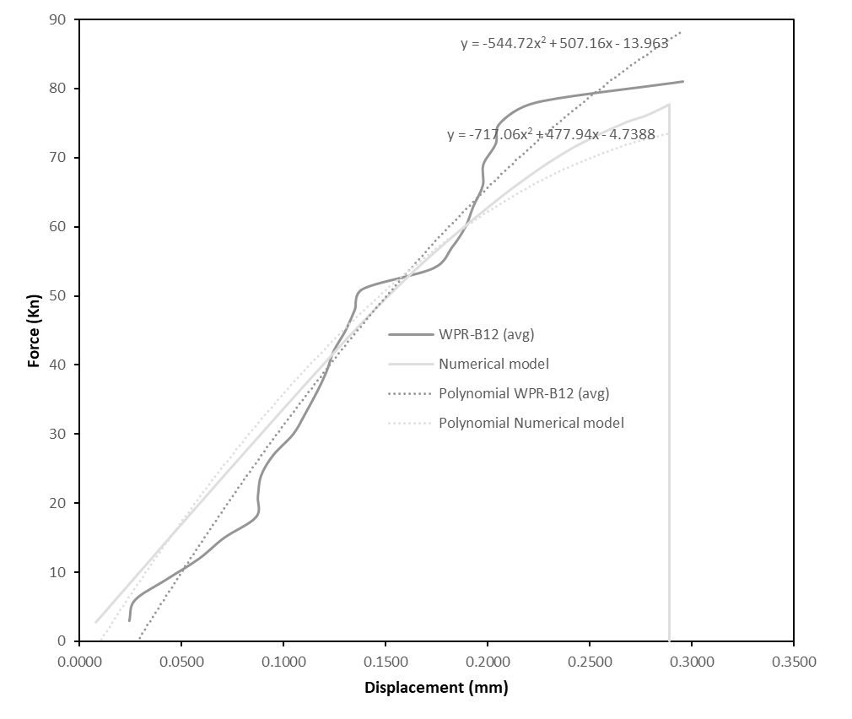
(a) (b)
Fig. 25. Force – displacement of observed and expected frequencies with their respective second – degree polynomial regression of (a) Block 15 and (b) Block 12

Table 7. Determination of the chi – square value using the observed and obtained frequency distribution of (a) Block 15 and (b) Block 12

Chi – Square test statistic B15
 | Frequency Distributions
Displacement “Y”  (mm) | F(x)-B15 | F(x)-NM | (fi-ei) | (fi-ei)^2/ei
Displacement “Y”  (mm) | Force results (kN)
0.0215 | 2.44 | 7.34 | 53.87 |  | 22.08
0.0229 | 3.18 | 8.52 | 72.58 |  | 22.79
0.0665 | 24.54 | 39.74 | 1579.54 |  | 64.37
0.0443 | 13.93 | 24.88 | 619.24 |  | 44.46
0.0443 | 13.93 | 24.88 | 619.24 |  | 44.46
0.0484 | 15.92 | 27.77 | 771.32 |  | 48.46
0.0508 | 17.08 | 29.44 | 866.97 |  | 50.75
0.0560 | 19.58 | 32.98 | 1087.55 |  | 55.53
0.0617 | 22.28 | 36.70 | 1346.64 |  | 60.45
0.0627 | 22.75 | 37.34 | 1394.16 |  | 61.28
0.0640 | 23.38 | 38.19 | 1458.28 |  | 62.38
0.0655 | 24.07 | 39.11 | 1529.86 |  | 63.57
0.0667 | 24.63 | 39.86 | 1589.01 |  | 64.52
0.0680 | 25.25 | 40.69 | 1655.54 |  | 65.57
0.0693 | 25.87 | 41.51 | 1722.79 |  | 66.60
0.0703 | 26.31 | 42.09 | 1771.31 |  | 67.32
0.0727 | 27.41 | 43.52 | 1893.85 |  | 69.09
0.0727 | 27.43 | 43.54 | 1896.09 |  | 69.13
0.0743 | 28.17 | 44.50 | 1980.41 |  | 70.30
0.0769 | 29.35 | 46.00 | 2115.87 |  | 72.10
0.0792 | 30.41 | 47.34 | 2240.87 |  | 73.69
0.0810 | 31.21 | 48.34 | 2336.54 |  | 74.86
0.1096 | 43.69 | 62.59 | 3917.21 |  | 89.66
0.1160 | 46.36 | 65.29 | 4262.52 |  | 91.95
0.1276 | 51.10 | 69.75 | 4865.13 |  | 95.20
0.1605 | 63.75 | 79.21 | 6273.62 |  | 98.41
0.2103 | 80.69 | 84.61 | 7158.65 |  | 88.72
 |  |  | X^2= |  | 1757.71

(a)

Chi – Square test statistic B15
 | Frequency Distributions
Displacement “Y”  (mm) | F(x)-B15 | F(x)-NM | (fi-ei) | (fi-ei)^2/ei
Displacement “Y”  (mm) | Force results (kN)
0.0242 | 0.00 | 6.42 | -6.43 |  | 6.43
0.0270 | 1.24 | 7.65 | -6.41 |  | 5.37
0.0426 | 8.07 | 14.31 | -6.24 |  | 2.72
0.0585 | 14.85 | 20.77 | -5.92 |  | 1.69
0.0707 | 19.90 | 25.48 | -5.58 |  | 1.22
0.0864 | 26.20 | 31.22 | -5.02 |  | 0.81
0.0873 | 26.55 | 31.53 | -4.98 |  | 0.79
0.0889 | 27.16 | 32.08 | -4.92 |  | 0.75
0.0949 | 29.51 | 34.17 | -4.66 |  | 0.63
0.1047 | 33.24 | 37.43 | -4.19 |  | 0.47
0.1106 | 35.47 | 39.35 | -3.88 |  | 0.38
0.1161 | 37.50 | 41.08 | -3.58 |  | 0.31
0.1209 | 39.26 | 42.56 | -3.30 |  | 0.26
0.1245 | 40.56 | 43.64 | -3.08 |  | 0.22
0.1303 | 42.66 | 45.37 | -2.71 |  | 0.16
0.1349 | 44.26 | 46.68 | -2.41 |  | 0.12
0.1388 | 45.65 | 47.79 | -2.14 |  | 0.10
0.1734 | 57.18 | 56.57 | 0.61 |  | 0.01
0.1825 | 60.04 | 58.60 | 1.44 |  | 0.04
0.1891 | 62.08 | 60.01 | 2.08 |  | 0.07
0.1930 | 63.27 | 60.80 | 2.47 |  | 0.10
0.1977 | 64.66 | 61.72 | 2.94 |  | 0.14
0.1979 | 64.72 | 61.76 | 2.96 |  | 0.14
0.2040 | 66.51 | 62.92 | 3.60 |  | 0.21
0.2061 | 67.14 | 63.31 | 3.83 |  | 0.23
0.2242 | 72.22 | 66.36 | 5.86 |  | 0.52
0.2958 | 89.64 | 73.89 | 15.75 |  | 3.36
 |  |  | X^2= |  | 27.24

(b)

Once the χ² values were obtained for each group, the corresponding distribution plots were generated. Fig. 26 presents the chi-square distribution for the M-QR case. Based on the test statistic and number of frequencies, 27 degrees of freedom (ν = 27) and a confidence level of P = 0.95 were adopted, yielding a critical value of χ = 40.11. Since the computed value χ² = 1757.71 lies within the critical region, the results indicate a poor fit between the distributions.
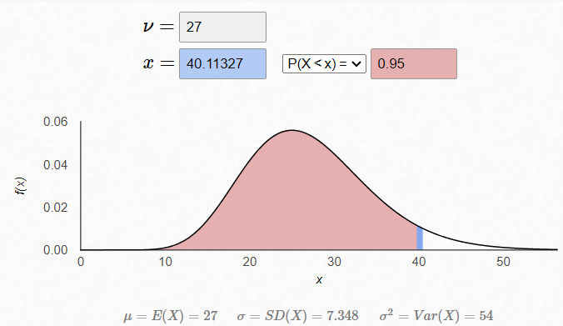

Fig. 26. Chi – square distribution for the Block 15 group using Matt Bognar software 2021.
In contrast, Fig. 27 shows the chi-square distribution for the M-VR case. Using 26 degrees of freedom (ν = 26) and P = 0.95, the critical value obtained was χ = 38.88. Because the computed value χ² = 27.24 does not fall within the critical region, a good agreement between the distributions is confirmed.

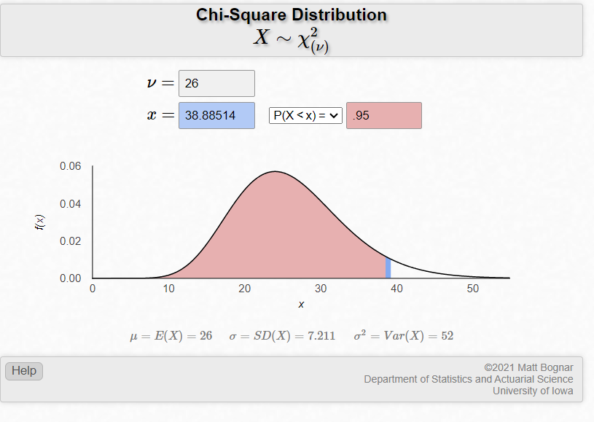

Fig. 27. Chi – square distribution for the Block 12 group using Matt Bognar software 2021.

To complement the interpretation of the chi-square test and provide a more direct measure of prediction error, the root mean square error (RMSE) and the normalized root mean square error (NRMSE) were also calculated. The RMSE quantifies the average deviation between experimental and numerical forces along the response curve.
Table 8 summarizes the statistical comparison between experimental and numerical responses for both wallette configurations. The B12 wallette shows a relatively small deviation between numerical and experimental responses, with an NRMSE of approximately 5.7%, indicating a satisfactory agreement between both curves. In contrast, the reinforced B15 wallette exhibits a larger deviation in displacement-related response, reflected by a higher chi-square value and an NRMSE of approximately 27.3%.

Table 8. Statistical comparison between experimental and numerical responses.

Specimen | n | $$X^{2}$$ | $$P_{max}Exp(kN)$$ | $$P_{max}Num(kN)$$ | $$RMSE (kN)$$ | $$NRMSE(\%)$$
B12 | 27 | 27.24 | 89.64 | 73.89 | 5.12 | 5.71
B15 | 27 | 1757.7 | 165.29 | 80.68 | 45.21 | 27.35

This difference suggests that while the numerical model captures the global strength response of the reinforced specimen, the displacement evolution is more sensitive to parameters associated with interface behavior and post-peak damage propagation. Such sensitivity is consistent with the parametric analysis presented earlier, which showed that fracture energy parameters significantly influence displacement capacity while having a smaller effect on peak load prediction.

4. Conclusions
This study presents the calibration of a finite element–based numerical model incorporating a coupled damage–plasticity microplane constitutive formulation and a cohesive zone model (CZM) to represent contact behavior. Model calibration was based on experimental testing of the constituent materials, both individually and in combination. When direct laboratory measurements were not available, analytical expressions were employed to estimate the required parameters.
The proposed model successfully reproduced the mechanical response of steel-reinforced masonry wallettes, exhibiting higher accuracy for specimens constructed with 12 cm units compared to those with 15 cm units. The goodness of fit between numerical and experimental results was evaluated using the chi-square statistical test. For the 12 cm units, the results indicated a satisfactory fit (P = .05, χ = 38.88 relative to χ² = 27.24), whereas for the 15 cm units, a poor fit was observed (P = 0.05, χ = 40.11 relative to χ² = 1757.71).
Although the model did not adequately capture the deformation response of the 15 cm reinforced masonry wallettes, the discrepancy in maximum load prior to failure was limited to −1.94%. This indicates that the primary differences between experimental and numerical results are associated with displacement predictions rather than load capacity.
Based on the findings of this research, the following recommendations are proposed.
• Advanced experimental equipment should be employed to measure a broader range of material properties, enabling improved numerical calibration and reduced uncertainty.
• The water absorption capacity of masonry units should be explicitly considered, as it may influence the strength of mortar joints and coatings, thereby affecting model parameters.
• Mortar calibration should be performed separately for each masonry unit type, both in prism and wallette specimens, to avoid bias associated with unit-dependent behavior.
• Finally, future studies should include full-scale wall testing to further validate the proposed numerical model for both conventionally reinforced masonry and masonry reinforced with steel mesh.

COMPETING INTERESTS DISCLAIMER:
Authors have declared that they have no known competing financial interests OR non-financial interests OR personal relationships that could have appeared to influence the work reported in this paper.
Disclaimer (Artificial intelligence)
Author(s) hereby declare that NO generative AI technologies such as Large Language Models (ChatGPT, COPILOT, etc.) and text-to-image generators have been used during the writing or editing of this manuscript.

References
Baqueiro F, Gómez M, Rivera V, Marín V. 2009. Determination of the diagonal compressive strength and shear modulus of hollow concrete block masonry. Ingeniería. 13(2):1–12.
Bažant ZP, Oh BH. 1983. Crack band theory for fracture of concrete. Materials and Structures. 16:155–177.
Bernat-Maso E, Gil L, Roca P. 2015. Numerical analysis of the load-bearing capacity of brick masonry walls strengthened with textile reinforced mortar and subjected to eccentric compressive loading. Engineering Structures. 91:96–111. https://doi.org/10.1016/j.engstruct.2015.02.032
Brignola A, Frumento S, Lagomarsino S, Podestá S. 2008. Identification of shear parameters of masonry panels through the in-situ diagonal compression test. International Journal of Architectural Heritage. 3(1):52–73. https://doi.org/10.1080/15583050802138634
D’Altri AM, Sarhosis V, Milani G, Rots J, Cattari S, Lagomarsino S, Sacco E, Tralli A, Castellazzi G, de Miranda S. 2020. Modeling strategies for the computational analysis of unreinforced masonry structures: Review and classification. Archives of Computational Methods in Engineering. 27(4):1153–1185. https://doi.org/10.1007/s11831-019-09351-x
de Borst R. 1992. Numerical methods for bifurcation analysis in geomechanics. Engineering Computations. 9(1):43–57.
Dizhur D, Ingham JM. 2013. Diagonal tension strength of vintage unreinforced clay brick masonry wall panels. Construction and Building Materials. 43:418–427. https://doi.org/10.1016/j.conbuildmat.2013.02.015
Imadeddin A, Zreid I, Kaliske M. 2017. A gradient-enhanced plasticity–damage microplane model for concrete. Computational Mechanics. 62(5):1239–1257. https://doi.org/10.1007/s00466-018-1561-1
INEGI. 2020. Housing. National Institute of Statistics and Geography. Available: https://cuentame.inegi.org.mx/poblacion/vivienda.aspx
INEGI. 2021. Private dwellings occupied by federal entity, census year series from 1990 to 2020. National Institute of Statistics and Geography. Available at: https://www.inegi.org.mx
Jirásek M, Bažant ZP. 2002. Inelastic Analysis of Structures. John Wiley & Sons.
Milosevic J, Lopes M, Gago AS, Bento R. 2013. Testing and modeling the diagonal tension strength of rubble stone masonry panels. Engineering Structures. 52:581–591. https://doi.org/10.1016/j.engstruct.2013.03.019
Complementary Technical Standards for the Design and Construction of Masonry Structures (NTC). 2020. Government of Mexico City, Mexico.
Mauludin, L.M., & Oucif, C. (2020). Computational modeling of fracture in concrete: A review. Frontiers of Structural and Civil Engineering. https://doi.org/10.1007/s11709-020-0573-z
National Organization for Standardization and Certification of Construction and Building, S.C. 2004. NMX-C-036-ONNCCE-2004: Construction industry – Blocks, bricks, partitions, and paving stones – Compressive strength – Test method. Mexico.
National Organization for Standardization and Certification of Construction and Building, S.C. 2010. NMX-C-464-ONNCCE-2010: Construction Industry – Masonry – Determination of the diagonal compressive strength and shear modulus of masonry walls, as well as determination of the compressive strength and modulus of elasticity of clay or concrete masonry piers – Test methods. Mexico.
National Organization for Standardization and Certification of Construction and Building, S.C. 2012. NMX-C-404-ONNCCE-2012: Construction Industry – Blocks, partitions, or bricks and partition walls for structural use – Specifications and test methods. Mexico.
Ordaz A. 2019. In Mexico, 7.4 million homes are built with substandard materials. Forbes Mexico. Available at: https://www.forbes.com.mx
Rodríguez-Mariscal JD, Ma Q, Solís M. 2020. Experimental analysis of diagonal compression and splitting tests for the characterization of shear and tensile behavior of adobe masonry. Engineering Structures. 215:110633. https://doi.org/10.1016/j.engstruct.2020.110633
Ruiz J, Zepeda JA, Alcocer SM, Meli R. 1994. Repair and reinforcement of a two-story, full-scale, three-dimensional confined masonry structure. In: Proceedings of the IX National Congress of Structural Engineering. Zacatecas, Mexico; p. 596–605.
Triola MF. 2009. Statistics. 10th ed. Pearson Education.
Zeevaert L. 2001. Compendium of seismic-geodynamics: Selection of articles by Dr. Leonardo Zeevaert Wiechers on seismic engineering. ICA Foundation.

