Effect of Electric Field on The Structural and Electronic Properties of the Graphene/Hexagonal Boron Nitride Heterobilayer

Abstract
The rapid advancement of nanoelectronics has intensified the search for atomically thin materials with tunable electronic properties suitable for high-performance devices. Van der Waals heterostructures composed of complementary two-dimensional materials provide a versatile platform for engineering band structures and controlling charge transport at the nanoscale. The study investigates the characteristics of a graphene sheet deposited on a hexagonal boron nitride (h-BN) layer. The study highlights that although graphene possesses exceptional properties, the absence of an intrinsic energy gap limits its applications, hence the interest in Van der Waals heterostructures such as graphene/h-BN for inducing a tunable electronic gap through symmetry breaking. The methodology relies on first-principles calculations using density functional theory (DFT) with the SIESTA code for structural properties and Quantum Espresso for electronic properties, employing the PBE approximation and van der Waals TS corrections. The comparative study of four stacking orders (AA, AA', AB, and BA) reveals that the AB configuration constitutes the most stable ground state with an equilibrium interlayer distance of 3.39 Å, while the other stackings exhibit larger distances ranging from 3.50 Å to 3.511 Å. Analysis of the sliding dynamics shows specific energy barriers for the wheelchair and zigzag paths, which are modified by the application of an electric field. On the electronic level, the interaction between the layers lifts the degeneracy of the Dirac cones and causes the opening of a 0.0143 eV (approximately 14.3 meV) gap for the AB stacking in the absence of a field. The results highlight a monotonic decrease in this band gap under the influence of a perpendicular electric field, from 0.014256 eV to 0.010025 eV as the field strength increases from 0 to 1 V/Å. This evolution is attributed to a change in band alignment due to induced polarisation, with the electric field partially counterbalancing the symmetry breaking. The geometric study under a 1 V/Å field confirms the stability of the structure, with unchanged intralayer distances (approximately 1.427 Å for C–C and B–N) and a stable average interlayer distance around 3.74 Å. In conclusion, the study asserts that the graphene/h-BN synergy allows for precise control of physical properties, positioning this material as a promising candidate for terahertz nano-optical devices and information electronics.

Keywords : Graphene/h-BN heterobilayer, External electric field, Energy barrier

Introduction
Since the discovery of graphene, two-dimensional (2D) materials have attracted enormous interest in condensed matter physics and nanotechnology owing to their remarkable electronic, thermal, and mechanical properties [1][2]. The emergence of atomically thin crystals has opened new opportunities for nanoscale electronic and optoelectronic device engineering. In recent years, the development of van der Waals (vdW) heterostructures has further expanded the potential of 2D materials by enabling the design of artificial layered systems with tailored electronic structures and novel physical properties. Density functional theory (DFT) studies have demonstrated that vdW heterostructures can exhibit engineered band gaps and tunable electronic behaviour that surpass those of individual monolayers [15].

Despite its exceptional carrier mobility and mechanical strength, graphene lacks an intrinsic band gap, which limits its application in next-generation logic circuits and optoelectronic devices. To address this limitation, vdW heterostructure engineering has emerged as an effective strategy, allowing graphene to be combined with insulating or semiconducting 2D materials in order to achieve controllable electronic properties. Recent theoretical and experimental studies have shown that graphene-based vdW heterostructures exhibit tunable electronic transport, improved mechanical stability, and enhanced device performance [16].

Among the various combinations, the graphene/hexagonal boron nitride (h-BN) heterobilayer has attracted particular attention [5]. Hexagonal boron nitride, often referred to as “white graphene,” possesses a lattice parameter closely matched to that of graphene (approximately 1.8% mismatch) and exhibits a wide band gap together with an atomically smooth and chemically inert surface. This structural compatibility allows the preservation of graphene’s high carrier mobility while enabling band-gap opening through sublattice symmetry breaking and interlayer interactions. Recent investigations have shown that graphene/h-BN heterostructures can exhibit tunable band gaps and enhanced thermoelectric and sensing properties, demonstrating their potential for nanoelectronic applications [17].

Although the structural properties of the graphene/h-BN interface have been widely investigated, a detailed understanding of the relative stability of different stacking configurations (AA, AA’, AB, and BA) and their response to external perturbations remains incomplete [6][7]. In particular, band-gap modulation under external electric fields and the evaluation of sliding energy barriers are key parameters governing charge transport and mechanical stability in layered heterostructures.

In this study, a comprehensive theoretical investigation of the structural and electronic properties of the graphene/h-BN heterobilayer is performed using density functional theory (DFT). The most energetically stable stacking configuration is determined, and the evolution of the electronic band structure is analysed with particular emphasis on the region near the Dirac points. The novelty of this work lies in the combined investigation of the effects of a strong perpendicular electric field and interlayer sliding dynamics along both chair and zigzag directions, providing valuable insights into the potential use of graphene/h-BN heterostructures in terahertz nano-optoelectronic and information-processing devices.

Methodology

The study performed first-principles calculations based on density functional theory (DFT) and using SIESTA for structural property calculations and Quantum Espresso (QE) for electronic property calculations with plane-wave expansion and norm-preserving relativistic scalar pseudopotentials [8], [9][10] to predict the geometric and electronic properties of the graphene/h-BN heterobilayer. Electron exchange and correlation functionals were treated using the generalised Perdew-Burke-Ernzerhof (PBE) gradient approximation [11], [12][13][14]. The van der Waals TS correction was also applied. The plane-wave basis kinetic energy cutoff was set to 75 Ry. The Monkhorst-Pack mesh with 12×12×1 elements was used for geometric relaxation and single-point energy calculations. A 20 Å gap was introduced in the non-periodic (z) direction to ensure decoupling of periodic replicas.
Structural relaxation is assumed to occur at convergence when the maximum component of residual forces on the ions is less than 0.05 eV/Å.
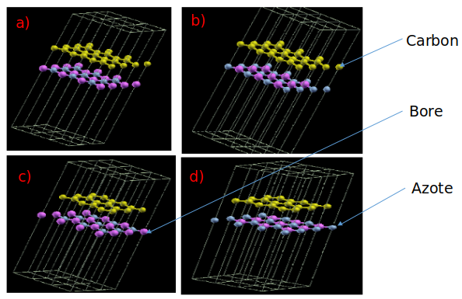

Fig. 1: Four different stacking orders of graphene/h-BN heterobilayers, namely the AA, AA', AB and BA stackings. The yellow, purple and blue spheres represent carbon, boron and nitrogen atoms, respectively.

We constructed graphene/hBN heterobilayers with four stacking configurations: AA, AA’, AB, and BA, as shown in Figure 1. For the AA and AA’ stacks, two carbon atoms from the top graphene layer are located directly above the B, N, and N, B atoms from the bottom hBN layer, respectively. In the AB stack, one carbon atom overlaps the bottom B atom, and the other carbon atom is above the centre of the BN hexagon; while in the BA stack, one carbon atom overlaps the bottom N atom, and the other carbon atom is above the centre of the hexagon.

- Results and discussions

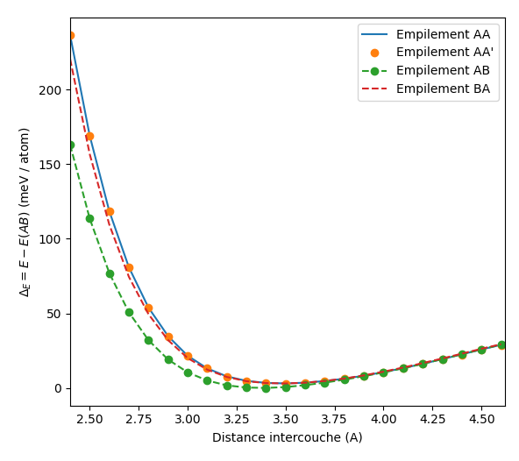

Fig. 2: Relationship between relative energy and interlayer distance in graphene/h-BN. We defined the zero energy point as the minimum energy of the AB stacking at 3.39 Å.

The equilibrium distances for the (AA, AA’, AB, and BA) stackings are, respectively, 3.510 Å, 3.511 Å, 3.39 Å, and 3.50 Å.
These results in Figure 2 show that the ground-state structure of graphene/h-BN is the AB stacking.
The study of thermodynamic stability is crucial for determining the experimental feasibility of the heterostructure. Figure 2 illustrates the evolution of the relative energy as a function of the interlayer distance (d) for the four stacking configurations (AA, AA’, AB, and BA).
Analysing the different heterostructure states, the AB stacking clearly emerges as the most stable configuration (minimum energy) with an equilibrium distance of 3.39 Å. This result is in excellent agreement with data from the literature on graphene/h-BN Van der Waals heterostructures.

An analysis of the Van der Waals forces reveals that the shape of the Morse curves suggests that the interaction is dominated by long-range Van der Waals dispersion forces.

The energy hierarchy allows us to observe that the AA and AA' configurations exhibit higher equilibrium distances (approximately 3.51 Å) and higher energies, which is explained by the stronger steric repulsion between the Pz orbitals of the vertically superimposed atoms (z being the growth direction).

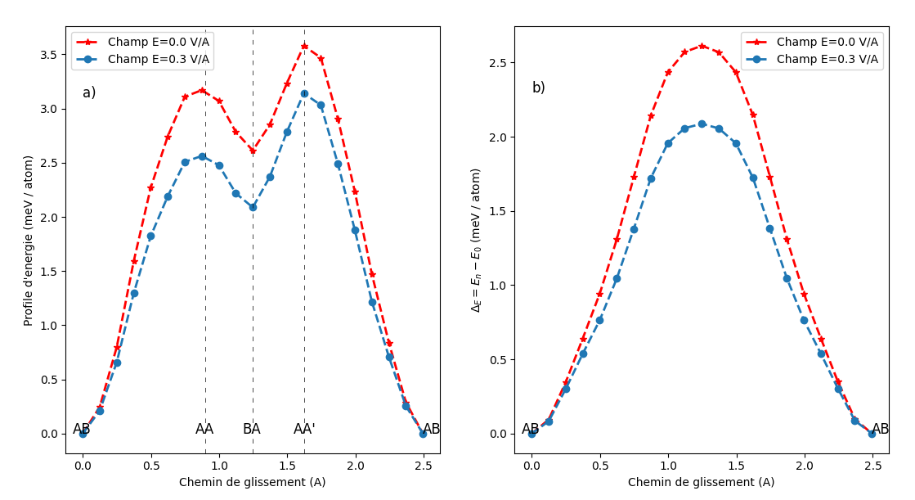

Fig-3. The energy profile and energy barrier of the AB stacking as a function of the sliding distance in a wheelchair Fig. a) and in zigzag Fig. b).

The mechanical manipulation of 2D layers is a key aspect of "twistronics." Figure 3 details the sliding barriers along the "armchair" and "zigzag" directions.
The energy profile shows that the "armchair" sliding path (Fig. 3a) is more complex, with maxima corresponding to transitions through the metastable states AA and AA', while the "zigzag" path (Fig. 3b) exhibits a smoother barrier, reflecting anisotropy of the sliding between the layers.
A major observation is the decrease in the energy barrier under the application of a 0.3 V/Å field. This suggests that the external electric field reduces the inter-layer friction force, a property that could be exploited to design electrically controllable electromechanical nanodevices (NEMS). This result reflects an effect of the electric field.

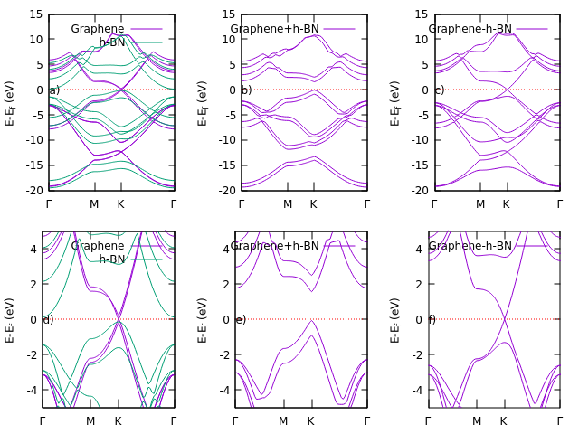

Fig-4. Band structures of the graphene bilayer, h-BN bilayer, and graphene/h-BN heterobilayer for AB stacking. a) Eg=0, b) Eg=4.44, c) Eg=0.01472

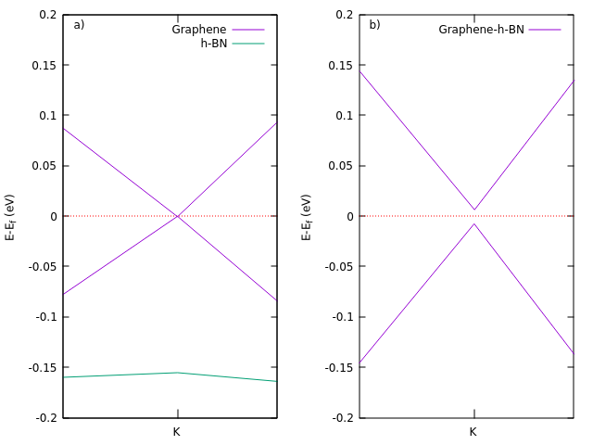

Fig-5. Band structures of the graphene bilayer and the graphene/h-BN heterobilayer for AB stacking at the Dirac cone. a) Eg = 0, b) Eg = 0.014256

The primary objective of the heterostructure is to modulate the band structure of graphene.

Figure 4 shows band hybridisation observed through the superposition of band structures. Indeed, the graphene π bands remain localised near the Fermi level, confirming that h-BN acts as a passive substrate that preserves the high carrier mobility.
The close-up of the Dirac delta function in Figure 5 is crucial. While pure graphene has a zero band gap, the AB heterobilayer exhibits a band gap of 14.26 meV.
The physical mechanism involved means that this opening is due to the breaking of sublattice symmetry (CA different from CB). The asymmetric periodic potential imposed by the boron and nitrogen atoms lifts the degeneracy at the K points, transforming the massless Dirac fermions into massive fermions.
Although small (14 meV), this gap is the signature of an effective interaction which makes it possible to consider the use of graphene in logic devices or terahertz photodetectors, where semi-metallic graphene fails. This study is therefore of great importance for future applications.
Two important aspects emerge from our calculations: the electric field allows for a monotonic reduction of the band gap (from 14.3 to 10.0 meV), providing fine electronic tuning. And despite the intense 1 V/Å field, the structure remains stable with minimal interlayer distance variations (approximately 3.74 Å), ensuring the device's durability.
Figure 6 illustrates the evolution of the band structure near point K (Dirac cone) under the influence of an increasing perpendicular electric field. This figure demonstrates that the external electric field acts as a direct control lever on the transport properties of the heterobilayer.
The main observation (Fig 6) is a monotonic and systematic decrease in the energy gap as the electric field strength increases. The data extracted from the figure and the associated table show a smooth transition:
At E = 0.1 V/Å (Fig. 6a): The initial gap induced by the substrate is slightly reduced to 0.013566 eV.
At E = 0.3 V/Å (Fig. 6b): A further reduction is observed, stabilising the gap at 0.012416 eV.
At E = 1.0 V/Å (Fig. 6c): Under a strong field, the gap reaches its minimum value of 0.010118 eV (or 0.010025 eV according to the convergence calculations in Table 1).
An intrinsic symmetry breaking is observed through the h-BN/Graphene interaction, which opens the initial band gap of approximately 14 meV.
Furthermore, the external electric field induced a polarisation between the layers, which partially counteracts the symmetry-breaking potential. This phenomenon "softens" the asymmetry of the sublattices, leading to a narrowing of the band gap.
Visually, in the same Figure 6, we observe that applying the field lifts the degeneracy. Indeed, the branches of the Dirac cones separate more clearly, but their effective crossing point approaches the Fermi level. However, the structure retains a certain linearity because, despite the gap opening, the dispersion remains almost linear near point K, suggesting that the Fermi velocity (and therefore the carrier mobility) is not drastically degraded by the field.

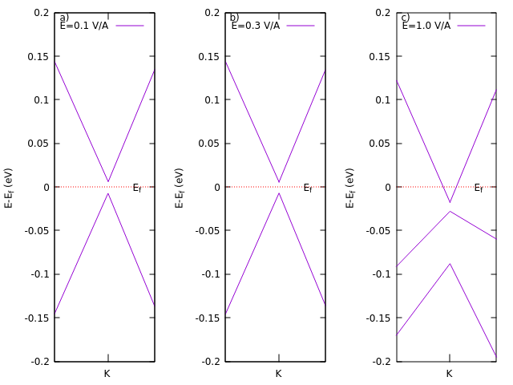

Fig-6. Band structures of the graphene bilayer and the graphene/h-BN heterobilayer for AB stacking at the Dirac cone. a) Eg = 0.013566, b) Eg = 0.012416, c) Eg = 0.010118.

Table 1: Gap energy variation as an applied electric field function
E (V/A) | 0 | 0.1 | 0.3 | 0.5 | 0.7 | 0.8 | 0.9 | 1
Eg (eV) | 0.014256 | 0.013566 | 0.012416 | 0.011497 | 0.010577 | 0.010232 | 0.010117 | 0.010025

The evolution of the electronic band gap Eg of the graphene/hBN heterobilayer as a function of the applied electric field shows a monotonic decrease in the band gap as the field strength increases. In the absence of a field, the system exhibits a small band gap (approximately 14 meV), characteristic of the band gap opening induced by the symmetry breaking in the graphene/hBN heterostructure.
The application of an external electric field leads to a progressive reduction of the band gap, decreasing from 0.0143 eV to 0.0100 eV for a field of 1 V/Å. This trend reflects a change in the alignment of the electronic bands due to the induced polarisation between the graphene and hBN layers. The electric field partially counteracts the symmetry breaking responsible for the band gap opening, thus leading to its attenuation.

The relatively small but systematic variation of the gap indicates that the graphene/hBN heterobilayer allows fine control of the electronic gap by electric field, which is an advantage for potential applications in nanoelectronics and field-effect devices.

Table 2: Geometric parameters of the graphene/hBN heterobilayer (rigid and relaxed configurations)
Configuration | C–C (Å) | C–N (Å) | C–B (Å) | B–N (Å) | Distance intercouche moyenne d (Å)
Rigide (1 V/Å) | 1,4266 | 3,8724 | 3,6000 | 1,4266 | 3,7362
Relaxée (1 V/Å) | 1,4267 | 3,8640 | 3,6065 | 1,4267 | 3,73525

The geometric study of the graphene/hBN heterobilayer under a 1 V/Å electric field shows that the intralayer bond distances (C–C in graphene and B–N in hBN) remain practically unchanged after relaxation, indicating excellent structural stability of both sheets. In contrast, the C–N and C–B interlayer distances are significantly larger, confirming that the interaction between graphene and hBN is dominated by van der Waals forces.
Relaxation results in only very small adjustments to the interlayer distances, without a significant change in the mean interlayer distance, which remains close to 3.74 Å. This indicates that the initial rigid configuration is already close to equilibrium and that the graphene/hBN heterobilayer exhibits a stable geometry under the applied electric field.
Conclusion :

In conclusion, this in-depth study using density functional theory (DFT) has allowed us to precisely characterise the structural and electronic properties of the graphene/h-BN heterobilayer. Our results unambiguously demonstrate that the AB stacking order constitutes the ground state configuration, distinguished by an equilibrium interlayer distance of 3.39 Å. The Van der Waals interaction between graphene and hexagonal boron nitride induces a breaking of the sublattice symmetry, which lifts the degeneracy of the Dirac cones and generates the opening of an intrinsic electronic gap of 14.3 meV.
The major contribution of this work lies in the demonstration of a fine modulation of this gap by the application of a perpendicular external electric field. We observed a monotonic decrease in the band gap, from 0.0143 eV in the absence of a field to 0.0100 eV under a 1 V/Å field, thus providing a dynamic control lever for transport properties. Simultaneously, the adjustment of the slip barrier under an electric field highlights the increased mechanical flexibility of these heterostructures.
Importantly, this electronic tunability is accompanied by excellent structural stability, with intralayer bond distances remaining virtually unchanged and the interlayer distance stabilising around 3.74 Å even under strong fields. These findings confirm that the graphene/h-BN heterobilayer represents a promising technological platform for the design of terahertz nano-optical devices and the development of next-generation information electronics.

COMPETING INTERESTS DISCLAIMER:
Authors have declared that they have no known competing financial interests OR non-financial interests OR personal relationships that could have appeared to influence the work reported in this paper.
Disclaimer (Artificial intelligence)
Author(s) hereby declare that NO generative AI technologies such as Large Language Models (ChatGPT, COPILOT, etc.) and text-to-image generators have been used during the writing or editing of this manuscript.

References
[1] J. T. Illakkiya, P. U. Rajalakshmi, and R. Oommen, “Nebulized spray pyrolysis: a new method for synthesis of graphene film and their characteristics,” Surf. Coatings Technol., vol. 307, pp. 65–72, 2016, doi: 10.1016/j.surfcoat.2016.08.051.
[2] Y. Zhang and I. V Grigorieva, “Electric Field Effect in Atomically Thin Carbon Films Electric Field Effect in Atomically Thin Carbon Films,” no. May 2016, 2004.
[3] K. S. Novoselov, A. Mishchenko, A. Carvalho, and A. H. C. Neto, “Waals heterostructures”.
[4] A. K. Geim and I. V Grigorieva, “Van der Waals heterostructures”.
[5] C. R. Dean, A. F. Young, I. Meric, C. Lee, L. Wang, and S. Sorgenfrei, “Boron nitride substrates for high quality graphene electronics”.
[6] T. Taniguchi, P. Moon, M. Koshino, and R. C. Ashoori, “Massive Dirac Fermions and Hofstadter Butterfly in a van der Waals Heterostructure,” Science (80-. )., vol. 340, no. June, pp. 1427–1431, 2013, doi: 10.1594/PANGAEA.808834.
[7] G. Giovannetti, P. A. Khomyakov, G. Brocks, P. J. Kelly, and J. Van Den Brink, “Substrate-induced band gap in graphene on hexagonal boron nitride : Ab initio density functional calculations nitrogen boron carbon,” Phys. Rev. B, pp. 2–5, 2007, doi: 10.1103/PhysRevB.76.073103.
[8] P. Giannozzi et al., “Quantum ESPRESSO toward the exascale,” J. Chem. Phys., vol. 152, no. 15, 2020, doi: 10.1063/5.0005082.
[9] D. Gironcoli et al., “Quantum ESPRESSO toward the exascale,” vol. 15, no. 2020, 2026.
[10] U. and DIPC, “7th Quantum Science and Technology Workshop 3rd IKUR Quantum Science and Technology Workshop 2024 Donostia / San Sebastián,” 2024.
[11] M. Fuchs and M. Scheffler, “Ab initio pseudopotentials for electronic structure calculations of poly-atomic systems using density-functional theory,” Comput. Phys. Commun., vol. 119, no. 1, pp. 67–98, 1999, doi: 10.1016/S0010-4655(98)00201-X.
[12] C. Y. Yeh, Z. W. Lu, S. Froyen, and A. Zunger, “Zinc-blendewurtzite polytypism in semiconductors,” Phys. Rev. B, vol. 46, no. 16, pp. 10086–10097, 1992, doi: 10.1103/PhysRevB.46.10086.
[13] D. R. Hamann, “Optimized norm-conserving Vanderbilt pseudopotentials,” pp. 1–21.
[14] A. Gaur, K. Khan, A. Soni, A. Dashora, J. Sahariya, and U. Ahuja, “Theoretical analysis of Sn-doped ZnS for optoelectronic applications,” J. Phys. Conf. Ser., vol. 1504, no. 1, 2020, doi: 10.1088/1742-6596/1504/1/012014.
[15] Oh, Y., Song, S., & Bae, J. (2024). A review of bandgap engineering and prediction in 2D material heterostructures: a DFT perspective. International Journal of Molecular Sciences, 25(23), 13104. https://doi.org/10.3390/ijms252313104
[16] Gao, Y., Xu, L., Li, A., & Ouyang, F. (2023). Band structure engineering and transport properties of graphene/BN van der Waals heterostructures. Results in Physics, 46, 106315. https://doi.org/10.1016/j.rinp.2023.106315
[17] Kumar, N., & Bera, C. (2024). Enhanced thermoelectric performance of a wide-bandgap twisted heterostructure of graphene and boron nitride. Nanoscale, 16(16), 7951-7957. https://doi.org/10.1039/D4NR00095A

