Successful Cutting Balloon Angioplasty in Renal Fibromuscular Dysplasia: A Case Report

Abstract
Fibromuscular dysplasia (FMD) is a rare non-atherosclerotic, non-inflammatory arterial disease that most often affects renal and carotid arteries in young women. This case report describes a 33-year-old female with symptomatic resistant hypertension refractory to multiple medications. An abdominal computed tomographic (CT) angiogram revealed mid to distal right renal artery stenosis with the classic 'string of beads' appearance, diagnostic for fibromuscular dysplasia (FMD). Following a successful percutaneous transluminal right renal angioplasty (PTRA) with cutting balloon without stent placement, the patient's blood pressure significantly improved, allowing for a reduction in medication. This case emphasizes the need for a high index of suspicion for Reno-vascular hypertension in young patients with resistant hypertension, as an early intervention with PTRA can lead to excellent clinical outcomes.
Keywords: fibromuscular dysplasia, resistant hypertension, percutaneous transluminal renal angioplasty, cutting balloon

Introduction
Resistant hypertension is defined as blood pressure that remains above goal despite the use of three or more antihypertensive medications of different classes, including a diuretic. Secondary causes should be investigated, particularly in young patients. Renal fibromuscular dysplasia (FMD), a non-atherosclerotic, non-inflammatory arterial disease, is a leading cause of Reno-vascular hypertension in patients under 50 years of age, predominantly affecting women. This report details the diagnosis and successful endovascular management of a patient with resistant hypertension caused by right renal FMD.
Table 1. Timeline of Clinical Events and Management
Time / Event | Clinical Details
2 years prior | Diagnosis of hypertension; started on triple antihypertensive therapy
Current presentation | Persistent hypertension with headache and dizziness; BP 190/110 mmHg
Initial investigations | Normal labs; ECG showed LVH with ST depression
Echocardiography | Concentric LVH with grade I diastolic dysfunction, LVEF-60%
CT Angiography | Right renal artery ‘string of beads’ appearance confirming FMD
Intervention | Percutaneous transluminal renal angioplasty (PTRA) with cutting balloon; no stent
1-month follow-up | BP 128/75 mmHg off medications; patent renal artery on Doppler
Case Presentation
A 33-year-old Asian female with no significant past medical history presented with frequent headaches and dizziness. She had a two-year history of hypertension, with persistently uncontrolled blood pressure over the preceding six months despite treatment with multiple antihypertensive medications, consistent with resistant hypertension. At presentation, she was receiving Tab. Amlodipine 10mg OD, Tab. Telmisartan 80mg OD, Tab. Chlorthalidone 12.5 mg OD, Tab. Metoprolol XL 50mg OD , with inadequate blood pressure control. On examination, her BP was 190/110 mmHg (right arm) and 176/110 mmHg (left arm). No abdominal bruit was heard. The systolic blood pressure difference between the two upper limbs was noted; however, subsequent vascular imaging did not reveal any significant subclavian artery stenosis. Routine blood tests were normal. The Evaluation for secondary causes of hypertension including renal function tests, serum electrolytes, and endocrine screening was performed and was within normal limits. ECG revealed left ventricular hypertrophy with inferolateral ST depressions (Figure 1A). Echocardiography showed concentric LV hypertrophy and grade I diastolic dysfunction with normal LV systolic Function (LVEF-60%). Renal Doppler ultrasound suggested distal right renal artery stenosis and reduced right renal size (8.5 x 4cm) as compared to left. Contrast-enhanced CT angiography confirmed alternating stenosis and dilatation of the right renal artery — the classic ‘string of beads’ appearance of medial fibroplasia (Figure 1B,C&D). Catheter-based angiography confirmed these findings (Figure 1E& 1F). DTPA scan showed reduced but preserved right renal function (24.8%).
Intervention
Given her uncontrolled hypertension and angiographic findings, percutaneous transluminal renal angioplasty (PTRA) was performed via the right femoral approach. Using a 6F Judkins right catheter and 0.014'' guidewire, serial balloon dilatations were attempted. The lesion was resistant to standard balloons; hence a 3.5×15 mm cutting balloon was used successfully. No stent was placed as balloon angioplasty alone is preferred for FMD. Post-procedural angiography showed restored flow without complications (Figure 2A&B).
Outcome and Follow-Up
Post-procedure, the patient’s blood pressure improved markedly. She was discharged with home BP monitoring. At one month, her BP was 128/75 mmHg without medications, and follow-up Doppler ultrasound confirmed sustained patency of the renal artery.
Discussion
Fibromuscular dysplasia (FMD) is an underrecognized non-atherosclerotic, non-inflammatory arteriopathy affecting medium-sized arteries, most commonly the renal and carotid arteries (1,2). It typically affects young women and presents with resistant hypertension due to renovascular involvement. The classic “string-of-beads” angiographic pattern, caused by medial fibroplasia, is pathognomonic (1).
Percutaneous transluminal renal angioplasty (PTRA) without stenting remains the first-line revascularization strategy in hemodynamically significant renal FMD, with cure or marked improvement in blood pressure achieved in 60–70% of appropriately selected patients (3–5). Early intervention, unilateral disease, and shorter hypertension duration predict better outcomes (4,6). Cutting-balloon angioplasty is preferred in resistant or non-dilatable lesions and can yield excellent results without requiring stent placement (5,7).
Routine stenting is not advised as it carries risk of restenosis or thrombosis and offers no additional benefit over balloon angioplasty (1,3). Long-term surveillance is essential, as restenosis or new vascular involvement may develop, warranting repeat imaging and blood pressure monitoring (2,6,8).
Cutting-balloon angioplasty has emerged as a valuable adjunctive technique in lesions that are resistant to conventional balloon dilation. The microblades of the cutting balloon create controlled intimal incisions, allowing more effective dilation of fibrotic or elastic lesions while minimizing excessive barotrauma to the vessel wall. This technique can therefore facilitate luminal expansion at lower inflation pressures and reduce the likelihood of elastic recoil or dissection (5,6). Clinical reports and small series have demonstrated high procedural success with cutting-balloon angioplasty in resistant renal artery lesions, often avoiding the need for bailout stent placement (3,7).
Long-term outcomes after renal angioplasty in FMD are generally favorable, with sustained blood pressure improvement and reduced antihypertensive medication burden reported in many patients (3,8). However, restenosis may occur in a minority of cases, particularly in complex or recurrent lesions, highlighting the importance of regular follow-up with clinical assessment and imaging surveillance (8). Repeat angioplasty procedures are feasible and may provide continued clinical benefit in patients with recurrent stenosis (3,8).
Recent advances in imaging and registry-based research have improved understanding of FMD and its systemic nature. Contemporary reviews emphasize the importance of comprehensive vascular evaluation because FMD frequently involves multiple arterial beds and may be associated with aneurysm formation or arterial dissection (1,4,6). Current recommendations advocate at least one screening evaluation of extracranial vascular territories using cross-sectional imaging to identify additional vascular involvement (1,4). Furthermore, emerging intravascular imaging techniques such as IVUS or OCT may improve characterization of lesion morphology and guide optimal endovascular therapy in selected cases (6).
In the present case, a young woman with unilateral mid-to-distal renal artery FMD underwent successful cutting-balloon angioplasty with complete normalization of blood pressure. This outcome is consistent with previously reported series demonstrating favorable results following endovascular therapy in appropriately selected patients (3,7,8). The case highlights the importance of considering FMD in young patients presenting with resistant hypertension and demonstrates that cutting-balloon angioplasty can be an effective strategy in resistant lesions, providing durable clinical benefit while avoiding stent implantation.
Recent contemporary literature further supports the evolving role of endovascular therapy and improved diagnostic strategies in fibromuscular dysplasia. Advances in high-resolution cross-sectional imaging and increasing awareness from international registries have improved detection of FMD and its systemic vascular involvement. Recent reviews emphasize that patients frequently have multivessel disease, including involvement of cerebrovascular or visceral arteries, reinforcing the importance of comprehensive vascular screening and long-term surveillance (9–11). Additionally, contemporary outcome analyses continue to demonstrate durable blood pressure improvement following renal angioplasty, particularly in younger patients with focal or multifocal renal FMD treated early in the disease course (9,10). These emerging data support current consensus recommendations that percutaneous angioplasty remains the cornerstone of therapy for renovascular FMD and that adjunctive techniques, including cutting-balloon angioplasty in resistant lesions, may enhance procedural success without necessitating routine stent implantation (9–12).

Conclusion
Renal fibromuscular dysplasia is an important and potentially reversible cause of secondary hypertension in young patients. Percutaneous renal angioplasty, particularly with cutting-balloon technology in resistant lesions, can achieve excellent blood pressure control without the need for stent implantation. Early recognition and appropriate endovascular management are essential for optimal outcomes.

Learning Points
• Fibromuscular dysplasia should be suspected in young patients with resistant hypertension.
• CT angiography is the diagnostic modality of choice; catheter angiography confirms and allows treatment planning.
• PTRA without stenting is the preferred first-line treatment for renal FMD.
• Cutting balloon angioplasty can be effective in resistant lesions.
• Regular follow-up is required to detect restenosis or involvement of other vascular beds

Consent

The written informed consent was obtained from the patient for publication of the case details and accompanying images.

Figure Legends
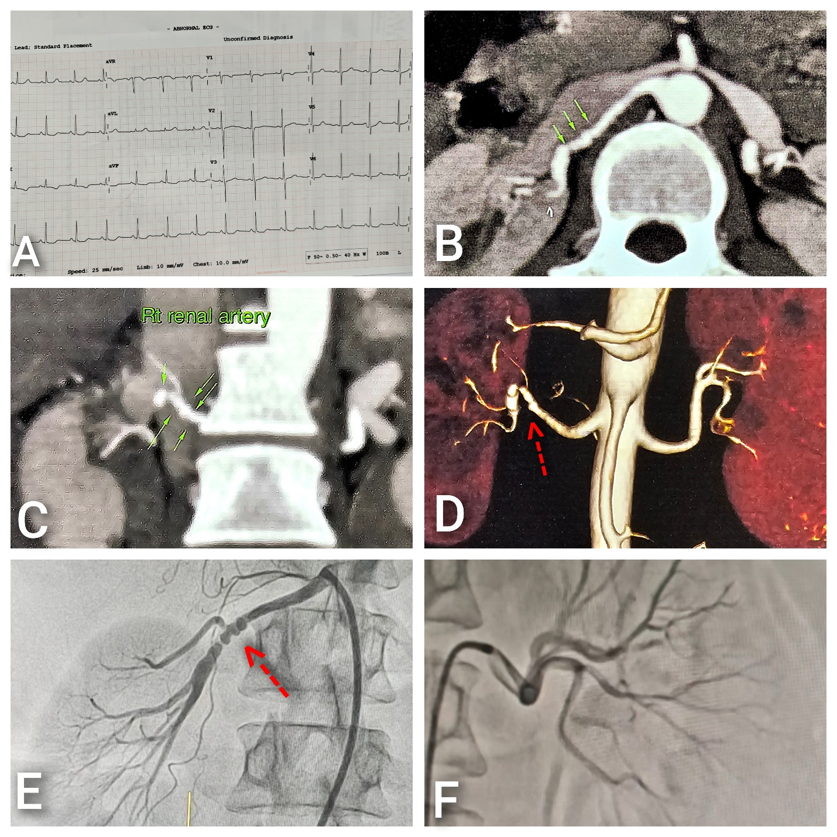

Figure 1(A) ECG showing LVH with strain;(B,C&D) CT angiography-“strings of beads” appearance of right renal artery; (E&F)Selective renal angiography-multifocal stenosis in right renal artery and normal left renal artery.

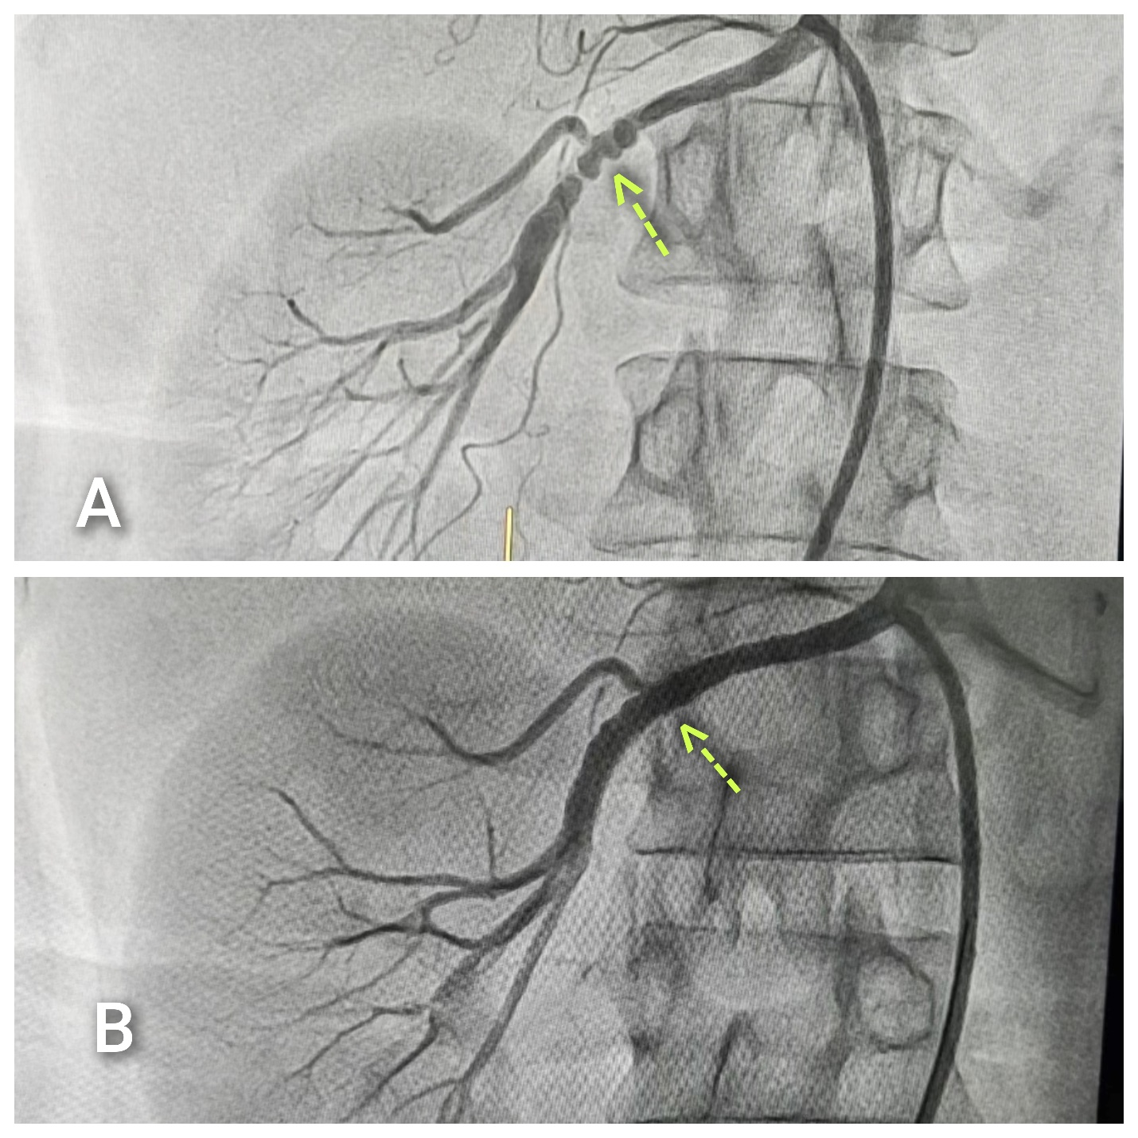
Figure 2 (A&B) ECG Showing restored blood flow after successful balloon angioplasty
Disclaimer (Artificial intelligence)
Author(s) hereby declare that NO generative AI technologies such as Large Language Models (ChatGPT, COPILOT, etc.) and text-to-image generators have been used during the writing or editing of this manuscript.

References
- Gornik, H. L., Persu, A., Adlam, D., Aparicio, L. S., Azizi, M., Boulanger, M., ... & Plouin, P. F. (2019). First international consensus on the diagnosis and management of fibromuscular dysplasia. Vascular Medicine, 24(2), 164-189.
- Olin, J. W., Gornik, H. L., Bacharach, J. M., Biller, J., Fine, L. J., Gray, B. H., ... & Stanley, J. C. (2014). Fibromuscular dysplasia: state of the science and critical unanswered questions: a scientific statement from the American Heart Association. Circulation, 129(9), 1048-1078.
- Lu YT, Zhou ZM, Zhang D, Sun L, Liu XC, Yang YK, Jiang XJ, Zhou XL. Percutaneous Transluminal Renal Angioplasty for Fibromuscular Dysplasia and Prognostic Risk Factors: A Retrospective Chinese Cohort Study. J Clin Med. 2022 Dec 20;12(1):23. doi: 10.3390/jcm12010023. PMID: 36614824; PMCID: PMC9821653..
- Plouin, P. F., Baguet, J. P., Thony, F., Ormezzano, O., Azarine, A., Silhol, F., ... & Arcadia Investigators. (2017). High prevalence of multiple arterial bed lesions in patients with fibromuscular dysplasia: the ARCADIA Registry (Assessment of Renal and Cervical Artery Dysplasia). Hypertension, 70(3), 652-658.
- Slovut DP, Olin JW. Fibromuscular Dysplasia. Curr Treat Options Cardiovasc Med. 2005 Jun;7(2):159-169. doi: 10.1007/s11936-005-0017-z. PMID: 15935124..
- Persu, A., Dobrowolski, P., Gornik, H. L., Olin, J. W., Adlam, D., Azizi, M., ... & Januszewicz, A. (2022). Current progress in clinical, molecular, and genetic aspects of adult fibromuscular dysplasia. Cardiovascular research, 118(1), 65-83.
- Youssef S, Gill AE, Shah JH, et al. Mid-to-long term outcomes following renal artery angioplasty in children and young adults with renal artery stenosis: a retrospective review. Pediatric Nephrology (Berlin, Germany). 2025 Aug;40(8):2589-2597. DOI: 10.1007/s00467-025-06727-z. PMID: 40164847; PMCID: PMC12187876.
- Gavalas MV, Gasparis AP, Tassiopoulos AK, Loh S, Labropoulos N. Long-term follow-up for percutaneous transluminal angioplasty in renal artery fibromuscular dysplasia. Int Angiol. 2015 Dec;34(6):529-37. Epub 2014 May 13. PMID: 24824840.
- Persu, A., Dobrowolski, P., Gornik, H. L., Olin, J. W., Adlam, D., Azizi, M., ... & Januszewicz, A. (2022). Current progress in clinical, molecular, and genetic aspects of adult fibromuscular dysplasia. Cardiovascular research, 118(1), 65-83.
- Kang YY, Chen Y, Wu QH, Dong H, Zou YB, Gao PJ, Xu JZ, Jiang XJ, Wang JG. Prevalence and clinical characteristics of renovascular hypertension associated with fibromuscular dysplasia in China. J Hypertens. 2023 Apr 1;41(4):638-647. doi: 10.1097/HJH.0000000000003382. Epub 2023 Jan 31. PMID: 36723459; PMCID: PMC9994795.

- Szczerbo-Trojanowska M, Maciąg R, Sterliński I, Witkowski A, Januszewicz A, Adlam D, Januszewicz M, Persu A. Risks and benefits of renal artery stenting in fibromuscular dysplasia: Lessons from the ARCADIA-POL study. Vasc Med. 2024 Feb;29(1):50-57. doi: 10.1177/1358863X231210523. Epub 2023 Dec 12. PMID: 38084723.
- Youssef, S., Gill, A.E., Shah, J.H. et al. Mid-to-long term outcomes following renal artery angioplasty in children and young adults with renal artery stenosis: a retrospective review. Pediatr Nephrol 40, 2589–2597 (2025). https://doi.org/10.1007/s00467-025-06727-z.

