Original Research Article
Environmental Impact Assessment of Lithium mining on Soil Quality in Libata Mining site, Ngaski L.G.A. Kebbi state, Nigeria

Abstract
The mining of lithium has grown at a very high rate all over the globe owing to the rising demand in lithium-ion batteries in renewable energy technology and in electric vehicles. Nonetheless, mining operations can cause heavy metals to enter the local soils, which can be fatal to the environment and ecology. The study evaluated the environmental effects of lithium mining on soil quality in the Libata mining site in the Ngaski Local Government area of Kebbi state in Northwestern Nigeria. Samples of soil were collected from five mining locations (SL1-SL5) and a control site that was located several kilometres away from the mining site. The concentrations of the chosen heavy metals (As, Cd, Cr, Cu, Co, Mn, Ni, Pb and Zn) were measured by means of Atomic Absorption Spectrophotometry (AAS). The Contamination Factor (CF), Geo-Accumulation Index (Igeo), and Pollution Load Index (PLI) were used to assess environmental contamination. The findings indicated that mining areas had higher heavy metal concentrations in the soils than the control site. Zinc and copper showed the highest concentrations with maximum values reported at SL5 and SL2 respectively. The analysis of contamination factors showed that several metals were moderately or considerably contaminated, As, Cd, Cu, and Ni. All the mining sites had higher values of the calculated PLI that exceeded unity (PLI > 1), which showed that the quality of soil was being deteriorated as a result of mining. The statistical test using one-way ANOVA indicated that the concentration of heavy metals significantly differed (p < 0.05) between sampling locations. The findings conclude that the lithium mining processes have enhanced the heavy metal content of soils in the research site. It therefore suggested to engage in continuous environmental monitoring and adopt sustainable mining practices to reduce any further environmental degradation.
Keywords: Lithium mining; Heavy metal; Contamination factor; Geo-accumulation index; Pollution load index, Kebbi State.
INTRODUCTION
The Northwest region of Nigeria is currently developing into a significant niche in mineral resources and particularly lithium. Artisanal miners and recent studies note that the area has more than 120 known lithium reserves (Obaje, 2009; Salau et al., 2016; Dzukogi et al., 2020; Dzukogi et al., 2022). The spodumene, amblygonite, white cast and lepidolite are the most common lithium ores. These deposits are either associated with vein-type mineralisation (pegmatite veins) or a variety of disseminated mineralisation in a variety of host rocks (schist, gneiss, intruded granite) (Solomon, 2004; Dzukogi et al., 2022). According to the tectonic model (Abu-Adam et al. 2013), the formation of these minerals was as a result of hydrothermal solutions generated at deeper levels of the crust due to magmatic process.
The world is experiencing an unprecedented lithium demand due to the adoption of renewable sources of energy in the world rather than fossil fuels. As the energy sector moves to cleaner technologies and electric vehicles (EVs), wind energy, and hydrogen, it is the work of the metals and mining industry to challenge the issue of supplying the required raw materials to the movement (Daniel Dele-Yaro, 2023; Moshine, 2022). This change is also critical in the context of globalisation of decarbonisation of the energy and transport systems, where high-targeted policy aims are brought by countries in Asia, Europe, and the USA (IEA, 2020).
Even though it is not scarce, lithium has only small amounts that are economically viable in China and the world at large. The recognized reserves of lithium in the world are mainly in salt deposits of brines of approximately 60 percent of the known reserves, about 78 percent of which are of subsurface and dried salt lakes. Others include geothermal source, petroleum deposits and seawater desalination wastes (McLellan, 2023). Industrially produced lithium is predominantly produced in two forms lithium carbonate using the brines and lithium hydroxide using the hard rock.
However, lithium mining is not without any environmental concerns. The geologic mining and production of lithium-bearing-ores can have a significant amount of environmental risks, including water pollution, soil erosion, air pollution, and health hazards due to the release of toxic chemicals/heavy metal (March Zheng, 2023). The ecological situation in Northern Nigeria is complex because there is a lack of water resources, the soil is of low quality, and vegetation is not rich (Abdulkadir et al., 2013). The intense mining in the region that is largely conducted with little or no regulation puts severe questions on the sustainability of the industry.
Lithium mining in Ngaski Local Government Area of Kebbi State particularly, the localities such as Libata have elicited the issue of environmental effects. These societies can be regarded as proper case studies because mining activities occur. Awareness of environmental effects of the mining activities in this region of the environment will be at the centre stage to promote sustainable development of minerals and safety of the local communities.
This paper investigated the environmental impact of lithium mining in libata mining site and the evaluation of the existing regulations, and compared against the global norms. It is also attempting to inform the policy makers who are in the industry and the local communities about the environmental problems and the opportunities associated with lithium mining, in an attempt to enhance sustainable management of the resources.
The study examines the effect of the lithium mining exploitation in the region of Libata mining site in Ngaski Local Government in Kebbi State. The research findings are empirical which will assist the Ngaski Local Government and the Kebbi State authorities establish and enforce the minimum environmental standards on solid mine exploitation. In addition, it aims at promoting the best management in reclaiming surface mines.

2.0 MATERIALS AND METHODS
2.1 Study Area: Kebbi State is one of the states that is blessed with solid minerals. On the earth, the State is situated between latitudes 10º and 13º N, longitudes 3º and 6º E. It is located in the North-Western geopolitical region of Nigeria and borders on Sokoto State in the north, Niger State in the south, and Zamfara State in the east. It has a total land mass of 36,800 km2 (Yahaya et al., 2022). Study Area is located in Ngaski local government area of Kebbi state and is accessible through Abuja, the Federal Capital Territory, via Minna – Kontagora – Ibeto– salka – Wara. The mining site located in Libata.

Table 1: Showing the sampling points.
Locations Coordinates
Control Site 11°40571″N 5°23991″E
Location 1 10°13856″N 4°58969″E
Location 2 10°14063″N 4°59163″E
Location 3 10°14554″N 4°59001″E
Location 4 10°18741″N 4°61776″E
Location 5 10°18978″N 4°62292″E
Picture 1. Map Showing locations of Sample points.
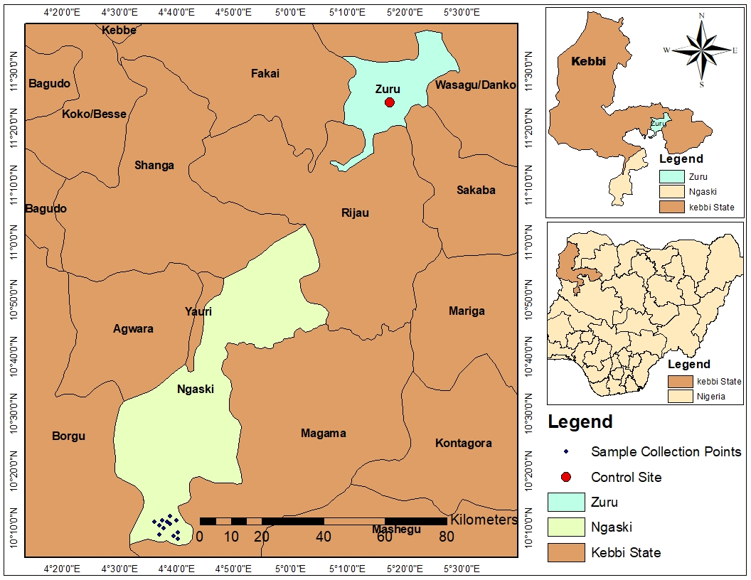
2.2 Collection of soil sample
Six (6) samples was systematically collected from different points of the mining site and one (1) sample as control from non-mining site several kilometers away. Soil sample was collected by using measuring tape, hand glove and stainless steel soil Auger. The method of collecting the surface soil (the upper 3cm layer) was according to the norm AFNOR X31B (AFNOR, 1999). The soil samples packed in separate clean polyethylene bags and was taken to the laboratory for analysis.
2.2.1 Digestion of soil sample
The soil samples was separately undergo open total digestion method described by (A.O.A.C., 2010).
2.2.2 Determination of the physico-chemical parameters from soil sample
Major physical and chemical quality parameter that was analyzed in the digested samples included soil pH, electrical conductivity (EC), organic carbon (OC), nitrogen (N), phosphorus (P), potassium (K). The approaches of (Yusuf et al., 2024) were used.
2.2.3 Determination of heavy metals from soil sample
The digested samples was separately analyzed for lead (Pb), cadmium (Cd), arsenic (As), chromium (Cr), nickel (Ni), zinc (Zn), copper (Cu), Manganese (Mn) and cobalt (Co) by Atomic absorption spectrophotometer (AAS BUCK SCIENTIFIC 211) VGP.
2.3 Contamination Factor (CF)
The contamination factor (CF) compares metal concentrations in mining site soils to the control (CTR) and is calculated using the formula:
$$CF=\frac{Csample}{Cbackground}$$
Where;
Csample = Mean concentration of the metal in the sample
Cbackground = Mean background concentration
Using CTR as a control site (background) for CF calculation:

2.4 Geo-Accumulation Index (Igeo)
Geo-accumulation Index (Igeo) is utilized to determine the extent of heavy metal pollution on soils or sediments by comparing actual concentrations to the background level (control or pre-industrial) concentrations.
Formula; Igeo = log2 ( Cn / (1.5 × Bn) )
Where:
Cn = Measured concentration of the metal in the sample
Bn = Background concentration (control site or geochemical baseline)
1.5 = Background correction factor to account for natural variability in the environment

2.5. Pollution Load Index (PLI)
In this study, the level of heavy metal contamination in the overall sampling localities was measured using Pollution Load Index (PLI). The PLI is used to measure the quality of a site through a combination of the contamination factors of the individual metals into the single index of quality. The PLI is used to measure general site pollution based on the geometric mean of the all the values of contamination factor (CF):
PLI = (CF1 × CF2 × CF3 × ... × CFn)^(1/n)
Where n represents the total number of metals analyzed in the study.
The PLI values were interpreted as follows:
PLI = 1 → Baseline level of pollution
PLI < 1 → No overall pollution
PLI > 1 → Deterioration of site quality (pollution exists)
2.6. Statistics analysis of data
Analysis of data was done by using one-way Analysis of Variance (ANOVA) to determine whether significant differences exist among sampling locations. Which significant differences were observed, Dunnett’s post hoc test was used to compare each mining site directly with the control site. The level of significance was set at α = 0.05.
3. Results and discussions
3.1. Table 2 shows the concentrations of the heavy metals (As, Cd, Cr, Cu, Co, Mn, Ni, Pb, Zn) in soil samples taken inside the mining locations (SL1-SL5) and the control location (CTR). All values represent Mean ± SD (n = 3).

Table 2: Showing Mean ± SD of Heavy Metals contains of polluted and control sites of soil (mg/kg).
Sample | As | Cd | Cr | Cu | Co | Mn | Ni | Pb | Zn
CTR | 0.011 ± 0.001 | 0.019 ± 0.001 | 0.049 ± 0.001 | 0.079 ± 0.001 | 0.014 ± 0.001 | 0.099 ± 0.001 | 0.019 ± 0.001 | 0.049 ± 0.001 | 0.199 ± 0.001
SL1 | 0.046 ± 0.001 | 0.096 ± 0.001 | 0.136 ± 0.001 | 0.295 ± 0.001 | 0.045 ± 0.001 | 0.229 ± 0.001 | 0.072 ± 0.001 | 0.128 ± 0.001 | 0.368 ± 0.001
SL2 | 0.040 ± 0.001 | 0.081 ± 0.001 | 0.144 ± 0.001 | 0.414 ± 0.001 | 0.056 ± 0.001 | 0.196 ± 0.001 | 0.088 ± 0.001 | 0.104 ± 0.001 | 0.290 ± 0.001
SL3 | 0.034 ± 0.001 | 0.055 ± 0.001 | 0.080 ± 0.001 | 0.360 ± 0.001 | 0.029 ± 0.001 | 0.243 ± 0.001 | 0.095 ± 0.001 | 0.142 ± 0.001 | 0.332 ± 0.001
SL4 | 0.051 ± 0.001 | 0.051 ± 0.001 | 0.112 ± 0.001 | 0.313 ± 0.001 | 0.036 ± 0.001 | 0.257 ± 0.001 | 0.100 ± 0.001 | 0.098 ± 0.001 | 0.371 ± 0.001
SL5 | 0.037 ± 0.001 | 0.073 ± 0.001 | 0.156 ± 0.001 | 0.218 ± 0.001 | 0.053 ± 0.001 | 0.176 ± 0.001 | 0.086 ± 0.001 | 0.134 ± 0.001 | 0.456 ± 0.001

Table 2 indicates that the average levels of As, Cd, Cr, Cu, Co, Mn, Ni, Pb and Zn at each of the mining sites (SL1-SL5) show evident spatial enrichment as compared to the control (CTR). The lowest concentrations were always noted at the control site, which is an indication of geochemical baseline conditions. Conversely, the mean value was high in all mining sites, The high level of all metals in the soil may be attributed to mining of lithium in the area, as a result of mining of the mineral, transporting of the rocks, processing the rocks in the area and disposal of the waste at the mine area (Salomons, W. 1995). It is also in line with recent studies that active and abandoned mines often have high soil metal levels because of mechanical disturbance, tailings scattering, and sulfide-bearing mineral oxidative weathering (Li et al., 2021; Zhang et al., 2022).

The Arsenic (As) content of mining soils (0.034-0.051 mg/kg) was higher than the Arsenic (As) content of the control site (0.011 mg/kg) with the highest level at SL4. Arsenic is commonly related to sulfide minerals like arsenopyrite and it is emitted during oxidative weathering. Other reports have shown similar patterns of enrichment in the mining-affected soils of other regions worldwide where As build-up is associated with ore mineralization areas and tailings dumping (Wang et al., 2023). The As concentrations that are recorded at all sites are within the tolerance level established by the USEPA of sediment, 520 mg/kg (Orosun et al., 2020).

The level of cadmium (Cd) was extremely high in SL1 (0.096 mg/kg) and SL2 (0.081 mg/kg) as compared to 0.019 mg/kg in the control site. Cd is typical as an impurity in minerals of Zn, and that is why it is spatially related to the distribution of Zn. More recent researchers note that Cd poses a high ecological risk because of its mobility and ability to accumulate in the body even in low doses (Rahman et al., 2021; Liu et al., 2024). Its occurrence in mining soils could represent long-term hazards of soil biota and agricultural system in the case of dispersion outside of the mining carriage.

The levels of chromium (Cr) were high especially at SL5 (0.156 mg/kg) and SL2 (0.144 mg/kg). Cr can be obtained both of lithogenic sources and anthropogenic disturbance. Cr-rich bedrock may be exposed due to mining excavation, which may raise its surface concentration. (Zhou et al., 2023).

The highest level of enrichment was recorded in copper (Cu) where SL2 was 0.414mg/kg against 0.079mg/kg in the control site. This high increase signals the fact that it is close to lithium mines. In general, copper enrichment is frequently described in active mining areas and is commonly regarded as a major indicator of the intensity of mineralization (Zhou et al., 2022). High levels of Cu can affect the enzyme activity in the soil and the microbial biodiversity (Sun et al., 2023). Cobalt (Co) and nickel (Ni) showed intermediate enrichment with the maximum values of SL2 and SL5. The fact that they are co-varied indicates that they have common mineralogical backgrounds in the lithium mining zone. Mobility of Ni during the oxidizing conditions has been associated with mining disturbance coupled with acid-producing waste materials (Khan et al., 2021).

The levels of manganese (Mn) were elevated in SL4 and SL3. Mn being a redox sensitive element, the variation in Mn may indicate oxidative weathering and alterations in soil aeration. Increased levels of Mn in disturbed mining soils have been experienced as a result of increased dissolution of minerals (Zhang et al., 2022).

The highest level of lead (Pb) was at SL3 (0.142 mg/kg). Weathering of sulfide minerals or mechanical deposition due to hard rock lithium processing could be the source of Pb enrichment in the mining regions. Since Pb is toxic and not mobile, its concentration in the topsoil can be a possible ecological issue (WHO, 2021).
Zinc (Zn) was the most abundant in general, as the value at SL5 was 0.456 mg/kg as compared to 0.199 mg/kg at the control site. The high Zn compositions favour the conclusion of the Zn-carrying mineralization. Zn was mostly indicated as a predominant pollutant in mining-affected soil (Liu et al., 2024). Even though Zn is a crucial micronutrient, too much of it can inhibit the biological activity of soils.

Contamination Gradient of the study in terms of the overall concentration magnitudes indicates the following order: SL2 ≈ SL4 ≈ SL5 > SL1 > SL3 > CTR, SL2 and SL4 seem to be the hotspots of contamination in the study, probably, they are the active excavation or hard rock lithium concentration hotspots. The enrichment of the Cu and Zn indicates prevalent sulfide mineralization, and the occurrence of Cd and Pb indicates the possibility of the toxicological issues. Although contamination on the low level can have no immediate harm to the environment, it can cause ecological risk with time through bioaccumulation (Rahman et al., 2021). The research shows the evident geochemical change of soils induced by mining which is spatially non-uniform in distribution. Zn and Cu describe the most enriched metals, whereas Cd and Pb have more ecological concern, even though in a lower concentration.
According to the international soil quality guidelines (WHO, 2021; FAO, 2022), the continuous monitoring in mining areas is necessary because of the cumulative effects and potential transfer in food-chain.
The heavy metal enrichment pattern observed in this study is in line with the findings from previous studies conducted in the Egbe–Isanlu lithium belt (Kogi State) and some parts of the states of Nasarawa and Kwara have shows high levels of Cu, Zn, Cd, and Pb in the soils around active and artisanal mining areas (Orosun et al., 2023; Sule et al., 2025).. Similarly in these areas, Cu and Zn were found to be the dominant metals according to their association with sulfide bearing pegmatites which is in line with the high levels of Cu (0.414 mg/kg at SL2) and Zn (0.456 mg/kg at SL5) found in this study. On the same note, recent research on abandoned and active mines in Nasarawa State found high Ni, Co, and Mn, which correlated with weathering of the mafic and ultramafic rocks that were exposed during excavation (Kana & John, 2019; Onwuka et al., 2022). This is in line with the median enrichment of Ni, Co and Mn in this study showing a mixture of lithologic and mining sources. In another research conducted in angwa-kede community, kokona lga, nasarawa state, Nigeria show high values of heavy metals (Clinton et al., 2024).
Table 3. Contamination Factor (CF)
Metal | SL1 | SL2 | SL3 | SL4 | SL5
As | 4.18 | 3.64 | 3.09 | 4.64 | 3.36
Cd | 5.05 | 4.26 | 2.89 | 2.68 | 3.84
Cr | 2.78 | 2.94 | 1.63 | 2.29 | 3.18
Cu | 3.73 | 5.24 | 4.56 | 3.96 | 2.76
Co | 3.21 | 4.00 | 2.07 | 2.57 | 3.79
Mn | 2.31 | 1.98 | 2.45 | 2.59 | 1.78
Ni | 3.79 | 4.63 | 5.00 | 5.26 | 4.53
Pb | 2.61 | 2.12 | 2.90 | 2.00 | 2.73
Zn | 1.85 | 1.46 | 1.67 | 1.86 | 2.29

Table 3 presents the contamination factor (CF) of this research that adopted to assess the percentage of heavy metal pollution in soils sampled at five sites (SL1-SL5) on the mining site. The CF classification will be determined as follows: CF < 1 (low contamination), 1 ≤ CF < 3 (moderate contamination), 3 ≤ CF < 6 (considerable contamination), and CF ≥6 (very high contamination).

In all the sampling sites, the majority of metals had CF values exceeding 1 which implies that soils are mostly affected by the mining processes.

The contamination of cadmium (Cd), arsenic (As), copper (Cu), cobalt (Co), and nickel (Ni) was high (CF 3-6) at SL1 whereas chromium (Cr), manganese (Mn), lead (Pb), and zinc (Zn) levels contaminated moderately.

At SL2, the copper (Cu) and nickel (Ni) demonstrated a comparatively higher value of CF in comparison to other metals, showing a great degree of enrichment probably attributed to mineral exploration and ore processing operations. There was also a significant contamination of cadmium (Cd) and arsenic (As).

At SL3, nickel (Ni) and copper (Cu) showed significant contaminations and chromium (Cr), manganese (Mn), and zinc (Zn) were at moderate levels of contamination. This implies that there are spatial differences in the distribution of metals within the site.

Nickel (Ni) at SL4 was among the highest CFs of all locations indicating that it was highly anthropogenic. Arsenic (As) and copper (Cu) were also contaminated significantly.

Nickel (Ni), cobalt (Co), cadmium (Cd) and arsenic (As) were strongly contaminated at SL5 and as manganese (Mn) and zinc (Zn) were not extremely high.

In general, nickel (Ni), cadmium (Cd), copper (Cu), and arsenic (As) were found to have a greater contamination factor throughout the field of study, and so it can be inferred that these metals form the main source of soil pollution in the mining site. The value of CF which is below 6 means that there is significant contamination that is yet to attain the level of very high.

The high CF values could be explained by mining activities, hard rock lithium digging, dumping of waste rocks, and abrasion of mineralized pegmatite formations in the study site. The steady build-up of these metals can be a threat to the ecological environment of vegetation, soil microorganisms, and even human health in bioaccumulation and food chain transfer.

Table 4. Geo-Accumulation Index (Igeo)
Site | As | Cd | Cr | Cu | Co | Mn | Ni | Pb | Zn
CTR | -0.585 | -0.585 | -0.585 | -0.585 | -0.585 | -0.585 | -0.585 | -0.585 | -0.585
SL1 | 1.479 | 1.752 | 0.888 | 1.316 | 1.1 | 0.625 | 1.337 | 0.8 | 0.302
SL2 | 1.278 | 1.507 | 0.97 | 1.805 | 1.415 | 0.4 | 1.627 | 0.501 | -0.042
SL3 | 1.043 | 0.948 | 0.122 | 1.603 | 0.466 | 0.71 | 1.737 | 0.95 | 0.153
SL4 | 1.628 | 0.84 | 0.608 | 1.401 | 0.778 | 0.791 | 1.811 | 0.415 | 0.314
SL5 | 1.165 | 1.357 | 1.086 | 0.879 | 1.336 | 0.245 | 1.593 | 0.866 | 0.611
The Geo-accumulation Index (Igeo) gives a numerical measure of the degree of contamination and it includes a background correction factor. The values of Igeo less than 0 are said to be uncontaminated, 0-1 uncontaminated to moderately contaminated, 1-2 moderately contaminated, and 2-3 moderately to strongly contaminated. The Igeo in this research demonstrates that the majority of metals in the mining locations are within the moderate level of contamination. Igea values of cadmium (Cd) and copper (Cu) are higher at SL1-SL5 suggesting a high anthropogenic impact and ecological risk.

Table 5: Pollution Load Index (PLI) of Mining Sites
Site | PLI | Pollution Status
SL1 | 3.48 | Polluted
SL2 | 3.57 | Polluted
SL3 | 3.02 | Polluted
SL4 | 3.18 | Polluted
SL5 | 3.24 | Polluted

Pollution Load Index, PLI, is greater than 1 in all 5 locations indicating that the mining activity causes a lot of pollution. This is in line with the high CF values in As, Cd, Cu and Ni metals. The soils at the mining site have high concentration of metals than that of the control, which reflects the mining activities in the mining area. Metals such as As, Cd, Cu, and Ni are of utmost concern and CF exceeded 3 at several points. The value of PLI greater than 1 at all the sites signifies that the general quality of soils is impaired and contaminated. These findings reveal that there is a need to monitor bioaccumulation of plants cultivated on such soils, particularly when metals are close to WHO/FAO allowable limits.
Table 6: Physicochemical Properties of Soil Samples

Sample | pH | EC (dS/m) | OC (%) | N (%) | P (mg/kg) | K (mg/kg)
CTR | 6.72 ± 0.03 | 0.18 ± 0.01 | 1.12 ± 0.02 | 0.098±0.003 | 14.6 ± 0.5 | 112 ± 2
SL1 | 6.41 ± 0.02 | 0.31 ± 0.01 | 0.86 ± 0.01 | 0.072±0.002 | 10.8 ± 0.4 | 84 ± 3
SL2 | 6.38 ± 0.03 | 0.36 ± 0.02 | 0.79 ± 0.02 | 0.065±0.002 | 9.6 ± 0.3 | 76 ± 2
SL3 | 6.29 ± 0.02 | 0.34 ± 0.01 | 0.74 ± 0.01 | 0.061±0.002 | 8.9 ± 0.4 | 71 ± 2
SL4 | 6.21 ± 0.03 | 0.39 ± 0.01 | 0.69 ± 0.02 | 0.056±0.002 | 7.8 ± 0.3 | 66 ± 3
SL5 | 6.15 ± 0.02 | 0.42 ± 0.02 | 0.63 ± 0.01 | 0.052±0.001 | 6.9 ± 0.3 | 60 ± 2

Table 6 shows the physicochemical properties of the soil samples at the Libata mining site. The pH of the soil in the different sites sampled was between 6.15 and 6.72 which represents moderately acidic to slightly neutral soil. The highest pH value was obtained on the control site (6.72), and the lowest value on SL5 (6.15). The fact that pH in the mining regions is slightly lower can be linked to mineral weathering and mining disruption.

The EC values between 0.18 and 0.42 dS/m were also low, which shows the low salinity in the area of study. A higher EC value at SL4 and SL5 however, could be because of higher ionic concentration due to mining activities and dissolution of minerals.

The content of organic carbon (OC) was between 0.63% and 1.12 with the highest reading being at the control site. The decreased organic carbon in mining sites indicate the destabilization and degradation of the organic matter in the soil through digging and scraping away of the surface soils.

Equally, the levels of nitrogen (N), phosphorus (P), and potassium (K) were also more in the control site than in the mining sites. The nitrogen values were 0.052-0.098, phosphorus 6.9-14.6mg/kg and potassium 60-112 mg/kg. The comparatively low nutrient concentration in the mining sites means that the soil has low fertility due to mining activities.

The findings in general indicate that the lithium mining activities could have effects on the physicochemical properties of soil in terms of decreasing the soil organic matter and nutrient presence and slightly changing soil acidity and electrical conductivity.

Table 7: One-Way ANOVA Results for Heavy Metal Concentrations Across Sampling Location.
Metal | F-value | p-value | Remark
As | 166.200 | <0.001 | Significant
Cd | 626.657 | <0.001 | Significant
Cr | 511.490 | <0.001 | Significant
Cu | 2267.508 | <0.001 | Significant
Co | 215.114 | <0.001 | Significant
Mn | 782.275 | <0.001 | Significant
Ni | 347.739 | <0.001 | Significant
Pb | 332.619 | <0.001 | Significant
Zn | 646.794 | <0.001 | Significant

Decision rule: Differences are considered statistically significant when p < 0.05 The analysis of variance (ANOVA) was conducted, to establish the existence of significant differences in heavy metal concentrations within the sampling sites (CTR, SL1, SL2, SL3, SL4, and SL5). These findings indicated that statistically significant differences between the sampling sites were observed in all the analyzed metals (As, Cd, Cr, Cu, Co, Mn, Ni, Pb, and Zn). The large F-values, especially the F-value of Cu (2267.508), Mn (782.275), Zn (646.794), and Cd (626.657) show that there is a great spatial variation of the heavy metal elements in the study area. This implies that these metals are not uniformly distributed in the sites.

The large gaps that are evident between the sampling sites suggest that heavy metal mining in the Libata mining site has had a considerable impact on the level of heavy metals in the soils around the site. Most of the mining sites ( SL1- SL5 ) had more metal concentrations than the control site (CTR), which implies the enrichment due to anthropogenic activities related to mining activities.
The considerable outcome of ANOVA supported the use of post-hoc multiple comparison tests (Dunnett test) to identify which mining sites were significantly different to the control site.
Table 8: Dunnett Post‑Hoc Test Results (Control vs Mining Sites)

Dunnett Post-hoc Test for Arsenic (As)
Comparison | t-value | p-value | Remark
CTR vs SL1 | 22.913 | <0.001 | Significant
CTR vs SL2 | 18.985 | <0.001 | Significant
CTR vs SL3 | 15.057 | <0.001 | Significant
CTR vs SL4 | 26.186 | <0.001 | Significant
CTR vs SL5 | 17.021 | <0.001 | Significant

Dunnett Post-hoc Test for Cadmium (Cd)
Comparison | t-value | p-value | Remark
CTR vs SL1 | 50.408 | <0.001 | Significant
CTR vs SL2 | 40.589 | <0.001 | Significant
CTR vs SL3 | 23.568 | <0.001 | Significant
CTR vs SL4 | 20.949 | <0.001 | Significant
CTR vs SL5 | 35.351 | <0.001 | Significant

Dunnett Post-hoc Test for Chromium (Cr)
Comparison | t-value | p-value | Remark
CTR vs SL1 | 33.695 | <0.001 | Significant
CTR vs SL2 | 36.793 | <0.001 | Significant
CTR vs SL3 | 12.006 | <0.001 | Significant
CTR vs SL4 | 24.400 | <0.001 | Significant
CTR vs SL5 | 41.441 | <0.001 | Significant

Dunnett Post-hoc Test for Copper (Cu)
Comparison | t-value | p-value | Remark
CTR vs SL1 | 61.505 | <0.001 | Significant
CTR vs SL2 | 95.390 | <0.001 | Significant
CTR vs SL3 | 80.014 | <0.001 | Significant
CTR vs SL4 | 66.631 | <0.001 | Significant
CTR vs SL5 | 39.580 | <0.001 | Significant

Dunnett Post-hoc Test for Cobalt (Co)
Comparison | t-value | p-value | Remark
CTR vs SL1 | 20.294 | <0.001 | Significant
CTR vs SL2 | 27.495 | <0.001 | Significant
CTR vs SL3 | 9.820 | <0.001 | Significant
CTR vs SL4 | 14.402 | <0.001 | Significant
CTR vs SL5 | 25.531 | <0.001 | Significant

Dunnett Post-hoc Test for Manganese (Mn)
Comparison | t-value | p-value | Remark
CTR vs SL1 | 44.445 | <0.001 | Significant
CTR vs SL2 | 33.163 | <0.001 | Significant
CTR vs SL3 | 49.231 | <0.001 | Significant
CTR vs SL4 | 54.017 | <0.001 | Significant
CTR vs SL5 | 26.325 | <0.001 | Significant

Dunnett Post-hoc Test for Nickel (Ni)
Comparison | t-value | p-value | Remark
CTR vs SL1 | 23.443 | <0.001 | Significant
CTR vs SL2 | 30.520 | <0.001 | Significant
CTR vs SL3 | 33.617 | <0.001 | Significant
CTR vs SL4 | 35.828 | <0.001 | Significant
CTR vs SL5 | 29.636 | <0.001 | Significant

Dunnett Post-hoc Test for Lead (Pb)
Comparison | t-value | p-value | Remark
CTR vs SL1 | 29.859 | <0.001 | Significant
CTR vs SL2 | 20.788 | <0.001 | Significant
CTR vs SL3 | 35.151 | <0.001 | Significant
CTR vs SL4 | 18.520 | <0.001 | Significant
CTR vs SL5 | 32.127 | <0.001 | Significant

Dunnett Post-hoc Test for Zinc (Zn)
Comparison | t-value | p-value | Remark
CTR vs SL1 | 35.070 | <0.001 | Significant
CTR vs SL2 | 18.884 | <0.001 | Significant
CTR vs SL3 | 27.599 | <0.001 | Significant
CTR vs SL4 | 35.692 | <0.001 | Significant
CTR vs SL5 | 53.331 | <0.001 | Significant

Table 8 presents Dunnett post-hoc test that was done to compare heavy metal concentrations in the mining sites (SL1-SL5) and the control site (CTR) with a level of significance (p) of 0.05. Statistically significant differences were found between the control and each of the mining locations in all the metals analyzed (As, Cd, Cr, Cu, Co, Mn, Ni, Pb and Zn). The p-values of all the comparisons were less than 0.001 that is significantly lower than the critical value of 0.05 that implies that there is a strong statistical evidence of high concentrations of heavy metals in the soils of the mining sites.

The t-values are large in all the comparisons which indicate that the mining areas are highly enriched with heavy metals when compared with the control site. Metals like Cu, Cd, Mn, and Zn had very high t-values indicating a significant impact of mining activities on their presence in soils. Comprehensively, the findings validate that mining operations in the region of study have a strong impact on elevating the level of heavy metal in the surrounding soils that could be potentially hazardous in terms of environmental and ecological consequences.

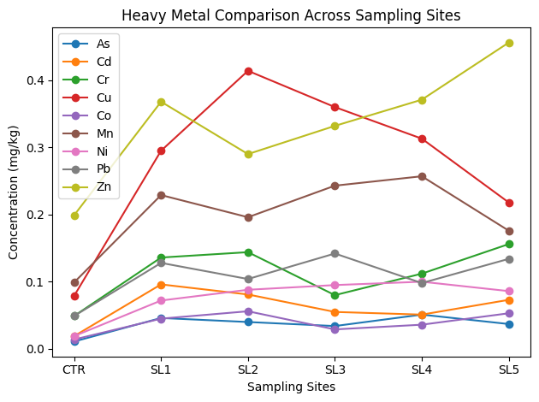
Figure 1. The figure Heavy Metal Comparison Across Sampling Sites presents all the metals (As, Cd, Cr, Cu, Co, Mn, Ni, Pb, Zn) plotted together across the sampling sites CTR 2 SL5. at the Libata lithium mining site. The values are the average concentration of triplicate measurements. The comparison reveals that Cu and Zn is the most enriched and CTR always presents the lowest values with SL2 and SL5 are the key contamination hotspots.

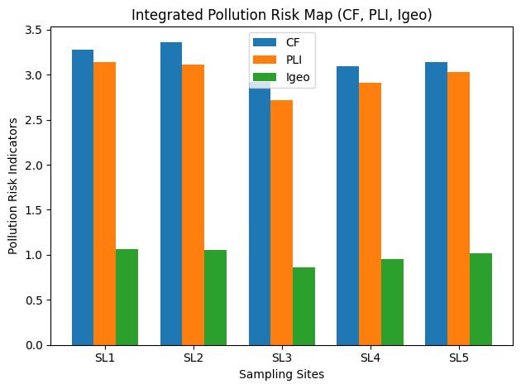
Figure 2: Integrated pollution risk Map (SL1–SL5).
The combined risk assessment of CF and PLI, and Igeo is an integrated model that includes a broad picture of the heavy metal contamination of the mining sites. The findings reveal that SL2 and SL1 are the most contaminated as the values of CF and PLI are higher. There is also significant pollution in SL5 and SL4 and relatively smaller contamination in SL3 that also exceeds the baseline conditions. Igeo values suggest moderate level of contamination in majority of the sites which is in line with CF and PLI results. In general, the combined risk map proves that the lithium mining operations have played a major role in the enrichment of heavy metals in the soils of the Libata mining site, and that pollution levels vary across the sampling sites.
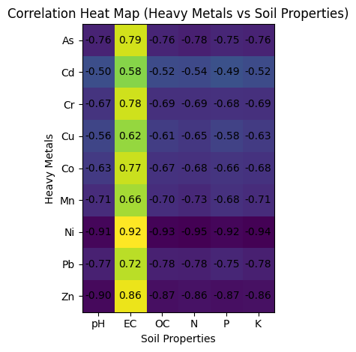
Figure 3. Correlation heat map of relationship between heavy metal (As, Cd, Cr, Cu, Co, Mn, Ni, Pb, Zn) and physicochemical properties (pH, EC, OC, N, P, K) of soils of the Libata lithium mining site. The correlation test showed that there were different relations between heavy metals and the soil physicochemical properties. Negative correlations were found to be strong between most of the heavy metals with soil nutrients and organic matter such as organic carbon (OC), nitrogen (N), phosphorus (P), and potassium (K). This implies that as heavy metal goes higher, it is possible that the soil will be less fertile and the depletion of organic matter as is routine in the mining affected soils.

Electrical conductivity (EC) had positive relationships with a number of metals, which means that, the increasing levels of ionic concentrations in the soil can enable the movement and deposition of heavy metals in the mining environment. Nickel (Ni) and zinc (Zn) had the most significant correlations with soil properties and, therefore, their distribution can be highly dependent on soil chemistry and mining disturbance. The negative correlations with pH show that slightly acidic surroundings could increase the metal solubility and availability in the soil.

In general, the correlation heat map shows that the mining of lithium has impacted the levels of both the heavy metals and the soil physicochemical properties, and this demonstrates the relationship between the soil chemistry and the metal contamination in the research site.

Conclusion

The research determined the environmental impact of lithium mining at Libata mining site in the Ngaski Local Government Area of Kebbi State in Northwestern Nigeria by assessing the concentrations of heavy metals in soil and the use of contamination indices such as Contamination Factor (CF), Geo-Accumulation Index (Igeo), Pollution Load Index (PLI) and statistical analysis using ANOVA and Dunnett post-hoc test.

The results indicate that soils in the mining field have significant levels of heavy metals as opposed to the control site. Metals analyzed (As, Cd, Cr, Cu, Co, Mn, Ni, Pb, and Zn) were always found to be higher in all mining sites (SL1-SL5) which means that there was a great geochemical change of the soil environment by the mining activities. Zinc and copper were the richest metals in the entire study area with cobalt having the least concentration.

Analysis of contamination factor indicated moderate to high levels of contamination of most of the metals; arsenic, cadmium, copper and nickel recorded the greatest contamination levels at various sampling sites. Likewise, the Geo-accumulation Index in terms of placing the majority of the metals as moderately contaminated indicated anthropogenic enrichment of the lithium extraction and other related mining activities.

All the values of Pollution Load Index (PLI) were above unity (PLI > 1) at the places of sampling, which means the general degradation of the soil quality within the mining area. This proves that Libata mining site is affected by heavy metal contamination due to the lithium exploitation activities.

The measured concentrations of metals are in the range of certain international regulatory limits, but the steady enrichment of all of the mining sites may indicate the progressive accumulation that can lead to the ecological risk in the long-term. Cadmium, arsenic, and lead are some of the heavy metals that have been associated with persistence, toxicity, and likelihood of bioaccumulating in the soil-plant systems. Further mining without proper environmental management can consequently lead to pollution of the agricultural soils, groundwater systems, and the local food chain.

Recommendations

The results of this analysis indicate that environmental studies should be conducted regularly in the Libata mining site to monitor the accumulation and diffusion of heavy metals over the long term in the soil, water, and vegetation. Consistent surveillance will assist in detecting the initial environmental degradation indicators and aid in proper environmental management policies. Moreover, the regulatory bodies like the Nigerian Environmental Standards and Enforcement Agency (NESREA) and the Federal Ministry of Mines and Steel Development must enforce the environmentally-compliant regulations by asking the mining companies to comply with the environmental impact assessment (EIA) requirements and to monitor the mining activities to ascertain whether the activities are in line with the standards of environmental protection. Sustainable mining practices should also be embraced by mining companies to reduce soil disturbance and toxic metal release in the immediate ecosystems and put in place proper mine waste management systems to prevent heavy metal leaching in soils and groundwater.
Moreover, mining should be followed by land reclamation and ecological rehabilitation programs aimed at restoring degraded land by soil remediation and re-vegetating it with native plant species.
Acknowledgment
The authors extend their appreciation to the TETFUND Nigeria for funding this work through Institutional Research Project under grant number: TETF/DR&D/CE/UNI/ZURU/IBR/2025/VOL. 1.
Declaration of competing interest
The authors have no competing interests to declare

Disclaimer (Artificial intelligence)

Author(s) hereby declare that NO generative AI technologies such as Large Language Models (ChatGPT, COPILOT, etc.) and text-to-image generators have been used during the writing or editing of this manuscript.

REFERENCES
- Abdulkadir, A., Usman, M. T., Shaba, A. H., & Saidu, S. (2013). An appraisal of the eco-climatic characteristics in Northern Nigeria. African Journal of Environmental Science and Technology. https://doi.org/10.5897/AJEST12.161
- Abu-Alam, T., Grosch, E., & Monsef, M. A. (2013). Pan-African shear zone-hosted gold mineralization in the Arabian-Nubian Shield. EGU General Assembly Conference Abstracts, Vienna, Austria. https://doi.org/10.1144/SP478.
- AFNOR. (1999). Qualité des sols (Soil quality): Recueil de normes françaises (Vol. 1). Paris, France: Association Française de Normalisation.
- Association of Official Analytical Chemists (AOAC). (2010). Official Methods of Analysis (18th ed.). Washington, DC: AOAC International.
- Clinton, E. E. E., Mohammed, R. A., & Thomas, D. G. (2024). Investigating the impact of lithium mining on soil quality and plant growth in Angwa-Kede community, Kokona LGA, Nasarawa State, Nigeria. Innovare Journal of Social Sciences, 12(6). https://doi.org/10.22159/ijss.2024v12i6.52606Dele-Yaro, D. (2023). Lithium mining and exploration in Nigeria. SSRN Electronic Journal. https://doi.org/10.2139/ssrn.4388085.
- Dzukogi, A. N., Sanusi, Y. A., Mohammad, S. B., & Adeyinka, K. S. (2020). Euler deconvolution and two-dimensional modeling of subsurface structures over part of Northern Bida Basin and its surrounding basement rocks, Northwest Nigeria. International Journal of Earth Science and Geophysics, 6, 038. https://doi.org/10.35840/2631-5033/1838
- Dzukogi, A. N., Sanusi, Y. A., Mohammad, S. B., & Roko, A. (2022). Application of aeromagnetic data analysis and interpretation to investigate solid mineral potential in part of Northwest Nigeria. International Journal of Earth Science and Geophysics, 8, 057. https://doi.org/10.35840/2631-5033/2057
- Food and Agriculture Organization of the United Nations (FAO). (2022). Soil pollution: A hidden reality. FAO. https://www.fao.org/3/i9183en/i9183en.pdf.
- International Energy Agency. (2020). The role of critical minerals in clean energy transitions. https://www.iea.org/reports/the-role-of-critical-minerals-in-clean-energy-transitions
- Kana, O. J., & John, C. (2019). Environmental impact of heavy metals concentration in parts of Kokona/Nasarawa LGAs, Nasarawa State, North Central Nigeria. African Journal of Environment and Natural Science Research, 2(3), 50–61. https://abjournals.org/ajensr/papers/volume-2/issue-3/environmental-impact-of-heavy-metals-concentration-in-parts-of-kokona-nasarawa-lgas-nasarawa-state-north-central-nigeria/.
- Khan, S., Naushad, M., Lima, E. C., et al. (2021). Global soil pollution by toxic elements: Current status and future perspectives. Journal of Hazardous Materials, 417, 126039. https://doi.org/10.1016/j.jhazmat.
- Li, J., Wang, Q., & Zhao, Y. (2021). Heavy metal contamination in soils near mining areas: Spatial distribution and risk assessment. Science of the Total Environment, 789, 147998. https://doi.org/10.1016/j.scitotenv.
- Liu, P., Chen, L., & Wang, S. (2024). Ecological risk assessment of heavy metals in mining-affected agricultural soils. Environmental Research, 233, 116321. https://doi.org/10.1016/j.envres.
- McLellan, J. (2023). How is lithium mined? General Kinematics. https://www.generalkinematics.com/blog/how-is-lithium-mined/
- Moshine, A. (2022). Raw materials will be at the core of decarbonisation efforts. Skillings. https://skillings.net/raw-materials-will-be-at-the-core-of-decarbonisation-efforts/
- Obaje, N. G. (2009). Geology and mineral resources of Nigeria. Springer. https://doi.org/10.1007/978-3-540-92685-6.
- Orosun, M. M., Adewuyi, A. D., Salawu, N. B., Isinkaye, M. O., Orosun, O. R., & Oniku, A. S. (2020). Monte Carlo approach to risk assessment of heavy metals at automobile spare part and recycling market in Ilorin, Nigeria. Scientific Reports, 10(1), 22084. https://doi.org/10.1038/s 41598-020-78861-8.
- Orosun, M. M., Inuyomi, S. O., Usikalu, M. R., Okoro, H. K., Louis, H., Omeje, M., & Ehinlafa, E. O. (2023). Heavy metal contamination of selected mining fields in North-Central Nigeria. MethodsX, 10, 102201. https://doi.org/10.1016/j.mex.2023.102201.
- Onwuka, J. C., Nwaedozie, J. M., Kwon-Dung, E. H., Terna, P. T., & Nwobodo, G. N. (2022). Environmental risk assessment of metal contamination of agricultural soils along major roads of peri-urban areas in Nasarawa State, Nigeria. Journal of Multidisciplinary Applied Natural Science, 3(1), 1–23. https://doi.org/10.44028/jmans.2022.03.001.
- Rahman, M. A., Rahman, M. M., & Reichman, S. M. (2021). Cadmium contamination in agricultural soils and crops: A review. Environmental Pollution, 275, 116646. https://doi.org/10.1016/j.envpol.
- Salau, S. L., Danbatta, U. A., & Agunleti, Y. S. (2016). Interpretation of aeromagnetic and satellite imagery for structures coincident with gold mineralization in Anka Schist Belt, Northwestern Nigeria. Journal of Applied Geology and Geophysics, 4(5), 29–34.
Retrieved from: https://www.iosrjournals.org.
- Salomons, W. (1995). Environmental impact of metals derived from mineral activities: Processes, predictions, prevention. Journal of Geochemical Exploration, 52(1–2), 5–23. https://doi.org/10.1016/0375-6742.
- Sule, A. A., Umar, I., Opaluwa, D. O., Kaika, Y. K., & Hamza, A. M. (2025). Assessment of heavy metals concentration in soil, plants and grains in Nasarawa North. Lafia Journal of Scientific and Industrial Research, 3(1), 118–122. https://doi.org/10.62050/ljsir2025.v3n1.261.
- Sun, Y., Zhou, Q., & Xie, X. (2023). Impacts of copper contamination on soil microbial communities. Ecotoxicology and Environmental Safety, 252, 114590. https://doi.org/10.1016/j.ecoenv.
- Wang, T., Song, B., & Li, Z. (2023). Arsenic and associated heavy metals in mining soils: Source apportionment and risk evaluation. Chemosphere, 318, 137891. https://doi.org/10.1016/j.chemosphere.
- WHO. (2021). Lead poisoning and health. World Health Organization.
- Yahaya, T. O., Adewale, M. K., Fagbayi, T., Salisu, T. F., Umar, J., & Nasir, J. (2024). Concentration, characterization, and risk assessment of microplastics in two main rivers in Birnin Kebbi, Nigeria. Environmental Health Engineering and Management Journal, 11(3), 315–325. https://doi.org/10.34172/EHEM.2024.31.
- Yusuf, S., James, P. A., Solomon, R. I., Musa, S. Y., & Joseph, J. (2024). Impact of selected soil physical and chemical properties regulating phosphate availability in Hadejia–Jama’are wetland soils. Asian Journal of Plant and Soil Sciences, 9(1), 74–85.
https://doi.org/10.56557/ajopss/2024/v9i1108.
- Zhang, H., Zhao, F., & Luo, Y. (2022). Heavy metal accumulation and mobility in mining-impacted soils. Journal of Environmental Management, 309, 114654. https://doi.org/10.1016/j.jenvman.
- Zheng, M. (2023). The environmental impacts of lithium and cobalt mining. Earth.Org. https://earth.org/lithium-and-cobalt-mining/
- Zhou, W., Liu, G., & Wu, D. (2022). Copper distribution and environmental risk in active mining areas. Environmental Science and Pollution Research, 29, 45678–45690. https://doi.org/10.1007/s11356-022-22060-6.
- Zhou, H., Yue, X., & others. (2023). Source-specific probabilistic contamination risk and health risk assessment of soil heavy metals in a typical ancient mining area. Science of the Total Environment, 906, 167772. https://doi.org/10.1016/j.scitotenv.2023.167772.

