Hydrogeochemical Assessment of Groundwater for Drinking and Irrigation in the Tandur Limestone Area, Vikarabad District, Telangana, India

Abstract
Groundwater constitutes the principal source of water for drinking and irrigation in semi-arid regions of Telangana State, particularly in limestone-dominated terrains affected by mining and intensive agriculture. The present study evaluates the hydrogeochemical characteristics of groundwater in and around the Tandur Limestone area, Vikarabad District, Telangana, with the objectives of assessing its suitability for drinking and irrigation and understanding the geochemical processes governing groundwater composition. Thirty-five groundwater samples were collected during pre-monsoon and post-monsoon seasons and analyzed for major physico-chemical parameters and ions following standard procedures. Hydrochemical facies were identified using Piper diagrams, and irrigation suitability was assessed using indices such as SAR, RSC, Kelly’s Ratio, and percent sodium. The results indicate that groundwater chemistry is predominantly controlled by carbonate weathering processes, resulting in Ca–Mg–HCO₃ type waters, with localized influence of anthropogenic activities reflected by elevated nitrate, fluoride, and chloride concentrations in certain locations. Seasonal variations suggest enhanced water–rock interaction during the post-monsoon period. While most samples are suitable for drinking and irrigation, a few exceed permissible limits, warranting continuous monitoring and groundwater management measures in this mining-dominated limestone terrain.
Keywords: Groundwater quality; Limestone aquifer; Hydrogeochemistry; Drinking water; Irrigation suitability
Introduction
Groundwater is a vital freshwater resource supporting domestic, agricultural, and industrial needs, particularly in semi-arid regions where surface water availability is limited. But in addition to geogenic sources, human activities like excessive fertiliser and pesticide application, improper sewage disposal and excessive groundwater withdrawal lead to degradation of groundwater quality. Further, an alteration of groundwater quality can reduce the quality of drinking water, incur high costs for alternative water supplies, and pose potential health risks (Chen et al., 2023; Basavaraja et al., 2025). Around one-third of the total human population globally depends on groundwater for drinking purposes (Ravindiran et al., 2023). In India, increasing population pressure, agricultural intensification, and industrial activities have resulted in growing stress on groundwater resources, both in terms of quantity and quality (Swain et al., 2022). The quality of groundwater is largely governed by natural processes such as mineral weathering, dissolution, and ion exchange, as well as anthropogenic influences including agriculture, mining, and urbanization.
The Tandur region of Vikarabad District, Telangana State, is characterized by extensive limestone mining and cement-related industrial activities. The Tandur Limestone forms one of the most economically important carbonate formations in southern India and constitutes a major aquifer system supplying water for domestic and irrigation purposes. Limestone terrains are particularly susceptible to groundwater quality variations due to high solubility of carbonate minerals, well-developed fracture systems, and rapid infiltration of recharge waters (Wali et al., 2024). Despite the environmental sensitivity of the area, systematic hydrogeochemical studies linking lithology, groundwater chemistry, and water-use suitability remain limited.
Previous studies from Telangana and adjoining regions have primarily focused on routine groundwater quality assessment using standard indices and diagrams. However, site-specific understanding of hydrogeochemical processes in mining-affected limestone terrains is essential for sustainable groundwater management. In this context, the present study aims to evaluate groundwater quality for drinking and irrigation purposes in the Tandur Limestone area and to interpret the role of carbonate lithology and anthropogenic activities in controlling groundwater chemistry.
Objectives of the Study
The present study aims to:
- Assess the seasonal variation in groundwater quality for drinking and irrigation purposes
- Identify dominant hydrogeochemical processes controlling groundwater chemistry;
- Examine the influence of limestone lithology and mining activities on groundwater composition;
- Provide a scientific basis for groundwater management in a limestone-dominated terrain within the Bhima basin.
Novelty and significance
Although groundwater quality studies are available from different parts of Telangana, systematic hydrogeochemical characterization of groundwater in the Tandur Limestone mining belt remains limited. This study integrates seasonal hydro chemical data with lithological controls to explain groundwater evolution in a carbonate aquifer influenced by intensive limestone mining and agriculture. The findings provide new insights into carbonate weathering processes, irrigation suitability, and groundwater sustainability in one of India’s largest limestone-producing regions.
Study Area and Geology Setting
The study area falls under Western part of Vikarabad district of Telangana State, with an extent of 635 km²The study area is bounded by longitude 77⁰ 20’ 0’’ to 77⁰ 45’ 0’’ and latitudes 17⁰ 5’ 0’’ to 17⁰ 25’ 0’’ and falled in the SOI (survey of India toposheet) No. 56G/07, 56G/08, 56G/11 and 56G/12. Majority of villages in the study area of Tandur, Yelal, and Basheerabad mandal, including Masanpalle M, Navalga, Ekmai, Jettur, Karankote, Oggipur, Khanjampur, and Malkapur, have an economy centered on mining and are thus economically underdeveloped (Figure 1). The research region is underlined by peninsular gneissic complex (PGC-II) of Archean age to Palaeoproterozoic age, Bhima Group of Neoproterozoic age. The PGC-II comprises grey granite gneiss sand pink granite. It covers a large area in the southern part. It is medium to coarse-grained, hard massive. Sedimentary rocks of the Bhima Group lie unconformably over the PGC-II. The Bhima Group is represented by Rabanpalli Formation and Shahbad Formation. While the former is constituted of sandstone, purple shale, and green shale the latter is entirely made up of limestone. The sandstone occurs around Belkatur (Figure 2). Sedimentary rocks of the Bhima Group lie unconformably over the PGC-II. The Bhima Group is represented by Rabanpalli Formation and Shahbad Formation. While the former is constituted of sandstone, purple shale, and green shale the latter is entirely made up of limestone. The sandstone occurs around Belkallur. It is light grey to greenish-grey or brown. The presence of angular grains of quartz and feldspar is indicative of the proximity of the provenance. The matrix is both siliceous and ferruginous. In places the sandstone exhibits graded bedding. Purple shale, with thin intercalations of greenish-grey shale, lies conformably over sandstone around Mittha Bagalli and Vireddipalli.

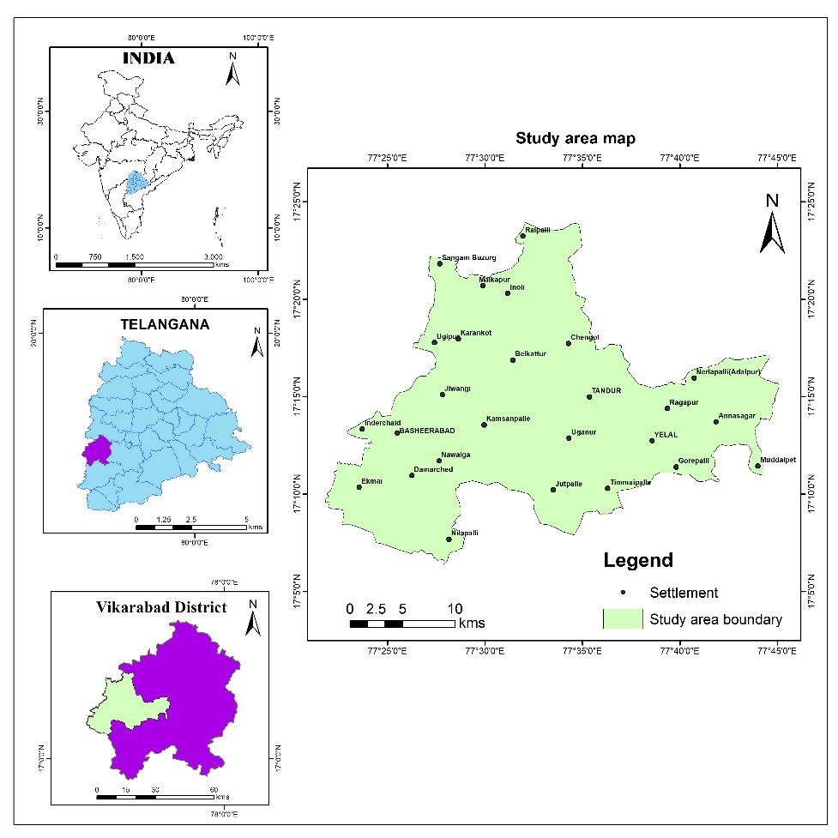

Figure 1. Location map of the study area

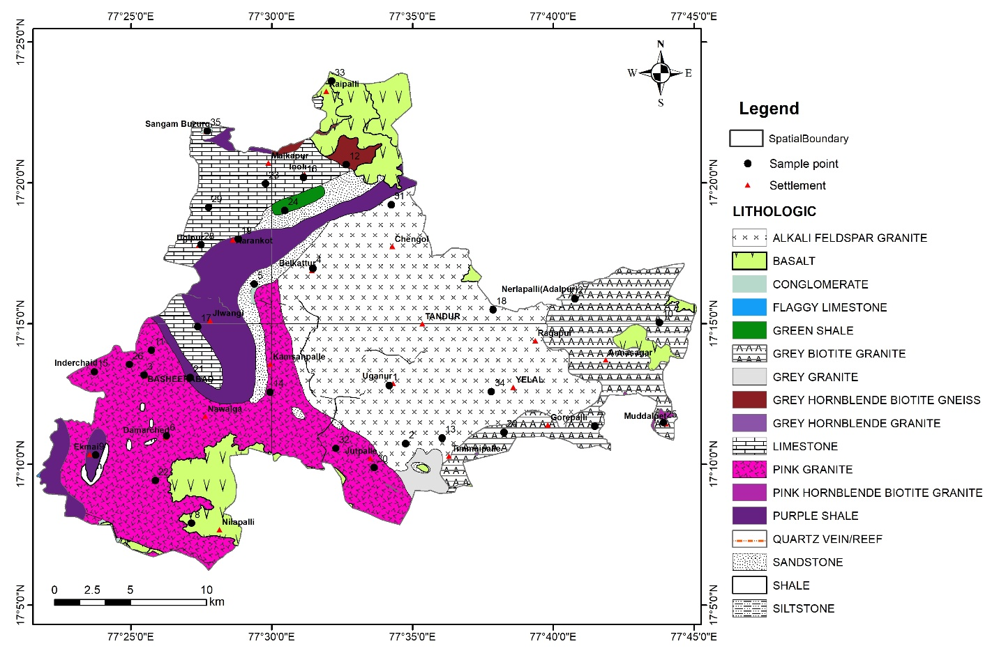
Figure 2. Geology with water samples location

MATERIALS AND METHODS
Sampling of groundwater
Groundwater samples were collected from thirty-five sites study area using prewashed polypropylene narrow-mouth bottles. Samples were collected in the pre and post monsoon seasons subsequently (Figure 2). A fresh water sample is obtained from the bore well or hand pumps after thoroughly rinsing the bottle with the same water multiple times to prevent contamination. The plastic container is then sealed and transported to the laboratory for chemical analysis. Care is taken to prevent hand contact during the filling of the container. Water samples from groundwater were collected in tagged containers, securely packaged, transported directly to the laboratory, and stored at 4°C for subsequent chemical analysis. Blanks and standards were analyzed at the outset of the procedures.
Equipment /instruments
The study utilized various devices to analyze groundwater samples, including conductivity meters (Model 304, Systronics) for measuring electrical conductivity and digital pH meters (Model 802, Systronics) for evaluating pH levels. A numerical method was employed to estimate the total dissolved solids. A Systronics Model 130 flame photometer was employed to measure the concentrations of sodium and potassium. The volumetric analysis of total hardness (TH) and calcium (Ca²⁺) was conducted using conventional EDTA methods. In the titration with standard HCl, phenolphthalein and methyl orange served as acid-base indicators to calculate the concentration of magnesium (Mg²⁺). This concentration was ascertained by determining the difference between total hardness (TH) and the concentrations of Ca²⁺, CO₃²⁻, and HCO₃⁻. The quantity of chloride (Cl⁻) was determined through the titration of standard AgNO₃. Nitrate (NO₃⁻) and sulphate (SO₄²⁻) measurements were conducted using the Spectronics-21 (Model BAUSCH & LOMB). An Orion ion analyzer and a fluoride ion-selective electrode were employed to determine the concentration of fluoride (F⁻). Other chemical variables, excluding pH, were quantified in milligrams per litre (mg/l), whereas electrical conductivity was assessed in micro-siemens per centimetre (µS/cm) at 25ºC. Tables 1a, 1b, and 2 present the analytical results for the pre- and post-monsoon seasons comprehensively.
Analytical chemical procedures
The collected groundwater samples were analysed for various physico-chemical parameters such as pH, Electrical Conductivity (EC), Total Dissolved Solids (TDS), Total Hardness (TH), Calcium (Ca²⁺), Magnesium (Mg²⁺), Sodium (Na⁺), Potassium (K⁺), Carbonate (CO³⁻), Bicarbonate (HCO₃⁻), Chloride (Cl⁻), Sulphate (SO₄²⁻), Nitrate (NO₃⁻) and Fluoride (F⁻) for all physico-chemical parameters using standards methods prescribed by Americal Public Health Association (APHA, 2012). The results obtained were utilized to create graphical representations of the concentrations of various ions in a groundwater sample, employing both the Piper diagram and the Wilcox diagram. The assessment of groundwater quality suitability for irrigation was conducted using the Kelly Ratio (KR), Sodium Adsorption Ratio (SAR), and Residual Sodium Carbonate (RSC).

Table 1a. Chemical parameters and major ions of groundwater samples collected during pre-monsoon season. (EC in µS/cm-1, remaining mg/l, except pH).
S.No | Latitude | Longitude | PH | EC | TDS | TH | Ca²⁺ | Mg²⁺ | Na⁺ | K⁺ | CO₃⁻ | HCO₃⁻ | Cl⁻ | SO₄²⁻ | NO₃⁻ | F⁻
1 | 17.213472 | 77.569389 | 8.37 | 910 | 582 | 165 | 28.1 | 23.1 | 58 | 2.0 | 0 | 30.5 | 184 | 188 | 41.2 | 0.1
2 | 17.179040 | 77.579150 | 7.95 | 180 | 115 | 60 | 18.2 | 3.6 | 24 | 8.0 | 18 | 73.2 | 53 | 47.1 | 30.8 | 0.5
3 | 17.219639 | 77.424278 | 8.09 | 290 | 186 | 265 | 24.1 | 49.9 | 90 | 2.0 | 0 | 48.8 | 234 | 204.4 | 139 | 0.1
4 | 17.282806 | 77.524222 | 9.08 | 1090 | 698 | 225 | 50.1 | 24.3 | 90 | 4.0 | 0 | 42.7 | 372 | 278 | 12.1 | 0.2
5 | 17.273583 | 77.489500 | 7.83 | 560 | 358 | 130 | 39.3 | 7.8 | 30 | 2.0 | 12 | 146.4 | 74 | 44.7 | 44 | 1
6 | 17.183583 | 77.437667 | 6.91 | 540 | 346 | 120 | 36.3 | 7.2 | 80 | 1.0 | 0 | 341.6 | 82 | 48.7 | 39.6 | 2
7 | 17.189389 | 77.691083 | 7.05 | 1600 | 1024 | 210 | 63.5 | 12.5 | 74 | 32.0 | 12 | 219.6 | 287 | 52.7 | 132 | 1
8 | 17.131861 | 77.452361 | 7.10 | 750 | 480 | 200 | 60.5 | 11.9 | 104 | 1.0 | 0 | 256.2 | 128 | 48.2 | 132 | 1
9 | 17.172389 | 77.395694 | 7.12 | 660 | 422 | 190 | 57.5 | 11.3 | 42 | 2.0 | 0 | 219.6 | 106 | 48 | 88 | 0.8
10 | 17.250833 | 77.729389 | 7.70 | 1250 | 800 | 200 | 60.5 | 11.9 | 106 | 12.0 | 18 | 256.2 | 206 | 53.5 | 132 | 1
11 | 17.234333 | 77.428639 | 8.16 | 2200 | 1408 | 160 | 30.1 | 20.7 | 77 | 144.0 | 0 | 109.8 | 209 | 283.4 | 147.4 | 0
12 | 17.344250 | 77.544000 | 8.04 | 1210 | 774 | 225 | 48.1 | 25.5 | 74 | 2.0 | 0 | 48.8 | 248 | 159 | 117 | 0
13 | 17.182470 | 77.600740 | 7.96 | 960 | 614 | 445 | 66.1 | 68.1 | 150 | 101.0 | 8 | 67.1 | 791 | 229.2 | 235 | 0.1
14 | 17.209556 | 77.498944 | 8.16 | 3300 | 2112 | 340 | 116.2 | 12.2 | 177 | 66.0 | 0 | 91.5 | 936 | 479.8 | 55.4 | 0
15 | 17.221556 | 77.394972 | 7.73 | 1130 | 723 | 285 | 82.2 | 19.5 | 111 | 4.0 | 0 | 42.7 | 464 | 140.4 | 250.4 | 0
16 | 17.336667 | 77.518694 | 7.36 | 1150 | 736 | 180 | 54.4 | 10.7 | 88 | 4.0 | 30 | 329.4 | 220 | 51 | 132 | 1
17 | 17.248306 | 77.456139 | 8.32 | 680 | 435 | 140 | 24.1 | 19.5 | 37 | 2.0 | 0 | 42.7 | 78 | 141.4 | 99.4 | 0
18 | 17.258417 | 77.630917 | 7.27 | 1190 | 762 | 300 | 90.7 | 17.9 | 89 | 3.0 | 0 | 231.8 | 259 | 63.7 | 88 | 0.9
19 | 17.300194 | 77.480111 | 8.58 | 840 | 538 | 245 | 58.1 | 24.3 | 58 | 2.0 | 0 | 48.8 | 103 | 249 | 19.5 | 0
20 | 17.185750 | 77.637333 | 7.03 | 1180 | 755 | 200 | 60.5 | 11.9 | 75 | 2.0 | 6 | 195.2 | 110 | 51.5 | 44 | 0.9
21 | 17.218139 | 77.451667 | 8.33 | 350 | 224 | 170 | 26.1 | 25.5 | 9 | 2.0 | 0 | 24.4 | 39 | 106.6 | 39 | 0
22 | 17.157222 | 77.431000 | 8.27 | 1410 | 902 | 175 | 24.1 | 28.0 | 61 | 111.0 | 0 | 67.1 | 284 | 206.1 | 106 | 0
23 | 17.332944 | 77.496222 | 7.57 | 1180 | 755 | 160 | 48.4 | 9.6 | 87 | 126.0 | 24 | 256.2 | 206 | 49.3 | 132 | 0.7
24 | 17.317167 | 77.507583 | 6.86 | 684 | 438 | 300 | 104.0 | 9.7 | 150 | 0.9 | 0 | 183.9 | 0 | 0.3 | 4 | 0
25 | 17.191444 | 77.731722 | 8.49 | 960 | 614 | 375 | 28.1 | 74.2 | 103 | 1.0 | 0 | 61.0 | 39 | 443 | 39.6 | 0
26 | 17.225889 | 77.415694 | 7.83 | 340 | 218 | 215 | 38.1 | 29.2 | 27 | 2.0 | 0 | 30.5 | 209 | 109.3 | 69.1 | 0
27 | 17.264833 | 77.679278 | 7.12 | 1560 | 998 | 280 | 84.7 | 16.7 | 72 | 1.0 | 24 | 158.6 | 330 | 61.1 | 220 | 0.9
28 | 17.296806 | 77.457944 | 7.31 | 990 | 634 | 180 | 54.4 | 10.7 | 115 | 42.0 | 0 | 500.2 | 160 | 68.3 | 88 | 2
29 | 17.318806 | 77.462444 | 7.87 | 620 | 397 | 90 | 27.2 | 5.4 | 112 | 3.0 | 0 | 73.2 | 138 | 45.2 | 26.4 | 5
30 | 17.164910 | 77.560520 | 8.11 | 660 | 422 | 175 | 46.1 | 14.6 | 118 | 2.0 | 0 | 48.8 | 436 | 192.9 | 123.2 | 0.1
31 | 17.320583 | 77.570583 | 7.90 | 890 | 570 | 230 | 44.1 | 29.2 | 30 | 23.0 | 0 | 61.0 | 142 | 211.1 | 16.9 | 0
32 | 17.176250 | 77.537806 | 7.42 | 720 | 461 | 140 | 42.3 | 8.4 | 71 | 1.0 | 18 | 146.4 | 138 | 56.6 | 44 | 0.8
33 | 17.393694 | 77.535250 | 7.46 | 540 | 346 | 130 | 39.3 | 7.8 | 120 | 1.5 | 30 | 85.4 | 1 | 0.7 | 10 | 0.1
34 | 17.209861 | 77.629917 | 8.35 | 430 | 275 | 180 | 42.1 | 18.2 | 37 | 5.0 | 0 | 36.6 | 106 | 196 | 20.6 | 0.1
35 | 17.364250 | 77.461694 | 7.60 | 1030 | 659 | 300 | 90.7 | 17.9 | 74 | 2.0 | 18 | 280.6 | 280 | 53.5 | 39.6 | 2

Table 1b. Chemical parameters and major ions of groundwater samples collected during post-monsoon season. (EC in µS/cm⁻¹, remaining mg/l, except pH).
S.No | Latitude | Longitude | PH | EC | TDS | TH | Ca²⁺ | Mg²⁺ | Na⁺ | K⁺ | CO₃⁻ | HCO₃⁻ | Cl⁻ | SO₄²⁻ | NO₃⁻ | F⁻
1 | 17.213472 | 77.569389 | 8.03 | 960 | 614 | 220 | 56 | 19 | 52 | 4 | 6 | 49 | 177 | 31 | 102.5 | 3.4
2 | 17.179040 | 77.579150 | 7.62 | 750 | 480 | 190 | 57 | 11 | 57 | 7 | 24 | 171 | 135 | 49 | 44.0 | 2.0
3 | 17.219639 | 77.424278 | 7.24 | 1680 | 1075 | 260 | 96 | 5 | 80 | 1 | 15 | 49 | 372 | 66 | 308.4 | 1.6
4 | 17.282806 | 77.524222 | 8.42 | 1090 | 698 | 160 | 24 | 24 | 73 | 5 | 12 | 12 | 223 | 58 | 48.8 | 4.5
5 | 17.273583 | 77.489500 | 7.29 | 1250 | 800 | 130 | 39 | 8 | 116 | 163 | 24 | 268 | 128 | 57 | 88.0 | 3.0
6 | 17.183583 | 77.437667 | 7.09 | 1750 | 1120 | 190 | 57 | 11 | 144 | 68 | 0 | 336 | 365 | 57 | 176.0 | 0.7
7 | 17.189389 | 77.691083 | 7.58 | 650 | 416 | 130 | 39 | 8 | 71 | 4 | 12 | 268 | 67 | 46 | 22.0 | 0.8
8 | 17.131861 | 77.452361 | 6.8 | 620 | 397 | 120 | 36 | 7 | 119 | 1 | 0 | 293 | 71 | 49 | 88.0 | 1.0
9 | 17.172389 | 77.395694 | 7.02 | 680 | 435 | 120 | 36 | 7 | 40 | 2 | 0 | 293 | 121 | 58 | 44.0 | 5.0
10 | 17.250833 | 77.729389 | 7.23 | 1050 | 672 | 190 | 57 | 11 | 78 | 7 | 18 | 220 | 227 | 57 | 44.0 | 0.7
11 | 17.234333 | 77.428639 | 7.45 | 1150 | 736 | 220 | 52 | 22 | 61 | 133 | 6 | 49 | 216 | 33 | 165.9 | 1.9
12 | 17.344250 | 77.544000 | 7.42 | 810 | 518 | 170 | 51 | 10 | 55 | 2 | 18 | 305 | 163 | 53 | 88.0 | 1.0
13 | 17.182470 | 77.600740 | 7.78 | 740 | 474 | 160 | 48 | 10 | 47 | 10 | 18 | 232 | 99 | 56 | 44.0 | 2.0
14 | 17.209556 | 77.498944 | 7.9 | 1550 | 992 | 200 | 44 | 22 | 111 | 97 | 12 | 110 | 326 | 68 | 88.4 | 1.6
15 | 17.221556 | 77.394972 | 6.9 | 1000 | 640 | 490 | 156 | 24 | 101 | 7 | 12 | 67 | 762 | 92 | 514.8 | 1.3
16 | 17.336667 | 77.518694 | 7.29 | 1140 | 730 | 190 | 57 | 11 | 93 | 5 | 30 | 183 | 124 | 60 | 88.0 | 1.0
17 | 17.248306 | 77.456139 | 7.47 | 660 | 422 | 160 | 60 | 2 | 34 | 2 | 6 | 24 | 78 | 60 | 156.6 | 0.9
18 | 17.258417 | 77.630917 | 7.56 | 740 | 474 | 180 | 54 | 11 | 94 | 5 | 12 | 171 | 124 | 51 | 44.0 | 0.8
19 | 17.300194 | 77.480111 | 7.6 | 1050 | 672 | 200 | 72 | 5 | 48 | 1 | 18 | 49 | 238 | 56 | 52.8 | 0.8
20 | 17.185750 | 77.637333 | 7.55 | 560 | 358 | 120 | 36 | 7 | 71 | 2 | 18 | 207 | 124 | 46 | 35.2 | 1.0
21 | 17.218139 | 77.451667 | 7.6 | 470 | 301 | 140 | 48 | 5 | 10 | 1 | 12 | 24 | 35 | 46 | 78.3 | 0.8
22 | 17.157222 | 77.431000 | 7.39 | 540 | 346 | 100 | 30 | 6 | 95 | 1 | 30 | 153 | 53 | 67 | 88.0 | 2.0
23 | 17.332944 | 77.496222 | 7.76 | 390 | 250 | 110 | 33 | 7 | 58 | 4 | 30 | 134 | 92 | 56 | 39.6 | 1.0
24 | 17.317167 | 77.507583 | 7.58 | 580 | 371 | 170 | 51 | 10 | 46 | 3 | 12 | 122 | 64 | 56 | 35.2 | 2.0
25 | 17.191444 | 77.731722 | 7.24 | 1300 | 832 | 210 | 64 | 13 | 127 | 2 | 18 | 305 | 273 | 61 | 88.0 | 1.0
26 | 17.225889 | 77.415694 | 7.3 | 980 | 627 | 200 | 64 | 10 | 23 | 2 | 18 | 12 | 230 | 58 | 137.3 | 1.3
27 | 17.264833 | 77.679278 | 7.52 | 890 | 570 | 160 | 48 | 10 | 78 | 3 | 6 | 232 | 128 | 57 | 44.0 | 0.7
28 | 17.296806 | 77.457944 | 7.58 | 460 | 294 | 130 | 39 | 8 | 37 | 5 | 30 | 134 | 99 | 71 | 30.8 | 0.6
29 | 17.318806 | 77.462444 | 7.98 | 250 | 160 | 80 | 24 | 5 | 81 | 4 | 18 | 85 | 43 | 63 | 44.0 | 2.0
30 | 17.164910 | 77.560520 | 7.42 | 890 | 570 | 170 | 51 | 10 | 81 | 3 | 18 | 305 | 167 | 52 | 44.0 | 0.7
31 | 17.320583 | 77.570583 | 7.52 | 720 | 461 | 140 | 42 | 8 | 38 | 3 | 6 | 171 | 113 | 45 | 44.0 | 1.0
32 | 17.176250 | 77.537806 | 6.8 | 1190 | 762 | 200 | 60 | 12 | 133 | 2 | 0 | 305 | 156 | 58 | 220.0 | 2.0
33 | 17.393694 | 77.535250 | 7.56 | 800 | 512 | 160 | 48 | 10 | 79 | 2 | 0 | 256 | 124 | 51 | 132.0 | 0.9
34 | 17.209861 | 77.629917 | 7.51 | 1020 | 653 | 180 | 54 | 11 | 100 | 3 | 18 | 329 | 167 | 77 | 44.0 | 2.0
35 | 17.364250 | 77.461694 | 7.25 | 1570 | 1005 | 290 | 88 | 17 | 139 | 84 | 18 | 268 | 245 | 58 | 176.0 | 0.9

Table 2. The summary of the physical and chemical variables and ions in the groundwater samples collected during pre-and post-monsoon seasons.
Variables | Pre-monsoon season |  |  |  |  | Post-monsoon season |  |  |  | WHO (2011) acceptable limit
Variables | Min | Max | Mean | % of samples exceeded the limits |  | Min | Max | Mean | % of samples exceeded the limits | WHO (2011) acceptable limit
pH | 6.86 | 9.08 | 7.78 | 6 |  | 6.8 | 8.42 | 7.46 | Nil | 6.5 - 8.5
EC (µS/cm⁻¹) | 180 | 3300 | 972.4 | 11 |  | 250 | 1750 | 912.29 | 11 | 1500
TDS (mg/L⁻¹) | 115.2 | 2112 | 622.34 | 57 |  | 160 | 1120 | 583.86 | 57 | 500
TH as CaCO₃ (mg/L⁻¹) | 60 | 445 | 211 | - |  | 80 | 490 | 178.29 | - | -
Ca²⁺ (mg/L⁻¹) | 18.15 | 116.23 | 51.66 | 17 |  | 24.05 | 156.31 | 53.72 | 9 | 75
Mg ²⁺ (mg/L⁻¹) | 3.58 | 74.18 | 19.97 | 6 |  | 2.43 | 24.32 | 10.76 | Nil | 50
CO₃⁻ (mg/L⁻¹) | 0 | 30.05 | 6.24 | - |  | 0 | 30.05 | 14.17 | - | -
HCO₃⁻ (mg/L⁻¹) | 24.4 | 500.2 | 138.76 | 3 |  | 12.2 | 335.5 | 176.9 | Nil | 500
Na⁺ (mg/L⁻¹) | 9 | 177 | 80.57 | 6 |  | 10 | 144 | 76.29 | Nil | 200
K⁺ (mg/L⁻¹) | 0.9 | 144 | 20.55 | 23 |  | 1 | 163 | 19 | 14 | 12
F⁻ (mg/L⁻¹) | 0.01 | 5 | 0.64 | 11 |  | 0.6 | 5 | 1.54 | 40 | 1.5
NO₃⁻ (mg/L⁻¹) | 4.04 | 250.36 | 84.5 | 54 |  | 22 | 514.8 | 99.68 | 57 | 45
SO₄²⁻ (mg/L⁻¹) | 8.25 | 479.82 | 134.98 | 11 |  | 31.48 | 92.27 | 56.58 | Nil | 250
Cl⁻ (mg/L⁻¹) | 10 | 935.88 | 220.58 | 29 |  | 35.45 | 762.18 | 175.12 | 14 | 250
*WHO: World Health Organization, Min: Minimum & Max: Maximum
Sources and Spatial Variation of Major Contaminants
Elevated nitrate concentrations in select samples are likely associated with intensive agricultural practices and unregulated use of nitrogenous fertilizers. Fluoride enrichment may be linked to prolonged groundwater residence time and interaction with fluoride-bearing accessory minerals within the limestone and associated shale units. Higher chloride levels near mining and settlement zones suggest localized anthropogenic influence rather than regional saline intrusion.
RESULTS AND DISCUSSION
Tables 1a, 1b, and 2 present various physico-chemical parameters obtained through the examination of water samples from the study area.
Chemical characteristics of groundwater
pH: A quantitative assessment of the acidity or alkalinity of a solution. The pH of a fluid quantifies its hydrogen ion (H+) concentration in comparison to a standard solution. The pH scale spans from 0 to 14, with 0 indicating acidity, 14 representing basicity, and 7 denoting neutrality. Pre and post monsoon seasons, respectively, saw the pH of the groundwater in the research area fluctuate between 6.86 & 9.08 with an average of 7.78 and 6.80 to 8.42 with an average of 7.46. According to WHO (2011), the pH range for drinking water is 6.5 to 8.5, hence the groundwater samples from the study location are a little on the alkaline side. The centre part of the research region has a high concentration of pH in both the pre & post monsoon seasons.
Electrical Conductivity (EC): The electrical conductivity (EC) quantifies a material's capacity to conduct electric current; thus, a higher EC signifies increased salt concentration in groundwater. Electrical conductivity is quantified in Siemens per meter (S/m). The research region experiences EC during the pre & post monsoon seasons that ranges from 180 to 3300 µS/cm with an average of 972 µS/cm and from 250 to 1750 µS/cm with an average of 912.29 µS/cm (Table 1a & 1b). In pre and post monsoon seasons, 11% & 11% of samples, respectively, exceeded most recommended limits (WHO, 2011) of EC in drinking water, which are set at 1500 µS/cm (Table 2). Pre-monsoon season spatial distribution of EC indicates a high concentration in the southern part of the study region, and post-monsoon season spatial distribution of EC shows a high concentration in the southern, north, and western parts of the study area.
Total Dissolved Solids (TDS): The concentration of TDS is ranging from the pre monsoon season, the TDS concentration ranges from 115.20 to 2112 mg/L with a mean value of 622.34 mg/L, while in the post monsoon season, it ranges from 160 to 1120 with an average of 583.86 mg/L (Table 1a & 1b). Based on TDS classification, 91.42% and 91.42% suitable for fresh drinking and irrigation purpose respectively. The pre & post monsoon seasons in the research area have high TDS levels that range from 2112 to 1120 mg/L. The presence of high TDS is caused by anthropogenic sources like home sewage, septic tanks, and agricultural activities. The highest acceptable level for standards TDS is 500 mg/L, according to the WHO (2011). sentence seem incomplete.
Total Hardness (TH as CaCO₃): The combined presence of Ca2+ and Mg2+ ions determines overall hardness, expressed as CaCO₃, and quantified in milligrams per liter (mg/l) or parts per million (ppm). The total hardness of water samples ranged from ranged from 60 to 445 mg/L on average of 211 mg/L and from 80 to 490 mg/L on average of 178.29 mg/L in the pre- and post-monsoon seasons, respectively, tables 1a, 1b. The concentration of TH increases in the topographic low regions, particularly during the post-monsoon period. Total hardness distribution generally aligns with trends observed in total dissolved solids. The study indicates that there are no 'soft' groundwaters in the area, with hard to very hard groundwater being predominant in both seasons.
Calcium (Ca²⁺) and magnesium (Mg²⁺): WHO (2011) reports that the average concentration of Ca2+ in water samples collected before and after the monsoon season is 51.66 mg/l and 53.77 mg/l, respectively. The upper limit for calcium consumption is 75 mg/l. Mg2+ concentrations in groundwater samples are higher during the pre-monsoon period, with a mean of 19.97 mg/l, and lower during the post-monsoon period, with a mean of 10.76 mg/l (Table 2). According to WHO (2011) water specifications, the maximum allowable Mg2+ concentration is 50 mg/l. Magnesium exhibits cation-exchange behavior that is also comparable to calcium's. Clay minerals and other surfaces with exchangeable sites strongly adsorb these ions.
Sodium (Na⁺) and potassium (K⁺): Sodium is a critical factor in determining the suitability of water for irrigation purposes. The primary source of sodium in natural water is the dissolution of soluble compounds resulting from the weathering of sodic feldspars. The regular application of irrigated water can elevate soil salinity, leading to reduced permeability and altered texture, ultimately making the soil unfit for agricultural purposes (Trivedy and Goel, 1984). The sodium concentrations in the study region range from 9 to 177 mg/l during the pre-monsoon and from 10 to144 mg/l in the post-monsoon, as indicated in Tables 1a, 1b, and 2. Samples from the pre-monsoon season also within the limit, at sample 14 near the Gottiga kurdu village has a high concentration observed and post-monsoon seasons are deemed safe for consumption, as sodium levels do not exceed the recommended limit of 200 mg/l (WHO, 2011). Ionic potassium (K+) is found in relatively low concentrations in groundwater, originating from the weathering of stable minerals such as orthoclase, microcline feldspars, and biotite present in the region's granites (Satish Kumar et al., 2007). During the pre- and post-monsoon seasons, potassium concentrations 0.90 to144 mg/L with an average of 20.55mg/L and from 1 to163 mg/L with an average of 18.51 mg/L respectively (Tables 1a, 1b, and 2). The permissible limit for calcium is 12 mg/l (WHO, 2011). The regions are primarily characterized by the weathering of orthoclase, microcline, and biotite minerals, which predominantly make up the granitic host rock in the study area.
Carbonate (CO₃⁻²) and Bi-carbonate (HCO₃⁻): The solubility of CO2 in the hydrosphere, lithosphere, and atmosphere-stemming from sources such as the soil zone, dissolution of carbonate rocks, and organic matter degradation results in the presence of dissolved carbonate species in various water types. During the pre- and post-monsoon seasons, carbonate values range from 0 and 30.05 mg/L with an average of 6.24 mg/L and 0 to 30.05 mg/L with an average of 14.17 mg/L (Tables 1a, 1b, and 2).
The organic matter in the aquifer, upon oxidation, generates carbon dioxide and facilitates mineral dissolution, representing a potential source of bicarbonate (Khashogji and El Maghra, 2013). The bicarbonate concentration in the groundwaters of the research region varies from 24.40 and 500.20 mg/L with an average of 138.76 mg/L and 12.20 and 335.50 mg/L with an average of 176.90 mg/L during the pre- and post-monsoon seasons (Tables 1a, 1b, and 2). Groundwater contains calcium, magnesium, and bicarbonate ions. Bicarbonate ions may result from the weathering of silicate minerals (Gastmans et al., 2010). The WHO standards stipulate that the permissible limit for total alkalinity in drinking water is 500 mg/l. Pre-monsoon season high carbonate and bi-carbonate values are seen in Inelli and Oggipur mine quarry area, while post monsoon season high values are shown in spatial distribution maps at sample no. 16, 23 and 28 all samples area geology is limestone, N and SW part of study area and bi-carbonates are observed in south east and south western part of the study area high at Damerched village near limestone mining.
Chloride (Cl⁻): The maximum allowable concentration of Cl⁻ is 250 mg/l (WHO, 2011). Chloride levels in groundwater samples during the pre- and post-monsoon seasons range from 0.17 and 935.88 mg/l and 35.45 and 762.18 mg/l, respectively (Tables 1a and 1b). During the pre-monsoon and post-monsoon seasons, elevated chloride concentrations were observed in approximately 29% and 14% of the samples, respectively (Table 2). The vagus/river environment significantly impacts the aquifer system, with the highest chloride concentrations recorded during the pre- and post-monsoon seasons at Gottiga kurdu and Inderchaid village (Sample no. 14, Sample no. 15). 250 mg/L is the ideal level of chloride for drinking purposes. The geographic distribution of the highest chloride content found at Gottiga kurdu village area (sample no.14) during the Pre monsoon season. The post monsoon season's high chloride content at Inderchaid village (sample no.15), which is due to the study area receiving less rainfall during the study season, is explained by this.
Sulphate (SO₄²⁻): The average sulphate levels in groundwater during the pre- and post-monsoon seasons varied: 8.25 to 479.82 mg/l with a mean of 134.98 mg/l for the pre-monsoon and 31.48 to 92.27 mg/L with an average of 56.58 mg/L for the post-monsoon (Table 2). 250 mg/L of sulphate is the ideal level for drinking purposes (WHO, 2011). In the pre monsoon sulphate concentration in the research area's 11% of groundwater samples exceeded limit and the post monsoon season sample were within the permitted limits. Sulphate concentrations result from the decomposition of organic materials in the topsoil and the water-leachable sulphate present in fertilizers used by farmers.
Nitrate (NO₃⁻): Tables 1a and 1b indicate that nitrate levels in pre-monsoon season samples vary from 4.04 to 250.36 mg/L with a mean value 84.50 mg/L, while post-monsoon season samples range from 22 to 514.80 mg/L with mean value of 99.68% mg/l. The maximum allowable concentration of NO3− is 45 mg/l (WHO, 2011). In the both pre and post monsoon seasons about 54% and 57% of groundwater samples from the research area have nitrate concentrations that are greater than the maximum tolerance limit of 45 mg/L advised by the (WHO, 2011). Both before and after the monsoon, a high concentration of nitrate is seen near Inderchaid village (sample no.15). In the both seasons. The primary causes are unhygienic conditions and the excessive application of fertilizers in the research area to enhance crop yields.
Fluoride (F⁻): Fluoride concentrations range from 0.01 to 5.0 mg/L a median of 0.64 mg/L, as well as 0.60 to 5.0 mg/L a median of 1.54 mg/L in both seasons. The max fluoride level was found at Oggipur Mine (sample no. 29) in pre monsoon season and in the post monsoon season highest value found at Ekmai village near temple (sample no. 9). During the pre-monsoon and post-monsoon seasons. The maximum permissible concentration of fluoride in groundwater is 1.5 mg/l (WHO, 2011). During pre- post monsoon seasons 11% and 40% of samples are exceeded permissible limit. The concentration of F- in the study area is primarily influenced by geogenic sources such as apatite, biotite, and clays, as well as anthropogenic sources including chemical fertilizers. Additionally, a higher evaporation rate and prolonged interaction of water with aquifer materials in an alkaline environment contribute to this concentration (Subba Rao, 2009a). Exceeding this amount leads to fluorosis (Satyanarayana et al., 2017). Fluoride leaching from parent minerals in rocks and soils is affected by several factors, including significant weathering, accessibility to circulating water from extensive irrigation, a semi-arid climate, and prolonged groundwater residence time in the aquifer (Wodeyar and Sreenivasan, 1996). Fluoride release into groundwater during rock-water interaction was enhanced by elevated sodium levels and reduced calcium concentrations (Narsimha and Sudarshan, 2017).

Influence of Limestone Lithology on Groundwater Chemistry
The dominance of Ca²⁺, Mg²⁺, and HCO₃⁻ ions in groundwater samples indicates strong control of limestone dissolution on groundwater chemistry. The Tandur Limestone, composed predominantly of calcite and dolomite, contributes Ca–Mg–HCO₃ type water through carbonate weathering reactions. Elevated bicarbonate concentrations observed during the post-monsoon period suggest enhanced water–rock interaction due to increased recharge and prolonged residence time within the fractured limestone aquifer.
Higher hardness values and alkaline pH further support the influence of carbonate lithology. Spatial variations in Ca²⁺ and Mg²⁺ concentrations may also reflect differential mining intensity, fracture density, and aquifer exposure across the study area.
Hydrogeochemical facies
This study classified groundwater samples hydrochemically by analyzing major cations and anions through the conventional Piper trilinear diagram (1944) to assess variations in hydrochemical facies. Piper diagram analysis reveals that groundwater samples predominantly fall within the Ca–Mg–HCO₃ and mixed Ca–Mg–Cl facies, indicating carbonate dissolution as the primary geochemical process, with secondary influence from anthropogenic inputs. The shift toward chloride-rich facies in certain locations may be attributed to agricultural return flow, domestic wastewater infiltration, or evaporative concentration during the pre-monsoon period.
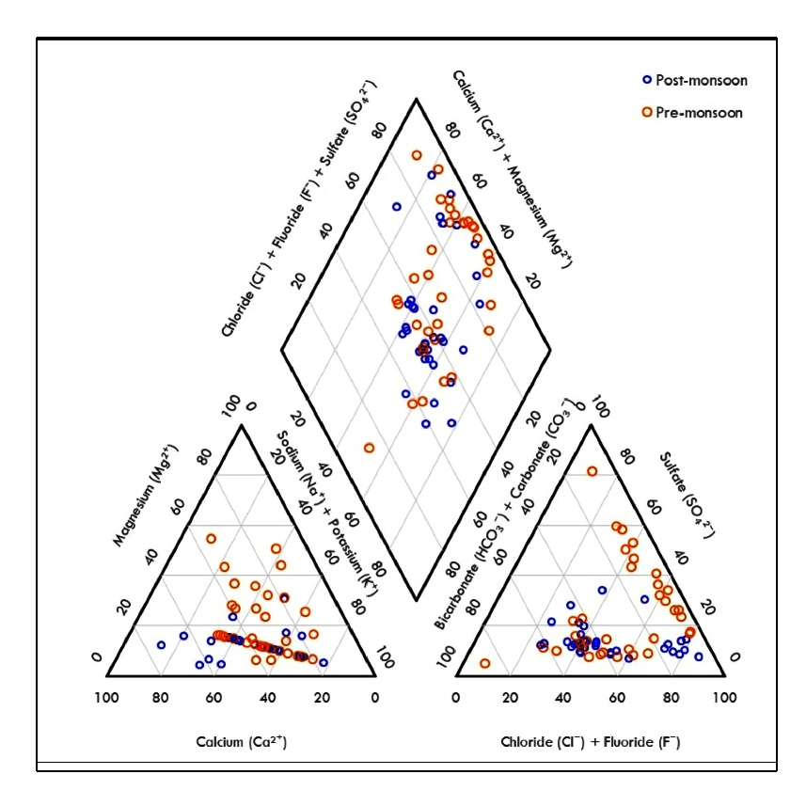

Figure 3. Comparison map of pre-and post-monsoon season's hydrochemical
facies classification of groundwater from the study area

Irrigation purpose
By reducing the osmotic pressure in the structural cells of the plant, high amounts of dissolved ions in irrigation water have a physical and chemical impact on agricultural soil and plants (Thorne and Peterson, 1954). This lowers agricultural yield by keeping water from getting to the leaves and branches.
Kelly Ratio (KR): Kelly's Ratio (KR), which compares salt concentration to calcium and magnesium levels, serves as an important metric for evaluating irrigation water quality (Kelley, 1957). A high sodium concentration in water generally modifies soil permeability and other characteristics, indicating an alkali hazard (Wagh et al., 2016). A reduced calcium content in water leads to soil dispersion, consequently decreasing the infiltration rate (Gowrisankar et al., 2017). The Kelly criterion can be represented by the subsequent equation.
KR= Na⁺ / Ca²⁺ + Mg²⁺ ………... (1)
Irrigation is considered acceptable when KR is less than 1, while a KR greater than 1 signifies an excess of salt in the water, rendering it unsuitable for irrigation. The Kelly’s Ratio (KR) values for both seasons show significant variation, ranging from 0.12–2.71 (pre-monsoon) and 0.16–2.20 (post-monsoon). Since a KR value > 1 indicates unsuitability of groundwater for irrigation, it is evident that: During the pre-monsoon season, some samples exceed the safe limit, reflecting higher sodium hazard and possible accumulation of salts due to evaporation or limited recharge. In the post-monsoon season, although the average KR is slightly higher (1.01) than in pre-monsoon (0.89), the maximum value is lower, suggesting reduced severity in the worst-affected areas, likely due to dilution from monsoonal recharge. (Table 3).
Table 3. Kelly’s ratio (in meq/l) and Suitability classification of groundwater for irrigation purposes in the study area
Parameter | Pre-monsoon | Post-monsoon
Minimum KR | 0.12 | 0.16
Maximum KR | 2.71 | 2.2
Average KR | 0.89 | 1.01
% Suitable (KR < 1) | 62.86% | 48.57%
% Marginal (1 ≤ KR ≤ 2) | 31.43% | 42.86%
% Unsuitable (KR > 2) | 5.71% | 0.00%

Sodium Adsorption Ratio (SAR): The specific adsorption ratio of the samples ranges from 0.30 to 5.13 meq/l, during the pre-monsoon season, and from 0.37 to 4.72 meq/l, in the post-monsoon season, respectively. The values during both pre- and post-monsoon seasons range well below 10, with averages of 2.45 and 2.55 respectively. According to standard irrigation water classification, 100% of the samples fall in the “Excellent” category (SAR < 10) (Table 4). This indicates that the groundwater is highly suitable for irrigation across both seasons and can be safely used for all types of crops and soils, except those that are highly sensitive to sodium.
Table 4. Sodium Adsorption Ratio (SAR) (in meq/l) and Groundwater Quality Assessment Based on Richards Classification (1954)
SAR Parameter | Pre-monsoon | Post-monsoon
Minimum | 0.3 | 0.37
Maximum | 5.13 | 4.72
Average | 2.45 | 2.55
% in Excellent Category | 100% | 100%

The Wilcox (1955) classification indicates that in the study area 51.42%, 37.14%, 5.7%, 2.85% and 2.85% respectively, of the 35 pre monsoon groundwater samples from the study region fell into the high salinity low Na (C3S1), medium salinity low Na (C2S1), low salinity low Na (C1S1), very high salinity medium Na (C4S2) and very high salinity low sodium (C4S1) classifications. Samples from the (C3S1) field pose low risk to exchangeable sodium and are safe for irrigation on practically all types of soil. Coming to post monsoon season 60% and 40% of groundwater samples from the study region fell into the high salinity low Na (C3S1) and medium salinity low Na (C2S1) respectively.

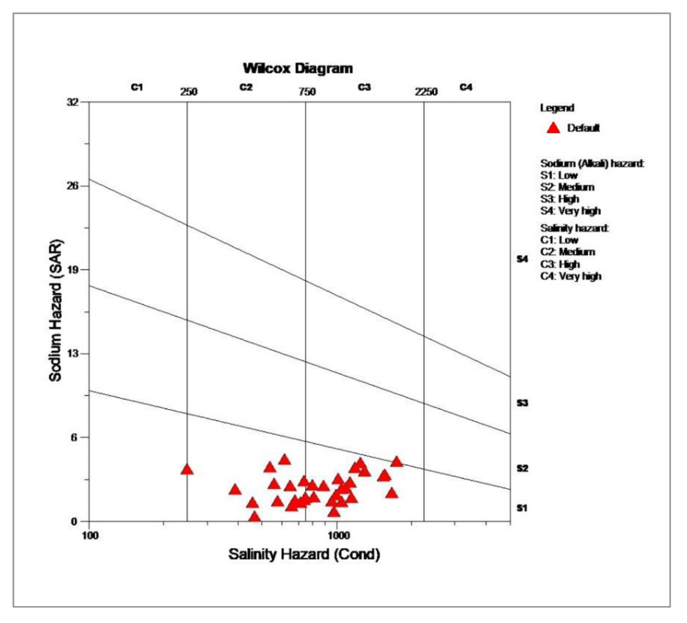
Figure 4. Wilcox diagram for the groundwater of study area in the
pre-monsoon season.

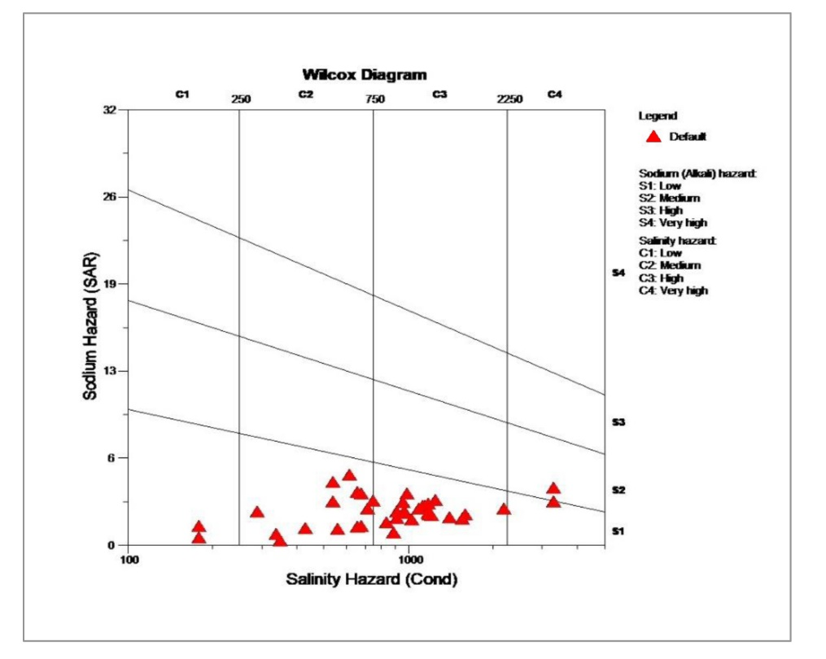
Figure 5. Wilcox diagram for the groundwater of study area in the
post-monsoon season
Residual Sodium Carbonate (RSC): Excessive precipitation or the dissolution of alkaline earth carbonates modifies the concentrations of calcium and magnesium, thereby affecting the soil's SAR content. Carbonate deposition in groundwater occurs at a higher intensity. Groundwater with elevated bicarbonate levels and a partial pressure of CO₂ exists in equilibrium; however, upon extraction and exposure to the atmosphere, CO₂ is released, leading to the formation of calcium and magnesium carbonate deposits (Eaton, 1950). Calcium and magnesium ions precipitate as carbonate during this process, and the residual sodium carbonate (RSC) can be calculated using the provided equation. Milliequivalents per liter (meq/l) is utilized to denote all concentrations (Eaton, 1950).
$RSC = {(CO}_{3}^{2-} + {HCO}_{3 }^{-}) + ({Ca}^{2+} + {Mg}^{2+})$ ………………….……… (2)
Table 5 categorizes RSC as unsuitable if its value exceeds 2.50 meq/l, slightly suitable if it ranges from 1.25 to 2.50 meq/l, and marginally suitable if it is below 2.50 meq/l. The Residual Sodium Carbonate (RSC) values indicate that the average RSC in both seasons is negative, indicating that carbonate and bicarbonate levels are not a concern for most samples. Pre-monsoon season shows 88% of samples as suitable, with only 8.57% falling into the unsuitable category, likely due to localized carbonate accumulation. Post-monsoon season shows improved conditions, with a higher percentage of marginally suitable samples (28.57%) but only 2.85% as unsuitable. Overall, RSC values indicate good irrigation water quality in both seasons, with slight improvement post-monsoon due to dilution by rainwater and enhanced groundwater recharge. Field studies examining the distribution of alkali white patches and soil penetrability offer substantial evidence for this phenomenon. Consequently, the application of high-residue sodium carbonate waters affects crop productivity.
Table 5. Residual Sodium Carbonate (in meq/l) and Classification in study area
RSC Range / Classification | Criteria / Unit | Pre-monsoon | Post-monsoon
Minimum RSC | - | -7.53 | -8.3
Maximum RSC | - | 4.6 | 2.6
Average RSC | - | -1.74 | -0.19
% Suitable | RSC < 1.25 | 88.00% | 68.57%
% Marginally Suitable | 1.25 ≤ RSC ≤ 2.5 | 2.85% | 28.57%
% Unsuitable | RSC > 2.5 | 8.57% | 2.85%

Water quality management
Managing water quality is associated with the broader concept of managing water resources for optimal and efficient human utilization. It is essential to manage and utilize water resources in a manner that safeguards their quality for current and future users. This is the basis of effective water management. Implementing water management practices like rainwater harvesting can effectively reduce the concentrations of TDS, TH, Mg²⁺, Cl⁻, NO₃⁻, and F⁻ for industrial, agricultural, and drinking purposes. The objective of rainwater harvesting is to gather runoff at suitable locations, taking into account the specific field conditions of topography, soil cover, drainage, geomorphology, geology, lineaments, and land use/cover. These factors facilitate the identification of appropriate locations to enhance groundwater conditions. Lowering the concentrations of F⁻ ions can improve water quality through processes such as water softening and defluoridation. Development of additional subsurface drainage conditions, deep farming techniques, reclamation, leaching, and the use of drip or sprinkler irrigation are significant agricultural practices that enhance soil texture and manage soil and water salinity, thereby facilitating more efficient irrigation. A campaign is necessary to inform the public about the negative effects of low water quality on industry, agriculture, and human health (Subba Rao et al., 2012). Water quality management events are essential for achieving sustainable growth. To improve water quality, it is essential for policymakers, planners, and administrators to take responsibility for implementing suitable site-specific actions.
Regional Implications for Groundwater Management
The Tandur Limestone aquifer forms an important component of the Bhima basin groundwater system, supporting domestic, agricultural, and industrial water demands. Given Telangana’s increasing dependence on groundwater and ongoing initiatives such as Mission Bhagiratha, understanding localized hydrogeochemical controls is essential for sustainable groundwater management in mining-affected regions.

CONCLUSIONS
The present study demonstrates that groundwater quality in the Tandur Limestone area is primarily controlled by carbonate weathering processes, with localized anthropogenic influences from mining and agriculture. While most groundwater samples are suitable for drinking and irrigation, elevated concentrations of nitrate, fluoride, and chloride in certain locations raise concerns regarding long-term groundwater sustainability. Seasonal variations highlight the role of recharge and water–rock interaction in governing groundwater chemistry. The findings underscore the need for continuous groundwater monitoring, regulation of mining activities, and identification of suitable recharge zones to ensure sustainable use of groundwater resources in the Tandur limestone belt.

REFERENCES
Adimalla, N. (2019) Groundwater quality for drinking and irrigation purposes and potential health risks assessment: a case study from semiarid region of south India. Expo Health 11:109 123.
Adimalla, N., Li, P., Qian, H. (2018b) Evaluation of groundwater contamination for fluoride and nitrate in semi-arid region of Nirmal Province, South India: a special emphasis on human health risk assessment (HHRA). Human and Ecological Risk Assessment: An International Journal. https://doi.org/10.1080/10807039.2018.1460579.
Adimalla N, Venkatayogi S (2017) Mechanism of fluoride enrichment in groundwater of hard rock aquifers in Medak, Telangana state, South India. Environ Earth Sci 76:45. https://doi.org/10.1007/s12665-016-6362-2.
Adimalla N, Venkatayogi S (2018) Geochemical characterization and evaluation of groundwater suitability for domestic and agricultural utility in semi-arid region of Basara, Telangana state, South India. Appl Water Sci 8:44. https://doi.org/10.1007/s13201-018-0682-1.
Adimalla, N., Vasa, S.K. and Li, P., (2018). Evaluation of groundwater quality, Peddavagu in Central Telangana (PCT), South India: an insight of controlling factors of fluoride enrichment. Modeling Earth Systems and Environment, 4, pp.841-852.
APHA, (2012). Standard Methods for the Examination of Water and Waste Water. 22nd Edition, American Public Health Association, American Water Works Association, Water Environment Federation.
Back, W. and Hanshaw, B.B., (1965). Chemical geohydrology. In Advances in hydroscience (Vol. 2, pp. 49-109). Elsevier.
Blessy Ganduri, Uday Laxmi, G. and Vidyasagarachary, D. 2019. Deleterious Concentrations of Heavy Metals in Ground Water Along River Musi, Telangana State, India. Int. J. of Geology & Earth Sci. 5 (2):146-58.
Blessy Ganduri, Udaya Laxmi G., Vidyasagarachary D, Ramdass G (2020). Assesing contaminant migration in groundwater near musi river, Telangana state, India. Eminternational (Poll Res. 39 (3): 733-738.
Eaton, E. M., (1950). Significance of carbonates in irrigation waters. Soil Sci., 69, 123-133.
Gastmans D, Chang HK, Hutcheon I (2010). Groundwater geochemical evolution in the northern portion of the guarani aquifer system (Brazil) and its relationship to diagenetic features. Appl Geochem 25:16–33.
Gowrisankar, G., Jagadeshan, G. and Elango, L., (2017). Managed aquifer recharge by a check dam to improve the quality of fluoride-rich groundwater: a case study from southern India, Env. Moni. Asses., 189, 200.
Islam, M.S., (2023). Hydrogeochemical Evaluation and Groundwater Quality. Springer.
Karanth K. R., 1987. Groundwater assessment, Development and management, Tata- McGraw Hill Publishing Company Limited, New Delhi, p.720.
Karunanidhi, D., Aravinthasamy, P., Subramani, T., Wu, J., & Srinivasamoorthy, K. (2020). Potential Health Risk Assessment for Fluoride and Nitrate Contamination in Hard Rock Aquifers of Shanmuganadhi River basin, South India. Human Ecological Risk Assessment, 25, 250–270.
Kelly, W. P., (1957). Adsorbed sodium cation exchange capacity and percentage sodium sorption in alkali soils. Science., 84, 473–477.
Khashogji MS and El Maghraby MMS (2013). Evaluation of groundwater resources for drinking and agricultural purposes, Abar Al Mashi area, south Al Madinah Al Munawarah City, Saudi Arabia. Arab J Geosci 6(10):3929–3942.
McCarthy, M. F. (2004). Should we restrict chloride rather than sodium? Medical Hypothesis, 63, 138–148.
Mukherjee, R. and Ramachandran, A.V., (2021). A Combination of Melatonin and Alpha Lipoic Acid Abrogates Chromium-Induced Cardiac Oxidative Damage. Asian Journal of Research in Cardiovascular Diseases, 3(1), 28-43.
Muthusamy, K., Gopalakrishnan, S., Ravi, T.K., Sivachidambaram, P. 2008. Biosurfactants: properties, commercial production and application. Current science, 736-747.
Narsimha A, and Sudarshan V (2018). Drinking water pollution with respective of luoride in the semi-arid region of Basara, Nirmal district, Telangana State, India. Data in Brief 16:752–757. https ://doi. org/10.1016/j.dib.2017.11.087
Narsimha, A. and Sudarshan, V., 2017. Assessment of fluoride contamination in groundwater from Basara, Adilabad district, Telangana state, India. Applied Water Science, 7, pp.2717-2725.
Piper, A. M., (1944). A graphical procedure in the geochemical interpretation of water analysis. Trans. Am. Geophys. Union., 25,914–928.
Raja Reddy, D. (1979). Hand book of neurology. Amsterdam: North Holland Publishing Company. 465 p.
Richards, L.A. (Ed) (1954) Hand. U.S. Dep. Agric. 60
Satish Kumar T., Sudarshan V. and Kalpana G., (2007). Geochemical characterization of ground water, banks of Musi River, Hyderabad city, Andhra Pradesh, India. Poll. Res. Vol.26, No.4, pp.795-800.
Satyanarayana, G., Ramadasu, P., Devi, P.P. and Rao, G.N., (2017). Ground water quality Assessment in Uddanam region, Costal Srikakulam, Andhra pradesh, India. International Journal of Pharmaceutics and Drug Analysis, pp.116-128.
Sharma, S. and Bhattacharya, A.J.A.W.S., (2017). Drinking water contamination and treatment techniques. Applied water science, 7(3), pp.1043-1067.
Subba Rao, N. (2003). Groundwater quality-focus on fluoride concentration in rural parts of Guntur District, Andhra Pradesh, India. Hydrological Sciences Journal, 48, 835-847.
Subba Rao, N. (2009a). Fluoride in groundwater, Varaha River Basin, Visakhapatnam District, Andhra Pradesh, India. Environmental Monitoring and Assessment, 152, 47–60.
Subba Rao, N., (2018). Groundwater quality from a part of Prakasam district, Andhra Pradesh, India. Applied water science, 8, pp.1-18.
Subba Rao, N.S., Rao, P.S., Reddy, G.V., Nagamani, M., Vidyasagar, G. and Satyanarayana, N.L.V.V., (2012). Chemical characteristics of groundwater and assessment of groundwater quality in Varaha River Basin, Visakhapatnam District, Andhra Pradesh, India. Environmental monitoring and assessment, 184(8), pp.5189-5214.
Sunitha, V. and Reddy, Y.S., 2019. Hydrogeochemical evaluation of groundwater in and around Lakkireddipalli and Ramapuram, YSR District, Andhra Pradesh, India. HydroResearch, 2, pp.85-96.
Thorne, D. W., & Peterson, H. B. (1954). Irrigated soils. London: Constable and Company Limited. 113 p.
Trivedy, R.K. and Goel, P.K., (1984). Chemical and biological methods for water pollution studies. Environmental publications.
Wagh, V. M., Panaskar, D. B., Varade, A. M., Mukate, S. V., Gaikwad, S. K., Pawar, R. S., Muley, A. A., and Aamalawar, M. L., (2016). Major ion chemistry and quality assessment of the groundwater resources of Nanded tehsil, a part of southeast Deccan Volcanic Province, Maharashtra, India, Environmental Earth Science, 75(21),1418.
WHO (2011). Guidelines for drinking water quality. World Health Organization, Geneva.
WHO (World Health Organization), (2002). The world health report 2002: reducing risks, promoting healthy life. World Health Organization.
Wilcox, L. V. (1955). Classification and use of irrigation water. U.S. Department of Agriculture Circular 969, Washington, DC, 19 p.
Wodeyar, B.K. and Sreenivasan, G., (1996). Occurrence of fluoride in the groundwaters and its impact in Peddavankahalla basin, Bellary District, Karnataka—a preliminary study. Current science, pp.71-74.
Zhang, B., Song, X., Zhang, Y., Ma, Y., Tang, C., Yang, L. and Wang, Z.L., (2016). The interaction between surface water and groundwater and its effect on water quality in the Second Songhua River basin, northeast China. Journal of Earth System Science, 125, pp.1495-1507.
Zhang, Y., Huang, C., Zhang, W., Chen, J. and Wang, L., (2021). The concept, approach, and future research of hydrological connectivity and its assessment at multiscales. Environmental Science and Pollution Research, 28, 52724-52743.
Basavaraja, D., Kambale, J. B., Jahnavi, A. P., & Hadimani, D. K. (2025). Evaluation of groundwater quality in northeastern region of Karnataka, India using correlation and regression analysis. Archives of Current Research International, 25(11), 41–49. DOI: https://doi.org/10.9734/acri/2025/v25i111599
Ravindiran, G., Rajamanickam, S., Sivarethinamohan, S., Karupaiya Sathaiah, B., Ravindran, G., Muniasamy, S. K., & Hayder, G. (2023). A Review of the Status, Effects, Prevention, and Remediation of Groundwater Contamination for Sustainable Environment. Water, 15(20), 3662. https://doi.org/10.3390/w15203662
Wali, S. U., Usman, A. A., Usman, A. B., Abdullahi, U., Mohammed, I. U., & Hayatu, J. M. (2024). Impact of geology on hydrogeological and hydrochemical characteristics of groundwater in tropical environments: a narrative review. International Journal of Hydrology, 8(6), 202-221.
Swain, S., Taloor, A. K., Dhal, L., Sahoo, S., & Al-Ansari, N. (2022). Impact of climate change on groundwater hydrology: a comprehensive review and current status of the Indian hydrogeology. Applied Water Science, 12(6), 120. https://doi.org/10.1007/s13201-022-01652-0
Chen, K., Liu, Q., Yang, T., Ju, Q., Hou, X., Gao, W., & Jiang, S. (2023). Groundwater pollution source identification and health risk assessment in the North Anhui Plain, eastern China: Insights from positive matrix factorization and Monte Carlo simulation. Science of the Total Environment, 895, 165186.

