Glymphatic Function in Health and Neurological Disease: Mechanisms and Emerging Therapeutic Targets

.
ABSTRACT

Background: The glymphatic system is a recently characterized brain-wide transport pathway that supports the movement of cerebrospinal fluid through perivascular spaces, enabling removal of metabolic waste and potentially harmful proteins from neural tissue. Efficient functioning of this clearance mechanism is essential for maintaining neuronal stability and cognitive performance. Disturbances in glymphatic activity have been increasingly linked with neurological disorders. Although substantial progress has been made, the precise mechanisms governing glymphatic transport particularly the relative contributions of diffusion and bulk flow remain under active scientific debate.
Objective: The present review aims to provide a comprehensive overview of the structure and physiological mechanisms of the glymphatic system, its regulatory factors, its contribution to neurological disease development, and potential therapeutic strategies targeting its function.
Mechanisms and Pathophysiological Implications: The glymphatic pathway operates through coordinated cerebrospinal fluid influx along periarterial spaces and interstitial fluid clearance via perivenous routes, largely mediated by aquaporin-4 channels located on astrocytic endfeet. Physiological factors such as sleep patterns, vascular pulsations, body posture, autonomic signaling, and aging significantly influence system efficiency. Impairment of glymphatic clearance contributes to accumulation of neurotoxic proteins, including amyloid and tau, which are associated with neurodegenerative conditions such as Alzheimer’s disease, Parkinson’s disease, and idiopathic normal pressure hydrocephalus. Recent advances in imaging modalities and computational approaches have enhanced understanding of glymphatic dynamics and highlighted its therapeutic relevance.
Conclusion: The glymphatic system represents a promising target for preventive and therapeutic strategies in neurological diseases. Translating emerging experimental insights into effective clinical interventions remains a critical priority for future research.

Keywords: Glymphatic system; Aquaporin-4; Neurodegeneration; Alzheimer’s disease; Pharmacological modulation; Drug delivery
1. INTRODUCTION
The glymphatic system has emerged as a critical component of brain homeostasis. Discovered in the last decade, it represents a glial-dependent pathway for the clearance of interstitial waste. This introduction outlines the conceptual framework and the transformative impact this discovery has had on neuroscience and pharmacology. For decades, it was widely accepted that the central nervous system lacked a distinct lymphatic system, making the process of neural waste clearance a persistent scientific enigma. The identification of the glymphatic system has provided a major breakthrough in perceiving how the brain maintains fluid balance and eliminates metabolic byproducts. This specialized pathway enables continuous exchange between cerebrospinal fluid and interstitial fluid, thereby supporting detoxification, nutrient transport, and homeostatic regulation within brain tissue.
The process begins when CSF from the subarachnoid space enters periarterial compartments, also known as Virchow–Robin spaces. Its movement is largely driven by physiological forces including arterial pulsation, respiratory activity, and CSF pressure gradients. Perivascular spaces serve as low-resistance conduits that allow CSF to penetrate deeper into the brain. A critical component of this system is aquaporin-4, a water channel protein that is densely localized in astrocytic endfeet adjoining cerebral blood vessels (Iliff et al., 2012). Through aquaporin-4-mediated transport, CSF moves into the parenchyma, generating convective ISF fluxes that travel toward perivenous regions. Waste-rich ISF is then collected in these venous pathways and ultimately drained into cervical lymphatic vessels. The combination of glial regulation and lymphatic-like clearance functions led to the term “glymphatic system” (Johnston et al., 2004) (Murtha et al., 2014).
The functional significance of this pathway was first demonstrated in 2012 through two-photon imaging experiments in mice. In these studies, fluorescent tracers injected into the cisterna magna were shown to rapidly move along periarterial channels, spread into brain tissue, and exit predominantly along deep veins. Importantly, the system was found to facilitate the elimination of β-amyloid, a peptide central to Alzheimer’s disease pathology. Radiolabeled amyloid injections revealed efficient clearance along glymphatic efflux routes. In contrast, aquaporin-4-deficient mice displayed dramatically reduced CSF flow through the parenchyma and impaired clearance capacity, underscoring the dependence of this pathway on astrocytic aquaporin-4.
The broader implications of glymphatic function extend to health and disease. Reduced efficiency of this clearance mechanism is associated with the buildup of amyloid plaques and tau aggregates in neurodegenerative conditions. Furthermore, glymphatic activity is markedly enhanced during sleep, suggesting a physiological explanation for the link between sleep deprivation and cognitive decline. Collectively, these discoveries position the glymphatic system as a key regulator in CNS waste clearance and highlight its prospective as a therapeutic target in aging, neurodegeneration, and brain injury (Iliff et al., 2012).
The glymphatic framework first outlined in 2012 remains central to explaining how amyloid-β is cleared from brain tissue, but further discoveries have expanded this model. In 2015, the Kipnis and Alitalo groups identified functional lymphatic vessels in the meninges, later confirmed in additional regions. These meningeal lymphatic capillaries, located near the dural venous sinuses, serve as downstream pathways for solutes transported along glymphatic routes. The revised model now describes four steps: cerebrospinal fluid entry along periarterial spaces, movement of solutes through the interstitium, efflux along perivenous spaces and cranial or spinal nerves, and final clearance via meningeal lymphatic drainage. Although this system depends on microscopic structures such as astrocytic endfeet, perivascular spaces, and lymphatic vessels, its activity spans the macroscopic level of the entire cranial cavity. Effective waste clearance requires consideration of long transport distances within the human brain, CSF circulation through ventricles, cisterns, and subarachnoid spaces, the branching of the cerebrovascular tree, and the influence of intracranial pressure on fluid and solute dynamics. Together, these refinements illustrate that glymphatic and lymphatic pathways form an integrated system linking microscopic anatomy to whole-brain fluid physiology (Jessen et al., 2015).
- PHYSIOLOGY OF THE GLYMPHATIC SYSTEM
The glymphatic system operates through CSF influx along periarterial spaces, exchange with interstitial fluid, and efflux along perivenous spaces. aquaporin-4 channels localized to astrocytic endfeet regulate fluid exchange. Factors such as sleep, arterial pulsatility, and adrenergic tone critically influence glymphatic function (Hablitz and Nedergaard, 2021).
- GLYMPHATIC BULK FLUID SIGNALING
Cerebrospinal fluid CSF, mainly secreted by the choroid plexus, follows a directed flow pattern through the ventricles: from the lateral to the third ventricle, then via the aqueduct of Sylvius to the fourth ventricle, before exiting through the foramina of Magendie and Luschka. From here, CSF enters the cisterna magna and is either cleared via meningeal lymphatics or recirculated into the brain through the glymphatic pathway. Entry occurs through the pontine cistern, where CSF travels along the perivascular space of the basilar artery to the circle of Willis, then ascends with the cerebral arteries. Experimental models reveal that CSF transport is markedly enhanced during sleep, whereas in the active state, redistribution favors lymphatic clearance. (Hablitz et al., 2020)
In addition to fluid transport, the choroid plexus delivers solutes, nutrients, and signaling molecules into CSF. Many neuromodulators, including acetylcholine, norepinephrine, and serotonin, are released from nuclei positioned along ventricular walls, allowing potential distribution via CSF flow. By contrast, dopaminergic neurons of the substantia nigra do not have direct ventricular contact, implying a more localized mode of action.
The hypothalamus exemplifies CSF-mediated signaling. Situated around the third ventricle and in contact with basal cisterns, it is strategically placed for direct CSF interaction. Specialized tanycytes facilitate exchange, while hypothalamic nuclei release a wide array of peptides such as vasopressin (AVP), oxytocin, VIP, and melanocortins into CSF, influencing appetite, circadian rhythms, vascular tone, and glymphatic dynamics. The hypothalamic–pituitary axis adds another dimension: posterior pituitary hormones (oxytocin and AVP) are secreted into blood but can also be released within hypothalamic tissue, reaching CSF and modulating social or cognitive processes. Anterior pituitary hormones, however, bypass CSF transport, exerting systemic metabolic and endocrine effects via circulation.
Evidence suggests that stress and neuroendocrine activity modulate glymphatic flow. Chronic stress disrupts glymphatic clearance, but the impact of acute stress on fluid dynamics remains unclear. Altogether, bulk fluid signaling through the glymphatic system integrates CSF circulation, neuromodulator distribution, and neuroendocrine regulation, linking local brain activity with whole-body homeostasis. (Liu et al., 2015) (Hablitz and Nedergaard, 2021).
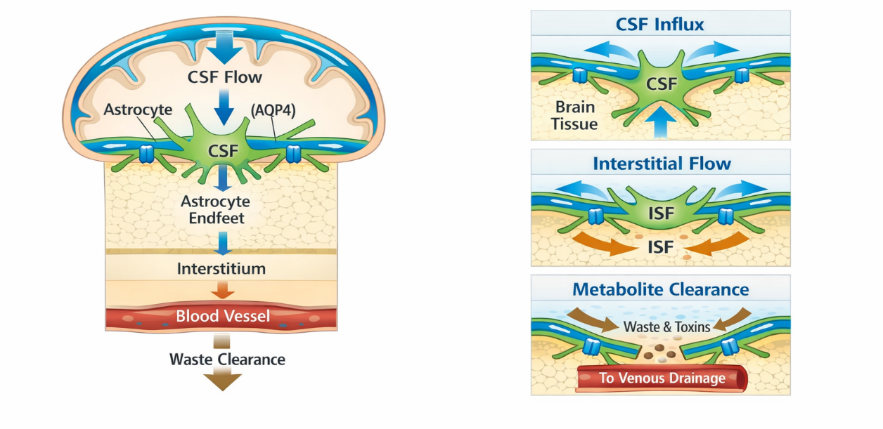
Fig. 1. Flow of glymphatic fluid

- MECHANISMS OF GLYMPHATIC FUNCTION
The glymphatic system operates as a coordinated, brain-wide network for fluid and solute transport. Understanding its mechanisms requires integrating both global physiological processes and localized structural factors. While a complete picture is still emerging, current evidence highlights several critical components.
The pathway begins with cerebrospinal fluid flow through perivascular spaces, which serve as entry points into the brain. In the brain tissue, solutes are transported through convective bulk flow and by the exchange between cerebrospinal fluid and interstitial fluid. This process is controlled by aquaporin-4 water channels located in the endfeet of astrocytes. Dynamic interactions between perivascular spaces and the parenchyma ensure effective delivery and clearance of solutes. From there, efflux routes channel waste products toward perivenous spaces and, ultimately, out of the brain through meningeal lymphatics or cranial and spinal nerves.
Beyond structural pathways, neuronal activity exerts regulatory influence on glymphatic function. Fluctuations in vascular pulsatility, sleep–wake states, and neurotransmitter-mediated modulation (e.g., norepinephrine levels) all alter CSF–ISF exchange efficiency. For instance, glymphatic transport is enhanced during sleep but suppressed during wakefulness, emphasizing the role of neurophysiological states in maintaining waste clearance.
In summary, glymphatic mechanisms involve a multilevel system integrating perivascular flow, parenchymal transport, astroglial regulation, and brain efflux routes, all of which are further modulated by neuronal and vascular activity. These interlinked processes provide the foundation for modeling brain fluid dynamics and exploring therapeutic strategies targeting glymphatic function. (Mestre et al., 2020) (Du et al., 2022)
4.1 Perivascular Flow
In the glymphatic system, cerebrospinal fluid flows into the brain along the spaces around arteries, which play a critical role in controlling the movement and distribution of fluid Although in vivo studies demonstrate movement along these pathways, the precise mechanisms controlling CSF flow remain incompletely understood. Under pathological conditions, such as stroke or cardiac arrest, arterial contractions combined with spreading depolarization waves appear to drive CSF movement. In contrast, during normal physiological states, cardiac pulsations serve as the primary driver, with periarterial flow closely following the heartbeat. Respiratory activity may also influence CSF movement, mainly affecting perivenous spaces and the ventricles. (Rajna et al., 2021) (Tuovinen et al., 2020)
Additional factors contributing to glymphatic flow include minor pressure gradients, wave reflections, and global changes in intracranial blood volume. Functional hyperemia, which increases blood flow to active cortical regions, can displace CSF over slower timescales, while CSF production from the choroid plexus and subarachnoid space appears to play a supporting but largely independent role.
The anatomical features of periarterial spaces further modulate flow efficiency. Pial periarterial spaces tend to be elliptical and interconnected, reducing resistance and facilitating communication with perivenous channels, whereas penetrating vessels are narrower and more circular. Although the presence of pericapillary spaces remains debated, vessel geometry clearly affects glymphatic transport. Overall, periarterial CSF flow is predominantly driven by cardiac-induced arterial pulsations, with its efficiency shaped by structural characteristics, pressure differences, and local blood flow dynamics. (Kedarasetti et al., 2020) (Daversin-Catty et al., 2020)
4.2 Transport in Brain Parenchyma
Transport within the brain parenchyma occurs primarily through the extracellular space (ECS), which is essential for nutrient exchange and metabolic waste removal. Early radiotracer studies estimated an ECS volume fraction of approximately 18–20% and a tortuosity of ~1.5, although spatial resolution was limited (Levin et al., 1970; Fenstermacher and Patlak, 1976). Subsequent methodological refinements, including real-time iontophoresis, demonstrated that ECS properties are dynamic and may decrease during wakefulness or pathological conditions. Integrative optical imaging extended these findings to larger solutes, revealing size-dependent hindrance and suggesting an average extracellular width of approximately 40 nm (Nicholson and Hrabětová, 2017).
Diffusion is widely regarded as the dominant mechanism governing solute displacement within the ECS; however, additional forces may influence this process. Experimental observations have reported superficial interstitial velocities in the range of tens of micrometers per minute under certain physiological conditions, and osmotic gradients mediated through aquaporin-4 channels may contribute to fluid redistribution (Thorne and Nicholson, 2006; Syková and Nicholson, 2008). Importantly, ECS geometry is not static. It contracts during ischemia, seizures, or spreading depolarization, while expansion during sleep may enhance interstitial exchange efficiency.
Nevertheless, whether substantial pressure-driven bulk flow occurs within the dense neuropil remains an area of active debate. While early interpretations of glymphatic transport emphasized convective mechanisms, recent analyses highlight limitations of purely convection-based models and emphasize the need for an integrative framework that incorporates diffusion, dispersion, and structural heterogeneity (Masri et al., 2025). Complementing this perspective, large-scale computational simulations integrating realistic tissue permeability and perivascular architecture suggest that physiologically generated pressure gradients may be insufficient to sustain uniform directional bulk flow across the parenchyma (Quirk et al., 2024). Together, these findings support the view that solute transport within brain tissue likely reflects a composite mechanism in which diffusion predominates, modulated by localized advective and structural factors. Continued integration of advanced imaging with validated computational modeling will be essential to refine understanding of parenchymal transport dynamics.
4.3 Interfaces to Perivascular Spaces
Transport of solutes and fluids in the brain relies heavily on the boundaries between perivascular spaces, parenchyma, and other fluid compartments. These interfaces regulate how cerebrospinal fluid enters and interacts with interstitial fluid.
Tracer studies show that only a portion of CSF entering the subarachnoid space actually moves into perivascular spaces. For small molecules, around 20% may reach the brain, while larger tracers show much lower entry. Conversely, studies using isotopically labeled water reported much higher influx, emphasizing that molecular size and selective membrane transport, particularly through aquaporin-4 (aquaporin-4), play major roles. Moreover, ISF is not derived solely from CSF; vascular fluid crossing the blood–brain barrier may contribute significantly, although estimates vary widely. (Xie et al., 2013) (Lee et al., 2018) (Petitclerc et al., 2021)
At the perivascular spaces–parenchyma boundary, astrocytic endfeet boosted with aquaporin-4 channels form a key regulatory interface. Loss or mislocalization of aquaporin-4 disrupts glymphatic flow, underscoring its importance (Iliff et al., 2012). Two models have been proposed: water transfer through astrocytes or movement via narrow endfoot gaps, where aquaporin-4 indirectly modulates flow. These gaps also permit small molecules, including amyloid-β, to pass. Additionally, variability in endfoot size along vessels influences transport efficiency (Nielsen et al., 1997).
If pericapillary spaces exist, they may provide a direct fluid pathway from arteries to veins, bypassing extracellular diffusion, warranting further anatomical investigation. (Nagelhus et al., 1998) (Mestre et al., 2018) (Hannocks et al., 2018) (Ferris, 2021)
4.4 Efflux Routes
While cerebrospinal fluid (CSF) entry pathways into the brain have been widely examined, the routes by which interstitial fluid (ISF) exits remain less clearly defined. Based on conservation of mass, the amount of fluid leaving the central nervous system (CNS) must balance the influx, suggesting the existence of multiple efflux channels (Rasmussen et al., 2022) (Steven, 2021)
Several pathways for fluid clearance have been described, including perivenous spaces, routes along cranial and spinal nerves, subarachnoid granulations, and connections to cervical lymphatics. The cleared fluid is eventually transported into the systemic circulation, typically near the subclavian veins. However, the relative contribution of these different pathways is not yet well quantified. (Lee et al., 2015)
Efflux dynamics appear to be influenced by physiological and pathological factors. For instance, posture, brain activity, and intracranial pressure (ICP) can shift the preferred clearance routes in the short term, while aging, cardiovascular health, and disease may alter them chronically. Early tracer studies indicated that only a small fraction of ISF mixes with CSF before leaving the CNS, though these results require confirmation with modern, less invasive techniques.
The traditional role of subarachnoid granulations in CSF clearance is also debated, as they are absent in infants and poorly developed in many experimental animals, raising questions about their overall significance (Cserr et al., 1981).
- PATHOLOGICAL IMPAIRMENT
Impairment of the glymphatic system has been associated with several neurodegenerative conditions, including Alzheimer’s disease, idiopathic normal pressure hydrocephalus, and traumatic brain injury. Disruption of glymphatic clearance has been associated with reduced removal of proteins such as amyloid-β and tau, which may contribute to disease progression. Disorders like Alzheimer’s, Parkinson’s, and Huntington’s disease involve gradual cognitive decline and dementia, mainly caused by the accumulation of misfolded proteins that form aggregates either inside neurons or in the surrounding extracellular space. In Alzheimer’s disease, key pathological features include extracellular amyloid-beta plaques and intracellular tau tangles, whereas Parkinson’s disease is characterized by the buildup of alpha-synuclein aggregates, known as Lewy bodies. Soluble forms of amyloid-β can diffuse through the interstitial space, but over time, these oligomers convert into insoluble fibrils, contributing to plaque formation. The efficiency of soluble amyloid-β clearance declines with aging, indicating a progressive reduction in waste removal capacity. Similarly, tau protein, though predominantly intracellular, can propagate extracellularly in a prion-like manner, with truncated forms being more prone to aggregation (Peng et al., 2023).
5.1 Alzheimer’s Disease
In Alzheimer’s disease, dysfunction of the glymphatic system is characterized by the misplacement of aquaporin-4 and disrupted fluid movement along the perivascular spaces. These alterations are associated with impaired clearance of amyloid-β and tau, which may facilitate plaque and tangle accumulation. Reduced clearance has also been linked to sustained neuroinflammatory responses and progressive cognitive decline.
5.2 Parkinson’s Disease
Pathology of Parkinson’s disease is similarly influenced by reduced glymphatic clearance. Insufficient removal of α-synuclein has been proposed to favor its aggregation in dopaminergic neurons, driving neuronal degeneration in the substantia nigra. This accumulation underscores the role of clearance failure in both onset and progression of the disease.
5.3 Stroke
In ischemic stroke, redistribution of aquaporin-4 and dilation of perivascular spaces are associated with altered solute movement and may contribute to edema and metabolic stress. Hemorrhagic stroke adds another dimension, as fibrin and other blood components physically obstruct perivascular channels, further restricting CSF–ISF exchange and compounding secondary brain injury.
5.4 Traumatic Brain Injury
Following traumatic brain injury, glymphatic function is persistently impaired due to astrocytic reactivity and aquaporin-4 depolarization. These changes diminish CSF influx and solute clearance, allowing amyloid-β and tau to accumulate. Such alterations may partially account for the observed association between TBI and heightened risk of Alzheimer’s disease and chronic traumatic encephalopathy (Peng et al., 2023).
5.5 Multiple Sclerosis
In multiple sclerosis, inflammatory demyelination disrupts the architecture of perivascular pathways. This disruption may impair solute drainage and has been associated with prolonged lesion activity. Inefficient clearance within demyelinated regions may also facilitate chronic immune activation, worsening disease progression (Reeves et al., 2020).
5.6 Diabetes and Metabolic Disorders
Hyperglycemia and metabolic dysregulation alter vascular function and enlarge perivascular spaces, particularly in hippocampal regions. These structural changes have been associated with impaired glymphatic transport and may contribute to oxidative stress and neuroinflammation. Consequently, diabetic patients are more prone to cognitive decline linked to poor waste clearance.
5.7 Migraine
During cortical spreading depression in migraine, transient vasoconstriction and ionic disturbances narrow perivascular channels. This restriction may compromise clearance of solutes and may contribute to the white matter lesions frequently observed in patients with chronic migraine.
5.8 Normal Pressure Hydrocephalus
Normal pressure hydrocephalus is characterized by compromised clearance of interstitial solutes, including amyloid-β, leading to ventriculomegaly and dementia-like symptoms. While shunt procedures relieve symptoms by diverting CSF, glymphatic dysfunction has been proposed to contribute to disease progression (Peng et al., 2023).
5.9 Sleep Disorders
Sleep, particularly deep non-REM slow-wave stages, is essential for efficient glymphatic transport. Disruption of sleep architecture, as seen in insomnia and sleep apnea, diminishes solute clearance and promotes accumulation of neurotoxic proteins. Chronic sleep disruption has been associated with reduced glymphatic efficiency and may increase vulnerability to neurodegenerative changes (Reeves et al., 2020).
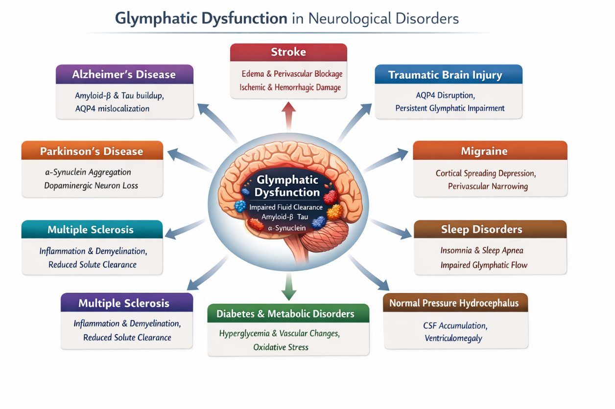Fig. 2. Factors modifying glymphatic activity

- MOLECULAR DRIVERS: RECEPTORS AND CHANNELS
The glymphatic system depends on specific molecular processes to control the influx of cerebrospinal fluid, the exchange of interstitial fluid, and the removal of metabolic waste. Two key molecular drivers Aquaporin-4 and norepinephrine (NE) coordinate the dynamics of fluid transport and perivascular flow, linking structural astrocytic features with neuromodulatory control.
6.1 Aquaporin-4 (AQUAPORIN-4)
6.1.1 Role and Localization
Aquaporin-4 is the prime water channel in the central nervous system, highly concentrated in astrocytic endfeet surrounding cerebral vasculature. This polarized localization facilitates bidirectional water movement between CSF and ISF, supporting efficient clearance of neurotoxic metabolites such as β-amyloid and α-synuclein (Walz et al., 2009).
6.1.2 Isoforms and Structural Organization
Aquaporin-4 isoforms, including M1, M23, and the extended readthrough aquaporin-4x, assemble into orthogonal particle arrays, optimizing water permeability. The relative ratio of M1 to M23 determines OAP stability, while aquaporin-4x preferentially localizes near the blood–brain barrier, enhancing the removal of amyloid deposits and contributing to neuroprotection. (Silberstein et al., 2004) (Badaut et al., 2014) (Stokum et al., 2015) (Nicchia et al., 2010)
6.1.3 Regulation of Polarization
Polarized localization of aquaporin-4 is maintained by anchoring proteins such as α-syntrophin. Disruption of this scaffolding or loss of aquaporin-4x mislocalizes aquaporin-4, impairing CSF–ISF circulation. Experimental deletion or depolarization of aquaporin-4 has been shown to reduce glymphatic transport by up to 70%, underscoring its central role in brain fluid homeostasis. (Gratwicke et al., 2015)
6.2 Norepinephrine (NE)
6.2.1 Role and Source
NE, synthesized by the locus coeruleus, is a key neuromodulator that links glymphatic function to the sleep–wake cycle. It regulates astrocytic morphology and interstitial space volume, thereby controlling CSF influx and ISF-mediated clearance.
6.2.2 Sleep-Wake Dependency and Vasomotion
High NE levels during wakefulness contract astrocytes, reducing interstitial space and limiting glymphatic activity. During non-REM sleep, decreased NE allows astrocytic relaxation, expansion of interstitial space, and enhanced CSF flow. NE infraslow oscillations drive arterial vasomotion, generating a perivascular pumping mechanism that facilitates bulk CSF transport. (Gao et al., 2023) (Bohr et al., 2022)
6.2.3 Modulation and Interplay with aquaporin-4
NE oscillations act in concert with aquaporin-4-mediated water transport. Low NE during sleep optimizes astrocytic relaxation and perivascular water movement, while elevated NE during wakefulness restricts glymphatic clearance. Pharmacological or lifestyle factors that disrupt NE signaling can impair interstitial flow and reduce waste removal efficiency.
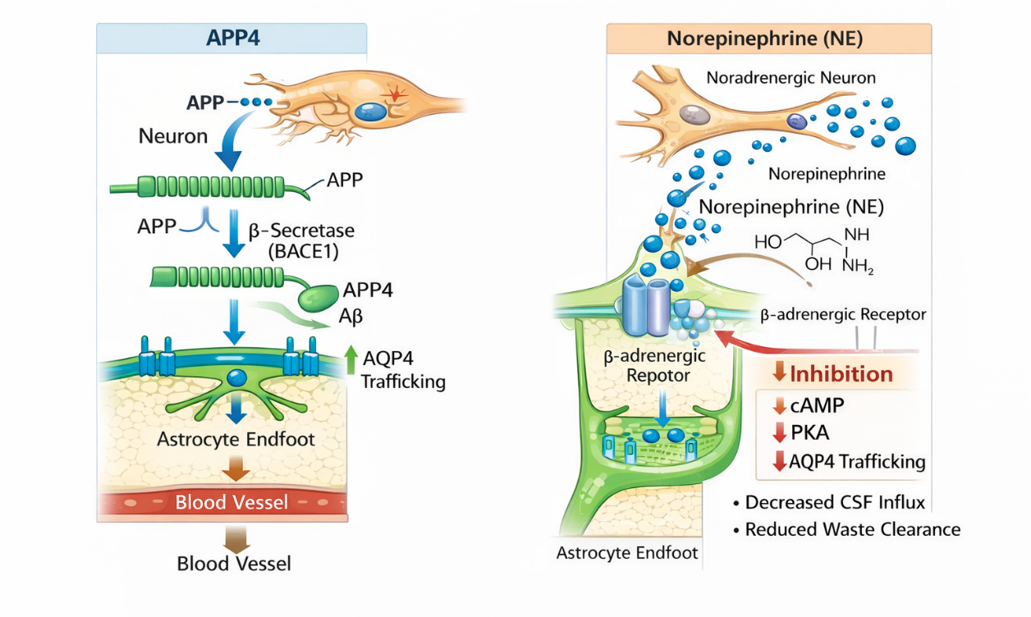
Fig. 3. Molecular drivers of glymphatic function

- INTEGRATED IMPLICATIONS
The interplay between aquaporin-4 and NE represents a core molecular mechanism underpinning glymphatic function. Dysregulation of either pathway through altered aquaporin-4 polarization, sleep disturbances, or chronic adrenergic overactivity can impair metabolic waste clearance, promoting accumulation of β-amyloid, tau, and other neurotoxic proteins. This contributes to neurodegenerative disease progression, including Alzheimer’s and Parkinson’s disease, and may exacerbate outcomes following acute CNS injury.
- PHARMACOLOGICAL IMPLICATIONS
The glymphatic system represents a novel target for therapeutic intervention. Strategies include enhancing aquaporin-4 function, modulating adrenergic signaling, and leveraging glymphatic pathways for improved CNS drug delivery. Such interventions may have applications in Alzheimer’s disease, Parkinson’s disease, and sleep disorders. (Gao et al., 2023) (Bohr et al., 2022)
- THERAPEUTIC TARGETS OF THE GLYMPHATIC SYSTEM IN NEUROLOGICAL DISORDERS
The glymphatic system, due to its role in fluid transport and clearance of metabolic waste, has emerged as a potential therapeutic target in several neurological conditions. Different components of this system can be modulated pharmacologically to improve brain health.
9.1 Sleep Architecture
Deep non-REM sleep, marked by slow-wave EEG activity, is the optimal stage for glymphatic function. Both natural sleep and anesthesia increase interstitial space by nearly 60%, enhancing CSF-ISF exchange and accelerating amyloid-β clearance. Studies show that anesthetic choice alters CSF flow, with dexmedetomidine (an α2-adrenergic agonist) combined with isoflurane promoting greater glymphatic influx than isoflurane alone. Beyond sleep modulation, anesthetics may also enhance CSF entry through cerebral vasoconstriction that enlarges perivascular spaces. Thus, targeting sleep and slow-wave activity could represent a novel approach for neurodegenerative disorders, stroke, and TBI (Benveniste et al., 2017).

9.2 Aquaporin-4 Regulation
Aquaporin-4 water channels are central to glymphatic circulation. Experimental studies show that both inhibition and overexpression of aquaporin-4 influence outcomes in ischemic stroke and brain edema. Compounds like TGN-073 enhance ISF flow across the BBB. However, challenges include off-target effects since aquaporin-4 is also expressed in peripheral tissues (kidney, stomach, glands, muscle) and the existence of different aquaporin-4 isoforms (M1, M23) with varying structural arrangements. Drug delivery must therefore achieve CNS specificity (Huber et al., 2018) (Verkman et al., 2017).
9.3 CSF Flow in Perivascular Space (PVS)
Molecular size influences solute penetration into the brain, with smaller molecules diffusing more readily. Cardiac pulsations also drive CSF movement, and impaired pulsatility in hypertension reduces glymphatic transport. Adrenergic agonists like dobutamine can boost perivascular flow by enhancing vascular pulsations. Similarly, systemic adrenergic antagonists have shown benefit in ischemic models by preserving AQUAPORIN-4 polarization, improving CSF-ISF exchange, and reducing infarct size. Epidemiological data suggest that highly BBB-permeable β-blockers may lower Alzheimer’s risk by promoting waste clearance (Gao et al., 2023).
9.4 Adrenergic Modulation
Adrenergic signaling plays a key role in regulating glymphatic activity. Experimental studies in ischemic stroke models demonstrate that systemic administration of adrenergic receptor antagonists facilitates clearance of extracellular potassium, improves recovery of neural function, reduces infarct size, and maintains astrocytic aquaporin-4 polarization, thereby enhancing CSF–ISF exchange. Clinical observations further suggest that blood–brain barrier permeable β-blockers may lower the risk of Alzheimer’s disease, possibly by promoting more efficient clearance of metabolic waste. In contrast, β-receptor activation decreases extracellular space and increases astrocytic process volume, which may hinder fluid transport. Beyond neural effects, adrenergic modulation also influences vascular pulsatility and cardiac cycles that drive perivascular CSF flow. Collectively, these findings highlight adrenergic antagonists—particularly lipophilic β-blockers—as promising modulators of glymphatic function in conditions such as stroke and neurodegeneration (Gao et al., 2023).
9.5 Other Approaches
Non-pharmacological interventions such as exercise, specific sleep postures, vagus nerve stimulation, and moderate alcohol intake can enhance glymphatic flow, while high alcohol intake impairs it. Nutritional strategies like polyunsaturated fatty acids have also been linked to improved clearance.
- THE GUT–BRAIN AXIS AND GLYMPHATIC FUNCTION
The glymphatic system appears to interact closely with metabolic and satiety signals arising from the gastrointestinal tract. Evidence suggests that dietary lipids and other nutrients absorbed in the gut can influence CSF composition after passing through the liver and crossing either the choroid plexus or blood–brain barrier. Once in the brain, apolipoprotein E (APOE), a key cholesterol carrier synthesized by both astrocytes and the choroid plexus, may facilitate lipid distribution along perivascular spaces. Importantly, different APOE isoforms vary in how effectively they mediate cerebrospinal fluid transport, a distinction that is clinically significant because the APOE genotype represents the most influential genetic risk factor for late-onset Alzheimer’s disease. Impaired glymphatic function in AD models further highlights the possibility that gut-derived lipids may contribute to neurodegeneration through altered perivascular distribution (Hanson et al., 2019) (Xu et al., 2006) (Achariyar et al., 2016) (Belloy et al., 2019).
Neural pathways also mediate gut–brain–glymphatic communication. The vagus nerve directly conveys satiety and hunger cues from enteroendocrine cells via signals such as cholecystokinin (CCK), ghrelin, and GLP-1. Experimental evidence shows that vagal stimulation enhances glymphatic influx, suggesting that feeding states may modulate CSF circulation and thereby influence hypothalamic signaling. GLP-1, in particular, has therapeutic relevance, with receptor agonists shown to reduce CSF production and improve outcomes in neurodegeneration models. Similarly, fibroblast growth factor 21 (FGF21), secreted by the liver, modulates appetite when delivered into CSF and regulates hypothalamic–pituitary–thyroid signaling, linking peripheral metabolism to brain fluid dynamics (von Holstein-Rathlou and Gillum, 2019) (von Holstein-Rathlou et al., 2016).
The gut microbiome provides an additional dimension to this axis. Microbial composition influences endocrine signals such as GLP-1 and vagal activity, while also affecting blood–brain barrier integrity and, indirectly, CSF composition. Preliminary evidence suggests interactions between APOE genotype and microbiota composition, although mechanistic pathways remain poorly defined. These findings collectively point toward the gut–brain axis as a potential therapeutic target to modulate glymphatic function, with implications for treating metabolic and neurodegenerative disorders (Parikh et al., 2020) (Martin et al., 2018).
- FUTURE PROSPECTS
The glymphatic system is increasingly recognized as a critical regulator of cerebral homeostasis, yet translation of experimental findings into clinical practice remains an evolving priority. Advances in non-invasive neuroimaging, particularly diffusion tensor imaging along perivascular spaces (DTI-ALPS) and multimodal MRI approaches, now permit in vivo assessment of glymphatic function in human subjects. Recent clinical investigations have demonstrated altered glymphatic-related imaging indices in Alzheimer’s disease, with associations to amyloid deposition and cerebrospinal fluid dynamics (Zhou et al., 2025; Lin et al., 2025). These findings support the potential utility of imaging-derived glymphatic markers as diagnostic and prognostic tools.
Beyond Alzheimer’s disease, MRI-based assessments have revealed glymphatic alterations in other neurological conditions, including demyelinating disorders and vascular cognitive impairment (Kim et al., 2024; Reeves et al., 2022). Emerging longitudinal imaging studies further suggest that glymphatic dysfunction may precede or parallel neurodegenerative progression, underscoring its potential role in disease monitoring (Zhu et al., 2023). Standardization of imaging protocols and validation across larger cohorts will be essential for clinical translation.
Therapeutically, modulation of glymphatic activity offers a promising avenue to enhance clearance of neurotoxic metabolites such as amyloid-β and tau. Strategies aimed at restoring aquaporin-4 polarization, optimizing sleep architecture, and preserving vascular integrity may improve interstitial waste removal and influence neurodegenerative trajectories. Additionally, exploitation of perivascular pathways for targeted drug delivery may enhance central nervous system bioavailability of biologics and small-molecule therapeutics.
Future large-scale, longitudinal clinical studies are necessary to validate glymphatic imaging biomarkers, establish normative reference values, and determine whether therapeutic enhancement of glymphatic function yields measurable clinical benefit. Integrating advanced imaging technologies with pharmacological and behavioral interventions may facilitate meaningful translation of glymphatic research into neurological practice.
- Conclusion
The glymphatic system is a crucial pathway for clearing metabolic waste and neurotoxic proteins, maintaining brain homeostasis and cognitive health. Dysfunction of this system contributes to neurodegenerative disorders, including Alzheimer’s, Parkinson’s, and idiopathic normal pressure hydrocephalus, by impairing the removal of amyloid-β, tau, and other aggregation-prone proteins. Advances in imaging and experimental studies have highlighted the roles of vascular pulsations, sleep, adrenergic signaling, and aquaporin-4 in modulating glymphatic flow. Targeting these mechanisms through pharmacological or lifestyle interventions offers promising avenues to enhance waste clearance, slow disease progression, and preserve neurological function.

Disclaimer (Artificial intelligence)
Author(s) hereby declare that NO generaive AI technologies such as Large Language Models (ChatGPT, COPILOT, etc.) and text-to-image generators have been used during the writing or editing of this manuscript.

References
- Iliff JJ, Wang M, Liao Y, Plogg BA, Peng W, Gundersen GA, et al. A paravascular pathway facilitates CSF flow through the brain parenchyma and the clearance of interstitial solutes, including amyloid beta. Sci Transl Med. 2012;4:147ra111.
- Johnston M, Zakharov A, Papaiconomou C, Salmasi G, Armstrong D. Evidence of connections between cerebrospinal fluid and nasal lymphatic vessels in humans, non-human primates and other mammalian species. Cerebrospinal Fluid Res. 2004;1:2.
- Murtha LA, Yang Q, Parsons MW, Levi CR, Beard DJ, Spratt NJ. Cerebrospinal fluid is drained primarily via the spinal canal and olfactory route in young and aged spontaneously hypertensive rats. Fluids Barriers CNS. 2014;11:12
- Jessen NA, Nedergaard M, Ruthazer ES. The glymphatic system: a beginner’s guide. Neurochem Res. 2015;40(12):2583-99.
- Hablitz LM, Nedergaard M. The glymphatic system: a novel component of fundamental neurobiology. J Neurosci. 2021;41(37):7698-711.
- Hablitz LM, Plá V, Giannetto M, Vinitsky HS, Stæger FF, Metcalfe T, et al. Circadian control of brain glymphatic and lymphatic fluid flow. Nat Commun. 2020;11:4411.
- Liu AK, Chang RC, Pearce RK, Gentleman SM. Nucleus basalis of Meynert revisited: anatomy, history and differential involvement in Alzheimer’s and Parkinson’s disease. Acta Neuropathol. 2015;129:527-40.
- Mestre H, Du T, Sweeney AM, Liu G, Samson AJ, Peng W, et al. Cerebrospinal fluid influx drives acute ischemic tissue swelling. Science. 2020;367:eaax7171.
- Du T, Mestre H, Kress BT, Liu G, Sweeney AM, Samson AJ, et al. Cerebrospinal fluid is a significant fluid source for anoxic cerebral oedema. Brain. 2022;145:787-97.
- Rajna Z, Mattila H, Huotari N, Tuovinen T, Krüger J, Holst SC, et al. Cardiovascular brain impulses in Alzheimer’s disease. Brain. 2021;144:2214-26.
- Tuovinen T, Kananen J, Rajna Z, Lieslehto J, Korhonen V, Rytty R, et al. The variability of functional MRI brain signal increases in Alzheimer’s disease at cardiorespiratory frequencies. Sci Rep. 2020;10:21559.
- Kedarasetti RT, Drew PJ, Costanzo F. Arterial pulsations drive oscillatory flow of CSF but not directional pumping. Sci Rep. 2020;10:10102.
- Daversin-Catty C, Vinje V, Mardal KA, Rognes ME. The mechanisms behind perivascular fluid flow. PLoS One. 2020;15:e0244442.
- Levin VA, Fenstermacher JD, Patlak CS. Sucrose and inulin space measurements of cerebral cortex in four mammalian species. Am J Physiol. 1970;219:1528-33.
- Fenstermacher JD, Patlak CS. The movements of water and solutes in the brains of mammals. In: Pappius HM, Feindel W, editors. Dynamics of brain edema. Berlin: Springer; 1976. p. 87-94.
- Nicholson C, Hrabětová S. Brain extracellular space: the final frontier of neuroscience. Biophys J. 2017;113:2133-42.
- Thorne RG, Nicholson C. In vivo diffusion analysis with quantum dots and dextrans predicts the width of brain extracellular space. Proc Natl Acad Sci U S A. 2006;103:5567-72.
- Syková E, Nicholson C. Diffusion in brain extracellular space. Physiol Rev. 2008;88:1277-340.
- Masri MA, Corell A, Jakola IS. Glymphatics in neurovascular diseases: current challenges and future directions. J Neurointerv Surg. 2025.
- Quirk K, Boster KAS, Tithof J, Kelley DH. A brain-wide solute transport model of the glymphatic system. J R Soc Interface. 2024;21:20240369.
- Xie L, Kang H, Xu Q, Chen MJ, Liao Y, Thiyagarajan M, et al. Sleep drives metabolite clearance from the adult brain. Science. 2013;342:373-7.
- Lee H, Mortensen K, Sanggaard S, Koch P, Brunner H, Quistorff B, et al. Quantitative Gd-DOTA uptake from cerebrospinal fluid into rat brain using 3D VFA-SPGR at 9.4T. Magn Reson Med. 2018;79:1568-78.
- Petitclerc L, Hirschler L, Wells JA, Thomas DL, van Walderveen MAA, van Buchem MA, et al. Ultralong-TE arterial spin labeling reveals rapid and brain-wide blood-to-CSF water transport in humans. Neuroimage. 2021;245:118755.
- Nagelhus EA, Veruki ML, Torp R, Haug FM, Laake JH, Nielsen S, et al. Aquaporin-4 water channel protein in the rat retina and optic nerve: polarized expression in Muller cells and fibrous astrocytes. J Neurosci. 1998;18:2506-19.
- Mestre H, Hablitz LM, Xavier AL, Feng W, Zou W, Pu T, et al. Aquaporin-4-dependent glymphatic solute transport in the rodent brain. Elife. 2018;7:e40070.
- Nielsen S, Nagelhus EA, Amiry-Moghaddam M, Bourque C, Agre P, Ottersen OP. Specialized membrane domains for water transport in glial cells: high-resolution immunogold cytochemistry of aquaporin-4 in rat brain. J Neurosci. 1997;17:171-80.
- Hannocks MJ, Pizzo ME, Huppert J, Deshpande T, Abbott NJ, Thorne RG, et al. Molecular characterization of perivascular drainage pathways in the murine brain. J Cereb Blood Flow Metab. 2018;38:669-86.
- Ferris CF. Rethinking the conditions and mechanism for glymphatic clearance. Front Neurosci. 2021;15:624690.
- Rasmussen MK, Mestre H, Nedergaard M. Fluid transport in the brain. Physiol Rev. 2022;102:1025-51.
- Steven TP. Cerebrospinal fluid outflow: a review of the historical and contemporary evidence for arachnoid villi, perineural routes, and dural lymphatics. Cell Mol Life Sci. 2021;78:2429-57.
- Lee H, Xie L, Yu M, Kang H, Feng T, Deane R, et al. The effect of body posture on brain glymphatic transport. J Neurosci. 2015;35:11034-44.
- Cserr HF, Cooper DN, Suri PK, Patlak CS. Efflux of radiolabeled polyethylene glycols and albumin from rat brain. Am J Physiol. 1981;240:F319-28.
- Peng, S., Liu, J., Liang, C., Yang, L., & Wang, G. (2023). Aquaporin-4 in glymphatic system and its implication for central nervous system disorders. Neurobiology of Disease, 179, 106035. https://doi.org/10.1016/j.nbd.2023.106035
PMID: 36716780
- Reeves BC, Karimy JK, Kundishora AJ, Mestre H, Nedergaard M. Glymphatic system impairment in Alzheimer’s disease and idiopathic normal pressure hydrocephalus. Trends Mol Med. 2020;26(3):285-95.
- Walz, Thomas, Fujiyoshi, Yoshinori, Engel, Andreas, 2009. The Aqp structure and functional implications. Handb. Exp. Pharmacol. 190, 31–56.
- Silberstein, Claudia, Bouley, Richard, Huang, Yan, Fang, Pingke, Pastor-Soler, Nuria, Brown, Dennis, Van Hoek, Alfred N., 2004. Membrane organization and function of M1 and M23 isoforms of Aquaporin-4 in epithelial cells. Am. J. Physiol. Ren. Physiol. 287 (3), F501–F511. https://doi.org/10.1152/ajprenal.00439.2003.
- Badaut, J´erome, ˆ Fukuda, Andrew M., Jullienne, Amandine, Petry, Klaus G., 2014. Aquaporin and brain diseases. Biochim. Biophys. Acta 1840 (5), 1554–1565. https:// doi.org/10.1016/j.bbagen.2013.10.032.
- Stokum, Jesse A., Kurland, David B., Gerzanich, Volodymyr, Simard, J. Marc, 2015. Mechanisms of astrocyte-mediated cerebral edema. Neurochem. Res. 40 (2), 317–328. https://doi.org/10.1007/s11064-014-1374-3.
- Nicchia, G.P., Rossi, A., Mola, M.G., Pisani, F., Stigliano, C., Basco, D., Mastrototaro, M., Svelto, M., Frigeri, A., 2010. Higher order structure of Aquaporin-4. Neuroscience 168 (4), 903–914. https://doi.org/10.1016/j.neuroscience.2010.02.008.
- Gratwicke, J., Jahanshahi, M., Foltynie, T., 2015. Parkinson’s disease dementia: a neural networks perspective. Brain 138 (Pt 6), 1454–1476. https://doi.org/10.1093/brain/ awv104.
- Gao J, Li Y, Chen Z. The glymphatic system: an emerging therapeutic target for neurological diseases. Pharmacol Ther. 2023;241:108302.
- Bohr T, Hjorth PG, Holst SC, Nedergaard M. The glymphatic system: current understanding and modeling. iScience. 2022;25(6):104548.
- Benveniste, H., Lee, H., Ding, F., Sun, Q., Al-Bizri, E., Makaryus, R., et al. (2017). Anesthesia with dexmedetomidine and low-dose isoflurane increases solute transport via the glymphatic pathway in rat brain when compared with high-dose isoflurane. Anesthesiology 127, 976–988. doi: 10.1097/aln.0000000000001888
- Huber, V. J., Igarashi, H., Ueki, S., Kwee, I. L., and Nakada, T. (2018). Aquaporin-4 facilitator TGN-073 promotes interstitial fluid circulation within the blood-brain barrier: [17O]H2O JJVCPE MRI study. Neuroreport 29, 697–703. doi: 10.1097/ wnr.0000000000000990
- Verkman, A. S., Smith, A. J., Phuan, P. W., Tradtrantip, L., and Anderson, M. O. (2017). The aquaporin-4 water channel as a potential drug target in neurological disorders. Expert Opin. Ther. Targets 21, 1161–1170. doi: 10.1080/14728222.2017.1398236
- Hanson AJ, Banks WA, Bettcher LF, Pepin R, Raftery D, Craft S (2019) Cerebrospinal fluid lipidomics: effects of an intravenous triglyceride infusion and apoE status. Metabolomics 16:6
- Xu Q, Bernardo A, Walker D, Kanegawa T, Mahley RW, Huang Y (2006) Profile and regulation of apolipoprotein E (ApoE) expression in the CNS in mice with targeting of green fluorescent protein gene to the ApoE locus. J Neurosci 26:4985–4994.
- Achariyar TM, Li B, Peng W, Verghese PB, Shi Y, McConnell E, Benraiss A, Kasper T, Song W, Takano T, Holtzman DM, Nedergaard M, Deane R (2016) Glymphatic distribution of CSF-derived apoE into brain is isoform specific and suppressed during sleep deprivation. Mol Neurodegener 11:74
- Belloy ME, Napolioni V, Greicius MD (2019) A quarter century of APOE and Alzheimer’s disease: progress to date and the path forward. Neuron 101:820–838.
- von Holstein-Rathlou S, Gillum MP (2019) Fibroblast growth factor 21: an endocrine inhibitor of sugar and alcohol appetite. J Physiol 597:3539– 3548.
- von Holstein-Rathlou S, BonDurant LD, Peltekian L, Naber MC, Yin TC, Claflin KE, Urizar AI, Madsen AN, Ratner C, Holst B, Karstoft K, Vandenbeuch A, Anderson CB, Cassell MD, Thompson AP, Solomon TP, Rahmouni K, Kinnamon SC, Pieper AA, Gillum MP, et al. (2016) FGF21 mediates endocrine control of simple sugar intake and sweet taste preference by the liver. Cell Metab 23:335–343
- Parikh IJ, Estus JL, Zajac DJ, Malik M, Maldonado Weng J, Tai LM, Chlipala GE, LaDu MJ, Green SJ, Estus S (2020) Murine gut microbiome association with APOE alleles. Front Immunol 11:200
- Martin CR, Osadchiy V, Kalani A, Mayer EA (2018) The brain-gut-microbiome axis. Cell Mol Gastroenterol Hepatol 6:133–148.
- Zhou L, Nguyen TD, Chiang GC, et al. Brain glymphatic fluid mapping in Alzheimer’s disease using combined MRI and PET imaging. Brain Communications. 2025;7(3):fcaf200.
- Lin W, Chen H, Zhang Z, et al. Multimodal MRI evidence of impaired glymphatic function in Alzheimer’s disease. Scientific Reports. 2025;15:30409.
- Kim M, Hwang I, Park JH, et al. MRI-based assessment of glymphatic alterations in multiple sclerosis and neuromyelitis optica spectrum disorder. Human Brain Mapping. 2024;45(5):e26680.
- Reeves BC, Karimy JK, Kundishora AJ, et al. Glymphatic system impairment in neurological disorders: human imaging perspectives. Frontiers in Neurology. 2022;13:827398.
- Zhu Y, Wang G, Kolluru C, et al. Dynamic contrast-enhanced MRI assessment of cerebrospinal fluid tracer transport and glymphatic activity. Scientific Reports. 2023;13:13882.

