Case report
Mucinous borderline tumour with microinvasion arising from a Mature Teratoma

ABSTRACT
A mucinous borderline tumour with microinvasion arising from a mature teratoma is typically detected incidentally and diagnosed postoperatively with histopathological confirmation. Due to the limited limited cases reported in literature; therefore no established management recommendation are currently available. We reported a 25 year-old woman who presented with a painless, large ovarian mass, and was associated with elevated cancer-antigen 125 (CA125). Pre-operative contrast-enhanced computed tomography (CT) reported a large multiloculated ovarian tumour (solid-cystic) otherwise, other findings were normal. Patient underwent staging laparotomy with fertility sparing surgery, with no evidence of residual disease. Following surgery, histopathological examination revealed mucinous borderline tumour with microinvasion (2mm) arising from mature teratoma. Immunohistochemical stain showed diffuse and strong expression of cytokeratin 7 (CK7), but heterogeneous expression of cytokeratin 20 (CK20) and caudal-type homeobox transcription factor 2 (CDX2). This case report highlighted the importance of histopathological evaluation in patient management, selection of surgical approach, disease surveillance and monitoring of disease progression in this condition.
Key words: Mature teratoma, mucinous borderline tumour, large ovarian mass, CA125
INTRODUCTION
Ovarian teratoma is a common type of germ cell tumour which is typically benign. It consists of tissues from three blastodermic layers, namely the ectoderm, mesoderm and endoderm. It has a rare potential for malignant transformation, in which cells within a typical benign teratoma develops into somatic cancer, such as adenocarcinoma and sarcoma. Although rare, this transformation may demonstrate aggressive behaviour and resistance to conventional chemotherapy and radiotherapy. Such cases often manifested as metastatic disease at initial presentation and are associated with poor prognosis. A borderline ovarian tumour (BOV) is a neoplasm characterised by intermediate features between benign and malignant lesions, and is often referred to as tumours of low malignant potential. (Shen et al, 2018) Therefore, a borderline ovarian tumour arising from an ovarian mature teratoma is an uncommon entity and often diagnosed postoperatively by incorporating immunohistochemical and histopathological evaluation. (Vang R et al, 2007)This case report described a 25 year- old woman who presented with a large ovarian mass. Following surgery, immunohistochemical and histopathological analysis demonstrated features of mucinous borderline tumour with microinvasion arising from a mature teratoma.

CASE PRESENTATION
A 25 years women presented with painless abdominal distension over 2 months which was gradually increasing in size. There was no compressive or constitutional symptom. Clinically, patient was afebrile and hemodynamically stable. There was a huge mass occupying the entire abdomen on abdominal examination. A contrast-enhanced computed tomography (CT) scan of the thorax, abdomen and pelvis demonstrated a large multiloculated solid-cystic ovarian mass measuring 40x22cm (Figure 1), with no ascites or evidence of regional or distant metastases. The pre-operative cancer-antigen 125 (Ca125) level was elevated (241 U/ml; reference range 0 – 34 U/ml), while other blood parameters were within normal limits.
Following extensive discussion and counselling, a decision was made to proceed with a fertility sparing approach. Patient underwent staging laparotomy with right salping-oopherectomy, omentectomy, right pelvic lymphadenectomy, appendicectomy and peritoneal fluid for cytology. Intraoperatively, a 35x35cm right ovarian mass was identified, solid-cystic (predominantly cystic) with a smooth surface without ascites. The omentum and appendix appeared normal. Sub-centimetre pelvic lymph nodes were noted, and the peritoneal survey was unremarkable. The patient had an uneventful postoperative recovery and was discharged on postoperative day 2. Histopathological examination revealed a teratoma-associated mucinous tumour, with features of mucinous borderline tumour with microinvasion (2mm). The mucinous component demonstrated histological and immunohistochemical features consistent with an ovarian epithelial origin. There was no evidence of immature or other germ cell tumour components and no features suggestive of low-grade mucinous neoplasm of appendix (LAMN).
The patient was subsequently followed up with serial CA125 monitoring and pelvic ultrasonography. CA-125 levels normalised, and no evidence of any pelvic recurrence was observed over 15 months. She subsequently conceived spontaneously after 15 months of surveillance; however the pregnancy was complicated with a rupture left tubal ectopic pregnancy. She underwent diagnostic laparoscopy and left salpingectomy. Intraoperatively, a ruptured left tubal ectopic pregnancy measuring 4x5cm was noted, which was confirmed on histopathological examination. The left ovary and remainder of abdominal survey showed no evidence of disease recurrence. The patient recovered well postoperatively and resumed regular follow-up. She has also been counselled regarding the option of assisted reproductive technology (ART). At the time of writing, there was no evidence of tumour recurrence over a 2 –year follow up period.
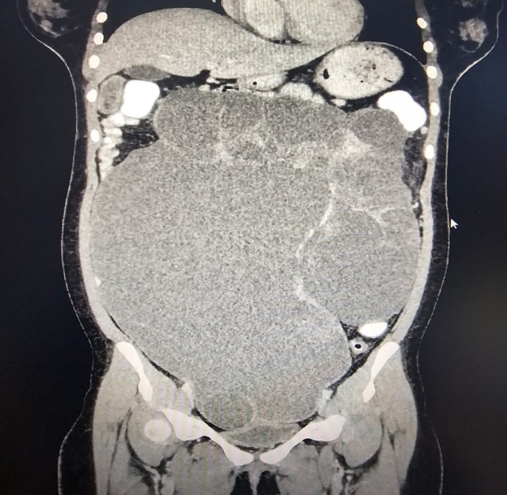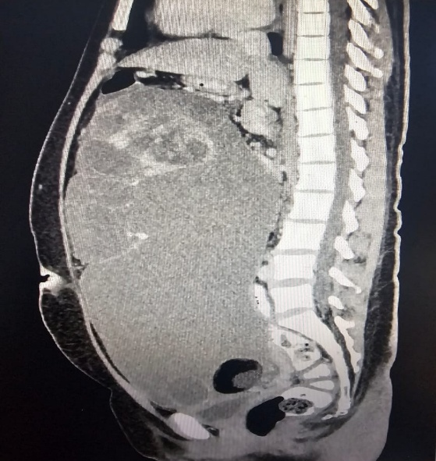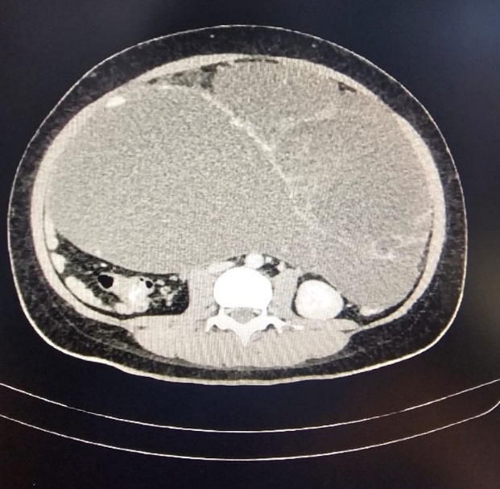
C
B
A
Figure 1: Contrast-enhanced computed tomography (CT) images demonstrated (A) a large multiloculated ovarian mass with enhancing solid component. (B) The mass caused significant displacement of adjacent bowel loops without evidence of bowel dilatation.
(C)There was compression of major vascular structures, including the inferior vena cava (IVC), abdominal aorta, right common iliac artery, and bilateral external iliac vessels. No clear plane was identified between the mass and the uterus or urinary bladder inferiorly.
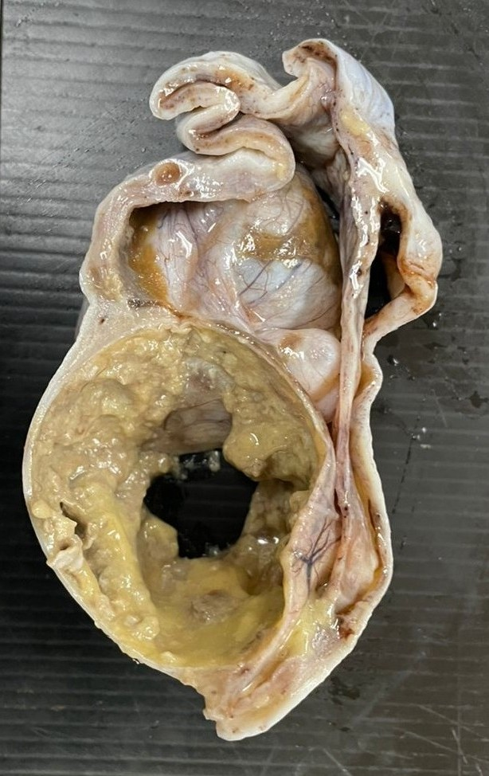
*
Figure 2: Gross specimen consisted of a partially incised ovarian tumour measuring 260x240x70mm, with an attached fallopian tube measuring 65mm in length and 15mm in diameter (*). The tumour was well defined and predominantly encapsulated. The incised surface demonstrated a capsular defect with an irregular surface area measuring 65mm in diameter. The tumour was multiloculated, with cyst ranging from 25 to 75mm in diameter containing abundant mucoid material. Multiple solid areas measuring 35 to 90mm were identified. These solid areas are composed of dense, compact and thick mucoid materials. One thin-walled locule measuring 60mm contained sebaceous material and fine hair.

Extensive histopathological examination with adequate sampling was performed in accordance with the Royal College of Pathologists of Australasia guidelines (rcpa.edu.au). Sampling included at least one block per centrimeter of maximum tumour dimension for neoplasm <10cm, and two blocks per centimetre for larger tumours (Silverberg et al, 2004). A consensus diagnosis was made following multidisciplinary pathological review.

DISCUSSION
Mature Teratomas are common benign ovarian tumours, often referred to as dermoid cysts, and are most frequently seen in younger women. They are typically identified incidentally during routine pelvic imaging in asymptomatic patients. However, some patients may present with a pelvic mass, which can extend into the abdomen and may be associated with abdominal discomfort (Shen et al, 2018). Compressive symptoms, such as urinary frequency and constipation, may occur in cases of large tumours (Jong et al, 2009).On imaging, including CT or magnetic resonace imaging (MRI), these tumours are characterised as large, multiloculated cystic lesions containing fat components and calcifications. Mucinous tumours arising in association with mature teratomas require a careful histological evaluation for accurate diagnosis. A key diagnostic challenge lies in differentiating between a mucinous tumour arising from a mature teratoma and a collision tumour. Collision tumors are characterised as the coexistence of two or more histologically distinct neoplasms, occurring adjacent to each other without histological admixture. The most common ovarian collision tumors involve mucinous tumors and mature teratomas (Kim et al,1999). Mucinous tumors occur in approximately 2–11% of mature teratomas, while 3–8% of ovarian mucinous tumors are associated with mature teratomas (Vang et al, 2007). Borderline mucinous tumours arising from mature teratomas are relatively rare, accounting for approximately 5% of cases.
Histological appearance of ovarian mucinous tumours arising from mature teratomas may closely resemble mucinous neoplasm of appendiceal or lower gastrointestinal origin, making differentiation more challenging (Ronnett et al, 2003)(Stewart et al, 2006). In the present case, immunohistochemical study demonstrated diffuse and strong expression of cytokeratin 7 (CK7), with heterogenous expression of cytokeratin 20 (CK 20) and caudal-type homeobox transcription factor 2 (CDX2). The expression pattern of CK7 and CK20 is particularly useful in the distinguishing ovarian mucinous borderline tumours from lower gastrointestinal tract tumours, where diffuse expression of CK 20 and absent of CK7 typically favour a gastrointestinal origin. (Steffen et al, 2016)
Notably, teratoma-associated mucinous borderline tumours may demonstrate an immunohistochemical expression profile similar to mucinous neoplasms of the lower gastrointestinal tract, with diffuse expression of CK 20 and CDX2, and absence of CK7. (Vang et al, 2007) (Olivia et al, 2016) Therefore, it is plausible that such teratoma- associated low grade mucinous tumour of the ovary should be classified as distinct entity among other primary or metastatic mucinous tumours. (Olivia et al, 2016) No single criterion reliably distinguishes primary from metastatic mucinous tumours of the ovary. A comprehensive assessment incorporating clinical, histological, and immunohistochemical features, together with molecular genotyping, allow more accurate diagnosis in more than 85% of cases. (Steffen at al, 2016) (Olivia et al, 2016)
Borderline mucinous changes require more extensive and thorough histopathological evaluation; this has crucial implications to the surgical approach and decision making for adjuvant treatment. In cases of malignant transformation, a more radical surgical approach may be considered. Nevertheless, in tumours with low malignant potential, such as borderline mucinous tumours, fertility sparing surgery with more conservative approach may be performed. Currently, there are no specific tumour markers that would be reliable in establishing preoperative diagnosis of mucinous tumours arising from mature teratomas. Clinically, patients often present with a large pelvic mass. A limited number of studies have described CT or MRI findings of these tumours. (Tanaka et al, 2023). These lesions are typically described as multilocular cystic mass containing both fatty and non-fatty components (Okada et al, 2004). Therefore, with very limited information available due to its rarity, preoperative diagnosis remains challenging, and definitive diagnosis often established with the aid of histopathological examination.

CONCLUSION
Given the rarity of mucinous borderline tumours arising from mature teratomas, definitive diagnosis is typically established through a comprehensive assessment including immunohistochemical analysis and histopathological examination. Careful histological examination is essential, as these lesions may exhibit a spectrum ranging from a tumour of low malignant potential which may be managed conservatively with surveillance, to more aggressive form of malignancy that required radical treatment.
Consent
As per international standards or university standards, patient(s) written consent has been collected and preserved by the author(s).
Ethical Approval:
As per international standards or university standards written ethical approval has been collected and preserved by the author(s).
Disclaimer (Artificial intelligence)

Author(s) hereby declare that NO generative AI technologies such as Large Language Models (ChatGPT, COPILOT, etc.) and text-to-image generators have been used during the writing or editing of this manuscript.

REFERENCES
Jong HH, Kyeong-A S, Gayatri M, Jae K, Lee N, Woo L et al. "Borderline-like mucinous tumor arising in mature cystic teratoma of the ovary associated with pseudomyxoma peritonei." (Int J Gynecol Pathol) 28, no. 3 (2009): 376-80.
Kim SH, Kim YJ, Park BK, Cho JY, Kim BH, Byun JY. "Collision tumors of the ovary associated with teratoma: clues to the correct preoperative diagnosis." (J Comput Assist Tomogr) 23, no. 6 (1999): 929-933.
Okada S, Ohaki Y, Ogura J, Ishihara M, Kawamura T, Kumazaki T. "Computed tomography and magnetic resonance imaging findings in cases of dermoid cyst coexisting with surface epithelial tumors in the same ovary." (J Comput Assist Tomogr.) 28, no. 2 (2004): 169-173.
Olivia L Snir, Natalia Buza, Pei Hui. "Mucinous epithelial tumours arising from ovarian mature teratomas: a tissue genotyping study." (Histopathology) 2016.
Ronnett BM, Seidman JD. "Mucinous tumors arising in ovarian mature cystic teratomas: relationship to the clinical syndrome of pseudomyxoma peritonei." (Am J Surg Pathol. ) 27, no. 5 (2003): 650-657.
Shen Q, Tong J, Xiang J, Lai L, Shang H. "Co-existing mature cystic teratoma and borderline ovarian mucinous cystadenoma: a report of three cases." (Int J Clin Exp Med) 11, no. 5 (2018): 5227-31.
Silverberg SG, Bell DA, Kurman RJ, Seidman JD, Prat J, Ronnet BM et al. "Borderline ovarian tumours: key points and workshop summary." Hum. Pathol. 35, no. 8 (2004): 910-7.
Steffen Hauptmann, Katrin Friedrich, Raymond Redline, Stefanie Avril. "Ovarian boderline tumours in 2014 WHO classification: evolving concepts and diagnostic criteria." (Virchows Arch ) 470 (2016): 125-142.
Stewart CJ, Tsukamoto T, Cooke B, Leung YC, Hammond IG. "Ovarian mucinous tumour arising in mature cystic teratoma and associated with pseudo-myxoma peritonei: report of two cases and comparison with ovarian involvement by low-grade appendiceal mucinous tumour. Pathology." 38, no. 6 (2006): 534-538.
Tanaka YO, Sugawara E, Tonooka A, et al. "Mucinous tumors arising from ovarian teratomas as another source of pseudomyxoma peritoneii: MR findings comparison with ovarian metastases from appendiceal mucinous tumors." (BJR Open) 5, no. 1 (2023).
Vang R, Gown AM, Zhao C, et al. "Ovarian mucinous tumors associated with mature cystic teratomas: morphologic and im-munohistochemical analysis identifies a subset of potential teratomatous origin that shares features of lower gastrointestinal tract mucinous tumors more commonly encounte." (Am J Surg Pathol) 31, no. 6 (2007): 854-869.

