Case report
Mucinous borderline tumour with microinvasion arising from a Mature Teratoma

ABSTRACT
A mucinous borderline tumour with microinvasion arising from a mature teratoma is usually an unexpected finding that is noted after surgery with histological confirmation. There are very limited cases reported in literature therefore no proper recommendation is readily available. We report a young lady who presented with a huge ovarian mass which was painless and associated with elevated CA125. Pre operative CT reported only a huge multiloculated ovarian tumour (solid-cystic) otherwise other findings were normal. Patient underwent staging laparotomy with fertility sparing surgery for a suspicious early-stage ovarian malignancy which was successfully done with no residual disease. Following surgery, histopathological examination confirmed a mucinous borderline tumour with microinvasion (2mm) arising from a mature teratoma. Immunohistochemical stain showed diffuse and strong intensity of CK7, but heterogeneous staining pattern of CK20 and CDX2. This case report emphasizes on importances of the histopathological report in managing the patient, surgical options available, disease surveillance methods as well as progress and follow up of this patient.
Key words: Mature teratoma, mucinous borderline tumour

INTRODUCTION
Ovarian teratoma is a common type of germ cell tumour which is usually benign. It consists of tissues from three blastodermic layers namely the ectoderm, mesoderm and endoderm. It has a rare potential to present with malignant transformation which cells within a typically benign teratoma develop into somatic cancer such as adenocarcinoma and sarcoma. This peculiar transformation besides being rare it is also an aggressive type and making it resistant to conventional chemotherapy and radiotherapy. They usually have metastatic disease on presentation with poor prognosis. Where-else a borderline ovarian tumour (BOV) is an ovarian growth with features between benign and malignant often called as tumours of low malignant potential. Therefore, a borderline ovarian tumour arising from an ovarian mature teratoma is an uncommon entity and often diagnosed after surgery and histopathological examination. Here we report a 25 years young lady who presents with a huge ovarian mass and following surgery, histopathological reported as Teratoma associated Mucinous tumour and the mucinous component showed features of mucinous borderline tumour with microinvasion.

CASE PRESENTATION
25 years women presented with abdominal distension over 2 months duration which was gradually increasing in size and painless. Patient did not have any compressive symptoms or constitutional symptoms. On clinical examination, patient was hemodynamically stable and afebrile. On inspection and palpation, there was a huge mass measuring occupying the entire abdomen. Patient had a CT thorax, abdomen and pelvis done revealed a huge multiloculated solid-cystic ovarian mass measuring 40x22cm (Figure 1) with no ascites, and no evidence of regional or distant metastases. Pre operative Ca125 levels were elevated 241 U/ml (reference range 0 – 34 U/ml), otherwise the other blood parameters were within normal range. Following extensive discussion and counselling patient was decide for a fertility sparing procedure in which she underwent a staging laparotomy with right salping-oopherectomy, omentectomy, right pelvic lymphadenectomy, appendicectomy and peritoneal fluid for cytology. Intraoperatively, there was a huge right ovarian mass 35x35cm, solid-cystic (predominantly cystic), smooth surface, no ascites, normal omentum, normal appendix, sub-centimetre pelvic lymph nodes and normal peritoneal survey was noted. Patient had a rapid recovery post operatively and discharged well on day 2 post surgery. Subsequently the histopathological report revealed a Teratoma associated Mucinous tumour and the mucinous component showed features of mucinous borderline tumour with microinvasion (2mm). The mucinous component shows histologically and immunohistochemically features similar to mucinous tumour of ovarian epithelial origin. Otherwise, no immature or other germ cell tumour component seen and no features of low-grade mucinous neoplasm of appendix (LAMN) seen as well. Subsequently patient was under surveillance in our clinic with CA125 monitoring and pelvic ultrasound. Patient had her CA125 normalized and no evidence of any pelvic recurrence seen by pelvic ultrasound over 15 months. Following which patient successfully conceive after 15 months of surveillance, unfortunately the pregnancy was complicated with a rupture tubal ectopic pregnancy. Patient underwent a diagnostic laparoscopy and left total salpingectomy for ruptured ectopic pregnancy, intraoperatively there was a ruptured left tubal ectopic pregnancy measuring about 4x5cm totally distorted fallopian tube which was confirmed histopathological. Besides that, the left ovary and remaining abdominal survey did not show any evidence of disease recurrence. Patient recovered well with adequate counselling post-surgery and resumed her regular surveillance in our clinic. She has been advised for ART (Assisted Reproductive Technology) as well. And no tumour recurrence noted for 2 years at the time this manuscript was written.
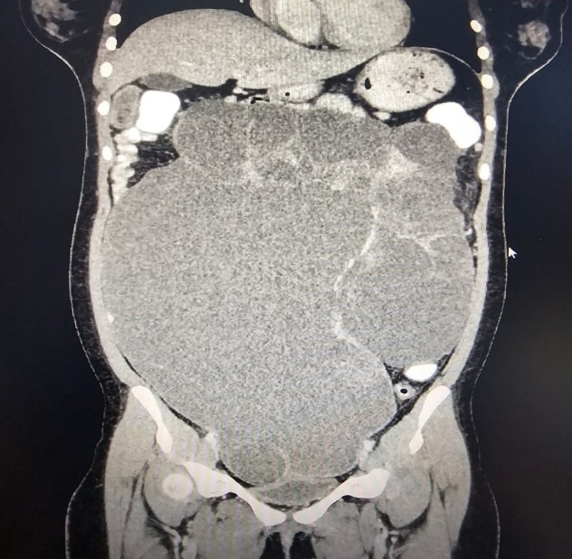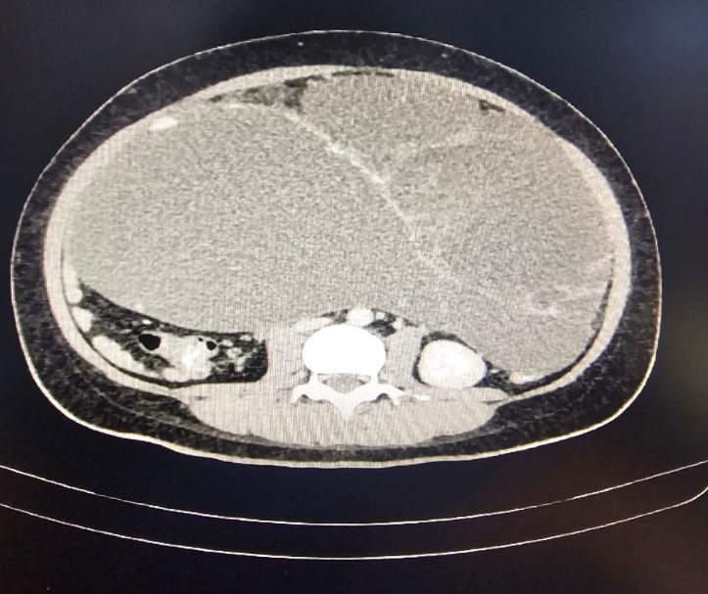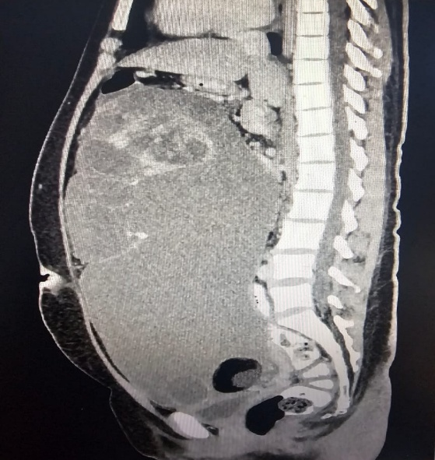
Figure 1: CT findings of the huge multiloculated ovarian mass. There is presence of enhancing solid components within. The mass displaces the adjacent bowel loops, however, no bowel dilatation seen. There is compression onto IVC, abdominal aorta, right common iliac artery, bilateral external iliac artery and bilateral external iliac vein. No clear plane to the uterus and urinary bladder inferiorly.
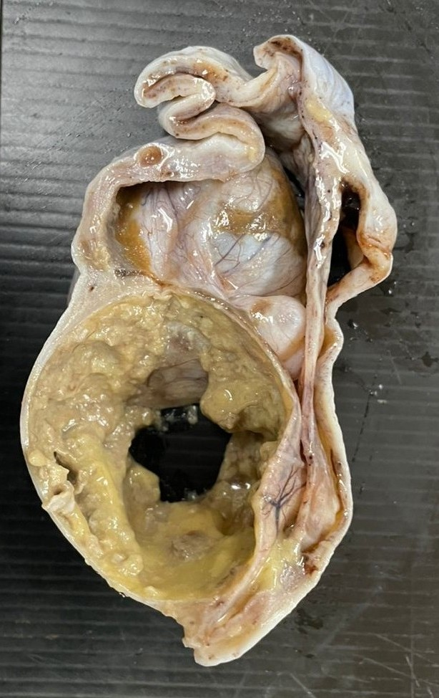
Figure 2: The specimen consists of a partially cut opened ovarian tumour measuring 260x240x70mm with attached fallopian tube measuring 65mm long and 15mm in diameter. The tumour is well defined and encapsulated in most areas. The cut opened area shows capsular defect with an area of irregular surface measuring 65mm in diameter. Cut surface is multiloculated with cyst measuring from 25mm to 75mm in diameter. The cyst contains abundant mucoid material. There are multiple solid areas measuring from 35mm to 90mm in diameter. These solid areas are composed of dense, compact and thick mucoid materials. One of the thin walled locules measured 60mm in diameter, contains sebaceous material and fine hair.

Extensive histopathological examination and adequate sampling have been carried out according to the guideline of Royal College of Pathologists of Australasia (rcpa.edu.au) in which sampling was done at least one block per cm of maximum dimension for neoplasm <10cm and two blocks per cm for larger tumours (Silverberg SG 2004) before the consensus for histopathological diagnosis was made among the pathologists.

DISCUSSION
Mature Teratomas are common benign ovarian tumour often called dermoid cyst and seen especially in younger women. They are typically found incidentally during routine pelvic ultrasound in a asymptomatic patient. Some patients present with a pelvic mass which might extend abdominally and may be associated with abdominal discomfort (Shen Q 2018). Compressive symptoms would be apparent if the mass if larger in size which includes frequent urination and constipation (Jong HH 2009). On imaging either CT or MRI theses tumours typically are large, multiloculated cystic lesions with fat components and calcifications within. Mucinous tumour associated with a mature teratoma requires a careful histological examination and confirmation. Challenges include differentiating between collision tumour and mucinous tumour arising from a mature teratoma. Collision tumors are characterized by presences of two or more histologically distinct tumors, adjacent to each other without histologic admixture. The most common ovarian collision tumors consist of mucinous tumors and mature teratomas (Kim SH 1999). A mucinous tumor occurs in 2%–11% of ovarian mature teratomas, whereas 3%–8% of ovarian mucinous tumors co-exist with mature teratomas (Vang R 2007). Where-else a borderline mucinous tumour arising from a mature teratoma is about 5%.
Histological appearance of an ovarian mucinous tumour arising from a mature teratoma are similar to mucinous neoplasm arising from the appendix and lower intestine as well, this makes the task of the pathologist more difficult to differentiate between them(Ronnett BM 2003)(Stewart CJ 2006). In our case, the immunohistochemical study showed diffuse and strong intensity of CK7, whereas heterogenous staining pattern for CK 20 and CDX2. While the expression pattern of CK7 and 20 is most useful in the differential of mucinous borderline tumour and lower gastrointestinal tract tumours, with diffuse expression of CK 20 and absence of CK7 favouring gastrointestinal origin. (Steffen Hauptmann 2016) Of note, teratoma-associated mucinous borderline tumours are characterized by an immunohistochemical expression profile similar to mucinous neoplasms of the lower gastrointestinal tract, with diffuse expression of CK 20 and CDX2, and absence of CK7. (Vang R 2007) (Olivia L Snir 2016) Taken together, it is plausible that such teratoma- associated low grade mucinous tumour of the ovary should be classified as distinct entity among other primary or metastatic mucinous tumours. (Olivia L Snir 2016) No single criterion allows definitive differentiation of primary versus metastatic ovarian mucinous tumours, but by taking into account combined clinical, histological, and immunohistochemical features, together with molecular genotyping, distinction is possible in more than 85% of cases. (Steffen Hauptmann 2016) (Olivia L Snir 2016) As for borderline mucinous changes, it requires even more extensive and careful histological examination; this would change the approach of surgery as well decision for adjuvant treatment. In a malignant transformation, a more radical approach would be considered and those tumours with low malignant potential as the borderline mucinous tumours, fertility sparing surgery and a more conservative approach can be considered. There are no specific tumour markers that would be helpful in preoperative diagnosis or suspicion of this condition. In most cases, clinically patient presents with large pelvic mass and very few studies have described CT or MRI findings of mucinous tumour associated with mature teratoma (Tanaka YO 2023). It typically described as fat containing cystic fluid with a multilocular cystic mass filled with non-fatty fluid (Okada S 2004). Therefore, with very limited information available due to its rarity, pre operative diagnosis of this peculiar condition is very much impossible.

CONCLUSION
As conclusion, a mucinous borderline tumour arising from a mature teratoma is a rare entity and the diagnosis very much relies on the histopathological examination. A careful histological examination is essential as this benign condition may give rise to a spectrum of condition from a tumour of low malignant potential which only requires surveillance, to an aggressive form of malignancy which could be resistant to most treatment modality.

Disclaimer (Artificial intelligence)

Author(s) hereby declare that NO generative AI technologies such as Large Language Models (ChatGPT, COPILOT, etc.) and text-to-image generators have been used during the writing or editing of this manuscript.

REFERENCES
- Jong HH, Kyeong-A S, Gayatri M, Jae K, Lee N, Woo L et al. "Borderline-like mucinous tumor arising in mature cystic teratoma of the ovary associated with pseudomyxoma peritonei." (Int J Gynecol Pathol) 28, no. 3 (2009): 376-80.
- Kim SH, Kim YJ, Park BK, Cho JY, Kim BH, Byun JY. "Collision tumors of the ovary associated with teratoma: clues to the correct preoperative diagnosis." (J Comput Assist Tomogr) 23, no. 6 (1999): 929-933.
- Okada S, Ohaki Y, Ogura J, Ishihara M, Kawamura T, Kumazaki T. "Computed tomography and magnetic resonance imaging findings in cases of dermoid cyst coexisting with surface epithelial tumors in the same ovary." (J Comput Assist Tomogr.) 28, no. 2 (2004): 169-173.
- Olivia L Snir, Natalia Buza, Pei Hui. "Mucinous epithelial tumours arising from ovarian mature teratomas: a tissue genotyping study." (Histopathology) 2016.
- Ronnett BM, Seidman JD. "Mucinous tumors arising in ovarian mature cystic teratomas: relationship to the clinical syndrome of pseudomyxoma peritonei." (Am J Surg Pathol. ) 27, no. 5 (2003): 650-657.
- Shen Q, Tong J, Xiang J, Lai L, Shang H. "Co-existing mature cystic teratoma and borderline ovarian mucinous cystadenoma: a report of three cases." (Int J Clin Exp Med) 11, no. 5 (2018): 5227-31.
- Silverberg SG, Bell DA, Kurman RJ, Seidman JD, Prat J, Ronnet BM et al. "Borderline ovarian tumours: key points and workshop summary." Hum. Pathol. 35, no. 8 (2004): 910-7.
- Steffen Hauptmann, Katrin Friedrich, Raymond Redline, Stefanie Avril. "Ovarian boderline tumours in 2014 WHO classification: evolving concepts and diagnostic criteria." (Virchows Arch ) 470 (2016): 125-142.
- Stewart CJ, Tsukamoto T, Cooke B, Leung YC, Hammond IG. "Ovarian mucinous tumour arising in mature cystic teratoma and associated with pseudo-myxoma peritonei: report of two cases and comparison with ovarian involvement by low-grade appendiceal mucinous tumour. Pathology." 38, no. 6 (2006): 534-538.
- Tanaka YO, Sugawara E, Tonooka A, et al. "Mucinous tumors arising from ovarian teratomas as another source of pseudomyxoma peritoneii: MR findings comparison with ovarian metastases from appendiceal mucinous tumors." (BJR Open) 5, no. 1 (2023).
- Vang R, Gown AM, Zhao C, et al. "Ovarian mucinous tumors associated with mature cystic teratomas: morphologic and im-munohistochemical analysis identifies a subset of potential teratomatous origin that shares features of lower gastrointestinal tract mucinous tumors more commonly encounte." (Am J Surg Pathol) 31, no. 6 (2007): 854-869.

