Mindfulness Research in Mental Health in Vietnam: A Citation Analysis
Abstract
Background: Citation analysis is a scholarly method for evaluating citation patterns to examine the impact, knowledge exchange, and academic communication. Despite its global growth, citation analysis has been limited in evaluating mindfulness and mental health research in the Vietnamese context.
Purpose: This study aims to conduct a citation analysis to systematically examine the intellectual structure and research trends in mindfulness in mental healthcare in the Vietnamese context.
Methodology: The present study used quantitative citation analysis to assess the academic impact and intellectual structure of research on mindfulness in mental healthcare in the Vietnamese context. The data for this study were gathered from Clarivate's Web of Science (WoS), which includes high-quality papers from rigorously peer-reviewed journals. Records were exported from WoS and analyzed using VOSviewer 1.6.20 to construct and visualize citation, co-citation, and co-occurrence networks. The search command was employed, covering publications from 2015-01-01 to 2025-12-31. In addition, results were refined by document type (articles), language (English), and region/country (Vietnam). As a result, only 28 relevant articles were selected for citation analysis.
Findings: The data analysis reveals that mindfulness remains a comparatively current and emerging theme in mental healthcare and psychological well-being in Vietnam. The majority of publications and citations have steadily increased since 2020, suggesting growing recognition of the benefits, impacts, and applications of mindfulness in mental healthcare across several populations in Vietnam, including university students and adults. Based on an analysis of the top 10 most cited publications, the researcher found that the COVID-19 pandemic emerged as a significant catalyst for the application of mindfulness to improve individuals' well-being. The co-citation networks based on authors and sources offer valuable insights into the intellectual framework of mindfulness research in Vietnam's mental healthcare field.
Implications: Improving mental health can be achieved by effectively applying mindfulness across diverse populations in the Vietnamese context.
Conclusion: The current study lays a foundation for future research, aiming to strengthen academic networks, foster collaboration between institutions, and establish a more consistent, coherent, and internationally recognized framework for mindfulness in mental healthcare in Vietnam.
Keywords: Citation analysis, mindfulness, mental healthcare, co-citation analysis, Vietnam

1. Introduction
Buddhism was introduced in Vietnam in the first century and became deeply intertwined with Vietnamese culture and religions. Engaged Buddhism in Vietnam emerged in the 1950s as a transformative movement that sought to integrate Buddhism into everyday life. Thich Nhat Hanh, a Vietnamese Zen Buddhist, was a pioneer of Engaged Buddhism, addressing contemporary issues in life. Mindfulness is one of the central Buddhist practices and is widely used across various fields, especially in psychosocial support for mental health in modern Vietnamese society. According to Chems-Maarif et al. (2025), mindfulness involves awareness of the present moment, nonjudgment, and attention to internal experiences and external surroundings, cultivated with acceptance and equanimity. Mindfulness-based interventions originate in Buddhist meditation but are secular and aim to regulate and improve emotional and cognitive functioning rather than promote spiritual development (Weiss et al., 2025).
The literature reviews reveal that mindfulness is a promising intervention in mental healthcare, with notable positive effects across various psychological issues. Research shows that mindfulness not only boosts psychological well-being but also decreases psychological symptoms and emotional problems (Keng et al., 2011). Studies on mindfulness suggest promising yet emerging mental healthcare strategies for youth in Vietnam. Mindfulness interventions have been enthusiastically embraced by young Vietnamese people and viewed as a stress-prevention tool (Le et al., 2014). Additionally, mindfulness has been shown to lower stress, anxiety, and depression among Vietnamese university students, based on self-compassion and psychological well-being (Tran et al., 2024). Similarly, Vu (2024) highlighted the potential of mindfulness-based cognitive practices to address stress and improve well-being among university students in Vietnam.
Citation analysis is a scholarly method used to evaluate reference patterns to explore the impact, knowledge exchange, and academic communication. Mindfulness research has experienced exponential growth in publications and citations, especially in clinical and mixed-population research in the mental healthcare field. Citation analysis in mindfulness studies, using bibliometric techniques such as co-citation and bibliographic coupling, helps map the field's intellectual structure (Walsh & Daniel, 2018). Analyzing mindfulness research in mental health through citation analysis uncovers key thematic clusters, including measurement, underlying mechanisms, and intervention efficacy (Bunjak et al., 2022). Despite its global growth, citation analysis has been limited in evaluating mindfulness and mental health research in Vietnam. Therefore, this study aims to conduct a citation analysis to systematically examine the intellectual structure and research trends of mindfulness in mental healthcare in the Vietnamese context. These are the five specific research objectives (RO), including:
- RO1: To analyze trends in yearly publications and citation counts related to mindfulness in mental healthcare in Vietnam.
- RO2: To identify the most highly cited papers on mindfulness in mental healthcare in Vietnam.
- RO3: To assess author co-citation patterns in the field of mindfulness within mental healthcare in Vietnam.
- RO4: To identify the most common co-citation sources in the field of mindfulness within mental healthcare in Vietnam.
- RO5: To explore the main clusters that emerge within the field of mindfulness research related to healthcare in Vietnam.
- RO6: To assess the co-authority that emerges in the field of mindfulness within mental health care in Vietnam
2. Methodology
Figure 1. Citation analysis research steps

Note: The researchers created the image
The present study used quantitative citation analysis to assess the academic impact and intellectual structure of research on mindfulness in mental healthcare in the Vietnamese context. Citation analysis is a systematic method for examining reference patterns in scholarly literature to understand research impact, knowledge networks, and research trends. The key steps in citation analysis are shown in Figure 1, including data collection, citation counting, exploration and analysis of the most influential publications, identification of relationships between authors and publications, and interpretation and discussion of research trends, flows, and academic collaborations in mindfulness and mental healthcare in Vietnam.
Figure 2 illustrates the data collection process for the citation analysis of mindfulness and mental healthcare in Vietnam. The data for this study were gathered from Clarivate's Web of Science (WoS), which includes high-quality papers from rigorously peer-reviewed journals. WoS is particularly well-suited for citation analysis due to its standardized citation database and strong reliability in assessing and interpreting research impact factors. A targeted search method was employed to ensure relevance and exclude research unrelated to mental healthcare. The literature search was performed in WoS using the Topic Search field. The search command used included (“Mindfulness” AND (“mental health” OR “mental healthcare” OR “Intervention” OR “Psychological” OR therapy OR Wellbeing OR well-being) AND (Vietnam OR Vietnamese)), covering publications from 2015-01-01 to 2025-12-31. Additionally, results were refined by document type (articles), language (English), and region/country (Vietnam). As a result, only 28 relevant articles were selected for citation analysis. Records were exported from WoS and analyzed using VOSviewer 1.6.20 to construct and visualize co-citation, co-authorship, and co-occurrence networks.
Figure 2. Data collection process for citation analysis

Note: The researchers created the image
Figure 2 illustrates the data collection process for the citation analysis of mindfulness and mental healthcare in Vietnam. The data for this study were gathered from Clarivate's Web of Science (WoS), which includes high-quality papers from rigorously peer-reviewed journals. WoS is particularly well-suited for citation analysis due to its standardized citation database and strong reliability in assessing and interpreting research impact factors. A targeted search method was employed to ensure relevance and exclude research unrelated to mental healthcare. The literature search was performed in WoS using the Topic Search field. The search command used included (“Mindfulness” AND (“mental health” OR “mental healthcare” OR “Intervention” OR “Psychological” OR therapy OR Wellbeing OR well-being) AND (Vietnam OR Vietnamese)), covering publications from 2015-01-01 to 2025-12-31. Additionally, results were refined by document type (articles), language (English), and region/country (Vietnam).
Inclusion and Exclusion Criteria
Inclusion criteria:
- Research type must be articles.
- Articles that emphasize mindfulness in association with mental health, psychological well-being, mental healthcare, psychological interventions, and therapy.
- Publications which are indexed in the WoS database.
- Articles must be published in English
- Spanning publications must be between 1st January, 2015 and 31st December 2025.
Exclusion criteria:
- Non-article research types must be excluded.
- Articles that do not focus on mindfulness in relation to mental health, well-being, mental healthcare, psychological interventions, and therapy.
- Publications which are not indexed in WoS databases.
- Articles that are published in non-English.
- Articles that were published before 1st January, 2015 and after 31st December, 2025.
As a result, only 28 relevant articles were selected for citation analysis. Records were exported from WoS and analyzed using VOSviewer 1.6.20 to construct and visualize co-citation, co-authorship, and co-occurrence networks.
3. Results
3.1. Annual trends in publications and citation counts regarding mindfulness in mental healthcare in Vietnam.
Figure 3. Overall trend analysis of publications and citations
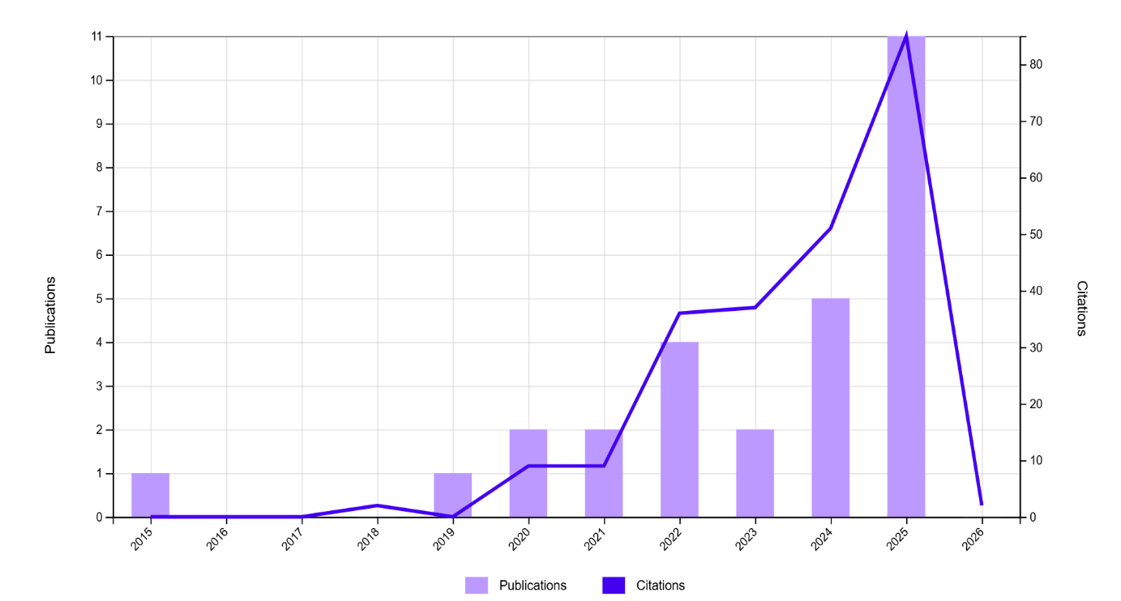
Note: The image was exported from WoS
Figure 3 illustrates the trends in annual publications and citation counts in the field of mindfulness and mental healthcare in Vietnam from 2015 to 2025. In the early years from 2015 to 2019, there were very few publications, with only one paper published and minimal citation activity. Research on mindfulness and mental well-being started to emerge gradually between 2020 and 2021. As shown in Figure 3, the increase in published articles and significant citations during this brief period indicates growing recognition of the topic. The influential papers published between 2020 and 2021 may serve as key references for future scholars. A rapid increase in both annual publications and citations occurred between 2022 and 2024. The number of publications steadily rose from 4 to 5 articles per year. Citations also grew rapidly, reflecting the high impact of literature on mindfulness-based interventions in mental healthcare in Vietnam. Additionally, the field reached its peak impact in 2025 with 85 citations and 11 publications. This pattern is typical of research areas transitioning from exploration to consolidation.
3.2. The most highly cited papers in mindfulness in mental healthcare in Vietnam
Table 1. Top ten most cited papers in mindfulness and mental health in Vietnam
No | Authors | Cites | Title | Year
1 | Tran, M. A. Q., Vo-Thanh, T., Soliman, M., Khoury, B., & Chau, N. N. T. | 41 | Self-compassion, Mindfulness, Stress, and Self-esteem Among Vietnamese University Students: Psychological Well-being and Positive Emotion as Mediators | 2022
2 | Nguyen, T. M., & Le, G. N. H. | 40 | The Influence of COVID-19 Stress on Psychological Well-Being Among Vietnamese Adults: The Role of Self-Compassion and Gratitude | 2021
3 | Tran, M. A. Q., Vo-Thanh, T., Soliman, M., Ha, A. T., & Van Pham, M | 39 | Could mindfulness diminish mental health disorders? The serial mediating role of self-compassion and psychological well-being | 2024
4 | Nguyen, N. P., Wu, H., Evangelista, F., & Nguyen, T. N. Q | 35 | The effects of organizational mindfulness on ethical behaviour and firm performance: empirical evidence from Vietnam | 2020
5 | Nguyen, T., Pu, C., Waits, A., Tran, T. D., Ngo, T. H., Huynh, Q. T. V., & Huang, S. L. | 12 | Transforming stress program on medical students' stress mindset and coping strategies: a quasi-experimental study | 2023
6 | Quang, A. M. T., Van Pham, M., Mai, T. T., Le, G. N. H., & Song, G. A. N. | 11 | Self-compassion and Students' Well-Being Among Vietnamese Students: Chain Mediation Effect of Narcissism and Anxiety | 2022
7 | Tam, D. U., & Trang, N. T. M. | 8 | Customer and supervisor incivility, psychological distress, and job performance among airport frontline employees: the moderating role of mindfulness | 2024
8 | Van Do, V., Spears, C. A., Van Minh, H., Huang, J., Redmon, P. B., Long, N. X., & Eriksen, M. P. | 8 | Perceptions About Mindfulness and Text Messaging for Smoking Cessation in Vietnam: Results From a Qualitative Study | 2020
9 | Nguyen, H. V., Van Nguyen, A., & Dinh, H. L. H. | 7 | COVID-19 uncertainties to impulsive buying behavior: the roles of mindfulness and afterlife belief | 2023
10 | Niemi, M., Nguyen, M. T., Bartley, T., Faxelid, E., & Falkenberg, T. | 6 | The Experience of Perinatal Depression and Implications for Treatment Adaptation: A Qualitative Study in a Semi-rural District in Vietnam | 2015
Note: The researchers compiled the table
Table 1 shows the top 10 most-cited papers on mindfulness research in mental healthcare. Among these highly cited publications, the highest number of citations is 41, and the lowest is 6. The average number of citations for these top 10 articles is 20.7. Overall, the most-cited papers indicate that mindfulness research in Vietnam has grown, driven by psychologically and contextually integrative mechanisms within mental healthcare systems. The interaction of self-compassion, mindfulness, and well-being models acts as a coping mechanism to improve mental health, especially among university students and adults in Vietnam, as shown in the most-cited studies by Tran et al. (2022) and Nguyen and Le (2021). This finding emphasizes the modern clinical mindfulness approach, which considers self-compassion a key method through which mindfulness effectively supports individuals dealing with mental health issues like stress, anxiety, and depression.
Although most highly cited papers on mindfulness theories are actively involved in psychological, clinical, and educational practices, they also reach into non-clinical settings. Several influential studies assess the use of mindfulness in applied and work environments, including the effects of organizational mindfulness on ethical behavior and company performance (Nguyen et al., 2020), the moderating role of mindfulness in encounters with customer and supervisor incivility, psychological distress, and job performance among airport frontline employees (Tam & Trang, 2024), and the combination of mindfulness and text messaging for smoking cessation (Van Do et al., 2020).
Interestingly, the COVID-19 pandemic has catalyzed an increase in citation impact for research on mindfulness-based interventions in mental healthcare. Several highly cited publications identify psychological disorders caused by COVID-19 (Nguyen & Le, 2021; Nguyen et al., 2023), highlighting how mindfulness mediates the process of addressing individuals' mental health issues during this challenging period. In other words, the pandemic functions as a contextual factor that significantly boosts the number of publications and citations in the field of mindfulness and mental health in Vietnam.
3.3. Author co-citation patterns in the field of mindfulness in mental healthcare in Vietnam
3.3.2. Co-cited author analysis
The co-citation analysis in terms of cited authors indicates a well-defined intellectual structure in the research area, with four main clusters. The co-citation analysis based on references identified 1719 authors; however, because the database included only the first authors, the sample was narrowed to 200 authors who were cited at least twice. These created 9 clusters, each in a different color, and were connected by 200 links, as shown in Figure 4. The largest cluster focuses on Neff and K.D., representing theories of self-compassion and their relationship to mental health. Additionally, Brown, K.W., and Kabat-Zinn, J. J are the central authors, highlighting a conceptual approach and methods for measuring mindfulness that emphasize the present moment. Conversely, two methodologically oriented clusters emerge, including Hayes, A. F., and Hair, J.F., with the former representing mediating analysis and the latter focusing on structural equation modeling and scale reliability evaluation. Although the co-citation analysis is based on author pairs, node sizes reflect the overall level of co-citation across different authors. The study results indicate that the field is grounded in a robust conceptual framework of mindfulness and self-compassion and relies on quantitative research methods.
Figure 4. Network visualization of co-cited author analysis
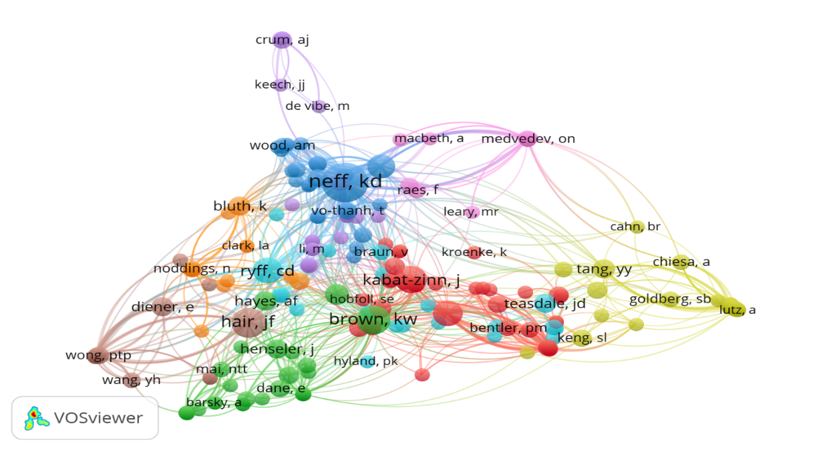
Note: The researchers created the image using VOSviewer
3.4. The most frequent co-citation sources in the field of mindfulness in mental healthcare in Vietnam
From the initial dataset of 1111 sources, a threshold was set to include only those cited at least twice, resulting in a final sample of 282 sources, as shown in Figure 5. This method helps identify the most influential sources or journals that serve as key references for researchers exploring mindfulness in mental health. The final sample consisted of 8 clusters in different colors, 10781 links, and a total link strength of 32787. The co-citation analysis of cited sources demonstrates a well-organized flow of intellectual development in mindfulness research. The central cluster features journals such as Mindfulness, Frontiers in Psychology, Journal of Environmental Research and Public Health, and Personality and Individual Differences, reflecting the theoretical and empirical background of mindfulness in psychological well-being and individual differences. Additionally, other clusters reveal interdisciplinary extensions, including mindfulness in clinical psychology (Clinical Psychology Review, Journal of Child Psychology and Psychiatry, Consciousness and Cognition, and Psychosomatic Medicine); occupational and organizational psychology (Journal of Applied Psychology, Journal of Occupational Health Psychology, and Journal of Business Ethics); and Business, Marketing, and Behavior (Journal of Business Research, Computers in Human Behavior, International Journal of Information Management, and Marketing Letters). Furthermore, a distinct cluster of methodological and educational journals highlights the growing focus on mindfulness assessment, psychometrics, and education and training (Assessment, Psychometrika, Nurse Education Today, and Thinking Skills and Creativity). Therefore, the source co-cited network indicates that mindfulness has expanded from psychological well-being into multidisciplinary areas within mental healthcare.
Figure 5. Network visualization of co-cited source analysis
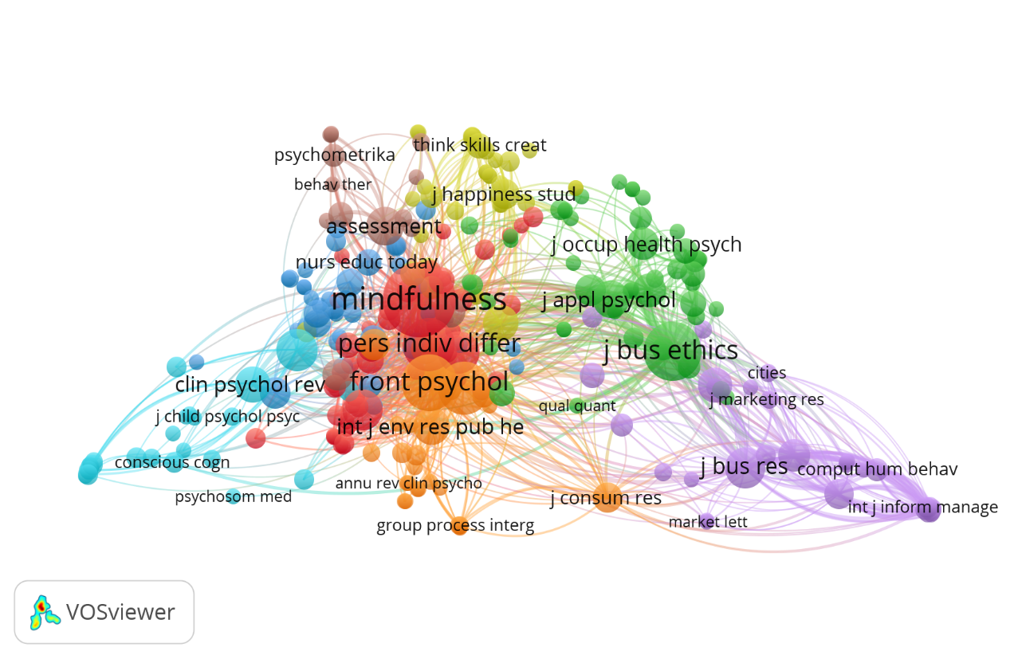
Note: The researchers created the image using VOSviewer
3.5. The main thematic clusters that emerge from co-citation analysis in the field of mindfulness research in correlation to healthcare in Vietnam
Figure 6. Network visualization of keyword co-occurrence
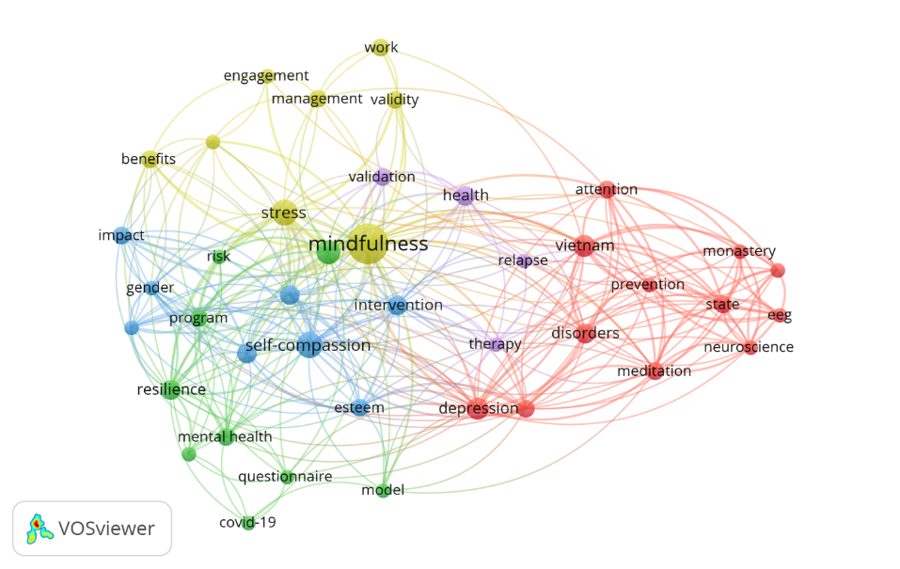
Note: The researchers created the image using VOSviewer
To explore the conceptual landscape of mindfulness in mental healthcare, a keyword co-occurrence analysis was conducted on WoS records, as shown in Figure 6. This analysis examines terminology and highlights key thematic clusters that guide the scholarly literature on mindfulness in mental healthcare. Out of 24741 keywords were selected based on the threshold of at least two occurrences for each keyword. These keywords formed 5 clusters, 204 links, and a total link strength of 433. Figure 6 shows the co-occurrence of keywords in publications about mindfulness in mental healthcare within Vietnam. Mindfulness is at the centre of the map, indicating it is a core concept closely linked to other research themes. The map has five clusters, each representing a specific theme. The yellow cluster relates to mindfulness and stress or work, with keywords such as stress, work, validity, benefits, engagement, and management. This theme shows that mindfulness has been studied in non-clinical settings, such as workplace areas, for stress management, as coping strategies. These studies also conducted scale validity testing of mental health and identify the association between mindfulness and the psychological wellbeing various different populations. The purple cluster focuses on health and mindfulness-based interventions, with keywords like health, intervention, therapy, relapse, and validation. This highlights the importance or significance of mindfulness in psychological treatments aimed at strengthening personal well-being in the clinical context. Additionally, exploration of scale validation is a significant research trend in mindfulness-based mental health interventions. The red cluster combines psychiatry and meditation, featuring keywords such as neuroscience, monastery, prevention, depression, disorders, therapy, and meditation. This indicates that mindfulness has been examined from clinical, neurobiological, and Buddhist meditative perspectives. Furthermore, the green cluster involves mental health measurement, research models, and the impact of COVID-19 on psychological well-being, pointing to a new trend in social research. The blue cluster emphasizes self-compassion and psychological factors, including resilience, self-esteem, gender, and intervention programs. This theme is relevant for applied psychology and education research.
3.6. Explore co-authorship emerging in the research field
3.6.1. Co-authorship analysis by authors
Figure 7. Network visualization of co-authorships based on author analysis
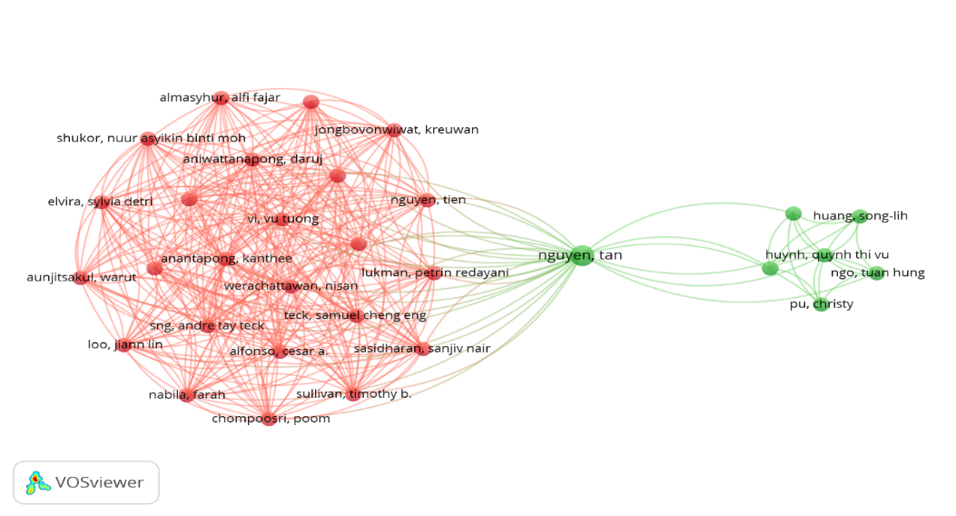
Note: The researchers created the image using VOSviewer
A total of 129 authors is grouped into 2 clusters with 321 links. Figure 7 shows the two main groups within the authors' co-authorship network. The first group includes international researchers, indicating strong, ongoing collaborations in mindfulness and mental health research. The second group consists of Vietnamese authors, with Nguyen (Tan) playing a key role in connecting them with other international scholars. In other words, Nguyen (Tan) actively helped expand the research network between Vietnamese and international researchers. Although these collaborations remain weak, this structure highlights emerging aspects of mindfulness research in mental healthcare in Vietnam and the increasing integration of Vietnamese scholars into the global academic community.
3.6.2. Co-authorship by organizations
Figure 8. Overlay visualization of co-authorships based on organizational analysis
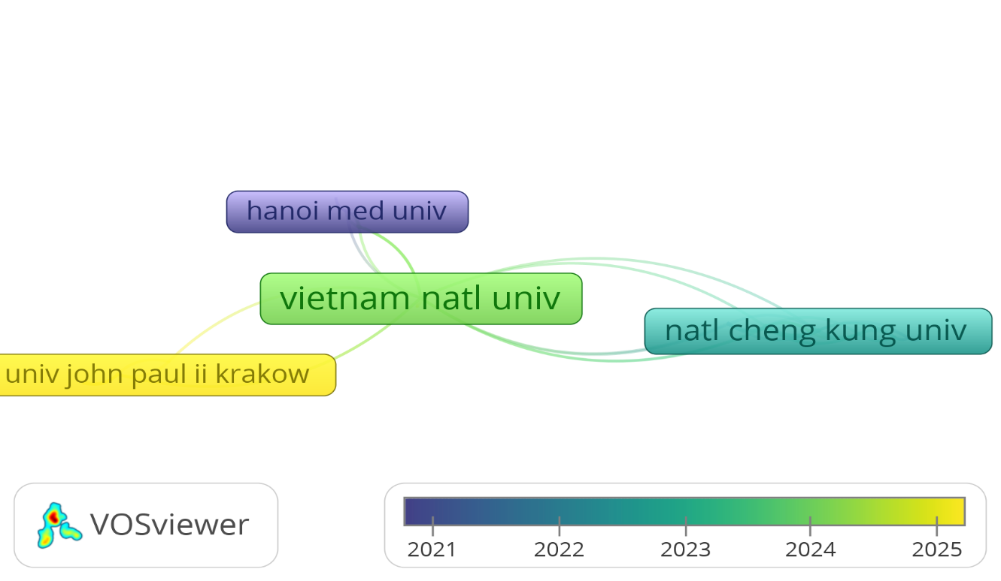
Note: The researchers created the image using VOSviewer
Of 7329 cooperating organizations were selected based on a threshold of at least 1 document per organization. These selected organizations formed five clusters, 81 links, and a total link strength of 89. The organizational co-authorship network exhibits a centralized collaboration structure, with Vietnam National University serving as a key hub that connects domestic and international organizations. The initial cooperation began in 2021 with Hanoi Medical University, while other current international collaborations have developed with National Cheng Kung University in Taiwan and the Pontifical University John Paul II Krakow in Poland, as shown in Figure 8.
3.6.3. Co-authorship by countries
Figure 9. Network visualization of co-authorships based on country analysis
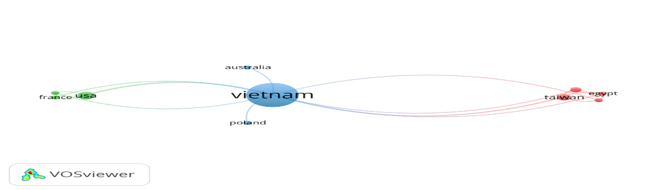
Note: The researchers created the image using VOSviewer
The co-authorship analysis based on references identified 19 countries; however, a threshold was set to include only countries with at least 2 publications, reducing the sample to 10. As shown in Figure 9, the co-authorship network of countries has three clusters, 18 links, and a total link strength of 36, indicating that several collaboration groups are somewhat separate. Despite this division, Vietnam remains centrally located, connecting all clusters in international cooperation, including Western, Asian, and emerging research partners or collaborators. The green cluster highlights the strong collaboration between Vietnam and Western countries, such as the USA and France. The red cluster shows strong cooperation among Vietnam and other Asian countries, including Egypt and Taiwan. However, there were no partnerships between this cluster and Western countries related to mindfulness research in mental health within the Vietnamese context. The light blue cluster shows peripheral collaboration in the research field between Vietnam and countries such as Australia and Poland.
4. Discussion
This study's findings provide a detailed overview of the intellectual and collaborative body of literature on mindfulness in mental healthcare in Vietnam, significantly advancing bibliometric research in this area. While previous studies have examined the effects of mindfulness on the psychological well-being of the Vietnamese population, this is the first study to analyze the social and intellectual structures of research, primarily using bibliometric analysis, with citation analysis as the main method, and restricting to 28 English-language articles in Vietnam. Selecting only 28 English articles from WoS and including the dataset for research in Vietnam may introduce several limitations for citation analysis. The small sample size decreases the stability and representativeness of network visualizations or citation models. Additionally, focusing on studies within a specific research area, like Vietnam, might limit the field's intellectual diversity. Moreover, using a small dataset in VOSviewer can yield a sparse, unstable network, rendering sensitive citation indicators highly susceptible to minor variations. However, the priorities are the dataset's concentration and quality rather than the number of articles, which helps this citation analysis provide an in-depth interpretation within the context of an emerging field of mindfulness in mental healthcare in Vietnam.
The data analysis reveals that mindfulness remains a comparatively current and emerging theme in mental healthcare and psychological well-being in Vietnam. The majority of publications and citations have steadily increased since 2020, suggesting growing recognition of the benefits, impacts, and applications of mindfulness in mental healthcare across several populations in Vietnam, including university students and adults. The analysis of the top 10-cited articles across 28 selected publications demonstrates that mindfulness research has grown and been shaped by psychological and contextual mechanisms within mental healthcare systems. From the top 10-cited papers in the dataset, it can be seen that mindfulness theories have gradually shifted from the psychological, clinical, and educational domains into non-clinical domains. This transition marks a significant expansion and coverage of mindfulness across multiple disciplines, with a view to strengthening mental healthcare for various populations in Vietnam. Based on an analysis of the top 10 most cited publications, the researcher found that the COVID-19 pandemic emerged as a significant catalyst for the application of mindfulness to improve individuals' well-being. In the global context, spiritual practices, such as mindfulness or meditation, can also be considered useful methods for community members to cope with mental issues during COVID-19. Similarly, the study by Bossi et al. (2022) stated that online mindfulness training programs play an important role in helping employees address their stress, particularly post-COVID-19. Furthermore, individual or group spiritual practices, including yoga, meditation, mindfulness, and engagement with the natural environment, help to cultivate resilience and transformation during the pandemic (Kelley et al., 2023). This also demonstrates that the importance of psychological intervention can be expanded at low cost, for example, through mindfulness practices and self-compassion. Cooperation between structured mindfulness and compassion nurturance training may strengthen the positive impact of psychological interventions (Conversano et al., 2020).
The co-citation networks based on authors and sources offer valuable insights into the intellectual framework of mindfulness research in Vietnam's mental healthcare field. In the Vietnamese context, the co-citation structure observed in mindfulness research within mental healthcare strongly depends on the international psychological conceptual framework, as shown by many core co-cited journals. Although there are collaborative clusters across clinical, organizational, and methodological areas, their peripheral positions suggest a lack of studies rooted in the Vietnamese context. This structure indicates that mindfulness in Vietnam's mental healthcare is still in its early stages, with empirical studies often preceding knowledge exploration. Additionally, the co-cited author network reveals that mindfulness research in mental health is driven by a small group of highly influential authors. Their publications are frequently co-cited, reflecting the underlying theoretical framework and research methods. The prominence of these core figures demonstrates intellectual cohesion across theoretical and clinical frameworks. However, the peripheral status of many authors suggests that the overall landscape of mindfulness in mental healthcare remains limited and poorly integrated into the broader scholarly community.
Based on the thematic co-occurrence analysis, mindfulness research primarily concentrates on clinical, neuroscientific, and mental health interventions. This focus reflects the application of mindfulness in mental healthcare and underscores the limited number of studies examining its use in management, organizational contexts, education, and psychological resources. The impact of mindfulness in mental healthcare has been studied across different populations in Vietnam, including adolescents (Duc, 2025), students (Chau, 2025), Buddhist followers (Truong et al., 2022), employees (Vu et al., 2022), and young adults (Nguyen et al., 2025). This indicates a potential research gap, creating opportunities to further investigate mindfulness in non-clinical environments and psychosocial and institutional settings. Based on the co-authorship analysis, the researchers also identified a network of cooperation among authors, organizations, and countries regarding mindfulness in mental health in Vietnam. Vietnamese researchers and organizations emerged as a central hub for international research partnerships in this field. However, limited cooperation among partner countries suggests limited integration of multilateral research.
Although mindfulness research in mental health care in Vietnam is still in an early stage, the active cooperation and engagement among domestic and international organizations have created research trends and foundations for exploring the effectiveness and impacts of mindfulness in nurturing resilience and healing for individuals and supporting their psychological well-being. Studies in this research area, particularly in the Vietnamese context and more broadly in the global context, have significantly contributed to both the intellectual landscape and practical domains. The emergence and transformation from clinical to non-clinical settings in the application of mindfulness in addressing mental healthcare in Vietnamese communities substantially strengthen the mental well-being of anyone who struggles to live fruitfully and peacefully in a life with plenty of traumas, conflicts, and sufferings.
5. Implications
Nowadays, people frequently face psychological issues such as stress, anxiety, and depression caused by various factors, including workload, financial pressures, societal expectations, and social relationship problems. Mindfulness is not only an effective and valuable tool for psychologists and psychiatrists in mental healthcare but also easily adaptable to other fields, such as education and workplaces, to help individuals manage their mental health. In other words, mindfulness can be expanded in non-clinical settings with training support from professionals in social work, human resources management, education, and sociology. Therefore, it is important to strengthen collaboration among researchers and organizations involved in mindfulness within mental healthcare in the Vietnamese context, both domestically and internationally. This approach not only enhances empirical research but also promotes knowledge innovation in applying mindfulness for well-being across different populations and organizations in Vietnam, thereby enriching its intellectual framework. The study results may assist policymakers and mental healthcare providers in considering and applying mindfulness and other strategies to improve psychological well-being for various populations in Vietnam while addressing stress, anxiety, and depression.
6. Conclusion
The current study lays a foundation for future research by aiming to strengthen academic networks, promote collaboration among institutions, and develop a more consistent, coherent, and internationally recognised framework for mindfulness in mental healthcare in Vietnam. Overall, research interest in applying mindfulness for well-being in Vietnam has increased since 2020. The present study highlights the importance of both concepts amidst the growing awareness of mental healthcare during the COVID-19 pandemic. Although most of the co-cited theories and mythologies originate in the international sphere, this study offers a comprehensive overview of the limited theoretical and methodological framework in Vietnam, encouraging scholarly engagement of Vietnamese and international researchers in conducting and collaborating on studies of mindfulness and mental healthcare within the Vietnamese context.
Disclaimer (Artificial intelligence):
The authors declare that Grammaly has been utilized for editing this manuscript to assist with language refinement and grammar checking.

REFERENCES
- Bossi, F., Zaninotto, F., D’Arcangelo, S., Lattanzi, N., Malizia, A. P., & Ricciardi, E. (2022). Mindfulness-based online intervention increases well-being and decreases stress after Covid-19 lockdown. Scientific reports, 12(1), 6483. https://doi.org/10.1038/s41598-022-10361-2
- Bunjak, A., Černe, M., & Schölly, E. L. (2022). Exploring the past, present, and future of the mindfulness field: A multitechnique bibliometric review. Frontiers in psychology, 13, 792599. https://doi.org/10.3389/fpsyg.2022.792599
- Chau, D. Q. M. (2025). Investigating the Relationship between Mindfulness and Anxiety among Non-English Major Students in English Classes at Universities in Vietnam: The Moderating Role of Resilience. English Teaching & Learning, 1-19. https://doi.org/10.1037/ser0001000
- Chems-Maarif, R., Cavanagh, K., Baer, R., Gu, J., & Strauss, C. (2025). Defining mindfulness: A review of existing definitions and suggested refinements. Mindfulness 16 (1), 1–20. https://doi.org/10.1007/s12671-024-02507-2
- Conversano, C., Ciacchini, R., Orrù, G., Di Giuseppe, M., Gemignani, A., & Poli, A. (2020). Mindfulness, compassion, and self-compassion among health care professionals: What's new? A systematic review. Frontiers in psychology, 11, 564573. https://doi.org/10.3389/fpsyg.2020.01683
- Duc, T. M. (2025). Mindfulness Education and Emotion Self-Regulation Among Vietnamese Adolescents: An Empirical Study. TPM–Testing, Psychometrics, Methodology in Applied Psychology, 32(3-September), 545-559. https://doi.org/10.5281/zenodo.17963086
- Kelley, H. H., Dollahite, D. C., James, S., & Marks, L. D. (2023). Changes in spiritual practices and relational well-being during the COVID-19 pandemic. Marriage & Family Review, 59(2), 41-64. https://doi.org/10.1080/01494929.2021.2022563
- Keng, S. L., Smoski, M. J., & Robins, C. J. (2011). Effects of mindfulness on psychological health: A review of empirical studies. Clinical psychology review, 31(6), 1041-1056. https://doi.org/10.1016/j.cpr.2011.04.006
- Le, T. N., & Trieu, D. T. (2014). Feasibility of a mindfulness-based intervention to address youth issues in Vietnam. Health Promotion International, 31(2), 470-479. https://doi.org/10.1093/heapro/dau101
- Nguyen, H. V., Van Nguyen, A., & Dinh, H. L. H. (2023). COVID-19 uncertainties to impulsive buying behavior: the roles of mindfulness and afterlife belief. Current Psychology, 42(34), 30535-30547. https://doi.org/10.1007/s12144-023-05185-w
- Nguyen, N. P., Wu, H., Evangelista, F., & Nguyen, T. N. Q. (2020). The effects of organizational mindfulness on ethical behaviour and firm performance: Empirical evidence from Vietnam. Asia Pacific Business Review, 26(3), 313-335. https://doi.org/10.1080/13602381.2020.1727649

- Nguyen, T. M., & Le, G. N. H. (2021). The influence of COVID-19 stress on psychological well-being among Vietnamese adults: The role of self-compassion and gratitude. Traumatology, 27(1), 86. https://doi.org/10.1037/trm0000295
- Nguyen, T., Pu, C., Waits, A., Tran, T. D., Ngo, T. H., Huynh, Q. T. V., & Huang, S. L. (2023). Transforming stress program on medical students’ stress mindset and coping strategies: a quasi-experimental study. BMC Medical Education, 23(1), 587. https://doi.org/10.1186/s12909-023-04559-9
- Nguyen, V. H. A., Do-Nguyen, N. A., & Le, T. H. D. (2025). The relationship between self-compassion and depression in young adults: the mediating role of gratitude. BJPsych International, 1-8. doi:10.1192/bji.2025.10073
- Niemi, M., Nguyen, M. T., Bartley, T., Faxelid, E., & Falkenberg, T. (2015). The experience of perinatal depression and implications for treatment adaptation: a qualitative study in a semi-rural district in Vietnam. Journal of Child and Family Studies, 24(8), 2280-2289. https://doi.org/10.1007/s10826-014-0031-4
- Quang, A. M. T., Van Pham, M., Mai, T. T., Le, G. N. H., & Song, G. A. N. (2022). Self-compassion and students' well-being among Vietnamese students: chain mediation effect of narcissism and anxiety. Journal of Rational-Emotive & Cognitive-Behavior Therapy, 40(3), 618-633. https://doi.org/10.1007/s10942-021-00431-1
- Tam, D. U., & Trang, N. T. M. (2024). Customer and supervisor incivility, psychological distress, and job performance among airport frontline employees: the moderating role of mindfulness. Service Business, 18(3), 395-416. https://doi.org/10.1007/s11628-024-00565-z
- Tran, M. A. Q., Vo-Thanh, T., Soliman, M., Ha, A. T., & Van Pham, M. (2024). Could mindfulness diminish mental health disorders? The serial mediating role of self-compassion and psychological well-being. Current Psychology, 43(15), 13909-13922. https://doi.org/10.1007/s12144-022-03421-3
- Tran, M. A. Q., Vo-Thanh, T., Soliman, M., Khoury, B., & Chau, N. N. T. (2022). Self-compassion, mindfulness, stress, and self-esteem among Vietnamese university students: Psychological well-being and positive emotion as mediators. Mindfulness, 13(10), 2574-2586. https://doi.org/10.1007/s12671-022-01980-x
- Truong, Q. C., Nguyen, T. M., Nguyen, A. H., Medvedeva, A., & Medvedev, O. N. (2022). Investigating stable and dynamic aspects of the Vietnamese self-compassion scale using generalisability theory. Mindfulness, 13(9), 2215-2226. https://doi.org/10.1007/s12671-022-01950-3
- Van Do, V., Spears, C. A., Van Minh, H., Huang, J., Redmon, P. B., Long, N. X., & Eriksen, M. P. (2020). Perceptions about mindfulness and text messaging for smoking cessation in Vietnam: results from a qualitative study. JMIR mHealth and uHealth, 8(6), e17337. doi: 10.2196/17337
- Vu, T. V., Vo‐Thanh, T., Chi, H., Nguyen, N. P., Nguyen, D. V., & Zaman, M. (2022). The role of perceived workplace safety practices and mindfulness in maintaining calm in employees during times of crisis. Human Resource Management, 61(3), 315-333. https://doi.org/10.1002/hrm.22101
- Vu, X. (2024). The Influence of Mindfulness-Based Cognitive Interventions on the Well-being of University Students. North American Journal of Psychology, 26(2).
- Walsh, I., & Daniel, C. (2018, July). Mindfulness: Review and identification of research gaps. In Academy of Management Proceedings (Vol. 2018, No. 1, p. 10471). Briarcliff Manor, NY 10510: Academy of Management. https://doi.org/10.5465/AMBPP.2018.10471abstract
- Weiss, B., Vu, V., Dang, H. M., & Trung, L. (2025). Protocol for a cluster-randomized clinical trial to evaluate the effectiveness of mindfulness-based cognitive therapy for depression, implemented in Vietnamese Buddhist pagoda. BMC psychology, 13(1), 527. https://doi.org/10.1186/s40359-025-02754-5

