Geospatial Assessment and Mapping of Soil Nutrient Status for Sustainable Agricultural Planning in Mizoram, India

Abstract
Site-Specific Nutrient Management (SSNM) promotes sustainable farming by tailoring fertilizer use to local soil variability, improving yield while reducing environmental damage. Soil testing plays a key role by providing data for precise nutrient management based on spatial differences in soil properties. This study evaluates the soil fertility status of Mizoram, India—a state situated within the North Eastern Hill (NEH) region encompassing a total geographical area of approximately 21,081 sq. km—to support Soil Health Management (SHM) under the National Mission for Sustainable Agriculture (NMSA).Integrating GIS and GPS technologies, 20,991 soil samples from 273 villages were analysed to generate thematic maps of pH, organic carbon (OC), and primary macronutrients (N, P, K) via Inverse Distance Weighted (IDW) interpolation. The results show that 97.49% of the state’s area is acidic ($pH < 6.5$), with 62.64% slightly acidic and 34.85% moderately acidic. Macronutrient levels are predominantly in the "medium" range, covering 91.21% for Nitrogen, 90.71% for Phosphorus, and 93.05% for Potassium, while 54.75% of the area maintains medium OC levels. These findings necessitate site-specific management, specifically the application of lime to mitigate widespread acidity and balanced NPK fertilization to optimize regional crop productivity. This high-resolution spatial database provides a critical decision-support tool for sustainable agricultural planning and nutrient management across Mizoram.
Keywords: Soil fertility map, Soil Health Card, GIS, GPS, Mizoram
1. Introduction
In the contemporary world, food farming requires a scientific approach to sustainable soil production and sustainable farming, based on managing fertility of soils. Given the dual pressures on global food systems of increasing demand and environmental degradation, Site-Specific Nutrient Management (SSNM) has become an important paradigm. Unlike conventional "blanket" fertilizer recommendations, which assume uniformity for large-scale landscapes, SSNM recognizes that soil parameters are always different for small spatial scales. The strategy accepts that there is an economic cost to over-application of fertilizers and a socio-ecological degradation, because by overusing fertilizer we lead to nutrient leaching and soil structure degradation. In this way, SSNM allows for the appropriate delivery of nutrients to crops in an appropriate way, and thus, by emphasizing a relative disparity among the nutrients available at different locations, optimizes yield and increases environmental safety of the crop (Dobermann and Cassman, 2002). Soil testing is the principal diagnostic tool to identify suitable agricultural lands and assess subsurface conditions in this scenario (Aboh et al., 2016; Alao, 2024, Joseph, 2022). It produces the necessary quantitative data that is essential for fertilizer recommendations for economic production protection (Khadka et al., 2019). The spatial distribution of soil properties can be controlled by an intricate interaction of intrinsic and extrinsic factors, including the intrinsic, such as climate, parent material, and physiography (Cambardella and Karlen, 1999).
In highly heterogeneous landforms like the NEH region of India, these variations frequently lead to high-frequency variation of soil fertility, that require sophisticated scientific methods. Managing such extreme spatial variability has always been difficult. But when Global Positioning Systems and Geographic Information Systems (GIS) are combined, they represent high-resolution mapping of the soil fertility through thematic mapping. Modern agricultural development has managed to treat these as one area of the same spatial analysis in a unified way. The use of an optimal geographical position in the environment, or the precise position based on GPS provides a framework for GIS application of interpolation such as Inverse Distance Weighting (IDW) which are also suitable so GIS tools can automatically interpolate continuous soil surfaces, taking place on blocks or districts (Mishra and Saren, 2013; Rathore et al.,2023; Singh et al., 2024).
Acknowledging the opportunities of these technologies, the Government of India has initiated the National Mission for Sustainable Agriculture (NMSA) to improve productivity with Soil Health Management (SHM). This mission has a strong foundation of that of the Soil Health Card (SHC) program which supplies reports of 12 relevant parameters and personal advice on fertilizer dosages (Dogara et al., 2017; Alao & Danjuma, 2022). This geospatial strategy has been emphasized by recent mapping endeavors in NEH. In Sikkim, 71.92% of the state is found to be rich in organic carbon but is mostly acidic (Das et al., 2025). An estimate by NESAC, based on a report on Arunachal Pradesh, revealed that 79% of the study area was moderately acidic area although nitrogen content varied between 11% and 89% in spatial variability (NESAC, 2023). The effectiveness of such technology has been emphasized by an extensive state-wide assessment in Meghalaya. Researchers then used grid derived soil health data on SHC portal, which yielded high resolution fertility maps for acidity, salinity and macronutrients in each of the districts. It was found that although the state is completely non-saline, there is a significant range of acidity; West and South West Garo Hills are mostly mildly acidic and the Jaintia Hills districts are moderately acidic (97.06% in East Jaintia Hills). Also, 99% of the Jaintia and Khasi Hills districts are organic carbon rich. Geographical nutrient allocation as well as regional nutrient distribution patterns were found, including medium phosphorus availability on 54% of the state and a distinct deficit in potassium levels found over 66% at the 6 districts (Das et al., 2022). The block-level and district-level case studies show that the identification of those zones enables producing a fine-focused fertilizer recommendation map for major crops such as potato, tomato and ginger (Das et al., 2014).
Despite the significant geospatial advancements achieved in neighboring states, Mizoram still lacks comprehensive data on the spatial variability of soil fertility parameters required to support site-specific nutrient management. Although the state possesses immense potential for horticultural expansion, the absence of high-resolution spatial information remains a primary bottleneck, preventing the transition from generalized fertilizer recommendations to precision agriculture. To address this critical gap, the present study was conducted to provide a detailed spatial assessment and mapping of soil fertility across Mizoram (Figure 1). The resulting database serves as an authoritative decision-support tool for sustainable nutrient management and regional agricultural planning.
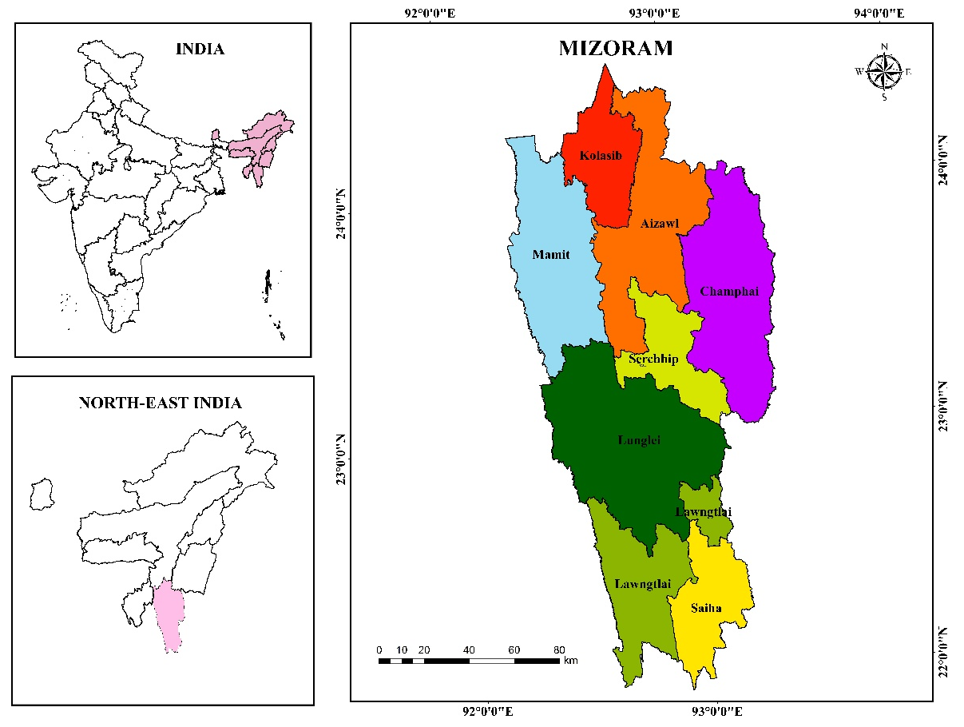
Figure 1: Location of study area
2. Materials and Methods
2.1 Data Acquisition and Pre-processing
The soil health records at Mizoram were captured and filed to the official SHC portal (https://soilhealth.dac.gov.in). Village-level datasets were extracted from the dashboard, audited for consistency and converted into GIS formats. With the help of ArcGIS Pro, a complete geospatial database was designed, producing a point layer based on the geospatial coordinates of each soil sample. It combined 20,991 soil samples from 273 villages in Mizoram (Figure 3).
2.2 Spatial Interpolation and Mapping
Five soil fertility parameters critical for crop planning, are soil reaction (pH), organic carbon (OC), available nitrogen (N), available phosphorus (P), and available potassium (K). In order to predict the nutritional content on an unsampled region, the Inverse Distance Weighted interpolation method was used through the Spatial Analyst tool in ArcGIS. IDW considers the value of an unvisited point as the distance-weighted mean of neighboring observed points, making it an appropriate choice for regional soil fertility modelling, since local variability depends on topography. The systemic workflow, from data ingestion through generation of thematic fertility maps until it finally works out is described in methodology flowchart (Figure 2).
2.2 Geospatial Processing
Data downloaded was processed in its GIS space using ArcGIS 10.8.2 software. Using the locations of sample soils (latitude and longitude), a point layer was created where sample numbers are added, village names are included, and analyses are taken.
2.3 Spatial Interpolation
Thematic maps for pH, OC, and available N, P, and K were created using the Spatial Analyst tools available in ArcGIS. A technique for Inverse Distance Weighted (IDW) interpolation was applied to predict values at unknown locations based on the known sample points. The details of the methodology are shown in Figure 2.
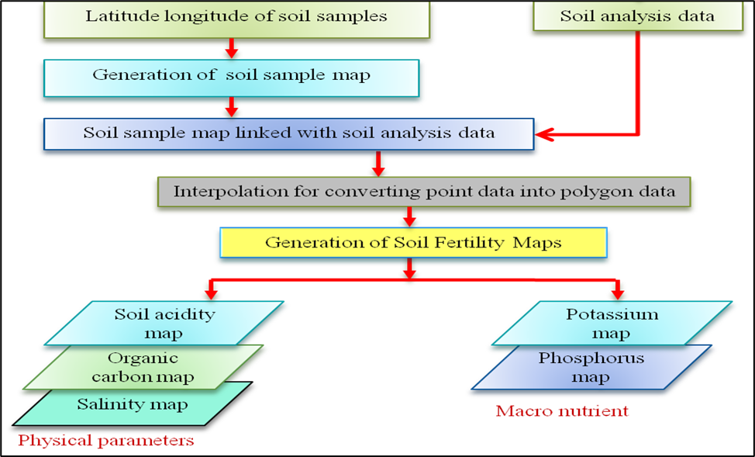
Figure 2: Systematic workflow for the generation of thematic soil fertility maps
3. Results and Discussion
Geospatial analysis produced five thematic fertility maps for Mizoram, showcasing spatial distribution of pH, Organic Carbon (OC), and available N, P and K across the state. The quantitative distribution of these parameters over different classes of fertility is summarized in Table 1.
3.1 Soil Reaction (pH) and Salinity
According to the study, Mizoram soils are predominantly non-saline and acidic in nature. A large part of the state, 62.64% (1,319,679.13 ha), belongs to that of an acidic (Slightly Acidic; pH 5.5–6.5); 34.85% (734,190.93 ha) to moderate acid, pH 4.5–5.5. Only a small proportion (0.17%) are under the position of neutrality (Figure 3). This widespread acid is due to the high-rainfall hilly land in the North East Region, which generates acid (leaching of base cations) from the ground.
3.2 Organic Carbon (OC)
Soil Organic Carbon, a key marker of soil health and microbial activity, was high in moderate amounts in most of the state. The OC levels are in the medium (0.50%–0.75%) values within 54.75% area while 31.05% of the region of observed was Low OC (<0.50%). The high organic carbon content was limited to about 12.19% of the total area, probably in areas with more vegetated (forest) areas or with little farming to disturb soil (Figure 3).
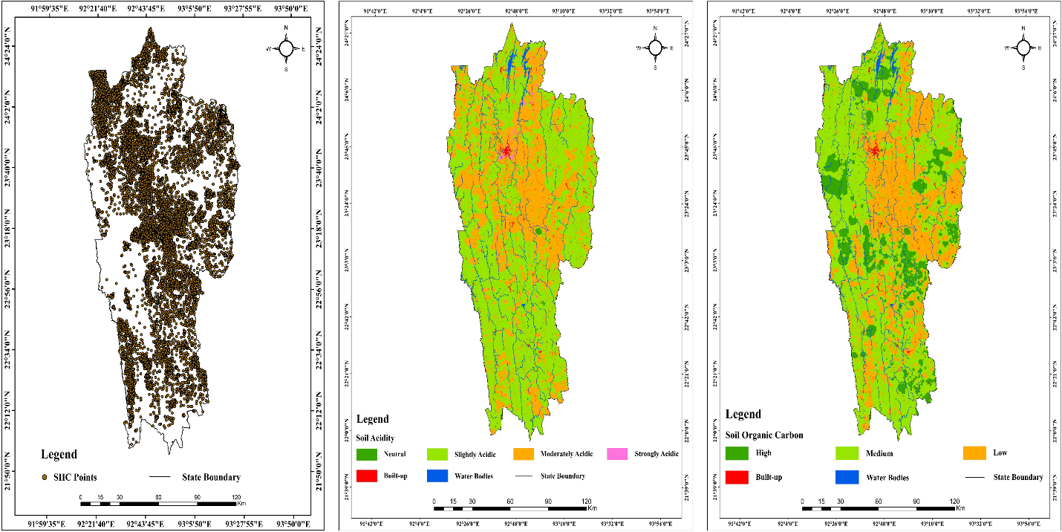
Figure 3: Spatial distribution of SHC points, soil acidity and Soil organic carbon
3.3 Available Macro-nutrients (N, P, K)
The availability of primary macro-nutrients follows a highly uniform "Medium" distribution pattern across Mizoram (Figure 4).
Available Nitrogen (N): The vast majority of the state (91.21%) contains Medium Nitrogen (280–560 kg/ha). Low nitrogen availability was observed in 6.78% of the area, with no regions recording "High" nitrogen status.
Available Phosphorus (P): Phosphorus availability is similar to Nitrogen in 90.71% of the area it is classified as Medium (10–25 kg/ha). Minor portions of 4.69% and 2.59% of the soil coverage are low and High phosphorus, respectively.
Available potassium (K): Potassium status is overwhelmingly Medium (120–280 kg/ha) in 93.05% of the state. In only 4.45% of the soils there were high potassium levels (>280 kg/ha).
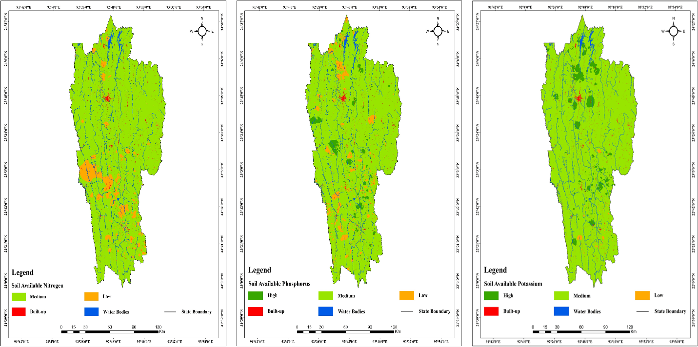
Figure 4. Spatial distribution of macro nutrients in Mizoram
Table 1: Spatial Distribution of Soil Fertility Classes in Mizoram
Parameters | Class | Area (ha) | % Area
pH | Strongly Acidic (<4.5) | 6,980.06 | 0.33
pH | Moderately Acidic (4.5–5.5) | 734,190.93 | 34.85
pH | Slightly Acidic (5.5–6.5) | 1,319,679.13 | 62.64
pH | Neutral (6.5–7.5) | 3,563.19 | 0.17
OC (%) | Low (<0.50) | 654,284.95 | 31.05
OC (%) | Medium (0.50–0.75) | 1,153,775.60 | 54.75
OC (%) | High (>0.75) | 256,769.48 | 12.19
N (kg/ha) | Low (<280) | 142,853.99 | 6.78
N (kg/ha) | Medium (280–560) | 1,922,152.89 | 91.21
N (kg/ha) | High (>560) | - | -
P (kg/ha) | Low (<10) | 98,906.59 | 4.69
P (kg/ha) | Medium (10–25) | 1,911,347.33 | 90.71
P (kg/ha) | High (>25) | 54,576.13 | 2.59
K (kg/ha) | Low (<120) | 10,438.05 | 0.50
K (kg/ha) | Medium (120–280) | 1,960,656.58 | 93.05
K (kg/ha) | High (>280) | 93,735.41 | 4.45
Most soils in Mizoram fall under medium nutrients, especially nitrogen and potassium, according to soil fertility status analysis. This pattern is attributed largely to the humid tropical environment and hilly country. The Mizoram region is a region of high annual rainfall (more than 2000 mm), leading in the most part to highly leaching soluble nutrients from the layer, which reduces the nutrient build-up in the upper soil. In addition, the soils are very strongly acidic, and severely weathered soils such that the saturation of the base as well as fixation of phosphorus by iron and aluminum oxides are low, which limits its availability to plants. The steep slopes and poor hill ecosystem also promote soil erosion and runoff, which lead to the removal of nutrient-rich topsoil and moderate fertility status. Furthermore, shifting cultivation (jhum), which occurred for shorter periods of time in the fallows, leads to the natural regeneration of soil organic matter and nutrient pools being lost. Similar findings have also been reported in some studies from Northeast India, where soil fertility under hill agro-ecosystems and shifting cultivation systems often is moderate due to nutrient losses from leaching, erosion and land-use changes (Kenye et al., 2019; Ovung et al., 2021; Manpoong et al., 2020). In addition, investigations of soil signatures and contaminant transport further emphasize how subsurface conditions and external pollutants can exacerbate nutrient leaching and soil degradation (Alao, 2023; 2024 & 2025). These insights align with the observed acidic and nutrient moderate soil in Mizoram. This indicates that sustainable land management in the form of soil conservation measures, organic matter addition and better fallow management processes are required to improve and sustain soil fertility in the hill ecosystem in Mizoram.
4. Summary and Conclusion
This study provides the first comprehensive, high-resolution spatial assessment of soil fertility across the 21,081 Sq. Km landscape of Mizoram, India, bridging a critical data gap in the North Eastern Hill region. By leveraging GIS and GPS technologies to analyze 20,991 georeferenced soil samples, the research successfully mapped the pervasive nature of soil acidity driven by the region’s high-rainfall tropical climate. Results indicate that 97.49% of the state is characterized by mild to moderate acidity (pH < 6.5), highlighting an urgent need for targeted liming interventions to optimize nutrient availability.
While macronutrient levels for Nitrogen (91.21%), Phosphorus (90.71%), and Potassium (93.05%) predominantly fall within the "medium" range, the significant spatial variability identified through IDW interpolation underscores the inadequacy of traditional "blanket" fertilizer recommendations for such a topographically diverse terrain. These high-resolution thematic maps serve as a definitive baseline for formulating village-level fertilizer recommendation charts and identifying high-potential zones for diversifying into specific horticultural or commercial crops. Such findings are particularly critical as the state considers transitioning toward intensive commercial horticulture and high-demand crops like Oil Palm, which require precise, data-driven nutrient management.
The implications of this research are twofold. For farmers, these maps serve as a localized guide for site-specific nutrient management (SSNM), enabling the precise application of inputs that minimize economic waste and prevent environmental degradation. For policymakers, this spatial database provides an authoritative decision-support tool for the Department of Agriculture, Government of Mizoram, to facilitate regional crop planning and the strategic allocation of resources under the National Mission for Sustainable Agriculture (NMSA). Ultimately, this work establishes a scientific baseline that facilitates the transition toward precision agriculture, ensuring long-term soil health and food security for the state.
Acknowledgements
The authors wish to express their profound gratitude to Dr. S.P. Aggarwal, Director, North Eastern Space Applications Centre (NESAC), Umiam, for providing the necessary institutional support and state-of-the-art infrastructure required to carry out this study. Special appreciation is extended to Dr. K.K. Sarma, Group Head, NESAC, for his constant encouragement and for facilitating the technical resources essential for the geospatial analysis and soil mapping components of this research. The authors also acknowledge the technical staff and field investigators whose contributions were vital to the successful completion of this work.

Disclaimer (Artificial intelligence)
Author(s) hereby declares that NO generative AI technologies such as Large Language Models (ChatGPT, COPILOT, etc.) and text-to-image generators have been used during the writing or editing of this manuscript.

References
- Aboh, H. O., Dogara, M. D., & Alao, J. O. (2016). Evaluation of the geotechnical parameters in part of Kaduna, Kaduna State, Nigeria. World Journal of Applied Science and Technology, 8(2), 108–117.
- Alao, J. O. (2023). Impacts of open dumpsite leachates on soil and groundwater quality. Groundwater for Sustainable Development, 20, 100877.
- Alao, J. O. (2024a). Determination of the geophysical signature of soft-clay and hard lateritic soils and the implications on geotechnical works using electrical resistivity imaging. Results in Earth Sciences, 1, 100025.
- Alao, J. O. (2024b). The factors influencing the landfill leachate plume contaminants in soils, surface and groundwater and associated health risks: A geophysical and geochemical view. Public Health and Environment, 1(1), 20–43.
- Alao, J. O. (2025). The evolving roles of geophysics in environmental assessment, monitoring, and management of landfill leachate contaminant plumes: An overview. Case Studies in Chemical and Environmental Engineering, 11, 101124.
- Alao, J. O., Danjuma, T. T., & Nur, M. S. (2022). Electrical conductivity for selection of viable land for agricultural activities and suitable sites for borehole. Asian Journal of Geological Research, 5(1), 37–50. Article no. AJOGER.87693.
- Cambardella, C. A., & Karlen, D. L. (1999). Spatial analysis of soil fertility parameters. Precision Agriculture, 1(1), 5–27.
- Chouhan, D., Awasthi, M. K., Nema, R. K., Sharma, S. K., Singh, M., & Patle, D. (2025). Spatial assessment of soil fertility using GIS techniques in Shahdol district, Madhya Pradesh. International Journal of Research in Agronomy, 8(5), 183–188.
- Das, P. T., Lakiang, T., & Saikia, B. (2022). Soil fertility mapping using GIS in Meghalaya plateau. International Journal of Current Microbiology and Applied Sciences, 11(3), 71–79.
- Das, P. T., Passah, M. E. S., Saikia, B., Handique, B. K., Sarma, K. K., & Aggarwal, S. P. (2025). Soil fertility mapping using geospatial technology for sustainable agriculture in Sikkim. In: Bio-Based Resource Management. ISBN: 978-93-48070-31-9.
- Das, P. T., Saikia, B., Lakiang, T., Majaw, R. M., & Saiborne, I. B. (2022). District wise soil fertility mapping from Soil Health Card data using GIS in Meghalaya. International Journal of Scientific Research and Engineering Development, 5(4), 1184–1195.
- Dobermann, A., & Cassman, K. G. (2002). Plant nutrient management for enhanced productivity in intensive grain production systems. Applied Soil Ecology, 15(1), 25–40.
- Dogara, M. D., Aboh, H. O., Joseph, O. A., & Kogi, K. A. (2017). The aquifer overlying the basement complex in some parts of Dan-Hono, Kaduna, Nigeria. KADA Journal, 1(2), 45–52.
- Iftiker, W., Chattopadhyay, G. N., Majumdar, K., & Sulewski, G. D. (2010). Use of village-level soil fertility maps as a fertilizer decision support tool in the red and lateritic soil zone of India. Better Crops, 94, 10–12.
- Jena, R. K., et al. (2015). Spatial variability of soil fertility parameters in Jirang block of Ri-Bhoi district, Meghalaya. Clay Research, 34(1), 35–45.
- Joseph, O. A., Danjuma, T. T., Ahmad, M. S., & Abdullahi, D. (2022). Application of geoelectric resistivity technique to a selected site for agricultural practices, at Kujama Farmland, Kaduna, Nigeria. SSRG International Journal of Geoinformatics and Geological Science, 9(1), 46–51.
- Kenye, A., Sahoo, U. K., Singh, S. L., & Gogoi, A. (2019). Soil organic carbon stock of different land uses of Mizoram, northeast India. AIMS Geosciences, 5(1), 25–40.
- Manpoong, C., Hauchhum, R., & Tripathi, S. K. (2020). Soil fertility and root carbon exudation in Tephrosia candida hedgerows under sloping agricultural land technology in Mizoram. Journal of Tropical Agriculture, 58(1), 12–22.
- Mishra, A., Das, D., & Saren, S. (2013). Preparation of GPS and GIS based soil fertility maps for Khurda district, Odisha. Indian Agriculturist, 57(1), 11–20.
- NESAC. (2021). Mapping of soil fertility in Meghalaya using geospatial technology and Soil Health Card data (Report No. NESAC-SR-259-2021). North Eastern Space Applications Centre, Umiam, India.
- NESAC. (2023). Soil fertility mapping of Arunachal Pradesh using geospatial technology (Report No. NESAC-SR-292-2023). North Eastern Space Applications Centre, Umiam, India.
- Ovung, E. Y., Tripathi, S. K., & Brearley, F. Q. (2021). Changes in soil exchangeable nutrients across different land uses in steep slopes of Mizoram, northeast India. Journal of Applied and Natural Science, 13(3), 995–1003.
- Panda, S. C. (2010). Soil Management and Organic Farming. Agrobios (India).
- Rathore, A. S., Sharma, Y. M., Tagore, G. S., Nagwanshi, A., & Jayaraman, S. (2023). Soil fertility mapping using GPS and GIS in Jhabua district, Madhya Pradesh, India. Journal of the Indian Society of Soil Science, 71(3), 276–286.
- Ratre, G. K., Thakur, D. S., Ayam, G. P., & Savu, R. M. (2024). Soil fertility mapping using geo-spatial techniques for agricultural land management. International Journal of Plant & Soil Science, 36(8), 177–186.
- Sheoran, D., Garhwal, R. S., Sharma, M., & Karuna. (2024). Assessment and mapping of nutrients in soils using GIS techniques. International Journal of Plant & Soil Science, 36(7), 720–732.
- Singh, S. K., Tagung, T., Kumar, A., & Singh, K. K. (2024). Geospatial analysis of soil fertility in Muzaffarpur district, Bihar using GPS and GIS technologies. Journal of Advances in Biology & Biotechnology, 27(7), 1083–1093.
- Sood, A., Sharma, P. K., Tur, N. S., & Nayyar, V. K. (2009). Micronutrient status and their spatial variability in soils of Muktsar district of Punjab – A GIS approach. Journal of the Indian Society of Soil Science, 57(3), 300–306.

