Malar Reduction Techniques: A Review of Surgical Approaches and Clinical Considerations

Abstract
The zygomatic complex plays a fundamental role in determining midfacial contour, projection, and overall facial width. Excessive prominence of the malar eminence can result in a broad or square facial appearance, which many patients perceive as aesthetically undesirable. Consequently, reduction malarplasty has become an increasingly performed procedure in facial contour surgery, aimed at decreasing the prominence of the zygomatic body and arch while preserving facial harmony, skeletal stability, and soft-tissue support. Over the past two decades, advances in osteotomy design, fixation techniques, and digital surgical planning have significantly improved the precision, safety, and predictability of malar reduction procedures.
Several operative techniques have been described to address malar prominence, including L-shaped osteotomy, I-shaped osteotomy, isolated zygomatic arch reduction, intraoral approaches, coronal approaches, and minimally invasive endoscopic techniques. Selection of the appropriate technique depends on the degree and location of malar prominence, the patient’s facial morphology, and the desired aesthetic outcome. Recent integration of three-dimensional imaging, virtual surgical planning, and patient-specific cutting guides has further enhanced surgical accuracy and intraoperative control, allowing more precise repositioning of the zygomatic complex.
Despite these technological advances, reduction malarplasty remains a technically demanding procedure because of the complex anatomy of the zygomatic region and its close relationship with important neurovascular structures, including the infraorbital nerve and branches of the facial nerve. Inadequate surgical planning or fixation may result in complications such as midfacial ptosis, sensory disturbances, asymmetry, infection, or nonunion of osteotomized segments.
This review aims to provide a comprehensive overview of contemporary malar reduction techniques, surgical approaches, clinical considerations, complications, and outcomes.
Keywords
Malar reduction; reduction malarplasty; zygomatic osteotomy; facial contour surgery; zygomatic arch reduction; midface aesthetics; craniofacial surgery
Introduction
Malar prominence plays a crucial role in defining facial aesthetics, particularly in individuals of Asian descent, where a wider and more prominent zygomatic complex is often perceived as less desirable [1,14]. The growing demand for facial contouring procedures has led to significant advancements in reduction malarplasty techniques aimed at achieving a harmonious and balanced facial profile [2,5]. Over time, surgical approaches have evolved from simple reduction methods to more refined techniques emphasizing controlled osteotomy design, precise bone repositioning, and stable fixation [3,6].
Reduction malarplasty is a technically demanding procedure that requires a comprehensive understanding of zygomatic anatomy, facial proportions, and biomechanical stability [4,7]. The selection of an appropriate surgical technique is influenced by multiple factors, including the degree and pattern of malar prominence, patient-specific anatomical variations, and desired aesthetic outcomes [8,12]. Contemporary techniques range from traditional infracture methods to advanced procedures such as L-shaped osteotomies, I-shaped osteotomies, and minimally invasive approaches, each offering distinct advantages and limitations [2,6,11].
Despite the availability of diverse techniques, variability persists in clinical outcomes, complication rates, and long-term stability [9,16]. This variability highlights the importance of a comprehensive and comparative evaluation of available surgical methods to guide clinical decision-making [10,17]. In addition, recent advancements in three-dimensional imaging, virtual surgical planning, and computer-assisted techniques have enhanced surgical precision and predictability, allowing more individualized treatment planning [15,17].
This review aims to provide a structured and clinically relevant overview of contemporary malar reduction techniques, focusing on their indications, advantages, limitations, and associated complications [5,13]. By integrating existing evidence with clinical insights, the authors seek to offer a balanced perspective that supports individualized surgical planning and optimizes aesthetic outcomes. Emphasis is placed on the importance of tailoring surgical approaches to patient-specific anatomical and aesthetic requirements while minimizing complications and preserving facial harmony [16,20,23].
The purpose of this review is to provide a comprehensive overview of contemporary malar reduction techniques, surgical approaches, clinical considerations, and postoperative outcomes based on current literature.
Surgical Anatomy of the Zygomatic Complex
A thorough understanding of the anatomy of the zygomatic complex is essential for safe and effective malar reduction surgery.
The zygomatic bone forms the most prominent part of the cheek and contributes to the lateral wall and floor of the orbit (Figure 1). It articulates with four bones:
- Frontal bone
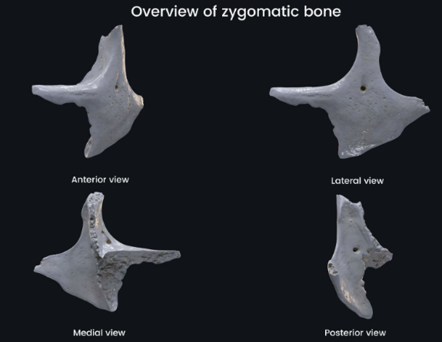
- Maxilla
- Temporal bone
- Sphenoid bone
The zygomatic arch is formed by the temporal process of the zygomatic bone and the zygomatic process of the temporal bone [8].
Several important neurovascular structures are located in proximity to the zygomatic complex, including:
- Infraorbital nerve
Figure 1: Anatomical views of the zygomatic bone illustrating its articulations and key structural features.
Source: Adapted from standard anatomical references on craniofacial skeleton (Netter FH. Atlas of Human Anatomy, Elsevier; 2019).
- Zygomaticofacial nerve
- Zygomaticotemporal nerve
- Branches of the facial nerve
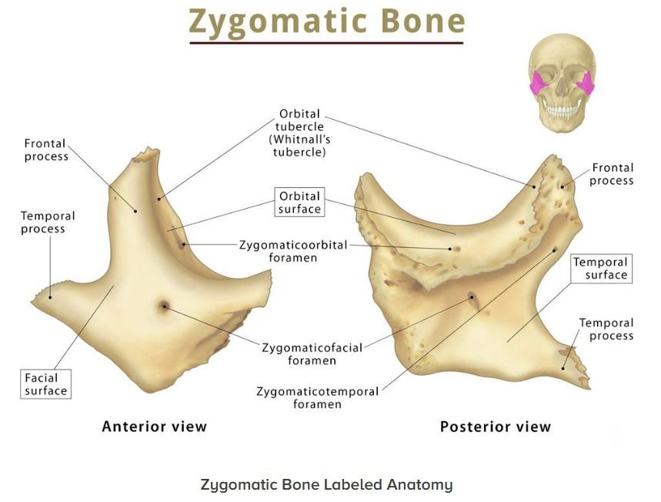
Damage to these structures may lead to sensory disturbances, facial weakness, or other postoperative complications [9].
The masseter muscle attaches to the inferior border of the zygomatic arch, and excessive reduction of the arch may alter muscular function and facial contour.

Indications for Malar Reduction Surgery
Reduction malarplasty is performed primarily for aesthetic purposes. Common indications include:
- Prominent zygomatic bones
- Excessive midfacial width
Figure 2: Schematic representation of L-shaped osteotomy technique showing osteotomy lines and direction of repositioning.
Source: Adapted from Yang X et al. Plast Reconstr Surg. 2012;129(3):651–662. doi:10.1097/PRS.0b013e3182412d3c
- Asymmetrical cheek prominence
- Broad or square facial contour
- Facial contour irregularities following trauma
Patients typically seek this procedure to achieve a more slender and harmonious facial appearance [10].

Surgical Techniques for Malar Reduction
- L-Shaped Osteotomy
The L-shaped osteotomy (Figure 2) is currently regarded as the most widely utilized and reliable technique for reduction malarplasty, particularly in patients presenting with prominent cheekbones and increased midfacial width. From a surgical perspective, this technique offers predictable control over the three-dimensional repositioning of the zygomatic complex, allowing the surgeon to reduce both malar projection and transverse facial width simultaneously while maintaining stable skeletal support.
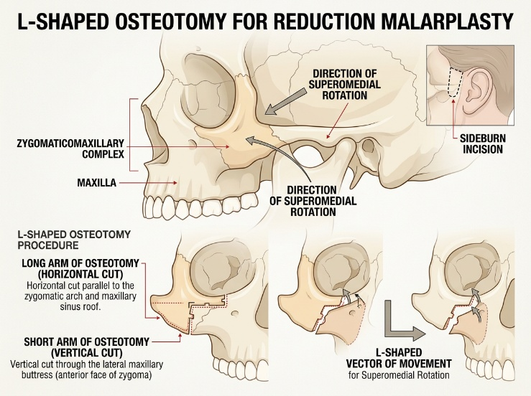
The procedure is typically performed through an intraoral approach, beginning with a carefully placed incision along the maxillary vestibule in the region of the zygomaticomaxillary buttress. This approach provides excellent access to the malar body while avoiding visible external scars. Following the incision, subperiosteal dissection is carried out to expose the zygomatic body, the infraorbital rim, and the anterior portion of the zygomatic arch. During this stage, meticulous attention is required to preserve the infraorbital nerve and surrounding soft tissues, as injury to these structures may lead to postoperative sensory disturbances.
Figure 3 : L- Shaped osteotomy
Author’s own image
Once adequate exposure of the zygomatic complex is achieved, the osteotomy design is marked on the bone surface, outlining the characteristic L-shaped configuration (Figure 3). The first component of the osteotomy is a horizontal cut along the zygomatic body, usually extending from the zygomaticomaxillary buttress toward the lateral orbital rim. This horizontal osteotomy serves to mobilize the anterior malar segment. The second component is a vertical osteotomy extending superiorly or obliquely toward the zygomatic arch, creating the L-shaped pattern. In many cases, an additional posterior osteotomy of the zygomatic arch is performed through a small temporal or sideburn incision to allow complete mobilization of the zygomatic complex.
Following completion of the osteotomy cuts, the zygoma and attached arch segment are carefully mobilized using osteotomes or elevators. The mobilized bone segment is then repositioned medially and posteriorly, effectively reducing the outward projection of the malar eminence and narrowing the midfacial width. This repositioning maneuver is a critical step in the procedure, as it determines the final contour of the cheek and the overall harmony of the midface [24,25].
Once the desired repositioning has been achieved, rigid internal fixation is performed using titanium miniplates and screws, typically placed at the zygomaticomaxillary buttress or along the osteotomy lines. Stable fixation is essential to maintain the new position of the zygomatic complex during bone healing and to prevent complications such as displacement or nonunion.
One of the principal advantages of the L-shaped osteotomy is that it provides precise intraoperative control over the direction and magnitude of bone movement, allowing the surgeon to tailor the correction according to the patient’s facial anatomy. The intraoral approach eliminates visible scars and provides a direct surgical field for accurate osteotomy placement. In addition, rigid fixation ensures reliable stabilization of the repositioned zygoma and contributes to predictable postoperative outcomes.
Despite its effectiveness, the technique is not without potential limitations. Because the procedure involves mobilization of the zygomatic complex and manipulation of the overlying soft tissues, there is a potential risk of midface ptosis or cheek soft-tissue sagging if soft tissue support is not adequately maintained. Other possible complications include bone nonunion, malunion, contour irregularities, and transient infraorbital nerve paresthesia. Careful surgical planning, precise osteotomy execution, and stable fixation are therefore essential to minimize these risks.
Advances in three-dimensional imaging and preoperative planning have further enhanced the precision of this technique. Contemporary morphometric and three-dimensional studies have demonstrated that L-shaped osteotomy produces significant reductions in zygomatic width and malar prominence, confirming its effectiveness in achieving midfacial contour refinement. Consequently, the L-shaped osteotomy remains a cornerstone technique in modern facial contouring surgery, particularly for patients requiring substantial reduction of malar projection and facial width while maintaining natural facial proportions [15].
- I-Shaped Osteotomy Technique
The I-shaped osteotomy represents a controlled and conservative surgical technique used in reduction malarplasty to decrease malar prominence while preserving the structural integrity of the surrounding anatomical structures, particularly the maxillary sinus and lateral orbital rim. From a surgical standpoint, this technique is designed to address localized prominence of the anterior malar body without extensive mobilization of the entire zygomatic complex. Unlike the L-shaped osteotomy, which repositions the zygoma through rotational movement of the zygomaticomaxillary complex and arch, the I-shaped osteotomy primarily focuses on direct reduction of the malar eminence through removal or controlled recession of a defined bone segment. Because the procedure involves limited osteotomy lines and minimal disruption of surrounding structures, it is considered a relatively less invasive approach that allows precise contour modification while maintaining facial skeletal stability.
This technique is particularly suitable for patients presenting with moderate to severe anterior malar prominence, especially in cases where the primary concern is excessive projection of the malar body rather than widening of the entire zygomatic arch. It is also advantageous in situations where preservation of the maxillary sinus and adjacent anatomical structures is desirable, thereby reducing the risk of sinus involvement and postoperative complications. By selectively targeting the central malar eminence, the I-shaped osteotomy enables the surgeon to achieve controlled reduction of cheek prominence while maintaining the natural curvature of the midfacial skeleton.
The surgical design of the I-shaped osteotomy is based on a configuration that resembles the capital letter “I,” consisting of three precise osteotomy cuts that isolate a central segment of the malar bone. These include a superior transverse osteotomy, a vertical osteotomy through the malar body, and an inferior transverse osteotomy. Together, these cuts create a rectangular or elongated bone segment within the most prominent portion of the zygoma. Once isolated, this segment may be removed, medially recessed, or repositioned posteriorly, depending on the degree of correction required. This controlled segmental reduction allows the surgeon to precisely modify the contour of the malar prominence while preserving the surrounding skeletal framework.
The procedure is typically performed through a 1.5–3 cm intraoral vestibular incision placed over the zygomaticomaxillary buttress, which provides direct access to the malar body without producing visible external scars. After the incision is made, subperiosteal dissection is carefully carried out to expose the zygomatic body, infraorbital foramen, lateral orbital rim, and the anterior portion of the zygomatic arch. During this stage, meticulous surgical technique is essential to protect the infraorbital nerve, as injury to this structure may lead to postoperative sensory disturbances in the midface region. Adequate exposure allows accurate identification of the most prominent area of the malar eminence and facilitates precise planning of the osteotomy lines.
Once the surgical field is adequately exposed, the osteotomy lines are carefully marked on the malar eminence. The superior horizontal osteotomy is typically positioned just inferior to the lateral orbital rim, ensuring preservation of the orbital structure while defining the upper boundary of the bone segment. The vertical osteotomy is then planned through the center of the malar prominence, extending between the superior and inferior cuts. Finally, the inferior horizontal osteotomy is marked just above the zygomaticomaxillary buttress, forming the lower boundary of the segment. These three osteotomy lines together create the characteristic I-shaped configuration (Figure 4), allowing isolation of the central malar bone segment responsible for excessive cheek projection.
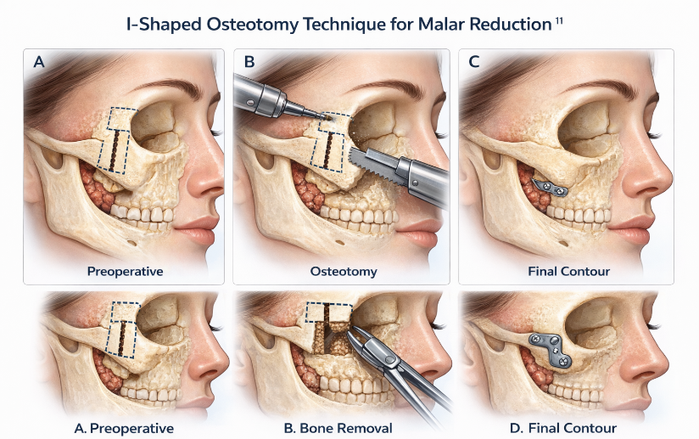
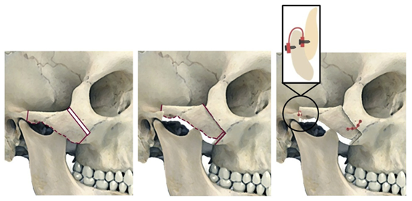
The osteotomy is then performed using a reciprocating saw or piezoelectric surgical device, depending on the surgeon’s preference and available instrumentation. Typically, the superior horizontal osteotomy is completed first, followed by the vertical osteotomy through the malar prominence, and finally the inferior horizontal osteotomy, which completes the I-shaped pattern. Careful execution of these cuts allows the surgeon to isolate the central bone segment without causing unnecessary damage to adjacent structures. Once the segment is mobilized, it can be removed entirely or recessed medially, usually by approximately 3–5 mm, depending on the degree of malar prominence and the desired postoperative facial contour.
Figure 4: Illustration of I-shaped osteotomy demonstrating segmental bone removal and controlled malar reduction.
Source: Adapted from Kim JH et al. Maxillofac Plast Reconstr Surg. 2017;39:14. doi:10.1186/s40902-017-0119-2
Reduction of the central bone segment results in decreased malar projection and narrowing of the midfacial contour (Figure 5), producing a flatter and more harmonious cheek profile. In most cases, the amount of reduction achievable with this technique is limited to approximately 5 mm, which is generally sufficient for moderate prominence but may not be adequate in cases of severe zygomatic protrusion.
Following repositioning or removal of the bone segment, contour refinement is performed using bone rasps or rotary burs to smooth the osteotomy margins and eliminate any step deformities or irregular transitions between bone segments. This step is particularly important for achieving a natural postoperative contour and preventing palpable or visible irregularities beneath the overlying soft tissues.
Figure 5: Surgical approach for zygomatic arch reduction showing osteotomy and medial repositioning of the arch.
Source: Adapted from Gao ZW et al. J Craniofac Surg. 2013;24(4):1313–1316. doi:10.1097/SCS.0b013e31828dcd88
To maintain stability of the remaining zygomatic structure, rigid fixation is performed using titanium microplates and miniscrews. These fixation devices are typically placed along the osteotomy lines to ensure intimate bone contact and stable immobilization during the healing process. Adequate fixation is essential because the masseter muscle exerts significant functional forces on the zygomatic arch, which could otherwise lead to displacement or instability of the osteotomized segments.
One of the principal advantages of the I-shaped osteotomy is its ability to achieve controlled anterior malar reduction while preserving the integrity of the maxillary sinus and orbital structures. Compared with more extensive osteotomy techniques such as the L-shaped osteotomy, it is relatively less invasive and technically straightforward, making it a valuable option for selected patients requiring localized contour modification. In addition, the intraoral surgical approach eliminates the possibility of visible scars and provides direct access to the malar body.
However, the technique also has certain limitations. Because the osteotomy primarily targets the anterior malar body, the extent of bone reduction is generally limited to approximately 5 mm, and the procedure may not adequately address severe malar protrusion or significant zygomatic arch widening. In such cases, more extensive procedures such as L-shaped osteotomy or combined arch osteotomy techniques may be required to achieve optimal facial contouring.
Potential complications associated with the procedure include nonunion or malunion of the osteotomy site, cheek ptosis due to soft tissue repositioning, transient infraorbital nerve paresthesia, and contour irregularities of the malar region. Nevertheless, with careful preoperative planning, precise osteotomy execution, and stable rigid fixation, these complications can be significantly minimized. When performed appropriately in well-selected patients, the I-shaped osteotomy provides a reliable and effective method for achieving a subtle yet meaningful reduction of malar prominence while preserving the structural integrity of the midface [16].
- Zygomatic Arch Reduction
In patients where increased facial width is predominantly due to lateral flaring of the zygomatic arch rather than excessive projection of the malar body, a zygomatic arch reduction procedure may be indicated. From a surgical perspective, this technique specifically addresses the lateral expansion of the midface by repositioning the zygomatic arch medially, thereby narrowing the transverse facial dimension and improving overall facial balance. Zygomatic arch reduction is particularly useful in individuals who present with wide cheek contours caused by arch prominence, and it is often performed in conjunction with other malar reduction techniques, such as zygomatic body osteotomy, to achieve comprehensive midfacial contouring.
The procedure typically begins with a small temporal incision placed within the hair-bearing scalp, usually in the sideburn or temporal region, which allows the scar to remain well concealed postoperatively. Through this incision, subperiosteal dissection is carefully carried out to expose the zygomatic arch, taking care to avoid injury to the temporal branch of the facial nerve and surrounding soft tissue structures. Once the arch is adequately exposed, an osteotomy is performed at the predetermined site along the zygomatic arch, usually at its relatively narrowest portion. This osteotomy allows the bony segment to be mobilized and repositioned.
Following completion of the osteotomy, the mobilized zygomatic arch segment is gently repositioned medially, reducing the lateral projection of the arch and thereby decreasing the overall facial width. Depending on the surgical plan, fixation may be achieved with microplates, wires, or other fixation devices to maintain the new position of the arch during healing. In many clinical situations, zygomatic arch reduction is combined with osteotomy of the zygomatic body, such as an L-shaped or other malar reduction technique, to simultaneously correct both malar prominence and arch flaring. This combined approach allows the surgeon to achieve a more balanced and harmonious midfacial contour, improving both the projection and width of the cheek region while maintaining natural facial proportions [17].
- Coronal Approach
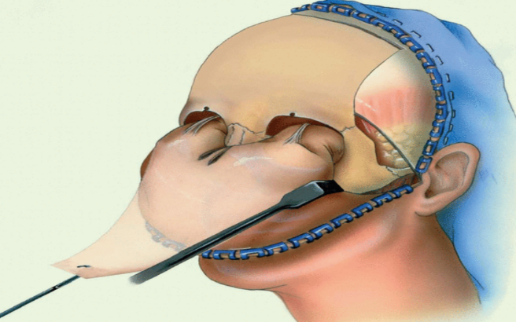
The coronal approach is a comprehensive surgical technique that provides wide and direct exposure of the zygomatic complex (Figure 6), including the zygomatic body, zygomatic arch, lateral orbital rim, and surrounding midfacial structures. From a surgical standpoint, this approach is particularly valuable in cases requiring extensive malar reduction, complex osteotomies, or simultaneous correction of multiple midfacial skeletal deformities, as it allows excellent visualization and access to the entire upper and midface. Although less commonly used for routine reduction malarplasty due to its relatively invasive nature, the coronal approach remains an important technique in complex craniofacial and facial contouring procedures where precise control of osteotomy placement and bone repositioning is essential.
Figure 6: Coronal (bicoronal) surgical approach demonstrating wide exposure of the zygomatic complex.
Source: Adapted from Seol JY, Kim HS. Plast Reconstr Surg Glob Open. 2023. doi:10.1097/GOX.0000000000005304

The procedure typically begins with a bicoronal incision placed posterior to the hairline, extending from one temporal region to the other across the scalp. Positioning the incision behind the hairline helps conceal the postoperative scar within the hair-bearing scalp. Following the incision, subgaleal or subperiosteal dissection is carried out across the forehead and extending inferiorly toward the midface, allowing the surgeon to elevate the scalp flap and expose the underlying frontal bone, lateral orbital rim, and zygomatic complex. During this stage, careful dissection is necessary to preserve the supraorbital and supratrochlear neurovascular bundles, as well as to protect the temporal branch of the facial nerve.
Once adequate exposure is achieved, the zygomatic body and zygomatic arch are clearly visualized, allowing precise marking and execution of the planned osteotomy lines. Depending on the surgical objective, osteotomies of the zygomatic body, lateral orbital rim, and zygomatic arch can be performed using a reciprocating saw, osteotomes, or piezoelectric surgical instruments. The osteotomized zygomatic segments are then carefully mobilized and repositioned medially or posteriorly to reduce malar prominence and achieve the desired midfacial contour. After repositioning, rigid internal fixation is performed using titanium plates and screws, which provide stable stabilization of the bone segments during the healing process.
One of the major advantages of the coronal approach is the excellent surgical exposure it provides, allowing the surgeon to perform precise osteotomies under direct visualization and to simultaneously address multiple skeletal structures of the midface. This extensive exposure can improve the accuracy of bone repositioning and facilitate symmetrical contouring in complex cases. However, despite these advantages, the approach is associated with several potential drawbacks. Because it involves a large scalp incision and extensive soft tissue dissection, the procedure may result in complications such as temporary or permanent scalp numbness due to sensory nerve injury, alopecia along the incision line, increased operative time, and prolonged postoperative recovery. Consequently, while the coronal approach remains a valuable option for complex facial skeletal surgery, less invasive intraoral or limited-incision techniques are often preferred for routine reduction malarplasty procedures [18].
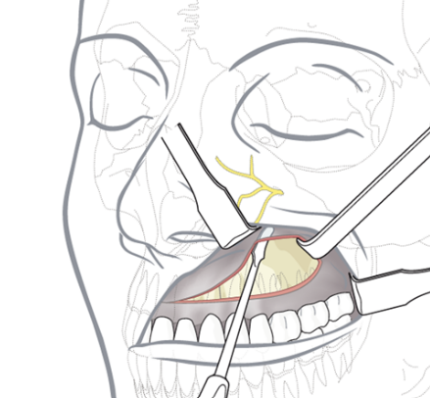
- Intraoral Approach
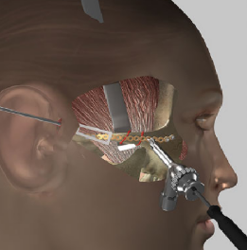
The intraoral approach remains the most commonly employed surgical technique in reduction malarplasty because it provides adequate access to the zygomatic complex while completely avoiding visible external scars. From a surgeon’s perspective, this approach offers a direct pathway to the zygomatic body and zygomaticomaxillary buttress, allowing precise osteotomy placement and controlled manipulation of the malar bone while maintaining favourable aesthetic outcomes.
The procedure typically begins with a vestibular incision made in the maxillary mucosa, usually extending along the upper gingivobuccal sulcus in the region of the zygomaticomaxillary buttress (Figure 7). This incision provides direct access to the anterior aspect of the zygomatic complex while keeping the surgical scar hidden within the oral cavity. Following the incision, subperiosteal dissection is carefully performed to elevate the soft tissues and expose the zygomatic body, infraorbital foramen, lateral maxillary wall, and the anterior portion of the zygomatic arch. During this step, meticulous dissection is essential to protect the infraorbital neurovascular bundle and prevent postoperative sensory disturbances.
Figure 7: Intraoral approach for malar reduction showing vestibular incision and access to the zygomatic body.
Source: Adapted from Kim YH, Seul JH. Plast Reconstr Surg. 2000;106(7):1514–1519. doi:10.1097/00006534-200012000-00011
Once adequate exposure of the zygomatic body has been achieved, the planned osteotomy lines are marked and executed using a reciprocating saw, oscillating saw, or piezoelectric surgical device, depending on the surgeon’s preference. The osteotomy allows controlled mobilization of the zygomatic segment, which can then be repositioned medially or posteriorly to reduce malar prominence and narrow facial width. After achieving the desired contour correction, rigid fixation with titanium plates and screws is commonly performed to stabilize the repositioned bone and promote proper healing.
The primary advantage of the intraoral approach lies in its excellent aesthetic outcome, as it eliminates the possibility of visible facial scars. Additionally, the approach allows direct access to the malar body with minimal disruption of facial soft tissues, making it suitable for various malar reduction techniques, including I-shaped, L-shaped, and other osteotomy designs. However, careful surgical technique is required to avoid complications such as infraorbital nerve injury, hematoma formation, or postoperative infection, which may occur if proper exposure and fixation are not achieved. Overall, the intraoral approach continues to be the preferred method for most reduction malarplasty procedures due to its combination of surgical access, safety, and favourable cosmetic results.

Minimally Invasive and Endoscopic Techniques
Recent advancements in facial contouring surgery have led to the development of minimally invasive malar reduction techniques, which aim to achieve effective reduction of malar prominence while minimizing surgical trauma, operative morbidity, and recovery time. These modern approaches incorporate advanced visualization technologies and digital surgical planning, allowing surgeons to perform osteotomies with greater precision and improved safety. Among the most notable innovations are endoscopic malar reduction, percutaneous osteotomy techniques, and computer-guided osteotomy procedures, each designed to enhance surgical accuracy while reducing the invasiveness of traditional open approaches.
Figure 8: Endoscopic-assisted malar reduction technique illustrating minimal access approach and instrument positioning.
Source: Adapted from Chen X et al. J Craniofac Surg. 2020;31(5):e480–e484. doi:10.1097/SCS.0000000000006463
Endoscopic malar reduction has gained attention as a minimally invasive alternative that utilizes small incisions combined with endoscopic visualization to access the zygomatic complex (Figure 8). Through limited temporal or intraoral incisions, an endoscope is inserted to provide magnified visualization of the surgical field, allowing the surgeon to identify key anatomical structures such as the infraorbital nerve, zygomatic arch, and surrounding soft tissues. This enhanced visualization improves the accuracy of osteotomy placement while minimizing extensive soft tissue dissection. As a result, endoscopic techniques may lead to reduced intraoperative bleeding, decreased postoperative swelling, and faster recovery compared with conventional open procedures.
Another emerging technique is percutaneous osteotomy, in which osteotomies are performed through small skin punctures or minimal incisions using specialized instruments. This approach allows the surgeon to perform controlled bone cuts with minimal disruption of surrounding soft tissues. Percutaneous methods are particularly useful in selected cases where limited bone reduction or arch repositioning is required. Because the incisions are extremely small, this technique may reduce postoperative scarring, tissue trauma, and operative time, while still achieving satisfactory contour modification.
In addition, computer-guided osteotomy techniques represent a significant advancement in surgical planning and execution. Using three-dimensional imaging, computer-aided design (CAD), and virtual surgical planning, surgeons can simulate osteotomy patterns and bone repositioning before the operation. Patient-specific surgical guides can then be fabricated to assist in precise intraoperative osteotomy placement. This technology improves the accuracy and predictability of malar reduction procedures, allowing for better control of bone movement and more symmetrical facial contouring. Furthermore, computer-guided techniques help reduce the risk of complications by enabling surgeons to carefully plan around critical anatomical structures.
Overall, these minimally invasive and technology-assisted approaches represent an important evolution in reduction malarplasty. By combining improved visualization, precise osteotomy planning, and reduced soft tissue disruption, these techniques have the potential to enhance surgical precision, decrease postoperative morbidity, and improve overall patient outcomes in facial contouring surgery [19].

Fixation Techniques
Rigid fixation plays a critical role in reduction malarplasty and other zygomatic osteotomy procedures, as it ensures postoperative skeletal stability and maintains the repositioned bone segments in their intended anatomical position during the healing phase. Following osteotomy and repositioning of the zygomatic body or arch, the surrounding muscular forces—particularly those exerted by the masseter and temporalis muscles—can potentially displace the mobilized bone segments if adequate stabilization is not achieved. Therefore, rigid internal fixation is essential to prevent postoperative displacement, maintain proper bone alignment, and promote predictable bone healing.
Several fixation methods are commonly used to stabilize the osteotomized zygomatic segments. The most widely utilized method involves titanium plates and screws, which provide strong and reliable mechanical stabilization. These fixation devices are typically placed along the zygomaticomaxillary buttress, zygomatic body, or osteotomy lines, depending on the surgical technique used. Titanium plates are favored due to their biocompatibility, strength, and resistance to corrosion, making them highly effective for maintaining stable fixation throughout the bone healing process.
In recent years, resorbable fixation systems have also been introduced as an alternative to conventional metallic hardware. These systems are composed of biodegradable polymers that gradually degrade and are absorbed by the body over time. Resorbable fixation eliminates the need for a secondary procedure to remove hardware and may be particularly beneficial in younger patients or in cases where long-term implant presence is undesirable. However, while these systems provide adequate fixation in many situations, they may offer slightly less mechanical strength compared with titanium plates, and careful case selection is therefore important.
Another significant advancement in fixation technology is the use of patient-specific fixation devices, which are designed using three-dimensional imaging and computer-assisted surgical planning. These customized plates are fabricated to match the patient’s unique anatomical contours and planned osteotomy pattern. By conforming precisely to the bone surface, patient-specific implants can improve accuracy of bone repositioning, optimize fixation stability, and enhance overall surgical outcomes.
Regardless of the fixation system used, achieving stable and rigid fixation is essential for successful postoperative healing. Proper stabilization ensures intimate bone contact at the osteotomy site, which facilitates bone union and reduces the risk of complications such as displacement, malunion, or nonunion. Consequently, careful selection and placement of fixation devices remain a fundamental component of modern malar reduction surgery [20].
Soft Tissue Considerations
Although malar reduction surgery primarily involves modification of the underlying skeletal framework, the behavior of the overlying soft tissues plays a critical role in determining the final postoperative facial contour and aesthetic outcome. The relationship between skeletal repositioning and soft tissue adaptation is particularly important in the midface, where structures such as the malar fat pad, superficial musculoaponeurotic system (SMAS), and facial retaining ligaments contribute significantly to facial volume and youthful contour. When the zygomatic bone is reduced or repositioned, the surrounding soft tissues inevitably undergo secondary displacement, and the degree of this movement directly influences the final external appearance of the cheek and midface.
Excessive or poorly planned skeletal reduction can lead to undesirable aesthetic consequences. If too much bone is removed or if the malar prominence is excessively recessed, the support for the overlying soft tissues may be compromised. This can result in midface ptosis, where the soft tissues of the cheek descend inferiorly due to loss of skeletal support. In addition, excessive reduction may produce a flattened or overcorrected cheek contour, diminishing the natural convexity of the malar region that contributes to facial youthfulness and aesthetic balance. Such changes may also create an appearance of premature facial aging, as diminished malar projection can accentuate nasolabial folds and contribute to a hollowed or deflated midfacial appearance.
Recent studies utilizing three-dimensional facial imaging and morphometric analysis have provided valuable insights into the relationship between skeletal movement and soft tissue response in malar reduction procedures. These investigations demonstrate that soft tissue displacement typically corresponds to approximately 60–70% of the underlying skeletal movement. In practical terms, this means that for every millimeter of zygomatic repositioning, the overlying soft tissue envelope tends to move slightly less but still follows the general direction of the skeletal change. Understanding this ratio is essential for surgeons during preoperative planning, as it allows for more accurate prediction of postoperative facial contour and helps prevent overcorrection.
Consequently, modern approaches to reduction malarplasty emphasize not only precise osteotomy techniques but also careful preservation of soft tissue attachments and balanced skeletal reduction. By maintaining adequate structural support and avoiding excessive bone removal, surgeons can achieve harmonious midfacial contouring while minimizing the risk of soft tissue ptosis or unnatural flattening of the cheek region. Proper consideration of both skeletal and soft tissue dynamics is therefore fundamental to achieving optimal aesthetic and functional outcomes in malar reduction surgery [22].
Therefore, surgeons must balance skeletal reduction with preservation of soft tissue support.
Complications
Malar reduction surgery, while generally safe and effective when performed with proper surgical planning and technique, may be associated with several potential complications related to both skeletal manipulation and soft tissue response. As with any osteotomy-based facial procedure, careful attention to anatomical structures, fixation stability, and balanced bone reduction is essential to minimize adverse outcomes. Reported complications following reduction malarplasty include midface ptosis, facial nerve injury, infraorbital nerve paresthesia, postoperative infection, facial asymmetry, and bone nonunion or malunion.
Among these, midface ptosis is one of the most frequently reported complications. This condition occurs when the overlying soft tissues of the cheek descend inferiorly following reduction of the underlying zygomatic support. Excessive bone removal or overly aggressive medial repositioning of the zygoma may reduce the structural support of the malar fat pad and associated soft tissues, leading to downward displacement of the cheek. Clinically, this may manifest as flattening of the midface, deepening of the nasolabial fold, and an overall aged facial appearance. Inadequate fixation of the osteotomized segments can further contribute to this complication by allowing subtle postoperative displacement of the zygomatic complex.
Another important potential complication is facial nerve injury, particularly involving the temporal branch of the facial nerve, which may occur during procedures that involve temporal or arch incisions. Injury to this nerve branch can lead to temporary or, rarely, permanent weakness of the frontalis or orbicularis oculi muscles, resulting in impaired forehead movement or asymmetry of facial expression. Similarly, infraorbital nerve paresthesia is a recognized complication due to the proximity of the infraorbital nerve to the surgical field during exposure of the zygomatic body. Patients may experience temporary numbness, tingling, or altered sensation in the upper lip, cheek, and lateral nose, although these symptoms are often transient and resolve over time as nerve function recovers.
Postoperative infection is another potential risk, particularly with intraoral surgical approaches where the operative field is exposed to oral flora. Although relatively uncommon with appropriate sterile technique and antibiotic prophylaxis, infection may lead to delayed healing, localized swelling, or hardware-related complications if not promptly managed. Facial asymmetry may also occur if osteotomy placement, bone repositioning, or fixation is not perfectly symmetrical on both sides of the face. Even minor differences in zygomatic positioning can produce noticeable contour irregularities in the midface.
Finally, bone nonunion or malunion represents a significant skeletal complication in cases where adequate stabilization of the osteotomized segments is not achieved. Nonunion refers to the failure of the bone segments to properly heal together, while malunion occurs when the bone heals in an incorrect position. Both conditions may lead to persistent facial asymmetry, contour deformities, or functional discomfort, potentially requiring revision surgery.
Among all these complications, midface ptosis remains the most commonly reported issue in reduction malarplasty, often associated with excessive skeletal reduction or inadequate fixation of the repositioned zygomatic segments. Consequently, modern surgical techniques emphasize conservative bone reduction, preservation of soft tissue attachments, and rigid fixation to maintain the structural support of the midface and ensure stable postoperative outcomes. Careful patient selection, precise surgical execution, and thorough postoperative monitoring are therefore essential to minimize complications and achieve optimal aesthetic results [21].
Discussion
Reduction malarplasty has evolved from conventional bone reduction procedures into a highly individualized and precision-oriented surgical discipline. Contemporary approaches emphasize not only reduction of malar prominence but also preservation of facial balance, soft tissue support, and long-term structural stability. This shift reflects a broader transition in facial contouring surgery toward patient-specific planning and outcome predictability.
Among the available techniques, the L-shaped osteotomy remains the most widely utilized method due to its ability to simultaneously address malar projection and transverse facial width [14]. From a clinical standpoint, this technique offers superior three-dimensional control of the zygomatic complex, allowing precise contour modification. However, its success depends heavily on surgical accuracy and fixation stability. In the authors’ opinion, excessive medial repositioning or inadequate fixation may increase the risk of midface ptosis, underscoring the need for balanced and conservative correction.
The I-shaped osteotomy, in contrast, represents a more conservative and localized approach, primarily indicated for anterior malar prominence. While it is less invasive and technically simpler, it offers limited control over arch width and may be insufficient in cases of significant facial widening [16]. Clinically, this technique is most appropriate for mild to moderate deformities, where subtle contour refinement is required. The authors emphasize that improper case selection may lead to undercorrection or suboptimal aesthetic outcomes.
Zygomatic arch reduction specifically addresses transverse facial width caused by lateral arch flaring and is often used in combination with other osteotomy techniques [17]. From a comparative perspective, isolated arch reduction may not adequately correct anterior malar projection; therefore, combined approaches frequently produce more balanced and harmonious results. The authors advocate for an integrated surgical strategy when both projection and width contribute to the deformity.
The coronal approach, although less commonly employed in routine aesthetic procedures, remains valuable in complex or revision cases requiring extensive exposure [18]. It allows direct visualization of the zygomatic complex and facilitates precise osteotomy placement. However, its invasive nature, longer recovery period, and risk of complications limit its routine use. In the authors’ view, this approach should be reserved for selected cases where enhanced access is essential.
The intraoral approach continues to be the preferred surgical access due to its favorable cosmetic outcome and adequate exposure of the zygomatic body. It allows precise osteotomy execution while avoiding visible scars. However, it requires meticulous technique to prevent complications such as infraorbital nerve injury and postoperative infection. When performed appropriately, it provides an optimal balance between surgical accessibility and aesthetic outcome.
Advancements in minimally invasive and endoscopic techniques have introduced new possibilities for reducing surgical morbidity while maintaining effectiveness [19]. These approaches offer improved visualization, reduced soft tissue disruption, and faster recovery. Nevertheless, they are technically demanding and may not be suitable for severe deformities requiring extensive skeletal repositioning. At present, their use is best limited to selected cases with mild to moderate malar prominence.
A critical aspect influencing outcomes across all techniques is the relationship between skeletal modification and soft tissue adaptation. Excessive reduction of the zygomatic complex may compromise soft tissue support, resulting in midface ptosis and an aged appearance. Since soft tissue response does not fully mirror skeletal repositioning, careful planning is required to avoid overcorrection [17]. The authors strongly emphasize a conservative and balanced approach that preserves soft tissue integrity while achieving desired contour changes.
Equally important is the role of rigid fixation in maintaining postoperative stability. Titanium plate fixation remains the standard due to its strength and reliability in preventing displacement and ensuring proper bone healing [20]. Inadequate fixation can lead to complications such as asymmetry, nonunion, or relapse. Emerging technologies, including patient-specific implants and computer-guided fixation systems, are expected to further improve surgical accuracy and outcomes.
Although reduction malarplasty is generally safe, complications such as midface ptosis, nerve injury, asymmetry, and bone healing disturbances remain concerns [21]. Importantly, many of these complications are technique-dependent and can be minimized through proper case selection, precise surgical execution, and adequate fixation. In the authors’ perspective, surgical judgment and individualized planning play a more critical role than the choice of technique alone.
Overall, reduction malarplasty should be approached as a customized procedure tailored to individual patient anatomy and aesthetic goals rather than a standardized intervention. No single technique is universally applicable, and optimal results are achieved through careful selection and combination of techniques based on clinical presentation. Future advancements in digital planning, navigation systems, and artificial intelligence are likely to further refine surgical precision and enhance patient-specific outcomes.
Table 1: Comparison of various techniques for malar reduction
Technique | Surgical Approach | Main Indications | Advantages | Limitations
L-shaped osteotomy | Intraoral | Prominent zygomatic body and arch | Precise control of bone movement, simultaneous reduction of width and projection | Risk of midface ptosis requires rigid fixation
I-shaped osteotomy | Intraoral | Mild to moderate malar prominence | Simpler technique, shorter operative time | Limited control over zygomatic arch width
Zygomatic arch reduction | Temporal or intraoral | Lateral facial width due to arch prominence | Effective reduction of facial width | May require a combination with body osteotomy
Coronal approach osteotomy | Bicoronal incision | Severe malar prominence requiring extensive exposure | Excellent visualization and access | Risk of alopecia, longer operative time
Endoscopic malar reduction | Endoscopic-assisted | Mild to moderate malar prominence | Minimally invasive, reduced scarring | Technically demanding

Conclusion
Malar reduction surgery is an effective procedure for improving facial aesthetics in patients with prominent zygomatic bones. Advances in osteotomy techniques, fixation systems, and digital surgical planning have significantly improved the safety and predictability of reduction malarplasty.
Among the various techniques available, L-shaped osteotomy remains the most widely used method, providing reliable reduction of malar prominence and facial width while maintaining facial harmony.
Careful patient selection, thorough surgical planning, and meticulous operative technique are essential to minimize complications and achieve optimal aesthetic outcomes.Future research should focus on long-term clinical outcomes, soft tissue adaptation, and the integration of advanced digital technologies in craniofacial surgery.
Author Contributions:
Dr. M. R. Haranadha Reddy conceptualized the study, provided overall guidance, and supervised the clinical and academic aspects of the work. Dr. Lavanya UmmadiSingh contributed to the design of the methodology, assisted in clinical interpretation, and supported manuscript refinement. Dr. Sarah Fatima was actively involved in drafting and structuring the manuscript, integrating clinical, radiological, and surgical details into a cohesive narrative. Dr. Falguni K. N. and Dr. Ghazala Hussain contributed to the literature review, data compilation, and preliminary drafting of sections, ensuring clarity and accuracy. Dr. G. Anusha assisted in reference validation, formatting, and manuscript editing. Dr. Ghazala Hussain and Dr. G. Anusha served as corresponding authors, coordinating communication, submission, and revisions with the journal.
Conflict of Interest:
The authors declare that there are no conflicts of interest related to this work.
Funding:
No external funding was received for the preparation of this manuscript.
Acknowledgments:
The authors sincerely acknowledge the support of Panineeya Mahavidyalaya Institute of Dental Sciences and Research Centre, Hyderabad, for providing the necessary facilities and academic environment to carry out this work. The authors also extend their gratitude to colleagues and mentors for their valuable insights and encouragement during the preparation of this manuscript. All figures are either original or adapted from previously published literature with appropriate citation.

Disclaimer (Artificial intelligence)

Author(s) hereby declare that NO generative AI technologies such as Large Language Models (ChatGPT, COPILOT, etc.) and text-to-image generators have been used during the writing or editing of this manuscript.

References
- Baek SM, Chung YD, Kim SS. Reduction malarplasty. Plast Reconstr Surg. 1991;88(1):53–61. doi:10.1097/00006534-199107000-00009
- Yang DB, Park CG. Infracture technique for the zygomatic body and arch reduction. Aesthetic Plast Surg. 1992;16(1):1–5. doi:10.1007/BF01570700
- Kim YH, Seul JH. Reduction malarplasty through an intraoral incision: a new method. Plast Reconstr Surg. 2000;106(7):1514–1519. doi:10.1097/00006534-200012000-00011
- Lee HY, Yang HJ, Cho YN. Minimally invasive zygoma reduction. Plast Reconstr Surg. 2006;117(7):2413–2418. doi:10.1097/01.prs.0000218764.10260.6d
- Mu X, Yang X, Zhang Y, et al. Reduction malarplasty: clinical analysis of 588 cases. Plast Reconstr Surg. 2010;126(6):2035–2043. doi:10.1097/PRS.0b013e3181f9597a
- Ma YQ, Li J, Li ZB. Reduction malarplasty with a new L-shaped osteotomy through an intraoral approach. Plast Reconstr Surg. 2009. doi:10.1097/PRS.0b013e31819e6562
- Gao ZW, Wang WG, Zeng G, et al. A modified reduction malarplasty utilizing 2 oblique osteotomies for prominent zygomatic body and arch. J Craniofac Surg. 2013;24(4):1313–1316. doi:10.1097/SCS.0b013e31828dcd88
- Hong SE, Liu SY, Kim JT, Lee JH. Intraoral zygoma reduction using L-shaped osteotomy. J Craniofac Surg. 2014;25(3):758–761. doi:10.1097/SCS.0000000000000759
- Park JH, Lee JH. Zygomatic reduction malarplasty: surgical outcomes and considerations. J Craniofac Surg. 2015;26(5):e440–e443. doi:10.1097/SCS.0000000000002047
- Hwang CH, Lee MC. Reduction malarplasty using a zygomatic arch-lifting technique. J Plast Reconstr Aesthet Surg. 2016;69(6):822–829. doi:10.1016/j.bjps.2016.03.004
- Lee TS, Park S. Advantages of a beveled osteotomy on the zygomatic arch during reduction malarplasty. J Craniofac Surg. 2017;28(5):e452–e456. doi:10.1097/SCS.0000000000003785
- Li Q, Zhang Y, Wang Y, et al. Reduction malarplasty techniques and outcomes: clinical analysis. J Oral Maxillofac Surg. 2017;75(12):2658–2666. doi:10.1016/j.joms.2017.06.022
- Kim JH, Park SH, Kim MK. Surgical outcomes of reduction malarplasty using modified osteotomy techniques. Maxillofac Plast Reconstr Surg. 2017;39:14. doi:10.1186/s40902-017-0119-2
- Yang X, Mu X, Li Z, et al. Facial contouring surgery in Asian patients. Plast Reconstr Surg. 2012;129(3):651–662. doi:10.1097/PRS.0b013e3182412d3c
- Chen X, He Y, Zhang Y. Application of computer-assisted techniques in malarplasty. J Craniofac Surg. 2020;31(5):e480–e484. doi:10.1097/SCS.0000000000006463
- Myung Y, Yoon ES. Complications after reduction malarplasty. Aesthetic Plast Surg. 2017;41(4):834–842. doi:10.1007/s00266-017-0893-x
- Choi JW, Lee JH. Three-dimensional evaluation of soft tissue changes after malarplasty. J Plast Reconstr Aesthet Surg. 2015;68(11):e259–e266. doi:10.1016/j.bjps.2015.08.006
- Seol JY, Kim HS. The rationale of coronal approach to malar/zygoma reduction. Plast Reconstr Surg Glob Open. 2023. doi:10.1097/GOX.0000000000005304
- Choi JW, Kim YH. Revision malarplasty: clinical outcomes and surgical considerations. J Craniofac Surg. 2018;29(2):e123–e127. doi:10.1097/SCS.0000000000003950
- Kim HJ, Lee JH. Complications associated with facial contouring surgery. J Craniofac Surg. 2016;27(3):e257–e260. doi:10.1097/SCS.0000000000002323
- Wang T, Gui L, Tang X, et al. Reduction malarplasty with a new L-shaped osteotomy through an intraoral approach: retrospective study of 418 cases. Plast Reconstr Surg. 2009. doi:10.1097/PRS.0b013e31819e6562
- Hattori Y, Uda H, Mashiko T, Fukuta K, Sugawara Y. Extended reduction malarplasty for Asians with flat and wide faces: comparison with L-shaped osteotomy. Plast Reconstr Surg. 2025. doi:10.1097/PRS.0000000000011527
- Cho, B. C. (2003). Reduction malarplasty using osteotomy and repositioning of the malar complex: clinical review and comparison of two techniques. Journal of Craniofacial Surgery, 14(3), 383-392.
- Newberry, C. I., Mccrary, H., Thomas, J. R., & Cerrati, E. W. (2020). Updated management of malar edema, mounds, and festoons: a systematic review. Aesthetic Surgery Journal, 40(3), 246-258.
- Myung, Y., Kwon, H., Lee, S. W., & Baek, R. M. (2017). Postoperative complications associated with reduction malarplasty via intraoral approach: a meta analysis. Annals of Plastic Surgery, 78(4), 371-378.

