Case report

Quadruple Amputations in professional electrical burns: A multidisciplinary approach on early prosthetics and patient motivation

.
ABSTRACT

Background
High-voltage electrical burns are a relatively uncommon but severe form of burn injury, frequently occurring in occupational settings. These injuries often cause extensive deep tissue destruction and may require repeated surgical debridement and major limb amputations. Survivors frequently experience profound functional impairment and psychological distress, making early multidisciplinary management paramount.

Case Presentation
We report the case of a 32-year-old male electrician who sustained a work-related high-voltage electrical injury. The electrical current entered through both upper limbs and exited through both lower limbs, resulting in extensive necrosis of all four extremities. Initial management included repeated surgical debridements. Due to the extent of irreversible tissue destruction, definitive surgical treatment required bilateral scapulohumeral disarticulation and bilateral transtibial amputations.
The patient was admitted to the intensive care unit for four days for hemodynamic stabilization and monitoring of systemic complications. Early psychological support was initiated to facilitate emotional adaptation and encourage active participation in the rehabilitation process. After satisfactory stump healing, the patient was transferred to a specialized rehabilitation unit where a structured rehabilitation program was implemented, including progressive prosthetic fitting. Lower-limb prostheses were fitted first to restore standing and gait, followed by upper-limb prostheses to improve functional autonomy.

Conclusion
This case illustrates the potentially devastating consequences of high-voltage electrical injuries. We aim to demonstrate that meaningful functional recovery is possible through early multidisciplinary care. Early psychological support, structured rehabilitation, modern prosthetic fitting, and strong patient motivation are critical determinants of successful functional recovery and long-term social reintegration.

Keywords: Electrical burns, high voltage, quadruple amputations, prosthesis, psychological support.

1. INTRODUCTION

Electrical burns are a relatively infrequent cause of burns accounting for less than 10% of admissions to specialized burn centers (Koumbourlis, 2002; Al-Benna, 2023) yet are shown to be associated with a disproportionately higher toll of mortality and significantly greater morbidity due to their unique pathophysiological mechanisms. The passage of electrical current through live tissue generates both thermal and non-thermal damage, leading to extensive deep tissue necrosis that may not be clearly apparent in the initial clinical assessment leading to a possible under estimation of the extension of the damage and can have very severe and potentially fatal consequences.
Epidemiological data indicate that High-voltage electrical burns (>1000 V) occur predominantly in work-related circumstances (39%), particularly in manual labor jobs such as construction, especially in industrial and electrical sectors, in which occupational exposure represents one of the most common contexts of electrical injury worldwide (Arnoldo et al., 2004; Gandhi et al., 2022). Occupational exposure has been shown to primarily involve young working-age men (86,9% of victims were male with a mean age of 21,8) practicing heavy and physically demanding professions, (Rehan et al., 2022).
These injuries are caused by the generation of high-temperature heat which is most commonly associated with extensive skin and deep tissue damage including muscular, vascular and neural necrosis. Muscle tissue is susceptible to electrical injury due to its relatively low electrical resistance, leading to extensive necrosis and progressive ischemic damage along the current pathway (Handschin et al., 2007). Due to these factors, High-voltage electrical injuries may appear deceptively limited at the cutaneous level while severe destruction of deep structures is already present.
Consequently, electrical burns are often clinically underestimated at the initial clinical assessment and frequently require a long surgical management including repeated debridements, decompressive fasciotomies and vascular exploration. In severe cases, limb amputations were judged paramount in order to control infection and prevent life-threatening systemic complications (Cancio et al., 2005). Limb amputations rate is shown to be significantly higher in electrical burns compared to non-electrical injury. (Kim et al., 2023).
Patients who undergo limb amputations face considerable physical, psychological and social challenges in order to regain a satisfactory level of autonomy and achieve social reintegration. Successful rehabilitation involves an advancement in the management of prosthetics and a comprehensive multidisciplinary care including physical rehabilitation, continuous prosthetics care and psychological support in order to avoid prosthesis rejection and optimize the patient’s long term well-being. (Resnik et al., 2012; Engdahl et al., 2015).

2. Case PRESENTATION

A 32-year-old male electrician, with no significant past medical history, was admitted on an emergency basis following a work-related high-voltage electrical injury caused by direct exposure to an industrial electrical line resulting in severe electrical trauma. The current pathway showed entry points in both hands and exit points at both feet.
Initial clinical examination revealed relatively limited lesions in all four limbs. Initial clinical care consisted of serial debridement sessions in order to correctly judge the progression of tissue necrosis.
Further evaluation of the lesions revealed extensive necrosis, particularly involving muscular and vascular tissues of the four extremities. The evolution was judged to be halted after a couple and surgical exploration was conducted.
Both upper limbs showed widespread muscle destruction and vascular compromise reaching the arm along with absent distal perfusion. Similarly, both lower limbs demonstrated deep tissue necrosis extending proximally with signs of evolving compartment syndrome.
Laboratory investigations showed severe rhabdomyolysis with markedly elevated creatine kinase levels along with the presence of myoglobinuria showing signs of potential severe metabolic complications .
Given the irreversible nature of the lesions and the high metabolic risk associated with a conservative approach, the four limbs were considered non-salvageable and the decision to amputate was judged paramount to stop the course of infection and prevent further metabolic complications.

- Surgical management and initial care:
The surgical intervention was performed under general anesthesia with the patient positioned in the supine position. The operative strategy consisted of removing all necrotic tissues. Special case taken to preserve viable structures and optimize stump formation allowing for adequate future prosthetic fitting.

Upper limb procedure
Intraoperative exploration revealed that the extensive necrosis extends proximally beyond the arm level in both upper limbs. Limb preservation was judged to be impossible.
Bilateral scapulohumeral disarticulation was therefore performed.
A deltopectoral approach with a large elliptical incision was first carried out in order to expose the glenohumeral joint.
The axillary vessels were carefully dissected,isolated and ligated to ensure vascular control.
The brachial plexus elements were identified and sharply transected under tension to allow proximal retraction, thus reducing the risk of painful neuroma formation. (Chaker et al., 2024).
The glenohumeral joint capsule was incised circumferentially.
Capsuloligamentous elements were divided and the humeral head disarticulated from the glenoid cavity.
Extensive debridement of devitalized tissues was performed.
Viable portions of the deltoid and pectoralis major muscles were preserved and an adapted myoplasty was performed.
These muscles were mobilized and sutured over the glenoid region to provide adequate soft-tissue coverage and adequate padding over the glenoid region.
Closed suction drain was placed in the operative site.
Layered closure was performed. Sterile compressive dressing was applied.

Lower limb procedure
Both lower limbs demonstrated deep muscle necrosis and vascular thrombosis extending throughout the leg compartments. Trastibial Amputation at the upper-middle thirds of both legs was deemed necessary to remove all necrotic tissue and prevent any further systemic complications. This level was deemed sufficient in length for future prosthetic fitting.
A long posterior flap transtibial amputation technique was used.
After skin incision, the anterior and lateral compartments were dissected and muscles were sectioned.The anterior tibial artery was ligated and sectioned. The nerve was sectioned as proximal as possible with no retraction.
The tibia and fibula were sectioned using an oscillating saw. The fibula was sectioned 2 cm higher than the tibia. The anterior border of the tibia was beveled to reduce pressure points and improve prosthetic tolerance.
The posterior tibial pedicle was respected all the way until the end of the posterior flap. The posterior tibial vessels are ligated and the nerve is transected posteriorly. The medial sural cutaneous nerve is transected as high as possible.
The posterior muscle compartment was then mobilized and advanced anteriorly to provide soft-tissue coverage of the distal tibial stump.
The aponeurosis of the gastrocnemius muscles is sutured laterally to the aponeurosis of the muscles of the anterolateral compartment, and anteriorly and medially to the tibial periosteum
Following meticulous hemostasis, suction drains were inserted and layered closure was performed.
Finally, non compressive dressing extended above the knee and covered the entire stump.

Figure 1. Postoperative view of the patient
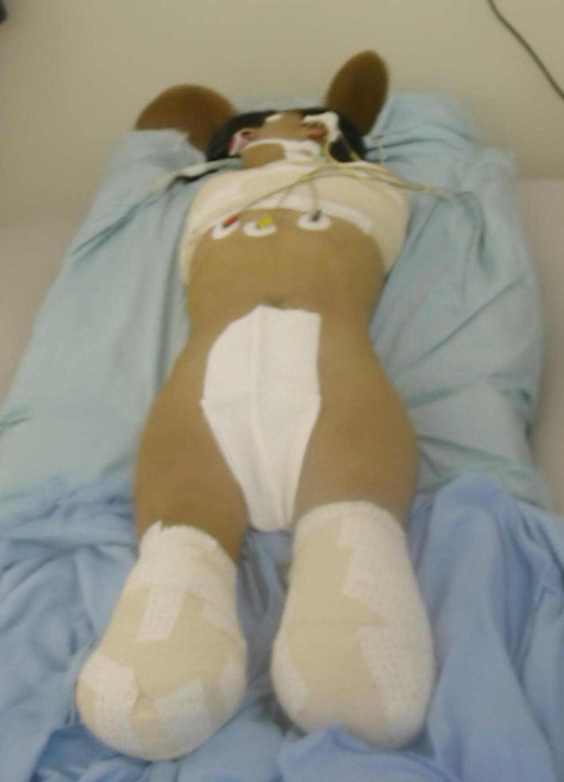

mmediate postoperative care
The patient was transferred to the intensive care unit for close monitoring. The immediate postoperative management included hemodynamic stabilization, management of rhabdomyolysis, prevention of renal failure and control of systemic inflammatory response.
Pain control was achieved through multimodal analgesia.
Given the potential catastrophic impact of quadruple limb amputation, early psychological intervention was initiated. Supportive psychotherapy was introduced immediately in order to facilitate emotional stabilization, promote acceptance of the amputation and reinforce adherence to the rehabilitation program.

Rehabilitation and prosthetic fitting
After satisfactory stump healing, the patient was transferred to a specialized physical medicine and rehabilitation department. Rehabilitation followed a progressive and hierarchical strategy in accordance with current recommendations for the management of multiple limb amputees (Tanaka et al., 2024, Dhole et al. 2025).
Initial rehabilitation focused on stump care, prevention of joint contractures, strengthening of residual muscles and balance training. Prostheses fitting was initiated upon full stump healing.
Lower-limb prostheses were fitted first in order to restore standing posture and gait training.
Modern lower-limb prosthetic systems allowed improved gait biomechanics and increased functional independence.
Following successful adaptation to lower-limb prostheses, bilateral myoelectric upper-limb prostheses were fitted allowing for more intuitive motor control and improved dexterity (Engdahl et al., 2024).
Through structured therapy sessions, the patient progressively regained grasping functions enabling activities such as eating, dressing and personal hygiene. Continuous psychological support was maintained throughout the rehabilitation process to reinforce adherence and facilitate acceptance of the prostheses.
Functional outcome was favorable, with significant gains in autonomy, improved quality of life and satisfactory social reintegration.

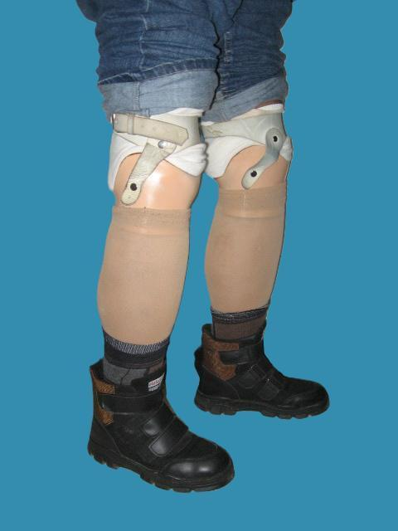

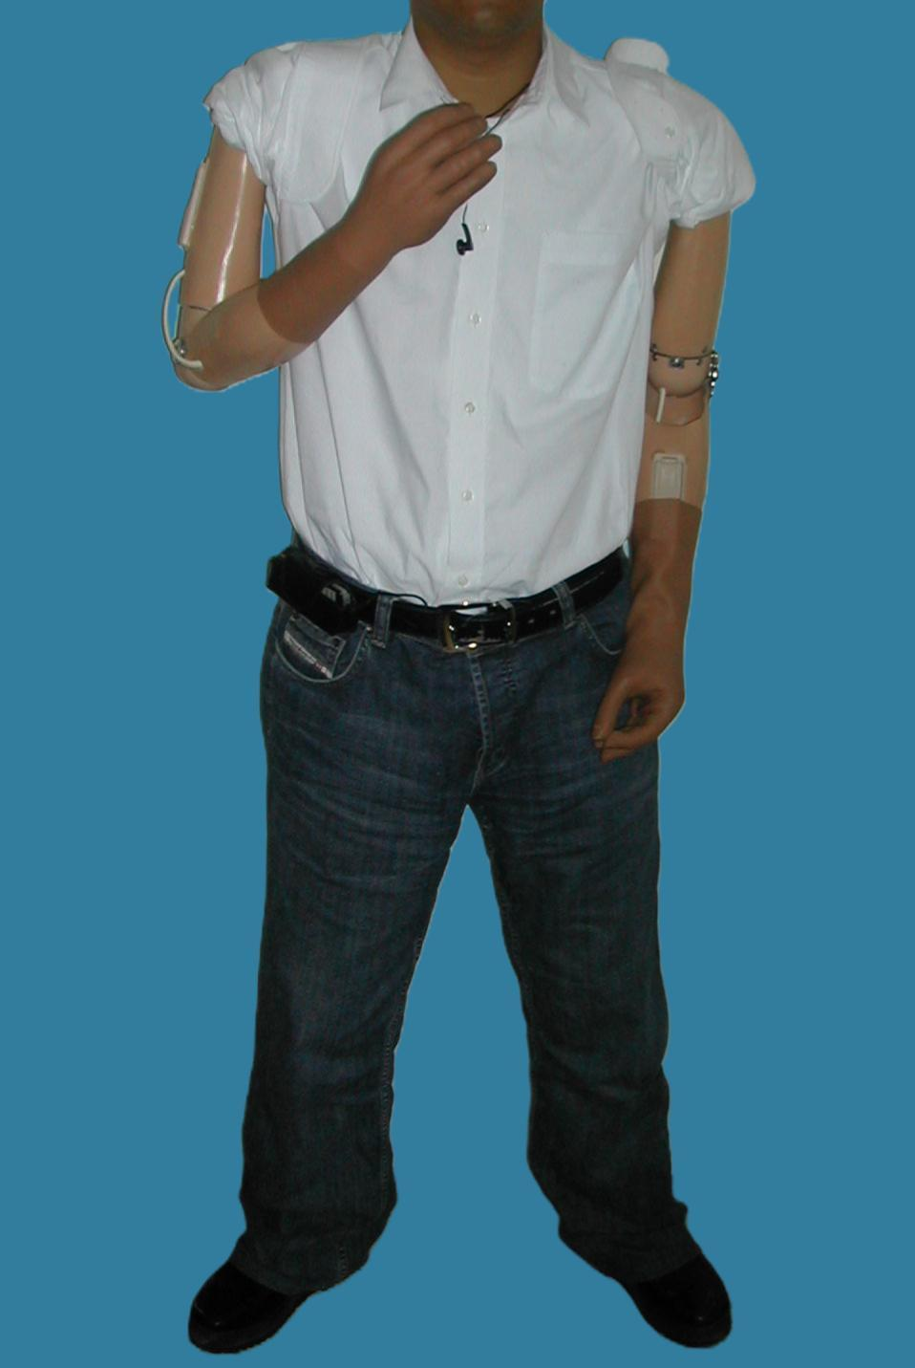
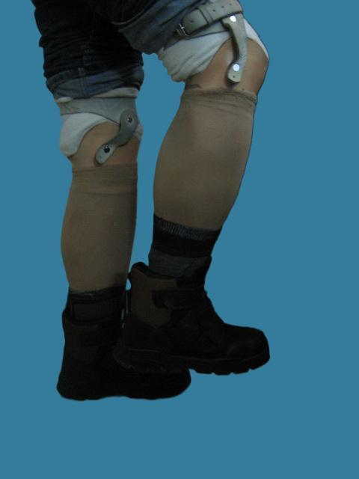
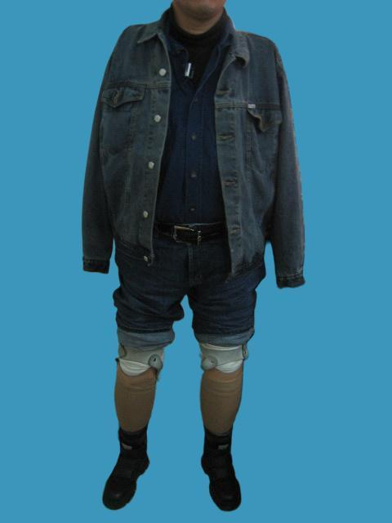

Figure 2. - Rehabilitation and Prosthetic Fitting in the Patient

3. discussion
Epidemiology of high-voltage electrical injuries
Electrical injuries represent an uncommon form of occupational accident but are associated with high mortality and severe long-term complications and disabilities (Salehi et al., 2022). High-voltage electrical burns are particularly dangerous due to the high level of energy and heat transferred through the body, leading to deep tissue destruction that may not be fully apparent during initial assessment.
Recent epidemiological studies confirm that these injuries predominantly affect young male workers and frequently occur in industrial or construction environments (Gandhi et al., 2022). Death toll related to high-voltage electrical injuries remains significant and accounts for the second highest rate of mortality related to electrical injury reaching 5% in some series (Arnoldo et al., 2004).

Incidence of amputations after electrical burns
High-voltage electrical burns carry a high risk of deep-tissue necrosis affecting the limbs. Progressive ischemia, vascular thrombosis and compartment syndrome frequently lead to secondary amputation as a salvatory solution.
According to a published series, between 10% and 30% of patients with extensive electrical burns require at least one amputation (Handschin et al., 2007; Cancio et al., 2005). More recent studies report even higher rates, with some burn centers documenting amputation rates approaching 30.3% in severe electrical burn injuries (Kim et al., 2023).
Upper right limbs are most frequently affected because they usually represent the entry point of the electrical current. Multiple amputations, particularly quadruple amputations, remain exceptional but represent some of the most devastating complications of electrical trauma (Dash et al., 2021).

Prosthetic fitting and reliability
Technological advances in prosthetic engineering have significantly improved functional outcomes in amputees.
Modern lower-limb prostheses allow more natural gait patterns and improved stability.
Technological improvements have resulted in increased prosthetic comfort and long-term use rates exceeding 80% among appropriately selected patients especially if couples with structured rehabilitation programs (Highsmith et al., 2016).
For upper limbs, myoelectric prostheses represent a major technological advancement allowing for a more precise grasping and functional autonomy.
Recent studies have shown that myoelectric prosthetic systems significantly improve activity performance and reduce prosthesis rejection rates compared with traditional body-powered prostheses (Biddiss & Chau, 2007, Engdahl et al., 2024).

Role of supportive psychotherapy
Multiple limb amputation represents a major psychological trauma, particularly in young and active individuals. Psychological disorders such as anxiety, depression and post-traumatic stress disorder are common following major amputations.
Previous studies have reported prevalence rates of approximately 29.9% for anxiety disorders and 13.4% for depression among amputees (Atherton & Robertson, 2006). Persistent psychological distress may negatively affect adherence to rehabilitation programs and increase the risk of prosthesis rejection.
Supportive psychotherapy is a cornerstone of psychological care and should be initiated as early as possible in order to establish a strong therapeutic alliance and facilitate patient adaptation to the new physical condition.

Role of patient motivation and family support
The literature emphasizes that patient motivation and active participation in rehabilitation are independent prognostic factors for successful prosthetic integration. Motivation plays a decisive role in prosthesis acceptance and long-term functional recovery regardless of prosthetic sophistication..
External factors such as family support and social environment also significantly influence psychological adaptation and rehabilitation success (Resnik et al., 2012; Monné Cuevas et al., 2021).
In the present case, the patient demonstrated strong determination and adherence to the therapeutic program, which greatly contributed to successful prosthetic use and effective social reintegration.

Post-prosthetic course
Over time, the patient gradually adapted to the use of prosthetic limbs and regained an adequate level of functional autonomy. Long-term follow-up includes regular clinical evaluation, continued psychological monitoring and periodic prosthetic adjustments or replacement in case of wear.
Limitations
The case was managed in a resource-limited setting where access to advanced prosthetic technology remains scarce due to financial and logistical constraints. Consequently prosthetic fitting may require prolonged delays.
The limited scope of this study may highlight the importance of a multidisciplinary approach and highlight the role of patient motivation regardless of prosthetic sophistication but due the inherent limitation of case reports does not allow for generalizability.

4. Conclusion
Occupational high-voltage electrical injuries can lead to catastrophic and extensive tissue damage requiring major amputations. Although these injuries present dramatic functional and psychological challenges, early multidisciplinary management can significantly improve outcomes.
Prompt surgical intervention, appropriate stump formation, modern prosthetic technologies, intensive rehabilitation and sustained psychological support together constitute the cornerstone of successful recovery.
Even in cases of quadruple limb amputation, favorable functional outcomes and meaningful social reintegration can be achieved when the patient remains actively engaged in the rehabilitation process. Patient motivation and adherence to the therapeutic program remain central determinants of long-term functional prognosis.

Ethical Approval:

As per international standards or university standards written ethical approval has been collected and preserved by the author(s).

Consent
All authors declare that they received written informed consent was obtained from the patient

COMPETING INTERESTS DISCLAIMER:
Authors have declared that they have no known competing financial interests OR non-financial interests OR personal relationships that could have appeared to influence the work reported in this paper.
Disclaimer (Artificial intelligence)

Author(s) hereby declare that NO generative AI technologies such as Large Language Models (ChatGPT, COPILOT, etc.) and text-to-image generators have been used during the writing or editing of this manuscript.

References
[1] Koumbourlis AC. Electrical injuries: Critical Care Medicine 2002;30:S424–30. https://doi.org/10.1097/00003246-200211001-00007.
[2] Al-Benna S. Electrical burns in adults. Acta Chir Plast 2023;65:66–9. https://doi.org/10.48095/ccachp202366.
[3] Arnoldo BD, Purdue GF, Kowalske K, Helm PA, Burris A, Hunt JL. Electrical Injuries: A 20-Year Review. The Journal of Burn Care & Rehabilitation 2004;25:479–84. https://doi.org/10.1097/01.BCR.0000144536.22284.5C.
[4] Gandhi G, Parashar A, Sharma RK. Epidemiology of electrical burns and its impact on quality of life - the developing world scenario. WJCCM 2022;11:58–69. https://doi.org/10.5492/wjccm.v11.i1.58.
[5] Rehan M, Ain QT, Iqbal T, Tariq MH, Khan MS, Waheed U, et al. Electrical burn injuries: disabling lives even in 2022. Eur J Plast Surg 2023;46:1299–304. https://doi.org/10.1007/s00238-023-02088-8.
[6] Handschin AE, Vetter S, Jung FJ, Guggenheim M, Künzi W, Giovanoli P. A Case-Matched Controlled Study on High-Voltage Electrical Injuries vs Thermal Burns: Journal of Burn Care & Research 2009;30:400–7. https://doi.org/10.1097/BCR.0b013e3181a289a6.
[7] Cancio LC, Jimenez-Reyna JF, Barillo DJ, Walker SC, McManus AT, Vaughan GM. One Hundred Ninety-Five Cases of High-Voltage Electric Injury: Journal of Burn Care & Rehabilitation 2005;26:331–40. https://doi.org/10.1097/01.BCR.0000169893.25351.A9.
[8] Kim E, Wan B, Solis-Beach KJ, Kowalske K. Outcomes of Patients with Amputation following Electrical Burn Injuries. Eur Burn J 2023;4:318–29. https://doi.org/10.3390/ebj4030029.
[9] Resnik L, Meucci MR, Lieberman-Klinger S, Fantini C, Kelty DL, Disla R, et al. Advanced Upper Limb Prosthetic Devices: Implications for Upper Limb Prosthetic Rehabilitation. Archives of Physical Medicine and Rehabilitation 2012;93:710–7. https://doi.org/10.1016/j.apmr.2011.11.010.
[10] Engdahl SM, Christie BP, Kelly B, Davis A, Chestek CA, Gates DH. Surveying the interest of individuals with upper limb loss in novel prosthetic control techniques. J NeuroEngineering Rehabil 2015;12:53. https://doi.org/10.1186/s12984-015-0044-2.
[11] Chaker SC, Hung Y-C, Saad M, Cardenas D, Perdikis G, Thayer WP. Systematic Review and Meta-Analysis of Global Neuroma Incidence in Upper Extremity Amputees. Ann Plast Surg 2024;92:80–5. https://doi.org/10.1097/SAP.0000000000003742.
[12] Dhole S, K P, Daulatabad VS, Gaikar RR, More S. Rehabilitation Following Multiple Limb Amputation: A Case Report. Cureus 2025;17:e78527. https://doi.org/10.7759/cureus.78527.
[13] Tanaka Y, Nakayama S, Ueno T, Miura T. Prosthetic Rehabilitation for a Patient With Purpura Fulminans Undergoing Quadruple Amputation: A Case Report. Cureus 2024. https://doi.org/10.7759/cureus.67384.
[14] Salehi SH, Sadat Azad Y, Bagheri T, Ghadimi T, Rahbar A, Ehyaei P, et al. Epidemiology of Occupational Electrical Injuries. Journal of Burn Care & Research 2022;43:399–402. https://doi.org/10.1093/jbcr/irab171.
[15] Handschin A, Jung F, Guggenheim M, Moser V, Wedler V, Contaldo C, et al. Die chirurgische Behandlung von Hochspannungsverletzungen. Handchir Mikrochir plast Chir 2007;39:345–9. https://doi.org/10.1055/s-2007-965721.
[16] Dash S, Arumugam PK, Muthukumar V, Kumath M, Sharma S. Study of clinical pattern of limb loss in electrical burn injuries. Injury 2021;52:1925–33. https://doi.org/10.1016/j.injury.2021.04.028.
[17] Highsmith MJ, Kahle JT, Miro RM, Orendurff MS, Lewandowski AL, Orriola JJ, et al. Prosthetic interventions for people with transtibial amputation: Systematic review and meta-analysis of high-quality prospective literature and systematic reviews. J Rehabil Res Dev 2016;53:157–84. https://doi.org/10.1682/JRRD.2015.03.0046.
[18] Biddiss E, Chau T. Upper-Limb Prosthetics: Critical Factors in Device Abandonment. American Journal of Physical Medicine & Rehabilitation 2007;86:977–87. https://doi.org/10.1097/PHM.0b013e3181587f6c.
[19] Engdahl SM, Gonzalez MA, Lee C, Gates DH. Perspectives on the comparative benefits of body-powered and myoelectric upper limb prostheses. J Neuroeng Rehabil 2024;21:138. https://doi.org/10.1186/s12984-024-01436-4.
[20] Atherton R, Robertson N. Psychological adjustment to lower limb amputation amongst prosthesis users. Disability and Rehabilitation 2006;28:1201–9. https://doi.org/10.1080/09638280600551674.
[21] Monné Cuevas P, Borrás Correa A, Vidal Fortuny E, Ángeles Diaz Vela M, Calvo Sanz J. Traumatic quadruple amputee rehabilitation: from amputation to prosthetic functionality: a case report. Disability and Rehabilitation: Assistive Technology 2021;16:112–8. https://doi.org/10.1080/17483107.2019.1644675.

