CASE REPORT
Duplication of Internal Jugular Vein During Neck Dissection:
A Rare Anatomical Variation

ABSTRACT
Background: The major tributaries of the internal jugular vein typically originate from the anterior surface of the vein in the neck and almost never have posterior branches, thus facilitating dissection of the posterior triangle of the neck. Uncommonly, this vein may present with posterior branches and duplications.
Aims: The study highlighted a case report is to explain the anatomical variation and the presentation of such duplication, related to internal jugular vein.
Presentation of case: In this case report, while doing bilateral neck dissection we incidentally encountered the unilateral duplication of Right internal jugular vein in a case of oral squamous cell carcinoma of lower labial vestibule with lymph node metastasis.
Discussion: It is essential for the clinicians performing catheterization and surgeons operating in the neck to understand normal and abnormal venous anatomy structure within the neck. Duplication of the internal jugular vein is a rare anatomical variation which may cross across during surgery on the neck. This abnormality is manifested as two separate internal jugular veins rather than a single one.
Conclusion: Such anatomical variations are considered to be more easily noted intraoperatively or unexpectedly, and as there might be a potential for SAN (Spinal Accessory Nerve) and vascular injuries, patients should be evaluated thoroughly before surgery so that the risk of iatrogenic injury could at least theoretically reduced.

Keywords: Neck dissection, Internal Jugular Vein, Duplication, Unilateral

- INTRODUCTION

Variations in the anatomical course and distribution of blood vessels are relatively frequent, with such anomalies being more commonly observed in veins than in arteries. The internal jugular vein (IJV) courses from the base of the skull to the root of the neck along the carotid axis (1). In the cervical region, the internal jugular vein maintains close anatomical relationships with the internal carotid and common carotid arteries. Specifically, the IJV lies lateral to the hypoglossal nerve and medial to the spinal accessory nerve, before descending to join the subclavian vein at the base of the neck. Beyond its vascular role, the IJV serves as a critical surgical landmark, facilitating the identification of the carotid arteries and the evaluation of cervical lymph nodes. Anatomical observations further indicate that the left internal jugular vein is generally of smaller calibre than its right-sided counterpart (2).
The major tributaries of the internal jugular vein typically originate from the anterior surface of the vein in the neck and almost never have posterior branches, thus facilitating dissection of the posterior triangle of the neck. Uncommonly, this vein may present with posterior branches and duplications.
Duplication of the internal jugular vein (IJV) is an uncommon anatomical variation, with a reported incidence of approximately 4 cases per 1,000 unilateral neck dissection procedures (3). A review of the available literature indicates that only 21 cases of IJV duplication have been documented in 18 patients to date. Among these reported cases, 15 presented as unilateral duplications, while only 3 cases exhibited bilateral duplication (7). The presence of a duplicated internal jugular vein may present technical challenges during surgical interventions in the cervical region, particularly during neck dissection procedures. Therefore, awareness and careful consideration of this anatomical variation are essential for surgeons to minimise the risk of inadvertent vascular injury and to ensure safe operative management.
In this case report, an incidental unilateral duplication of the right internal jugular vein was identified during bilateral neck dissection in a patient with oral squamous cell carcinoma of the lower labial vestibule with lymph node metastasis

- CASE PRESENTATION

A 60-year-old female patient presented to the Department of Oral and Maxillofacial Surgery with a 2-month history of an ulceroproliferative lesion involving the lower labial vestibule. Clinical examination revealed a roughly oval, reddish-white lesion measuring approximately 6 × 6 cm, fixed to the underlying soft tissue and mandible. Histopathological analysis of a biopsy specimen confirmed the diagnosis of well-differentiated oral squamous cell carcinoma of the lower labial vestibule. The patient was clinically staged as T4aN2cM0, reflecting involvement of the lower lip skin.
The patient subsequently underwent wide local excision of the primary lesion with anterior marginal mandibulectomy, followed by bilateral modified radical neck dissection type III (levels I–IV), preserving the spinal accessory nerve, internal jugular vein, and sternocleidomastoid muscle. Reconstruction was achieved using a pectoralis major myocutaneous (PMMC) flap. During the right-sided neck dissection, duplication of the internal jugular vein (IJV) was identified at the level of the superior belly of the omohyoid muscle, manifesting as medial and lateral tributaries. The medial tributary measured approximately 6 cm in length and was positioned medial to the carotid bulb, whereas the lateral tributary measured approximately 7 cm and occupied the typical anatomical location of the IJV, lateral to the common carotid artery.
Further superior dissection undertaken to identify the spinal accessory nerve revealed that the two tributaries were interconnected by a small communicating vein, forming a configuration resembling the letter ‘H’ (Fig. 1). The spinal accessory nerve was observed to lie further lateral to the lateral tributary and anterior to the external carotid artery. Both venous tributaries were carefully preserved during the procedure, and lymph nodes from levels II–IV were dissected and removed while maintaining the dissection plane along both the medial and lateral tributaries of the duplicated internal jugular vein.

Post-operative CECT though required to supplement our findings we were not able to do so due to financial constraints.

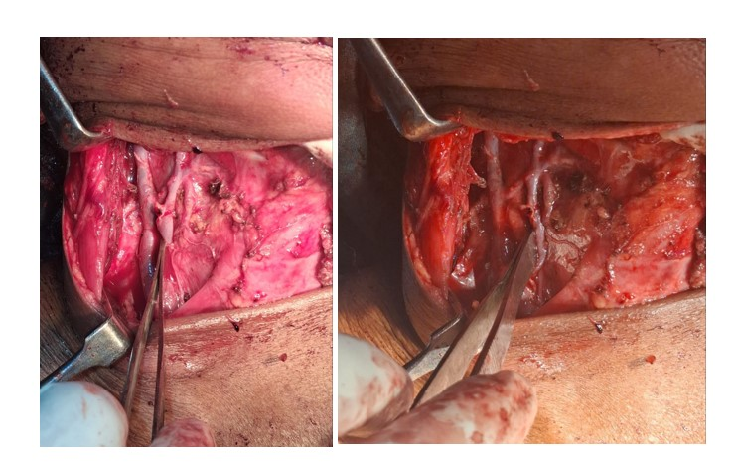
Fig. 1 – Duplication of Internal jugular vein. Medial and lateral tributaries are separated and recommunicated by an interconnecting vein at upper part.

- DISCUSSION
The major vascular structures of the head and neck comprise the carotid arteries, which provide arterial supply, and the jugular veins, which are responsible for venous drainage. These vessels are frequently encountered by head and neck surgeons during neck dissections and by anaesthesiologists or intensivists when placing central venous catheters for central venous pressure monitoring, drug administration, or fluid resuscitation.
Several classifications have been proposed to describe variations of the internal jugular vein (IJV). Mumtaz S et al. categorised IJV anatomical variations into duplication, bifurcation, fenestration, posterior tributary, and trifurcation [5]. Downie et al. described a simpler system, distinguishing between duplicated and fenestrated patterns. In the duplicated pattern, the IJV bifurcates into two separate veins, each draining independently into the subclavian vein, thereby forming an inverted-Y configuration. In the fenestrated pattern, the IJV originates as a single vein from the base of the skull, branches into two channels over a certain distance, and subsequently reunites proximal to the subclavian vein (10).
Building on these observations, Nayak SP et al. proposed a classification system for IJV duplication comprising three principal patterns. Type A, the most commonly observed variant, involves the convergence of the duplicated venous channels cranial to, or at the level of, the omohyoid tendon. Type B is characterised by union of the duplicated veins caudal to the omohyoid tendon. Type C represents a distinctive anatomical configuration in which the duplication begins around the level of the hyoid bone, with the lateral venous channel coursing outside the carotid sheath within the posterior triangle before entering the carotid sheath at the root of the neck (7).
So in our case report, in the duplication of the right internal jugular vein the medial tributaries and lateral tributaries runs parallel to carotid axis and spinal accessory nerve is present lateral to lateral tributaries of the internal jugular vein. Lateral and medial tributaries combine at both upper and lower parts of the internal jugular vein, at upper parts through a small communicating vein and at lower parts as a main branch of IJV which supplies further to subclavian vein.
So, according to Nayak SP et al. classification and variation we discovered while doing neck dissection, we would like to suggest a modification in Nayak SP classification:
1) Type 4: involves the union of duplicate veins at the level of omohyoid tendon which again united superiorly just below the level of hyoid bone giving the anterior tributaries. (fig 2)

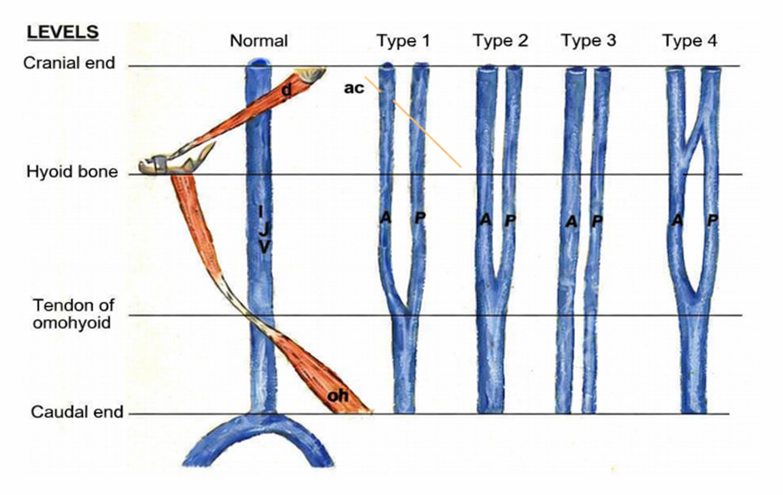
FIG 2: Modification of Nayak SP et al. classification

- CONCLUSION
Duplication of the internal jugular vein although a rare anatomical variation. Knowledge of such vascular anomalies is important for head and neck surgeons, as unrecognized variations may increase the risk of vascular injury or damage to adjacent structures such as the spinal accessory nerve during neck dissection. Careful intraoperative identification and preservation of these structures are essential to prevent complications. Therefore, a thorough understanding of possible venous variations and meticulous surgical dissection are crucial for safe and effective surgical management in the cervical region.
Consent
As per international standards or university standards, patient(s) written consent has been collected and preserved by the author(s).
Ethical Approval:

As per international standards or university standards written ethical approval has been collected and preserved by the author(s).
Disclaimer (Artificial intelligence)
Author(s) hereby declare that NO generative AI technologies such as Large Language Models (ChatGPT, COPILOT, etc.) and text-to-image generators have been used during the writing or editing of this manuscript.

ACKNOWLEDGEMENTS
The authors would like to express their gratitude to Dr. Kiran Holikatti Professor and HOD, Department of oral pathology, ACPM Dental College Dhule for Histopathology report.

COMPETING INTERESTS
“Authors have declared that no competing interests exist.”

REFERENCES

1) Rusu MC, Vrapciu AD, Popescu ȘA. High bilateral fenestration of the internal jugular vein. Surg Radiol Anat. 2022 May;44(5):703-708. doi: 10.1007/s00276-022-02931-w. Epub 2022 Apr 9. PMID: 35396939.
2) Deepak CA, Sarvadnya JJ, Sabitha KS. Variant anatomy of internal jugular vein branching. Ann Maxillofac Surg. 2015 Jul-Dec;5(2):284-6. doi: 10.4103/2231-0746.175751. PMID: 26981491; PMCID: PMC4772581.
3) Vijayakumar Jain, K.V. Sureka, G. Satheesh, V. Venugopalan, D. Durairaj, Duplication of internal jugular vein - An incidental finding, Oral Oncology Reports, Volume 13, 2025, 100699, ISSN 2772-9060, https://doi.org/10.1016/j.oor.2024.100699
4) Wang X, Peng L, Guo H, Hernesniemi J, Xiong X, Andrade-Barazarte H, Qian R. Internal Jugular Vein Fenestration and Duplication: Anatomical Findings, Prevalence, and Literature Review. Front Surg. 2020 Nov 13; 7:593367. doi: 10.3389/fsurg.2020.593367. PMID: 33282909; PMCID: PMC7691239.
5) Mumtaz S, Singh M. Surgical review of the anatomical variations of the internal jugular vein: an update for head and neck surgeons. Ann R Coll Surg Engl. 2019 Jan;101(1):2-6. doi: 10.1308/rcsann.2018.0185. Epub 2018 Oct 16. PMID: 30322289; PMCID: PMC6303832.
6) Young M, Zavitsky A, Niceley J, Battiston G, Sakthi-Velavan S. A unique variation of the jugular veins and its clinical significance. Folia Morphol (Warsz). 2024;83(4):920-924. doi: 10.5603/fm.98618. Epub 2024 Feb 23. PMID: 38390747.
7) Nayak SP, Ashraf M, Dam A, Biswas J. Internal Jugular Vein Duplication: Review and Classification. Indian J Surg Oncol. 2017 Jun;8(2):222-226. doi: 10.1007/s13193-015-0452-6. Epub 2015 Sep 24. PMID: 28546726; PMCID: PMC5427012.
8) Nova-Baeza P, Valenzuela-Fuenzalida JJ, Valdivia-Arroyo R, Becerra-Rodríguez ES, Escalona-Manzo C, Castaño-Gallego YT, Luque-Bernal RM, Oyanedel-Amaro G, Suazo-Santibáñez A, Orellana-Donoso M, Bruna-Mejias A, Sanchis-Gimeno J, Gutiérrez-Espinoza H. Systematic Review and Meta-Analysis of Internal Jugular Vein Variants and Their Relationship to Clinical Implications in the Head and Neck. Diagnostics (Basel). 2024 Dec 9;14(23):2765. doi: 10.3390/diagnostics14232765. PMID: 39682673; PMCID: PMC11640428.
9) Contrera KJ, Aygun N, Ward BK, Gooi Z, Richmon JD. Internal jugular vein duplication and fenestration: Case series and literature review. Laryngoscope. 2016 Jul;126(7):1585-8. doi: 10.1002/lary.25743. Epub 2015 Oct 26. PMID: 26498831; PMCID: PMC5405004.
10) Downie SA, Schalop L, Mazurek JN, Savitch G, Lelonek GJ, Olson TR. Bilateral duplicated internal jugular veins: case study and literature review. Clin Anat. 2007 Apr;20(3):260-6. doi: 10.1002/ca.20366. PMID: 16838288.
11) Bhoriwal, S., Sharma, J., Dhall, K., Mandal, A., Chhebbi, M., & Surya, T. S. H. V. (2020). Duplication of the internal jugular vein-A rare anatomical variation. Oral Oncology, 112, 104985-104985.

