The Silent Swell in the Anterior Maxilla: Unmasking a Peripheral Ameloblastoma
Abstract
Peripheral ameloblastoma is a rare extraosseous odontogenic tumour arising from the soft tissues overlying tooth-bearing regions of the jaws. In contrast to the conventional intraosseous ameloblastoma, this variant demonstrates relatively indolent biological behaviour and minimal invasive potential. Due to its innocuous clinical appearance and similarity to common reactive gingival lesions, peripheral ameloblastoma often presents a diagnostic challenge in clinical practice.
This report presents a rare case of peripheral ameloblastoma involving the anterior palatal mucosa in a 44-year-old male patient who presented with a painless swelling that gradually increased in size over six months. Clinical examination revealed a firm sessile mass measuring approximately 2.5 × 1.5 cm extending from tooth 21 to 13 along the palatal mucosa. Radiographic investigations, including periapical radiography, maxillary occlusal imaging, and cone beam computed tomography, revealed no evidence of underlying osseous involvement. The lesion was surgically excised under local anaesthesia, and histopathological examination demonstrated classical follicular architecture with peripheral palisading and reverse polarization consistent with peripheral ameloblastoma.
Postoperative healing was uneventful, and no recurrence was observed during a 12-month follow-up period. The present case highlights the importance of considering peripheral odontogenic tumours in the differential diagnosis of persistent palatal swellings. Early diagnosis and conservative surgical excision remain the mainstay of management with a favourable prognosis.
Keywords: Peripheral ameloblastoma, odontogenic tumour, palatal swelling, gingival lesion, histopathology, surgical excision
Introduction
Ameloblastoma is a benign odontogenic neoplasm characterized by slow but locally aggressive growth originating from odontogenic epithelial remnants associated with tooth development [1]. It represents approximately 10–15% of all odontogenic tumours and most commonly arises as an intraosseous lesion involving the posterior mandible [2]. Despite its benign nature, conventional ameloblastoma demonstrates locally invasive behaviour and a high recurrence rate if inadequately treated [3].
Among the various clinicopathologic variants of ameloblastoma, peripheral ameloblastoma represents a rare extraosseous form that arises within the soft tissues of the gingiva or alveolar mucosa without significant intraosseous involvement [4]. This lesion accounts for less than 10% of all ameloblastomas and is generally regarded as a distinct clinical entity due to its superficial location and less aggressive biological behaviour [5].
The pathogenesis of peripheral ameloblastoma has been attributed to remnants of the dental lamina, also known as the rests of Serres, located within the gingival connective tissue [6]. Another proposed mechanism suggests that the tumour may arise from the basal cell layer of the oral epithelium, which possesses odontogenic potential and can undergo neoplastic transformation [7].
Clinically, peripheral ameloblastoma typically manifests as a slow-growing, painless, sessile or pedunculated swelling located on the gingiva or alveolar mucosa [8]. The lesion is usually well circumscribed and covered by intact mucosa, frequently resembling reactive lesions such as fibroma, peripheral ossifying fibroma, or pyogenic granuloma [9]. Because of this clinical similarity, peripheral ameloblastoma is often misdiagnosed during initial examination and only identified following histopathological evaluation [4].
The tumour most frequently affects individuals between the fourth and sixth decades of life and demonstrates a slight male predilection [5]. The mandibular premolar region is considered the most common site of occurrence. In contrast, lesions arising in the maxillary region, particularly the anterior palate, are extremely rare, and only a limited number of cases have been documented in the literature [10].
Radiographically, peripheral ameloblastomas generally demonstrate no significant bone involvement because of their superficial location [8]. However, mild saucerization or pressure resorption of the underlying alveolar bone has occasionally been reported [8]. Histologically, the tumour resembles conventional ameloblastoma and may exhibit follicular, plexiform, acanthomatous, or granular cell patterns [11].
The standard treatment involves conservative surgical excision with adequate margins, and the overall prognosis is favourable with relatively low recurrence rates compared with intraosseous ameloblastoma [4]. Nevertheless, long-term follow-up is recommended because occasional recurrences and rare malignant transformation have been reported [12].
FIG: 1 Firm, sessile, dome-shaped mass located on the palatal mucosa
The present report describes an unusual case of peripheral ameloblastoma involving the anterior palatal mucosa extending from tooth 21 to 13, highlighting its clinical presentation, diagnostic challenges, and management.

Case Presentation
A 44-year-old male patient presented to the Department of Oral and Maxillofacial Surgery with a chief complaint of a painless swelling in the anterior palatal region that had progressively increased in size over the past six months. The patient first noticed a small, nodular swelling on the palate that gradually enlarged over time. The swelling was asymptomatic and was not associated with pain, bleeding, discharge, or ulceration. The patient denied any history of trauma, local irritation, previous dental procedures, or infection in the region. His medical history was non-contributory, and no systemic illness or medication use was reported.
Clinical Examination
Extraoral examination revealed no evidence of facial asymmetry, swelling, or cervical lymphadenopathy. The overlying facial skin appeared normal, and no tenderness was elicited on palpation.
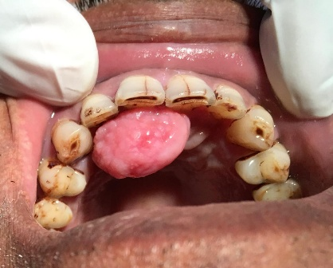
Intraoral examination revealed a well-defined dome-shaped swelling located on the anterior palatal mucosa extending from the region of tooth 21 to tooth 13. The lesion measured approximately 2.5 × 1.5 cm (Fig:1). The surface mucosa covering the swelling appeared smooth and intact with normal coloration and showed no evidence of ulceration, erythema, or surface irregularity.
On palpation, the lesion was firm in consistency, non-tender, and non-fluctuant. The swelling was sessile in nature and appeared well circumscribed with clearly defined margins. There was no blanching on pressure, and no spontaneous bleeding was noted. The adjacent teeth were vital and demonstrated no mobility, displacement, or periodontal involvement. No paraesthesia or sensory disturbances were reported by the patient.
Based on the clinical appearance, the lesion resembled a benign reactive soft-tissue growth. The provisional diagnosis included common gingival reactive lesions such as:
- Irritational fibroma
- Peripheral ossifying fibroma
- Pyogenic granuloma
- Peripheral giant cell granuloma
However, due to the unusual palatal location and firm nodular consistency, the possibility of a peripheral odontogenic tumour was also considered in the differential diagnosis.
Radiographic Evaluation
Radiographic evaluation was performed to assess the presence of any underlying osseous involvement.
The following imaging modalities were utilized:
- Intraoral periapical radiographs
- Maxillary occlusal radiograph
- Cone Beam Computed Tomography (CBCT)

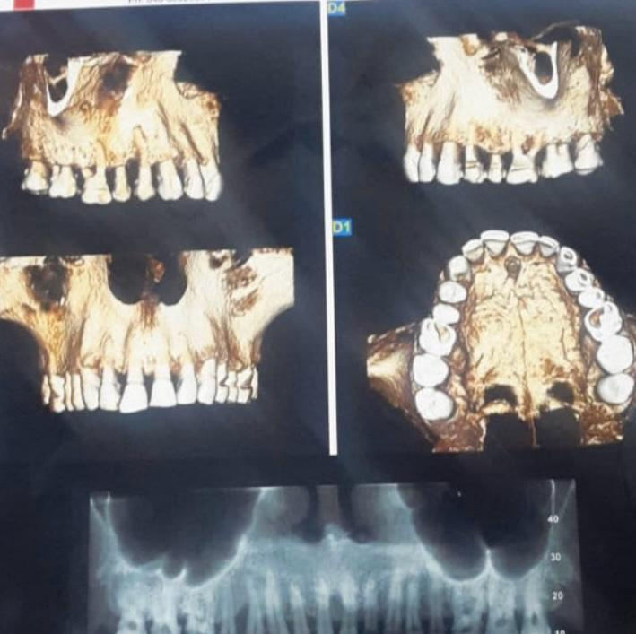

FIG: 2 Radiographic Image

The intraoral radiographs revealed no evidence of radiolucency, bone destruction, or root resorption associated with the lesion. The periodontal ligament spaces and lamina dura of the adjacent teeth appeared normal.
CBCT imaging was performed to obtain a more detailed assessment of the palatal bone. The CBCT scans demonstrated intact cortical plates and a normal trabecular bone pattern without any signs of cortical expansion, erosion, or intraosseous involvement. The lesion appeared confined entirely to the soft tissues of the palatal mucosa, suggesting a peripheral origin (Fig 2).
These radiographic findings supported the clinical suspicion of a soft-tissue lesion rather than an intraosseous odontogenic tumour.
Surgical Management
Considering the small size and well-circumscribed nature of the lesion, an excisional biopsy was planned as both a diagnostic and therapeutic procedure.
The procedure was carried out under local anaesthesia using 2% lignocaine with 1:80,000 adrenaline following standard aseptic surgical protocol.
A circumferential full-thickness mucosal incision was made around the lesion with a small margin of surrounding normal tissue to ensure complete removal. The lesion was carefully dissected from
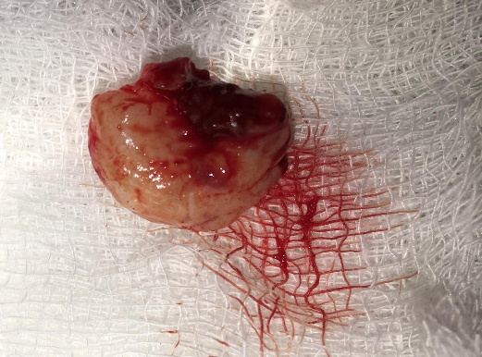
the underlying connective tissue using blunt and sharp dissection techniques (Fig :3).
The mass was excised in total, and the surgical field was thoroughly irrigated with sterile saline. Minimal intraoperative bleeding was encountered and haemostasis was achieved using pressure and suturing.
FIG: 3 Surgical excised lesion
The surgical defect was closed using resorbable sutures, ensuring proper approximation of the mucosal margins to facilitate optimal healing.
The excised specimen was immediately placed in 10% buffered formalin and submitted for histopathological examination.
Postoperative instructions were provided to the patient, including maintenance of oral hygiene, avoidance of trauma to the surgical site, and adherence to prescribed medications. The patient was prescribed analgesics and advised to return for follow-up evaluation.
Healing progressed uneventfully, and the sutures were removed after seven days.
Histopathological Findings
Histopathological examination of the excised specimen revealed multiple islands and strands of odontogenic epithelium embedded within a fibrous connective tissue stroma.
The epithelial islands exhibited a follicular pattern characteristic of ameloblastoma. The peripheral layer of the epithelial islands consisted of tall columnar cells arranged in a palisading configuration, with nuclei exhibiting reverse polarization away from the basement membrane. These features represent the classical histological characteristics of ameloblastoma.
The central portion of the epithelial islands contained loosely arranged polygonal cells resembling the stellate reticulum of the enamel organ. The surrounding connective tissue stroma was composed predominantly of dense fibrous tissue with minimal inflammatory cell infiltrate.
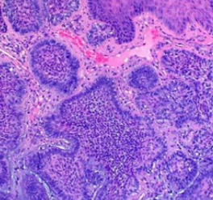
Importantly, there was no evidence of bone invasion, cellular atypia, increased mitotic activity, or malignant transformation (Fig 4).

FIG: 4 malignant transformation

Based on the histopathological findings, a definitive diagnosis of peripheral ameloblastoma was established.
Follow-Up
The patient was placed on a regular follow-up schedule to monitor postoperative healing and detect any signs of recurrence.
Clinical examinations performed during follow-up visits demonstrated satisfactory healing of the surgical site with complete mucosal recovery. The patient remained asymptomatic and exhibited no clinical evidence of recurrence during a 12-month follow-up period.
Discussion
Peripheral ameloblastoma is an uncommon odontogenic tumour that differs from conventional intraosseous ameloblastoma in both clinical behaviour and anatomical location [4]. Although histologically similar to central ameloblastoma, peripheral ameloblastoma demonstrates limited growth potential and generally remains confined to the soft tissues of the gingiva or alveolar mucosa [5].
The origin of peripheral ameloblastoma remains a subject of debate. One widely accepted theory suggests that the tumour arises from remnants of the dental lamina present within the gingival tissues [6]. Another hypothesis proposes that neoplastic transformation of basal epithelial cells of the oral mucosa may give rise to the tumour, supported by cases demonstrating continuity between tumour islands and surface epithelium [7].
Epidemiologically, peripheral ameloblastoma occurs most frequently in middle-aged adults and demonstrates a slight male predominance [5]. The mandibular gingiva is the most common site of occurrence, particularly in the premolar region [5]. Maxillary involvement is less common, and lesions involving the anterior palate are rarely reported, making the present case clinically significant [10].
Clinically, peripheral ameloblastoma typically presents as a painless gingival mass with slow progressive enlargement [8]. The lesion often appears similar to reactive gingival lesions such as fibroma, peripheral ossifying fibroma, or pyogenic granuloma [9]. Because of this resemblance, clinical diagnosis alone is often insufficient, and histopathological examination is essential for definitive diagnosis.
Radiographic findings are usually minimal because the lesion is located primarily within the soft tissues [8]. However, superficial bone resorption or saucerization may occasionally occur due to pressure exerted by the tumour on the underlying alveolar bone [8]. Advanced imaging modalities such as CBCT are useful for confirming the absence of intraosseous involvement and planning surgical management.
Histologically, peripheral ameloblastoma demonstrates the same epithelial patterns seen in conventional ameloblastoma, including follicular and plexiform arrangements [11]. The follicular pattern observed in the present case is characterized by epithelial islands composed of peripheral palisading columnar cells with reverse polarization and central stellate reticulum-like cells.
Several histological variants have been described in the literature, including acanthomatous, granular cell, and clear cell variants [13]. Rare cases showing hybrid features with calcifying epithelial odontogenic tumour-like areas have also been reported [14].
Treatment of peripheral ameloblastoma generally involves conservative surgical excision with adequate margins [4]. Because the lesion demonstrates limited invasive potential, radical surgical procedures are usually unnecessary. Recurrence rates reported in the literature range from 10% to 20%, typically associated with incomplete excision [4,8].
Although uncommon, malignant transformation into ameloblastic carcinoma has been reported in rare cases [12]. Therefore, long-term clinical follow-up is recommended to monitor for recurrence or aggressive behaviour.
The present case demonstrated typical clinical, radiographic, and histopathological characteristics of peripheral ameloblastoma and was successfully managed with complete surgical excision. The patient remained recurrence-free during the follow-up period.
Conclusion
Peripheral ameloblastoma is a rare odontogenic tumour that may clinically mimic common reactive gingival lesions. Accurate diagnosis requires histopathological confirmation because clinical and radiographic findings are often nonspecific.
The anterior palatal region represents an uncommon site for this tumour, making early recognition important for appropriate management. Conservative surgical excision remains the treatment of choice and generally provides favourable outcomes. Long-term follow-up is recommended due to the possibility of recurrence.
Acknowledgements
The authors acknowledge the support of the Department of Oral Pathology and the clinical staff of Panineeya Mahavidyalaya Institute of Dental Sciences and Research Centre for their assistance in the diagnosis and management of this case.
Conflict of Interest
The authors declare no conflict of interest.
Author Contributions
Concept and supervision – G.V. Reddy
Surgical management – Godvine
Case documentation – Kavya Rachana
Literature review – Lagishetty Sunayana
Data analysis – Nishmitha S
Clinical documentation – Lokeshwar Sara
Literature search – Karthikeya Saket
Manuscript preparation – Israa Mohammed Younus
Data collection – Appaji Krishna Sahithi
Manuscript editing – Saba Anjum
Patient Consent
Written informed consent was obtained from the patient for publication of the clinical details and associated images.

Ethical Approval:

As per international standards or university standards written ethical approval has been collected and preserved by the author(s).

References
- Anpalagan A, Tzortzis A, Twigg J, Wotherspoon R, Chen-got P, Kanatas A. Current practice in the management of peripheral ameloblastoma: A structured review. Br J Oral Maxillofac Surg. 2021;59(1):e1-e8. doi:10.1016/j.bjoms.2020.08.084
- Baden E, Doyle JL, Petriella V. Malignant transformation of peripheral ameloblastoma. Oral Surg Oral Med Oral Pathol. 1993;75(2):214-219. doi:10.1016/0030-4220(93)90096-M
- Vered M, Wright JM. Update from the 5th edition of the WHO classification of odontogenic and maxillofacial bone tumours. Head Neck Pathol. 2022;16(1):63-75. doi:10.1007/s12105-021-01404-7
- Luciani F, Papa E, Leggeri A, Condò R, Giovannetti F, Calabrese L. Peripheral ameloblastoma: Case report and review of literature. Acta Biomed. 2023;94(S1):e2023127. doi:10.23750/abm.v94iS1.13527
- Ghai S. Ameloblastoma: An updated narrative review of an enigmatic tumor. Cureus. 2022;14(8):e27734. doi:10.7759/cureus.27734
- Ide F, Mishima K, Miyazaki Y, Saito I, Kusama K. Peripheral ameloblastoma in situ: Evidence of surface epithelium origin. Oral Surg Oral Med Oral Pathol Oral Radiol Endod. 2009;108(5):763-767. doi:10.1016/j.tripleo.2009.06.018
- Ide F, Ito Y, Miyazaki Y, Nishimura M, Kusama K, Kikuchi K. A new look at the history of peripheral ameloblastoma. Head Neck Pathol. 2020;14(4):1052-1057. doi:10.1007/s12105-020-01168-6
- Philipsen HP, Reichart PA, Nikai H, Takata T, Kudo Y. Peripheral ameloblastoma: Biological profile based on 160 cases. Oral Oncol. 2001;37(1):17-27. doi:10.1016/S1368-8375(00)00064-6
- Manor Y, Mardinger O, Katz J, Taicher S, Hirshberg A. Peripheral odontogenic tumours: Differential diagnosis in gingival lesions. Int J Oral Maxillofac Surg. 2004;33(3):268-273. doi:10.1016/j.ijom.2003.05.008
- Vanoven BJ, Parker NP, Petruzzelli GJ. Peripheral ameloblastoma of the maxilla: A case report and literature review. Am J Otolaryngol. 2008;29(5):357-360. doi:10.1016/j.amjoto.2007.10.002
- Shi HA, Ng CWB, Kwa CT, Sim QXC. Ameloblastoma: Classification, genetic understanding, and novel therapies. Surgeon. 2021;19(4):238-243. doi:10.1016/j.surge.2020.06.009
- Singh R, Shrestha S, Acharya P, Shrestha A. Peripheral ameloblastoma of acanthomatous variant: Case report. JNMA J Nepal Med Assoc. 2022;60(256):1045-1048. doi:10.31729/jnma.7739
- Tajima Y, Kuroda-Kawasaki M, Ohno J, Yi J, Kusama K, Tanaka H, et al. Peripheral ameloblastoma with malignant potential: Keratin profile analysis. J Oral Pathol Med. 2001;30(8):494-498. doi:10.1034/j.1600-0714.2001.030008494.x
- Borrello R, Bettio E, Bacci C, Valente M, Sivolella S, Mazzoleni S, et al. Conservative approach to peripheral ameloblastoma. Case Rep Dent. 2016;2016:8254571. doi:10.1155/2016/8254571
- Wright JM, Vered M. Update on odontogenic tumors from the WHO classification. Head Neck Pathol. 2022;16(1):1-9. doi:10.1007/s12105-021-01407-4
- Speight PM, Takata T. New tumour entities in the WHO classification of head and neck tumours. Virchows Arch. 2023;482(1):23-34. doi:10.1007/s00428-022-03312-7
- Barnes L, Eveson JW, Reichart P, Sidransky D. Pathology and genetics of head and neck tumours. IARC Press; 2022 update. doi:10.1007/978-3-030-46061-3
- Zhang L, Li Y, Wang Y, et al. Clinicopathologic characteristics of odontogenic tumors: A retrospective analysis. Oral Surg Oral Med Oral Pathol Oral Radiol. 2023;135(4):456-464. doi:10.1016/j.oooo.2022.11.012
- Fonseca FP, de Andrade BAB, Rangel ALCA, et al. Peripheral odontogenic tumors: Clinical and pathological study. J Oral Pathol Med. 2022;51(7):620-627. doi:10.1111/jop.13302
- de Matos FR, Nonaka CFW, Pinto LP, et al. Peripheral ameloblastoma: A clinicopathologic study of rare odontogenic tumors. Oral Dis. 2022;28(8):2083-2090. doi:10.1111/odi.13984
- Pereira T, Shetty S, Prasad S. Peripheral ameloblastoma: Diagnostic challenges and management strategies. J Oral Biol Craniofac Res. 2023;13(4):523-527. doi:10.1016/j.jobcr.2023.05.012
- Patil S, Rao RS, Sanketh DS, et al. Peripheral odontogenic tumors: Review of literature and diagnostic considerations. J Clin Exp Dent. 2022;14(6):e508-e513. doi:10.4317/jced.59610
- Kumar G, Manjunatha BS. Peripheral ameloblastoma: Clinicopathologic review. J Maxillofac Oral Surg. 2023;22(2):201-207. doi:10.1007/s12663-022-01716-1
- Sharma R, Gupta S, Bansal P. Rare presentations of ameloblastoma: Diagnostic and therapeutic considerations. J Stomatol Oral Maxillofac Surg. 2024;125(2):101561. doi:10.1016/j.jormas.2023.101561

