Spectrum of Ocular Tuberculosis: Pathophysiology, Diagnosis and Management :A Case series

.
ABSTRACT
One of the rare causes of CNV is tuberculosis (TB), which is regulated by vascular endothelial growth factor (VEGF). However,VEGF expression in the RPE, is revealed by experimental animal models of intraocular TB which has been shown to harbor Mycobacterium tuberculosis that survive by inhibiting phagolysosome fusion. Choroidal neovascular membranes (CNV) represent the pathological development of blood vessels and can lead to loss of visual function. Various array of pathological processes involving the retinal pigment epithelium (RPE) and Bruch’s membrane can lead to the formation of CNV. In this case series we highlight three patients who developed ocular manifestation of tuberculosis and describe their subsequent management.

Aims:To describe the various Ocular manifestations in Tuberculosis and its treatment.In this case series we highlight three patients who developed ocular manifestation of tuberculosis and describe their subsequent management.

Place of Study: Department of Ophthalmology, Regional Institute of Ophthalmology, Bhimrao Ambedkar Memorial Hospital, Pt.JNM ,Raipur,Chhattisgarh, India

Methodology:We have described three patients with ocular manifestation of tuberculosis,one patient presented with RE-TB(Tubercular) Chorioretinitis with CNVM with CME.LE - TB (Tubercular) Chorioretinitis.There was history of tuberculosis in father 5 years back and taken course of antituberculosistreatment (ATT) for 6 months. Rubella IgM was positive, MANTOUX test – induration 20mm was positive,TB Quantiferon gold test was positive.Patient was started on ATT for 9 months ,RE -Injection posterior subtenons triamcinolone acetonide was given.Patient was started on oral steroids 20 mg in tapering doses,Intravitreal ranbizumab 0.5 mg in 0.05 ml injection was given one month later. After 1 month there was improvement in her vision in right eye,which was counting finger 5 meters and left eye 6/6. Second case presents a 20yr old male presented with diplopia since 3 days, deviation of LE towards nasal side since 3 days.Fundus examination revealed choroidal granuloma.Third case presented with optic neuritis.
Conclusion:While tubercular chorioretinitis is a known entity, the occurrence of CNVM with CME in a pediatric patient with presumed ocular tuberculosis represents a rare and noteworthy manifestation. Ocular tuberculosis as a cause of chorioretinitis.TB is a well-recognized cause of posterior uveitis and chorioretinitis, especially in endemic countries. Pediatric presentation (13 years) of bilateral tubercular chorioretinitis, which is rare compared to adults.Concurrent presence of active choroidal tubercle,multifocal chorioretinitis,Inflammatory CNVM with CME,in the same eye, which is infrequently reported.Macular CNVM as the presenting cause of severe vision loss.Asymmetric bilateral disease,Right eye with active inflammation and CNVM,Left eye showing only healed lesions.

Keywords:Tubercular Chorioretinitis,CNVM with CME(Choroidal neovascular membrane with cystoid macular odema,Antituberculosistreatment (ATT)

1. INTRODUCTION

Choroidal neovascularization (CNV) has multiple recognized etiologies. Broadly, these can be categorized into degenerative conditions (such as age-related macular degeneration, pathologic myopia, and angioid streaks), hereditary degenerative disorders (including vitelliform macular dystrophy), inflammatory conditions (such as ocular histoplasmosis syndrome and multifocal choroiditis), infectious causes (notably toxoplasmosis), neoplastic processes, traumatic causes, and idiopathic cases. Identifying the underlying etiology of a CNV membrane (CNVM) is critical, as it directly influences treatment decisions and prognosis.Elucidating the underlying etiology of a CNV membrane (CNVM) is important for determining the treatment and prognosis of the eye. Age-related macular degeneration (AMD) and myopia are the conditions that often lead to the development of CNV, with ocular inflammation being the second most common cause^{[2–4].} CNV can occur in variety of uveitis. Inflammatory CNV (i-CNV) can arise either directly from a local inflammation mediated angiogenic stimulus , as a result of a degenerative disruption in the Bruch’s membrane–RPE complex, or both ^{[2, 5]} TB chorioretinitis likely develops as an overactive immune response to reactivation of dormant Mycobacterium tuberculosis harbored in the RPE.Choroidal seeding occurs secondary to reactivation elsewhere in the body may cause intraocular TB inflammation^{.[6]} Experimental animal models of ocular TB reveal localized tissue hypoxia and increased levels of VEGF at foci of TB infections,^{[7]}which may explain the cause of CNV in cases of tuberculous uveitis.

Case Presentation

Case 1
A 13 years old female with diminution of vision in right eye since 6 months.There was history of tuberculosis in father 5 years back and taken course of antituberculosistreatment (ATT) for 6 months.Her vision in right eye was counting finger 3 meters and left eye 6/6.Anterior segment examination in both eye was within normal limits.Fundus examination revealed right eye media clarity- grade 0,disc circular, margins defined, 0.3 cup disc ratio, intact neuroretinal rim,1 yellow white focal dome shaped well circumscribed 0.5mm lesion s/o tubercle present at 2 disc diameter in superotemporal quadrant and 4 multifocal yellowish lesion with fuzzy border with some healed part s/o Chorioretinitis patches present temporal to disc and dull greyish membrane like area present at macula s/o Chorioretinitis with CNVM.Fundus examination in left eye revealed media clarity- grade 0 ,disc circular, margins defined, 0.3 cup disc ratio, intact NRR, foveal reflex was dull.Healed lesions scar like with well defined margin present in inferonasal quadrant s/o healed Chorioretinitis patch. Patient was diagnosed as RE-TB(Tubercular) Chorioretinitis with CNVM with CME.LE - TB (Tubercular) Chorioretinitis..HIV was Negative,HBsAG – Negative,HCV – Negative,Toxoplasma – IgM and IgG Negative,Rubella IgM – positive,Rubella IgG – Negative,HSV IgG – Negative,CMV IgM and IgG – Negative,HSV 2 IgG and IgM – Negative,MANTOUX test – induration 20mm was positive,ESR – 20MM/Hr,CRP < 6mg/L,TB Quantiferon gold test was positive.HRCT Thorax revealed-Thymus hyperplasia,

. Treatment -Patient was started on ATT for 9 months ,RE -Injection posterior subtenons triamcinolone acetonide was given.Patient was started on oral steroids 20 mg in tapering doses,Intravitreal ranbizumab 0.5 mg in 0.05 ml injection was given one month later. After 1 month there was improvement in her vision in right eye,which was counting finger 5 meters and left eye 6/6.On fundus examination on follow up after 1 month,in right eye there was decrease in size of tubercle,membrane present over macula and CNVM .OCT revealed decrease is size of cystoid spaces.Then patient lost to follow up.

- Colour Fundus photograph of right eye revealed media clarity- grade 0,disc circular, margins defined, 0.3 cup disc ratio, 1 yellow white focal dome shaped well circumscribed 0.5mm lesion s/o tubercle present at 2 disc diameter in superotemporal quadrant and 4 multifocal yellowish lesion with fuzzy border with some healed part s/o Chorioretinitis patches present temporal to disc and dull greyish membrane like area present at macula s/o Chorioretinitis with CNVM.Colour Fundus photograph in left eye revealed media clarity- grade 0 ,0.3 cup disc ratio, intact NRR, foveal reflex was dull.Healed lesions scar like with well defined margin present in inferonasal quadrant s/o healed Chorioretinitis patch.

Case 1

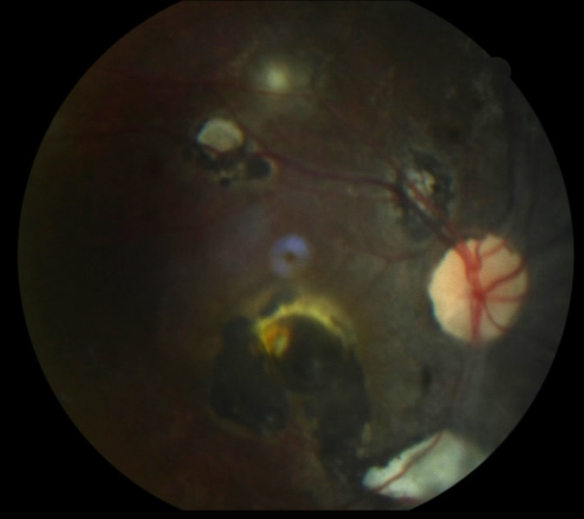

Fig 1: Colour Fundus photograph of right eye

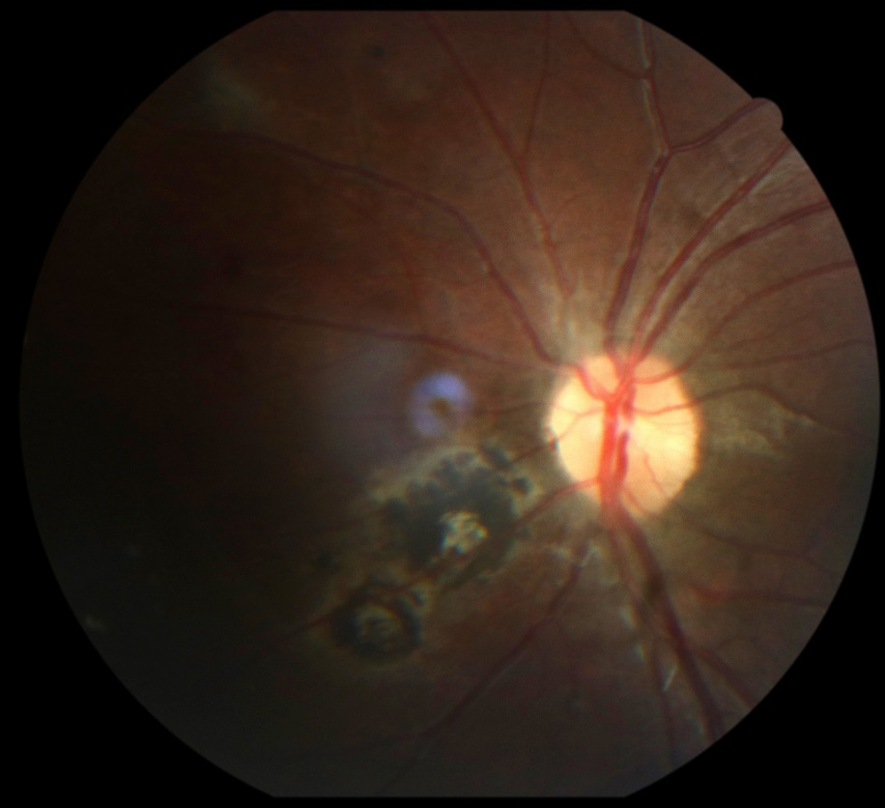
Fig 2: Colour Fundus photograph of left eye

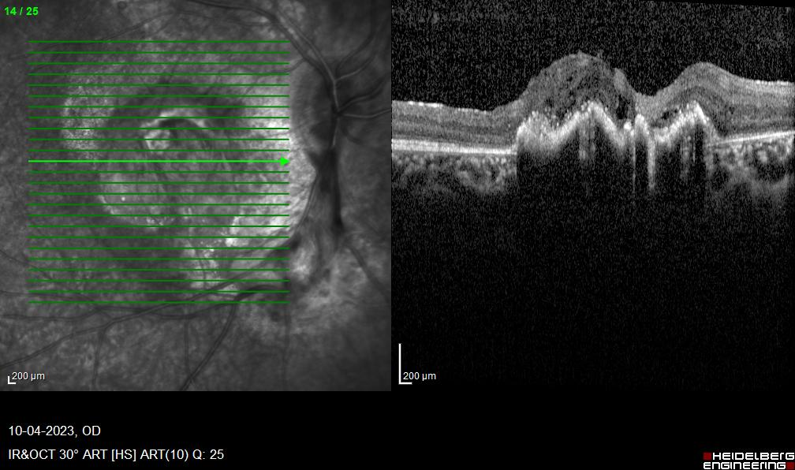
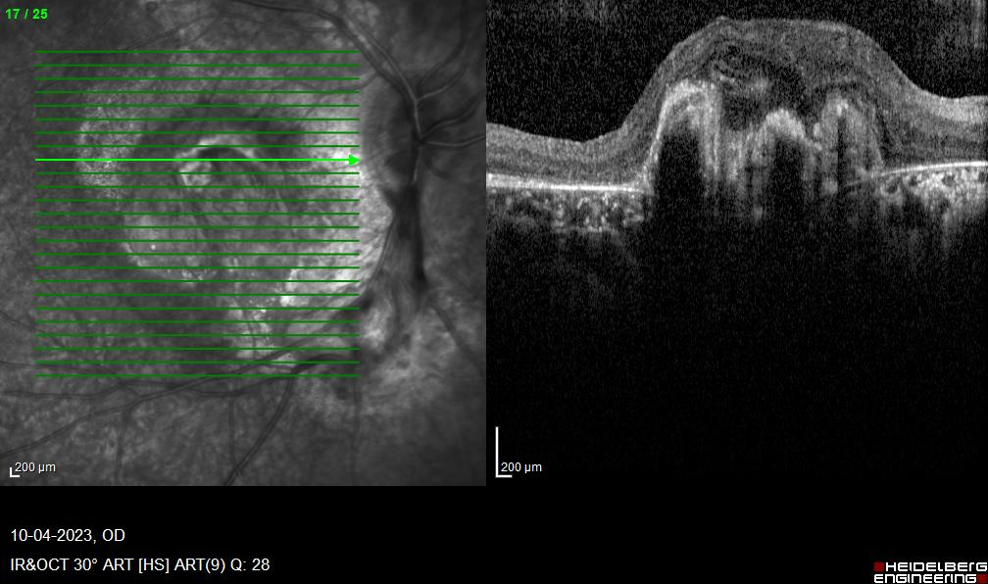
Fig 3: OD – Cystoid spaces with sub retinal neovascular membrane
OS- OCT macula was within normal limits.

FFA

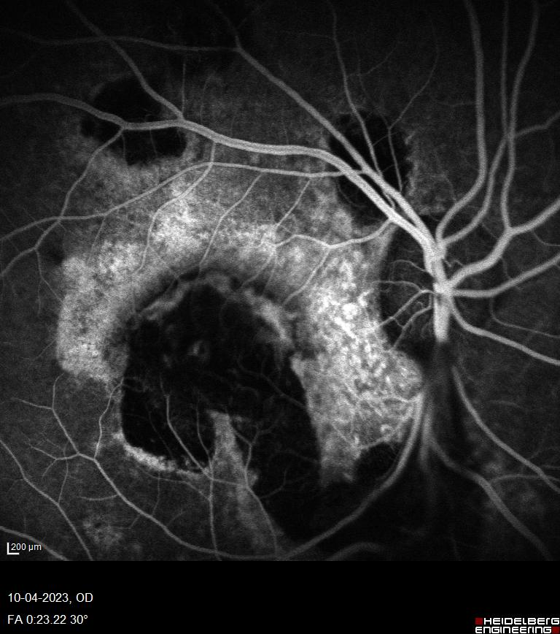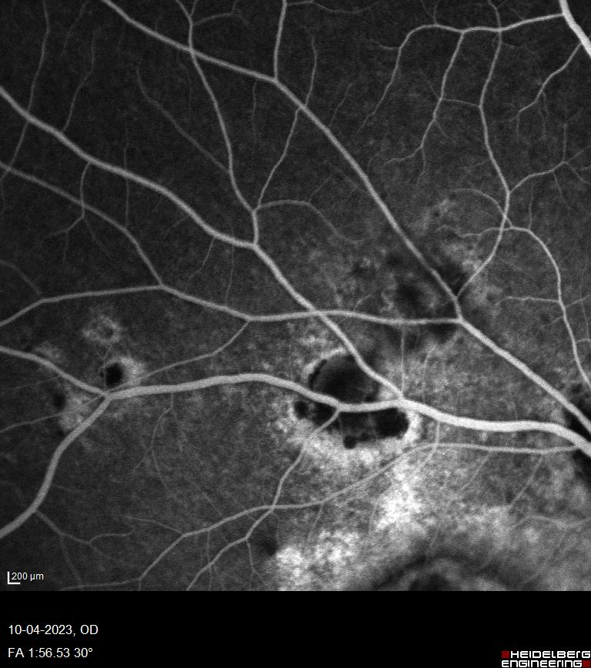

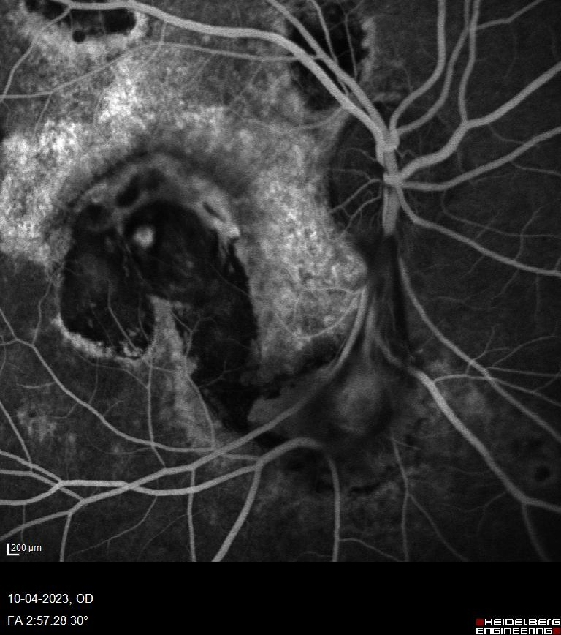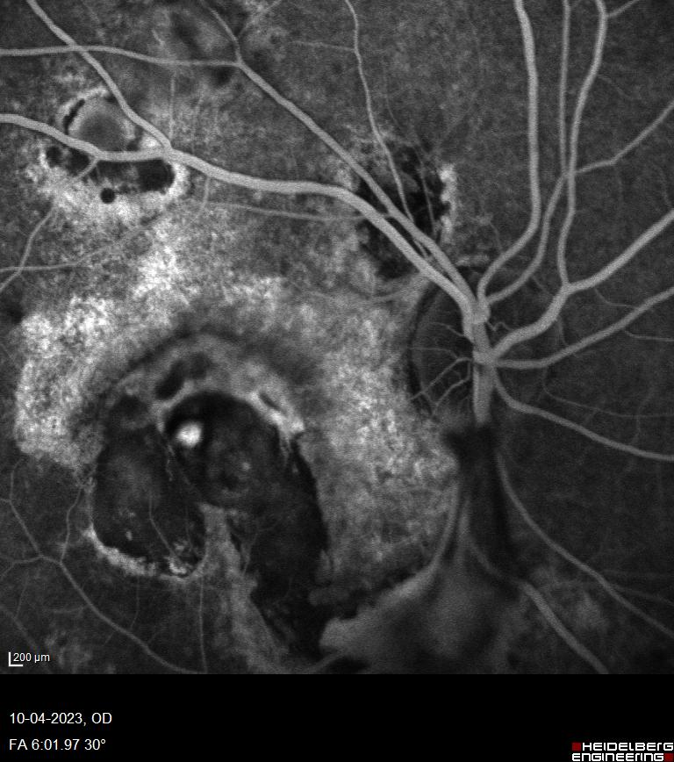
Fig 4: OD- macular area showing hypofluoroscence surrounded by hyperfluoroscence and spot increased in size and intensity with time – s/o active chorioretinitis and CNVM.

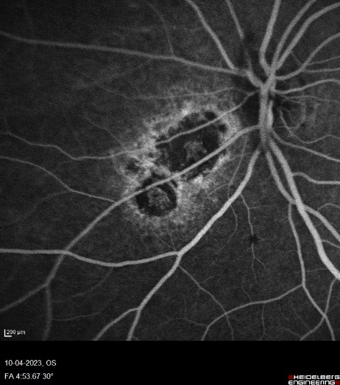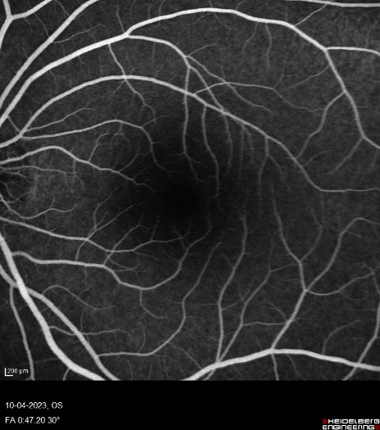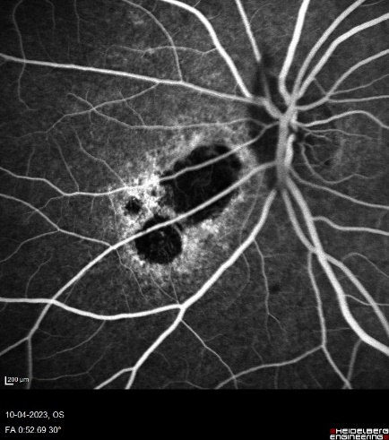 Fig 5: OS – hypofluorescence lesion surrounded by Staining s/o healed chorioretinitis

Case 2
A 20yr old male without past medical history presented with diplopia since 3 days, deviation of LE towards nasal side since 3 days projectile type vomiting since 5 days,low grade fever headache, generalised weakness since 2 weeks.Horizontal separation of images with both eyes open and disappeared when one eye was closed.Aggravated when looking right, relieved when looking left.Neck rigidity was present, Brudzinski sign was positive, Kernig Sign was positive.On initial presentation, BCVA was 6/6 in right eye and 6/9 in left eye . In right eye ocular motility uniocular/ binoucular was free and full in all directions.In left eye ocular motility restricted in supero temporal, temporal and inferotemporal quadrant,abduction of left eye was restricted for -3.Esotropia <15 degree in LE in primary gaze position.Face was slightly turn towards right side.Examination revealed right eye fundus was normal,Left eye revealed multiple yellowish pale nodular elevations along blood vessel seen superiorly as choroidal granuloma. CBC – TLC 17.33 raised,Hb- 10 g/dl,RFT/ LFT – WNL.Blood Sugar Level Fasting blood sugar- 60mg/dl,PPBS-78mg/dl,HIV : NR.Based on a positive tuberculin skin test and MRI (Brain + Orbit) revealed Multiple tuberculomas in left basal ganglia, right temporal region and right temporoparietal region. Meningeal enhancement indicative of acute meningitis. He was diagnosed with OS-Acute onset 6th nerve palsy with choroidal granulomas due to Tubercular meningitis started on a nine-month course of quadruple therapy.Patient developed severe neurological symptoms and was dead. Right eye fundus was normal,Left eye revealed multiple pale yellowish nodular elevations along blood vessel seen superiorly as choroidal granuloma.

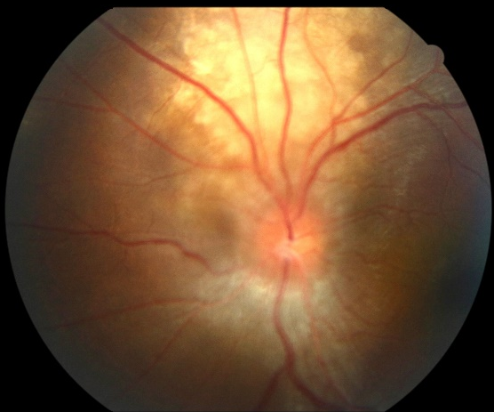

Fig 6: Right eye fundus was normal,Left eye revealed multiple pale yellowish nodular elevations along blood vessel seen superiorly as choroidal granuloma.

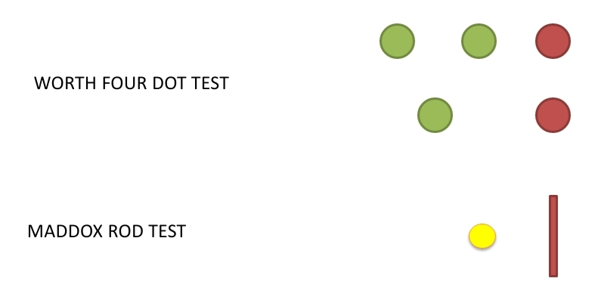
IMP: UNCROSSED DIPLOPIA

DIPLOPIA CHARTING

PATIENT’S VIEW

Case 3
48 yrs old female,with Diminution of vision in Right eye since 15 days,history of hypertension and diabetes mellitus since 8 yrs.Best corrected visual acuity in was Right eye Perception of light present and projection of rays present in all quadrants and Left eye 6/6.Anterior segment examination in Right eye revealed RAPD grade II, Left eye pupil was normal reacting to light.Blood pressure was 140/80 mm of Hg.Fundus examination revealed Right eye disc margin was elevated,disc margin was blurred,blood vessel around the disc were tortuous suggestive of Right eye disc odema,Left eye fundus examination was within normal limits suggestive of Right eye Optic neuritis,left eye fundus examination was within normal limit.Quantiferon TB gold was positive.CT scan of Brain revealed calcified granuloma in left parietal region.HIV and HBSAg reports were non reactive.B scan was within normal limits.Patient was started on ATT, Rifampin, isoniazid, pyrazinamide, and ethambutol.Oral streoid was started one week after ATT.

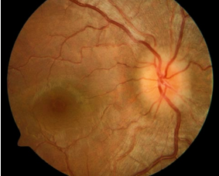

Fundus picture of RE-Optic neuritis

Discussion

The earliest mention of TB-associated CNV in the literature was in a 1987 case report, in which “subretinal neovascularization” occurred 34 years after the initial TB diagnosis and was treated successfully with isoniazid and laser photocoagulation.Several therapeutic strategies have been attempted for uveitis related CNV: focal laser photocoagulation,^{[8]}photodynamic therapy with verteporfin,^{[9]} local and systemic corticosteroids,^{[10]} systemic immunosuppression,^{[11]} surgery,^{[12]}and most recently, intravitreal bevacizumab injections.^{[13,14]} According to the elevated VEGF levels associated with intraocular TB infections, anti-VEGF therapy may effectively suppress TB-related CNV. In a study by Julian et al., ^{[13]}patients with CNV secondary to uveitis, including one tuberculous uveitis, received intravitreal bevacizumab injections for CNV treatment.
Tuberculous meningitis is a chronic disease, and cranial nerve palsies are common signs. A part of its presentation spectrum is neuro-ophthalmic involvement,which is important, and many reported neuro-ophthalmologic complications are combinations of oculomotor palsies, pupil abnormalities, disc changes suggestive of papillitis, papilledema, or optic atrophy and choroidal tubercles.^{[15]} Ophthalmic pathologies have also been reported, and its complications include; conjunctivitis, third or sixth nerve palsies, choroidal tuberculoma, homonymous hemianopia, and nystagmus.^{[16]} Involvement of the oculomotor nerve may occur due to basal meningitis due to the long course of this nerve in the base of brain, due to vasculitis in the arteries supplying the midbrain region, or due to a tuberculoma situated in the midbrain region. Choroidal tuberculoma is the most common ocular manifestation after bacillus dissemination via the blood stream. Choroidal tubercles are often unilateral and appear mainly in the posterior pole as solitary or multiple amelanotic lesions.^{[17]} ATT for 6
Davis et al. ^{[18]} collected a large series of optic disc tuberculosis in order to determine the progress of the disease and propose the most authoritative therapeutic regimen. In this analysis of 62 eyes from 49 patients with tuberculous optic neuropathy, papillitis was present in 51.6%, neuroretinitis in 14.5%, and optic nerve tubercle in 11.3%, with uveitis absent in 11.3% and extraocular tuberculosis absent in 63.3% of patients. Tuberculosis (TB) is a multisystem disease. About 80% of cases of ocular TB do not show any pulmonary manifestation. Ocular TB may present with various manifestations ranging from corneal involvement, uveitis, scleritis, serpiginous choroiditis, choroidal granuloma, and retinal detachment (RD) to neuroretinitis.^{[19]}
Diagnosis of these cases is usually made on the basis of clinical manifestations, immunological reaction to the tubercular antigen (tuberculin test, tuberculin interferon-gamma release assay), and other supportive evidence in the form of X-ray and computed tomography (CT) chest where we can get an active lesion or a healed lesion. These cases are included under the diagnosis of presumptive ocular TB. Polymerase chain reaction (PCR) test of ocular fluid can be used as supportive evidence, but because of its low sensitivity, TB cannot be ruled out, even though PCR is negative.^{[20]} For diagnosis confirmation biopsy of lymph nodes and sputum examination can be done.^{[21]}
Recurrence of inflammatory lesions in ocular TB can also present with acute RPE elevations on optical coherence tomography (OCT) at the posterior pole. Sub- RPE inflammatory lesions have not been reported in a typical case of TB MFC(Multifocal choroiditis).TB MFC,can present with peripapillary CNVM and yellow lesions on the fundus corresponding to sub- RPE elevated lesions on OCT during the follow- up.Treatment for peripapillary CNVM is (ATT),tapering doses of oral corticosteroids and intravitreal anti- VEGF injection.^{[22]}
Conclusion
While tubercular chorioretinitis is a known entity, the occurrence of CNVM with CME in a pediatric patient with presumed ocular tuberculosis represents a rare and noteworthy manifestation. Ocular tuberculosis as a cause of chorioretinitis.TB is a well-recognized cause of posterior uveitis and chorioretinitis, especially in endemic countries.Choroidal tubercles appear as yellow-white, dome-shaped, well-circumscribed lesions, commonly located in the posterior pole.Pediatric presentation (13 years) of bilateral tubercular chorioretinitis, which is rare compared to adults.Concurrent presence of active choroidal tubercle,multifocal chorioretinitis,Inflammatory CNVM with CME,in the same eye, which is infrequently reported.Macular CNVM as the presenting cause of severe vision loss rather than active inflammation.Asymmetric bilateral disease,Right eye with active inflammation and CNVM,Left eye showing only healed lesions.
SHORT SUMMARY
S.No | Clinical features | Treatment
1 | RE-TB(Tubercular) Chorioretinitis with CNVM with CME.LE - TB (Tubercular) Chorioretinitis | Rubella IgM–positive,Rubella IgG Negative,HSV IgG – Negative,CMV IgM and IgG – Negative,HSV 2 IgG and IgM –Negative,MANTOUX test – induration 20mm was positive,ESR – 20MM/Hr,CRP < 6mg/L,TB Quantiferon gold test was positive.HRCT Thorax revealed-Thymus hyperplasia,  Patient was started on ATT for 9 months ,RE-Injection posterior subtenons triamcinolone acetonide was given.Patient was started on oral steroids 20 mg in tapering doses,  Intravitreal ranbizumab 0.5 mg in 0.05 ml injection was given one month later.  After 1 month there was improvement in her vision in right eye,which was counting finger 5 meters and left eye 6/6.  On fundus examination on follow up after 1 month,in right eye there was decrease in size of tubercle,membrane present over macula and CNVM .OCT revealed decrease is size of cystoid spaces.Then patient lost to follow up.
2 | Left eye-Acute onset 6th nerve palsy with choroidal granulomas due to Tubercular meningitis | nine-month course of quadruple therapy.Patient developed severe neurological symptoms and was dead. Right eye fundus was normal,Left eye revealed multiple pale yellowish nodular elevations along blood vessel seen superiorly as choroidal granuloma.
3 | Right eye Optic neuritis | Quantiferon TB gold was positive.CT scan of Brain revealed calcified granuloma in left parietal region.HIV and HBSAg reports were non reactive.B scan was within normal limits.Patient was started on ATT, Rifampin, isoniazid, pyrazinamide, and ethambutol.Oral streoid was started one week after ATT

Acknowledgements
I take this opportunity to express my gratitude,sincere regards to my respected consultants Dr.Nidhi Pandey,Dr.Swati Kujur for their valuable guidance. Their innovative ideas and superb guidance are not limited to study design, collection, analysis and interpretation of data of case series alone but encompass the full spectrum of life.

Consent
As per international standards or university standards, patient(s) and parental written consent has been collected and preserved by the author(s).

Ethical Approval:

As per international standards or university standards written ethical approval has been collected and preserved by the author(s).

COMPETING INTERESTS

Authors have declared that no competing interests exist.

AUTHORS’ CONTRIBUTIONS

Dr. Sangeeta Thakur designed the case series,wrote the first draft of the manuscript.Dr. Nidhi Pandey and Dr. Swati Kujur managed the analyses of the study,managed the literature search.All authors read and approved the final manuscript.
Disclaimer (Artificial intelligence)
Author(s) hereby declare that NO generative AI technologies such as Large Language Models (ChatGPT, COPILOT, etc.) and text-to-image generators have been used during the writing or editing of this manuscript.

References-months.Her
1. Choroidal neovascularization secondary to tuberculosis: Presentation and management Esther Lee Kim , Damien C Rodger , Narsing A Rao, Am J Ophthalmol Case Rep 2017 Jan 6;5:124–129
2. Neri P et al , Lettieri M , Fortuna C , Manoni M , Giovannini A (2009) Inflammatory choroidal neovascularization. Middle East Afr J Ophthalmol 16(4):245–251.
3. Dhingra N et al , Kelly S , Majid MA , Bailey CB , Dick AD (2010) Inflammatory choroidal neovascular membrane in posterior uveitis-pathogenesis and treatment. Indian J Ophthalmol 58(1):3–10.
4. Bansal R , Bansal P, Gupta A et al (2017) Diagnostic challenges in inflammatory choroidal neovascular membranes. Ocul Immunol Inflamm 25(4):554–562.
5.Liu B et al, Faia L, Hu M, Nussenblatt RB (2010) Pro-angiogenic effect of IFNgamma is dependent on the PI3K/mTOR/translational pathway in human retinal pigmented epithelial cells.Mol Vis 16:184–193
6.Rao NA et al, Albini TA, Kumaradas M, Pinn ML, Fraig MM, Karakousis PC. Experimental ocular tuberculosis in Guinea pigs. Arch Ophthalmol. 2009;127: 1162e1166u
7. Thayil SM , Albini TA, Nazari H et al Local ischemia and increased expression of vascular endothelial growth factor following ocular dissemination of Mycobacterium tuberculosis. PLoS One. 2011;6:e2838n
8. Fine SL et al, Wood WJ, Isernhagen RD. Laser treatment for subfoveal neovascular membranes in ocular histoplasmosis syndrome: results of a pilot randomized clinical trial. Arch Ophthalmol. 1993;111:19e20
9. Parodi MB et al , Di Crecchio L, Lanzetta P, Polito A, Bandello F, Ravalico G. Photodynamic therapy with verteporfin for subfoveal choroidal neovascularization associated with multifocal choroiditis. Am J Ophthalmol. 2004;138:263e269
10. Flaxel CJ et al, Owens SL, Mulholland B, Schwartz SD, Gregor ZJ. The use of corticosteroids for choroidal neovascularisation in young patients. Eye (Lond). 1998;12(Pt 2):266e272.
11. Dees C et al, Arnold JJ, Forrester JV, Dick AD. Immunosuppressive treatment of choroidal neovascularization associated with endogenous posterior uveitis. Arch Ophthalmol. 1998;116:1456e1461.i
12. Hawkins BS et al , Bressler NM, Bressler SB. Surgical removal vs observation for subfoveal choroidal neovascularization, either associated with the ocular histoplasmosis syndrome or idiopathic: I. Ophthalmic findings from a randomized clinical trial: submacular Surgery Trials (SST) Group H Trial: SST Report No. 9. Arch Ophthalmol. 2004;122:1597e1611.g
13. Julian K et al, Terrada C, Fardeau C. Intravitreal bevacizumab as first local treatment for uveitis-related choroidal neovascularization: long-term results. Acta Ophthalmol. 2011;89:179e184.
14. Tran T et al, Fardeau C, Terrada C, Ducos De Lahitte G, Bodaghi B, Lehoang P. Intravitreal bevacizumab for refractory choroidal neovascularization (CNV) secondary to uveitis. Graef Arch Clin Exp. 2008;246:1685e1692
15.Desai HG et al , Anklesaria ED. Ophthalmological aspects of tuberculous meningitis. J Indian Med Assoc 196749:429-32
16.Milla E et al, Zografos L, Piguet B. Bilateral optic papillitis following mycoplasma pneumoniae pneumonia. Opthalmologica 1998;212:344-6.
17.Levecq LJ et al, De Potter P. Solitary choroidal tuberculoma in an immunocompetent patient. Arch Ophthalmol 2005;123: 864-6
18.Davis EJ et al, Rathinam SR, Okada AA, Tow SL, Petrushkin H, Graham EM, Chee S-P, Guex-Crosier Y, Jakob E, Tugal-Tutkun I, Cunningham ET Jr, Leavitt JA, Mansour AM, Winthrop KL, Hills WL, Smith JR: Clinical spectrum of tuberculous optic neuropathy. J Ophthalmic Inflamm Infect 2012;2:183–189.
19.Gupta V, Gupta A, Rao NA. Intraocular tuberculosis – An update. Surv Ophthalmol 2007;52:561-87.
20. Agarwal A, Agrawal R, Gunasekaran DV, Raje D, Gupta B, Aggarwal K, et al. The collaborative ocular tuberculosis study (COTS)-1 report 3: Polymerase chain reaction in the diagnosis and management of tubercular uveitis: Global trends. Ocul Immunol Inflamm 2019;27:465-73.
21.Singh A,Kumar Singh B,Singh V,Nagarajan S Presumptive ocular tuberculosis:A case series of rare cases, Oman J Ophthalmol 2023;16:529-32r
22.Kaza H, Gala JM, Rani PK. Subfoveal retinal pigment epithelium inflammatory lesion presenting as a sign of reactivation of tubercular multifocal choroiditis ,BMJ Case Rep 2021;14:e240280.

