Case report

Occult Posterior Scleral Rupture Following Sports-Related Orbito-Palpebral Trauma:
A Case Report

ABSTRACT

Sports-related orbitopalpebral trauma is a common cause of ocular injury and may lead to complex involvement of both the anterior and posterior segments, with severe visual consequences. Despite prominent external findings, significant intraocular lesions may remain occult at the initial presentation. We present the case of a 22-year-old patient who sustained severe orbitopalpebral trauma during a sports accident, presenting with extensive anterior segment injury. Progressive clinical findings and multimodal imaging raised suspicion of an occult posterior scleral rupture. Urgent surgical exploration confirmed a deeply posterior, surgically inaccessible scleral tear—a rare and easily overlooked complication of blunt ocular trauma—ultimately resulting in a poor visual outcome. This case underscores the necessity of a thorough and systematic ophthalmic evaluation in orbitopalpebral trauma to avoid missed diagnoses with potentially detrimental visual consequences. Early recognition, appropriate imaging, and timely intervention are essential, while preventive strategies such as protective eyewear and education remain crucial in reducing sports-related ocular injuries.

Keywords: Sports-related - Orbitopalpebral trauma- Posterior scleral injury- Visual prognosis

1.INTRODUCTION

Ocular trauma is a critical ophthalmic emergency with the potential to cause permanent vision loss. Sports-related injuries account for 7.5–27.3% of cases, nearly 90% of which are preventable [1]. Occurring in the context of athletic activity, these injuries range from minor superficial lesions to severe, vision-threatening trauma, representing a significant concern for athletes [2]. They often result not only in physical impairment but also in disruptions to social functioning and overall quality of life [3]. The risk and severity of ocular trauma vary according to the level of contact involved, the type of equipment used, and the size, speed, and density of the game object [4].

2.CASE PRESENTATION

We report the case of a 22-year-old patient with no medical history who presented to the emergency department with redness, ocular pain, and decreased visual acuity in the right eye following orbitopalpebral trauma sustained during a sports accident involving an elastic band and wooden equipment. Ophthalmologic examination of the right eye revealed visual acuity reduced to near counting fingers, a large horizontal eyelid laceration, and periorbital ecchymosis with hematoma restricting eyelid mobility (Fig.1.).
Slit-lamp examination revealed mild corneal edema, epithelial debridement with fluorescein uptake,grade 1 hyphema,inferior iris tear with mydriasis and lens subluxation(Fig.2.). Intraocular pressure could not be assessed due to the extent of the eyelid hematoma, severe pain, and the presence of corneal edema, and fundus visualization was obscured.The examination of the fellow eye showed no abnormalities.Orbital CT demonstrated a right frontal bone fracture and signs of vitreous hemorrhage without evidence of intraocular foreign body, the contours of the globes were preserved(Fig.3).
The patient was admitted and started on systemic antibiotics and corticosteroids. Surgical repair of the eyelid laceration was performed using ten 6-0 silk sutures, and a maxillofacial consultation was obtained for management of the fracture.
Ten hours later, visual acuity suddenly deteriorated from near counting fingers to light perception,accompanied by pronounced chemosis and worsening corneal edema (Fig. 4). Reassessment of the orbital CT raised suspicion of a scleral rupture prompting urgent surgical exploration (Fig.5).
Intraoperative exploration after 360° peritomy and 4-0 silk muscle traction revealed sub-Tenon hyperpigmentation,likely choroidal,in the superotemporal quadrant without vitreous prolapse (Fig. 6). A posterior scleral wound was suspected but could not be visualized and was presumed self-sealed. Sub-Tenon and conjunctival closure was performed with 8-0 Vicryl . The patient was evaluated at one week and one month postoperatively. Examination revealed negative light perception, resolution of corneal edema, a nonreactive dilated pupil with sphincter rupture, a subluxated crystalline lens, and a flat retina (Fig. 7).

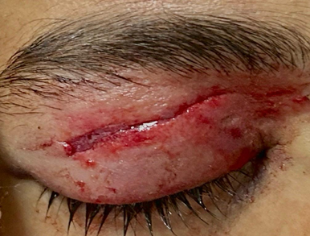
Fig.1. Aspect of the eyelid on admission showing a large horizontal eyelid laceration, and periorbital ecchymosis.

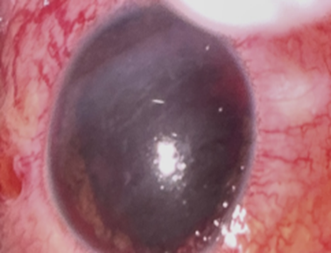
Fig.2.Aspect of the eye on admission showing corneal edema,hyphema , inferior iris tear with mydriasis and lens subluxation

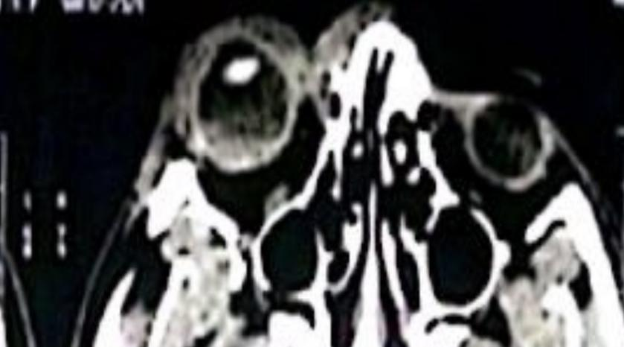

Fig.3.Orbital CT of the patient in admission showing a right frontal bone fracture and signs of vitreous hemorrhage , without evidence of intraocular foreign body, the contours of the globes were preserved
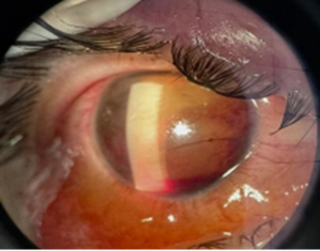

Fig.4.Picture of the eye ten hours post admission showing pronounced chemosis and worsening corneal edema

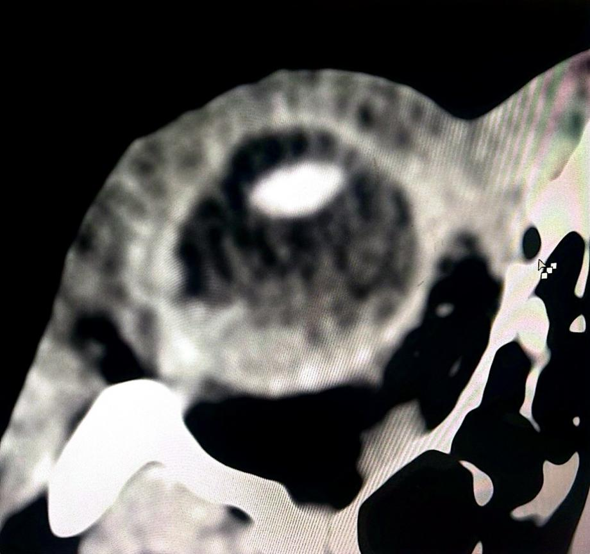

Fig.5. Re-review of the orbital CT scan revealed a questionable scleral discontinuity on the temporal aspect of the right globe (blue arrow)

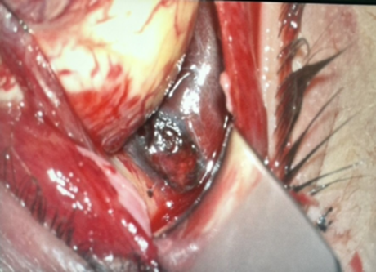
Fig.6.Intraoperative exploration revealing sub-Tenon hyperpigmentation in the superotemporal quadrant .

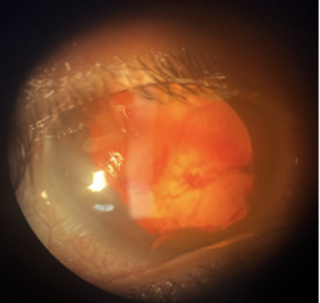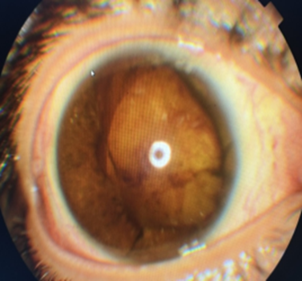
Fig.7.Postoperative aspect of the eye

3. DISCUSSION
Sports-related contusive ocular trauma represents a form of blunt, non-penetrating injury affecting the eye or periocular tissues, typically caused by impact sustained during athletic activities.
In the United States, an estimated 40,000–600,000 cases occur annually, with approximately 13,500 resulting in permanent vision loss [1,5,6]. Globally, sports injuries account for 7.5–12.5% of ocular trauma hospitalizations [7.8] with bilateral involvement reported in 17.7% of cases [9]. Young adults aged 20–29 are predominantly affected, with a marked male predominance (male-to-female ratio 15.4:1) [1,5,10]. The most common mechanisms include direct ball impacts (74.7%), player collisions (13.8%), and injuries caused by sports equipment (9%) [1].
Closed-globe injuries (CGI) are characterized by partial-thickness damage to the ocular wall without full-thickness rupture and may involve periocular structures [5]. In sports-related trauma, these injuries are predominant, although open periocular wounds have also been reported [11]. Blunt force can induce a sudden rise in intraocular pressure, leading to rupture at anatomically vulnerable sites such as the limbus, equator, or areas previously compromised by surgery or prior trauma. the extent of damage dependes on the energy and depth of impact [1]. This mechanism was illustrated in our case, in which a severe orbitopalpebral contusion resulted in a posterior scleral laceration. In contrast, open-globe injuries (OGI) involve full-thickness disruption of the ocular wall and are classified as rupture, penetrating, or perforating injuries. Penetrating and perforating wounds typically result from sharp objects or projectiles and primarily affect the anterior segment of the globe[12].
Closed globe injuries can affect both the anterior and posterior segments of the eye. Eyelid lacerations, ranging from superficial cuts to complex canalicular injuries, requiremeticulous assessment and precise repair to preventcomplications such as ptosis, epiphora, or lid malposition. Subconjunctival hemorrhage is common. Corneal abrasions present with pain, foreign body sensation, and tearing; fluorescein staining and prompt evaluation are essential to exclude deeper injuries. Hyphema can elevate intraocular pressure and threaten the optic nerve. When hyphema is associated with subconjunctival hemorrhage, particularly in the setting of ocular hypotony, a scleral laceration should be suspected. In our case, the development of non-hemorrhagic chemosis alongside hyphema drew attention to the possibility of a scleral wound, prompting surgical exploration. Posterior segment injuries include retinal contusions, tears, detachment,Berlin oedema and choroidal ruptures. Moreover Retrobulbar hematoma can lead to orbital compartment syndrome while traumatic optic neuropathy often results in poor visual outcomes despite treatment [12].
In case of suspected globe rupture or scleral laceration, all contact or pressure-inducing ocular examinations are contraindicated , imaging is required to identify intraocular foreign bodies, with CT for metallic and MRI for non-metallic materials [12].
Visual outcomes after ocular trauma depend on age, initial acuity, ocular structures involved, trauma type,and surgical intervention[5], and may be further compromised by severe complications such as traumatic cataract, retinal detachment, endophthalmitis, or sympathetic ophthalmia [13].The Ocular Trauma Score (OTS), with approximately 80% accuracy, reliably predicts visual outcomes, guiding management and patient counseling [14].According to a U.S study ,most sports-related ocular injuries are minor anterior segment trauma, where as severe injuries areless common and typically associated with high-velocity projectile sports [15].
Management of ocular trauma depends on the severity of the injury, ranging from medical treatment with antibiotics, NSAIDs, and ocular hypotensives for minor lesions, to urgent surgery for severe or open-globe injuries. A Chinese retrospective study (2015–2019) reported that 21.5% of sports-related ocular injuries required surgery, including intraocular surgery, vitrectomy, lens procedures, and scleral buckling. Rare interventions included keratoplasty, optic nerve sheath decompression, and orbital fracture repair. Eye loss occurred in 0.8% of cases [1] [16].
Accessible posterior scleral ruptures may be closed using a progressive ‘close-as-you-go’ technique, where as extensive or inaccessible defects are often managed conservatively due to the risk of iatrogenic vitreous prolapse. Small defects may heal spontaneously by granulation, whereas larger tissue losses may require scleral or pericardial patch grafting[17,18,19].Select posterior pole defects have been successfully managed using ab interno suturing or autologous scleral patch grafting during pars plana vitrectomy [20]
A multidisciplinary preventive strategy—including education, regular ophthalmologic screening, and protective eyewear—can prevent up to 90% of sports-related ocular injuries, as endorsed by major ophthalmologic and pediatric organizations [12] [21].

4. Conclusion

Sports-related eye injuries are a significant cause of visual morbidity .While severe cases require specialized care,prevention remains essential to reduce both their incidence and severity . This case underscores the importance of considering posterior scleral rupture, which may be occult on clinical examination, and the necessity of maintaining vigilance in identifying radiologic signs indicative of such injuries.

CONSENT

The authors certify that they have obtained all appropriate patient consent forms.

ETHICAL APPROVAL

As per international standards or university standards written ethical approval has been collected and preserved by the author(s).

COMPETING INTERESTS

Authors have declared that no competing interests exist.

DISCLAIMER (ARTIFICAL INTELLIGENC)

Author(s) hereby declare that NO generative AI technologies such as Large Language Models (ChatGPT, COPILOT, etc.) and text-to-image generators have been used during the writing or editing of this manuscript.

REFERENCES

- Y. Zhang et al., « Discrepancy of eye injuries in mechanism, clinical features, and vision prognosis by different causative sports », Front. Public Health, vol. 11, p. 1182647, oct. 2023, doi: 10.3389/fpubh.2023.1182647.
[2] Jiao Z, Hou T. Analyzing the causes of sports injuries in college sports activities and research on the recovery strategy using an intelligent approach. Sci Rep. 2025;15(1):13357. doi:10.1038/s41598-025-96770-5
[3] Sheehan N, Summersby R, Bleakley C, Caulfield B, Matthews M, Klempel N, Holden S. Adolescents’ experience with sports-related pain and injury: A systematic review of qualitative research. Phys Ther Sport. 2024;68:7–21. doi:10.1016/j.ptsp.2024.05.003.
[4] Mishra A, Verma AK. Sports related ocular injuries. Med J Armed Forces India. 2012;68(3):260–266. doi:10.1016/j.mjafi.2011.12.004.
[5] Hoskin AK, Sheng SNM, Blanch RJ, Giridhar A, Pauly M, Shah M, et al. Geographical differences in ophthalmic trauma outcomes and risk factors: The International Globe and Adnexal Trauma Epidemiological Eye Study (IGATES). Eye (Lond). 2025;39(8):1532-1539. doi:10.1038/s41433-024-03581-5.
[6] D. E. Lee, H. W. Ryoo, S. Moon, J. Y. Ahn, J. H. Kim, et J.-Y. Kim, « Epidemiology and risk factors for sports- and recreation-related eye injury: a multicenter prospective observational study », Int. J. Ophthalmol., vol. 14, no 1, p. 133-140, janv. 2021, doi: 10.18240/ijo.2021.01.19.
[7] G. Ashraf, J. Arslan, C. Crock, et R. Chakrabarti, « Sports-related ocular injuries at a tertiary eye hospital in Australia: A 5-year retrospective descriptive study », Emerg. Med. Australas. EMA, vol. 34, no 5, p. 794-800, oct. 2022, doi: 10.1111/1742-6723.13982.
[8] S. Zafar et al., « Epidemiology of Hyphema-Related Emergency Department Visits in The United States Between 2006 and 2015 », Ophthalmic Epidemiol., vol. 26, no 3, p. 208-215, juin 2019, doi: 10.1080/09286586.2019.1579917.
[9] R. P. Maurya et al., « The study of simultaneous bilateral ocular trauma in Northern India: clinical presentation, epidemiology and patterns of injury », Int. Ophthalmol., vol. 42, no 4, p. 1193-1203, avr. 2022, doi: 10.1007/s10792-021-02104-5.
[10] American Academy of Pediatrics Committee on Sports Medicine and Fitness; American Academy of Ophthalmology Eye Health and Public Information Task Force. Protective eyewear for young athletes. Ophthalmology. 2004 Mar;111(3):600-603. doi:10.1016/j.ophtha.2003.12.027.
[11] R. S. Haring, I. D. Sheffield, J. K. Canner, et E. B. Schneider, « Epidemiology of Sports-Related Eye Injuries in the United States », JAMA Ophthalmol., vol. 134, no 12, p. 1382-1390, déc. 2016, doi: 10.1001/jamaophthalmol.2016.4253.
[12] O. Ohana et C. Alabiad, « Ocular related sports injuries », J. Craniofac. Surg., vol. 32, no 4, p. 1606-1611, juin 2021, doi: 10.1097/SCS.0000000000007618.
[13] Morikawa S, Okamoto F, Okamoto Y, Inomoto N, Ishikawa H, Ueda T, Sakamoto T, Hirano Y, Sawada O, Mori J, Takamura Y, Oshika T. Clinical characteristics and visual outcomes of sport-related open globe injuries. Acta Ophthalmol. 2018;96(7):e898–e899. doi:10.1111/aos.13704.
[14] Scott R. The Ocular Trauma Score. Community Eye Health. 2015;28(91):44-45. doi:10.56920/cehj.497
[15] V. Patel, P. Pakravan, D. Mehra, A. Watane, N. A. Yannuzzi, et J. Sridhar, « Trends in Sports-Related Ocular Trauma in United States Emergency Departments from 2010 to 2019: Multi-Center Cross-Sectional Study », Semin. Ophthalmol., vol. 38, no 4, p. 333-337, mai 2023, doi: 10.1080/08820538.2022.2107400.
[16] A. C. Gauthier et al., « Clinical Characteristics and Outcomes in Patients Undergoing Primary or Secondary Enucleation or Evisceration After Ocular Trauma », Clin. Ophthalmol. Auckl. NZ, vol. 14, p. 3499-3506, oct. 2020, doi: 10.2147/OPTH.S273760.
[17] Chronopoulos A, Ong JM, Thumann G, Schutz JS. Occult globe rupture: diagnostic and treatment challenge. Surv Ophthalmol. 2018 Sep–Oct;63(5):694-699. doi:10.1016/j.survophthal.2018.04.001. PMID: 29649485.
[18] Zhou Y, DiSclafani M, Jeang L, Shah AA. Open globe injuries: review of evaluation, management, and surgical pearls. Clin Ophthalmol. 2022;16:2545–2559. doi:10.2147/OPTH.S372011. PMID: 35983163; PMCID: PMC9379121.
[19] Chang EK; Curriculum Editors. Video-based surgical curriculum for open-globe injury repair, V: scleral wounds. Digit J Ophthalmol. 2023;29(2):14–19. doi:10.5693/djo.01.2022.02.001. PMID:37727461; PMCID:PMC10506619.
[20] Doganay S, Kiristioglu MO, Ucan Gunduz G. A novel surgical technique: “Ab interno” autologous lamellar scleral patch for a large traumatic scleral defect at the posterior pole. Oman J Ophthalmol. 2025;18(1):77–80. doi:10.4103/ojo.ojo_104_24. PMID: 40124454; PMCID: PMC11925371.
[21] Mishra A, Bhirud A, Agrawal M, Tripathi A, Baranwal VK, Kapoor G. A prospective study to evaluate the effectiveness of preventive aspects in relation to sports related ocular injuries. Int Ophthalmol. 2024;44(1):436. doi:10.1007/s10792-024-03357-6. PMID:39578254

