A PRELIMINARY CHECK LIST OF DIVERSITY OF LIGHT TRAPPED INSECTS AT JHALAWAR, RAJASTHAN, INDIA.

.
ABSTRACT

Nocturnal entomofauna are less investigated although they are more in numbers. Aim of this research was to investigated the species richness of nocturnal entomofauna in Jhalawar district of Rajasthan state (India).The light trap and light sheet methods were used for individual’s collection. The collection of individuals was carried out between the periods of August, 2020 to March, 2021. Total 145 species of nocturnal entomofauna belonging to 7 orders, 36 families and 132 genuses were collected from the research sites. In the present research species richness was maximum from order Lepidoptera (Heterocera) with 111 species 18 families followed by Coleoptera (beetles) 17 species of 6 families, Hemiptera (bugs) 11 species 6 families. Only 2 species were collected from order Orthoptera, Similarly 2 species of order Neuroptera with one species each from family Ascalaphidae and Chrysopidae were collected. One species from Diptera order and one species observed from Hymenoptera.

Keywords: species richness, nocturnal, entomofauna, jhalawar

- INTRODUCTION
India had 2 per cent area of world but, is one of the 17 megadiversity nations in the world in terms of insect diversity with a very rich and diverse entomofauna. About 66,363 species of entomofauna have been identified from India, representing about 6.29 per cent of the world entomofauna (Banerjee et al, 2022)$.$The number of actually described insects in the world stands at 9,65,431–10,15,897 (Chapman, 2009). Insects are the omnipresent, successful and ruling forms in the whole of animal kingdom and are remarkably adaptable to a variety of environments. According to orders, the largest number of endemic species of insects in India are; Hymenoptera (bugs) (9000 species), Coleoptera (3100 species), Hemiptera (2421 species) (Varshney, 1998). The nocturnal moth represents about 95% of all lepidoptera species (Winfree et al, 2011). Assemble 331 quantitative comparisons of the abundances of insects between day and night periods from 78 studies worldwide and use multi-level meta-analytical models to show that insect activity is on average 31.4% higher at night than in the day (Wong and Didham, 2024). Too much artificial light at night and poor sky quality at night disturb insect biodiversity. Therefore, artificial light at night and sky quality must be appraised, responsible for decline in insect biodiversity along with other known factors (Hakami et al, 2020). Urbanization has resulted with a new phenomenon associated with cities and towns called ‘light pollution” (Riegel, 1973). The artificial light at night is known to have strong impacts on population dynamics of nocturnal insects. Worldwide level it has been increasing at the rate of 2%–6% per annum over the last decades (Holker et al, 2010; Kyba and Holker, 2013). Despite its omnipresent, the importance of artificial light as an agent of global change is often leave when analysing nocturnal insect population declines. Nocturnal insects perform as primary consumer and provide essential support in ecosystem regulation services such as decomposition of organic substances, nutrient and energy flow regulation, seed and pathogen dispersal, pollination (Schowalter et al, 2018). The decreasing number of nocturnal and diurnal insects may substantially affect preservation of these functions and services, with significance for food production and ecosystem health. Night light is an important visual and nonvisual indicator for insects (Tierney et al, 2017). Many nocturnal and crepuscular insects use astronomical light sources such as stars and the moon as visual indication for movement across landscapes (Foster et al, 2018). With their sophisticated sensitive visual systems, nocturnal insects have developed a remarkable capacity to differentiate colours, orient themselves by using indefinite celestial cues, fly unrestricted through a complex habitat, and navigate to and from a nest using skilled visual landmarks. Even though the compound eyes of nocturnal insects are more sensitive to night light than those of their closely related diurnal relatives, their compound eyes photoreceptors absorb photons at very low rates in dim light, even during demanding nocturnal visual tasks (Warrant and Dacke, 2011).
2. material and methods

Light-trapping is an effective means of assessing species composition and relative abundances of nocturnal entomofauna assemblages, but sample collection has to be carried out all night in order to maximize specimen collection and avoid biases due to different flight times of species (Beck and Linsenmair, 2006). The research works presented here are based on field collection surveys of nocturnal entomofauna carried out at two selected sites of Jhalawar district of Rajasthan state. The collection of individuals was carried out between the periods of August, 2020 to March, 2021. While applying collection method, 175W mercury vapour bulb was hung on vertical pole above 20 feet. A white cotton cloth sheet (10’×6’) was hung between two vertical poles in such a way that it was just above (half foot) the surface and extended forward over the ground slightly away from direct source of light placed at such a point that the whole sheet from edge to edge brightly reflected the light. A light trap was made from material available in the local market and used for the specimen’s collection.
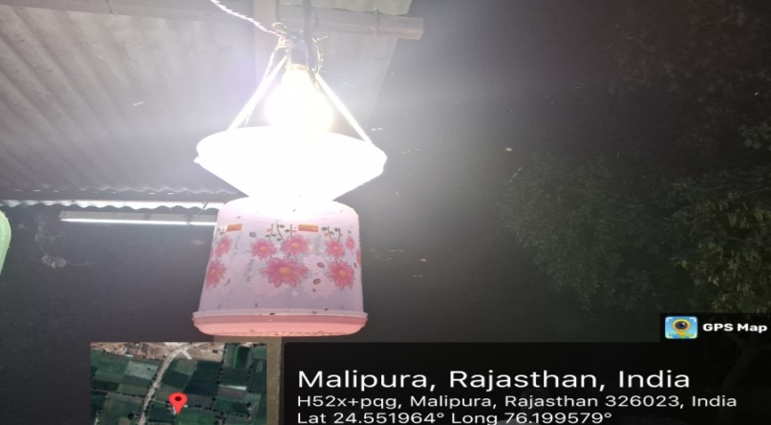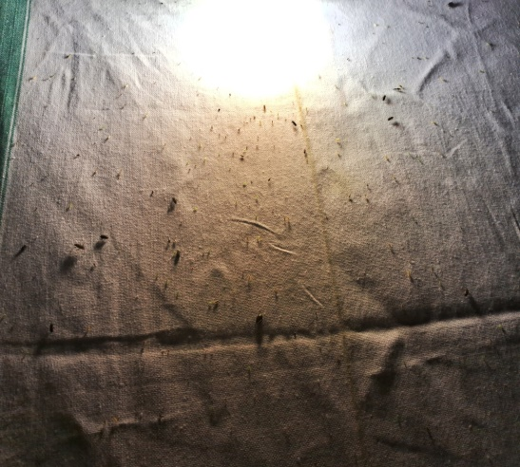
Image 1. Study Site-1(Light trap) Study Site-2 (Light sheet)
3. results and discussion

Total 145 species of nocturnal entomofauna belonging to 7 orders, 36 families and 132 genuses were collected and identified from the research sites. In the present research species richness was found maximum from order Lepidoptera with 111 species belonging to 18 families of suborder heterocera. Family Erebidae of superfamily Noctuidea was observed with maximum number of 31 species followed by Noctuidae 25 species, Crambidae (Grass moths) 21 species, Geometridae (Geometer moths) 17 species, Sphingidae (Hawk moths) 3 species, Pyralidae (Snout moths) 2 species. In the present research the second species rich order was Coleoptera (Beetles) with 17 species of 6 families. Family Scarabaeidae (Scarab beetles) was identified with maximum 5 species followed by Dytiscidae (Diving beetles) 3 species, Carabidae (Ground beetles) 3 species, Cerembycidae (Longhorn beetles), Hydrophilidae (Water scavenger beetles) and Meloidae (Blister beetles) 2 species each. Hemiptera (Bugs) was the third order with 11 species belonging to 6 families. Family Pentatomidae (Stink bugs) was identified with maximum 6 species and single species of Dinidoridae (True bugs), Hydrometridae (Water measurers), Pyrrhocoridae (Red bugs), Reduviidae (Assassin bugs) and Rhyparochromidae (Seed bugs) each. The field research area has highly diversified vegetation and crops. The field area received 1000mm rain fall annually. Due to high rain fall, varieties of vegetation and crop the field area has high diversity of nocturnal insects. The Shannon-Weiner diversity index (H) (3.409), Simpson’s diversity index (D) (0.024) and Pielou’s evenness index (E) (0.862) indicated research area as diversity rich and healthy ecosystem.
Species richness of all living organisms is influenced by different seasons. Nocturnal insects are also not untouched by the effects of weather. Nocturnal insects are generally more sensitive to weather changes and the various life-forms stages of insects are adaptively timed according to the different weather conditions. Generally, hot, moist and moonless night shows maximum induviduals specimen counts. In the present research we divided whole year into three season monsoon (July to October), winter (November to February) and summer (March to June). The result of 100 field research survey at night was that total 145 species were collected from both research sites. The maximum species number 98 were, in summer season followed by 87 in monsoon season and 39 in winter season. In monsoon season maximum numbers of 68 species were observed from Lepidoptera order followed by Coleoptera (9 species), Hemiptera (6 species), Orthoptera (2 species), Neuroptera (1 species), Diptera (1 species) and nil species from Hymenoptera order. In summer season maximum numbers of 69 species were observed from Lepidoptera order followed by Coleoptera (14 species), Hemiptera (9 species), Orthoptera (2 species), Neuroptera (2 species), Diptera (1 species) and Hymenoptera (1 species). In winter season maximum numbers of 37 species were observed from Lepidoptera order followed by Coleoptera (1 species), Hemiptera (1 species), and nil species from Hymenoptera, Neuroptera, Orthoptera and Diptera order. A total 16 species, 15 from order Lepidoptera and 1 species from order Hemiptera were commonly present in all three season (Table-3).
Rose stated that the number of collections made in the month of May, October and September were comparatively better (Rose, 2002). The correlation between moth diversity and nine weather factors. Result of stepwise regression analysis was that the species richness was more directly affected by weather factors than the abundance (Choi, 2008). Species richness and abundance of nocturnal insects were not significantly influenced by rain or wind speed. The number of species captured per night increased dramatically in mid-May and remained high (40 species) throughout August (Khan and Rehman, 2019). Maximum species richness was in the rainy season, in August and September: 06 species and 07 species respectively (Kumari and Priya, 2022).
Temperature is the most important environmental factor that influences insect’s egg lying, hatching, development of larvae and activity. Positive correlation between species richness and temperature was found by many researchers. To estimate the effect of Temperature on nocturnal insect’s abundance mean value of temperature were obtained from https://www.weatherapi.com/ history/q/jhalawar. In the present field collection the species richness of nocturnal insects increased with increasing temperature up to optimum temperature 30°C and after that decrease in species richness was noticed. Analysis of result data showed that maximum species richness 52 (36%) was observed at temperature range between 25°C-30°C and minimum species richness 6 (4%) was observed between 10°C-15°C temperature. Second peak of species richness 32 (22%) was observed between 20°C-25°C temperature range and third peak of species richness 21 (14%) between 35°C-40°C (Table-2). Finally, temperature range between 25°C-30°C was observed optimum range for collection of nocturnal insect’s species richness as well as abundance. Decreasing collection number of most species of mosquitoes is positively correlated with decreasing temperature (Bidlingmayer, 1985). Light trap catches of seven noctuid and seven geometrid species out of 10 species are positively correlated with temperature Holyoak et al., (1997). The species richness of nocturnal insects increased with increasing temperature observed (Yela and Holyoak, 1997). Result of stepwise regression analysis showed that mean daily temperature was the main predictor for moth diversity. Species diversity was significantly correlated with mean temperature (Choi, 2008). More species were collected when sampling was done on warm night (Jonason et. al, 2014). Temperature was the most important factor for trapping more nocturnal species of order Lepidoptera (Khan and Rehman, 2019). The species richness of moth was significantly positively correlated with temperature. Undoubtedly, for cold-blooded organisms like insects, average night temperature is always being more favourable for the activity of insects (Fetnassi et al, 2022).
4. Conclusion
Biodiversity provides the basic foundation for inclusive development. For the conservation of biodiversity found in any area, it is necessary to know about the data of diversity as a primary task. This research work is the first attempt to obtain primary information of nocturnal insect’s diversity in this area.
In this research work, the diversity and abundance of nocturnal insects and effect of phases of the moon, atmospheric temperature and humidity were studied at the two selected sites of Jhalawar district. This will increase the knowledge about the diversity and abundance of nocturnal insects in the research area and will also provides brief information about the current status of regional biodiversity of nocturnal insects for the future action plan for biodiversity conservation.
In the present research study the diversity of nocturnal insects was studied in two sites (urban and rural each) of Jhalawar area, Rajasthan, India. The study objectives included collection of different species of nocturnal adult insect and abundance from the study sites and their identification, study of seasonal variation of the diversity and abundance, diversity variation during all the four moon phases and effect of humidity and temperature and their effect on the diversity. A comparative study of the diversity between the urban and rural study sites also studied.

Table 1. Nocturnal insects species with families

ORDER- COLEOPTERA
SL.NO. | NAME OF FAMILY |  |  | NAME OF SPECIES
1 | Carabidae |  |  | Brachinus sp.
2 |  |  |  | Pheropsophus sp.
3 | Cicindelidae |  |  | Cylindera minuta (Olivier, 1790)
4 | Cerembycidae |  |  | Celosterna scabrator (Fabricius, 1781)
5 |  |  |  | Xystrocera globosa (Olivier, 1795)
6 | Dytiscidae |  |  | Cybister tripunctatus asiaticus (Sharp, 1882)
7 |  |  |  | Eretes sticticus (Linnaeus, 1767)
8 |  |  |  | Sandracottus dejeani (Aube, 1838)
9 | Hydrophilidae |  |  | Hydrophilus olivaceous (Fabricius, 1781)
10 |  |  |  | Sternolophus rufipes (Fabricius, 1792)
11 | Meloidae |  |  | Cylindrothorax ruficollis (Olivier, 1790)
12 |  |  |  | Epicauta sp.
13 | Scarabaeidae |  |  | Anomala bengalensis (Blanchard, 1851)
14 |  |  |  | Anomala rugosa (Arrow, 1899)
15 |  |  |  | Cetonia sp.
16 |  |  |  | Holotrichia sp.
17 |  |  |  | Digitonthophagus gazella (Fabricius, 1787)
ORDER-DIPTERA
1 | Bibionidae |  |  | Placia sp.
ORDER- ORTHOPTERA
1 | Gryllotalpidae |  |  | Gryllotalpa sp.
2 | Gryllidae |  |  | Acheta domesticus (Linnaeus, 1758)
ORDER- NEUROPTERA
1 | Ascalaphidae |  |  | Ululodes quadripunctatus (Burmeister, 1839)
2 | Chrysopidae |  |  | Chrysoperla sp.
ORDER- HYMENOPTERA
1 | formicidae |  |  | Dorylus sp.
SL.NO. | NAME OF FAMILY | NAME OF SPECIES
ORDER- HEMIPTERA
1 | Dinidoridae | Coridius janus (Fabricius, 1775)
2 | Hydrometridae | Hydrometra sp.
3 | Pentatomidae | Carbula biguttata (Fabricius, 1794)
4 | Pentatomidae | Eocanthecona furcellata (Wolf, 1811)
5 | Pentatomidae | Halyomorpha picus (Fabricius, 1794)
6 | Pentatomidae | Nezara viridula (Linnaeus, 1758)
7 | Pentatomidae | Pentatoma sp.
8 | Pentatomidae | Plavtia fimbriata (Fabricius, 1787)
9 | Pyrrhocoridae | Dysdercus cingulatus (Fabricius, 1775)
10 | Reduviidae | Acanthaspis sp.
11 | Rhyparochromidae | Metochus uniguttata (Thunberg, 1822)
ORDER- LEPIDOPTERA
1 | Crambidae | Parapoynx diminutalis (Snellen, 1880)
2 | Crambidae | Pyrausta phoenicealis (Hubner, 1818)
3 | Crambidae | Pyrausta panopealis (Walker, 1859)
4 | Crambidae | Parapoynx fluctuosalis (Zeller, 1852)
5 | Crambidae | Diphania indica (Saunders, 1851)
6 | Crambidae | Maruca vitrata (Fabricius, 1787)
7 | Crambidae | Perotis sp.
8 | Crambidae | Chilo partellus (Swinhoe, 1885)
9 | Crambidae | Eoophyla sejunctalis (Snellen, 1876)
10 | Crambidae | Sameodes cancellolis (Zeller, 1852)
11 | Crambidae | Leucinodes oebonalis (Guenee, 1854)
12 | Crambidae | Patania ruralis (Scopoli, 1763)
13 | Crambidae | Conogethes punctiferalis (Guenee, 1854)
14 | Crambidae | Pagyda botydalis (Snellen, 1880)
15 | Crambidae | Ostrinia nubilalis (Hubner, 1796)
16 | Crambidae | Noorda blitealis (Walker, 1859)
17 | Crambidae | Elophila nigralbalis (Caradja, 1925)
18 | Crambidae | Hydriris ornatalis (Duponchell, 1832)
19 | Crambidae | Euchromius sp.
20 | Crambidae | Spoladea recurvalis (Fabricius, 1775)
21 | Crambidae | Cnaphalocrocis medinalis (Guenee, 1854)
22 | Cossidae | Phragmataecia impure (Hampson, 1890)
SL.NO. | NAME OF FAMILY | NAME OF SPECIES
23 | Depressariidae | Tonica niviferana (Walker, 1864)
24 | Erebidae | Eudocima sp.
25 | Erebidae | Spilarctia lutea (Hufnagel, 1766)
26 | Erebidae | Creatonotos transiens (Walker, 1855)
27 | Erebidae | Creatonotos gangis (Linnaeus, 1763)
28 | Erebidae | Euproctis lunata (Walker, 1855)
29 | Erebidae | Syntomoides imaon (Cremer, 1779)
30 | Erebidae | Arna bipunctapex (Hampson, 1891)
31 | Erebidae | Eilema caniola (Hubner, 1808)
32 | Erebidae | Perina nuda (Fabricius, 1787)
33 | Erebidae | Utetheisa lotrix (Cremer, 1779)
34 | Erebidae | Lymentria mathura (Moore, 1865)
35 | Erebidae | Olepa ricini (Fabricius, 1775)
36 | Erebidae | Spirama retorta (Clerck,1764)
37 | Erebidae | Digama hearseyana (Moore, 1859)
38 | Erebidae | Anomis flava (Fabricius, 1775)
39 | Erebidae | Acantholipes hypenoides (Moore, 1881)
40 | Erebidae | Plecoptera sp.
41 | Erebidae | Amerila astreus (Drury, 1773)
42 | Erebidae | Caeneressa sp.
43 | Erebidae | Pandesma robusta (Walker, 1858)
44 | Erebidae | Micraloa lineola (Fabricius, 1793)
45 | Erebidae | Prozorovia kailashi (Singh &Kriti, 2016)
46 | Erebidae | Mocis frugalis (Fabricius, 1775)
47 | Erebidae | Pericyma umbrina (Geunee, 1852)
48 | Erebidae | Anticarsia irrorata (Fabricius, 1781)
49 | Erebidae | Siccia guttulosana (Walker, 1863)
50 | Erebidae | Anomis fulvida (Guenee, 1852)
51 | Erebidae | Amata passalis (Fabricius, 1781)
52 | Erebidae | Cyana sp.
53 | Erebidae | Orvasca subnotata (Walker, 1865)
54 | Erebidae | Aloa lactinea (cremer, 1777)
SL.NO. | NAME OF FAMILY |  | NAME OF SPECIES
55 | Eupterotidae |  | Eupterote bifasciata (Hubner, 1820)
56 | Geometridae |  | Isturgia disputaria (Guenee, 1858)
57 |  |  | Gymnoscelis imparatalis (Walker, 1865)
58 |  |  | Eupithecia orphnata (Bohatsch, 1883)
59 |  |  | Prasinocyma rhodocycla (Prout, 1917)
60 |  |  | Hyposidra talaca (Walker, 1860)
61 |  |  | Hypomecis sp.
62 |  |  | Rhodometra sacraria (Linnaeus, 1767)
63 |  |  | Chiasmia eleonora (Cramer, 1780)
64 |  |  | Thalassodes sp.
65 |  |  | Traminda mundissima (Walker, 1861)
66 |  |  | Hyperythra lutea (Stoll, 1781)
67 |  |  | Comibaena sp.
68 |  |  | Macaria sp.
69 |  |  | Cleora injecteria (Walker, 1860)
70 |  |  | Scopula immutata (Linnaeus, 1758)
71 |  |  | Pingasa lariaria (Walker, 1860)
72 |  |  | Chiasmia fidoniata (Guenee, 1858)
73 | Gelechidae |  | Pectinophora gossypiella (Saunders, 1844)
74 | Hyblaeidae |  | Hyblaea puera (Cremer, 1777)
75 | Noctuidae |  | Sesamia inferens (Walker, 1856)
76 |  |  | Spodoptera litura (Fabricius, 1775)
77 |  |  | Helicoverpa armigera (Hubner, 1808)
78 |  |  | Mythimna impure (Hubner, 1808)
79 |  |  | Amyna axis (Guenee, 1852)
80 |  |  | Agrotis ipsilon (Hufnagel, 1766)
81 |  |  | Spodoptera littoralis (Boisduval, 1833)
82 |  |  | Attha ino (Drury, 1782)
83 |  |  | Chrysodeixis eriosoma (Doubleday, 1843)
84 |  |  | Trigonodes hyppasia (Cremer, 1779)
85 |  |  | Heliothis peltigera (Denis & Schiffermuller, 1775)
86 |  |  | Thysanoplusia orichalcea (Febricius, 1775)
87 |  |  | Mythimna sicula (Treitschke, 1835)
88 |  |  | Mythimna unipuncta (Haworth, 1809)
SL.NO. | NAME OF FAMILY |  | NAME OF SPECIES
89 | Noctuidae |  | Eupterote bifasciata (Hubner, 1820)
90 |  |  | Isturgia disputaria (Guenee, 1858)
91 |  |  | Gymnoscelis imparatalis (Walker, 1865)
92 |  |  | Eupithecia orphnata (Bohatsch, 1883)
93 |  |  | Prasinocyma rhodocycla (Prout, 1917)
94 |  |  | Hyposidra talaca (Walker, 1860)
95 |  |  | Hypomecis sp.
96 |  |  | Rhodometra sacraria (Linnaeus, 1767)
97 |  |  | Chiasmia eleonora (Cramer, 1780)
98 |  |  | Thalassodes sp.
99 |  |  | Traminda mundissima (Walker, 1861)
100 | Nolidae |  | Earias insulana (Boisduval, 1833)
101 | Pyralidae |  | Pima boisdualiella (Guenee, 1845)
102 |  |  | Etiella zinckenella (Treitschke, 1832)
103 | Saturniidae |  | Antheraea sp.
104 | Sphingidae |  | Nephela sp.
105 |  |  | Hippotion boerhaviae (Fabricius, 1775)
106 |  |  | Hippotion rosetta (Swinhoe, 1892)
107 | Tineidae |  | Opogona sacchari (Bojer, 1856)
108 | Tortricidae |  | Agapeta zoegana (Linnaeus, 1767)
109 | Uraniidae |  | Micronia aculeata (Guenee, 1857)
110 | Thyrididae |  | Banisia sp.
111 | Utelidae |  | Eutelia sp.

Table-2: Species richness with temperature
Temperature (°C) | Species richness (%)
10.1 - 15.0 | 4%
15.1 - 20.0 | 11%
20.1 - 25.0 | 22%
25.1 - 30.0 | 36%
30.1 - 35.0 | 12%
35.1-40.0 | 14%

Table-3: Season wise species richness of different Orders
 |  | Total number of Species Trapped
Sl.No. | Name of Order | Monsoon | Winter | Summer
1 | Lepidoptera | 68 | 37 | 69
2 | Coleoptera | 9 | 1 | 14
3 | Hemiptera | 6 | 1 | 9
4 | Orthoptera | 2 | 0 | 2
5 | Neuroptera | 1 | 0 | 2
6 | Diptera | 1 | 0 | 1
7 | Hymenoptera | 0 | 0 | 1
 | Total | 87 | 39 | 98

Fig. 1-21 Pictures of light trapped insects.

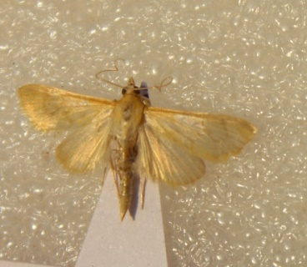 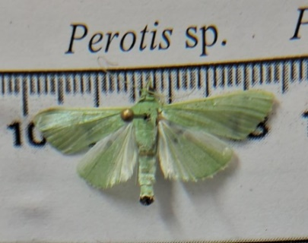 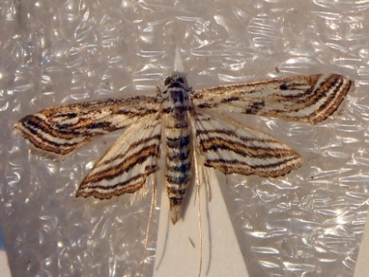 Fig. 1 Pyrausta sp. Fig. 2 Parotis sp. Fig. 3 Paraponyx fluctuosalis
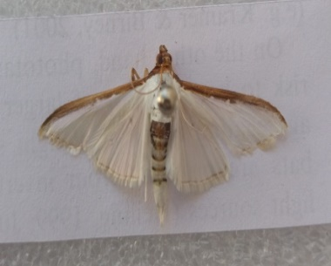 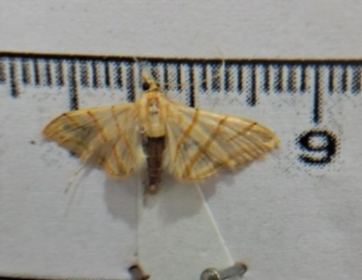 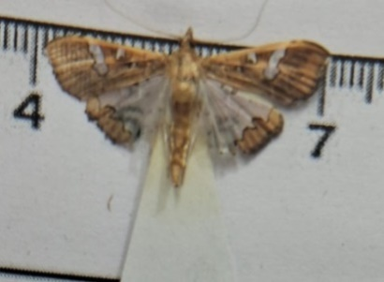 Fig. 4 Palpita asiaticalis Fig. 5 Pagyda botydalis Fig. 6 Maruca vitrata
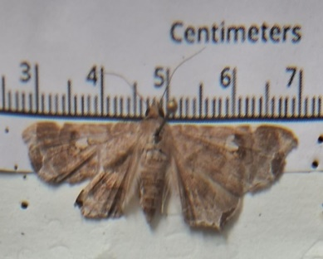 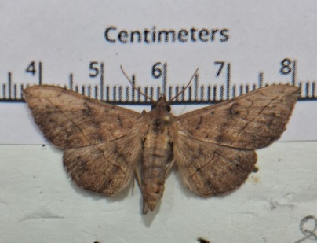 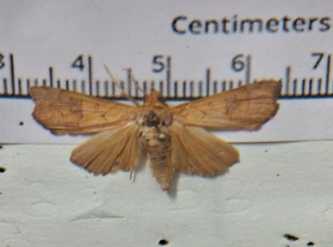 Fig. 7 Episparis liturata Fig. 8 Anticarsia irrorata Fig. 9 Anomis flava
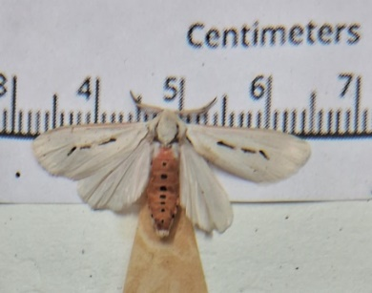 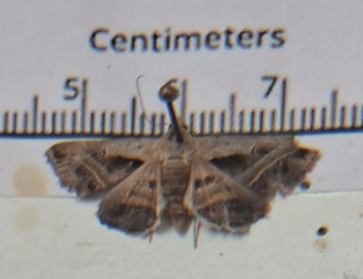 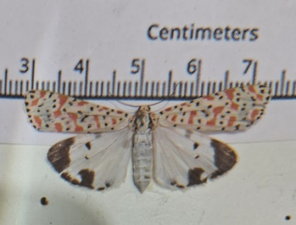 Fig.10 Micraloa lineola Fig.11 Acantholipes hypenoide Fig.12Utetheisa lotrix
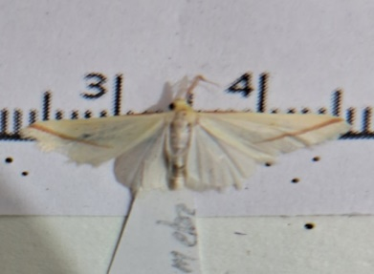 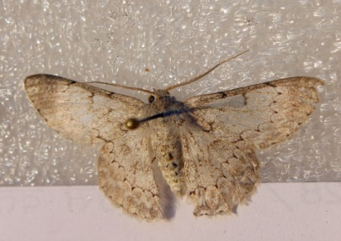 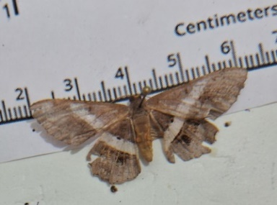 Fig.13 Rhodometra sacraria Fig.14 Pingasa lariaria Fig.15 Chiasmia elenora
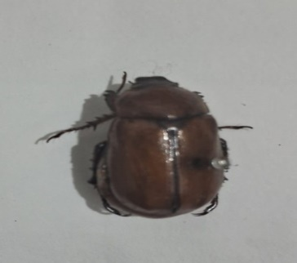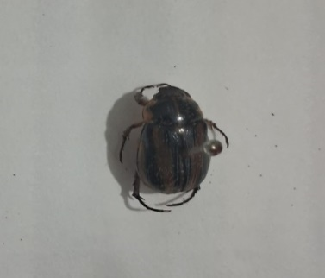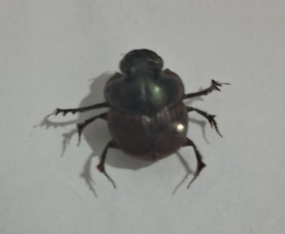

Fig.16 Anomala bengalensis Fig.17 Anomala rugosa Fig.18 Digitonthophagus gazelle
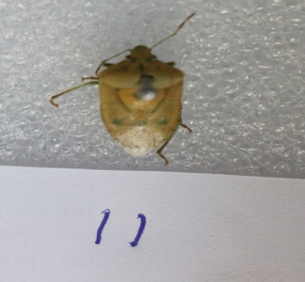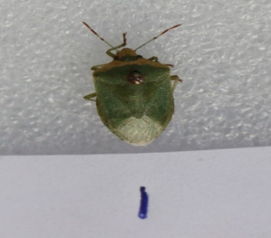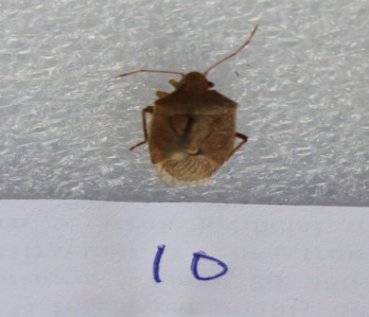
Fig.19 Plavtia fimbrita Fig.20 Nezara viridula Fig.21 Pentatoma sp.

Disclaimer (Artificial intelligence)

Author(s) hereby declare that NO generative AI technologies such as Large Language Models (ChatGPT, COPILOT, etc.) and text-to-image generators have been used during the writing or editing of this manuscript.

References

- Banerjee, D., Raghunathan, C., Rizvi A. N., & Das D. (2022). Animal Discoveries 2021: New Species and New Records, Zoological Survey of India, 1-232.
- Chapman, A. D. (2009). Numbers of living species in Australia and the world.
- Varshney, R. K. (1998). Faunal diversity in India: Insecta, 146-157.
- Winfree, R., Bartomeus, I. & Cariveau, D. P. (2011). Native pollinators in anthropogenic habitats. Annual review of ecology, evolution, and systematics, 42 (1), 1-22.
- Wong, M. K. & Didham, R. K. (2024). Global meta-analysis reveals overall higher nocturnal than diurnal activity in insect communities. Nature Communications. 15 (1), 32-36.
- Hakami, A. R., Khan, K. A., Ghramh, H. A., Ahmad, Z. & Al-Zayd, A. A. A. (2020). Impact of artificial light intensity on nocturnal insect diversity in urban and rural areas of the Asir province, Saudi Arabia. Plos one, 15(12), p.e0242315.
- Riegel, K. W. (1973). Light pollution: outdoor lighting is a growing threat to astronomy. Science, 179(4080),1285–91. https://doi.org/10.1126/science.179.4080.1285 PMID: 17835929
- Holker, F., Moss, T., Griefahn, B., Kloas. W., Voig,t C. C., Henckel, D. (2010). The dark side of light: a trans disciplinary research agenda for light pollution policy. Ecology and Society, 15(4).
- Kyba, C. C. & Holker, F. (2013). Do artificially illuminated skies affect biodiversity in nocturnal landscapes?: Springer.
- Schowalter, T. D., Noriega, J. A., Tscharntke, T. (2018). Insect effects on ecosystem services—Introduction. Elsevier.
- Tierney, S. M., Friedrich, M., Humphreys, W. F., Jones, T. M., Warrant, E. J. & Wcislo, W. T. (2017). Consequences of evolutionary transitions in changing photic environments. Austral Entomology, 56(1):23–46.
- Foster, J. J., Smolka, J., Nilsson, D. E. & Dacke, M. (2018). How animals follow the stars. Proceedings of the Royal Society B: Biological Sciences, 285(1871):20172322. https://doi.org/10.1098/rspb.2017.2322 PMID: 29367394
- Warrant, E. & Dacke, M. (2011). Vision and visual navigation in nocturnal insects. Annual review of entomology, 56(1), pp.239-254.
- Beck, J. & Linsenmair, K. E. (2006). Feasibility of light-trapping in community research on moths attraction radius of light, completeness of samples, nightly flight times and seasonality for Southeast Asian hawkmoths (Lepidoptera: Sphingidae). The Journal of Research on the Lepidoptera, 39, 18–36.
- Rose, H. S. (2002). An inventory of the moth fauna (Lepidoptera) of Jatinga, Assam, India. Zoos’ Print Journal, 17(2), 707-721.
- Choi, S. W. (2008). Effects of weather factors on the abundance and diversity of moths in a temperate deciduous mixed forest of Korea. Journal of Zoological Research, 25(1), 53-58.
- Khan, A. N. & Rehman, H. (2019). Nocturnal Insect’s Richness and Abundance in Gardens: A Review. International Journal of Scientific and Research Publications, 9.
- Kumari, B. & Priya, A. (2022). Seasonal variation in insect biodiversity in a transitioning sub-urban area. Zoological and Entomological Letters, 2(1), 42-49.
- Bidlingmayer, W. L. (1985). The measurement of adult mosquito population changes some considerations. Journal of American Mosquito Control Association, 1(3), 328-348.
- Holyoak, M. Jarosik, V. & Novak, I. (1997). Weather-Induced Changes in Moth Activity Bias Measurement of long-term population dynamics from light trap samples. Entomologia Experimentalis et Applicata. 83, 329-335.
- Yela, J. L. & Holyoak, M. (1997). Effects of moonlight and meteorological factors on light and bait trap catches of noctuid moths (Lepidoptera: Noctuidae). Environmental Entomology, 26(6), 1283-1290.
- Jonason, D. Franzén, M. & Ranius, T. (2014). Surveying moths using light traps: effects of weather and time of year. PloS one, 9(3).
- Fetnassi, N. Ude, K. Kull, A. & Tammaru, T. (2022). Weather Sensitivity of Sugar Bait Trapping of Nocturnal Moths: A Case Study from Northern Europe. Insects, 13(12), 1087.

