Antimicrobial Efficacy of Crude Extracts from Cinnamomum zeylanicum and Illicium verum Against Bacteria Isolated from Spoiled Vegetables and Human Pathogens

Abstract
The present study evaluates the antimicrobial efficacy of ethanolic extracts from Cinnamomum zeylanicum and Illicium verum against bacterial strains isolated from spoiled vegetables and selected human pathogenic microorganisms. In recent years, plant-based antimicrobials have attracted considerable attention as safer and environmentally sustainable alternatives to synthetic food preservatives. In this investigation, ethanolic extracts of the selected spices were prepared and subjected to standard microbiological assays to assess their antibacterial activity. The results revealed a significant concentration-dependent inhibitory effect for both extracts against the tested bacterial strains. Notably, the extract of Cinnamomum zeylanicum exhibited comparatively higher antimicrobial activity than Illicium verum, indicating the presence of potent bioactive constituents. The observed antibacterial effects are likely attributed to phytochemicals such as cinnamaldehyde, eugenol, and anethole, which are known for their strong antimicrobial properties. Furthermore, the study demonstrates the effectiveness of these spice-derived extracts in inhibiting food spoilage bacteria, thereby highlighting their potential application in reducing post-harvest losses and enhancing food preservation. Their activity against human pathogenic bacteria also underscores their relevance in improving food safety and public health.
In conclusion, the findings support the potential use of Cinnamomum zeylanicum and Illicium verum as natural antimicrobial agents in food systems. The incorporation of plant-based bioactive compounds may reduce dependence on synthetic preservatives and promote sustainable food safety practices. However, further research focusing on the isolation of active compounds, elucidation of mechanisms of action, and validation in real food matrices is essential to establish their practical applicability and commercial viability.

Keywords
Cinnamomum zeylanicum, Illicium verum, antimicrobial activity, Ethanolic extract, Natural preservatives, Food spoilage

Introduction:
Food spoilage caused by microorganisms remains a critical issue affecting both food safety and the economy, particularly in perishable produce such as carrots (Daucus carota) and potatoes (Solanum tuberosum). These vegetables are widely consumed worldwide due to their high nutritional value and their importance as staple foods. However, their high moisture content and nutrient availability make them highly susceptible to microbial contamination during harvesting, storage, transportation, and marketing. Such contamination results in rapid deterioration, leading to significant post-harvest losses and reduced market quality.(Food and Agriculture Organization, 2019; James M. Jay et al., 2005).
Bacterial contamination—mainly by Pseudomonas, Erwinia, Bacillus, Enterobacter, and Pectobacterium species—leads to discoloration, tissue maceration, texture loss, unpleasant odors, and overall degradation of the vegetable tissues. These spoilage microorganisms produce various enzymes such as pectinases, cellulases, and proteases that break down plant cell walls and accelerate decay. In addition to spoilage, certain bacterial species associated with vegetables may act as opportunistic pathogens, posing potential risks to human health when contaminated food is consumed.
Conventionally, synthetic chemical preservatives and antimicrobial agents have been widely used to control microbial growth in food systems. Although effective, the excessive and prolonged use of these chemicals has raised serious concerns regarding toxicity, environmental impact, and the development of antimicrobial resistance among microorganisms. Moreover, consumers are increasingly demanding safer, natural, and minimally processed foods without synthetic additives. These challenges have encouraged researchers to explore alternative natural preservatives derived from plant sources.
Medicinal and aromatic plants have long been recognized as valuable sources of antimicrobial compounds. Plant extracts, essential oils, and phytochemicals possess a wide range of biological activities, including antibacterial, antifungal, antioxidant, and anti-inflammatory properties. Among these plants, Cinnamomum zeylanicum (cinnamon) and Illicium verum (star anise) have gained considerable attention due to their strong antimicrobial potential and widespread use in traditional medicine and culinary applications. (Hyldgaard, M., Mygind, T., & Meyer, R. L., 2012)
Cinnamomum zeylanicum, commonly known as true cinnamon, contains several bioactive compounds such as cinnamaldehyde, eugenol, and cinnamic acid, which exhibit strong antimicrobial activity against a wide range of microorganisms. These compounds are known to disrupt bacterial cell membranes, interfere with enzyme activity, and inhibit the growth and metabolic processes of microbial cells. Similarly, Illicium verum (star anise) is rich in bioactive components such as anethole, flavonoids, and phenolic compounds that contribute to its antimicrobial and antioxidant properties. These phytochemicals are capable of damaging microbial cell structures, altering the permeability of cell membranes, and inhibiting essential biochemical pathways.
Recent studies have demonstrated that plant-derived extracts and essential oils can effectively inhibit food spoilage microorganisms and certain human pathogens. The use of such natural antimicrobials in food preservation systems not only enhances food safety but also extends the shelf life of perishable products. Additionally, plant-based preservatives are biodegradable, environmentally friendly, and generally recognized as safe (GRAS), making them suitable alternatives to synthetic chemicals.
Therefore, the present study aimed to evaluate the antimicrobial efficacy of ethanolic extracts of Cinnamomum zeylanicum and Illicium verum against bacteria isolated from spoiled vegetables and selected human pathogenic bacteria. The findings of this study may contribute to the development of natural antimicrobial agents that can be used in food preservation and food safety management strategies.

Materials and Methods

1. Collection and Isolation of Microorganisms
Spoiled vegetable samples, specifically carrot (Daucus carota) and potato (Solanum tuberosum), were collected aseptically from the local vegetable market in Palayamkottai, Tirunelveli District, Tamil Nadu, India. Samples exhibiting visible signs of spoilage, such as discoloration, softening, and an unpleasant odor, were selected for microbial analysis. The collected samples were placed in sterile polyethylene bags and transported immediately to the microbiology laboratory for further processing.(Aneja, 2003)
Approximately 10 g of each spoiled vegetable sample was homogenized in 90 mL of sterile distilled water using a sterile mortar and pestle to obtain the initial suspension. Serial dilution was performed up to 10⁻⁶ using sterile saline solution. From appropriate dilutions, 0.1 mL of the suspension was spread onto sterile nutrient agar plates using a sterile spreader. The plates were incubated at 37 °C for 24 hours.(American Public Health Association, 2015).
After incubation, distinct bacterial colonies were observed and selected based on differences in morphology, including colony size, shape, color, and margin. Individual colonies were further purified by repeated streaking on fresh nutrient agar plates to obtain pure cultures. The purified isolates were maintained on nutrient agar slants and stored at 4 °C for subsequent antimicrobial testing. The isolates obtained from spoiled vegetables were coded as V1–V7.(Cappuccino & Sherman, 2014).

2. Preparation of Plant Extracts
Dried samples of cinnamon (Cinnamomum zeylanicum) bark and star anise (Illicium verum) were procured from a local herbal store in Tirunelveli. The plant materials were cleaned to remove dust and other contaminants and then shade-dried at room temperature for several days to remove residual moisture while preserving the active compounds.(Harborne, 1998).
The dried plant materials were coarsely powdered using a mechanical grinder. Approximately 50 g of each powdered sample was soaked separately in 500 mL of ethanol in sterile conical flasks. The extraction was conducted for 72 hours at room temperature with occasional shaking to ensure thorough mixing and efficient extraction of phytochemicals.(Sofowora, 1993).
After the extraction period, the mixtures were filtered through Whatman No. 1 filter paper to remove plant debris. The filtrates were then concentrated under reduced pressure using a rotary evaporator to remove the solvent and obtain crude ethanolic extracts. The concentrated extracts were stored in sterile airtight containers at 4 °C until further use in antimicrobial assays.

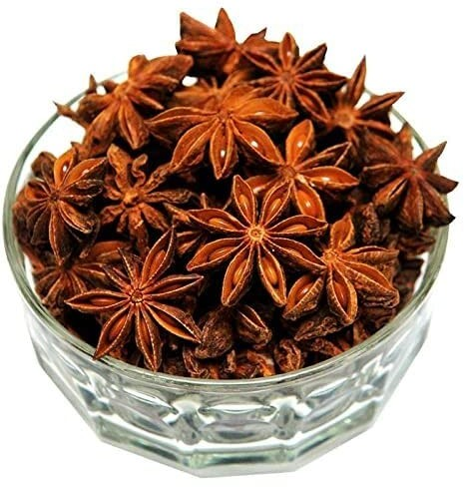
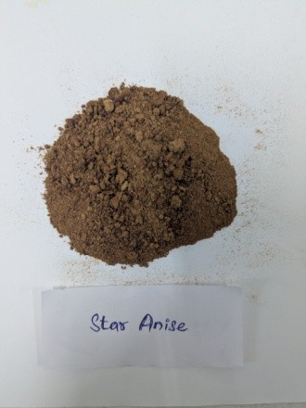

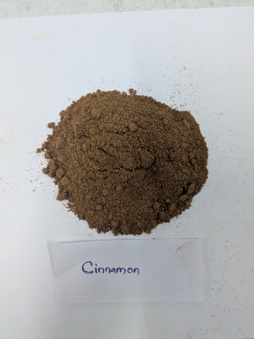

Plate 1. Star anise (Illicium verum) and Cinnamon sticks (Cinnamomum zeylanicum) powder

(iii)Microorganisms Used
The antimicrobial activity of the plant extracts was evaluated against both vegetable spoilage bacteria and selected human pathogenic bacterial strains. The pathogenic strains used in the study included Klebsiella spp., Proteus mirabilis (MTCC-3310), Serratia marcescens (MTCC-4622), Staphylococcus aureus (MTCC-15029), Enterococcus faecalis (MTCC-15036), Bacillus cereus (MTCC-12856), Streptococcus mutans (MTCC-497), and Methicillin-resistant Staphylococcus aureus (MRSA).
These cultures were obtained from a recognized microbial culture collection and maintained in the microbiology laboratory under appropriate conditions. Before the antimicrobial assay, bacterial cultures were revived and grown in nutrient broth at 37 °C for 18–24 hours to obtain actively growing cultures.(Pelczar et al., 2005).
In addition to these pathogenic strains, seven bacterial isolates obtained from spoiled vegetables (designated as V1–V7) were also included in the study to evaluate the effectiveness of plant extracts against food spoilage microorganisms.

(iv) Antimicrobial Assay
The antimicrobial activity of the ethanolic plant extracts was determined using the standard disc diffusion method on Mueller–Hinton agar plates. Fresh bacterial cultures were adjusted to an appropriate turbidity equivalent to the 0.5 McFarland standard to ensure uniform bacterial inoculum.
Sterile Mueller–Hinton agar plates were prepared and allowed to solidify. The surface of each plate was uniformly inoculated with the bacterial suspension using a sterile cotton swab to create a lawn culture. Sterile filter paper discs (6 mm diameter) were impregnated with different concentrations of the plant extracts.(Bauer et al., 1966).
Two concentrations of the extracts were tested: 5 mg/disc and 10 mg/disc. The impregnated discs were carefully placed on the surface of the inoculated agar plates using sterile forceps. Streptomycin (25 µg/disc) was used as the positive control to compare the antimicrobial effectiveness of the plant extracts. A disc containing only ethanol served as the negative control.
The plates were incubated at 37 °C for 24 hours under suitable conditions. After incubation, the antimicrobial activity was assessed by measuring the diameter of the zones of inhibition around each disc. The zones were measured in millimeters (mm) using a standard ruler or caliper. The experiments were performed in triplicate, and the average values of the inhibition zones were recorded for analysis.

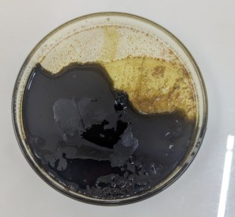
Star anise ethanol extract, Cinnamon sticks, ethanol Extract

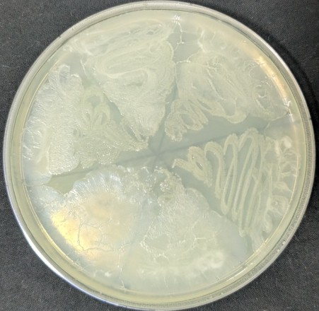
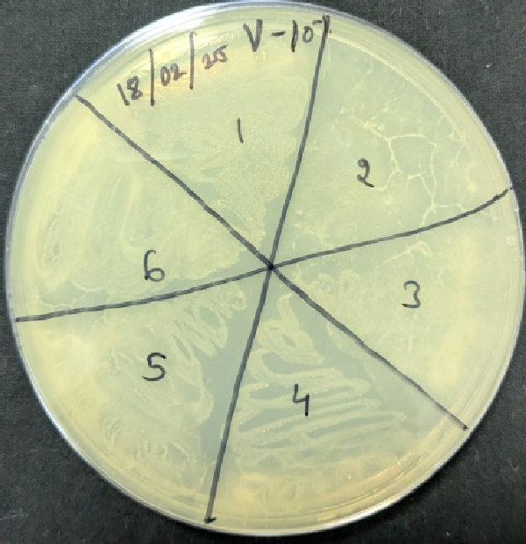
Plate:2 Vegetable Bacteria and Sub-Culture Plate
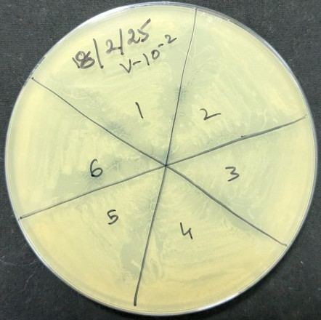
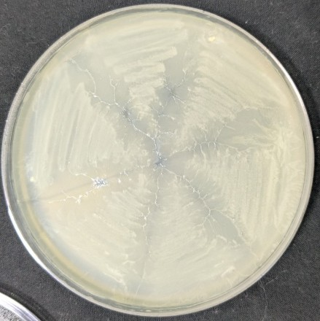
Subculture plate
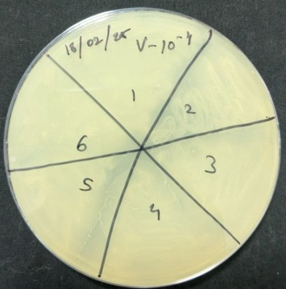
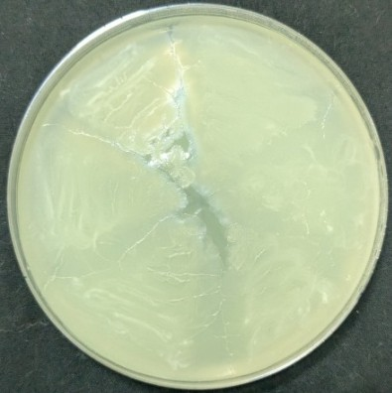

Plate: 3 . Subculture plate

Result:
The antimicrobial activity of the ethanolic extracts of Cinnamomum zeylanicum (cinnamon) and Illicium verum (star anise) was evaluated against selected human pathogenic bacteria and bacterial isolates obtained from spoiled vegetables using the disc diffusion method. The antibacterial potential of the extracts was determined by measuring the diameter of the clear zones of inhibition formed around the discs containing the plant extracts. The results were expressed in millimeters (mm), representing the susceptibility of the tested microorganisms to the extracts.
Overall, the extracts from the studied plants demonstrated varying levels of antibacterial activity against the tested bacterial strains. The presence of clear inhibition zones around the discs indicated that both plant extracts possessed antimicrobial properties. However, differences in the magnitude of the inhibition zones suggested variations in the antibacterial effectiveness of the two plant extracts as well as differences in susceptibility among the bacterial species.
The ethanolic crude extract of Cinnamomum zeylanicum exhibited comparatively stronger antibacterial activity than the extract of Illicium verum. Among the tested pathogens, the highest antibacterial activity of the cinnamon extract was observed against Proteus mirabilis, which produced a maximum inhibition zone of 14 mm. Moderate antibacterial activity was observed against Bacillus cereus MTCC-12856 with an inhibition zone of 13 mm, followed by Streptococcus mutans MTCC-497 with an inhibition zone of 12 mm. The extract also showed inhibitory activity against several vegetable-derived bacterial isolates, including Vegetables Bacteria 1 (V-1), Vegetables Bacteria 3 (V-3), Vegetables Bacteria 4 (V-4), and Vegetables Bacteria 5 (V-5). Additionally, the extract demonstrated inhibitory effects against Klebsiella spp. and Staphylococcus aureus MTCC-15029 with a zone of inhibition measuring approximately 8 mm. The lowest inhibitory activity of the cinnamon extract was observed against Vegetables Bacteria 7 (V-7), with an inhibition zone of 5 mm.
Similarly, the ethanolic crude extract of Illicium verum also exhibited noticeable antibacterial activity, though comparatively lower than that of the cinnamon extract. The highest inhibition produced by the star anise extract was recorded against Bacillus cereus MTCC-12856, with a zone of inhibition measuring 12 mm. Moderate antibacterial activity was observed against Streptococcus mutans MTCC-497 with an inhibition zone of 10 mm. The extract also demonstrated inhibitory effects against Methicillin-resistant Staphylococcus aureus (MRSA), producing an inhibition zone of 9 mm, indicating the potential effectiveness of the extract against antibiotic-resistant bacterial strains.
In addition, the star anise extract showed inhibitory activity against Staphylococcus aureus MTCC-15029, Proteus mirabilis, and Vegetables Bacteria 5 (V-5), each producing inhibition zones of approximately 7 mm. Lower levels of activity were observed against Vegetables Bacteria 3 (V-3) and Vegetables Bacteria 1 (V-1), both showing inhibition zones of about 5 mm.
The variation in antimicrobial activity observed among the tested microorganisms may be attributed to differences in the structural and physiological characteristics of bacterial cell walls, as well as the sensitivity of individual species to the bioactive compounds present in the plant extracts. The higher antibacterial activity exhibited by Cinnamomum zeylanicum may be associated with the presence of potent phytochemicals such as cinnamaldehyde and eugenol, which are known to disrupt bacterial cell membranes, inhibit enzyme activity, and interfere with microbial metabolic processes. Similarly, the antimicrobial activity of Illicium verum can be attributed to the presence of bioactive compounds such as anethole and various phenolic constituents.
The results clearly indicate that both plant extracts possess considerable antibacterial activity against food spoilage bacteria as well as selected human pathogenic bacteria. However, the cinnamon extract demonstrated relatively stronger antimicrobial effects compared to the star anise extract. These findings highlight the potential application of these plant-derived extracts as natural antimicrobial agents in food preservation and food safety management.The detailed results of the antibacterial activity, including the inhibition zone diameters for each bacterial strain, are presented in Table 1.
The antimicrobial activity of ethanolic extracts of Cinnamomum zeylanicum and Illicium verum, expressed as mean ± standard deviation (n = 3), is summarized in Table 1. The control antibiotic, streptomycin, exhibited strong inhibitory effects, with maximum zones observed against Staphylococcus aureus (29 ± 0.9 mm) and Bacillus cereus (29 ± 0.8 mm), followed by Streptococcus mutans (25 ± 0.7 mm) and Proteus mirabilis (24 ± 0.8 mm). Among the plant extracts, cinnamon demonstrated comparatively higher antibacterial activity than star anise. Cinnamon extract at 10 mg/disc showed notable inhibition against Proteus mirabilis (14 ± 0.6 mm), Bacillus cereus (13 ± 0.6 mm), and Streptococcus mutans (12 ± 0.5 mm), while moderate activity was observed at 5 mg/disc. Star anise extract exhibited moderate antimicrobial effects, with the highest activity recorded against Bacillus cereus (12 ± 0.5 mm) and MRSA (9 ± 0.5 mm). Several isolates, including V2, V6, Serratia marcescens, and Enterococcus faecalis, showed no inhibition against either extract. Overall, the results indicate that cinnamon possesses stronger and more consistent antibacterial activity compared to star anise against both vegetable spoilage bacteria and selected human pathogens.Table -2
while the comparative graphical representation of the antimicrobial activity of the two plant extracts is shown in Figure 1.

Table 1: Antimicrobial activities (in mm) of different crude extracts against random bacteria in rotten vegetables

S. Pathogen Control Concentration

no streptomycin
Cinnamonsticks (Cinnamomum zeylanicum) Ethanolextract (3)
Staranise (Illiciumverum)

Ethanolextract(4)

 |  | 5mg/disc | 10mg/disc | 5mg/disc | 10mg/disc
 |  | (5) | (6) | (7) | (8)
1 Vegetables Bacteria 1 | 15mm | 7mm | 8mm | - | 5mm
(V-1)
2 Vegetables Bacteria | - | - | - | - | -
2(V-2)
3 Vegetables Bacteria | 15mm | - | 8mm | - | 5mm
3(V-3)
4 Vegetables Bacteria | 6mm | 5mm | 8mm | - | -
4(V-4)
5 Vegetables Bacteria | - | 5mm | 8mm | - | 7mm
5(V-5)
6 Vegetables Bacteria | - | - | - | - | -
6(V-6)
7 Vegetables Bacteria | - | - | 5mm | - | -
7(V-7)
8 Serratia marcescens | - | - | - | - | -
9 Klebsiella spp. | 17mm | - | 8mm | - | -
10 Proteus mirabilis | 24mm | 10mm | 14mm | - | 7mm
11 Staphylococcus aureus | 29mm | 6mm | 8mm | 6mm | 7mm
12 Enterococcus faecalis | - | - | - | - | -
13 Bacillus cereus | 29mm | 10mm | 13mm | 10mm | 12mm
14 Streptococcus mutans | 25mm | 10mm | 12mm | 8mm | 10mm
15 Methicilin-resistant | 24mm | - | - | 7mm | 9mm
Staphylococcus aureus
(MRSA)

Fig-1

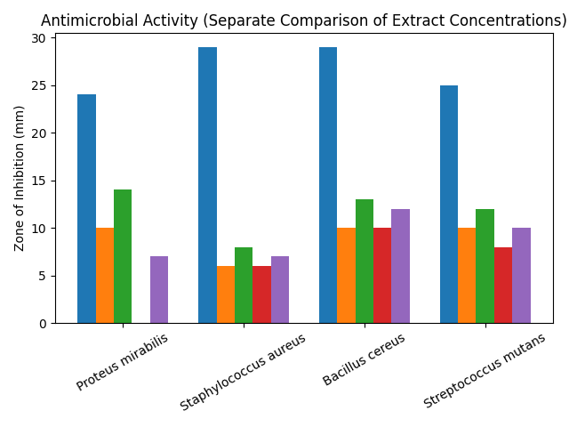

• Control (Streptomycin) (Blue)
• Cinnamon (5 mg) (Orange)
• Cinnamon (10 mg) (Green)
• Star anise (5 mg)( Red)

• Star anise (10 mg)(Purple)

Table 2: Antimicrobial activity of crude extracts (mean ± SD, n = 3)

S.No | Pathogen | Control (Streptomycin) | Cinnamon (5 mg/disc) | Cinnamon (10 mg/disc) | Star Anise (5 mg/disc) | Star Anise (10 mg/disc)
1 | V1 | 15 ± 0.5 | 7 ± 0.3 | 8 ± 0.4 | – | 5 ± 0.2
2 | V2 | – | – | – | – | –
3 | V3 | 15 ± 0.6 | – | 8 ± 0.5 | – | 5 ± 0.3
4 | V4 | 6 ± 0.4 | 5 ± 0.2 | 8 ± 0.3 | – | –
5 | V5 | – | 5 ± 0.3 | 8 ± 0.4 | – | 7 ± 0.5
6 | V6 | – | – | – | – | –
7 | V7 | – | – | 5 ± 0.2 | – | –
8 | Serratia marcescens | – | – | – | – | –
9 | Klebsiella spp. | 17 ± 0.7 | – | 8 ± 0.3 | – | –
10 | Proteus mirabilis | 24 ± 0.8 | 10 ± 0.5 | 14 ± 0.6 | – | 7 ± 0.4
11 | Staphylococcus aureus | 29 ± 0.9 | 6 ± 0.3 | 8 ± 0.4 | 6 ± 0.2 | 7 ± 0.3
12 | Enterococcus faecalis | – | – | – | – | –
13 | Bacillus cereus | 29 ± 0.8 | 10 ± 0.5 | 13 ± 0.6 | 10 ± 0.4 | 12 ± 0.5
14 | Streptococcus mutans | 25 ± 0.7 | 10 ± 0.4 | 12 ± 0.5 | 8 ± 0.3 | 10 ± 0.4
15 | MRSA | 24 ± 0.9 | – | – | 7 ± 0.3 | 9 ± 0.5

Values are expressed as mean ± standard deviation (n = 3). “–” indicates no detectable inhibition zone.

Fig: 2 Antimicrobial activities (in mm) of different crude extract against random bacteria in rotten vegetables
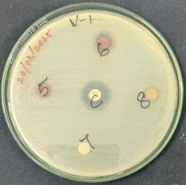
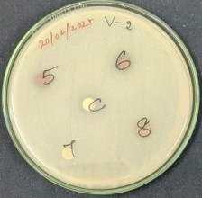
Vegetables Bacteria 1 (V-1) Vegetables Bacteria 2 (V-2)
Extract: Ethanol
C (Control): Streptomycin Control: 15 mm length
5: 5 mg - 7 mm length
6: 10 mg - 8 mm length
7: 5 mg - 0 mm length
8: 10 mg - 5 mm length
Extract: Ethanol
C (Control): Streptomycin Control: 0 mm length
5: 5 mg - 0 mm length
6: 10 mg - 0 mm length
7: 5 mg - 0 mm length
8: 10 mg - 0 mm length

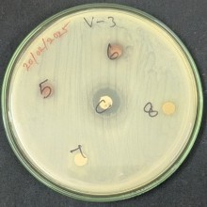
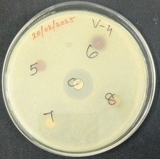
vegetables Bacteria 3 (V-3) Vegetables Bacteria 4 (V-4)
Extract: Ethanol
C (Control): Streptomycin Control: 6 mm length
5: 5 mg - 5 mm length
6: 10 mg - 8 mm length
7: 5 mg - 0 mm length
8: 10 mg - 0 mm length
Extract: Ethanol
C (Control): Streptomycin Control: 15 mm length
5: 5 mg - 0 mm length
6: 10 mg -8 mm length
7: 5 mg - 0 mm length
8: 10 mg - 5 mm length

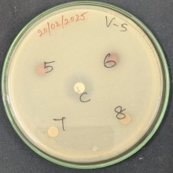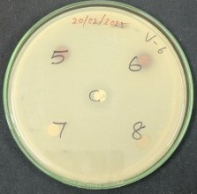

Vegetables Bacteria 5 (V-5) Vegetables Bacteria 6 (V-6)
Extract: Ethanol
C (Control): Streptomycin Control: 0 mm length
5: 5 mg - 5 mm length
6: 10 mg - 8 mm length
7: 5 mg - 0 mm length
8: 10 mg - 7 mm length
Extract: Ethanol
C (Control): Streptomycin Control: 0 mm length
5: 5 mg - 0 mm length
6: 10 mg - 0 mm length
7: 5 mg - 0 mm length
8: 10 mg - 0 mm length

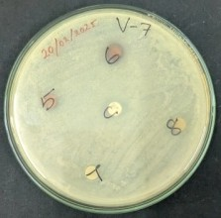
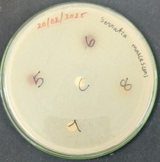

Vegetables Bacteria 7 (V-7) Serratia marcescens
Extract: Ethanol
C (Control): Streptomycin Control: 0 mm length
5: 5 mg - 0 mm length
6: 10 mg - 5 mm length
7: 5 mg - 0 mm length
8: 10 mg - 0 mm length
Extract: Ethanol
C (Control): Streptomycin Control: 0 mm length
5: 5 mg - 0 mm length
6: 10 mg - 0 mm length
7: 5 mg - 0 mm length
8: 10 mg - 0 mm length

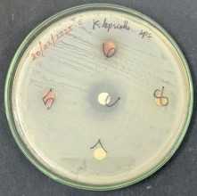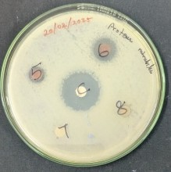

Klebsiella spp. Proteus mirabilis
Extract: Ethanol
C (Control): Streptomycin Control: 17 mm length
5: 5 mg - 0 mm length
6: 10 mg - 8 mm length
7: 5 mg - 0 mm length
8: 10 mg - 0 mm length
Extract: Ethanol
C (Control): Streptomycin Control: 24 mm length
5: 5 mg - 10 mm length
6: 10 mg - 14 mm length
7: 5 mg - 0 mm length
8: 10 mg - 7 mm length

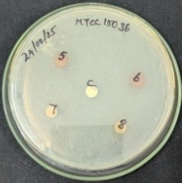
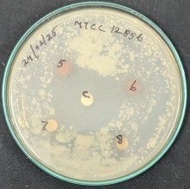

Enterococcus faecalis (MTCC-15036) Bacillus cereus (MTCC-12856)
Extract: Ethanol
C (Control): Streptomycin Control: 0 mm length
5: 5 mg - 0 mm length
6: 10 mg - 0 mm length
7: 5 mg - 0 mm length
8: 10 mg - 0 mm length
Extract: Ethanol
C (Control): Streptomycin Control: 29 mm length
5: 5 mg - 10 mm length
6: 10 mg - 13 mm length
7: 5 mg - 10 mm length
8: 10 mg - 12 mm length

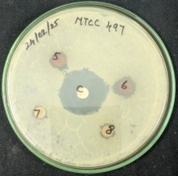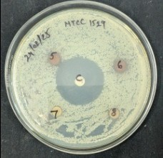

Streptococcus mutans (MTCC-497) Staphylococcus aureus (MTCC-15029)
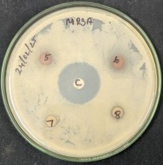
Extract: Ethanol
C (Control): Streptomycin Control: 24 mm length
5: 5 mg - 0 mm length
6: 10 mg - 0 mm length
7: 5 mg - 7 mm length
8: 10 mg - 9 mm length
Extract: Ethanol
C (Control): Streptomycin Control: 25 mm length
5: 5 mg - 10 mm length
6: 10 mg - 12 mm length
7: 5 mg - 8 mm length
8: 10 mg - 10 mm length
Extract: Ethanol
C (Control): Streptomycin Control: 29 mm length
5: 5 mg - 6 mm length
6: 10 mg - 8 mm length
7: 5 mg - 6 mm length
8: 10 mg - 7 mm length

Methicillin-resistant Staphylococcus aureus MRSA
Discussion:
The discovery and development of antibiotics over the past century have saved countless lives and provided reliable treatment options in clinical settings. However, the rise of antibiotic-resistant bacteria has significantly diminished the effectiveness of antibiotics in both prevention and treatment. Despite the continuous introduction and modification of antibiotics to counter bacterial resistance, the demand for new antibiotics, particularly for multidrug-resistant (MDR) bacteria, remains a growing challenge. This difficulty arises due to the complex chemical structures of these molecules, making their development challenging. Moreover, antibiotics designed for specific infections cannot simply be discarded as obsolete when resistance emerges in certain regions. Instead, there is a need to introduce complementary or adjuvant drugs alongside existing antibiotics to combat infections caused by MDR bacteria, thereby addressing morbidity and mortality (Davies and Davies, 2010).
Ultimately, there is a global demand for suitable antibiotics on a large scale to reduce the risk of resistant strains emerging through Darwinian selection. Methanol-based extraction of phytochemicals offers a unique approach, as this solvent effectively extracts a broad range of phytocompounds, from highly polar to non-polar substances (Rezaie et al., 2015). The current study supports the use of organic solvents, such as methanol, for plant extraction over aqueous methods. The polarity of antibacterial compounds makes them more effectively extracted by organic solvents, which preserve their bioactivity against bacteria. In fact, some antimicrobial agents can only be extracted using organic solvents, making these solvents more suitable for isolating such compounds (Thongson et al., 2004).
The plant extracts in this study exhibited varying antibacterial activity, with inhibition zones measured in millimeters. The ethanolic extract from cinnamon sticks (Cinnamomumzeylanicum) was particularly effective against Proteus mirabilis (14 mm) and showed moderate activity against other bacteria, such as MTCC-12856 and MTCC-497. Similarly, the ethanolic extract from star anise (Illicium verum) demonstrated strong activity against MTCC-12856 (12 mm) and moderate activity against several other strains, including MRSA and Proteus mirabilis.
Overall, the results indicate that all plant extracts inhibited the growth of tested pathogens to varying degrees. Moringa oleifera exhibited the ability to inhibit both Gram- positive and Gram-negative bacteria, regardless of the extraction solvent used, highlighting its potential as a broad-spectrum antibiotic source. As noted by Dike-Ndudim et al. (2016),
M. oleifera extracts are effective against both types of bacteria, justifying its traditional therapeutic uses. In particular, methanol extracts of M. oleifera showed significant inhibition against Staphylococcus aureus at 150 mg/mL. The leaves, stems, and seeds of M. oleifera could serve as an alternative for controlling infections, including those caused by S. aureus in humans and cows with mastitis (Tirado-Torres et al., 2019).
Similar findings were reported by Sivanandham and Institutions, as well as Shikwambi et al., who observed that organic solvent extracts exhibited greater inhibitory activity compared to aqueous extracts, which were ineffective against most tested microorganisms. In a study on Sargassum polycystum extracts from Bangladesh, ethanol extracts demonstrated the highest antibacterial activity against Escherichia coli (16.50 ± 0.13 mm), while methanol extracts were more effective against Salmonella typhimurium (14.6 ± 0.18 mm) at a 7 mg/mL concentration (Dip et al., 2024). The crude extract of Thalictrum rhynchocarpum exhibited superior antibacterial activity, with the lowest minimum inhibitory concentrations (MICs): 0.48 µg/mL against S. aureus and E. coli, and 0.98 µg/mL against Klebsiella pneumoniae and Pseudomonas aeruginosa, highlighting the potency of certain plant extracts (Dubale et al., 2023).
Plants, as sources of novel pharmacological compounds, continue to be valuable in the search for new antibiotics. In Jordan, the plant Arum hygrophilum Boiss is traditionally used for medicinal purposes. A study evaluating its antibacterial activity found that water, methanol, and ethanol extracts had significant effects against bacteria such as S. aureus, E. coli, Pseudomonas aeruginosa and Klebsiella pneumoniae. Notably, the water extract exhibited a significant inhibition zone against P. aeruginosa (30 mm ± 3.0), while the methanol extract showed notable inhibition against E. faecalis (15 ± 0.37 mm) (Jaber et al., 2020). Similarly, a study on thirty-nine methanolic extracts from twenty-five Australian native plants found that most of the extracts inhibited bacterial growth. Among them, Backhousia citriodora and Callistemon citrinus were particularly effective, inhibiting all four bacterial strains tested: Bacillus cereus, Bacillus subtilis, Pseudomonas fluorescens and Aeromonas hydrophila (Cock, 2008).
These studies demonstrate that plant extracts, especially those extracted with organic solvents, can provide an effective alternative to synthetic antibiotics. Their broad-spectrum antibacterial properties could contribute significantly to addressing the growing problem of antibiotic resistance.

Conclusion
The present study reports on the antimicrobial activity of medicinal plant extracts from cinnamon sticks (Cinnamomum zeylanicum) (Patti) and star anise (Illicium verum) (Annachi Poo) against spoiled vegetable bacteria and human pathogens. The extracts demonstrated notable antimicrobial potential against the tested pathogens. These findings validate the traditional use of these botanicals in food preservation while providing scientific evidence for their application in modern food safety protocols. The observed inhibitory effects were concentration-dependent, with higher extract concentrations yielding more pronounced zones of inhibition in the agar diffusion assays. To enhance the effectiveness and stability of these plants, an in-depth exploration of the most active components of these plants is needed, particularly focusing on their synergistic interactions and stability under different storage conditions. Further study should investigate the minimum inhibitory concentrations (MICs) of individual bioactive compounds like cinnamaldehyde and anethole against specific spoilage bacteria. The thermal stability and pH tolerance of these antimicrobial compounds should also be examined to determine their suitability for various food processing applications. These findings open promising avenues for developing natural preservative systems that could reduce reliance on synthetic additives while maintaining food quality and safety.

Disclaimer (Artificial intelligence)

Author(s) hereby declare that NO generative AI technologies such as Large Language Models (ChatGPT, COPILOT, etc.) and text-to-image generators have been used during the writing or editing of this manuscript.

References:
1.Akrami, S., Amin, M., & Saki, M. (2021). In vitro evaluation of antibacterial effects of Cinnamomum zeylanicum essential oil against multidrug-resistant Shigella isolates. Molecular Biology Reports, 48(3), 2583-2589.
2.American Public Health Association (APHA). (2015). Standard Methods for the Examination of Water and Wastewater.
3.Aneja, K. R. (2003). Experiments in Microbiology, Plant Pathology and Biotechnology.
4.Al-Zubaidi, S. (2025). In vitro antibacterial activity of Cinnamomum zeylanicum and screening of its bioactive compounds. Journal of Current Medical Research and Opinion, 8(10), 4-10.
5Ben Selma, W., Ferjeni, S., Farouk, A., Marzouk, M., & Boukadida, J. (2025). Antimicrobial activity of Cinnamomum zeylanicum essential oil against colistin-resistant Gram-negative bacteria. International Journal of Environmental Health Research, 35(1), 169-181.
6.Bauer, A. W., Kirby, W. M. M., Sherris, J. C., & Turck, M. (1966). Antibiotic susceptibility testing by a standardized single disk method.
7Cappuccino, J. G., & Sherman, N. (2014). Microbiology: A Laboratory Manual.
8.Davies and Davies, 2010).Origins and Evolution of Antibiotic Resistance, Journal of Microbiology and Molecular Biology Reviews,volume-74,issue:3 https://doi.org/10.1128/mmbr.00016-10.
9.Dike-Ndudim, J.N., Anyanwu, G.O., Egbuobi, R.C., Okorie, H.M., Udujih, H.I., Nwosu, D.C. and Okolie, N.J.C., 2016. Anti-bacterial and phytochemical potential of Moringa oleifera leaf extracts on some wound and enteric pathogenic bacteria. Eur J Bot Plant Sci Phytol, 3(1), pp.50-60.
19 .Dubale, S., Kebebe, D., Zeynudin, A., Abdissa, N. and Suleman, S., 2023. Phytochemical screening and antimicrobial activity evaluation of selected medicinal plants in Ethiopia. Journal of experimental pharmacology, pp.51-62.
11 . Ellaiah, P., Purna Chandra Rao, N., & Siva Rama Krishna, M. (1996). Isolation of microorganisms from different samples by serial dilution plate technique. Indian Journal of Microbiology, 36(2), 124-128. https://doi.org/10.1007/BF02972852
12. El Atki, Y., Aouam, I., El Kamari, F., Taroq, A., Nayme, K., Timinouni, M., Lyoussi, B. and Abdellaoui, A., 2019. Antibacterial activity of cinnamon essential oils and their synergistic potential with antibiotics. Journal of advanced pharmaceutical technology & research, 10(2), pp.63-67.
13 Friedman, M. (2017). Chemistry and antimicrobial mechanisms of cinnamon and its components. Journal of Agricultural and Food Chemistry, 65(24), 4789-4800.
14. Food and Agriculture Organization. (2019). The State of Food and Agriculture 2019: Moving forward on food loss and waste reduction. Rome: FAO.
15.Harborne, J. B. (1998). Phytochemical Methods.
16. Hyldgaard, M., Mygind, T., & Meyer, R. L. (2012). Essential oils in food preservation: mode of action, synergies, and interactions with food matrix components. Frontiers in Microbiology.
17.Hyun-Jeong, C., et al. (2019). Antimicrobial properties of star anise (Illicium verum) essential oil against foodborne pathogens. Food Science & Nutrition, 7, 3122-3130.
18.Pelczar, M. J., Chan, E. C. S., & Krieg, N. R. (2005). Microbiology.
19.Sofowora, A. (1993). Medicinal Plants and Traditional Medicine in Africa.
20. Tirado-Torres, D., Chan-Keb, C.A., Pérez-Balán, R.A., Ake-Canché, B., Gómez Solano, M.I., Aragón-Gastélum, J.L., Gómez-López, I., Aguirre-Crespo, F.J., López-Ramos, M.C. and Gutiérrez-Alcántara, E.J., 2019. Antimicrobial activity of Moringa oleifera against multidrug-resistant Staphylococcus aureus isolated from raw milk. Appl. Ecol. Environ. Res, 17(1), pp.587-599.
21. Thongson C, Davidson PM, Mahakarnchanakul W, Weiss J. Antimicrobial activity of ultrasound-assisted solvent-extracted spices. Letters Appl Microbiol 2004; 39:401-406.
22. USDA. (2023). Carrots: Nutritional content and health benefits. United States Department of Agriculture. Retrieved from https://www.nutrition.gov.
23. USDA. (2023). Potatoes: Nutritional content and health benefits. United States Department of Agriculture. Retrieved from https://www.nutrition.gov
24. Valanarasu, A., Muthu, M., & Murugesan, G. (2009). Isolation and characterization of microorganisms from spoiled fruits and vegetables. Journal of Applied Microbiology, 107(3), 981-991. https://doi.org/10.1111/j.1365-2672.2009.04238.
25. Vasconcelos, L. A. (2018). Cinnamon and its antimicrobial activity: A review. Pharmacognosy Reviews, 12(24), 40-45. https://doi.org/10.4103/phrev.phrev_24_18
26.Wells-Bennik, M. H., de Vos, W. M., & Tjalsma, H. (2016). Clostridium spp. and their role in anaerobic putrefaction of plant material. International Journal of Food Microbiology, 234, 123-130. https://doi.org/10.1016/j.ijfoodmicro.2016.07.018.

