Original Research Article

Habitat Use and Spatial distribution of the Indian Chevrotain (Moschiola indica) in the Buffer Zone of Bhadra Wildlife Sanctuary: A Case Study from Kuvempu University Campus, Shivamogga, Karnataka

ABSTRACT
The Indian chevrotain (Moschiola indica) is a cryptic and inadequately researched ungulate that plays a crucial role in forest ecosystems, which are increasingly threatened by habitat fragmentation. This study's objective is to confirm the species' presence, assess its habitat use, analyse the distribution and identify associated threats within a modified human habitation. The research was carried out at the Kuvempu University campus, located in the buffer zone of the Bhadra Wildlife Sanctuary in the Western Ghats from January to June 2025. A non-invasive, multifaceted approach was employed, utilizing motion-activated infrared camera traps set up across three forest sites for a continuous duration of six months, supplemented by indirect sign surveys for pellets and tracks, as well as opportunistic sightings. The study established that M. indica persists in the area, with the highest detections observed in microhabitats with dense bamboo thickets and minimal disturbances. Detections peaked in microhabitats with dense bamboo thickets and low human disturbance, showing overall frequency rate of 75%. March recorded the highest encounter rate with 57 encounters among the study months, whereas June had the lowest with 17. Other ungulates like spotted deer, sambar deer, barking deer and wild boar dominated the area with 38% of overall sightings. A heat map was created using the gathered coordinates to determine the differences in the density of mouse deer across the study area. The survey recorded a varied sympatric herbivore community along with the predators, encompassing other species living in the study area. Nevertheless, the research revealed notable dangers, especially the existence of stray dogs closes to wildlife areas. These results highlight the ecological importance of the university campus as a viable sanctuary for the Indian chevrotain beyond conventional protected zones

Keywords: Indian Chevrotain, Western Ghats, Camera trap, Non-invasive monitoring.

INTRODUCTION
Among the hoofed animals of Asia, the Indian chevrotain or mouse deer (Moschiola indica) is Asia's tiniest hoofed mammal from family Tragulidae (Groves and Meijaard 2005), they are distributed in the countries like India and Srilanka and some parts of Nepal (Corbett and Hill 1992). No much studies have been carried out on the mouse deer as they are mostly nocturnal and crepuscular in nature and is characterized by small, compact body with short and slender legs, inhabiting the evergreen and deciduous forests of India with dense shrub and undergrowth and areas with less human disturbances (Matsubayashi et al. 2003). They act as major seed dispersals, thereby maintaining the ecosystem in which they live (Devy 2006; Soumya and Sukumar 2010) Mouse deer are omnivorous in nature, primarily consuming fruits and plant extracts, bus also have been observed to feed on fungi, animal matter and tubers (Soumya et al. 2010). Mouse deer is listed as Schedule 1 species under the Wildlife protection act 1972 (Amol et al. 2013) and currently listed as Least concerned on the IUCN Red list (IUCN), there are also many gaps in the literature, neither a formal study on the species nor documentation of its habitat usage have been conducted (McShea et al. 2009). The mouse deer are the primary key stone species of moist deciduous and semi-evergreen forests as their presence influence the forest due to their role as seed dispersals and in nutrient cycling (Tharmalingam et al., 2013). The population of mouse deer has drastically decreased as a result of severe anthropogenic pressure bought by the decreasing forest and increased human activity. They are heavily hunted for food (Madhusudan and Karanth 2000, 2002; Raman 2004). We currently know very little about the ecology of these species; further research is necessary if we want to understand how tropical forests work and how primitive ruminants evolved (MacKenzie et al. 2002; Ramesh et al. 2012). Buffer regions act as a transition zone between the human settlements and the forest (Lisa Naughton-Treves et al. 2005). Buffer regions act as a migratory corridor for the animals, they shild the core from the developing stress protecting its natural core (Zang et al. 2021). Studies in the human dominated fragmented landscapes are comparatively low though they support wide varieties of faunal species including the least studies ones et al. 2010). In recent times the camera trapping method is emerging as the most used methodology in wildlife research for evaluating the abundance, occupancy, and habitat selection of animals (Tobler et al. 2009). The use of the capture and recapture method can improve the work in subsequent studies (O'Connell et al. 2011), photographic evidence based on natural body markings is the most dependable method used to identify each species individually (Amol et al. 2013), with a precise focus on mouse deer abundance for research, ecological role, conservation, and management. To know the overall ecology of any species, long term monitoring of them is the only way (Raman 2004). Kuvempu University campus sits on the eastern slopes of the Western Ghats, right at the edge of Karnataka’s Bhadra Wildlife Sanctuary. Forest type at the study area is of moist deciduous mixed in with built-up areas. With this background study aimed to know the habitat preference, distribution pattern and frequency of mouse deer, through camera trap method. The study blends camera traps and indirect sign surveys, data on anthropogenic threats and threats by the predators were also collected to provide a baseline information on the importance of mouse deer, its current status and the threats that are faced by them at the study area to suggest the mitigation measures.

MATERIALS AND METHODS

Study Area
The current research was carried out in the forest region of the Kuvempu university campus situated in Shankaraghatta, Shivamogga District, Karnataka. The campus is situated on the eastern slopes of the Western Ghats, a recognized global biodiversity hotspot. The campus is located in the buffer zone of the Bhadra Wildlife Sanctuary, encompassing around 230 acres. The area has a tropical monsoon climate with yearly rainfall averaging between 1200 and 1600 mm, while temperatures vary from 15°C to 35°C throughout the seasons. The landscape is somewhat uneven, comprising moist deciduous forest, mixed with patches of bamboo. Despite the presence of academic infrastructure and moderate human activity, many semi-natural forest patches stay preserved, offering suitable microhabitats for cryptic fauna.

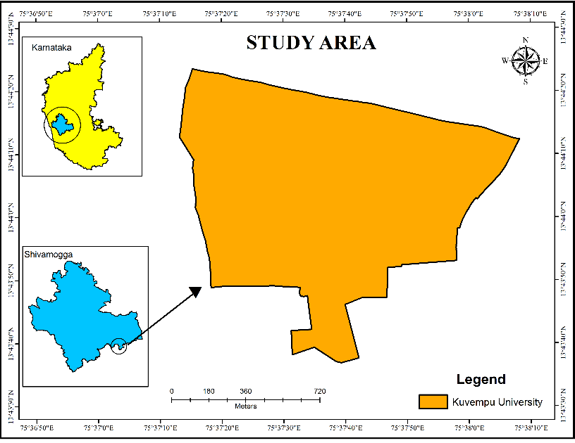
Figure 1. Location of the Study Area University campus, located at Shankaraghatta, Shivamogga District

Methodology
Study was carried out from January 2025 to June 2025 for the span of 6 months with methodologies such as camera trapping (Avinash et al. 2018), indirect sign surveys (Gopalaswamy et al.2012), opportunistic sighting, and threat assessments. The area was divided 200 meter grids, total of 51 grids covered the entire area, camera traps were deployed at 20 different locations throughout the forest patch based on trial paths and indirect signs for almost around 150 days, with continuous 24 hours recordings. Infrared camera traps were deployed at a height of 30-40 cm along animal trails, operating 24 hours a day and recording, GPS coordinates for each location were collected with the help of Garmin 64S GPS device in order to determine the distribution. Indirect surveys like pellet, and hoof marks were also photographed and GPS locations were noted to know the distribution (Basak et al. 2017). Furthermore, we also recorded ecological and anthropogenic threats like activity of feral dog and other carnivore species in the forest.

Data Analysis: Kernel Density Estimation

Kernel Density Estimation uses the line and points features of any area to draw a density or the heat map in the ARC GIS Software (Mintu Jana et al. 2024). It is a technique for estimation of probability density function (Stanisław Węglarczyk. 2018)
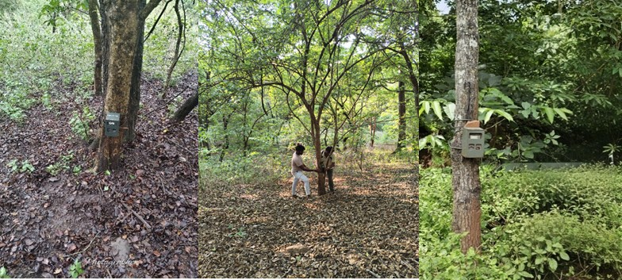
Figure 2. Camera Traps deployment

RESULTS AND DISCUSSION

3.1 Species Occurrence
The study confirmed the presence of Indian mouse deer (M. indica) in the forested regions of Kuvempu University campus through the camera trap evidence and indirect signs. A total of 20 sites were selected using grid method and camera traps were set up along the trails. Of the total captures of camera trap 18% comprised of mouse deer, while other ungulates such as Spotted deer, Sambar deer, Wild boar, and Barking deer dominated at 38%. False triggers and other animals like porcupines, monkeys, and mongooses accounted for 20%. Stray dogs made up 15% of captures, followed by human activity at 11% of photo records. The least represented were predator animals like Tigers, Leopards, Dholes, and Jackals, comprising only 5% (Figure. 3). Mouse deer were found at 15 sites out of 20, confirming their ongoing presence, while indirect evidence of mouse deer was noted, including pellets and hoof marks. Total of 6 sites with the indirect signs were recorded, four of which had no mouse deer captured in the camera trap survey. The greatest pellet densities were located in regions with thick bamboo patches and little human activity. The temporal pattern of the animal capture and the sightings from Jan to June revealed that, the highest sightings and camera trap captures were observed in the month of march (n= 57) followed by April(n=39) with second highest, next comes February and January(n=28) followed by May with n=25 and the least in June(n=19) (Figure. 4). The variation in the result is because of the ecology of the mousedeer, as they are ground dwellers and summers are the dry month with greater visibility and scares food and water sources it results in the highest sightings at the month of march, which is a peak summer month (Eisenberg and Lockhart 1972)
3.2 Density of Mouse deer
Using the recorded locations of species occurrence and indirect indicators, a heat map/density map, was plotted to determine the density of probability of occupancy of mouse deer (Figure 5). The density map highlighted the priority zones and revealed the unequal distribution of mouse deer in the study area. Based on the data the occurrence probability was divided into 4 zones (Very high, High, Moderate and Low/ Unexplored).
Higher density zones were the areas with dense undergrowth and thick bamboo patches and minimal human disturbances. Moderate zone was observed by little less herb and shrub cover, while the low-density area was the fragment forest area and the human habitations, also it contained some patch of forest which was unexplored during the study. Result revealed that the chevrotains prefer well grown thick forest patch as they act as the hiding ground and safeguard them from the predators, it also highlights the quality and health of habitat that plays a major role in supporting the presence of the mouse deer, perhaps highlights the need for the conservation of the habitat preferred by the mouse deer which may serve as the hideout, breeding and foraging grounds and so on(Eisenberg and lockhart 1972).
3.2: Non-target species and threats
Other ungulate species found in the study area were captured by the camera traps, including the Spotted Deer (Axis axis), Sambar (Rusa unicolor), Barking Deer (Muntiacus muntjak), and Wild Boar (Sus scrofa). Barking deer and sambar were less frequently reported than spotted deer, which were most frequently observed in pairs or groups. Wild boars were also photographed in several locations. Predator species such as Leopard, Tiger, Dholes, Jackals and Feral dogs were also found at the sited that are marked with the presence of the mouse deer. Their presence close to the wildlife areas is a threat due to predation and displacement. Mouse deer were more common in areas with dense vegetation and less common in areas that were more disturbed. No anthropogenic threats to mouse deer were observed during the study though there were human movement recorded, it was only limited to the fragmented habitats. The one that can be called a severe threat to the deer was the frequent movement of feral dogs in the forest patched. Only anthropogenic effect was the movement of humans into some areas of the forest, but it’s was not that significant to be considered threat to the mouse deer as the frequency was quite low. Feral dogs were most frequently sighted along animal trails and forest edges which pose the risk to small, ground-dwelling mammals such as M. indica. Many studies have revealed that feral dogs can suppress small mammal activity and contribute to localized population declines, particularly in fragmented or semi-disturbed areas (Vanak and Gompper 2009).

Figure 3. Species wise % of captures Figure 4. Encounter rate of Mouse deer

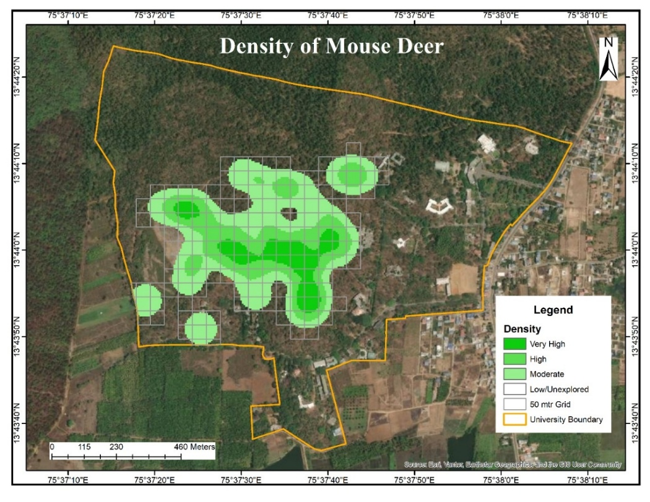
Figure 5. Density map showing the probability of occupancy of mouse deer

Conclusion
The present study successfully confirmed the presence of the Indian mouse deer (M. indica) within the forested patches of Kuvempu University campus. The data collected through camera traps and field observation for indirect signs like pellets and hoof marks provide clear evidence of M. indica presence and habitat use within the Kuvempu University campus. Additionally, the study also shows the spatial distribution of mouse deer indicating that the mouse deer are more active relatively in undisturbed patches with rich understorey vegetation with low human disturbance. The results of the study provided a strong baseline data on the occurrence, distribution and dependence of the mousedeer in the study area. The Study also demonstrated the role and significance of the forest patches of Kuvempu university for inhabiting such rare and cryptic species. The camera trap survey exhibited the presence of many non-target species highlighting the ecological value the forest of Kuvempu University hold. However, the study also identified several threats, most notably from the feral dogs, which pose challenges for conservation and management of many species including the mouse deer. Identification of individuals is also necessary to know the abundance of the mouse deer and also it reveals the overall ecology of the species and dependence on the forest patch (Karanth and Nichols 1998), in this view present study lack the individual count which limits the study. Mouse deer are critical seed dispersers, influencing the plant community composition with their varied diet, act as generalist species and helps in regulating the population of weeds (Berl et al. 2017). The conservation of the buffer region of forest is most important as they also support the biodiversity and helping to reduce human wildlife conflict as they act as a transition zone between the forest and human settlement, effect management of these areas for long term conservation and coexistence with the wildlife (Lisa Naughton-Treves. 2005). Several studies in the Mudumalai and Periar Tiger Reserves and various forests of Western have revealed that wide distribution of the mouse deer in the areas with thick ground cover and minimal human disturbances along the evergreen and semievergreen forests, various studies have disclosed the frequent presence of the mouse deer in protected areas with the semi evergreen forests highlighting their habitat preference for well preserved forest. Thich forest cover and well protected areas are in need to maintain the viable population of the mouse deer in their natural habitat (Anand et al. 2010, Tharmalingam et al. 2013). Current findings emphasize the need for immediate management actions to cutdown the pressure on the mouse deer and other resident and migrant fauna of the study area, feral dogs pose severe impact on the wildlife by competing with the native predators as they have habituated to prey on small animals, their presence is increasing at the buffer areas of forest which can even cause negative impact on wildlife by spreading disease and disrupting the natural ecosystem, perhaps regular monitoring of feral dog activity and populating at forest fringes is mandatory, also vaccination, sterilization programs can be carried out to regulate the population growth. Along with awareness programs to nearby villagers, wildlife enthusiasts and community people can help in managing the feral dog issues (Vanak and Gompper. 2009). with this regard current study act as the baseline for future long term ecological studies on the mouse deer. With appropriate habitat protection the landscape of the Kuvempu University can continue to serve as vital area for the wildlife.

Author(s) hereby declare that NO generative AI technologies such as Large Language Models (ChatGPT, COPILOT, etc.) and text-to-image generators have been used during the writing or editing of this manuscript.

References

Amol Kumbhar, Charles Leo Prabhu, Jaya Kumar Yogesh, Pichaiyan Francies, Gaurang Patwardhan, Qamar Qureshi and Yadavendradev Jhala (2013). Application of Photographic Capture-Recapture Sampling for Estimating Abundance of Indian Mouse Deer Moschiola indica. World Journal of Zoology. 8 (4): 388-391

A. M. Gopalaswamy, K. U. Karanth, N. S. Kumar, D. W. Macdonald (2012) Estimating tropical forest ungulate densities from sign surveys using abundance models of occupancy. Animal Conservation. 15(6): 669-679

Avinash Krishnan, Aaranya Gayathri, Sagarika Phalke, Dilip Kumar AV (2018). Terrestrial mammals of Bannerghatta National Park, Karnataka, India: A camera-trap inventory and seasonal assessments. Journal of Biodiversity and Environmental Sciences (JBES). 12(3): 273-282.

Basak, K, Mondal, M & Ahmed, M. F. (2017). Confirming presence of Indian mouse deer from Chhattisgarh, Central India with photographic evidence after 112 years. International Journal of Fauna and Biological Studies. 4(4):192-195

Berl, J. L., Johnstone, H. A., Wu, J. Y., Flaherty, E. A., & Swihart, R. K. (2017). Winter Preference for Weed Seed and Waste Grain by Native Mice in Row-Crop Agriculture. Weed Science, 65(3): 406-412

Devy, MS (2006) Effects of fragmentation on a keystone tree species in the rainforest of Kalakad-Mundanthurai Tiger Reserve, India. Project Report, Ashoka Trust for Research in Ecology and the Environment, Bangalore.

Eisenberg JF, Lockhart M (1972) An ecological reconnaissance of Wilpattu National Park, Ceylon. Smithson Contr Zool 101:1-118.

IUCN Red List of Threatened Species. Version <www.iucnredlist.org>.

Karanth, K. U., & Nichols, J. D. (1998). Estimation of tiger densities in India using photographic captures and recaptures. Ecology, 79(8): 2852–2862.
- Lisa Naughton-Treves, Margaret Buck Holland, Katrina Brandon. (2005). The role of protected areas in conserving biodiversity and sustaining local livelihoods. Annual Review of Environment and Resources, 30: 219–252.

McShea, WJ, Stewart C, Peterson L, Erb P, Stuebing R, Giman B (2009) The importance of secondary forest blocks for terrestrial mammals within an Acacia/secondary forest matrix in Sarawak, Malaysia. Biol Conserv 142:3108-3119.

MacKenzie, D.I., Nichols, J.D., Lachman, G.B., Droege, S., Royle, J.A. & Langtimm, C.A. (2002) Estimating site occupancy rates when detection probabilities are less than one. Ecology, 83:2248-2255.

Madhusudan MD, Karanth KU (2000) Hunting for an answer: is local hunting compatible with large mammal conservation in India. In: Robinson JG, Bennett EL (eds) Hunting for sustainability in the tropics. Columbia University Press, New York, pp 339-355

Madhusudan MD, Karanth KU (2002) Local hunting and the conservation of large mammals in India. Ambio 31:49-54

Matsubayashi H, Bosi E, Kohshima S (2003) Activity and habitat use of lesser mouse-deer (Tragulus javanicus). Journal of Mammalogy. 41():234-242.
- Mintu Jana, Dr. Dipak Bisai and Mrs. Taniya Roy (2024) Application of Kernel density estimation (kde) for identifying spatial pattern of road density and its impact on landscape fragmentation in Visakhapatnam city, Andhra Pradesh, India International Journal of Current Research. 16(09) : 29901-29911
- M.O. Anand, Jagdish Krishnaswamy, Ajith Kumar, Archana Bali (2010) Sustaining biodiversity conservation in human-modified landscapes in the Western Ghats: Remnant forests matter. Biological Conservation 143:2363–2374

O’Connell, A. F., Nichols, J. D., & Karanth, K. U. (2011). Camera Traps in Animal Ecology: Methods and Analyses. Springer.

Raman TRS (2004) Mouse deer (Moschiola meminna Erxleben, 1777). ENVIS Bulletin: Wildlife Institute of India, Dehra Dun 7:131-140

Ramesh T, Kalle R, Sankar K, Qureshi Q (2012) Factors affecting habitat patch use by sloth bears in Mudumalai Tiger Reserve, Western Ghats, India. Ursus 23:78-85.

Soumya Prasad and R. Sukumar (2010) Context-dependency of a complex fruit-frugivore mutualism: temporal variation in crop size and neighborhood effects. Oikos 119:514-523.

Soumya Prasad, Andre´ Pittet and R. Sukumar (2010) Who really ate the fruit? A novel approach to camera trapping for quantifying frugivory by ruminants. Ecol Res 25:225-231.
- Stanisław Węglarczyk (2018) Kernel density estimation and its application. ITM Web of Conferences. XLVIII Seminar of Applied Mathematics. 23:1-8 https://doi.org/10.1051/itmconf/20182300037

Tharmalingam Ramesh & Riddhika Kalle and Kalyanasundaram Sankar & Qamar Qureshi (2013). Dry season factors determining habitat use and distribution of mouse deer in the Western Ghats. European Journal of Wildlife Research. Springer
- The Wildlife protection act. 1972.

Tobler MW, Carrillo-Percastegui SE, Powell G (2009) Habitat use, activity patterns and use of mineral licks by five species of ungulate in south-eastern Peru. J Trop Ecol 25:261-270.
- Vanak, A. T., & Gompper, M. E. (2009). Dogs Canis familiaris as carnivores: Their role and function in intraguild competition. Mammal Review. 39(4):265-283.
- Zhang, J., Wang, X., & Xie, Y. (2021). Implication of Buffer Zones Delineation Considering the Landscape Connectivity and Influencing Patch Structural Factors in Nature Reserves. Sustainability, 13(19), 10833.

ACRONYMS
- M. indica: Moschiola indica (Indian Chevrotain/Mouse Deer)
- GPS: Global Positioning System
- IUCN: International Union for Conservation of Nature
- cm: Centimeter
- mm: Millimeter
- °C: Degrees Celsius

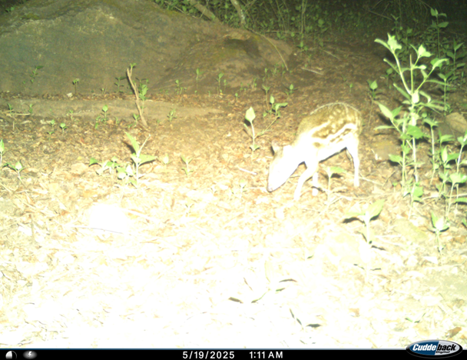
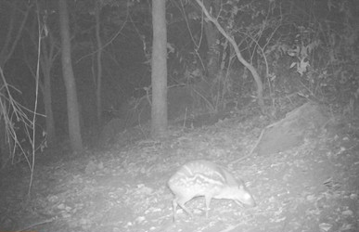
Figure 6. Camera Trap images
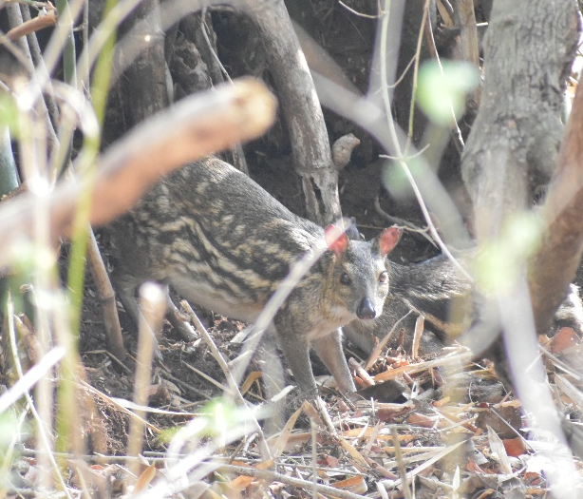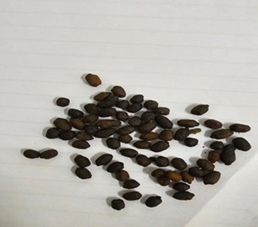
Figure 7. Visual sighting Figure 8. Pellets of Mouse Deer

Instruments Used
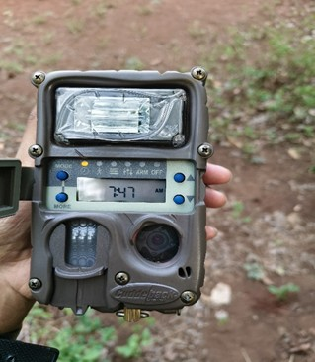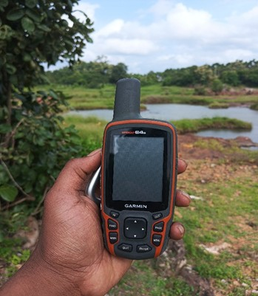
Figure 9. Camer trap Figure 10. GPS Device
Non- Target Species
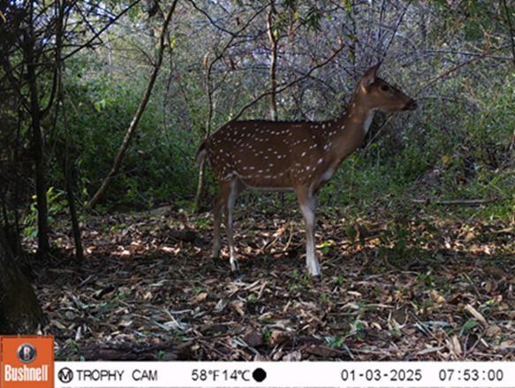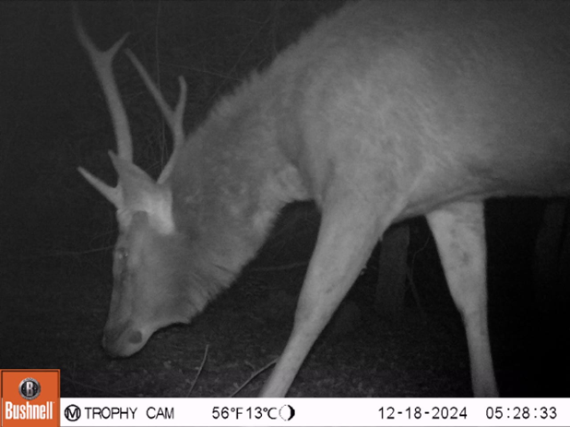
Figure 11. Spotted Deer Figure 12. Sambar

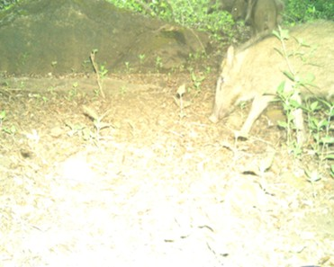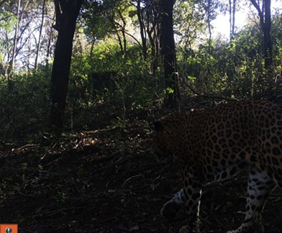

Figure 13. Wild Boar Figure 14. Leopard

Threat

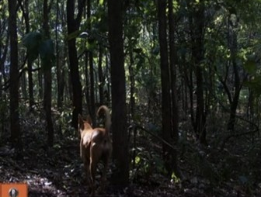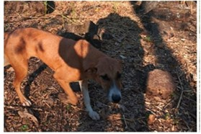
Figure 15 . Feral Dogs

