Distributional Records of a Salticid Spider Species Epocilla aura (Dyal, 1935) (Araneae : Salticidae) in Different Districts of Chhattisgarh State, India

Abstract
Epocilla aura (Dyal, 1935), (Family: Salticidae) is a medium sized jumping spider species described in 1935 by Dyal. It is found in India and Pakistan. Studies on the distribution of this species in the state of Chhattisgarh are limited. Available scientific records indicate that Epocilla aura has been primarily recorded in the Gariaband district of Chhattisgarh, while there are no confirmed records from other districts. The aim of this study is to provide a brief overview of the current distribution status of Epocilla aura in various districts of Chhattisgarh. Based on available literature and published research, it is clear that comprehensive surveys on spider biodiversity are lacking in most districts of the state, resulting in an incomplete understanding of the true distribution area of this species. This study describes the distribution of this spider, Epocilla aura, in eight districts of Chhattisgarh state. It has also been documented in two protected areas: Indravati National Park and Udanti Wildlife Sanctuary.
Keywords: Biodiversity, Chhattisgarh, Epocilla aura, Distribution, Gariaband, Salticidae, Spider.

Introduction
Epocilla aura (Dyal, 1935) is a jumping spider species in the genus Epocilla Thorell, 1887, classified in the family Salticidae. This species is a medium sized colorful and predatory species. This genus contains 12 species, found worldwide. Epocilla has six synonyms. The maximum number of species recorded in India is six (WSC, 2026). In India, the first species of this genus was recorded in Maharashtra state (Tikader, 1965), later other species were also discovered. This species has so far been recorded only in six states and one union territory region of India (Singh et al., 2023).
In Chhattisgarh state, it was first recorded in the Bhuteshwar Nath Forest Region of Gariaband District (Nichat et al., 2025b). Although new distributions of spiders are being recorded in Chhattisgarh state, this species has not been recorded in other districts (Nayak et al,. 2025a; 2025b; 2025c; 2025d). Chhattisgarh is a biodiversity-rich state, with a wide variety of spider species currently being recorded (Nayak et al,. 2026). However, only a few spider species have been recorded so far (Nichat et al., 2024; 2025a; 2025b), a significant decrease compared to other states. This study addresses this research gap and explores the distribution of Epocilla aura in the state.

Materials and Methods
This study documents the distribution of only one jumping spider species, Epocilla aura (Dyal, 1935), recorded in various districts of Chhattisgarh during field surveys (Fig. 1). Epocilla aura has been collected randomly through hand picking methods from different sites in all districts of Chhattisgarh. This study was conducted for three hours from 8:30 am to 11:30 am in the morning. In the study, leaf litters, shrubs and trees of forest region, shrubs and plants of agricultural land and litters, shrubs and trees of urban region were analyzed by direct visual method because these species are found only in sites with dense vegetation. But these species were also found randomly in some sites. In this study, a jumping spider species Epocilla aura (Dyal, 1935) has been documented in eight districts of Chhattisgarh namely Baloud, Bijapur, Dantewada, Dhamtari, Durg, Gariaband, Mahasamund and Raipur. The distribution of this species has been described because it was recorded only in Gariaband district, through this study the distribution of this species is to be explored in entire Chhattisgarh. The collected specimens were preserved in 70% ethanol (Caleb et al., 2021). These specimens have been deposited in the Department of Zoology, Govt. D. B. Girls College, Raipur. These specimens are identified based on their morphological characteristics such as eye arrangement, leg configuration, body coloration, pattern on abdomen and carapace. Live photographs of this spider species were taken using Infinix Smart HD Camera and Canon HD DSLR Camera. The elevation and coordination of the collection sites of this spider species has been taken with the help of Google Earth software.

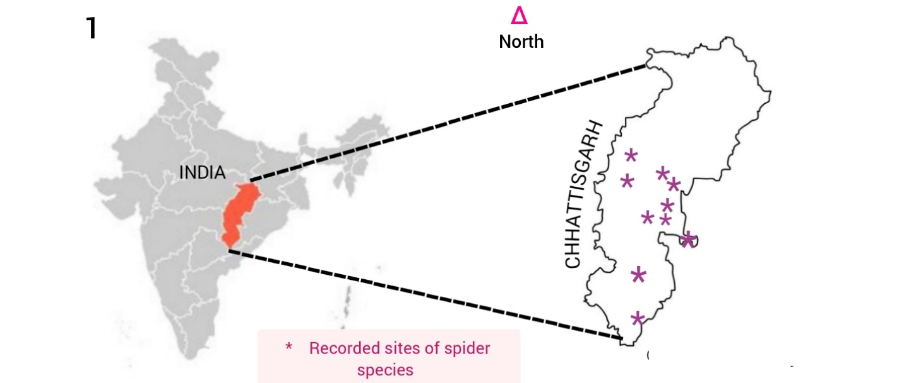

Figure 1: Map represents the distribution of Epocilla aura in different districts of Chhattisgarh state.

Result and Discussion
Earlier, this species was recorded only in Gariaband district but this study proves that this species is found in different locations of Chhattisgarh, across three distinct habitats: forested, urban, and agricultural regions. Three specimens of this species have been collected in Deobhog, Udanti Wildlife Sanctuary and Gariaband city forest region of Gariaband district alone, while from the remaining districts, one specimen each has been documented. While five specimens have been collected from urban area districts like Baloud, Durg, Gariaband, Mahasamund and Raipur, three specimens have been recorded from forest region districts Bijapur, Dantewada and Gariaband. A total of two specimens were collected from agricultural areas, one each in the Gariaband and Dhamtari districts. Of all the sites, it has been documented in two protected areas, Udanti Wildlife Sanctuary, Gariaband and Indravati National Park, Bijapur. A total of ten specimens of Epocilla aura (Dyal, 1935) were collected in the study, out of which nine were female and one male was collected from Udanti Wildlife Sanctuary of Gariaband. Analysis of the elevation of the sites where this species is found reveals that this species has been found in the Deobhog region of Gariaband district at a minimum elevation of 256.85m and a maximum elevation of 421.81m in Udanti Wildlife Sanctuary Gariaband. The complete description, recorded locations and morphological characteristics of this species are well described. As shown in Figure 2-7, the habitats of Epocilla aura (Dyal, 1935) is illustrated through multiple views, including the dorsal view of the female (Figures 2-3), the dorsal view of male (Figure 4), and the anterior and dorsal views of the female (Figures 5-7).
Taxonomy
Salticidae Blackwall, 1841
Epocilla Thorell, 1887
Epocilla aura (Dyal, 1935)
(Figure 2-7)

Characteristics
Female: The cephalothorax is quite small and rectangular in shape compared to the abdomen, the entire lateral and ventral part is white in colour, the central carapace is silvery and posteriorly oval in shape. A thick rectangular shaped reddish orange colour stripe is present between the central and whitish lateral region. It has eight eyes, of which the anterior median eyes are the largest and are found in the front, all the other eyes are small and present in the dorsal part of the carapace.
The abdomen or Opisthosoma is large and oval shaped, its ventral and lateral parts are whitish in colour. Its dorsal part bears red transverse patterns, these patterns are thick and dark in the anterior part while being paler in the posterior part. The entire median dorsal region is silvery in colour. Spinnerets are present in the most terminal region of the abdomen which are thick, cylindrical and whitish in colour. The legs are transparent in colour. The coxa is thick and cylindrical, the trochanter is small, thick and hairy, the femur is long, hairy and cylindrical, the patella is small and cylindrical, the tibia is cylindrical, small, translucent and hairy, the metatarsus and tarsus are cylindrical, thin and covered with short and thin hairs, the claws are at the terminal end covered with short and thin setae (Figures 2-7 and 5-7)
Male: The cephalothorax is round-shaped and broad, with a broad red stripe running down the middle of the carapace and medium-sized lateral white stripes on the sides. The terminal part of the pedipalps is pale greenish, while the proximal part is light brown. The abdomen is long and cylindrical with a broad red stripe running from front to back in the dorsal part and the lateral and ventral parts are pale greenish white. The spinnerets are located at the terminal end of the abdomen and are black and cylindrical. Its first pair of legs is big, strong, thick and reddish brown in colour which shows the male character. The other three pairs of legs are translucent and greenish in color, similar to the female’s legs (Figure 4)

Diagnosis
The main morphological characteristics of this species that help in identification are the broad rectangular red orange stripe found in its carapace and the transverse pattern of dark reddish colour found in the abdomen, which is found across the dorsal part of abdomen. (Dyal, 1935; Nichat et al., 2025b).
Global Distribution: Pakistan and India (WSC, 2026).
Indian Distribution: Kerala (Rajeevan et al., 2019), Maharashtra (Vairale, 2016; Deshmukh, 2017), Andaman & Nicobar (Tikader, 1977; Caleb et al., 2021), Andhra Pradesh (Subba Reddy, 2014), Haryana (Malik & Goyal, 2017), Punjab (Singh et al., 2020), Chhattisgarh (Nichat et al., 2025b).
Specimen Description
Table 1: List of different districts of Chhattisgarh State where recorded Epocilla aura (Dyal, 1935)
S. No. | Districts | Location | Collection date/ Time | Elevation | Types of Area | No. of specimens
 | Baloud | Tandula (20°42’11”N/ 81°14’11”E) | 09.i.2025, 12:09 PM | 368.25m | Urban area | 1
 | Bijapur | Kutru (19°05’23”N/ 80°46’50”E) | 12.ii.2025, 11:54 PM | 381.09m | Forest region | 1
 | Dantewada | Barsur (19°08’07”N/ 81°25’17”E) | 04.ii.2025, 09:56 AM | 395.06m | Forest region | 1
 | Dhamtari | Bhakhara (20°57’05”N/ 81°36’07”E) | 12.xii.2025, 01:45 PM | 309.78m | Agricultural area | 1
 | Durg | Smriti Nagar, (Junwani) (21°13’04”N/ 81°18’40”E) | 28.vi.2025, 03:14 PM | 321.27m | Urban area | 1
 | Gariaband | Deobhog (19°53'34"N/ 82°39'51"E)  Udanti Wildlife Sanctuary (20°07'25"N/ 82°18'21"E)  Gariaband (20°35'38"N/ 82°04'19"E) | 12.xi.2025, 09:56 AM  29.iv.2025, 02:02 PM  17.xii.2025, 08:12 AM | 256.85m  421.81m  391.49 m | Agricultural + Forest region + urban area | 3
 | Mahasamund | Mahasamund city (21°07'18"N/ 82°05'11"E) | 22.xii.2025, 11:44 AM | 305.17m | Urban area | 1
 | Raipur | Abhanpur (20°03’7”N/ 81°44’20”E) | 20.iii.2025, 03:23PM | 333.05m | Urban area | 1

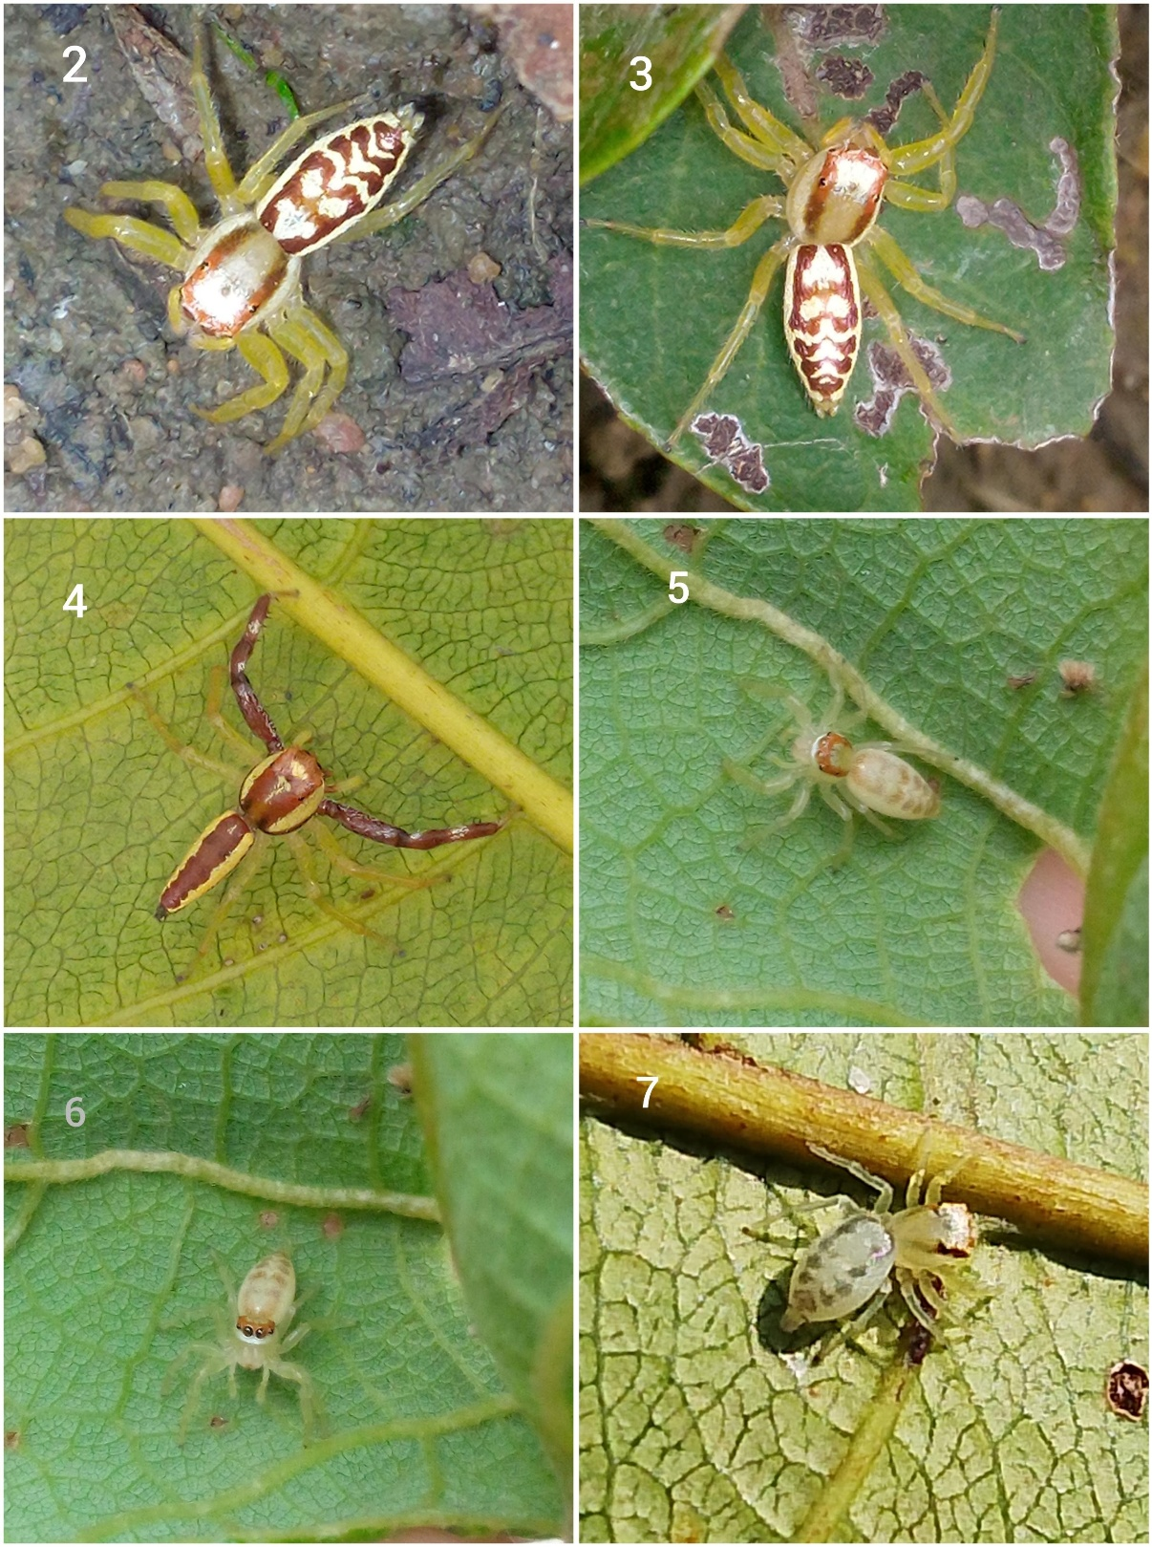
Figure 2-7: Habitus of Epocilla aura (Dyal, 1935): (2-3) Female, dorsal view; (4) Male. dorsal view; (5-7) Female, anterior and dorsal views.

Epocilla aura, a jumping spider species, was collected from eight districts of Chhattisgarh and its distributional pattern in the state was described with clarity (Fig. 8). Apart from Chhattisgarh state, this species has already been documented in 6 other states and one union territory. This is the first time that the distribution of this species has been explained in unreported districts of the state.
The maximum number of this species has been recorded from urban areas (5 specimens) and from agricultural and forest regions (3 specimens each). The spider is found in the region from Durg in the west, Mahasamund in the east, Dantewada in the south and Raipur in the north. This study shows the distribution only in the central and some southern Chhattisgarh region, but due to lack of survey, the distribution of this species in the northern districts of Chhattisgarh is not known. Documented species have also been found in urban areas like Raipur and Durg, while the rest of the districts are covered by forest areas. This species has been recorded at only one site in the seven districts but has been recorded at three different sites in the Gariaband District.
To understand the complete distribution of this salticid species, a large-scale survey is required which will help in understanding its geographical distribution in the entire region of Chhattisgarh state. In this survey, two specimens have been recorded from two protected areas, the first is Indravati National Park which is an important part of Bastar region. Bijapur district falls under the same protected area. One specimen has been recorded from Udanti Wildlife Sanctuary located in Gariaband. This study represents the first documented record of Epocilla aura within these protected areas. Epocilla aura is found in highly disturbed areas as well as protected wildlife sanctuaries suggested it is a highly adaptable species. This species’ predatory behavior, jumping strategy and ability to live in trees or dense vegetation make it highly adaptable.

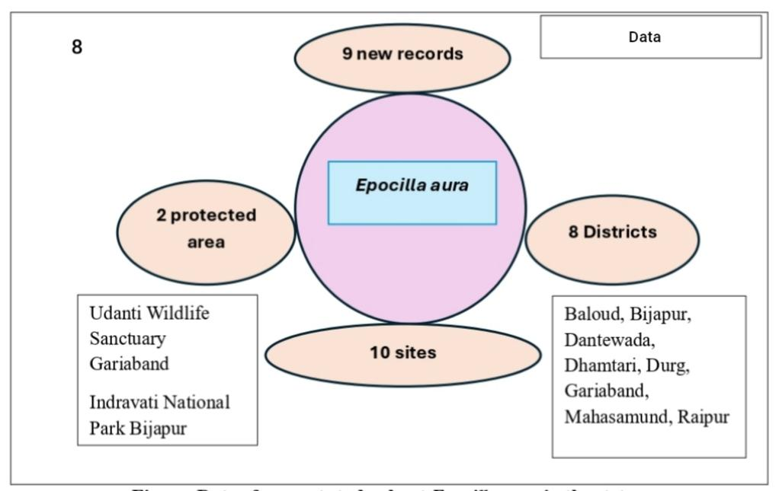
Figure 8: Data of current study about Epocilla aura in the state.

Conclusion
Epocilla aura is a unique spider that was previously recorded only in the Gariaband district of Chhattisgarh. However, this study has led to the exploration of other districts in the state, revealing that the species is found in eight districts. Evidence of its occurrence in two protected areas has also been found. This study has provided important data that will be useful in future spider research. This type of study will provide more information about unknown and known species in different sites of Chhattisgarh state in future and will explore new species.
Disclaimer (Artificial Intelligence)
Author(s) hereby declare that NO generative AI technologies such as Large Language Models
(ChatGPT, COPILOT, etc) and text-to-image generators have been used during writing or editing of this manuscript.
Competing Interests
Authors have declared that no competing interests exist.
Reference
- Ali, P. A., Maddison, W. P., Zahid, M. & Butt, A. (2018). New chrysilline and aelurilline jumping spiders from Pakistan (Araneae, Salticidae). ZooKeys 783: 1-15. doi: 10.3897/zookeys.783.21985
- Blackwall, J. (1841). The difference in the number of eyes with which spiders are provided proposed as the basis of their distribution into tribes; with descriptions of newly discovered species and the characters of a new family and three new genera of spiders. Transactions of the Linnean Society of London 18(4): 601-670. doi: 10.1111/j.1095-8339.1838.tb00210.x
- Caleb, J. T. D., Sanap, R. V., Prajapati, D. A. & Bambhaniya, P. (2021). Taxonomic notes on two jumping spider species of the genus Epocilla Thorell, 1887 (Araneae: Salticidae: Chrysillini) from India and Pakistan. Arthropoda Selecta 30(2): 221-229. doi: 10.15298/arthsel.30.2.09
- Deshmukh, U.S. (2017). Can spiders be the biological control measure: a survey through orange and cotton fields. Indian Journal of Scientific Research, 12(2): 011-016.
- Dyal, S. (1935). Fauna of Lahore. 4.–Spiders of Lahore. Bulletin of the Department of Zoology of the Panjab University 1: 119-252, pl. 11-17.
- Malik, V. & Goyal, V. (2017). Biodiversity of spiders in different habitats of Western Haryana, India. Journal of Entomology & Zoology Studies, 5(4): 822-825.
- Nayak, J. (2025). Stenaelurillus jagannathae Das, Malik & Vidhel, 2015: First Description in Chhattisgarh, India. Bioscience Discovery, 16(3):37-40. http://biosciencediscovery.com/Archive.html#
- Nayak J., Sori P., Sahu L., Bharti D. (2025a). A new observational record of jumping spider (Aranae: Salticidae: Aelurillini: Aelurillina) Stenaelurillus metallicus Caleb & Mathai, 2016 in Chhattisgarh, India . International Journal of Biology Research 10(1) 19-21.https://www.biologyjournal.in/assets/archives/2025/vol10issue1/10007-1740555118544.pdf
- Nayak J., Warte H.K., Sori P. & Sahu L. (2025b). Study on Jumping Spiders (Aranae: Araneomorphae: Salticidae) Diversity in Shraddha Public School Campus Gariaband, Chhattisgarh, India. International Journal Of Latest Technology In Engineering, Management & Applied Science : 14 (3): 350- 353 DOI : https://doi.org/10.51583/IJLTEMAS.2025.140300037
- Nayak, J., Chaure, M., Warte, H. K., Majumdar, M., Harris, K. K., & Nichat, A. R. (2025c). A new distribution of the spider genus Storenomorpha Simon, 1884 (Araneae: Zodariidae) in Chhattisgarh State, India. Asian Journal of Research in Zoology, 8(4), 127–133. https://doi.org/10.9734/ajriz/2025/v8i4224
- Nayak, J., Warte, H. K., & Chaure, M. (2025d). A brief study of jumping spider (Arachnida: Araneae: Salticidae) diversity around Tandula Dam, Balod, Chhattisgarh, India. Journal of Science Research International, 11(8), 1–8. https://doi.org/10.5281/zenodo.17442064
- Nayak, J., Warte, H. K., Sahu, L., & Singh, L. (2026). New distribution of two cobweb (Araneae: Theridiidae Sundevall, 1833) spiders in Chhattisgarh State, India. Asian Journal of Research in Zoology, 9(1), 1–9. https://doi.org/10.9734/ajriz/2026/v9i1235
- Nichat A. R., Warte H.K., Nayak J., (2024). Spider diversity (Arachnida:Aranae) in Deobhog region Gariyaband Chhattisgarh India : International Journal of Innovation and Science and Engineering. : 11 (8) : 39 – 45. https://ijiset.com/vol11/v11s8/IJISET_V11_I08_03.pdf
- Nichat A. R., Harris K.K., Warte H.K., Dubey M., Sori P. & Nayak J. (2025a). Spiders Diversity in North East Gariaband Forest Regions of Chhattisgarh, India. Uttar Pradesh Journal of Zoology, 46(4):119-127. DOI: https://doi.org/10.56557/upjoz/2025/v46i44808
- Nichat, A. R., Nayak, J., Sori, P., & Warte, H. K. (2025b). Description of new jumping spider species Epocilla aura (Aranae: Salticidae: Chrysillini) from Gariaband district, Chhattisgarh State, India. International Research Journal of Biological Sciences, 14(2), 1–4. http://www.isca.in
- Nichat, A. R., Harris, K. K., Nayak, J., Kashyap, L., & Pawar, V. (2026a). Cyrtophora Moluccensis Doleschall, 1857 (Arachnida: Araneae: Araneidae): First report in Chhattisgarh state of India. BIONATURE, 46(1), 55–63. https://doi.org/10.56557/bn/2026/v46i12091
- Nichat, A. R., , Harris, K. K., Nayak, J., Majumdar, M., Warte, H. K., Sona, V., & Kumar, R. (2026b). First record of two Argyrodes Simon, 1864 (Araneae: Theridiidae) Species from Chhattisgarh, India. Journal of Applied Life Sciences International, 29(1), 159–165. https://doi.org/10.9734/jalsi/2026/v29i1758
- Rajeevan, S., Kunnath, S.M., Varghese, T. & Kandambeth, P.P. (2019). Spider diversity (Arachnida: Araneae) in different ecosystems of the Western Ghats, Wayanad Region, India. South Asian Journal of Life Science, 7(2): 29-39.
- Singh, R., Verma, A. K., Singh, B. B., & Singh, G. (2023). Spider fauna of India. Asian Biological Research Foundation & Nature Light Publications. ISBN: 978-81-959483-4-5, pp.1-562.
- Singh, S., Sekhar, R. & Sunil Jose K. (2020). Predatory spider fauna in fruit crops of Punjab, India along with new records. Indian Journal of Agricultural Sciences, 90 (9): 1695–1701.
- Subba Reddy, H.R. (2014). Diversity of spiders in Kurnool district with special reference on house, garden and open land spiders. Ph.D. thesis, awarded by Sri Krish Nadevaraya University, Anantapuram, Andhra Pradesh, India. https://shodhganga.inflibnet.ac.in/handle/10603/102180.
- Thorell, T. (1887). Viaggio di L. Fea in Birmania e regioni vicine. II. Primo saggio sui ragni birmani. Annali del Museo Civico di Storia Naturale di Genova 25: 5-417.
- Tikader, B. K. (1965). A new species of spider of genus Marpissa (Salticidae) from India. Science and Culture 31: 261-262.
- Tikader, B.K. (1977). Studies on spider fauna of Andaman and Nicobar islands, Indian Ocean. Records of the Zoological Survey of India, 72: 153-212.
- Tikader, B. K. & Biswas, B. (1981). Spider fauna of Calcutta and vicinity: Part-I. Records of the Zoological Survey of India, Occasional Paper 30: 1-149.
- Vairale, A.B. (2016). Diversity of spiders in the multiple used area from Satpuda region, Maharashtra, India. Vidyabharati International Interdisciplinary Research Journal, 5(2): 68-78.
- World Spider Catalog (2026). World Spider Catalog. Version 26. Natural History Museum Bern, online at http://wsc.nmbe.ch, accessed on {19/02/2026}. https://doi: 10.24436/2

