Toxicological Evaluation of Mucin-Capped Silver Oxide (Ag₂O) Nanomaterials in the Land Snail Lissachatina fulica: Histological Alterations in the Brain and Ovotestis
Abstract-
The present study investigates the toxicological impact of mucin-capped silver oxide nanoparticles (Ag₂O NPs) on the brain and ovotestis histology of Lissachatina fulica, a major invasive agricultural pest and intermediate host of parasitic diseases. Ag₂O nanoparticles were synthesized using a mucin-assisted method and characterized by X-ray diffraction (XRD), field-emission scanning electron microscopy (FE-SEM), energy-dispersive X-ray analysis (EDX), and high-resolution transmission electron microscopy (HR-TEM), confirming their crystalline, phase-pure, and nanoscale nature. Adult snails were exposed to varying concentrations (5, 10, and 15 ppm) of Ag₂O NPs for 24, 48, and 72 hours, respectively. Histological analysis of cerebral ganglia revealed progressive neurodegenerative alterations, including disruption of connective tissue layers, vacuolation, neuronal necrosis, neuropil disorganization, and degeneration of giant nerve cells in a dose- and time-dependent manner. Similarly, the ovotestis exhibited marked structural damage such as degeneration of seminiferous tubules, rupture of basement membranes, fusion of acini, vacuolation, reduction in spermatogenic stages, and loss of oocytes under higher exposure conditions. Severe necrosis and architectural disintegration were evident at the highest concentration and prolonged exposure. The findings demonstrate that Ag₂O nanoparticles exert significant neurotoxic and reproductive toxicity in L. fulica, suggesting their potential application in targeted pest management strategies while also highlighting ecological considerations regarding nanoparticle exposure in terrestrial invertebrates.
Keyword- Lissachatina fulica, Silver Oxide Nanoparticals (Ag2ONP’s), Characterization, histology, Cellular changes

Research Highlight-
- Recent investigations indicate that silver oxide Nanoparticals (Ag₂O) nanoparticles exert strong cytotoxic effects in the land snail Lissachatina fulica.
- Lissachatina fulica is a major non-insect agricultural pest responsible for considerable economic losses in crop production.
- The present study aims to evaluate the neurotoxic potential of Ag₂O nanoparticles by examining histological alterations in the brain and Ovotestis.
- Exposure to the nanoparticles resulted in pronounced structural and cellular damage within the cerebral architecture and Seminiferous tubules.

- Introduction-
The giant African snail, Achatina fulica, is listed among the world’s 100 worst invasive alien species by the International Union for Conservation of Nature (International Union for Conservation of Nature) (Lowe et al., 2000). Native to East Africa, the species has been widely introduced across many parts of the globe (Lowe et al., 2000). Its invasion success is largely attributed to its high reproductive potential, voracious feeding behaviour on nearly 500 plant species, poor quarantine measures, and human-mediated dispersal (Fontanilla et al., 2007).
The snail is of considerable public-health importance because it serves as an intermediate host of Angiostrongylus cantonensis, the causative agent of angiostrongylosis and eosinophilic meningoencephalitis in humans. Furthermore, the faecal matter of the snail aids in spreading black pod disease caused by Phytophthora palmivora (Raut & Barker, 2002).
A. fulica is regarded as one of the most destructive pests in tropical and subtropical regions, producing extensive damage to agricultural fields, commercial plantations, and home gardens (Vasconcellos & Pile, 2001). The species is commonly associated with trees, decomposing organic substrates, and garbage accumulation sites. Climate-based predictive models have been developed to understand and forecast its invasion pattern in India, which may support management planning (Sarma et al., 2015).
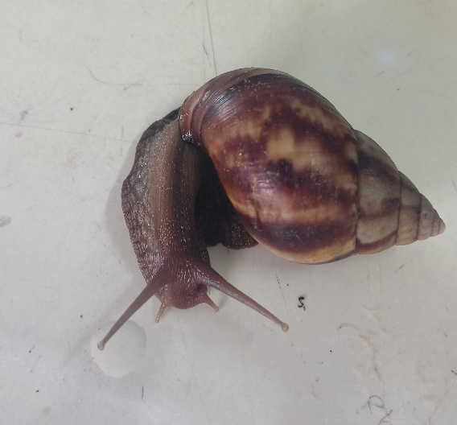
Fig.1 The Giant African Land Snail Lissachatina fulica (formaly Achatina fulica). A live specimen

Historically, control of A. fulica has relied on non-specific molluscicides (Panigrahi & Raut, 1994). In recent years, there has been a shift toward safer and more selective plant-based products to minimize environmental hazards (Panigrahi & Raut, 1994). A variety of botanical compounds have proven effective against snails such as Lymnaea acuminata (Chauhan et al., 2011), Subulina octona (Silva et al., 2012), Indoplanorbis exustus (Pandey & Singh, 2009), Eobania vermiculata, and Monacha cartusiana (Aal & Hamed, 2010). However, only limited natural compounds have been evaluated specifically against A. fulica (Panigrahi & Raut, 1994; Justin et al., 2008; Rao & Singh, 2002).
Several investigations have demonstrated that metal-based nanoparticles can be transferred along terrestrial food chains, highlighting the importance of dietary exposure in nanoparticle accumulation (Hawthorne et al., 2014; Unrine et al., 2012). Nevertheless, the quantitative contribution of dietary intake to silver nanoparticle (AgNP) bioaccumulation remains unclear.
Recent work emphasizes that nanosilver hazards are strongly shaped by environmental transformations (e.g., aggregation, dissolution and speciation), meaning that exposure medium chemistry can substantially alter bioavailability and toxicity (Yang et al., 2024). In freshwater invertebrates, synthesis of current evidence supports oxidative-stress–linked adverse outcomes and recommends AOP-oriented approaches to connect mechanistic events with higher-level endpoints (Wang & Liu, 2022). Trophic-transfer studies increasingly demonstrate that food-chain exposure can be a major pathway for AgNP uptake and biological effects in gastropods under realistic exposure scenarios (Wang et al., 2025), while toxicokinetic evidence for “aged” forms such as Ag₂S nanoparticles suggests bioaccumulation patterns may differ from ionic silver and do not necessarily translate into biomagnification (Silva et al., 2022). Given that Lissachatina fulica continues to expand its invasive range in India and poses sustained agricultural and public-health concerns (Vijayan et al., 2022), clarifying how silver-based nanomaterials interact with gastropod biology remains ecotoxicologically and management-relevant.
In aquatic organisms, dietary exposure is widely regarded as the dominant pathway for metal uptake according to biodynamic modelling based on metal-uptake kinetics (Luoma & Rainbow, 2005; Dang et al., 2009). Partitioning total accumulation into individual processes, such as dietary versus waterborne routes, may therefore enhance the mechanistic understanding of nanoparticle bioavailability. Recent research has confirmed that biodynamic models are powerful tools for evaluating AgNP uptake through both food and water in estuarine and freshwater snails, as well as for elucidating the mechanisms governing this process (Khan et al., 2012, 2015; Croteau et al., 2011, 2014; Oliver et al., 2014). Despite these advances, distinguishing the specific contribution of dietary exposure to overall AgNP accumulation remains unresolved.
Accordingly, the present study aims to evaluate the impact of silver oxide nanoparticles (Ag₂O NPs) on the histological architecture of the brain and ovotestis of the land snail Lissachatina fulica. Nanoparticles are known to penetrate biological tissues and may induce structural and cellular alterations through mechanisms such as oxidative stress and metal ion release. Therefore, special emphasis is placed on examining the cerebral ganglia to assess neurotoxic effects and on the ovotestis to determine possible reproductive impairments. Histological analysis is carried out to compare treated specimens with control groups in order to identify tissue disorganization, cellular degeneration, and other pathological changes. The findings of this study will contribute to understanding the toxicological effects of Ag₂O nanoparticles on targeted terrestrial invertebrates and their potential application in pest control strategies.

- Material and Method-
2.1 Materials-
All chemicals and reagents used in this study were of analytical grade and used without further purification. Silver Oxide, (Ag2O, 99%), Alcohol Ethanol etc. was purchased from Sigma-Aldrich.
2.2 Collection and maintenance of snails
Adult snails of Lissachatina fulica were collected from local grapes garden Nashik Maharashtra, India. Healthy snails in the weight range of 62 gms ± 22 gms were used for the current studies. They were maintained at a temperature of 25˚C ± 2˚C in transparent plastic boxes ( 14’’ x 10.5’’x 10’’). These boxes were laden with garden soil at the bottom forming a 4 cm layer. The open ends of the boxes were small holes to facilitate free flow of air. The snails were fed on grapes leaves on a daily basis and appropriate humidity was maintained by sprinkling water on the soil layer intermittently.(Dickens, Capinera, & Smith, 2018)
2.3 Collection and Preparation of Snail Mucin-
Live specimens of Lissachatina fulica were manually collected from local grape gardens in the Nashik district. Mucus was obtained by gently stimulating the foot muscles of the snails. Approximately 5 mL of freshly secreted raw mucus was collected and immediately diluted to 50 mL with HPLC-grade water to prepare the mucin stock solution. The mixture was vortexed for 5 minutes to ensure uniform dispersion and then stored at –20 °C to preserve its bioactive components. The prepared mucin solution was used within 1 hour for subsequent reactions.
2.4 Synthesis of Mucin capped Silver Oxide Nanoparticles (Ag2O NPs) –
One gram (1 g) of silver oxide (Ag₂O) was dispersed in 50 mL of distilled water (D.W.) under continuous stirring to obtain a homogeneous suspension. Separately, the collected mucus was mixed with alcohol to facilitate proper dissolution. The mucus–alcohol mixture was then added dropwise to the silver oxide suspension using a magnetic stirrer. The reaction was carried out at 80 °C with a constant stirring speed of 220 rpm. The mixture was maintained under these conditions until completion of the reaction to allow effective interaction and formation of mucin-capped silver oxide nanoparticles.(Siddiqi, Husen, & Rao, 2018)
2.5 Characterization of Mucin-Capped Ag₂O Nanoparticles
2.5.1 X-Ray Diffraction (XRD) Analysis
The crystalline structure and phase purity of the synthesized mucin-capped silver oxide (Ag₂O) nanoparticles were determined using X-ray diffraction (XRD). The analysis was performed using Cu-Kα radiation (λ = 1.5406 Å) over a 2θ range of 10°–80° at a scanning rate of 2° per minute. The obtained diffraction peaks were compared with standard JCPDS data to confirm the crystalline phase of Ag₂O. The average crystallite size (D) was calculated using the Debye–Scherrer equation:
$$D=\frac{Kλ}{βcos⁡θ}$$
where K is the shape factor (0.9), λ is the wavelength of X-ray radiation, β is the full width at half maximum (FWHM), and θ is the Bragg diffraction angle (Cullity & Stock, 2014; Patterson, 1939).
2.5.2 Scanning Electron Microscopy (SEM)
The surface morphology and particle distribution of the synthesized nanoparticles were examined using Scanning Electron Microscopy (SEM). A small amount of dried nanoparticle powder was mounted on a carbon-coated copper stub and sputter-coated with a thin layer of gold to enhance conductivity. The samples were observed at an accelerating voltage of 10–20 kV. SEM images provided information regarding particle shape, surface texture, and degree of agglomeration (Goldstein et al., 2018).
2.5.3 Transmission Electron Microscopy (TEM)
Transmission Electron Microscopy (TEM) was used to determine the particle size, morphology, and internal structural features of the nanoparticles. A dilute nanoparticle suspension was ultrasonicated and a drop was placed onto a carbon-coated copper grid, followed by air drying under ambient conditions. The samples were analyzed at an accelerating voltage of 100–200 kV. TEM images were used to measure particle size distribution and confirm nanoscale dimensions (Williams & Carter, 2009).
2.6 Histology-
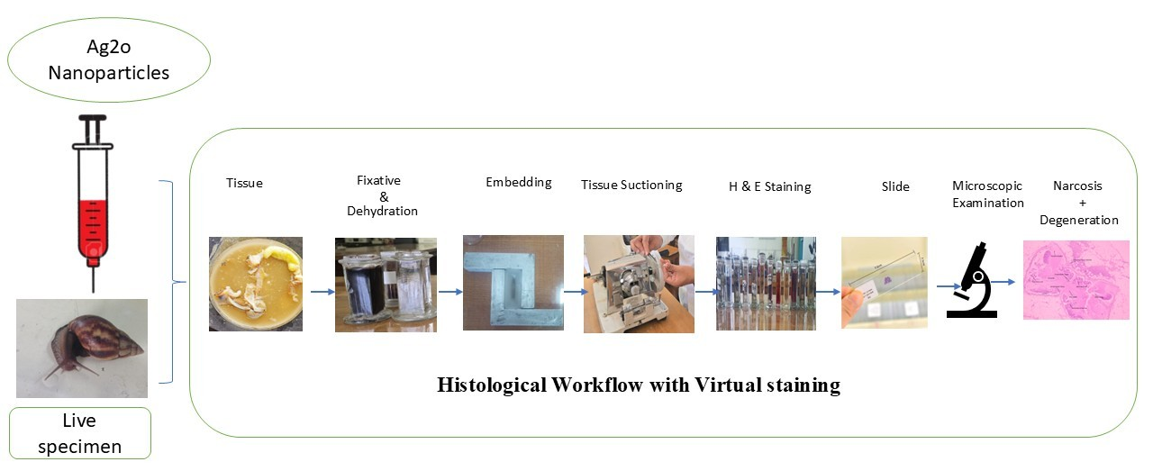
Fig-2. Schematics Representation of regular paraffin embedding method
Adult Lissachatina fulica snails were randomly assigned into experimental groups (n = 10 per group), including a control and treatment groups receiving silver oxide (Ag2O NP’s) nanoparticles at concentrations of 5 ppm, 10 ppm and 15 ppm respectively. The nanoparticle suspensions were administered by injection. Mortality was monitored at 24h. 48h. and 72h. hours after exposure. Snails were considered dead when they failed to exhibit any response to gentle tactile stimulation with a fine stainless-steel needle(Syringe) , in accordance with WHO guidelines (1965).(Ali, Yousef, & Nafady, 2015).
For histological examination, brain tissues and Ovateties were carefully dissected and immediately fixed in 10% neutral buffered formalin to preserve cellular architecture. The fixative was prepared by mixing 10 ml of formalin (40% formaldehyde) with 90 ml of distilled water, and tissues were kept in the solution for 24–48 hours. After fixation, the specimens were rinsed under running tap water to remove excess fixative. The tissues were then subjected to dehydration through ascending grades of ethanol (30%, 50%, 70%, 90%, and two changes of absolute alcohol), with each step lasting approximately one hour to ensure complete removal of water. Clearing was performed by transferring the tissues into a 1:1 mixture of absolute alcohol and xylene for 30 minutes, followed by immersion in pure xylene for two hours, rendering the tissues transparent and preparing them for wax impregnation. Infiltration was carried out using a 1:1 mixture of xylene and paraffin wax at 58 °C for 30 minutes, after which the tissues were kept overnight in molten paraffin wax. For embedding, L-shaped metal moulds were used; a base layer of melted wax was allowed to solidify slightly, the tissue was positioned at the centre with heated forceps, and additional molten wax was poured to form a block. The paraffin blocks were trimmed and mounted on a Leica semi-automatic microtome, and sections of approximately 4–7 µm thickness were cut. Glass slides were coated with egg albumin to improve adhesion, and the sections were placed on the slides, gently warmed, and dried overnight. Finally, the prepared sections were stained with hematoxylin and eosin (H&E) and examined under a light microscope for detailed histological analysis showing in fig-2
2.7 Histological Staining Procedure (Haematoxylin and Eosin Stain)
Paraffin-embedded tissue sections mounted on glass slides were processed for Haematoxylin and Eosin (H&E) staining following a standard histological procedure. Slides were first gently warmed and immersed in xylene for 2–3 minutes, then placed in fresh xylene until the tissues became fully transparent. The sections were subsequently rehydrated through a descending ethanol series, beginning with two changes of absolute alcohol (1 minute each), followed by brief dips in 95%, 70%, 50%, and 30% ethanol. After thorough washing in distilled water, the slides were stained in haematoxylin for 2–20 minutes depending on the type used (Harris’ haematoxylin: 3–5 minutes; Ehrlich’s haematoxylin: 15–20 minutes). The slides were rinsed in distilled water and examined under low magnification to assess staining intensity, with additional staining or washing performed as needed. Differentiation was carried out using acidified alcohol, and the slides were then “blued” in either alkaline tap water or 1% lithium carbonate solution. Following another rinse in distilled water, the sections were dehydrated through an ascending ethanol series (30%, 50%, 70%, and 95%), and counterstained with 0.5–1.0% eosin in 90% ethanol for 30 seconds to 1 minute. Final dehydration was completed with 95% ethanol, followed by two changes of absolute alcohol (3 minutes each). The sections were cleared in two successive xylene baths until fully transparent and finally mounted using DPX. Prepared slides examined under a light microscope. Histological lesions and severity assessed and documented.

- Result and Discussion-
3.1 XRD Analysis-
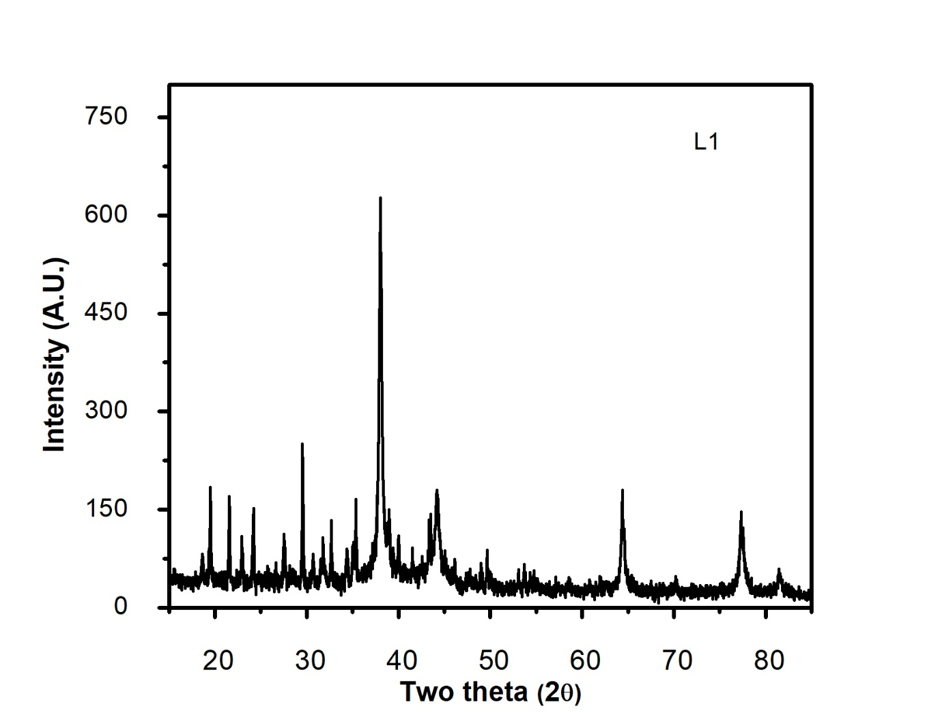Fig-3 XRD spectra of Mucin-Capped Ag₂O NPs.
The most intense diffraction peak observed at 29.43° corresponds to the (111) crystallographic plane of Ag₂O, confirming it as the dominant phase in the synthesized sample.( S. Elyamny, M. Eltarahony, et al.2021) (A. Athawale et al.,2020)
The X-ray diffraction (XRD) pattern of sample L1 displays sharp and well-defined diffraction peaks within the 2θ range of 10°–80°, confirming the crystalline nature of the synthesized material. The most intense peak observed around 38° (2θ), along with additional prominent reflections near approximately 32–33°, 44°, 64°, and 77–78°, corresponds to the characteristic crystallographic planes of cubic silver oxide (Ag₂O).fig-3 These peak positions are consistent with standard JCPDS data for Ag₂O, confirming the successful formation of the crystalline silver oxide phase (Cullity & Stock, 2014). The absence of significant impurity peaks indicates high phase purity of the synthesized nanoparticles. Moreover, slight peak broadening suggests nanoscale crystallite dimensions, which can be estimated using the Debye–Scherrer equation, a widely accepted method for determining crystallite size from XRD data (Patterson, 1939). Overall, the XRD results confirm the successful synthesis of crystalline, phase-pure Ag₂O nanoparticles with nanoscale dimensions.
3.2 FE-SEM/EDX Element analysis -

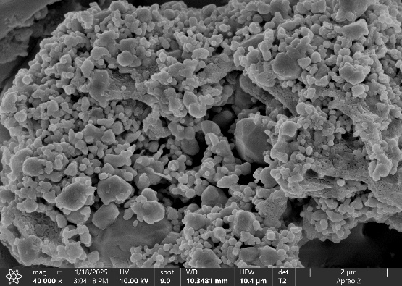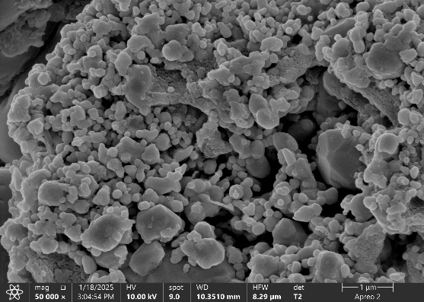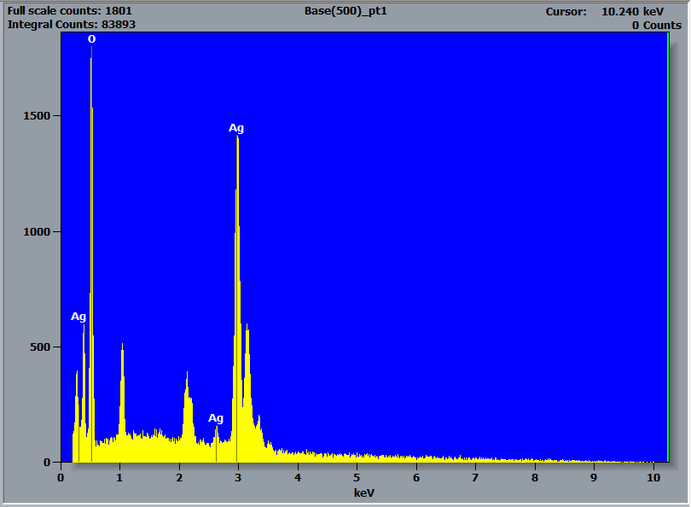
C
B
A
Fig-FE-SEM/EDX Elemental Analysis
Fig-4 (A) And (B) Scanning electron image of the nanoparticle size analysed. (C) Represent EDX spectrum showing graphical peaks for Ag and O.

Figure FE-SEM/EDX illustrates the morphological and elemental characterization of the synthesized nanoparticles. Figures (A) and (B) show the FE-SEM micrographs, revealing densely aggregated nanoparticles with irregular to nearly spherical morphology. The particles appear clustered due to high surface energy and strong interparticle interactions, which are commonly observed in metal oxide nanoparticles synthesized at the nanoscale. The surface texture appears rough and porous, and the particle dimensions are within the nanometer range, confirming successful nanoparticle formation. Such agglomeration behavior and morphological features are typical characteristics of metal oxide nanomaterials observed under scanning electron microscopy (Goldstein et al., 2018).
Figure (C) presents the energy-dispersive X-ray (EDX) spectrum, confirming the elemental composition of the synthesized material. The spectrum exhibits strong and distinct peaks corresponding to silver (Ag), particularly around ~3 keV, which is characteristic of Ag Lα emission lines, along with a peak in the lower energy region (~0.5 keV) corresponding to oxygen (O). The absence of significant additional peaks suggests high elemental purity and confirms the formation of silver oxide (Ag₂O) nanoparticles. EDX analysis is widely used to determine elemental composition and verify the presence of expected elements in nanomaterials (Williams & Carter, 2009). Overall, the FE-SEM and EDX analyses collectively confirm the successful synthesis of nanoscale, compositionally pure silver oxide nanoparticles.

3.4 HR-TEM micrograph showing the morphology of the Ag₂O NPs-
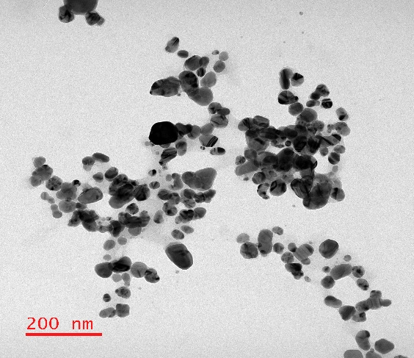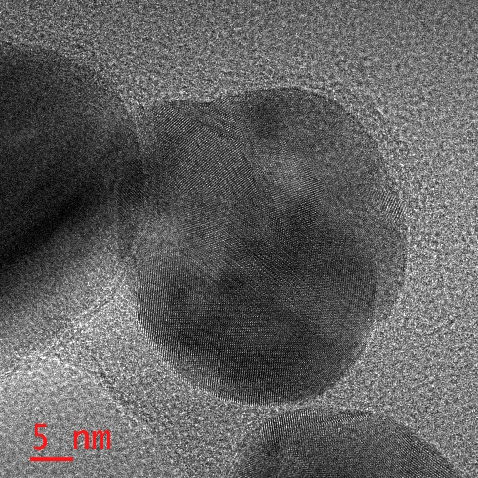
A
B
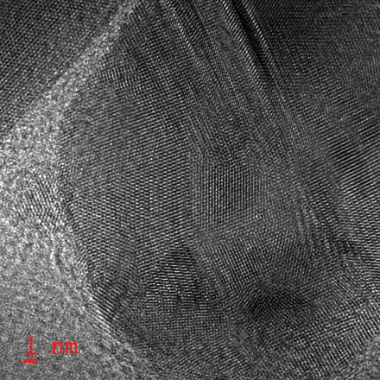
D
C
Fig. 5. Structural and Crystallographic Characterization.
(A,B,C,D) Representative HR-TEM micrograph showing the morphology of the Ag₂O NPs. Particle size distribution derived from TEM image analysis. High-resolution TEM image of a single nanoparticle displaying clear lattice fringes of cubic Ag₂O, confirming its polycrystalline nature.

Figure 5 (A–D) presents the high-resolution transmission electron microscopy (HRTEM) analysis of the synthesized Ag₂O nanoparticles, providing detailed information regarding their morphology, particle size, and crystallographic structure. The low-magnification TEM image (A) shows predominantly spherical to quasi-spherical nanoparticles with slight agglomeration, which is commonly observed in metal oxide nanomaterials due to high surface energy and interparticle interactions. The particles are clearly within the nanometer range, as indicated by the 200 nm scale bar. Particle size distribution derived from TEM image analysis (B) confirms relatively uniform nanoscale dimensions. TEM is widely used for direct visualization and accurate size determination of nanomaterials (Williams & Carter, 2009).
The high-resolution TEM images (C, D) reveal distinct and well-resolved lattice fringes within individual nanoparticles. The presence of clear lattice spacing (d-spacing) confirms the crystalline nature of the synthesized material. The measured interplanar distances correspond to characteristic crystallographic planes of cubic Ag₂O, supporting the phase identification obtained from XRD analysis. The observation of multiple lattice orientations within a single particle suggests a polycrystalline nature. HR-TEM analysis is considered a powerful technique for evaluating crystallinity, lattice structure, and nanoscale structural features in metal oxide nanoparticles (Egerton, 2016; Williams & Carter, 2009). Overall, the TEM findings confirm the successful synthesis of crystalline, nanosized Ag₂O nanoparticles with well-defined lattice structures.

3.5 Histology of Lissachatina Fulica-
The Histological study undergone by the brain and Ovotestis tissues on treatment with Silver Oxide Ag2O NP’S were studied as compared to the control as listed below: -
The land snail Lissachatina fulica shows well-defined external and internal anatomical structures. Externally, the foot (fp) is a muscular organ used for locomotion, while the head (H) bears the mouth (M) containing a radula for scraping food. The snail has two pairs of tentacles: the longer posterior tentacles (ct-pt) with eyes for vision, and the shorter anterior tentacles (ct-at) for touch and chemical sensing. The penis opening (p) is located on the right side of the head, as the snail is hermaphroditic. The shell apex (Sh) is the oldest part of the shell and indicates growth. Internally, the reproductive system includes the ovary (Ov), oviduct, uterus (Ut), vagina, vasa differentia (Vd), prostate gland (P), and albumin gland (Alg), which together function in egg production, fertilization, and nourishment of embryos. The digestive gland (Dg) plays a major role in digestion, nutrient absorption, and detoxification. These organs are important in toxicological studies because exposure to toxic substances can affect digestion, reproduction, and overall physiological functions of the snail in fig-6
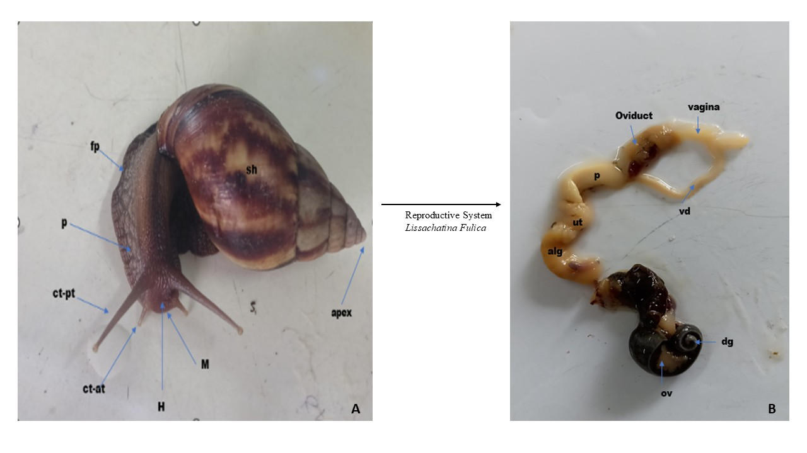
Fig-6 Lissachatina fulica live specimen and dissected reproductive system -fp-Foot p-penis opening site ct-pt-tentacle posterior ct-at-Tentacle Anterior H-Head M-Mouth Sh-Shell Apex B) Oviduct Vagina Vd-vasa differentia P-Prostate gland Ut-uterus Alg- Albumin Gland Ov-Overy Dg-Digestive gland

3.5 Histological Alterations in the Brain of Achatina fulica Exposed to Silver Oxide Nanoparticles (Ag₂O NPs)

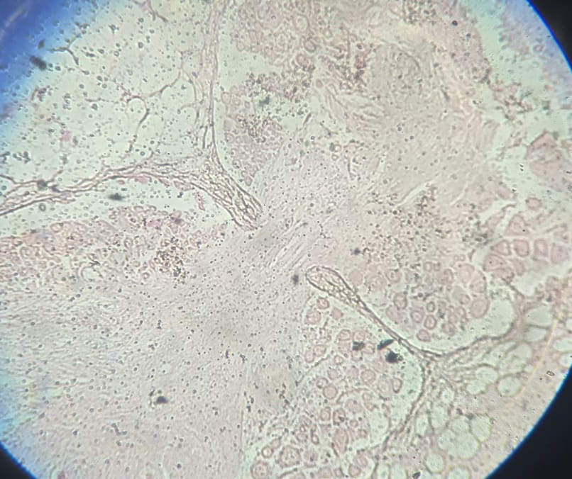
B
D
CTC
GNC
A
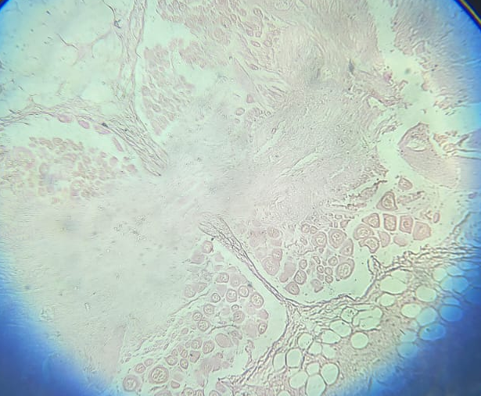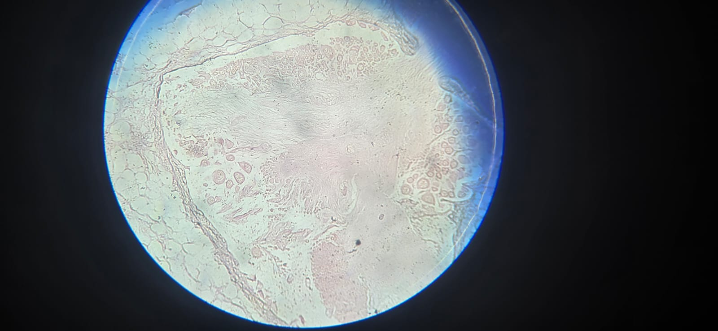
CG
CG
CTC
GNC
CTC
GNC
C
Fig-7. T. S. of Brain of Lissachatina fulica A-(Normal) tissue histology B-(5PPM /24h.) GNC-Giant Nerve cell Disturb CTC-connective tissue capsules changes MT-median tissue Degeneration C - GNC-Giant Nerve cell Disturb CTC-Connective tissue cell C-(10PPM /48h.) connective tissue capsules changes MT-median tissue Degeneration D- -(15PPM /72h.) GNC-Giant Nerve cell Disturb CTC-connective tissue capsules changes MT-median tissue Degeneration

The cerebral ganglia of L. fulica are paired structures located dorsally to the oesophagus, behind the buccal ganglia. They are enclosed by two connective tissue layers: an outer perineurium and an inner endoneurium. The ganglia are interconnected by a cerebral commissure and are divided into three regions—procerebrum, mesocerebrum, and metacerebrum—separated by a septum. A central neuropil composed of nerve fibers, glial filaments, and synapses occupies the middle region and extends posteriorly. Under control conditions, the cerebral ganglia exhibit normal architecture, well-defined regions, intact neuropil, and clearly distinguishable giant nerve cells, globuli cells, and other neurons.(Lu et al., 2018)
Short-Term Exposure to Silver Oxide Nanoparticles (5 ppm 24 Hours) Exposure to Ag₂O nanoparticles for 24 hours induced marked cellular alterations. The brain cell showed degeneration and partial destruction. Extensive vacuolation appeared in neuronal cytoplasm due to necrosis. The neuropil exhibited abnormal enlargement and lateral extension with areas of tissue loss in fig-7
Giant nerve cells showed altered morphology; some increased in size while others were reduced and damaged. Globuli cells displayed vacuolated cytoplasm. The mesocerebrum contained distorted large, medium, and small neurons along with proliferated neuroglial cells. These changes indicate early neurotoxic effects of silver oxide nanoparticles on neuronal integrity.
Prolonged Exposure to Silver Oxide Nanoparticles (10 ppm 48 Hours) After 48 hours of Ag₂O nanoparticle exposure, severe degeneration was evident. disorganization of the neuropil were observed, The number of nerve cells declined significantly.
Giant nerve cells showed cytoplasmic degeneration with prominent vacuoles and reduction in size. Many neurons were morphologically distorted, and neural tissue damage extended toward the metacerebrum. Darkly stained degenerating neurons were frequently observed, reflecting progressive neurotoxicity.
Higher Dose / Intensified Nanoparticle Exposure (15 ppm 72Hours) At higher concentrations or intensified exposure to silver oxide nanoparticles, the cerebral ganglia exhibited extensive structural damage. The perineurium and endoneurium were disrupted, and inflammatory changes were apparent. Fusion of procerebrum and mesocerebrum occurred due to loss of the separating septum. The neuropil became discontinuous, highly vacuolated, and necrotic.
Giant nerve cells demonstrated severe cytoplasmic degeneration, triangular or distorted nuclei, and increased vacuolation. The number of globuli cells and other neurons was markedly reduced. Axons within the neuropil were disoriented and deteriorated, and extracellular matrix loss was prominent. In advanced stages, the typical organization of procerebrum, mesocerebrum, metacerebrum, and neuropil was no longer distinguishable.

Overall, exposure to silver oxide nanoparticles (Ag₂O NPs) induced marked and progressive neurodegenerative alterations in the cerebral ganglia of Achatina fulica. Histopathological examination revealed destruction of the protective connective tissue layers, along with pronounced vacuolation and necrosis of neuronal cells. The neuropil exhibited significant disorganization and areas of hyperplasia, indicating disruption of normal neural connectivity. Additionally, giant nerve cells showed evident degeneration and a noticeable reduction in number, further compromising neural integrity. These structural abnormalities ultimately led to a loss of the normal ganglionic architecture. The severity of these histological changes increased with prolonged and intensified nanoparticle exposure, clearly demonstrating the dose- and duration-dependent neurotoxic potential of silver oxide nanoparticles in terrestrial gastropods.
- Recent literature indicates that adverse outcomes from silver-based nanomaterials in aquatic systems can reflect a combination of particle-specific effects and Ag⁺-mediated toxicity, and that transformations in realistic media (aggregation and chemical aging) can strongly modulate bioavailability and hazard (Yang et al., 2024). In freshwater invertebrates, oxidative stress is repeatedly identified as a dominant upstream event linking metal nanoparticle exposure to tissue injury, and AOP-oriented synthesis is increasingly recommended to strengthen causal interpretation across biological levels (Wang & Liu, 2022). Gastropod-focused evidence further shows that AgNPs can bioaccumulate in key organs and elicit oxidative stress responses, with neurotoxicity detectable at higher concentrations and effects sometimes diverging from dissolved silver—underscoring the importance of explicitly distinguishing nanoparticle versus ionic contributions in interpretation (Wang et al., 2022). Longer-term studies also suggest that chronic exposure can produce persistent and even transgenerational impacts in Lymnaea stagnalis, supporting the value of extended exposure and recovery designs when extrapolating from short-term histopathology (Wang & Liu, 2023). Finally, recent mechanistic reviews consolidate oxidative stress, inflammation, and dysregulated autophagy/signaling as recurring pathways in AgNP-associated neurotoxic injury and advocate integrating mechanistic biomarkers with neuropathological endpoints to improve weight-of-evidence (Yang et al., 2024).

3.6 Histological Alterations in the Ovotestis of Achatina fulica Exposed to Silver Oxide Nanoparticles (Ag₂O NPs)
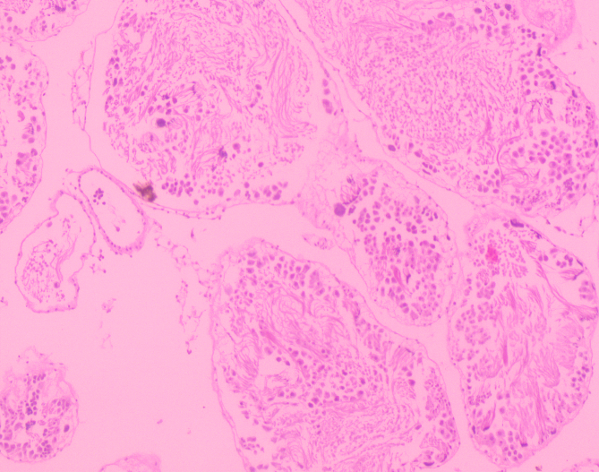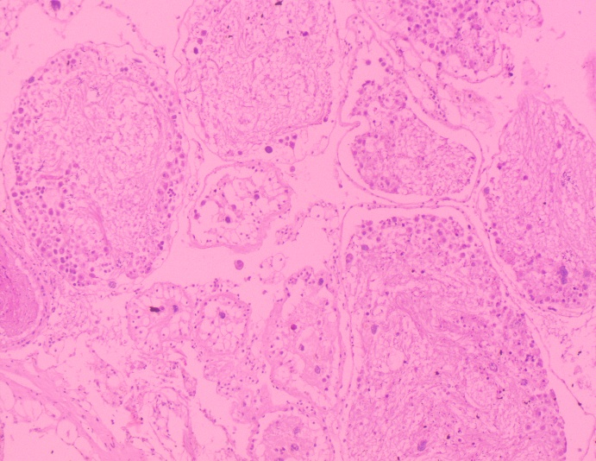
St-D
B
St
Sp-B
BM
A
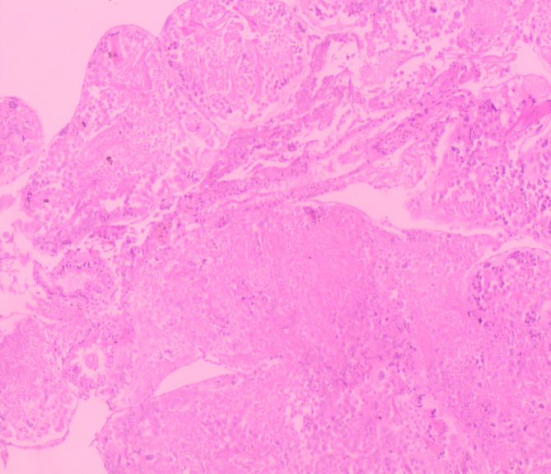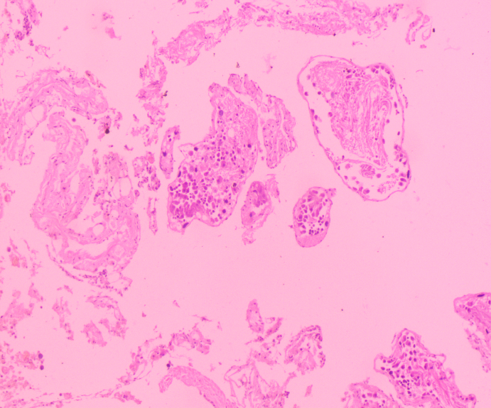
D
St-D
St-F
C
Fig-8-Histological section Lissachatina Fulica Showing many Ovotestis A)- Showing Normal snail specimen (10X) Sp-B -Sperm Bundle, BM-Basement Membrane, St- Seminiferous tubules B)-(5PPM /24h.) Showing St-D-Seminiferous tubules start to degeneration or rupture C) -(10PPM /48h.) Showing fusion and disturb of St-Seminiferous tubules D) -(15PPM /72h.) Showing of St-D degeneration of seminiferous tubules

- The ovotestis of L. fulica is a lobular structure embedded in the digestive gland or hepatopancreas and consists of many oval-shaped follicles or acini. It shows normal structure in the control group (Fig. 8). Each acinus is bounded by an outer basement membrane, beneath which lies the follicular germinal epithelium producing both male and female gametes. Loose connective tissue is present between the acini. Periacinar cells are observed close to the acinar wall at some places. The acini contain numerous spermatocytes and comparatively fewer oocytes. Irregular or elongated Sertoli cells are located toward the periphery of the follicles (Fig. 8 A & B).
- The spermatogenic cells within the germinal epithelium exhibit different stages of spermatogenesis, including spermatogonia, spermatocytes, spermatids, and spermatozoa. Spermatogonia are spherical, smaller than spermatocytes, usually attached to each other, and located near the germinal epithelium. Spermatocytes are larger and spherical with prominent nuclei. Spermatids possess condensed nuclei and more cytoplasm; some show an acrosomal cap and initiation of tail formation. Mature spermatozoa, which are comparatively large, are clustered in the central region of the acini. Numerous spermatozoa appear as aggregated clumps with long tails and densely stained heads associated with Sertoli cells. A single large oocyte with a prominent nucleus and granular cytoplasm is observed near the acinar wall, surrounded by follicular cells (Fig.8).
- In the ovotestis of A. fulica exposed to silver oxide nanoparticles (Ag₂O NPs) for 24 hours, disorientation of cells within the acini is observed (Fig.8B). A gap between the basement membrane and spermatogonial cells appears due to degeneration of gametogenic cells (Fig. 8B). Reduction in acinar size and degeneration of several cells are evident. The interacinar space increases. Suppression of follicular growth and a decreased number of spermatocytes due to necrosis are noticeable; however, an ovum with a distinct nucleus and nucleolus and some mature sperms are still present. Cytoplasmic reduction in spermatids and vacuolated spaces due to necrosis are also observed.
- After 48 hours of exposure to silver oxide nanoparticles, fusion of some acini is evident. Cellular disruption, degeneration, and necrosis are prominent (Fig. 8C). Acini become irregular in shape, and the basement membrane is damaged. The interacinar space is markedly reduced. Increased interacinar cells and connective tissue with hemocytes are visible. More than one developing oocyte is occasionally observed in a single acinus. Although one developed oocyte with a distinct nucleus and nucleolus is seen, spermatozoa are reduced, while undifferentiated spermatogenic cells increase. Vacuolation is also evident.
- With higher concentration or prolonged exposure to silver oxide nanoparticles(72hr) , marked derangement, degeneration, and destruction of gametogenic cells occur, along with disruption of the basement membrane (Fig. 8D). Many acini appear distorted in shape. Damaged and fewer spermatozoa are seen, whereas spermatocytes appear enlarged. Sertoli cells are reduced in number, and stages of spermatogenesis and oogenesis become indistinct. Increased vacuolation due to necrosis and destruction of connective tissue is evident. Oocytes are absent in severely affected acini.
- Prolonged nanoparticle exposure further results in degeneration and sloughing of the germinal epithelium and basement membrane. Acini exhibit severe cellular damage and increased vacuolated spermatogenic cells. Sertoli cells and oocytes are markedly absent. Histolysis of spermatogonia and mature spermatozoa is evident, and spermatozoa are displaced toward the periphery instead of the central lumen. Connective tissue is reduced, and interacinar space increases.
- At intensified exposure levels, rupture of the basement membrane, distortion of acini, hyperplasia of spermatogenic cells, and increased connective tissue with hemocytes are observed. Acini become irregular, with damaged basement membranes and enlarged Sertoli cells. Numerous spermatozoa in different developmental stages fill the follicles, while oocytes are rarely observed. Some spermatids show acrosome formation and elongated tail-like structures.
- At the highest exposure levels of silver oxide nanoparticles, the overall structure of the ovotestis is severely damaged due to extensive necrosis . Degeneration of gametogenic cells creates empty spaces between the basement membrane and cells. Acini become irregular, fused, and highly disorganized. Damaged spermatogenic cells, increased spermatocytes, scattered spermatozoa, vacuolation, and occasional mature oocytes with nuclei are observed. Connective tissue proliferation is also evident in several regions.
Limitations and Future Research
This study provides evidence of tissue-level alterations in Lissachatina fulica following exposure to mucin-capped Ag₂O nanoparticles; however, several limitations should be considered. First, although the nanomaterial was characterized by XRD and electron microscopy, additional physicochemical metrics in the exposure vehicle (hydrodynamic size distribution, zeta potential, stability/aggregation over time, and dissolution to Ag⁺) were not quantified, limiting interpretation of particle-specific versus ionic contributions. Second, the exposure design relies on an acute dosing regime, and environmentally realistic uptake pathways (e.g., dietary or waterborne exposure) were not directly tested. Third, histopathological outcomes were largely qualitative; blinded scoring, lesion quantification, and inferential statistics would strengthen reproducibility and enable clearer dose–response modeling. Fourth, the work did not include functional endpoints (behavioral assays, reproduction metrics, neurophysiology) or mechanistic biomarkers (oxidative stress, apoptosis, inflammation) to link tissue injury to organism-level effects. Future research should integrate controlled route-comparisons, chronic/recovery experiments, quantitative histology with robust statistics, tissue silver burden measurements, and multi-level biomarkers to establish causality and derive ecologically relevant risk thresholds.

- 4. Conclusion –
The present investigation clearly demonstrates that mucin-capped silver oxide nanoparticles (Ag₂O NPs) induce significant dose- and duration-dependent histopathological alterations in the brain and ovotestis of Lissachatina fulica. Characterization studies confirmed the successful synthesis of crystalline, nanosized, and phase-pure Ag₂O nanoparticles. Exposure to these nanoparticles resulted in progressive neurodegeneration, including destruction of protective connective tissue layers, vacuolation, neuronal necrosis, disorganization of neuropil, and reduction of giant nerve cells, ultimately leading to loss of normal ganglionic architecture. In addition, severe reproductive impairment was observed in the ovotestis, characterized by degeneration and fusion of acini, disruption of basement membranes, reduction in spermatogenesis and oogenesis, vacuolation, and extensive necrosis at higher concentrations.
These findings indicate that Ag₂O nanoparticles possess strong cytotoxic, neurotoxic, and reproductive toxic effects in terrestrial gastropods. The results suggest their possible utility as an alternative nano-based strategy for controlling invasive snail populations. However, further studies are necessary to evaluate environmental safety, bioaccumulation potential, and long-term ecological impacts before large-scale application.

  - Vikas Varpe: Conceptualization; Data curation; Formal analysis; Investigation, Methodology; Project administration; Resources; Software. Sudhir Naphade: Supervision; Validation; Visualization; Writing, original draft; Writing, review and editing.
  - Conflicts of Interest: Authors declare no conflicts of interest.

Disclaimer (Artificial intelligence)

Author(s) hereby declare that NO generative AI technologies such as Large Language Models (ChatGPT, COPILOT, etc.) and text-to-image generators have been used during the writing or editing of this manuscript.

- References:
- 1. Pandey, J. K., & Singh, D. K. (2009). Molluscicidal activity of plant-derived products against Indoplanorbis exustus. Indian Journal of Experimental Biology, 47(8), 643–648.
- 2. Panigrahi, A., & Raut, S. K. (1994). Plant products as molluscicides against the giant African snail Achatina fulica. Memórias do Instituto Oswaldo Cruz, 89(4), 495–499. https://doi.org/10.1590/S0074-02761994000400004
- 3. Rani, P. U., Rajasekharreddy, P., & Ramakrishna, A. (2012). Eugenol—A potential antifungal and antiseptic compound. International Journal of Pharmaceutical Sciences and Research, 3(9), 3231–3237.
- 4. Rao, I. G., & Singh, D. K. (2002). Toxic effects of plant extracts on Achatina fulica. Journal of Applied Toxicology, 22(3), 211–215. https://doi.org/10.1002/jat.850
- 5. Raut, S. K., & Barker, G. M. (2002). Achatina fulica Bowdich and other achatinidae as pests in tropical agriculture. In G. M. Barker (Ed.), Molluscs as crop pests (pp. 55–114).
- 6. Santos Carvalho, O. S., Scholte, R. G. C., Mendonça, C. L. F., Passos, L. K. J., & Caldeira, R. L. (2003). Role of Achatina fulica in the transmission of Angiostrongylus cantonensis. Revista de Biología Tropical, 51(2), 219–227.
- 7. Silva, E. J., et al. (2012). Molluscicidal activity of plant extracts against Subulina octona.
- 8. Vasconcellos, M. C., & Pile, E. (2001). Occurrence of Angiostrongylus cantonensis in the giant African snail Achatina fulica. Memórias do Instituto Oswaldo Cruz, 96(8), 1199–1204.
- 9. Croteau, M.-N., & Luoma, S. N. (2008). A biodynamic understanding of diet-borne metal uptake by a freshwater invertebrate. Environmental Science & Technology, 42(5), 1801–1806. https://doi.org/10.1021/es7022913
- 10.Dang, F., Huang, Y., Wang, Y., Zhou, D., & Xing, B. (2021). Transfer and toxicity of silver nanoparticles in the food chain. Environmental Science: Nano, 8(6), 1519–1535. https://doi.org/10.1039/D0EN01190H
- 11. Hawthorne, J., De la Torre Roche, R., Xing, B., Newman, L. A., Ma, X., Majumdar, S., Gardea-Torresdey, J., & White, J. C. (2014). Particle-size dependent accumulation and trophic transfer of cerium oxide through a terrestrial food chain. Environmental Science & Technology, 48(22), 13102–13109. https://doi.org/10.1021/es503792f
- 12. Khan, F. R., Misra, S. K., García-Alonso, J., Smith, B. D., Strekopytov, S., Rainbow, P. S., Luoma, S. N., & Valsami-Jones, E. (2012). Bioaccumulation dynamics and modeling in an estuarine invertebrate following aqueous exposure to nanosized and dissolved silver. Environmental Science & Technology, 46(14), 7621–7628. https://doi.org/10.1021/es301253s
- 13.Lopez-Serrano Oliver, A., Croteau, M., Stoiber, T. L., Tejamaya, M., Römer, I., Lead, J. R., & Luoma, S. N. (2014). Does water chemistry affect the dietary uptake and toxicity of silver nanoparticles by the freshwater snail Lymnaea stagnalis? Environmental Pollution, 189, 87–91. https://doi.org/10.1016/j.envpol.2014.02.010
- 14. Luoma, S. N., & Rainbow, P. S. (2005). Why is metal accumulation so variable in aquatic organisms? A biodynamic explanation. Environmental Toxicology and Chemistry, 24(10), 2496–2506.
- 15. Unrine, J. M., Shoults-Wilson, W. A., Zhurbich, O., Bertsch, P. M., & Tsyusko, O. V. (2012). Trophic transfer of Au nanoparticles from soil along a simulated terrestrial food chain. Environmental Science & Technology, 46(17), 9753–9760. https://doi.org/10.1021/es3025325
- S. Elyamny, M. Eltarahony, M. Abu-Serie, M. M. Nabil, and A. E.-H. B. Kashyout, “One-pot fabricationof Ag @Ag2O core–shell nanostructures for biosafe antimicrobial and antibiofilm applications,” Sci Rep,vol. 11, no. 1, p. 22543, Nov. 2021, doi: 10.1038/s41598-021-01687-4.
- A. Athawale et al., “Synthesis of Ag2O Coated TiO2 Nanoparticles by Sonochemically ActivatedMethods for Enhanced Photocatalytic Activities,” Top Catal, vol. 63, no. 11–14, pp. 1056–1065, Oct.2020, doi: 10.1007/s11244-020-01374-0.
- Cullity, B. D., & Stock, S. R. (2014). Elements of X-ray diffraction (3rd ed.). Pearson.
- Goldstein, J., Newbury, D., Joy, D., Lyman, C., Echlin, P., Lifshin, E., Sawyer, L., & Michael, J. (2018). Scanning electron microscopy and X-ray microanalysis (4th ed.). Springer.
- Patterson, A. L. (1939). The Scherrer formula for X-ray particle size determination. Physical Review, 56(10), 978–982. https://doi.org/10.1103/PhysRev.56.978
- Williams, D. B., & Carter, C. B. (2009). Transmission electron microscopy: A textbook for materials science (2nd ed.). Springer.
- Cullity, B. D., & Stock, S. R. (2014). Elements of X-ray diffraction (3rd ed.). Pearson.
- Patterson, A. L. (1939). The Scherrer formula for X-ray particle size determination. Physical Review, 56(10), 978–982. https://doi.org/10.1103/PhysRev.56.978
- Goldstein, J., Newbury, D., Joy, D., Lyman, C., Echlin, P., Lifshin, E., Sawyer, L., & Michael, J. (2018). Scanning electron microscopy and X-ray microanalysis (4th ed.). Springer.
- Williams, D. B., & Carter, C. B. (2009). Transmission electron microscopy: A textbook for materials science (2nd ed.). Springer.
- Egerton, R. F. (2016). Physical principles of electron microscopy: An introduction to TEM, SEM, and AEM (2nd ed.). Springer.
- Ali, S. M., Yousef, N. M. H., & Nafady, N. A. (2015). Application of biosynthesized silver nanoparticles for the control of land snail eobania vermiculata and some plant pathogenic fungi. Journal of Nanomaterials, 2015(May). https://doi.org/10.1155/2015/218904
- Dickens, K. L., Capinera, J. L., & Smith, T. R. (2018). Laboratory assessment of growth and reproduction of Lissachatina fulica (Gastropoda: Achatinidae). Journal of Molluscan Studies, 84(1), 46–53. https://doi.org/10.1093/mollus/eyx044
- Lu, X. T., Gu, Q. Y., Limpanont, Y., Song, L. G., Wu, Z. D., Okanurak, K., & Lv, Z. Y. (2018). Snail-borne parasitic diseases: An update on global epidemiological distribution, transmission interruption and control methods. Infectious Diseases of Poverty, 7(1), 1–16. https://doi.org/10.1186/s40249-018-0414-7
- Siddiqi, K. S., Husen, A., & Rao, R. A. K. (2018). A review on biosynthesis of silver nanoparticles and their biocidal properties. Journal of Nanobiotechnology, 16(1). https://doi.org/10.1186/s12951-018-0334-5
- Ali, S. M., Yousef, N. M. H., & Nafady, N. A. (2015). Application of biosynthesized silver nanoparticles for the control of land snail eobania vermiculata and some plant pathogenic fungi. Journal of Nanomaterials, 2015(May). https://doi.org/10.1155/2015/218904
- Dickens, K. L., Capinera, J. L., & Smith, T. R. (2018). Laboratory assessment of growth and reproduction of Lissachatina fulica (Gastropoda: Achatinidae). Journal of Molluscan Studies, 84(1), 46–53. https://doi.org/10.1093/mollus/eyx044
- Lu, X. T., Gu, Q. Y., Limpanont, Y., Song, L. G., Wu, Z. D., Okanurak, K., & Lv, Z. Y. (2018). Snail-borne parasitic diseases: An update on global epidemiological distribution, transmission interruption and control methods. Infectious Diseases of Poverty, 7(1), 1–16. https://doi.org/10.1186/s40249-018-0414-7
- Siddiqi, K. S., Husen, A., & Rao, R. A. K. (2018). A review on biosynthesis of silver nanoparticles and their biocidal properties. Journal of Nanobiotechnology, 16(1). https://doi.org/10.1186/s12951-018-0334-5
- Wang, T., Marle, P., Slaveykova, V. I., Schirmer, K., & Liu, W. (2022). Comparative study of the sensitivity of two freshwater gastropods, Lymnaea stagnalis and Planorbarius corneus, to silver nanoparticles: Bioaccumulation and toxicity. Environmental Pollution, 312, 119999. https://doi.org/10.1016/j.envpol.2022.119999
- Wang, T., & Liu, W. (2022). Emerging investigator series: Metal nanoparticles in freshwater: Transformation, bioavailability and effects on invertebrates. Environmental Science: Nano, 9, 2237–2263. https://doi.org/10.1039/D2EN00052K
- Wang, T., & Liu, W. (2023). Chronic and transgenerational effects of silver nanoparticles in freshwater gastropod Lymnaea stagnalis. Chemosphere, 313, 137386. https://doi.org/10.1016/j.chemosphere.2022.137386
- Yang, H., Niu, S., Guo, M., & Xue, Y. (2024). Molecular mechanisms of silver nanoparticle-induced neurotoxic injury and new perspectives for its neurotoxicity studies: A critical review. Environmental Pollution, 362, 124934. https://doi.org/10.1016/j.envpol.2024.124934
- Yang, Y., Wang, K., Liu, X., Xu, C., You, Q., Zhang, Y., & Zhu, L. (2024). Environmental behavior of silver nanomaterials in aquatic environments: An updated review. Science of the Total Environment, 907, 167861. https://doi.org/10.1016/j.scitotenv.2023.167861
- Wang, T., Santos, J. P., Slaveykova, V. I., Stoll, S., & Liu, W. (2025). From microalgae to gastropods: Understanding the kinetics and toxicity of silver nanoparticles in freshwater aquatic environment. Environmental Pollution, 367, 125643. https://doi.org/10.1016/j.envpol.2025.125643
- Silva, P. V., Pinheiro, C., Morgado, R. G., Verweij, R. A., van Gestel, C. A. M., & Loureiro, S. (2022). Bioaccumulation but no biomagnification of silver sulfide nanoparticles in freshwater snails and planarians. Science of the Total Environment, 808, 151956. https://doi.org/10.1016/j.scitotenv.2021.151956
- Vijayan, K., Suganthasakthivel, R., Naggs, F., Fontanilla, I. K., Soorae, P. S., Sajeev, T. V., & Wade, C. M. (2022). Fine-scale geographical sampling and molecular characterization of the giant African land snail in its invasive range in Asia shows low genetic diversity, new haplotypes and the emergence of another haplotype from the Indian Ocean Islands. Biological Journal of the Linnean Society, 137(3), 421-433. https://doi.org/10.1093/biolinnean/blac106

