An assessment of the coagulation, antibacterial, and cytotoxic qualities of extracts from Nymphaea nouchali stem and Artocarpus altilis peel for the treatment of wastewater
Abstract

Untreated sewage and industrial waste discharge contaminates water sources, causing major risks to ecosystems and human health. This study aimed to compare the coagulation, antibacterial, and cytotoxic properties of Artocarpus altilis (Park.) Fosh. (Breadfruit) peel, and Nymphaea nouchali Burm. f. (Blue Water Lily) stem, as a natural and eco-friendly wastewater treatment agent. Aqueous plant extracts (PEs) were prepared, and their antibacterial effects were evaluated via disk diffusion, coagulation efficiency via turbidity using spectrophotometry, and cytotoxicity by brine shrimp assay. Turbidity removal was most significantly different at 10⁻¹ g/mL (21.63%), 10⁻² g/mL (11.19%), and 10⁻³ g/mL (9.86%) for A. altilis, N. nouchali, and the mixed extracts, respectively (p<0.05). However, the positive control showed the most significant turbidity reduction (p<0.05). The PEs did not exhibit antibacterial properties and had no significant cytotoxic effects (p>0.05) compared to the positive control. Further research should involve investigating different extraction procedures to yield more potent compounds.
Keywords: Sustainable Water Treatment; Coagulation; Natural Coagulants.

Introduction
Water contamination from untreated sewage, agricultural, and industrial waste poses a significant threat to human health and ecosystems worldwide. The accumulation of physical and chemical pollutants, such as plastic waste and hazardous chemicals, as well as untreated sewage, industrial discharges, and agricultural runoff, is a major source of this contamination (Owhonka et al., 2021). The quality of freshwater sources is affected by these contaminants, which enter aquatic bodies by surface runoff or direct discharge. The infiltration of biological agents, like pathogenic microorganisms, which have adverse effects on public health and environmental systems, is one of the most concerning aspects of this contamination (Nada et al., 2025). Although around 71% of the earth is covered with water, only 2.5% is freshwater, and less than 1% is accessible for usage (UN, 2020). According to a 2023 report by the World Health Organization (WHO), approximately 80% of all diseases in developing countries are caused by waterborne pathogens (World Health Organization, 2023). Typhoid, dysentery, cholera, salmonellosis, and hepatitis are just a few of the infectious diseases that can spread when humans consume contaminated water, particularly in areas without effective water treatment facilities. In addition, to causing widespread diseases, these have the potential to be fatal, especially for vulnerable groups like children, the elderly, and people with compromised immune systems (Koul et al., 2022).
Currently, many different kinds of water treatment techniques are employed globally to ensure the elimination of biological, chemical, and physical pollutants (Saravanathamizhan and Perarasu, 2021). Chemical treatments are the most commonly used which include chemical coagulants (such as alum or ferric chloride) for flocculation and coagulation, chlorination for disinfection, and the use of lime or soda ash for pH correction. However, traditional methods usually comprise several types of procedures, such as screening, sedimentation, filtering, and disinfection (Saravanan et al., 2021). Large-scale purification in industrial and municipal systems often includes chemical treatments, particularly coagulation with alum or ferric chloride and chlorination (Sultana et al., 2022).
Coagulation is one of the most important steps in all the techniques used to purify water. The process of coagulation is adding specific compounds, referred to as coagulants, which help small suspended particles aggregate into bigger clusters, or flocs, that are easier to remove during later treatment procedures like sedimentation and filtering (Koul et al., 2022). Owodunni and Ismail, 2021 suggested that coagulation enhances water quality and purity by removing contaminants that traditional filtration would not be able to remove. However, the most widely used chemical coagulants, such as ferric chloride and aluminium sulphate (alum), present health and environmental risks. According to a study done by Bratby, 2006, these chemical coagulants may produce harmful byproducts, including heavy metals and sludge, which can negatively impact the ecosystems and potentially lead to chronic health issues in humans (Koul et al., 2022). Additionally, research on environmentally friendly alternatives to treat wastewater has been driven by the high cost and harmful environmental effects of manufacturing and discarding chemical coagulants.
Plant-based coagulants, which are alternatives to chemical treatment, are viewed as promising as they are valued for their biodegradability, lack of toxicants, and low environmental impact (Khursheed et al., 2022). These natural coagulants, derived from various plants such as seeds, leaves, bark, and peels, are considered environmentally friendlier than chemical coagulants; however, their safety and efficacy can vary depending on the plant source and require thorough toxicological and performance evaluation before use in water treatment (Khursheed et al., 2022). Such options are especially beneficial in underdeveloped nations where high-end technology for wastewater treatment is limited and the prevalence of waterborne diseases is high.
Water treatment systems based on plants and biomaterials are growing increasingly as environmentally friendly substitutes for chemical processes. Coagulants made from plants such as Strychnos potatorum, Moringa oleifera, and Cactus mucilage have demonstrated efficacy in lowering turbidity by using natural proteins and polysaccharides to aggregate suspended (Sheeba et al., 2025; Desta and Bote, 2021; Nitola et al., 2025). Chitosan, a biopolymer derived from crab shells, is an effective flocculant that also has antibacterial qualities (Karim et al., 2024; Ke et al., 2021). Furthermore, it has been shown that agricultural waste products like banana peels and coconut husks can absorb colours and heavy metals from water that has been contaminated (Jangir et al., 2024; Ke et al., 2021).
The present research investigates the coagulation, antibacterial, and cytotoxic properties of two underutilized plant materials: the inner peel of Artocarpus altilis (Park.) Fosh., also known as breadfruit, and the stem of Nymphaea nouchali Burm. f., also known as blue water lily.
The tropical plant known as Artocarpus altilis, or breadfruit, is well known for its therapeutic and nutritional benefits (Jagtap and Bapat, 2010; Mehta et al., 2023). Since the plant's leaves, bark, and latex contain antibacterial, anti-inflammatory, and antioxidant qualities, they have been used in traditional medicine to treat conditions including fevers and digestive problems (Sikarwar, 2016). The peel of the A. atilis fruit specifically had demonstrated anti-oxidant and anticancer properties against lung cancer cell lines proving the importance of the phytochemicals in fruit waste (Nicole Estudillo and Tolentino., 2024). The starchy fruit of A. altilis has drawn interest from the industrial sector since it is a gluten-free food source that can also be used to make bioethanol, bioplastics, and animal feed (Zainol et al., 2022). Its potential for environmental uses has been investigated recently; in particular, the leaf and bark extracts have demonstrated the ability to function as natural coagulants in wastewater treatment by stimulating floc formation and lowering turbidity (Zainol et al., 2022).
In South Asia, Nymphaea nouchali, commonly referred to as blue lotus or nil mānel, is an aquatic plant that has medicinal and religious significance. Due to its analgesic, anti-diabetic, antipyretic, and antioxidant properties, it has long been utilized in Ayurvedic and Siddha medicine (Kiranmai et al., 2023) Extracts from the flowers and rhizomes have also shown pharmacological promise (Sarma et al., 2025). Since it contains its bioactive flavonoids and phenolic components, it finds usage in nutraceuticals and cosmetics, among other industrial applications. However, this plant has not been widely studied for its coagulation properties.
Although both of these plants are widely accessible in many tropical areas and have long been utilized in traditional medicine, their potential application in water treatment remains underexplored.
The objectives are to determine the antibacterial, coagulant, and cytotoxic properties of Nymphaea nouchali Burm. f. and Artocarpus altilis (Park.) Fosh. and compare the effectiveness of the individual mixed extracts of both effective plant concentrations.

Materials and Methods

Collection of plant material and preparation of plant extracts
The plant materials were collected from Bellanvila (6°50'43.1"N 79°53'24.7"E) and Kadawatha (7°01'01.9"N 79°57'25.4"E), respectively, and authenticated at Bandaranayake Memorial Ayurveda Research Institute (BMARI), where the specimens were deposited under the accession numbers 3192 for Nymphaea nouchali Burm. f. and 3193 Artocarpus altilis (Park.) Fosh. A 1:9 (w/v) plant-to-solvent extract was prepared using 10 g of the fresh plant material (Stem of the Nymphaea nouchali Burm. f. and inner peel of Artocarpus altilis (Park.) Fosh.) in 90 mL of sterilized water (solvent). This extract was then filtered using Whatman filter paper (6mm) in 2 steps: first via the gravity filtration method using a funnel and filter paper, followed by the syringe filter method. The extraction time was 60 minutes per plant extract and was conducted at room temperature (25ºC). The extracts were further diluted via serial dilution from 0.111 g/mL (10⁻¹) to 0.0000111 g/mL (10⁻⁴). The extracts were refrigerated at 4ºC. According to the method described by Al-Mamun and Basir, 2016, synthetic turbid water was prepared using the bentonite clay.

Investigation of coagulation properties
A volume of 27.5 mL of bentonite water was added to each jar, and the turbidity was checked using a Thermo Scientific GeneSys 10s uv-vis spectrophotometer, followed by adding 2.5 mL of the PE, for the positive control, 2.5 mL of ferric chloride was added, and for the negative control, 2.5 ml of the turbid water was added. Flocculation was carried out with rapid mixing at 180 rpm for 3 minutes, slow mixing at 110 rpm for 30 minutes, and settling for 30 minutes (Al-Mamun and Basir, 2016). Turbidity was checked using the surface water in each jar using a Thermo Scientific Genesys 10s uv-vis spectrophotometer. This procedure was repeated using mixed concentrations of the PE and two extra lotus extract concentrations. The coagulation coefficient was calculated using the formula:

$$C\%=\frac{A_{0}-A_{t}}{A_{0}}×100$$
(2.1)

Where C is the coagulation coefficient, A₀ is the sample's initial turbidity (absorbance) before treatment, and 𝐴_{t} is the turbidity (absorbance) of the supernatant after treatment with the extract.

Investigation of anti-bacterial properties
The most effective concentrations of both the PE's antibacterial properties were assessed. Following Jenkins and Maddocks, 2019, the disc diffusion method was carried out to evaluate antibacterial effects against Escherichia coli (E. coli), Staphylococcus aureus (S. aureus), and Pseudomonas aeruginosa (P. aeruginosa). PE, 1% Ampicillin, and 0.00001% Ciprofloxacin and sterile water were used as the test sample, positive and negative control, respectively. Zones of inhibition were observed after a 24-hour incubation period at 37°C. The experiment was repeated using the effective PE combination concentrations.

Investigation of cytotoxic properties
The toxicity of the effective PE’s was evaluated using the brine shrimp (Artemia salina) lethality assay as described by Zakwan et al., 2023. Each well of a 96-well plate had 40μl of seawater and 60μl of the effective concentration of PE, followed by an aliquot of 200μL of seawater containing 10 nauplii. Sea water was the negative control, while H₂O₂ was the positive control. After 24 hours, the mortality percentage of the brine shrimp was observed and calculated using:
Mortality (%) = $\frac{N_{0}-N_{a}}{N_{0}}×100$
(2.2)
Where N₀ is the total number of nauplii added, and N_{a} is the number of nauplii alive after 24 hours.

Statistical Analysis
All experiments were carried out in triplicate. Data analysis was conducted with RStudio (version 2022.12.0+353 – ‘Elsbeth Geranium’), where p < 0.05 represents a significant difference. To evaluate the coagulation efficiency of the PEs, the paired t-test and Wilcoxon signed-rank exact test were carried out. To evaluate the results of the cytotoxicity assay, the paired t-test and Wilcoxon signed rank test with continuity correction were executed.

Results And Discussion

The Effect of the Natural Coagulants on Turbidity
Coagulation is the chemical process that neutralizes the pollutant's charge in water. This allows them to form interparticle bridges, resulting in floc formation (Owodunni and Ismail, 2021). Flocculation is the physical process where the flocs cluster together. Throughout this process, rapid and slow mixing is provided to uniformly distribute the coagulant, ensuring it interacts with the pollutants and forms floc-to-floc interparticle bridging. A rest period allows the flocs to sediment. The type of coagulant, mixing speed, and wastewater affect the efficacy of this process. The concentration of the coagulant utilized is also considered when determining the efficiency of the coagulation process (Lemma et al., 2024). Thus, a range of four concentrations per coagulant extract was prepared by dilution to establish the optimum concentration of A. altilis and N. nouchali as individual coagulants and as a mixed extract. Turbidity was measured as absorbance. The experiment was performed in triplicate (n = 3), and data are expressed as mean ± SD. Statistical analysis was carried out using one-way ANOVA followed by Tukey’s HSD post-hoc test, with p < 0.05 considered as statistically significant. Fig. 1 and 2 depict the coagulation efficiency (%) of A. altilis and N. nouchali as individual agents, in reducing the turbidity of the synthetic turbid water, respectively. The coagulant concentrations that resulted in a significant decrease (p<0.05) in turbidity were combined and used as a mixed extract (Fig. 3).

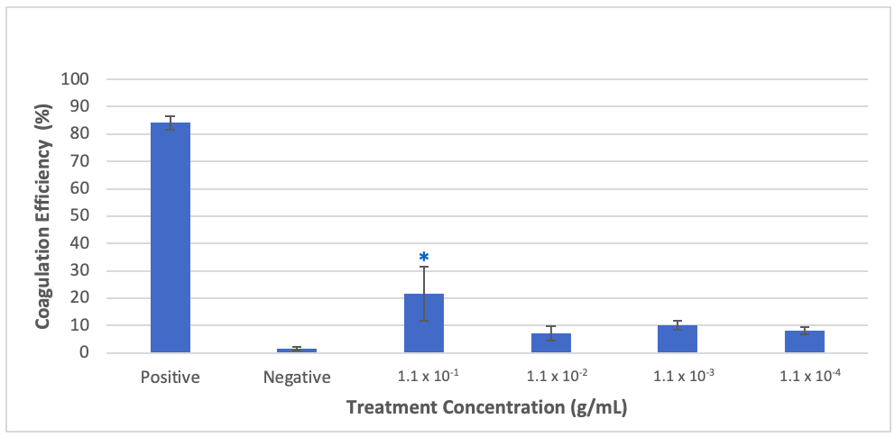

Fig. 1. The coagulation efficiency of A. altilis extract Significant coagulation efficiency compared to the negative control is noted by * on the respective bars (p<0.05). Values are presented as mean + SD (n=3). Error bars represent standard deviation.

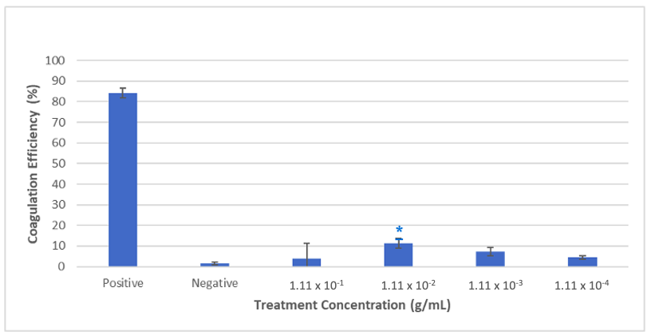

Fig. 2. The coagulation efficiency of N. nouchali. Significant coagulation efficiency compared to the negative control is noted by * on the respective bars (p<0.05). Values are presented as mean + SD (n=3). Error bars represent standard deviation.

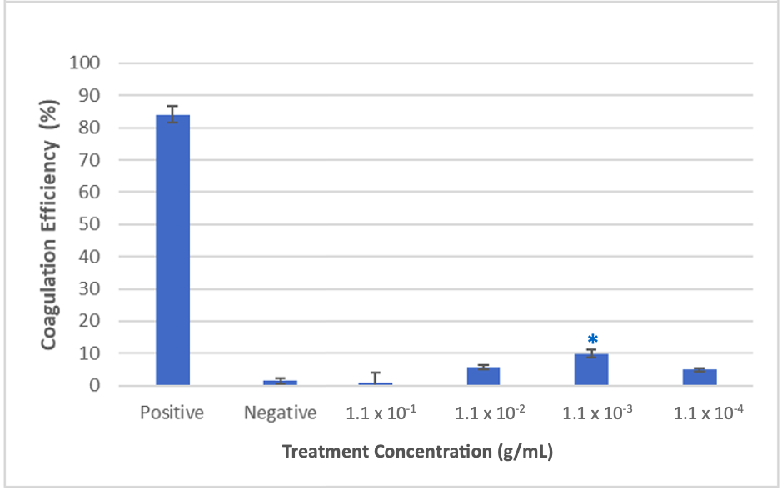

Fig. 3. The coagulation efficiency percentage for N. nouchali and A. altilis as mixed extracts. Significant coagulation efficiency compared to the negative control is noted by * on the respective bars (p<0.05). Values are presented as mean + SD (n=3). Error bars represent standard deviation.

The coagulation efficiency was statistically significant at 10⁻² g/mL concentration of the N. nouchali extract, with a mean reduction in absorbance of 11.19% (SD = 2.36) (p<0.05). The A. altilis concentration with the most statistically significant difference in coagulation efficiency was at 10⁻¹ g/mL and had a mean reduction in absorbance of 21.63% (SD = 9.88) (p<0.05). However, the positive control (FeCl₃) had a significant reduction in turbidity of 84.10% (SD = 2.42) (p<0.05). Based on these results, the extracts with the highest concentration of the coagulant showed the most significant difference in turbidity reduction. Similar results were reported by Desta and Bote, 2021, who used Moringa oleifera powder to treat domestic wastewater. They reported that a dosage of 0.4 g/500 mL was optimal for turbidity removal, with a 99.99% removal in basic water and 95.99% in acidic water. Okra gel had also been reported with significant flocculant activity in a study carried out using industrial waste and sludge (Nair and Rana, 2025). According to a review on use of natural coagulants for wastewater treatment, a continuous progression of publications from 5 to 51, have been noted during 2015 - 2024 years. In addition, the review placed 13 countries as frontiers of using natural extracts in wastewater treatments, bringing Malaysia, Turkey and Oman to first, second and third places in the list (Alazaiza et al., 2025).
The mixed extracts indicated that the coagulation efficiency was statistically significant at 10⁻³ g/mL, with a mean absorbance reduction of 9.86% (p<0.05). The mixed extract concentrations of 10⁻² g/mL and 10⁻⁴ g/mL also had a significant reduction of 5.69% and 4.88%, respectively (p<0.05). Nonetheless, the coagulation efficiency was significantly less in comparison to the positive control (p<0.05).
Active compounds, such as amines, hydroxyl groups, and carboxylic acids, are responsible for the coagulation properties seen in plant-based coagulants (Ravele et al., 2025). Parimala and Shoba, 2013 reported that N. nouchali seed had a composition of 13.92% carbohydrate, 17.47% proteins, and 0.10% lipids. Additionally, its flavonoids, phenolics and tannin composition was 23.55 ± 1.46 QE/g, 179.56 ± 1.59 GE/g, and 195.84 ± 0.8 GE/g, respectively. However, no reports have specifically indicated the phytochemicals present in stem of N. nouchali. A. altilis is also composed of macromolecules, such as carbohydrates, proteins, and lipids. Soifoini et al., 2018 found the composition of A. altilis to be 4.64 ± 0.83 g/100 g sugars, 4.44 g/100 g proteins, and 0.77 g/100 g lipids. Further, the tannins, castalagin and vescalagin, were one of the phenolic groups that was mainly identified, with a composition of 26.59 ± 5.38 mg/100 g castalagin and 15.99 ± 5.65 mg/100 g vescalagin. The composition of active compounds is dependent on the extraction process and the solvent.
There is limited research on coagulation regarding the plants used in the current study. A study by Salazar-Gámez, 2024 showed that A. altilis fruit had a 67.2% turbidity removal. However, this study had a mean absorbance reduction of 21.63% for A. altilis inner peel. Similarly, there is no research on the coagulation properties of N. nouchali, specifically the stem. As A. altilis fruit is a food source, and peel is a waste product, it is important to concentrate on improving the coagulation efficiency of the peel, as it would not affect the sustainability of food source availability. Also, it is important to investigate how to increase the coagulation coefficient of the stem material using different types of sample preparation methods. The use of a water bath shaker to administer mixing may have been aggressive and not uniform, preventing the coagulant from binding to the pollutant's surface area. A more effective concentration may have been found if a wider concentration series had been used. The extraction method used and the differences in the compounds of the peel of A. altilis inner peel and the N. nouchali stem may have limited the final coagulant properties. Thus, further research into obtaining a pure extract or utilizing a different form of the plant (freeze-dried or sun-dried) may prove advanced results.

The Antibacterial Properties of the Extracts
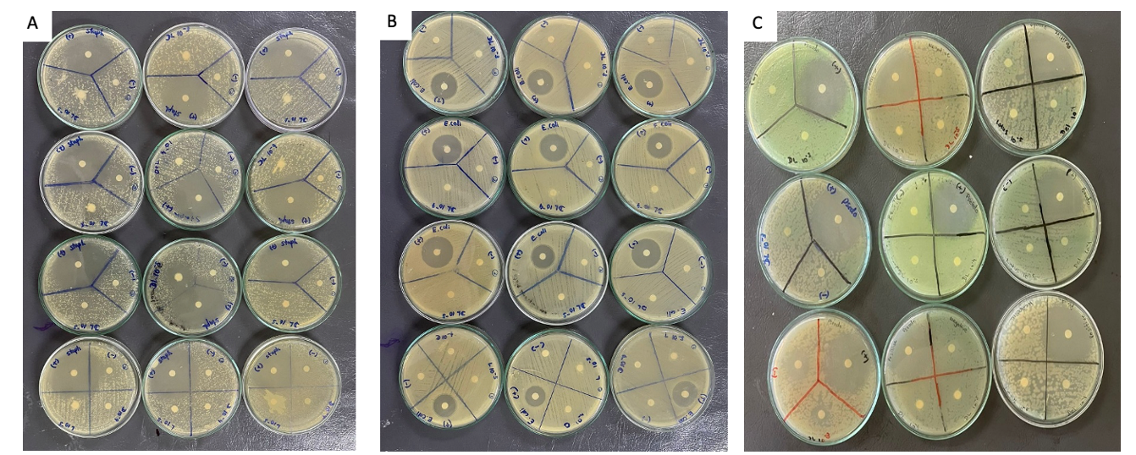
For E. coli and S. aureus, 1% Ampicillin was used as a positive control, while 0.00001% Ciprofloxacin was used for P. aeruginosa. All three bacterial strains, E. coli, S. aureus, and P. aeruginosa, showed a mean zone of inhibition of 24.8 ± 2.78 mm, 42.75 ± 2.38 mm, and 40.5 ± 2.64 mm, respectively, for the positive control, indicating that the antibiotics were effective in inhibiting the growth of these strains when exposed. The negative control using sterile water showed no zone of inhibition, indicating that there was no contamination and there was no other variable affecting the results, thus ensuring that the data was reliable. The concentrations of the PEs that had a significant coagulation efficiency were studied to determine their antibacterial effect. However, there was no zone of inhibition produced by either PE, indicating that there was no antibacterial effect (Figure 4).
Figure 4: Antibacterial activity of the plant extracts that had the highest coagulation property against (A) S. aureus, (B) E. coli, and (C) P. aeruginosa.
No inhibitory effect was observed for the plant extracts, whereas the positive controls displayed effective inhibition, with clear inhibition zones. (+): Positive control; (-): Negative Control: DL: Dilution

A study by Banu. A et al., 2021 investigated the antibacterial properties of the pulp and the peel of A. altilis. They reported that while the antibacterial activity increased with increasing extract concentrations of the pulp and peel, the peel extract had a higher inhibitory potential. For example, when testing against S. aureus, the peel had a maximum inhibitory activity of 23 mm, whereas the pulp was 18 mm. Similarly, the hexane and dichloromethane extracts of the peel had antibacterial activity against S. aureus, but the methanol extract had the highest activity (Jalal et al., 2015). On the other hand, research on the antibacterial properties of N. nouchali, are mostly conducted on the flower and the seeds. One study used the hot percolation method, where the seeds were extracted with ethanol and then evaporated. The seed extract of N. nouchali showed high zones of inhibition of 25 mm and 20 mm for P. aeruginosa and S. aureus, respectively (Parimala and Shoba, 2014). Finally, Dash et al., 2013 reported that the methanol flower extract had greater antibacterial properties instead of the other extracts utilized, with a zone of inhibition of 30 ± 0.18 mm against B. cereus.
The negative results of the PEs may be due to the narrow range of concentrations used, degradation in storage, and incompatibility of the extraction method. Further studies should be done to analyze if the extraction method, storage conditions, and time have any influence on the antibacterial effect. In addition, testing with different McFarland standard concentrations will be required to ensure a more precise evaluation of the antibacterial activity. This might lead to more potentially positive results by supporting the finding of the optimal bacterial density to determine the PE’s efficacy at various doses. The antibacterial activity is likely due to the presence of secondary metabolites like alkaloids, tannins, steroids, phenol, saponins, and flavonoid compounds, which have been previously reported for their antimicrobial property in both the PE (Dash et al., 2013; Soifoini et al., 2021).

The Cytotoxic Properties of the Plant Extracts
The brine shrimp lethality assay is conducted to determine the cytotoxicity of the plant components (Waghulde et al., 2019). As shown in Table 1, the results of the brine shrimp assay showed no significant difference for all concentrations compared to the negative control (p>0.05). The results indicate that neither of the PEs was toxic, as the motility rate was comparatively lower. Even so, to ensure that there are no toxic compounds produced over time, tests should be conducted at regular time intervals. This could help monitor the changes in the composition of the PE and ensure its safety and effectiveness. A study by Sikder et al., 2012 showed that there is a zero-mortality rate for the methanol extract of the flower petals of N. nouchali, while a study done by Eriadi et al., 2022 showed that the ethyl acetate extract of A. altilis (Parkinson's ex F.A. Zorn) Fosberg leaves has high cytotoxic activity for the Brine Shrimp Lethality Test.

Table 1. The effect of the plant extract concentrations with significant coagulation efficiency on brine shrimp mortality.
Sample | Concentration | Mean Mortality Rate (%)
A. altilis | 0.000111 (10⁻³) | 3.33 ± 0.33
N. nouchali | 0.0000111 (10⁻⁴) | 10 ± 1
A. altilis + N. nouchali | 0.00111 (10⁻²) | 0
A. altilis + N. nouchali | 0.000111 (10⁻³) | 13.33 ± 0.88
A. altilis + N. nouchali | 0.0000111 (10⁻⁴) | 3.33 ± 0.33
Positive control (conc. H₂O₂) | - | 100
Negative control | - | 26.67 ± 2.19

Conclusion
This study focuses on the potential of Artocarpus altilis (Park.) Fosh. (Breadfruit) and Nymphaea nouchali Burm. f. (Blue Water Lily) as natural coagulants for waste water treatment. N. nouchali showed significant effects at lower doses (10⁻² g/mL), but A. altilis required a higher dosage (10⁻¹ g/mL) for effective coagulation, however, with significantly lower efficacy to the positive control (a chemical coagulant) utilized in the study. No antibacterial effects were exhibited by the individual or mixed plant extracts, suggestive of further optimization of extraction methods and testing wide concentration series. The brine shrimp lethality assay was used for cytotoxicity testing, and the results indicated that there were no significant toxic effects compared to the positive control used, proving the safety of these extracts for possible application in water treatment. Use of actual waste water samples, scaling up and cost analysis of use these plant waste material would be added advantages in this line of study for progression.
With future studies concentrating on enhancing the extraction procedure, producing a pure extract, or using a different plant material form (sun- or freeze-dried), the peel of A. altilis and stem of N. nouchali could be used as an environment friendly coagulant, sans toxic effects advanced results.

COMPETING INTERESTS DISCLAIMER:
Authors have declared that they have no known competing financial interests OR non-financial interests OR personal relationships that could have appeared to influence the work reported in this paper.

Disclaimer (Artificial intelligence)

Author(s) hereby declare that NO generative AI technologies such as Large Language Models (ChatGPT, COPILOT, etc.) and text-to-image generators have been used during the writing or editing of this manuscript.

References
Alazaiza, M.Y., Alzghoul, T.M., Nassani, D.E. and Bashir, M.J., 2025. Natural coagulants for sustainable wastewater treatment: current global research trends. Processes, 13(6), p.1754.
Ali, Eman N., Suleyman A. Muyibi, Hamzah M. Salleh, Md Zahangir Alam, and Mohd Ramlan M. Salleh. 2010. “Production of Natural Coagulant from Moringa oleifera Seed for Application in Treatment of Low Turbidity Water.” Journal of Water Resource and Protection, 2(3): 259–266. 10.4236/jwarp.2010.23030.
Al-Mamun, Abdullah, and Ahmad Tsaqif A. Basir. 2016. “White Popinac as Potential Phyto-Coagulant to Reduce Turbidity of River Water.” ARPN Journal of Engineering and Applied Sciences, 11(11): 7180–7183. https://www.researchgate.net/publication/306208208_White_popinac_as_potential_phyto-coagulant_to_reduce_turbidity_of_river_water.
Banu, A. Saffiya, Sheila John, Sarah Jane Monica, Priyadarshini S., and Sivaraj C. 2021. “Comparative Evaluation of Bioactive Compounds, Antioxidant and Antibacterial Activities of Pulp and Peel Extracts of Breadfruit (Artocarpus altilis)—An Underutilized Fruit.” The Journal of Indian Botanical Society, 101(3): 204–213. 10.5958/2455-7218.2021.00024.3.
Bratby, John. 2006. Coagulation and Flocculation in Water and Wastewater Treatment. 2nd ed. London, UK: IWA Publishing.
Daruliza, K. M. A., K. L. Yang, K. L. Lam, J. T. Priscilla, E. Sunderasan, and M. T. Ong. 2011. “Anti-Candida albicans Activity and Brine Shrimp Lethality Test of Hevea brasiliensis Latex B-Serum.” European Review for Medical and Pharmacological Sciences, 15(10): 1163–1171. https://pubmed.ncbi.nlm.nih.gov/22165677/.
Dash, Biplab Kumar, Monokesh Kumer Sen, Khasrul Alam, Kamal Hossain, Rezuanul Islam, Nilufa Akhter Banu, Shahedur Rahman, and Abu Hena Mostofa Jamal. 2013. “Antibacterial Activity of Nymphaea nouchali (Burm. f) Flower.” Annals of Clinical Microbiology and Antimicrobials, 12(1): 27. https://doi.org/10.1186/1476-0711-12-27.
Desta, Wendesen Mekonin, and Million Ebba Bote. 2021. “Wastewater Treatment Using a Natural Coagulant (Moringa oleifera Seeds): Optimization through Response Surface Methodology.” Heliyon, 7(11): e08451. https://doi.org/10.1016/j.heliyon.2021.e08451.
Eriadi, Aried, Dwi Dinni Aulia Bakhtra, Sonia Septi Maelani, and Ully Chairunisa. 2022. “Cytotoxic Test of Ethyl Acetate Extract of Breadfruit Leaves (Artocarpus altilis (Parkinson’s ex F.A. Zorn) Fosberg) by Brine Shrimp Lethality Test Method.” International Journal of Research Publication and Reviews, 3(11): 3120–3124. https://doi.org/10.55248/gengpi.2022.3.11.43.
Jagtap, U. B., and V. A. Bapat. 2010. “Artocarpus: A Review of Its Traditional Uses, Phytochemistry and Pharmacology.” Journal of Ethnopharmacology, 129(2): 142–166. https://doi.org/10.1016/j.jep.2010.03.031.
Jalal, Tara Kamal, Idris Adewale Ahmed, Maryam Mikail, Lailuma Momand, Samsul Draman, Muhammad Lokman Md Isa, Mohammad Syaiful Bahari Abdull Rasad, Muhammad Nor Omar, Muhammad Ibrahim, and Ridhwan Abdul Wahab. 2015. “Evaluation of Antioxidant, Total Phenol and Flavonoid Content and Antimicrobial Activities of Artocarpus altilis (Breadfruit) of Underutilized Tropical Fruit Extracts.” Applied Biochemistry and Biotechnology, 175: 3231–3243. https://doi.org/10.1007/s12010-015-1499-0.
Jangir, Lokesh Kumar, Apoorva Singh, Abhishek R. Rai, Varad Nagar, Garima Awasthi, Poonam Kumari, Ragini Gupta, Kumud Kant Awasthi, Kamlendra Awasthi, and Mahipal Singh Sankhla. 2024. “Green Solution for Heavy Metal Removal: Utilizing Banana Peel Waste as a Sustainable and Effective Adsorbent.” Letters in Applied NanoBioScience, 13(2): 95. https://doi.org/10.33263/LIANBS132.095.
Jenkins, Rowena, and Sarah Maddocks. 2019. “Antimicrobial Testing.” In Bacteriology Methods for the Study of Infectious Diseases, 73–97. Amsterdam, Netherlands: Elsevier.
Karim, Mobarok, Tahera Lasker, Ali Zaber Sahin, Shajjad Hossain, and Heru Agung Saputra. 2023. “Low-Cost Production of Chitosan Biopolymer from Seafood Waste: Extraction and Physiochemical Characterization.” Journal of Research Updates in Polymer Science, 12: 17–26. 10.6000/1929-5995.2024.13.03.
Ke, Cai-Ling, Fu-Sheng Deng, Chih-Yu Chuang, and Ching Hsuan Lin. 2021. “Antimicrobial Actions and Applications of Chitosan.” Polymers, 13(6): 904. https://doi.org/10.3390/polym13060904.
Khursheed, Aadil, Manzoor A. Rather, Vikrant Jain, Ab Rouf Wani, Shahid Rasool, Rukhsana Nazir, Nisar Ahmad Malik, and Sheikh Abdul Majid. 2022. “Plant Based Natural Products as Potential Ecofriendly and Safer Biopesticides: A Comprehensive Overview of Their Advantages over Conventional Pesticides, Limitations and Regulatory Aspects.” Microbial Pathogenesis, 173: 105854. doi.org/10.1016/j.micpath.2022.105854.
Kiranmai, Basani, Mondi Sandhyarani, and Ashok Kumar Tiwari. 2023. “Water Lily (Nymphaea nouchali Burm. f): An Ancient Treasure of Food and Medicine.” Pharmacognosy Research, 15(2): 226–234. 10.5530/pres.15.2.024.
Koul, Bhupendra, Nargis Bhat, Mustapha Abubakar, Meerambika Mishra, Ananta Prasad Arukha, and Dhananjay Yadav. 2022. “Application of Natural Coagulants in Water Treatment: A Sustainable Alternative to Chemicals.” Water, 14(22): 3751. https://doi.org/10.3390/w14223751.
Lemma, M., A. W. Kalsido, and M. W. Wotee. 2024. “Removal of River Water Turbidity and Total Dissolved Solids Using Natural Coagulants Derived from Banana Peel and Moringa stenopetala Seed.” AQUA - Water Infrastructure, Ecosystems and Society, 73(7): 1467–1493. https://doi.org/10.2166/aqua.2024.130.
Mehta, Kervyn Ajay, Yu Chin Rina Quek, and Christiani Jeyakumar Henry. 2023. “Breadfruit (Artocarpus altilis): Processing, Nutritional Quality, and Food Applications.” Frontiers in Nutrition, 10: 1–15. https://doi.org/10.3389/fnut.2023.1156155.
Nada, M. Jawi, Bint Sasud Al-Saud Najla, Othman Y. Alyahyawy, and Salah E. M. Abo-Aba. 2025. “Water Contamination and Disinfection: A Review.” Journal of Pioneering Medical Sciences, 14(2): 96–102. https://doi.org/10.47310/jpms2025140215.
Nair, A.S. and Rana, M.M., 2025. To Study the Wastewater Treatment Using Bio Flocculants Okra Gel: Green Chemistry Approach for a Safe Environment. Biosys J Biotechnol Bioeng, 1(1), pp.01-09.
Nicole Estudillo, P.M. and Tolentino, J.H.G., 2024. Antioxidant and Antiproliferative Properties of Artocarpus altilis (Breadfruit) and Artocarpus odoratissimus (" Marang") Fruit Wastes. Philippine Journal of Science, 153(5).
Nitola, J.C., Moreno, L.M. and Medina, O.J., 2025. Application of Magnetized Cacti Biomass as Flocculants in Water Treatment. Waste and Biomass Valorization, pp.1-16.
Owhonka, A., E. F. Fubara, and O. B. Justice. 2021. “Wastewater Quality—Its Impact on the Environment and Human Physiology: A Review.” International Journal of Advance Research and Innovation, 9(4): 43–58. 10.51976/ijari.942107.
Owodunni, Amina Adedoja, and Suzylawati Ismail. 2021. “Revolutionary Technique for Sustainable Plant-Based Green Coagulants in Industrial Wastewater Treatment—A Review.” Journal of Water Process Engineering, 42: 102096. https://doi.org/10.1016/j.jwpe.2021.102096.
Parimala, Mabel, and Francis Gricilda Shoba. 2013. “Phytochemical analysis and in vitro antioxidant acitivity of hydroalcoholic seed extract of Nymphaea nouchali Burm. f.” Asian Pacific Journal of Tropical Biomedicine, 3(11): 887 – 895. https://doi.org/10.1016/S2221-1691(13)60174-4.
Parimala, Mabel, and Francis Gricilda Shoba. 2014. “In Vitro Antimicrobial Activity and HPTLC Analysis of Hydroalcoholic Seed Extract of Nymphaea nouchali Burm. f.” BMC Complementary and Alternative Medicine, 14: 361. https://doi.org/10.1186/1472-6882-14-361.
Kiranmai, B., Sandhyarani, M. and Tiwari, A.K., 2023. Water Lily (Nymphaea nouchali Burm. f): An Ancient Treasure of Food and Medicine. Pharmacognosy Research, 15(2).
Ravele, Murendeni P., Olalekan C. Olatunde, Opeyemi A. Oyewo, Seshibe S. Makgato, and Damian C. Onwudiwe. 2025. “Plant-based coagulants for wastewater treatment: Recent advances and applications.” Cleaner Water, 4: 100147. https://doi.org/10.1016/j.clwat.2025.100147.
Salazar-Gámez, L., M. Luna-delRisco, Edgar Narváez-Jojoa, R. Salazar-Cano, Diana Rosales-Delgado, David Pinchao, Edson Ivan Santander-Yela, et al. 2024. “Turbidity Removal Performance of Selected Natural Coagulants for Water Treatment in Colombian Rural Areas.” Civil Engineering Journal, 10(2): 655–667. doi.org/10.28991/CEJ-2024-010-02-020.
Saravanan, A., P. Senthil Kumar, Sunita Varjani, S. Jeevanantham, P. R. Yaashikaa, P. Thamarai, B. Abirami, and Cynthia Susan George. 2021. “A Review on Algal-Bacterial Symbiotic System for Effective Treatment of Wastewater.” Chemosphere, 271: 129540. https://doi.org/10.1016/j.chemosphere.2021.129540.
Sarma, H., Sahariah, G., Bharadwaj, A., Sharma, D., Porasar, P. and Dutta, K.N., 2024. A systematic review on botanical background, phytochemical and pharmacological properties of Nymphaea nouchali. Journal of Applied Pharmaceutical Research, 12(6), pp.21-36.
Saravanathamizhan, R., and V. T. Perarasu. 2021. “Improvement of Biodegradability Index of Industrial Wastewater Using Different Pretreatment Techniques.” In Wastewater Treatment: Cutting Edge Molecular Tools, Techniques and Applied Aspects, edited by Maulin P. Shah, Angana Sarkar, and Sukhendu Mandal, 103–136. Amsterdam, Netherlands: Elsevier.
Sheeba, N.L., Devi, L.R., Esakki, E.S. and Sundar, S.M., 2025. An approach to improve sustainability: performance of Strychnos potatorum seed as a natural coagulant in water treatment at tourist sites. EQA-International Journal of Environmental Quality, 68, pp.13-20.
Sikarwar, Mukesh S. 2016. “Nutraceutical and Medicinal Value of Breadfruit [Artocarpus altilis (Parkinson) Fosberg].” In Tropical Agriculture, 93: 70–76. https://journals.sta.uwi.edu/ojs/index.php/ta/article/view/6510.
Sikder, Al Amin, Hasnin Rahman Jisha, Ruhul Kuddus, Farhana Rumi, Mohammad A. Kaisar, and Mohammad A. Rashid. 2012. “Evaluation of Bioactivities of Nymphaea nouchali (Burm. f)—the National Flower of Bangladesh.” Bangladesh Pharmaceutical Journal, 15(1): 1–5. https://www.researchgate.net/publication/266487888_Evaluation_of_Bioactivities_of_Nymphaea_nouchali_Burm_f_-_the_National_Flower_of_Bangladesh.
Soifoini, Toilibou, Dario Donno, Victor Jeannoda, Ernest Rakotoniaina, Soule Hamidou, Said Mohamed Achmet, Noe Rene Solo, Kamaleddine Afraitane, Cristina Giacoma, and Gabriele Loris Beccaro. 2018. “Bioactive Compounds, Nutritional Traits, and Antioxidant Properties of Artocarpus altilis (Parkinson) Fruits: Exploiting a Potential Functional Food for Food Security on the Comoros Islands.” Journal of Food Quality, 5697928. https://doi.org/10.1155/2018/5697928.
Soifoini, Toilibou, Dario Donno, Victor Jeannoda, Danielle Doll Rakoto, Ahmed Msahazi, Saidi Mohamed Mkandzile Farhat, Mouandhoime Zahahe Oulam, and Gabriele Loris Beccaro. 2021. “Phytochemical Composition, Antibacterial Activity, and Antioxidant Properties of the Artocarpus altilis Fruits to Promote Their Consumption in the Comoros Islands as Potential Health-Promoting Food or a Source of Bioactive Molecules for the Food Industry.” Foods, 10(9): 2136. https://doi.org/10.3390/foods10092136.
Sultana, Marzia, Mahbub Hasan Rownok, Meherunnesa Sabrin, Md Hafezur Rahaman, and S. M. Nur Alam. 2022. “A Review on Experimental Chemically Modified Activated Carbon to Enhance Dye and Heavy Metals Adsorption.” Cleaner Engineering and Technology, 6: 100382. https://doi.org/10.1016/j.clet.2021.100382.
UN. 2020. UN World Water Development Report. United Nations Educational, Scientific and Cultural Organization. Vol. 88. https://www.unwater.org/publications/un-world-water-development-report-2023.
Waghulde, Sandeep, Mohan K. Kale, and Vijay R. Patil. 2019. “Brine Shrimp Lethality Assay of the Aqueous and Ethanolic Extracts of the Selected Species of Medicinal Plants.” Proceedings, 41(1): 47. https://doi.org/10.3390/ecsoc-23-06703.
World Health Organization. 2023. “Drinking Water.” World Health Organization. https://www.who.int/news-room/fact-sheets/detail/drinking-water.
Zainol, Noorazwani, Norhayati Mohamed Noor, Dayang Norulfairuz Abang Zaidel, Zarani Mat Taher, Muna Mohamed, and Norasiah Sadek. 2022. “Breadfruit (Artocarpus altilis) Studies: Rheological Stability, Incorporation of Gluten Free, and Bioactive Compound as an Intermediate Ingredient in Health-Related Products.” ECS Transactions, 107(1): 14455. 10.1149/10701.14455ecst.
Zakwan, M., Sutriana, A., Asmilia, N., Ammar, M. and Novianti, A.N., 2023. Toxicity Test of Flavonoid Compounds from Ethyl Acetate Extract of Malacca Leaves with Brine Shrimp Lethality Test. Jurnal Medik Veterinar, 6(3).

