Case report

Successful Treatment of Chronic Ulcerative Facial Scar Using Multimodal Regenerative Therapy: A Case Report

.
ABSTRACT

Aims
To report successful management of a chronic ulcerative facial scar following ablative laser therapy using multimodal regenerative treatment combining photobiomodulation and fractional laser.
Presentation of Case
A 29-year-old female presented with a 3 cm ulcerative scar on the left cheek secondary to undocumented ablative laser treatment. The lesion showed persistent granulation tissue, fibrinous exudate, and poor healing. Initial management included mechanical debridement to remove fibrin and necrotic debris, followed by surgical suturing to approximate the wound edges. A multimodal approach was implemented, consisting of four sessions of red and near-infrared light-emitting diode photobiomodulation therapy combined with five sessions of fractional ablative Erbium:YAG laser. This regimen resulted in approximately 80% clinical improvement, with the Vancouver Scar Scale decreasing from 11 to 2.
Discussion
Chronic ulcerative scars after ablative laser therapy remain uncommon but challenging, often resulting from prolonged inflammation, impaired re-epithelialization, and collagen disorganization. The combination of photobiomodulation and fractional Erbium:YAG laser likely promoted tissue regeneration through mitochondrial stimulation, reduced inflammation, enhanced angiogenesis, and controlled neocollagenesis. Photobiomodulation accelerates wound closure and modulates inflammatory pathways, while fractional laser induces microthermal zones that trigger collagen remodeling and scar maturation. This synergistic effect appears particularly effective for chronic ulcerative scars, offering a safe, non-invasive alternative to prolonged conservative care or more aggressive interventions.
Conclusion
Early multimodal therapy combining photobiomodulation and fractional ablative Erbium:YAG laser is highly effective for managing chronic ulcerative facial scars post-ablative laser, achieving rapid healing and excellent aesthetic outcomes.

Keywords: hyaluronic acid, laser therapy, light-emitting diode therapy, scars, wound healing.

1. INTRODUCTION

Scar formation is an outcome of the wound healing process in tissues damaged by physical injury, surgical incisions, or inflammatory disorders of the skin (Osman et al., 2024). Although they may seem like cosmetic concerns, they do have a significant impact on physical health, such as limiting mobility, pain, itching, and also on mental health, causing low self-esteem and social isolation (Chowdhury et al., 2021). Various modalities have been employed for scar treatment with varying success(Hsieh et al. 2021). Ablative lasers, such as erbium: yttrium-aluminum-garnet (Erbium: YAG) and LED (light-emitting diode) therapy, improve scar appearance by modulating skin fibrosis and reducing pro-inflammatory signals (El-Orabi et al. 2022) showing a promising efficacy in scar management. We report a case of successful management of a chronic ulcerative facial scar following ablative laser therapy using a multimodal regenerative protocol combining photobiomodulation and fractional ablative laser. This approach highlights the therapeutic interest of early non-invasive regenerative treatment to accelerate healing, significantly improve scar quality, and achieve excellent aesthetic outcomes in post-laser ulcerative complications.

2. Presentation of Case

A 29-year-old female patient presented to our center with a chronic ulcerative scar on the left cheek, secondary to prior laser treatment of an undocumented lesion that developed 18 months earlier and subsequently progressed to ulceration. Clinical examination revealed an oval-shaped ulceration lesion, measuring approximately 3 cm in major axis, well-demarcated, with a clean surface, a fibrous base, and areas of granulation tissue (Figure 1). We started with mechanical debridement to clear the fibrin, followed by surgical suture to bring the edges together and accelerate healing, resulting in a linear scar (Figure 2). The multimodal regenerative treatment was administered over 16 weeks. This consisted of four sessions of red and near-infrared light-emitting diode (LED) photobiomodulation therapy (625 to 940 nm, every 15 days) combined with five sessions of fractional ablative Erbium: YAG laser (Fotona F-Runner, 2940 nm) performed at 4-week intervals, with fluence progressively reduced from 100 J to 45 J, frequency ranging from 10 to 20 Hz, and 10% coverage. Intradermal mesotherapy with hyaluronic acid was performed concomitantly during each laser session to enhance hydration and tissue regeneration (Figure 3). Upon completion of treatment, the scar exhibited approximately 80% clinical improvement, with the Vancouver Scar Scale score decreasing from 11 to 2 (Figure 4). No adverse effects, such as transient erythema, pain, edema, blistering, or other post-procedural reactions, were observed during or after the treatment sessions. Post-laser care instructions included strict sun protection (SPF 50+ applied daily), topical fusidic acid antibiotic cream for 10 days, application of barrier creams, avoidance of irritants and makeup for 7–10 days after each session, and gentle cleansing with non-soap, fragrance-free products.

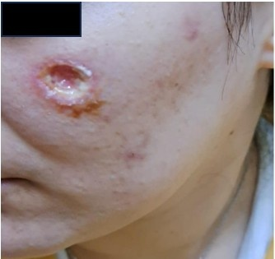

Figure 1: Baseline clinical appearance of the chronic ulcerative facial scar on the left cheek before treatment, showing a 3 cm well-demarcated oval lesion with persistent granulation tissue, fibrinous exudate, and poor re-epithelialization.

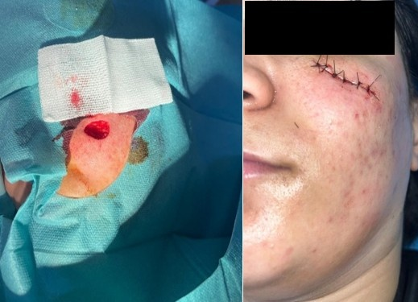

Figure 2: Immediate postoperative view following mechanical debridement to remove fibrin and necrotic debris, followed by precise surgical excision and layered suturing to achieve tension-free wound closure.

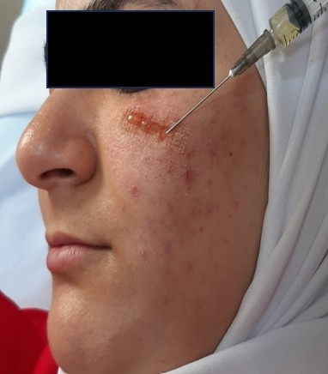

Figure 3: Intraoperative view during fractional ablative Erbium:YAG laser resurfacing (Fotona F-Runner, 2940 nm) combined with concomitant intradermal hyaluronic acid mesotherapy to enhance hydration and tissue regeneration.

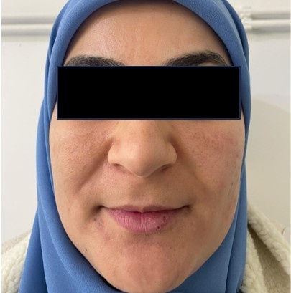

Figure 4: Final clinical appearance at the end of multimodal regenerative therapy, demonstrating significant improvement in scar texture, color, and pliability, with the Vancouver Scar Scale (VSS) reduced from 11 to 2.

3. Discussion

The skin is the most vulnerable organ, constantly exposed to potential injury. Chronic ulcerative scars are a rare but serious and devastating complication that can occur after ablative or fractional laser resurfacing of the skin (Schmidt et al. 2025), particularly on the face, where the skin is thin and more susceptible to damage. This complication can arise from excessive thermal injury, delayed re-epithelialization, secondary infections, or abnormal wound healing, leading to prolonged ulceration, crusting, and eventual atrophic or hypertrophic scarring (Prohaska et al.2025). Areas that present with pruritus, prolonged erythema, and delayed healing, which may become hardened or red, are more susceptible to scarring after resurfacing procedures, particularly in the cervicofacial region and over bony prominences such as the malar area (Costa et al. 2011). As noted, this is particularly relevant in our patient, where a chronic ulcerative scar is present on the left cheek, a region with thin overlying skin and a bony prominence, indicating its role in delaying healing and ulceration. Wound healing involves hemostasis, inflammation, proliferation, and remodeling (Magni et al. 2022). Treatment targets reduction of inflammation, collagen remodeling, and physical scar modification, often requiring multimodal approaches (Elsaie et al. 2010). Debridement of necrotic tissue and fibrinous exudate is a key initial step in managing chronic ulcerative wounds, as it reduces bacterial load and prepares a viable bed for subsequent therapies (Manna et al. 2025). In selected cases, surgical scar revision with precise excision and layered suturing can achieve tension-free closure and improve aesthetic outcomes (Căiţă et al. 2024). Lasers are used to remodel scars, with better results when treatment is initiated early (Akl et al. 2025). This specific combination therapy, fractional Erbium: YAG laser followed by LED photobiomodulation and intradermal hyaluronic acid, was chosen to address the distinct yet overlapping phases of pathological wound healing present in chronic ulcerative scars. The fractional ablative Erbium: YAG laser (2940 nm) promotes neocollagenesis and collagen remodeling through the creation of microthermal zones, followed by transepidermal elimination of debris (Yumeen et al. 2025). Red and near-infrared LED therapies (630–830 nm) enhance wound healing by photobiomodulation, stimulating the proliferation of fibroblasts, increasing type 1 collagen and MMP-9, decreasing MMP-1, stimulating angiogenesis, cytokine release (TNF-alpha, IL-1, IL-6), reducing reactive oxygen species (ROS) and interleukins (Ngoc et al. 2023). The association of the fractional Erbium: YAG laser with LED therapy was found to be more efficient and superior to the fractional Erbium: YAG laser alone (Osman et al., 2024), which demonstrated that patients in the combination group exhibited greater improvement in scar depth, erythema, and overall clinical outcomes in postsurgical and post-traumatic scars. This finding supports the synergistic effect of combining ablative fractional resurfacing with photobiomodulation. Furthermore, in the context of wound healing,(Martins et al. 2025) showed that adjuvant photobiomodulation significantly accelerated the healing process in chronic leg ulcers compared to conventional treatment alone, with the intervention group demonstrating statistically significant reductions in wound area and exudation, highlighting its role as a valuable adjunct for resolving ulcerative components. Regarding scar remodeling,(Osman and Kassab 2024) reported that the fractional Erbium: YAG laser was highly effective in treating both immature and mature scars, with significant improvements in vascularity, pliability, and height, reinforcing its position as a cornerstone in scar revision. The synergy of these therapies, as selected for our patient, is therefore not only biologically plausible but also supported by emerging clinical evidence demonstrating their superior efficacy when used in combination. On the other hand, intradermal mesotherapy with hyaluronic acid provides hydration, anti-inflammatory effects, skin rejuvenation, and regeneration(Scarano et al. 2025). It is therefore an important tool for improving the pliability of scars.

4. Conclusion

Facial scarring is known to cause considerable psychosocial distress and can negatively impact quality of life. The combination of intralesional hyaluronic acid injection, laser treatments, and LED therapy in the early stage of wound healing has demonstrated a significant positive effect on scar aesthetic outcomes in this case. This manuscript is important because it presents a useful approach for managing a difficult condition, namely chronic ulcerative facial scar after laser treatment. Such complications are uncommon but challenging to treat, especially on the face, where cosmetic outcome is of major importance. The combined therapy, including photobiomodulation and fractional laser, shows promising results and may guide clinicians facing similar cases. This case report adds practical clinical value and may contribute to improving patient care in dermatology and aesthetic medicine. Larger cohort studies are needed to confirm the effectiveness and long-term safety of this multimodal regenerative strategy.

Disclaimer (Artificial intelligence)

Author(s) hereby declare that NO generative AI technologies such as Large Language Models (ChatGPT, COPILOT, etc.) and text-to-image generators have been used during the writing or editing of this manuscript.

Consent section
Written informed consent was obtained from the patient for publication of this case report and accompanying images. A copy of the written consent is available for review by the Editorial office/Chief Editor/Editorial Board members of this journal

References

- Osman MA, Samy NA, Jasim AS. (2024). Efficacy of fractional 2940-nm erbium:yag laser combined with platelet-rich plasma versus its combination with low-level laser therapy for scar revision. Journal of Clinical and Aesthetic Dermatology, 17(11), 39-44. PMID: 39758221
- Chowdhury B, Kassir M, Salas-Alanis J, Nistico S, Galadari H, Fritz K, et al. (2021). Laser in surgical scar clearance: an update review. Journal of Cosmetic Dermatology, 20(12), 3808–3811. https://doi.org/10.1111/jocd.14325
- Hsieh JC, Maisel-Campbell AL, Joshi CJ, Zielinski E, Galiano RD. (2021). Daily quality-of-life impact of scars: an interview-based foundational study of patient-reported themes. Plastic and Reconstructive Surgery Global Open, 9(4), e3522. doi: 10.1097/GOX.0000000000003522. PMID: 33868874
- El-Orabi RA, El-Hadidy MR, El-Sabbagh AH. (2022). Assessment and management of immature facial scars by non-surgical methods. Chinese Journal of Plastic and Reconstructive Surgery, 4(2), 67-73. https://doi.org/10.1016/j.cjprs.2022.06.004
- Schmidt TR, Mármora BC, Brochado FT, Gonçalves L, Campos PS, Lamers ML, et al. (2025). Red light-emitting diode on skin healing: an in vitro and in vivo experimental study. Anais Brasileiros de Dermatologia, 100(1), 54–62. https://doi.org/10.1016/j.abd.2024.02.008
- Prohaska J, Hohman MH. (2025). Laser complications. In: StatPearls [Internet]. Treasure Island (FL): StatPearls Publishing. PMID: 30335281
- Costa FB, El Ammar ABPC, Campos VB, et al. (2011). Complications in laser dermatologic surgery. Part II: fractional and non-fractional ablative laser and fractional non-ablative laser. Surgical and Cosmetic Dermatology, 3(2), 135-146.
- Magni G, Tatini F, Siena GD, Pavone FS, Alfieri D, Cicchi R, et al. (2022). Blue-led-light photobiomodulation of inflammatory responses and new tissue formation in mouse-skin wounds. Life (Basel), 12(10), 1564. https://doi.org/10.3390/life12101564
- Elsaie M, Choudhary S. (2010). Lasers for scars: a review and evidence-based appraisal. Journal of Drugs in Dermatology, 9(11), 1355–1362. PMID: 21061757
- Manna B, Nahirniak P, Morrison CA. (2025). Wound debridement. In: StatPearls [Internet]. Treasure Island (FL): StatPearls Publishing. PMID: 29939659
- Căiţă GA, Lascu CF, Bodog FD, Buhaş CL, Voiţă-Mekeres F, Voiţă GF. (2024). Surgical scar management - an evaluation of surgical techniques. Medicine and Pharmacy Reports, 97(2), 149–153. https://doi.org/10.15386/mpr-2701
- Akl J, El Hajj H, Jeha D, Habre M. (2025). A multimodal approach to the early treatment of a facial scar: a case report. Clinical Case Reports, 13(8), e70719. https://doi.org/10.1002/ccr3.70719Digital Object Identifier (DOI)
- Yumeen S, Hohman MH, Khan T. (2025). Laser erbium-yag resurfacing. In: StatPearls [Internet]. Treasure Island (FL): StatPearls Publishing. PMID: 32809766
- Ngoc LTN, Moon J, Lee Y. (2023). Utilization of light‐emitting diodes for skin therapy: systematic review and meta‐analysis. Photodermatology, Photoimmunology and Photomedicine, 39(4), 303–317.https://doi.org/10.1111/phpp.12841
- Martins AGE, Ruas EFG, Prado PF, Souto SGT, Pimenta HES, Nascimento JE, et al. (2024). Use of photobiomodulation in the healing of difficult-to-heal leg ulcers: A randomized clinical trial. Seven Editora Academic Research, 7(4), 1-12. https://doi.org/10.56238/arev7n4-228
- Osman MA, Kassab AN. (2024). Fractional Er:YAG laser versus fractional CO2 laser in the treatment of immature and mature scars: A comparative randomized study. Archives of Dermatological Research, 316(2), 75. https://doi.org/10.1007/s00403-023-02764-6
- Scarano A, Qorri E, Sbarbati A, Gehrke SA, Marchetti M, Desiderio V, et al. (2025). Mesotherapy with hyaluronic acid solutions enriched by amino acids in the neck area: open-label uncontrolled, monocentric study. Journal of Cosmetic and Laser Therapy, 27(4–5), 121–126. https://doi.org/10.1080/14764172.2025.2502380

