MULTI-ENVIRONMENTS EVALUATION OF ELITE MUTANT LINES OF IMPROVED GINGER FOR YIELD STABILITY AND SELECTION

ABSTRACT:
A multi-location evaluation of 15 improved elite ginger mutant lines was conducted in the 2023 and 2024 cropping seasons across 10 states in Nigeria. The states were Abia, Bauchi, Benue, Borno, Cross River, Kaduna, Nasarawa, Osun, Plateau and FCT. The objective of the work was to evaluate the newly developed improved ginger lines across the major producing areas in Nigeria to ascertain their yield potential, yield stability ,adaptability and suitability for selection. The experiment was laid out in a Randomized Complete block Design with 3 replications. Data were collected on yield- related traits including plant height, number of tillers per plant, number of rhizome fingers, rhizome length and rhizome yield.The combined analysis of variance showed that Genotype , Environment, Genotype by Environment Interaction(GEI) and Years were significant at P< 0.01 and P< 0.05 for all yield related traits but no significant difference in G xY interaction in rhizome yield . Multivariate analysis using AMMI and GGE biplots was performed to identify stable and high- yielding ginger mutant lines. The AMMI analysis of variance showed a high level of environmental effect, accounting for a larger percentage of 66.5% (plant height) , 52.43% ( rhizome fingers ) , 46.26% ( numbers of tillers) ,40.95% ( rhizome length) and 49.10% ( rhizome yield) of the total variation across all yield components. The interaction sum of squares was partitioned into IPCA 1 and IPCA 2 which joinly accounted for the total variations with IPCA 1 being significant in plant height (10.85%) ,Tillers (9.0%), rhizome fingers (8.05%) , rhizome length (5.53%) and rhizome yield(8.06%) .The GGE biplot analysis was used to visualize the relationship between tester environment and the ginger mutant lines to determine the Which-Won-Where portion which reveals the stability of genotypes. The GGE biplot explained 88.2% of the total variation in rhizome yield attributable to genotype and GE interactions. The E4 (Cross River) and E10 ( Abia) were the most discriminatory environments for rhizome yield. The polygon view of the GGE biplot for rhizome yield identified the best genotypes for the environment and the result showed G13(UG2-5-49) as winner in the mega environment of E4(Cross River) and E10(Abia). Two environments E1 (Bauchi) ,E7(FCT) favors UG2-5-04, UG2-5-52,UG2-9-01 ,UG1-13-02) while the environments E2 (Benue) ,E3(Borno), E5(Kaduna) ,E8(Osun) and E9(Plateau) favors UG1-11-07, UG1-5-31 and UG2-5-48. From multiple environment testing, five best- performing genotypes with relative stability across all yield attributes were identified and selected. These genotypes are UG1-11-03, UG1-13-02, UG2-5-04, UG2-5-49 and UG2-9-01. These genotypes will be recommended for registration and release to farmers.

Keywords:Environment, Genotypes, Interactions, Mutants, Stability,Variations,Biplots

INTRODUCTION
Ginger (Zingiber officinale.Rosc.) is a monocotyledonous perennial herb in the family Zingiberaceae, grown mainly for its spicy and aromatic rhizomes . It is an important plant with several medicinal and nutritional values(Kela, et.al, 2023) and it is cultivated in many tropical and subtropical countries (Ashraf, et al. 2014). Ginger is used to treat diarrhoea, nausea, asthma, and respiratory disorders (Osabor et.al, 2015). It has been reported to aid digestion, boost the immune system and reduce cholesterol level (Yakubu, 2007). It can be steeped in boiling water to make ginger tea or used as flavour for cookies and cakes. Globally, ginger is available in various forms including as raw ginger, dry ginger, bleached dry ginger, ginger powder, ginger oil, ginger candy and ginger beverage. Ginger is one of the most important ingredient used in food processing industries(Mary,et.al.2021). In most Nigerian homes, ginger is mainly used as spice to flavour a variety of dishes and drinks such as stew, rice, pap, "kunu", "zobo" and "burukutu".
Ginger is cultivated in more than 25 countries worldwide, but India, Nigeria, Nepal, China, Indonesia, Thailand, Korea, Philippines, Australia and Malaysia are the main producers. India is the largest producer of ginger accounting for about 42.67% of global production while Nigeria produces 734.3 thousand metric tons acounting for only 16.99% globally(Statista ,2025). Nigeria is the largest producer and exporter of ginger in Africa and ranks second globally but the land area unde the cultivation of ginger is about 56.23% of the total global area followed by India with 23.6% and China with only 4.47% land area. This depict low yield performance of ginger on farmers field in Nigeria. The low yield is ascribed to unimproved varieties cultivated by the farmers. The production trend therefore is low due to poor, non-commensurable yields, averaging between 2 and 5 t ha⁻¹ in local farmers’ fields. The low yield is largely attributed to the lack of improved varieties (Iwo and Amadi, 2012). The non- availability of improved varieties tend to be a major constraint to ginger farmers in the country because the farmers relied mostly on two cultivars; Tafin giwa(Yellow ginger) and Yasun biri(Black ginger). Development of ginger varieties is hampered by poor flowering and seed set making gene recombination difficult by hybridization. Genetic improvement through conventional breeding procedure can be through induced mutagenesis. It serves as an important tool for creating usable genetic variability in ginger. However, the existing landraces or cultivars have been transformed into many ginger lines through gamma-ray irradiation (Iwo, et al.2013) at the Department of Crop Science, University of Calabar in collaboration with National Root Crop Research Institute,Umudike in Nigeria. The improved ginger lines have a high- yielding capacity of 22.0 – 38.7 t ha⁻¹ with corresponding high oleoresin content (Abua, et al.2020). These ginger lines have been tested on-station under research environmental conditions but need further testing across multiple environments to assess stability and selection.
Adaptability of a given cultivar or genotype is defined as the inherent genetic ability of a cultivar to remain stable or high yielding across various environments and the effects of these factors are usually reflected on their yields. Under certain environmental conditions, genotypes with better adaptation will produce higher yields than those with lower adaptation. The adaptability of a cultivar across different environment is usually assessed by its degree of interaction with those environments. The maximum yield potential of a particular crop variety can only be realized if a suitable environment is provided. It is, therefore necessary to determine the environment that allows full expression of genes controlling quantitative traits such as yield. The newly developed ginger mutant lines need to be tested across multi-environments to identify and select genotypes with superior performance and stability. Therefore, the objective of the work was to evaluate the newly developed improved ginger lines across the major producing areas in Nigeria to ascertain their yield potential, yield stability ,adaptability and suitability for onward on-farm testing before registration and release as variety to farmers.

Materials and methods
Experimental site:
The multi-location field evaluation of the improved ginger mutant lines was conducted in 10 states across Nigeria’s six geopolitical regions during the 2023 and 2024 cropping seasons (April -December). The States are Abia, Cross River, Benue, Bauchi, Borno, Kaduna, Nasarawa, Plateau, Osun, and the FCT Abuja. The descriptions and the geographical coordinates of the states used to evaluate the mutant lines are presented in Table 1. Figure.1.is a map of Nigeria, indicating each location and the country’s geopolitical zones.
Table 1. The geographical coordinates of the environments ( States)
S/N | ENVIRONMENTS (States ) | LATITUDE | LONGITUDE
1 | Abia | 5.4167^{0N} | 7.5000^{0E}
2 | Cross River | 6.3333^{0 N} | 8.5000^{0 E}
3 | Kaduna | 10.3333^{0N} | 7.7500^{0 E}
4 | Benue | 7.3333^{0 N} | 8.7500^{0 E}
5 | Bauchi | 10.3333^{0 N} | 9.8333^{0 E}
6 | FCT (Abuja) | 9.0600^{0 N} | 7.4953^{0 E}
7. | Borno | 12.0000^{0 N} | 13.1667^{0 E}
8. | Osun | 7.5000^{0 N} | 4.5000^{0 E}
9 | Nasarawa | 8.5333^{0 N} | 8.3000^{0 E}
10 | Plateau | 9.1667^{0 N} | 9.7500^{0 E}

Planting Materials and Experimental Design:
The planting materials consisted of 15 improved ginger mutant lines obtained from the National Root Crop Research Institute (NRCRI), Umudike where the genetic resources of ginger are conserved. The materials are UG1-5-35, UG1-5-22, UG1-5-31, UG1-11-03, UG1-7-24, UG1-5-18, UG1-13-02, UG1-11-07,UG2-5-04,UG2-5-35,UG2-5-38,UG2-5-48,UG2-5-48, UG2-5-52 and UG2-9-01 .An experimental plot of 20m x 17m (306m²) was used for the experiment in each location. The plot was manually cleared, ploughed, and seed beds raised. The experiment was laid out in Randomized Complete Block Design (RCBD) with 3 replications. Each ginger line was planted on a two row plot of 5m x 0.8m (4.m² ) with inter-row and intra-row spacing of 40cm respectively. Mulching was carrried out immediately after planting using dried grasses and manual hoe weeding was carried out at 5 weeks after planting. This was followed by regular hand weeding whenever weeds are found in the plot. Basal application of N:P:K fertilizer (15:15:15) was carried out at 6 weeks after planting.
Data collection:
Pre-harvest field data on plant heigh t(cm) and number of tillers were collected during the active physiological growth stage of the ginger in the field, while the post-harvest data such as the rhizome fingers, rhizome length (cm) and total rhizome yield (t/ha) were collected after the final harvest at the end of December 2023 and 2024.

Data Analysis:
The data collected during the 2023 and 2024 cropping seasons were analyzed using the GenStat package version 8.1 for the analysis of variance (ANOVA) and treatment means were separated using Duncan Multiple Range Test (DMRT) at 5% level of significance. The AMMI and GGE Biplot were used analyzed GEI. The environmental factors were formulated using ten locations and two years(2023 and 2024) to give twenty environments; E1(Bauchi ), E2 (Benue ), E3 (Bornu), E4(Cross River), E5( Kaduna),E6( Nasarawa), E7(FCT),E8 (Osun),E9(Plateau),and E10(Abia State). The genotype by Environment Interaction was analyzed using the Genotype and Genotype by Environment (GGE) biplot model according to Yan (2001) as follows:
Y_{ij}- µ - ß = α_{i} + j_{ij}
and the Additive Main Effects and Multiplicative Interaction (AMMI) Model according to Gauch (2006) as follows:
Y_{ij} - µ- ß_{j} - α_{j} = j_{ij}
Where:
Y_{ij} is the measure of the ith genotype in the jth environment , u is the grand mean , α_{i} is the main effect of the ith genotype , β_{j} is the main effect of the jth environment , j_{ij} is the interaction between the ith genotype and jth environment. The performances of each improved ginger mutant line across the locations are indicated on the analyzed data.
Genotype stability ranking in these studies was calculated using the formula by Purchase (1997) as follows:
ASV = √ SSIPCA1 ( IPCA 1Score)2 + (IPCA 2 Score)2
SSIPCA2
Where :
ASV = AMMI stability value; SSIPCA = Interactive Principal Component Analysis sum of squares 1 and 2.
IPCA 1 and 2 score = Interactive principal Component Analysis 1 and 2 scores
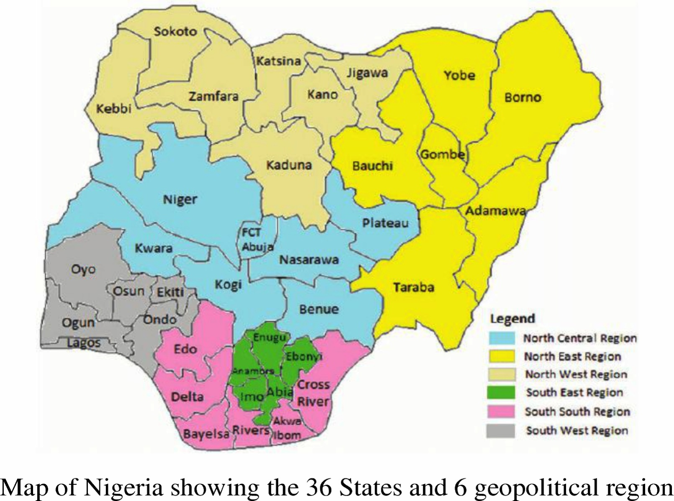
Fig 1. Map Nigeria showing the 36 states and 6 geopolitical region.

RESULTS
Combined Analysis of Variance:
The combined analysis of variance (ANOVA) for the two years evaluation of 15 improved ginger mutant lines across 10 states in Nigeria is presented in Table 2. The analysis showed significant difference in Genotypes, Environments, Genotype x Environment Interaction (GEI) and Years at P< 0.01 and P<0.05 for all yield- related traits including plant height, number of tillers, number of rhizome fingers per plant, rhizome length (cm) and the total rhizome yield (t/ha). However, there was no significant difference in G xY interaction and GEI in total rhizome yield which depict genotype discrimination against location. The environment specific to superiority of some of the ginger lines underscores their suitability for the targeted environments whereas those with broad adaptability across multiple environments will enhance productivity regardless of resilient environmental conditions. The positive relationship of genotypes interaction with environment (GEI) for plant height, number of tillers, rhizome fingers, rhizome length and rhizome yield showed differences in the performance of ginger mutant lines at each environment. This led to the strategic identification of genotypes that gives high productivity and stable performance across the diverse agro-ecological zones.

Table 2: Mean squares from combined ANOVA for yield and yield-related traits of the ginger genotypes over ten environments
Sources of variation | Degree of freedom | Plant height (Cm) | No of Tillers | No of Rhizome fingers/plant | Rhizome length (Cm) | Total Rhizome Yield (t/ha)
Year | 1 | 4410.66** | 101.48* | 700.583** | 511.070** | 0.2075ns
Genotype | 14 | 179.31** | 40.91** | 27.689** | 7.578** | 2.4746**
Environment | 9 | 17005.54** | 1881.02** | 1484.416** | 449.069** | 78.8748**
GY | 14 | 47.33ns | 18.77ns | 8.890ns | 5.160ns | 0.7864ns
EY | 9 | 1699.04** | 239.83** | 177.481** | 145.533** | 2.7461**
GE | 126 | 111.40** | 24.05* | 21.898** | 7.371** | 0.4493ns
GEY | 126 | 74.51** | 18.17ns | 15.787** | 5.193** | 0.5172ns
Error | 600 | 51.06 | 18.74 | 7.603 | 3.743 | 0.9548
* *And * = significant level at P<0.01 and P<0.05 respectively; ns=not significant, GY=Genotype Year interaction, EY= Environment Year interaction; GEI = genotype environment interaction, GEY; Genotype Environment and Year interaction

Stability Analysis of Yield and Yield Components
The AMMI analysis of variance for rhizome yield and yield related components across 15 mutant lines, tested at 10 locations over 2 years is presented in Table 3. The observed variations in plant height, number of tillers, rhizome fingers, rhizome length and total rhizome yield indicated that these parameters were influenced by genotype (G), environment (E), and genotype by environment interaction (GEI). The AMMI analysis for plant height showed significant differences for treatment, genotype, and environment except interaction (GEI). The genotype, environment and their interaction (GEI) accounted for 12.09, 66.55 and 20.10% of the treatment sum of squares respectively. The interaction sum of squares was partitioned into IPCA1 and IPCA2 and residuals. The IPCA1 and IPCA2 jointly accounted for 10.85 of the total variation due to interaction, with IPCA1 being significant. The environment contributed largely to variations in plant height (Table 3). The numbers of tillers showed that the genotypes (G), environment (E) and genotype environment interaction (GEI) were also significant and each of the variations accounted for 10.56, 46.26 and 18.28% respectively. The environmental effect was high with moderate interaction. The interaction partitioned into IPCA1 and IPCA2 jointly accounted for 9.0% with IPCA1 being significant. AMMI analysis for rhizome fingers showed that G, E, GEI effect accounted for 11.52, 52.43 and 10.83% treatment sum of squares. The IPCA1 and IPCA2 accounted for 8.05% of the variations due to interaction.
Considering rhizome length, the G, E, and GEI were significant and accounted for 14.07, 40.95 and 9.41% of the variations. The IPCA1 and IPCA2 counted for 5.53% of the variations due to interactions. The AMMI analysis of variance for total rhizome yield showed that G, E, and GEI were significant and this accounted for 20.45, 49.10 and 15.91% of the variations. The effect of GEI was low indicating that in most environment rhizome yield was stable. From the analysis, IPCA1 and IPCA2 accounted for 8.06 and 3.41% of the interaction sum of squares respectively. The general observations from the AMMI analysis of variance indicated a high level of environmental effect which accounted for a higher percentage of the total variation for all the yield components. This underscores the influence of agro-ecological factors such as temperature, rainfall and soil types. The AMMI stability values (ASV) from the interaction principal components axis (IPCA1 andIPCA2) explain the magnitude of genotype x environment interaction (GEI) in which the lower values of interaction depict greater stability in tested yield components.

Table 3: AMMI Analysis of Variance for plant height (cm), number of tiller, number of rhizome fingers, rhizome length(cm) and rhizome yield(t/ha)
 |  | Plant Height (cm) |  |  |  | Number of Tiller |  |  |  |  |  | Number of Rhizome fingers |  |  |  |  | Rhizome Length (cm) |  |  |  |  |  | Total Rhizome Yield (t/h)
SV | Df | MS | Explainedvariation % |  |  |  | MS | Explained  variation % |  |  |  |  | MS | Explained  variation % |  |  |  | MS | Explained variation% |  | MS |  |  |  | Explained variation%
Total | 899 | 256 |  |  |  | 40.7 |  |  |  |  |  | 28.3 |  |  |  |  | 10.98 |  |  |  |  |  | 1.610
Treatment | 149 | 1138** |  | 98.74 |  | 137.8** |  |  | 76.11 |  |  | 110.3** |  |  | 89.77 |  | 34.07** |  |  | 51.42 |  |  | 5.189** |  |  | 53.42
Genotype | 14 | 179* |  | 12.09 |  | 40.9 |  |  | 10.56 |  |  | 27.7* |  |  | 11.52 |  | 7.58** |  |  | 14.07 |  |  | 0.475* |  |  | 20.45
Environment | 9 | 17006** |  | 66.55 |  | 1881.0** |  |  | 46.26 |  |  | 1484.4** |  |  | 52.43 |  | 449.07** |  |  | 40.95 |  |  | 78.875** |  |  | 49.10
Blocks | 20 | 117** |  | 1.02 |  | 10.8 |  |  | 0.59 |  |  | 9.5 |  |  | 0.75 |  | 5.57 |  |  | 1.12 |  |  | 7.628 |  |  | 10.54
Interaction | 126 | 111 |  | 20.10 |  | 24.1** |  |  | 18.28 |  |  | 21.9** |  |  | 10.83 |  | 7.37* |  |  | 9.41 |  |  | 0.449** |  |  | 15.91
IPCA1 | 22 | 284** |  | 2.71 |  | 95.0** |  |  | 5.77 |  |  | 68.3** |  |  | 5.90 |  | 15.67** |  |  | 3.49 |  |  | 2.019** |  |  | 8.06
IPCA2 | 20 | 122 |  | 8.14 |  | 22.6 |  |  | 3.23 |  |  | 27.4** |  |  | 2.15 |  | 10.11 |  |  | 2.04 |  |  | 0.293 |  |  | 3.41
Residual | 84 | 64 |  | 2.33 |  | 5.8 |  |  | 1.33 |  |  | 8.4 |  |  | 2.77 |  | 4.54 |  |  | 3.87 |  |  | 0.075 |  |  | 0.43
Error | 730 | 80 |  | 25.23 |  | 21.7 |  |  | 43.29 |  |  | 12.0 |  |  | 34.47 |  | 6.41 |  |  | 47.43 |  |  | 0.714 |  |  | 36.03

*p≤0.05; **p≤0.01; Df = degree of freedom; MS = Mean square; SV = Source of variation; IPCA = Interactive Principal Component Analysis

AMMI Biplot Analysis for the yield components:
AMMI-1 biplot provides a visual expression of the relationship between the interaction principal axis (IPCA) and the mean performance of genotypes and environment. The AMMI estimate for environment and genotypes using AMMI-1 biplot shows the relative mean performance of the genotypes and environments for plant height. The Figure 2, shows the relative mean performance of genotypes and environments for plant height. The biplot indicated G1 (UG1-11-03) , G4(UG1-5-18, G9 (UG2-5-04) and G10 (UG2-5-35) as the best performing genotypes for plant height while G6(UG1-5-31) was the worst. E8 produced the tallest plants while E1 and E3 produced the shortest plants.
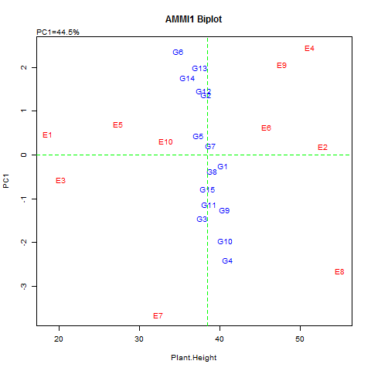
Key: G1=UG1-11-03, G2=UG1-11-07,G3=UG1-13-02, G4=UG1-5-18, G5 = UG1-5-22, G6=UG1-5-31, G7=UG1-5-35, G8=UG1-7-24, G9=UG2-5-04, G10=UG2-5-35, G11=UG2-5-38, G12=UG2-5-48, G13=UG2-5-49, G14=UG2-5-52, G15=UG2-9-01
E1=Bauchi, E2=Benue, E3=Borno, E4=Cross River, E5=Kaduna, E6=Nasarawa, E7=FCT(Nyanya), E8=Osun, E9=Plateau E10=Abia (Umudike)
Fig.2. AMMI-1 biplot showing the relative mean performance of genotypes and environments for the plant height.

The AMMI-biplot analysis for the numbers of tillers per plant is presented in Fig.3 which shows the relative mean performance of the genotypes and environment for numbers of tillers per plant. The Figure 3, indicated G13 (UG2-5-49) and G9 (UG2-5-04) to be the highest tillering ginger lines favoured by E4 (Cross River) and E8 (Osun) and E2 (Benue) environment. The worst environment for tillering were observed on E6 (Nasarawa), E7 (FCT) and E1(Bauchi) states.

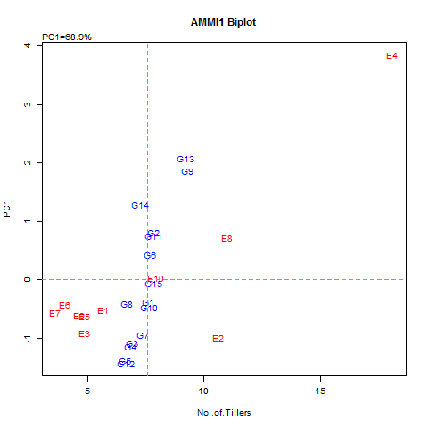
Key: G1=UG1-11-03, G2=UG1-11-07,G3=UG1-13-02, G4=UG1-5-18, G5 = UG1-5-22, G6=UG1-5-31, G7=UG1-5-35, G8=UG1-7-24, G9=UG2-5-04, G10=UG2-5-35, G11=UG2-5-38, G12=UG2-5-48, G13=UG2-5-49, G14=UG2-5-52, G15=UG2-9-01
E1=Bauchi, E2=Benue, E3=Borno, E4=Cross River, E5=Kaduna, E6=Nasarawa, E7=FCT(Nyanya), E8=Osun, E9=Plateau E10=Abia (Umudike)
Fig.3. AMMI-1 biplot showing the relative mean performance of genotypes and environments for the number of tillers per plant
The AMMI-biplot analysis for the rhizome fingers is presented in Fig.4 which shows the relative mean performance of the genotypes and environment for rhizome fingers per plant. The biplot indicated that the genotypes; G3 (UG1-13-02), G9 (UG2-5-04) and G15(UG2-9-01) are the best performing genotypes for rhizome fingers while the environment E2(Benue), E8 (Osun) and E10 (Abia) were indicated as the best environment for this trait. The worst performer in terms of rhizome fingers per plant are G6 (UG1-5-31), G2 (UG1-11-07) on environment such as E4(Cross River), E5 (kaduna) and E7(Benue).
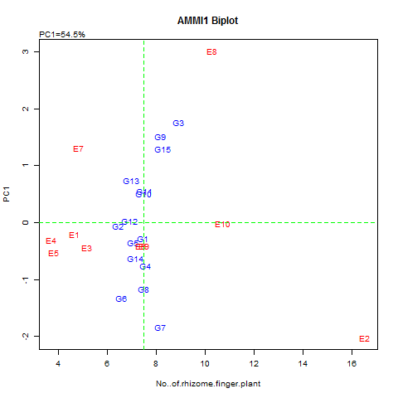
Key: G1=UG1-11-03, G2=UG1-11-07,G3=UG1-13-02, G4=UG1-5-18, G5 = UG1-5-22, G6=UG1-5-31, G7=UG1-5-35, G8=UG1-7-24, G9=UG2-5-04, G10=UG2-5-35, G11=UG2-5-38, G12=UG2-5-48, G13=UG2-5-49, G14=UG2-5-52, G15=UG2-9-01
E1=Bauchi, E2=Benue, E3=Borno, E4=Cross River, E5=Kaduna, E6=Nasarawa, E7=FCT, E8=Osun, E9=Plateau E10=Abia
Fig.4. AMMI-1 biplot showing the relative mean performance of genotypes and environments for number of rhizome fingers per plant

The AMMI-1 biplot showing the relative mean performance of the ginger genotypes and environment for rhizome length is presented in Fig.5. Two locations; E4 (Cross River) and E8 (Osun) were the environments that favored the development of rhizome length among the ginger genotypes; G3 (UG1-13-07), G10 (UG2-5-35 and G9 (UG2-5-04). The least favorable environment for rhizome length development was E7 (FCT). Most of the genotypes exhibited little interaction with the environment because of being close to the origin of the biplot. These included G2 (UG1-11-07), G11 (UG2-5-35), G14 (UG2-5-52), and G1(UG1-11-03). These genotypes tend to have a negative interaction with the environment which shows discriminatory performance
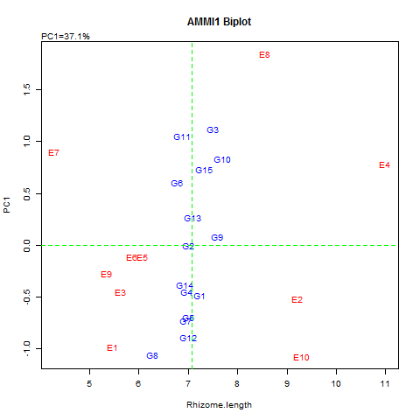
Key: G1=UG1-11-03, G2=UG1-11-07,G3=UG1-13-02, G4=UG1-5-18, G5 = UG1-5-22, G6=UG1-5-31, G7=UG1-5-35, G8=UG1-7-24, G9=UG2-5-04, G10=UG2-5-35, G11=UG2-5-38, G12=UG2-5-48, G13=UG2-5-49, G14=UG2-5-52, G15=UG2-9-01
E1=Bauchi, E2=Benue, E3=Borno, E4=Cross River, E5=Kaduna, E6=Nasarawa, E7=FCT, E8=Osun, E9=Plateau E10=Abia.
Fig.5. AMMI-1 biplot showing the relative mean performance of genotypes and environments for rhizome length.

The relative mean performance of the ginger genotypes and environment for rhizome yield using AMMI-1 biplot showed G3(UG1-13-02), G13 (UG2-5-49), G1 (UG1-11-03),and G9 (UG2-5-04) as the best performing genotypes in terms of rhizome yield while the other genotypes showed no variations in rhizome yield. The environment E4(Cross River) and E10(Abia) were regarded as the best environment while other environments (Locations) tend to have high interaction with the genotypes (Fig.6)
.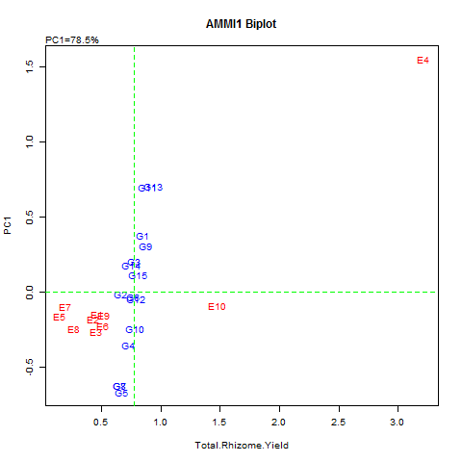
Key: G1=UG1-11-03, G2=UG1-11-07,G3=UG1-13-02, G4=UG1-5-18, G5 = UG1-5-22, G6=UG1-5-31, G7=UG1-5-35, G8=UG1-7-24, G9=UG2-5-04, G10=UG2-5-35, G11=UG2-5-38, G12=UG2-5-48, G13=UG2-5-49, G14=UG2-5-52, G15=UG2-9-01
E1=Bauchi, E2=Benue, E3=Borno, E4=Cross River, E5=Kaduna, E6=Nasarawa, E7=FCT, E8=Osun, E9=Plateau E10=Abia
Fig.6. AMMI-1 biplot showing the relative mean performance of genotypes and environments for total rhizome yield.

3.1.3. GGE Biplot Analysis for Rhizome Yields (t/ha)
The GGE biplot analysis was used to visualize the relationship between tester environment and the ginger mutant lines to determine the Which -Won-Where portion and the stability of genotypes. The genotypes located near the biplot origin are considered as widely adapted while those far are specifically adapted. The biplot shows the relationship of the test environments and their discriminating ability which depends on the length of their vectors. The GGE biplot indicated that 88.2% of the total variation in rhizome yield was due to genotype and GE interactions. The PC1 axis explained 78.6% while the PC2 axis explained 9.6%. This is presented in Figure 7 which displays the GGE biplot environment vector view for rhizome yield (t/ha). The E4 (Cross River) had the longest vector was the most discriminating environment for yield followed by E10 (Abia ).
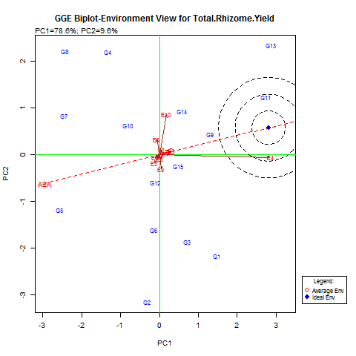
Fig.7. GGE biplot environment view showing representativeness and ranking of environment for rhizome yield(t/ha)

The GGE biplot for genotype ranking view of mean performance and stability of rhizome yield across the locations is presented in Figure 8. Desirability is indicated in terms of both mean performance and stability. The genotype G13 (UG2-5-49) is shown as the best performing genotype followed by G11(UG2-5-38). They are relatively stable for rhizome yield and thus ranked closest to the ideal genotype. Two genotypes G5 (UG1-5-22) and G7 (UG1-5-35) had the lowest mean yield with high interactions. In the ranking of genotypes; G13 (UG2-5-49 and G11 (UG2-5-38) were ranked closest to the ideal genotype. Other genotype such as G9 (UG2-5-04), G1 (UG1-11-03), G14 (UG2-5-52) and G15 (UG2-9-01) were relatively stable with average mean yield performance.

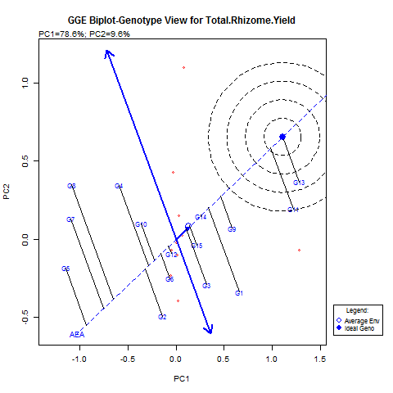
Key: G1=UG1-11-03, G2=UG1-11-07,G3=UG1-13-02, G4=UG1-5-18, G5 = UG1-5-22, G6=UG1-5-31, G7=UG1-5-35, G8=UG1-7-24, G9=UG2-5-04, G10=UG2-5-35, G11=UG2-5-38, G12=UG2-5-48, G13=UG2-5-49, G14=UG2-5-52, G15=UG2-9-01
E1=Bauchi, E2=Benue, E3=Borno, E4=Cross River, E5=Kaduna, E6=Nasarawa, E7=FCT, E8=Osun, E9=Plateau E10=Abia
Fig.8: GGE biplot genotype ranking view for both mean performance and stability for rhizome yield (t/ha)

The polygon view of the GGE Biplot for rhizome yield indicates the best genotypes for an environment. The genotypes located on the vertex of a polygon are the ones that gave the highest yield for the environment that falls within the quadrant for rhizome yield. The vertex genotype in each sector is the best genotype in the environment whose markers fall into the respective sector. Figure 9, shows the “What-Won-Where”GGE biplot for rhizome yield. The genotype, G13 (UG2-5-49) won in a E4 (Cross River) and E10 (Abia State) environments. Other genotypes that excelled in the same environments include G11(UG2-5-38) and G1(UG1-11-03).Two environments; E1 (Bauchi), E7 (FCT) favours G9 (UG2-5-04), G14( UG2-5-52),G15 (UG2-9-01) and G3(UG1-13-02). Three genotypes thrive favorably in five different environments which included E2 (Benue), E3(Borno), E5(Kaduna), E8 (Osun) and E9 (Plateau state). The genotypes are G2(UG1-11-07) G6(UG1-5- 31) and G12 (UG2-5-48). However, the performance of G8 (UG1-7-24), G7 (UG1 -5-35) and G5 (UG1-5-22) were low across the environment.
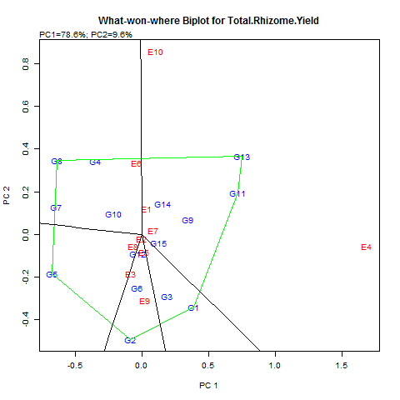
Key: G1=UG1-11-03, G2=UG1-11-07,G3=UG1-13-02, G4=UG1-5-18, G5 = UG1-5-22, G6=UG1-5-31, G7=UG1-5-35, G8=UG1-7-24, G9=UG2-5-04, G10=UG2-5-35, G11=UG2-5-38, G12=UG2-5-48, G13=UG2-5-49, G14=UG2-5-52, G15=UG2-9-01
E1=Bauchi, E2=Benue, E3=Borno, E4=Cross River, E5=Kaduna, E6=Nasarawa, E7=FCT(Nyanya), E8=Osun, E9=Plateau E10=Abia (Umudike)
Fig.9: “What-Won-Where” GGE biplot for rhizome yield (t/ha)

DISCUSSION
Crop varieties differs genetically in their performance across environments and the yield stability of genotypes should be assessed over a wide range of environments (Diana-Abasi,et.al.2018). In other words the variation of a genotype across locations is a measure of its adaptability. Hence identification of stable and high yielding cultivars across diverse environment holds great promise for sustainable agriculture.The combined analysis of the two year evaluation of 15 improved ginger mutant lines across 10 states in Nigeria showed significant differences in all the yield- related traits . These variations are attributable to inherent genetic characteristics of ginger mutant lines (Abua et al, 2021 and 2024). In this study, the ginger mutant lines differed significantly in their mean performances The analysis for Genotype, Environment, Genotype by Environment interaction (GEI) and years showed significant differences in all yield- related traits but no significant difference in G x Y interaction and GEI (Genotype x Environment interaction) for the total rhizome. The lower interaction between genotype and environment for rhizome yield revealed genotype discrimination against location with no specificity of environment in rhizome yield. The inconsistencies observed among the genotypes were an indication of adaptation to a specific environment. However, the positive relationship of genotypes with environment (GEI) for plant height, number of tillers, rhizome fingers and rhizome length, showed differences in performance of ginger mutant lines at each environment. According to Mohamed (2013) , significant genotype by environment interaction across different locations showed that some genotypes are more stable than the others. This is also in line with the report of Oliveira, et.al (2017) and that yield differences attributed to the environment are relevant to genotype evaluation. The evaluation of genotypes in different environment across years is important in determining their desirability and also to identify genotypes with average performance across environment with wide range of adaptation (Edugbo, et. al, 2015).
Multivariate analysis using AMMI and GGE biplot was performed to identify stable and high yielding ginger mutant lines. The ginger mutant lines exhibited varying stability of the characters evaluated. The AMMI analysis of variance showed a high level of environmental effect which accounted for a higher percentage of variation for the entire yield components. The AMMI stability values from the interaction principal components axis (IPCA1 and IPCA2) explained the magnitude of genotype x environment interaction (GEI) in which the lower values of interaction depicted greater stability in tested yield components. According to Yan and Tinker (2006) positive interaction between genotype and environment indicated specific adaptation of the genotype to that environment suggesting that the environment was more favorable for the genotype. AMMI-1 biplot provides a visual expression of the relationship between the interaction principal axis (IPCA) and the mean performance of genotypes and environment. The AMMI-1 biplot shows the relative mean performance of the genotypes and environments for plant height showed UG1-11-03, UG1- 5-18, UG2-5-04 and UG2-5-35 as the best genotypes for this trait under the favorable environment of Osun State while Bauchi and Borno States were observed as the worst environments for plant height. The relative mean performance of the genotypes and environments for the numbers of tillers per plant showed UG2-5-49 and UG2-5-04 to be the highest tillering ginger mutant lines favoured by Cross River, Osun, and Benue environments. The mean performance of genotypes and environment for rhizome fingers per plant showed UG1- 13- 02, UG2-5-04, and UG2-9-01 as the best genotypes for this trait under ideal environment of Benue , Osun, and Abia States. According to Karimizadehi,et.al(2013) an ideal genotype should have the highest mean performance and must be stable. This agrees with the report of Abua, et al, (2020) that UG2- 9-01 and UG1-13-02 were genotype of choic with respect to stability and performance in rhizome finger and rhizome length. Two locations ; Cross River and Osun states favours the development of rhizome length on three genotypes; UG1-13-07, UG2-5-35 and UG2-5-04. The least favorable environment for rhizome length was FCT (Abuja). Most of the genotypes exhibited little interaction with the environment because of being close to the origin of the biplot. These genotypes tend to have a negative interaction with the environment which shows discriminatory performance. Test environments that are both discriminatory and representative are good for selecting well adapted genotypes. The relative mean performance of the ginger mutant lines and the environment for rhizome yield using AMMI -1 biplot showed UG1-13-02, UG2-5-49, UG1-11-03 as the best performing genotypes. Two environments , Cross River and Abia were regarded as the best.
The GGE biplot analysis for the rhizome yield showed the visualized relationship among the test environments and their discriminating ability, which depends on the length of their vectors. It explained 88.2% of the total variation in rhizome yield due to genotype and genotype by environment interaction (GEI). In this study Cross River State was found to be the most discriminating environment for rhizome yield followed by Abia State. In ranking the genotypes for both mean performance and stability of rhizome yield across the locations UG2-5-49 and UG2-5-38 were ranked as ideal genotype but other genotypes such as UG2-5-04, UUG1-11-03 and UG2-9-01 were averagely stable. This findings conformed with the report of Abua et al (2020) . The polygon view of the GGE biplot for rhizome yield indicated the best genotypes for an environment with the vertex genotype in each sector being the best genotype at that environment. The Which –won-Where polygon view shows which genotypes win in which environment with specific adaptation and environmental interaction for rhizome yield. The genotype UG2-5-04 won in E4( Cross River )and E10( Abia State). The biplot identified Bauchi (E1) and FCT(E7) as mega environment for UG2-5-04, UG2-5-52, UG2-9-01 and UG1-13-02. Mega environment grouping allows a breeder to recommend genotypes that are good for a particular environment(Gasura et.al,2025) . According to Yan and Tinker (2006) a mega environment is a group of locations that consistently share best genotypes. From the multiple environmental testing, the five best performing genotypes with relative stability for each of the yield attributes were identified and selected. These genotypes are UG1-11-03, UG1-13-02, UG2-5-04, UG2-5-49, and UG2-9-01. This report supports the earlier report of Amiri, et.al,(2025) on multi-year evaluation of chickpea and Abua et.al (2020) on a muti- location trial of some ginger mutant lines in Cross River State. In view of these findings, genotypes adapted to specific locations and broad or wide locations have to be selected.

CONCLUSION:
The essence of multi-environment evaluation of newly developed crop genotypes is to identify genotypes with superior performance and stability across diverse agro-climatic conditions. In this study, the strategic identification of ginger mutant lines that simultaneously gives high productivity and stable performances in diverse locations is a major key to this evaluation. The superiority of some of the ginger mutant lines over a wide range of environments was the basis of the trial and the variation of the genotypes across location was regarded as a measure of their adaptability. Genotypes adapted to a specific location or have broad stability across different environment have to be selected. From the multi-environment testing, the five best performing ginger mutants lines with relative stability on yield; UG1-11-03, UG1-13-02, UG2-5-04, UG2-5-49 and UG2-9-01 were selected. This highlights the importance of thorough testing of genotypes in a multi-environment trial before recommending them to farmers

Disclaimer (Artificial intelligence)

Author(s) hereby declare that NO generative AI technologies such as Large Language Models (ChatGPT, COPILOT, etc.) and text-to-image generators have been used during the writing or editing of this manuscript.

REFERENCES
Abua, M. N., Ittah, M. A., Obok, E. E, Iwo, G. A., Edugbo, R. E and Amadi, C. O. (2020a). Nutritional
qualities of ginger mutant lines grown in the humid tropical agroecology of Nigeria. Asian Journal of
Advances in Agricultural Research, 12 (2): 35 -42.

Abua, Mary Njei, Iwo, Godfrey Akpan, IttahMacauuleyAsim, and Obok.Ekemini Edet (2020b).GGE biplot analysis of multi-location yield trial of ginger (ZingiberofficinaleRosc)genotypes in South- Eastern Nigeria.Asian journal of Agriculture and Rural Development, Vol.10(1)485-503.
Abua, M.N., Ittah, M.A. and Iwo, G.A, (2021).Application of AMMI biplot model to evaluate some ginger (ZingiberofficinaleRosc.) genotypes for adaptation and stability. Journal of Agricultural and Crop Research, 9(5):121-133.
Abua.M.N, Obok.E.E, Usen.M.J, and Iwo.G.A(2024).Comparative evaluation of growth and yield indices in some mutant lines of ginger (ZingiberofficinaleRosc). African journal of Agriculture, Technology and Environment, Vol..13(1):12-17.
Amiri,S , Arminian ,A ,Khoshro.H.A, Waseem.M and Fazeli-Nasab.B(2025). Multi-year evaluation of chckpea (Cicer arietinum L.)genotypes for agronomic traits stability using AMMI, GGE biplot and BLUP under rainfed conditions. Plant Molecular Biology Reporter, 1- 15
Ashraf, K.; Ahmad, A.; Chaudhary, A.; Mujeeb, M.; Ahmad, S.; Amir, M. & Mallick, N. (2014) Genetic diversity analysis of Zingiber Officinale (Roscoe) by RAPD collected from subcontinent of India. Saudi Journal of Biological Sciences. 21: 159-165
Diana-AbasiUdoh,Soren. K.Rasmussen, Sven-Erik Jacobsen, Godfrey.A.Iwo, and Walter de Milliano(2018).
Yield stability of sweet sorghum genotypes for Bioenergy production under contrasting temperete and Tropical environments. Journal of Agricultural Science, Vol. 10 (12)42-53.
EdugboR.E, Nwofia.G.E and Fayeun.L.S(2015).An asseement of soybean (Glycine max L.Merril) yield in different environment using AMMI and GGE biplot model in humid rainforest fringes of Nigeria. Agricultura Tropica et Subtropica, Vol. 48(3)82-90
Gasura.E, Setmela.P.S and Souta.C.M(2015).Evaluation of the performance of sorghum genotypes using GGE biplot. Canadian Journal of Plant Science, Vol.95:1205-1214.
Gauch, H .G (2006).Statistical analysis of yield trials by AMMI and GGE. Crop Science, Vol. 46:1488-1500.
Iwo.G. A. and Amadi, C. O. (2012). Evaluation of advanced M₄ mutant lines of ginger for selection. Nigerian
Journal of Genetics, 27: 151 -156

Iwo, G. A., Amadi, C. O., Eleazu, C. O. and Ukpabi, J. U. (2013). Induced mutagenesis on ginger for
improved yield components and oleoresin content. Canadian Journal of Plant Breeding, 1(3): 90 – 95.

Karimizadeh.R.,Mohammadi.M,Sabaghni.N,Mahmoodi.A.A,Roustami.B.,Seyyedi.F and kbari.F(2013).GGE
biplot analysis of yield stability in muti-environment trials of lentil geonotypes under rainfed
condition. Notulae Scientia Biologicae,5(2)256-262.

Kela .E, Sosbesan,A.O and Wakil,U.B (2023). Evaluation of phytochemical composition of ginger extracts.
Fisheries and Aquaculture Journal, Vol.14:317

Mary.N.Abua, Godfrey .A.Iwo, Macauley. A.Ittah, Ekemini.E.Obok, Richmond.E.Edugbo(2021). Growth
and yield performance of mutant ginger (Zingiber officinale .Rosc) lines in South-Eastern Nigeria . Journal of Applied Biology and Biotechnology.Vol1.:1-14.

Mohamed .N.E (2013). Genotype by environment interactions for grain yield in bread wheat
(Triticum aestivum .L).Journal of Plant Breeding and Crop Science , Vol.7: 150 -157

Oliveira, T.R.A, Carvalho, H.W.L , Costa.E.F.N and Carvalho.F.J.L.S(2017).Correlation among adaptability and stability assessment mode in maize cultivars. Australian Journal of Crop Science, Vol. 11: 516 -521
Osabor.V.N, Bassey. F.I, and Umoh .U.U (2015).Phytochemical screening and quantitative evaluation of nutritional values of Zingiber officinale(Ginger). American Chemical Science Journal, Vol.8 (4)1-6
Purchase J.L (1997).Parametric analysis analysis to describe genotypes x environment interaction and yield
stability in winter wheat (Ph.D Thesis)Department of Agronomy, Faculty of Agriculture, University of Free State Bloemfontein, Soth Africa

Statista (2025).Production volume of ginger in Nigeria from 2010 -2021.Statista Research Department, https://www.statista.com

Yakubu, Y. (2007). Briefs on Ginger Processing: Proceeding of the National Workshop on Ginger Promotion, Processing, Utilization and Marketing in Nigeria. Held on the 12th -17th November, 2007 at the Kaduna State Agricultural Development Programme (KADP) Skill Development Center, Kafanchan, Kaduna State.pp30-32.
Yan.W.K(2001).GGE biplot. A windows application for graphical analysis of multi-environment trial data
and other types of two-way data. Agronomy Journal ,Vol.93:1111 -1118.
Yan W.K and Tinker N.A(2006).Biplot analysis of multi-evironment trial data: Principles and Application.
Canadian Journal of Plant Science, Vol.86:623-645.

