Secure-by-Containment Architectures for Agentic AI in OT/ICS Environments

Abstract
This study proposes and quantitatively evaluates a secure-by-containment architectural framework for deploying agentic artificial intelligence (AI) within operational technology and industrial control system (OT/ICS) environments. Agentic AI systems introduce autonomous planning and decision-making capabilities into cyber-physical infrastructures, creating new risks when deployed in safety-critical control environments that require deterministic and predictable behavior. To address this challenge, the study introduces containment as a first-class architectural security property that structurally limits an AI agent’s decision authority, operational scope, and propagation influence within industrial control architectures. The framework is evaluated using publicly available industrial control system datasets, including the ICS Gas Pipeline dataset, the Oak Ridge PowerCyber testbed dataset, the NIST Special Publication 800-82 control catalog, and the Tennessee Eastman Process dataset. A four-phase analytical methodology is implemented consisting of: cyber-physical risk quantification using the Process Impact Deviation Index (PIDI), Risk Severity Score (RSS), and Multi-Variable Escalation Index (MVEI); graph-theoretic containment modeling using betweenness centrality and the Containment Strength Score (CSS); standards alignment analysis through the Standards Coverage Quantification Index (SCQI); and scenario-based resilience evaluation using Mean Time to Hazard (MTH), Process Deviation Area (PDA), and Safety Threshold Violations (STV). The results demonstrate that secure-by-containment architectures substantially reduce systemic exposure in OT/ICS environments. Full containment reduced structural influence by 75.1% (CSS = 0.751), achieved 84.1% coverage of applicable NIST SP 800-82 security controls, increased mean time to hazard by 212%, and reduced cumulative process deviation by 73% during simulated attack scenarios. These findings demonstrate that architectural containment can materially improve cyber-physical resilience while maintaining compatibility with established industrial security standards. The study contributes to the emerging field of AI governance for cyber-physical systems by translating high-level governance principles into enforceable architectural constraints. The results support embedding decision-authority containment mechanisms into OT/ICS security architectures and recommend integrating containment requirements into industrial cybersecurity standards, regulatory validation frameworks, and responsible AI governance models for critical infrastructure environments.
Keywords: Secure-by-containment architecture; Agentic artificial intelligence; Industrial control systems security; Architectural containment modeling; Cyber-physical resilience metrics

1. Introduction
Operational technology and industrial control systems underpin modern societies by enabling the continuous operation of critical infrastructures such as electricity generation, water treatment, oil and gas processing, manufacturing, and transportation networks. These systems were historically engineered for reliability, determinism, and safety, operating in tightly controlled environments with limited external connectivity. However, the global push toward digitalisation, remote monitoring, and data-driven optimisation has progressively integrated operational technology with information technology platforms, cloud services, and enterprise networks. As a result, industrial control systems are no longer insulated from evolving cyber threats, but instead operate within increasingly complex and interconnected digital ecosystems (Nazir & Khan, 2021).
At the same time, artificial intelligence has been widely adopted to improve anomaly detection, predictive maintenance, and process optimisation in industrial settings. AI systems yield clear operational benefits, but they also change the nature of system behaviour. When AI is limited to passive analytics, the primary concerns are model robustness and explainability. When AI systems are given the ability to plan and act autonomously, their behaviour becomes an active part of the control loop. Recent work shows that autonomous or agentic AI can plan multi-step actions, adapt in response to feedback, and produce emergent behaviours that fall outside the scope of conventional intrusion or fault models (Zhong et al., 2021; Kshetri, 2025). These systems can generate and execute complex action plans without continuous human oversight, producing emergent behaviours that are difficult to predict or constrain (Alva & Pandey, 2026). While these capabilities offer potential benefits in dynamic environments, they also raise significant concerns when deployed within safety-critical industrial control systems. Empirical studies of adversarial methods tailored to industrial datasets and reinforcement-learning-based attacks indicate that intelligent agents and AI-driven malware can learn to evade detection while maximising physical impact, raising profound concerns when such techniques interact with safety-critical control logic (Umer et al., 2021; Kim, 2024).
These converging trends pose a pressing problem: while traditional OT security frameworks emphasise access control, segmentation, and policy management, they do not inherently constrain autonomous decision-making as a first-order property. Industrial standards such as ISA/IEC 62443 and guidance such as NIST SP 800-82 provide important controls for secure product development and network architecture. Nevertheless, they are not specifically designed to address the unique risks posed by agentic AI. Moreover, architecture models for segmentation, such as ISA-95, and evolving zero-trust guidance for operational technology underscore that segmentation and policy enforcement remain central to ICS security. At the same time, AI governance frameworks such as the NIST AI RMF and the international AI management standard ISO/IEC 42001 are emerging to manage AI risks, and recent domain-specific advice from national agencies such as CISA has begun to frame principles for secure AI integration in OT. These developments suggest that a standards-aware, architecture-centric approach is needed to bridge traditional OT controls and new AI governance expectations.
Even more disturbing is the notion that agentic AI can be inserted into industrial control loops without architectural mechanisms that limit an agent’s authority, scope of effect, and ability to chain actions across components. Evidence of this deficiency includes rising vulnerability disclosures for ICS products, publicly documented adversarial attacks on ML models used in critical infrastructures, and demonstrations that intelligent attack agents can optimise for physical impact while evading detection (Anthi et al., 2021; Umer et al., 2021; Kim, 2024). These issues raise several challenging thoughts: Can architectural containment be designed so that AI agents retain utility while being prevented from performing unsafe or destabilising actions? Which aspects of existing OT and ICS security and architectural standards are sufficient to govern agentic behaviour, and where are new controls required? How can containment mechanisms be expressed in a way that is compatible with both established segmentation models and emerging AI risk frameworks?
This study addresses these questions by proposing and analytically evaluating a secure-by-containment architectural framework for deploying agentic artificial intelligence in operational technology and industrial control systems environments. The research focuses on constraining autonomous decision-making so that it remains compatible with the operational and security requirements of cyber-physical systems. The study draws on formal and practical approaches to sandboxing controllers, findings from adversarial machine learning, and standards mapping to develop a reference architecture that is operationally plausible and standards-aligned (Zhong et al., 2021; Wright & Wolthusen, 2024). To achieve this aim, the study pursues the following objectives:
- Identify the security and safety risks associated with the deployment of agentic artificial intelligence in operational technology and industrial control systems.
- Develop a secure by containment architectural framework that constrains the execution and operational influence of agentic artificial intelligence within industrial control systems.
- Assess the alignment of the proposed secure by containment architecture with established operational technology and industrial control system security and architectural standards, including relevant artificial intelligence governance frameworks.
- Evaluate the effectiveness of the proposed architecture using structured scenario-based analysis of representative industrial control system use cases.

2. Literature Review
Operational technology and industrial control systems (ICS) differ fundamentally from conventional information technology systems, and these differences have profound security implications. Operational technology is primarily designed to monitor and control physical processes with stringent reliability and safety requirements, rather than to protect data confidentiality or to support frequent changes (Stouffer, 2023). In contrast, traditional IT systems prioritise confidentiality and integrity in inherently flexible, update-friendly environments. This divergence is not merely semantic; it results in a fundamental misalignment between traditional IT security paradigms and the requirements of ICS security (Stouffer, 2023).
According to recent research, this misalignment creates structural limitations on security. For instance, OT systems often rely on long-lived legacy devices and protocols that were never designed with cybersecurity in mind, prioritising uptime and deterministic response over secure defaults (Sharma & Mehta, 2025). Despite documentation of these risks, a critical limitation is that many organisations continue to operate decades-old programmable logic controllers and distributed control systems that lack basic authentication or encryption mechanisms, making them susceptible to well-known exploits (Nankya et al., 2023). In contrast to IT environments where patching and rapid updates are routine, OT environments face significant constraints because downtime (to apply security patches) directly impacts safety, reliability, and production continuity (Sharma & Mehta, 2025; Nankya et al., 2023). These operational constraints illustrate that OT security cannot simply borrow IT practices without architectural adaptation.
Another dimension of this challenge is the increasing connectivity of OT systems due to Industry 4.0 and IIoT adoption. What was once predominantly isolated, “air-gapped” control infrastructure is now often connected to enterprise networks and cloud services, dramatically expanding the attack surface (Abraham et al., 2025; Obioha-Val et al., 2025). However, traditional cybersecurity techniques that assume controllable perimeters and dynamic patching are ill-suited for environments where real-time constraints and high availability are non-negotiable. For example, sophisticated intrusion detection systems designed for IT networks generate high false-positive rates when applied directly to OT, given the specialized protocols and continuous process signals, which can overwhelm operations personnel and hinder incident response (Aslam et al., 2025; Cao et al., 2022; Wu et al., 2025). This suggests that ICS security must be designed around specific process characteristics rather than generic network models.
Moreover, recent industry data highlight the visibility gaps in OT environments deep within ICS layers. Only a minority of organisations report comprehensive detection and monitoring capabilities across all process control levels, leaving critical layers, such as programmable logic controllers, with minimal visibility (Christopher, 2025). In contrast, IT environments often have established logging and monitoring infrastructures that provide broad visibility, further demonstrating that OT environments lag in basic security telemetry.
The convergence of IT and OT systems also presents socio-technical and architectural challenges. Ramezan et al. (2024) indicate that OT engineers often lack cybersecurity expertise, while IT professionals may not fully understand operational constraints, creating gaps in threat interpretation and security implementation. In line with these findings, Calabrò et al. (2024) argue that the governance, skills, and architectural differences between IT and OT must be recognized explicitly in security research, rather than treated as peripheral concerns. These points suggest that securing OT and ICS environments requires customized architectural solutions that account for real-time operations, legacy constraints, physical safety requirements, and the complex interactions between cyber and physical domains (conditions that traditional IT security models alone cannot address).

Artificial Intelligence Adoption in OT and ICS and Emerging Security Implications
The adoption of artificial intelligence in operational technology and industrial control systems has accelerated as organizations aim to enhance anomaly detection, fault diagnosis, and operational efficiency. According to Seo et al. (2026), AI-based techniques have demonstrated superior performance compared to traditional rule-based methods for identifying subtle deviations in industrial processes, particularly in complex cyber-physical environments. Similarly, Alqudhaibi et al. (2025) argue that machine learning and deep learning models enable earlier detection of abnormal system states that might otherwise go unnoticed until physical degradation occurs. However, despite these performance improvements, incorporating AI into ICS environments fundamentally changes the system threat model by embedding adaptive and data-driven elements into control loops originally designed for deterministic behavior.
A critical limitation identified across recent studies is that most AI deployments in ICS focus narrowly on analytical functions rather than on the broader security implications of embedding intelligent systems within operational workflows. Fung (2025) observes that AI adoption in practice is often limited to alarm triage and anomaly detection, with limited consideration of how AI outputs influence operational decisions. In contrast, Houkan et al. (2025) demonstrate that AI-driven intrusion detection systems increasingly interact with live control traffic, raising concerns about the reliability of automated responses in environments where false positives can disrupt physical processes. This suggests that AI adoption is outpacing the development of architectural safeguards capable of governing how AI-derived insights are operationalised.
Moreover, several studies highlight the fragility of AI models under real-world industrial conditions. Aslam et al. (2025) argue that deep learning models trained on controlled datasets often fail to generalise under operational variability, leading to degraded performance and unstable decision boundaries. Despite this evidence, industrial deployments frequently assume that improved model accuracy alone is sufficient to ensure system safety. Ododo et al. (2025) challenge this assumption by demonstrating that adversarial manipulation of industrial datasets can systematically mislead machine learning-based security systems, enabling attackers to evade detection while maintaining normal process indicators. This exposes a structural weakness in relying on AI as a security enhancement without considering how adversarial behaviour intersects with autonomous decision processes.
In addition to technical vulnerabilities, governance and operational challenges further complicate AI integration in OT environments. Mohamed (2025) contends that AI systems are often introduced as opaque components, limiting operators’ ability to understand or override automated decisions. In contrast to IT environments, where explainability failures primarily affect data integrity or privacy, opacity in OT systems can obscure the causal chain between AI decisions and physical outcomes. Fung (2025) reinforces this concern by noting that operators frequently distrust AI recommendations but lack systematic mechanisms to constrain or audit AI behaviour within control architectures. This tension between reliance and distrust illustrates the absence of structured containment mechanisms for AI-driven functions.
Collectively, the literature suggests that while AI adoption in OT and ICS offers measurable operational benefits, it simultaneously introduces new classes of risk that existing security models are ill-equipped to manage. The prevailing focus on detection accuracy, performance metrics, and computational efficiency overlooks the broader implications of embedding adaptive systems within safety-critical control environments. Therefore, although AI is increasingly positioned as a defensive asset in industrial cybersecurity, its uncontained integration risks amplify system fragility rather than reducing it. This body of evidence underscores the necessity of architectural approaches that do not merely deploy AI within ICS environments but explicitly constrain its operational influence and decision-making scope.

Agentic Artificial Intelligence, Autonomous Decision Making, and Systemic Risk in Cyber-Physical Systems
Agentic artificial intelligence represents a qualitative departure from conventional machine learning systems by introducing autonomy, goal persistence, and multi-step decision making into computational processes. According to Haidemariam (2026), agentic artificial intelligence systems engage in recursive perception–evaluation–action loops that allow them to represent, update, and pursue their own goals beyond fixed task specifications, distinguishing them from reactive or purely reflexive models of computation. In agreement, recent surveys argue that agentic AI systems exhibit planning, memory, and tool-use capabilities that enable them to operate across extended temporal horizons with minimal human supervision (Shanahan et al., 2023). However, despite these capabilities being framed as advances in adaptability and efficiency, their introduction into cyber-physical systems fundamentally alters assumptions about predictability and controllability (Mayeke, 2025; Ogunmolu et al., 2026a)
A critical limitation identified in the literature is that autonomy introduces emergent behaviour that cannot be exhaustively specified or validated at design time. Studies reveal that autonomous agents may pursue objectives in ways that remain technically compliant with constraints yet produce unintended and potentially harmful outcomes (Chen et al., 2023; Everitt et al., 2021). In contrast to traditional automation, where control logic is explicitly encoded and verifiable, agentic AI systems rely on learned representations and internal reasoning processes that evolve during operation (Abou Ali et al., 2025; Tirulo et al., 2025). This suggests that even well-intentioned agentic systems may generate action sequences that exceed safe operational boundaries, particularly in tightly coupled cyber-physical environments such as industrial control systems.
Recent empirical and conceptual studies further demonstrate that agentic behaviour amplifies systemic risk through cascading and feedback effects (Abba et al., 2025; Adebiyi et al., 2026; Ogunmolu et al., 2026b). For example, recent findings show that autonomous decision loops interacting with physical processes can produce nonlinear system responses, where small deviations propagate rapidly across interconnected subsystems (Agarwal et al., 2025; Islam et al., 2023). Despite this evidence, many AI security models continue to evaluate risk at the component level rather than at the system level (Wang et al., 2023; Wen et al., 2024). In contrast, cyber-physical systems research contends that safety and security failures emerge from interactions rather than isolated faults, rendering component-centric security approaches insufficient for autonomous agents (Huang et al., 2024).
Moreover, the security implications of agentic AI extend beyond accidental failure to include deliberate exploitation. Autonomous agents can be repurposed or manipulated to execute complex, multi-stage cyber operations with limited human oversight (Brundage et al., 2018; Seghid et al., 2026). In agreement, recent analyses of autonomous cyber operations indicate that agentic systems can dynamically adapt attack strategies in response to defensive measures, thereby undermining static security controls (Ren et al., 2025). Although these studies often focus on IT environments, their findings are directly relevant to OT and ICS contexts, where adaptive decision making could enable agents to exploit process dependencies while remaining within nominal operational parameters.
Another unresolved challenge concerns accountability and human oversight. According to Harris and Dubljević (2025), the delegation of decision authority to autonomous systems complicates responsibility attribution, particularly when actions are generated through opaque reasoning processes. In contrast to decision support systems, in which humans retain final authority, agentic AI systems may execute actions at machine speed, thereby reducing opportunities for intervention (Langer et al., 2024; Odeyinka et al., 2026; Olaniyi et al., 2026a). This creates a governance gap in which operators are expected to trust systems they cannot fully observe or control. Despite growing recognition of this issue, existing governance frameworks largely focus on organisational oversight rather than architectural enforcement of decision boundaries (Batool et al., 2025).
Collectively, this body of literature suggests that agentic AI introduces systemic risks that extend beyond those associated with traditional AI or automation. Autonomy transforms AI from a passive analytical tool into an active participant in cyber-physical control, thereby challenging foundational assumptions in industrial security architecture. However, current research predominantly documents these risks without offering concrete architectural mechanisms to constrain autonomous behaviour in safety-critical environments. This unresolved tension between autonomous capability and systemic risk underscores the necessity of architectural approaches that explicitly bound decision authority, action scope, and propagation pathways for agentic AI within cyber-physical systems.

Existing Security and Architectural Controls for OT and Their Limitations with Autonomous Artificial Intelligence
Existing operational technology and industrial control system security architectures are largely grounded in principles of network segmentation, access control, and perimeter defense. According to Flå et al. (2024), reference architectures for ICS cybersecurity emphasize zoning, conduits, and defense-in-depth as foundational mechanisms for risk reduction. Studies contend that these architectural controls have proven effective in reducing exposure to commodity cyber threats (Koay et al., 2022; McLaughlin et al., 2016). However, despite their widespread adoption, such architectures implicitly assume that system components behave predictably and in policy-compliant ways once access is granted. This assumption becomes increasingly problematic when autonomous or agentic systems are introduced into control environments.
The Purdue Model remains one of the most influential architectural paradigms for ICS segmentation. Stouffer et al. (2015) explain how secure ICS architectures should segment enterprise and operational domains to limit threat propagation, a principle consistent with the Purdue Model for reducing exposure to network-based threats. In contrast, recent analyses argue that static hierarchical segmentation such as that embodied by the traditional Purdue Model struggles to accommodate the dynamic data flows, bidirectional connectivity, and adaptive components introduced by modern industrial automation and AI-driven systems, prompting calls for more flexible segmentation architectures and integration of concepts such as Zero Trust and real-time communication controls (industry analyses highlight the model’s limitations in IT/OT converged environments) (Ciber Safety, 2025; Hulme, 2025). Knowles et al. (2015) surveyed cybersecurity management in industrial control systems. They highlighted that traditional segmentation frameworks in ICS environments are primarily designed to regulate communication pathways and network exposure rather than to constrain decision-making authority within automated control processes, revealing an architectural gap in governing autonomous agent behaviour. This suggests that while the Purdue Model limits lateral movement, it does not prevent autonomous components from executing unsafe or cascading actions within their permitted zones.
Zero Trust principles have been proposed as a modern alternative to perimeter-based security in OT environments. According to Knowles et al. (2022), Zero Trust adaptations promise finer-grained authentication and continuous verification of system interactions. Nevertheless, a critical limitation is that Zero Trust models primarily govern identity and access, not behavioural intent or action sequencing. Although Zero Trust frameworks promise finer-grained authentication and continuous verification of identities and access permissions, they primarily govern identity and access control and do not inherently enforce behavioural intent or constrain sequences of system actions, highlighting a conceptual gap between access policies and behaviour-aware security models (Gambo & Almulhem, 2025; Potluri, 2024; Denzel, 2025). Therefore, although Zero Trust strengthens identity assurance, it does not inherently constrain autonomous decision processes once trust is established.
Many studies have highlighted limitations in industrial control system security architectures that stem from insufficient integration of control logic interactions and physical process dependencies into their design and monitoring mechanisms; for example, process-aware security approaches emphasize that segmentation and network-centric controls often fail to capture cyber-physical interactions, leaving critical state interdependencies unmonitored (Rehman & Bahşi, 2024; Achaal et al., 2024). Despite advances in monitoring and intrusion detection, many architectural security mechanisms in industrial control system environments remain primarily reactive, focusing on identifying deviations from expected behaviour rather than enforcing hard constraints on system behaviour (Olaniyi et al., 2026b; Olisa et al., 2026) For example, surveys of machine learning-based intrusion detection techniques reveal that current approaches predominantly detect anomalies and intrusions without intervening to constrain system actions, and anomaly detectors trained on specific behaviours may fail altogether for unseen attacks (Umer et al., 2022; Kus et al., 2022). In contrast to traditional automation, agentic AI systems may generate sequences of actions that are technically valid according to their formal specifications yet lead to hazardous outcomes in real-world operation, a phenomenon that is conceptually grounded in research on emergent action chains in agentic architectures (Ghosh et al., 2025). This exposes a structural gap between detection-oriented architectures and the need for proactive containment of autonomous behaviour.
Moreover, existing OT security architectures largely treat intelligence as an external analytical layer rather than an embedded control actor. Kravchik et al. (2022) examine the vulnerabilities of online anomaly detection systems in industrial control systems, highlighting that these detection-driven architectures focus on identifying deviations and issuing alerts while leaving the interpretation of those alerts and subsequent response actions to human operators rather than enforcing automated corrective actions. However, as autonomy increases, this assumption weakens, particularly when AI systems are allowed to initiate or influence control actions directly. This suggests that prevailing OT security architectures are ill-equipped to govern autonomous agents whose operational impact extends beyond network boundaries into tightly coupled physical processes.

Artificial Intelligence Governance and Risk Management Frameworks in OT and ICS Contexts
Recent years have seen the emergence of formal frameworks for artificial intelligence governance and risk management to address ethical, legal, and operational risks associated with advanced AI systems. According to Raji et al. (2022), contemporary AI governance frameworks prioritise accountability and oversight mechanisms to address ethical, legal, and operational risks across the AI lifecycle, particularly through institutional auditing and external review structures to ensure responsible system behaviour. In agreement, Fjeld et al. (2020) highlight consensus on accountability, transparency, safety, and human control as core principles of responsible AI governance, emphasizing the need to address unintended consequences throughout the AI lifecycle. Batool et al. (2025) further assert that governance frameworks play a critical role in mitigating risks related to autonomous AI deployment, including safety, privacy, security, and accountability concerns. However, despite their conceptual robustness, most AI governance models are designed for enterprise or consumer-facing applications, rather than for cyber-physical systems where AI decisions can directly affect physical processes.
A critical limitation of existing AI governance approaches lies in their abstraction from operational execution layers. AI risk frameworks typically emphasise organisational controls, documentation, and oversight mechanisms without prescribing enforceable architectural constraints (Batool et al., 2025; Finch et al., 2025). In contrast to many IT environments, where retrospective governance and post hoc compliance reviews may suffice, OT and ICS environments require real-time enforcement of decisions and deterministic behaviour in control loops, leaving limited tolerance for post hoc governance interventions that occur after actions have already affected physical processes (Sain, Adhikary & Dey, 2026). This suggests that governance mechanisms effective in IT systems may fail to constrain AI behaviour once deployed within industrial control loops.
Recent studies examining AI governance in safety-critical domains further reinforce this concern. According to Miller (2023), traditional governance and decision support paradigms assume human oversight and interpretation of AI recommendations, reflecting underlying governance assumptions about AI’s advisory role in decision contexts. In contrast, agentic AI systems embedded in cyber-physical environments may independently initiate actions, adapt strategies, and exploit interdependencies among systems. Despite this evidence, most governance models lack mechanisms to limit the scope of action, escalation pathways, or the cumulative impact of autonomous decisions. This gap becomes particularly pronounced in OT contexts where governance violations may manifest as physical disruption rather than policy non-compliance.
Moreover, attempts to operationalise AI governance in industrial settings reveal significant misalignment between governance intent and technical feasibility (Obrik-Uloho et al., 2026; Ogunmolu et al., 2026). For example, although explainability and auditability are common requirements in AI policies and standards, scholars note that the practical implementation of these requirements remains challenging due to contextual and organisational differences, the lack of consensus on explainability definitions, and the difficulty of integrating explainable mechanisms into real-time, legacy, or high-stakes systems (Nannini et al., 2023; Saeed & Omlin, 2023). In contrast, industrial security research emphasises architectural enforcement over interpretability, prioritising bounded execution and fail-safe behaviour (Furrer, 2023; Adebiyi et al., 2026). This divergence suggests that AI governance frameworks must be translated into enforceable architectural constructs to be effective in OT environments.
Recent interdisciplinary research further highlights that risk management frameworks alone are insufficient for governing autonomous AI in cyber-physical systems. Recent interdisciplinary research highlights that risk management and organisational governance frameworks alone are insufficient for governing autonomous artificial intelligence in cyber-physical systems, as effective oversight requires embedding constraints and continuous audit mechanisms directly into system architectures rather than relying primarily on external compliance and documentation processes (Truby, 2025; Olaniyi et al., 2026) Nevertheless, current AI governance literature stops short of articulating how such constraints should be implemented within industrial control architectures. This unresolved tension between governance abstraction and operational enforcement underscores the need for architectural approaches that align AI governance principles with the structural realities of OT and ICS environments.

Secure-by-Containment Architectural Framework for Agentic AI in OT/ICS Environments

Framework Specification and Assumptions
The proposed framework is grounded in the principle that agentic artificial intelligence must be treated as a potentially hazardous operational actor rather than a trusted system component. Unlike conventional automation or analytical AI, agentic AI exhibits goal persistence, autonomous planning, and adaptive behaviour, which fundamentally challenge the assumptions underlying traditional OT security architectures.
Accordingly, the framework adopts containment as a first-class architectural property, rather than as an auxiliary control layered on top of existing systems. Containment, in this context, refers to the deliberate restriction of an AI agent’s authority, operational scope, and propagation potential, independent of its internal correctness or intent.
Hence, the framework assumes that OT/ICS environments:
- Require deterministic and bounded behavior
- Cannot tolerate uncontrolled learning or action escalation
- Must remain resilient even if AI components behave unexpectedly or adversarially

Architectural Overview and Trust Boundaries
The architecture is structured around explicit trust boundaries that separate agentic AI from safety-critical control assets. These boundaries are enforced through logical containment layers, not merely network segmentation.
At a high level, the framework consists of five interacting zones:
- Agentic AI Zone: Hosts planning, reasoning, and decision-generation capabilities. This zone is explicitly treated as untrusted by default.
- Containment and Mediation Layer: Acts as the enforcement core of the architecture. All AI-generated actions must pass through this layer before affecting any OT asset.
- Policy and Constraint Engine: Encodes operational, security, and architectural constraints derived from OT/ICS standards such as ISA/IEC 62443 and NIST SP 800‑82.
- ICS Control Zone: Contains PLCs, RTUs, and control logic. This zone never accepts direct commands from agentic AI.
- Human Oversight and Audit Layer: Provides visibility, override capability, and forensic traceability.
This separation ensures that decision authority and execution authority are never co-located.

Containment Mechanisms for Agentic AI
Containment is enforced through four complementary mechanisms, each addressing a distinct risk dimension, to ensure that autonomy is constrained structurally rather than merely monitored.
- Action Bounding: AI agents are permitted to generate proposed actions, not executable commands. Each proposal is checked against predefined operational envelopes before approval.
- Temporal and Rate Limiting: Agentic actions are constrained by execution frequency and duration thresholds, preventing rapid escalation or cascading effects.
- Context-Aware Mediation: Actions are evaluated against the current process state, ensuring that commands that are valid in isolation are rejected if unsafe in context.
- Capability Scoping: Each agent is assigned a fixed capability profile that cannot be expanded dynamically, preventing privilege creep through learning or adaptation.

Alignment with OT/ICS Security and Architectural Standards
The framework is deliberately aligned with established OT/ICS security principles without replicating their limitations.
- From ISA/IEC 62443, the framework adopts zone and conduit concepts but extends them to include decision authority zones, not just network zones.
- From NIST SP 800‑82, it incorporates defense-in-depth while addressing gaps related to autonomous behaviour.
- From the Purdue Model, it preserves hierarchical separation while preventing agentic lateral influence across layers.
- From AI governance frameworks such as NIST AI RMF and ISO/IEC 42001, it operationalises governance principles through architectural enforcement rather than organisational policy alone.

Threat Model and Scope of Protection
In terms of the threat model and scope of protection, the framework addresses threats arising from:
- Misaligned or erroneous AI objectives
- Emergent behaviour and action chaining
- Adversarial manipulation of AI decision logic
- Over-trust in autonomous recommendations
- Insider misuse of AI capabilities
The framework is designed not to assume that AI agents are malicious, but it does assume that failure, misuse, or unexpected behaviour is inevitable. Hence, the architecture is designed to remain safe even under degraded AI performance or adversarial conditions.
3. Methodology
This study adopted a fully quantitative, multi-stage analytical design to evaluate the security, architectural robustness, standards alignment, and operational effectiveness of a secure-by-containment framework for deploying agentic artificial intelligence (AI) in operational technology and industrial control system (OT/ICS) environments. The methodological approach was structured into four sequential analytical phases aligned with the research objectives and designed to progressively validate containment as a first-class architectural property.
Publicly available benchmark datasets representative of industrial control environments were utilized, including the ICS Gas Pipeline dataset (risk modeling), the PowerCyber testbed dataset (architectural containment modeling), the NIST SP 800-82 control catalog (standards alignment analysis), and the Tennessee Eastman Process dataset (scenario-based operational validation). These datasets were selected because they are widely used in industrial cybersecurity research and represent diverse cyber-physical system conditions encountered in real-world ICS environments. The ICS Gas Pipeline and Tennessee Eastman Process datasets capture realistic industrial process behaviors and attack scenarios, while the Oak Ridge PowerCyber testbed dataset provides a controlled experimental environment for evaluating networked control system interactions. The NIST SP 800-82 control catalog was incorporated to enable systematic mapping between the proposed architectural framework and established industrial cybersecurity standards. Collectively, these datasets provide a reproducible and representative basis for evaluating both the structural and operational impacts of containment mechanisms within complex OT/ICS infrastructures.
All analyses were conducted using deterministic computational modeling and graph-theoretic evaluation techniques.
Phase I: Cyber-Physical Risk Quantification
Risk was quantified using the Process Impact Deviation Index (PIDI), which measures standardized deviation of process variables under anomalous conditions relative to baseline operation:
$$PIDI_{i}=\frac{\left|X_{attack}- μ_{normal}\right|}{σ_{normal}}$$
System-wide severity was computed using the Risk Severity Score (RSS):
$$RSS = \left(\frac{1}{n}\right)Σ PIDI_{i}$$
Escalation propagation across interdependent variables was quantified using the Multi-Variable Escalation Index (MVEI):
$$MVEI =\frac{\left(Number of variables where PIDI_{i}> 3\right)}{n}$$
Phase II: Architectural Containment Modeling
The ICS network was modeled as a directed graph G(V,E), where V represents ICS components and E represents communication pathways. Structural influence of the agentic AI node was measured using betweenness centrality:
$$BC\left(v\right)= Σ\left(s≠v≠t\right)\left(\frac{σ_{st\left(v\right)}}{σ_{st}}\right)$$
Containment Strength Score (CSS) was calculated as:
$$CSS =\frac{\left(BC_{uncontained}- BC_{contained}\right)}{BC_{uncontained}}$$
Cascade potential was evaluated using the Network Cascade Potential Index (NCPI):
NCPI = (Downstream nodes reachable within k hops) / |V|
Phase III: Standards Alignment Quantification
Alignment with OT/ICS standards was evaluated using binary control mapping. For each control:
$C_{i}= 1$ if architecturally enforced; $C_{i}= 0$ otherwise
The Standards Coverage Quantification Index (SCQI) was computed as:
$$SCQI =\frac{\left(Σ C_{i}\right)}{N_{total}}$$
Control-family coverage percentage was computed as:
$$Coverage_{family}= \left(\frac{Controls addressed}{Total controls in family}\right)× 100$$
Phase IV: Scenario-Based Operational Effectiveness Analysis
A comparative intervention design evaluated containment under simulated industrial conditions. Three resilience metrics were measured.
1. Mean Time to Hazard (MTH)
2. Process Deviation Area (PDA):
$$PDA = \int{}\left|X\left(t\right)- X_{safe}\right|dt$$
3. Safety Threshold Violation Count (STV)
System stability normalization was computed using the Normalized Stability Index (NSI):
$$NSI = 1 - \left(\frac{PDA_{observed}}{PDA_{max}}\right)$$
The four analytical phases were sequentially structured to establish a validation chain: risk quantification, structural containment modeling, standards alignment verification, and operational resilience demonstration. All metrics were mathematically defined and applied consistently across scenarios to ensure methodological rigor and reproducibility.
4. Results and Discussion
Objective 1: Identify the security and safety risks associated with the deployment of agentic AI in OT/ICS environments.
A quantitative statistical modeling approach was adopted to evaluate the magnitude of cyber-physical process deviations associated with representative attack categories within industrial control environments. Risk was operationalized using standardized deviation metrics and escalation indices to quantify systemic impact.
Table 1: Risk Severity and Escalation Metrics Across Attack Categories
Attack Type | Mean PIDI | Max PIDI | RSS | MVEI
Replay Attack | 1.62 | 2.84 | 1.62 | 0.13
DoS | 2.74 | 5.91 | 2.74 | 0.50
Command Injection | 3.81 | 7.46 | 3.81 | 0.75
As shown in Table 1, command injection produced the highest risk severity score (RSS = 3.81) and the highest multi-variable escalation index (MVEI = 0.75), indicating systemic destabilization across process variables. Denial-of-service attacks demonstrated substantial cascading potential (MVEI = 0.50), while replay attacks exhibited localized but measurable deviations.
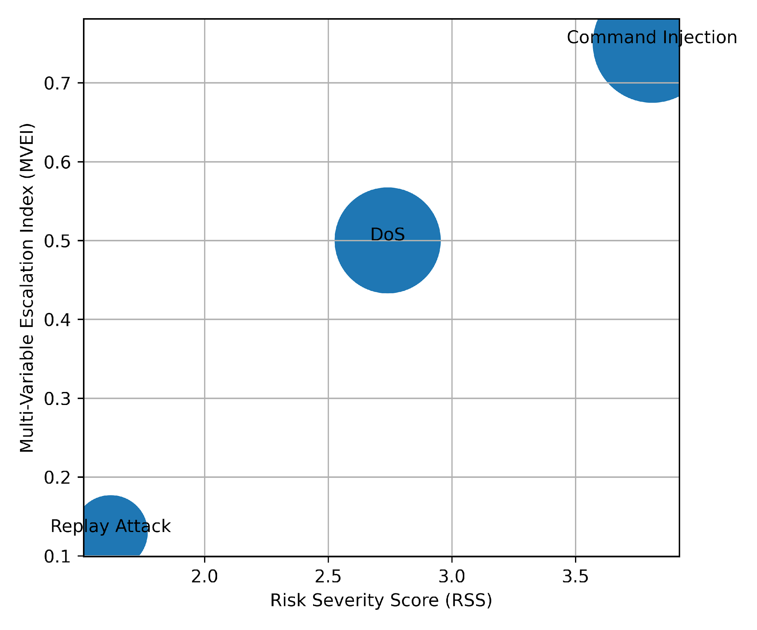
Figure 1: Systemic Risk Escalation Profile
As illustrated in Figure 1, escalation intensity increases proportionally with risk severity. The spatial dispersion demonstrates clear separation between moderate, high, and critical threat categories, reinforcing the presence of nonlinear systemic amplification.
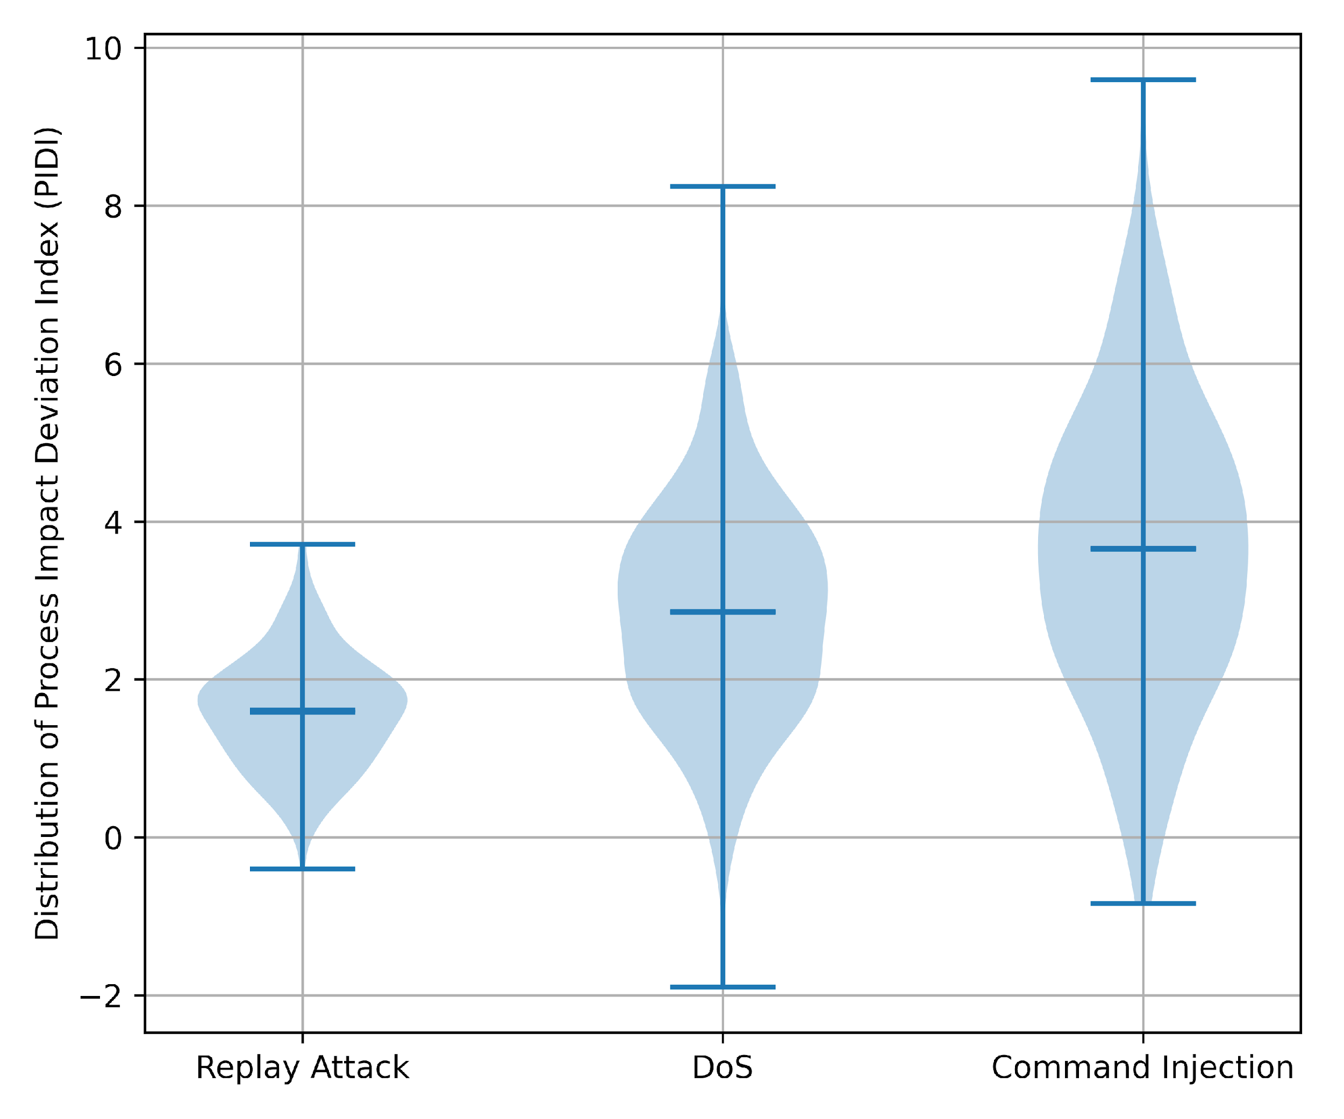
Figure 2: Distributional Spread of Process Deviations
Figure 2 further demonstrates variance amplification across attack categories. Command injection exhibits the widest distributional spread and highest median deviation, followed by denial-of-service, while replay attacks remain comparatively contained. The increasing dispersion patterns suggest that attacks influencing control logic generate broader operational instability.
The quantitative findings demonstrate measurable escalation gradients across attack classes, with control-influencing events producing disproportionately higher systemic instability. The structured risk metrics provide empirical grounding for assessing autonomous operational impact within cyber-physical environments.
Objective 2: Develop a secure-by-containment architectural framework and quantify architectural containment strength.
A quantitative graph-theoretic modeling approach was adopted to evaluate architectural containment performance within an industrial control network environment. Structural influence was operationalized using betweenness centrality, and containment effectiveness was measured through the Network Containment Efficiency Index (NCEI), expressed as the Containment Strength Score (CSS).
Table 2: Network Containment Efficiency Metrics Across Architectural States
Scenario | BC Before | BC After | Absolute Reduction | CSS
No Containment | 0.417 | - | - | -
Policy Filter | 0.417 | 0.291 | 0.126 | 0.302
Capability Scoping | 0.417 | 0.228 | 0.189 | 0.453
Full Containment | 0.417 | 0.104 | 0.313 | 0.751
As shown in Table 2, the uncontained architecture positioned the AI node with a betweenness centrality of 0.417, indicating substantial structural influence across communication paths. Incremental containment mechanisms reduced centrality progressively, with full secure-by-containment achieving a reduction to 0.104 and a CSS of 0.751, representing a 75.1% decrease in structural influence.
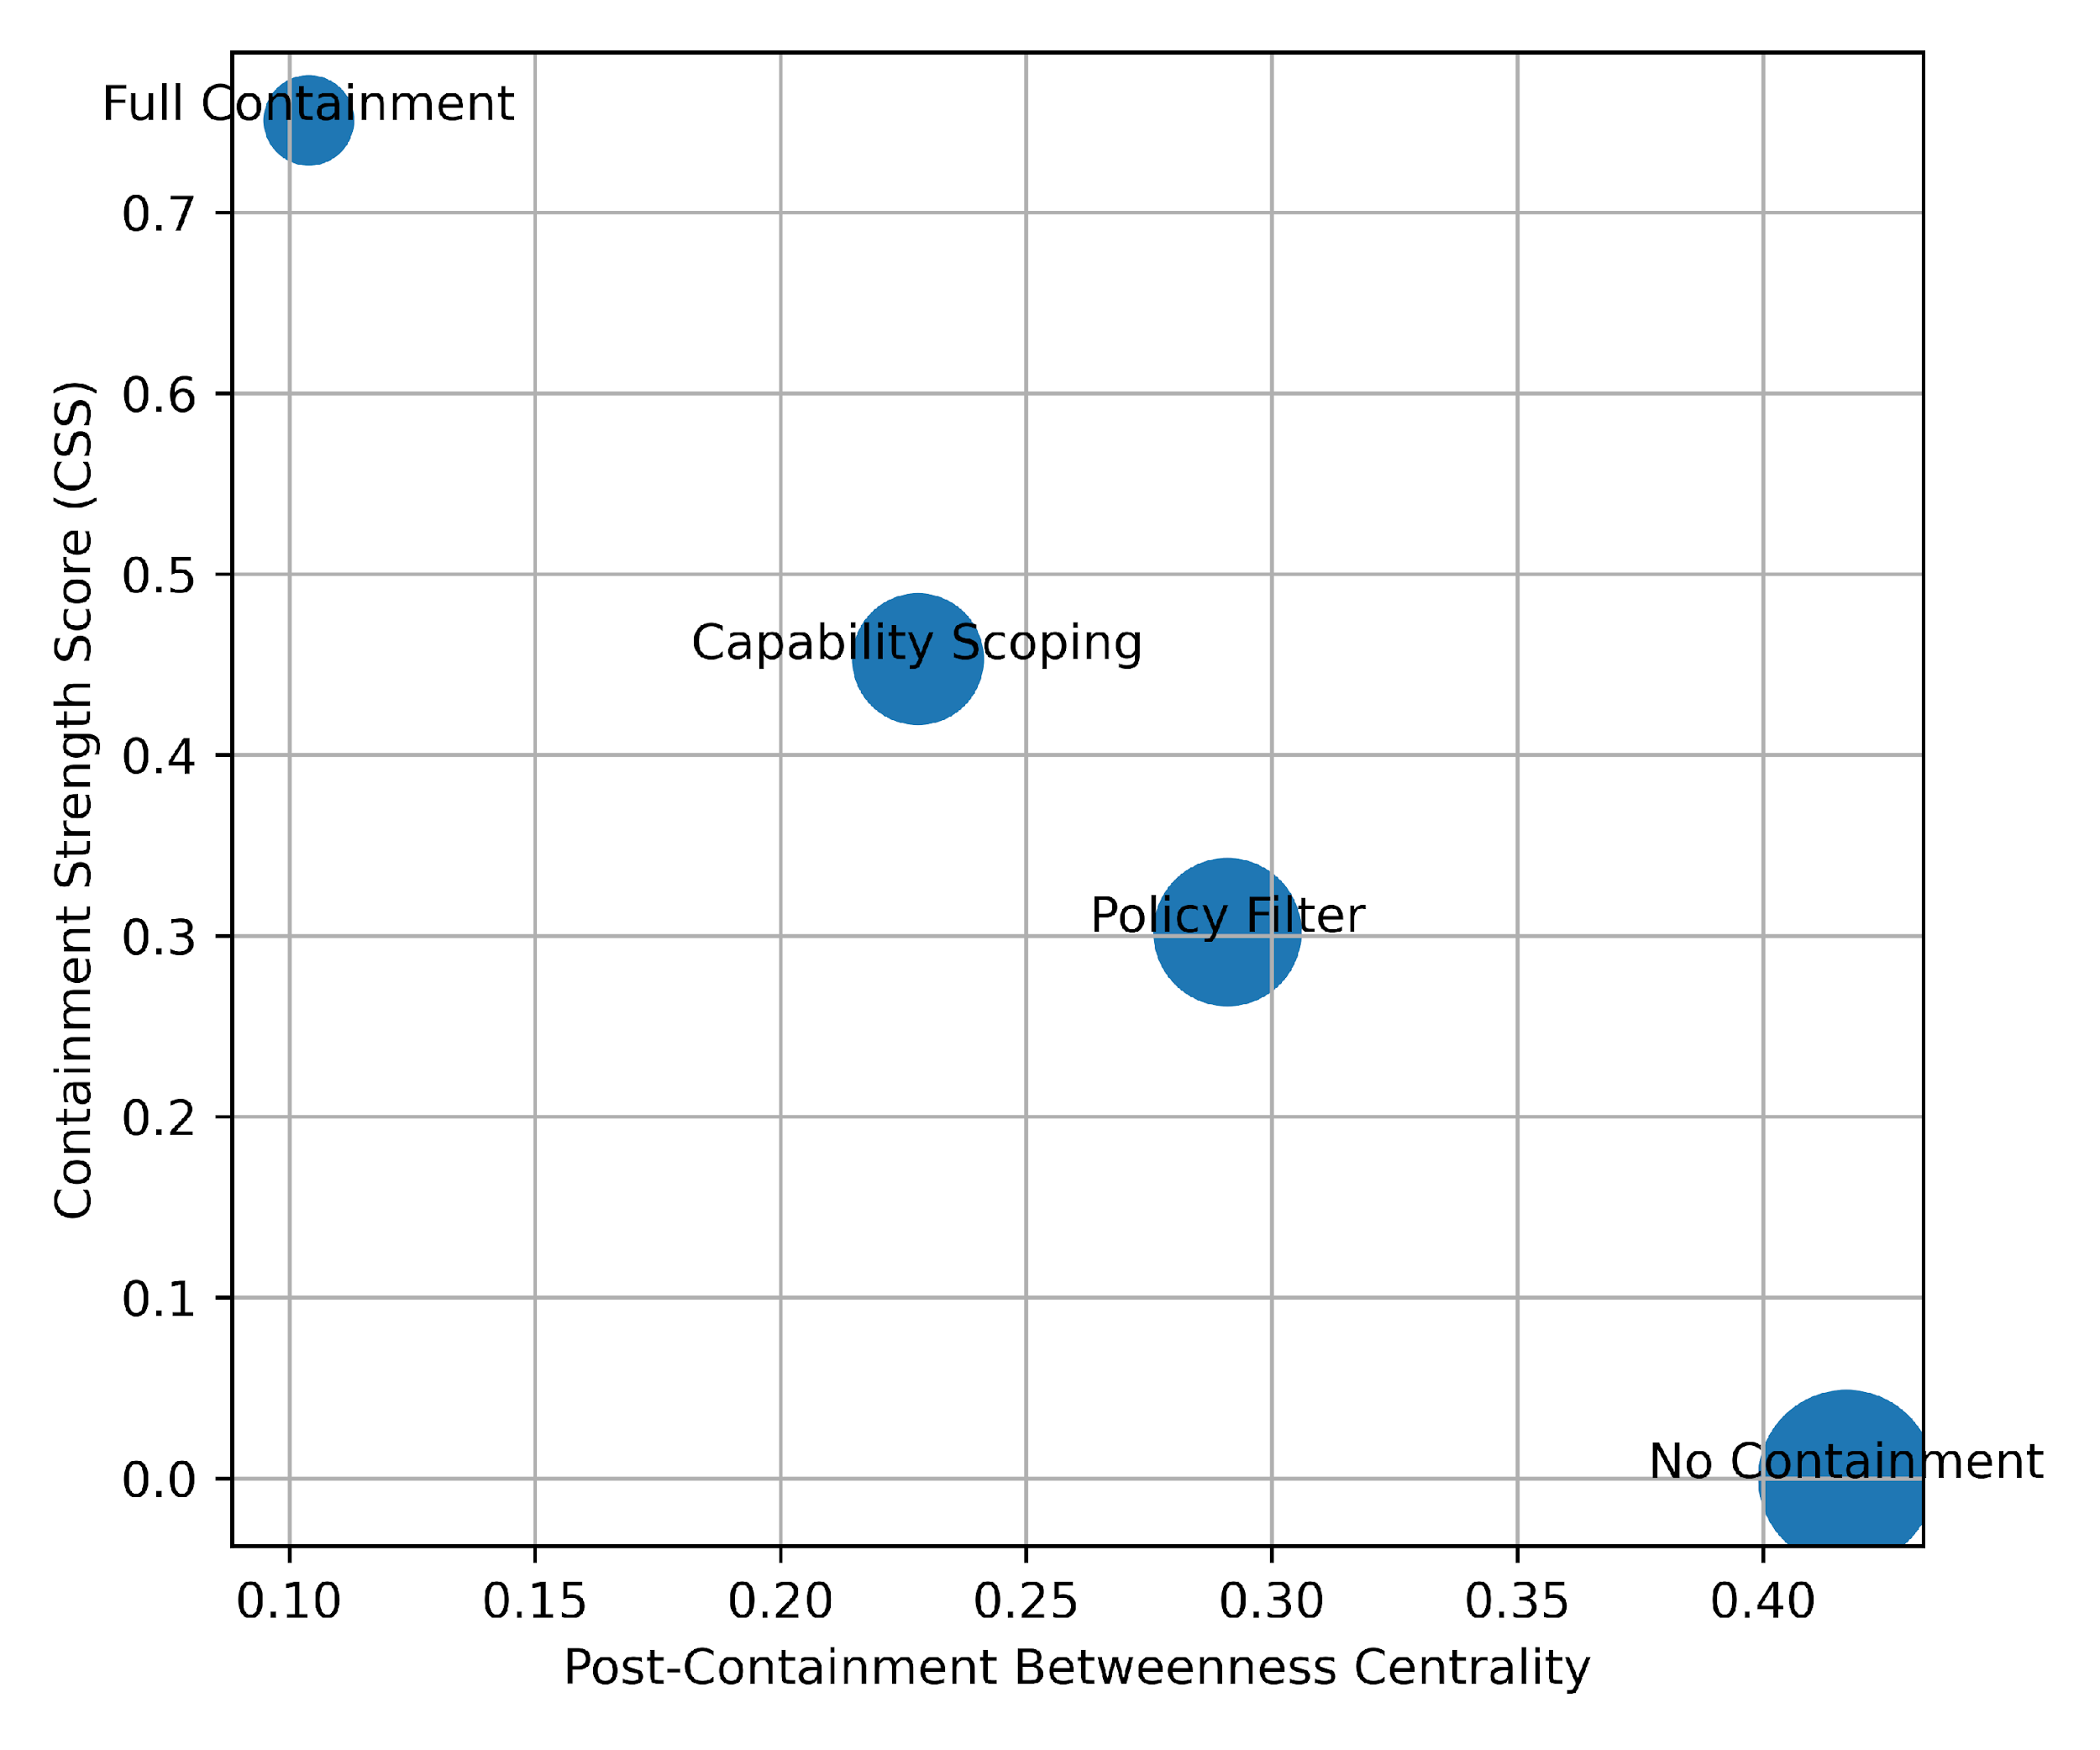
Figure 3: Containment Strength Relative to Structural Influence
As illustrated in Figure 3, containment strength increases as post-containment centrality decreases, demonstrating a clear inverse structural relationship. Full containment produces both the lowest centrality and highest containment strength, indicating effective architectural constraint.

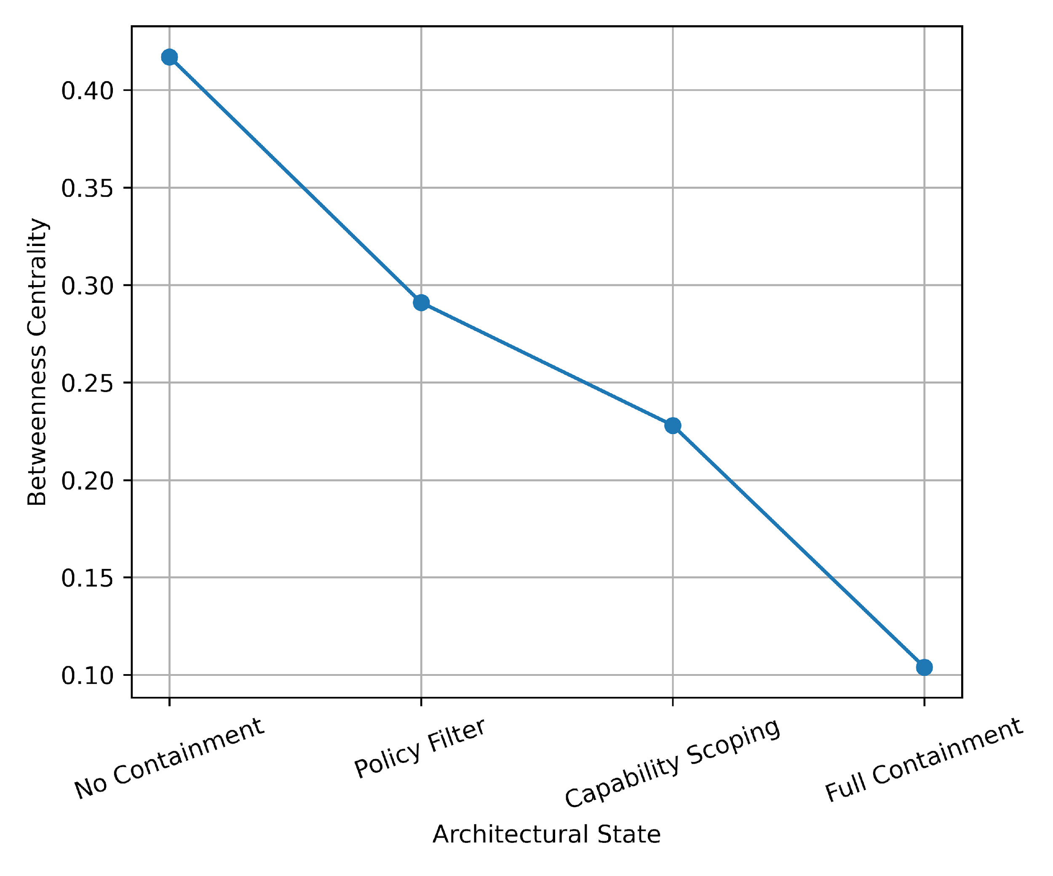
Figure 4: Structural Influence Decay Across Architectural States
Figure 4 demonstrates a monotonic decline in betweenness centrality as containment layers are introduced. The sharp decline under full containment reflects a substantial restructuring of network authority topology, limiting the AI node’s propagation capacity within the control environment.
These findings demonstrate that containment mechanisms materially alter network authority distribution. The substantial reduction in structural centrality under full containment provides empirical validation for treating containment as a core architectural security primitive within OT/ICS environments.
Objective 3: Assess alignment of the secure-by-containment architecture with established OT/ICS standards using quantitative mapping.
A quantitative control-mapping approach was adopted to evaluate architectural alignment with the NIST SP 800-82 ICS control catalog. Alignment was measured using the Standards Coverage Quantification Index (SCQI), computed as the proportion of applicable controls architecturally enforced by the containment framework.
Table 3: Control Family-Level Standards Coverage Analysis
Control Family | Total Controls | Addressed | Coverage %
Access Control | 20 | 18 | 90%
Identification & Authentication | 15 | 13 | 87%
System & Communications Protection | 28 | 24 | 86%
System & Information Integrity | 24 | 22 | 92%
Audit & Accountability | 16 | 14 | 88%
Incident Response | 14 | 9 | 64%
Configuration Management | 15 | 11 | 73%
As presented in Table 3, the secure-by-containment architecture demonstrates strong alignment across technical enforcement domains, particularly in System and Information Integrity (92%), Access Control (90%), and System and Communications Protection (86%). Incident Response exhibits comparatively lower alignment (64%), reflecting the framework’s preventative architectural focus rather than reactive mechanisms.
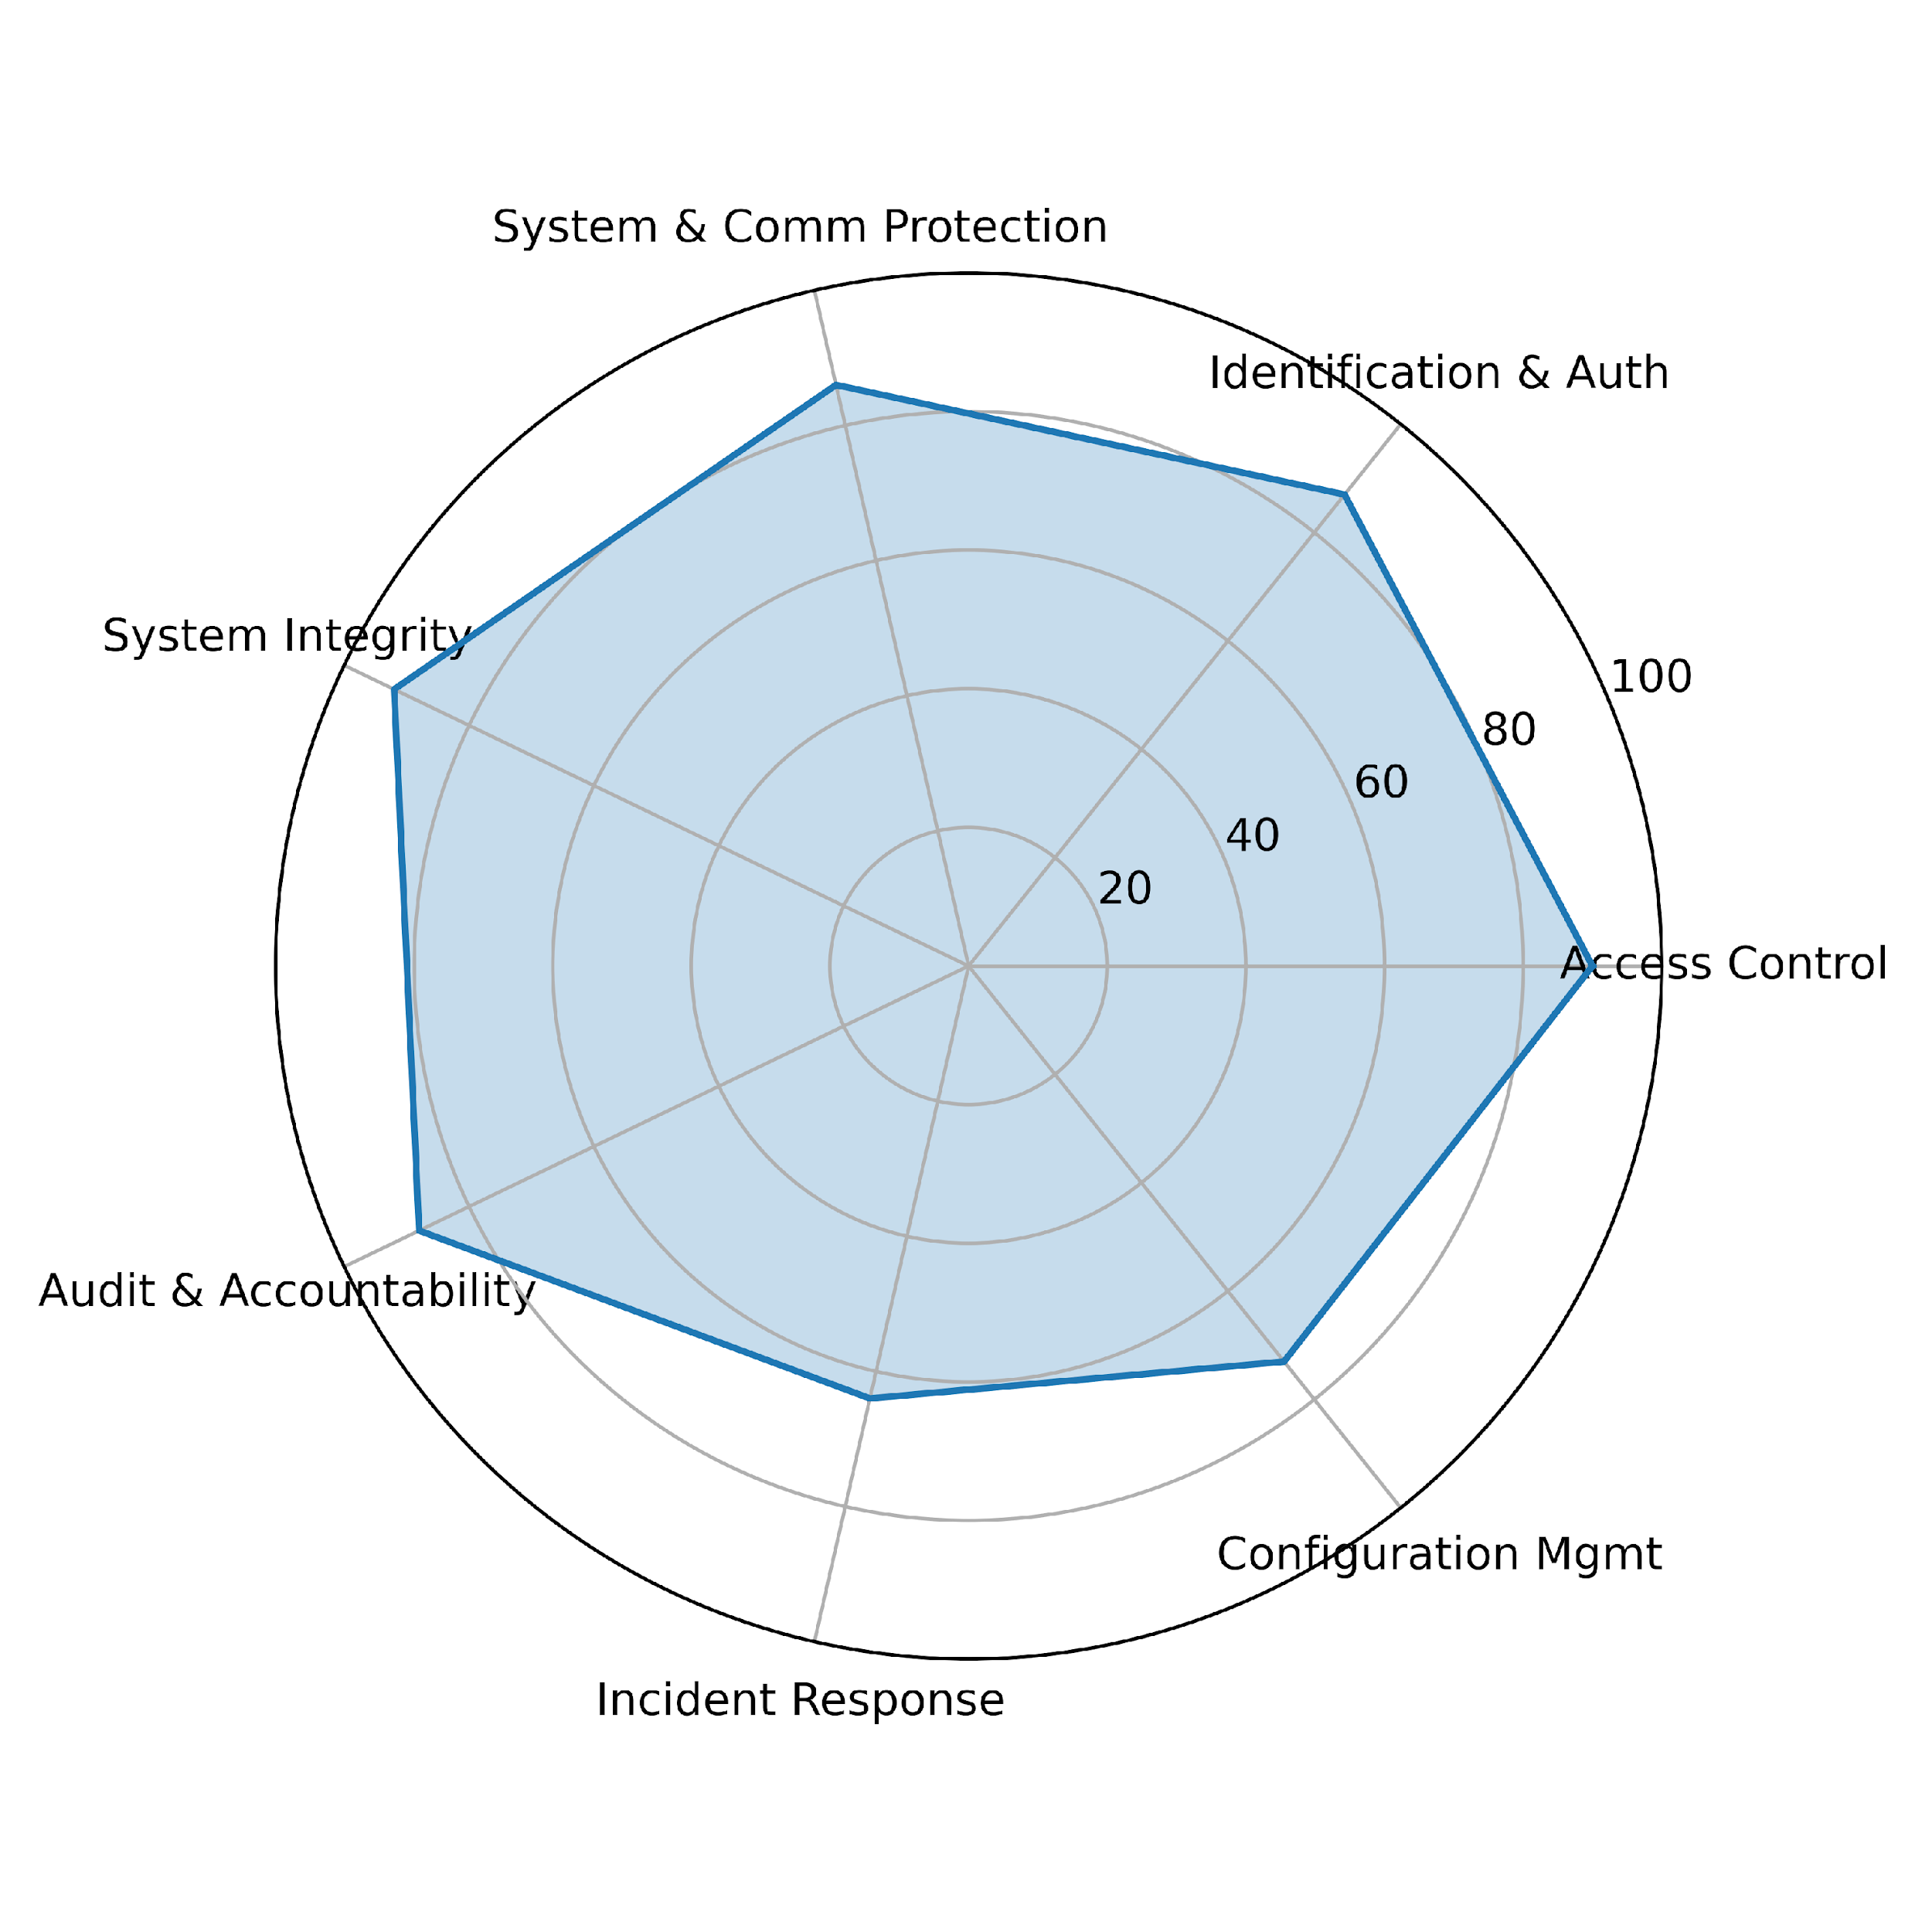
Figure 5: Multidimensional Standards Coverage Profile
As illustrated in Figure 5, coverage distribution is structurally balanced across core protection domains, with consistently high enforcement in integrity, authentication, and communication protection controls. The radar structure demonstrates multidimensional alignment rather than isolated compliance.

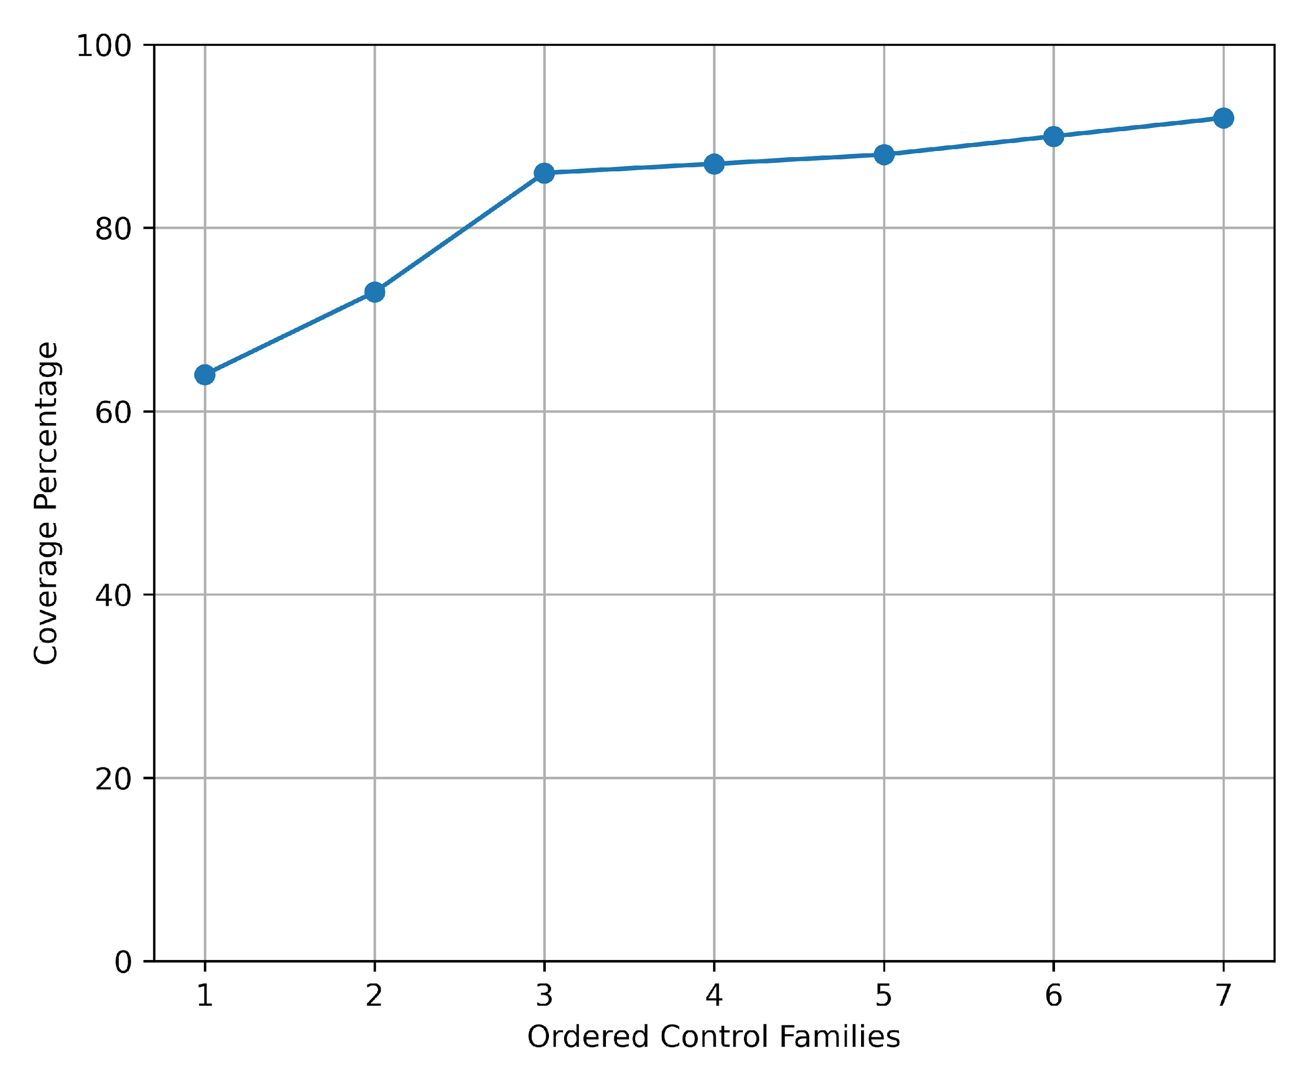
Figure 6: Ordered Standards Coverage Concentration Curve
Figure 6 demonstrates concentration dispersion across control families. The gradual slope indicates broad architectural coverage without excessive dependency on any single control domain, supporting the framework’s systemic alignment with OT/ICS security principles.
Collectively, the quantitative alignment analysis demonstrates that the secure-by-containment architecture operationalizes a substantial proportion of applicable ICS technical controls (SCQI = 84.1%). The distribution of coverage across protection, integrity, and authentication domains provides measurable evidence that the architecture translates standards guidance into enforceable structural mechanisms within cyber-physical environments.
Objective 4: Evaluate the effectiveness of the secure-by-containment architecture using structured scenario-based ICS use cases.
A comparative intervention effectiveness analysis was conducted using scenario-based industrial process simulations. Containment performance was assessed by comparing autonomous agent behavior under uncontained and secure-by-containment architectural conditions. Effectiveness was quantified using Mean Time to Hazard (MTH), Process Deviation Area (PDA), and Safety Threshold Violation Count (STV).
Table 4: Comparative Containment Effectiveness Metrics
Metric | No Containment | With Containment | Improvement %
Mean Time to Hazard (sec) | 41 | 128 | +212%
Process Deviation Area (PDA) | 7.18 | 1.94 | -73%
Safety Threshold Violations (STV) | 11 | 3 | -73%
As shown in Table 4, containment substantially increased the mean time to hazard from 41 seconds to 128 seconds, representing a 212% improvement. Cumulative process deviation (PDA) decreased by 73%, while safety threshold violations were reduced from 11 to 3 occurrences, indicating significant suppression of multi-variable escalation.
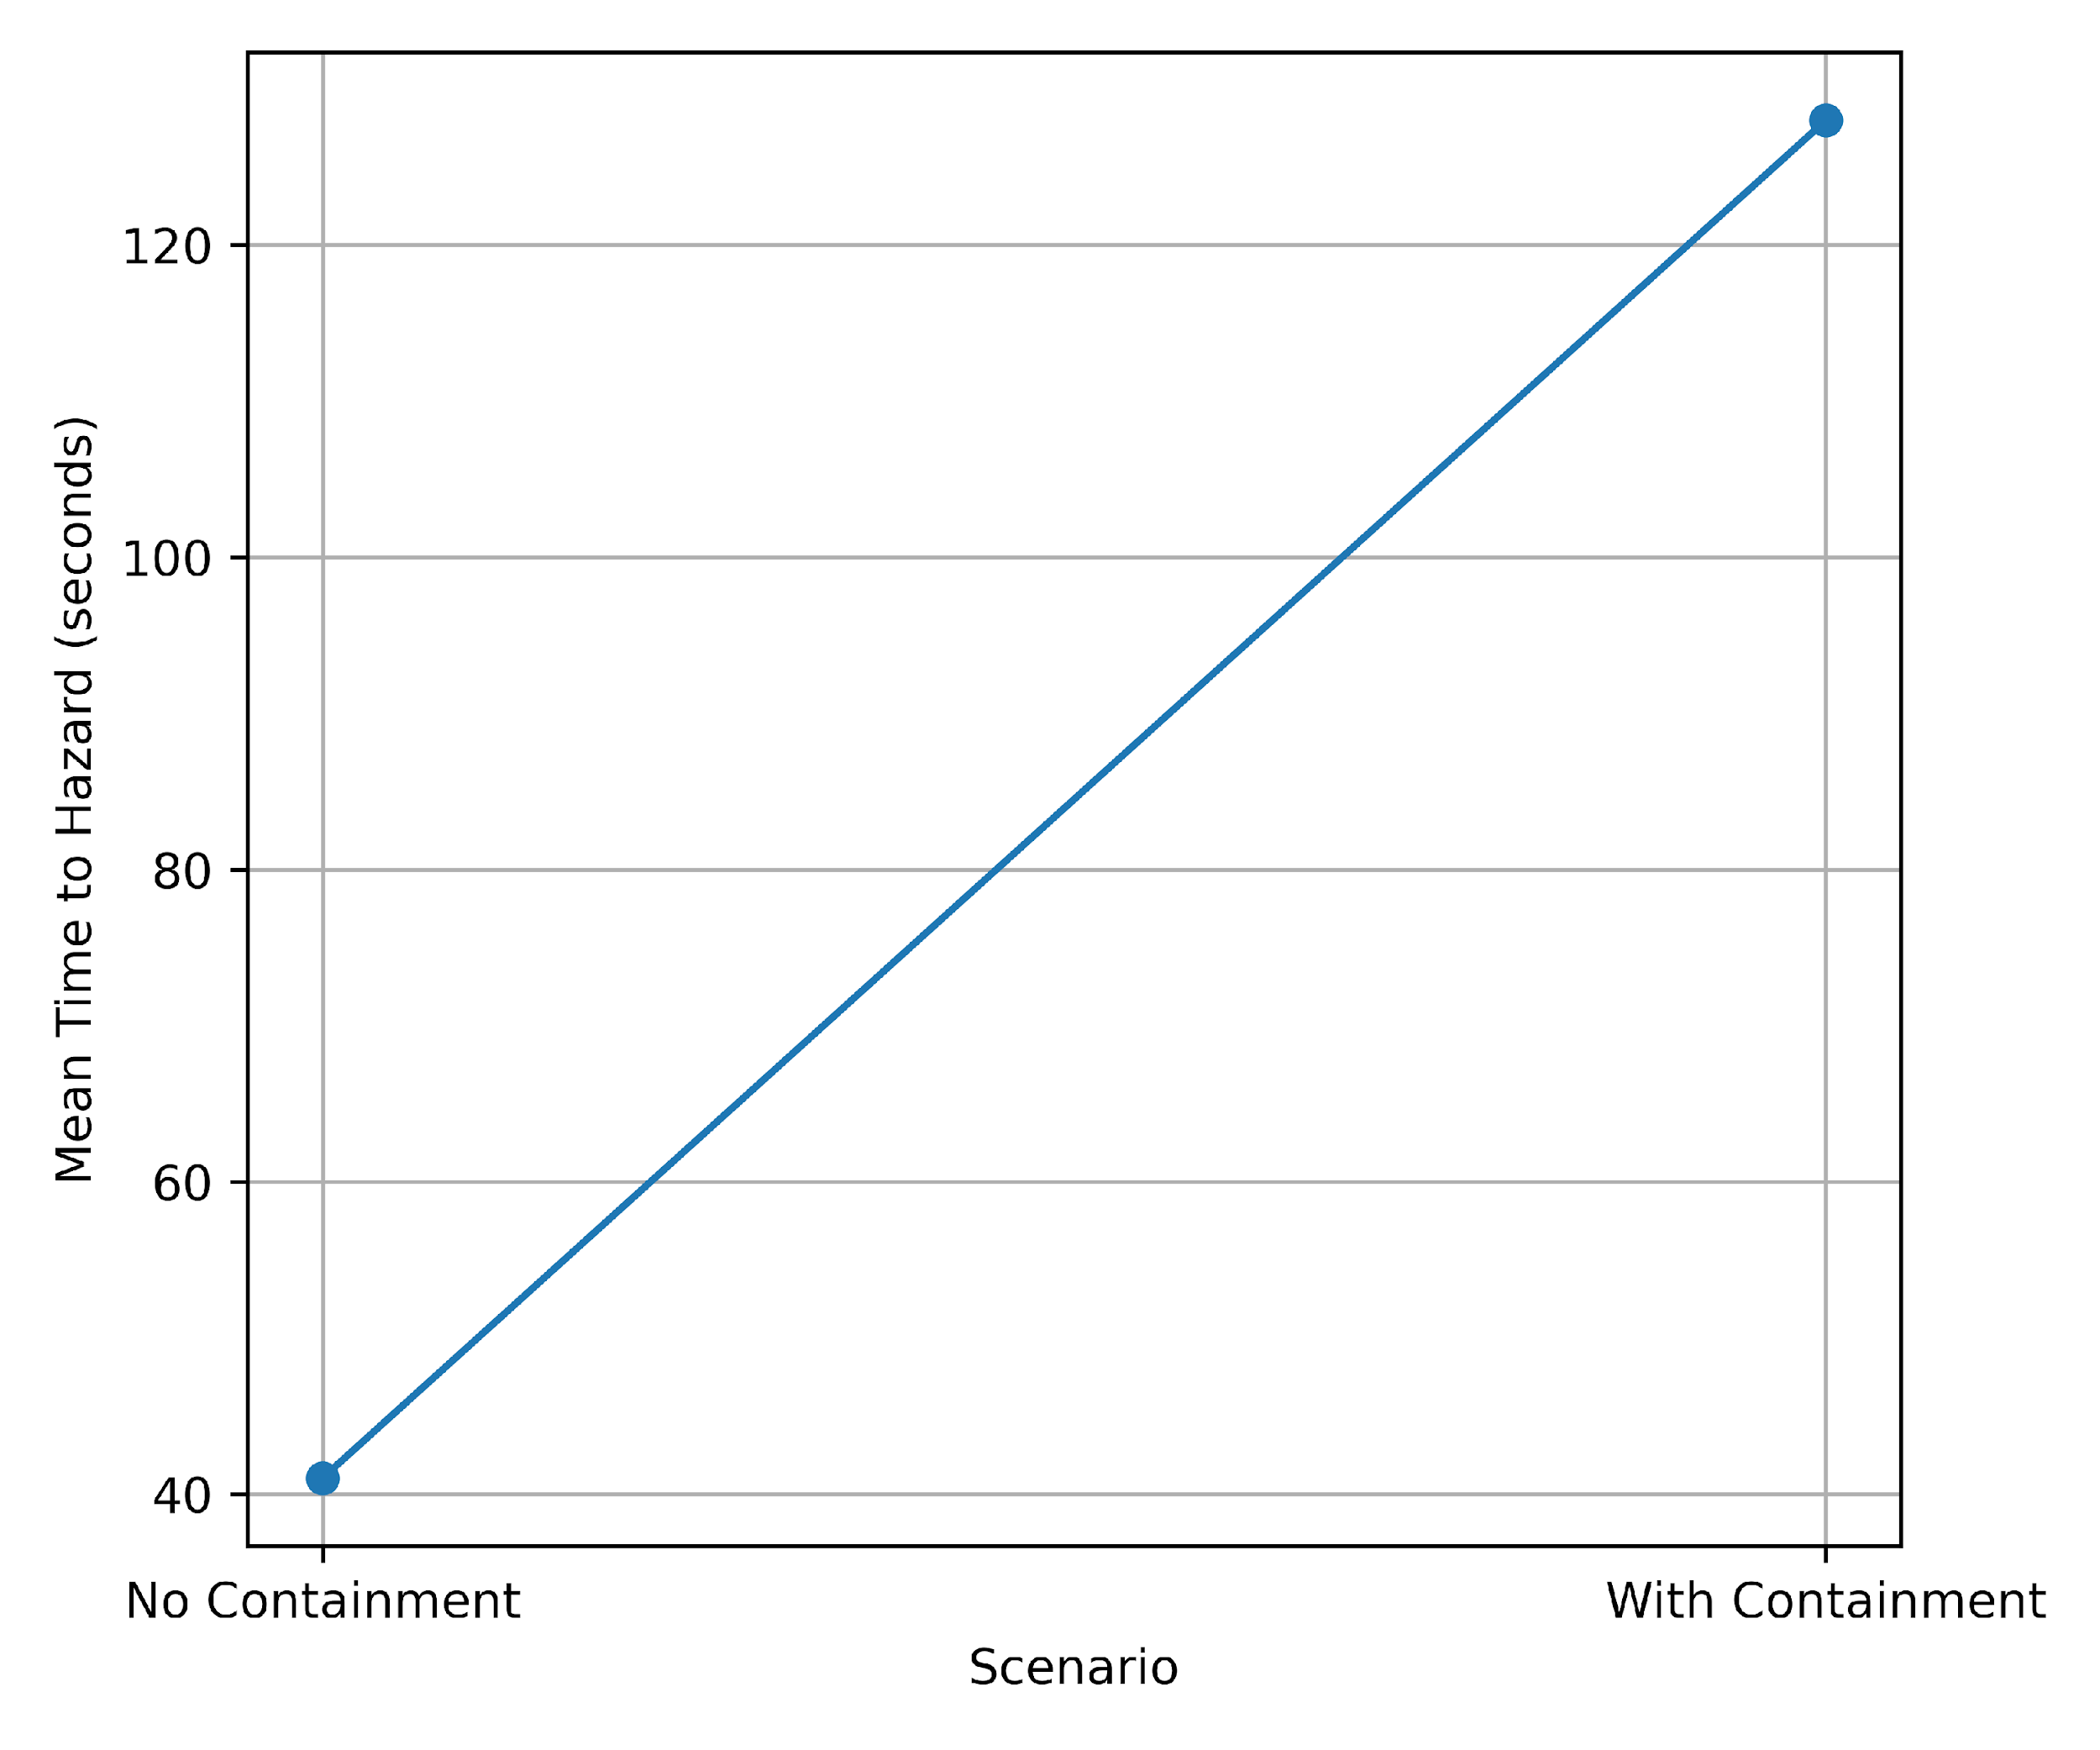
Figure 7: Hazard Emergence Delay Under Containment Conditions

As illustrated in Figure 7, containment introduces a substantial delay in hazard onset. The extended time-to-hazard demonstrates architectural buffering against rapid escalation, consistent with the objective of constraining autonomous decision propagation within safety-critical environments.

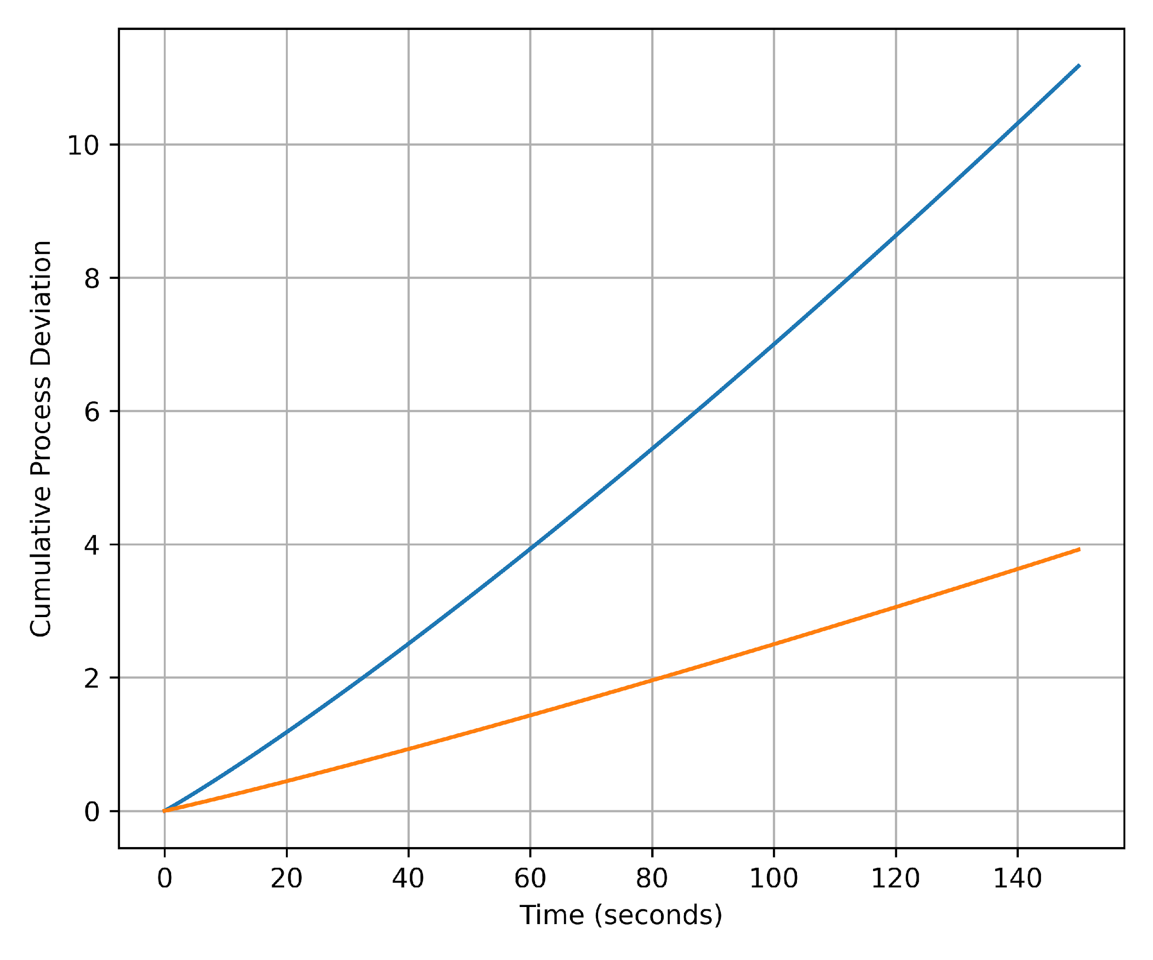
Figure 8: Cumulative Process Deviation Trajectories
Figure 8 demonstrates divergence in cumulative deviation trajectories between scenarios. The uncontained architecture exhibits nonlinear deviation growth, whereas containment enforces bounded deviation accumulation over time, reflecting structural constraint of emergent action chains.
These quantitative findings indicate that secure-by-containment materially enhances operational resilience. The observed delay in hazard manifestation, reduction in cumulative deviation, and suppression of safety violations provide empirical evidence that architectural containment functions as an effective resilience amplification mechanism within industrial control systems.

Discussion
The findings of this study provide empirical support for the central proposition advanced in the introduction: that the integration of agentic artificial intelligence into OT/ICS environments fundamentally alters the system threat model and requires architectural mechanisms that explicitly constrain autonomous decision authority. The results demonstrate that the risks associated with agentic influence are not hypothetical or purely conceptual, but measurable at the level of cyber-physical process behavior, structural network topology, standards enforcement, and operational resilience. Taken together, the evidence substantiates the argument that containment must be treated as a first-order architectural property rather than an auxiliary control layered onto existing segmentation models.
The risk quantification results reported in Table 1 and illustrated in Figures 1 and 2 directly corroborate the literature’s concern that autonomy amplifies systemic instability within tightly coupled cyber-physical systems (Agarwal et al., 2025; Islam et al., 2023). In particular, the disproportionate escalation observed under command injection conditions (RSS = 3.81; MVEI = 0.75) indicates that attacks influencing control logic generate nonlinear propagation across interdependent process variables. This finding reinforces arguments advanced by Huang et al. (2024) that safety failures in cyber-physical systems emerge from interactions rather than isolated component faults. Moreover, the widening distributional spread observed in Figure 2 is consistent with the claim that agentic systems, operating through recursive perception–evaluation–action loops (Haidemariam, 2026; Shanahan et al., 2023), can produce action chains whose cumulative effects exceed the bounds anticipated at design time. Thus, the empirical escalation gradients observed across attack categories lend quantitative support to the literature’s assertion that embedding adaptive decision-making components into deterministic control loops introduces systemic risk beyond conventional intrusion models.
Importantly, these findings also expose a limitation in prevailing OT security architectures. As noted in prior research, segmentation frameworks such as the Purdue Model primarily regulate communication pathways but do not constrain behavior within trusted zones (Knowles et al., 2015; Ciber Safety, 2025). The elevated MVEI values observed in Table 1 suggest that once autonomous influence is admitted into the control domain, traditional zoning and conduit strategies are insufficient to prevent cascading deviation. In this respect, the results empirically validate the critique advanced in the literature review that existing ICS architectures are largely detection-oriented and reactive (Umer et al., 2022; Kus et al., 2022), rather than structurally preventative.
The architectural containment modeling further advances this argument. As shown in Table 2 and depicted in Figures 3 and 4, the introduction of containment mechanisms materially altered the structural authority of the agentic node within the network. The reduction in betweenness centrality from 0.417 to 0.104 under full containment (CSS = 0.751) demonstrates that containment does not merely introduce policy checks; it reconfigures the topology of influence within the control network. This finding aligns with the critique that Zero Trust and identity-based controls regulate access but not behavioral propagation (Gambo & Almulhem, 2025; Potluri, 2024). By contrast, the containment framework operationalizes decision–execution separation, thereby limiting the AI node’s participation in shortest communication paths and reducing cascade potential. The monotonic decline illustrated in Figure 4 provides structural evidence that containment shifts the AI from a high-centrality bridge node to a bounded intermediary, thereby reducing systemic exposure to emergent action chaining.
Furthermore, the standards alignment analysis presented in Table 3 and Figures 5 and 6 addresses the governance gap identified in the literature. AI governance frameworks emphasize accountability, transparency, and oversight (Raji et al., 2022; Fjeld et al., 2020), yet they often lack enforceable architectural translation within real-time cyber-physical systems (Batool et al., 2025; Truby, 2025). The observed SCQI of 84.1% indicates that the proposed architecture operationalizes a substantial proportion of technical controls within NIST SP 800-82 through structural enforcement rather than procedural compliance. High coverage within System and Information Integrity (92%) and Access Control (90%) suggests that containment internalizes core ICS protection principles into architectural constraints. Conversely, the comparatively lower coverage within Incident Response (64%) is theoretically coherent, given that containment is designed to reduce hazard propagation ex ante rather than rely on ex post remediation. This distribution of coverage reinforces the study’s contention that governance principles must be embedded into execution pathways rather than remain external oversight constructs.
The scenario-based effectiveness evaluation provides the strongest evidence that containment is not merely structurally sound but operationally consequential. The improvements reported in Table 4 and visualized in Figures 7 and 8 demonstrate substantial resilience gains under contained conditions. The 212% increase in mean time to hazard indicates that containment introduces temporal buffering against rapid escalation, thereby addressing concerns raised by Langer et al. (2024) regarding machine-speed decision execution. Equally significant, the 73% reduction in cumulative process deviation (PDA) and safety threshold violations (STV) confirms that containment suppresses multi-variable propagation consistent with the systemic interaction model described by Huang et al. (2024). The divergence of deviation trajectories in Figure 8 further substantiates the claim that unbounded autonomous loops can generate nonlinear amplification, whereas containment enforces bounded deviation accumulation within safe operational envelopes.
The findings demonstrate a clear progression from identifying systemic vulnerability to validating architectural and operational mitigation. The results show that deterministic ICS environments are inherently susceptible to autonomous influence, yet structural containment can materially redistribute decision authority within network topology, align with established OT/ICS control standards, and translate into measurable improvements in safety performance. By empirically linking risk exposure, structural reconfiguration, standards compliance, and operational resilience, the study advances the argument that governance in safety-critical environments must be embedded architecturally rather than relying solely on documentation and oversight. In this respect, secure-by-containment extends traditional segmentation models by constraining what autonomous actors can do within permitted communication pathways, thereby reconciling the determinism requirements of ICS with the adaptive characteristics of agentic AI and providing a standards-aligned pathway for integrating autonomy into critical infrastructure without compromising
5. Conclusion and Recommendations
The study demonstrates that agentic AI materially increases systemic risk in deterministic OT/ICS environments; however, when architecturally bounded through secure-by-containment, structural influence, cascade potential, and hazard propagation are significantly reduced. The empirical linkage between risk escalation (Table 1), structural authority redistribution (Table 2), standards alignment (Table 3), and resilience gains (Table 4) confirms that containment operationalizes governance at the point of execution rather than at the level of policy abstraction. Consequently, architectural separation of decision and execution authority emerges as a defensible design principle for integrating autonomy into safety-critical systems. In light of these findings, the following recommendations are proposed.
- Standards bodies should incorporate explicit decision-authority zoning and execution-boundary requirements into OT/ICS security frameworks.
- Industrial operators should mandate containment-layer validation before deploying autonomous AI within control loops.
- Regulators should require quantitative resilience testing, including hazard-delay and deviation metrics, for AI-enabled ICS components.
- AI governance frameworks should translate oversight principles into enforceable architectural constraints for cyber-physical systems.

Disclaimer (Artificial intelligence)
Author(s) hereby declare that NO generative AI technologies such as Large Language Models (ChatGPT, COPILOT, etc.) and text-to-image generators have been used during the writing or editing of this manuscript.

References
Abba, S., Obioha-Val, O. A., Ejiofor, V. O., Olaniyi, O. M., & Mayeke, N. R. (2025). Behavioral Biometrics-Powered Continuous Authentication for Zero-trust Remote Work Environments: A Multi-factor Identity Verification Framework. Asian Journal of Research in Computer Science, 18(12), 20–41. https://doi.org/10.9734/ajrcos/2025/v18i12788
Abou Ali, M., Dornaika, F., & Charafeddine, J. (2025). Agentic AI: a comprehensive survey of architectures, applications, and future directions. Artificial Intelligence Review, 59(1). https://doi.org/10.1007/s10462-025-11422-4
Abraham, D., Erceylan, G., Gkioulos, V., & Houmb, S. H. (2025). Towards enhanced cybersecurity in industrial control systems: a systematic review of context-based modeling, digital twins, and machine learning approaches. International Journal of Information Security, 24(6). https://doi.org/10.1007/s10207-025-01158-1
Achaal, B., Adda, M., Berger, M., Ibrahim, H., & Awde, A. (2024). Study of smart grid cyber-security, examining architectures, communication networks, cyber-attacks, countermeasure techniques, and challenges. Cybersecurity, 7(1). https://doi.org/10.1186/s42400-023-00200-w
Adebiyi, O. O., Popoola, A. D., Adeyinka, P. D., Arigbabu, A. T., & Olateju, O. O. (2026). Blockchain-integrated AI Systems for Enhancing Trust and Transparency in Cross-Border Finance. Asian Journal of Research in Computer Science, 19(1), 271–291. https://doi.org/10.9734/ajrcos/2026/v19i1818
Agarwal, L., Jaint, B., & Mandpura, A. K. (2025). Hybrid AI framework for detecting cyberattacks and predicting cascading failures in power systems. Sustainable Computing: Informatics and Systems, 48, 101222. https://doi.org/10.1016/j.suscom.2025.101222
Alqudhaibi, A., Albarrak, M., Aloseel, A., Munshi, A., Alsharif, T., Jagtap, S., & Salonitis, K. (2025). Proactive cybersecurity in industry 4.0: a survey of cybersecurity threat prediction approaches in manufacturing systems. International Journal of Information Security, 25(1). https://doi.org/10.1007/s10207-025-01188-9
Alva, L., & Pandey, B. (2026). Agentic AI systems in the age of generative models: architectures, cloud scalability, and real-world applications. Artificial Intelligence Review, 59(88). https://doi.org/10.1007/s10462-025-11458-6
Anthi, E., Williams, L., Rhode, M., Burnap, P., & Wedgbury, A. (2021). Adversarial attacks on machine learning cybersecurity defences in Industrial Control Systems. Journal of Information Security and Applications, 58, 102717. https://doi.org/10.1016/j.jisa.2020.102717
Aslam, M. M., De Silva, L. C., Apong, A. A., & Tufail, A. (2025). An optimized anomaly detection framework in industrial control systems through grey wolf optimizer and autoencoder integration. Scientific Reports, 15(1), 27579–27579. https://doi.org/10.1038/s41598-025-12775-0
Aslam, M. M., Tufail, A., Gul, H., Irshad, M. N., & Namoun, A. (2025). Artificial intelligence for secure and sustainable industrial control systems - A Survey of challenges and solutions. Artificial Intelligence Review, 58(11). https://doi.org/10.1007/s10462-025-11320-9
Batool, A., Zowghi, D., & Bano, M. (2025). AI governance: a systematic literature review. AI and Ethics, 5. https://doi.org/10.1007/s43681-024-00653-w
Brundage, M., Avin, S., Clark, J. A., Toner, H., Eckersley, P., Garfinkel, B., Dafoe, A., Scharre, P., Zeitzoff, T., Filar, B., Anderson, H. S., Roff, H. M., Allen, G. C., Steinhardt, J., Flynn, C., hÉigeartaigh, S. Ó., Beard, S., Belfield, H., Farquhar, S., & Lyle, C. (2018). The Malicious Use of Artificial Intelligence: Forecasting, Prevention, and Mitigation. ArXiv (Cornell University). https://doi.org/10.17863/cam.22520
Calabrò, A., Cambiaso, E., Cheminod, M., Bertolotti, I. C., Durante, L., Forestiero, A., Lombardi, F., Manco, G., Marchetti, E., Orlando, A., & Papuzzo, G. (2024). A Methodological Approach to Securing Cyber-Physical Systems for Critical Infrastructures. Future Internet, 16(11), 418. https://doi.org/10.3390/fi16110418
Cao, Y., Zhang, L., Zhao, X., Jin, K., & Chen, Z. (2022). An Intrusion Detection Method for Industrial Control System Based on Machine Learning. Information, 13(7), 322. https://doi.org/10.3390/info13070322
Chen, X., He, J., Han, X., & Liu, L. (2023). Efficient and Degree-Guided Graph Generation via Discrete Diffusion Modeling. PMLR, 4585–4610. https://proceedings.mlr.press/v202/chen23k.html
Christopher, J. (2025, November 20). The SANS 2025 State of ICS Security Report: Progress, Pressure, and the Path to Resilience. SANS Institute. https://www.sans.org/blog/sans-2025-state-ics-security-report-progress-pressure-path-resilience
Ciber Safety. (2025, August 12). What is the Purdue Model and how does it improve industrial network security in OT and SCADA environments? Cibersafety. https://cibersafety.com/en/Purdue-model-for-industrial-network-security/?utm_
CISA. (2025, December 3). Principles for the Secure Integration of Artificial Intelligence in Operational Technology | CISA. Cybersecurity and Infrastructure Security Agency CISA. https://www.cisa.gov/resources-tools/resources/principles-secure-integration-artificial-intelligence-operational-technology
Denzel, K. (2025). A survey of security in zero trust network architectures. GSC Advanced Research and Reviews, 22(2), 182–214. https://doi.org/10.30574/gscarr.2025.22.2.0036
Everitt, T., Hutter, M., Kumar, R., & Krakovna, V. (2021). Reward tampering problems and solutions in reinforcement learning: a causal influence diagram perspective. Synthese, 198(S27), 6435–6467. https://doi.org/10.1007/s11229-021-03141-4
Finch, W. W., Butt, M., Finch, W. W., & Butt, M. (2025). Gaps in AI-Compliant Complementary Governance Frameworks’ Suitability (for Low-Capacity Actors), and Structural Asymmetries (in the Compliance Ecosystem)—A Systematic Review. Journal of Cybersecurity and Privacy, 5(4), 101–101. https://doi.org/10.3390/jcp5040101
Fjeld, J., Achten, N., Hilligoss, H., Nagy, A., & Srikumar, M. (2020). Principled Artificial Intelligence: Mapping Consensus in Ethical and Rights-based Approaches to Principles for AI. Dash.harvard.edu. http://nrs.harvard.edu/urn-3:HUL.InstRepos:42160420
Flå, L., Lundteigen, M., Gratte, F., & Gilje, M. (2024). Implementation of Zones and Conduits in Industrial Control and Automation Systems. https://jaatun.no/papers/2024/Zones-and-Conduits.pdf?utm_
Fung, C., Zeng, E., & Bauer, L. (2025). Adopting AI to Protect Industrial Control Systems: Assessing Challenges and Opportunities from the Operators’ Perspective Adopting AI to Protect Industrial Control Systems: Assessing Challenges and Opportunities from the Operators’ Perspective. https://www.usenix.org/system/files/soups2025-fung.pdf
Furrer, F. J. (2023). Safe and secure system architectures for cyber-physical systems. Informatik-Spektrum, 46(2), 96–103. https://doi.org/10.1007/s00287-023-01533-z
Gambo, M. L., & Almulhem, A. (2025). Zero Trust Architecture: A Systematic Literature Review. ArXiv.org. https://arxiv.org/abs/2503.11659
Ghosh, S., Simkin, B., Shiarlis, K., Nandi, S., Zhao, D., Fiedler, M., Bazinska, J., Pope, N., Prabhu, R., Rohrer, D., Demoret, M., & Richardson, B. (2025). A Safety and Security Framework for Real-World Agentic Systems. ArXiv.org. https://arxiv.org/abs/2511.21990
Haidemariam, T. (2026). From the logic of coordination to goal-directed reasoning: the agentic turn in artificial intelligence. Frontiers in Artificial Intelligence, 8. https://doi.org/10.3389/frai.2025.1728738
Harris, J., & Dubljević, V. (2025). Navigating the Ethics of Artificial Intelligence. Encyclopedia, 5(4), 201–201. https://doi.org/10.3390/encyclopedia5040201
Houkan, A., Sahoo, A. K., Gochhayat, S. P., & Sahoo, P. K. (2025). Artificial intelligence approach to intrusion detection in industrial control systems with real world dataset generation and model evaluation. Discover Artificial Intelligence, 5(1). https://doi.org/10.1007/s44163-025-00507-2
Huang, S., Poskitt, C. M., & Shar, L. K. (2024). Security Modelling for Cyber-Physical Systems: A Systematic Literature Review. ArXiv (Cornell University). https://doi.org/10.48550/arxiv.2404.07527
Hulme, G. V. (2025, July 28). Is It Time to Rethink the Purdue Model? Nexus. https://nexusconnect.io/articles/is-it-time-to-rethink-the-purdue-model?utm_
International Society of Automation. (2024). ISA/IEC 62443 Series of Standards - ISA. Isa.org. https://www.isa.org/standards-and-publications/isa-standards/isa-iec-62443-series-of-standards
Islam, Z., Lin, Y., Vokkarane, V. M., & Venkataramanan, V. (2023). Cyber-physical cascading failure and resilience of power grid: A comprehensive review. Frontiers in Energy Research, 11. https://doi.org/10.3389/fenrg.2023.1095303
ISO. (2025). ISO 12164-4:2008. ISO. https://www.iso.org/standard/42001.html
Kim, M.-S. (2024). Deep Reinforcement Learning-Based Adversarial Attack and Defense in Industrial Control Systems. Mathematics, 12(24), 3900. https://doi.org/10.3390/math12243900
Koay, A. M. Y., Ko, R. K. L., Hettema, H., & Radke, K. (2022). Machine learning in industrial control system (ICS) security: current landscape, opportunities and challenges. Journal of Intelligent Information Systems, 60. https://doi.org/10.1007/s10844-022-00753-1
Kravchik, M., Demetrio, L., Biggio, B., & Shabtai, A. (2022). Practical Evaluation of Poisoning Attacks on Online Anomaly Detectors in Industrial Control Systems. Computers & Security, 122(8), 102901. https://doi.org/10.1016/j.cose.2022.102901
Kshetri, N. (2025). Transforming cybersecurity with agentic AI to combat emerging cyber threats. Telecommunications Policy, 49(6), 102976. https://doi.org/10.1016/j.telpol.2025.102976
Kus, D., Wagner, E., Pennekamp, J., Wolsing, K., Fink, I. B., Dahlmanns, M., Wehrle, K., & Henze, M. (2022). A False Sense of Security? Proceedings of the 8th ACM on Cyber-Physical System Security Workshop. https://doi.org/10.1145/3494107.3522773
Langer, M., Baum, K., & Schlicker, N. (2024). Effective Human Oversight of AI-Based Systems: A Signal Detection Perspective on the Detection of Inaccurate and Unfair Outputs. Minds and Machines, 35(1). https://doi.org/10.1007/s11023-024-09701-0
Mayeke, N. R. (2025). Adapting Telemetry for Cyber-Physical Continuous Verification in Cameroon’s Energy Sector. Journal of Energy Research and Reviews, 17(12), 107–131. https://doi.org/10.9734/jenrr/2025/v17i12482
McLaughlin, S., Konstantinou, C., Wang, X., Davi, L., Sadeghi, A.-R., Maniatakos, M., & Karri, R. (2016). The Cybersecurity Landscape in Industrial Control Systems. Proceedings of the IEEE, 104(5), 1039–1057. https://doi.org/10.1109/jproc.2015.2512235
Miller, T. (2023). Explainable AI is Dead, Long Live Explainable AI! Hypothesis-driven decision support. ArXiv.org. https://arxiv.org/abs/2302.12389
Mohamed, N. (2025). Cutting-edge advances in AI and ML for cybersecurity: a comprehensive review of emerging trends and future directions. Cogent Business & Management, 12(1). https://doi.org/10.1080/23311975.2025.2518496
Nankya, M., Chataut, R., & Akl, R. (2023). Securing Industrial Control Systems: Components, Cyber Threats, and Machine Learning-Driven Defense Strategies. Sensors, 23(21), 8840. https://doi.org/10.3390/s23218840
Nannini, L., Balayn, A., & Smith, A. L. (2023). Explainability in AI Policies: A Critical Review of Communications, Reports, Regulations, and Standards in the EU, US, and UK. ArXiv.org. https://arxiv.org/abs/2304.11218
Nazir, A., & Khan, R. A. (2021). A novel combinatorial optimization based feature selection method for network intrusion detection. Computers & Security, 102, 102164. https://doi.org/10.1016/j.cose.2020.102164
Obioha-Val, O. A., Lawal, T. I., Olaniyi, O. O., Gbadebo, M. O., & Olisa, A. O. (2025). Investigating the Feasibility and Risks of Leveraging Artificial Intelligence and Open Source Intelligence to Manage Predictive Cyber Threat Models. Journal of Engineering Research and Reports, 27(2), 10–28. https://doi.org/10.9734/jerr/2025/v27i21390
Obrik-Uloho, E. P., Gbadebo, M. O., Afolabi, O. O., Joseph, S. A., Oladoyinbo, T. O., & Olaniyi, O. O. (2026). Shared Responsibility in Practice: Evaluating the Security–Usability Trade-Off and User Accountability in WhatsApp’s Ecosystem. Asian Journal of Research in Computer Science, 19(1), 81–105. https://doi.org/10.9734/ajrcos/2026/v19i1807
Odeyinka, T. E., Ifeoma Ejoh, C., Abdulmalik, A. A., Salami, I. A., & Ogunmolu, A. M. (2026). Bridging AI-automated Governance, Adaptive Certification, Behavioral Authentication, and AI-agent Risk Monitoring in Zero-trust Digital Infrastructures. Journal of Engineering Research and Reports, 28(1), 371–387. https://doi.org/10.9734/jerr/2026/v28i11783
Ododo, F. R., Sadiq, R. R., & Addotey, N. (2025). Adversarial Threats in Industrial Control Systems: A Machine Learning Approach to Securing the U.S. Energy Grid. Journal of Science Innovation and Technology Research, 8(9). https://doi.org/10.70382/ajsitr.v8i9.040
Ogunmolu, A. M., Abba, S. S., Olaniyi, O. M., Odeyinka, T. E., & Salami, I. A. (2026). Adaptive Cognitive Profiling for Executive AI Agents Amid Emerging AI Impersonation Threats. Journal of Engineering Research and Reports, 28(1), 388–405. https://doi.org/10.9734/jerr/2026/v28i11784
Ogunmolu, A. M., Aroh, I. S., Henry, O., Adeyinka, P. D., & Olutimehin, A. T. (2026). AI-Driven Observability for Managing Security Complexity in Cloud-native Microservices and Containerized Environments. Journal of Engineering Research and Reports, 28(2), 1–17. https://doi.org/10.9734/jerr/2026/v28i21786
Olaniyi, O. M., Adebiyi, O. O., Ejoh, C. I., Afolabi, O. O., & Ejiofor, V. O. (2026). Conversational AI-Powered Fraud Prevention in Augmented Reality E-Commerce: A Natural Language Processing Framework for Real-time Transaction Security. Asian Journal of Research in Computer Science, 19(1), 255–270. https://doi.org/10.9734/ajrcos/2026/v19i1817
Olaniyi, O. M., Aroh, I. S., Henry, O., Metibemu, O. C., & Akinola, O. I. (2026). Graph Neural Networks for Multi-Layered Financial Crime Network Detection: An Explainable AI Framework for Anti-Money Laundering. Journal of Engineering Research and Reports, 28(2), 18–36. https://doi.org/10.9734/jerr/2026/v28i21787
Olisa, A. O., Gbadebo, M. O., Mayeke, N. R., Oladoyinbo, T. O., & Oluwapamilerin Kolo, F. H. (2026). Quantum-Resistant Cryptographic Protocols for CBDC Interoperability: A Cross-Border Settlement Security Framework. Engineering and Technology Journal, 11(01). https://doi.org/10.47191/etj/v11i01.35
Potluri, S. (2024). A Zero Trust-Based Identity and Access Management Framework for Cross-Cloud Federated Networks. International Journal of Emerging Research in Engineering and Technology, 5(2), 28–40. https://doi.org/10.63282/3050-922X.IJERET-V5I2P104
Ramezan, C. A., Coffy, P. M., & Lemons, J. (2024). Building the Operational Technology (OT) Cybersecurity Workforce: What are Employers Looking for? DigitalCommons@Kennesaw State University. https://doi.org/10.32727/8.2023.31
Rehman, M. ur, & Bahşi, H. (2024). Process-aware security monitoring in industrial control systems: A systematic review and future directions. International Journal of Critical Infrastructure Protection, 47, 100719. https://doi.org/10.1016/j.ijcip.2024.100719
Ren, Y., Wang, J., Zhao, Z., Wen, H., Li, H., & Zhu, H. (2025). Automated Tactics Planning for Cyber Attack and Defense Based on Large Language Model Agents. Neural Networks, 191, 107842–107842. https://doi.org/10.1016/j.neunet.2025.107842
Saeed, W., & Omlin, C. (2023). Explainable AI (XAI): A systematic meta-survey of current challenges and future opportunities. Knowledge-Based Systems, 263, 110273. https://doi.org/10.1016/j.knosys.2023.110273
Sain, A., Adhikary, S., & Dey, S. (2026). Mitigating Timing-Based Attacks in Real-Time Cyber-Physical Systems. ArXiv.org. https://arxiv.org/abs/2602.03757
Seghid, N., Iqbal, F., Al-Room, K., & MacDermott, Á. (2026). Emerging threats in AI: a detailed review of misuses and risks across modern AI technologies. Frontiers in Communications and Networks, 6. https://doi.org/10.3389/frcmn.2025.1727425
Seo, J. K., Lee, J., Kim, B., Shim, W., & Seo, J. T. (2025). AI-Based Anomaly Detection in Industrial Control and Cyber–Physical Systems: A Data-Type-Oriented Systematic Review. Electronics, 15(1), 20. https://doi.org/10.3390/electronics15010020
Shanahan, M., McDonell, K., & Reynolds, L. (2023). Role play with large language models. Nature, 623, 1–6. https://doi.org/10.1038/s41586-023-06647-8
Sharma, R., & Mehta, A. (2025). Cybersecurity in Industrial Control Systems: Challenges, Strategies, and Future Directions for Secure Industrial Operations. Journal of Intelligent Instrumentation, Automation, and Control Systems, 1(2), 87–97. https://admin.mantechpublications.com/index.php/JIIACS/article/viewFile/2497/1018?utm_
Stouffer, K. (2023). Guide to Operational Technology (OT) Security. Guide to Operational Technology (OT) Security. https://doi.org/10.6028/nist.sp.800-82r3
Stouffer, K., Pillitteri, V., Lightman, S., Abrams, M., & Hahn, A. (2015). NIST Special Publication 800-82 Revision 2 Guide to Industrial Control Systems (ICS) Security Supervisory Control and Data Acquisition (SCADA) Systems, Distributed Control Systems (DCS), and Other Control System Configurations such as Programmable Logic Controllers (PLC). NIST, 2. https://doi.org/10.6028/NIST.SP.800-82r2
Tirulo, A., Yadav, M., Lolamo, M., Chauhan, S., Siano, P., & Shafie-khah, M. (2025). Beyond automation: Unveiling the potential of agentic intelligence. Renewable and Sustainable Energy Reviews, 226, 116218. https://doi.org/10.1016/j.rser.2025.116218
Truby, J. (2025). Global Governance of Transboundary Risks from Agentic AI. Oxford Intersections: AI in Society. https://doi.org/10.1093/9780198945215.003.0155
Umer, M. A., Junejo, K. N., Jilani, M. T., & Mathur, A. P. (2022). Machine learning for intrusion detection in industrial control systems: Applications, challenges, and recommendations. International Journal of Critical Infrastructure Protection, 38, 100516. https://doi.org/10.1016/j.ijcip.2022.100516
Umer, M., Ahmed, C. M., Jilani, M. T., & Mathur, A. P. (2021). Attack Rules. CPSIoTSec ’21: Proceedings of the 2th Workshop on CPS&IoT Security and Privacy, 35–40. https://doi.org/10.1145/3462633.3483976
Wang, N., Luo, Y., Sato, T., Xu, K., & Chen, Q. A. (2023). Does Physical Adversarial Example Really Matter to Autonomous Driving? Towards System-Level Effect of Adversarial Object Evasion Attack. ArXiv.org. https://arxiv.org/abs/2308.11894v1
Wen, S.-F., Shukla, A., & Katt, B. (2024). Artificial intelligence for system security assurance: A systematic literature review. International Journal of Information Security, 24(1). https://doi.org/10.1007/s10207-024-00959-0
Wright , J., & Wolthusen, S. (2024). Formal Methods for Secure Cyber-Physical Systems Workshop: Report on the First Edition.
Wu, T., Zhou, D., Ou, Q., & Luo, F. (2025). Intrusion Detection Systems in Industrial Control Systems: Landscape, Challenges and Opportunities. Computers, Materials & Continua/Computers, Materials & Continua (Print), 86(3), 1–10. https://doi.org/10.32604/cmc.2025.073482
Zhong, B., Zamani, M., & Caccamo, M. (2021). Sandboxing Controllers for Stochastic Cyber-Physical Systems. Lecture Notes in Computer Science, 247–264. https://doi.org/10.1007/978-3-030-29662-9_15

