6G-Enabled IoT: Emerging Communication Technologies, AI Integration, and Future Research Directions

Abstract
The development speed of IoT applications has brought with it ultra-low delay, high reliability, large-scale access, and energy saving needs. 5G makes massive IoT possible, but new use cases like autonomous systems, XR, Industry 4.0, and smart cities are beyond what our networks can support today. 6G will solve these problems by leveraging advanced technologies, such as THz communication (TC), RIS, massive MIMO (mMIMO), ultra-dense networks (UDNs), and integrated space–air–ground links. In this paper, we follow a systematic review methodology to analyze the state-of-the-art literature from 2020–2025, organize the examined works based on the types of communication technologies used, types of AI integration, security, QoS/URLLC support, and energy sustainability, and outline open challenges and research gaps. We, therefore, present a Broader cross-layer perspectives in terms of 6G-based IoT solutions by integrating the aspects of AI intelligence for sustainable communication solutions along with the support of network slicing, URLLC and management of a secure architecture in this paper. The significance of these technologies and the impact they can have for next-generation intelligent IoT applications are discussed, and finally open issues and future research directions towards IMT-2030 are presented.

Keywords
Internet of Things (IoT), Sixth-Generation Networks (6G), Artificial Intelligence (AI), Massive MIMO, Ultra-Dense Networks (UDN), Quality of Service (QoS)
- Introduction
The Internet of Things (IoT) is rapidly gaining significance as the fundamental technology behind innovative new applications that span many industries. For such applications, our work requires a heterogeneous mix of technologies to address common requirements, which are: extremely low latency and high reliability in communication; massive connectivity; dynamic traffic patterns; maximum energy efficiency; as well as suitability for mobile and simple devices [1]. For example, 6th generation (6G) wireless networks will transform the performance of current IoT applications and emerging IoT paradigms. While the technology for 6G is still in its infancy, various communication technologies are being developed to cope with these high requirements [2]. In addition, due to the generation of terahertz technology it is feasible that there could be high speed communication at short distances, which is also very appealing for IoT networks. The environment can be incorporated into the communication system by reconfigurable/metasurfaces and smart interfaces, which leads to better resource allocation and broader communication coverage. By applying heavy MIMO and UD networks we could achieve better performance in terms of reliability and throughput. Hybrid wireless designs can also offer redundant communication channels and prolong the battery lifetime by supporting visible light communication (VLC) in parallel with low frequency (LF) communication. These are combined with artificial intelligence (AI) and edge computing to enable more efficient computing power management within the IoT space [3]. The overall enabling technologies and future roadmap of 6G-IoT are illustrated in Figure 1 Security, privacy and trust are fundamental challenges in many of IoT applications. As one example, in federated learning on IoT devices, data is an authenticatable device without moving the data among the devices (the data are trained by a global AI model). Privacy-protecting data economy models enable the anonymisation of data without losing information required for value creation. Trust and policies such as risk management are the essence of preventing nefarious attackers from gaining entry. While both 5G URLLC and ultra-low-latency switching mechanisms aim to ensure the reliability, latency, and QoS of mobile and vehicular IoT communications. New energy harvesting solution, ultra-low power, batteryless and backscattered IoT communications and biomimetic green prototyping are some of the examples for physically inspired energy efficient solutions. [4] The vision of 6G envisages that by 2030, the world will have around 30 billion devices and approximately 2 billion of them would be operating in smart cities [5]. Population and data volume will grow further as individual consumption increases [6]. Bandwidth shortages in the radio frequency domain will induce technology migration toward higher bands and hybrid communication systems such as optical, radio frequency (RF), terahertz (THz)-band communications. 6G will revolutionize the way IoT services are provided [7].
The remainder of this paper is organized as follows. Section II reviews the related work and identifies existing research gaps. Section III presents the research methodology. Section IV discusses emerging communication technologies for IoT in 6G networks. Section V explores the role of artificial intelligence and edge intelligence in 6G-enabled IoT systems. Section VI addresses security, privacy, and trust challenges in 6G IoT environments. Section VII examines reliability, ultra-low latency, and mobility management mechanisms in 6G-enabled IoT systems. Section VIII presents energy harvesting techniques and green protocol design. Section IX highlights key applications of IoT over 6G networks. Finally, Section X discusses open challenges and future research directions.
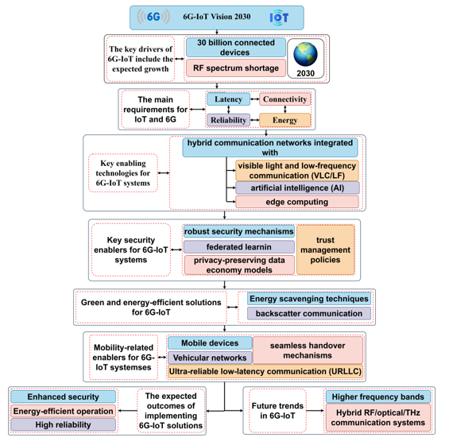
Figure 1. 6G-IoT: Enabling Technologies and Future Roadmap
1.2 Evolution from 5G to 6G
The overpass spanning 5G to 6G signifies transformation from higher connection speed-oriented architecture to intelligent, autonomous and completely integrated communication environment Figure 2. In contrast to 5G where achievements and technologies were focused on enhanced mobile broadband (eMBB), ultra-reliable low-latency communication (URLLC) and massive machine-like communication (mMTC), future applications such as holographic telepresence, digital twins, tactile internet and huge AI based IoT systems require superior functionalities beyond the architectural design points of 5G. 1 ms) latency, ultra-high reliability above 99.99999% of availability and global coverage through the convergence of terrestrial networks, airborne vehicles, low-earth orbit satellites (LEO), geostationary satellites (GEO), they support maritime traffic as well [8][9].
A significant paradigm change here is from AI-aided optimization in 5G to AI-native ubiquitous network design in 6G, where intelligence is integrated at all protocol layers which results into self-optimizing, self-healing and context-aware communication systems [10]. Moreover, 6G will also exploit spectrum in the terahertz (THz) bands which provides an enormous bandwidth but is also introducing new propagation and hardware challenges with a corresponding need for effective beamforming schemes, intelligent reflecting surfaces and novel materials [11]. From an architectural point of view, the 6G is expected to be completely distributed, edge-native and cell-free with sensing, computation and semantic communications deeply integrated into it. Energy efficiency is an optimization objective in 5G, while sustainability becomes a design principle of its own right in 6G with the emergence of green communication technologies, energy harvesting schemes and carbon-aware network management [12]. Thus, 6G is not just the next natural step after 5G in terms of speed and capacity improvement, but significantly reshapes the paradigm of wireless systems to intelligent, ubiquitous, and sustainable digital infrastructures that can support the rise of cyber– physical–human interactions.
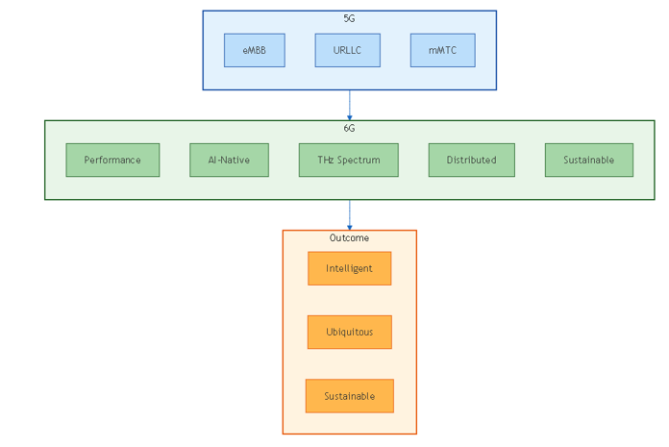
Figure 2. The 5G–6G Evolution: From Connectivity to Intelligence

- Related work
The sixth generation (6G) wireless communications system is expected to be the next revolutionary leap that will comprehensively facilitate a variety of emerging applications related to increasingly extending IoT [13]. Fast development and increasing requirement for higher degree of automation drive the need for ubiquitous, high-c capacity networks supporting ultra-reliable low-latency communication (URLLC) also efficient-supporting machine-type communications (MTC). Novelties such as the development of intelligent transport systems (ITSs), advanced vehicular networks, the modern smart cities built for urban mobility, and complete industry Internet serving Industry 4.0 applications are just some examples. The general target of 6G is to offer varied services that contain not only high capacity-content delivery, but also intelligent network orchestration and a sophisticated network slicing which is dedicated for promising applications with high revenue. An in-depth analysis of the basic technological enablers has been carried out to recognize which key technologies are expected to be crucial for the development of next-generation communication systems and service supporting at 6G age, with great emphasis on huge demand due to its extensive requirements by IoT that transforms diversely sectors and fosters innovative mobile communication.
Despite next-generation communication systems being deployed with IoT connectivity as the primary focus for interoperability in traditional cyber–physical scenarios with interaction between humans and physical objects at the level of machine-learning, 6G networks will pave the way to a cyber–cyber–physical approach that positions intelligence together with information and knowledge as an indispensable constituent for IoT communications: where layers in cloud–cyber agents are combined within these ends, socializing based on shared natural learning capabilities inherent within both data, information, and knowledge resources that interconnect via Internet [14]. IoT of the traditional definition in which only machine machines can be interconnected to network will not for so long belong only to IoT category; thus, a more generalized approach related with IoT is being envisaged, widening still more 6G/IoT. The 6G network will transform into fully flexible and self-evolving, decidable learning and self-configuring networks. Time information provisioning and control are the other key elements in 6G IoT architecture, as time domain was largely missing for 5G and former communication systems and not well served for general IoT applications despite fact that for many machines highly precise time is demanded to ensure high precision operation [15]. A large number of machines that are already networked via different access technologies want and gain highly precise time reference and time control for timing, synchronization and pay-load transfer On Trigger Enter(A).
Production architecture of IoT connectivity is also not yet available, and the appropriate handling about transportation of time superimposed to the regular space-time-effort-and intelligence based information for future IoT systems has not been fully explained. Motivated by this, the concept of when-IoT is introduced that explains the scenario where time and its control provisioning are essential; we propose a joint-charge model which includes space-time domain as well as fifth dimension termed cyber/machine interaction (CMI) smart-A-B-C hole for intelligence-information-knowledge envisaged charges [16]. It is important to set the quality of service (QoS) from an end user’s point of view, and also to clearly state and classify the sustainable, resilient, flexible, universal service provision time. In addition, the QoS broadens communication service domain beyond demand-side IoT to supply-side IoT by providing essential services of IoT, such as energy supply and ultimate water drought feeding and dry food provisioning by the IoT connected resource-centric regulators through them transmission mechanisms that are capable of transporting IEEE 802. 15. 4 IoT divided supply-side communication ( [17][18]).
The continuous development of 6G networks are to meet the requirements of Internet-of-Things (IoT) applications with key performance indicators beyond what may be achieved using current 5G technologies, such as ultra-reliable low-latency communications (URLLC), high-energy efficiency even for battery-free devices in long-term deployments and massive connectivity for tightly placed devices in factories and homes. 6G is predicted to bring about further growth areas, which will include improved mixed-reality experiences that incorporate volumetric video, spatial audio, haptics and autonomous systems (involving drone-to-drone communication, ground- robot communication and vehicleto-vehicle communication [19]). These new and (or) complementary KPIs are suggested including the Average Data Rate, Nominal Throughput, Area Traffic Capacity and even specific indicators like Quality of Experience, degree of freedom or amount of information Table 1. The high data-rate demands, also characterized as the performance requirement initially designed for eMBB, are still challenging 6G IoT for applications like AR/VR/XR and these works can be integrated with communication and monitoring/control capabilities in 6G IoT. Maturity of the volumetric video communication is a new turning point in Ubiquitous Ultra HD, and transmission interactive volumetric video over partial streaming also affects IoT with immersive MR experience. Further, multi-user collaborative AR/VR/XR based on UHD multiplayer volumetric video and multi-finger haptics raise the requirement of 6G in communication [20]. This work presents a new cross-layer framework that tackles the limitations discussed above by offering an integrated treatment of the three communication technologies, AI, security, QoS/URLLC and energy sustainability for the case of 6G IoT applications.

Table 1 Comparative Analysis of Existing Surveys on 6G-Enabled IoT
Ref. | Focus  Area | Communication Technologies | AI Integration | Security & Privacy | QoS / URLLC | Energy Sustainability | Limitations
[21]  [22] | THz Communications | ✔ THz | ✖ | ✖ | Limited | ✖ | Focuses mainly on PHY-layer aspects
[23] [24] | RIS & Smart Radio | ✔ RIS | Partial | ✖ | Limited | ✖ | Lacks IoT scalability analysis
[25] [26] | Massive MIMO & UDN | ✔ Massive MIMO | ✖ | ✖ | Partial | ✖ | Focused on broadband users
[27] [2] | AI for 6G | Partial | ✔ Federated & Edge AI | Limited | Partial | ✖ | Does not integrate energy or trust
[28] [29] | Network Slicing | Partial | ✔ AI-based slicing | ✖ | ✔ | ✖ | Mainly 5G-oriented frameworks
[30]  [31] | Security & Trust | ✖ | Partial | ✔ | ✖ | ✖ | High-level frameworks, lacks integration
[32]  [33] | Energy Harvesting | Partial | ✖ | ✖ | ✖ | ✔ | Studied independently from QoS/security
This Work | Integrated 6G IoT Ecosystem | ✔ | ✔ | ✔ | ✔ | ✔ | Unified cross-layer perspective

- Research Methodology
This paper follows a systematic and analytical review approach to analyses technologies that make IoT systems possible over the 6G networks. The research methodology is organized in a three-step cycle of extensive literature survey, comparative positioning and cross-layer abstract modeling. We pursued An SLR to identify state-of-the-art and high-impact works on 6G communication technology, AI-driven networking systems, edge intelligence approaches in communications networks, security mechanisms for communication network/subsystems and sustainable IoT solutions[34]. Peer-reviewed literature was searched in the major scientific databases including IEEE Xplore, Science Direct, MDPI, Springer and Wiley. The basis for selection was the existence of publications at the timeframe between 2020 and 2025, with emphasis on technological enablers such as Terahertz (THz) communications, Reconfigurable Intelligent Surfaces (RIS), massive MIMO, ultra-dense networks (UDNs), federated learning, network slicing, and energy harvesting. Second, the identified works were classified according to major dimensions which includes innovations on communication layer, level of integration of intelligence with AI, support for QoS/URLLC, security and privacy schemes and strategies for energy sustainability. A framework of comparative analysis was subsequently established (Table 1; Table 2) to systematically assess limitations, strengths and research gaps of the included studies.
Third, we explore a cross-nay integrated architecture for physical-layer innovations, AI-native orchestration, secure communication methods and green IoT principles. Its approach focuses in particular on interoperability, scalability and alignment with IMT-2030 (which is why the technological enablers are not considered separately but as part of a complete ecosystem). Last, open research challenges in the area have been identified through a gap analysis that covered topics that are still unresolved such as limitations regarding THz propagation, scalability of AI models, trade-off considerations for privacy-preserving learning, mobility management for ultra-dense deployments, and energy-autonomous IoT devices. Such a structured approach guarantees high analytical quality, technological coverage and forward-thinking perspective on the 6G-enabled IoT ecosystems evolution.
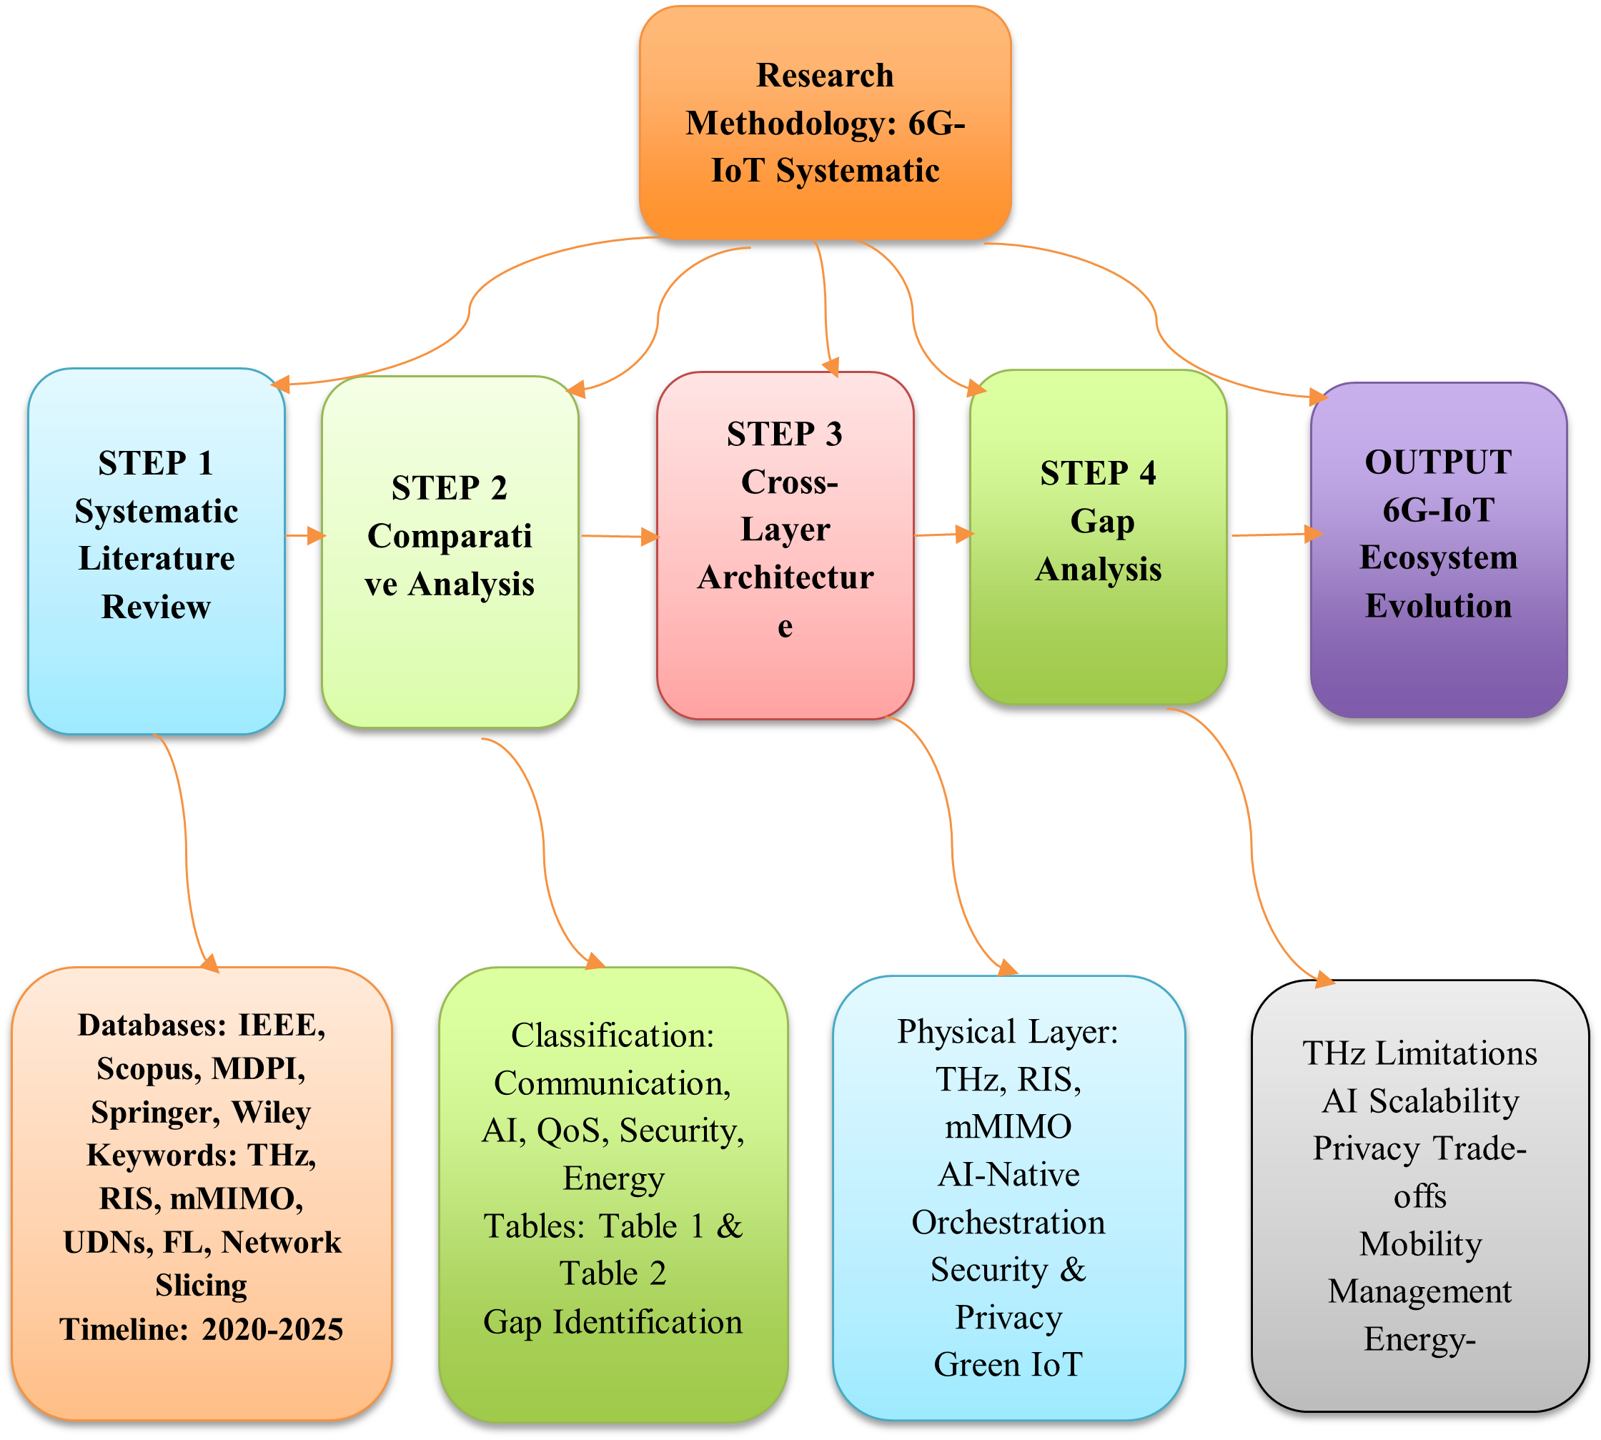
Figure 3. Systematic Research Methodology for 6G-IoT Review
- Emerging Communication Technologies for IoT in 6G
Revolutionizing connectivity, the sixth generation (6G) wireless system is expected to increase the interaction of everything from the digital world in an unprecedented level through emerging IoT paradigm. Where the previous generation of mobile technology, 5G, greatly increases the number of wireless devices that can be connected — as many as a million per square kilometer in some estimates — technology experts believe 6G will take that up by an order of magnitude. It is predicted that it could improve the capacity 100-fold, allowing well over a hundred million devices to work together in a similar space. These great advance needs novel communication techniques that are now high in demand for research and society. Among the proposed advancements there are terahertz communications, which can process data at unrivaled speeds, as well as intelligent surfaces that enhance signal quality. More interestingly, reconfigurable met surfaces have been proposed by researchers (Table 2, Figure 4): These structures can greatly control electromagnetic waves, which could not only be flexible but also effective in wireless communication. Furthermore, complex system designs, including massive MIMO systems and ultra-dense networks, show potential to provide additional connectivity[35]. Furthermore, progress in visible light communication and hybrid radio architecture is also an important part of the 6G vision. This next generation wireless will not be working in the vacuum; it is expected to be synergized with advanced AI techniques extensively. The joint initiative will be focusing on the needs for 6G in a variety of IoT services and how to meet them to support requirements through increasingly diverse use cases in future interconnections, etc.[36],[37].

-Terahertz and beyond Terahertz Communications: The Terahertz (THz) and sub-THz frequency ranges are believed to be one of the essential enablers for 6G in a reliable and energetically efficient manner to meet the multi-gigabit/terabit applications requirements across a wide variety of domains. These frequency bands are the last mile for wireless communications, they can provide a spectrally very large range according to Shannon law and above all high data rates. Short-range operation, non-ionizing radiation, and higher resilience to external EM noise, all help systems operate successfully at THz. THz communications assisted 6G is committed to provide a complete OSI layer-wide architecture, enabling ultra-channel parellelism and effective optimization. [21],[23].
-Intelligent Surfaces and Reconfigurable Metasurfaces :The rapid spread of wireless communication systems has brought the requirements for broad band transmission and connectivity out of reach of future most advanced networks extending high-speed spectrum support to the beyond 5 th generation (B5G) frameworks. Some of the established notions to fulfill these requirements are terahertz (THz) communications, integrated sensing, visible-light communications and ultra-reliable low-latency communications (URLLC). RIS and meta-surfaces (which we use interchangeably to refer to a surface consist of multiple unit cells) represent a new frontier in enabling high data rates or avoiding interference and deep fading by manipulating radio-wave propagation. RIS is a manmade surface that can be intelligently programmed for manipulating EM wave scattering to make the wireless systems work better. Such programmable surfaces can be used in combination with wireless communication systems for critical system use cases, like supply chain tracking/monitoring; social distancing/crowd control measures and autonomous-driving/vehicular networks [38].
There are numerous new technologies that support the realization of 6G wireless networks. Many of these technologies, when combined with complementary artificial intelligence algorithms are reported as being able to satisfy traffic requirements in next-generation wireless networks, lower energy consumption and enhance coverage for the IoT [39],[40] [24].
-Massive MIMO and Ultra-Dense Network Architectures:In the race for the beyond-5G and even Digi tal-6G systems, in which massive connectivity, extremely high data rates, and ultra-low latency will be essential requirements that must be fulfilled at all costs, to appropriately meet these demands ultra-dense network (UDN) topologies are expected to see a significant surge of prominence. Such high standards are driven by the skyrocketing demands for overall connectivity solutions, machine type communications and difficult multi-sensory data transmissions that originate from 6G enabled applications in a wide variety of domains and industries including smart environments, augmented reality (AR)/ virtual reality (VR), digital twins, as well as automated factory processes. One of the key technologies that serves as a strong enabler for UDNs is the technology of massive multiple input multiple output (MIMO) which has been identified as one of the most disruptive technology introduced in wireless-age. This advanced methodology introduces base stations (BSs) equipped with significantly larger number of antennas than the users fulfilling equipment complementarity to explore long communication distance, greatly improve average capacity of the overall system, as well as guarantee extremely high data rate for mobile user all over the network. This technology had a significant development throughout the years, since its first appearance with massive multi-antenna single BS and leads up to massive MIMO in cooperative systems. This evolution also goes on to cover cell-free massive MIMO system design in a novel way. In such state-of-the-art cell-free massive MIMO networks, strategically deployed access points (APs) over a large geographical area act as a joint interface cancellation device to serve a large number of users with low-cost single antennas simultaneously that makes the network an ideal framework for achieving high data rates and connectivity [25],[41],[42].
-Visible Light Communication and Hybrid Radio Architectures: Optical wireless communication (OWC) with the light-emitting diode (LED) as a transmitter, visible light communication (VLC), can provide high data rates in dL ranging from only few kb/s to several Gbit/s. The technology has been harshly explored for interconnecting IoT enabled devices, due to its native features like safety, reliability and security [26]. VLC can be integrated with the traditional RF communication to form hybrid VLC/RF networks where both technologies are complementary to each other and support the 6G KPIs (key performance indicators). The hybridization has been extensively studied for access point, channel, and sensor fusion. Hybrid VLC/RF networks offer the synergistic benefits in terms of throughput, coverage, reliability and latency performance as well as being able to enable satellite, aerial and underwater communication.Terahertz (THz) communications are a significant enabler for the next generation IoT systems, as they provide high capacity and ultra-wide bandwidth VPN access in frequency bands from 0.1 to 10 THz. This THz is defined as a significant threshold that lies between electronics and optics, and it contains the weakest linkage among electromagnetic spectrum, its origins, generation concepts, enabling technologies, physical limits and health problems. In terms of applications, the THz field has seen extensive research in wireless communication applications, such as free-space high-speed wireless communication (THz-wireless/wired), multi-interference wireless communications on chip optical wireless communication and satellite communication. Furthermore, THz can be employed for energy harvesting relevant to visible light communication (VLC), indoor localization, vehicular communication, spectral imaging and environmental sensing as important candidates of the future smart city [43].
Table 2 .Comparative Overview of Emerging 6G Communication Technologies for IoT Applications
Technology | Frequency/Scope | Key Advantages | Applications | Performance Metrics (KPI)
Terahertz (THz) | 0.1 – 10 THz | High data rates, wide bandwidth | IoT, smart cities, satellite communication | Throughput, Latency
RIS / Metasurfaces | Reconfigurable surfaces | Improved signal propagation, interference mitigation | Autonomous vehicles, monitoring | Reliability, Coverage
Massive MIMO | Multi-antenna BS | Increased capacity, extended range | Smart factories, AR/VR | Capacity, Connectivity
VLC / Hybrid RF | LEDs + RF | Reliable, secure, high-speed | IoT, underwater, satellite | Throughput, Latency

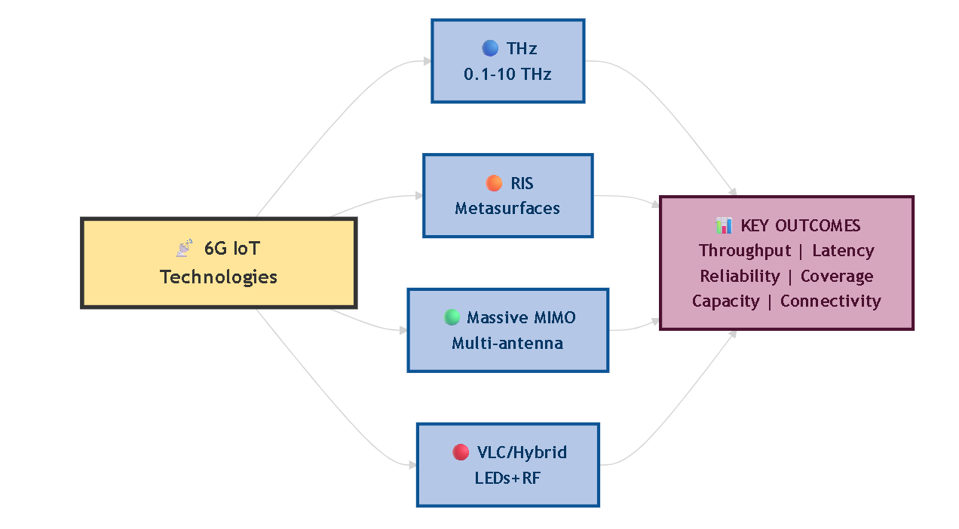
Figure 4 Emerging 6G Communication Technologies for IoT

- AI and Edge Intelligence in IoT over 6G
Technology development of 6G is a gradual evolution of the IoT system with intelligent, high-reliability, and high-efficiency communication networks [44]. Novel commutation techniques are to be implemented on THz and beyond-THz links for smart surfaces, which are a part of the communication systems under development for the beyond-6G era, aiming to improve signal quality and transmission efficiency [45]. Although Massive MIMO systems and ultra-dense network architectures enhance connectivity, high amount of devices are predicted in future networks of IoT systems [46]. Lastly, due to RF and optical resources need to be managed jointly for energy efficiency and reliability performances, hybrid RF–visible-light communication architectures are also significant [47]. These trends are fueling a convergence of AI and edge computing, the end goal of which is to enhance efficiencies in network operations, resource abstraction and service delivery through the application of AI techniques to increase the sophistication and performance of the network in areas including fine-grained to ultra-granular interference management, transmission scheduling, and static to predictive resource orchestration, etc. At scale, these capabilities are better complemented by edge computing: which enables energy- and time-efficient processing of data by offloading computation heavily offloaded from centralized cloud servers to nearby edge nodes as well as minimize energy costs associated with transporting the data to centralized locations—localizing further greater real-time feasibility of data processing. Edge intelligence allows devices without a connection to work on their own, learn from the environment, and draw contextual inferences [48]. Federated Learning (FL) and Semi Federated Learning (SFL) enable heterogeneous edge devices to participate in a cooperative model training while guaranteeing the local privacy of each device (i.e., not forwarding their local data to other devices), thus contributing to realize the privacy protection in data collection scenarios with limited communication resources[49]. In decentralized approaches, this system can utilize decentralized problem adaptive learning to various applications by holding user-specific and domain-specific knowledge. For the desired Quality-of-service (QoS) level, the computational, storage and network resources are provisioned to a particular service in real-time through resource orchestration and AI-driven network slicing. Supporting low-power, long-lifetime devices, of course, but also supporting high-bitrate and energy-harvesting devices with low-latency high-reliability support. Moreover, Multi-stage federated learning and reinforcement-learning frameworks (e.g., deep Q−networks) utilize dynamic resources in order to accommodate different traffic demand and heterogeneous workloads [46 , 47]. It caters to compute heavy applications including such as video real-time video analytics, speech recognition, and autonomous systems. Overall, the advancement of AI, edge computing, federated learning and hybrid communication architectures will bolster the really structures of enablers of the 6G-based IoT ecosystem. Still, latency, energy efficiency, and privacy challenges are open ones, the rest of the problems of high network efficiency, high scalability, and high reliability are all solved. Such combination enables seamless execution of heterogenous IoT services, therein making ground for the concept of autonomous, context-aware and sustained digital infrastructures of future smart environments

6. Security, Privacy, and Trust in 6G IoT
Although the International Telecommunication Union (ITU) has made remarkable work to set global efforts for 6G, covering a visionary part and an implementation plan of industrial requirements, it is important to emphasize that a achievable approach toward the complete interoperable global architecture looks more like concepts. In tandem with that, it's eminently possible -- even profoundly worthwhile -- to actively investigate the varied IoT citizens' needs and its relevant concepts, which will be key in driving 6G tech forward and beyond. The different desired properties for 6G IoT can be aptly summarized as:
6G is anticipated to leap performance across the board including economic, latency, data rate, devices per connection density, energy efficiency, coverage and mobility [52]. In addition, they are based on major technology breakthroughs in THz/beyond-THz, AI and the building of space-air-ground-sea integrated network. Nonetheless, those improvements bring a lot of challenges to the security, privacy, and trust in 6G that are beyond anything previously encountered regarding these three dimensions. To overcome such challenges, we envision a security and trust framework for 6G called SIX-Trust. The architecture is composed of three layers Sustainable trust, looking at the sustainability of the 6G system as a whole. - Infrastructure trust, making sure that infrastructures build and operate correctly. - Xenogeneic trust, takes into account trust on other things than just the usual septenary dimensions of 6G.
-Lightweight Cryptography and Secure Authentication: The Internet of Things (IoT) vision offers an enormous number of connected devices for a wide range of real-time applications such as smart cities, e-health, e-governance, Intelligent Transport systems (ITS), Industrial-IoT(IIoT), wearable sensor networks disaster management, smart homes and many more[53]. These new use cases require advanced technology, which will need to work over the current 4G, 5G networks and future 6G. [31]. Society, and the very definition of a network, have been transformed by 4G and 5G connections as well as the spread of Internet of Thing (IoT) tools[54]. In the beginning, emphasis was more on connectivity as opposed to security. With more and more clients deploying the IoT, security concerns come to light. What is more, 6G networks can provide the service capabilities and satisfy security requirements of confidentiality, integrity, data freshness and authenticity. [55]. Lightweight cryptology and secure authentication are essential to realize strong security measures in 6G networks. Existing there are already numerous lightweight cryptographic protocols for specific use cases, some of which also address IoT requirements [56]. New lightweight cryptographic protocols like ones that we presented here should be seriously taken into account while addressing security aspects of 6G networks in order to answer threats from IIoT environments.
-Privacy-Preserving Data Economics:The rapid development of 6G networks will bring unprecedented connectivity for IoT systems, but such deployments will also require a careful assessment of the privacy and security requirements for these systems [56]. IoT devices are often deployed in contexts where significant personal data is collected and shared, such as smart homes, smart cities, and remote health monitoring. As the number of devices and the amount of data collected grow, it becomes increasingly difficult for even knowledgeable individuals to track how data is collected, processed, and shared, which constitutes a violation of privacy [56]. The sophistication of the devices, the channels over which data can be transmitted, and the types of data being shared differ vastly among systems; thus, it is important to be able to take privacy considerations into account while also configuring the rest of the network parameters. The general requirements for ensuring privacy over IoT devices in 6G networks include the ability to control whose consent is required for a dataset to be considered “open,” the ability to prevent sensitive attributes from potentially being inferred by transmitted data, and the assurance that the individuals involved either actively consent or are not identifiable from the data [56]. The final requirement is often referred to as differential privacy, and ensuring that the privacy is controlled according to the types of consent also constitutes a major challenge.
- Trust, Resilience, and Risk Management :The IoT link a wide range of physical things to the internet for monitoring and controlling which enables transformation from Manual World to Autonomous World. The emerging technologies of 6G is crucial to the increasingly large number of IoT connectivity and high-capacity communication systems that provide greater spectral efficiency and energy efficiency. 6G will provide enormous data volume and massively distributed data generation, which could be realized by smart sensing and transmission, MMTC (machine-type communications) and unlimited connectivity [56]. resource orchestration, federation and integration) in order to support the diversity of services that different IoT devices may offer [57]. The local and servant domain federated, semi-federated learning based schemes contributes to the intelligent deployment of Machine Learning (ML) algorithms preserving confidentiality so that privacy is improved. If different type of connectivity was widely studied in 5G, the need to meet the various quality requirements handled by a heterogeneous set of applications is still open. Different applications with different Quality of Service (QoS) specifications, such as Ultra-Reliable Low-Latency Communication (URLLC), and massive Machine-Type Communication (mMTC), entail increasing demands.

7. Reliability, Low Latency, and Mobility in 6G IoT
Ultra-Reliable Low-Latency Communications (URLLC) is introduced as one of the three key performance requirements for 5G networks and its importance in 6G systems will further increase as mission-critical IoT services, such as industrial automation, autonomous driving and intelligent transportation call for new URLLC solutions. While many of the more traditional services running over IoT are offering low latency services, further use cases place tighter limits on latency at 1 ms or less with aspirations for sub-0.1 ms (under the new paradigm of enhanced URLLC in the long term). Ultra-low latency/reliability requirements of such applications that may include but are not limited to; vehicular communications, drone-assisted disaster management and telemedicine bring unprecedented challenges in the design of 6G systems to accommodate ultra-low latency levels [58]. These demands result in common targets like very low packet error rates (10⁻⁹ to 10⁻¹²) and very high spectral efficiency that are only 5G transmission schemes can outperform, while occupying very little resources.
Mobility and handover management is also another key challenge for QoS support in dynamic IoT environments in general, and in IoV in particular. Internet of vehicles (IoV) is the integration of a vehicle ad hoc network (VANETs), for vehicle-to-vehicle, vehicle-to-infrastructure, and vehicle-to-pedestrian communication, with vehicle-to-everything (V2X) communications to provide higher safety and efficiency [59]. These scenarios please URLLC limitations in the information prices 100 kbs to 1 Gbps. High vehicular speeds also create a need for novel handover schemes because traditional 5G mobility solutions will not be able to accommodate the vertical and horizontal high mobility requirements of V2X communication, due to high user demands in both directions. While millimeter-wave communications and expanded satellite broadband coverage can indeed enhance connectivity in rural areas, the general mobility optimization of 6G IoV continues to be an unsolved problem of how to provide 6G IoV to long distance [60]. The first proposal, single-point mobility management, proposes to retain the provisioning of compact and coherent QoS even when seamless connectivity is required during mobility between networks. It is also a consideration to energy efficiency. We will discuss novel solutions for hybrid energy harvesting, wireless power transfer and passive backscatter communication, which can ultimately facilitate battery-free IoT devices that reduce infrastructure energy footprint and have longer operational life time [61]. With the integration of Thermoelectric harvesting and dexterous utilization of transceiver, energy sustainability is boosted at no performance cost to the network. This is inevitable for the high density 6G IoT deployments to avoid performance penalties. Lastly, it requires an ultra-reliable low latency communication (URLLC) framework, efficient mobility strategies, and energy-efficient design for ultra-low latency, high reliability, and seamless mobility in 6G-enabled IoT. These capabilities drive mission-critical IoT applications, ranging from autonomous transport to smart factory systems, and will help to create a completely connected, intelligent and sustainable 6G IoT ecosystem.
8. Deployment Scenarios and Standardization Frameworks for 6G-Enabled IoT Ecosystems
Prospective deployment use-cases of IoT in the highly heterogeneous 6G network architecture cover a wide range of environments including smart cities, advanced healthcare systems, Industry 4.0 facility, and intensive agricultural systems. As these domains are still growing, specialized deployment architectures are rising to meet stringent needs such as ultra-low latency, ultra-high reliability, advanced data security and huge scalability. These capacities are more and more supported by new hardware platforms, flexible software frameworks, as well as smart orchestration approaches. Smart cities in particular are revolutionizing urban infrastructures into densely connected spaces with ubiquitous connectivity, massive sensor deployment and intelligent service endpoints that employ disruptive technologies to minimize energy consumption, communication bandwidth and urban mobility [57]. Leveraging on the 5G advanced specifications (Release 18 and further) and International Telecommunication Union (ITU) IMT-2030 requirements, future generation solutions will need to guarantee aero-trust security for the Industrial Internet of Things (IIoT), wide area vehicular communications, as well as smart transportation systems [62]. At the same time, Industry 4.0 predicts a future where production/management/supply chain operate fully independently with continuous monitoring in real-time and full transparency over industrial processes [63], [64].
Such heterogeneity should be addressed through the interoperability not only of devices, but also services and applications. As a result, standardization work has been accelerated with the emergence of low-power and low-throughput wireless networks, resource-constrained devices, machine-to-machine (M2M) communications, smart grid networks as well as building management systems. The vision of the expected widespread deployment of IPv6 multicasting is to obviate private addressing and at the same time permitting millions of hosts to access the global Internet [65]. In this regard, the Internet Engineering Task Force (IETF) is working on standardized IoT protocol stacks for deployment over diverse technological spaces [66]. These mechanisms aim at modifying existing Internet protocols in an incremental manner or the definition of new lightweight protocols to be used in highly constrained nodes such as sensors and actuators with low processing, memory capacity, radio transmission range and bandwidth. Therefore, addressing the issues of operating Internet protocol stacks over low-power and lossy networks, is a key for providing scalable, secure and sustainable 6G-enabled IoT ecosystem [67], [18].
- Applications of IoT over 6G: The convergence of IoT with sixth generation (6G) wireless networks is envisioned to open a new era of smart, autonomous and ultra-connected things. Contrary to the past generations, 6G is expected to deliver ultra-low latency (sub-millisecond), extremely high throughput (terabit per second scale), massive connection of devices, integrated sensing and communication, and in-network AI natively. These features greatly broaden the scope of IoT use cases beyond traditional smart monitoring[68]. Enabling real-time digital twins, autonomous traffic coordination, and massive environmental sensing in smart cities powered by 6G-IoT. In health, it provides worldwide robotic ‘surgery at a distance’, continuous holographic telepresence and AI-supported health monitoring with ultra-reliable communications. Distributed-latency control, including Industry 5.0 industrial IoT (IIoT), and co-machines with a deterministic latency enabling fully autonomous factories and human-machine co-workers configuration. Besides, other applications such as XR, connected autonomous driving (CAD), precision agriculture, space–air–ground integrated networks and mission-critical public safety become realizable thanks to 6G’s communication–sensing convergence and high reliability. More generally, IoT in 6G reflects a move away from massive connectivity towards intelligent context-aware and self-optimizing cyber-physical ecosystems.

9. Open Challenges and Future Directions
The Internet of Things (IoT) is forecast to create $78.9 trillion in economic value worldwide, providing predictive maintenance, robotic process automation and smart infrastructure. AIoT is expected to drive upwards of half of all technology investments by 2030. Despite the hype to 5G as a basis for industrial IoT applications, challenges exist including creating solutions for massive connectivity, ultra-reliable low-latency communication, security, privacy, and energy-efficiency.
Future research should shift to the speed up of the move towards 6G networks to take full advantages of the IoT. Some of the main areas are; scalable and sustainable networking architectures, AI powered edge intelligence, and interoperable device and service mesh. Moreover, global cooperation and harmonization are critical for large-scale deployment, ensuring consistent performance and reliability across regions.
Future industries will depend on IoT connected with production segments, devices resources and decentralized trust systems. It requires that the evolution of 5G and IoT be coordinated at the path to 6G whilst still retaining technological, economic, and operational obstacles to conjugation. Addressing these challenges would allow researchers to facilitate next-generation intelligent applications like autonomous systems, smart cities, XR-enabled services, and Industry 4.0, ultimately leading to fully connected and energy-optimized IoT ecosystems [57].

10. Conclusion
The development of the Internet has spurred the growth of the IoT, which consists of a web of connected objects and sensors exchanging data over shared communication networks. Although future 5G as envisioned by the ITU IMT-2020 path has provided more low-power connectivity support of large-scale IoT, bottleneck related to massive edge produced data and cloud-induced latency remain prominent. Looking beyond, the seamless integration of physical, digital and human worlds will be realized in 6G by achieving ultralow-latency connections (below 1 ms), massive connectivity including support for very low-Earth orbit satellites and immersive applications such as mixed reality or tactile Internet. Research is generally in advanced connectivity, intelligent routing, AI (or deep learning) driven network management and service orchestration, new cost-effective security mechanisms. In addition to enhancing performance, 6G highlights energy efficiency, sustainability, trustworthiness, privacy and lightweight security solutions against prospective cyber threats while maintaining trustable and reliable IoT ecosystems.

Disclaimer (Artificial intelligence)

Author(s) hereby declare that NO generative AI technologies such as Large Language Models (ChatGPT, COPILOT, etc.) and text-to-image generators have been used during the writing or editing of this manuscript.

References
[1] P. Popovski et al., “Internet of Things (IoT) connectivity in 6G: An interplay of time, space, intelligence, and value,” arXiv Prepr. arXiv2111.05811, 2021.
[2] R. Chataut, M. Nankya, and R. Akl, “6G Networks and the AI Revolution-Exploring Technologies, Applications, and Emerging Challenges.,” Sensors (Basel)., vol. 24, no. 6, Mar. 2024, doi: 10.3390/s24061888.
[3] A. Bourechak, O. Zedadra, M. N. Kouahla, A. Guerrieri, H. Seridi, and G. Fortino, “At the confluence of artificial intelligence and edge computing in iot-based applications: A review and new perspectives,” Sensors, vol. 23, no. 3, p. 1639, 2023.
[4] M. M. Rashid, S. U. Khan, F. Eusufzai, M. A. Redwan, S. R. Sabuj, and M. Elsharief, “A Federated Learning-Based Approach for Improving Intrusion Detection in Industrial Internet of Things Networks,” Network, vol. 3, no. 1. pp. 158–179, 2023. doi: 10.3390/network3010008.
[5] S. Sharma et al., “The role of 6G technologies in advancing smart city applications: Opportunities and challenges,” Sustainability, vol. 16, no. 16, p. 7039, 2024.
[6] E. Ganivet, “Growth in human population and consumption both need to be addressed to reach an ecologically sustainable future: E. Ganivet,” Environ. Dev. Sustain., vol. 22, no. 6, pp. 4979–4998, 2020.
[7] M. A. AbdlNabi, B. J. Hamza, and A. T. Abdulsadda, “6G optical-RF wireless integration: a review on heterogeneous cellular network channel modeling, measurements, and challenges,” Telecommun. Syst., vol. 87, no. 4, pp. 1201–1244, 2024.
[8] A. Jospine, L. H. M. Audah, and ..., “Vehicle monitoring system with geofencing capability,” J. Electron. Volt. Appl., vol. 1, no. 2, pp. 1–13, 2020.
[9] M. Höyhtyä et al., “Multi-layered satellite communications systems for ultra-high availability and resilience,” Electronics, vol. 13, no. 7, p. 1269, 2024.
[10] Y. Usman, H. Oladipupo, A. D. During, A. Robert, and R. Chataut, “AI, ML, and LLM integration in 5G/6G networks: A comprehensive survey of architectures, challenges, and future directions,” IEEE Access, 2025.
[11] Z. Chen, X. Ma, C. Han, and Q. Wen, “Towards intelligent reflecting surface empowered 6G terahertz communications: A survey,” China Commun., vol. 18, no. 5, pp. 93–119, 2021.
[12] E. Alzubi, “AI-Powered Smart Grids in the 6G Era: A Comprehensive Survey on Security and Intelligent Energy Systems”.
[13] D. C. Nguyen et al., “6G Internet of Things: A comprehensive survey,” IEEE Internet Things J., vol. 9, no. 1, pp. 359–383, 2021.
[14] X. Wang, Y. Zhao, C. Qiu, Q. Hu, and V. C. M. Leung, “Socialized learning: A survey of the paradigm shift for edge intelligence in networked systems,” IEEE Commun. Surv. Tutorials, vol. 27, no. 3, pp. 2085–2128, 2024.
[15] N. Gupta, S. Sharma, P. K. Juneja, and U. Garg, “Sdnfv 5g-iot: A framework for the next generation 5g enabled iot,” in 2020 international conference on advances in computing, communication & materials (ICACCM), 2020, pp. 289–294.
[16] P. Popovski et al., “A perspective on time toward wireless 6G,” Proc. IEEE, vol. 110, no. 8, pp. 1116–1146, 2022.
[17] O. Said, “Design and performance evaluation of QoE/QoS-oriented scheme for reliable data transmission in Internet of Things environments,” Comput. Commun., vol. 189, pp. 158–174, 2022, doi: https://doi.org/10.1016/j.comcom.2022.03.020.
[18] T. Mazhar et al., “Quality of Service (QoS) Performance Analysis in a Traffic Engineering Model for Next-Generation Wireless Sensor Networks,” Symmetry, vol. 15, no. 2. p. 513, 2023. doi: 10.3390/sym15020513.
[19] N. H. Mahmood, G. Berardinelli, E. J. Khatib, R. Hashemi, C. De Lima, and M. Latva-aho, “A functional architecture for 6G special-purpose industrial IoT networks,” IEEE Trans. Ind. informatics, vol. 19, no. 3, pp. 2530–2540, 2022.
[20] A. Hazarika and M. Rahmati, “Towards an Evolved Immersive Experience: Exploring 5G- and Beyond-Enabled Ultra-Low-Latency Communications for Augmented and Virtual Reality,” Sensors, vol. 23, no. 7. p. 3682, 2023. doi: 10.3390/s23073682.
[21] M. Polese, J. M. Jornet, T. Melodia, and M. Zorzi, “Toward end-to-end, full-stack 6G terahertz networks,” IEEE Commun. Mag., vol. 58, no. 11, pp. 48–54, 2020.
[22] W. Jiang et al., “Terahertz communications and sensing for 6G and beyond: A comprehensive review,” IEEE Commun. Surv. Tutorials, vol. 26, no. 4, pp. 2326–2381, 2024.
[23] Y. Feng, Q. Hu, K. Qu, W. Yang, Y. Zheng, and K. Chen, “Reconfigurable intelligent surfaces: Design, implementation, and practical demonstration,” Electromagn. Sci., vol. 1, no. 2, pp. 1–21, 2023.
[24] G. Gradoni et al., “Smart radio environments,” arXiv Prepr. arXiv2111.08676, 2021.
[25] Z. Gao et al., “Compressive-sensing-based grant-free massive access for 6G massive communication,” IEEE Internet Things J., vol. 11, no. 5, pp. 7411–7435, 2023.
[26] V. Stoynov, V. Poulkov, Z. Valkova-Jarvis, G. Iliev, and P. Koleva, “Ultra-Dense Networks: Taxonomy and Key Performance Indicators,” Symmetry, vol. 15, no. 1. p. 2, 2023. doi: 10.3390/sym15010002.
[27] E. Peltonen et al., “6G white paper on edge intelligence,” arXiv Prepr. arXiv2004.14850, 2020.
[28] S. Khan, S. Khan, Y. Ali, M. Khalid, Z. Ullah, and S. Mumtaz, “Highly accurate and reliable wireless network slicing in 5th generation networks: a hybrid deep learning approach,” J. Netw. Syst. Manag., vol. 30, no. 2, p. 29, 2022.
[29] S. Mhatre, F. Adelantado, K. Ramantas, and C. Verikoukis, “Intelligent QoS-aware slice resource allocation with user association parameterization for beyond 5G O-RAN-based architecture using DRL,” IEEE Trans. Veh. Technol., vol. 74, no. 2, pp. 3096–3109, 2024.
[30] Y. Wang, X. Kang, T. Li, H. Wang, C.-K. Chu, and Z. Lei, “SIX-trust for 6G: Towards a secure and trustworthy 6G network,” arXiv Prepr. arXiv2210.17291, 2022.
[31] T. Alam, “A reliable communication framework and its use in internet of things (IoT),” Authorea Prepr., 2023.
[32] J. Hu, Q. Wang, and K. Yang, “Energy self-sustainability in full-spectrum 6G,” IEEE Wirel. Commun., vol. 28, no. 1, pp. 104–111, 2020.
[33] O. L. A. López, H. Alves, R. D. Souza, S. Montejo-Sánchez, E. M. G. Fernández, and M. Latva-Aho, “Massive wireless energy transfer: Enabling sustainable IoT toward 6G era,” IEEE Internet Things J., vol. 8, no. 11, pp. 8816–8835, 2021.
[34] K. A. Hashim, H. H. Qasim, A. E. Hamzah, O. A. Hasan, and M. Al-Jadiri, “Door lock system based on internet of things and Bluetooth by using Raspberry Pi,” Bull. Electr. Eng. Informatics, vol. 12, no. 5, pp. 2753–2762, 2023.
[35] H. H. Qasim, “Enhancing Weather Monitoring : A Comprehensive Study Utilizing IoT , ESP32 , Sensor Integration , and Blynk Platform,” 2024 IEEE 10th Int. Conf. Smart Instrumentation, Meas. Appl., pp. 156–161, 2024, doi: 10.1109/ICSIMA62563.2024.10675553.
[36] S. K. Pattnaik et al., “Future Wireless Communication Technology towards 6G IoT: An Application-Based Analysis of IoT in Real-Time Location Monitoring of Employees Inside Underground Mines by Using BLE.,” Sensors (Basel)., vol. 22, no. 9, Apr. 2022, doi: 10.3390/s22093438.
[37] F. Salahdine, T. Han, and N. Zhang, “5G, 6G, and Beyond: Recent advances and future challenges,” Ann. Telecommun., vol. 78, no. 9, pp. 525–549, 2023, doi: 10.1007/s12243-022-00938-3.
[38] M. Di Renzo et al., “Smart radio environments empowered by reconfigurable intelligent surfaces: How it works, state of research, and the road ahead,” IEEE J. Sel. areas Commun., vol. 38, no. 11, pp. 2450–2525, 2020.
[39] W. Tang et al., “Wireless communications with reconfigurable intelligent surface: Path loss modeling and experimental measurement,” IEEE Trans. Wirel. Commun., vol. 20, no. 1, pp. 421–439, 2020.
[40] W. U. Khan, M. A. Javed, S. Zeadally, E. Lagunas, and S. Chatzinotas, “Intelligent and secure radio environments for 6G vehicular aided HetNets: Key opportunities and challenges,” IEEE Commun. Stand. Mag., vol. 7, no. 3, pp. 32–39, 2023.
[41] H. Q. Ngo, G. Interdonato, E. G. Larsson, G. Caire, and J. G. Andrews, “Ultradense cell-free massive MIMO for 6G: Technical overview and open questions,” Proc. IEEE, vol. 112, no. 7, pp. 805–831, 2024.
[42] V. Stoynov, V. Poulkov, Z. Valkova-Jarvis, G. Iliev, and P. Koleva, “Ultra-dense networks: Taxonomy and key performance indicators,” Symmetry (Basel)., vol. 15, no. 1, p. 2, 2022.
[43] M. T. Mamaghani, G. S. Member, Y. Hong, and S. Member, “Aerial Intelligent Reflecting Surface Enabled Terahertz Covert Communications in Beyond-5G Internet of Things,” pp. 1–24, 2027.
[44] S. P. Tera, R. Chinthaginjala, G. Pau, and T. H. Kim, “Toward 6G: An overview of the next generation of intelligent network connectivity,” IEEE Access, vol. 13, pp. 925–961, 2024.
[45] V. Petrov, H. Guerboukha, A. Singh, and J. M. Jornet, “Wavefront hopping for physical layer security in 6G and beyond near-field THz communications,” IEEE Trans. Commun., vol. 73, no. 5, pp. 2996–3012, 2024.
[46] W. Sun, Q. Wang, N. Zhao, H. Zhang, C. Shen, and L. W.-C. Wong, Ultra-Dense Heterogeneous Networks. CRC Press, 2022.
[47] R. F. Miranda et al., “A review of cognitive hybrid radio frequency/visible light communication systems for wireless sensor networks,” Sensors, vol. 23, no. 18, p. 7815, 2023.
[48] D. Xu et al., “Edge intelligence: Empowering intelligence to the edge of network,” Proc. IEEE, vol. 109, no. 11, pp. 1778–1837, 2021.
[49] A. Kareem, S. Sahran, A. Essa, H. Hadi, and D. Albashih, “Comparative Analysis of Color Space in Histopathology Image Classification,” vol. 37, no. 2, pp. 617–634, 2025.
[50] A. A. Ismail, N. E. Khalifa, and R. A. El-Khoribi, “A survey on resource scheduling approaches in multi-access edge computing environment: a deep reinforcement learning study,” Cluster Comput., vol. 28, no. 3, p. 184, 2025.
[51] L. F. de Sousa, “RAMPART-FL: Federated Learning for Intrusion Detection in the Edge through Reinforcement-based Multi-Criteria Participant Selection.” Universidade do Porto (Portugal), 2025.
[52] R. Kumar, S. K. Gupta, H.-C. Wang, C. S. Kumari, and S. S. V. P. Korlam, “From efficiency to sustainability: Exploring the potential of 6G for a greener future,” Sustainability, vol. 15, no. 23, p. 16387, 2023.
[53] H. H. Qasim, A. M. Jasim, and K. A. Hashim, “Real-time monitoring system based on integration of internet of things and global system of mobile using Raspberry Pi,” vol. 12, no. 3, pp. 1418–1426, 2023, doi: 10.11591/eei.v12i3.4699.
[54] A. F. Kadhim et al., “Design and Implementation of an Accurate and Simple Remote Medical Store Monitoring System Using ESP32 Microcontroller-Based Wi-Fi and IoT Technology,” Appl. Mech. Mater., vol. 934, pp. 63–73, 2026.
[55] P. Bhide, D. Shetty, and S. Mikkili, “Review on 6G communication and its architecture, technologies included, challenges, security challenges and requirements, applications, with respect to AI domain,” IET Quantum Commun., vol. 6, no. 1, p. e12114, 2025.
[56] H. Al-Aqrabi, P. Lane, and R. Hill, “Performance evaluation of multiparty authentication in 5G IIoT environments,” in International Conference on Cyberspace Data and Intelligence, 2019, pp. 169–184.
[57] S. Li, M. Iqbal, and N. Saxena, “Future industry internet of things with zero-trust security,” Inf. Syst. Front., vol. 26, no. 5, pp. 1653–1666, 2024.
[58] M. K. Banafaa et al., “A comprehensive survey on 5G-and-beyond networks with UAVs: Applications, emerging technologies, regulatory aspects, research trends and challenges,” IEEE access, vol. 12, pp. 7786–7826, 2024.
[59] H. H. Qasim, H. Z. Abidin, and S. A. C. Abdullah, “Handover management in vehicle communication: applications, techniques, issues, and challenges: a review,” Bull. Electr. Eng. Informatics, vol. 13, no. 5, pp. 3167–3186, 2024.
[60] E. Yaacoub and M.-S. Alouini, “A key 6G challenge and opportunity—Connecting the base of the pyramid: A survey on rural connectivity,” Proc. IEEE, vol. 108, no. 4, pp. 533–582, 2020.
[61] T. Jiang et al., “Backscatter communication meets practical battery-free Internet of Things: A survey and outlook,” IEEE Commun. Surv. Tutorials, vol. 25, no. 3, pp. 2021–2051, 2023.
[62] L. Mohjazi, B. Selim, M. Tatipamula, and M. A. Imran, “The journey toward 6G: A digital and societal revolution in the making,” IEEE Internet Things Mag., vol. 7, no. 2, pp. 119–128, 2024.
[63] A. Jahid, M. H. Alsharif, and T. J. Hall, “The convergence of blockchain, IoT and 6G: Potential, opportunities, challenges and research roadmap,” J. Netw. Comput. Appl., vol. 217, p. 103677, 2023.
[64] L. Jebaraj, A. Khang, V. Chandrasekar, A. R. Pravin, and K. Sriram, Smart city: Concepts, models, technologies and applications. CRC Press, 2023.
[65] A. Nikoukar, S. Raza, A. Poole, M. Güneş, and B. Dezfouli, “Low-power wireless for the internet of things: Standards and applications,” IEEE Access, vol. 6, pp. 67893–67926, 2018.
[66] R. Morabito and J. Jiménez, “IETF protocol suite for the Internet of Things: Overview and Recent Advancements,” IEEE Commun. Stand. Mag., vol. 4, no. 2, pp. 41–49, 2020.
[67] M. Höyhtyä, S. Boumard, A. Yastrebova, P. Järvensivu, M. Kiviranta, and A. Anttonen, “Sustainable satellite communications in the 6G era: A European view for multilayer systems and space safety,” IEEe Access, vol. 10, pp. 99973–100005, 2022.
[68] H. H. Qasim, A. E. Hamza, L. Audah, H. H. Ibrahim, H. A. Saeed, and M. I. Hamzah, “Design and implementation home security system and monitoring by using wireless sensor networks WSN/internet of things IoT,” Int. J. Electr. Comput. Eng., vol. 10, no. 3, pp. 2617–2624, Aug. 2020, doi: 10.11591/ijece.v10i3.pp2617-2624.

